ASSESSMENT-1

1) Create table employee (empno(PK),name,salary,designation)

2) Create table location(empno(FK),locid,state,city)

3) Add a column (dept) to employee table.

4) Add a column (road no) to location table.

5) Change the name of the table employee to hydemployee.

6) Change the name of the table location to emplocation.

7) find average,min,max salary of each dept of employee table.

8) Combine 2 table and display the columns of 2 tables(empno,name,salary,designation,dept,locid,roadno,state,city)

9) count number of rows of the 2 tables

10) find the 3rd highest salary of the employee table.

11) add a tax column and find the tax dedection and display the gross salary.

\*tax is 10% of the total salary

12)Select the unique salary from the employee table.

13) A table Employee has the following data:

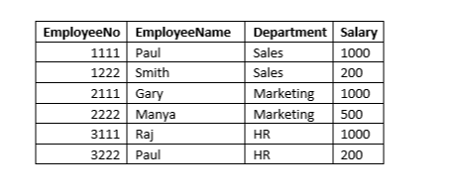

The following queries were executed on the table successfully :  
  
 UPDATE EMPLOYEE SET DEPARTMENT  = 'HR' WHERE DEPARTMENT = 'Marketing' ;  
  
 DELETE FROM EMPLOYEE WHERE DEPARTMENT = 'HR' AND SALARY = 1000;  
  
What will be the output of the following query?  
SELECT COUNT(\*) FROM EMPLOYEE;

5

6

4

2

Mail your assessment in sandipmohapatra2016@gmail.com