Trees in Data Structure

What are trees?

* Tree is a hierarchical data structure which stores the information naturally in the form of hierarchy style.
* Tree is one of the most powerful and advanced data structures.
* It is a non-linear data structure compared to arrays, linked lists, stack and queue.
* It represents the nodes connected by edges.

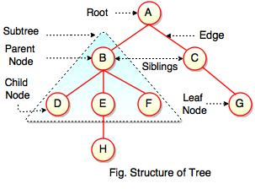  
  
The above figure represents structure of a tree. Tree has 2 subtrees.  
A is a parent of B and C.  
B is called a child of A and also parent of D, E, F.  
  
Tree is a collection of elements called Nodes, where each node can have arbitrary number of children.

|  |  |
| --- | --- |
| **Field** | **Description** |
| Root | Root is a special node in a tree. The entire tree is referenced through it. It does not have a parent. |
| Parent Node | Parent node is an immediate predecessor of a node. |
| Child Node | All immediate successors of a node are its children. |
| Siblings | Nodes with the same parent are called Siblings. |
| Path | Path is a number of successive edges from source node to destination node. |
| Height of Node | Height of a node represents the number of edges on the longest path between that node and a leaf. |
| Height of Tree | Height of tree represents the height of its root node. |
| Depth of Node | Depth of a node represents the number of edges from the tree's root node to the node. |
| Degree of Node | Degree of a node represents a number of children of a node. |
| Edge | Edge is a connection between one node to another. It is a line between two nodes or a node and a leaf. |

In the above figure, D, F, H, G are**leaves**. B and C are **siblings**. Each node excluding a root is connected by a direct edge from exactly one other node  
parent →  children.

**Levels of a node**

Levels of a node represents the number of connections between the node and the root. It represents generation of a node. If the root node is at level 0, its next node is at level 1, its grand child is at level 2 and so on. Levels of a node can be shown as follows:  
  
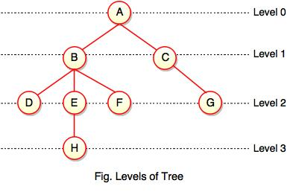  
  
**Note:**  
  
- If node has no children, it is called **Leaves** or **External Nodes.**  
  
- Nodes which are not leaves, are called **Internal Nodes**. Internal nodes have at least one child.  
  
- A tree can be empty with no nodes or a tree consists of one node called the **Root**.

**Height of a Node**

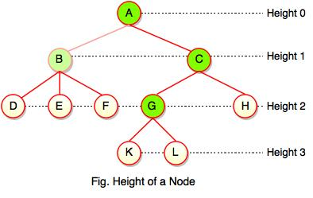  
  
As we studied, height of a node is a number of edges on the longest path between that node and a leaf. Each node has height.  
  
In the above figure, A, B, C, D can have height. Leaf cannot have height as there will be no path starting from a leaf. Node A's height is the number of edges of the path to K not to D. And its height is 3.  
  
**Note:**  
  
- Height of a node defines the longest path from the node to a leaf.  
  
- Path can only be downward.

**Depth of a Node**

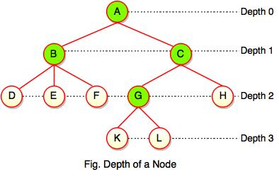  
  
While talking about the height, it locates a node at bottom where for depth, it is located at top which is root level and therefore we call it depth of a node.  
  
In the above figure, Node G's depth is 2. In depth of a node, we just count how many edges between the targeting node & the root and ignoring the directions.  
  
**Note:** Depth of the root is 0.

**Advantages of Tree**

* Tree reflects structural relationships in the data.
* It is used to represent hierarchies.
* It provides an efficient insertion and searching operations.
* Trees are flexible. It allows to move subtrees around with minimum effort.

AVL Tree

* AVL tree is a height balanced tree.
* It is a self-balancing binary search tree.
* AVL tree is another balanced binary search tree.
* It was invented by **A**delson-**V**elskii and **L**andis.
* AVL trees have a faster retrieval.
* It takes O(logn) time for addition and deletion operation.
* In AVL tree, heights of left and right subtree cannot be more than one for all nodes.

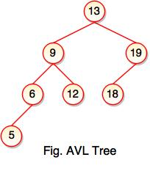

* The above tree is AVL tree because the difference between heights of left and right subtrees for every node is less than or equal to 1.

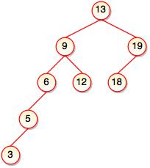

* The above tree is not AVL because the difference between heights of left and right subtrees for 9 and 19 is greater than 1.
* It checks the height of the left and right subtree and assures that the difference is not more than 1. The difference is called balance factor.