Dockerfile.txt - UI

from tomcat:8.0.51-jre8-alpine

ENV MONGO_CI_URL=172.18.2.50

ENV MONGO_CI_PORT=27017

ENV MONGO_CLI_DB=projectManagerDB

copy . /usr/src/projectmanager

workdir /usr/src/projectmanager

add ./target/projectmanager.war /usr/local/tomcat/webapps/projectmanager.war

expose 9000

CMD ["catalina.sh", "run"]

Dockerfile.txt - Service

FROM node:latest

ENV WEBAPI_DOMAIN=172.18.2.50

ENV WEBAPI_PORT=4200

ENV WEBAPI_PATH=/projectmanager/webapi/users

# Create app directory

WORKDIR /usr/src/ProjectManagerUI (1)

# Install app dependencies

# A wildcard is used to ensure both package.json AND package-lock.json are copied

# where available (npm@5+)

#COPY package*.json ./

#RUN npm install

# If you are building your code for production

# RUN npm install --only=production

# Bundle app source

COPY . .

EXPOSE 8080

CMD [ "npm", "start" ]

Docker Command

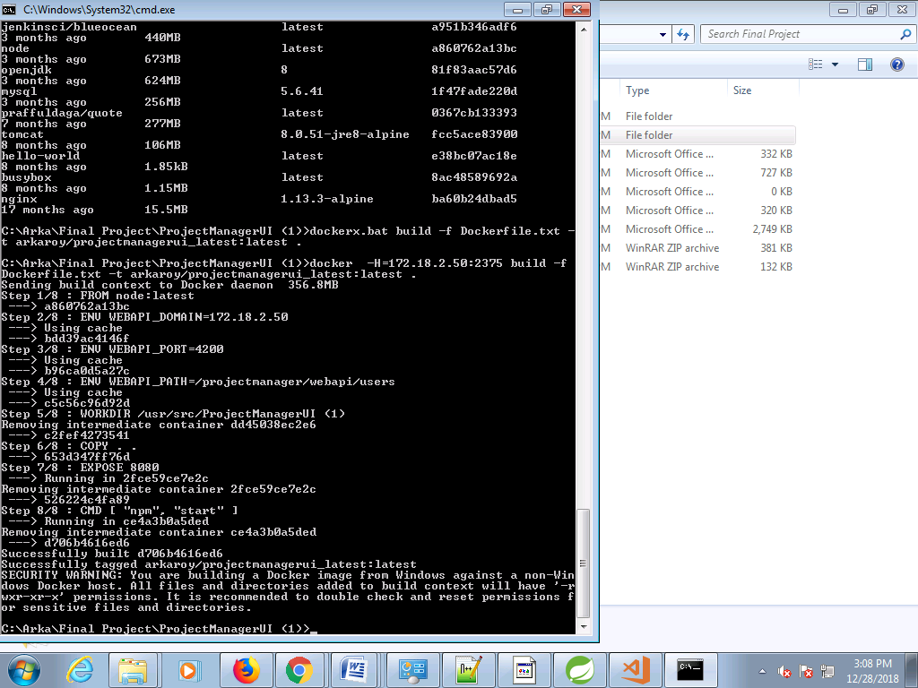

Docker Images

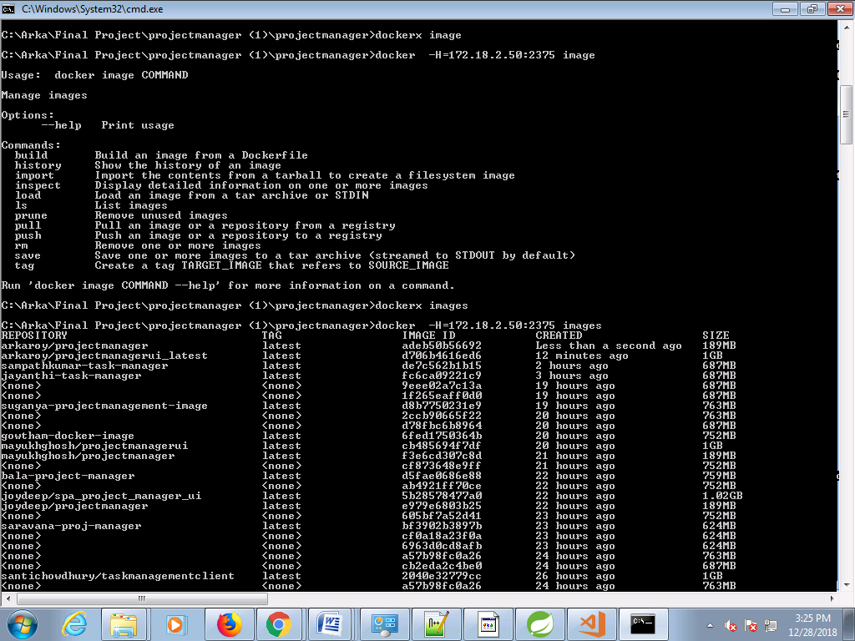

Docker - Compose .yml

version: '3.1'

services:

web:

image: arkaroy/ProjectManagerUI (1)

restart: always

container_name: ProjectManagerUI (1)

ports:

- 8080:4200

javaapp:

image: arkaroy/projectmanager

restart: always

container_name: projectmanager

ports:

- 8090:8080

depends_on:

- arkaroy/mongodb

mongo:

image: arkaroy/mongodb

container_name: mongodb

volumes:

- data/db

- data/bkp

restart: always