**ANGULAR ASSIGNMENT 1**

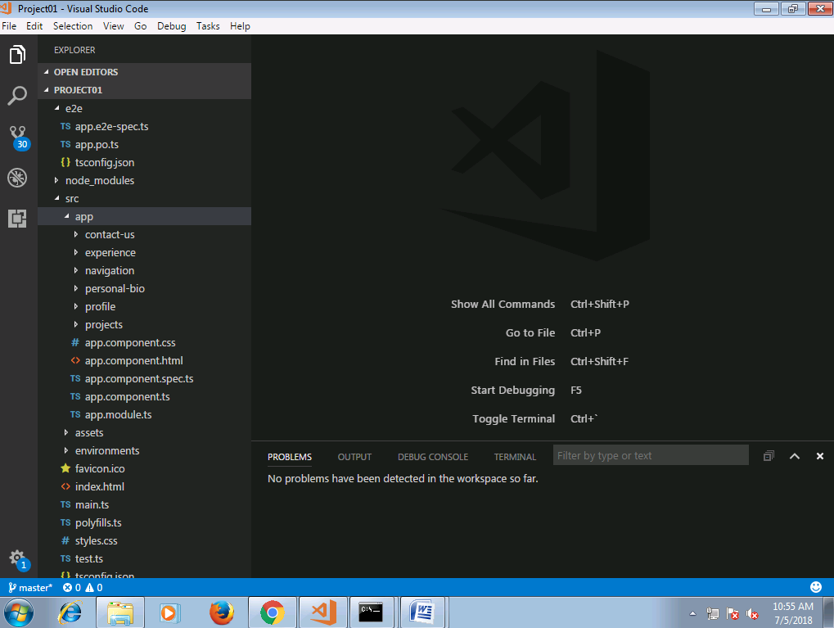

**app.component.html**

<app-navigation></app-navigation>

**app.component.ts**

import { Component } from '@angular/core';

@Component({

selector: 'app-root',

templateUrl: './app.component.html',

styleUrls: ['./app.component.css']

})

export class AppComponent {

}

**app.module.ts**

import { BrowserModule } from '@angular/platform-browser';

import { NgModule } from '@angular/core';

import { FormsModule } from '@angular/forms';

import { HttpModule } from '@angular/http';

import { AppComponent } from './app.component';

import { NavigationComponent } from './navigation/navigation.component';

import { ProfileComponent } from './profile/profile.component';

import { ProjectsComponent } from './projects/projects.component';

import { ExperienceComponent } from './experience/experience.component';

import { PersonalBioComponent } from './personal-bio/personal-bio.component';

import { ContactUsComponent } from './contact-us/contact-us.component';

@NgModule({

declarations: [

AppComponent,

NavigationComponent,

ProfileComponent,

ProjectsComponent,

ExperienceComponent,

PersonalBioComponent,

ContactUsComponent,

],

imports: [

BrowserModule,

FormsModule,

HttpModule,

],

providers: [],

bootstrap: [AppComponent]

})

export class AppModule {

}

**navigation.component.html**

<!DOCTYPE html>

<html lang="en">

<head>

<title>navigation page</title>

<meta charset="utf-8">

<meta name="viewport" content="width device-width, intial-scale 1">

<link rel="stylesheet" href="https://maxcdn.bootstrapcdn.com/bootstrap/3.3.7/css/bootstrap.min.css"/>

</head>

<body>

<div class="container-fluid">

<h2 class="bg-success">My Profile Application</h2>

<nav>

<div class="display">

<span class="btn" (click)="showView('profile')">Profile Highlights</span>

<span class="btn" (click)="showView('projects')">Projects</span>

<span class="btn" (click)="showView('exp')">Experience</span>

<span class="btn" (click)="showView('persBio')">Personal Biography</span>

<span class="btn" (click)="showView('contact')">Contact Me</span>

</div>

</nav>

<div *ngIf="profile"><app-profile></app-profile></div>

<div *ngIf="projects"><app-projects></app-projects></div>

<div *ngIf="exp"><app-experience></app-experience></div>

<div *ngIf="persBio"><app-personal-bio></app-personal-bio></div>

<div *ngIf="contact"><app-contact-us></app-contact-us></div>

</div>

</body>

**navigation.component.ts**

import { Component, OnInit } from '@angular/core';

@Component({

selector: 'app-navigation',

templateUrl: './navigation.component.html',

styleUrls: ['./navigation.component.css']

})

export class NavigationComponent implements OnInit {

constructor() { }

ngOnInit() {

}

profile =true;

projects =false;

exp=false;

persBio=false;

contact=false;

showView(display){

this.profile =false;

this.projects =false;

this.exp=false;

this.persBio=false;

this.contact=false;

if(display == 'profile'){

this.profile =true;

}

if(display == 'projects'){

this.projects =true;

}

if(display == 'exp'){

this.exp =true;

}

if(display == 'persBio'){

this.persBio =true;

}

if(display == 'contact'){

this.contact =true;

}

}

}

**navigation.component.css**

*{ margin:10px; padding:10px;}

body{

background-color:#AED6F1;

outline-style: solid;

outline-color:#33238A;

}

h2{

font-family: 'Times Header';

text-align:center;

text-transform: uppercase;

color:#33238A;

border-bottom: solid #33238A;

}

iframe{

border-radius: 25px;

border: 2px solid #78281F;

background-color:#FDEDEC;

}

nav{

padding:8px; margin-top:0px; margin-bottom:0px;

}

nav span{

text-decoration:none; display:inline-block; padding:5px; margin:5px; border-radius:5px; background-color:#FADBD8;

}

nav span:hover {

color: red; }

**profile.component.html**

<!DOCTYPE html>

<html lang="en">

<head>

<title>index page</title>

<meta charset="utf-8">

<meta name="viewport" content="width device-width, intial-scale 1">

<link rel="stylesheet" href="https://maxcdn.bootstrapcdn.com/bootstrap/3.3.7/css/bootstrap.min.css"/>

</head>

<body class="bg-warning">

<div class="container-fluid">

<h3>My Profile</h3>

<div class="row">

<div class="col-sm-6">

<div class="row">

<div class="col-sm-3">Name:</div>

<div class="col-sm-4">Karthikeyan T</div>

</div>

<div class="row">

<div class="col-sm-3">Age:</div>

<div class="col-sm-4">32</div>

</div>

<div class="row">

<div class="col-sm-3">Gender:</div>

<div class="col-sm-4">Male</div>

</div>

<div class="row">

<div class="col-sm-3">Company:</div>

<div class="col-sm-4">Cognizant</div>

</div>

<div class="row">

<div class="col-sm-3">Designation: </div>

<div class="col-sm-4">Senior Associate</div>

</div>

<div class="row">

<div class="col-sm-3">Location:</div>

<div class="col-sm-4">Coimbatore</div>

</div>

<div class="row">

<div class="col-sm-3">Mobile</div>

<div class="col-sm-4">1234567890</div>

</div>

<div class="row">

<div class="col-sm-3">Email</div>

<div class="col-sm-4">xyz@cognizant.com</div>

</div>

</div>

<div class="col-sm-6">

<div class="row">

<div class="col-sm-4"><img [src]="profilePic" class="img-thumbnail"></div>

</div>

</div>

</div>

</div>

</body>

**profile.component.ts**

import { Component, OnInit } from '@angular/core';

@Component({

selector: 'app-profile',

templateUrl: './profile.component.html',

styleUrls: ['./profile.component.css']

})

export class ProfileComponent implements OnInit {

profilePic :String;

constructor() {

this.profilePic = '/assets/images/Chrysanthemum.jpg';

}

ngOnInit() { }

}

**profile.component.css**

h3{

font-family: 'Times New Roman';

text-align:left;

color:#33238A;

border-bottom: double #33238A;

}

iframe{

border-radius: 25px;

border: 2px solid #78281F;

background-color:#FDEDEC;

}

table {

border-collapse: collapse;

}

td{

font-weight: normal;

}

th{

color: #33238A;

}

p{

text-decoration: underline;

color:#33238A; }

**projects.component.html**

<body class="bg-warning">

<div class="container-fluid">

<h3>Projects</h3>

<form id="projectsForm">

<div class="form-group">

<label>Project name</label>

<input type="text" class="form-control" [(ngModel)]="projname" name="projname" required>

</div>

<div class="form-group">

<label>Domain</label>

<input type="text" class="form-control" [(ngModel)]="domain" name="domain" required>

</div>

<div class="form-group">

<label>Project Description</label>

<textarea rows="2" class="form-control" [(ngModel)]="projdesc" name="projdesc" required></textarea>

</div>

<div class="form-group">

<label>Duration</label>

<input type="text" class="form-control" [(ngModel)]="duration" name="duration" required>

</div>

</form>

<span class="btn btn-info" (click)="addRow()">Click to add</span>

<table id ="projTable" class="table table-bordered table-hover">

<thead>

<tr>

<th>S.No</th>

<th>Project Name</th>

<th>Domain</th>

<th>Project Description</th>

<th>Duration</th>

<th>Action</th>

</tr>

</thead>

<tbody>

<tr *ngFor="let row of rows ;let i=index;">

<td>

{{i+1}}

</td>

<td>

{{row.projname}}

</td>

<td>

{{row.domain}}

</td>

<td>

{{row.projdesc}}

</td>

<td>

{{row.duration}}

</td>

<td>

<span class="btn btn-info" (click)="delRow(i)">Delete</span>

</td>

</tr>

</tbody>

</table>

</div>

</body>

**projects.component.ts**

import { Component, OnInit } from '@angular/core';

@Component({

selector: 'app-projects',

templateUrl: './projects.component.html',

styleUrls: ['./projects.component.css']

})

export class ProjectsComponent implements OnInit {

projname:string;

domain:string;

projdesc:string;

duration:string;

rows:Array<any> = [];

addRow(){

this.rows.push({projname:this.projname,domain:this.domain,projdesc:this.projdesc,duration:this.duration});

this.projname = '';

this.domain = '';

this.projdesc = '';

this.duration = '';

}

delRow(i){

this.rows.splice(i,1);

}

constructor() { }

ngOnInit() {

}

}

**experience.component.html**

<body class="bg-warning">

<div class="container-fluid">

<h3>Work Experience</h3>

<form id="expForm">

<div class="form-group">

<label>Organization name:</label>

<input type="text" class="form-control" [(ngModel)]="orgname" name="orgname" required>

</div>

<div class="form-group">

<label>Duration</label>

<input type="text" class="form-control" [(ngModel)]="duration" name="duration" placeholder="MM/DD/YYYY - MM/DD/YYYY" required>

</div>

<div class="form-group">

<label>Location</label>

<input type="text" class="form-control" [(ngModel)]="location" name="location" required>

</div>

<div class="form-group">

<label>Role</label>

<input type="text" class="form-control" [(ngModel)]="role" name="role" required>

</div>

<div class="form-group">

<label>Responsiblities</label>

<textarea class="form-control" rows="2" [(ngModel)]="responsibilities" name="responsibilities" id="responsibilities" required></textarea>

</div>

</form>

<span class="btn btn-info" (click)="addRow()">Click to add</span>

<table id ="exp" class="table table-bordered table-hover">

<thead>

<tr>

<th>S.No</th>

<th>ORGANIZATION</th>

<th>DURATION</th>

<th>LOCATION</th>

<th>ROLE</th>

<th>RESPONSIBILITIES</th>

<th>Action</th>

</tr>

</thead>

<tbody>

<tr *ngFor="let row of rows ;let i=index;">

<td>

{{i+1}}

</td>

<td>

{{row.orgname}}

</td>

<td>

{{row.duration}}

</td>

<td>

{{row.location}}

</td>

<td>

{{row.role}}

</td>

<td>

{{row.responsibilities}}

</td>

<td>

<span class="btn btn-info" (click)="delRow(i)">Delete</span>

</td>

</tr>

</tbody>

</table>

</div>

</body>

**experience.component.ts**

import { Component, OnInit } from '@angular/core';

@Component({

selector: 'app-experience',

templateUrl: './experience.component.html',

styleUrls: ['./experience.component.css']

})

export class ExperienceComponent implements OnInit {

orgname:string;

duration:string;

location:string;

role:string;

responsibilities:string;

rows:Array<any> = [];

addRow(){

this.rows.push({orgname:this.orgname,duration:this.duration,location:this.location,role:this.role,responsibilities:this.responsibilities});

this.orgname = '';

this.duration = '';

this.location = '';

this.role = '';

this.responsibilities = '';

}

delRow(i){

this.rows.splice(i,1);

}

constructor() { }

ngOnInit() {

}

}

**personal-bio.component.html**

<body class="bg-warning">

<div class="container-fluid">

<strong><p>Personal Information</p></strong>

<table class="table table-hover">

<tr>

<td>Name: </td>

<td>Karthikeyan T</td>

</tr>

<tr>

<td>Father's name</td>

<td>Thirumurthy A</td>

</tr>

<tr>

<td>Mother's name</td>

<td>Santhi N</td>

</tr>

<tr>

<td>Gender: </td>

<td>Male</td>

</tr>

<tr>

<td>Place of Birth: </td>

<td>Chennai</td>

</tr>

<tr>

<td>Marital Status: </td>

<td>Married</td>

</tr>

<tr>

<td>Place of Residence: </td>

<td>Coimbatore</td>

</tr>

<tr>

<td>Mobile: </td>

<td>1234567890</td>

</tr>

<tr>

<td>Email: </td>

<td>xyz@cognizant.com</td>

</tr>

</table>

<strong><p>Education</p></strong>

<ul>

<li>St.Joseph's matric high school</li>

<li>Coimbatore Institute of Technology</li>

</ul>

<strong><p>Skills</p></strong>

<ul>

<li>Web designing</li>

<li>Content management</li>

</ul>

<strong><p>Interests</p></strong>

<ul>

<li>Programming</li>

<li>Designing</li>

<li>Photography</li>

</ul>

<strong><p>Extra Curricular</p></strong>

<ul>

<li>Music club</li>

<li>Yoga</li>

</ul>

</div>

</body>

**personal-bio.component.ts**

import { Component, OnInit } from '@angular/core';

@Component({

selector: 'app-personal-bio',

templateUrl: './personal-bio.component.html',

styleUrls: ['./personal-bio.component.css']

})

export class PersonalBioComponent implements OnInit {

constructor() { }

ngOnInit() {

}

}

**contact-us.component.html**

<body class="bg-warning">

<div class="container-fluid">

<h3>Contact Me</h3>

<span class="bg-success" id="result">

{{submitMsg}}

</span>

<form (ngSubmit)="onSubmit()">

<div class="form-group">

<label>Enter your name:</label>

<input type="text" class="form-control" [(ngModel)]="usrname" name="usrname">

</div>

<div class="form-group">

<label>Email ID:</label>

<input type="email" class="form-control" [(ngModel)]="email" name="email">

</div>

<div class="form-group">

<label>Mobile Number:</label>

<input type="tel" class="form-control" [(ngModel)]="phone" minlength="10" maxlength="10" placeholder="123-456-7890" name="phone">

</div>

<div class="form-group">

<label>Remarks:</label>

<textarea class="form-control" [(ngModel)]="remarks" rows="4" name="remarks"></textarea>

</div>

<input type="submit" class="btn btn-info" value="Submit">

<input type="reset" class="btn btn-info" value="Reset">

<div class="form-group">

<input type="hidden" class="form-control" [(ngModel)]="submitMsg" name="submitMsg">

</div>

</form>

</div>

</body>

**contact-us.component.ts**

import { Component, OnInit } from '@angular/core';

@Component({

selector: 'app-contact-us',

templateUrl: './contact-us.component.html',

styleUrls: ['./contact-us.component.css']

})

export class ContactUsComponent implements OnInit {

submitMsg :string;

constructor() { }

ngOnInit() {

}

onSubmit(){

this.submitMsg="Thanks for your details !!";

}

}

**APPLICATION SCREENSHOTS**

**PROFILE HIGHLIGHTS**

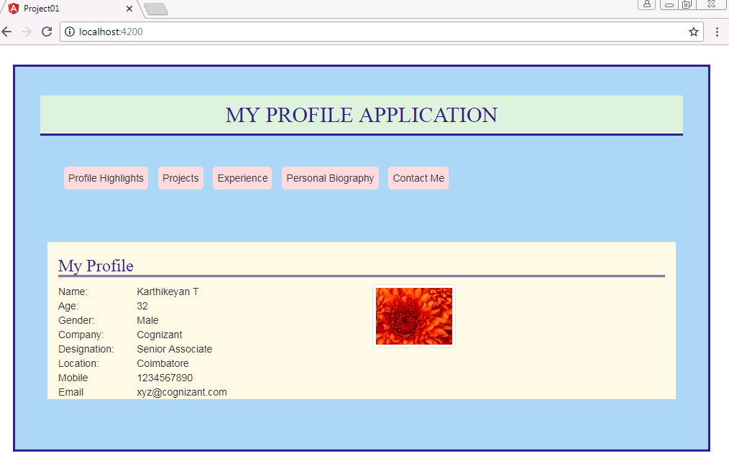

**PROJECTS**

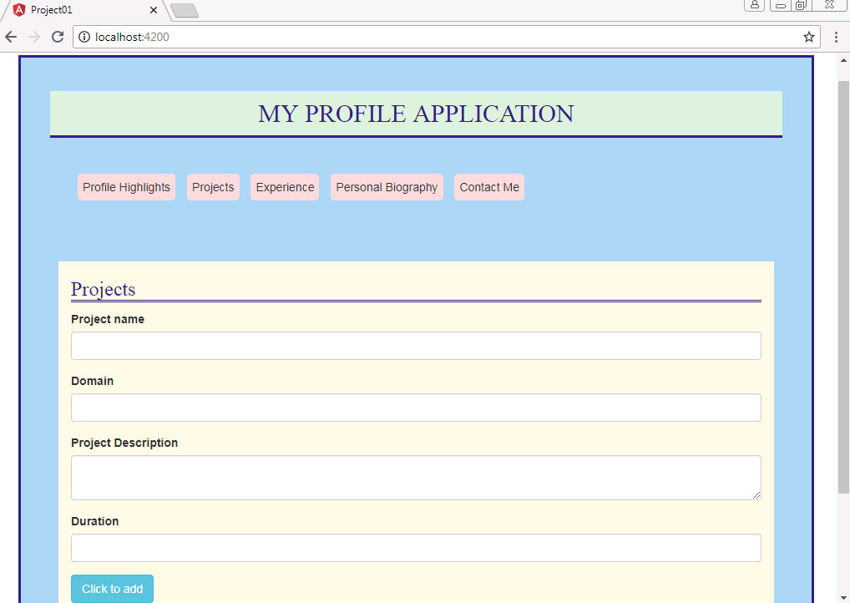

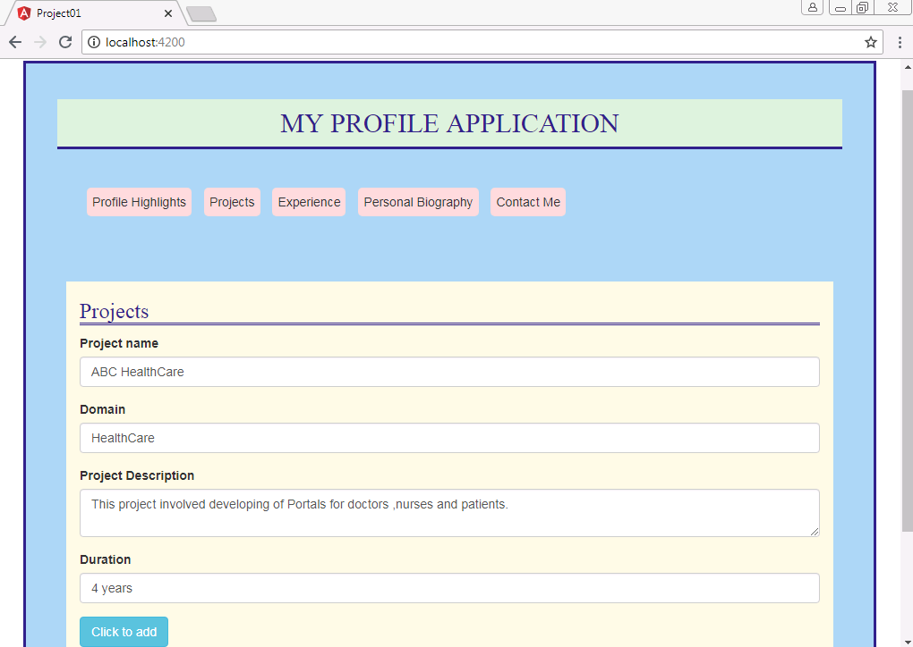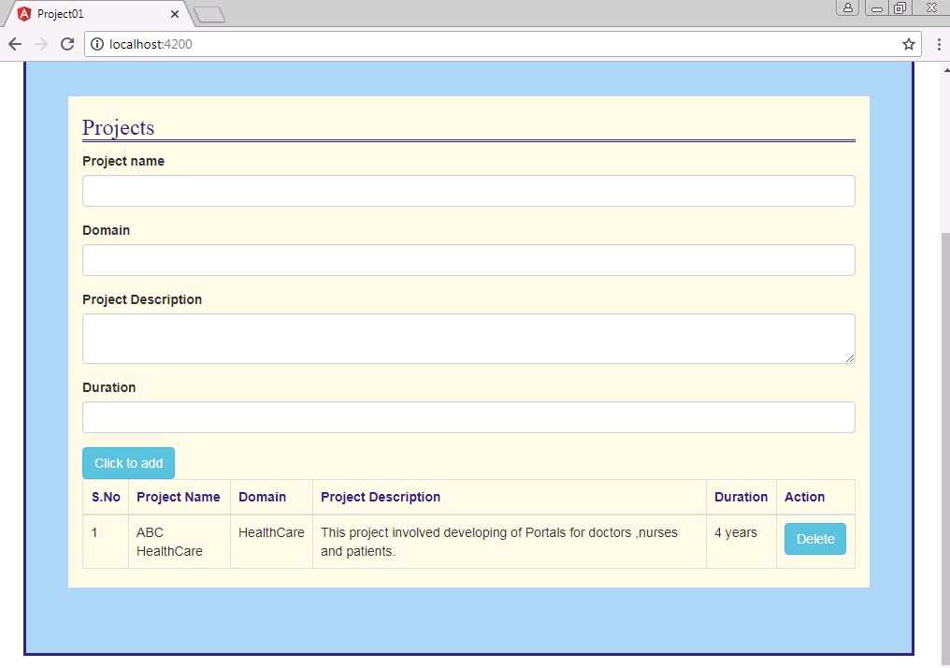

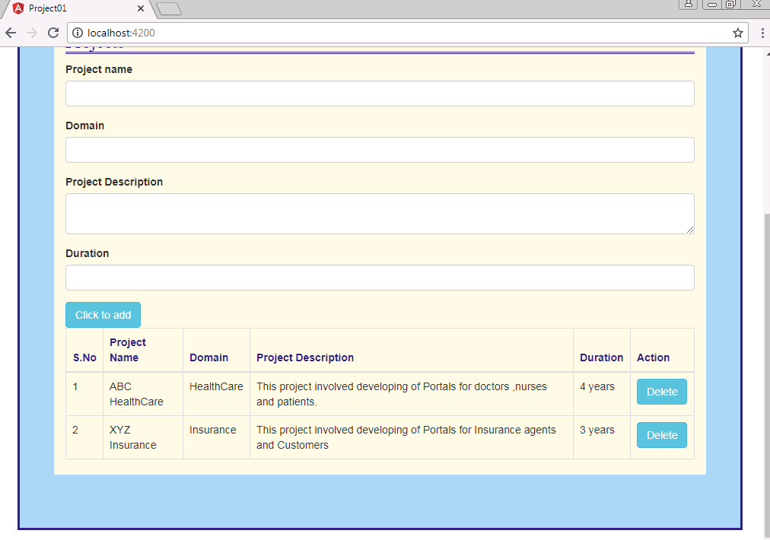

**EXPERIENCE**

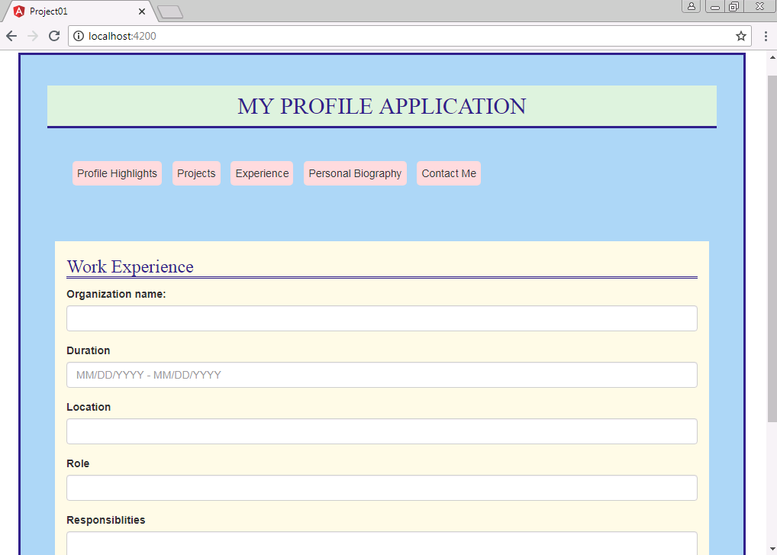

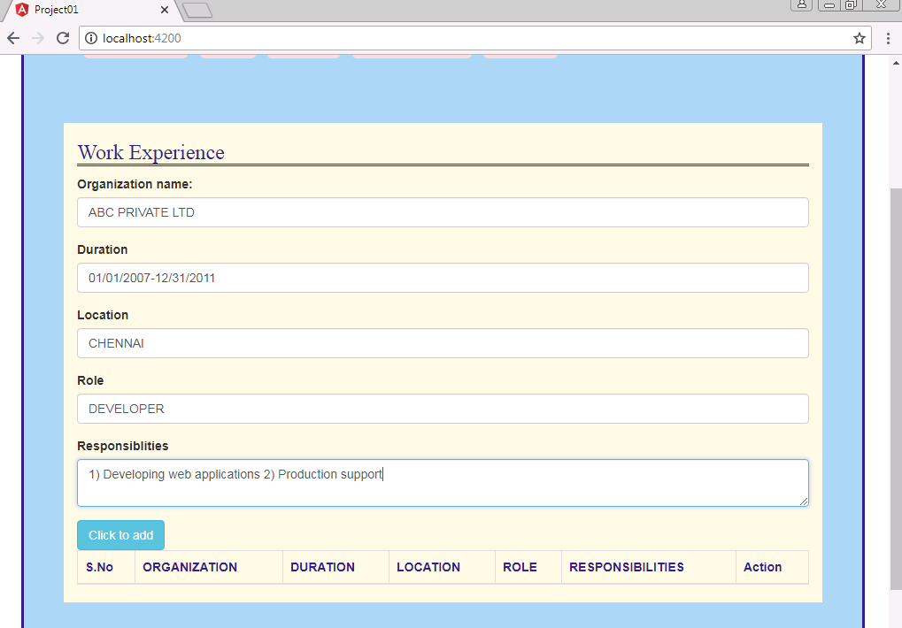

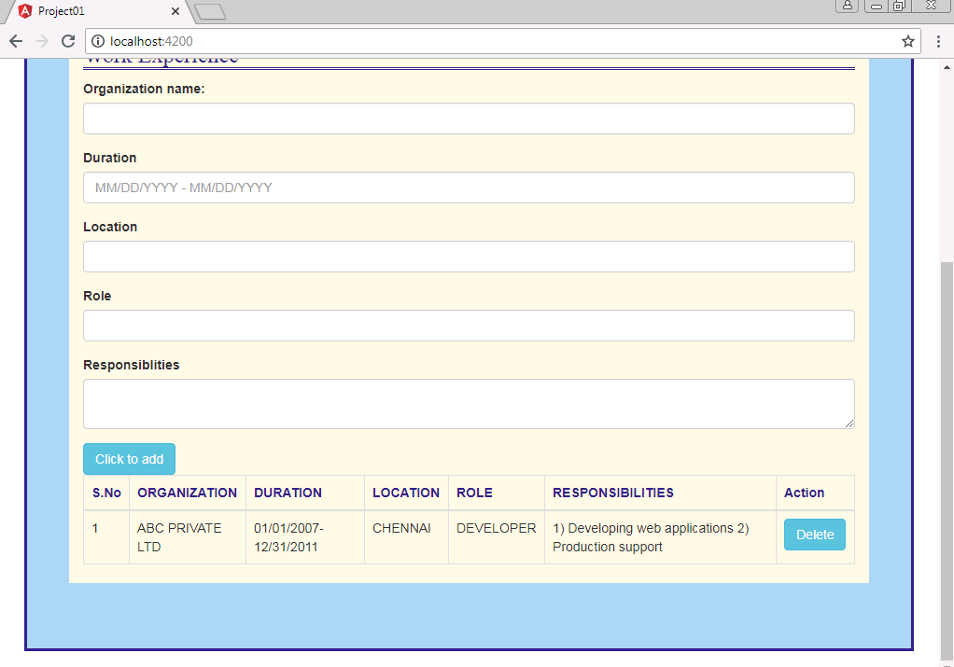

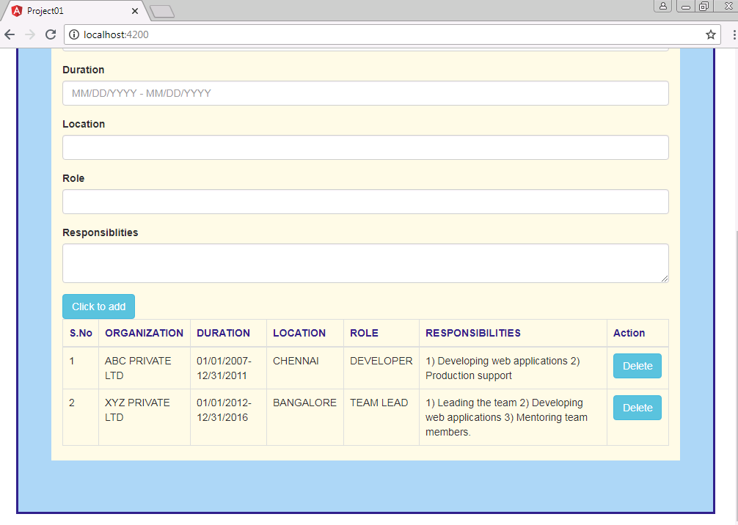

**PERSONAL BIOGRAPHY**

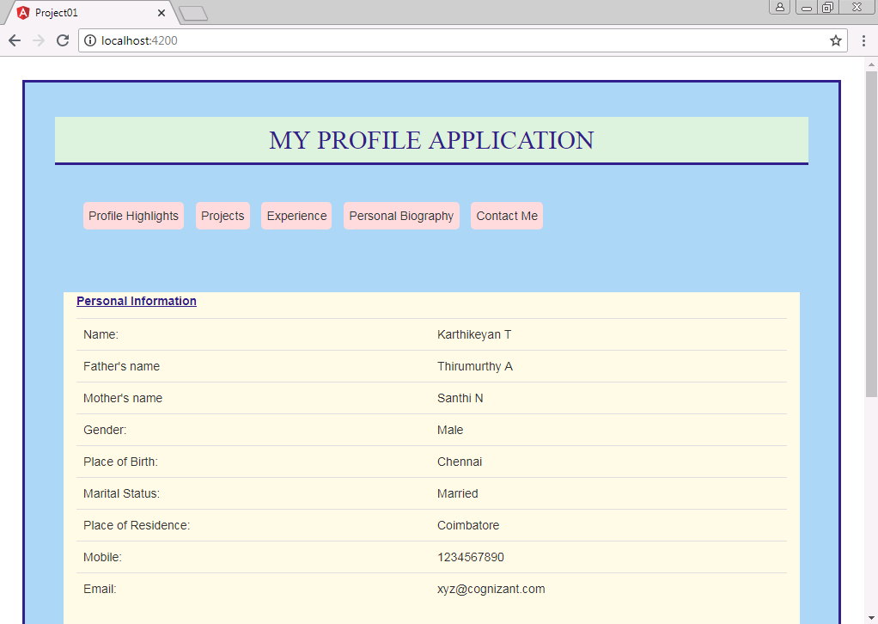

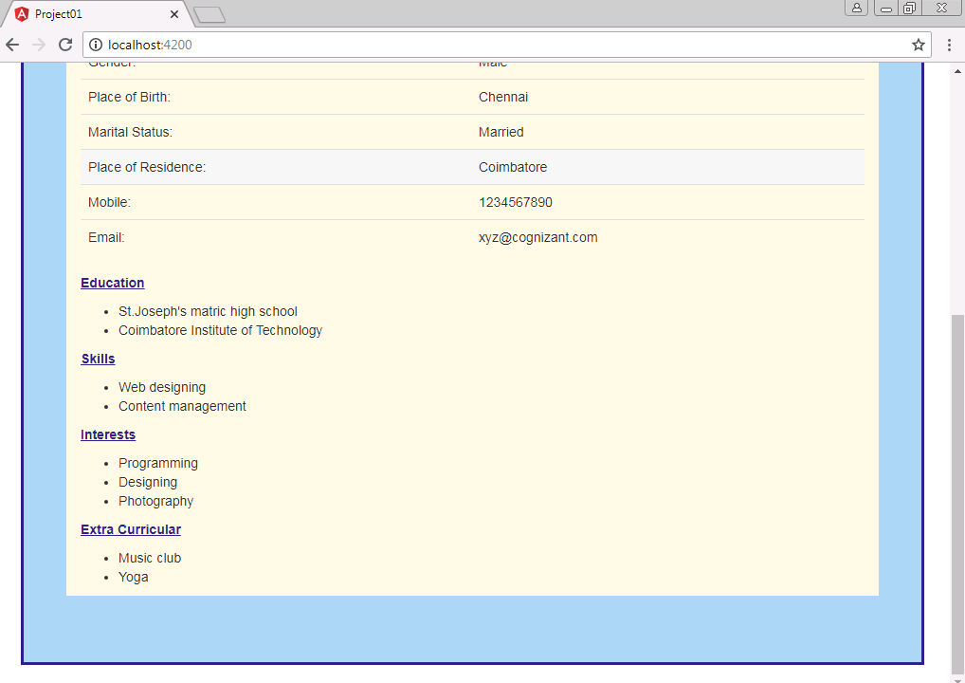

**CONTACT ME**

