**ANGULAR ASSIGNMENT 2**

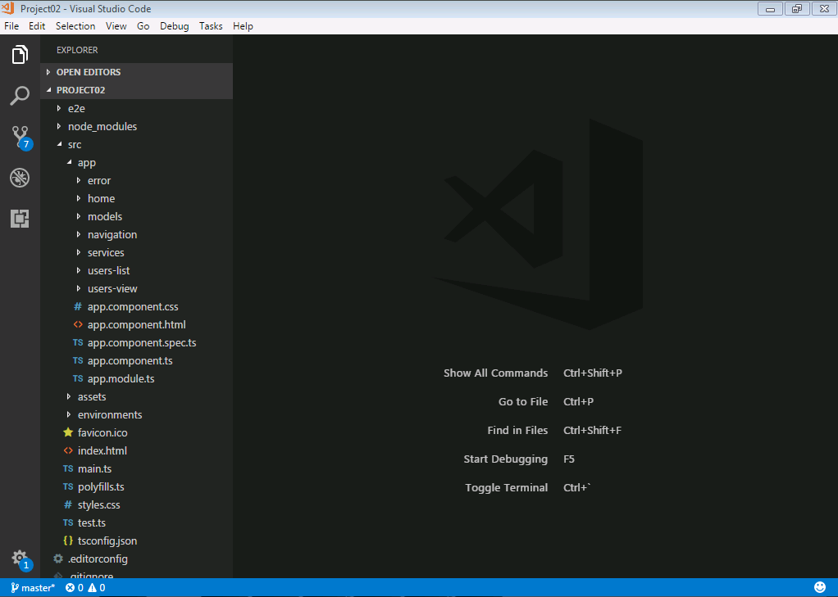

**app.component.html**

<app-navigation></app-navigation>

<div class="container">

<router-outlet></router-outlet>

</div>

**app.module.ts**

import { BrowserModule } from '@angular/platform-browser';

import { NgModule } from '@angular/core';

import { FormsModule , ReactiveFormsModule } from '@angular/forms';

import { HttpModule } from '@angular/http';

import { RouterModule , Routes} from '@angular/router';

import { AppComponent } from './app.component';

import { NavigationComponent } from './navigation/navigation.component';

import { UsersListComponent } from './users-list/users-list.component';

import { UsersViewComponent } from './users-view/users-view.component';

import { HomeComponent } from './home/home.component';

import { ErrorComponent } from './error/error.component';

import { UserDataService } from './services/user-data.service';

const appRoutes : Routes = [

{ path: '', pathMatch: 'full',component: HomeComponent},

{ path: 'users', pathMatch: 'full', component: UsersListComponent},

{ path: 'users/new', component: UsersViewComponent},

{ path: 'users/:id', component: UsersViewComponent},

{ path: 'user-not-found', component: ErrorComponent},

{ path: '**',redirectTo:'user-not-found'},

];

@NgModule({

declarations: [

AppComponent,

NavigationComponent,

UsersListComponent,

UsersViewComponent,

HomeComponent,

ErrorComponent

],

imports: [

BrowserModule,

FormsModule,

ReactiveFormsModule,

HttpModule,

RouterModule.forRoot(appRoutes)

],

providers: [

UserDataService

],

bootstrap: [AppComponent]

})

export class AppModule { }

**navigation.component.html**

<!DOCTYPE html>

<html lang="en">

<head>

<title>navigation bar</title>

<meta charset="utf-8">

<meta name="viewport" content="width device-width, intial-scale 1">

<link rel="stylesheet" href="https://maxcdn.bootstrapcdn.com/bootstrap/3.3.7/css/bootstrap.min.css"/>

</head>

<body>

<div class="container-fluid">

<nav class="navbar navbar-inverse">

<div class="navbar-header">

<a class="navbar-brand" routerLink="">ANGULAR CRUD APPLICATION</a>

</div>

<ul class="nav navbar-nav navbar-right">

<li><a href="#" routerLinkActive="active">Home</a></li>

</ul>

<ul class="nav navbar-nav navbar-right">

<li><a routerLink="/users" >Manage users</a></li>

</ul>

</nav>

</div>

</body>

**users-list.component.html**

<!DOCTYPE html>

<html lang="en">

<head>

<meta charset="utf-8">

<meta name="viewport" content="width device-width, intial-scale 1">

<link rel="stylesheet" href="https://maxcdn.bootstrapcdn.com/bootstrap/3.3.7/css/bootstrap.min.css"/>

<link rel="stylesheet" href="https://fonts.googleapis.com/icon?family=Material+Icons"/>

</head>

<body>

<div class="container-fluid">

<h5 class="text-info">

USERS COUNT <strong>{{ users.length }}</strong>

</h5>

<table class="table table-bordered table-hover">

<thead>

<tr>

<th data-field="name">UserName</th>

<th data-field="email">Email</th>

<th data-field="company">Company Name</th>

<th data-field="edit">Edit</th>

<th data-field="delete">Delete</th>

</tr>

</thead>

<tbody>

<tr *ngFor="let user of users">

<td>{{ user.name }}</td>

<td>{{ user.email }}</td>

<td>{{ user.company.name }}</td>

<td>

<a [routerLink]="['/users', user.id]">

<i class="material-icons">edit</i>

</a>

</td>

<td>

<a (click)="deleteUser(user)" [routerLink]="['/users']" >

<i class="material-icons" style="color:red">remove_circle</i>

</a>

</td>

</tr>

</tbody>

</table>

<div class="fixed-action-btn" style="top: 45px; right: 24px;">

<a routerLink="/users/new"><strong>NEW USER</strong>

<i class="material-icons" style="color:green">add_circle</i>

</a>

</div>

</div>

</body>

**users-list.component.ts**

import { Component, OnInit } from '@angular/core';

import { UserDataService} from '../services/user-data.service';

import { User } from '../models/user';

@Component({

selector: 'app-users-list',

templateUrl: './users-list.component.html',

styleUrls: ['./users-list.component.css']

})

export class UsersListComponent implements OnInit {

private users : User[] = [];

constructor(private userDataService :UserDataService) { }

ngOnInit() {

this.userDataService.getUsers()

.subscribe(data => this.users = data);

}

deleteUser(user){

if (confirm("Are you sure want to delete " + user.name + "?")) {

var index = this.users.indexOf(user);

this.users.splice(index, 1);

this.userDataService.deleteUser(user)

.subscribe(null,

err => {

alert("Could not delete user.");

this.users.splice(index, 0, user);

});

}

}

}

**users-view.component.html**

<!DOCTYPE html>

<html lang="en">

<head>

<meta charset="utf-8">

<meta name="viewport" content="width device-width, intial-scale 1">

<link rel="stylesheet" href="https://maxcdn.bootstrapcdn.com/bootstrap/3.3.7/css/bootstrap.min.css"/>

<link rel="stylesheet" href="https://fonts.googleapis.com/icon?family=Material+Icons"/>

</head>

<body class="bg-warning">

<div class="container-fluid">

<h4>{{ title }}</h4>

<form materialize class="col s12" [formGroup]="form" (ngSubmit)="save()">

<div class="form-group">

<div class="input-field col s12">

<i class="material-icons prefix" style="color:blue">account_circle</i>

<label for="name" >User Name</label>

<input class="form-control" id="name" formControlName="name" type="text" [(ngModel)]="user.name">

</div>

</div>

<div class="form-group">

<div class="input-field col s12">

<i class="material-icons prefix" style="color:blue">email</i>

<label for="email">Email</label>

<input class="form-control" id="email" formControlName="email" type="email" [(ngModel)]="user.email" >

</div>

</div>

<div class="form-group">

<div class="input-field col s12">

<i class="material-icons prefix" style="color:blue">business_center</i>

<label for="company" >Company Name</label>

<input class="form-control" id="company" formControlName="company" type="text" [(ngModel)]="user.company.name" >

</div>

</div>

<button type="submit">

<i class="material-icons right" style="font-size:24px;color:green">send</i>

</button>

</form>

</div>

</body>

**users-view.component.ts**

import { Component, OnInit } from '@angular/core';

import { User } from '../models/user';

import { FormBuilder ,FormGroup } from '@angular/forms';

import { Router, ActivatedRoute } from '@angular/router';

import { UserDataService } from '../services/user-data.service';

@Component({

selector: 'app-users-view',

templateUrl: './users-view.component.html',

styleUrls: ['./users-view.component.css']

})

export class UsersViewComponent implements OnInit {

title: string;

form: FormGroup;

user: User = new User();

constructor(

formBuilder: FormBuilder,

private router: Router,

private route: ActivatedRoute,

private userDataService: UserDataService

){

this.form = formBuilder.group({

name :[],

email :[],

company :[]

});

}

ngOnInit() {

var id = this.route.params.subscribe(params => {

var id = params['id'];

this.title = id ? 'EDIT USER' : 'ADD NEW USER';

if (!id)

return;

this.userDataService.getUser(id)

.subscribe(

user => this.user = user,

response => {

if (response.status == 404) {

this.router.navigate(['NotFound']);

}

});

});

}

save() {

var result,

userValue = this.form.value;

if (userValue.id){

result = this.userDataService.updateUser(userValue);

} else {

result = this.userDataService.addUser(userValue);

}

result.subscribe(data => this.router.navigate(['']));

}

}

**SERVICE:**

**user-data.service.ts**

import { Injectable } from '@angular/core';

import { Http } from '@angular/http';

import 'rxjs/add/operator/map';

import { Observable } from 'rxjs/Rx';

@Injectable()

export class UserDataService {

private url :string ="http://jsonplaceholder.typicode.com/users";

constructor(private http : Http) { }

getUsers(){

return this.http.get(this.url)

.map(res => res.json());

}

getUser(id){

return this.http.get(this.getUserUrl(id))

.map(res => res.json());

}

getUserUrl(id){

return this.url +"/"+id;

}

addUser(user){

return this.http.post(this.url,JSON.stringify(user))

.map(res => res.json());

}

updateUser(user){

return this.http.put(this.getUserUrl(user.id),JSON.stringify(user))

.map(res => res.json());

}

deleteUser(user){

return this.http.delete(this.getUserUrl(user.id))

.map(res => res.json());

}

}

**MODELS:**

**user.ts**

import { Company } from '../models/company';

export class User {

id: number;

name: string;

email: string;

company: Company = new Company();

}

**company.ts**

export class Company {

name:string;

}

**home.component.html**

<html>

<body>

<h4>

<p>Welcome !!</p>

<p>Let's manage our team</p>

</h4>

</body>

</html>

**error.component.html**

<p>

User Not Found !!

</p>

**APPLICATION SCREENSHOTS:**

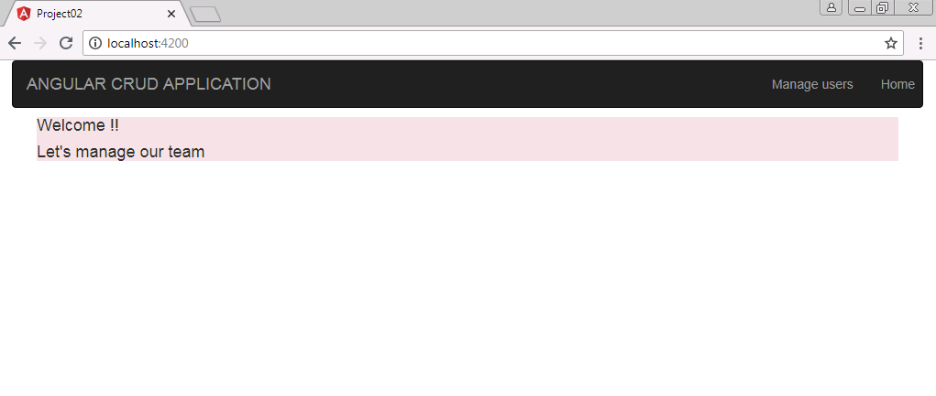

**http://localhost:4200/users**

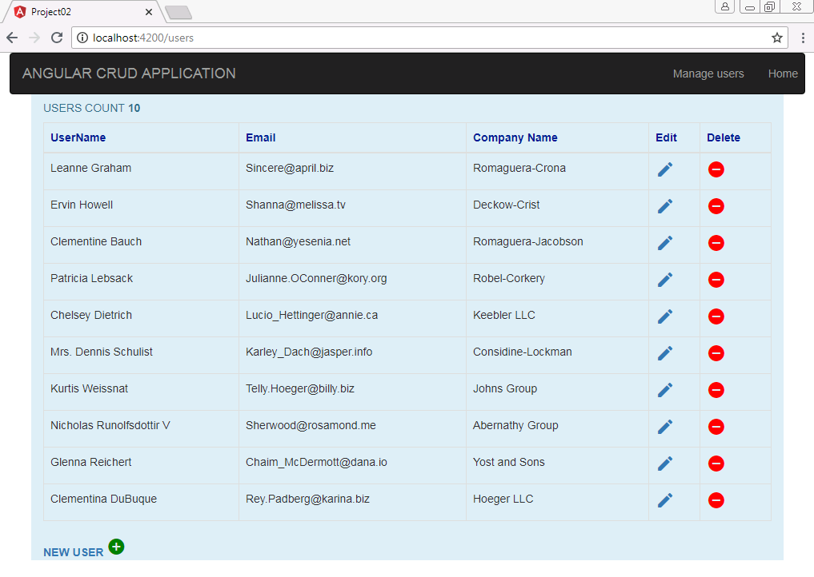

**On clicking Edit icon of a user, user details can be updated.**

**http://localhost:4200/users/1**

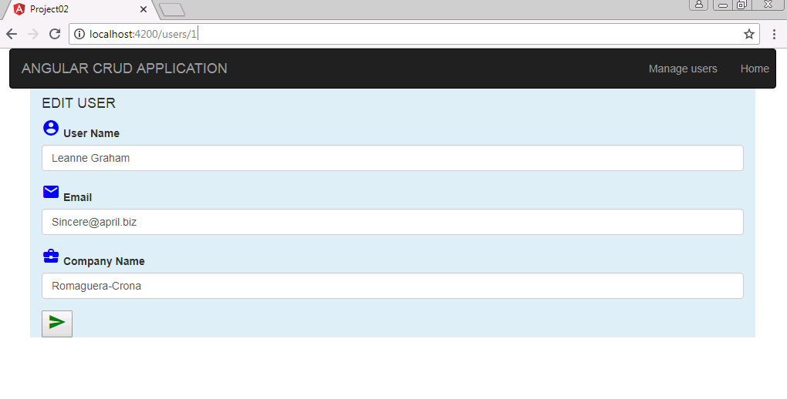

**On clicking NEW USER link at the bottom,**

**http://localhost:4200/users/new**

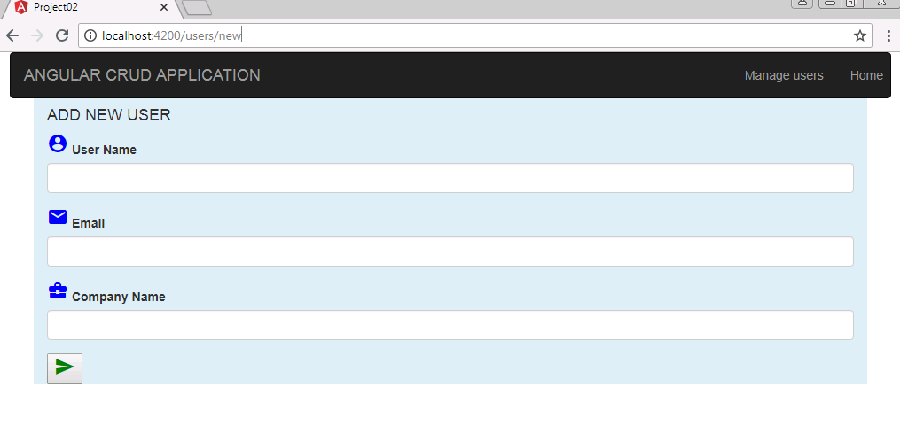

**Once new user details are entered and submitted, new user will be added to the users data list.**

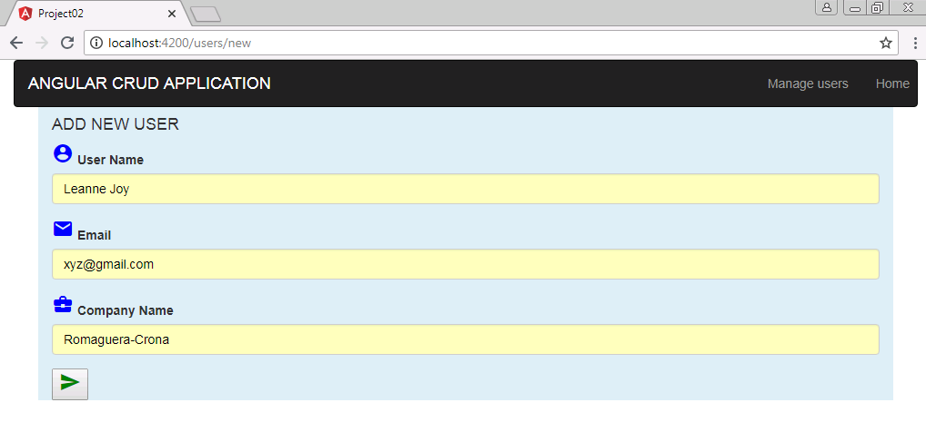

**On clicking of Delete icon of any user , user record can be deleted.**

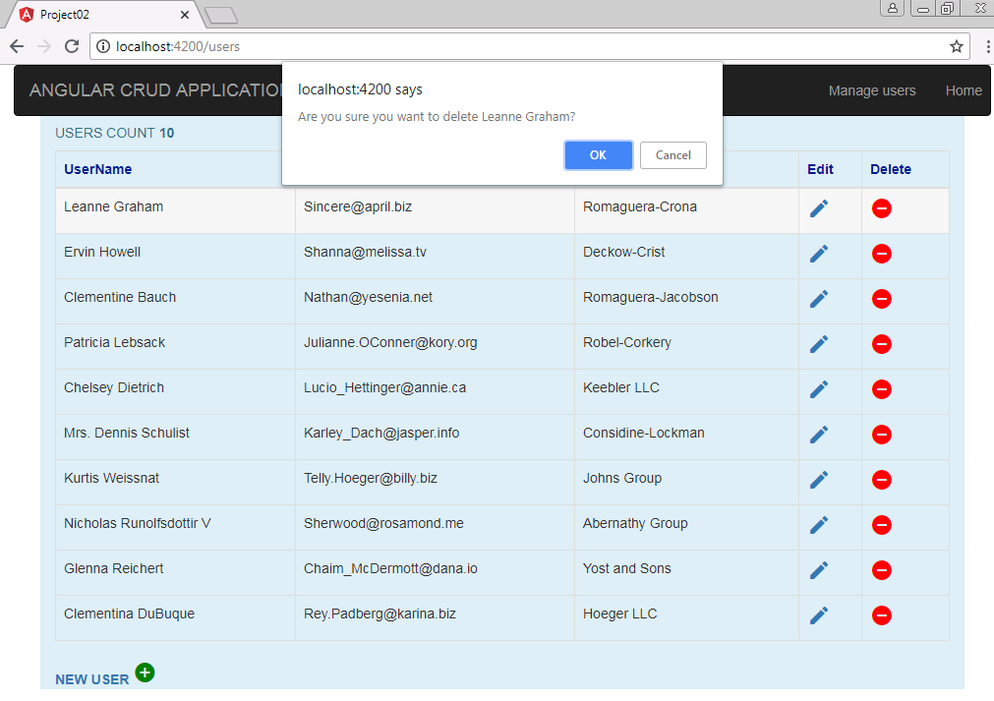

**http://localhost:4200/users**

