**RESTFULAPI ASSIGNMENT 3**

**Angular Client code:**

**book-app.service.ts**

import { Injectable } from '@angular/core';

import { Http } from '@angular/http';

import 'rxjs/add/operator/map';

@Injectable()

export class BookAppService {

constructor(private http:Http) { }

private url : string ="/springmvcrestfulapi/bookapp/allbooks";

private addUrl : string ="/springmvcrestfulapi/bookapp/newbook";

private updateUrl : string ="/springmvcrestfulapi/bookapp/updatebook";

private deleteUrl : string ="/springmvcrestfulapi/bookapp/deletebook";

private getUrl : string = "/springmvcrestfulapi/bookapp/findbook";

viewbooks(){

return this.http.get(this.url)

.map(res => res.json());

}

addbook(book){

return this.http.post(this.addUrl,book)

.map(res => res.json());

}

updatebook(book,id){

book.bookId = id;

return this.http.put(this.updateUrl,book)

.map(res => res.json());

}

deletebook(book){

return this.http.delete(this.deleteUrl+"/"+book.bookId)

.map(res => res.status);

}

getbook(id){

return this.http.get(this.getUrl+"/"+id)

.map(res => res.json());

}

}

**subject.ts**

export class Subject {

subtitle:string;

    subjectId:number;

    durationInHours:number;

}

**book.ts**

import { Subject } from '../model/subject';

export class Book {

bookId: number;

title: string;

price: number;

volume: number;

publistDt: Date;

subject: Subject = new Subject();

}

**app.component.html**

<app-navigation></app-navigation>

<div>

<router-outlet></router-outlet>

</div>

**app.module.ts**

import { BrowserModule } from '@angular/platform-browser';

import { NgModule } from '@angular/core';

import { FormsModule, ReactiveFormsModule } from '@angular/forms';

import { HttpModule } from '@angular/http';

import { RouterModule, Routes} from '@angular/router';

import { AppComponent } from './app.component';

import { ViewBooksComponent } from './view-books/view-books.component';

import { NavigationComponent } from './navigation/navigation.component';

import { HomeComponent } from './home/home.component';

import { AddBookComponent } from './add-book/add-book.component';

import { EditBookComponent } from './edit-book/edit-book.component';

import { BookAppService } from './service/book-app.service';

const appRoutes : Routes = [

{path: '', pathMatch: 'full',component: HomeComponent},

{path:'home' , component:HomeComponent},

{path:'viewbooks' ,component:ViewBooksComponent},

{path:'addbook' ,component:AddBookComponent},

{path:'editbook/:id' , component:EditBookComponent}

]

@NgModule({

declarations: [

AppComponent,

ViewBooksComponent,

NavigationComponent,

HomeComponent,

AddBookComponent,

EditBookComponent

],

imports: [

BrowserModule,

FormsModule,

ReactiveFormsModule,

HttpModule,

RouterModule.forRoot(appRoutes)

],

providers: [BookAppService],

bootstrap: [AppComponent]

})

export class AppModule { }

**navigation.component.html**

<!DOCTYPE html>

<html lang="en">

<head>

<title>navigation page</title>

<meta charset="utf-8">

<meta name="viewport" content="width device-width, intial-scale 1">

<link rel="stylesheet" href="https://maxcdn.bootstrapcdn.com/bootstrap/3.3.7/css/bootstrap.min.css"/>

</head>

<body>

<div class="container-fluid">

<h2 class="bg-success">Book Management Application</h2>

<nav>

<a routerLink="/home">Home</a>

<a routerLink="/viewbooks">View Books</a>

<a routerLink="/addbook">Add Book</a>

</nav>

</div>

</body>

**view-books.component.html**

<!DOCTYPE html>

<html lang="en">

<head>

<meta charset="utf-8">

<meta name="viewport" content="width device-width, intial-scale 1">

<link rel="stylesheet" href="https://maxcdn.bootstrapcdn.com/bootstrap/3.3.7/css/bootstrap.min.css"/>

<link rel="stylesheet" href="https://fonts.googleapis.com/icon?family=Material+Icons"/>

</head>

<body>

<div class="container-fluid">

<table class="table table-responsive table-bordered table-hover">

<thead>

<tr>

<th>Book ID</th>

<th>Book Title</th>

<th>Price</th>

<th>Volume</th>

<th>Subject Title</th>

<th>Edit</th>

<th>Delete</th>

</tr>

</thead>

<tbody>

<tr *ngFor="let book of books">

<td>{{book.bookId}}</td>

<td>{{book.title}}</td>

<td>{{book.price}}</td>

<td>{{book.volume}}</td>

<td *ngIf="book.subject != null">{{book.subject.subtitle}}</td>

<td *ngIf="book.subject == null"></td>

<td><a [routerLink]="['/editbook', book.bookId]" >

Edit Book</a>

</td>

<td>

<a (click)="deleteBook(book)" [routerLink]="['/viewbooks']" >

Delete Book

</a>

</td>

</tr>

</tbody>

</table>

</div>

</body>

**view-books.component.ts**

import { Component, OnInit } from '@angular/core';

import { BookAppService } from '../service/book-app.service';

import { Book } from '../model/book';

@Component({

selector: 'app-view-books',

templateUrl: './view-books.component.html',

styleUrls: ['./view-books.component.css'],

providers: [BookAppService]

})

export class ViewBooksComponent implements OnInit {

private books : Book[] =[];

book : Book = new Book();

constructor(private bookAppService : BookAppService) { }

ngOnInit() {

this.bookAppService.viewbooks()

.subscribe(data => this.books = data)

}

deleteBook(book){

if (confirm("Are you sure want to delete " + book.title + "?")) {

this.bookAppService.deletebook(book)

.subscribe(success => {

var index = this.books.indexOf(book);

this.books.splice(index, 1);

this.getlatestView();

});

}

}

getlatestView(){

this.bookAppService.viewbooks()

.subscribe(data => this.books = data)

}

}

**add-book.component.html**

<!DOCTYPE html>

<html lang="en">

<head>

<meta charset="utf-8">

<meta name="viewport" content="width device-width, intial-scale 1">

<link rel="stylesheet" href="https://maxcdn.bootstrapcdn.com/bootstrap/3.3.7/css/bootstrap.min.css"/>

<link rel="stylesheet" href="https://fonts.googleapis.com/icon?family=Material+Icons"/>

</head>

<body class="bg-warning">

<div class="container-fluid">

<h4 class="bg-primary">ADD NEW BOOK</h4>

<form materialize class="col s12" [formGroup]="form" (ngSubmit)="addNewBook()">

<div class="form-group">

<div class="input-field col s12">

<label for="bookId" >Book ID</label>

<input class="form-control" id="bookId" formControlName="bookId" type="text" [(ngModel)]="book.bookId">

</div>

</div>

<div class="form-group">

<div class="input-field col s12">

<label for="title" >Book Name</label>

<input class="form-control" id="title" formControlName="title" type="text" [(ngModel)]="book.title">

</div>

</div>

<div class="form-group">

<div class="input-field col s12">

<label for="price" >Price</label>

<input class="form-control" id="price" formControlName="price" type="text" [(ngModel)]="book.price" >

</div>

</div>

<div class="form-group">

<div class="input-field col s12">

<label for="volume" >Volume</label>

<input class="form-control" id="volume" formControlName="volume" type="text" [(ngModel)]="book.volume" >

</div>

</div>

<div class="form-group">

<div class="input-field col s12">

<label for="publistDt" >Published Date</label>

<input class="form-control" id="publistDt" formControlName="publistDt" type="date" [(ngModel)]="book.publistDt" >

</div>

</div>

<div class="form-group">

<div class="input-field col s12">

<label for="subtitle">Subject Title</label>

<div formGroupName="subject">

<input class="form-control" id="subtitle" formControlName="subtitle" type="text" [(ngModel)]="book.subject.subtitle" >

</div>

</div>

</div>

<button class="btn btn-success" type="submit">Save Book</button>

</form>

</div>

</body>

**add-book.component.ts**

import { Component, OnInit } from '@angular/core';

import { FormBuilder ,FormGroup } from '@angular/forms';

import { BookAppService } from '../service/book-app.service';

import { Router } from '@angular/router';

import { Book } from '../model/book';

import { Subject } from '../model/subject';

@Component({

selector: 'app-add-book',

templateUrl: './add-book.component.html',

styleUrls: ['./add-book.component.css']

})

export class AddBookComponent implements OnInit {

form: FormGroup;

book : Book = new Book();

subject : Subject = new Subject();

constructor(

formBuilder: FormBuilder,

private router: Router,

private bookAppService : BookAppService) {

this.form = formBuilder.group({

bookId :[],

title :[],

price :[],

volume :[],

publistDt :[],

subject: formBuilder.group({

subtitle :[]

})

});

}

ngOnInit() {

}

addNewBook() {

var bookvalue = this.form.value;

this.bookAppService.addbook(bookvalue)

.subscribe(data => this.router.navigate(['viewbooks']));

}

}

**edit-book.component.html**

<!DOCTYPE html>

<html lang="en">

<head>

<meta charset="utf-8">

<meta name="viewport" content="width device-width, intial-scale 1">

<link rel="stylesheet" href="https://maxcdn.bootstrapcdn.com/bootstrap/3.3.7/css/bootstrap.min.css"/>

<link rel="stylesheet" href="https://fonts.googleapis.com/icon?family=Material+Icons"/>

</head>

<body class="bg-warning">

<div class="container-fluid">

<h4 class="bg-primary">EDIT BOOK</h4>

<form materialize class="col s12" [formGroup]="form" (ngSubmit)="saveBook()">

<div class="form-group">

<div class="input-field col s12">

<label for="bookId" >Book ID</label>

<input class="form-control" id="bookId" formControlName="bookId" type="text" [(ngModel)]="book.bookId">

</div>

</div>

<div class="form-group">

<div class="input-field col s12">

<label for="title" >Book Name</label>

<input class="form-control" id="title" formControlName="title" type="text" [(ngModel)]="book.title">

</div>

</div>

<div class="form-group">

<div class="input-field col s12">

<label for="price" >Price</label>

<input class="form-control" id="price" formControlName="price" type="text" [(ngModel)]="book.price" >

</div>

</div>

<div class="form-group">

<div class="input-field col s12">

<label for="volume" >Volume</label>

<input class="form-control" id="volume" formControlName="volume" type="text" [(ngModel)]="book.volume" >

</div>

</div>

<div class="form-group">

<div class="input-field col s12">

<label for="publistDt" >Published Date</label>

<input class="form-control" id="publistDt" formControlName="publistDt" type="date" [(ngModel)]="book.publistDt" >

</div>

</div>

<div class="form-group">

<div class="input-field col s12">

<label for="subtitle">Subject Title</label>

<div formGroupName="subject">

<input class="form-control" id="subtitle" formControlName="subtitle" type="text" [(ngModel)]="book.subject.subtitle" >

</div>

</div>

</div>

<button class="btn btn-success" type="submit">Update Book</button>

</form>

</div>

</body>

**edit-book.component.ts**

import { Component, OnInit } from '@angular/core';

import { FormBuilder ,FormGroup } from '@angular/forms';

import { BookAppService } from '../service/book-app.service';

import { Router , ActivatedRoute } from '@angular/router';

import { Book } from '../model/book';

import { Subject } from '../model/subject';

@Component({

selector: 'app-edit-book',

templateUrl: './edit-book.component.html',

styleUrls: ['./edit-book.component.css']

})

export class EditBookComponent implements OnInit {

form: FormGroup;

book : Book = new Book();

subject : Subject = new Subject();

id :string;

constructor(

formBuilder: FormBuilder,

private router: Router,

private route: ActivatedRoute,

private bookAppService : BookAppService) {

this.form = formBuilder.group({

bookId :[],

title :[],

price :[],

volume :[],

publistDt :[],

subject: formBuilder.group({

subtitle :[]

})

});

}

ngOnInit() {

var id = this.route.params.subscribe(params => {

var id = params['id'];

this.id = id;

if (!id)

return;

this.bookAppService.getbook(id)

.subscribe(

book => this.book = book,

response => {

if (response.status == 404) {

this.router.navigate(['NotFound']);

}

});

});

}

saveBook() {

var bookvalue = this.form.value;

this.bookAppService.updatebook(bookvalue,this.id)

.subscribe(data => this.router.navigate(['viewbooks']));

}

}

**proxy.conf.json**

{

"/springmvcrestfulapi/*" :{

"target" :"http://localhost:9090",

"secure" : false

}

}

**Results:**

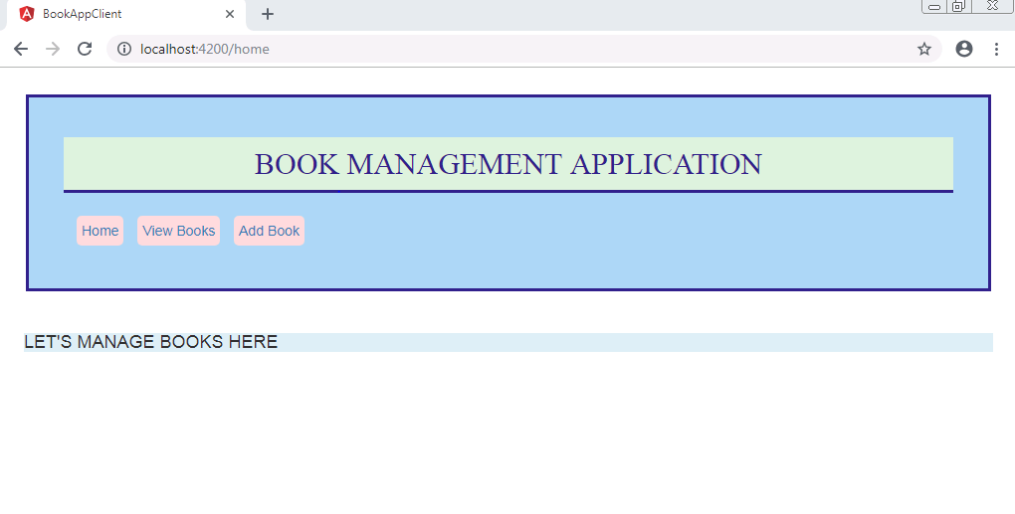

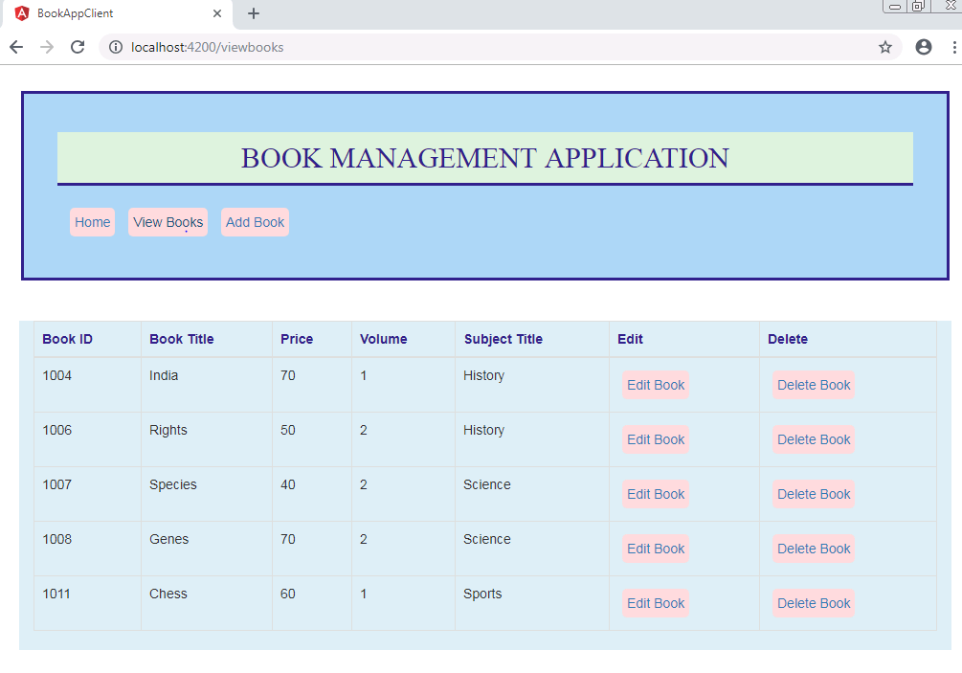

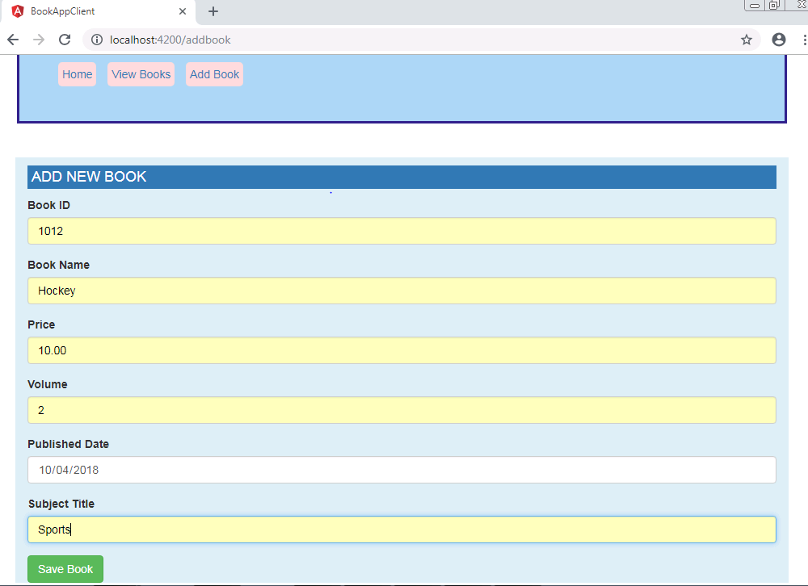

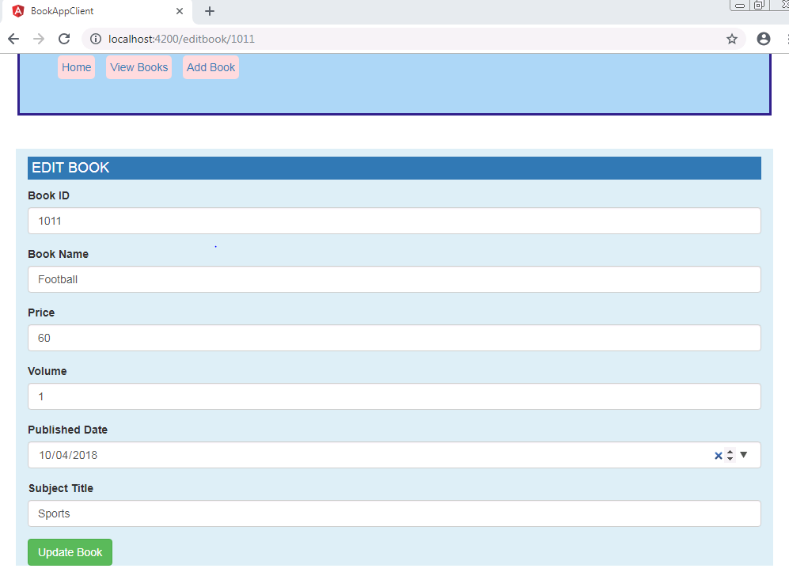

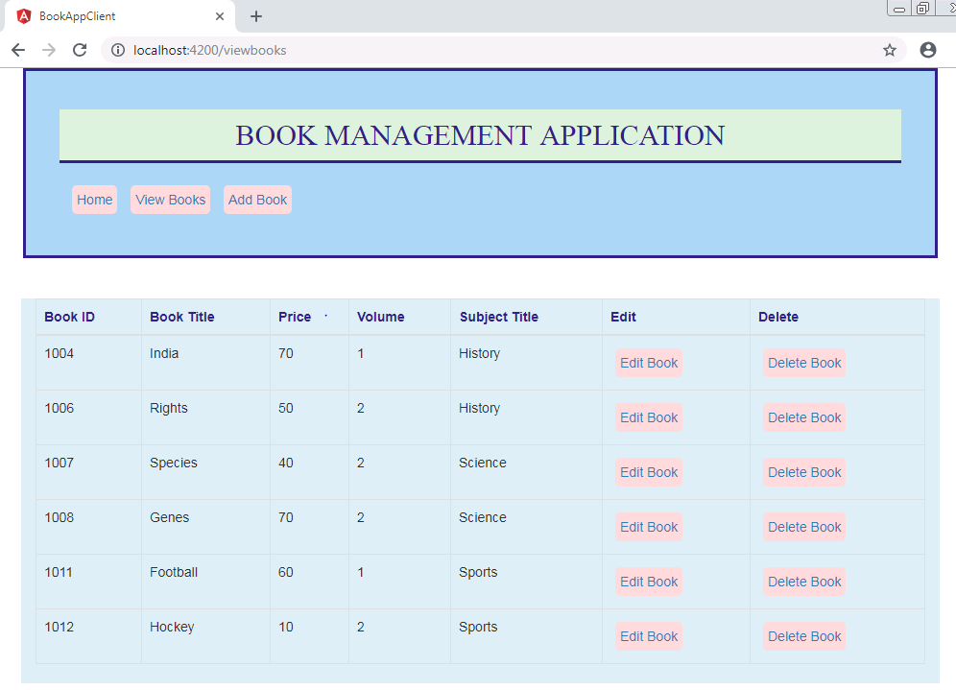

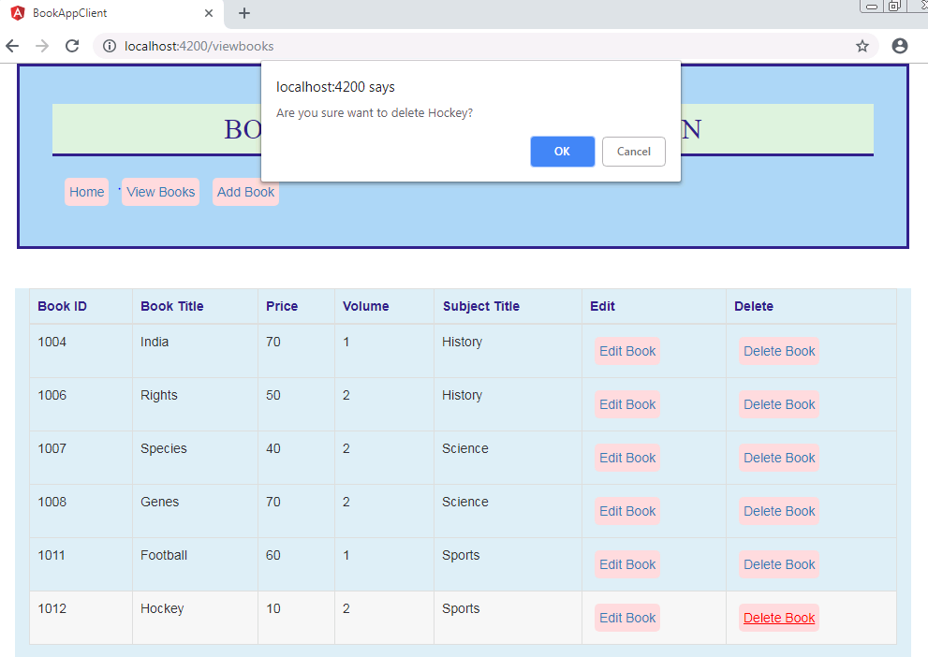

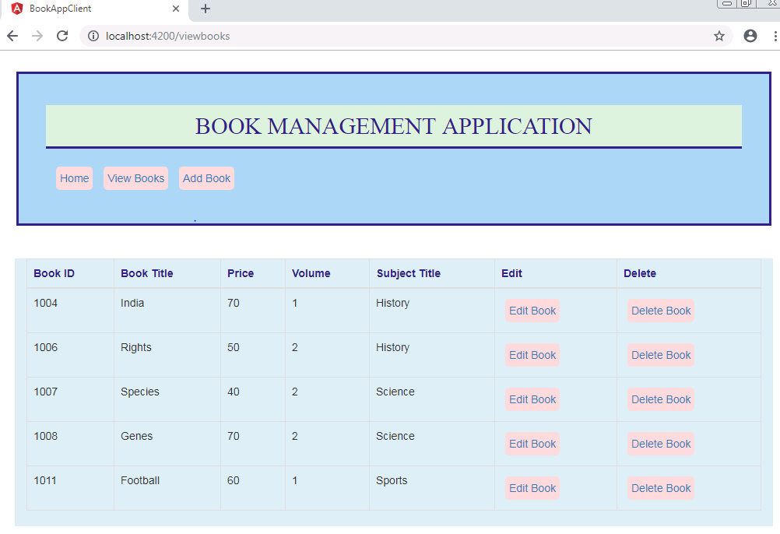

**Spring Web Restful API Code:**

**web.xml**

<web-app xmlns=*"http://java.sun.com/xml/ns/javaee"*

version=*"2.5"*

xmlns:xsi=*"http://www.w3.org/2001/XMLSchema-instance"*

xsi:schemaLocation=*"http://java.sun.com/xml/ns/javaee http://java.sun.com/xml/ns/javaee/web-app_2_5.xsd"*>

<display-name>Spring MVC Rest API Application</display-name>

<servlet>

<servlet-name>dispatcher</servlet-name>

<servlet-class>org.springframework.web.servlet.DispatcherServlet</servlet-class>

<init-param>

<param-name>contextConfigLocation</param-name>

<param-value>/WEB-INF/dispatcher-servlet.xml</param-value>

</init-param>

<load-on-startup>1</load-on-startup>

</servlet>

<servlet-mapping>

<servlet-name>dispatcher</servlet-name>

<url-pattern>/</url-pattern>

</servlet-mapping>

<listener>

<listener-class>

org.springframework.web.context.ContextLoaderListener

</listener-class>

</listener>

<context-param>

<param-name>contextConfigLocation</param-name>

<param-value>/WEB-INF/spring.xml</param-value>

</context-param>

</web-app>

**spring.xml**

<beans xmlns=*"http://www.springframework.org/schema/beans"*

xmlns:xsi=*"http://www.w3.org/2001/XMLSchema-instance"* xmlns:context=*"http://www.springframework.org/schema/context"*

xmlns:tx=*"http://www.springframework.org/schema/tx"* xmlns:p=*"http://www.springframework.org/schema/p"*

xmlns:jpa=*"http://www.springframework.org/schema/data/jpa"*

xsi:schemaLocation=*"http://www.springframework.org/schema/beans*

*http://www.springframework.org/schema/beans/spring-beans-3.0.xsd*

*http://www.springframework.org/schema/context*

*http://www.springframework.org/schema/context/spring-context-3.0.xsd*

*http://www.springframework.org/schema/tx*

*http://www.springframework.org/schema/tx/spring-tx.xsd*

*http://www.springframework.org/schema/data/jpa*

*http://www.springframework.org/schema/data/jpa/spring-jpa-1.8.xsd"*>

<context:component-scan base-package=*"com.books.app"* />

<bean id=*"bookAppService"* class=*"com.books.app.service.BookAppServiceImpl"*></bean>

<context:property-placeholder location=*"classpath:database.properties"* />

<bean id=*"basicDataSource"* class=*"org.apache.commons.dbcp2.BasicDataSource"*

destroy-method=*"close"*>

<property name=*"driverClassName"* value=*"${database.driverClassName}"* />

<property name=*"url"* value=*"${database.url}"* />

<property name=*"username"* value=*"${database.username}"* />

<property name=*"password"* value=*"${database.password}"* />

</bean>

<bean name=*"hibernateJpaVendorAdapter"*

class=*"org.springframework.orm.jpa.vendor.HibernateJpaVendorAdapter"* />

<bean id=*"entityManagerFactory"*

class=*"org.springframework.orm.jpa.LocalContainerEntityManagerFactoryBean"*>

<property name=*"jpaVendorAdapter"* ref=*"hibernateJpaVendorAdapter"* />

<property name=*"dataSource"* ref=*"basicDataSource"* />

<property name=*"persistenceUnitName"* value=*"myJpaPersistenceUnit"* />

<property name=*"packagesToScan"*>

<list>

<value>com.books.app.model</value>

</list>

</property>

<property name=*"jpaProperties"*>

<props>

<prop key=*"hibernate.dialect"*>${hibernate.dialect}</prop>

<prop key=*"hibernate.show_sql"*>${hibernate.show_sql}</prop>

<prop key=*"hibernate.format_sql"*>${hibernate.format_sql}</prop>

<prop key=*"hibernate.id.new_generator_mappings"*>${hibernate.id.new_generator_mappings}</prop>

</props>

</property>

</bean>

<bean id=*"transactionManager"* class=*"org.springframework.orm.jpa.JpaTransactionManager"*>

<property name=*"entityManagerFactory"* ref=*"entityManagerFactory"* />

</bean>

<tx:annotation-driven transaction-manager=*"transactionManager"* />

<jpa:repositories base-package=*"com.books.app.dao"*

entity-manager-factory-ref=*"entityManagerFactory"* />

</beans>

**dispatcher-servlet.xml**

<beans xmlns=*"http://www.springframework.org/schema/beans"*

xmlns:mvc=*"http://www.springframework.org/schema/mvc"* xmlns:context=*"http://www.springframework.org/schema/context"*

xmlns:xsi=*"http://www.w3.org/2001/XMLSchema-instance"*

xsi:schemaLocation=*" http://www.springframework.org/schema/beans http://www.springframework.org/schema/beans/spring-beans-3.0.xsd http://www.springframework.org/schema/mvc http://www.springframework.org/schema/mvc/spring-mvc.xsd http://www.springframework.org/schema/context http://www.springframework.org/schema/context/spring-context-3.0.xsd"*>

<mvc:annotation-driven />

<context:component-scan base-package=*"com.books.app"* />

<mvc:resources location=*"/resources/"* mapping=*"/resources/**"*></mvc:resources>

</beans>

**database.properties**

database.driverClassName=com.mysql.jdbc.Driver

database.url=jdbc:mysql://localhost:3306/bookshop

database.username=root

database.password=root

hibernate.dialect = org.hibernate.dialect.MySQLDialect

hibernate.show_sql = true

hibernate.format_sql = true

hibernate.id.new_generator_mappings = false

**pom.xml**

<project xmlns=*"http://maven.apache.org/POM/4.0.0"* xmlns:xsi=*"http://www.w3.org/2001/XMLSchema-instance"*

xsi:schemaLocation=*"http://maven.apache.org/POM/4.0.0 http://maven.apache.org/maven-v4_0_0.xsd"*>

<modelVersion>4.0.0</modelVersion>

<groupId>books.app</groupId>

<artifactId>springmvcrestfulapi</artifactId>

<packaging>war</packaging>

<version>0.0.1-SNAPSHOT</version>

<name>springmvcrestfulapi Maven Webapp</name>

<url>http://maven.apache.org</url>

<properties>

<project.build.sourceEncoding>UTF-8</project.build.sourceEncoding>

<spring.version>5.0.7.RELEASE</spring.version>

<spring.data>2.0.1.RELEASE</spring.data>

</properties>

<dependencies>

<dependency>

<groupId>org.springframework</groupId>

<artifactId>spring-context</artifactId>

<version>${spring.version}</version>

</dependency>

<dependency>

<groupId>org.springframework</groupId>

<artifactId>spring-core</artifactId>

<version>${spring.version}</version>

</dependency>

<dependency>

<groupId>org.springframework</groupId>

<artifactId>spring-webmvc</artifactId>

<version>${spring.version}</version>

</dependency>

<dependency>

<groupId>org.springframework</groupId>

<artifactId>spring-orm</artifactId>

<version>${spring.version}</version>

</dependency>

<dependency>

<groupId>org.springframework.data</groupId>

<artifactId>spring-data-jpa</artifactId>

<version>${spring.data}</version>

</dependency>

<dependency>

<groupId>javax.servlet</groupId>

<artifactId>jstl</artifactId>

<version>1.2</version>

</dependency>

<dependency>

<groupId>mysql</groupId>

<artifactId>mysql-connector-java</artifactId>

<version>5.1.44</version>

</dependency> <!-- Hibernate 5.2.6 Final -->

<dependency>

<groupId>org.hibernate</groupId>

<artifactId>hibernate-core</artifactId>

<version>5.2.6.Final</version>

</dependency>

<dependency>

<groupId>org.apache.commons</groupId>

<artifactId>commons-dbcp2</artifactId>

<version>2.1.1</version>

</dependency>

<dependency>

<groupId>com.fasterxml.jackson.core</groupId>

<artifactId>jackson-databind</artifactId>

<version>2.9.0</version>

</dependency>

<dependency>

<groupId>junit</groupId>

<artifactId>junit</artifactId>

<version>3.8.1</version>

<scope>test</scope>

</dependency>

<dependency>

<groupId>commons-logging</groupId>

<artifactId>commons-logging</artifactId>

<version>1.2</version>

</dependency>

</dependencies>

<build>

<finalName>springmvcrestfulapi</finalName>

</build>

</project>

**BookController.java**

**package** com.books.app.controller;

**import** java.util.List;

**import** org.springframework.beans.factory.annotation.Autowired;

**import** org.springframework.http.HttpStatus;

**import** org.springframework.http.MediaType;

**import** org.springframework.http.ResponseEntity;

**import** org.springframework.web.bind.annotation.DeleteMapping;

**import** org.springframework.web.bind.annotation.GetMapping;

**import** org.springframework.web.bind.annotation.PathVariable;

**import** org.springframework.web.bind.annotation.PostMapping;

**import** org.springframework.web.bind.annotation.PutMapping;

**import** org.springframework.web.bind.annotation.RequestBody;

**import** org.springframework.web.bind.annotation.RequestMapping;

**import** org.springframework.web.bind.annotation.RequestMethod;

**import** org.springframework.web.bind.annotation.RestController;

**import** com.books.app.exception.BookAppException;

**import** com.books.app.model.Book;

**import** com.books.app.service.IBookAppService;

@RestController

@RequestMapping("/bookapp")

**public** **class** BookController {

@Autowired

IBookAppService bookAppService;

@RequestMapping(value = "/allbooks", method = RequestMethod.***GET***, produces = MediaType.***APPLICATION_JSON_VALUE***)

**public** ResponseEntity<List<Book>> viewAllBooks() **throws** BookAppException {

List<Book> books = bookAppService.view();

**return** **new** ResponseEntity<List<Book>>(books, HttpStatus.***OK***);

}

@GetMapping("/findbook/{bookId}")

**public** ResponseEntity<Book> getBookById(@PathVariable(value = "bookId") **int** bookId) **throws** BookAppException {

Book book = bookAppService.search(bookId);

**if** (book == **null**) {

**return** **new** ResponseEntity("No Book found for ID " + bookId, HttpStatus.***NOT_FOUND***);

}

**return** **new** ResponseEntity<Book>(book, HttpStatus.***OK***);

}

@PostMapping("/newbook")

**public** ResponseEntity<Book> addNewBook(@RequestBody Book book) **throws** BookAppException {

**if** (book == **null**) {

**return** **new** ResponseEntity("Book data required ", HttpStatus.***BAD_REQUEST***);

}

**return** **new** ResponseEntity<Book>(bookAppService.add(book, book.getSubject().getSubtitle()), HttpStatus.***OK***);

}

@PutMapping("/updatebook")

**public** ResponseEntity<Book> editBook(@RequestBody Book book) **throws** BookAppException {

Book sbook = bookAppService.edit(book);

**if** (sbook == **null**) {

**return** **new** ResponseEntity("No Book found for ID " + book.getBookId(), HttpStatus.***NOT_FOUND***);

}

**return** **new** ResponseEntity<Book>(sbook, HttpStatus.***OK***);

}

@DeleteMapping("/deletebook/{bookId}")

**public** ResponseEntity<Void> deleteBook(@PathVariable(value = "bookId") **int** bookId) **throws** BookAppException {

ResponseEntity<Void> response = **null**;

bookAppService.delete(bookId);

response = **new** ResponseEntity<>(HttpStatus.***OK***);

**return** response;

}

}

**IBookAppService.java**

**package** com.books.app.service;

**import** java.util.List;

**import** com.books.app.exception.BookAppException;

**import** com.books.app.model.Book;

**public** **interface** IBookAppService {

Book add(Book book, String subtitle) **throws** BookAppException;

Book edit(Book book) **throws** BookAppException;

**void** delete(**int** bookid) **throws** BookAppException;

Book search(**int** bookid) **throws** BookAppException;

List<Book> view() **throws** BookAppException;

}

**BookAppServiceImpl.java**

**package** com.books.app.service;

**import** java.util.List;

**import** java.util.Optional;

**import** org.springframework.beans.factory.annotation.Autowired;

**import** org.springframework.stereotype.Service;

**import** org.springframework.transaction.annotation.Transactional;

**import** com.books.app.dao.IBookRepository;

**import** com.books.app.dao.ISubjectRepository;

**import** com.books.app.exception.BookAppException;

**import** com.books.app.model.Book;

**import** com.books.app.model.Subject;

@Service

**public** **class** BookAppServiceImpl **implements** IBookAppService {

@Autowired

**private** ISubjectRepository subjRepo;

@Autowired

**private** IBookRepository bookRepo;

@Transactional

@Override

**public** Book add(Book book, String subtitle) **throws** BookAppException {

Subject subject = **null**;

**if** (book.getSubject() != **null**) {

List<Subject> subjectList = subjRepo.findAll();

**for** (Subject subj : subjectList) {

**if** (subj.getSubtitle() != **null** && subj.getSubtitle().equalsIgnoreCase(subtitle)) {

subject = subj;

}

}

**if** (subject == **null**) {

subject = **new** Subject();

subject.setSubtitle(subtitle);

subjRepo.save(subject);

}

}

book.setSubject(subject);

Book sbook = bookRepo.save(book);

**return** sbook;

}

@Transactional

@Override

**public** Book edit(Book book) **throws** BookAppException {

String subtitle = book.getSubject().getSubtitle();

Subject subject = **null**;

**if** (book.getSubject() != **null**) {

List<Subject> subjectList = subjRepo.findAll();

**for** (Subject subj : subjectList) {

**if** (subj.getSubtitle() != **null** && subj.getSubtitle().equalsIgnoreCase(subtitle)) {

subject = subj;

}

}

**if** (subject == **null**) {

subject = **new** Subject();

subject.setSubtitle(subtitle);

subjRepo.save(subject);

}

}

Book fbook = search(book.getBookId());

**if** (fbook != **null**) {

fbook.setBookId(book.getBookId());

fbook.setTitle(book.getTitle());

fbook.setPrice(book.getPrice());

fbook.setVolume(book.getVolume());

fbook.setPublistDt(book.getPublistDt());

}**else** {

**return** **null**;

}

fbook.setSubject(subject);

**return** bookRepo.save(fbook);

}

@Transactional

@Override

**public** **void** delete(**int** bookid) **throws** BookAppException {

bookRepo.deleteById(bookid);

}

@Override

**public** Book search(**int** bookid) **throws** BookAppException {

Optional<Book> optBook = bookRepo.findById(bookid);

Book book = optBook.isPresent() ? optBook.get() : **null**;

**return** book;

}

@Override

**public** List<Book> view() **throws** BookAppException{

**return** bookRepo.findAll();

}

}

**IBookRepository.java**

**package** com.books.app.dao;

**import** org.springframework.data.jpa.repository.JpaRepository;

**import** com.books.app.model.Book;

**public** **interface** IBookRepository **extends** JpaRepository<Book,Integer>{

}

**ISubjectepository.java**

**package** com.books.app.dao;

**import** org.springframework.data.jpa.repository.JpaRepository;

**import** com.books.app.model.Subject;

**public** **interface** ISubjectRepository **extends** JpaRepository<Subject,String>{

}

**BookAppException.java**

**package** com.books.app.exception;

@SuppressWarnings("serial")

**public** **class** BookAppException **extends** Exception {

**public** BookAppException(String errMsg) {

**super**(errMsg);

}

}

**Subject.java**

**package** com.books.app.model;

**import** java.util.Set;

**import** javax.persistence.Column;

**import** javax.persistence.Entity;

**import** javax.persistence.Id;

**import** javax.persistence.OneToMany;

**import** javax.persistence.Table;

**import** com.fasterxml.jackson.annotation.JsonIgnore;

@Entity

@Table(name="subjects")

**public** **class** Subject {

@Id

@Column(name="subtitle")

**private** String subtitle;

@Column(name="subjectid")

**private** **long** subjectId;

@Column(name="durationInHours")

**private** **int** durationInHours;

@JsonIgnore

@OneToMany(mappedBy="subject",orphanRemoval=**true**)

**private** Set<Book> references;

**public** **long** getSubjectId() {

**return** subjectId;

}

**public** **void** setSubjectId(**long** subjectId) {

**this**.subjectId = subjectId;

}

**public** String getSubtitle() {

**return** subtitle;

}

**public** **void** setSubtitle(String subtitle) {

**this**.subtitle = subtitle;

}

**public** **int** getDurationInHours() {

**return** durationInHours;

}

**public** **void** setDurationInHours(**int** durationInHours) {

**this**.durationInHours = durationInHours;

}

**public** Set<Book> getReferences() {

**return** references;

}

**public** **void** setReferences(Set<Book> references) {

**this**.references = references;

}

}

**Book.java**

**package** com.books.app.model;

**import** java.time.LocalDate;

**import** javax.persistence.Column;

**import** javax.persistence.Entity;

**import** javax.persistence.Id;

**import** javax.persistence.JoinColumn;

**import** javax.persistence.ManyToOne;

**import** javax.persistence.Table;

**import** org.springframework.format.annotation.DateTimeFormat;

**import** com.books.app.util.BookHelper;

**import** com.fasterxml.jackson.databind.annotation.JsonDeserialize;

@Entity

@Table(name="books")

**public** **class** Book {

@Id

@Column(name="bookid")

**private** **int** bookId;

@Column(name="title")

**private** String title;

@Column(name="price")

**private** **double** price;

@Column(name="vol")

**private** **int** volume;

@Column(name="pdate")

@DateTimeFormat(pattern ="dd-MM-yyyy")

@JsonDeserialize(using=BookHelper.**class**)

**private** LocalDate publistDt;

@ManyToOne

@JoinColumn(name="stitle" , nullable=**false**)

**private** Subject subject;

**public** Subject getSubject() {

**return** subject;

}

**public** **void** setSubject(Subject subject) {

**this**.subject = subject;

}

**public** **int** getBookId() {

**return** bookId;

}

**public** **void** setBookId(**int** bookId) {

**this**.bookId = bookId;

}

**public** String getTitle() {

**return** title;

}

**public** **void** setTitle(String title) {

**this**.title = title;

}

**public** **double** getPrice() {

**return** price;

}

**public** **void** setPrice(**double** price) {

**this**.price = price;

}

**public** **int** getVolume() {

**return** volume;

}

**public** **void** setVolume(**int** volume) {

**this**.volume = volume;

}

**public** LocalDate getPublistDt() {

**return** publistDt;

}

**public** **void** setPublistDt(LocalDate publistDt) {

**this**.publistDt = publistDt;

}

}

**BookHelper.java**

**package** com.books.app.util;

**import** java.io.IOException;

**import** java.time.LocalDate;

**import** java.time.format.DateTimeFormatter;

**import** com.fasterxml.jackson.core.JsonParser;

**import** com.fasterxml.jackson.core.JsonProcessingException;

**import** com.fasterxml.jackson.databind.DeserializationContext;

**import** com.fasterxml.jackson.databind.JsonDeserializer;

**public** **class** BookHelper **extends** JsonDeserializer<LocalDate>{

@Override

**public** LocalDate deserialize(JsonParser p, DeserializationContext ctxt)

**throws** IOException, JsonProcessingException {

DateTimeFormatter formatter = DateTimeFormatter.*ofPattern*("yyyy-MM-dd");

LocalDate localDate = **null**;

localDate = LocalDate.*parse*(p.getText(), formatter);

**return** localDate;

}

}