**JENKINS ASSIGNMENT 1**

**Installation location :**

C:\Program Files (x86)\Jenkins

**Login details :**

Username - karthik0828

password - cts2018

**Build results:**

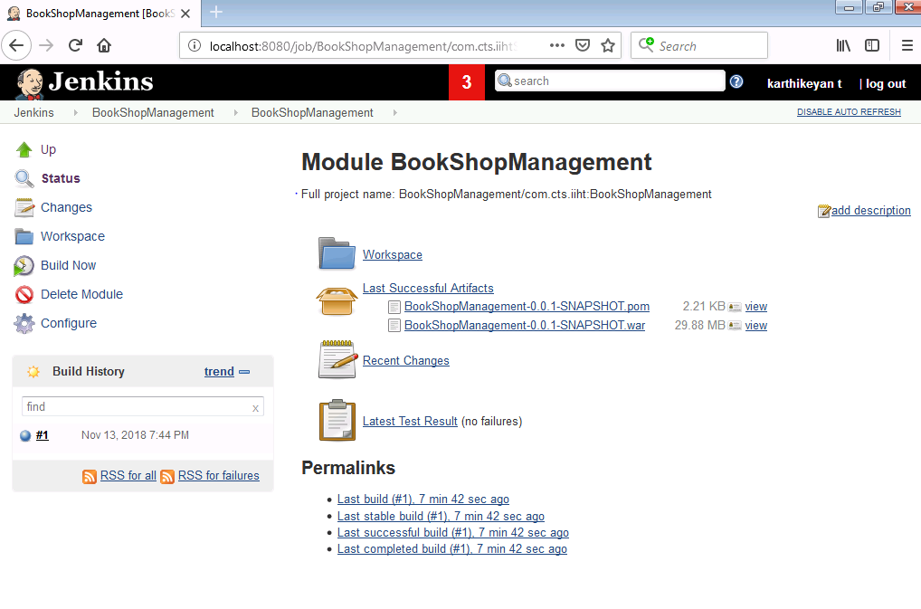

**Testcases results:**

