CLI Commands:

Git global setup

git config --global user.name "Paramita Nandi"

git config --global user.email "paramita.tia@gmail.com"

adding the project to created folder and commiting the code.

cd existing_folder

git init

git remote add origin http://172.18.2.18/paramitan/Test-project.git

git add .

git commit -m "Initial commit"

git push -u origin master

URL :

http://localhost/sunnyjis49/14_Spring_Test_Assignment1.git

Steps followed:

1. Git registration

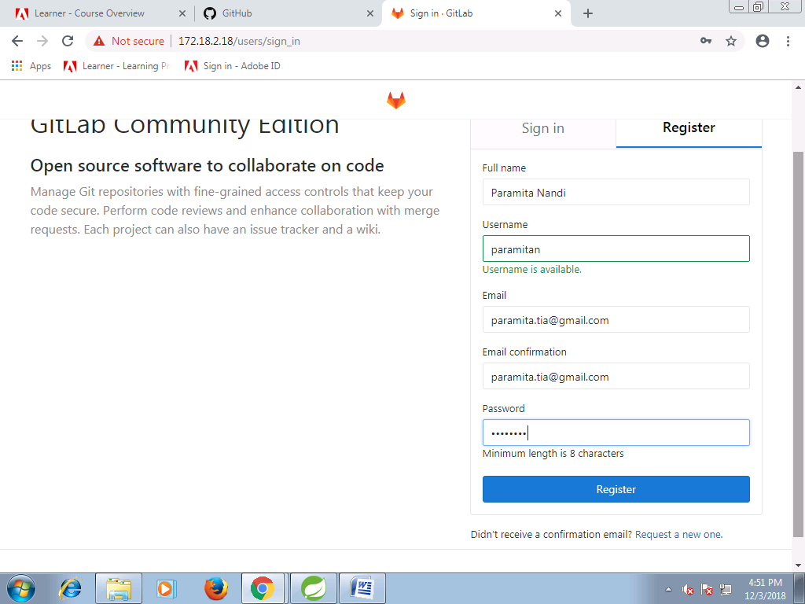

2. Creating blank project folder

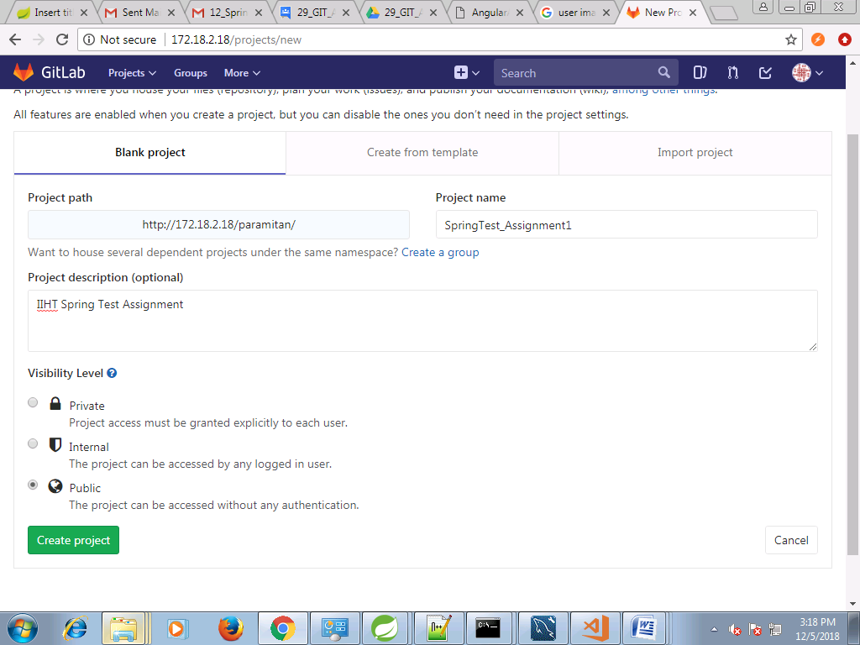

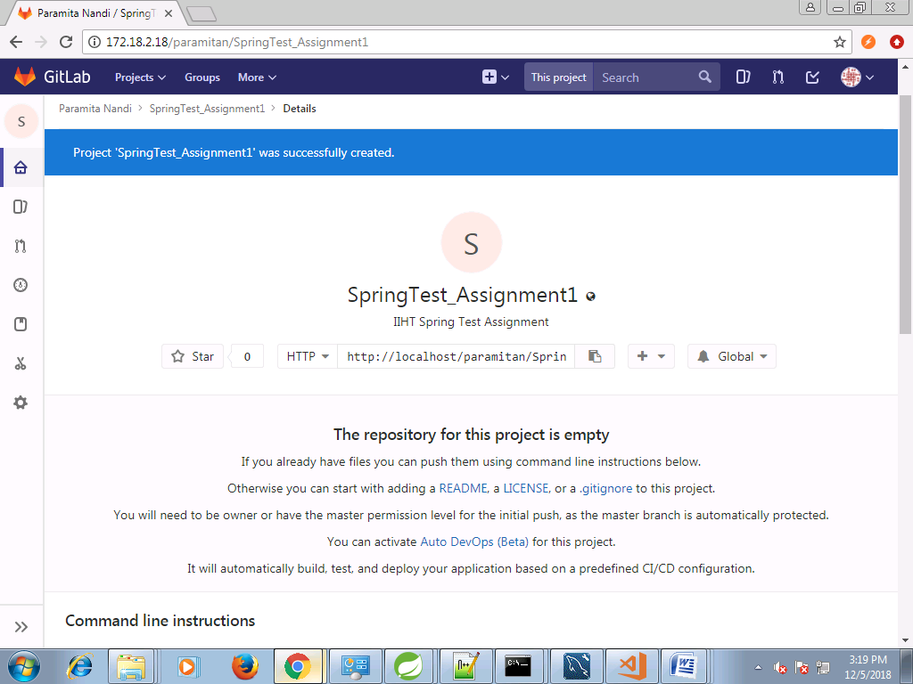

3. Git global setup using cli command

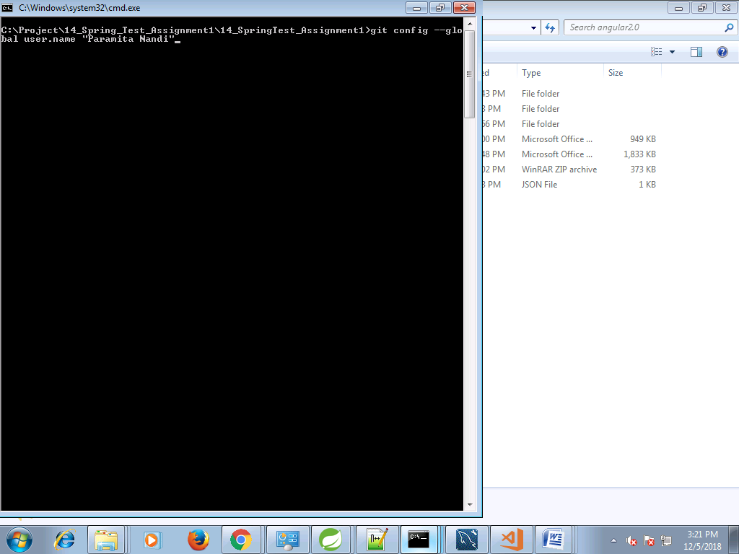

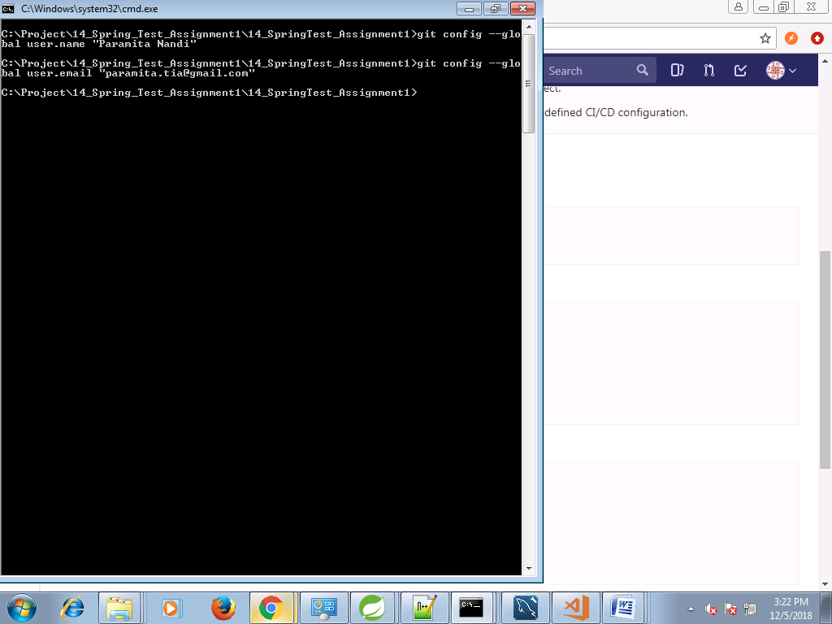

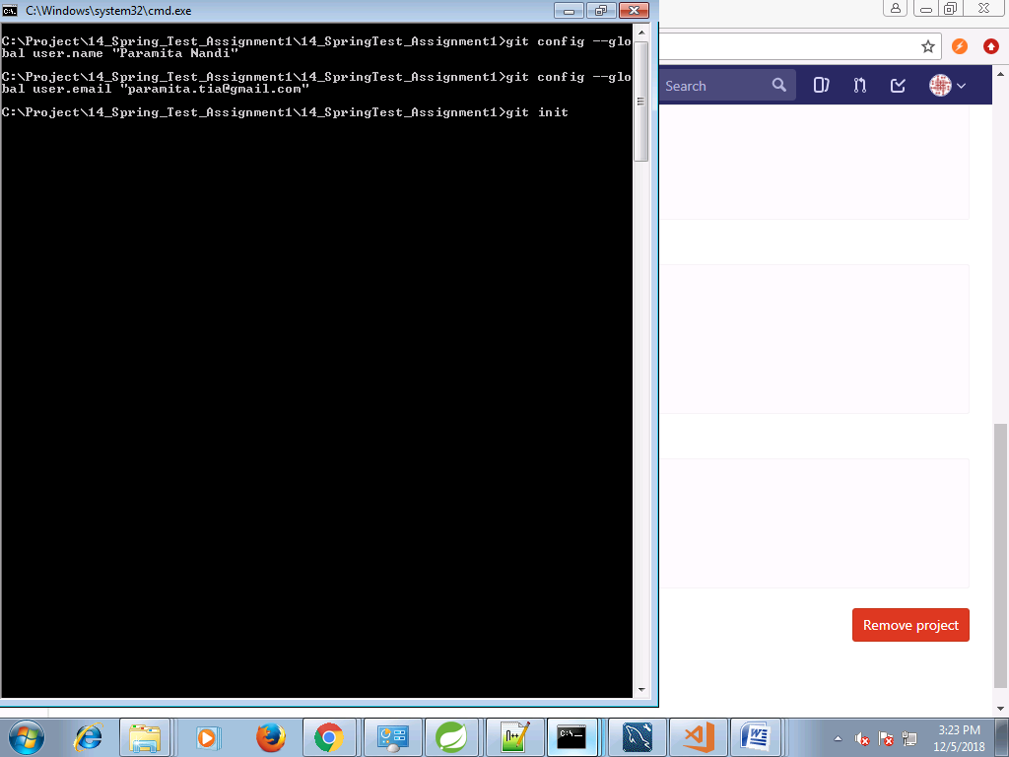

4. Adding the project from local workspace to Git

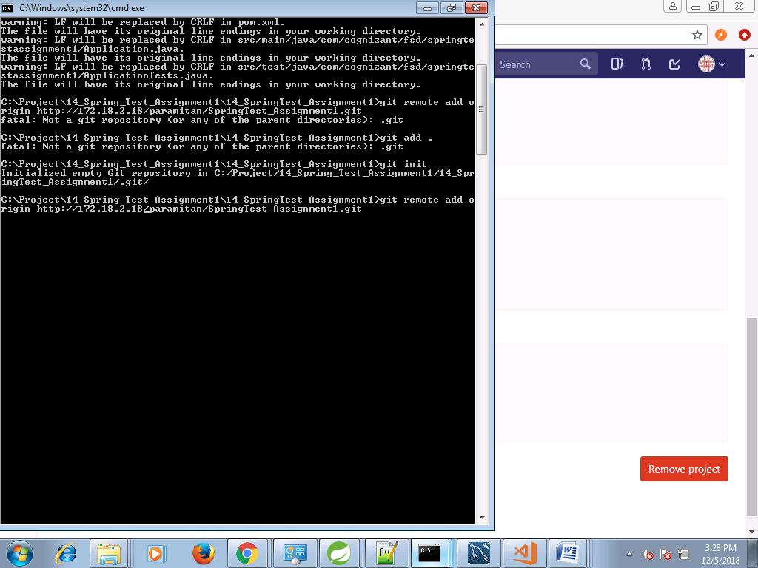

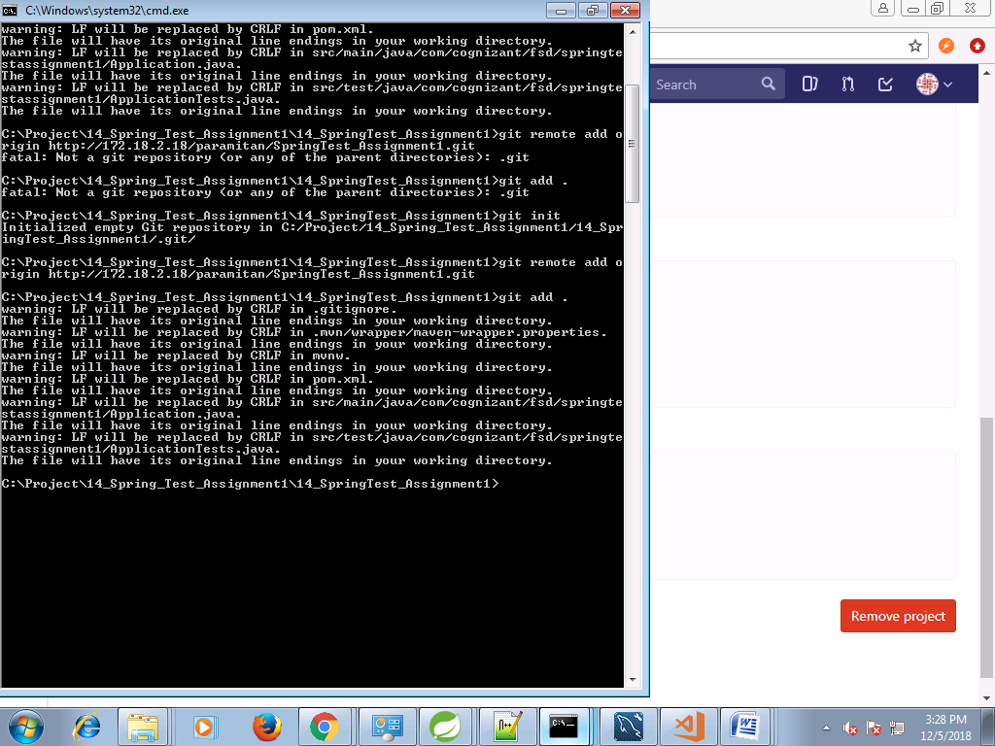

5. Committing the project



