ASSESSMENT-1

1) Create table employee (empno(PK),name,salary,designation)

2) Create table location(empno(FK),locid,state,city)

3) Add a column (dept) to employee table.

4) Add a column (road no) to location table.

5) Change the name of the table employee to hydemployee.

6) Change the name of the table location to emplocation.

7) find average,min,max salary of each dept of employee table.

8) Combine 2 table and display the columns of 2 tables(empno,name,salary,designation,dept,locid,roadno,state,city)

9) count number of rows of the 2 tables separately.

10) find the 3rd highest salary of the employee table.

11) add a tax column and find the tax dedection and display the gross salary.

*tax is 10% of the total salary

12)Select the unique salary from the employee table.

13) A table Employee has the following data:

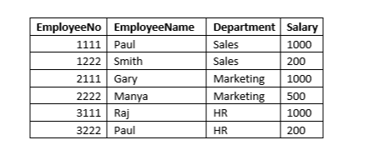

The following queries were executed on the table successfully :  
 UPDATE EMPLOYEE SET DEPARTMENT  = 'HR' WHERE DEPARTMENT = 'Marketing' ;  
 DELETE FROM EMPLOYEE WHERE DEPARTMENT = 'HR' AND SALARY = 1000;  
What will be the output of the following query?  
SELECT COUNT(*) FROM EMPLOYEE;

5

6

4

2

### 14) Consider the below table SalesPerson:

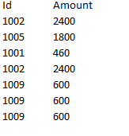

SELECT DISTINCT Id, Amount FROM SalesPerson ORDER BY Amount ASC;

Based on the output of the above query, identify the correct statement.

1005 will be 3rd record

1009 will be 4th record

1002 will be 1st record

1001 will be 4th record

15) Consider the following "employee" table and the code given below:

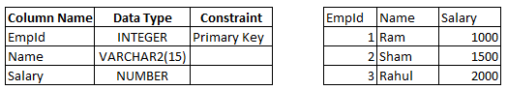

BEGIN  
  UPDATE Employee SET Salary=5000 WHERE EmpId = 1;  
  COMMIT;  
  UPDATE Employee SET Name='Dravid', Salary = 5000 WHERE EmpId = 3;  
  INSERT INTO Employee VALUES(3, 'Yuvraj', 2500);  
EXCEPTION  
  WHEN OTHERS THEN  
   COMMIT;  
END;  
  
What will happen when the above code gets executed?

First update will be successful

Both the updates will be successful

Neither update nor insert will be successful

Both the updates and insert will be successful

16) Consider the tables vehtype and vehicle given below:

vehtype(vid ,vtype) with vid being the primary key.

vehicle(id, vid,  brand, model, price) with id being the primary key and vid foreign key to the vehtype table.

Consider the below join query:

select brand from vehicle v join vehtype vt  
on v.vid=vt.vid group by brand  
having count(vtype)>1

Choose an equivalent subquery that would achieve the functionality performed by the above join query.

Note: The only difference between the options is in the 'WHERE' clause.

SELECT brand FROM vehicle WHERE vid in (SELECT vid FROM vehtype HAVING COUNT(vtype)>1);

SELECT brand FROM vehicle WHERE vid in (SELECT vid FROM vehtype GROUP BY vid HAVING COUNT(vtype)>1)

SELECT brand FROM vehicle WHERE vid IN (SELECT vid FROM vehtype) HAVING COUNT(vid)>1;

SELECT brand FROM vehicle WHERE vid in (SELECT vid FROM vehtype) GROUP BY brand HAVING COUNT(vid)>1

### 17)

Consider the tables emp and dept given below:

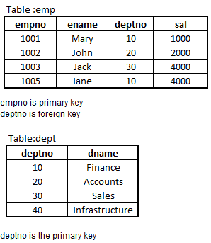

Which of the following queries will execute successfully?

1) INSERT INTO emp VALUES(1006, 'Fedrick', 10, 2000);

2) INSERT INTO emp VALUES (1008, 'Fedrick', NULL, 3000);

3) INSERT INTO dept (deptno) VALUES (40);

4) INSERT INTO dept VALUES (NULL, 'HR');

### 18)

Consider the table toys given below:

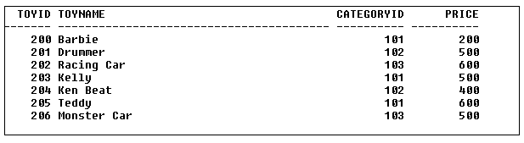

What will be the output of the below query?  
  
SELECT * FROM toys t1 WHERE price = (SELECT MAX(price) FROM toys t2 WHERE t1.categoryid=t2.categoryid );

A) 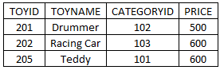

B) 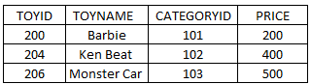

C) 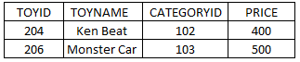

D) 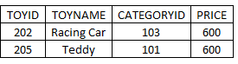

A

B

C

D

19)

create table broker(brokerno int,commission int);

insert into broker values(103,3500);

insert into broker(brokerno) values(105);

SELECT BrokerNo, COUNT(NVL(Commission,0)) Commission

FROM Broker GROUP BY BrokerNo;

select * from broker;

SELECT BrokerNo, COUNT(Commission)

FROM Broker GROUP BY BrokerNo;

alter table broker add totalsalary int;

update broker set totalsalary=commission+salary ;

update broker set totalsalary=nvl(commission,0)+salary ;