A **Cell** is a virtual unit that is built of a [Deployment Manager](https://itdevworld.wordpress.com/2009/05/03/websphere-concepts-cell-node-cluster-server/#DeploymentManager)and one or more nodes.

[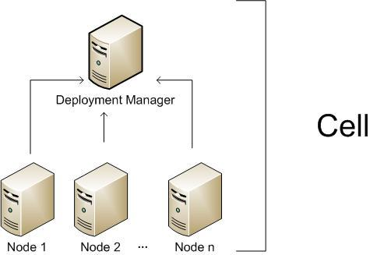](https://itdevworld.files.wordpress.com/2009/05/websphere-cell.jpg)

Web logic Cell

Weblogic Concepts

The Deployment Manager is a process (in fact it is an special Web logic instance) responsible for managing the installation and maintenance of Applications, Connection Pools and other resources related to a J2EE environment. It is also responsible for centralizing user repositories for application and also for Web logic authentication and authorization.

The Deployment Manager communicates with the Nodes through another special Web logic process, the Node Agent.

The Node is another virtual unit that is built of a Node Agent and one or more Server instances.

The Node Agent it the process responsible for spawning and killing server processes and also responsible for configuration synchronization between the Deployment Manager and the Node. Extra care must be taken when changing security configurations for the cell, since communication between Deployment Manager and Node Agent is ciphered and secured when security is enabled, Node Agent needs to have configuration fully resynchronized when impacting changes are made to Cell security configuration.

Servers are regular Java process responsible for serving J2EE requests (eg.: serving JSP/JSF pages, serving EJB calls, consuming JMS queues, etc).

And to finish, Clusters are also virtual units that groups Servers so resources added to the Cluster are propagated to every Server that makes up the cluster, this will in fact affect usually more than a single Node instance.

Lets finish this post with another diagram to illustrate all those concepts.

[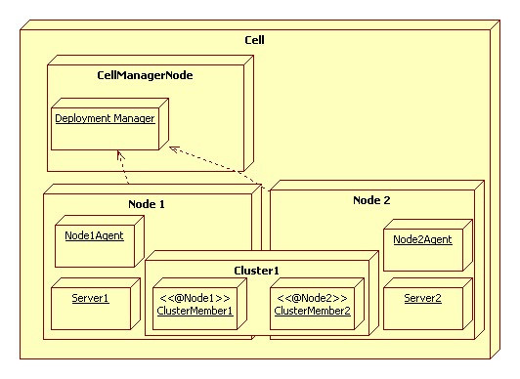](https://itdevworld.files.wordpress.com/2009/05/websphere-concepts.jpg)