# navigation.html

* <!DOCTYPE html>
* <html lang="en">
* <head>
* <title>My Profile</title>
* <meta charset="utf-8">
* <meta name="viewport" content="width=device-width, initial-scale=1">
* <link rel="stylesheet" href="https://maxcdn.bootstrapcdn.com/bootstrap/3.3.7/css/bootstrap.min.css">
* <script src="https://ajax.googleapis.com/ajax/libs/jquery/3.3.1/jquery.min.js"></script>
* <script src="https://maxcdn.bootstrapcdn.com/bootstrap/3.3.7/js/bootstrap.min.js"></script>
* <style>
* /* Set height of the grid so .sidenav can be 100% (adjust if needed) */
* .row.content {
* height: 100%;
* }
* * {
* box-sizing: border-box;
* }
* /* Style the header */
* header {
* background-color: #00FFFF;
* padding: 12px;
* text-align: center;
* font-size: 35px;
* color: rgb(20, 20, 13);
* }
* /* Set gray background color and 100% height */
* .sidenav {
* float: left;
* width: 26%;
* height: 600px;
* background: #aaa;
* padding: 20px;
* }
* article {
* float: left;
* padding: 20px;
* width: 100%;
* background-color: #f1f1f1;
* height: 100%;
* }
* article iframe {
* border: 2px solid #555;
* border-radius: 4px;
* }
* a {
* border: 1px solid rgb(116, 113, 109);
* border-radius: 5px;
* padding: 5px;
* }
* li {
* padding: 20px;
* }
* /* Set black background color, white text and some padding */
* footer {
* background-color: #555;
* color: white;
* padding: 15px;
* }
* /* On small screens, set height to 'auto' for sidenav and grid */
* @media screen and (max-width: 767px) {
* .sidenav {
* height: auto;
* padding: 15px;
* width: 100%;
* }
* .row.content {
* height: auto;
* }
* article {
* height: 600px;
* }
* .tab-2 {
* margin-left: 20px;
* }
* }
* @media screen and (min-width: 768px) {
* .col-sm-9 {
* height: 600px;
* width: 74%;
* }
* }
* .floatRight {
* float: right;
* }
* .col-sm-9 {
* padding-left: 0px !important;
* padding-right: 0px !important;
* }
* </style>
* </head>
* <body>
* <div class="">
* </div>
* <div class="container-fluid">
* <div class="row content">
* <div>
* <header>
* <h2>My Profile</h2>
* </header>
* </div>
* <div class="col-sm-3 sidenav ">
* <section>
* <nav>
* <li>
* <a href=".\index.html " target="iframe_a ">
* <b>Profile Highlights</b>
* </a>
* </li>
* <li>
* <a href=".\project.html " target="iframe_a ">
* <b>Projects</b>
* </a>
* </li>
* <li>
* <a href=".\experience.html " target="iframe_a ">
* <b>Experience</b>
* </a>
* </li>
* <li>
* <a href=".\personal_biography.html " target="iframe_a ">
* <b>Personal Biography</b>
* </a>
* </li>
* <li>
* <a href=".\education_script.html " target="iframe_a ">
* <b>Education</b>
* </a>
* </li>
* <li>
* <a href=".\contactme.html " target="iframe_a ">
* <b>Contact Me</b>
* </a>
* </li>
* </nav>
* </section>
* </div>
* <div class="col-sm-9 ">
* <article>
* <iframe height="100% " width="100% " src="index.html " name="iframe_a "></iframe>
* </article>
* </div>
* </div>
* </div>
* <div>
* <footer class="container-fluid ">
* <span>Sudhir Kumar Thakur (468973)</span>
* <span style="float: right">Cognizant</span>
* </footer>
* </div>
* </body>
* </html>

# education.html

* <!DOCTYPE html>
* <html>
* <head>
* <title>Education</title>
* <link rel="stylesheet" href="page.css">
* <meta charset="windows-1252">
* <meta name="viewport" content="width=device-width, initial-scale=1.0">
* <link rel="stylesheet" href="https://maxcdn.bootstrapcdn.com/bootstrap/3.3.7/css/bootstrap.min.css">
* <script src="https://ajax.googleapis.com/ajax/libs/jquery/3.3.1/jquery.min.js"></script>
* <script src="https://maxcdn.bootstrapcdn.com/bootstrap/3.3.7/js/bootstrap.min.js"></script>
* <style>
* .container {
* overflow: hidden
* }
* .tab {
* float: left;
* }
* .tab-2 input {
* display: block;
* margin-bottom: 5px
* }
* tr {
* transition: all .25s ease-in-out
* }
* tr:hover {
* background-color: rgb(247, 247, 155);
* cursor: pointer
* }
* .divClass {
* font-size: 15px !important;
* }
* </style>
* </head>
* <body>
* <h2 class="header">
* Education Details:
* </h2>
* <div class="container divClass">
* <div class="tab tab-1 table-responsive">
* <table id="table" class="table table-bordered">
* <tr class="bg-primary">
* <th>Degree</th>
* <th>Discipline</th>
* <th>Board / University</th>
* <th>Aggregate % / CGPA</th>
* </tr>
* <tr>
* <td>
* MCA
* </td>
* <td>Information Technology</td>
* <td>PTU</td>
* <td>73.25%</td>
* </tr>
* <tr>
* <td>
* B.Sc
* </td>
* <td>Maths(Hons)</td>
* <td>MU</td>
* <td>54</td>
* </tr>
* <tr>
* <td>
* 10+2
* </td>
* <td>Science</td>
* <td>CBSE</td>
* <td>7.9 CGPA</td>
* </tr>
* <tr>
* <td>
* 10
* </td>
* <td>Science</td>
* <td>CBSE</td>
* <td>79</td>
* </tr>
* </table>
* <div class="mt-3">
* <button type="submit" class="btn-primary btn-lg active center-block" onclick="addMoreDetails();">Add more details</button>
* </div>
* </div>
* <p>Note: Please click on row for modifying details</p>
* <div class="tab tab-2 invisible" id="formDiv">
* <div class="form-group">
* <label for="exampleInputDegree1">Degree :</label>
* <input type="text" class="form-control" id="degree" placeholder="Degree">
* </div>
* <div class="form-group">
* <label for="exampleInputDiscipline1">Discipline :</label>
* <input type="text" class="form-control" id="discipline" placeholder="Discipline">
* </div>
* <div class="form-group">
* <label for="exampleInputUniversity1">Board / University :</label>
* <input type="text" class="form-control" id="university" placeholder="Board / University">
* </div>
* <div class="form-group">
* <label for="exampleInputPercentage1">Aggregate % / CGPA :</label>
* <input type="text" class="form-control" id="percentage" placeholder="Aggregate % / CGPA">
* </div>
* <button class="btn-primary" onclick="addHtmlTableRow();">Add</button>
* <button onclick="editHtmlTbleSelectedRow();">Edit</button>
* <button class="btn-danger" onclick="removeSelectedRow();">Remove</button>
* </div>
* </div>
* <script>
* var rIndex,
* table = document.getElementById("table");
* // check the empty input
* function checkEmptyInput() {
* var isEmpty = false,
* degree = $('#degree').val();
* discipline = $('#discipline').val();
* university = $('#university').val();
* percentage = $('#percentage').val();
* console.log("degree: " + degree);
* console.log("discipline: " + discipline);
* console.log("university: " + university);
* console.log("percentage: " + percentage);
* if (degree === "") {
* alert("Degree Connot Be Empty");
* isEmpty = true;
* }
* else if (discipline === "") {
* alert("Discipline Connot Be Empty");
* isEmpty = true;
* }
* else if (university === "") {
* alert("university Connot Be Empty");
* isEmpty = true;
* }
* else if (percentage === "") {
* alert("percentage Connot Be Empty");
* isEmpty = true;
* }
* return isEmpty;
* }
* //add more details
* function addMoreDetails() {
* $('#degree').val('');
* $('#discipline').val('');
* $('#university').val('');
* $('#percentage').val('');
* $('#formDiv').removeClass("invisible");
* rIndex = undefined;
* }
* // add Row
* function addHtmlTableRow() {
* // get the table by id
* // create a new row and cells
* // get value from input text
* // set the values into row cell's
* if (!checkEmptyInput()) {
* var newRow = table.insertRow(table.length),
* cell1 = newRow.insertCell(0),
* cell2 = newRow.insertCell(1),
* cell3 = newRow.insertCell(2),
* cell4 = newRow.insertCell(3),
* degree = $('#degree').val();
* discipline = $('#discipline').val();
* university = $('#university').val();
* percentage = $('#percentage').val();
* cell1.innerHTML = degree;
* cell2.innerHTML = discipline;
* cell3.innerHTML = university;
* cell4.innerHTML = percentage;
* $('#formDiv').addClass("invisible");
* // call the function to set the event to the new row
* selectedRowToInput();
* }
* }
* // display selected row data into input text
* function selectedRowToInput() {
* for (var i = 1; i < table.rows.length; i++) {
* table.rows[i].onclick = function () {
* // get the selected row index
* rIndex = this.rowIndex;
* console.log("rIndex: " + rIndex);
* document.getElementById("degree").value = this.cells[0].innerHTML;
* document.getElementById("discipline").value = this.cells[1].innerHTML;
* document.getElementById("university").value = this.cells[2].innerHTML;
* document.getElementById("percentage").value = this.cells[3].innerHTML;
* $('#formDiv').removeClass("invisible");
* };
* }
* }
* selectedRowToInput();
* function editHtmlTbleSelectedRow() {
* degree = $('#degree').val();
* discipline = $('#discipline').val();
* university = $('#university').val();
* percentage = $('#percentage').val();
* console.log("degree: " + degree);
* console.log("discipline: " + discipline);
* console.log("university: " + university);
* console.log("percentage: " + percentage);
* if (!checkEmptyInput()) {
* table.rows[rIndex].cells[0].innerHTML = degree;
* table.rows[rIndex].cells[1].innerHTML = discipline;
* table.rows[rIndex].cells[2].innerHTML = university;
* table.rows[rIndex].cells[3].innerHTML = percentage;
* $('#formDiv').addClass("invisible");
* }
* }
* function removeSelectedRow() {
* // clear input text
* console.log("rIndex: " + rIndex);
* if (rIndex != undefined) {
* table.deleteRow(rIndex);
* $('#degree').val('');
* $('#discipline').val('');
* $('#university').val('');
* $('#percentage').val('');
* rIndex = undefined;
* $('#formDiv').addClass("invisible");
* } else {
* alert("Please select row for removing details");
* }
* }
* </script>
* </body>
* </html>

# project.html

* <!DOCTYPE html>
* <html lang="en">
* <head>
* <title>Project</title>
* <link rel="stylesheet" href="myprofile.css">
* <meta charset="utf-8">
* <meta name="viewport" content="width=device-width, initial-scale=1">
* <link rel="stylesheet" href="https://maxcdn.bootstrapcdn.com/bootstrap/3.3.7/css/bootstrap.min.css">
* <script src="https://ajax.googleapis.com/ajax/libs/jquery/3.3.1/jquery.min.js"></script>
* <script src="https://maxcdn.bootstrapcdn.com/bootstrap/3.3.7/js/bootstrap.min.js"></script>
* <style>
* .divClass {
* font-size: 15px !important;
* }
* .container {
* overflow: hidden
* }
* .tab {
* float: left;
* }
* .tab-2 input {
* display: block;
* }
* .form-control {
* width: 40%;
* }
* .form-group {
* margin-bottom: 5px;
* }
* </style>
* </head>
* <body>
* <h2 class="header">
* Project Details:
* </h2>
* <div class="container divClass">
* <div class="tab tab-1 table-responsive">
* <table id="projectTable" class="table table-bordered projectTable" border="1">
* <tr>
* <td>
* <b>Project Name</b>
* </td>
* <td>Shared Investigator Platform</td>
* </tr>
* <tr>
* <td>
* <b>Role</b>
* </td>
* <td>Associate - Projects</td>
* </tr>
* <tr>
* <td>
* <b>Customer</b>
* </td>
* <td>Transcelerate Biopharma</td>
* </tr>
* <tr>
* <td>
* <b>Team Size</b>
* </td>
* <td>30</td>
* </tr>
* <tr>
* <td>
* <b>Technical Skills</b>
* </td>
* <td>Java,J2EE,Spring,Hibernate,SOAP,REST,JQuery,JSP,Jasper,Liferay 6.2</td>
* </tr>
* <tr>
* <td>
* <b>Durations</b>
* </td>
* <td>March 2014 to till date</td>
* </tr>
* </table>
* </div>
* <button class="btn-primary" onclick="addProjectDetails()">Add More Project</button>
* <div class="row" id="inputDiv" style="display: none">
* <div class="form-group col-xs-10 col-sm-4 col-md-4 col-lg-4">
* <label for="exampleInputLabel">Item:</label>
* <input type="text" class="form-control" id="item" placeholder="Enter Item">
* </div>
* <div class="form-group col-xs-10 col-sm-4 col-md-4 col-lg-4">
* <label for="exampleInputEmail1">Item Details:</label>
* <input type="text" class="form-control" id="details" placeholder="Enter Item Details">
* </div>
* <div class="clearfix"></div>
* <div class="col-xs-10 col-sm-4 col-md-4 col-lg-4">
* <button class="btn btn-info" onclick="addRowInTable();">Add</button>
* <button class="btn btn-success" onclick="doneAddTable();">Done</button>
* </div>
* </div>
* <div class="tab tab-2 table-responsive" id="addProjDiv">
* <table id="newProjTable" class="table table-bordered projectTable">
* </table>
* </div>
* </div>
* <script>
* function addProjectDetails(){
* $('#inputDiv').show();
* }
* function addRowInTable(){
* var newRow = newProjTable.insertRow(newProjTable.length),
* cell1 = newRow.insertCell(0),
* cell2 = newRow.insertCell(1),
* item = $('#item').val();
* iDetails = $('#details').val();
* cell1.innerHTML = "<b>"+item+"</b>";
* cell2.innerHTML = iDetails;
* }
* function doneAddTable(){
* $('#inputDiv').hide();
* }
* </script>
* </body>
* </html>

# experience.html

* <html>
* <head>
* <title>Experience</title>
* <link rel="stylesheet" href="page.css">
* <link rel="stylesheet" href="https://maxcdn.bootstrapcdn.com/bootstrap/3.3.7/css/bootstrap.min.css">
* <script src="https://ajax.googleapis.com/ajax/libs/jquery/3.3.1/jquery.min.js"></script>
* <script src="https://maxcdn.bootstrapcdn.com/bootstrap/3.3.7/js/bootstrap.min.js"></script>
* <script>
* function moreDetails() {
* console.log("Inside moreDetails");
* if ($('#moreDetails').css('display') == 'none') {
* $("#moreDetails").show();
* $("#moreId").html("<b>Show less</b>");
* }else{
* $("#moreDetails").hide();
* $("#moreId").html("<b>Show more.....</b>");
* }
* }
* </script>
* </head>
* <body>
* <h2 class="header">
* Experience:
* </h2>
* <div class="divClass">
* Working as a Senior Developer in Cognizant Technology Solution, Kolkata as a part of the Digital Engagement Team - November
* 2014 to Till Date.
* <span style="display: none;" id="moreDetails">
* <br>Initially I started my work with a small company and continue with the same company for about 2.5 years and then
* made a switch to Cognizant and is working in SIP since then.
* </span>
* <a class="mt-5 " id="moreId" onclick="moreDetails()">
* <b>Show more.....</b>
* </a>
* </div>
* </body>
* </html>

# index.html

* <!DOCTYPE html>
* <html lang="en">
* <html>
* <head>
* <title>Profile Highlight</title>
* <link rel="stylesheet" href="page.css" >
* <meta charset="utf-8">
* <meta name="viewport" content="width=device-width, initial-scale=1">
* <link rel="stylesheet" href="https://maxcdn.bootstrapcdn.com/bootstrap/3.3.7/css/bootstrap.min.css">
* <script src="https://ajax.googleapis.com/ajax/libs/jquery/3.3.1/jquery.min.js"></script>
* <script src="https://maxcdn.bootstrapcdn.com/bootstrap/3.3.7/js/bootstrap.min.js"></script>
* </head>
* <body>
* <div>
* <img src=".\Images\Profile_Img.jpg" alt="My Profile Image" width="100" height="120"><br>
* </div>
* <h2 class="header">
* Profile Highlight:
* </h2>
* <div class="divClass">
* Working as a senior developer for cognizant having 6+ years of experience in Java/J2EE, Liferay
* that includes extensive knowledge in developing custom portlets, hooks, ext.
* </div>
* </body>
* </html>

# personal_biography.html

* <html>
* <head>
* <title>Personal Biography</title>
* <link rel="stylesheet" href="page.css">
* </head>
* <body>
* <h2 class="header">
* Personal Biography:
* </h2>
* <div class="divClass">Myself Sudhir Kumar Thakur. I am born and brought up in a small town of Arunachal Pradesh.
* After completing my academics from AP I moved to Patna, Bihar for Graduation and then I have done my
* Post Graduation from Punjab Technical University. I have done my PG in MCA.
* <br><br>I like watching cricket and currently enjoy watching football and cheering up for France.
* <br>I like watching movie and having a day out with friends and enjoying friendship.
* </div>
* </body>
* </html>

# contactme.html

* <html>
* <head>
* <title>Contact me</title>
* <link rel="stylesheet" href="page.css">
* <link rel="stylesheet" href="page.css">
* <meta name="viewport" content="width=device-width, initial-scale=1.0">
* <link rel="stylesheet" href="https://maxcdn.bootstrapcdn.com/bootstrap/3.3.7/css/bootstrap.min.css">
* <script src="https://ajax.googleapis.com/ajax/libs/jquery/3.3.1/jquery.min.js"></script>
* <script src="https://maxcdn.bootstrapcdn.com/bootstrap/3.3.7/js/bootstrap.min.js"></script>
* <style>
* .container {
* overflow: hidden
* }
* .tab {
* float: left;
* }
* .tab-1 input {
* display: block;
* margin-bottom: 5px
* }
* .form-control {
* width: 50%;
* }
* </style>
* </head>
* <body>
* <div class="container">
* <h2 class="header">
* Contact me:
* </h2>
* <p id="ptext">Please fill the below details and submit the form.Thanks for visiting the Site.Have a good day!!</p>
* <div class="tab tab-1">
* <form action="">
* <input type="text" class="form-control" placeholder="Full Name" required>
* <input type="text" class="form-control" placeholder="Mobile Number" required pattern="[0-9]{10}$" title="Enter 10 digits numeric number">
* <input type="text" class="form-control" placeholder="Email Id" required pattern="[a-z0-9._%+-]+@[a-z0-9.-]+\.[a-z]{2,3}$"
* title="Please provide valid email id">
* <textarea name="remarks" id="" cols="50" rows="8" placeholder="Please provide yours remarks here.."></textarea>
* <div class="">
* <button class="btn-primary btn-lg">Submit</button>
* </div>
* </form>
* </div>
* </div>
* </body>
* </html>

# page.css

* * {
* box-sizing: border-box;
* }
* body {
* font-family: Arial, Helvetica, sans-serif;
* }
* /* Style the header */
* header {
* background-color: #00FFFF;
* padding: 12px;
* text-align: center;
* font-size: 35px;
* color: rgb(20, 20, 13);
* }
* /* Create two columns/boxes that floats next to each other */
* nav {
* float: left;
* width: 25%;
* height: 400px;
* background: #aaa;
* padding: 20px;
* }
* /* Style the list inside the menu */
* nav ul {
* list-style-type: none;
* padding: 0;
* }
* article {
* float: left;
* padding: 20px;
* width: 75%;
* background-color: #f1f1f1;
* height: 400px;
* }
* body {
* padding: 10px;
* }
* /* Clear floats after the columns */
* section:after {
* content: "";
* display: table;
* clear: both;
* }
* /* Style the footer */
* footer {
* background-color: #b5dcb3;
* padding: 26px;
* text-align: left;
* font-size: 18px;
* color: rgb(20, 20, 13);
* }
* /* Responsive layout - makes the two columns/boxes stack on top of each other instead of next to each other, on small screens */
* @media (max-width: 600px) {
* nav,
* article {
* width: 100%;
* height: auto;
* }
* }
* .sidenav.a {
* border: 1px solid rgb(116, 113, 109);
* border-radius: 5px;
* padding: 5px;
* background-color: rgb(214, 236, 163);
* }
* li {
* padding: 20px;
* }
* iframe {
* padding: 5px;
* border-radius: 5px;
* }
* .floatRight{
* float: right;
* }
* .sidenav.a:active{
* background-color: white ;
* padding: 20px;
* border-radius: 10px;
* }
* /*Css for index.html*/
* .divClass {
* border: 3px solid rgb(38, 38, 39);
* border-radius: 15px;
* padding: 10px;
* font-style: italic;
* font-size: 18px;
* background-color: rgb(236, 246, 252);
* margin-top: 10px;
* text-justify: auto;
* }
* h2.header {
* font-size: 28px;
* font-family: 'Times New Roman', Times, serif;
* margin: 0px;
* }
* img {
* margin-bottom: 10px;
* border: 1px solid burlywood;
* }
* /*Css for project.html*/
* .projectTable.table {
* font-family: arial, sans-serif;
* border-collapse: collapse;
* width: 100%;
* }
* .projectTable td,th {
* border: 1px solid #1f1e1e;
* text-align: left;
* padding: 8px;
* }
* .projectTable tr:nth-child(even) {
* background-color: #dddddd;
* }
* /*Css for contactme.html*/
* button {
* background-color: rgb(104, 88, 243);
* border: none;
* border-radius: 5px;
* color: white;
* padding: 12px;
* text-align: center;
* text-decoration: none;
* display: inline-block;
* font-size: 15px;
* margin: 4px 2px;
* cursor: pointer;
* }
* input{
* height: 24;
* width: 190;
* }
* #ptext{
* background-color: rgb(221, 240, 155);
* }

# Screenshots:

Desktop view:

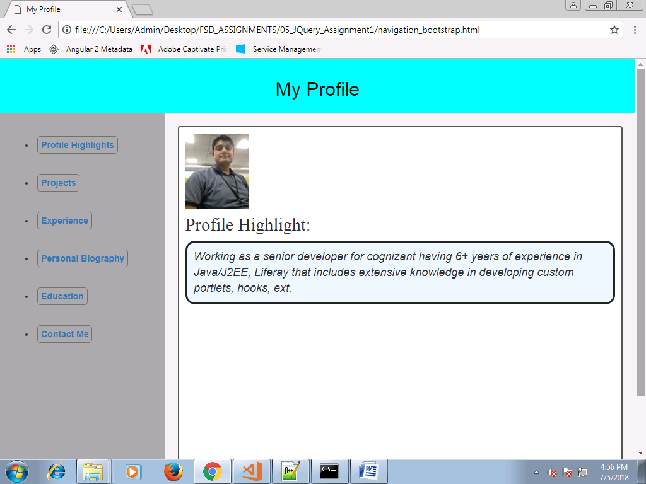

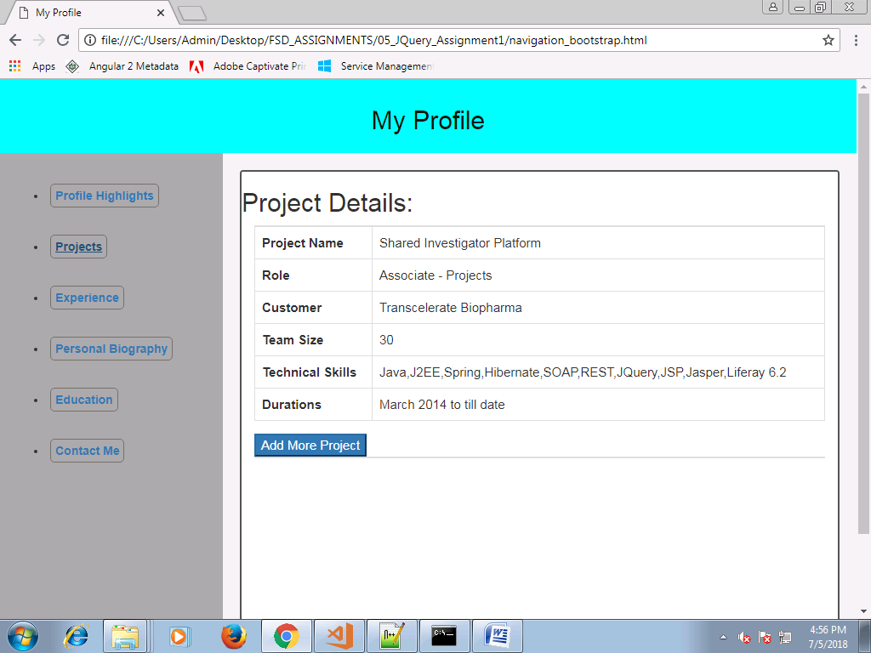

On clicking on Add more Project

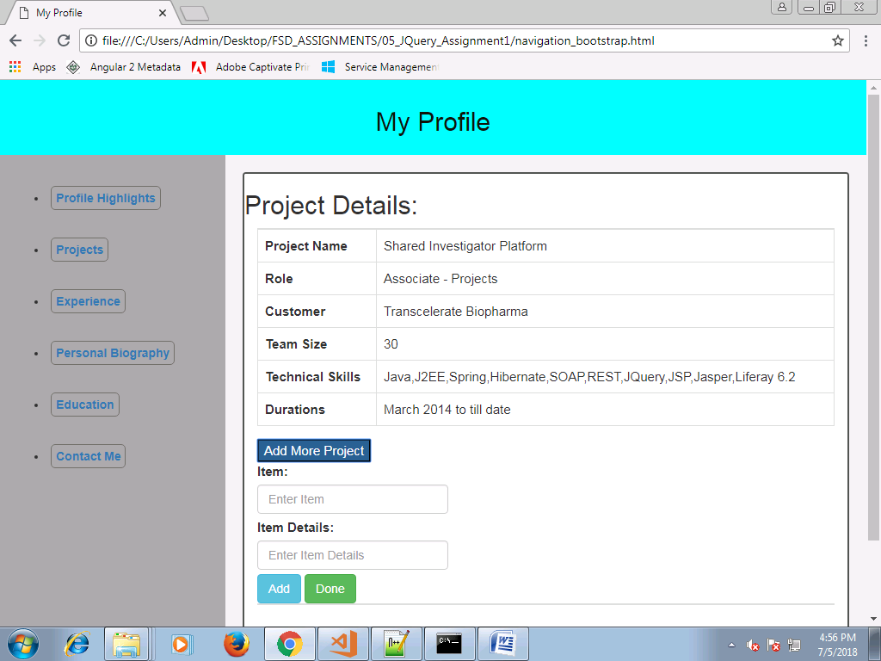

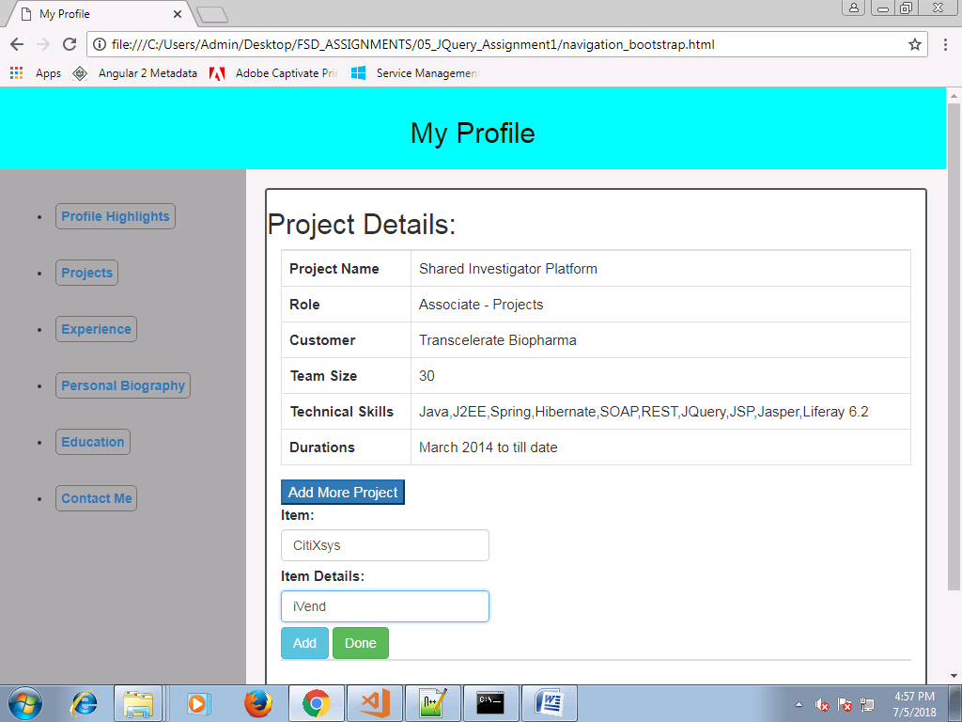

After Clicking on Add button

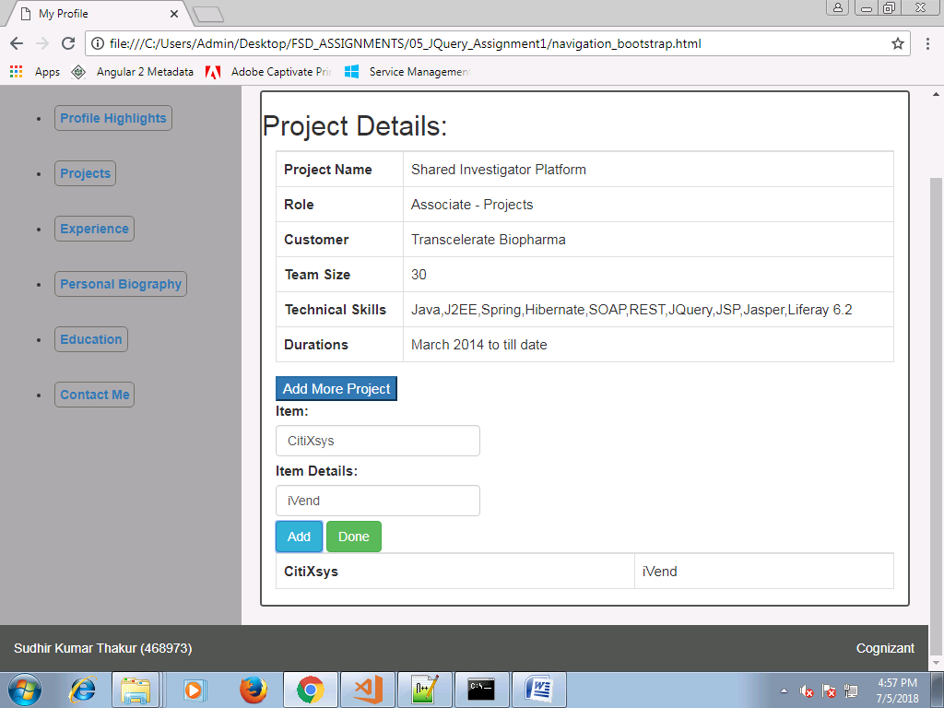

After clicking Done button

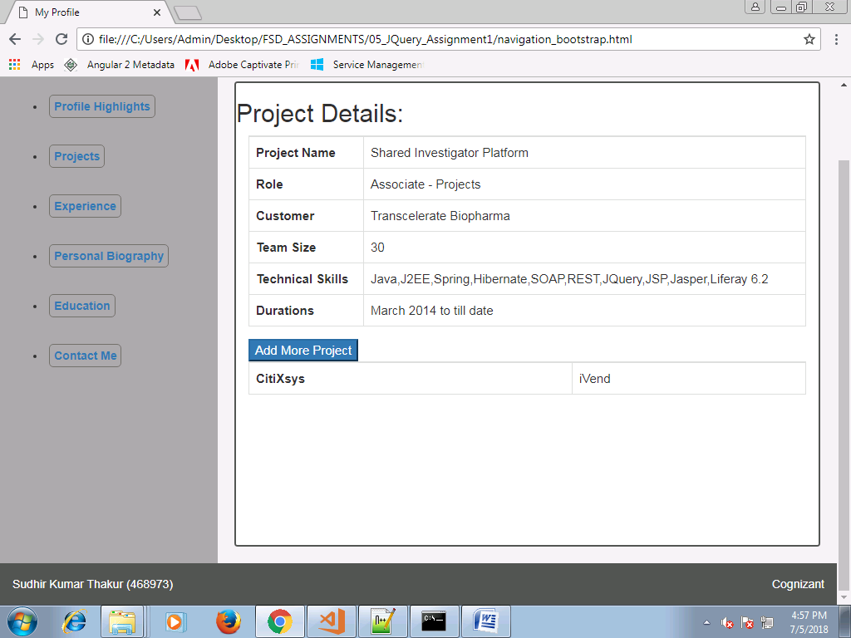

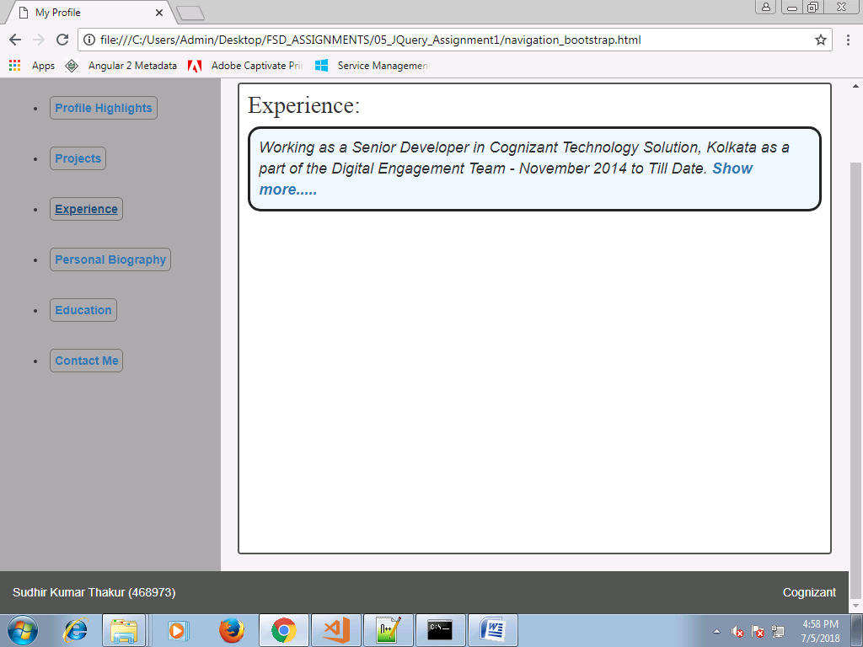

Clicking on show more

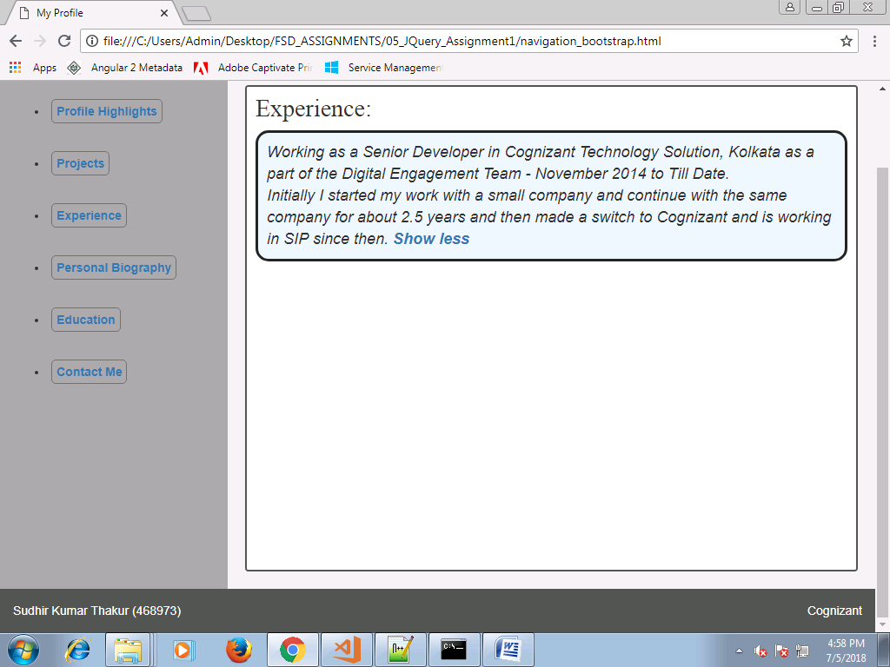

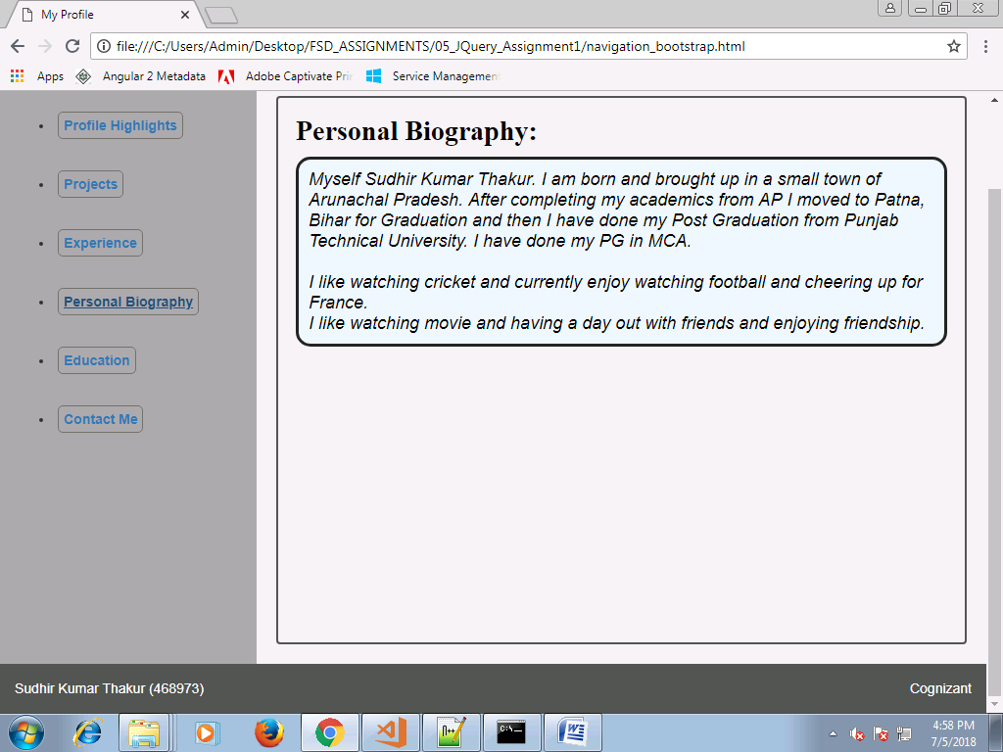

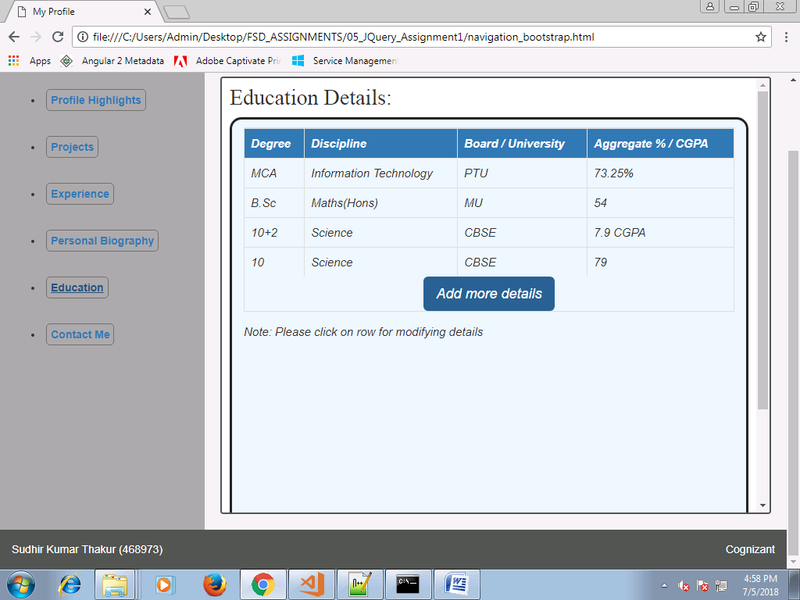

Clicking on Add more Details

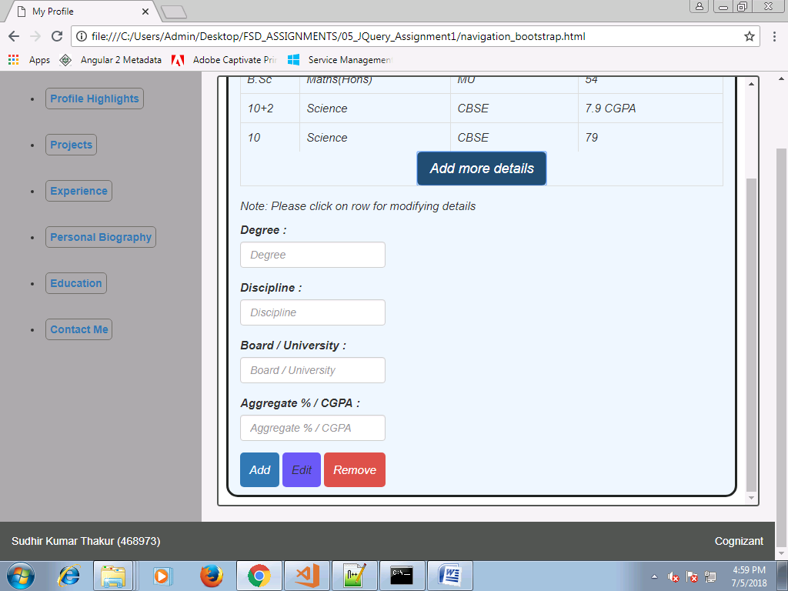

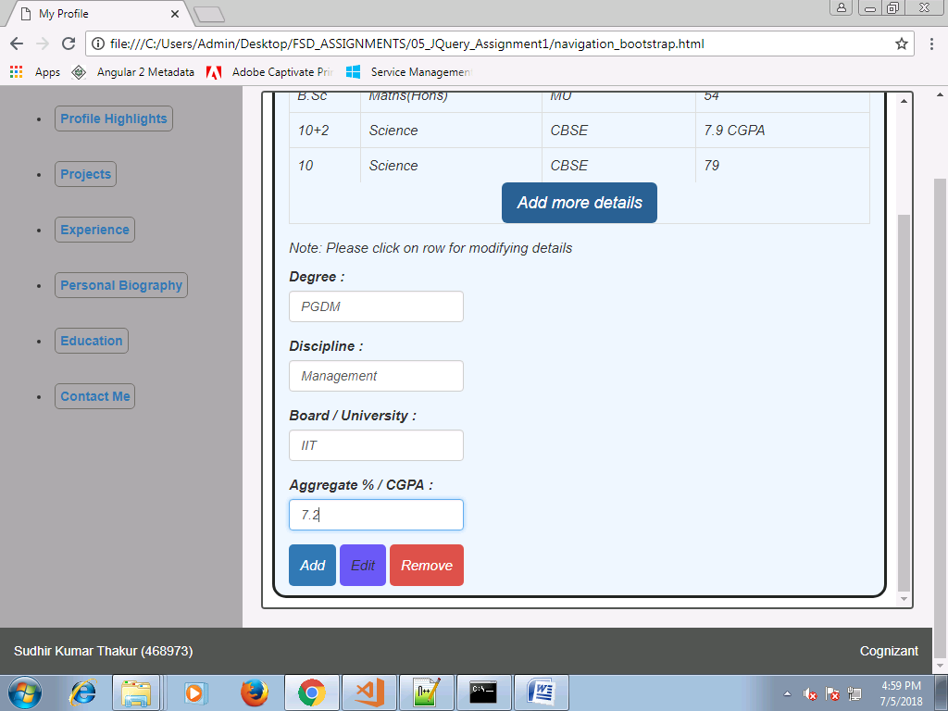

Clicking on add button:

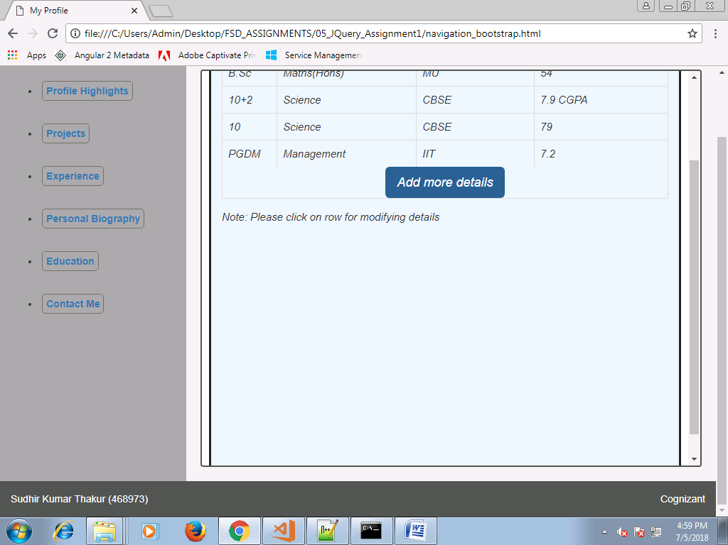

On clicking on highlighted row

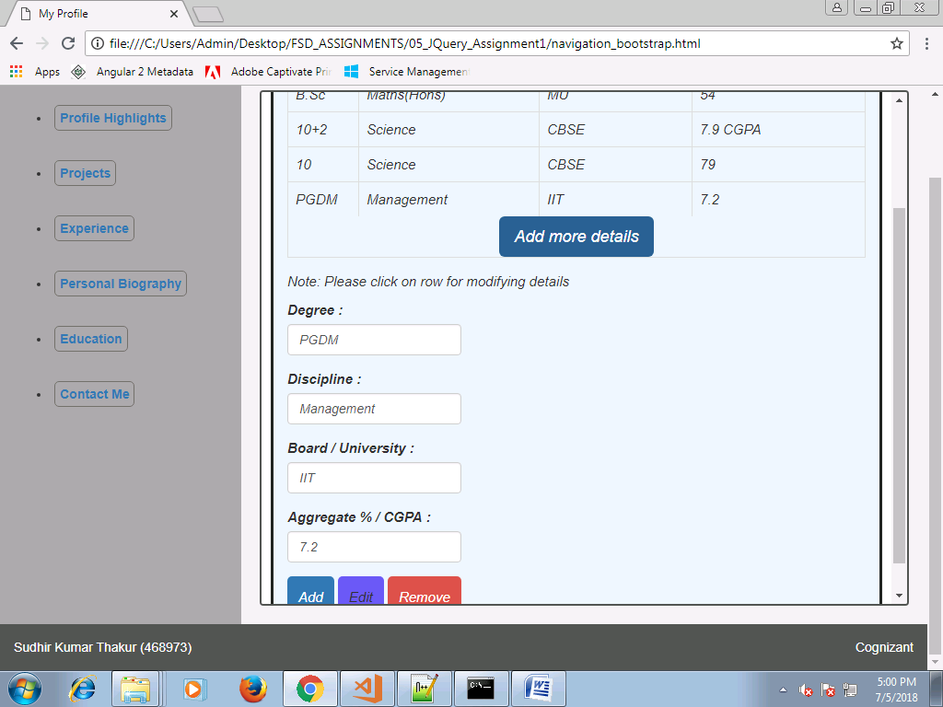

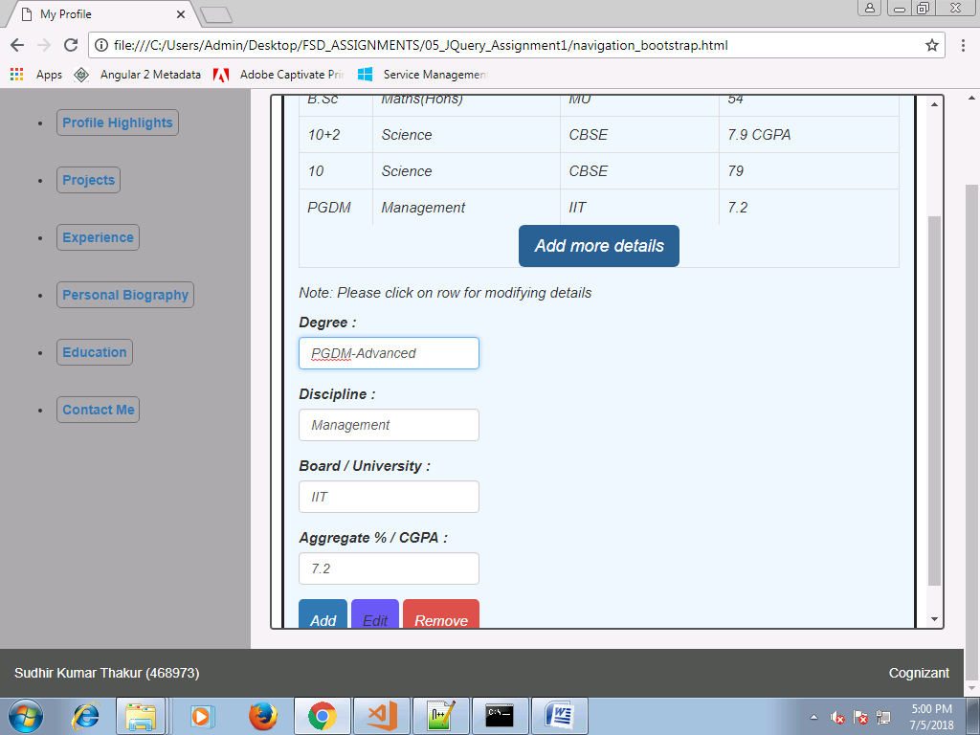

On clicking Edit button

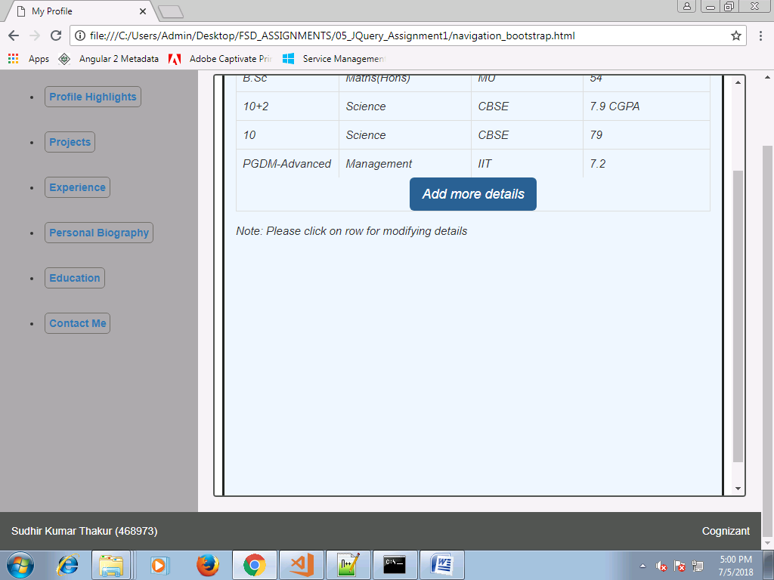

After clicking Remove button

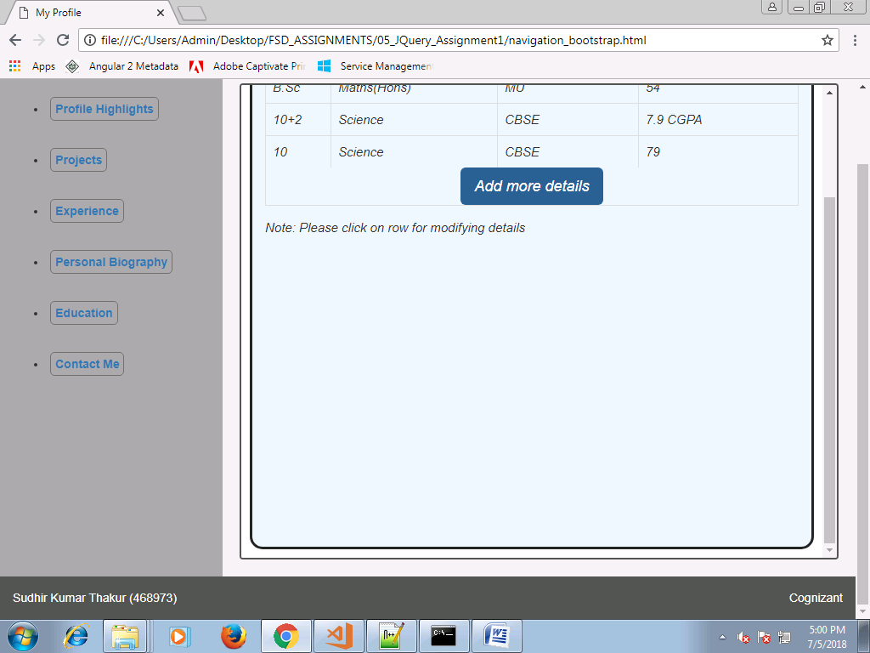

Mobile View:

