# app.component.html

* <nav class="navbar navbar-expand-sm bg-dark navbar-dark">
* <a class="navbar-brand" href="#">Home</a>
* <button class="navbar-toggler" type="button" data-toggle="collapse" data-target="#collapsibleNavbar">
* <span class="navbar-toggler-icon"></span>
* </button>
* </nav>
* <div class="container" style="margin-top:30px">
* <div class="row">
* <div class="col-sm-4">
* <h2>About Me</h2>
* <h5>Photo of Sudhir Kumar Thakur:</h5>
* <div><img [src]="fullImagePath" class="img-thumbnail rounded mx-auto d-block" alt="Cinque Terre"></div>
* <p></p>
* <h3>Some Links</h3>
* <p></p>
* <ul class="nav nav-pills flex-column">
* <li class="nav-item">
* <a class="nav-link" routerLink="/profile-highlights" routerLinkActive="active">Profile Highlights</a>
* </li>
* <li class="nav-item">
* <a class="nav-link" routerLink="/projects" routerLinkActive="active">Projects</a>
* </li>
* <li class="nav-item">
* <a class="nav-link" routerLink="/experience" routerLinkActive="active">Experience</a>
* </li>
* <li class="nav-item">
* <a class="nav-link" routerLink="/educational-qualification" routerLinkActive="active">Educational Qualification</a>
* </li>
* <li class="nav-item">
* <a class="nav-link" routerLink="/personal-biography" routerLinkActive="active">Personal Biography</a>
* </li>
* <li class="nav-item">
* <a class="nav-link" routerLink="/contact-me" routerLinkActive="active">Contact Me</a>
* </li>
* </ul>
* <hr class="d-sm-none">
* </div>
* <div class="col-sm-8">
* <h2>Biography</h2>
* <h5>About Myself</h5>
* <div class="bg-light" style="width: 600px;">
* As a Senior Developer, I am bound to execute my skills with full Potential. What is going to be a better space than this one.
* I have started my career way back in 2011, as a Java Developer and since then I have crossed a long way in achieving some of great skillset as per current market.
* Finally, my aim is to develop a quality application for the betterment of this world.
* </div>
* <p></p>
* <br>
* <div class="jumbotron" style="width: 600px;"><router-outlet></router-outlet></div>
* <p></p>
* </div>
* </div>
* </div>
* <nav class="navbar bg-dark ">
* <p class="text-left text-white">Sudhir Kumar Thakur (468973)</p>
* <p class="text-right text-white">Cognizant</p>
* </nav>

# profile-highlights.component.html

* <section id="about">
* <div class="container">
* <div class="row">
* <div class="col-lg-8 mx-auto">
* <h2>My Profile Details</h2>
* <p class="lead">I am working as a Developer since 2011 in Java skillset. I love developing since it requires lots of skillset that can be improved in due course of time. As far as Angular is concerned, I loved the feature in which most of the things are handled in Client Side and that too with such an ease.</p>
* <ul>
* <li>Working in Java/J2EE, Spring along with SQL Skillset.</li>
* <li>Moderating team requirements along with CET team and then explaining the same to Development team.</li>
* <li>Active Participation in Requirements Gathering and Design analysis.</li>
* </ul>
* </div>
* </div>
* </div>
* </section>

# projects.component.html

* <table class="table">
* <thead>
* <tr>
* <th scope="col">#</th>
* <th scope="col" colspan="2">Information Details</th>
* </tr>
* </thead>
* <tbody>
* <tr>
* <th scope="row">1</th>
* <td>
* <b>Project Name</b>
* </td>
* <td>Shared Investigator Platform</td>
* </tr>
* <tr>
* <th scope="row">2</th>
* <td>
* <b>Role</b>
* </td>
* <td>Associate</td>
* </tr>
* <tr>
* <th scope="row">3</th>
* <td>
* <b>Customer</b>
* </td>
* <td>USA based Biopharma Company</td>
* </tr>
* <tr>
* <th scope="row">4</th>
* <td>
* <b>Team Size</b>
* </td>
* <td>30</td>
* </tr>
* <tr>
* <th scope="row">5</th>
* <td>
* <b>Technical Skills</b>
* </td>
* <td>JAVA-J2ee (Servlet, JSP), Spring 4.0(MVC/IOC-DI/AOP/Security), Hibernate</td>
* </tr>
* <tr>
* <th scope="row">6</th>
* <td>
* <b>Durations</b>
* </td>
* <td>August 2016 to till date</td>
* </tr>
* </tbody>
* </table>

# experience.component.html

* <div class="container">
* <div class="row">
* <section id="experience" class="container">
* <div class="container">
* <div class="row">
* <div class="col-lg-8 mx-auto">
* <h2>Experience</h2>
* <p class="lead">Working as a Senior Developer in Cognizant Technology Solution, Kolkata as a part of the Digital Engagement Team - November
* 2014 to Till Date.</p>
* </div>
* </div>
* </div>
* </section>
* </div>
* </div>

# educational-qualification.component.html

* <table class="table table-striped table-bordered">
* <thead>
* <tr>
* <th>Qualification</th>
* <th>University</th>
* <th>Year Of Passing</th>
* <th colspan="2" class="text-center">Action</th>
* </tr>
* </thead>
* <tbody>
* <tr *ngFor="let educationalQualification of fieldArray; let i = index">
* <td>
* <input [(ngModel)]="educationalQualification.qualification" class="form-control" type="text" name="{{educationalQualification.qualification}}" />
* </td>
* <td>
* <input [(ngModel)]="educationalQualification.university" class="form-control" type="text" name="{{educationalQualification.university}}" />
* </td>
* <td>
* <input [(ngModel)]="educationalQualification.yop" class="form-control" type="text" name="{{educationalQualification.yop}}" />
* </td>
* <td>
* <button class="btn btn-lg btn-outline-primary" (click)="open(content,i)">Edit</button>
* </td>
* <td>
* <button class="btn btn-default" type="button" (click)="deleteFieldValue(i)">Delete</button>
* </td>
* </tr>
* <tr>
* <td>
* <input class="form-control" type="text" id="newAttributeCode" [(ngModel)]="newAttribute.qualification" name="newAttributeCode" />
* </td>
* <td>
* <input class="form-control" type="text" id="newAttributeName" [(ngModel)]="newAttribute.university" name="newAttributeName" />
* </td>
* <td>
* <input class="form-control" type="text" id="newAttributePrice" [(ngModel)]="newAttribute.yop" name="newAttributePrice" />
* </td>
* <td>
* <button class="btn btn-default" type="button" (click)="addFieldValue()">Add</button>
* </td>
* </tr>
* </tbody>
* </table>
* <ng-template #content let-c="close" let-d="dismiss">
* <div class="modal-header">
* <h4 class="modal-title" id="modal-basic-title">Profile update</h4>
* <button type="button" class="close" aria-label="Close" (click)="d('Cross click')">
* <span aria-hidden="true">&times;</span>
* </button>
* </div>
* <div class="modal-body">
* <form>
* <div class="form-group">
* <label for="dateOfBirth">Qualification</label>
* <div class="input-group">
* <input [(ngModel)]="editEducationalQualification.qualification" class="form-control" type="text" name="{{editEducationalQualification.qualification}}" />
* </div>
* </div>
* <div class="form-group">
* <label for="dateOfBirth">University</label>
* <div class="input-group">
* <input [(ngModel)]="editEducationalQualification.university" class="form-control" type="text" name="{{editEducationalQualification.university}}" />
* </div>
* </div>
* <div class="form-group">
* <label for="dateOfBirth">Year Of Passing</label>
* <div class="input-group">
* <input [(ngModel)]="editEducationalQualification.yop" class="form-control" type="text" name="{{editEducationalQualification.yop}}" />
* </div>
* </div>
* </form>
* </div>
* <div class="modal-footer">
* <button type="button" class="btn btn-outline-dark" (click)="c('save_click')">Save</button>
* </div>
* </ng-template>
* <hr>

# personal-biography.component.html

* <section id="services" class="container">
* <div class="container">
* <div class="row">
* <div class="col-lg-8 mx-auto">


* <table class="table">
* <thead>
* <tr>
* <th scope="col">#</th>
* <th scope="col" colspan="2">Information Details</th>
* </tr>
* </thead>
* <tbody>
* <tr>
* <th scope="row">1</th>
* <td>
* <b>Name </b>
* </td>
* <td>Sudhir Kumar Thakur</td>
* </tr>
* <tr>
* <th scope="row">2</th>
* <td>
* <b>Date of Birth</b>
* </td>
* <td>04/02/1985</td>
* </tr>
* <tr>
* <th scope="row">3</th>
* <td>
* <b>Qualification</b>
* </td>
* <td>MCA</td>
* </tr>
* <tr>
* <th scope="row">4</th>
* <td>
* <b>Hobbies</b>
* </td>
* <td>Playing Cricket, Watching Movies</td>
* </tr>
* </tbody>
* </table>



* </div>
* </div>
* </div>
* </section>

# contact-me.component.html

* <form id="contact-form" method="post" action="#" role="form">
* <div class="messages"></div>
* <div class="controls">
* <div class="row">
* <div class="col-md-6">
* <div class="form-group">
* <label for="form_name">Firstname *</label>
* <input id="form_name" [(ngModel)]="firstname" name="firstname" class="form-control" placeholder="Please enter your firstname *" required="required" data-error="Firstname is required.">
* <div class="help-block with-errors"></div>
* </div>
* </div>
* <div class="col-md-6">
* <div class="form-group">
* <label for="form_lastname">Lastname *</label>
* <input id="form_lastname" [(ngModel)]="surname" name="surname" class="form-control" placeholder="Please enter your lastname *" required="required" data-error="Lastname is required.">
* <div class="help-block with-errors"></div>
* </div>
* </div>
* </div>
* <div class="row">
* <div class="col-md-6">
* <div class="form-group">
* <label for="form_email">Email *</label>
* <input id="form_email" [(ngModel)]="email" name="email" class="form-control" placeholder="Please enter your email *" required="required" data-error="Valid email is required.">
* <div class="help-block with-errors"></div>
* </div>
* </div>
* <div class="col-md-6">
* <div class="form-group">
* <label for="form_phone">Phone</label>
* <input id="form_phone" [(ngModel)]="phone" name="phone" class="form-control" placeholder="Please enter your phone">
* <div class="help-block with-errors"></div>
* </div>
* </div>
* </div>
* <div class="row">
* <div class="col-md-12">
* <div class="form-group">
* <label for="form_message">Message *</label>
* <textarea id="form_message" [(ngModel)]="message" name="message" class="form-control" placeholder="Message for me *" rows="4" required="required" data-error="Please,leave us a message."></textarea>
* <div class="help-block with-errors"></div>
* </div>
* </div>
* <div class="col-md-12">
* <input type="submit" class="btn btn-success btn-send" value="Send message">
* </div>
* </div>
* <div class="row">
* <div class="col-md-12">
* <p class="text-muted"><strong>*</strong> These fields are required.</p>
* </div>
* </div>
* </div>
* </form>

# Screenshots:

Desktop view:

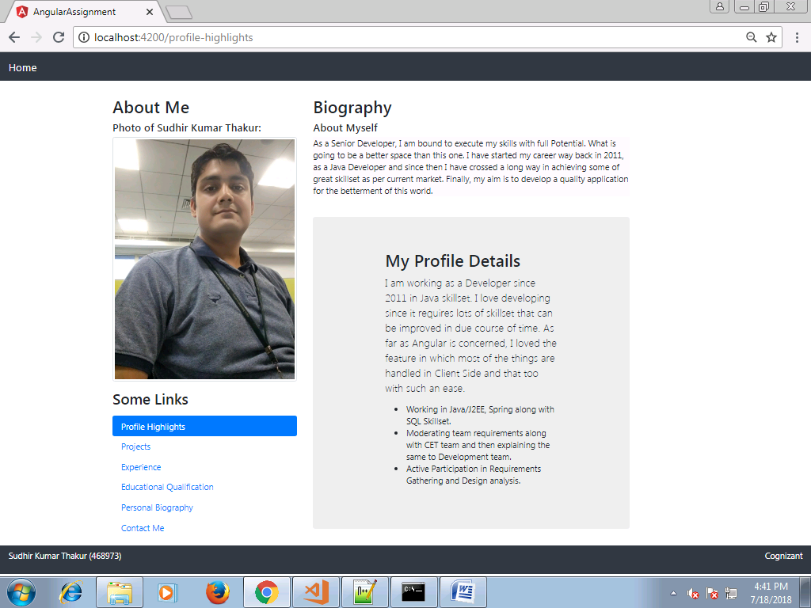

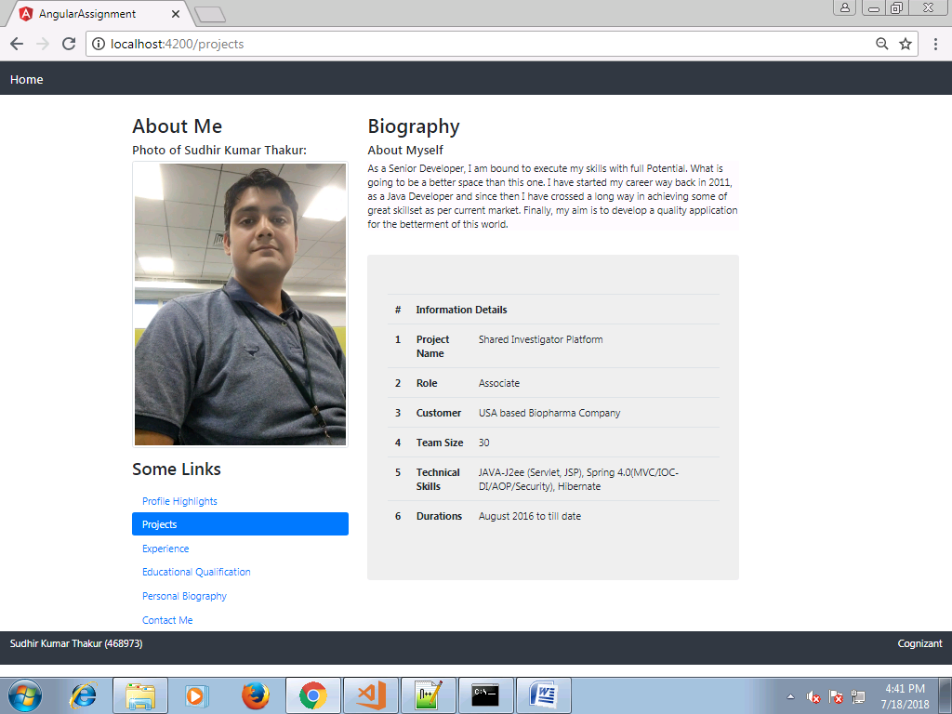

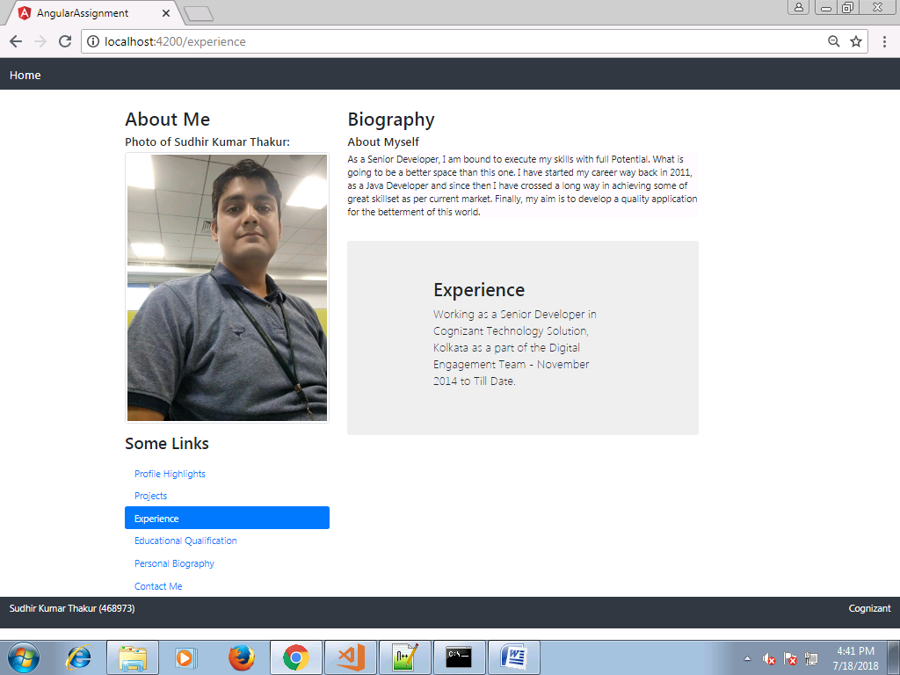

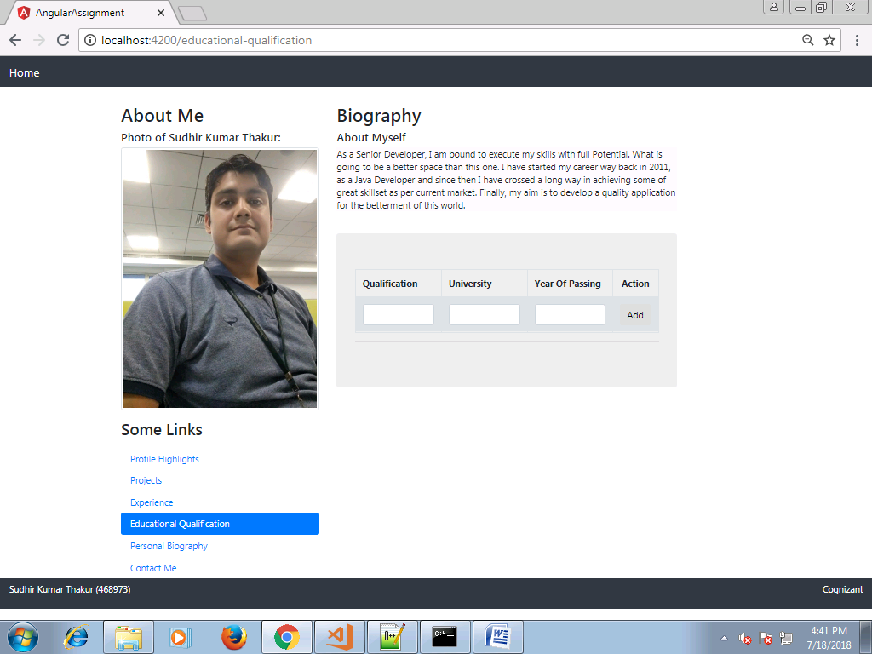

Enter the values

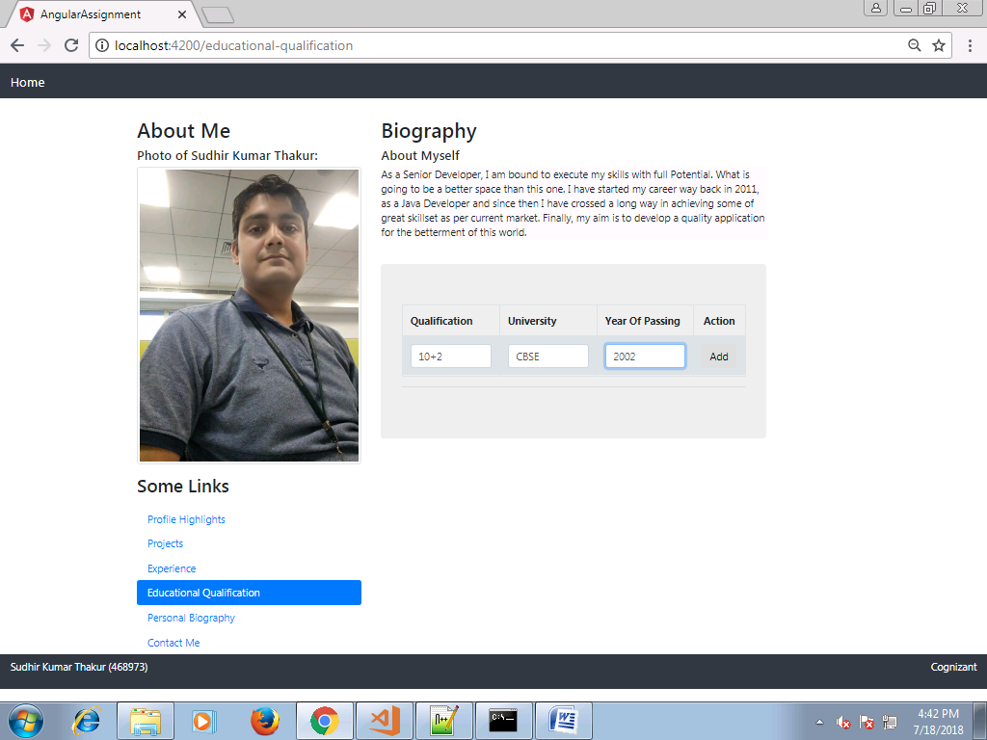

Click on Add

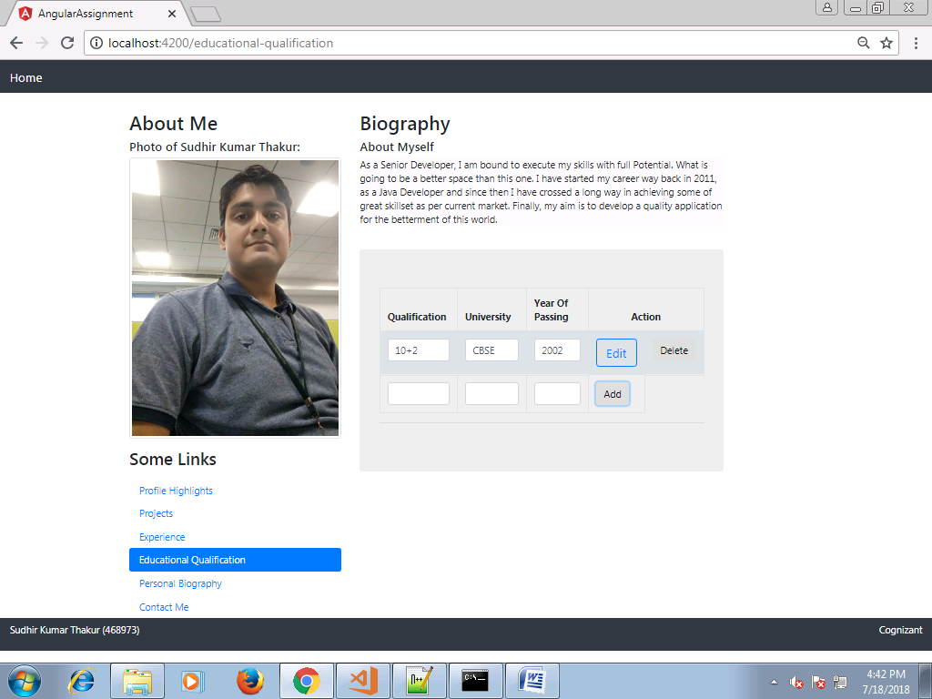

Click on Edit

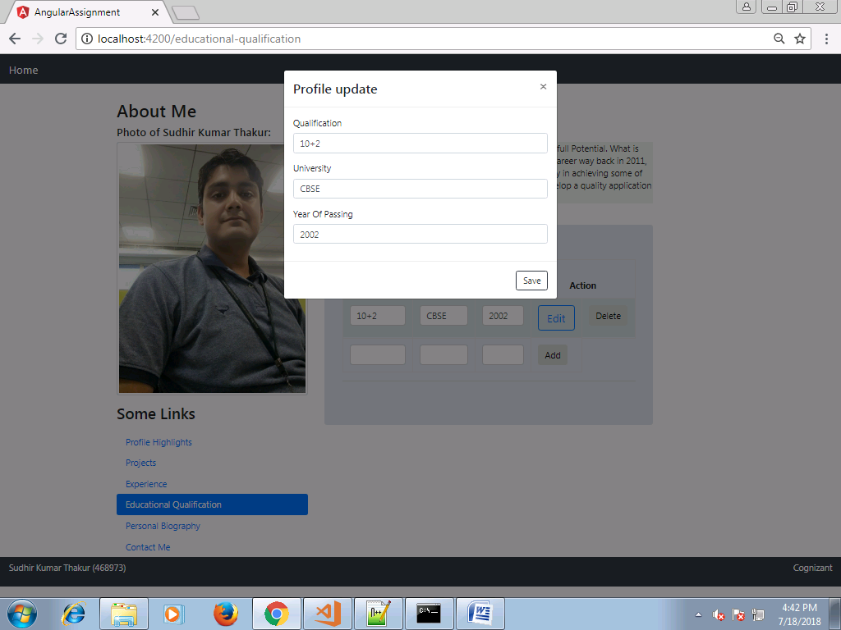

Update the value and click on Save

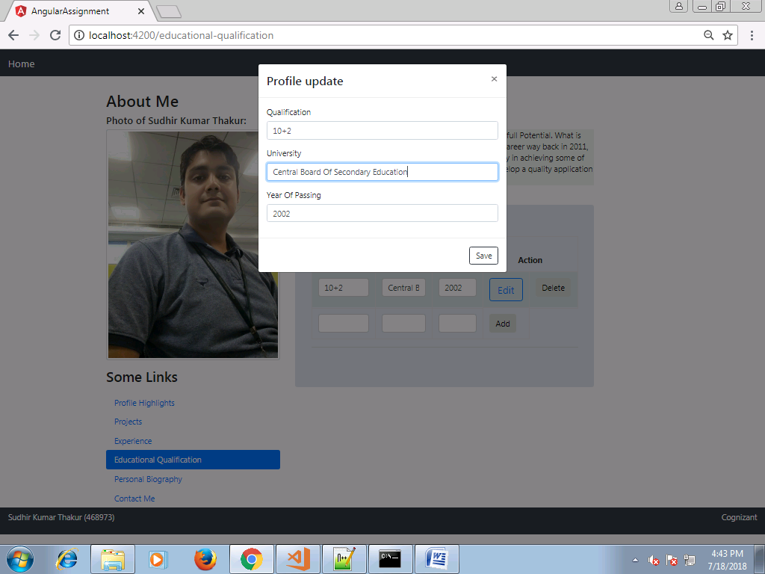

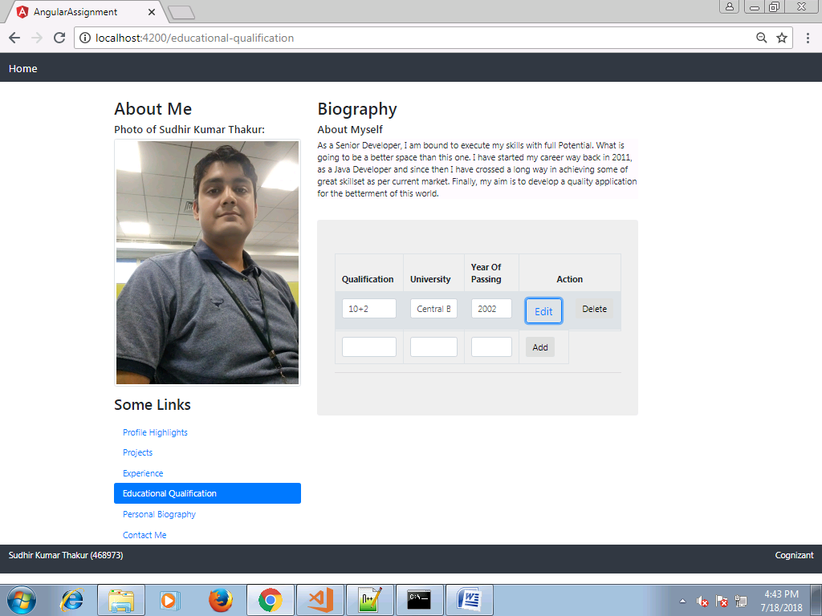

Click on Delete

