# app.component.html

* <!--The content below is only a placeholder and can be replaced.-->
* <div class="header" style="text-align:center;background-color:lightgrey;">
* <h1 style="display: inline;">
* Welcome to {{ title }}!
* </h1>
* </div>
* <div style="text-align:center;">
* <div class="sidenav">
* <a href="assign2">Assign2</a>
* </div>
* <div class="main">
* <!-- <router-outlet></router-outlet> -->
* <!-- <app-assignment2></app-assignment2> -->
* <router-outlet></router-outlet>
* </div>
* <div class="footer">
* <p class="text-left text-white">Sudhir Kumar Thakur (468973)</p>
* <p class="text-right text-white">Cognizant</p>
* </div>
* </div>

# assignment2.component

* <p>
* ass2-posts works! {{posts.length}}
* </p>
* <table border="1" style="margin: 0px auto" width="70%" >
* <tr>
* <td colspan="6"> Post List </td>
* </tr>
* <tr *ngFor="let post of posts, let i = index">
* <td> {{post.id}} </td>
* <td> {{post.title}} </td>
* <td> {{post.body}} </td>
* <td (click)="onDelete(post.id)"> Delete </td>
* <td > <a style="color: firebrick;text-decoration: none;" routerLink="./{{post.id}}"> Edit </a> </td>
* </tr>
* </table>

# post-edit.component

* <p>
* post-edit works!
* </p>
* <table>
* <tr>
* <td> Post Subject </td>
* <td> <input type="text" name="subject" value={{postData.title}}> </td>
* </tr>
* <tr>
* <td> Post Details </td>
* <td> <textarea name="message" rows="10" cols="30" value={{postData.body}}></textarea> </td>
* </tr>
* <tr>
* <td colspan="1">
* <!-- <input type="submit" > -->
* <button (click)="save()">save</button>
* </td>
* <td>
* <button (click)="goBack()">go back</button>
* </td>
* </tr>
* </table>

# Screenshots:

Desktop view:

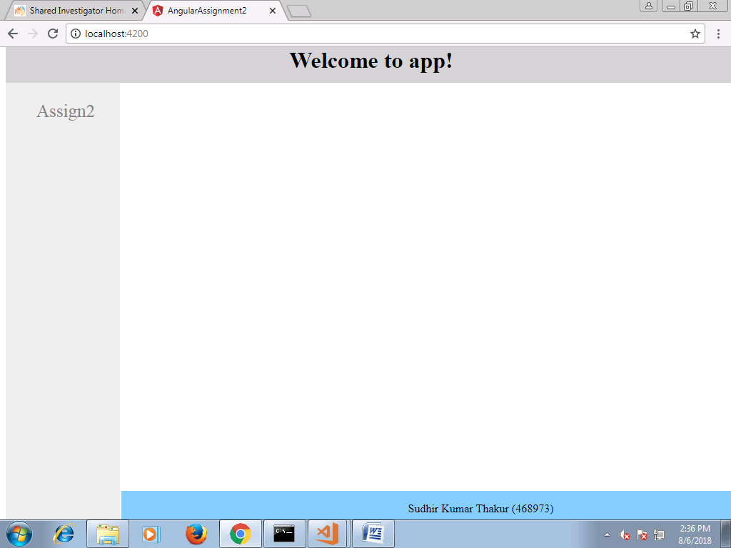

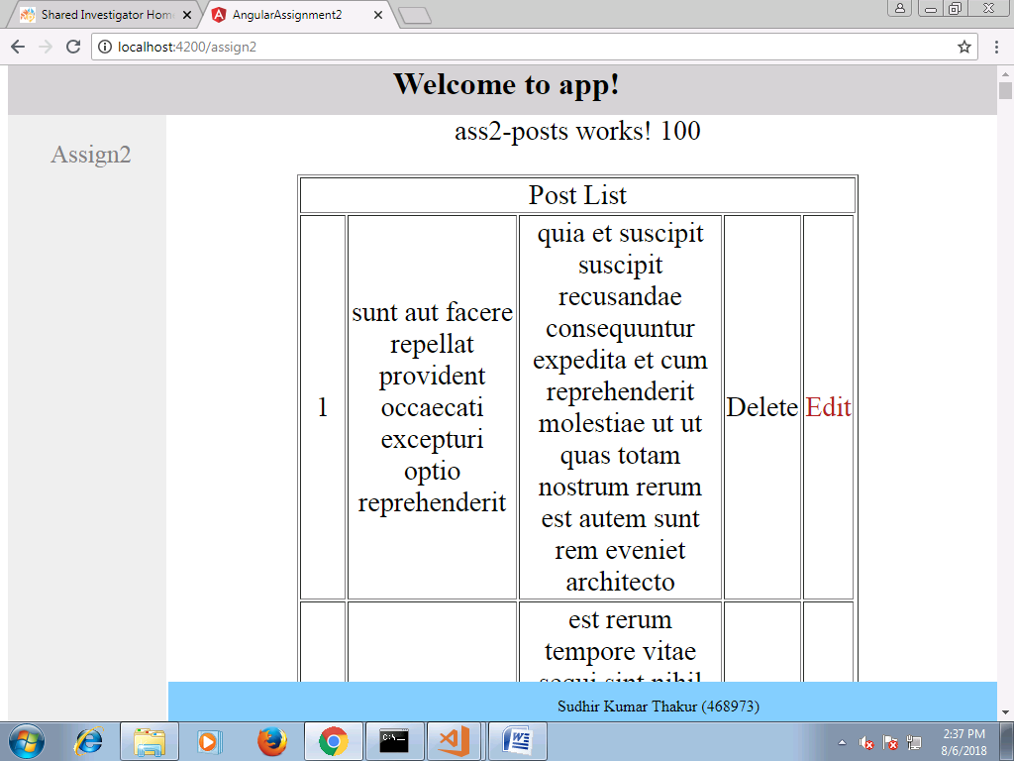

Clicking on Edit

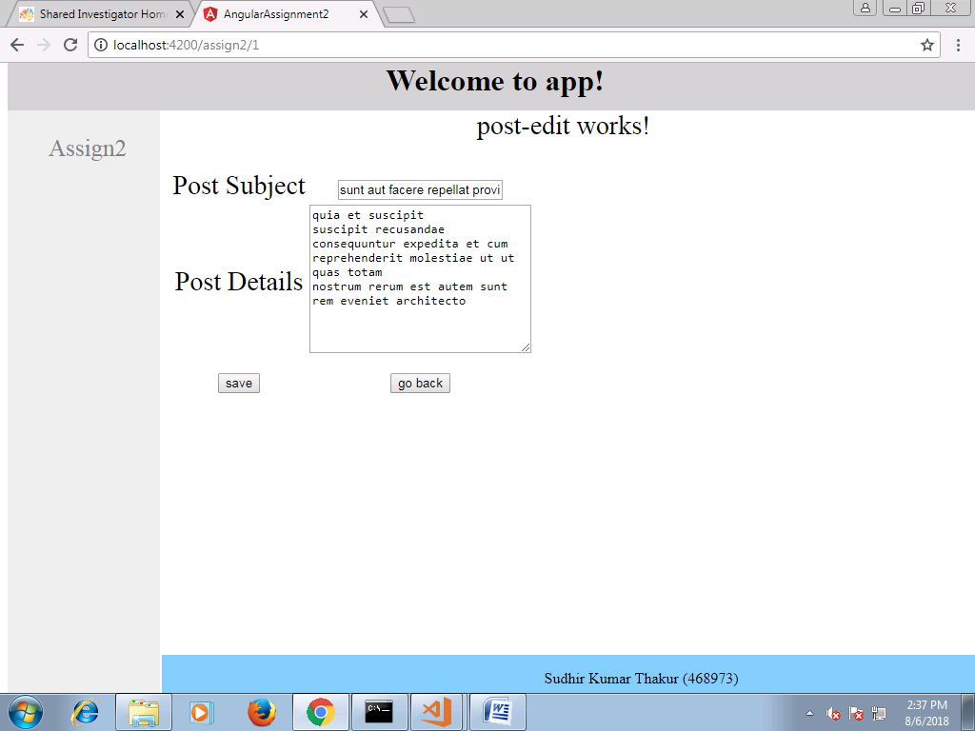

Clicking on Go Back

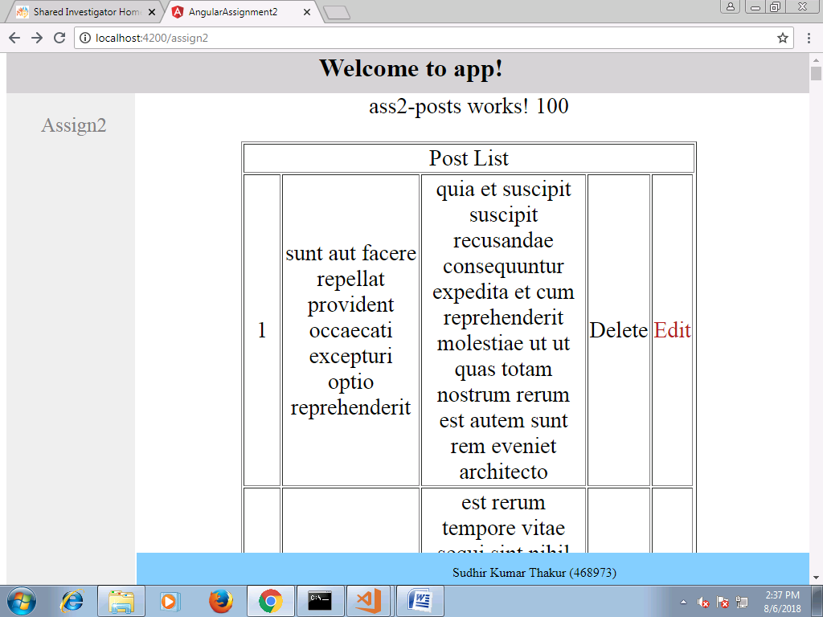

Clicking on save

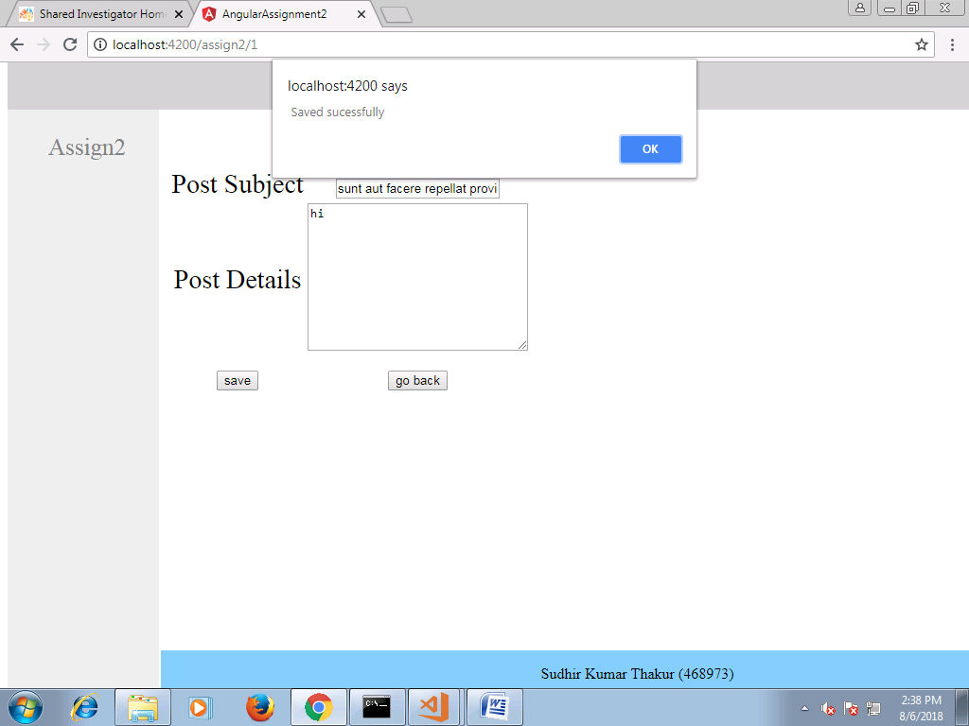

All the value being retrieved

