# Subject Table:

CREATE TABLE `subject` (

`subject_id` bigint(11) NOT NULL AUTO_INCREMENT,

`subject_title` varchar(128) NOT NULL,

`duration` int NOT NULL,

PRIMARY KEY (`subject_id`),

UNIQUE KEY `book_id_UNIQUE` (`subject_id`),

UNIQUE KEY `title_UNIQUE` (`subject_title`)

) ENGINE=InnoDB AUTO_INCREMENT=11 DEFAULT CHARSET=latin1;

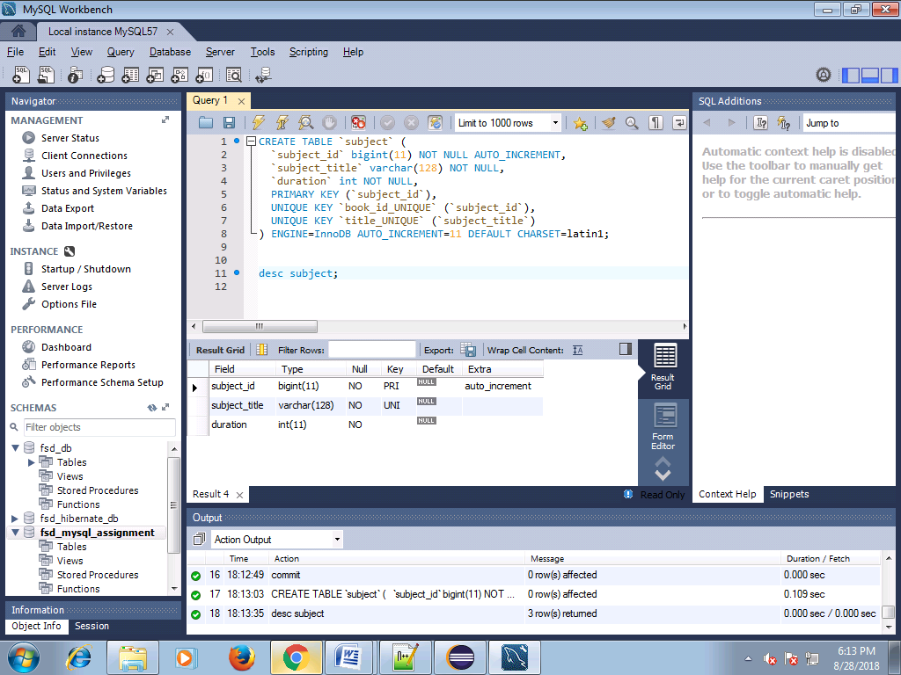

# Book Table

CREATE TABLE `book` (

`book_id` bigint(11) NOT NULL AUTO_INCREMENT,

`book_title` varchar(128) NOT NULL,

`price` double NOT NULL,

`volume` int(11) Not Null,

`publish_date` date not null,

`subject_id` bigint(20),

PRIMARY KEY (`book_id`),

UNIQUE KEY `book_id_UNIQUE` (`book_id`),

UNIQUE KEY `title_UNIQUE` (`book_title`),

FOREIGN KEY (`subject_id`) REFERENCES subject(`subject_id`)

) ENGINE=InnoDB AUTO_INCREMENT=1 DEFAULT CHARSET=latin1;

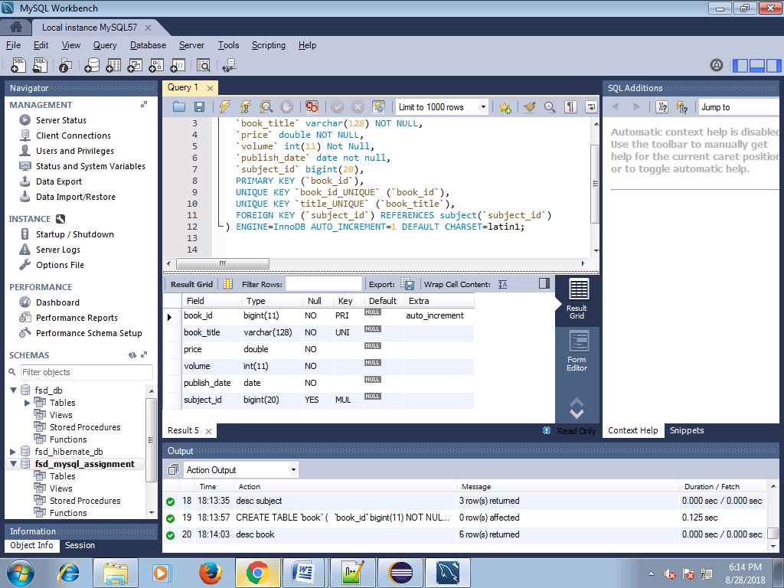

# Insert Statement:

insert into subject (`subject_title`,`duration`) values ('hindi',5);

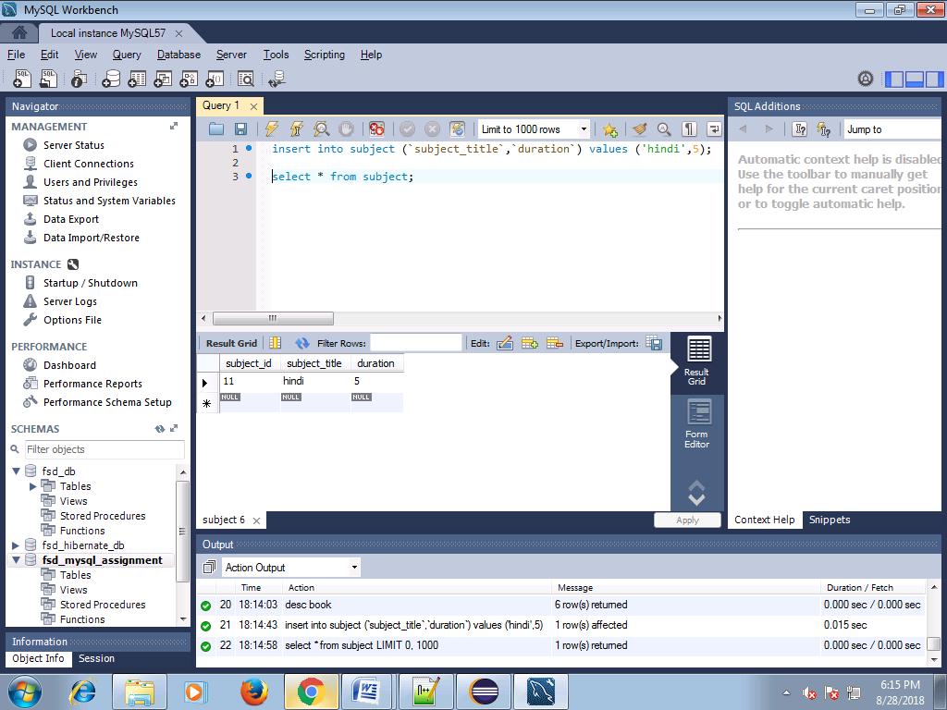

Update :

update subject set subject_id = 15 where subject_id = 11;

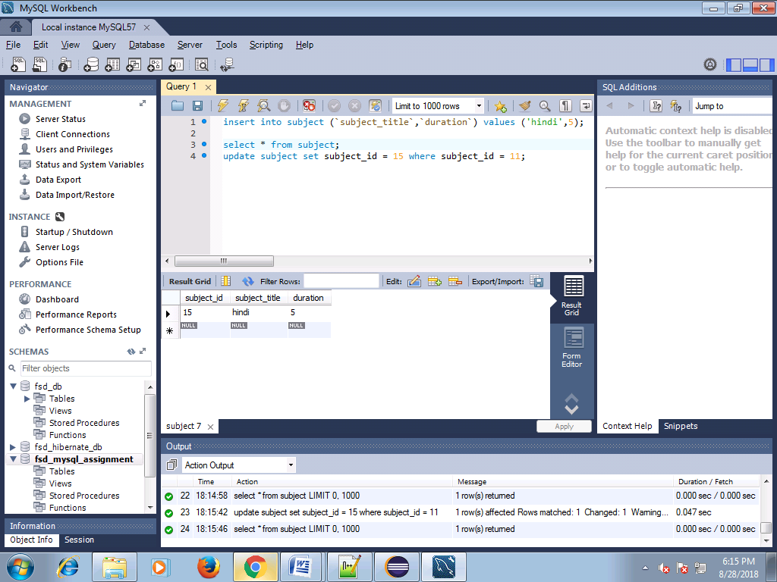

# Delete:

Delete from subject where subject_id=15;

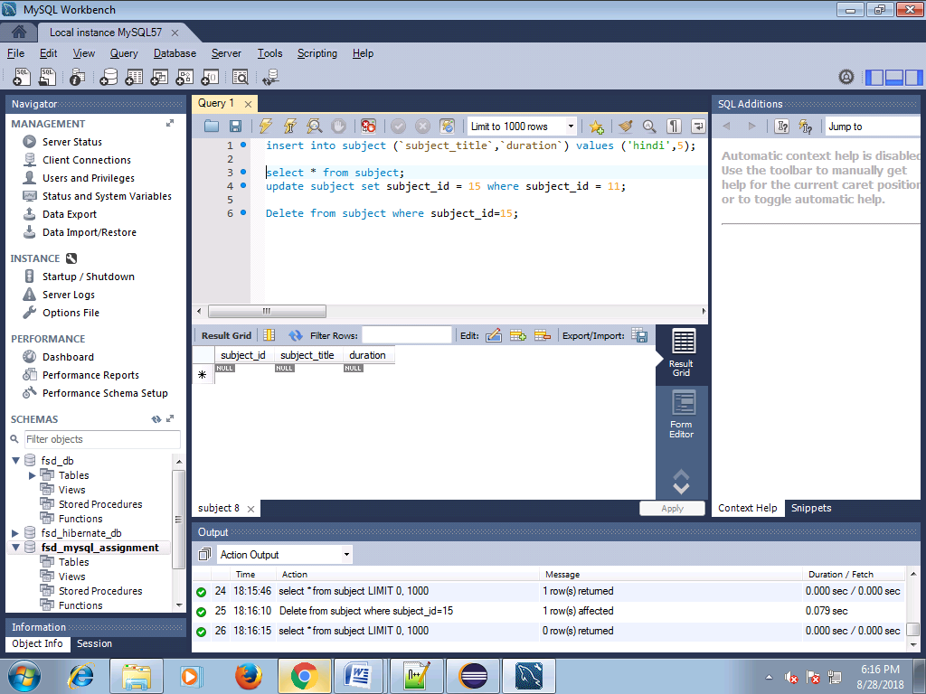

Insert Book:

insert into book (`book_title`,`price`,`volume`,`publish_date`,`subject_id`) values ('Java',1111,888,'1956-07-28',12);

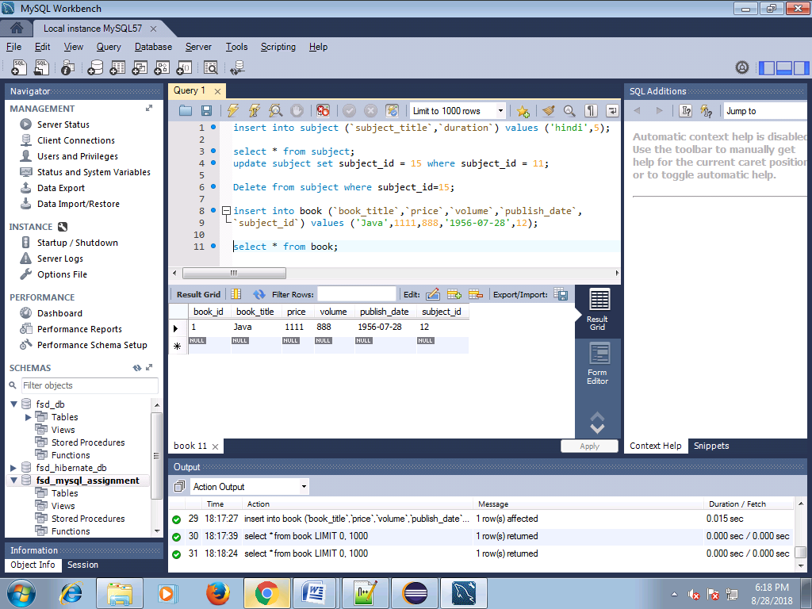

# Update On Book Table:

update book set book_title = 'Java updated' where book_id = 1;

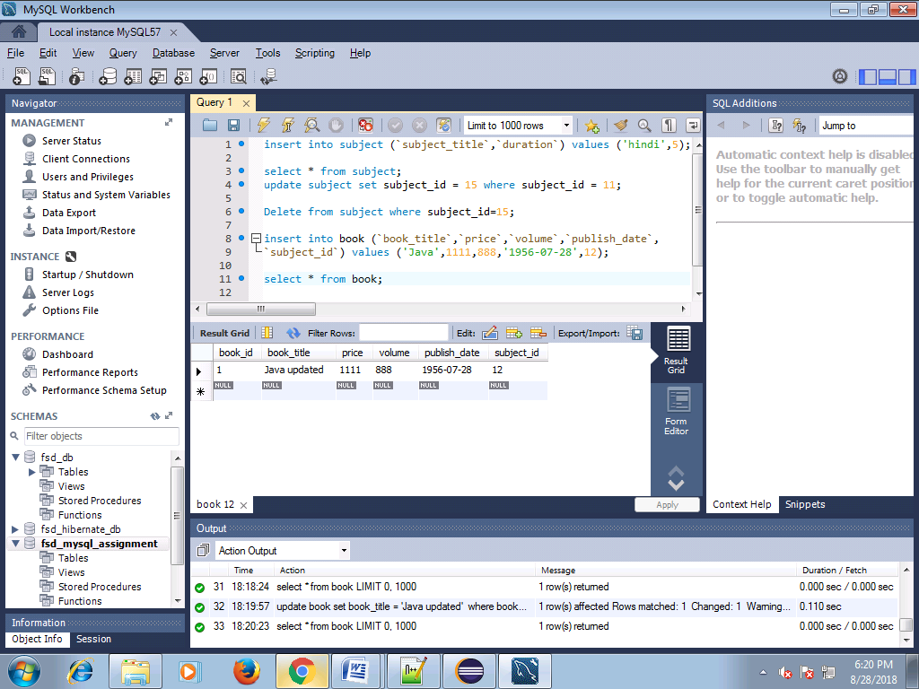

# Delete Statement on book:

delete from book where book_id = 1;

