1. Write a query to retrieve the book and its subject details using inner join

SELECT * FROM book,subject WHERE book.subject_id = subject.subject_id;

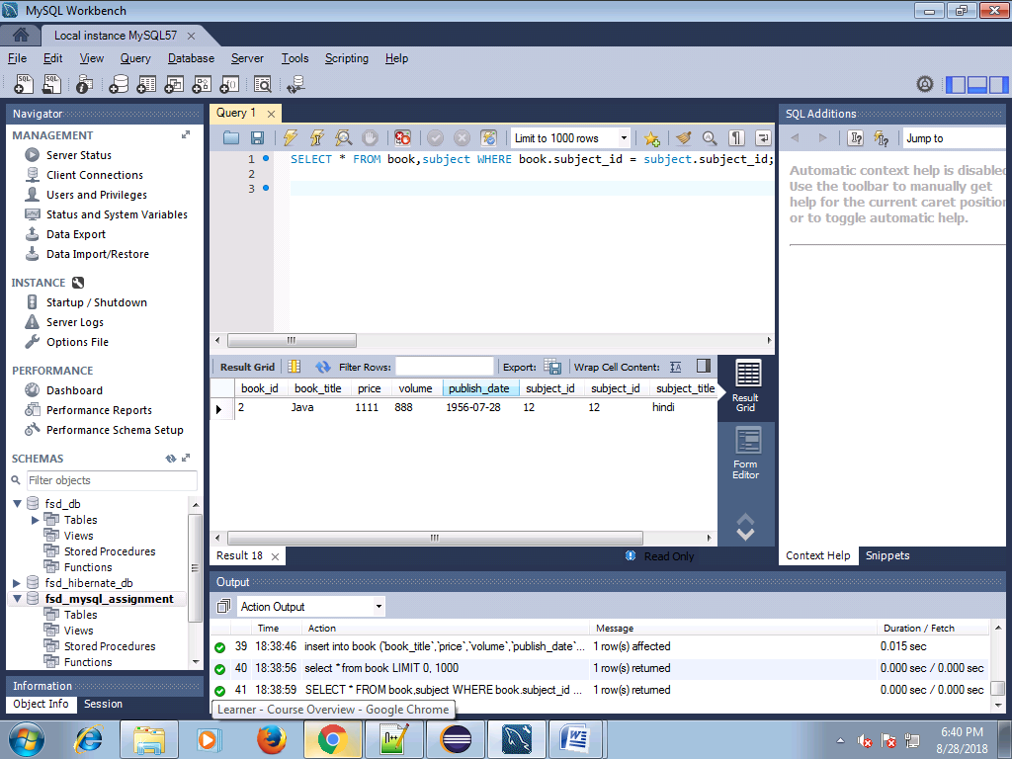

2. Write a query to retrieve the books list published in a given specific date interval

SELECT * FROM book WHERE publish_date BETWEEN '1956-07-01' AND '2018-08-30';

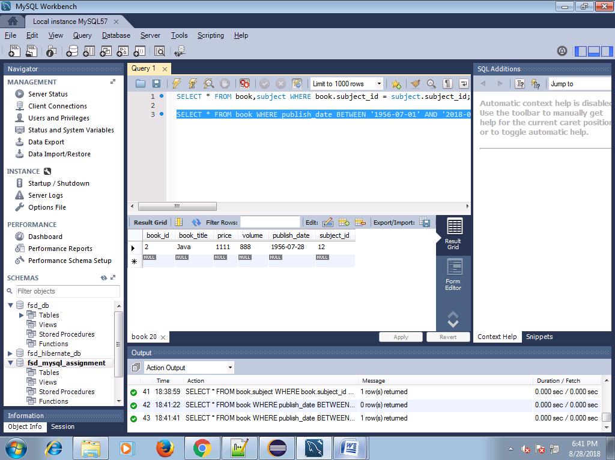

3.Write a query to retrieve the number of books referred by each subject where the subject title starts with a specific character (say ‘j’ for instance).

SELECT subject.subject_id,subject.subject_title, COUNT(book_id) AS NumberOfBooks FROM book,subject WHERE book.subject_id = subject.subject_id AND subject.subject_title LIKE 'h%' GROUP BY subject.subject_id ;

Subject Table:

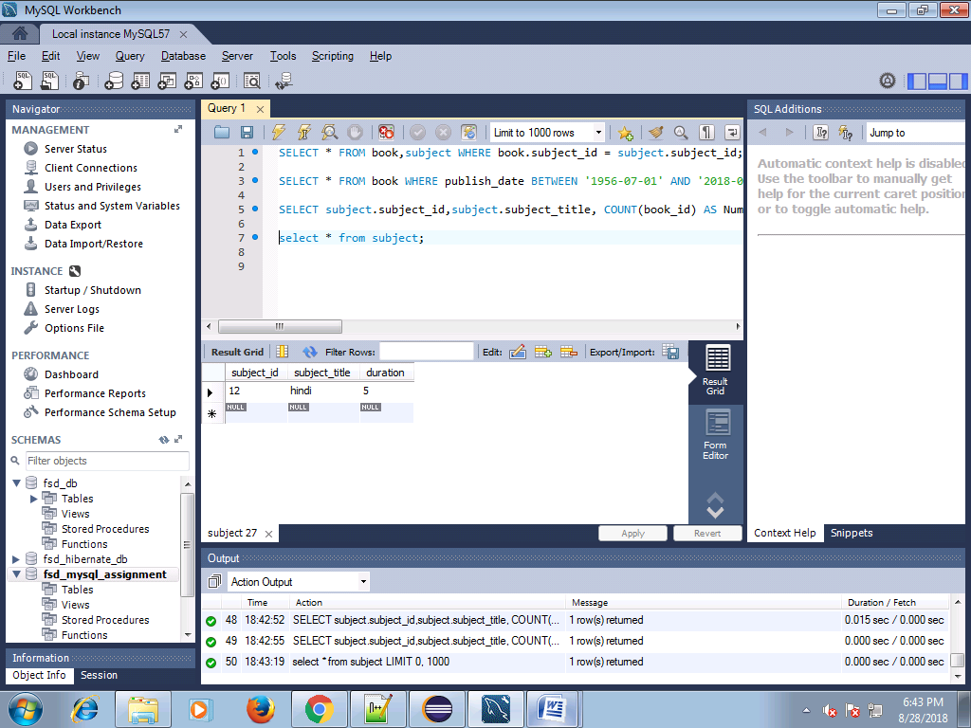

Book Table:

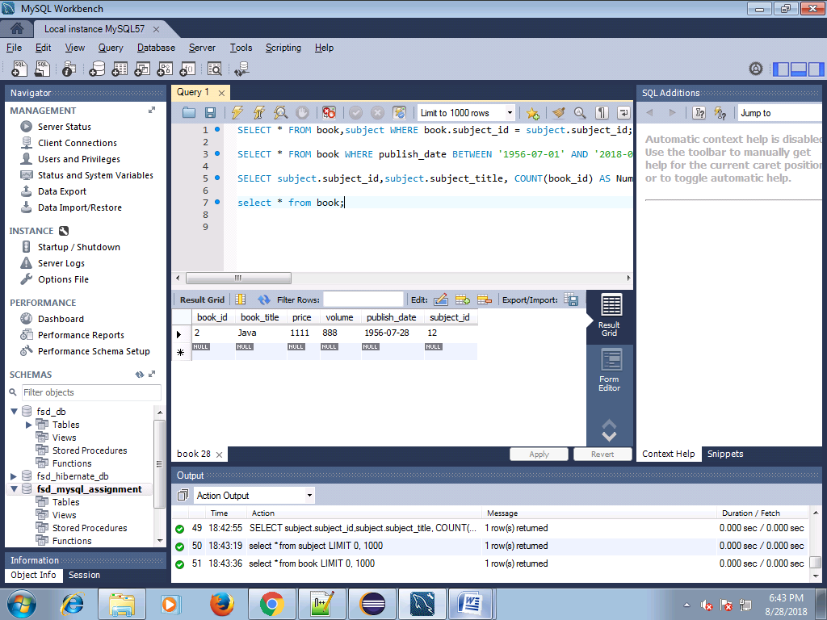

Output:

