**14_Spring_Test_Assignment2**

**package** com.cognizant.fsd.springtestassignment2;

**import** org.junit.Assert;

**import** org.junit.Test;

**import** org.junit.runner.RunWith;

**import** org.springframework.beans.factory.annotation.Autowired;

**import** org.springframework.boot.test.context.SpringBootTest;

**import** org.springframework.test.context.junit4.SpringRunner;

**import** com.cognizant.fsd.springtestassignment2.model.Subject;

**import** com.cognizant.fsd.springtestassignment2.repository.SubjectRepository;

@RunWith(SpringRunner.**class**)

@SpringBootTest

**public** **class** ApplicationTests {

@Autowired

**private** SubjectRepository subjectRepository;

@Test

**public** **void** save() {

//SubjectRepository

Subject subject=**new** Subject();

subject.setSubjectId(101l);

subject.setSubTitle("Bengali");

Assert.*assertNotNull*(subjectRepository.save(subject));

}

//@Test

**public** **void** findById() {

//SubjectRepository

Subject subject=**new** Subject();

subject.setSubjectId(501l);

subject.setSubTitle("Bengali");

subjectRepository.save(subject);

Assert.*assertNotNull*(subjectRepository.findById(501l));

}

//@Test

**public** **void** findAll() {

//SubjectRepository

Subject subject=**new** Subject();

subject.setSubjectId(510l);

subject.setSubTitle("Bengali");

subjectRepository.save(subject);

Assert.*assertNotNull*(subjectRepository.findById(501l));

}

}

com.cognizant.fsd.springtestassignment2.repository.AbstractDao

package com.cognizant.fsd.springtestassignment2.repository;

import org.hibernate.Session;

import org.hibernate.SessionFactory;

import org.springframework.beans.factory.annotation.Autowired;

public abstract class AbstractDao {

@Autowired

private SessionFactory sessionFactory;

protected Session getSession() {

return sessionFactory.getCurrentSession();

}

public void persist(Object entity) {

getSession().saveOrUpdate(entity);

}

public void delete(Object entity) {

getSession().delete(entity);

}

}

com.cognizant.fsd.springtestassignment2.repository.BookRepository

package com.cognizant.fsd.springtestassignment2.repository;

import org.springframework.data.repository.CrudRepository;

import com.cognizant.fsd.springtestassignment2.model.Book;

public interface BookRepository extends CrudRepository<Book, Long>{

}

com.cognizant.fsd.springtestassignment2.repository.SubjectRepository

package com.cognizant.fsd.springtestassignment2.repository;

import org.springframework.data.repository.CrudRepository;

import com.cognizant.fsd.springtestassignment2.model.Subject;

public interface SubjectRepository extends CrudRepository<Subject, Long>{

}

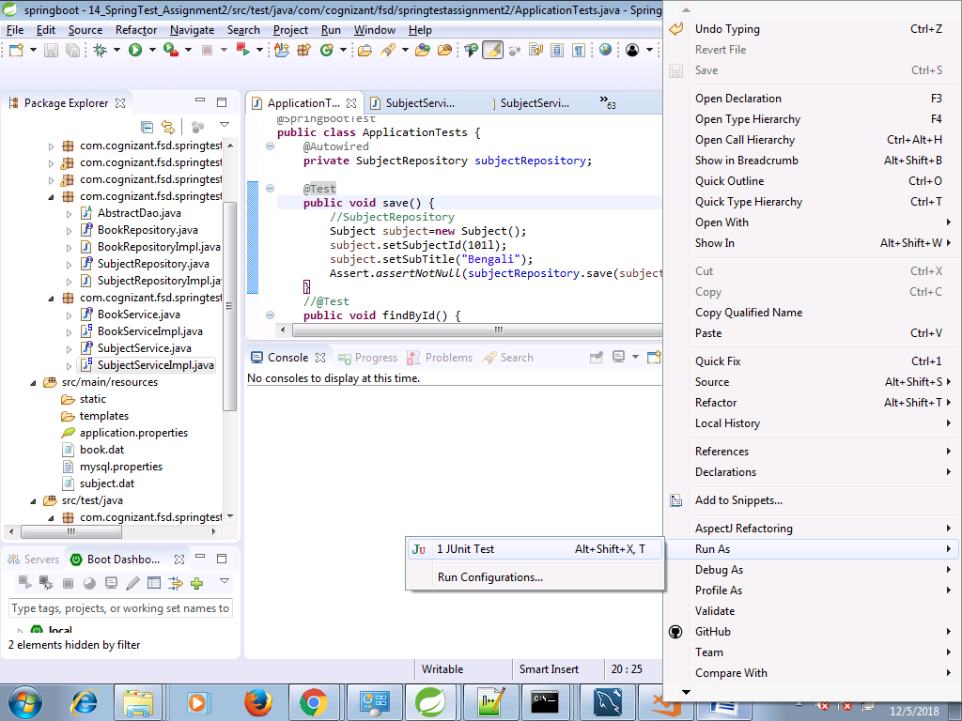

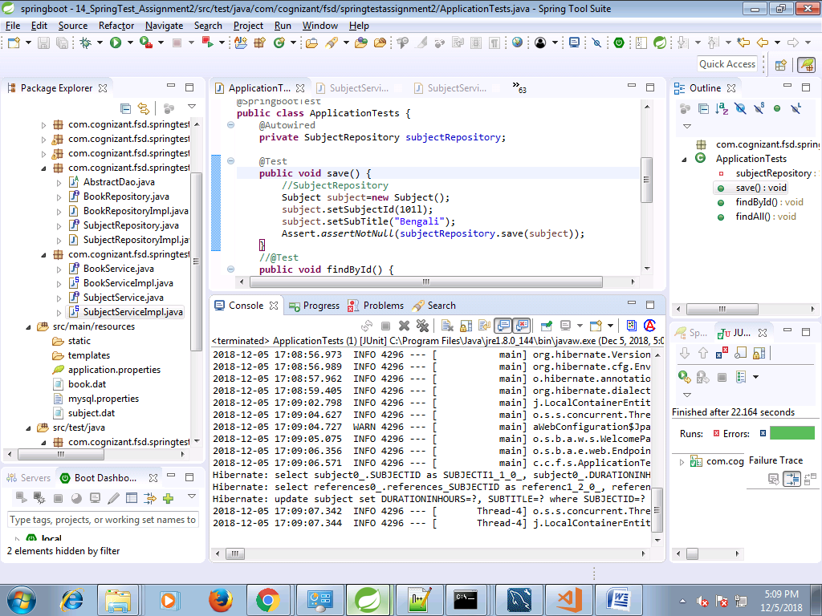

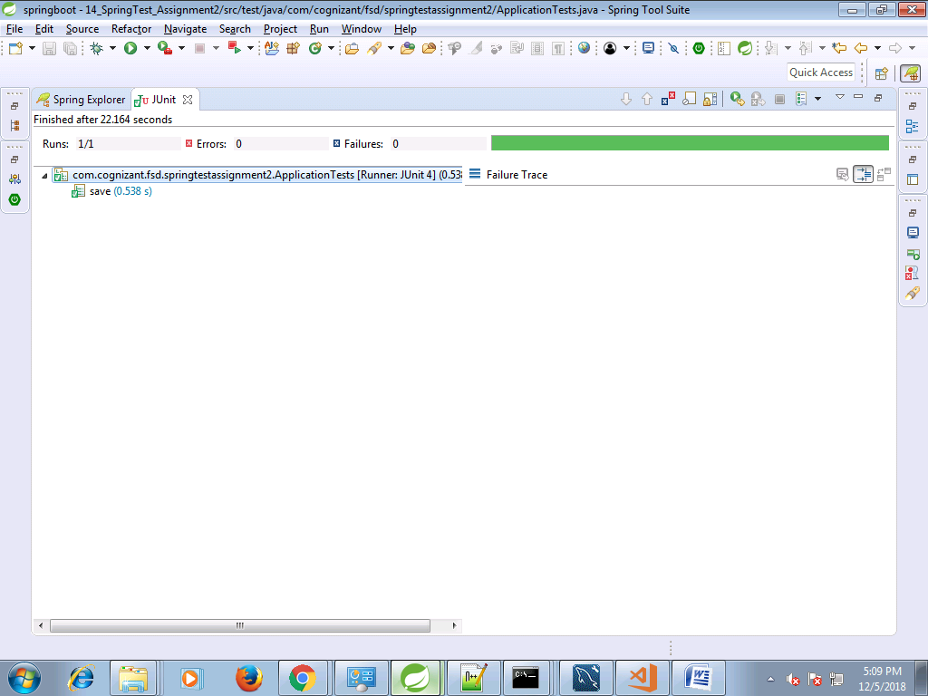

@Test

**public** **void** findById() {

//SubjectRepository

Subject subject=**new** Subject();

subject.setSubjectId(501l);

subject.setSubTitle("Bengali");

Assert.*assertNotNull*(subjectRepository.findById(501l).get());

}

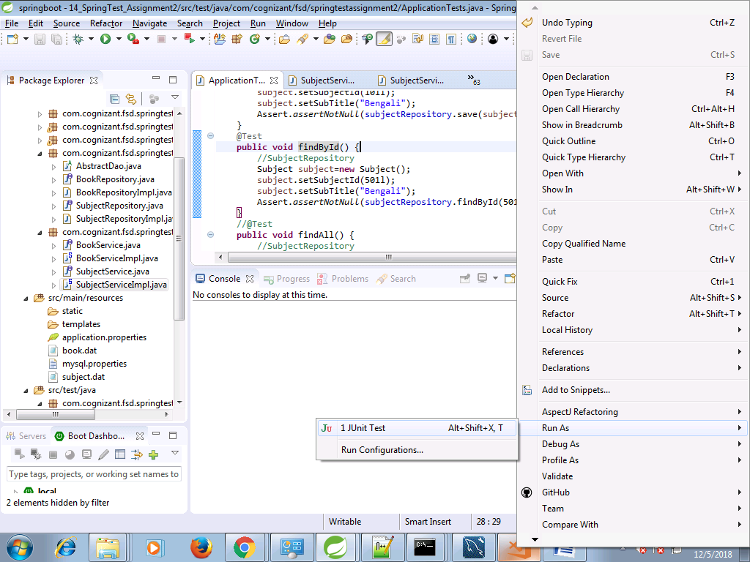

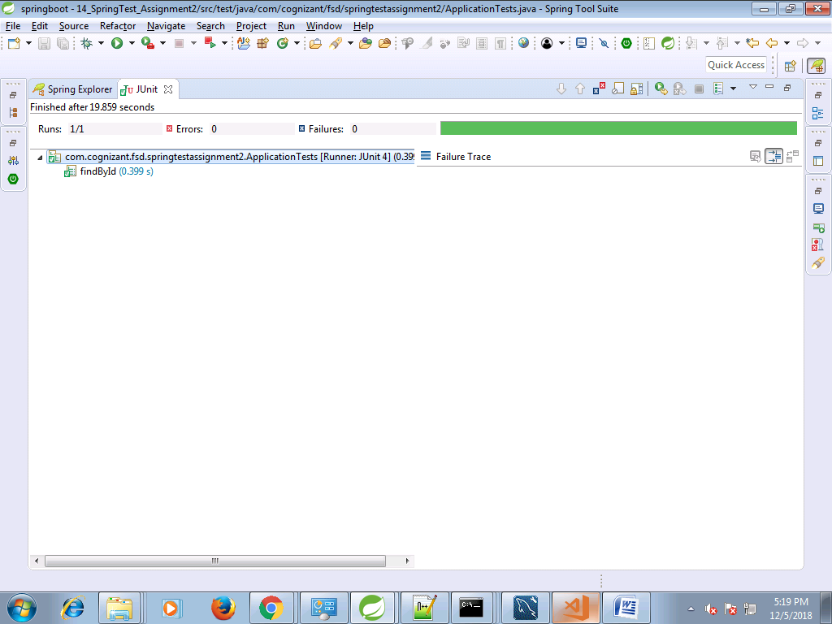

negative test

@Test

**public** **void** findById() {

//SubjectRepository

Subject subject=**new** Subject();

subject.setSubjectId(501l);

subject.setSubTitle("Bengali");

//Assert.assertNotNull(subjectRepository.findById(501l).get());

Assert.*assertNotNull*(subjectRepository.findById(502l).get());

}

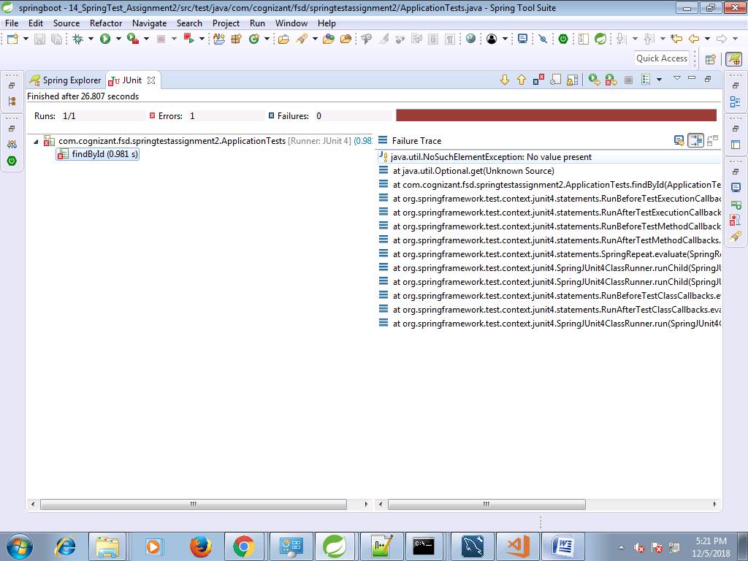

@Test

**public** **void** findAll() {

//SubjectRepository

List<Subject> subjectList=(List<Subject>)subjectRepository.findAll();

Assert.*assertEquals*(subjectList.size(), 2);

}

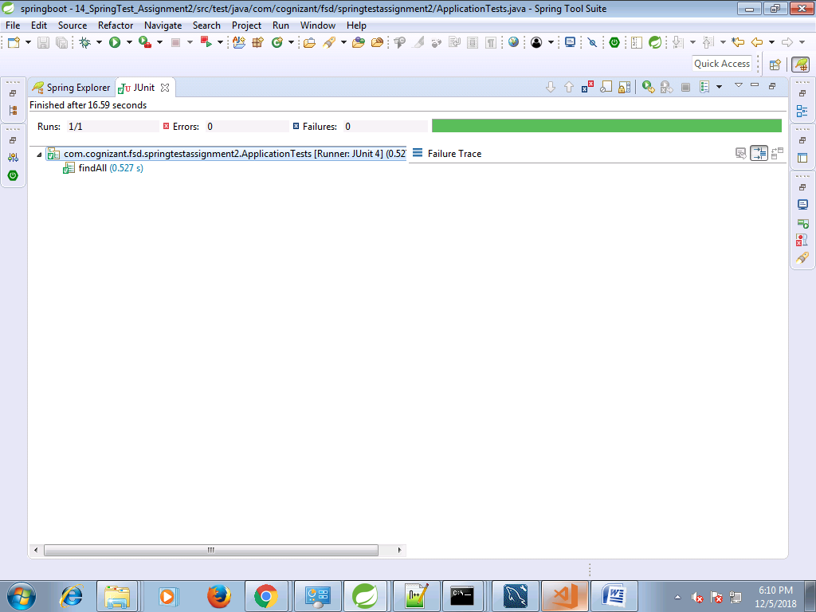

**BookRepository Testing**

**package** com.cognizant.fsd.springtestassignment2;

**import** java.util.List;

**import** org.junit.Assert;

**import** org.junit.Test;

**import** org.junit.runner.RunWith;

**import** org.springframework.beans.factory.annotation.Autowired;

**import** org.springframework.boot.test.context.SpringBootTest;

**import** org.springframework.test.context.junit4.SpringRunner;

**import** com.cognizant.fsd.springtestassignment2.model.Book;

**import** com.cognizant.fsd.springtestassignment2.model.Subject;

**import** com.cognizant.fsd.springtestassignment2.repository.BookRepository;

**import** com.cognizant.fsd.springtestassignment2.repository.SubjectRepository;

@RunWith(SpringRunner.**class**)

@SpringBootTest

**public** **class** ApplicationTests {

@Autowired

**private** SubjectRepository subjectRepository;

@Autowired

**private** BookRepository bookRepository;

@Test

**public** **void** saveBook() {

//BookRepository

Book book=**new** Book();

book.setBookId(101l);

book.setTitle("Java");

Assert.*assertNotNull*(bookRepository.save(book));

}

@Test

**public** **void** bookFindById() {

//BookRepository

Book book=**new** Book();

book.setBookId(101l);

book.setTitle("Java");

Assert.*assertNotNull*(bookRepository.findById(101l).get());

//Assert.assertNotNull(bookRepository.findById(502l).get());

}

@Test

**public** **void** findAllBooks() {

//SubjectRepository

List<Book> bookList=(List<Book>)bookRepository.findAll();

Assert.*assertEquals*(bookList.size(), 2);

}

//@Test

**public** **void** save() {

//SubjectRepository

Subject subject=**new** Subject();

subject.setSubjectId(101l);

subject.setSubTitle("Bengali");

Assert.*assertNotNull*(subjectRepository.save(subject));

}

//@Test

**public** **void** findById() {

//SubjectRepository

Subject subject=**new** Subject();

subject.setSubjectId(501l);

subject.setSubTitle("Bengali");

//Assert.assertNotNull(subjectRepository.findById(501l).get());

Assert.*assertNotNull*(subjectRepository.findById(502l).get());

}

//@Test

**public** **void** findAll() {

//SubjectRepository

List<Subject> subjectList=(List<Subject>)subjectRepository.findAll();

Assert.*assertEquals*(subjectList.size(), 2);

}

}

------------------------------------------------------------------------------------------------------------------------------------------

@Test

**public** **void** saveBook() {

//BookRepository

Book book=**new** Book();

book.setBookId(101l);

book.setTitle("Java");

Assert.*assertNotNull*(bookRepository.save(book));

}

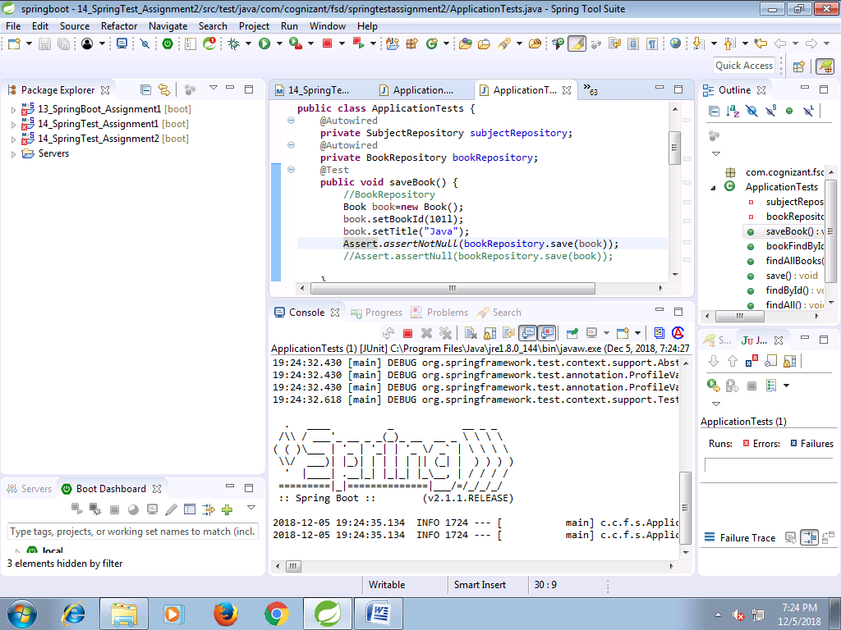

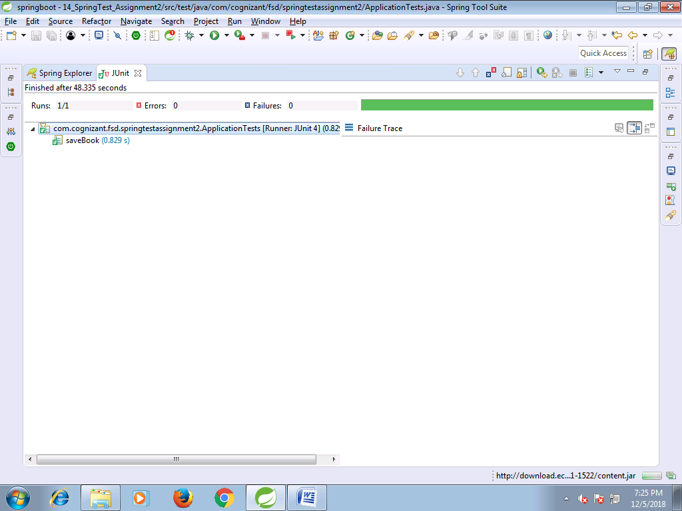

**negative testing**

@Test

**public** **void** saveBook() {

//BookRepository

Book book=**new** Book();

book.setBookId(101l);

book.setTitle("Java");

//Assert.assertNotNull(bookRepository.save(book));

Assert.*assertNull*(bookRepository.save(book));

}

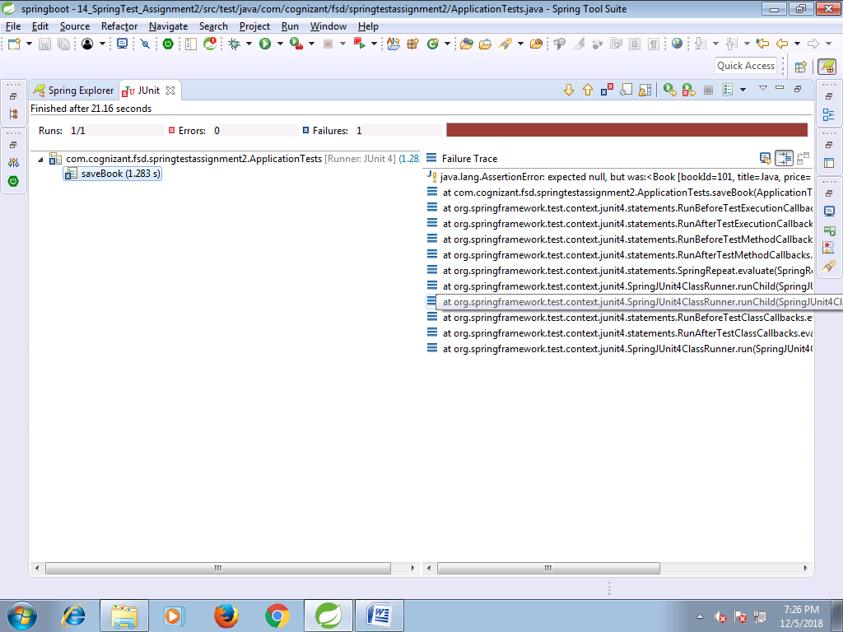

@Test

**public** **void** bookFindById() {

//BookRepository

Book book=**new** Book();

book.setBookId(101l);

book.setTitle("Java");

Assert.*assertNotNull*(bookRepository.findById(101l).get());

//Assert.assertNotNull(bookRepository.findById(502l).get());

}

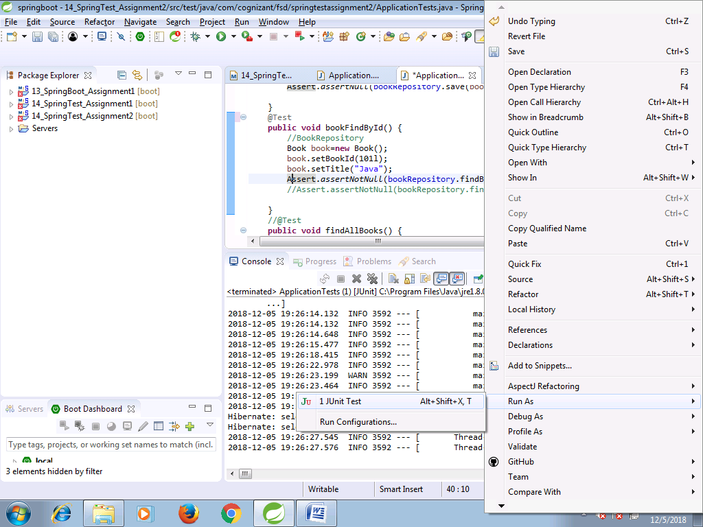

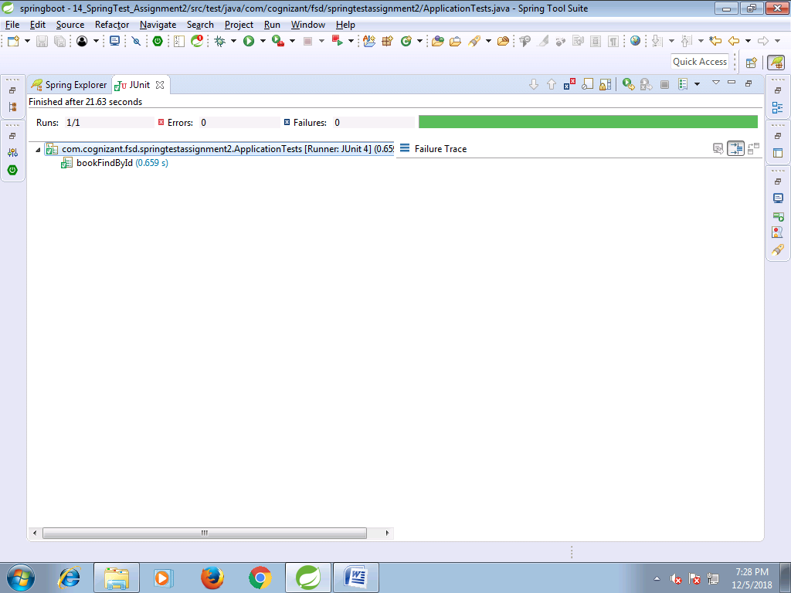

**negative testing**

@Test

**public** **void** bookFindById() {

//BookRepository

Book book=**new** Book();

book.setBookId(101l);

book.setTitle("Java");

//Assert.assertNotNull(bookRepository.findById(101l).get());

Assert.*assertNotNull*(bookRepository.findById(502l).get());

}

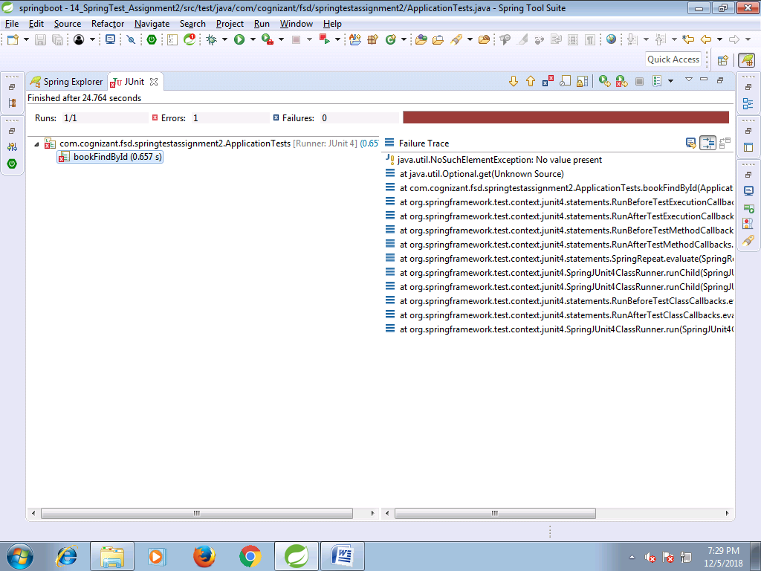

@Test

**public** **void** findAllBooks() {

//BookRepository

List<Book> bookList=(List<Book>)bookRepository.findAll();

Assert.*assertEquals*(bookList.size(), 1);

}

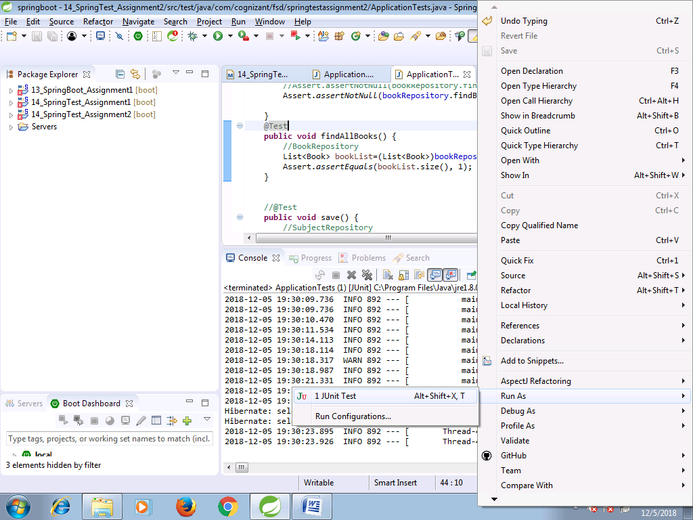

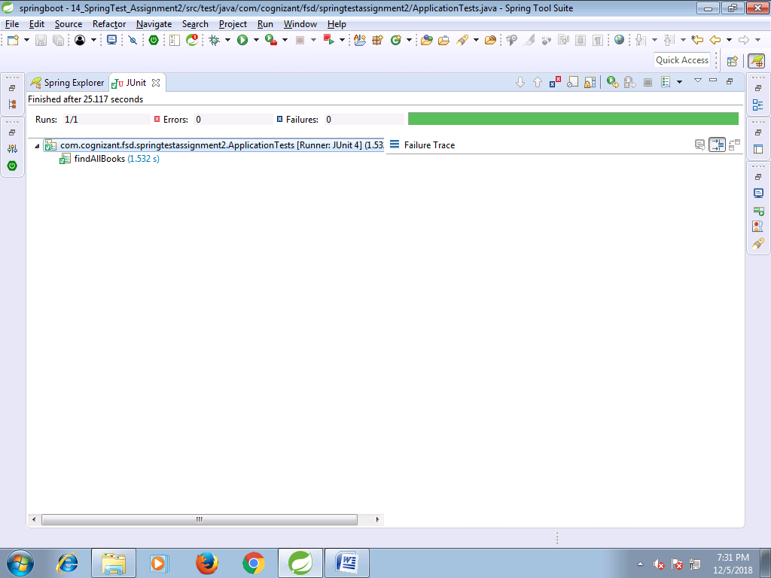

**negative testing**

@Test

**public** **void** findAllBooks() {

//BookRepository

List<Book> bookList=(List<Book>)bookRepository.findAll();

Assert.*assertEquals*(bookList.size(), 3);

}

