CLI Commands:

Git global setup

git config --global user.name "Sudhir Kumar Thakur"

git config --global user.email "sudhirktid@gmail.com"

adding the project to created folder and commiting the code.

cd existing_folder

git init

git remote add origin http://172.18.2.18/sudhir.thakur/14_SpringTest_Assignment1.git

git add .

git commit -m "Initial commit"

git push -u origin master

URL :

http://localhost /sudhir.thakur/14_SpringTest_Assignment1Steps followed:

1. Git user registration

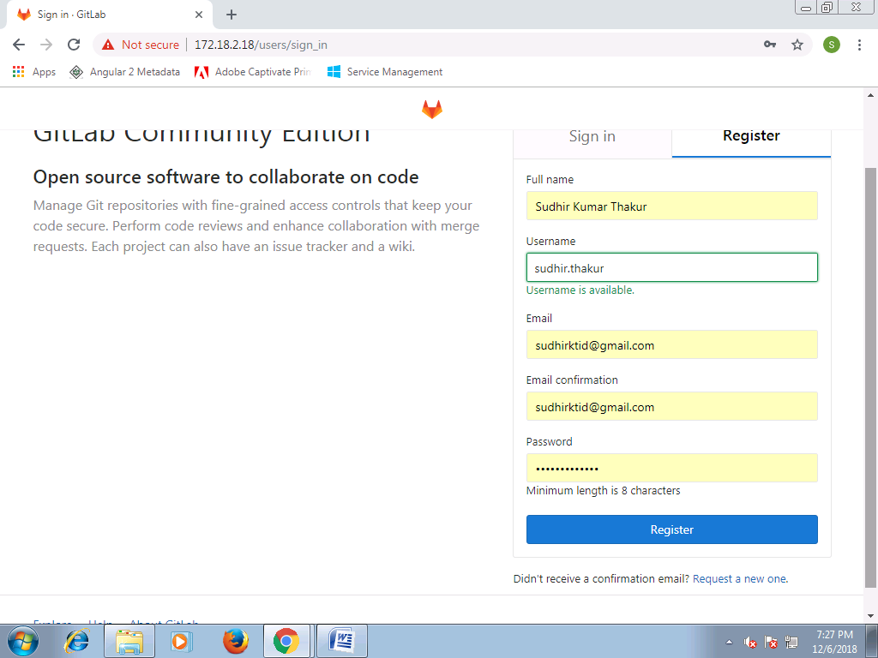

2. Creating a blank project folder

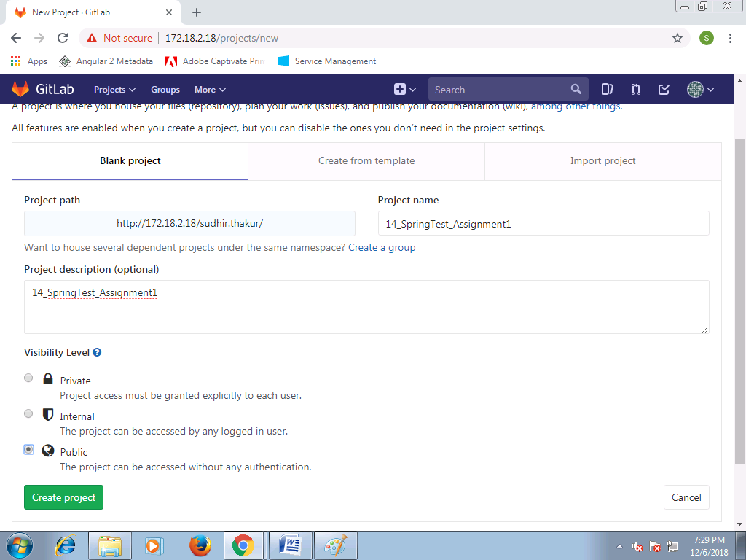

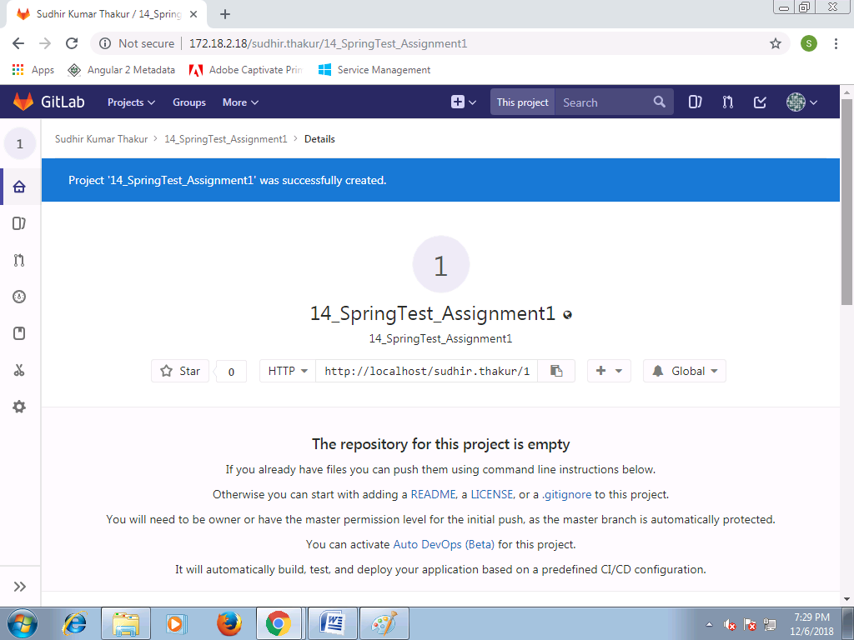

3. Git global setup by using CLI Command

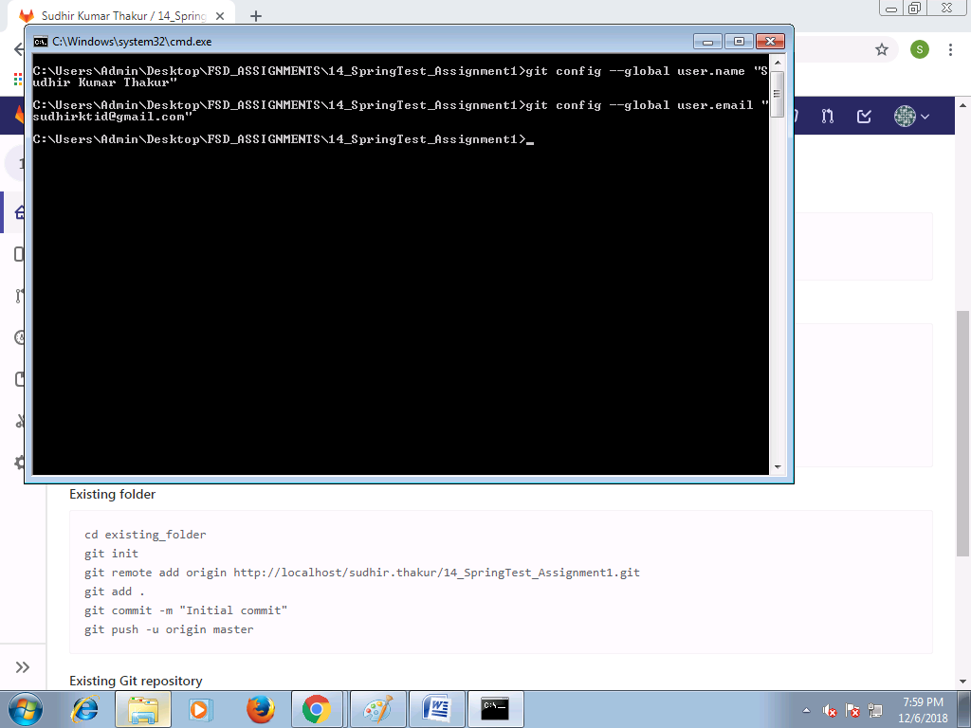

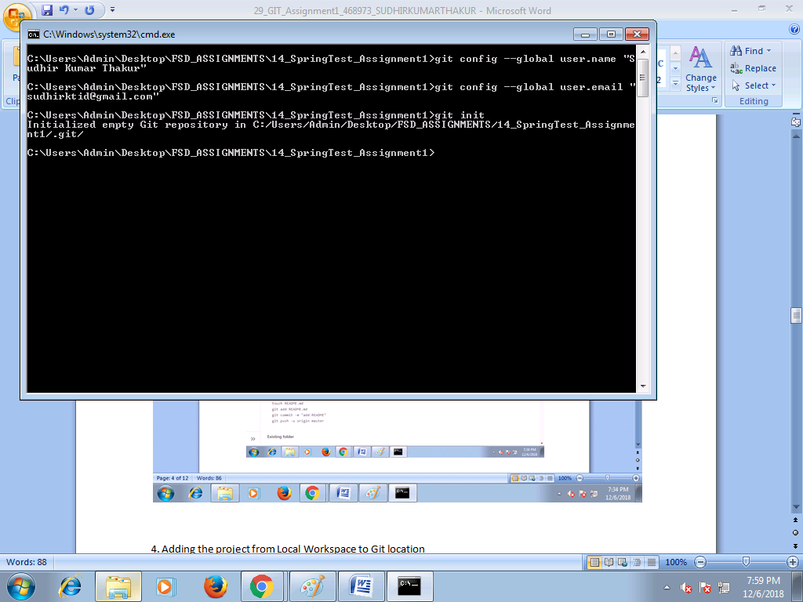

4. Adding the project from Local Workspace to Git location

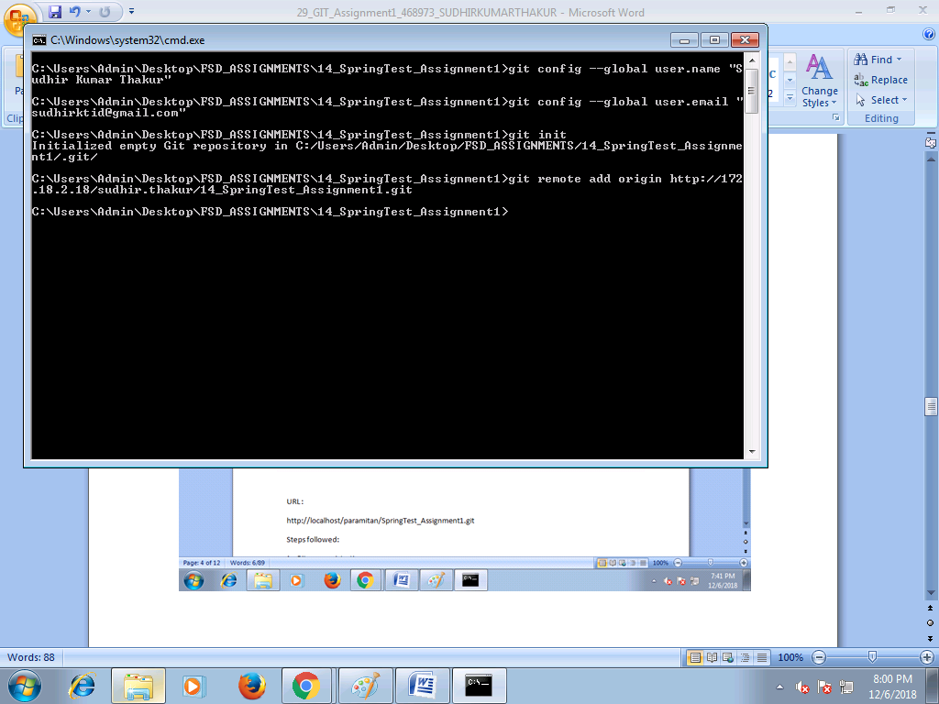

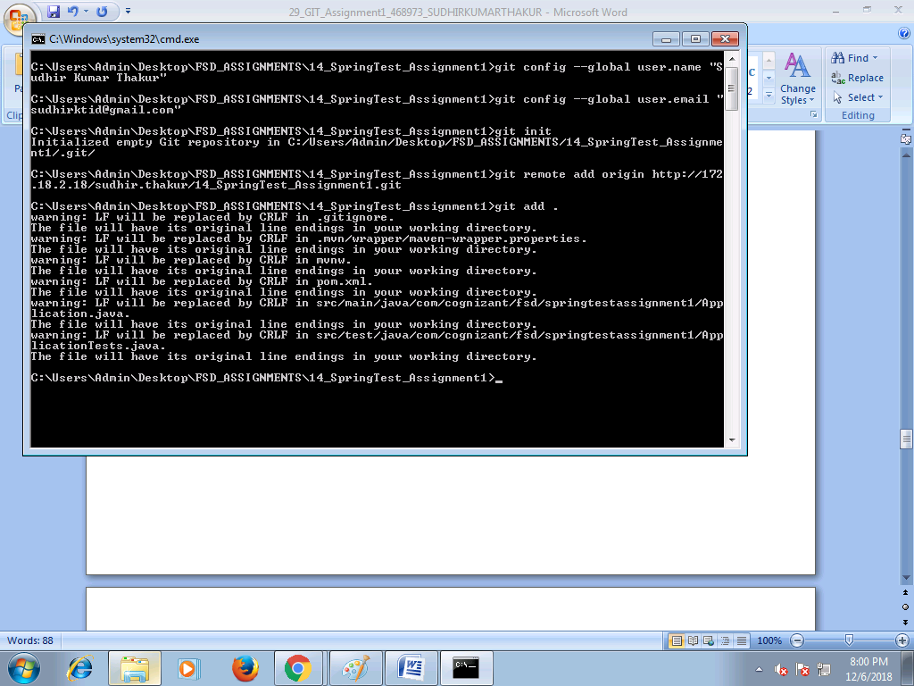

5. Committing the project

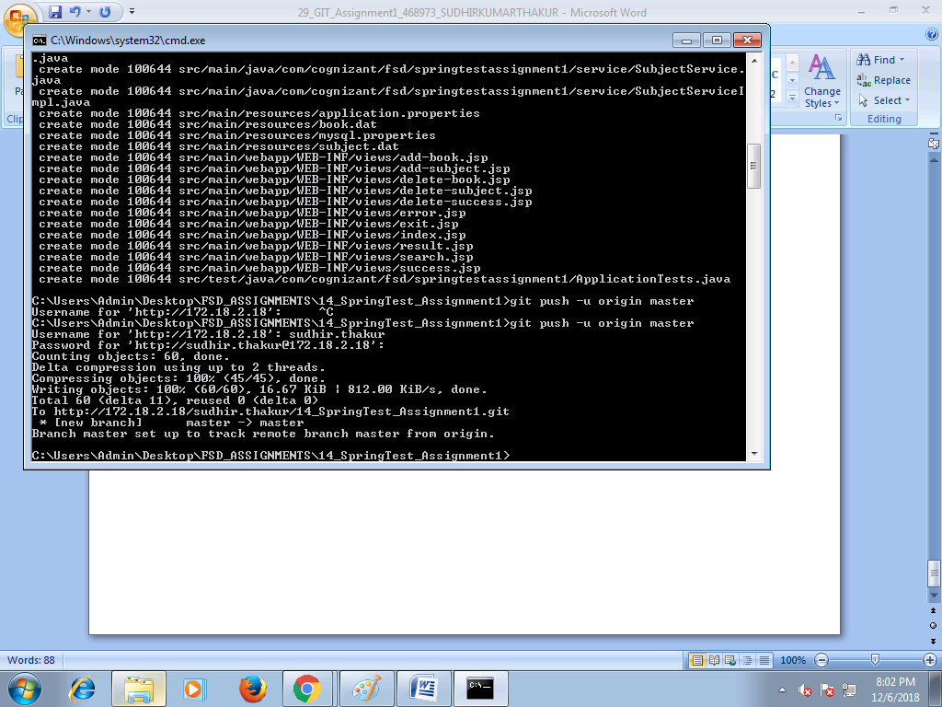

6. Project in GIT Location

