* **navigation.html**
* <!DOCTYPE html>
* <html lang="en">
* <head>
* <title>My Profile</title>
* <meta charset="utf-8">
* <meta name="viewport" content="width=device-width, initial-scale=1">
* <style>
* * {
* box-sizing: border-box;
* }
* body {
* font-family: Arial, Helvetica, sans-serif;
* }
* /* Style the header */
* header {
* background-color: #666;
* padding: 15px;
* text-align: center;
* font-size: 35px;
* color: white;
* }
* /* Create two columns/boxes that floats next to each other */
* nav {
* float: left;
* width: 25%;
* height: 400px;
* background: #ccc;
* padding: 20px;
* }
* /* Style the list inside the menu */
* nav ul {
* list-style-type: none;
* padding: 0;
* }
* article {
* float: left;
* padding: 20px;
* width: 75%;
* background-color: #f1f1f1;
* height: 400px;
* }
* /* Clear floats after the columns */
* section:after {
* content: "";
* display: table;
* clear: both;
* }
* /* Style the footer */
* footer {
* background-color: #777;
* padding: 15px;
* text-align: left;
* color: white;
* }
* /* Responsive layout - makes the two columns/boxes stack on top of each other instead of next to each other, on small screens */
* @media (max-width: 600px) {
* nav,
* article {
* width: 100%;
* height: auto;
* }
* }
* a {
* border: 1px solid rgb(116, 113, 109);
* border-radius: 5px;
* padding: 5px;
* }
* li {
* padding: 20px;
* }
* iframe {
* padding: 5px;
* border-radius: 5px;
* }
* </style>
* </head>
* <body>
* <header>
* <h2>My Profile</h2>
* </header>
* <section>
* <nav>
* <ul>
* <li>
* <a href=".\index.html" target="iframe_a">Profile Highlights</a>
* </li>
* <li>
* <a href=".\project.html" target="iframe_a">Projects</a>
* </li>
* <li>
* <a href=".\experience.html" target="iframe_a">Experience</a>
* </li>
* <li>
* <a href=".\personal_biography.html" target="iframe_a">Personal Biography</a>
* </li>
* <li>
* <a href=".\contactme.html" target="iframe_a">Contact Me</a>
* </li>
* </ul>
* </nav>
* <article>
* <iframe height="100%" width="100%" src="index.html" name="iframe_a"></iframe>
* </article>
* </section>
* <footer>
* <div>
* <span>Mayukh Ghosh (422892)</span>
* <span style="float: right">Cognizant</span>
* </div>
* </footer>
* </body>
* </html>
* **index.html**
* <html>
* <head>
* <title>Profile Highlight</title>
* <style>
* div {
* border: 1px solid rgb(35, 12, 184);
* border-radius: 15px;
* padding: 10px;
* font-style: italic;
* font-size: 18px;
* background-color: rgb(247, 230, 239)
* }
* h2 {
* border: 1px solid rgb(116, 113, 109);
* border-radius: 5px;
* padding: 5px;
* width: 190px;
* background-color: rgb(227, 235, 235)
* }
* </style>
* </head>
* <body>
* <img src=".\Images\Penguins.jpg" alt="My Profile Image" width="100" height="120">
* <h2>
* <u>Profile Highlight:</u>
* </h2>
* <div>
* I am basically a Java Resource having 7.6 years of IT experience, worked on technologies like Core java, J2EE, Spring, hibernate etc.
* </div>
* </body>
* </html>

* **project.html**
* <html>
* <head>
* <title>Project</title>
* <style>
* table {
* font-family: arial, sans-serif;
* border-collapse: collapse;
* width: 100%;
* }
* td,
* th {
* border: 1px solid #dddddd;
* text-align: left;
* padding: 8px;
* }
* tr:nth-child(even) {
* background-color: #dddddd;
* }
* h2 {
* border: 1px solid rgb(116, 113, 109);
* border-radius: 5px;
* padding: 5px;
* width: 160px;
* background-color: rgb(227, 235, 235)
* }
* </style>
* </head>
* <body>
* <h2>
* <u>Project Details:</u>
* </h2>
* <table>
* <tr>
* <td>
* <b>Project Name</b>
* </td>
* <td>Shared Investigator Platform</td>
* </tr>
* <tr>
* <td>
* <b>Role</b>
* </td>
* <td>Associate</td>
* </tr>
* <tr>
* <td>
* <b>Customer</b>
* </td>
* <td>USA based Biopharma Company</td>
* </tr>
* <tr>
* <td>
* <b>Team Size</b>
* </td>
* <td>20</td>
* </tr>
* <tr>
* <td>
* <b>Technical Skills</b>
* </td>
* <td>Java,J2EE,Spring,Hibernate,JQuery,JSP,Liferay</td>
* </tr>
* <tr>
* <td>
* <b>Durations</b>
* </td>
* <td>April 2014 to till date</td>
* </tr>
* </table>
* </body>
* </html>
* **experience.html**
* <html>
* <head>
* <title>Experience</title>
* <style>
* div {
* border: 1px solid rgb(35, 12, 184);
* border-radius: 15px;
* padding: 10px;
* font-style: italic;
* font-size: 18px;
* background-color: rgb(247, 230, 239)
* }
* h2 {
* border: 1px solid rgb(116, 113, 109);
* border-radius: 5px;
* padding: 5px;
* width: 130px;
* background-color: rgb(227, 235, 235)
* }
* </style>
* </head>
* <body>
* <h2>
* <u>Experience:</u>
* </h2>
* <div>
* I am currently working in cognizant for more than four years, previously I was in Infosys for 3 Years.
* </div>
* </body>
* </html>
* **personal_biography.html**
* <html>
* <head>
* <title>Personal Biography</title>
* <style>
* div {
* border: 1px solid rgb(35, 12, 184);
* border-radius: 15px;
* padding: 10px;
* font-style: italic;
* font-size: 18px;
* background-color: rgb(247, 230, 239)
* }
* h2 {
* border: 1px solid rgb(116, 113, 109);
* border-radius: 5px;
* padding: 5px;
* width: 215px;
* background-color: rgb(227, 235, 235)
* }
* </style>
* </head>
* <body>
* <h2>
* <u>Personal Biography:</u>
* </h2>
* <div>This is Mayukh, born and brough up in kolkata.My schooling was from a local school at Belgharia and my hobbies are playing cricket,playing keyboards and writing short stories.</div>
* </body>
* </html>
* **contactme.html**

<html>

<head>

<title>Contact me</title>

<style>

button {

background-color: rgb(128, 231, 245);

border: none;

border-radius: 5px;

color: gray;

padding: 10px;

text-align: center;

text-decoration: none;

display: inline-block;

font-size: 14px;

margin: 4px 2px;

cursor: pointer;

}

h2 {

border: 1px solid rgb(116, 113, 109);

border-radius: 5px;

padding: 5px;

width: 130px;

background-color: rgb(227, 235, 235)

}

</style>

</head>

<body>

<h2>

<u>Contact me:</u>

</h2>

<p>Please fill the below details and submit the form.</p>

<form action="">

<table>

<tr>

<td>

<input type="text" placeholder="Enter your Full Name" required>

</td>

</tr>

<tr>

<td>

<input type="text" placeholder="Enter your Mobile Number" required pattern="[0-9]{10}$" title="Enter 10 digits numeric number">

</td>

</tr>

<tr>

<td>

<input type="text" placeholder="Enter your Email Id" required pattern="[a-z0-9._%+-]+@[a-z0-9.-]+\.[a-z]{2,3}$" title="Please provide valid email id">

</td>

</tr>

<tr>

<td>

<textarea name="remarks" id="" cols="30" rows="8" placeholder="Please provide yours remarks here.."></textarea>

</td>

</tr>

<tr>

<td>

<button>Submit</button>

</td>

</tr>

</table>

</form>

</body>

</html>

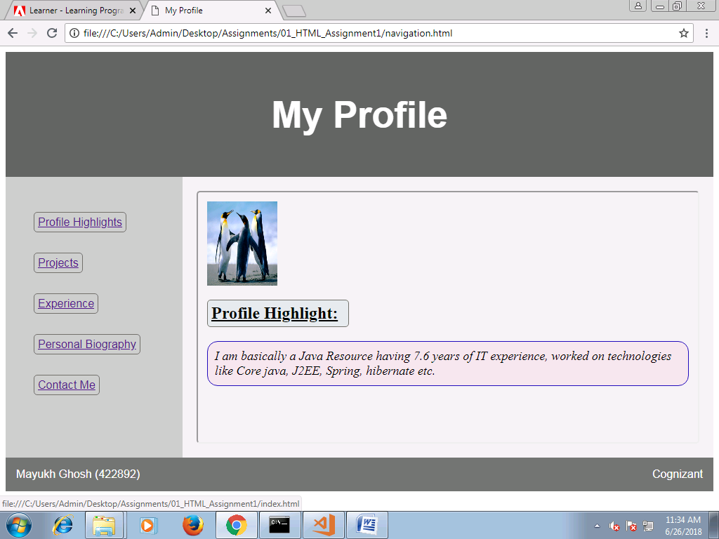

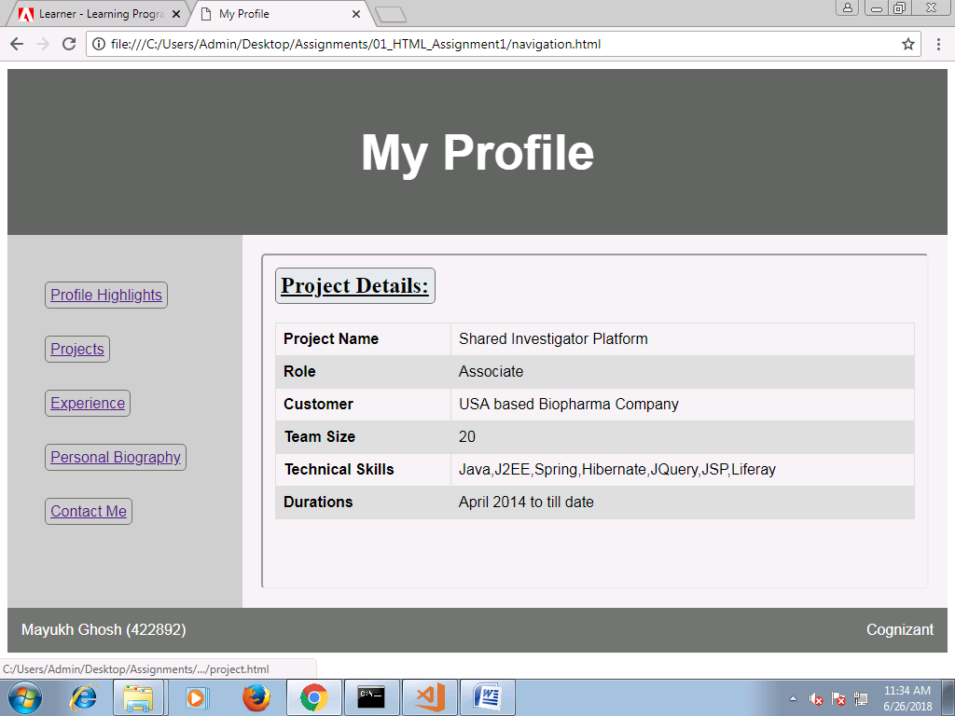

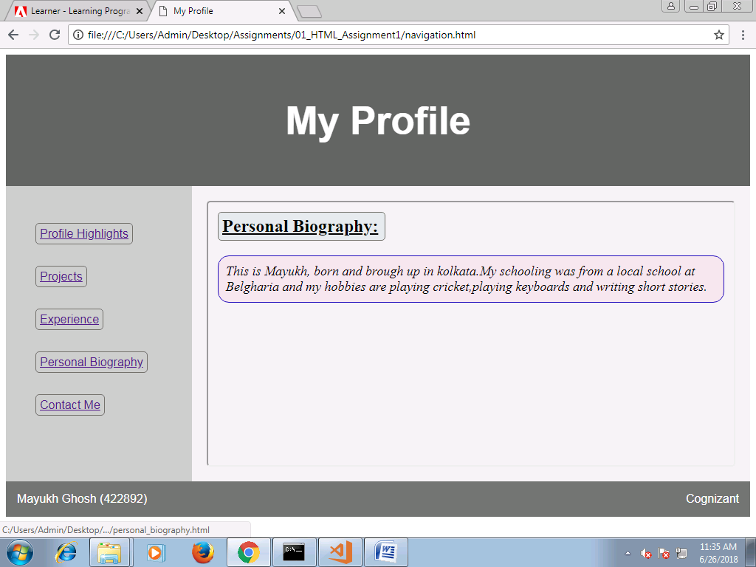

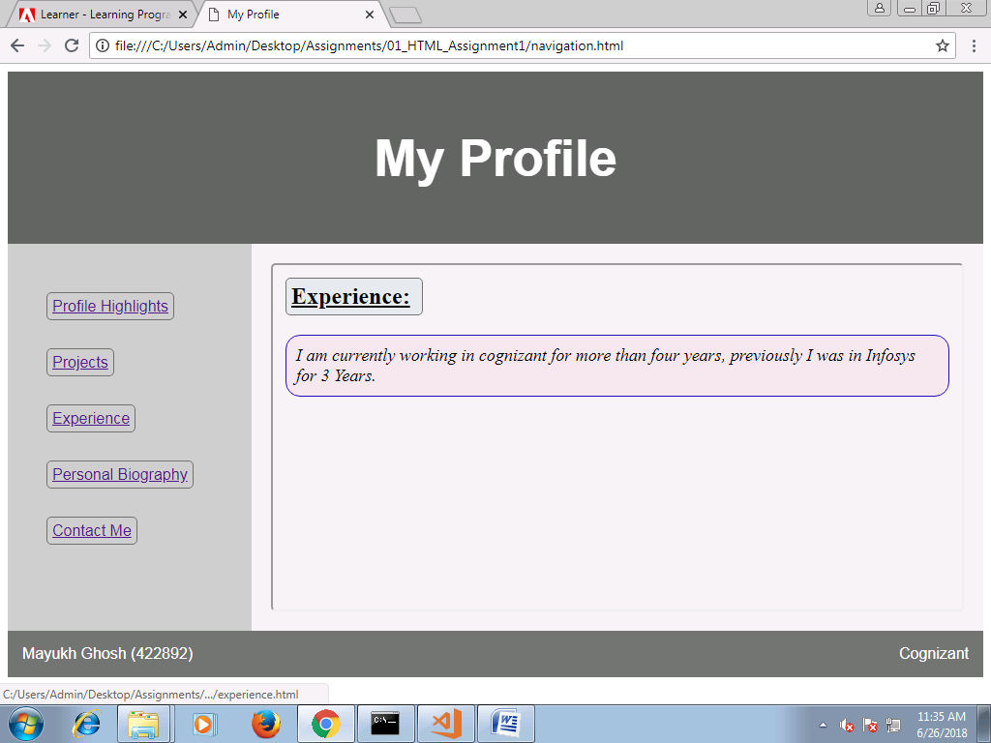

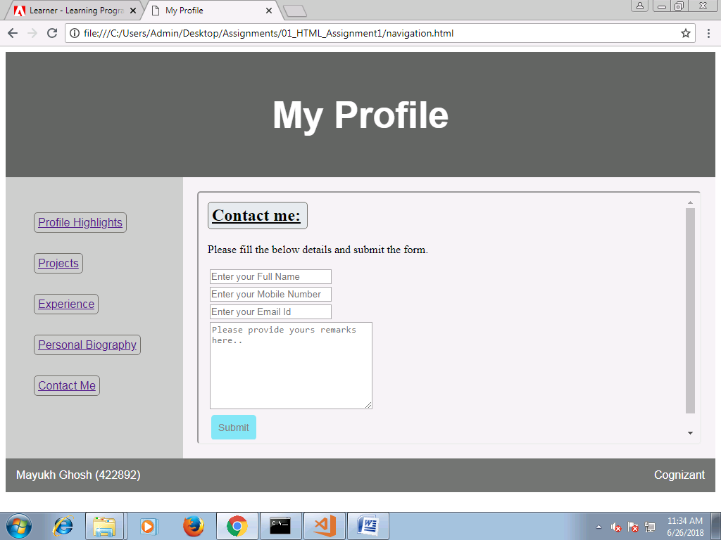

**Field validations:**

