# navigation.html

<!DOCTYPE html>

<html lang="en">

<head>

<title>My Profile</title>

<meta charset="utf-8">

<meta name="viewport" content="width=device-width, initial-scale=1">

<link rel="stylesheet" href="https://maxcdn.bootstrapcdn.com/bootstrap/3.3.7/css/bootstrap.min.css">

<script src="https://ajax.googleapis.com/ajax/libs/jquery/3.3.1/jquery.min.js"></script>

<script src="https://maxcdn.bootstrapcdn.com/bootstrap/3.3.7/js/bootstrap.min.js"></script>

<style>

/* Set height of the grid so .sidenav can be 100% (adjust if needed) */

.row.content {

height: 100%;

}

* {

box-sizing: border-box;

}

/* Style the header */

header {

background-color: #b5dcb3;

padding: 12px;

text-align: center;

font-size: 35px;

color: rgb(20, 20, 13);

}

/* Set gray background color and 100% height */

.sidenav {

float: left;

width: 26%;

height: 600px;

background: #aaa;

padding: 20px;

}

article {

float: left;

padding: 20px;

width: 100%;

background-color: #f1f1f1;

height: 100%;

}

article iframe {

border: 2px solid #555;

border-radius: 4px;

}

a {

border: 1px solid rgb(116, 113, 109);

border-radius: 5px;

padding: 5px;

}

li {

padding: 20px;

}

/* Set black background color, white text and some padding */

footer {

background-color: #555;

color: white;

padding: 15px;

}

/* On small screens, set height to 'auto' for sidenav and grid */

@media screen and (max-width: 767px) {

.sidenav {

height: auto;

padding: 15px;

width: 100%;

}

.row.content {

height: auto;

}

article {

height: 600px;

}

.tab-2 {

margin-left: 20px;

}

}

@media screen and (min-width: 768px) {

.col-sm-9 {

height: 600px;

width: 74%;

}

}

.floatRight {

float: right;

}

.col-sm-9 {

padding-left: 0px !important;

padding-right: 0px !important;

}

</style>

</head>

<body>

<div class="">

</div>

<div class="container-fluid">

<div class="row content">

<div>

<header>

<h2>My Profile</h2>

</header>

</div>

<div class="col-sm-3 sidenav ">

<section>

<nav>

<li>

<a href=".\index.html " target="iframe_a ">

<b>Profile Highlights</b>

</a>

</li>

<li>

<a href=".\project.html " target="iframe_a ">

<b>Projects</b>

</a>

</li>

<li>

<a href=".\experience.html " target="iframe_a ">

<b>Experience</b>

</a>

</li>

<li>

<a href=".\personal_biography.html " target="iframe_a ">

<b>Personal Biography</b>

</a>

</li>

<li>

<a href=".\education_script.html " target="iframe_a ">

<b>Education</b>

</a>

</li>

<li>

<a href=".\contactme.html " target="iframe_a ">

<b>Contact Me</b>

</a>

</li>

</nav>

</section>

</div>

<div class="col-sm-9 ">

<article>

<iframe height="100% " width="100% " src="index.html " name="iframe_a "></iframe>

</article>

</div>

</div>

</div>

<div>

<footer class="container-fluid ">

<span>Mayukh Ghosh (422892)</span>

<span class="floatRight ">Cognizant</span>

</footer>

</div>

</body>

</html>

# index.html

* <!DOCTYPE html>
* <html lang="en">
* <html>
* <head>
* <title>Profile Highlight</title>
* <link rel="stylesheet" href="myprofile.css" >
* <meta charset="utf-8">
* <meta name="viewport" content="width=device-width, initial-scale=1">
* <link rel="stylesheet" href="https://maxcdn.bootstrapcdn.com/bootstrap/3.3.7/css/bootstrap.min.css">
* <script src="https://ajax.googleapis.com/ajax/libs/jquery/3.3.1/jquery.min.js"></script>
* <script src="https://maxcdn.bootstrapcdn.com/bootstrap/3.3.7/js/bootstrap.min.js"></script>
* </head>
* <body>
* <div>
* <img src=".\Images\Penguins.jpg" alt="My Profile Image" width="100" height="120"><br>
* </div>
* <h2 class="header">
* Profile Highlight:
* </h2>
* <div class="divClass">
* I am basically a Java Resource having 7.6 years of IT experience, worked on technologies like Core java, J2EE, Spring, hibernate etc.
* </div>
* </body>
* </html>

# education.html

* <!DOCTYPE html>
* <html>
* <head>
* <title>Education</title>
* <link rel="stylesheet" href="myprofile.css">
* <meta charset="windows-1252">
* <meta name="viewport" content="width=device-width, initial-scale=1.0">
* <link rel="stylesheet" href="https://maxcdn.bootstrapcdn.com/bootstrap/3.3.7/css/bootstrap.min.css">
* <script src="https://ajax.googleapis.com/ajax/libs/jquery/3.3.1/jquery.min.js"></script>
* <script src="https://maxcdn.bootstrapcdn.com/bootstrap/3.3.7/js/bootstrap.min.js"></script>
* <style>
* .container {
* overflow: hidden
* }
* .tab {
* float: left;
* }
* .tab-2 input {
* display: block;
* margin-bottom: 5px
* }
* tr {
* transition: all .25s ease-in-out
* }
* tr:hover {
* background-color: rgb(247, 247, 155);
* cursor: pointer
* }
* .divClass {
* font-size: 15px !important;
* }
* </style>
* </head>
* <body>
* <h2 class="header">
* Education Details:
* </h2>
* <div class="container divClass">
* <div class="tab tab-1 table-responsive">
* <table id="table" class="table table-bordered">
* <tr class="bg-primary">
* <th>Degree</th>
* <th>Discipline</th>
* <th>Board / University</th>
* <th>Aggregate % / CGPA</th>
* </tr>
* <tr>
* <td>
* B.Tech
* </td>
* <td>Computer Science</td>
* <td>WBUT</td>
* <td>75.70</td>
* </tr>
* <tr>
* <td>
* Higher Secondary
* </td>
* <td>Science</td>
* <td>WBCHSE</td>
* <td>76.70%</td>
* </tr>
* </table>
* <div class="mt-3">
* <button type="submit" class="btn-primary btn-lg active center-block" onclick="addMoreDetails();">Add more details</button>
* </div>
* </div>
* <p>Note: Please click on row for modifying details</p>
* <div class="tab tab-2 invisible" id="formDiv">
* <div class="form-group">
* <label for="exampleInputDegree1">Degree :</label>
* <input type="text" class="form-control" id="degree" placeholder="Degree">
* </div>
* <div class="form-group">
* <label for="exampleInputDiscipline1">Discipline :</label>
* <input type="text" class="form-control" id="discipline" placeholder="Discipline">
* </div>
* <div class="form-group">
* <label for="exampleInputUniversity1">Board / University :</label>
* <input type="text" class="form-control" id="university" placeholder="Board / University">
* </div>
* <div class="form-group">
* <label for="exampleInputPercentage1">Aggregate % / CGPA :</label>
* <input type="text" class="form-control" id="percentage" placeholder="Aggregate % / CGPA">
* </div>
* <button class="btn-primary" onclick="addHtmlTableRow();">Add</button>
* <button onclick="editHtmlTbleSelectedRow();">Edit</button>
* <button class="btn-danger" onclick="removeSelectedRow();">Remove</button>
* </div>
* </div>
* <script>
* var rIndex,
* table = document.getElementById("table");
* // check the empty input
* function checkEmptyInput() {
* var isEmpty = false,
* degree = document.getElementById("degree").value,
* discipline = document.getElementById("discipline").value,
* university = document.getElementById("university").value;
* percentage = document.getElementById("percentage").value;
* if (degree === "") {
* alert("Degree Connot Be Empty");
* isEmpty = true;
* }
* else if (discipline === "") {
* alert("Discipline Connot Be Empty");
* isEmpty = true;
* }
* else if (university === "") {
* alert("university Connot Be Empty");
* isEmpty = true;
* }
* else if (percentage === "") {
* alert("percentage Connot Be Empty");
* isEmpty = true;
* }
* return isEmpty;
* }
* //add more details
* function addMoreDetails() {
* document.getElementById("degree").value = "";
* document.getElementById("discipline").value = "";
* document.getElementById("university").value = "";
* document.getElementById("percentage").value = "";
* var element = document.getElementById("formDiv");
* element.classList.remove("invisible");
* }
* // add Row
* function addHtmlTableRow() {
* // get the table by id
* // create a new row and cells
* // get value from input text
* // set the values into row cell's
* if (!checkEmptyInput()) {
* var newRow = table.insertRow(table.length),
* cell1 = newRow.insertCell(0),
* cell2 = newRow.insertCell(1),
* cell3 = newRow.insertCell(2),
* cell4 = newRow.insertCell(3),
* degree = document.getElementById("degree").value,
* discipline = document.getElementById("discipline").value,
* university = document.getElementById("university").value;
* percentage = document.getElementById("percentage").value;
* cell1.innerHTML = degree;
* cell2.innerHTML = discipline;
* cell3.innerHTML = university;
* cell4.innerHTML = percentage;
* var element = document.getElementById("formDiv");
* element.classList.add("invisible");
* // call the function to set the event to the new row
* selectedRowToInput();
* }
* }
* // display selected row data into input text
* function selectedRowToInput() {
* for (var i = 1; i < table.rows.length; i++) {
* table.rows[i].onclick = function () {
* // get the selected row index
* rIndex = this.rowIndex;
* console.log("rIndex: " + rIndex);
* document.getElementById("degree").value = this.cells[0].innerHTML;
* document.getElementById("discipline").value = this.cells[1].innerHTML;
* document.getElementById("university").value = this.cells[2].innerHTML;
* document.getElementById("percentage").value = this.cells[3].innerHTML;
* var element = document.getElementById("formDiv");
* element.classList.remove("invisible");
* };
* }
* }
* selectedRowToInput();
* function editHtmlTbleSelectedRow() {
* var degree = document.getElementById("degree").value,
* discipline = document.getElementById("discipline").value,
* university = document.getElementById("university").value;
* percentage = document.getElementById("percentage").value;
* console.log("degree: " + degree);
* console.log("discipline: " + discipline);
* console.log("university: " + university);
* console.log("percentage: " + percentage);
* if (!checkEmptyInput()) {
* table.rows[rIndex].cells[0].innerHTML = degree;
* table.rows[rIndex].cells[1].innerHTML = discipline;
* table.rows[rIndex].cells[2].innerHTML = university;
* table.rows[rIndex].cells[3].innerHTML = percentage;
* var element = document.getElementById("formDiv");
* element.classList.add("invisible");
* }
* }
* function removeSelectedRow() {
* // clear input text
* console.log("rIndex: " + rIndex);
* if (rIndex != undefined) {
* table.deleteRow(rIndex);
* document.getElementById("degree").value = "";
* document.getElementById("discipline").value = "";
* document.getElementById("university").value = "";
* document.getElementById("percentage").value = "";
* rIndex = undefined;
* var element = document.getElementById("formDiv");
* element.classList.add("invisible");
* } else {
* alert("Please select row for removing details");
* }
* }
* </script>
* </body>
* </html>

# experiece.html

* <html>
* <head>
* <title>Experience</title>
* <link rel="stylesheet" href="myprofile.css">
* <link rel="stylesheet" href="https://maxcdn.bootstrapcdn.com/bootstrap/3.3.7/css/bootstrap.min.css">
* <script src="https://ajax.googleapis.com/ajax/libs/jquery/3.3.1/jquery.min.js"></script>
* <script src="https://maxcdn.bootstrapcdn.com/bootstrap/3.3.7/js/bootstrap.min.js"></script>
* <script>
* function moreDetails() {
* console.log("Inside moreDetails");
* var x = document.getElementById("moreDetails");
* var anchor = document.getElementById("moreId");
* if (x.style.display === "none") {
* x.style.display = "block";
* anchor.innerHTML="<b>Show less</b>";
* } else {
* x.style.display = "none";
* anchor.innerHTML="<b>Show more.....</b>";
* }
* }
* </script>
* </head>
* <body>
* <h2 class="header">
* Experience:
* </h2>
* <div class="divClass">
* I am currently working in cognizant for more than four years, previously I was in Infosys for 3 Years.
* <span style="display: none;" id="moreDetails">
* <br>I was trained in JAVA/J2EE from Infosys mysore for 5 months.After that I got posted in Infosys,Chennai.I was there for more than 2 years then I moved to Bhubaneswar.I stayed at bhubaneswar for 7 months before i moved to Kolkata.
* </span>
* <a class="mt-5 " id="moreId" onclick="moreDetails()"><b>Show more.....</b></a>
* </div>
* </body>
* </html>

# project.html

* <!DOCTYPE html>
* <html lang="en">
* <head>
* <title>Project</title>
* <link rel="stylesheet" href="myprofile.css">
* <meta charset="utf-8">
* <meta name="viewport" content="width=device-width, initial-scale=1">
* <link rel="stylesheet" href="https://maxcdn.bootstrapcdn.com/bootstrap/3.3.7/css/bootstrap.min.css">
* <script src="https://ajax.googleapis.com/ajax/libs/jquery/3.3.1/jquery.min.js"></script>
* <script src="https://maxcdn.bootstrapcdn.com/bootstrap/3.3.7/js/bootstrap.min.js"></script>
* <style>
* .divClass {
* font-size: 15px !important;
* }
* .container {
* overflow: hidden
* }
* .tab {
* float: left;
* }
* .tab-2 input {
* display: block;
* }
* </style>
* </head>
* <body>
* <h2 class="header">
* Project Details:
* </h2>
* <div class="container divClass">
* <div class="tab tab-1 table-responsive">
* <table id="projectTable" class="table table-bordered" border="1">
* <tr>
* <td>
* <b>Project Name</b>
* </td>
* <td>Shared Investigator Platform</td>
* </tr>
* <tr>
* <td>
* <b>Role</b>
* </td>
* <td>Associate</td>
* </tr>
* <tr>
* <td>
* <b>Customer</b>
* </td>
* <td>USA based Biopharma Company</td>
* </tr>
* <tr>
* <td>
* <b>Team Size</b>
* </td>
* <td>30</td>
* </tr>
* <tr>
* <td>
* <b>Technical Skills</b>
* </td>
* <td>Java,J2EE,Spring,Hibernate,JQuery,JSP,Liferay</td>
* </tr>
* <tr>
* <td>
* <b>Durations</b>
* </td>
* <td>April 2014 to till date</td>
* </tr>
* </table>
* </div>
* </body>
* </html>

# personal_biography.html

* <html>
* <head>
* <title>Personal Biography</title>
* <link rel="stylesheet" href="myprofile.css">
* </head>
* <body>
* <h2 class="header">
* Personal Biography:
* </h2>
* <div class="divClass">This is Mayukh, born and brough up in kolkata.My schooling was from a local school at Belgharia and my hobbies are playing cricket,playing keyboards and writing short stories.
* <br><br>I also like to watch movies mainly in Bengali and hindi.Music and Cricket forms and integral part of my life.
* <br>I also love travelling a lot but do not get much chances.Besides these I love reading story books,net surfing and singing also.
* </div>
* </body>
* </html>

# contactme.html

* <html>
* <head>
* <title>Contact me</title>
* <link rel="stylesheet" href="myprofile.css">
* <link rel="stylesheet" href="myprofile.css">
* <meta name="viewport" content="width=device-width, initial-scale=1.0">
* <link rel="stylesheet" href="https://maxcdn.bootstrapcdn.com/bootstrap/3.3.7/css/bootstrap.min.css">
* <script src="https://ajax.googleapis.com/ajax/libs/jquery/3.3.1/jquery.min.js"></script>
* <script src="https://maxcdn.bootstrapcdn.com/bootstrap/3.3.7/js/bootstrap.min.js"></script>
* <style>
* .container {
* overflow: hidden
* }
* .tab {
* float: left;
* }
* .tab-1 input {
* display: block;
* margin-bottom: 5px
* }
* .form-control {
* width: 50%;
* }
* </style>
* </head>
* <body>
* <div class="container">
* <h2 class="header">
* Contact me:
* </h2>
* <p id="ptext">Please fill the below details and submit the form.Thanks for visiting the Site.Have a good day!!</p>
* <div class="tab tab-1">
* <form action="">
* <input type="text" class="form-control" placeholder="Full Name" required>
* <input type="text" class="form-control" placeholder="Mobile Number" required pattern="[0-9]{10}$" title="Enter 10 digits numeric number">
* <input type="text" class="form-control" placeholder="Email Id" required pattern="[a-z0-9._%+-]+@[a-z0-9.-]+\.[a-z]{2,3}$"
* title="Please provide valid email id">
* <textarea name="remarks" id="" cols="50" rows="8" placeholder="Please provide yours remarks here.."></textarea>
* <div class="">
* <button class="btn-primary btn-lg">Submit</button>
* </div>
* </form>
* </div>
* </div>
* </body>
* </html>

# myprofile.css

     * {

     box-sizing: border-box;

     }

     body {

     font-family: Arial, Helvetica, sans-serif;

     }

     /* Style the header */

     header {

     background-color: #b5dcb3;

     padding: 12px;

     text-align: center;

     font-size: 35px;

     color: rgb(20, 20, 13);

     }

     /* Create two columns/boxes that floats next to each other */

     nav {

     float: left;

     width: 25%;

     height: 400px;

     background: #aaa;

     padding: 20px;

     }

     /* Style the list inside the menu */

     nav ul {

     list-style-type: none;

     padding: 0;

     }

     article {

     float: left;

     padding: 20px;

     width: 75%;

     background-color: #f1f1f1;

     height: 400px;

}

body {

padding: 10px;

}

     /* Clear floats after the columns */

     section:after {

     content: "";

     display: table;

     clear: both;

     }

     /* Style the footer */

     footer {

     background-color: #b5dcb3;

     padding: 26px;

text-align: left;

font-size: 18px;

     color: rgb(20, 20, 13);

     }

     /* Responsive layout - makes the two columns/boxes stack on top of each other instead of next to each other, on small screens */

     @media (max-width: 600px) {

     nav,

     article {

     width: 100%;

     height: auto;

     }

     }

     .sidenav.a {

     border: 1px solid rgb(116, 113, 109);

     border-radius: 5px;

padding: 5px;

background-color: rgb(214, 236, 163);

     }

     li {

     padding: 20px;

     }

     iframe {

     padding: 5px;

     border-radius: 5px;

}

.floatRight{

float: right;

}

.sidenav.a:active{

background-color: white ;

padding: 20px;

border-radius: 10px;

}

/*Css for index.html*/

.divClass {

border: 3px solid rgb(38, 38, 39);

border-radius: 15px;

padding: 10px;

font-style: italic;

font-size: 18px;

background-color: rgb(236, 246, 252);

margin-top: 10px;

text-justify: auto;

}

h2.header {

font-size: 28px;

font-family: 'Times New Roman', Times, serif;

margin: 0px;

}

img {

margin-bottom: 10px;

border: 1px solid burlywood;

}

/*Css for project.html*/

#projectTable.table {

font-family: arial, sans-serif;

border-collapse: collapse;

width: 100%;

}

#projectTable td,th {

border: 1px solid #1f1e1e;

text-align: left;

padding: 8px;

}

#projectTable tr:nth-child(even) {

background-color: #dddddd;

}

/*Css for contactme.html*/

button {

background-color: rgb(104, 88, 243);

border: none;

border-radius: 5px;

color: white;

padding: 12px;

text-align: center;

text-decoration: none;

display: inline-block;

font-size: 15px;

margin: 4px 2px;

cursor: pointer;

}

input{

height: 24;

width: 190;

}

#ptext{

background-color: rgb(221, 240, 155);

}

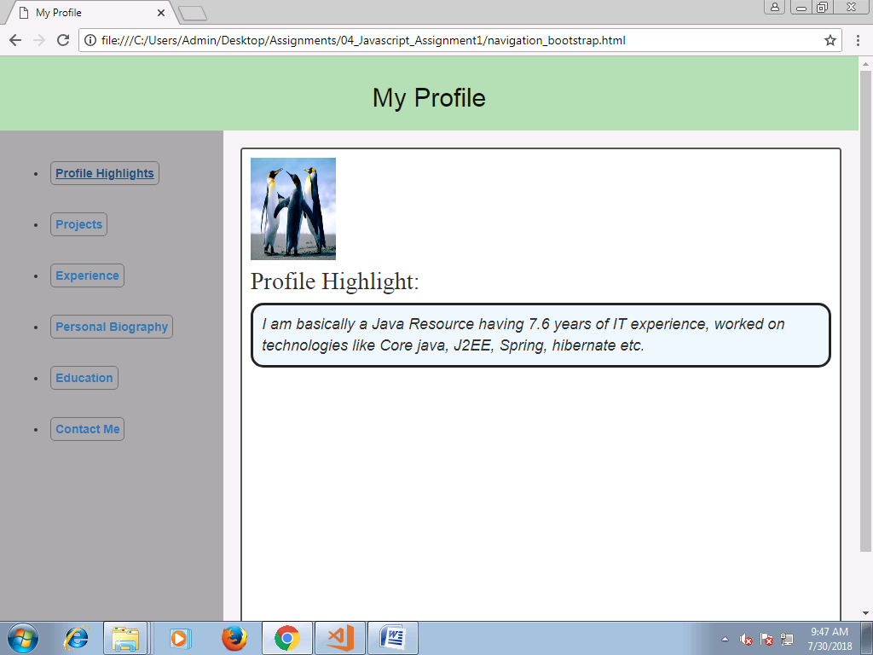

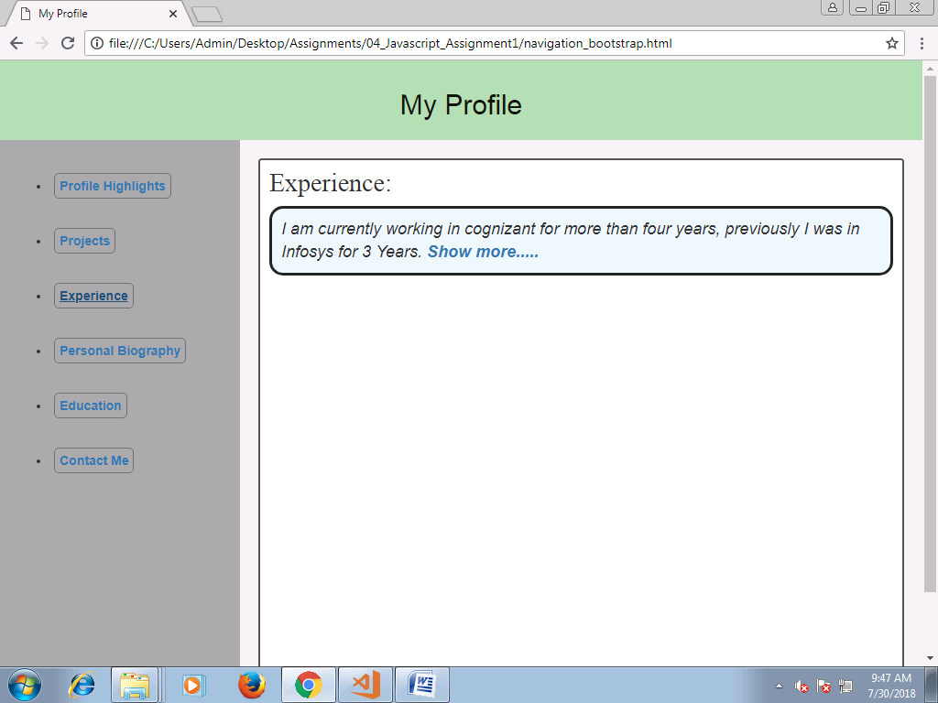

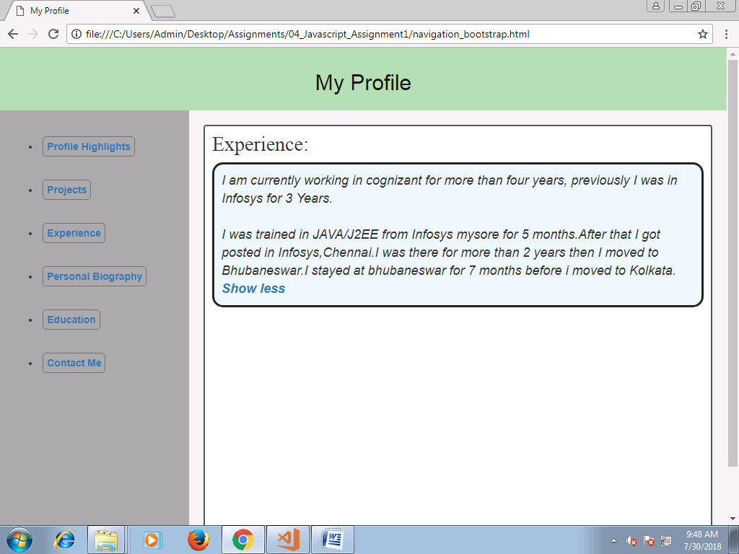

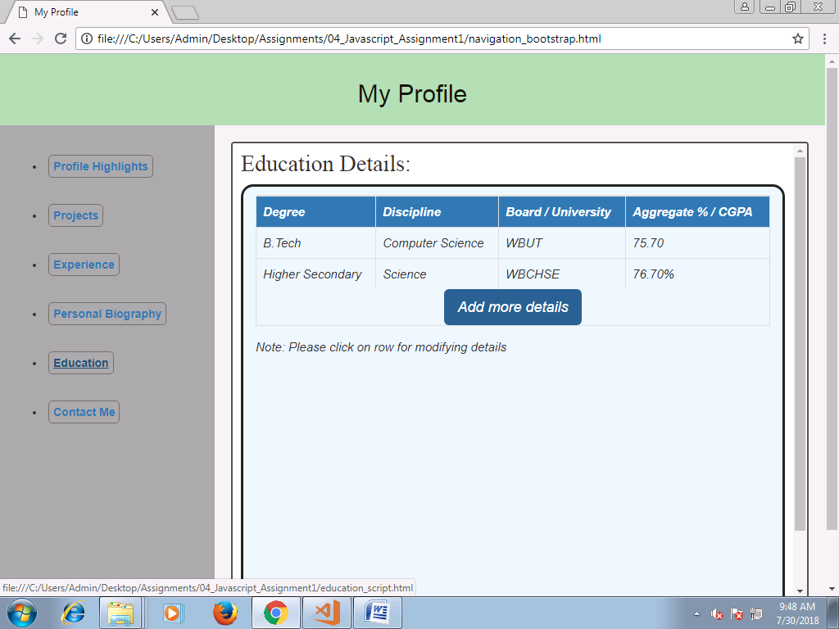

**click on Add more details button**

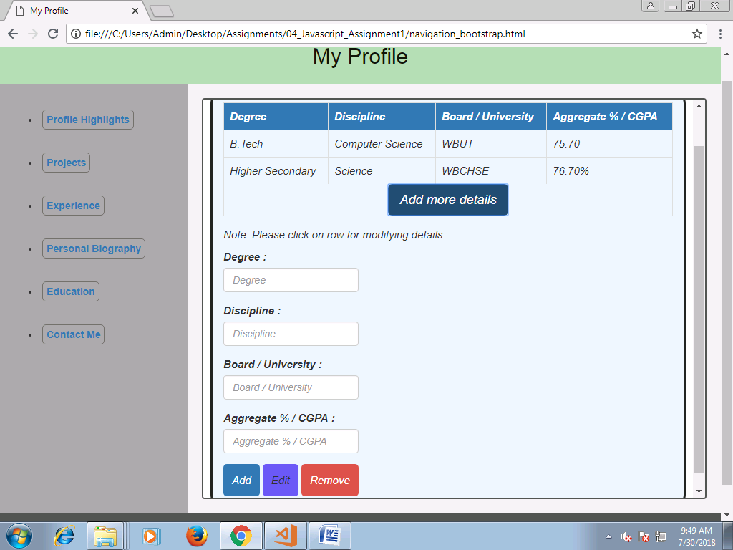

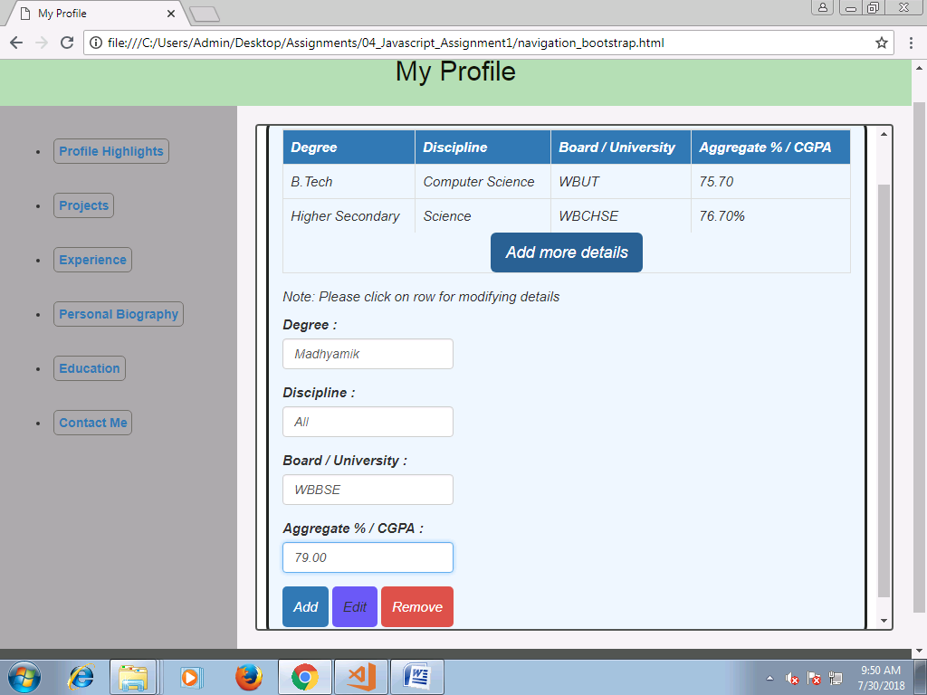

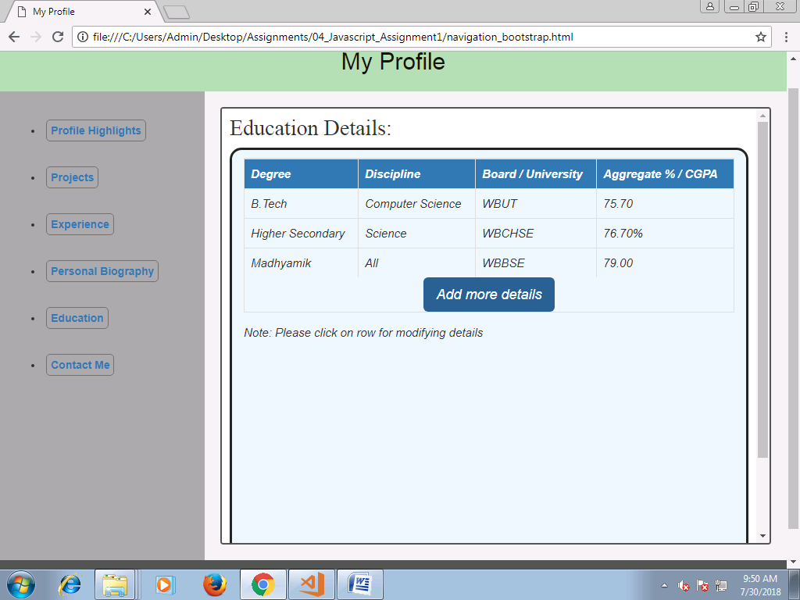

**Clicking on the row for modifying the details**

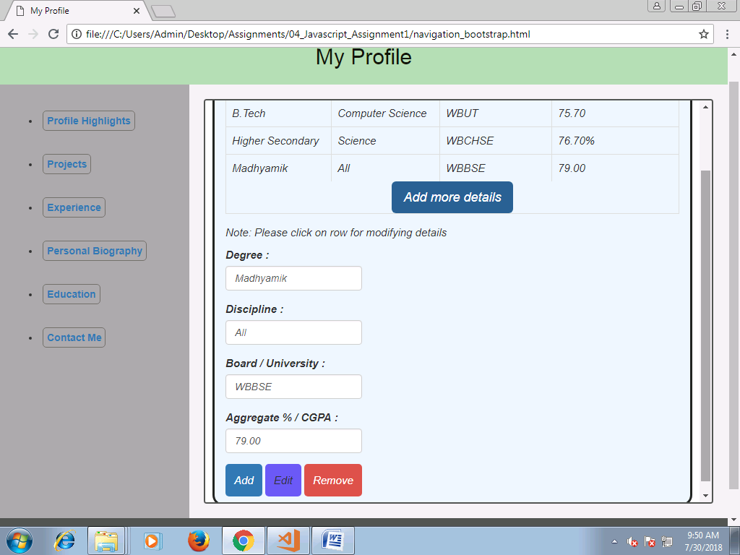

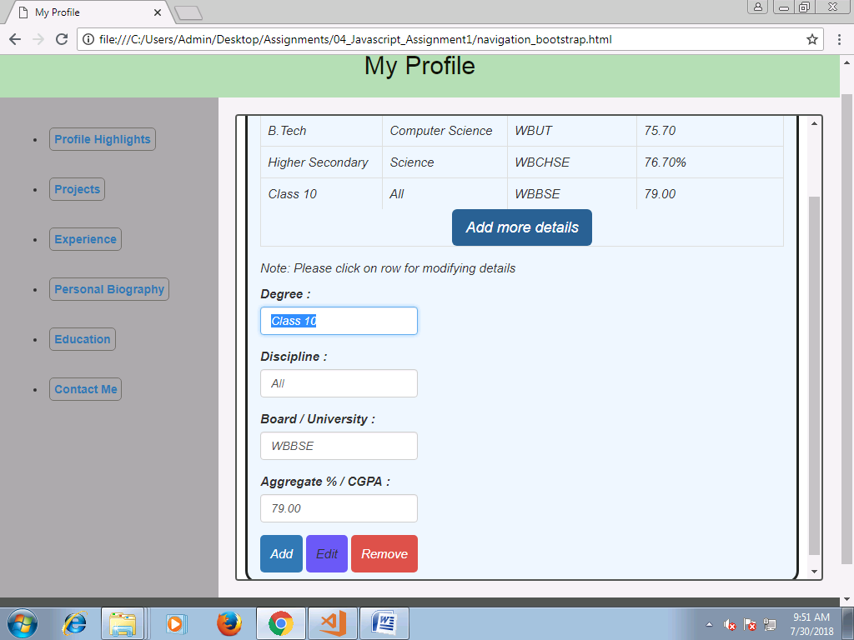

**Now Click on Edit button**

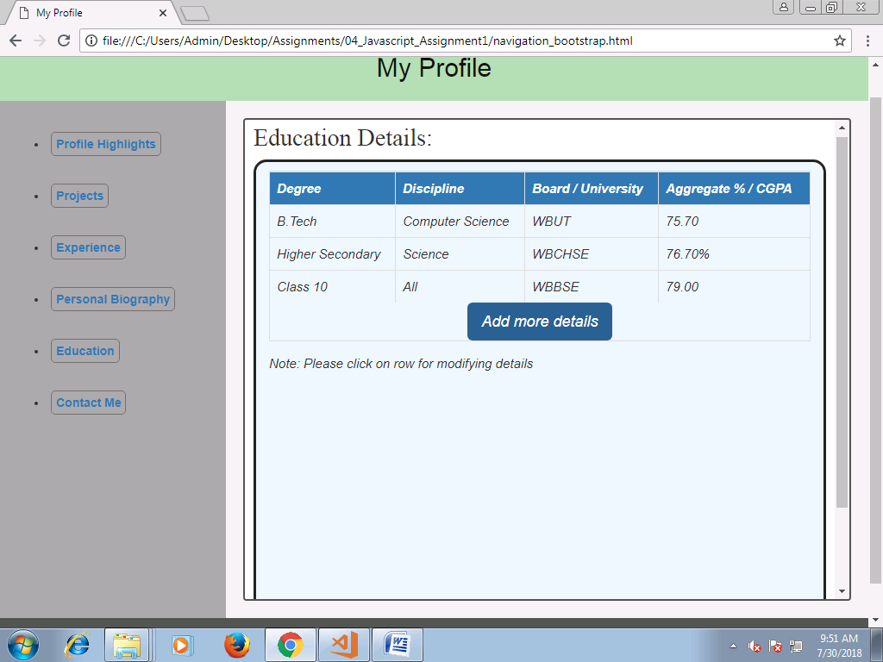

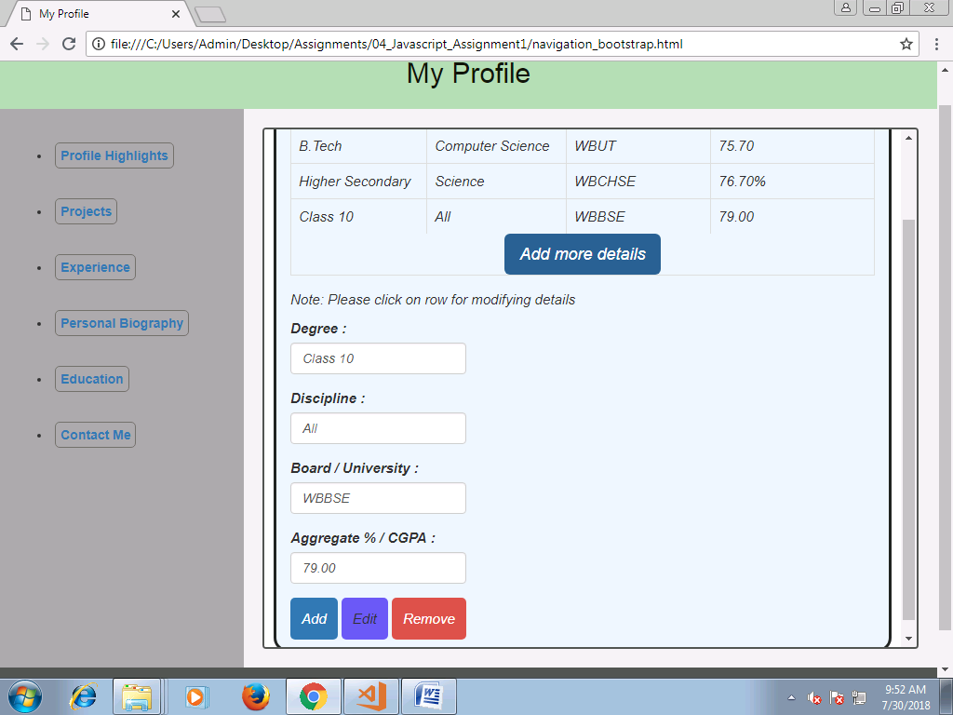

**Now Click on remove button**

