# Book.java

* /**
* *
* */
* package com.cognizant.model;
* import java.io.Serializable;
* import java.time.LocalDate;
* import javax.persistence.Column;
* import javax.persistence.Entity;
* import javax.persistence.GeneratedValue;
* import javax.persistence.GenerationType;
* import javax.persistence.Id;
* import javax.persistence.Table;
* import javax.persistence.Transient;
* /**
* * @author Sudhir Kumar Thakur
* *
* */
* @Entity
* @Table(name="book")
* public class Book implements Serializable{
* @Transient
* private static final long serialVersionUID = 3667779253735136971L;
* @Id
* //@GeneratedValue(strategy=GenerationType.AUTO)
* @Column(name="BOOKID")
* private long bookId;
* @Column(name="TITLE")
* private String title;
* @Column(name="PRICE")
* private double price;
* @Column(name="VOLUME")
* private Integer volume;
* @Column(name="PUBLISHDATE")
* private LocalDate publishDate;
* public long getBookId() {
* return bookId;
* }
* public void setBookId(long bookId) {
* this.bookId = bookId;
* }
* public String getTitle() {
* return title;
* }
* public void setTitle(String title) {
* this.title = title;
* }
* public double getPrice() {
* return price;
* }
* public void setPrice(double price) {
* this.price = price;
* }
* public Integer getVolume() {
* return volume;
* }
* public void setVolume(Integer volume) {
* this.volume = volume;
* }
* public LocalDate getPublishDate() {
* return publishDate;
* }
* public void setPublishDate(LocalDate publishDate) {
* this.publishDate = publishDate;
* }
* @Override
* public String toString() {
* return "Book [bookId=" + bookId + ", title=" + title + ", price=" + price + ", volume=" + volume
* + ", publishDate=" + publishDate + "]";
* }
* }

# Subject.java

* package com.cognizant.model;
* import java.io.Serializable;
* import java.util.HashSet;
* import java.util.Set;
* import javax.persistence.Column;
* import javax.persistence.ElementCollection;
* import javax.persistence.Entity;
* import javax.persistence.GeneratedValue;
* import javax.persistence.GenerationType;
* import javax.persistence.Id;
* import javax.persistence.JoinColumn;
* import javax.persistence.JoinTable;
* import javax.persistence.Table;
* import javax.persistence.Transient;
* /**
* * @author Sudhir Kumar Thakur
* *
* */
* @Entity
* @Table(name="subject")
* public class Subject implements Serializable{
* @Transient
* private static final long serialVersionId = 1L;
* @Id
* //@GeneratedValue(strategy=GenerationType.AUTO)
* @Column(name="SUBJECTID")
* private long subjectId;
* @Column(name="SUBTITLE")
* private String subTitle;
* @Column(name="DURATIONINHOURS")
* private int durationInHours;
* @ElementCollection
* @JoinTable(name="SUBJECT_BOOK",
* joinColumns=@JoinColumn(name="SUBJECT_ID")
* ,inverseJoinColumns=@JoinColumn(name="BOOK_ID"))
* private Set<Book> references=new HashSet<Book>();
* public long getSubjectId() {
* return subjectId;
* }
* public void setSubjectId(long subjectId) {
* this.subjectId = subjectId;
* }
* public String getSubTitle() {
* return subTitle;
* }
* public void setSubTitle(String subTitle) {
* this.subTitle = subTitle;
* }
* public int getDurationInHours() {
* return durationInHours;
* }
* public void setDurationInHours(int durationInHours) {
* this.durationInHours = durationInHours;
* }
* public Set<Book> getReferences() {
* return references;
* }
* public void setReferences(Set<Book> references) {
* this.references = references;
* }
* @Override
* public String toString() {
* return "Subject [subjectId=" + subjectId + ", subTitle=" + subTitle + ", durationInHours=" + durationInHours
* + "]";
* }
* }

# EntityDao.java

* package com.cognizant.repository;
* import java.util.List;
* import com.cognizant.model.Book;
* import com.cognizant.model.Subject;
* public interface EntityDao {
* public void addSubject(Subject subject);
* public void addBook(Book book);
* public void deleteSubject(long subjectId);
* public Subject searchSubject(long subjectId);
* public void deleteBook(long bookId);
* public Book searchBook(long bookId);
* public List<Subject> showAllSubjects();
* public List<Book> showAllBooks();
* public List<Book> sortBookByTitle();
* public List<Subject> sortSubjectByTitle();
* public List<Book> sortBookByPublishDate();
* }

# EntityDaoImpl.java

* package com.cognizant.repository;
* import java.util.List;
* import org.hibernate.Criteria;
* import org.hibernate.HibernateException;
* import org.hibernate.Session;
* import org.hibernate.SessionFactory;
* import org.hibernate.cfg.Configuration;
* import org.hibernate.criterion.Order;
* import com.cognizant.model.Book;
* import com.cognizant.model.Subject;
* public class EntityDaoImpl implements EntityDao {
* private SessionFactory sessionFactory;
* public EntityDaoImpl() {
* setSessionFactory(new Configuration().configure().buildSessionFactory());
* }
* public SessionFactory getSessionFactory() {
* return sessionFactory;
* }
* public void setSessionFactory(SessionFactory sessionFactory) {
* this.sessionFactory = sessionFactory;
* }
* @Override
* public void addSubject(Subject subject) {
* Session session = null;
* try {
* session = sessionFactory.openSession();
* session.beginTransaction();
* session.save(subject);
* session.getTransaction().commit();
* } catch (HibernateException e) {
* e.printStackTrace();
* } finally {
* closeSession(session);
* }
* }
* @Override
* public void addBook(Book book) {
* Session session = null;
* try {
* session = sessionFactory.openSession();
* session.beginTransaction();
* session.save(book);
* session.getTransaction().commit();
* } catch (HibernateException e) {
* e.printStackTrace();
* } finally {
* closeSession(session);
* }
* }
* @Override
* public void deleteSubject(long subjectId) {
* Session session = null;
* try {
* session = sessionFactory.openSession();
* session.beginTransaction();
* Subject subject = session.load(Subject.class, subjectId);
* session.delete(subject);
* session.getTransaction().commit();
* } catch (HibernateException e) {
* e.printStackTrace();
* } finally {
* closeSession(session);
* }
* }
* @Override
* public Subject searchSubject(long subjectId) {
* Session session = null;
* Subject subject = null;
* try {
* session = sessionFactory.openSession();
* subject = session.get(Subject.class, subjectId);
* } catch (HibernateException e) {
* e.printStackTrace();
* } finally {
* closeSession(session);
* }
* return subject;
* }
* @Override
* public void deleteBook(long bookId) {
* Session session = null;
* try {
* session = sessionFactory.openSession();
* session.beginTransaction();
* Book book = session.load(Book.class, bookId);
* session.delete(book);
* session.getTransaction().commit();
* } catch (HibernateException e) {
* e.printStackTrace();
* } finally {
* closeSession(session);
* }
* }
* @Override
* public Book searchBook(long bookId) {
* Session session = null;
* Book book = null;
* try {
* session = sessionFactory.openSession();
* book = session.get(Book.class, bookId);
* } catch (HibernateException e) {
* e.printStackTrace();
* } finally {
* closeSession(session);
* }
* return book;
* }
* @Override
* public List<Subject> showAllSubjects() {
* Session session = null;
* List<Subject> subjectList = null;
* try {
* session = sessionFactory.openSession();
* Criteria subjectCriteria = session.createCriteria(Subject.class);
* subjectList = subjectCriteria.list();
* } catch (HibernateException e) {
* e.printStackTrace();
* } finally {
* closeSession(session);
* }
* return subjectList;
* }
* @Override
* public List<Book> showAllBooks() {
* Session session = null;
* List<Book> bookList = null;
* try {
* session = sessionFactory.openSession();
* Criteria bookCriteria = session.createCriteria(Book.class);
* bookList = bookCriteria.list();
* } catch (HibernateException e) {
* e.printStackTrace();
* } finally {
* closeSession(session);
* }
* return bookList;
* }
* @Override
* public List<Book> sortBookByTitle() {
* Session session = null;
* List<Book> bookList = null;
* try {
* session = sessionFactory.openSession();
* Criteria bookCriteria = session.createCriteria(Book.class).addOrder(Order.asc("title"));
* bookList = bookCriteria.list();
* } catch (HibernateException e) {
* e.printStackTrace();
* } finally {
* closeSession(session);
* }
* return bookList;
* }
* @Override
* public List<Subject> sortSubjectByTitle() {
* Session session = null;
* List<Subject> subjectList = null;
* try {
* session = sessionFactory.openSession();
* Criteria subjectCriteria = session.createCriteria(Subject.class).addOrder(Order.asc("subTitle"));
* subjectList = subjectCriteria.list();
* } catch (HibernateException e) {
* e.printStackTrace();
* } finally {
* closeSession(session);
* }
* return subjectList;
* }
* @Override
* public List<Book> sortBookByPublishDate() {
* Session session = null;
* List<Book> bookList = null;
* try {
* session = sessionFactory.openSession();
* Criteria bookCriteria = session.createCriteria(Book.class).addOrder(Order.asc("publishDate"));
* bookList = bookCriteria.list();
* } catch (HibernateException e) {
* e.printStackTrace();
* } finally {
* closeSession(session);
* }
* return bookList;
* }
* public void closeSession(Session session) {
* // session.flush();
* session.close();
* }
* }

# Application.java

* package com.cognizant;
* import java.io.BufferedReader;
* import java.io.IOException;
* import java.io.InputStreamReader;
* import java.time.LocalDate;
* import com.cognizant.model.Book;
* import com.cognizant.model.Subject;
* import com.cognizant.repository.EntityDao;
* import com.cognizant.repository.EntityDaoImpl;
* /**
* * @author Sudhir Kumar Thakur
* *
* */
* public class Application {
* private EntityDao entityDao;
* Application() {
* this.entityDao = new EntityDaoImpl();
* while (true) {
* System.out.println("\n");
* System.out.println("1.Add a Subject");
* System.out.println("2.Add a Book");
* System.out.println("3.Delete a Subject");
* System.out.println("4.Delete a book");
* System.out.println("5.Search for a subject");
* System.out.println("6.Search for a book");
* System.out.println("7.Sort Book by Title");
* System.out.println("8.Sort Subject by Subject Title");
* System.out.println("9.Sort Books by publish Date");
* System.out.println("10.Show All");
* System.out.println("11.Exit");
* String input = gatValFromConsole("please select menu items::::::::::::::::");
* select(Integer.parseInt(input));
* }
* }
* public static void main(String[] args) {
* new Application();
* }
* public void select(int i) {
* switch(i) {
* case 1: entityDao.addSubject(addSubject());
* break;
* case 2: entityDao.addBook(addBook());
* break;
* case 3: entityDao.deleteSubject(deleteSubject());
* break;
* case 4: entityDao.deleteBook(deleteBook());
* break;
* case 5: Subject subject=entityDao.searchSubject(searchSubject());
* System.out.println("Result :"+subject);
* break;
* case 6: Book book=entityDao.searchBook(searchBook());
* System.out.println("Result :"+book);
* break;
* case 7: sortBookByTitle();
* break;
* case 8: sortSubjectByTitle();
* break;
* case 9: sortBookByPublishDate();
* break;
* case 10: showAll();
* break;
* case 11: exit();
* break;
* }
* }
* private void sortBookByTitle() {
* System.out.println("\n");
* System.out.println("<------Book List Sort by book title------->");
* entityDao.sortBookByTitle().stream().forEach(System.out::println);
* }
* private void sortSubjectByTitle() {
* System.out.println("\n");
* System.out.println("<------Subject List Sort by Subject Title------->");
* entityDao.sortSubjectByTitle().stream().forEach(System.out::println);
* }
* private void sortBookByPublishDate() {
* System.out.println("\n");
* System.out.println("<------Book List Sort by Publish Date------->");
* entityDao.sortBookByPublishDate().stream().forEach(System.out::println);
* }
* private void showAll() {
* System.out.println("\n");
* System.out.println("<------Total Subject List------->");
* entityDao.showAllSubjects().stream().forEach(System.out::println);
* System.out.println("\n");
* System.out.println("<------Total Book List------->");
* entityDao.showAllBooks().stream().forEach(System.out::println);
* }
* private Subject addSubject() {
* Subject subject = new Subject();;
* subject.setSubjectId(Long.parseLong(gatValFromConsole("enter subject id")));
* subject.setSubTitle(gatValFromConsole("enter subject title"));
* subject.setDurationInHours(Integer.parseInt(gatValFromConsole("enter duration (In Hours)")));
* System.out.println(subject.toString());
* return subject;
* }

* private long deleteSubject() {
* long subjectId=Long.parseLong(gatValFromConsole("enter the subject id to be deleted"));
* return subjectId;
* }
* private long searchSubject() {
* long subjectId=Long.parseLong(gatValFromConsole("enter the subject id for search"));
* return subjectId;
* }

* private Book addBook() {
* Book book = new Book();
* book.setBookId(Long.parseLong(gatValFromConsole("enter book id")));
* book.setTitle(gatValFromConsole("enter book title"));
* book.setPrice(Integer.parseInt(gatValFromConsole("enter book price")));
* book.setVolume(Integer.parseInt(gatValFromConsole("enter book volume")));
* book.setPublishDate(LocalDate.parse(gatValFromConsole("enter book publish date(yyyy-mm-dd) ")));
* System.out.println(book.toString());
* return book;
* }

* private long deleteBook() {
* long bookId=Long.parseLong(gatValFromConsole("enter the book id to be deleted"));
* return bookId;
* }

* private long searchBook() {
* long bookId=Long.parseLong(gatValFromConsole("enter the book id for search "));
* return bookId;
* }
* private String gatValFromConsole(String log) {
* System.out.println(log);
* String inputString = "";
* try {
* BufferedReader bufferRead = new BufferedReader(new InputStreamReader(System.in));
* inputString = bufferRead.readLine();
* } catch (IOException ex) {
* ex.printStackTrace();
* }
* return inputString;
* }

* private void exit() {
* System.exit(0);
* }
* }

# hibernate.cfg.xml

* <?xml version=*'1.0'* encoding=*'utf-8'*?>
* <!DOCTYPE hibernate-configuration PUBLIC
* "-//Hibernate/Hibernate Configuration DTD//EN"
* "http://www.hibernate.org/dtd/hibernate-configuration-3.0.dtd">
* <hibernate-configuration>
* <session-factory>
* <property name=*"hibernate.connection.driver_class"*>com.mysql.jdbc.Driver</property>
* <property name=*"hibernate.connection.url"*>jdbc:mysql://localhost:3306/fsd_hibernate_db</property>
* <property name=*"hibernate.connection.username"*>root</property>
* <property name=*"hibernate.connection.password"*>pass@word1</property>
* <property name=*"hibernate.dialect"*>org.hibernate.dialect.MySQL5InnoDBDialect</property>
* <property name=*"hibernate.hbm2ddl.auto"*>update</property>
* <property name=*"show_sql"*>false</property>
* <mapping class=*"com.cognizant.model.Book"*/>
* <mapping class=*"com.cognizant.model.Subject"*/>
* </session-factory>
* </hibernate-configuration>

**Screenshots**

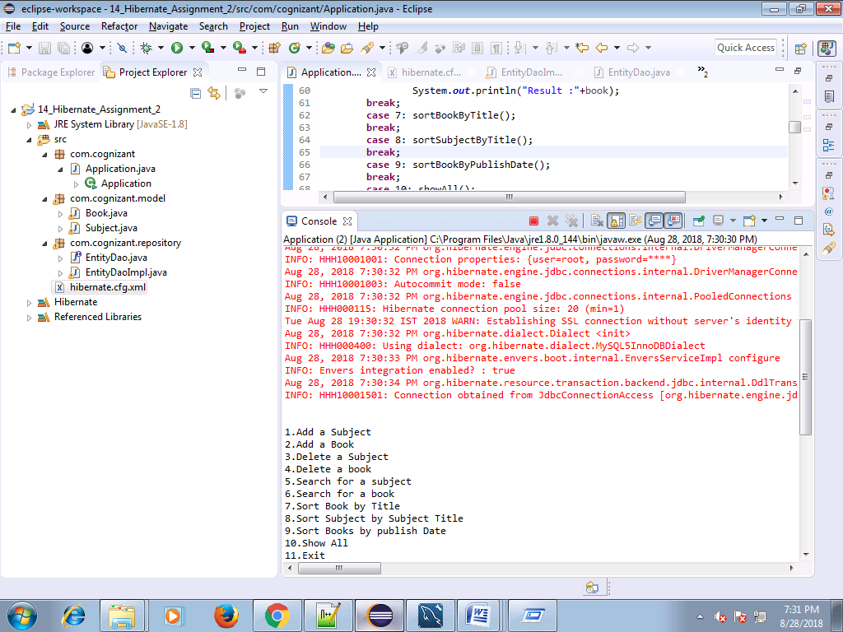

**Sort Book by Title**

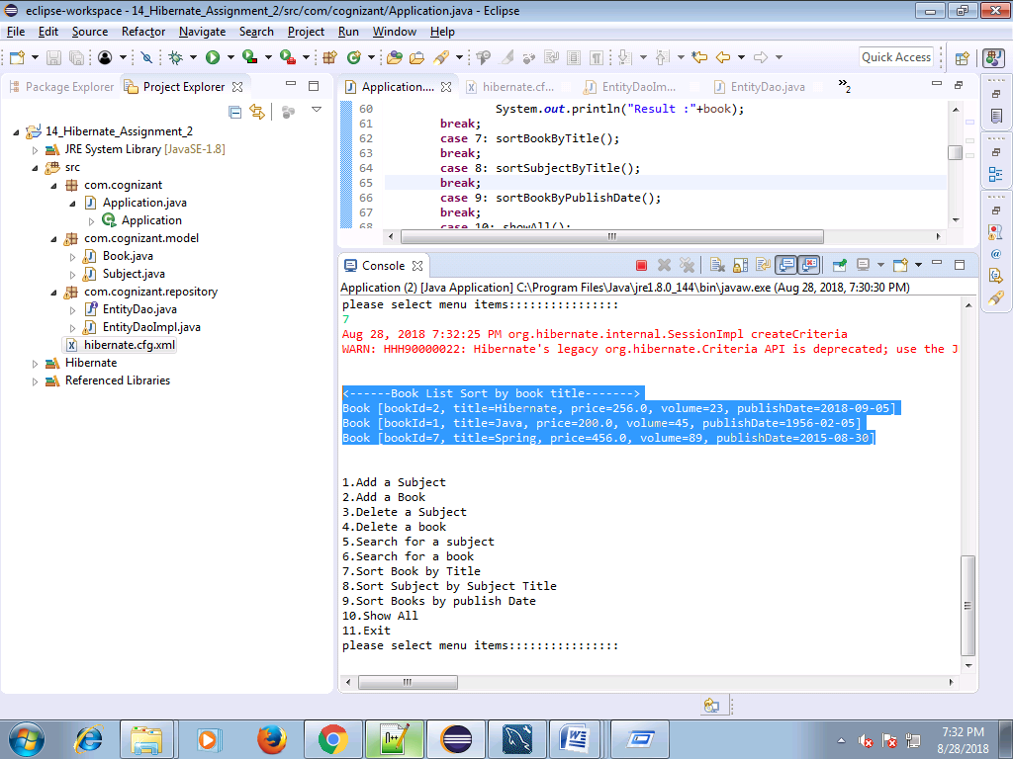

**Sort Subject By Subject Title**

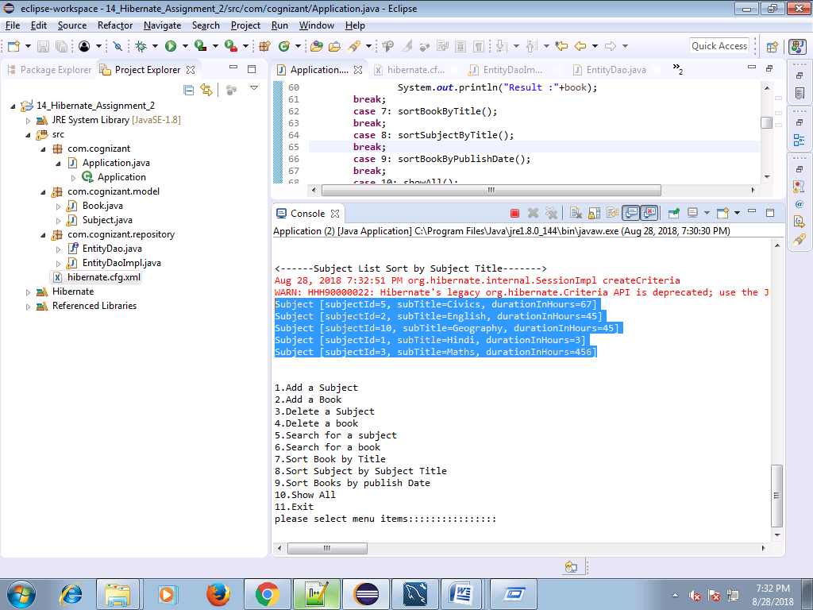

**Sort Book By Publish Date**

