CLI Commands:

Git global setup

git config --global user.name "Mayukh Ghosh"

git config --global user.email "mayukhghosh4@gmail.com"

adding the project to created folder and commiting the code.

cd existing_folder

git init

git remote add origin http://172.18.2.18/mayukhgh/Test-project.git

git add .

git commit -m "Initial commit"

git push -u origin master

URL :

http://172.18.2.18/mayukhgh/29_git_assignment

Steps followed:

1. Git registration

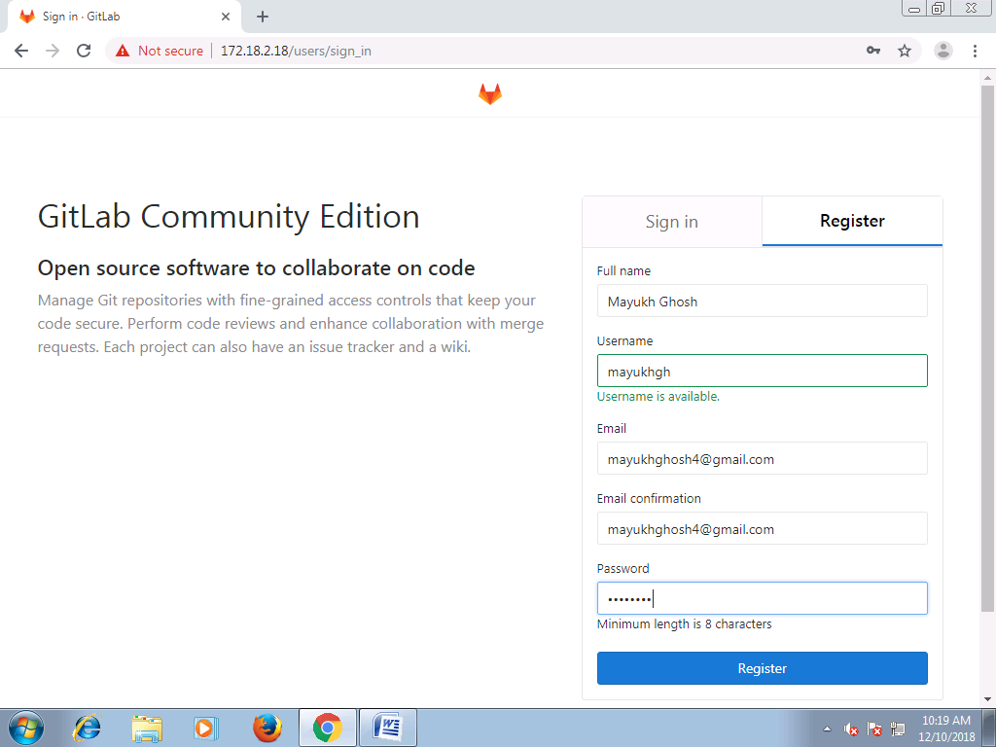

2. Creating blank project folder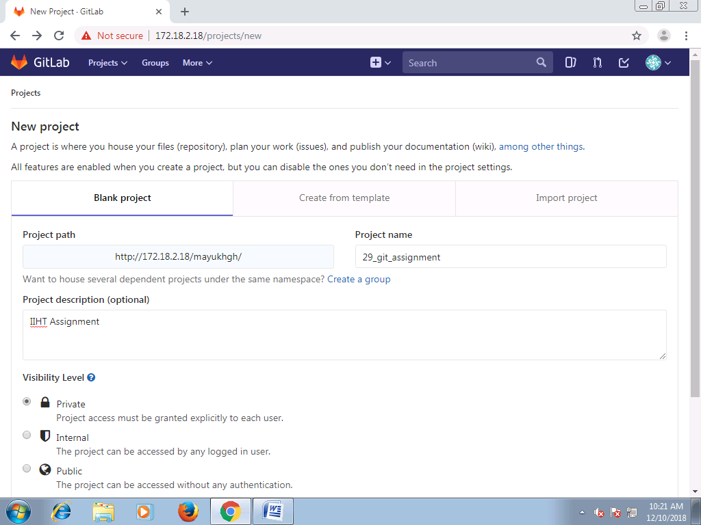

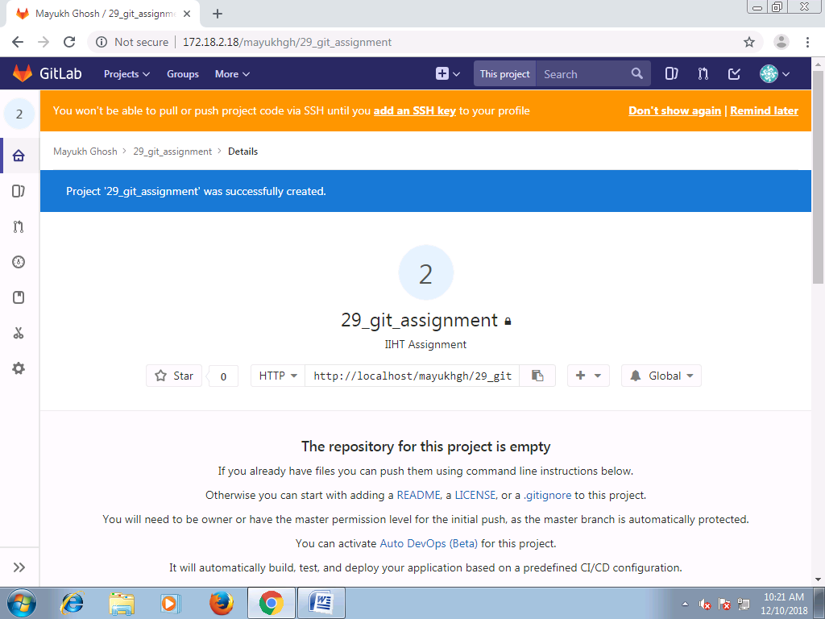

3. Git global setup using cli command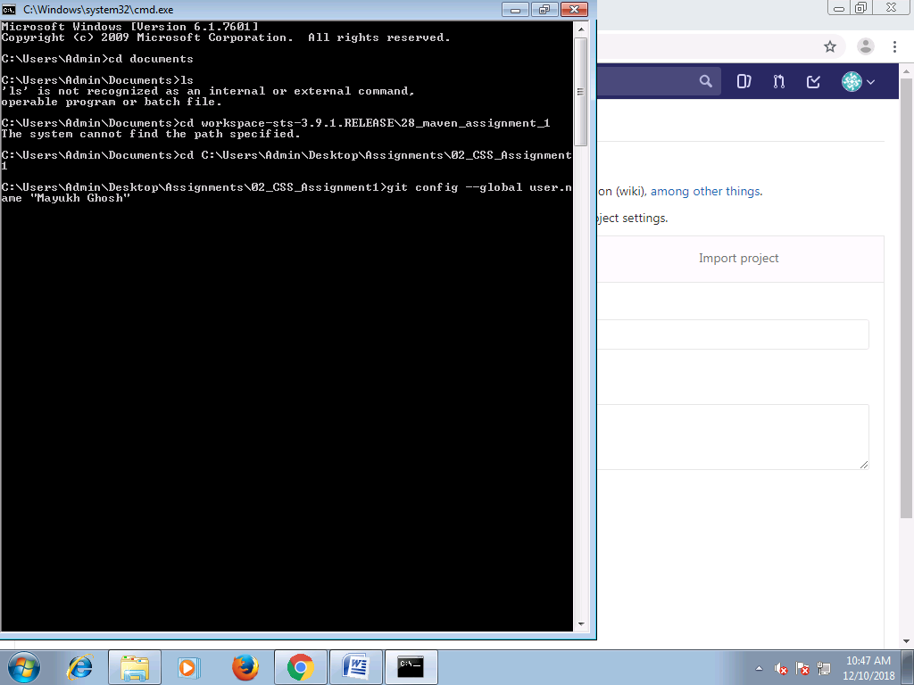

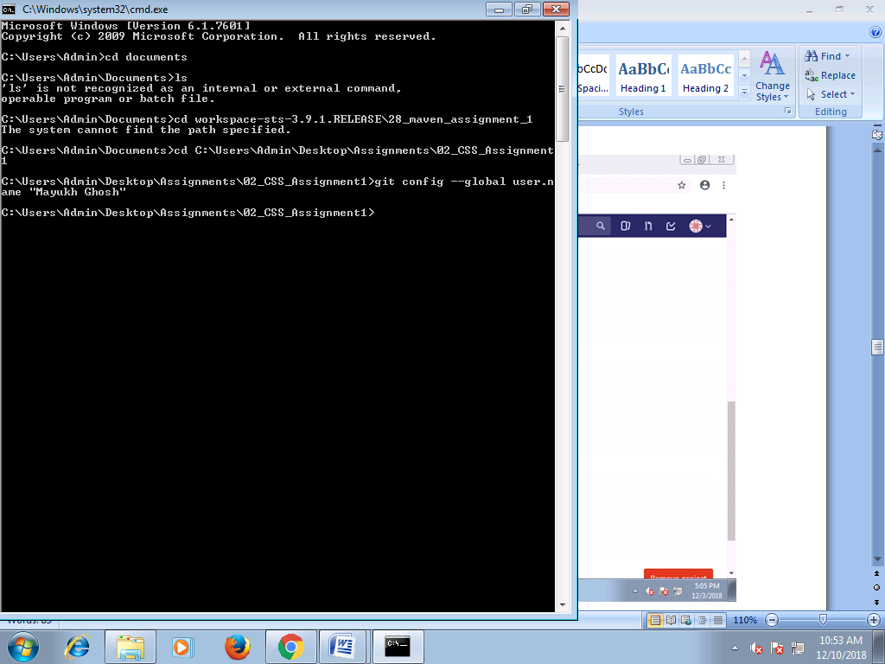

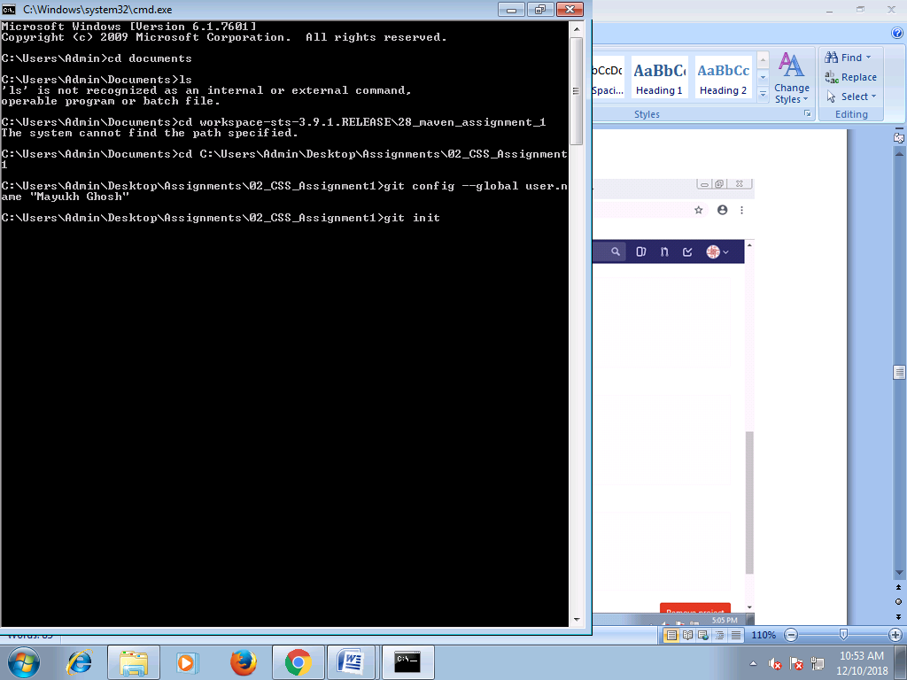

4. Adding the project from local workspace to Git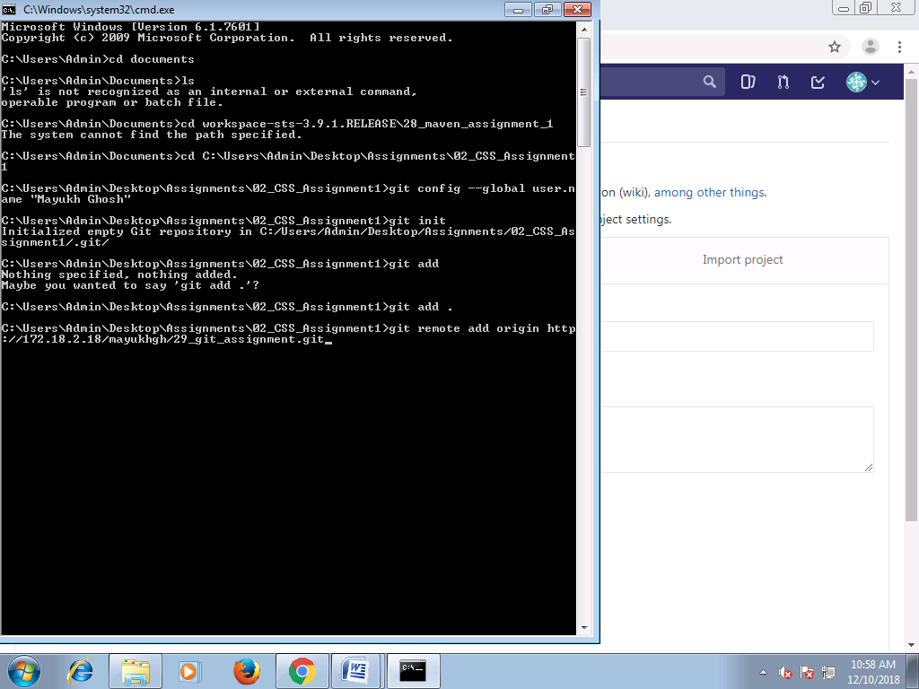

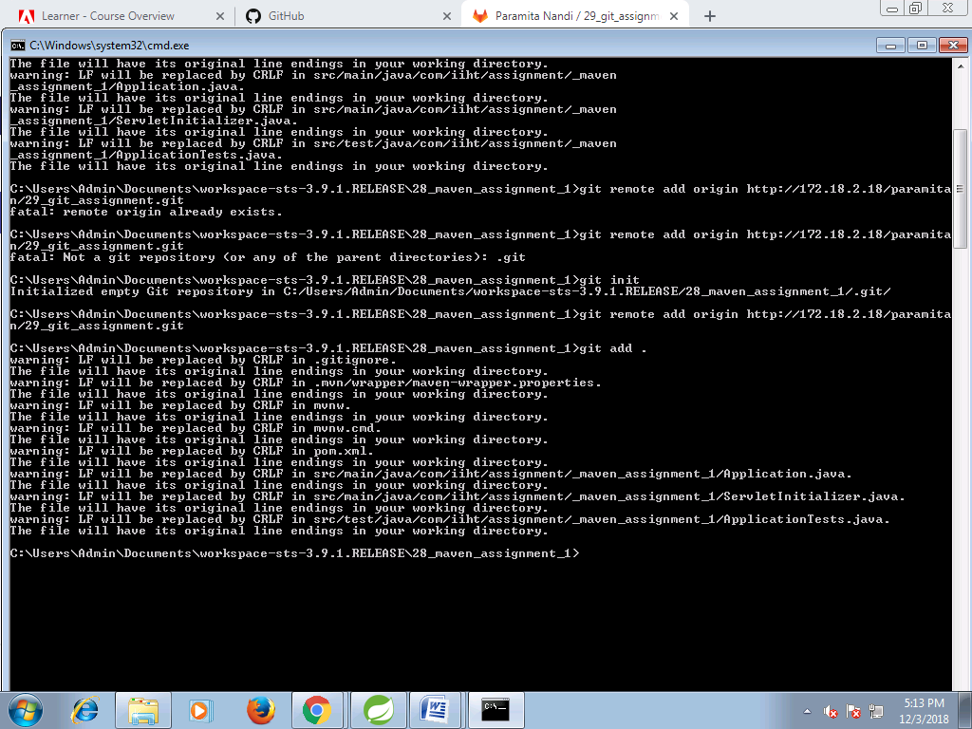

5. Committing the project