**Project Structure:**

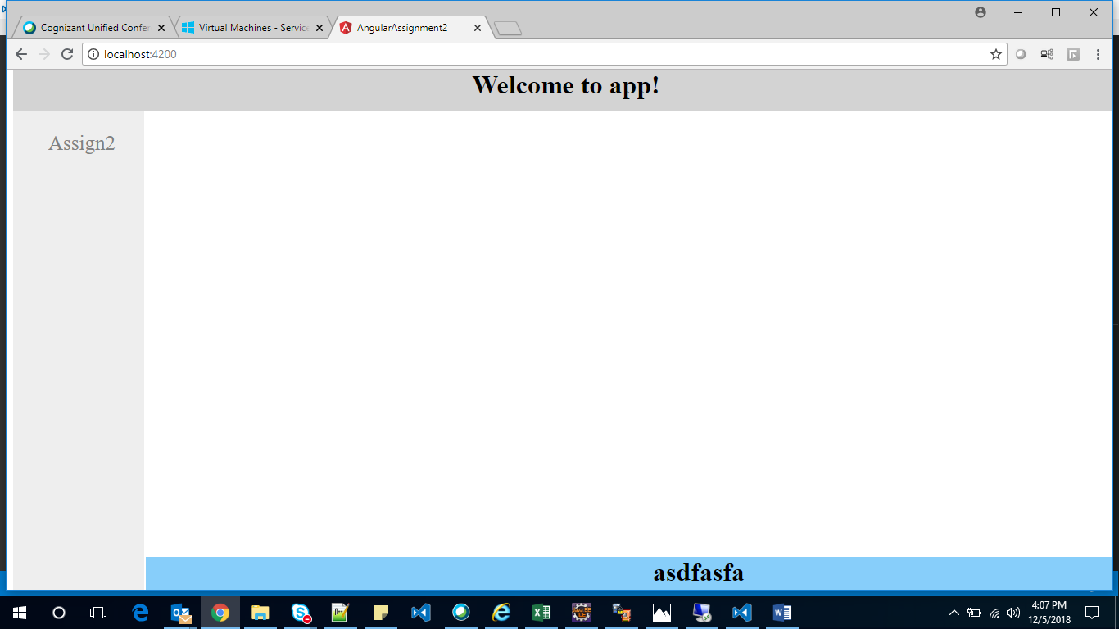

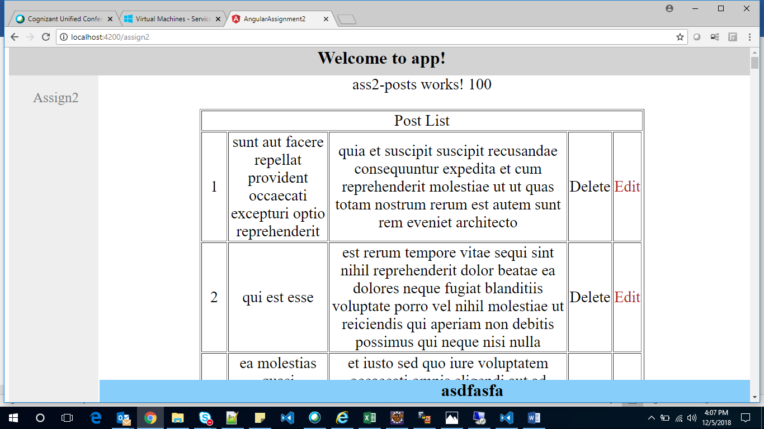

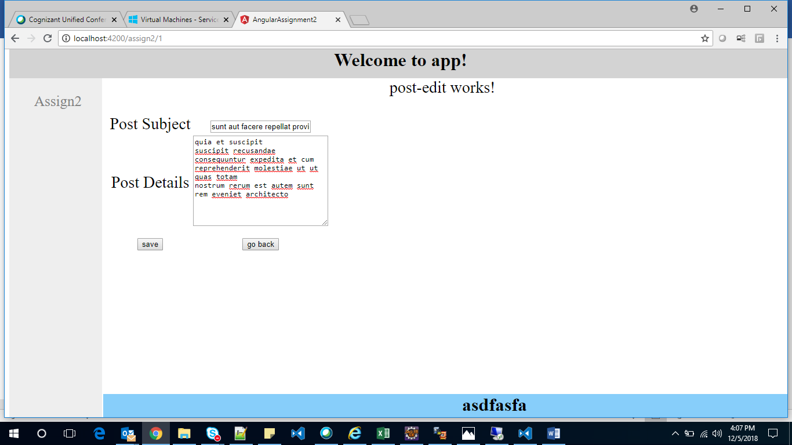

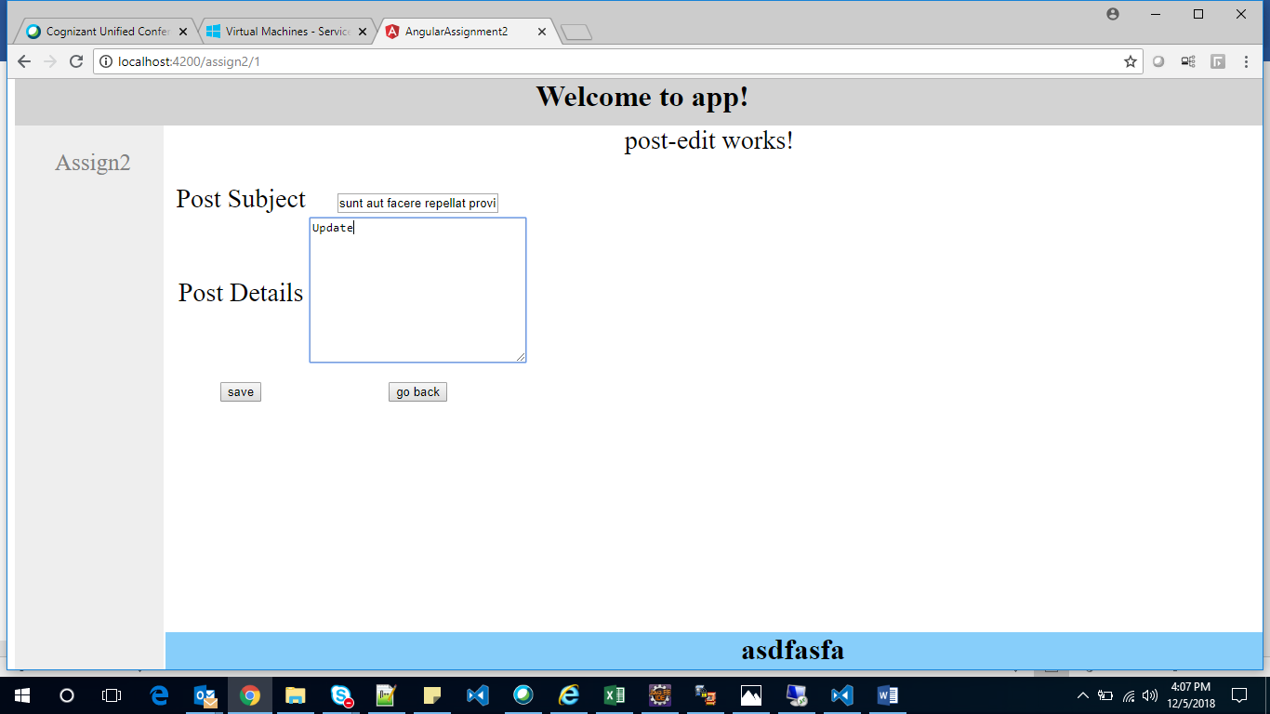

Update:

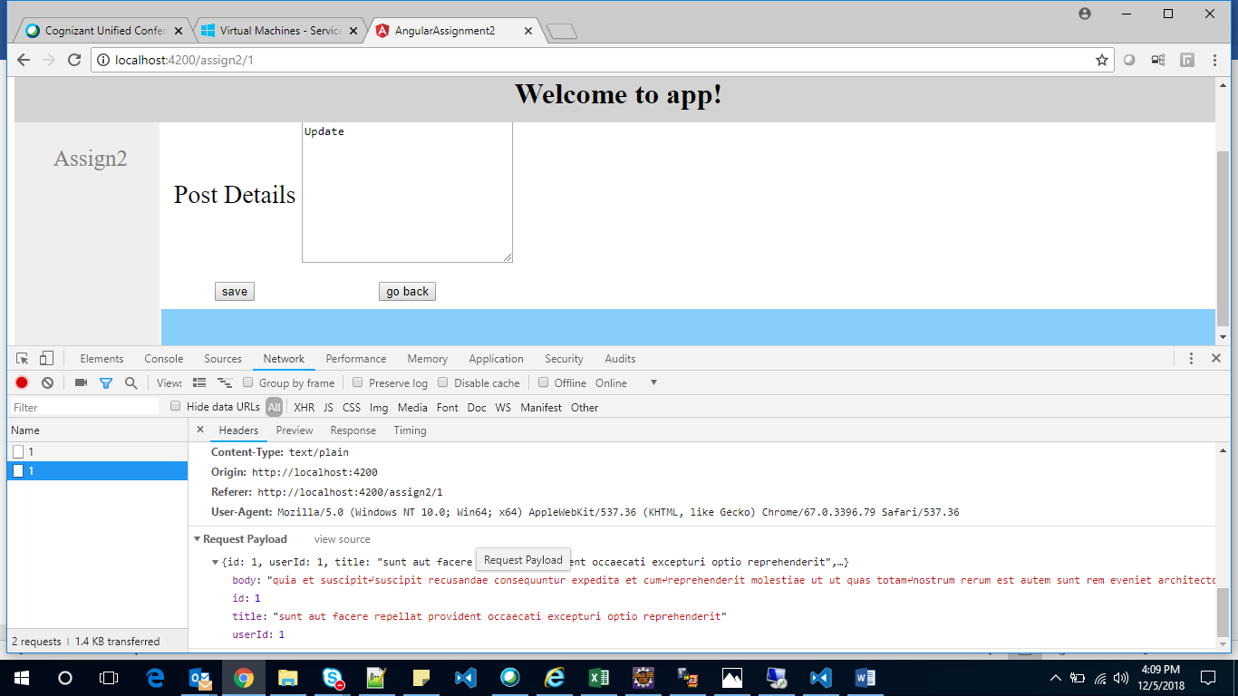

Delete:

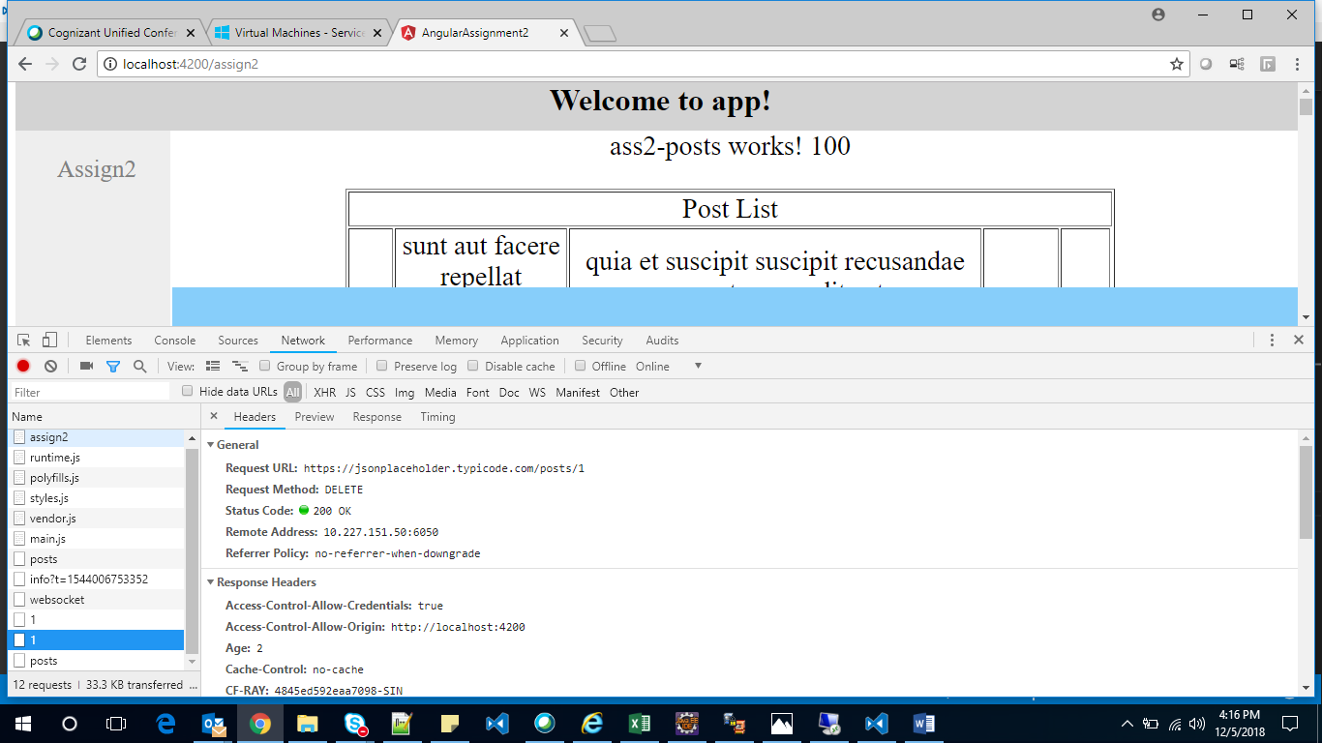

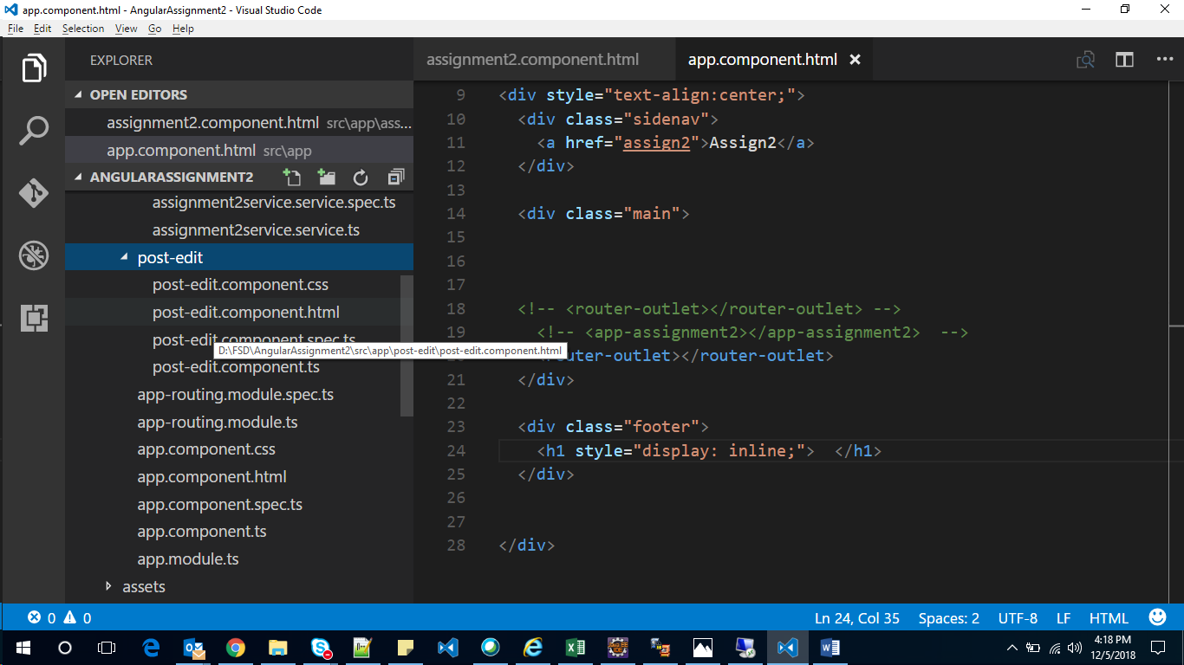

**app.module.ts**

import { BrowserModule } from '@angular/platform-browser';

import { NgModule } from '@angular/core';

import { AppComponent } from './app.component';

import { Assignment2Component } from './assignment2/assignment2.component';

import { HttpClientModule } from '@angular/common/http';

import { AppRoutingModule } from './/app-routing.module';

import { PostEditComponent } from './post-edit/post-edit.component';

@NgModule({

declarations: [

AppComponent,

Assignment2Component,

PostEditComponent

],

imports: [

BrowserModule,

HttpClientModule,

AppRoutingModule,

],

providers: [],

bootstrap: [AppComponent]

})

export class AppModule { }

**app.component.html**

<!--The content below is only a placeholder and can be replaced.-->

<div class="header" style="text-align:center;background-color:lightgrey;">

<h1 style="display: inline;">

Welcome to {{ title }}!

</h1>

</div>

<div style="text-align:center;">

<div class="sidenav">

<a href="assign2">Assign2</a>

</div>

<div class="main">

<!-- <router-outlet></router-outlet> -->

<!-- <app-assignment2></app-assignment2> -->

<router-outlet></router-outlet>

</div>

<div class="footer">

<h1 style="display: inline;"> </h1>

</div>

</div>

**app-routing.module.ts**

import { NgModule } from '@angular/core';

import { CommonModule } from '@angular/common';

import { RouterModule, Routes } from '@angular/router';

import { Assignment2Component } from './assignment2/assignment2.component';

import { PostEditComponent } from './post-edit/post-edit.component';

const routes: Routes = [

{ path: 'assign2', component: Assignment2Component },

{ path: 'assign2/:id', component: PostEditComponent }

];

@NgModule({

imports: [

CommonModule,

RouterModule.forRoot(routes),

],

exports: [ RouterModule ]

})

export class AppRoutingModule { }

**post-edit.component.ts**

import { Component, OnInit } from '@angular/core';

import { ActivatedRoute } from '@angular/router';

import { Assignment2serviceService } from '../assignment2/assignment2service.service';

import { Location } from '@angular/common';

@Component({

selector: 'app-post-edit',

templateUrl: './post-edit.component.html',

styleUrls: ['./post-edit.component.css']

})

export class PostEditComponent implements OnInit {

id;

// postId:number;

// postSubject:string;

// postDetails:string;

postData = {

id: '',

userId: '',

title: '',

body: ''

}

constructor(private route: ActivatedRoute,

private location: Location,

private ass2Service: Assignment2serviceService

) { }

ngOnInit() {

let id = this.route.snapshot.paramMap.get('id');

this.id = id;

alert(id);

if( id == "0"){

return

}

this.getHero(id);

}

getHero(id): void {

// const id = this.route.snapshot.paramMap.get('id');

this.ass2Service.getPost(id).then(response => {

this.postData.title = response["title"];

this.postData.body = response["body"];

this.postData.id = response["id"];

this.postData.userId = response["userId"];

alert(JSON.stringify(this.postData));

});

}

save(): void {

this.ass2Service.saveData(this.postData, this.postData.id).then(response => {

alert(JSON.stringify(response));

alert(" Saved sucessfully ");

});

}

goBack(): void {

this.location.back();

}

}

**post-edit.component.html**

<p>

post-edit works!

</p>

<table>

<tr>

<td> Post Subject </td>

<td> <input type="text" name="subject" value={{postData.title}}> </td>

</tr>

<tr>

<td> Post Details </td>

<td> <textarea name="message" rows="10" cols="30" value={{postData.body}}></textarea> </td>

</tr>

<tr>

<td colspan="1">

<!-- <input type="submit" > -->

<button (click)="save()">save</button>

</td>

<td>

<button (click)="goBack()">go back</button>

</td>

</tr>

</table>