1. Project Manager UI Docker Configuration

##Dockerfile.txt

FROM node:latest

ENV WEBAPI_DOMAIN=172.18.2.50

ENV WEBAPI_PORT=4200

ENV WEBAPI_PATH=/projectmanager/webapi/users

# Create app directory

WORKDIR /usr/src/projectmanagerUI

# Install app dependencies

# A wildcard is used to ensure both package.json AND package-lock.json are copied

# where available (npm@5+)

#COPY package*.json ./

#RUN npm install

# If you are building your code for production

# RUN npm install --only=production

# Bundle app source

COPY . .

EXPOSE 4200

CMD [ "npm", "start" ]

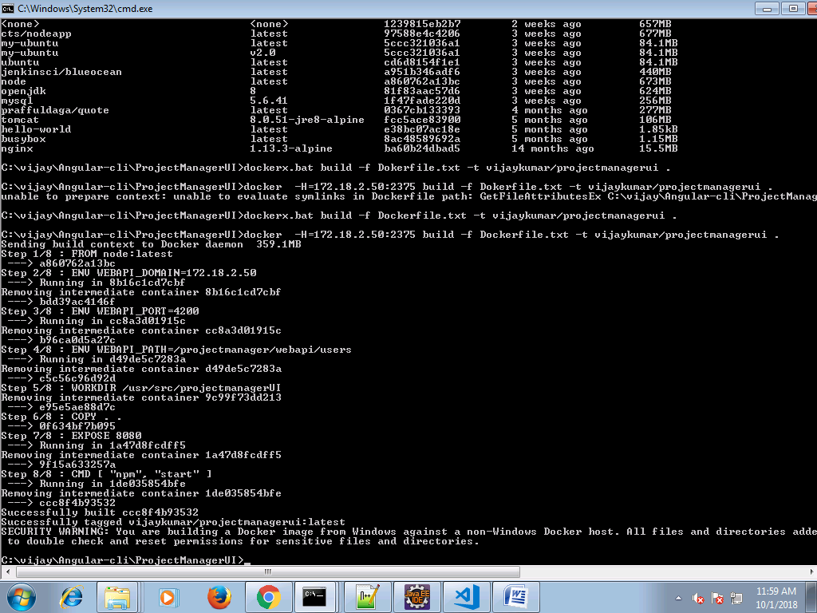

2. Project Manager api Server image

##Dockerfile.txt

from tomcat:8.0.51-jre8-alpine

ENV MONGO_CI_URL=172.18.2.50

ENV MONGO_CI_PORT=27017

ENV MONGO_CLI_DB=projectManagerDB

copy . /usr/src/projectmanagerAPI

workdir /usr/src/projectmanagerAPI

add ./target/projectmanager.war /usr/local/tomcat/webapps/projectmanager.war

expose 8080

CMD ["catalina.sh", "run"]

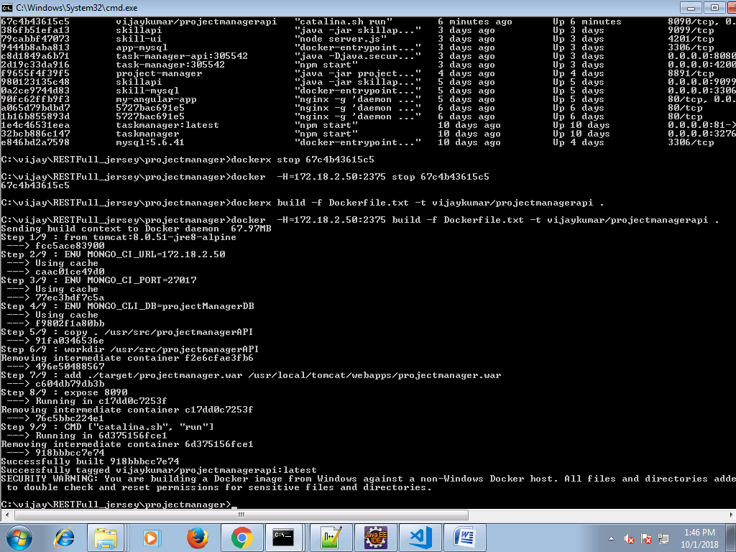

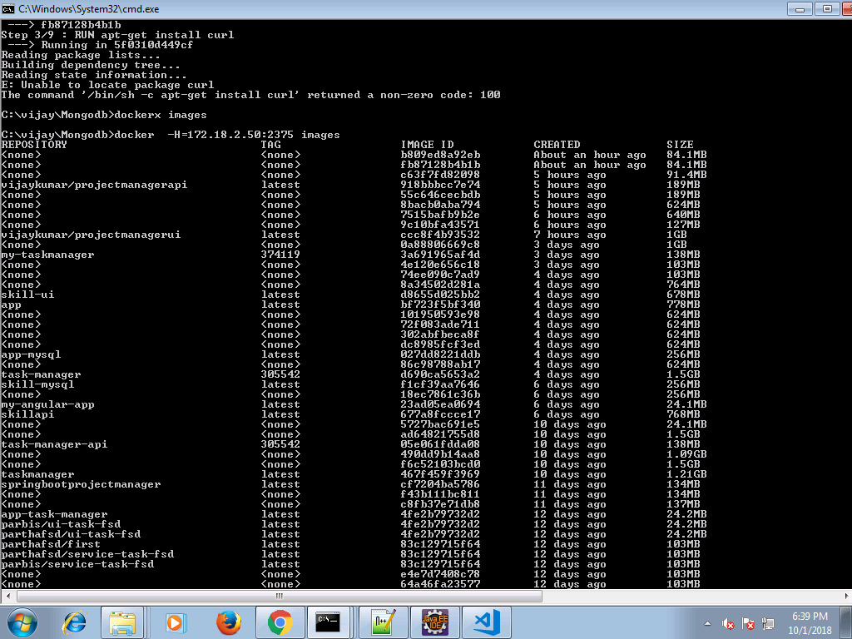

3. Docker - Compose .yml

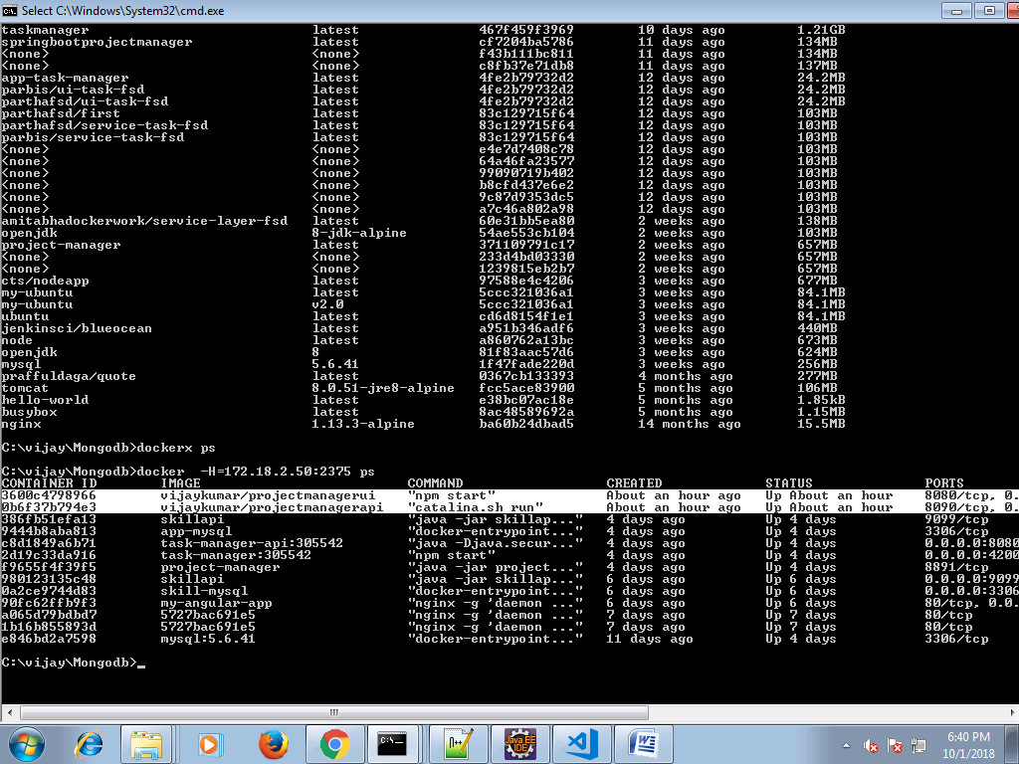

version: '3.1'

services:

web:

image: vijaykumar/projectmanagerui

restart: always

container_name: projectmanagerui

ports:

- 8080:4200

javaapp:

image: vijaykumar/projectmanagerapi

restart: always

container_name: projectmanagerapi

ports:

- 8090:8080

depends_on:

- vijaykumar/mongodb

mongo:

image: vijaykumar/mongodb

container_name: mongodb

# ports: # for demo/debug purpose only

# - 27018:27017

volumes:

- data/db

- data/bkp

restart: always