What is Data Structure?
- Data is a collection of raw facts, figures or values that can be processed to produce meaningful information.
  - For example:
    - User posts on Instagram
    - Product details on e-commerce platforms
- Structure describes how we store or organize the data.
  - For example:
    - On Instagram, each post is stored with fields like caption, image/video, likes and comments.
    - On e-commerce platforms, product details are stored with fields like name, price description and reviews.
- A Data Structure is a way to store and organize data so that operations (Insertion, Deletion, Searching, Updating) can be performed efficiently and quickly
  - For example:
    - Arrays : Stores data in continuous memory using index-based access
    - LinkedList : Stores data in nodes with pointers to the next node, allowing dynamic size and efficient insertions/deletions
- Types of Data Structures: 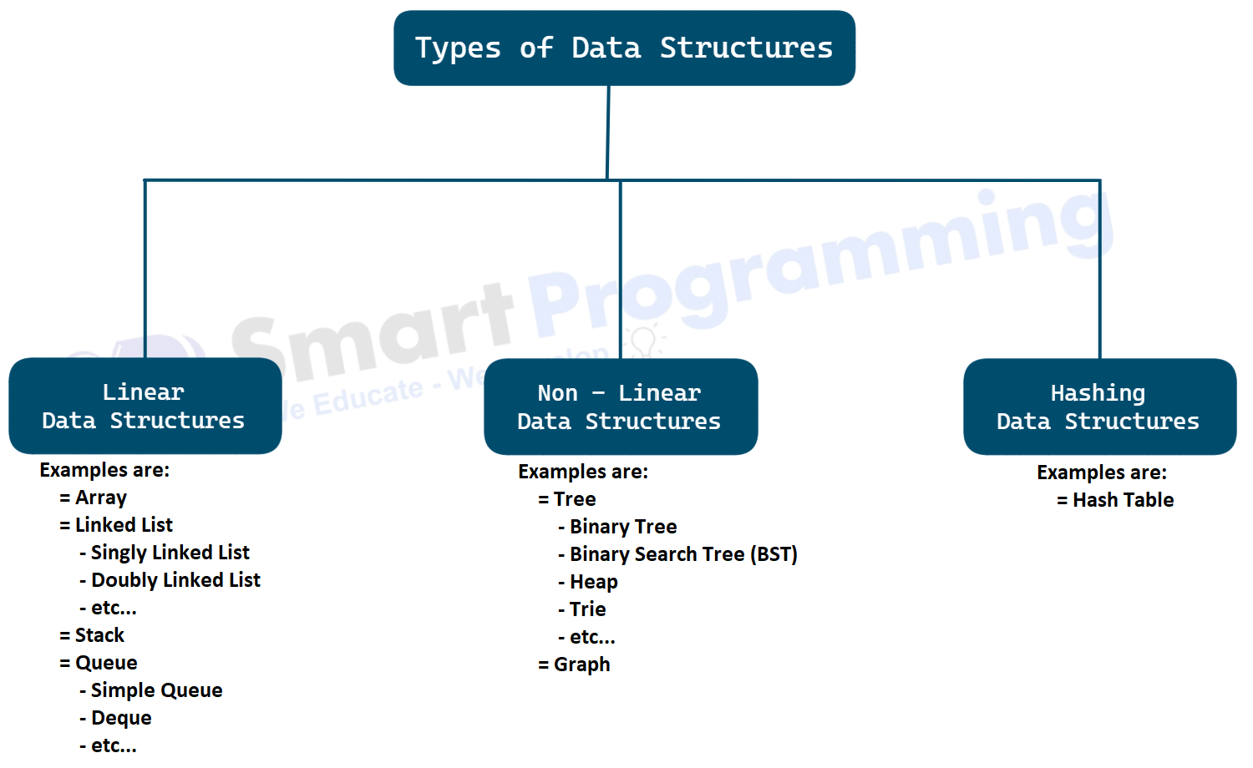
- Operations on Data Structures:
  - We can perform various operations on data structures to manipulate the data stored within them. Common operations include:
    - Insertion: Adding new data to the structure
    - Deletion: Removing existing data from the structure
    - Traversal: Accessing each element in the structure
    - Updation: Modifying existing data within the structure

What is Algorithm?
- What is an Algorithm?
  - An Algorithm is a step-by-step procedure or set of rules to solve a particular problem.
  - We use algorithms in daily life, for example:
    - ATM Transaction : Steps to withdraw cash, check balance, or transfer money.
    - Cooking Recipe : Steps to prepare a dish, like chopping vegetables, boiling water, and mixing ingredients.
  - In DSA, algorithms are used to solve problems using different approaches such as:
    - Sorting - Arrange data in a specific order
    - Searching - Find specific data in a collection
    - Pathfinding - Find the shortest path in a graph or network
    - Optimization - Improve performance or resource usage
- For a single problem, multiple algorithms may exist. But we need to choose the most efficient one (based on time and space complexity).
  - Choosing the right algorithm helps improve the performance of the program.
- Important Algorithms in DSA:
  - Searching Algorithms: Find the location of an element.
    - Linear Search
    - Binary Search
  - Sorting Algorithms: Rearrange elements in order.
    - Bubble Sort
    - Selection Sort
    - Insertion Sort
    - Merge Sort
    - Heap Sort
    - Quick Sort
  - Graph Traversal / Path-Finding Algorithms:
    - Dijkstra's Algorithm
    - BFS (Breadth-First Search)
    - DFS (Depth-First Search)
- Important Techniques in DSA:
  - Techniques in DSA are general approaches or methods used to design and solve problems efficiently.
  - They are not full algorithms, but strategies that help build or improve algorithms.
  - Some common techniques include:
    - Recursion
    - Backtracking
    - Divide and Conquer
    - Greedy Algorithm
    - Dynamic Programming (DP)

Use of DSA in Real World Applications:
- Social Media Platforms (e.g., Instagram , Facebook )
  - Use of DSA:
    - Graphs for user connections (friends/followers)
    - Queues for managing news feeds
    - HashMaps for fast user profile lookups
  - Example:
    - Showing your feed based on who you follow and what’s trending.
- E-commerce Websites (e.g., Amazon, Flipkart)
  - Use of DSA:
    - Arrays and HashMaps to manage inventory
    - Trees and Tries for search autocomplete
    - Sorting and searching algorithms to filter products
  - Example:
    - Displaying products sorted by price, rating, or relevance.
- Navigation & Maps (e.g., Google Maps)
  - Use of DSA:
    - Graphs for representing routes and intersections
    - Dijkstra’s algorithm for finding the shortest path
  - Example:
    - Finding the fastest route from your location to your destination.
DSA is very popular in product-based companies like Amazon, Flipkart, Google etc. But now-a-days also used in service-based companies like Infosys, TCS, Wipro etc.

Time & Space Complexity

Analysis of an Algorithm:
- Algorithm analysis is the process of evaluating an algorithm's efficiency.
- The goal is to predict performance without running the program, so it works efficiently for large inputs.
- The two main aspects of algorithm analysis are:
  - Time Complexity - How long an algorithm takes to run as input size increases.
  - Space Complexity - How much memory an algorithm uses as input size increases.

Time Complexity
- Time Complexity is the amount of time an algorithm takes to complete as the input size (n) increases.
- Real World Example:
  - Time complexity can be understood with the example of traveling from your home to the office. Here, the input size is affected by factors like:
    - Traffic lights
    - Traffic jams
    - Number of stops
  - Now, let's compare different modes of transport:
    - Metro - Even if distance increases, the time taken increases slowly. Like a metro, you can reach faster because it has fewer stops and no traffic.
    - Bike - Faster than a bus in small traffic but slows down as traffic increases.
    - Bus - Takes more time, especially with more stops and heavy traffic, similar to higher time complexity.

  - Conclusion: Just like metro, bike, and bus have different speeds depending on traffic, algorithms have different time complexities depending on input size.
- Project Example :
  - There are two shopping applications
  - Both use different algorithms to process orders.
  - What is Input Size (n)?
    - Input size means the number of items, orders, or data elements the algorithm needs to process.
    - Example: In a shopping app, input size could be the number of products ordered during a sale.
    - As n increases , execution time may increase depending on the algorithm's efficiency.

Below is the table showing the time taken by each algorithm for different input sizes (n):
Example Scenario | Input Size (n) | Algorithm A | Algorithm B
Small orders (Normal day) | 100 orders | takes 50 ms of time | takes 70 ms of time
Moderate sale event | 1,000 orders | takes 500 ms of time | takes 500 ms of time
Big festive sale | 10,000 orders | takes 5,000 ms of time | takes 3,000 ms of time
Massive flash sale | 1,00,000 orders | takes 50,000 ms of time | takes 15,000 ms of time
  - As the input size increases, Algorithm A takes more time compared to Algorithm B.
  - This means Algorithm B is more efficient for larger inputs.
  - Therefore, we can say that Algorithm B has better Time Complexity than Algorithm A.
- Why Time Complexity is Important ?
  - It determines the speed of the algorithm for large inputs.
  - It helps to compare the different algorithms for the same problem.
- How Time Complexity is Measured ?
  - Count how the number of basic operations (assignments, comparisons, loops, etc.) grows with the input size n, ignoring constants and machine-specific factors.
  - Use asymptotic notations to represent the growth of time complexity:
    - Big O Notation (O) - Describes the upper bound (commonly used for worst-case).
    - Omega Notation (Ω) - Describes the lower bound (sometimes used for best-case).
    - Theta Notation (Θ) - Describes the tight bound (exact growth, not average case).

Introduction:
- Analyzing (calculating) time and space complexity is an important topic for interviews and competitive programming.
- Why its so important?
  - Performance Prediction:
    - Estimate execution time and memory usage before implementation.
  - Algorithm Comparison:
    - Choose the most efficient algorithm for large inputs.
  - Bottleneck Identification:
    - Detect operations or structures causing slowdowns.
  - Optimization Guidance:
    - Decide whether to trade time for space or vice versa.
- Common Time Complexities :
  - Below is the table showing common time complexities and their growth rates:
Symbol | Name | Description | Efficiency | Notes / Examples
O(1) | Constant Time | Execution time does not depend on input size. | ✅ Excellent | Accessing an array element, HashMap get()
O(log n) | Logarithmic Time | Time grows slowly as input size increases. | ✅ Very Good | Binary Search, balanced BST operations
O(n) | Linear Time | Time grows directly in proportion to input size. | 👍 Good | Traversing an array or list
O(n log n) | Linearithmic Time | Slightly worse than linear but better than quadratic. | ⚖️ Acceptable | Merge Sort, Quick Sort (average case)
O(n²) | Quadratic Time | Time grows proportionally to the square of input size. | ❌ Poor | Nested loops (e.g., Bubble Sort)
O(n³) | Cubic Time | Time grows cubically with input size. | ❌ Very Poor | Triple nested loops
O(2ⁿ) | Exponential Time | Time doubles with every additional input element. | 🚫 Extremely Bad | Recursive Fibonacci without memoization
O(n!) | Factorial Time | Time grows factorially with input size. | 🚫 Worst | Generating all permutations

Space Complexity
- Space Complexity is the amount of memory an algorithm uses as the input size (n) increases.
- It includes both the auxiliary space (temporary space used by the algorithm) and the input space (space required to store the input data).
- Real World Example:
  - Space complexity can be understood with the example of a library. Here, the input size is affected by factors like:
    - Number of books
    - Size of each book
    - Number of shelves
  - Now, let's compare different storage methods:
    - Digital Library - Takes less space as it stores books in digital format.
    - Physical Library - Takes more space as it stores physical books.
  - Just like digital libraries take less space, algorithms with lower space complexity use less memory.
- Project Example :
  - There are two photo-editing applications
  - Both use different algorithms to apply filters to images.
  - What is Input Size (n)?
    - Input size means the size of the image or the amount of data the algorithm needs to process.
    - Example: In a photo-editing app, input size could be the file size of the image being edited.
    - As n increases , memory usage may increase depending on the algorithm's efficiency.
  - Below is the table showing the memory used by each algorithm for different input sizes (n):
Example Scenario | Input Size (n) | Algorithm X | Algorithm Y
Small image (Profile pic) | 1 MB | uses 5 MB memory | uses 4 MB memory
Medium image (Phone photo) | 5 MB | uses 25 MB memory | uses 15 MB memory
Large image (DSLR photo) | 20 MB | uses 100 MB memory | uses 50 MB memory
Ultra HD image (Poster) | 100 MB | uses 500 MB memory | uses 300 MB memory
  - As the input size increases, Algorithm X uses more memory compared to Algorithm Y.
  - This means Algorithm Y is more memory-efficient for larger inputs.
  - Therefore, we can say that Algorithm Y has better Space Complexity than Algorithm X.
- Why Space Complexity is Important ?
  - It determines the memory usage of the algorithm for different input sizes.
  - It helps to choose algorithms that are more memory-efficient, especially for large datasets or devices with limited RAM.
- How Space Complexity is Measured ?
  - Count how much memory is required by the algorithm, including:
    - Memory for input data (input size n).
    - Memory for variables and constants.
    - Memory for temporary data structures like arrays, lists, or stacks.
  - Represent the growth of memory usage with asymptotic notations
    - Big O Notation (O) - Represents the worst-case memory usage.
    - Theta Notation (Θ) - Represents the average-case memory usage.
    - Omega Notation (Ω) - Represents the best-case memory usage

Case | Description | Complexity
Worst Case | The element is either at the last position or not present at all, requiring n comparisons. | O(n)
Average Case | The element is found somewhere in the middle of the array, so we make about n/2 comparisons on average. | Θ(n)
Best Case | The element is found at the first position, so only one comparison is needed. | Ω(1)

