Vendors and Customers — Backend
Part of the Inventory System implementation guide. Read docs/BRD.md for the business picture and docs/backend/backend-setup.md for how the backend is organised.

Contents
1. What this is
2. Where the code lives
3. Data
4. API
5. How it works
5.1 Listing and getting one
5.2 Creating a party and its account
5.3 Updating
5.4 Deleting
5.5 Where the account is used
5.6 Dropdowns
6. Design decisions and gotchas
7. Build it yourself: order of work

1. What this is
Vendors are who the company buys from; customers are who it sells to. Both are a name with contact details (registration number, phone, address, email, remarks) and an active flag. The one thing that makes them more than a lookup list: every vendor or customer owns a ledger account in the chart of accounts. Credit purchases, credit sales, returns and payments post to that account, and the ledger, payable and receivable reports read it. The system creates that account when the party is created, keeps its name in step, and removes it when the party is deleted.
Vendors and customers are two identical copies of the same code, in two tables, with two sets of permissions, differing only in which side of the books their account sits on. This document describes vendors and notes the customer differences.

2. Where the code lives
File | What is in it
features/purchase/vendor/controllers/VendorController.java | /vendor endpoints, each with @RequiresOperation
features/purchase/vendor/services/VendorService.java | Validation, list, and the account creation / rename / delete that goes with each save
features/purchase/vendor/entities/Vendor.java | vendor table
features/purchase/vendor/dtos/VendorDTO.java | Request/response shape
features/purchase/vendor/repositories/VendorRepository.java | JpaRepository + JpaSpecificationExecutor, the dropdown query
features/sales/customer/controllers/CustomerController.java, services/CustomerService.java, entities/Customer.java, dtos/CustomerDTO.java, repositories/CustomerRepository.java | The same five files for customers, under /customer
features/accounting/account/entities/AccountMaster.java | The account entity the party services create; @OneToOne links vendor and customer
features/accounting/account/repositories/AccountMasterRepository.java | findByAccountName (the parent lookup), findByVendorId, findByCustomerId
common/dropdown/services/DropdownService.java | getVendorDropdown(status), getCustomerDropdown(status), and the account dropdown

3. Data
From backend/database.sql:
vendor and customer (same columns):
Column | Meaning
id | INTEGER PRIMARY KEY AUTOINCREMENT
name | TEXT NOT NULL. Not unique: nothing in the table or the service stops two vendors with one name
registration_number, contact, address, email, remarks | Free text
is_active | INTEGER DEFAULT 1
created_at, updated_at | Trigger-maintained, not mapped

account_master, the columns the party services set:
Column | Vendor account | Customer account
account_name | the vendor's name | the customer's name
account_type | Payables (an account_types row under heading Liability) | Receivables (heading Assets)
parent_id, parent_account_name | the seeded account Trader Payable (id 18) | the seeded account Trade Receivables (id 23)
remarks | For purchase entry purpose | For sales entry purpose
vendor_id / customer_id | vendor_id → vendor(id), UNIQUE | customer_id → customer(id), UNIQUE
is_active, deletable, is_system_generated, account_code | entity defaults: 1, 1, 0, NULL | same

The UNIQUE on vendor_id / customer_id is what makes "one account per party" true at the database level.
Who points at a party: master_purchase_entry.vendor_id, master_purchase_return.vendor_id, master_payment.vendor_id; master_sales_entry.customer_id, master_sales_return.customer_id, master_payment.customer_id. Who points at the account: journal_entry.account_master_id (every posted line). These foreign keys block the delete.

4. API
 | Base path | Permissions
Vendors | /vendor | ViewVendor, CreateVendor, EditVendor, DeleteVendor
Customers | /customer | ViewCustomer, CreateCustomer, EditCustomer, DeleteCustomer

Method | Path | What it does | Permission
GET | /vendor | Paged list with the shared filters (?name=abc, ?isActive=1) | ViewVendor
GET | /vendor/{id} | One vendor | ViewVendor
POST | /vendor | Create the vendor and its account; "Vendor Added successfully" | CreateVendor
PUT | /vendor/{id} | Update the vendor and rename its account; "Vendor Updated successfully" | EditVendor
DELETE | /vendor/{id} | Delete the vendor and its account; "Vendor Deleted successfully" | DeleteVendor
GET | /dropdown/vendor/{status} | {id, name} of vendors (active or all) | any logged-in user
GET | /dropdown/customer/{status} | Same for customers | any logged-in user
GET | /dropdown/accountMaster/party/vendor/{status} | The vendor accounts (ids are account ids) | any logged-in user

The controller method is annotated with @RequiresOperation("ViewVendor") and so on. Full shapes: backend/endpoints.md section 7 (parties) and section 4 (dropdowns).
Request body:
{ "name", "registration_number", "contact", "address", "email", "remarks", "is_active" }

The DTO is not snake-cased as a whole: only registration_number and is_active are renamed with @JsonProperty; the other names are single words anyway. Responses carry active next to is_active (the Lombok getter quirk described in the masters doc). Send every text field, as an empty string when blank: the mapping calls .trim() on each one without a null check, so an omitted field makes the save fail with a 500.

5. How it works

5.1 Listing and getting one
The list uses the shared SpecificationBuilder filters and QueryParamUtil paging: QueryParamUtil.toPageable(params) for pageIndex / pageSize / sort, every other param a "contains" filter on an entity field (name, contact, email, address, registrationNumber, isActive=1). GET /vendor/{id} answers 404 "Vendor not found" ("Customer not found").

5.2 Creating a party and its account
Idea. The books need one account per party, under a fixed group, before the first credit document or payment can be posted. Making the party service create it means the user never has to pick or remember an account, and the balance sheet always finds every vendor under Trader Payable and every customer under Trade Receivables. Both inserts run in one transaction (@Transactional), so a vendor never exists without its account.
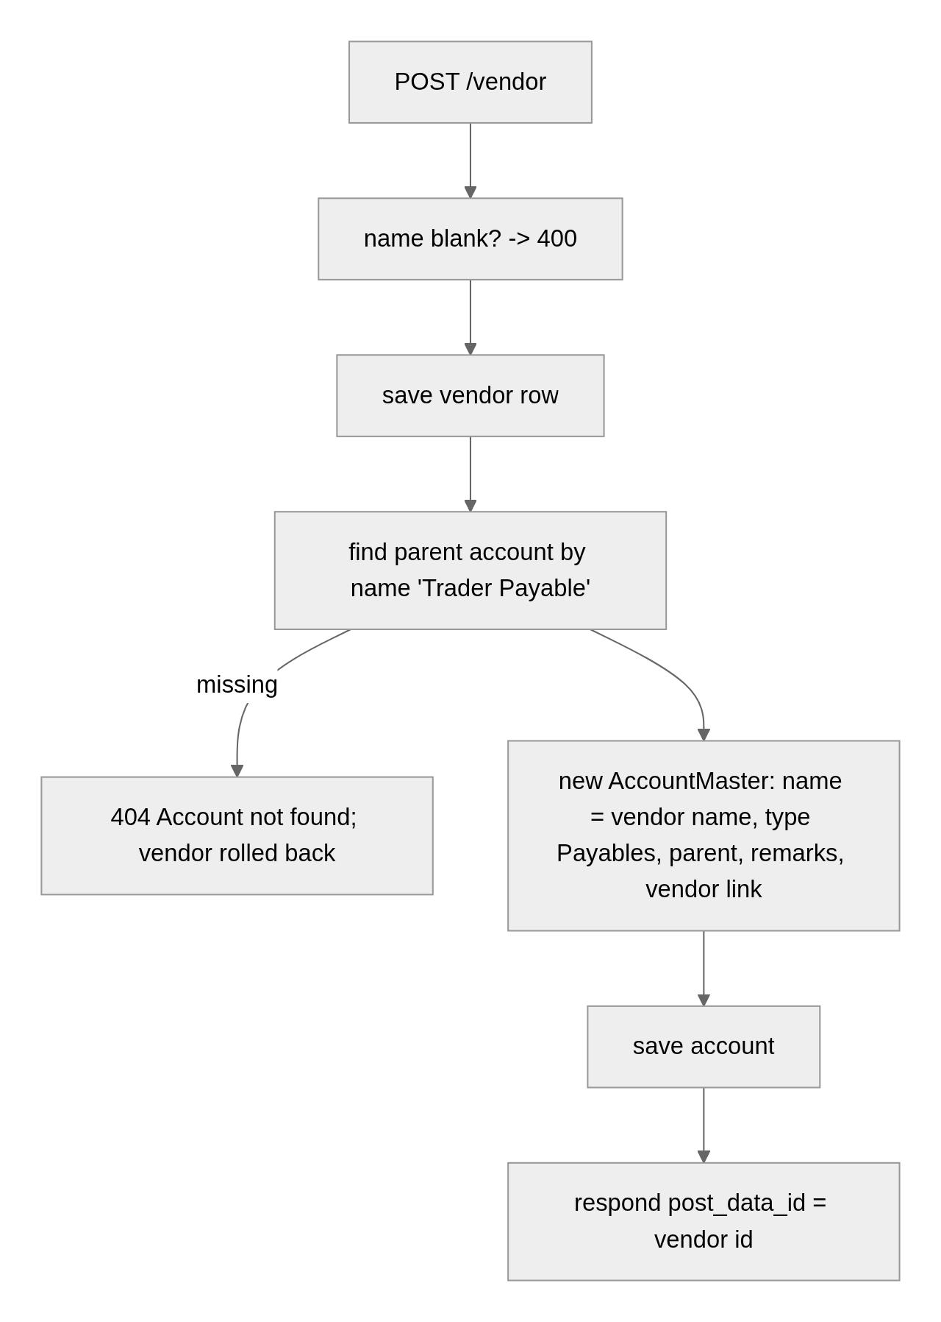
Steps.
create(dto): -- one transaction
if name null or blank -> 400 "Vendor name cannot be null or blank"
vendor = new Vendor; copy name, registration_number, contact, email, address, remarks (all trimmed), is_active
saved = repository.save(vendor)
account = new AccountMaster
accountName = saved.name
vendor = saved -- customers: customer = saved
accountType = "Payables" -- customers: "Receivables"
parent = accountMasterRepository.findByAccountName("Trader Payable") -- customers: "Trade Receivables"
-> 404 "Account not found" (whole transaction rolls back)
parentId = parent.id; parentAccountName = parent.accountName
remarks = "For purchase entry purpose" -- customers: "For sales entry purpose"
(defaults) isActive = true, deletable = true, isSystemGenerated = false, accountCode = null
accountMasterRepository.save(account)
respond with saved.id

Rules checked.
- Blank name → 400 "Vendor name cannot be null or blank" / "Customer name cannot be null or blank".
- Parent account missing → 404 "Account not found" (only if someone renamed or deleted the seeded group account).
- There is no duplicate-name check. VendorRepository.existsByName exists but is never called.

5.3 Updating
Idea. The account's name must follow the party's name, since documents and reports show the account name. The update therefore re-applies the whole account recipe (name, type, parent, remarks), which also repairs an account someone edited by hand in the chart of accounts.
Steps.
update(id, dto): -- one transaction
existing = findById(id) -> 404 "Vendor not found"
if name null or blank -> 400 "Vendor name cannot be null or blank"
copy all fields onto existing (trimmed)
account = accountMasterRepository.findByVendorId(id) -> 404 "Account not found"
account.accountName = existing.name
account.accountType = "Payables"; parent = "Trader Payable" again; remarks = "For purchase entry purpose"
save account; save vendor; respond with id

What the update does not touch: the account's is_active. Setting a vendor inactive hides it from /dropdown/vendor/active but its account stays active, still listed in account dropdowns and still usable on a manual journal. The account's deletable, is_system_generated and account_code are left alone too.

5.4 Deleting
Idea. The account points at the vendor (vendor_id), so it has to go first; both deletes share one transaction. No "is it used?" query is written: if a purchase, return or payment names the vendor, or a journal line names the account, SQLite refuses, the transaction rolls back, and GlobalExceptionHandler turns the FOREIGN KEY constraint failed error into a 409.
Steps.
delete(id): -- one transaction
vendor = findById(id) -> 404 "Vendor not found"
accountMasterRepository.findByVendorId(id).ifPresent(delete) -- first: it points at the vendor
repository.delete(vendor)
-- any document or journal line still using either:
-- 409 "This record is still used by other records, so it cannot be deleted"; nothing removed

The chart-of-accounts API refuses to delete a party account on its own: DELETE /accountMaster/{id} on one answers 400 "Selected Account belongs to a vendor or customer; delete them instead". The party is the only way in.

5.5 Where the account is used
Documents look the account up by the party, never by name:
Caller | How
Purchase entry / purchase return journal | transaction_type = Cash posts to the account named Cash; otherwise findByVendorId(vendor) → the vendor's account (404 "Account not found" if missing)
Sales entry / sales return journal | same with findByCustomerId(customer)
Payment journal | type = Vendor → findByVendorId, else findByCustomerId
Ledger, payable and receivable reports | read journal lines by account

5.6 Dropdowns
GET /dropdown/vendor/{status}: isActive = status equalsIgnoreCase "active" ? true : null
SELECT new DropdownDTO(v.id, v.name) FROM Vendor v WHERE (:isActive IS NULL OR v.isActive = :isActive)
GET /dropdown/customer/{status}: the same on Customer

No ORDER BY; rows come in id order. Both need only a login, since every purchase, sales and payment form uses them. The account dropdown /dropdown/accountMaster/{type}/{partyType}/{status} (party / nonparty / all, vendor / customer / all) lists the accounts linked to parties; its ids are account_master ids.

6. Design decisions and gotchas
- Two tables, not one "party" table with a type. A company can be both a vendor and a customer; keeping them apart gives each its own account under the right group (payable vs receivable), its own permissions, and its own document foreign keys. The cost is two copies of the code.
- The parent is found by name. findByAccountName("Trader Payable") and ("Trade Receivables") rely on the seeded accounts keeping those exact names. Rename one in the chart of accounts and every vendor (or customer) create and update fails with 404 "Account not found". findByAccountName returns a single Optional, so a second account with the same name would also break it (names are not unique in account_master).
- Names are not unique. Two vendors called ABC get two accounts called ABC; reports show the name only. Add existsByName checks if you want the masters' behaviour.
- Deactivating a party does not deactivate its account. If that matters, set the account's is_active from the party's in the update.
- Null text fields crash the save. Every text field is trimmed without a null check (dto.getContact().trim()), so a body missing contact, address, email, remarks or registration_number fails with a 500 NullPointerException rather than a 400. Send empty strings, or add null-safe trimming when you rebuild.
- The transaction annotation is jakarta.transaction.Transactional here (products use Spring's). Both roll back on a runtime exception; either works.
- Delete order matters. Deleting the vendor first would fail on account_master.vendor_id every time, since the account always exists.
- Account defaults come from the entity, not the DTO: deletable = true and is_system_generated = false, so a party account looks like a user-made account in the chart, except for the vendor/customer link that the account delete checks.

7. Build it yourself: order of work
- Tables: vendor and customer (section 3); in account_master, add vendor_id INTEGER DEFAULT NULL UNIQUE and customer_id INTEGER DEFAULT NULL UNIQUE with foreign keys. Seed the two group accounts Trader Payable (type Payables) and Trade Receivables (type Receivables).
- Entities: Vendor, Customer; give AccountMaster lazy @OneToOne links vendor and customer on those columns.
- Repositories: VendorRepository / CustomerRepository with the dropdown JPQL; AccountMasterRepository with findByAccountName, findByVendorId, findByCustomerId.
- DTOs: the seven fields with @JsonProperty("registration_number") and @JsonProperty("is_active").
- Services: saveVendor (vendor + account in one @Transactional), getPaginatedVendorsList, getVendorById, updateVendor (rename the account), deleteVendor (account first). Copy for customers with Receivables / Trade Receivables / For sales entry purpose.
- Controllers at /vendor and /customer with @RequiresOperation("ViewVendor"), "CreateVendor", "EditVendor", "DeleteVendor" (and the customer ones); add the operations to the seed and the Admin role.
- Dropdowns: getVendorDropdown / getCustomerDropdown in DropdownService, routes /dropdown/vendor/{status} and /dropdown/customer/{status}.
- Try it: POST /vendor, then GET /dropdown/accountMaster/party/vendor/active and see the new account; PUT with a new name and check the account was renamed; record a credit purchase for the vendor, DELETE /vendor/{id} and expect the 409; delete the purchase, delete the vendor, and confirm the account is gone.

