Accounting (Chart of Accounts, Journal Entries, Opening Balance) — Frontend
Part of the Inventory System implementation guide. Read docs/BRD.md for the business picture and docs/frontend/frontend-setup.md for how the web app is organised.

Contents
1. What this is
2. Where the code lives
3. Screens
3.1 Chart of Accounts list
3.2 Account form (400px right drawer)
3.3 Journal Entries list
3.4 Journal form (bottom drawer)
3.5 Opening Balance page
4. How it works
4.1 Loading the account list
4.2 Deleting an account
4.3 Opening and saving the account form
4.4 Journal lines: one debit or credit per line
4.5 Opening the journal form (add / edit / view)
4.6 Saving a journal
4.7 Deleting a journal
4.8 Opening balance: one record edited in place
4.9 Print and Export
5. Design decisions and gotchas
6. Build it yourself: order of work

1. What this is
Three pages under /accounting that look after the books themselves rather than documents:
- Chart of Accounts (/accounting/accounts): the list of accounts money is posted to (Cash, Sales, a bank, a vendor's payable account, …). The user adds, edits and deletes the accounts they created; system accounts and the accounts that belong to a vendor or customer are shown but locked.
- Journal Entries (/accounting/journal): manual accounting entries for things that are not a purchase, sale or payment, like a fuel bill paid in cash. Each line debits or credits one account, and the entry must balance.
- Opening Balance (/accounting/opening-balance): the one journal that holds the balances the accounts started with. It is edited in place, and saving replaces the whole thing.
Journal Entries and Opening Balance share one lines table and one set of rules, so the user learns them once.

2. Where the code lives
All paths are under frontend/src/app/features/accounting/.
File | What is in it
accounting.routes.ts | ACCOUNTING_ROUTES: accounts, journal, payments, payment-adjustment, opening-balance; each guarded by permissionGuard with its View operation. '' redirects to accounts. No child routes: every form is a drawer.
account/account.model.ts | Account, AccountPayload, AccountTypeGroup, AccountOwner (system / vendor / customer), AccountFormData.
account/account.service.ts | AccountService: list, types, parents(type), create, update, delete on /accountMaster.
account/account-list/ | AccountList: the paged table, owner chips, delete.
account/account-form/ | AccountForm: add/edit in a 400px right drawer.
journal/journal.model.ts | Journal, JournalLine, JournalPayload, JournalFormMode, JournalFormData.
journal/journal.service.ts | JournalService: list, get, nextNumber, create, update, delete, exportList, exportOne on /journal.
journal/journal-lines.ts | The shared line logic: JournalLineForm, createJournalLine, journalTotals, journalLinesProblem, toJournalLines.
journal/journal-lines-table/ | JournalLinesTable: the Account / Narration / Debit / Credit table with its totals row.
journal/journal-list/ | JournalList: manual journals, with date range, print and export.
journal/journal-form/ | JournalForm: add / edit / view in the bottom drawer.
opening-balance/opening-balance.service.ts | OpeningBalanceService: get, save on /opening-balance.
opening-balance/opening-balance-form/ | OpeningBalanceForm: the page itself (read-only until Edit).

Shared pieces used: LIST_PAGE_CARD, DateText, AmountTotals, DocNoPipe, AmountPipe, DropdownService (accounts(...)), FileDownloads, withMissing (shared/utils/options.ts), round2 (shared/utils/invoice.ts), toIsoDate / fromIsoDate / startOfToday (shared/utils/date.ts), apiErrorMessage. The API shapes are in backend/endpoints.md sections 8 (accounts) and 13 (journals and opening balance).

3. Screens

3.1 Chart of Accounts list
Column | Shows | Sorts by (backend field)
S.N | Running number across pages (01, 02, …) | —
Account Name/Code | The name (a link that opens edit when the user may edit), then the code or No code, plus an owner chip: System, Vendor or Customer | accountName
Account Type | The type, with its heading (Assets, Liability, …) underneath | accountType
Parent Account | parent_account_name or - | parentAccountName
Status | ACTIVE / INACTIVE chip | isActive
Actions | A menu with Edit and Delete | —

Filters (l-filter): the search box sends accountName; the filter columns are Account Code (accountCode), Account Type (accountType, a select grouped by heading, built from GET /accountMaster/getAccountTypes), Parent Account (parentAccountName) and Status (isActive, sending 1 or 0). Account type is the one filter the API matches on the whole name. Default sort is id:desc; page size 10.
Buttons and their permissions: Add Account needs CreateAccountMaster; the name link and Edit need EditAccountMaster; Delete needs DeleteAccountMaster and canDeleteRow(row) (see 4.2). The actions column is only added when the user can edit or delete.

3.2 Account form (400px right drawer)
Opened with AccountFormData (record to edit, none to add; owner when the account is a system, vendor or customer account). Title Add Account / Edit Account.
Field | Control | Rule
Account Name | text | required
Account Code | text | required (the API treats a missing code as a duplicate of the other accounts without one)
Account Type | searchable select grouped by heading (bindValue is the type name) | required; picking another type clears the parent
Parent Account | clearable select of GET /accountMaster/getParentAccount/{type} | placeholder Select an account type first until a type is picked, then No parent; hint "Only system accounts of the same type can be a parent."
Remarks | textarea | optional
Active | toggle, default on | hint "Inactive accounts are left out of dropdowns."

When owner is set, a lock note shows and the name, type and parent are disabled:
- system: "System account. The app relies on its name, type and parent, so they can't be changed."
- vendor / customer: "… account. Its name, type and parent follow the vendor and are reset whenever the vendor is saved." (same text with customer).
Footer: Cancel, and Add / Update (Saving… while the request runs).

3.3 Journal Entries list
Column | Shows | Sorts by
S.N | running number | —
Journal Number | system_entry_no through the docNo pipe, a link that opens view | systemEntryNo
Date | <app-date-text> in the page's AD/BS calendar | date
Remarks | or - | remarks
Accounts | Dr the names of the debited accounts, Cr the credited ones | —
Amount | the sum of the debits (which equals the credits) | —
Actions | View; Edit (EditJournalEntry); Delete (DeleteJournalEntry) | —

Title bar: search by remarks, a Journal No filter (systemEntryNo), an AD/BS segmented control, From and To dates (both default to today), Print and Export, and Add Journal Entry (CreateJournalEntry).

3.4 Journal form (bottom drawer)
Opened near full screen (position: 'bottom', size: 'calc(100vh - 48px)', panelClass: 'drawer-sheet', disableClose: true) with JournalFormData { mode, id?, calendar? }. Headings: Add Journal Entry, Edit Journal Entry, Journal Entry (view).
- A card with the Date (required, defaults to today) and a Journal Number chip (entryNo: the preview from GET /journal/generateNumber when adding, the saved number otherwise).
- Account Details: an Add Account button and the JournalLinesTable.
- Remarks textarea ("What this entry is for").
- Footer: view mode shows Close and, with EditJournalEntry, Edit (switches the same drawer to edit); add/edit modes show Cancel and Add / Update. View mode also offers Print and Export in the header.
JournalLinesTable columns: S.N, Account (searchable select), Narration (placeholder Same as remarks), Debit, Credit (number inputs with 2 decimals) and a remove button (hidden in view mode). Under it, AmountTotals shows Total Debit, Total Credit and Difference, the last in red while it isn't zero. In view mode an unused side shows -.

3.5 Opening Balance page
Not a list: the route loads OpeningBalanceForm itself, a card with a header and the same lines table.
- Header subtitle: "The balances your accounts had when you started using the system", or "Saving replaces the whole opening balance" while editing.
- Read-only by default. With CreateOpeningBalance the header shows Set Opening Balance (nothing saved yet) or Edit. While editing it shows Cancel and Save.
- Body: "No opening balance has been set yet." when none is saved and not editing; otherwise Date (BS calendar), Remarks (placeholder e.g. Opening balance FY 2083/84), the Account Balances section with Add Account and the lines table.
- A load failure shows the message with a Try again button.

4. How it works

4.1 Loading the account list
Idea. Query state lives in signals (filters, sort, pageIndex, pageSize, refresh); a computed request feeds toObservable + switchMap, so changing any of them refetches and a stale response is dropped. The rows are only replaced when the next page arrives, so the table never flashes empty.
request = computed: { pageIndex, pageSize, each filter as params[field], sort: SORT_FIELDS[key]:direction or "id:desc", refresh }
on request change:
loading := true
GET /accountMaster?params
ok -> rows := page.content, total := page.totalElements, loadError := ""
error -> rows := [], loadError := apiErrorMessage(error, "Could not load accounts.") (shown as the table's empty text)

Three lookups load once, quietly (a failure just leaves the list without them): the type groups (for the headings and the type filter), and the ids of vendor and customer accounts from GET /dropdown/accountMaster/party/vendor/all and .../party/customer/all. ownerOf(row) is system when is_system_generated, else vendor / customer when the id is in one of those sets, else nothing.

4.2 Deleting an account
Idea. The API will delete a vendor's or customer's account, but the party still needs it, so the list hides Delete for those as well as for system accounts: canDeleteRow = canDelete && row.deletable && !ownerOf(row).
Delete -> ConfirmDialog "Delete account?" / 'Account "<name>" will be deleted. This cannot be undone.'
confirm -> DELETE /accountMaster/{id}
error -> notification "Could not delete" + API message, dialog stays
ok -> notification "Account deleted"; if it was the last row of a page > 0, step back a page, else reload

API refusals the user can still hit: "Selected Account cannot be deleted" (system), "Selected Account belongs to a vendor or customer; delete them instead", and a 409 when journal lines use the account.

4.3 Opening and saving the account form
Idea. The row is handed over in DRAWER_DATA, so only the lookups load: the types once, and the parent list each time the type changes (switchMap on the type control). Parents are tied to a type, so a type change clears parent_id. The saved parent may be inactive and missing from the active-only parent list; withMissing adds it back, but only while the type is still the saved one. An account is also filtered out of its own parents.
save():
form invalid -> markAllAsTouched; warn "Missing details" / "Fill in the fields highlighted in red."
value = form.getRawValue() -- raw: locked fields are disabled
parent = parentOptions.find(parent_id)
payload = { account_code trimmed, account_name trimmed, account_type,
parent_id: parent.id or 0, parent_account_name: parent.name or null,
is_active, deletable: record.deletable or true, remarks trimmed or null }
editing ? PUT /accountMaster/{id} : POST /accountMaster
ok -> success "Account updated" / "Account added"; drawer closes with true; list reloads
error -> error "Could not save" + API message; drawer stays open

deletable is sent back because the API stores it as sent: a system account must say again that it can't be deleted. API messages: "Duplicate Account Code" (409), "Account Name cannot be null or blank", "Account Type cannot be null or blank".

4.4 Journal lines: one debit or credit per line
Idea. A journal line moves money one way. Instead of validating "both filled" after the fact, typing on one side clears the other (onDebit / onCredit in the table), so the form can never show a line with both. Saved lines carry 0 on the unused side; createJournalLine turns that 0 into a blank (|| null) so the table looks the same for new and loaded lines.
journalLinesProblem(lines) is the one check both forms run before saving; it returns a title and message to show, or null:
Condition | Title | Message
no lines | No accounts | Add the accounts to debit and credit.
a line with both sides, or neither | Check the amounts | Each line needs either a debit or a credit amount, not both.
journalTotals(lines).difference !== 0 | Not balanced | Total debit and total credit must be equal.

journalTotals sums each side with round2 (to the paisa) and returns { debit, credit, difference: debit − credit }; the table's totals row is computed from it. toJournalLines(lines, fallback) builds journalEntries: blank sides become 0, and a blank narration becomes fallback, because the ledger report shows line narrations rather than the journal's remarks.

4.5 Opening the journal form (add / edit / view)
constructor:
mode != add and id given -> load(id)
else -> mode := add; add two lines (a journal debits one account and credits another at the least);
GET /journal/generateNumber -> entryNo (a failure just leaves the chip out)

load(id): GET /journal/{id}
ok -> fill: entryNo := system_entry_no; savedAccounts := each line's {id, name};
rebuild the lines FormArray from journalEntries; patch date (fromIsoDate) and remarks; markAsPristine
error -> "Could not load the journal"; close the drawer

State: form (date, remarks, lines FormArray) plus a lines signal holding the same groups so the table re-renders on add/remove; value = toSignal(form.valueChanges → getRawValue()); totals = computed(journalTotals(value().lines)); accountOptions = withMissing(active accounts from GET /dropdown/accountMaster/all/all/active, savedAccounts) so an account that went inactive still shows its name; readonly = mode === 'view'; canEdit = hasOperation('EditJournalEntry'). View switches to edit in place with startEdit().

4.6 Saving a journal
save():
form invalid (date or an account missing) -> "Missing details"
problem = journalLinesProblem(lines) -> warn(problem.title, problem.message); stop
remarks = trimmed or null
payload = { date: toIsoDate(date), remarks, journalEntries: toJournalLines(lines, remarks) }
mode == edit ? PUT /journal/{id} : POST /journal
ok -> "Journal added" / "Journal updated"; close with true; list reloads
error -> "Could not save" + API message

The API checks the same rules again ("Journal requires at least one account line", "Debit and credit amounts cannot be negative", "Journal total cannot be zero", "Journal debits and credits must be equal"), and refuses to touch journals a document posted ("This journal was posted by a purchase, sale, return or payment; change that document instead") or the opening balance ("This journal is the opening balance; change it from the opening balance"). GET /journal never lists those, so the UI can't reach them from here.

4.7 Deleting a journal
Delete (needs DeleteJournalEntry) opens a ConfirmDialog, "Delete journal entry?" / "<number> will be deleted and its amounts taken out of the accounts. This cannot be undone.", runs DELETE /journal/{id}, shows "Journal deleted", and steps back a page if that was the last row of a page beyond the first.

4.8 Opening balance: one record edited in place
Idea. There is exactly one opening balance and the API's POST /opening-balance replaces it, so the page behaves like the configuration page: load, show read-only, Edit, Save, reload. It reuses the journal line helpers and table unchanged; the only differences are the fallback narration and that the number is fixed (OPENING-BALANCE).
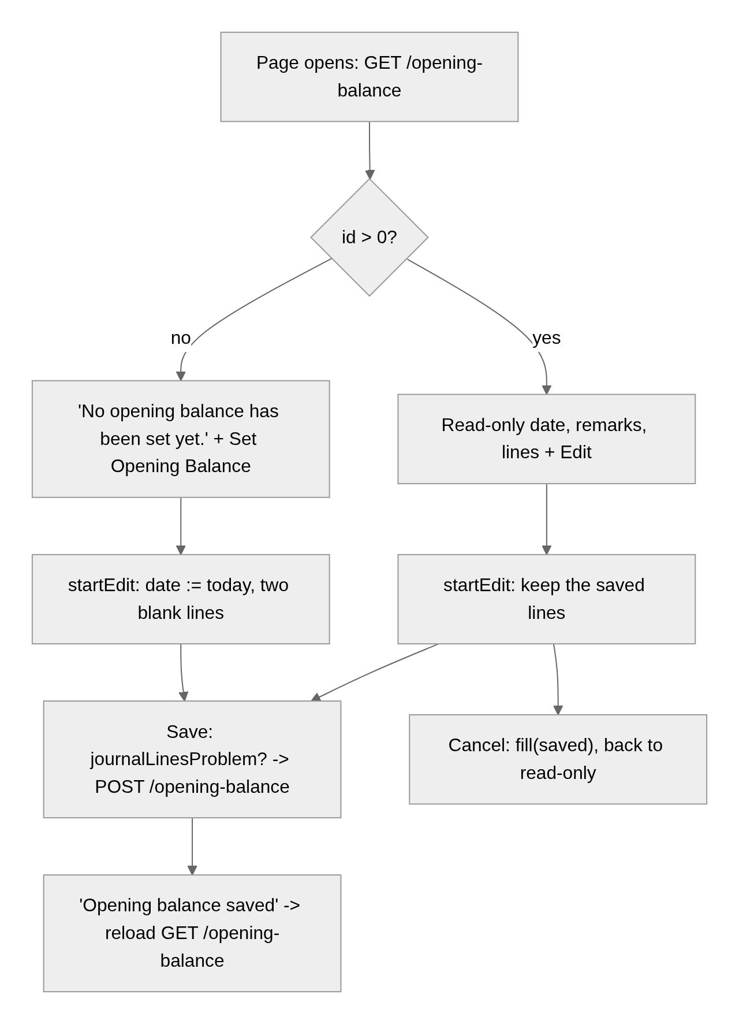
load(): GET /opening-balance -> saved := it; fill(it) (id 0 and journalEntries null until set)
error -> loadError (message + Try again)
startEdit(): if no date -> today; if no lines -> add two; editing := true
cancel(): fill(saved); editing := false
save():
form invalid -> "Missing details"; journalLinesProblem -> warn and stop
remarks = trimmed or null
POST /opening-balance { date, remarks, journalEntries: toJournalLines(lines, remarks ?? "Opening Balance") }
ok -> "Opening balance saved"; editing := false; load() -- shows it as stored (narrations filled in, new line ids)
error -> "Could not save" + API message ("Opening balance debits and credits must be equal", …)

canEdit here is CreateOpeningBalance (there is no separate edit operation). isSet = !!saved().id picks the button label and the empty text.

4.9 Print and Export
- The journal list's Print (PDF) and Export (Excel) call exportList(format, { ...query, calendar }), where query is the list's filters, dates and sort without paging, so the file holds every matching journal, one row per line, with dates in the page's calendar.
- The journal form in view mode calls exportOne(id, format, { calendar }): a PDF voucher or an Excel sheet of the lines.
- Both go through FileDownloads.run, which allows one download at a time, labels the button Printing… / Exporting…, and reports a failure as a notification. The account list and the opening balance have no print or export.

5. Design decisions and gotchas
- Typing on one side clears the other rather than erroring afterwards; the "Check the amounts" rule still exists for lines loaded with both sides or with neither.
- Blank narration becomes the remarks (or Opening Balance) because the ledger report shows line narrations; without this the ledger would show empty descriptions.
- Totals are rounded to the paisa with round2 before comparing, so 0.1 + 0.2 balances against 0.3.
- Account Code is required in the form although account_code can come back null on seeded rows: the API's duplicate check treats a missing code as a duplicate of the accounts that have none, so a second codeless account would fail anyway.
- Owner chips come from dropdown ids, not from the row: the account row only says is_system_generated; which accounts belong to a vendor or customer is learned from the party account dropdowns (all status, so inactive parties count too).
- Locked fields are disabled, so the payload reads getRawValue(), not value, or the name would be missing.
- deletable is sent on every save because the API stores it as sent.
- The journal list's dates default to today; a user looking for older entries must widen the range.
- The opening balance page reloads after saving instead of trusting the form: the API fills in narrations and assigns line ids, and the page should show what is stored.
- Drawers use disableClose: true, so only the form's own buttons close them and a backdrop click never throws away edits.

6. Build it yourself: order of work
- Add the /accounting child routes with permissionGuard and the View operations; add the sidebar links with the same operations.
- Write account.model.ts and AccountService against section 8 of endpoints.md.
- Build AccountList with the shared list card: signals → computed request → toObservable + switchMap; map column keys to backend sort fields; add the type-group and party-account lookups for headings and owner chips.
- Build AccountForm in a 400px right drawer: type select grouped by heading, parent list reloaded on type change, lock note for owned accounts, withMissing for the saved parent.
- Wire delete with ConfirmDialog, canDeleteRow, and the step-back-a-page rule.
- Write journal.model.ts, JournalService (including nextNumber, exportList, exportOne) and journal-lines.ts; unit-test journalTotals, journalLinesProblem, toJournalLines first (see journal-lines.spec.ts).
- Build JournalLinesTable (inputs lines, accounts, totals, readonly; output remove) with the clear-the-other-side handlers and AmountTotals.
- Build JournalForm in the bottom drawer with the three modes, the number preview, withMissing for saved accounts, and FileDownloads for view-mode Print/Export.
- Build JournalList with the calendar switch, date range, print/export and delete.
- Write OpeningBalanceService and OpeningBalanceForm reusing steps 6–7: load, Edit/Cancel/Save in place, reload after save.
- Log in as admin, add an account, post a balanced journal, set the opening balance, then check the ledger report shows the narrations.

