Authentication — Frontend
Part of the Inventory System implementation guide. Read docs/BRD.md for the business picture and docs/frontend/frontend-setup.md for how the web app is organised.

Contents
1. What this is
2. Where the code lives
3. What it provides
4. How it works
4.1 Logging in
4.2 Page load → authGuard → loadUser → permissionGuard
4.3 Checking permissions
4.4 Sending the token and ending the session
4.5 Token expiry
4.6 Loading the avatar
4.7 Refreshing the user
4.8 Logging out and session expiry
4.9 Change Password
5. Design decisions and gotchas
6. Build it yourself: order of work

1. What this is
Everything the web app does to know who is using it and what they may do. The user logs in once; the app keeps the JWT (a signed login token the browser sends on every request) in localStorage, loads the user's permitted operations, sends the token on every API call, hides pages and buttons the role lacks, and sends the user back to the login page when the token stops working. It also holds the Change Password page, which any signed-in user may open.

2. Where the code lives
All of it is under frontend/src/app/auth/.
File | What is in it
auth.service.ts | AuthService: the token, the signed-in user, hasOperation, login, logout, session expiry, avatar loading
auth-guard.ts | authGuard, guestGuard, permissionGuard (route guards)
auth-interceptor.ts | authInterceptor: adds the Bearer header, ends the session on token errors, parses Blob error bodies
auth.model.ts | LoginRequest, LoginResponse, UserRoleOperations (the API shape), AuthUser (the app shape), ChangePasswordRequest
login/ | The /login page (Login)
change-password/ | The /change-password page (ChangePassword)
auth.testing.ts | Spec helpers testUser() and testToken()
../shared/utils/password.ts | STRONG_PASSWORD, the new-password rule shared with the API
../app.routes.ts | Wires the guards: '' → Layout with authGuard, login with guestGuard, ** → dashboard
../app.config.ts | provideHttpClient(withInterceptors([authInterceptor]))

The API side is section 2 of backend/endpoints.md: POST /login, GET /getUserRoleOperations, PUT /change-password.

3. What it provides
AuthService (a singleton @Service()):
Member | What it does
user | Signal: the AuthUser, or null until loaded / after logout
getToken() | The stored token, or null when there is none or its exp has passed
isLoggedIn() | getToken() !== null
hasOperation(name) | Whether the role grants a backend operation such as CreatePurchaseEntry. Given a list, whether it grants any of them
login(credentials) | POST /login, stores the token, then loads the user
loadUser() | GET /getUserRoleOperations once per session; later calls reuse the result
refreshUser() | Fetches the user again (after editing your own role or account) so menus and header follow
changePassword(request) | PUT /change-password
logout() | Forgets the session and goes to /login
expireSession() | Called by the interceptor: forgets the session, warns, goes to /login with a returnUrl
clearSession() | Forgets the token and user without navigating

Guards (CanActivateFn): authGuard on the shell route, guestGuard on /login, permissionGuard on every feature route that declares data.operation.
Interceptor: authInterceptor, registered once in app.config.ts.
Pages: Login (/login) and ChangePassword (/change-password, inside the shell, opened from the profile menu).
Models: the API answers GET /getUserRoleOperations with snake_case fields (role_name, image_url, master_modules, operations, …); toAuthUser maps them to the camelCase AuthUser the app uses (fullName, role, roleId, masterModules, operations, plus avatarUrl once the picture loads).
Spec helpers (auth.testing.ts): testUser(overrides) returns a signed-in AuthUser (id: 1, username: 'admin', no operations unless you pass some), and testToken(expiresInSeconds = 3600) builds a fake three-part JWT whose payload carries sub and an exp that many seconds from now (negative for an expired one). The signature is the literal word signature; the app never verifies it, so specs can set any token into localStorage under auth_token.

4. How it works

4.1 Logging in
Idea. The login page is the only page outside the shell. It posts the credentials, and the service does the rest: store the token, load the user, then the page navigates to where the guard sent it from.
Login.submit():
if submitting: return
if form invalid (username or password blank): markAllAsTouched; return
submitting = true; error = ''
auth.login({ username, password }) -- POST /login → { token }
tap: setToken(token) -- localStorage 'auth_token' + token signal
switchMap: loadUser() -- GET /getUserRoleOperations (see 4.2)
on success: router.navigateByUrl(returnUrl())
on error: auth.clearSession(); error = apiErrorMessage(error, 'Unable to log in. Please try again.')
finally: submitting = false

returnUrl():
url = query param 'returnUrl'
return url if it starts with '/' and not with '//', else '/dashboard'

The button reads Logging in… while the request runs. The error shows in a red alert under the fields; it is the API's message, so the user sees exactly what the server decided:
API answer | Shown
401 "Username or Password is Incorrect." | that text
403 "Account is locked. Try again later." (after 5 wrong passwords, for an hour) | that text
403 "User account is inactive." | that text
Server unreachable (status 0) | Cannot reach the server. Check that the backend is running. (from apiErrorMessage)

Rules. Only in-app paths are honoured as returnUrl (never https://… or //evil), so a crafted link cannot bounce a user off-site after login.

4.2 Page load → authGuard → loadUser → permissionGuard
Idea. On a fresh page load the app has a token but no user. The shell route's authGuard loads the user before any page renders; the feature route's permissionGuard then checks the page's operation. Both call loadUser(), which runs the request once and shares it, so the two guards never fetch twice.
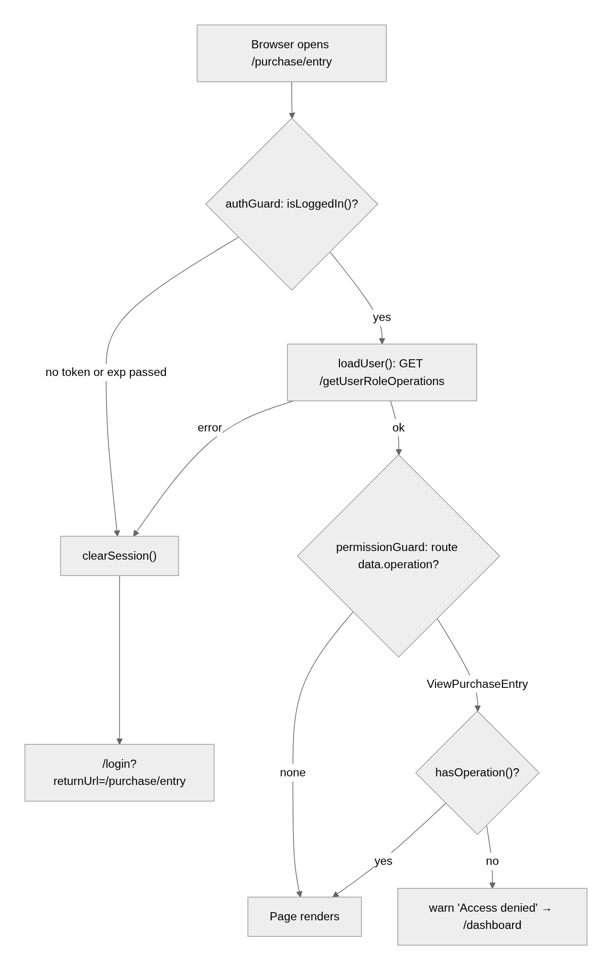
authGuard(route, state):
toLogin = UrlTree('/login', { returnUrl: state.url })
if not auth.isLoggedIn(): auth.clearSession(); return toLogin
return auth.loadUser() → true
on error: auth.clearSession(); return toLogin

guestGuard():
return auth.isLoggedIn() ? UrlTree('/dashboard') : true

permissionGuard(route):
operation = route.data['operation'] -- a name, a list of names, or nothing
if none: return true -- e.g. /dashboard, /change-password
return auth.loadUser() →
if auth.hasOperation(operation): true
else: notification.warn('Access denied', 'Your role does not allow this page (<names joined by " or ">).')
UrlTree('/dashboard')
on error: UrlTree('/login')

loadUser():
if user already set: return of(user)
userRequest ??= fetchUser() with shareReplay(1) and finalize(userRequest = null)
return userRequest

fetchUser():
GET /getUserRoleOperations
tap: loadAvatar(dto.id, dto.image_url) -- see 4.6
map: toAuthUser(dto)
tap: user.set(...)

Why clearSession() in authGuard's error path. If the token exists but the API rejects it, keeping it would make guestGuard on /login see isLoggedIn() === true and bounce straight back to the shell: an endless loop. Dropping the token breaks it.
Why shareReplay(1) and the ??=. The shell guard and the child guard run during the same navigation; without sharing, each would fire its own GET /getUserRoleOperations. The finalize clears the cached observable once it completes or fails so a later loadUser() after an error retries instead of replaying the failure.

4.3 Checking permissions
hasOperation reads a computed Set of the user's operations. With a string it checks membership; with a list it returns true if any one is granted. The list form exists for pages that two roles share: Payments is open to ViewVendorPayment or ViewCustomerPayment, and the Reports link to any report's View operation. Routes put the same value in data.operation, sidebar links in operation, and buttons call hasOperation('Create…') / 'Edit…' / 'Delete…' through small computed signals (canCreate, canEdit, canDelete).

4.4 Sending the token and ending the session
Idea. One interceptor adds the header everywhere, so no service thinks about it. The same interceptor is the only place that decides "the session is over", because it sees every failure.
authInterceptor(req, next):
if req.url is not under environment.apiUrl, or is exactly <apiUrl>/login: pass through untouched
token = auth.getToken()
request = token ? req with header 'Authorization: Bearer <token>' : req
return next(request) with catchError(error):
if error is HttpErrorResponse and error.error is a Blob:
error = withJsonBody(error) -- read the Blob as text, JSON.parse, rebuild the response
-- (unchanged if the body is not JSON)
if error is HttpErrorResponse and isSessionError(error): auth.expireSession()
rethrow error

isSessionError(error):
status 401 → true (no / bad token: "Please log in to access this resource.")
message matches /jwt|token|authorization header/i → true (403 "The JWT token has expired", 500 "JWT signature does not match…")
otherwise → false (403 "Operation not allowed" is a permission error for the caller)

Why parse Blob bodies. Print and Export call the API with responseType: 'blob'. When such a request fails, Angular hands back the error body as a Blob too, so neither isSessionError nor the page's apiErrorMessage(error) could read message. The interceptor rebuilds the HttpErrorResponse with the parsed JSON so both work for file downloads exactly as for JSON calls.

4.5 Token expiry
getToken() refuses a token whose exp claim is in the past, so the app logs itself out on the next navigation or request instead of sending a dead token and waiting for a 403. The check reads the JWT without a library:
isExpired(token):
payload = second dot-separated part, with '-' → '+' and '_' → '/' (base64url → base64)
{ exp } = JSON.parse(atob(payload))
return exp is a number and exp * 1000 <= Date.now()
any exception (not a JWT) → true

4.6 Loading the avatar
image_url is a server-relative path such as /uploads/users/<uuid>.png, and that endpoint needs the auth header, which an <img src> cannot send. So after the user loads, the service fetches the picture as a Blob through HttpClient (the interceptor adds the header), turns it into an object URL with URL.createObjectURL, and stores it as user.avatarUrl. It is set only if the user signal still holds the same id (the response may arrive after a logout). A failure is ignored: the profile menu shows a placeholder icon. clearSession() and refreshUser() call URL.revokeObjectURL on the previous URL so pictures don't leak.

4.7 Refreshing the user
After saving your own user record or your own role, call refreshUser(). It fetches again and replaces the user signal, so the sidebar, header and every hasOperation recompute. The token still names the old username, so renaming yourself needs a new login (the API will reject the old name).

4.8 Logging out and session expiry
logout(): clearSession(); navigate('/login')

expireSession(): -- from the interceptor
if no token: return -- already gone; several failures arrive at once
clearSession()
notification.warn('Session expired', 'Please log in again.')
returnUrl = the navigation in progress (finalUrl ?? extractedUrl) if any, else router.url
navigate('/login', { returnUrl }) — the param is omitted when returnUrl is '/'

clearSession(): revoke avatarUrl; localStorage.removeItem('auth_token'); token = null; user = null

Why look at currentNavigation(). When a fresh page load fails inside authGuard's loadUser(), router.url is still / (nothing has rendered). The navigation object knows where the user was heading, so after logging in again they land on that page.

4.9 Change Password
Idea. The API checks the current password and the strength rule, but the page checks the same things first so the user gets instant feedback, and it adds the "type it twice" check that only the browser can do. The session stays signed in: the token is unchanged.
Fields: Current Password, New Password (with Lumen's [showRules] checklist), Confirm New Password. Buttons: Cancel (Location.back()) and Change Password (Saving… while running). A hint under the form says five wrong current passwords in a row lock the account for an hour.
State: saving signal; name computed (fullName || username) for the subtitle; value = toSignal(form.valueChanges); newPassword, sameAsCurrent (new typed and equal to current) and mismatch (confirm typed and different from new) are computed from it.
save():
if saving: return
markAllAsTouched
if form invalid or sameAsCurrent or mismatch: return -- messages already on screen
PUT /change-password { current_password, new_password }
on success: notification.success('Password changed', response.message); form.reset()
on error: notification.error('Could not change password', apiErrorMessage(error))

Rules checked.
Rule | Where | Message
All three fields required | form validators | Lumen's required marker
New password matches STRONG_PASSWORD | Validators.pattern | the checklist turns green; API: "New password must be at least 8 characters with upper and lower case letters, a number and a symbol"
New differs from current | sameAsCurrent | Use a password different from the current one. (API: "New password must be different from the current password")
Confirmation equals new | mismatch | The passwords don't match.
Current password correct | API only | 400 "Current password is incorrect", and it counts towards the lock
Account not locked | API only | 403 "Account is locked. Try again later."

STRONG_PASSWORD is /^(?=.*[a-z])(?=.*[A-Z])(?=.*\d)(?=.*[^A-Za-z0-9]).{8,}$/: 8+ characters with a lower-case letter, an upper-case letter, a digit and a symbol. The backend AuthService.java compiles the same pattern, so the browser never accepts what the server would refuse.

5. Design decisions and gotchas
- Token in localStorage, user in memory. The token survives a reload (so the user stays signed in for the token's hour); the user and operations are refetched on every load because roles can change between visits.
- The token is never trusted for permissions. Operations come from GET /getUserRoleOperations, not from the JWT payload; the JWT is only read for exp.
- readToken() is wrapped in try/catch because localStorage can throw in private windows or when storage is blocked; the app then simply starts logged out.
- /login is excluded from the interceptor so a stale token in storage is never sent with a fresh login attempt.
- A plain 403 is not a logout. "Operation not allowed" means the role lacks a permission; the page shows it with apiErrorMessage. Only 401 and messages mentioning the JWT end the session.
- expireSession() is idempotent. Several requests can fail together when a token dies; the first clears the token, the rest see no token and return.
- guestGuard sends signed-in users to /dashboard, so bookmarking /login while logged in just opens the app.
- Routes without data.operation are open to any login: /dashboard and /change-password. Every feature list route declares one, with canActivate: [permissionGuard].
- The avatar is an object URL, not the API path. Components that show other users' pictures (user list, user form) use <app-user-avatar> from shared/, which does the same Blob fetch per picture.
- Specs: stub WebSocket and localStorage as needed, set auth.user.set(testUser({ operations: [...] })) to grant permissions, and localStorage.setItem('auth_token', testToken()) to look logged in.

6. Build it yourself: order of work
- Add apiUrl to environments/environment.ts and define the models in auth.model.ts (copy the field names from section 2 of endpoints.md).
- Write AuthService: token signal backed by localStorage (auth_token), isExpired from the JWT exp, user signal, operations computed Set, hasOperation with string or list.
- Add login() (POST /login → store token → loadUser()), loadUser() with the ??= + shareReplay(1) + finalize cache, fetchUser() mapping UserRoleOperations → AuthUser.
- Add clearSession(), logout(), expireSession() (with returnUrl from currentNavigation()), refreshUser(), then loadAvatar() as a Blob → object URL.
- Write authInterceptor: skip non-API and /login URLs, add the Bearer header, parse Blob error bodies, call expireSession() on isSessionError. Register it in app.config.ts.
- Write the three guards and wire them in app.routes.ts (authGuard on the shell, guestGuard on /login); put data.operation + permissionGuard on every feature route.
- Build the Login page: two Lumen inputs with (enter), submitting and error signals, the safe returnUrl().
- Build the ChangePassword page under the shell: three password inputs, STRONG_PASSWORD in shared/utils/password.ts, the sameAsCurrent / mismatch computeds, PUT /change-password.
- Add auth.testing.ts (testUser, testToken) and specs for the service (expiry, hasOperation list form), the guards (redirects, the clear-token loop fix) and the interceptor (header, 401, Blob body).
- Try it: log in as admin / Admin@123, reload the page (still signed in), set a token with a past exp in DevTools (bounced to /login?returnUrl=…), open a page your role lacks (warning + /dashboard).

