Frontend — Setup and Project Structure
Part of the Inventory System implementation guide. Read docs/BRD.md first for the business picture. This document explains how the web app is put together and in what order to build it. Each feature then has its own document in a sub-folder of docs/frontend/.

Contents
1. What the frontend is
2. Tools to install
3. Creating the project from scratch
4. Folder structure
5. How the app is wired
6. The two page patterns
7. Conventions
8. Commands and checks
9. Order to build the frontend from scratch
10. Feature documents

1. What the frontend is
An Angular single-page web app that people use in the browser. It talks to the API server over HTTP (JSON) with a login token, draws every screen with the Lumen UI component library, and leaves all business rules to the server. What it does own: the look of every page, form validation before sending, the arithmetic of document totals (so the user sees the same numbers that get stored), and the calendar shown on screen (AD or BS).
Piece | Choice | Why
Framework | Angular 22, standalone components, signals, OnPush change detection | Current Angular style; no NgModules; fast rendering
UI library | @lumen-ui/angular 0.1.0, installed from the local file lumen-ui-angular-0.1.0.tgz | Buttons, inputs, selects, date inputs (AD/BS), tables, pagination, drawers, dialogs, notifications, icons
Styling | SCSS; styles/colors.scss holds the colour variables; nested plain class names | Simple, readable stylesheets
HTTP | HttpClient with one functional interceptor that adds the token | One place for auth
Tests | Vitest (npx ng test --watch=false) | Fast unit tests; the specs stub HTTP and the WebSocket
Build | Angular CLI (npm start, npx ng build)

Lumen's API lives in node_modules/@lumen-ui/angular/types/lumen-ui-angular.d.ts. The components used most: l-button, l-text-input, l-number-input, l-select, l-date-input, l-textarea, l-checkbox, l-radio, l-toggle, l-table (with cell templates), l-pagination, l-card, l-tabs, l-icon, l-breadcrumb, l-file-upload, l-password-input, and the services DrawerService, ModalService, NotificationService, SpinnerService.

2. Tools to install
- Node.js 24 (LTS) with npm.
- The Angular CLI comes with the project (npx ng …), no global install needed.

3. Creating the project from scratch
- npx @angular/cli@22 new inventory-system --style=scss --routing (standalone components and Vitest are the defaults in Angular 22).
- Copy lumen-ui-angular-0.1.0.tgz into the project and npm install ./lumen-ui-angular-0.1.0.tgz.
- src/environments/environment.ts exports apiUrl: 'http://localhost:8080' (no trailing slash). Every service builds its URLs from it.
- src/styles.scss imports styles/colors.scss, styles/utils.scss and Lumen's form styles, sets the body font (Fira Sans, 14px) and the global drawer-sheet and print rules.
- src/main.ts bootstraps App with app.config.ts, which provides the router and HttpClient with the authInterceptor.
- npm start serves it at http://localhost:4200 with live reload.

4. Folder structure
src/
├── main.ts, index.html, styles.scss
├── environments/environment.ts apiUrl
├── styles/colors.scss, utils.scss CSS variables (accent, status, chart colours, text, backgrounds)
└── app/
├── app.ts / app.html <router-outlet> only
├── app.config.ts providers: router, HttpClient + authInterceptor
├── app.routes.ts the route tree (below)
├── auth/ AuthService, guards, interceptor, login page, change-password page, spec helpers
├── layout/ the shell around every page
│ ├── layout.ts sidebar + header + <router-outlet>
│ ├── sidebar/ menu from sidebar.data.ts; links hidden without their operation
│ └── header/ breadcrumb, printer button (range-print/), notification-menu/ (bell + live feed), profile-menu/
├── features/<module>/ one folder per menu area
│ ├── <module>.routes.ts lazy routes with data.operation + permissionGuard
│ ├── <module>.model.ts TypeScript shapes of the API's JSON
│ ├── <module>.service.ts one service per API resource
│ └── <feature>/<feature>-list/ + <feature>-form/ components
└── shared/
├── components/ list-page-card, invoice-summary-card, summary-card, amount-totals, party-details-card,
│ date-text, calculator, user-avatar, cancel-dialog
├── services/ dropdown, product, product-lookup, breadcrumb, file, file-downloads
├── pipes/ amount, docNo
├── utils/ invoice (totals), date, batch, options, file, api-error, password
├── models/ api, invoice, product
└── styles/ document-form.scss, document-list.scss, summary-card.scss

The feature folders: masters/ (one list + one form for units, categories, packings, tax types), product/, party/ (one list + one form for vendors and customers), purchase/ (purchase-entry, purchase-return), sales/ (sales-entry, sales-return), inventory/ (opening-stock, stock-adjustment, stock-edit), accounting/ (account, journal, opening-balance, payment, payment-adjustment), report/ (reports page, report-view, ledger-report), dashboard/ (one component per card, line-chart), user-roles/ (user, role), settings/ (configuration, document-numbering).

5. How the app is wired
Routes (app.routes.ts): the empty path loads Layout behind authGuard; its children are lazy feature route files (/dashboard, /purchase, /sales, /inventory, /accounting, /products, /masters, /reports, /user-roles, /settings, /change-password). /login sits outside the layout behind guestGuard. Anything else redirects to the dashboard. Each child route carries data: { breadcrumb: '…' } for the header, and feature routes add data: { operation: 'ViewPurchaseEntry' } with canActivate: [permissionGuard].
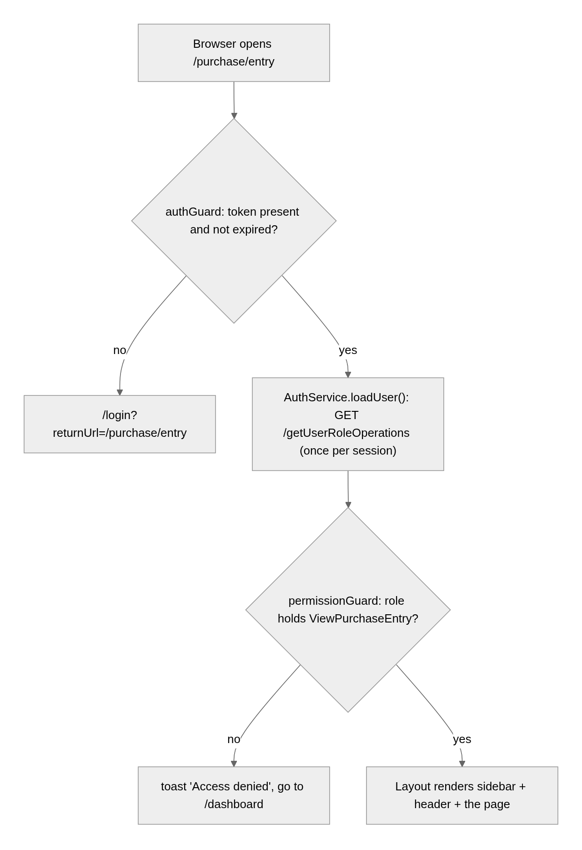
Login and permissions: AuthService keeps the token in localStorage, loads the user's operations once, and answers hasOperation('…') (a name or a list; any one grants). The sidebar hides links whose operation the role lacks; pages gate buttons the same way (Create…, Edit…, Delete…, Cancel…). The interceptor adds Authorization: Bearer <token> to every API call and ends the session on 401 or on any error whose message mentions the token.
Talking to the API: one service per resource (PurchaseEntryService, VendorService, …), building URLs from environment.apiUrl. JSON fields are snake_case; line lists are camelCase. Dates travel as YYYY-MM-DD strings and are converted with shared/utils/date.ts (never new Date('YYYY-MM-DD'), which parses as UTC and can shift the day). Failures are shown with Lumen's NotificationService and apiErrorMessage(error), which reads the API's message.

6. The two page patterns
Almost every feature is a list page and a form in a drawer. The shared document describes both in detail; in short:
List page (<app-list-page-card> with title, body and footer slots): the query state (filters, dates, sort, page index, page size) lives in signals; a computed builds the request parameters; toObservable + switchMap turn each change into one API call, so rows stay on screen while the next page loads. l-table with [serverSort] maps column keys to API sort fields; l-pagination binds the page signals. Print and Export buttons call the resource service's exportList(format, params) through FileDownloads.
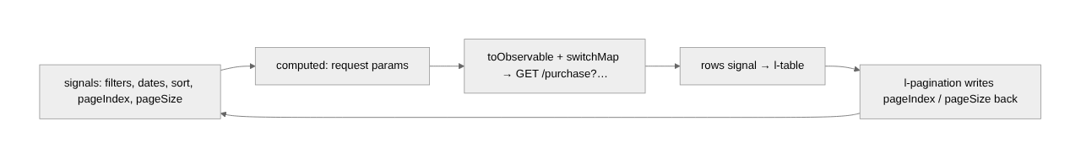
Form in a drawer: Add, Edit and View open the same component with DrawerService.open(Form, { position: 'bottom', panelClass: 'drawer-sheet', disableClose: true, data: { mode, id } }); the component reads DRAWER_DATA. Small forms (masters, accounts, opening stock, stock edit) use a right drawer of 350px or 400px with the row itself passed in. Lumen inputs take [viewMode], so the same template serves read-only view; the View form's Edit button switches to edit in place. Document forms (purchase, sales, returns, journals, payments, stock adjustments) keep their lines in a typed FormArray rendered by l-table cell templates, compute totals with calculateInvoice, and list ProductLookup in their own providers so each form fetches product details and batches once.

7. Conventions
- Lumen for everything. Never a native <button>: use <l-button> and restyle its inner element with .myclass ::ng-deep .btn { … }.
- Nested SCSS with short plain class names, never BEM; modifiers are extra classes (.item.active).
- Standalone components, ChangeDetectionStrategy.OnPush, signals, inject(), @Service() for services, selector prefix app-.
- Document numbers come back as |PE-000001; show them through the docNo pipe, send them back raw.
- The server stores the totals it is sent: compute them with calculateInvoice; discount holds what the user typed (percent or amount, per discount_type).
- Dropdowns come from DropdownService (active records); when editing a saved document, merge its own vendor/products into the options with withMissing so inactive ones still show a label.
- Show dates with <app-date-text>, passing the page's AD/BS switch as its calendar (BS by default); send the same calendar with every Print and Export so the file matches the screen. Never build a file or call window.print() in the browser: the API builds every file.

8. Commands and checks
Command | What it does
npm install | Install dependencies (first time)
npm start | Dev server at http://localhost:4200
npx ng build | Production build to dist/
npx ng test --watch=false | Run the Vitest specs

Known notes: src/app/app.spec.ts › "should render title" is a stale scaffold test that fails; ignore it. The initial bundle is over the 500 kB warning budget because Lumen ships as one module file.
To look at a page you need a real login, so a bare headless-Chrome screenshot only reaches /login; drive Chrome over the DevTools protocol (log in through the form, then navigate) when you want screenshots.

9. Order to build the frontend from scratch
- Scaffold: project, Lumen, environment.ts, global styles, colours.
- Auth: AuthService, authInterceptor, authGuard / guestGuard / permissionGuard, the login page. (docs/frontend/auth/)
- Layout: shell, sidebar from sidebar.data.ts with operation-based hiding, header with breadcrumb and profile menu. (docs/frontend/layout/)
- Shared toolkit: list-page-card, date.ts, api-error.ts, DropdownService, FileService + FileDownloads, pipes. (docs/frontend/shared/)
- Masters: the simplest list + right-drawer form; proves the list pattern and the drawer pattern. (docs/frontend/masters/)
- Parties (config-driven list + form) and Products (bigger form with a bonus FormArray). (docs/frontend/parties/, docs/frontend/products/)
- Purchase entry: the first document form; calculateInvoice, InvoiceSummaryCard, ProductLookup, batches typed. Then purchase return with batch picking and the reference purchase. (docs/frontend/purchase/)
- Sales and sales return with the cancel dialog. (docs/frontend/sales/)
- Inventory pages. (docs/frontend/inventory/)
- Accounting: chart of accounts, journal lines table, journal form, opening balance. (docs/frontend/accounting/)
- Payments with invoice settlement, and payment adjustments. (docs/frontend/payments/)
- Reports page, ReportView, ledger. (docs/frontend/reports/)
- Dashboard cards and the SVG line chart. (docs/frontend/dashboard/)
- Users and roles with the permission matrix; Settings. (docs/frontend/user-roles/, docs/frontend/settings/)
- Notifications: the bell and the live feed. (docs/frontend/layout/)
- Print and Export buttons everywhere, then Range Print in the header.
- Change Password page.

10. Feature documents
Document | Covers
auth/auth.md | Token, guards, interceptor, login, change password
layout/layout.md | Shell, sidebar, header, notification bell and live feed, range print, profile menu
shared/shared.md | Shared components, services, utilities, the list and drawer patterns, totals arithmetic
masters/masters.md | Units, categories, packings, tax types
products/products.md | Product list and form
parties/parties.md | Vendors and customers
purchase/purchase.md | Purchase entry and purchase return pages
sales/sales.md | Sales entry and sales return pages, cancelling
inventory/inventory.md | Opening stock, stock adjustment, stock edit
accounting/accounting.md | Chart of accounts, journal entries, opening balance
payments/payments.md | Payments, settlement, payment adjustments
reports/reports.md | Reports page, report view, ledger
dashboard/dashboard.md | Dashboard cards and chart
user-roles/user-roles.md | Users and roles
settings/settings.md | Configuration and document numbering

