Payments and Payment Adjustments — Frontend
Part of the Inventory System implementation guide. Read docs/BRD.md for the business picture and docs/frontend/frontend-setup.md for how the web app is organised.

Contents
1. What this is
2. Where the code lives
3. Screens
3.1 Payments list
3.2 Payment form (bottom drawer)
3.3 Payment Adjustments list
3.4 Adjust drawer
4. How it works
4.1 Loading the lists and the one-type rule
4.2 Settlement rows (settlement.ts)
4.3 Settle Oldest First (autoSettle)
4.4 Opening the payment form
4.5 Saving a payment
4.6 Deleting a payment
4.7 Adjusting a payment
4.8 Print and Export
5. Design decisions and gotchas
6. Build it yourself: order of work

1. What this is
Payments (/accounting/payments) record money paid to a vendor or received from a customer. The form lists the party's invoices with money due (credit purchases for a vendor, credit sales for a customer) and lets the user type what this payment settles of each, or spread the amount oldest-first with one click. Whatever is not settled stays as an unadjusted amount, an advance.
Payment Adjustments (/accounting/payment-adjustment) list the payments that still have an unadjusted amount and let the user apply it to the party's invoices later, for example a payment received before the invoice existed.
Vendor and customer payments are one list and one form; a "party type" picks which side the money goes.

2. Where the code lives
All paths are under frontend/src/app/features/accounting/.
File | What is in it
accounting.routes.ts | payments (operation ['ViewVendorPayment', 'ViewCustomerPayment']: either lets the user in) and payment-adjustment (ViewPaymentAdjustment), both through permissionGuard.
payment/payment.model.ts | PartyType, PARTY_TYPES, PAYMENT_DIRECTIONS (Send → Vendor, Receive → Customer), VIEW_PAYMENT_OPERATIONS, PaymentFormMode, PaymentFormData, PaymentAdjustmentFormData, PaymentDetail, Payment, PaymentPayload, OutstandingInvoice.
payment/payment.service.ts | PaymentService: list, get, nextNumber, create, update, delete, outstanding(type, partyId), unadjusted(params), adjust(paymentId, details), exportList, exportOne, printRange, exportUnadjusted.
payment/settlement.ts | SettlementRow, settlementRows, settledRows, settledTotal, autoSettle, toPaymentDetails.
payment/invoice-settlement/ | InvoiceSettlement: the invoices table with one amount input per row.
payment/payment-list/ | PaymentList.
payment/payment-form/ | PaymentForm: add / edit / view in the bottom drawer.
payment-adjustment/payment-adjustment-list/ | PaymentAdjustmentList.
payment-adjustment/payment-adjustment-form/ | PaymentAdjustmentForm: the Adjust drawer.

Shared pieces: LIST_PAGE_CARD, SummaryCard (SummaryItem { label, value, net?, error? }), DateText, DocNoPipe, AmountPipe, DropdownService (vendors, customers, paymentModes), FileDownloads, withMissing, round2, the date utils, apiErrorMessage. API shapes: backend/endpoints.md section 12.

3. Screens

3.1 Payments list
Column | Shows | Sorts by
S.N | running number | —
Payment Number | system_entry_no via docNo, a link to view | systemEntryNo
Date | <app-date-text> in the page calendar | date
Party Type | VENDOR / CUSTOMER chip | type
Party Name | vendor_name or customer_name by type | —
Payment Mode | payment_mode_name | paymentMode.accountName
Amount | bold | amount
Unadjusted | highlighted when > 0 | unadjustedAmount
Actions | View; Edit (EditPayment); Delete (DeletePayment) | —

Title bar: search by partyName (the API matches vendor and customer names alike), filters Payment No (systemEntryNo), Payment Mode (paymentMode.accountName), Narration (narration); a Party Type select (All Parties, clearable) shown only when the user may view both kinds; AD/BS switch; From / To dates (default today); Print, Export; Add Payment (CreatePayment). Default sort id:desc, page size 10.

3.2 Payment form (bottom drawer)
Opened with PaymentFormData { mode, id?, partyTypes?, calendar? } (position: 'bottom', size: 'calc(100vh - 48px)', panelClass: 'drawer-sheet', disableClose: true). Headings Add Payment, Edit Payment, Payment.
Section | Field | Control | Rule
Top card | Party Type | select of partyTypes (Vendor / Customer) | required; only the types the user may view
 | Date | date input in the list's calendar | required, default today
 | Payment Number | read-only chip/text (entryNo) | preview of the next number when adding
 | Vendor / Customer | searchable select, label is the type | required; cleared when the type changes
Payment Details | Payment Type | radios Send / Receive | the same type control as Party Type under another label
 | Transaction Type | select of GET /dropdown/paymentModes (Cash, banks) | required; new payments default to the account named Cash
 | Amount | number, 2 decimals | required, min 0.01
Payment Send/Receive Details | Settle Oldest First button, InvoiceSettlement table, SummaryCard

The invoices table columns: S.N, Invoice Date, Invoice Number (docNo), Invoice Amount, Amount Due (hidden in view mode, since it has moved on), and Paid (a number input, or the bold value in view mode). Empty text: "Pick a party to see their invoices with money due." → "No invoices due. The whole amount stays unadjusted." → in view mode "This payment does not settle any invoice yet."
Summary card: Total Adjusted Paid Amount (what the rows settle; red when more than the amount), Unadjusted Amount (amount − settled), Total Payment Amount (the bottom line).
There is no narration field: the API writes one (Payment received from Ram Traders). Footer: view → Close and Edit (EditPayment); add/edit → Cancel and Add / Update. View mode offers Print (PDF voucher or receipt) and Export (Excel) in the header.

3.3 Payment Adjustments list
Same rows as the payments list (the API's GET /payment-adjustment returns payments with an unadjusted amount), with these differences: a Settled column (total_adjusted_paid_amount, sort totalAdjustedPaidAmount), the payment mode shown under the party name, the Party Type select always shown, From / To open by default (money left over from any day can still be adjusted), no Add, no Edit/Delete, and an Adjust button per row (plus the number link) gated on CreatePaymentAdjustment. Empty text "No payments with an unadjusted amount." Print/Export call /payment-adjustment/export/{format}.

3.4 Adjust drawer
PaymentAdjustmentForm opens in the same bottom drawer with { payment, calendar } (the list row; nothing loads but the invoices). It shows the payment as a definition list (Payment Number, Date, the party under its type, Payment Mode, Amount, Settled So Far, Narration when any), then Invoices Due with Settle Oldest First, the InvoiceSettlement table (amount header Adjust Now, empty text No invoices due from <party>.) and a summary: Unadjusted Amount, Adjusting Now (red when too much), Left Unadjusted. Footer: Cancel and Adjust (Adjusting…; disabled while loading or with no rows).

4. How it works

4.1 Loading the lists and the one-type rule
Idea. Both lists use the standard signal → computed request → toObservable + switchMap loop. The payments list adds partyTypes = PARTY_TYPES filtered by hasOperation(VIEW_PAYMENT_OPERATIONS[type]). When only one type is allowed, the select is not rendered and type is fixed to that one; otherwise type is the select's pick (null = both). type goes out as the type query parameter, so a role that can view only vendor payments never receives customer ones, and the form it opens gets partyTypes with that one entry.
query = filters + type (if any) + fromDate/toDate (toIsoDate) + sort (SORT_FIELDS or "id:desc") -- no paging; also used by export
request = { ...query, pageIndex, pageSize } + refresh
GET /payment?request (adjustment list: GET /payment-adjustment)
ok -> rows, total; error -> empty text = apiErrorMessage(error, "Could not load payments.")

4.2 Settlement rows (settlement.ts)
Idea. The outstanding reports say what is due now, which already has the edited payment's own settlements taken off. To edit a payment, those settlements must count as available again, otherwise the user could not even re-save the same amounts. An invoice this payment settled in full is no longer outstanding at all, so it comes from the saved details alone.
settlementRows(outstanding, saved = []):
own = saved details grouped by invoice_number, paid_amount summed -- an adjusted payment can name an invoice twice
rows = for each outstanding invoice:
paid = own[invoice].paid_amount or 0; remove it from own
row(invoice, due = round2(invoice.due_amount + paid), paid)
for each detail left in own: -- settled in full, no longer outstanding
rows += row(detail, due = detail.paid_amount, paid = detail.paid_amount)
sort by invoice_date, then invoice_number -- oldest first
row(...): paid is a FormControl(paid or null) with validators min(0) and max(due)
settledRows(saved) = settlementRows([], saved) -- view mode
settledTotal(rows) = round2(sum of paid values)
toPaymentDetails(rows) = rows with paid > 0 -> { invoice_number, invoice_date, total_invoice_amount,
due_amount: round2(due − paid), paid_amount: paid }

PaymentService.outstanding(type, partyId) reads GET /reports/accounting/payable (vendors) or /receivable (customers) and keeps the rows whose party_id matches, since the reports cover every party.

4.3 Settle Oldest First (autoSettle)
autoSettle(rows, amount):
left = round2(max(amount, 0))
for row in rows: -- rows are already oldest first
paid = round2(min(row.due_amount, left))
row.paid := paid, or blank when 0
left = round2(left − paid)

Each invoice is settled in full while the money lasts; the first one it can't cover gets the remainder; the rest are cleared. Running it again with a smaller amount therefore un-settles later rows. The payment form runs it with the typed amount (warning "No amount" / "Enter the payment amount first." when it is 0); the Adjust drawer runs it with payment.unadjusted_amount.

4.4 Opening the payment form
constructor:
type.valueChanges:
setValue(type, emitEvent false) -- the select and the radios share the control; write the pick to both
if type != pickedType: pickedType := type; party_id := null -- vendors and customers are different lists
rows pipeline on computed { type, partyId, readonly, saved }:
own = saved.paymentDetails if saved has this type and party, else []
readonly -> rows := settledRows(own) -- view shows only what it settled
no party -> rows := []
else -> invoicesLoading; GET outstanding(type, partyId) -> settlementRows(invoices, own)
error -> "Could not load the invoices due"; rows := settlementRows([], own)
setRows: rebuild the `settlement` FormArray from the rows' paid controls (so validity counts with the form)
mode != add and id -> load(id): GET /payment/{id} -> fill
error -> "Could not load the payment"; close
else -> mode := add; GET /payment/generateNumber -> entryNo
fill(payment): entryNo, saved := payment, pickedType := payment.type (so the party is not cleared),
patch type, party_id (vendor_id or customer_id), date, payment_mode_id, amount; markAsPristine

Other state: vendorList / customerList load only for allowed types; modeList loads payment modes and, in add mode with nothing picked, sets the one named cash. partyOptions = withMissing(list for the type, the saved party if same type) and modeOptions = withMissing(modes, saved mode) keep inactive records labelled. value = toSignal(form.valueChanges → getRawValue()); settled = settledTotal(rows()) (recomputed on every value change); summary derives from amount and settled. Switching view → edit (startEdit) flips readonly, which makes the pipeline fetch the invoices due.

4.5 Saving a payment
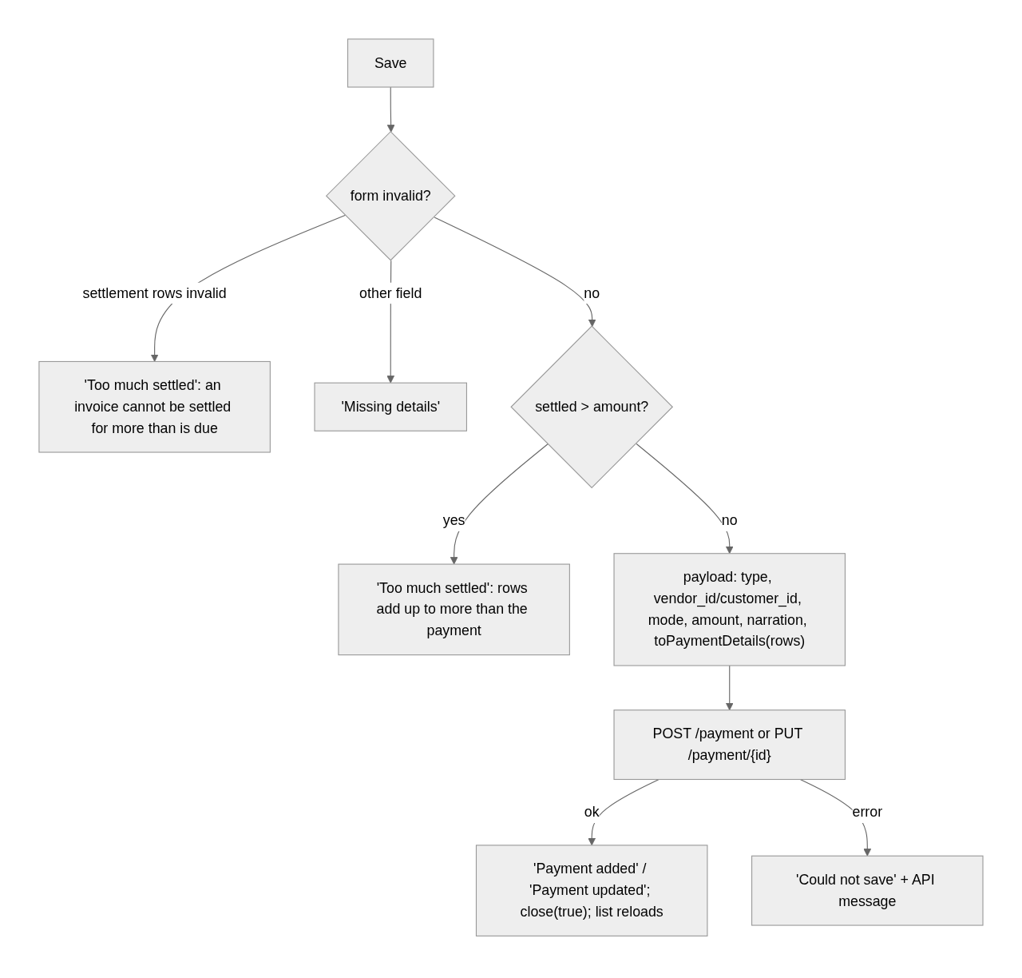
payload = { date: toIsoDate(date), type,
vendor_id: type == Vendor ? party_id : 0,
customer_id: type == Customer ? party_id : 0,
payment_mode_id, amount,
narration: same party as saved ? saved.narration : "", -- blank: the API writes one for the party
paymentDetails: toPaymentDetails(rows) }

Rules shown by the form
When | Title | Message
a row's paid > its due (validator max) | Too much settled | An invoice cannot be settled for more than is due on it.
type, party, date, mode or amount missing / amount < 0.01 | Missing details | Fill in the fields highlighted in red.
settled > amount | Too much settled | The invoices settled add up to more than the payment amount.
Settle Oldest First with amount ≤ 0 | No amount | Enter the payment amount first.

API rules behind them (shown through apiErrorMessage): "Payment type must be either Vendor or Customer", "Payment amount must be greater than zero", "Paid amount for an invoice must be greater than zero", "Paid amount exceeds due amount for invoice <no>", "Adjusted amount cannot exceed the payment amount", "Due Invoice not found: <no>", "Payment Mode Account not found". On update the API first takes back everything the payment settled (adjustments included), then applies the details sent, which is why the form sends every invoice the payment should still settle.

4.6 Deleting a payment
Delete (DeletePayment) confirms with "Delete payment?" / "<number> from <party> will be deleted, and the invoices it settled become due again. This cannot be undone.", runs DELETE /payment/{id}, shows "Payment deleted", and steps back a page when the last row of a later page goes.

4.7 Adjusting a payment
Idea. Adjustment only adds settlements out of the unadjusted amount; it never takes any back (editing the payment does that). So the drawer starts from settlementRows(invoices) with nothing pre-filled and compares against payment.unadjusted_amount, not amount.
constructor: GET outstanding(payment.type, vendor_id or customer_id)
-> rows := settlementRows(invoices); push each paid control into `amounts` (FormArray)
error -> "Could not load the invoices due"; rows := []
adjusting = settledTotal(rows) (recomputed on amounts.valueChanges)
save():
amounts invalid -> "Too much settled" / "An invoice cannot be settled for more than is due on it."
details = toPaymentDetails(rows); none -> "Nothing to adjust" / "Enter the amount to settle on at least one invoice."
adjusting > unadjusted -> "Too much settled" / "The invoices settled add up to more than the unadjusted amount."
POST /payment-adjustment/{payment.id} with the details list
ok -> "Payment adjusted"; close(true); the list reloads (a fully adjusted payment drops out; step back a page if it was the last row)
error -> "Could not adjust" + API message ("No invoice adjustments were provided",
"Adjusted amount cannot exceed the unadjusted amount of the payment", "Paid amount exceeds due amount for invoice <no>")

4.8 Print and Export
- Lists: exportList(format, { ...query, calendar }) → /payment/export/{format}; the adjustment list uses exportUnadjusted → /payment-adjustment/export/{format}. The query carries type when one is picked, so the file keeps to one kind.
- The form in view mode: exportOne(id, format, { calendar }) → /payment/{id}/export/{format}, a voucher (vendor) or receipt (customer) as PDF, or the settled invoices as Excel.
- printRange(params) → /payment/print?fromDate=&toDate=&type= is used by the header's Range Print drawer, not by these pages.
- All go through FileDownloads.run (one at a time, Printing… / Exporting…, failures as notifications).

5. Design decisions and gotchas
- Party Type and Payment Type are one control. The API ties direction to party type (Vendor = money out, Customer = money in), so Send / Receive are just PAYMENT_DIRECTIONS labels over the same type control. Angular does not propagate a pick from one bound control to the other, hence the setValue(..., { emitEvent: false }) write-back.
- Clearing the party on a type change is keyed on pickedType, not on every valueChanges, so loading a saved payment (which patches type too) keeps its party.
- View mode never calls the outstanding reports: it shows settledRows(saved details), and the Amount Due column is hidden because the figure has moved on. Switching to Edit triggers the fetch.
- Saved settlements count as available again (due + own paid), mirroring the API's reverse-then-reapply on update. A payment adjusted later can list the same invoice twice in paymentDetails; savedByInvoice merges them.
- The narration is kept only while the party stays the same; a new party gets a blank, and the API writes a fresh one.
- Rounding: every sum goes through round2, since the API compares to the paisa.
- The row paid controls are pushed into a FormArray on the form (settlement / amounts) only so their validity and changes flow into form.invalid and valueChanges; they are created by settlement.ts, not by the form builder.
- The payments list's dates default to today, the adjustment list's to open.
- Adjustment can't undo; the form's Edit can. Tell users to edit the payment to take a settlement back.

6. Build it yourself: order of work
- Routes and sidebar entries: payments with the two View operations (list), payment-adjustment with ViewPaymentAdjustment.
- payment.model.ts: the constants (PARTY_TYPES, PAYMENT_DIRECTIONS, VIEW_PAYMENT_OPERATIONS) and the API shapes from section 12.
- PaymentService, including outstanding (report + client-side party_id filter), unadjusted, adjust and the three file methods.
- settlement.ts with unit tests for settlementRows (merging saved details, fully settled invoices, sorting), autoSettle, toPaymentDetails (see settlement.spec.ts).
- InvoiceSettlement: columns, readonly hides Amount Due, amountHeader input.
- PaymentForm: the shared type control with write-back, the rows pipeline on { type, partyId, readonly, saved }, default Cash mode, summary card, save rules, view-mode Print/Export.
- PaymentList: partyTypes from permissions, the hidden select for one-type roles, type in the query, delete.
- PaymentAdjustmentList (open date range, Settled column, Adjust button) and PaymentAdjustmentForm (rows from outstanding only, compare against unadjusted_amount).
- Try it: add a credit sale, receive 1500 against a 1130 invoice, see 370 unadjusted, add another sale, adjust the 370 onto it, then edit the first payment and watch its settlements come back as available.

