Reports — Frontend
Part of the Inventory System implementation guide. Read docs/BRD.md for the business picture and docs/frontend/frontend-setup.md for how the web app is organised.

Contents
1. What this is
2. Where the code lives
Routes
API used (sections 14 and 18 of backend/endpoints.md)
3. Screens
3.1 The Reports page (/reports)
3.2 A table report (ReportView)
3.3 The ledger (LedgerReport)
4. How it works
4.1 Report configs (report.model.ts)
4.2 Loading a report
4.3 Search, sort and totals (report-table.ts)
4.4 Dates and the calendar
4.5 Trial balance to ledger
4.6 The ledger page
4.7 Print / Export
5. Design decisions and gotchas
6. Build it yourself: order of work

1. What this is
Reports are read-only tables the API builds from the documents and journals: registers of purchases, sales and returns, their totals per party, product and batch, the current stock, and the accounting views (journal, ledger, trial balance, receivables, payables). The user opens /reports, picks a report, sets the dates, searches and sorts the rows, reads the totals, and prints a PDF or exports an Excel file of exactly what is on screen.
Every table report is the same page, ReportView, driven by a config entry in REPORTS. Only the ledger has its own page, LedgerReport, because it needs an account picked and shows a running balance instead of a flat table.

2. Where the code lives
All under frontend/src/app/features/report/ unless noted.
File | What is in it
report.model.ts | Row types, ReportColumn, ReportConfig, discountAmount, every report's config (PURCHASE_REPORTS, PURCHASE_RETURN_REPORTS, SALES_REPORTS, SALES_RETURN_REPORTS, STOCK_REPORT, JOURNAL_REPORT, LEDGER_REPORT, TRIAL_BALANCE_REPORT, RECEIVABLE_REPORT, PAYABLE_REPORT), the REPORTS map by path, REPORT_GROUPS, REPORT_OPERATIONS
report.routes.ts | /reports (the Reports page), one route per REPORTS key, and the ledger route
report.service.ts | ReportService: rows, ledger, export, exportLedger
report-table.ts | Pure functions both pages share: cellValue, searchRows, sortRows, isCancelled, columnTotals, balanceSide, reportRange, startOfMonth, CALENDAR_OPTIONS
reports/ | Reports: the card page listing the reports the role may open
report-view/ | ReportView: the shared table report page
ledger-report/ | LedgerReport: one account's ledger
report.scss | Styles both pages share: .void, .expired, the sticky .totalled row, the print-only .print-head
report.model.spec.ts | Keeps the sidebar's operation list equal to REPORT_OPERATIONS and every listed report routed
shared/services/file-downloads.ts | FileDownloads: one Print / Export at a time; running() labels the button
shared/components/date-text/ | <app-date-text>: an API date shown in the AD or BS calendar
shared/utils/batch.ts | batchName (Default batch for a blank number), isExpired

Routes
REPORT_ROUTES is built from the config, so a report can't be listed without a page:
Path | Component | data
/reports | Reports | operation: REPORT_OPERATIONS (a list: any one of them opens the page)
/reports/<path> for every key of REPORTS (e.g. purchase/vendor) | ReportView | breadcrumb: title, operation, report: path
/reports/accounting/ledger | LedgerReport | operation: 'ViewAccount'; reads ?account=&fromDate=&toDate=

A report's page path is its API path: /reports/purchase/vendor reads GET /reports/purchase/vendor. Every route uses permissionGuard.

API used (sections 14 and 18 of backend/endpoints.md)
Method | Path | Used by
GET | /reports/<path>?fromDate&toDate | ReportService.rows: the whole report, not paged
GET | /reports/accounting/ledger/{accountId}?fromDate&toDate | ReportService.ledger
GET | /reports/<path>/export/{excel or pdf}?fromDate&toDate&calendar&search&sort | ReportService.export through FileService.download
GET | /reports/accounting/ledger/{accountId}/export/{format}?fromDate&toDate&calendar | ReportService.exportLedger

Permissions are per report (see the tables below). The API also accepts dateType=BS but answers an error for it, so the pages always send AD dates and convert only what they display.

3. Screens

3.1 The Reports page (/reports)
One l-card per entry of REPORT_GROUPS, with an icon, title, subtitle and a list of links (routerLink="/reports/<path>"). groups is a computed that keeps, in each group, the reports whose operation passes auth.hasOperation (a list means any one), then drops groups left empty. With nothing left it says "Your role has no reports to open."
Group | Reports (operation)
Purchase | Purchase Register, Purchase by Vendor, by Product, by Batch (ViewPurchaseEntry)
Purchase Return | the same four under purchase-return (ViewPurchaseReturn)
Sales | Sales Register, by Customer, by Product, by Batch (ViewSalesEntries)
Sales Return | the same four under sales-return (ViewSalesReturns)
Inventory | Stock Report (ViewStockEdit)
Accounting | Journal Report, Ledger, Trial Balance (ViewAccount); Accounts Receivable (ViewCustomerPayment, ViewAccount or CreatePaymentAdjustment); Accounts Payable (ViewVendorPayment, ViewAccount or CreatePaymentAdjustment)

REPORT_OPERATIONS is the de-duplicated set of every operation above. The sidebar's Reports link lists the same operations by hand; report.model.spec.ts fails if the two ever differ, and also checks that every listed report has a route (Object.keys(REPORTS).length + 1 listed, the + 1 being the ledger).

3.2 A table report (ReportView)
Title slot: a search box, an AD/BS segmented control, the date inputs the report's range asks for, then Print and Export. Body: the table. Footer: a row count.
range | Date inputs shown | What is sent
period | From and To (format="YYYY/MM/DD", each limited by the other) | fromDate and toDate; by default the 1st of this AD month (startOfMonth()) to today (startOfToday())
asOf | one "As of" input bound to toDate | only toDate
none | nothing | nothing

The trial balance is asOf because it must sum every movement from the very beginning; the stock, receivable and payable reports are none because they describe now.
Columns come from the config. Each ReportColumn has key, header, and optional format, value, total, width:
format | Cell
text (default) | the value, or -
amount | two decimals through the amount pipe, right-aligned
number | as is (quantities, counts), right-aligned
date | <app-date-text> in the page's calendar; an expiry_date in the past gets class expired (red)
docNo | through the docNo pipe; a cancelled row adds a red CANCELLED chip
batch | batchName(value): the batch number or Default batch
account | a link to the ledger of row.account_id over the same dates

The table shows an S.N column first, then the config columns, all sortable. When any column has total, a totals row is appended as the last row and pinned to the bottom (.totalled makes the last row sticky). In it, each total column shows its sum and the first column without total (totalLabelKey) reads "Total".
Buttons: Print (PDF) is disabled while a download runs; Export (Excel) also when there are no rows on screen. Both read downloads.running() to say Printing… / Exporting…. They need no extra permission: the API checks the same View operation as the report.
Footer: N rows, or N of M rows match while searching, plus · K cancelled, left out of the totals when any shown row is cancelled.

3.3 The ledger (LedgerReport)
Title slot: a searchable account l-select (every account, active or not: their past entries still matter), the AD/BS control, From and To, Print and Export (both disabled until a ledger is loaded). The table has fixed columns: S.N, Date, Entry No, Narration, Debit, Credit, Balance. Its rows are built from the API's Ledger:
- an opening row: narration "Opening Balance", balance opening_balance;
- one line row per rows[] entry, with the running balance;
- a total row: narration "Total", total_debit, total_credit, balance closing_balance.
Balances show as abs(balance) followed by Dr or Cr from balanceSide (positive is debit, negative credit, within ±0.005 nothing). A line's debit or credit cell is blank when zero. The footer reads N entries · closing balance X Dr, or "No account picked".

4. How it works

4.1 Report configs (report.model.ts)
Idea. A report is one API list and one table, so it is described, not coded: ReportConfig = { title, description, path, operation, range, columns, emptyText }. The four reports of each document kind are alike, so a documentReports(path, name, document, party, operation, cancellable) helper makes them, and REPORTS is a map from path to config built from every list.
Column sets worth knowing:
- registerColumns(party): date, system_entry_no (docNo), bill_no (vendor side only), vendor_name / customer_name, transaction_type, then sub_total, discount, non_taxable_amount, taxable_amount, total_tax, grand_total as amount with total.
- partyColumns(party): the party, entry_count (number, total), sub_total, total_tax, grand_total.
- PRODUCT_COLUMNS / BATCH_COLUMNS: product_name, (batch_no as batch, expiry_date), quantity, amount (total).
- OUTSTANDING_COLUMNS: invoice_date, invoice_number (docNo), total_invoice_amount, paid_amount, due_amount (all total), after a party_name column headed Customer or Vendor.
- STOCK_REPORT: product_name, batch_no, expiry_date, quantity ("In Stock"), cost_price, selling_price, mrp, stock_value (total).
- JOURNAL_REPORT: date, system_entry_no, account_name, narration, debit_amount, credit_amount (both total).
- TRIAL_BALANCE_REPORT: account_code, account_name (format account), account_type, total_debit, total_credit, debit_balance, credit_balance (all total).
The register's Discount column is the one place value is needed. The API's discount is what the user typed (a percent or an amount, per discount_type), so the column derives the money:
discountAmount(row) = max(round2(sub_total − taxable_amount − non_taxable_amount), 0)

value is honoured everywhere a cell's value is needed (display, search, sort, totals) through cellValue(row, column).

4.2 Loading a report
Idea. The API returns the whole report, so there is exactly one request per set of dates. Everything else (search, sort, totals, counts) is a computed over the rows already in memory and costs no round trip.
range = computed(reportRange(config.range, fromDate(), toDate()))
-- period: fromDate if set, toDate if set; asOf: toDate only; none: {}

toObservable(range)
-> tap: loading = true
-> switchMap: reportService.rows(config.path, range)
map -> { rows, error: '' }
catch -> { rows: [], error: apiErrorMessage(e, 'Could not load the <title>.') }
-> subscribe: loading = false; loadError = error; rows = rows

shownRows = sortRows(searchRows(rows, columns, search), columns, sort)
totals = columnTotals(shownRows, columns)
cancelledCount = shownRows.filter(isCancelled).length
tableRows = hasTotals and shownRows.length ? [...shownRows, totals] : shownRows
emptyText = loadError || (rows.length ? 'No rows match the search.' : config.emptyText)

The rows stay on screen while new dates load. The l-table is given [serverSort]="true" even though nothing is server-side: it makes the table only show the sort and leave the order to shownRows, so the totals row stays last.

4.3 Search, sort and totals (report-table.ts)
- Search looks only at text-like cells: amount, number and date columns contribute nothing; docNo and batch cells are searched as displayed (PE-000001, Default batch). Case-insensitive "contains" on the trimmed query; a blank query returns every row.
- Sort is on one column: blanks last, numbers by size, text with localeCompare(…, { numeric: true, sensitivity: 'base' }) so PE-2 sorts before PE-10.
- Totals add up each total column over the rows that are not cancelled (row.is_cancelled === true), rounded with round2. This mirrors the API's own per-party and per-product totals, which leave cancelled sales out.
- The sales and sales return registers list cancelled documents on purpose (the user should see them), mark them (CANCELLED chip; figures in class void, grey and struck through), and the footer says how many were left out.

4.4 Dates and the calendar
fromDate / toDate are Date objects from Lumen's date inputs; reportRange turns them into YYYY-MM-DD with toIsoDate (local time, never toISOString, which would shift the day). The AD/BS control changes only how dates are displayed ([calendar] on the inputs and on every <app-date-text>) and what the export file uses (the calendar param); the API always receives AD dates because dateType=BS is not supported.

4.5 Trial balance to ledger
An account column renders a routerLink to /reports/accounting/ledger with ledgerParams(row) = { account: row.account_id, ...range }. Because the trial balance is asOf, only toDate travels; the ledger then opens with no fromDate (everything from the start) and the same toDate, so its closing balance equals the figure the user clicked.

4.6 The ledger page
query = ActivatedRoute.snapshot.queryParamMap
linked = query.has('account')
accountId = Number(query.get('account')) || null
fromDate = linked ? fromIsoDate(query.get('fromDate')) : startOfMonth() -- a link's missing date means no limit
toDate = linked ? fromIsoDate(query.get('toDate')) : startOfToday()

request = computed({ accountId, range: reportRange('period', fromDate, toDate) })
toObservable(request)
-> tap: loading = accountId !== null
-> switchMap: accountId null ? of({ ledger: null }) : reportService.ledger(accountId, range)
(catch -> 'Could not load the ledger.')
-> subscribe: ledger = result
tableRows = ledger ? [opening row, ...lines, total row] : []
emptyText = loadError || 'Pick an account to see its ledger.'

The S.N cell shows index (not index + 1) padded to two digits because the opening row occupies index 0; only line rows show a number and a date.

4.7 Print / Export
Idea. The file must match the screen, so the page sends not just the dates but its search and sort too; the API applies the same rules and adds the same totals row (section 18).
download(format): -- ReportView
params = { ...range(), calendar: calendar() }
if search().trim(): params.search = search().trim()
if sort(): params.sort = `${sort.key}:${sort.direction}` -- a column key, which is the JSON field name
downloads.run(format, reportService.export(config.path, format, params))

download(format): -- LedgerReport, only with an account picked
downloads.run(format, reportService.exportLedger(accountId, format, { ...range(), calendar }))

FileDownloads is listed in each page's providers, so each page has its own running() state. It ignores a second click while one runs and turns a failure into a Print failed / Export failed notification with the API's message. The web app never builds a file or calls window.print(); the .print-head block (title and period) exists only for the browser's own print of the page, where the toolbar is hidden.
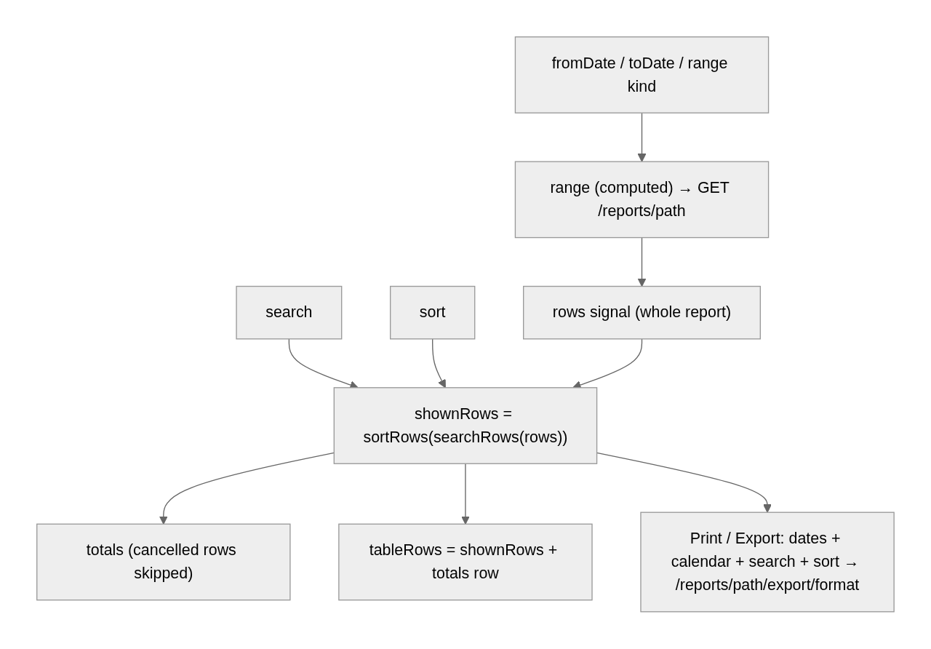

5. Design decisions and gotchas
- Config over components. Twenty-one table reports are one component and a table of column definitions. A new report is a config entry plus a backend endpoint; the route and the Reports page follow automatically, and the spec makes the sidebar keep up.
- Whole report, local processing. Reports are small enough to load at once; paging them would push totals and search to the server. The trade-off is memory on a very large register.
- Cancelled rows shown but not counted. Hiding them would make the register disagree with the sales list; counting them would make it disagree with the ledger. Marking them and excluding them from totals keeps both honest.
- discount is what was typed. Never sum the raw discount; use discountAmount.
- The default period is the AD calendar month (startOfMonth uses the JavaScript month), even when the page displays BS. A BS-month default would need Lumen's conversion; this is a product call still to confirm.
- asOf sends only toDate. A trial balance with a fromDate would be a movement report, not a balance.
- The ledger's query params beat the defaults. A deep link with an account but no fromDate means "from the start", not "from this month".
- sort in the export is a column key, so a value-derived column such as discount is sorted in the file by the API's own derivation, not the browser's.
- The account picker lists inactive accounts (accounts('all', 'all', 'all')), unlike the forms, because history is the point.
- serverSort without a server. Without it l-table would re-sort the rows itself and drag the totals row into the middle.

6. Build it yourself: order of work
- Write the row interfaces and ReportColumn / ReportConfig in report.model.ts; then discountAmount, the shared column sets and documentReports(); build REPORTS, REPORT_GROUPS and REPORT_OPERATIONS from them.
- Write report-table.ts with unit tests: cellValue, searchRows, sortRows, columnTotals (cancelled rows out), balanceSide, reportRange, startOfMonth.
- Write ReportService: rows, ledger, export, exportLedger through FileService.
- Build ReportView on app-list-page-card: the range computed and request pipeline, shownRows / totals / tableRows, the cell templates per format, the toolbar for each range kind, the footer counts, download().
- Build LedgerReport: the account picker from DropdownService.accounts('all', 'all', 'all'), query-param initialisation, the three-kind table rows, download().
- Build the Reports page from REPORT_GROUPS filtered by hasOperation.
- Write report.routes.ts from REPORTS and LEDGER_REPORT; mount it at /reports; put REPORT_OPERATIONS's members on the sidebar link and add the spec that compares them.
- Try it: open the Purchase Register for a month with a discounted purchase and check the Discount total; open the Sales Register with a cancelled sale and watch the footer; click an account in the Trial Balance and compare the ledger's closing balance.

