Layout: shell, sidebar and header — Frontend
Part of the Inventory System implementation guide. Read docs/BRD.md for the business picture and docs/frontend/frontend-setup.md for how the web app is organised.

Contents
1. What this is
2. Where the code lives
3. What it provides
4. How it works
4.1 The shell
4.2 The sidebar menu
4.3 The header
4.4 Range Print
4.5 The notification bell
4.6 The live feed
4.7 The profile menu
5. Design decisions and gotchas
6. Build it yourself: order of work

1. What this is
The frame every signed-in page sits in: a collapsible sidebar menu on the left, a header on top (breadcrumb, calculator, notification bell, Range Print button, profile menu) and the page itself in a scrolling area under the header. The menu shows only the pages the user's role may open, the bell keeps the user's notifications live over a WebSocket, and Range Print downloads every document of a period as one PDF.

2. Where the code lives
All of it is under frontend/src/app/layout/.
File or folder | What is in it
layout.ts / .html / .scss | Layout: <app-sidebar> + <app-header> + <router-outlet>; the route '' renders it behind authGuard
sidebar/sidebar.ts / .html / .scss | Sidebar: the menu, permission filtering, search, collapse
sidebar/sidebar.data.ts | SIDEBAR_SECTIONS (the whole menu) and SIDEBAR_FOOTER_ITEMS
sidebar/sidebar.model.ts | SidebarLink, SidebarItem, SidebarSection
sidebar/sidebar-item/ | SidebarItem: one link or one group with children; active and expanded state
header/header.ts / .html | Header: breadcrumb, calculator, bell, printer button, profile menu
header/range-print/ | RangePrint (the printer button's drawer) and range-print.model.ts (RANGE_PRINT_OPTIONS)
header/notification-menu/ | NotificationMenu (the bell), notification-feed.ts (NotificationFeed: list + socket), notification.model.ts (AppNotification, NOTIFICATION_KINDS), notification-feed.testing.ts (FakeSocket)
header/profile-menu/ | ProfileMenu: avatar, name and role, Change Password, Logout
../shared/services/breadcrumb.service.ts | BreadcrumbService, which the header reads
../shared/components/calculator/ | Calculator, opened by the header in a modal

API side: section 16 of backend/endpoints.md (notifications and the socket) and section 18 (range print: GET /<document>/print).

3. What it provides
Piece | Gives the app
Layout | The fixed shell: sidebar at its own width, header that stays put, page content scrolling inside .content (so list cards can fill the height). In print media the sidebar and header are hidden
Sidebar | The menu from SIDEBAR_SECTIONS, filtered by AuthService.hasOperation, searchable, collapsible (220px → 64px)
Header | title() and crumbs() from BreadcrumbService; openCalculator(); canRangePrint() and openRangePrint()
RangePrint | A 350px right drawer: From / To dates, Document Type, Print
NotificationMenu + NotificationFeed | The bell with an unread badge, the list, mark read / mark all read / clear all, live updates and toasts
ProfileMenu | Who is signed in, their role, and the two account actions

4. How it works

4.1 The shell
layout.html is three elements: <app-sidebar class="sidebar">, then a .main column holding <app-header class="header"> and <main class="content"><router-outlet /></main>. layout.scss makes .layout a 100vh flex row, .sidebar fixed-size, .main a flex column with .content taking the rest and overflow: auto. The header therefore never scrolls away, and a list page can use height: 100% for a page-high card. @media print turns the layout into a plain block with the sidebar and header hidden.

4.2 The sidebar menu
Idea. The menu is data, not markup. sidebar.data.ts mirrors the backend operation table (its master_module → module grouping) as two sections, Main Menu and Setup; each link carries the backend View… operation that opens its page, the same value the route's data.operation holds. A role that lacks the operation never sees the link, and a group whose links all vanish disappears too.
Model (sidebar.model.ts):
Type | Fields
SidebarLink | label, route, operation? (a name or a list; any one grants it), icon?
SidebarItem | a SidebarLink with a required icon, masterModule? (the backend operation.master_module, informational only: nothing reads it) and children?: SidebarLink[]
SidebarSection | title, items: SidebarItem[]

The menu: Dashboard (no operation); Purchase → Purchase Entry (ViewPurchaseEntry), Purchase Return (ViewPurchaseReturn), Vendors (ViewVendor); Sales → Sales Entry (ViewSalesEntries), Sales Return (ViewSalesReturns), Customers (ViewCustomer); Inventory → Opening Stock (ViewOpeningStock), Stock Adjustment (ViewStockAdjustment), Stock Edit (ViewStockEdit); Accounting → Chart of Accounts (ViewAccountMaster), Journal Entries (ViewJournalEntries), Payments (['ViewVendorPayment', 'ViewCustomerPayment']), Payment Adjustments (ViewPaymentAdjustment), Opening Balance (ViewOpeningBalance). Setup: Products (ViewProduct, a plain link), Master Data → Categories, Units, Packings, Tax Types (ViewCategory, ViewUnit, ViewPacking, ViewTaxType), User & Roles → Users, Roles (ViewUser, ViewRole), Reports (a list of nine operations, equal to REPORT_OPERATIONS of the reports feature; a spec keeps them in sync), Settings → Configuration, Document Numbering (ViewConfiguration, ViewDocumentNumbering). SIDEBAR_FOOTER_ITEMS holds one link, User Manual (help icon) → /user-manual. That page (features/user-manual/, any login may open it) lists MANUAL_SECTIONS from user-manual.data.ts: one card per area of the app with a contents column that scrolls to it, and each task as an accordion item of paragraphs, numbered steps and notes. A topic carrying an operation shows only when the role holds it, and a section left with no topics is dropped, so the manual describes only the pages the user can open.
State in Sidebar: collapsed and search signals; searching computed; sections computed (permission filter); filteredSections computed (search filter on top).
sections():
allowed(operation) = no operation, or auth.hasOperation(operation)
for each section: keep items where
item without children: allowed(item.operation)
item with children: the children that are allowed; drop the group if none are left
drop sections with no items

filteredSections():
query = search trimmed, lower-cased; if empty return sections()
for each section: keep an item whose label contains the query (with all its children),
else keep it with only the children whose labels contain the query
drop empty sections; the template shows: No menu items match "<query>"

Collapsed: the aside shrinks from 220px to 64px, the full logo (abis.svg) is swapped for the mark (abis-a.svg), the search box is hidden, and every item shows its label as a Lumen tooltip on the right (lTooltip). While a search is typed, every group is forced open (forceOpen).
SidebarItem (one row) keeps the current URL in a signal fed by the router's NavigationEnd events (urlAfterRedirects, starting with router.url):
hasChildren = item has children
groupActive = hasChildren and (url == item.route or url starts with item.route + '/')
expanded = forceOpen ? true : manuallyExpanded ?? groupActive -- manuallyExpanded is null until clicked
toggle() = manuallyExpanded = !expanded

A group shows .active only while it is active and closed (open groups highlight the child instead, through routerLinkActive="active"); .open rotates the caret. A child without an icon shows the first letter of its label.

4.3 The header
Header reads title and items from BreadcrumbService into <l-breadcrumb>, then a row of actions: a calculator button (ModalService.open(Calculator, { width: '256px', animation: 'fade' })), <app-notification-menu>, the printer button (only when canRangePrint(): some RANGE_PRINT_OPTIONS entry's operation is granted), and <app-profile-menu>. openRangePrint() is DrawerService.open(RangePrint, { position: 'right', size: '350px' }).
Breadcrumbs come from route data. Every route segment that declares data.breadcrumb (or title) adds a crumb: app.routes.ts gives Purchase, the feature routes give Purchase Entry, so the trail reads Home › Purchase › Purchase Entry and the title is the last label. BreadcrumbService.build() walks the route snapshot from the root, accumulates the URL for each crumb's link, merges a parent and its '' child that share a label, and removes the link from the last crumb. set(items) or setTitle(label) overrides the trail (e.g. to show a record's name) until the next NavigationEnd clears it. HOME_CRUMB is { label: 'Home', link: '/dashboard' }.

4.4 Range Print
Idea. Printing a month of invoices one by one is tedious; the API already prints a range as one PDF (GET /<document>/print?fromDate=&toDate=), so the header offers it from anywhere. The drawer only lists the document kinds the role may view, because the API would answer 403 for the rest.
RANGE_PRINT_OPTIONS (range-print.model.ts): purchase → Purchase (ViewPurchaseEntry), sales → Sales (ViewSalesEntries), purchase-return → Purchase Return (ViewPurchaseReturn), sales-return → Sales Return (ViewSalesReturns), payment → Payment (['ViewVendorPayment', 'ViewCustomerPayment']). The value is the resource's API path.
State: options (the entries whose operation hasOperation grants), calendar ('bs', follows the date inputs' AD/BS switch), fromDate and toDate (both startOfToday()), document (the first option), ready computed (all three set). FileDownloads is in the component's providers, so downloads.running() labels the button Printing… and disables it.
print():
if not (document and from and to): return
params = { fromDate: toIsoDate(from), toDate: toIsoDate(to), calendar }
file = by document:
'purchase' → PurchaseService.printRange(params) -- GET /purchase/print
'sales' → SalesService.printRange(params)
'purchase-return' → PurchaseReturnService.printRange(params)
'sales-return' → SalesReturnService.printRange(params)
'payment' → types = PARTY_TYPES the role may view (VIEW_PAYMENT_OPERATIONS)
if exactly one: params.type = that type -- as on the payments page
PaymentService.printRange(params)
downloads.run('pdf', file.pipe(tap(close the drawer)))

The From input's max is the To date and the To input's min is the From date, so the range can't be inverted. An empty period is the API's 404 ("No sales in this period"), which FileDownloads shows as a Print failed notification; the drawer stays open. The hint under the fields says each document prints on its own page, oldest first, with cancelled sales and sales returns marked.

4.5 The notification bell
Idea. The list (GET /notifications) is the truth and the socket is only a hint that it changed. Every time the socket opens, the list is reloaded, so nothing sent while the browser was offline or the tab asleep is missed; the socket's own messages just update the list in place between reloads. The feed is not a singleton: NotificationMenu lists NotificationFeed in its providers, so it is destroyed with the shell on logout, and DestroyRef.onDestroy closes the socket.
NotificationMenu calls feed.start() in its constructor and exposes notifications, unreadCount (a computed count of !is_read) and isEmpty. The trigger button carries [lBadge]="unreadCount()". The panel: a head with Notifications, N new and Mark all read (disabled when nothing is unread); an empty state (You're all caught up); otherwise one row per notification with the kind's icon tinted by severity, the title, message, actor · time ago, and an unread dot; a foot with Clear all. The menu has closeOnItemClick off so marking read doesn't close it.
open(notification):
if not is_read: feed.markRead(id)
route = notificationKind(notification).route
if route: close the menu; router.navigateByUrl(route)

timeAgo(created_at): 'Just now' | '<m>m ago' | '<h>h ago' | 'Yesterday' | '<d>d ago'

NOTIFICATION_KINDS maps the backend type to an icon and the page a row opens:
type | Icon | Route | Toast
purchase_entry | cart_add | /purchase/entry
purchase_return | cart_return | /purchase/return
sales_entry | receipt | /sales/entry
sales_return | undo | /sales/return
vendor_payment, customer_payment | money | /accounting/payments
stock_adjustment | refresh | /inventory/stock-adjustment
low_stock | warning | /inventory/stock-edit | yes
out_of_stock | error | /inventory/stock-edit | yes

An unknown type gets OTHER_KIND (notification icon, no route, so the row only marks itself read).

4.6 The live feed
Constants: FEED_SIZE = 50 (the API's page; the live list is trimmed to it too), RETRY_FIRST_MS = 1000, RETRY_LAST_MS = 30000. SOCKET_URL is environment.apiUrl with http → ws (so https becomes wss) plus /ws/notifications; the token goes in the query string because browsers can't set headers on a WebSocket.
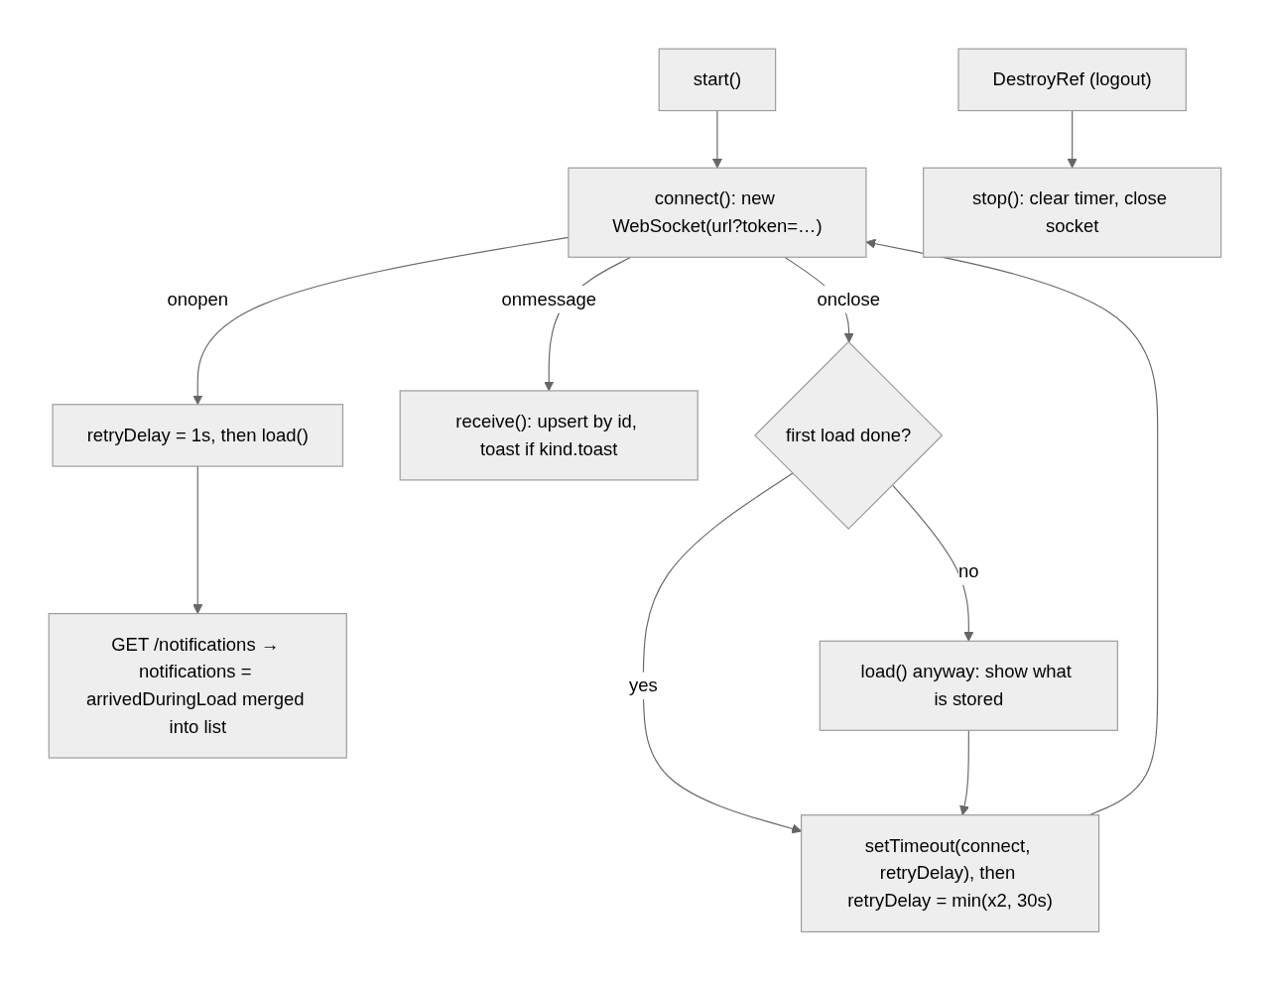
connect():
if not started, or auth.getToken() is null (expired): return -- no reconnect loop after logout
socket = new WebSocket(SOCKET_URL + '?token=' + encodeURIComponent(token))
onopen: retryDelay = 1s; load()
onmessage: receive(data)
onclose: if this socket is no longer the current one: return -- a stale socket closing late
socket = null
if never loaded: load()
retryTimer = setTimeout(connect, retryDelay); retryDelay = min(retryDelay * 2, 30s)

load():
cancel a reload in flight; arrivedDuringLoad = []
GET /notifications → loaded = true; notifications = list with every arrivedDuringLoad item upserted on top
on error: keep what is shown (the next reconnect retries)

receive(data):
message = JSON.parse(data); ignore anything whose event != 'notification'
arrivedDuringLoad.push(n); notifications = upsert(notifications, n)
if notificationKind(n).toast:
dismiss the toast previously shown for this id
show toast.error(title, message) when severity == 'error', else toast.warn

upsert(list, n) = [n, ...list without id n].slice(0, 50)

markRead(id): list updated at once (is_read = true); PUT /notifications/{id}/read
markAllRead(): all is_read = true; PUT /notifications/read
clear(): list = []; DELETE /notifications
each: on error → toast.error('Could not mark it read' | 'Could not mark them read' | 'Could not clear them', apiErrorMessage); load()

Why upsert by id. The API updates an unread stock alert instead of adding another (same id, new message), so a pushed notification whose id is already listed replaces that row and moves it to the top; its earlier toast is dismissed so the user sees one toast per product, not a pile.
Why arrivedDuringLoad. A message can arrive between sending GET /notifications and receiving its answer. Without the buffer the answer would overwrite the newer row; with it, the buffered rows are re-applied on top of the fresh list.
Specs stub the browser's socket with FakeSocket from notification-feed.testing.ts (vi.stubGlobal('WebSocket', FakeSocket)): it records every instance (FakeSocket.instances, FakeSocket.last), exposes onopen / onmessage / onclose for the test to call, flags closed, and push(notification) plays a server message. testNotification(overrides) builds a row.

4.7 The profile menu
A Lumen <l-menu mode="right"> whose trigger shows <l-avatar> with AuthService.user().avatarUrl (the object URL the auth service loaded; see the auth doc) or a placeholder user icon when there is none. The panel repeats the avatar with name (fullName || username || 'Account') and role (role || 'No role assigned'), then two full-width ghost buttons: Change Password → router.navigate(['/change-password']) and Logout → AuthService.logout().

5. Design decisions and gotchas
- One source for "may I open this page". The sidebar link's operation, the route's data.operation and the dashboard cards all name the same backend operation, so a role change hides the link and blocks the URL together. Payments and Reports use the list form (any one grants).
- A group's route is only a prefix (/purchase); nothing routes there. It is used for groupActive and as the track key.
- Search forces groups open but never changes manuallyExpanded, so clearing the search restores what the user had opened.
- The socket is created with the raw token in the URL; getToken() returns null once exp has passed, so an expired session stops reconnecting instead of hammering the server with 401 handshakes. When the token expires while a socket is open, the server closes it with code 4401 on the next message; the feed then backs off and connect() returns early.
- Reads and clears are optimistic: the list changes before the request answers, and a failure reloads the stored state.
- Toasts are for stock alerts only (toast: true on low_stock and out_of_stock); document notifications just add a row and bump the badge.
- The bell's rows navigate with navigateByUrl to the list page of that kind, not to the record: the API's message names the document and the user searches for it there.
- Range Print's payment type is added only when the role may view exactly one party type; with both, the API prints both.
- The profile menu uses <l-avatar> directly with the URL from AuthService, while other users' pictures go through <app-user-avatar> (the shared component with its own Blob fetch).
- Printing a page with the browser (Ctrl+P) hides the sidebar and header through the @media print rules, but the app never calls window.print(): Print buttons download API-built PDFs.

6. Build it yourself: order of work
- Layout: the three-part template and the flex CSS (height: 100vh, content overflow: auto). Route '' → Layout with authGuard and the feature children in app.routes.ts, each with data.breadcrumb.
- sidebar.model.ts, then sidebar.data.ts with every link's View… operation copied from the backend operation table.
- Sidebar: sections computed from AuthService.hasOperation, filteredSections for the search, collapsed with the 64px style and tooltips.
- SidebarItem: the URL signal from NavigationEnd, groupActive, manuallyExpanded, expanded, forceOpen; routerLinkActive on links.
- BreadcrumbService (shared/services): walk the snapshot tree, merge duplicate labels, unlink the last crumb, set() / setTitle() overrides.
- Header with <l-breadcrumb>, the calculator modal and the profile menu (ProfileMenu reading AuthService.user).
- notification.model.ts with NOTIFICATION_KINDS; NotificationFeed (@Service({ autoProvided: false })): load(), connect() with the backoff, receive() with upsert and toasts, markRead / markAllRead / clear; stop() from DestroyRef.
- NotificationMenu with providers: [NotificationFeed], the badge, rows and actions; FakeSocket and specs (reload on open, replace by id, backoff, close on destroy).
- range-print.model.ts, RangePrint with FileDownloads in providers and the per-document printRange switch; the header's printer button behind canRangePrint().
- Try it: log in with a limited role (links disappear, printer button hides when no document kind is viewable), save a sale in another browser (bell badge rises live), reload the API while the app is open (the feed reconnects and reloads), print a range with no documents (Print failed notification).

