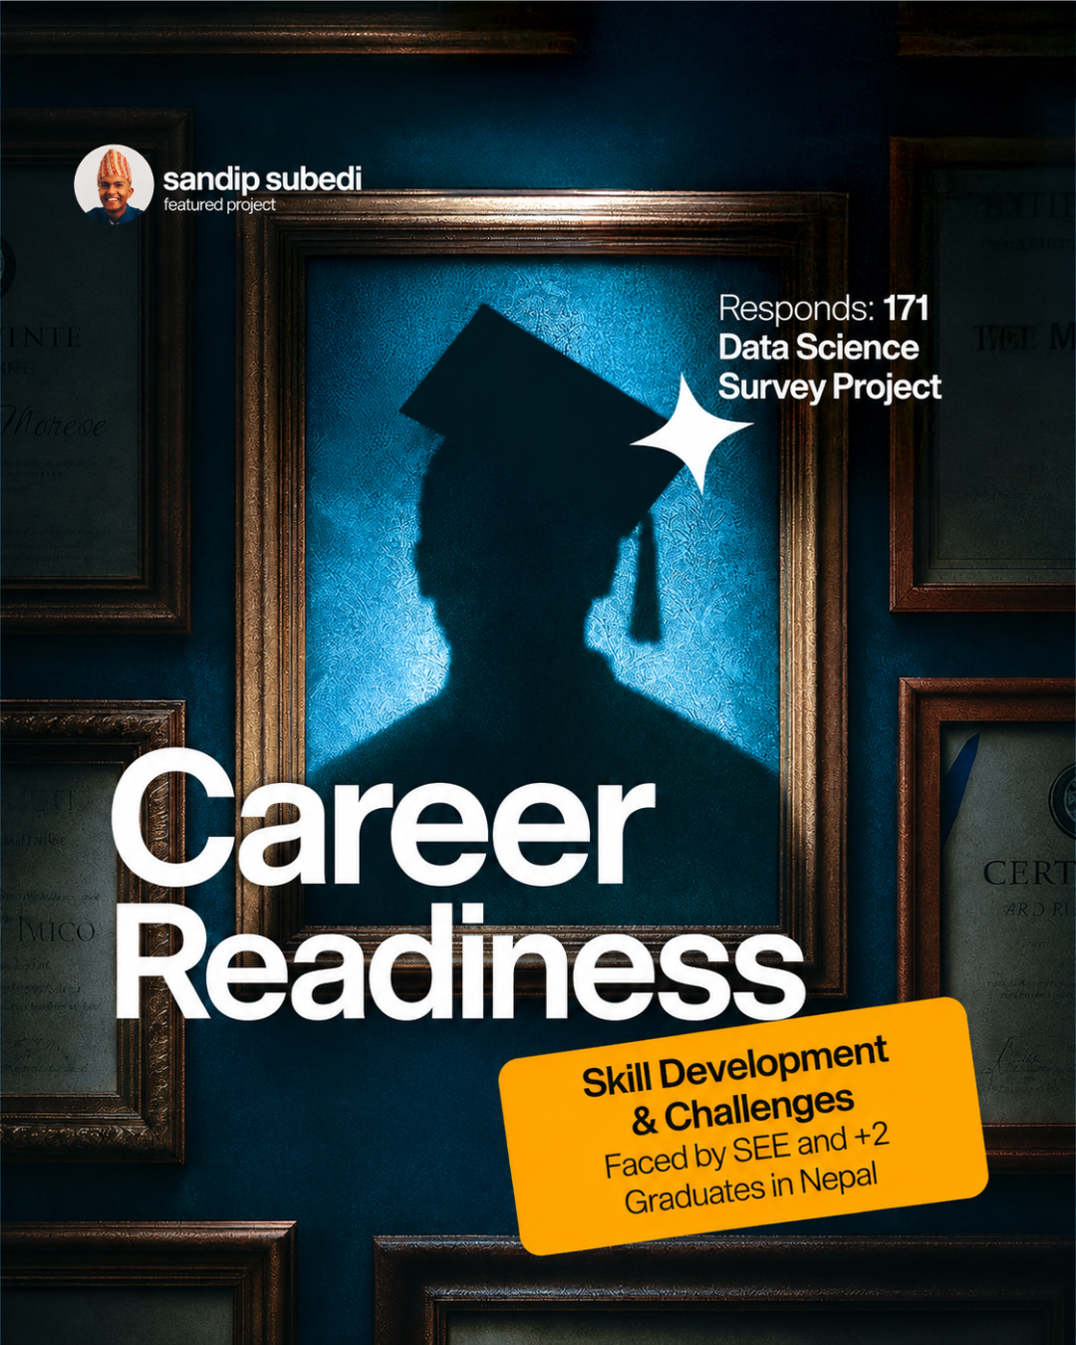
Career Readiness, Skill Development & Challenges
Faced by SEE and +2 Graduates in Nepal
A survey-based analysis with a machine-learning readiness model

Author: Sandip Subedi
Sample: 171 raw submissions · 167 analyzed responses
Method: Python (Pandas, scikit-learn, Matplotlib, Seaborn)
2026

Abstract
This report analyzes 167 survey responses from Nepali students who have recently completed their SEE or +2 examinations, examining what skills they are building, how they build them, the obstacles they face, and how “career-ready” they feel. A composite Career Readiness Score (0–100) was engineered from four self-reported attitude measures, skill-building effort, and challenge burden, then a Random Forest model was used to test which demographic and behavioral factors best predict that score. The sample skews toward Bagmati province and digitally-engaged students reached through social media, so findings should be read as indicative rather than nationally representative. The headline result: financial constraints and a lack of networking or mentorship — not lack of interest or GPA — are the dominant barriers, and structural factors (education-system perception, learning source, provincial context) predict readiness at least as strongly as personal effort.

1. Introduction & Motivation
Every year, hundreds of thousands of students in Nepal complete their Secondary Education Examination (SEE) or +2 (higher secondary) studies and face a pivotal transition: choosing further education, professional skill-building, or entering the workforce, often with limited structured guidance. Anecdotally, graduates report feeling unprepared for the job market despite strong academic performance, but there is little systematic data on what skills they are actually pursuing, why, and what specifically holds them back.
This project set out to answer three questions:
- What skills are SEE/+2 graduates developing, and through what channels?
- What are the biggest challenges they face in becoming career-ready, and does this vary by province or academic stream?
- How career-ready do graduates feel overall, and which demographic or behavioral factors best predict that feeling?
To answer these, a 23-question Google Form survey was distributed (primarily via an Instagram channel), collecting 171 raw responses. The data was cleaned, explored, engineered into a composite readiness score, and modeled with basic machine learning to surface the strongest predictors all detailed in the sections that follow.

2. Methodology

a) Survey Design & Sample
The survey (Q1–Q23) captured consent, demographics (age, gender, province, education level, stream, GPA), current activity, skill-building behavior (hours/week, which skills, why, and where learned), four Likert-scale career-awareness items (clarity, market awareness, perceived education support, confidence), top challenges and their frequency, career interest, a 5-year vision (open text), a view on whether Nepal's education system adequately prepares students, the single biggest obstacle, and open advice for peers.
Of 171 raw submissions, 3 were dropped for missing consent and 1 for leaving all four career-awareness questions blank, leaving a final analytic sample of 167 responses. No exact-duplicate submissions were found.

b) Data Cleaning
Google Forms exports full question text as column headers and stores multi-select (checkbox) answers as a single semicolon-separated string per cell. Cleaning involved:
- Renaming all 23 question columns to short, code-friendly snake_case names.
- Converting bucketed answers (age, GPA, weekly skill hours) into numeric midpoints for correlation and modeling use, while keeping the original bucket label for grouping/display.
- Exploding four multi-select questions (skills learning, learning reasons, learning sources, top challenges) into 34 individual binary (0/1) columns — one per option — with rare free-text “Other” answers normalized where they clearly duplicated an existing option.
- Mapping challenge_frequency (Never/Sometimes/Frequently/Always) to an ordinal 0–3 scale.
- Dropping rows with no consent or with all four core Likert items blank; open-text fields were left as-is for qualitative reading, not fed into any model.
This produced a clean, analysis-ready dataset of 167 rows × 66 columns, saved as cleaned_data.csv, with a full column dictionary provided in the Appendix.

c) Analytical Approach
The analysis proceeds in three stages: (1) exploratory data analysis (EDA) to understand sample composition, skill-building patterns, and challenges; (2) feature engineering of a transparent, weighted Career Readiness Score; and (3) machine-learning modeling to identify which non-attitudinal factors (demographics, learning behavior, career interest) best predict that score, using Linear Regression as an interpretable baseline and Random Forest to capture non-linear patterns and rank feature importance.

3. Exploratory Data Analysis

a) Who Responded? (Demographics)
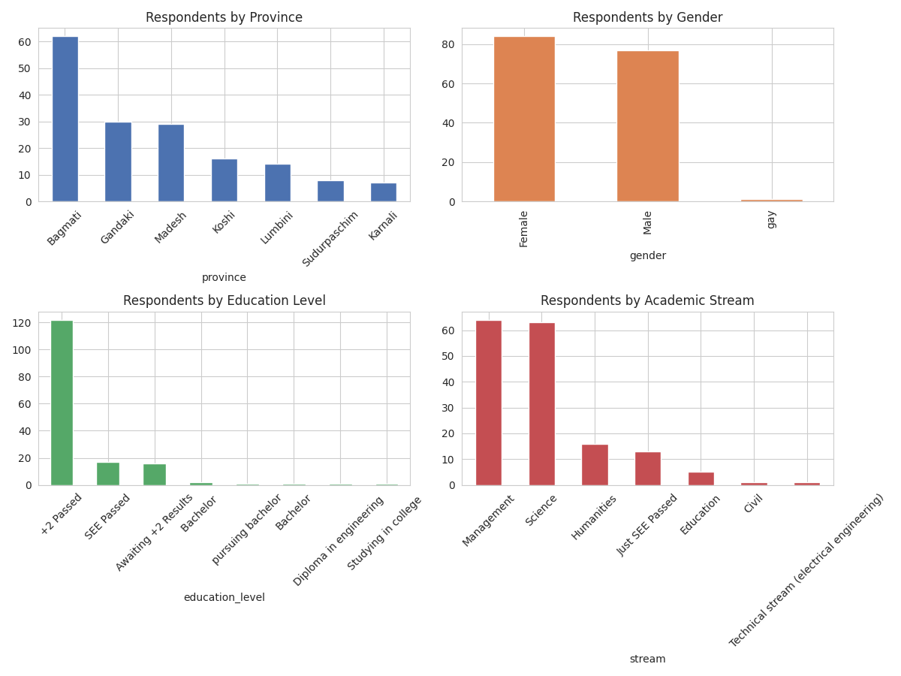
Figure 1. Respondent counts by province, gender, education level, and stream.
The sample is dominated by Bagmati province (62 of 167 respondents, 37%), with Gandaki (30) and Madesh (29) next, and Karnali (7) and Sudurpaschim (8) least represented. This mirrors the outreach channel (a single Instagram account, likely followed disproportionately by Kathmandu-valley students) rather than Nepal's actual population distribution — a sampling bias that should be kept in mind throughout. Gender split is fairly even (84 female, 77 male, 1 other). Academic stream is led by Management (64) and Science (63), with Humanities (16) and smaller technical/education streams making up the rest. Most respondents (122 of 167) have already passed +2.

b) Skill-Building Effort: Hours and GPA
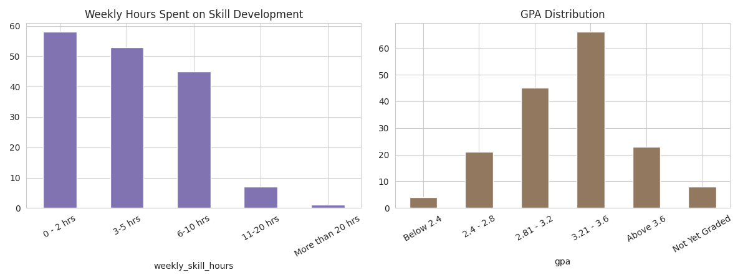
Figure 2. Distribution of weekly hours spent on skill development, and GPA distribution.
Weekly skill-building hours cluster in the low-to-moderate range (0–10 hrs/week for most respondents), with a smaller group investing more than 20 hours weekly. GPA is concentrated in the 2.81–3.6 range, roughly matching what would be expected from a self-selected, moderately high-achieving sample reached through social media.

c) Career-Awareness Sentiment
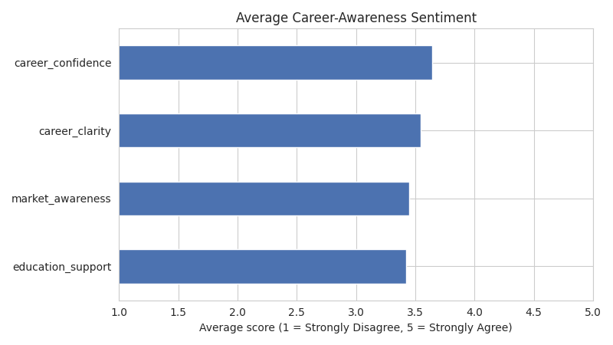
Figure 3. Average score (1–5) across the four career-awareness Likert questions.
Career confidence scores highest on average (3.64/5), followed by career clarity (3.55), market awareness (3.46), and perceived education support (3.42 the lowest of the four). In other words, respondents feel somewhat more confident and clear about their goals than they feel supported by their formal education in reaching them, a gap worth flagging for policymakers.

d) What Skills Are Students Learning?
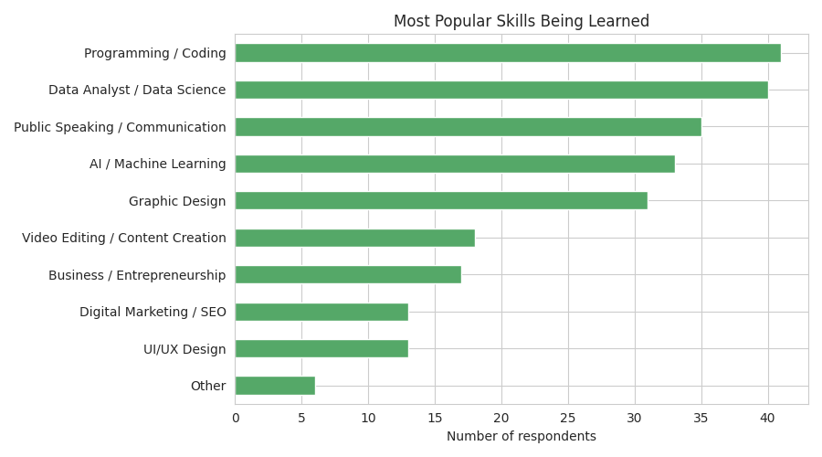
Figure 4. Most popular skills currently being learned (respondents could select multiple).
Programming/Coding (41 respondents) and Data Analyst/Data Science (40) lead, closely followed by Public Speaking/Communication (35), AI/Machine Learning (33), and Graphic Design (31). Digital Marketing/SEO and UI/UX Design are the least selected (13 each). A notable share of respondents selected “None yet,” indicating they have not started structured skill-building at the time of the survey.

e) Why and Where Are They Learning?
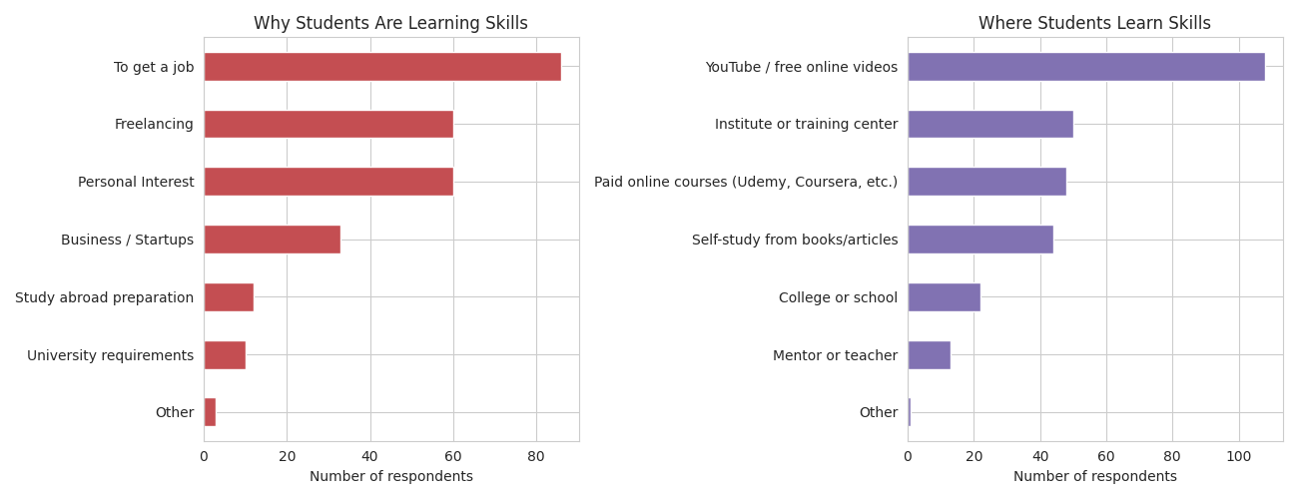
Figure 5. Motivations for learning skills (left) and where those skills are learned (right).
“To get a job” and “Personal interest” are the two dominant motivations, well ahead of freelancing, business/startup goals, or university requirements. On the source side, YouTube and other free online videos are the most common learning channel by a wide margin, followed by self-study from books/articles and paid online courses — institutes/training centers and mentors are comparatively underused, despite (per the modeling results in Section 4) being associated with higher readiness.

f) Career Awareness vs. GPA and Skill Hours
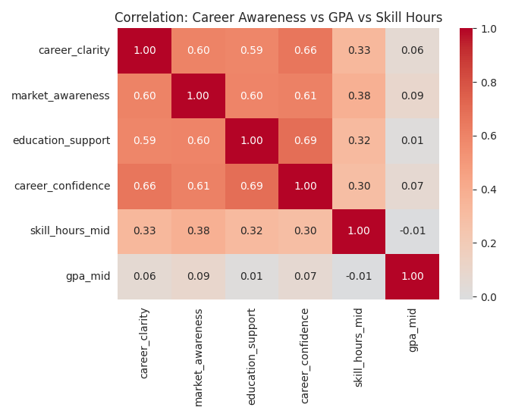
Figure 6. Correlation heatmap: the four career-awareness measures, GPA, and weekly skill hours.
The four career-awareness measures correlate moderately with each other (as expected — someone who feels clear about their path also tends to feel confident and aware of the market). Both GPA and skill hours show only weak correlation with any of the four attitude measures, suggesting that academic performance and time invested alone do not reliably translate into feeling more career-ready, other factors are clearly at play, which motivated the modeling in Section 4.

g) What's Blocking Students? (Challenges)
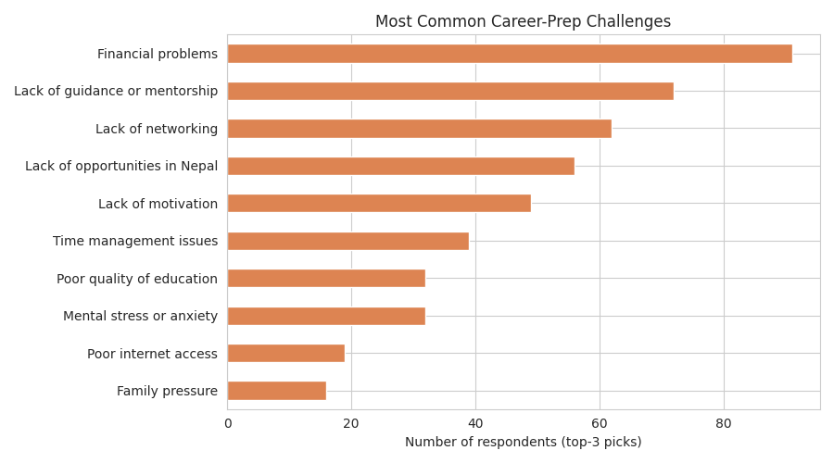
Figure 7. Most commonly selected top-3 career-preparation.
Financial problems are the single most common challenge (91 respondents, 54%), followed by lack of guidance or mentorship (72), lack of networking (62), lack of opportunities in Nepal (56), and lack of motivation (49). Poor internet access and family pressure are comparatively less common (19 and 16 respectively), suggesting infrastructure is a smaller barrier than economic and social-support factors for this sample.
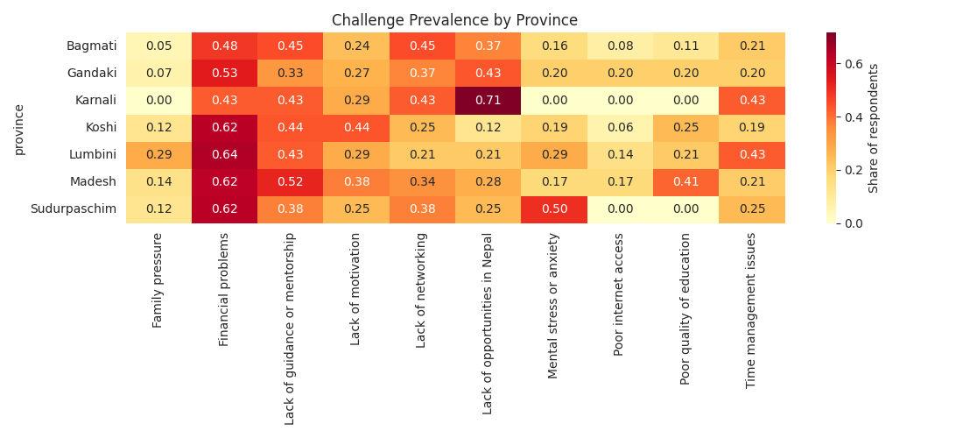
Figure 8. Challenge prevalence by province, showing how obstacle mix shifts geographically.
Breaking challenges down by province shows the mix is not uniform — provinces with fewer respondents (Karnali, Sudurpaschim) still show a heavier relative tilt toward financial and infrastructure-related obstacles, consistent with their generally lower socioeconomic and connectivity indicators, while Bagmati's challenge profile leans more toward networking and mentorship gaps than pure financial or infrastructure barriers.

h) Career Interests and Views on the Education System
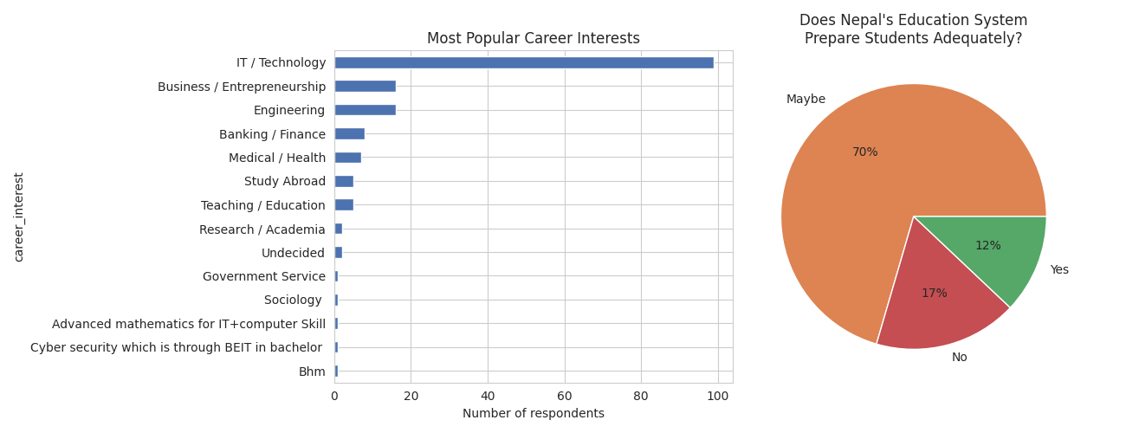
Figure 9. Most popular career interests (left) and views on whether Nepal's education system prepares students for careers (right).
IT/Technology dominates career interest by a wide margin (99 of 167, 59%), consistent with the skills most commonly being learned. On education-system adequacy, the plurality response is “Maybe” (117), with more respondents saying “No” (29) than “Yes” (20) a mildly skeptical, largely ambivalent overall sentiment rather than outright rejection.

5. Machine Learning Model: What Predicts Readiness?
To find out which context factors matter most — not just to predict the score — a model was trained using only features that are not themselves ingredients of the readiness score (i.e., excluding Q13–Q16 and skill hours/breadth/challenge frequency, to avoid circular prediction). Predictors included age, gender, province, stream, GPA, learning reasons and sources, career interest, and perceived education-system adequacy, one-hot encoded where categorical. Given the modest sample size (167 rows), a 75/25 train–test split was used with a fixed random seed for reproducibility.

a) Model Comparison
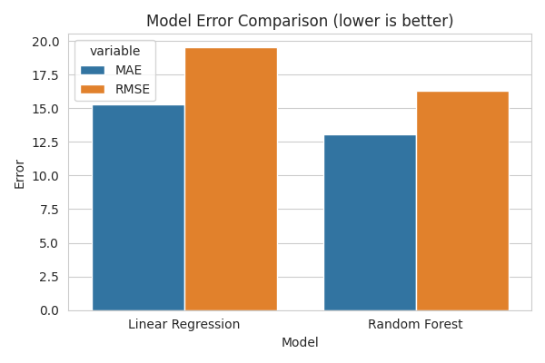
Figure 11. Test-set error (MAE, RMSE) for Linear Regression vs. Random Forest — lower is better.
Model | R² | MAE | RMSE
Linear Regression | -0.26 | 15.31 | 19.54
Random Forest | 0.13 | 13.09 | 16.29

Random Forest outperformed Linear Regression on every metric and was the only model with positive R², meaning readiness depends on non-linear combinations of context rather than a simple additive relationship, Linear Regression's negative R² indicates it performed worse than simply predicting the mean for every respondent. That said, an R² of 0.13 is modest: with 167 rows and no attitudinal predictors allowed (by design, to avoid leakage), the model explains only a limited share of variance. Results should be read as directional which factors matter, in what rough order — rather than as precise, generalizable predictions.

b) Which Factors Matter Most?
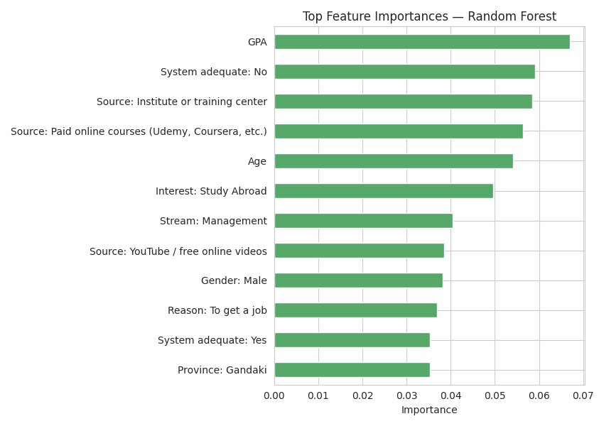
Figure 12. Top 12 Random Forest feature importances.
GPA emerged as the single strongest predictor, followed closely by whether a respondent believes the education system is inadequate, whether they learn via an institute/training center, and whether they use paid online courses. Age, wanting to study abroad, being in the Management stream, using YouTube as a learning source, gender, learning “to get a job,” being from Gandaki province, and believing the system is adequate round out the top twelve. The pattern is notable: three of the top four predictors relate to structural/environmental context (perceived system quality, and the learning channel used) rather than pure personal effort, reinforcing the EDA finding that hours invested alone doesn't reliably predict career-readiness sentiment — how and where someone learns, and their broader academic standing, seem to matter more.

6. Discussion, Limitations & Recommendations

a) Answering the Research Questions
What skills are graduates developing, and how? Mostly Programming/Coding, Data Science, Communication, AI/ML, and Design — predominantly self-directed via free YouTube content, motivated primarily by job-seeking and personal interest rather than formal requirements.
What are the biggest challenges, and does it vary by region/stream? Financial constraints, lack of mentorship, and lack of networking dominate nationally; the relative weight of financial/infrastructure vs. networking/mentorship challenges shifts somewhat by province, with less-connected provinces leaning more toward financial and infrastructure barriers.
How career-ready do graduates feel, and what predicts it? The average composite readiness score is about 50/100 (Medium band), with confidence scoring slightly higher than perceived education support. GPA, views on the education system, and the choice of learning channel (institute/paid course vs. informal self-study) are the strongest predictors identified — more so than age, gender, or province alone.

6.2 Limitations
- Convenience sample distributed primarily through one Instagram channel, producing an urban/Bagmati skew and likely over-representing digitally engaged students relative to the national population.
- Career clarity, confidence, and market-awareness scores are self-reported and subjective, not independently verified.
- A sample of 167 is small for machine learning; the R² of 0.13 should be read as exploratory and indicative, not production-grade or nationally generalizable.
- The data is cross-sectional (one point in time in mid-2026), so it cannot establish causal or longitudinal trends.

7. Conclusion
This analysis of 167 SEE/+2 graduates in Nepal finds a population that is actively building in-demand skills largely self-directed through free online content — but held back more by financial constraints and a lack of networking and mentorship than by lack of interest or academic ability. The engineered Career Readiness Score shows most graduates sit in a middle band: engaged, but not yet confidently prepared. Machine learning modeling, while limited by sample size, points toward structural and environmental factors (perceived system quality, choice of learning channel, GPA) mattering as much as or more than individual effort in shaping how ready a graduate feels. These findings, while not nationally representative, offer a concrete, data-grounded starting point for career-guidance interventions targeted at mentorship, networking, and financial access rather than skills-access alone.

