SELECT * FROM `obat` WHERE jenis_obat LIKE '%obat%';

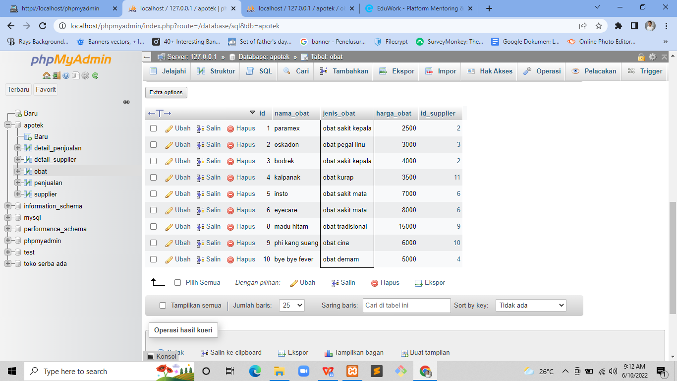

SELECT nama_obat, jenis_obat, harga_obat FROM `obat` WHERE jenis_obat = 'obat sakit kepala';

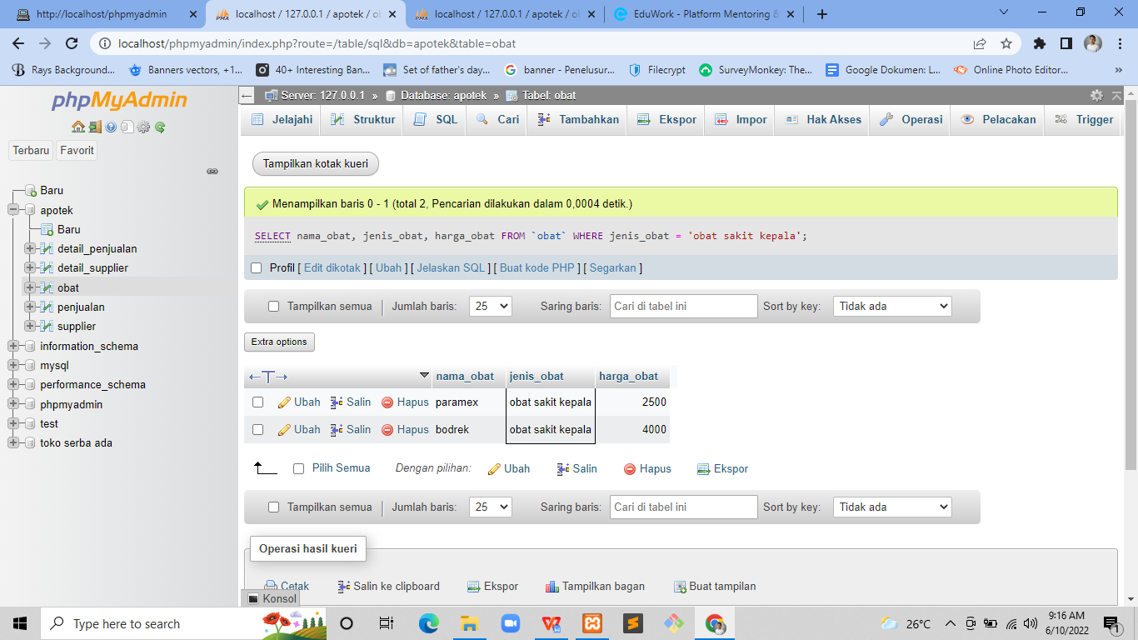

SELECT agama, alamat FROM `detail_supplier` WHERE agama = 'islam';

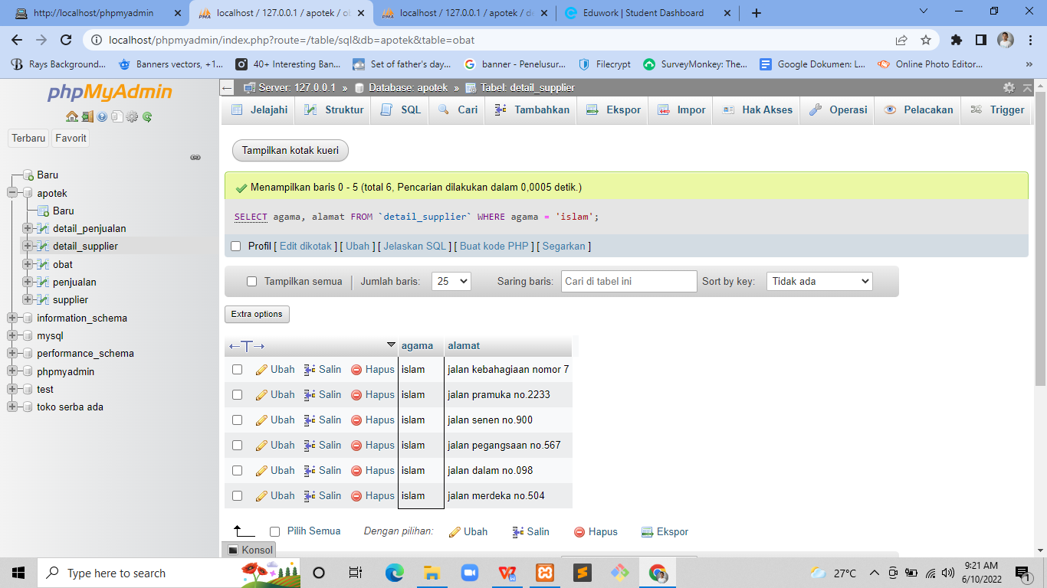

SELECT id, nama_obat, jumlah_barang FROM `penjualan` WHERE jumlah_barang < 50;

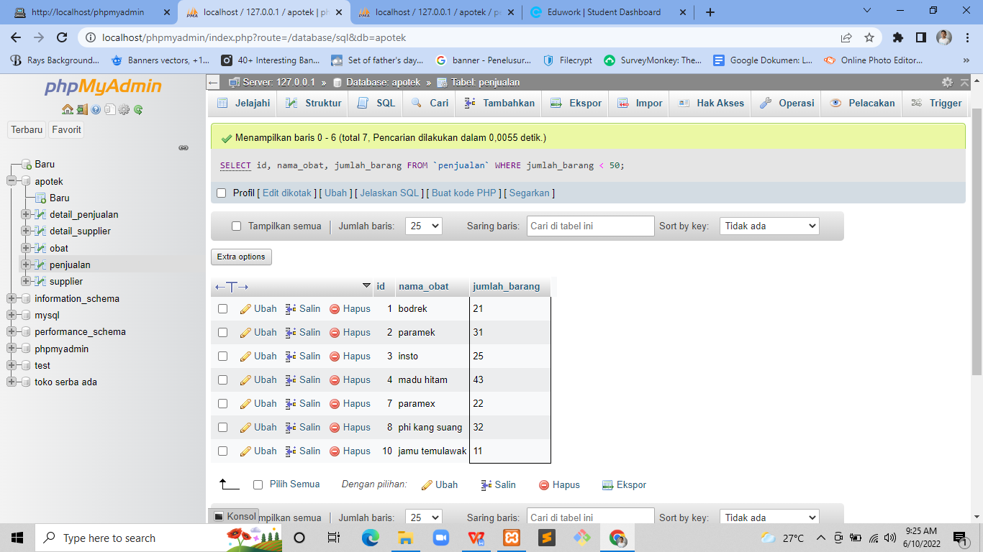

SELECT * FROM `detail_supplier` WHERE alamat LIKE '%no%';

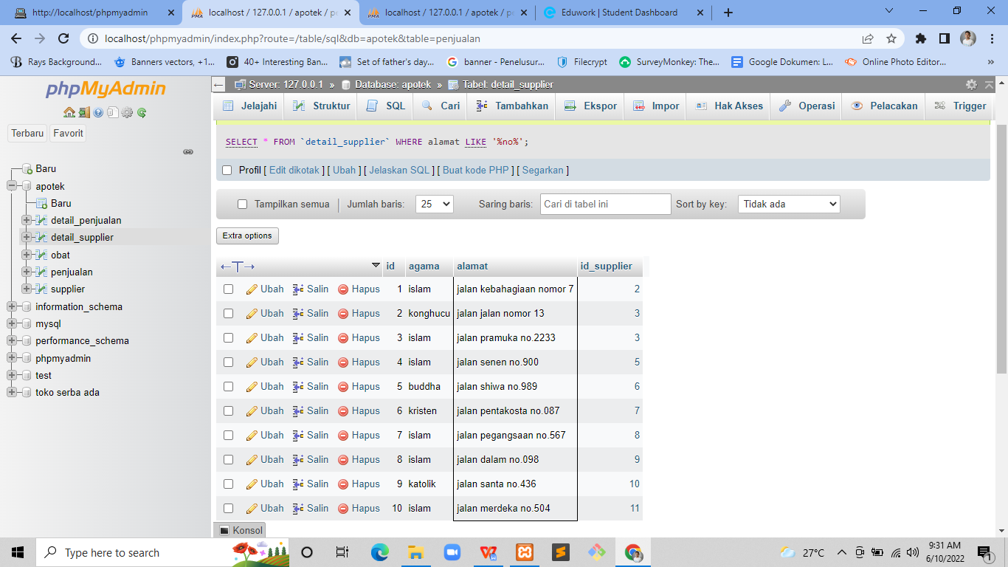

SELECT * FROM `detail_supplier` ORDER BY alamat DESC;

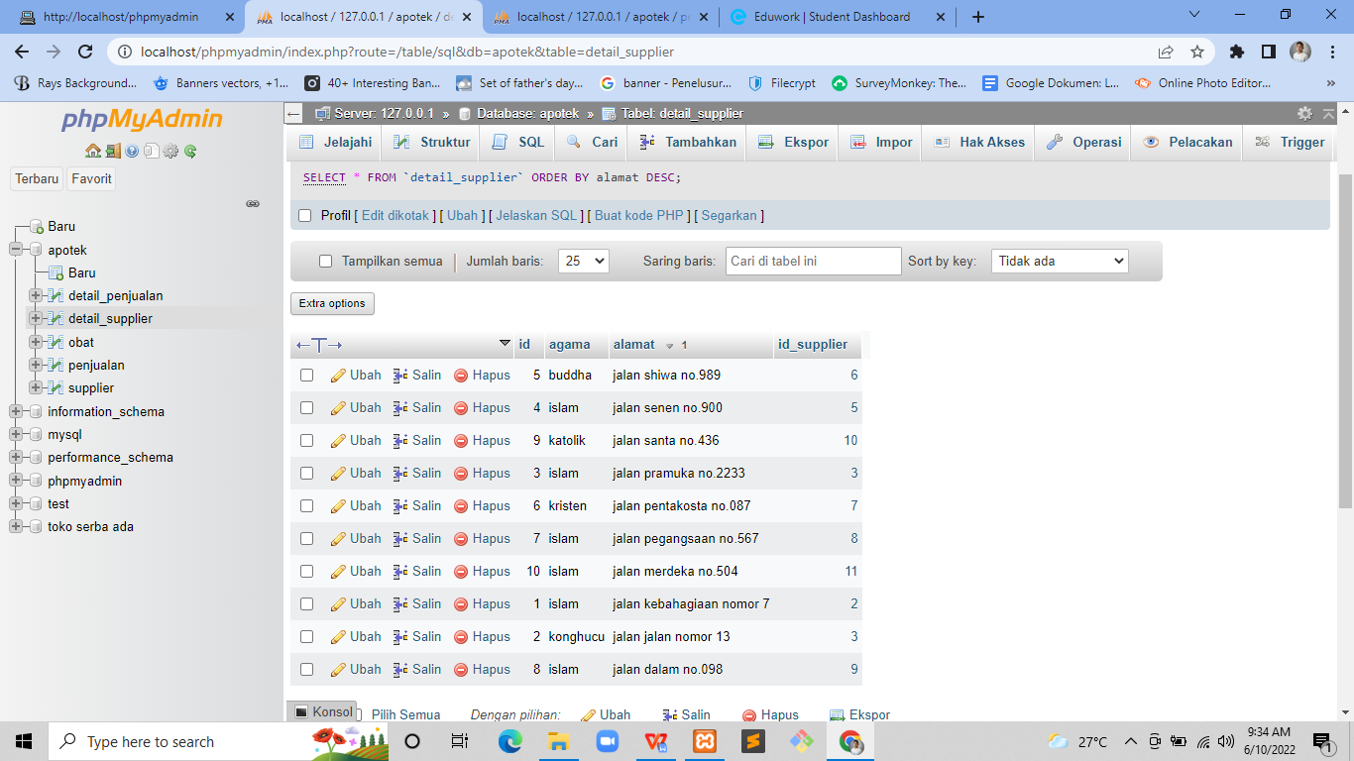

SELECT * FROM `penjualan` ORDER BY jumlah_barang ASC;

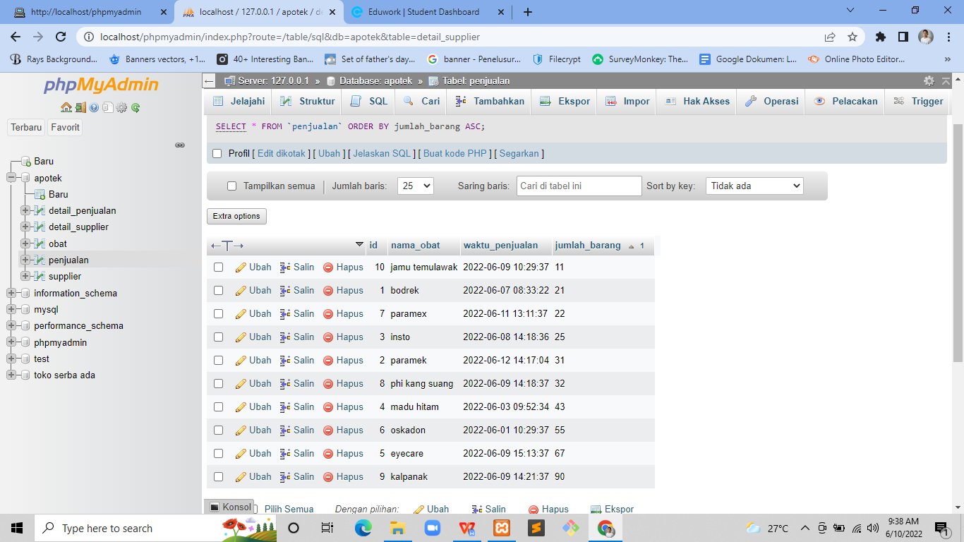

SELECT SUM(jumlah_barang) AS total FROM penjualan GROUP BY nama_obat;

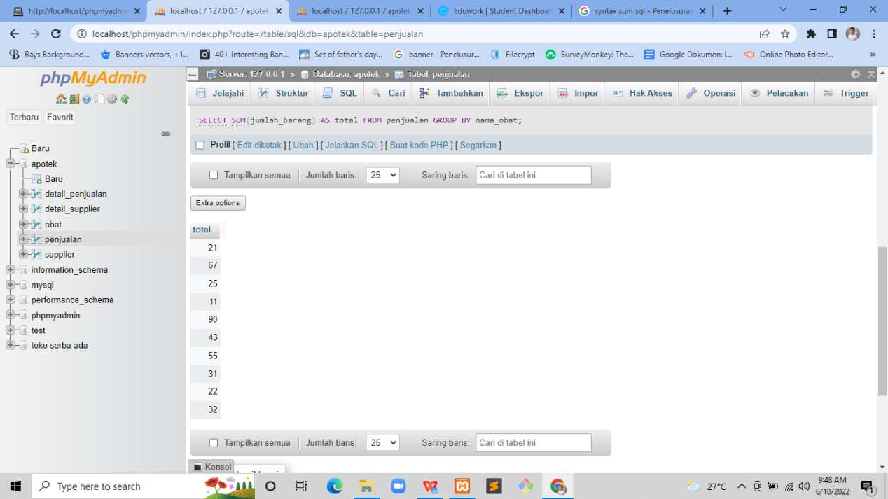

SELECT * FROM `detail_penjualan` ORDER BY id_obat DESC;

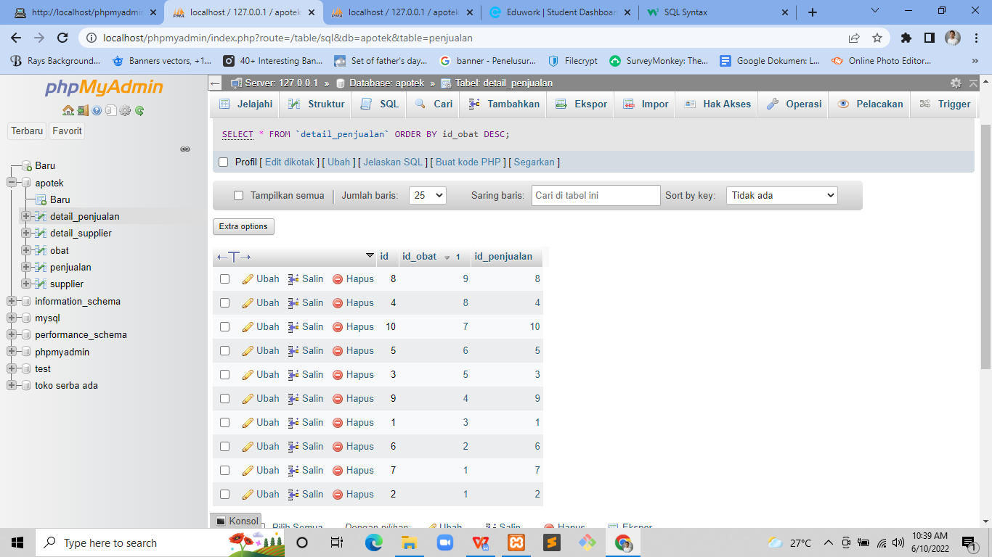

SELECT * FROM `supplier` WHERE nama LIKE '%i%';

