SELECT obat.id_supplier, obat.nama_obat, obat.jenis_obat, supplier.nama, supplier.jenis_supplier FROM obat JOIN supplier ON obat.id_supplier=supplier.id ORDER BY nama ASC;

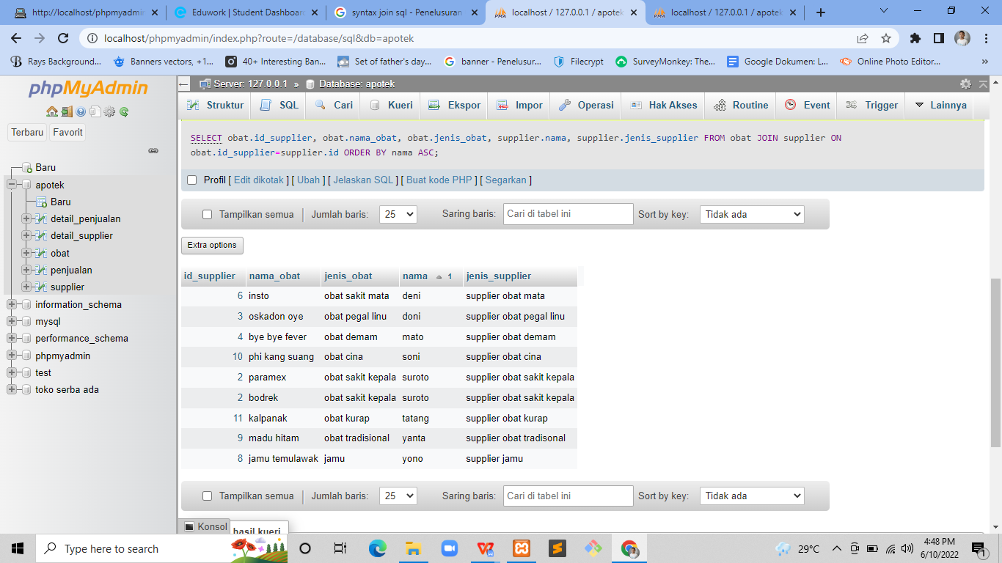

SELECT detail_supplier.id_supplier, detail_supplier.agama,detail_supplier.alamat, supplier.nama, supplier.jenis_supplier FROM detail_supplier JOIN supplier ON detail_supplier.id_supplier=supplier.id WHERE agama = 'islam';

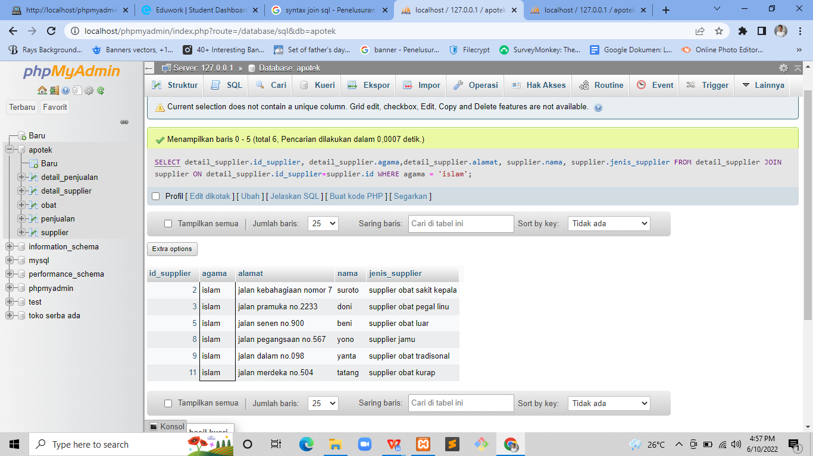

SELECT detail_supplier.id_supplier, detail_supplier.agama,detail_supplier.alamat, supplier.nama, supplier.jenis_supplier FROM detail_supplier JOIN supplier ON detail_supplier.id_supplier=supplier.id WHERE supplier.nama LIKE '%o%' ORDER BY supplier.nama DESC;

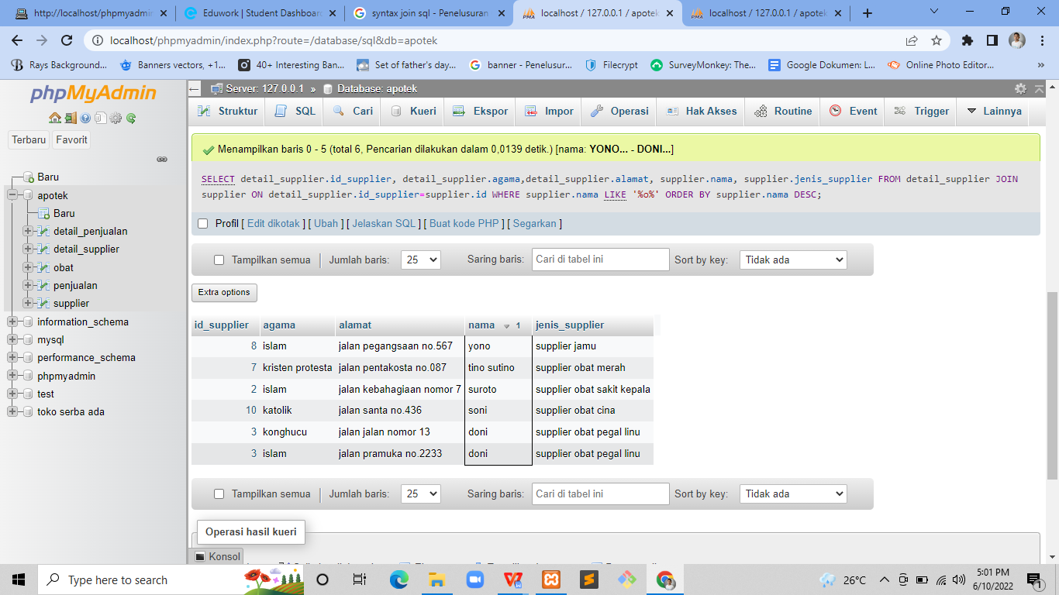

SELECT obat.id_supplier, obat.nama_obat, obat.jenis_obat, supplier.nama, supplier.jenis_supplier FROM obat RIGHT JOIN supplier ON obat.id_supplier=supplier.id ORDER BY nama ASC;

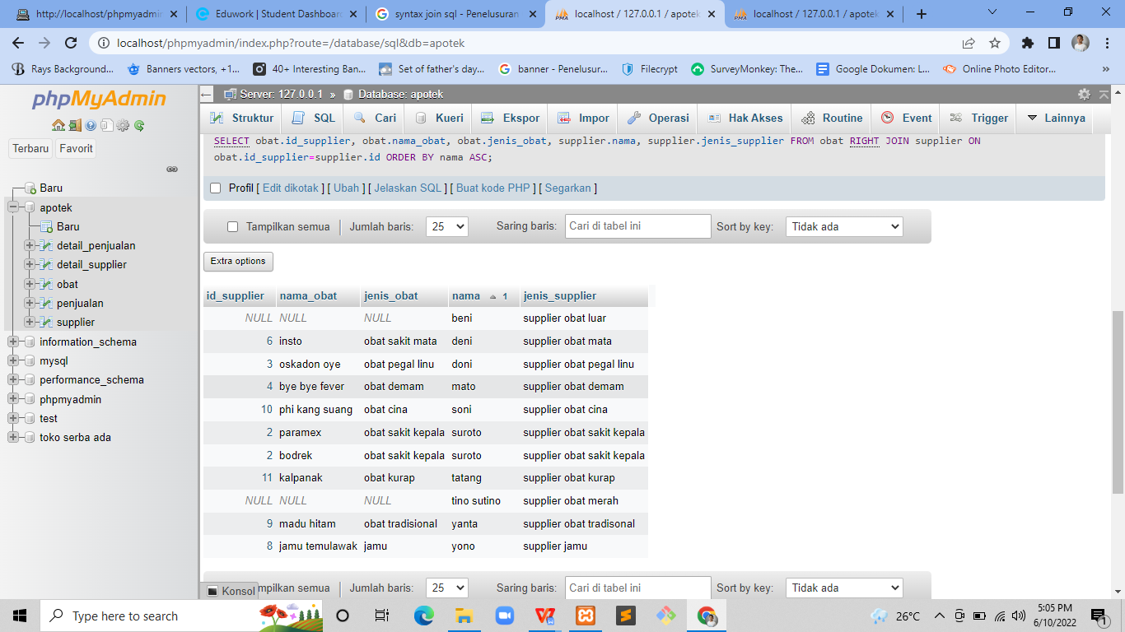

SELECT obat.id_supplier, obat.nama_obat, obat.jenis_obat, supplier.nama, supplier.jenis_supplier FROM obat LEFT JOIN supplier ON obat.id_supplier=supplier.id ORDER BY jenis_obat DESC;

