Order and entropy of lattices of unit vectors in d dimensions: label-free discovery of unusual local organization in simulated maintenance lattices and synthetic images
Leon Sandler
Independent Researcher, Northbrook, Illinois, USA
ORCID: https://orcid.org/0009-0007-4584-808X
Corresponding author: sandler.leon@gmail.com
Under consideration at Pattern Recognition Letters (submission PRLETTERS-D-26-02906)

Abstract
Averaged order parameters say how ordered a lattice of orientational states is, but not where its organization is unusual. We extend the local order and entropy quantities of the MyUncle maintenance-lattice model to unit vectors in d dimensions with the von Mises-Fisher distribution; both equal MyUncle's at d = 2 (tested against the unmodified code). On this basis we build a label-free rarity score for the sites of a lattice and ask when smoothing it spatially helps. On lattices simulated with MyUncle (parameter sets labeled polymer photodegradation, liquid crystal and magnetic storage decay), on synthetic stained-tissue images and on a controlled generator that varies only the size and shape of the anomalies, a fixed 3 x 3 mean destroyed the signal for scattered and bar-shaped anomalies and helped only with DINOv2 embeddings. Aggregation weighted by the similarity of the embeddings of neighboring sites preserved those anomalies: on independent test scenarios it raised the lower-tail average precision from 0.11 (fixed mean) and 0.23 (no smoothing) to 0.32, with paired 95% intervals above zero. Gates based on local order and on the von Mises-Fisher information did not beat ordinary similarity, and a GaaR search over 460 rule configurations did not beat random search. All evidence is simulated; validation on experimental micrographs is future work. Code and results are open.
Keywords: lattice models; statistical mechanics; von Mises-Fisher distribution; orientational order; entropy; unsupervised anomaly detection; microscopy image analysis; open-source software
1. Introduction
Lattice systems whose sites carry an orientation or a state vector, such as liquid-crystal textures, degrading polymer films, magnetic media and self-assembled layers, are commonly summarized by averaged order parameters. These say how ordered a system is, not where something unusual is. Finding unusual local organization without labels, and saying how unusual it is in the language of order and entropy, is the problem addressed here. Unsupervised anomaly detection has been developed in other fields: in astronomy for large surveys [1,2], and in medical imaging mostly as detection of deviation from a healthy appearance with generative models [3].
MyUncle [4] is a simulation framework for a maintenance lattice: rotors on a square lattice whose order is eroded by a state-dependent flux and restored by repair, with an order-entropy bridge that links the length of the neighbors' mean unit vector to a von Mises entropy. This paper makes six contributions. (1) It extends the local order and entropy quantities from the plane to unit vectors in d dimensions (the von Mises-Fisher distribution) and verifies that they equal MyUncle's at d = 2 against the unmodified code. (2) It builds a label-free score that judges the rarity of the state of a site at several prevalence scales and smooths it over the lattice. (3) It tests the score, with frozen settings and baselines, first on lattices simulated with MyUncle's kinetic Monte Carlo (damaged sites as ground truth; one development and three held-out model parameter sets) and second on synthetic stained-tissue images, where the lattice sites are image patches described by an embedding; the results are mixed and are reported as such. (4) It studies a supervised configuration search with GaaR [5] on fresh test scenarios that no search saw. (5) It tests, on independent scenarios with paired intervals, aggregation of the scores weighted by embedding similarity and gates on local order and on the von Mises-Fisher information (Section 4.8), which preserved scattered and bar-shaped anomalies that a fixed window destroys, while the entropy gate added nothing. (6) It provides an open, containerized pipeline for all of it, archived with the vendored MyUncle core [6]. All evidence is computational and simulated: no micrograph of a real material and no real tissue image was analysed, and the application to experimental data is stated as future work (Section 5).
2. Theory and method
2.1 Imaging application: images, patches and quality control
Slides are read with OpenSlide for SVS and other vendor formats [7] and as plain images otherwise. A tissue mask is made on a thumbnail (glass is bright and nearly colorless). The slide is cut into nonoverlapping square patches of 224 px at 0.5 µm/px; the patch grid is the lattice, and a patch is kept when at least half of it is tissue. Quality control marks a patch as an artifact when it is out of focus (Laplacian variance below an absolute floor or below 15% of the slide's own median), contains pen ink (saturated blue and green hues), is dark debris or a fold, or is mostly glass. These thresholds are heuristics that must be tuned on the slides at hand; a patch that is only partly blurred keeps the variance of its sharp part and escapes the rule. Artifact patches are excluded from the lattice, the reference set and the ranks.
2.2 Embeddings and the sphere
Each patch is encoded by DINOv2 ViT-S/14 [8] (384-d class-token embedding; natural-image pretraining, no fine-tuning) or, offline, by a deterministic handcrafted encoder of stain, color, gradient-orientation and texture statistics (64-d) built on color deconvolution [9]. Embeddings are centered and reduced by a cohort PCA (16 components, scikit-learn [10]) and normalized to unit length, so every patch is a point u on a sphere S^{d−1}.
2.3 Order and entropy of a lattice of unit vectors in d dimensions
MyUncle [4] describes a lattice of rotors whose order is eroded by a state-dependent flux and restored by repair. Its local disorder is one minus the length of the mean of the four neighbors' unit vectors, and its order-entropy bridge is the von Mises entropy of the angle at a given order. The same definitions hold for unit vectors in any dimension. With N_{i} the valid neighbors of site i and u_{j} the unit embedding of neighbor j,
$R_{i}=\left|\frac{1}{|N_{i}|}∑_{jinN_{i}}u_{j}\right|, D_{i}=1−R_{i}$ (1)
where D_{i} is MyUncle's local disorder. The concentration κ_{i} of the von Mises-Fisher distribution on S^{d−1} [11,12] that has mean resultant length R_{i} solves
$A_{d}(κ)=\frac{I_{d/2}(κ)}{I_{d/2−1}(κ)}=R_{i}$ (2)
and the entropy of that distribution and the information held in the local order are
$S_{\text{vMF}}(κ,d)=−\left(\frac{d}{2}−1\right)\text{ln}κ+\frac{d}{2}\text{ln}(2π)+\text{ln}I_{d/2−1}(κ)−κA_{d}(κ), H_{χ}=S_{\text{unif}}−S_{\text{vMF}}$ (3)
For d = 2 these are MyUncle's U = A(κ) = I₁/I₀, S(κ) and H_{χ}. The tests compare them with the vendored, unmodified core (Fig. 1): the local disorder on a periodic lattice agrees to 10⁻¹² and the entropy to 10⁻⁹. With a neighborhood of four patches the resultant length is a noisy estimate of the local order; this is a stated limitation.
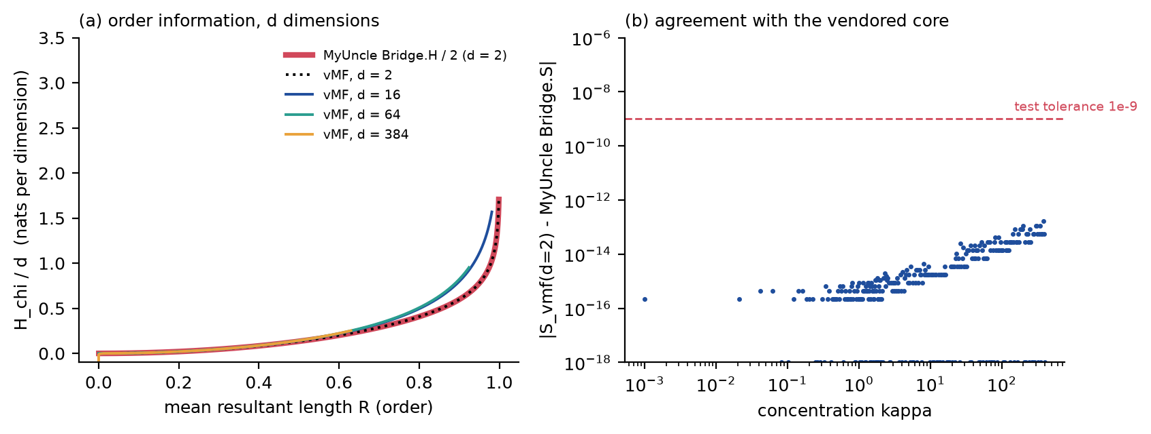
Fig. 1. (a) The order-information bridge in d dimensions, per dimension: MyUncle's H_{χ} (d = 2, red) and the vMF generalization for d = 2, 16, 64 and 384. (b) Difference between the d = 2 vMF entropy and the vendored MyUncle Bridge.S.
2.4 The frozen novelty score and the diagnostic axes
Three rank-based axes are computed for every nonartifact patch (empirical percentile in the cohort, 0 to 1): appearance rarity, state-wise disorder and contact rarity. Appearance rarity p_{emb} is the mean cosine distance to the k nearest patches of a reference set (a random sample of the cohort, same-slide neighbors within six lattice steps excluded). Because the prevalence of an interesting state is not known in advance, it is evaluated with k equal to 0.5, 1, 2, 5 and 10% of the reference set and the highest rank counts: a state that recurs but covers less than the scale is still rare at that scale. State-wise disorder p_{het} ranks D_{i} among the patches of the same prototype state (k-means with 12 states), so that routine interfaces between compartments are not unusual. Contact rarity p_{adj} ranks the mean of −ln P(s_{j} |s_{i}) over the neighbors, with P the cohort-wide frequency with which states touch. The novelty score of a patch is the mean of the valid scores of its 3 × 3 lattice window (lattice smoothing) of a weighted probabilistic OR of the axes,
$N_{i}=\frac{1}{|W_{i}|}∑_{jinW_{i}}q_{j}, q_{j}=1−(1−p_{emb,j})^{w_{emb}}(1−p_{het,j})^{w_{het}}(1−p_{adj,j})^{w_{adj}}$ (4)
with the frozen weights (w_{emb}, w_{het}, w_{adj}) = (1, 0, 0): the default score is the smoothed multi-scale appearance rarity. The disorder and contact axes were part of the original design (weights 0.4, 0.4, 0.2, one rarity scale, no smoothing) and are retained as diagnostics and as options (--weights), because in the evaluation below their effect depended on the encoder: they helped with handcrafted features and hurt with DINOv2, where they were inverted. A Mahalanobis-distance scorer, smoothed in the same way, is available as an alternative (--scorer mahalanobis).
2.5 Discovery, ranking and explanation
Patches in the top fraction q of the novelty scores (default 2%) are candidates. Connected candidates of at least three patches form regions; regions are clustered across slides by the cosine distance of their mean embeddings (average linkage). A cluster is a finding, ranked by mean novelty × (1 + ln of the number of slides) × (0.5 + 0.5 × reproducibility), where reproducibility is the fraction of its patches that stay above the median rank of appearance rarity when the reference set is split into two disjoint halves. The score is a ranking, not a probability. Each finding carries a plain-language explanation made only of measured numbers, an explicit statement when it occurs in one slide only, and the request for expert review; no pathological term is assigned.
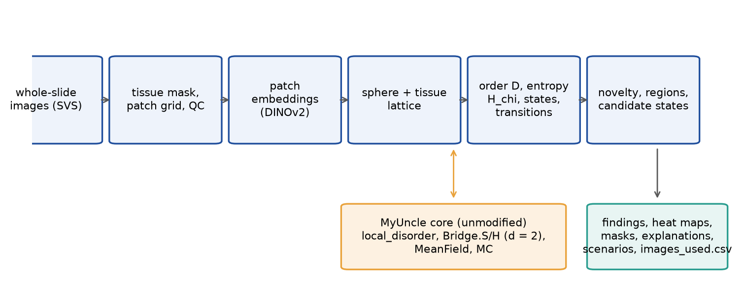
Fig. 2. MyUncleVision: from whole-slide images to ranked, mapped and explained candidate states, with the unmodified MyUncle core supplying the reference definitions.
2.6 Software
Python (numpy, scipy, scikit-learn, OpenCV, timm and PyTorch for the encoder). One command, `python -m myuncle_vision run --input DIR --output DIR`, also the default command of the Docker image, writes findings, per-slide annotations in level-0 pixel coordinates, masks, heat maps, patch scores, a CSV listing every image used and how, and a manifest with versions, configuration, model files and the hash of the MyUncle core. The code is archived and open (Data availability). A bridge module connects the two code bases in both directions (simulate any MyUncle preset and analyse its lattice states with the same order maps and novelty score, with a numerical equivalence check; Section 4.5), and an exploratory analysis that maps a slide onto MyUncle's simulation is opt-in and described in Appendix A.
3. Evaluation design
For the imaging application no real image of tissue or of a material was available for this work; the lattice simulations of Section 4.5 are a separate testbed. The evaluation uses synthetic slides (4,480 × 4,480 px at 0.5 µm/px) that imitate what the method measures, not kidney tissue: interstitium, tubule-like rings with nuclei, glomerulus-like discs, vessels, stain variation, planted anomalies and three artifact types (an out-of-focus disc, a pen stroke, a dark fold). They were written by the author of the method, which limits what they can show.
• The development cohort (8 slides, 1843 patches, 3.1% of them anomalous) was used while the method was built: two anomaly types (a patchwork of small tiles of different structure; a coherent striped state in an unusual hue). Settings were chosen on it.
• The held-out cohort (16 slides, 3786 patches, 0.8% anomalous) has three anomaly types never used in development (tightly packed small tubules, nuclear crowding, a cluster of glomerulus-like discs), seven planted instances, a prevalence near 1%, stain and scanner shifts and different artifacts. The settings were frozen and recorded (results/frozen_settings.json, written before this cohort existed) and the cohort was evaluated once. Two candidates were frozen: the score of Section 2.4 (selected by a rule fixed beforehand: the highest mean average precision, over the two encoders, among the MyUncleVision variants) and a smoothed Mahalanobis scorer, which was added after the development results showed that it scored higher and which the rule did not select.
Methods compared: the original default of v0.1 (three-axis OR at one scale, no smoothing), every axis alone and in pairs, multi-scale appearance with and without smoothing, local disorder alone, and four baselines on the same embeddings: Isolation Forest, Local Outlier Factor, nearest-neighbor distance with k = 10 and Mahalanobis distance, each raw and smoothed in the same way as the proposed score (percentile rank, then the 3 × 3 window). Metrics, on patches that pass QC, with artifact patches excluded: AUROC and average precision (AP) of planted anomalous against clean patches; for the top 3% of scores, the spatial coherence (the share that lie in connected groups of at least three patches), the region recall (planted instances that contain a candidate patch) and the number of connected candidate groups per slide that touch neither a planted anomaly nor an artifact (false regions). A robustness suite varies seeds, embedding dimension, number of states, axis weights, smoothing and patch size. Everything was run with two encoders, DINOv2 and the handcrafted one.
4. Results on synthetic images and simulated lattices
4.1 Development cohort
Method | AUROC | AP | coh. | rec. | AUROC | AP | coh. | rec.
three-axis OR, 1% scale (v0.1 default) | 0.90 | 0.18 | 0.42 | 0.62 | 0.22 | 0.02 | 0.00 | 0.00
appearance, 1% scale | 0.97 | 0.34 | 0.16 | 0.38 | 0.50 | 0.03 | 0.05 | 0.00
appearance, multi-scale | 0.98 | 0.45 | 0.42 | 0.75 | 0.87 | 0.20 | 0.30 | 1.00
MyUncleVision frozen (appearance, multi-scale, smoothed) | 0.92 | 0.47 | 0.91 | 1.00 | 0.98 | 0.74 | 0.87 | 1.00
three-axis OR, multi-scale, smoothed | 0.99 | 0.79 | 0.87 | 1.00 | 0.90 | 0.20 | 0.76 | 0.38
state-wise disorder | 0.67 | 0.06 | 0.58 | 0.25 | 0.25 | 0.02 | 0.25 | 0.00
contact rarity | 0.65 | 0.06 | 0.30 | 0.25 | 0.09 | 0.02 | 0.20 | 0.12
local disorder D alone | 0.84 | 0.25 | 0.96 | 0.38 | 0.22 | 0.02 | 0.25 | 0.00
Isolation Forest | 0.92 | 0.24 | 0.25 | 0.38 | 0.61 | 0.04 | 0.07 | 0.00
+ smoothing | 0.92 | 0.36 | 0.55 | 1.00 | 0.83 | 0.15 | 0.53 | 0.50
Local Outlier Factor | 0.65 | 0.22 | 0.44 | 0.50 | 0.33 | 0.02 | 0.05 | 0.00
Mahalanobis distance | 0.98 | 0.60 | 0.55 | 0.75 | 0.96 | 0.65 | 0.69 | 1.00
+ smoothing | 0.95 | 0.62 | 0.69 | 1.00 | 0.99 | 0.90 | 0.95 | 1.00
kNN distance, k = 10 | 0.81 | 0.28 | 0.22 | 0.38 | 0.28 | 0.02 | 0.00 | 0.00
+ smoothing | 0.89 | 0.42 | 0.71 | 0.62 | 0.30 | 0.02 | 0.42 | 0.00
Table 1. Development cohort: AUROC, average precision (AP), spatial coherence (coh.) and region recall (rec.) of the methods, handcrafted encoder (columns 2 to 5) and DINOv2 (columns 6 to 9). '+ smoothing' is the method above it with percentile ranks smoothed over the 3 × 3 lattice window.
The original default (three-axis OR at one rarity scale) had an AUROC of 0.90 with handcrafted features and 0.22 with DINOv2, below chance. The cause is a scale mismatch and an encoder property: the planted states covered 3.1% of the patches, more than the 1% rarity scale, and DINOv2 embeds them tightly, so the appearance axis alone is at chance at that scale (0.50); in addition, the DINOv2 embeddings of the planted regions are more homogeneous than those of normal tissue, so the disorder and contact axes point the wrong way (AUROC 0.25 and 0.09). Judging rarity at several scales fixed the appearance axis (AUROC 0.87 with DINOv2). Smoothing over the lattice raised the spatial coherence of every score: for the frozen score the coherence rose from 0.42 to 0.91 (handcrafted) and from 0.30 to 0.87 (DINOv2) and the region recall to 1.00 and 1.00. With smoothing, adding the disorder and contact axes to appearance (three-axis OR) raised the AP from 0.47 to 0.79 with handcrafted features and lowered it from 0.74 to 0.20 with DINOv2; the held-out cohort showed the same sign flip (Section 4.2).
Against the baselines the result is less flattering. A plain Mahalanobis distance, a single Gaussian model of the embeddings, reaches an AUROC of 0.98 and 0.96 and, smoothed in the same way, an AP of 0.62 and 0.90 (handcrafted, DINOv2) against 0.47 and 0.74 for the frozen score. The frozen score is better than the nonparametric baselines (Isolation Forest, Local Outlier Factor, nearest-neighbor distance), whose smoothed AP with DINOv2 was 0.15, 0.02 and 0.02. Smoothing raised the spatial coherence of every baseline in all four cases (cohort by encoder); it lowered the region recall of one of them (Isolation Forest, held-out, handcrafted) and not always the AUROC. Smoothing the raw Mahalanobis distance instead of its percentile rank did better still (AP 0.82 and 0.96); this was not adopted, because it was found after the settings were chosen and would need a new held-out cohort.
4.2 Held-out cohort, settings frozen
Method | AUROC | AP | coh. | rec. | AUROC | AP | coh. | rec.
three-axis OR, 1% scale (v0.1 default) | 0.95 | 0.13 | 0.63 | 0.71 | 0.45 | 0.01 | 0.00 | 0.00
appearance, 1% scale | 0.96 | 0.17 | 0.29 | 1.00 | 0.77 | 0.02 | 0.05 | 0.14
appearance, multi-scale | 0.98 | 0.17 | 0.31 | 0.86 | 0.95 | 0.15 | 0.20 | 0.86
MyUncleVision frozen (appearance, multi-scale, smoothed) | 0.80 | 0.04 | 0.89 | 0.29 | 0.99 | 0.59 | 0.65 | 1.00
three-axis OR, multi-scale, smoothed | 0.97 | 0.26 | 0.84 | 0.86 | 0.93 | 0.15 | 0.66 | 0.71
state-wise disorder | 0.82 | 0.06 | 0.67 | 0.57 | 0.20 | 0.01 | 0.17 | 0.00
contact rarity | 0.60 | 0.02 | 0.50 | 0.00 | 0.12 | 0.01 | 0.03 | 0.00
local disorder D alone | 0.92 | 0.07 | 0.87 | 0.57 | 0.21 | 0.01 | 0.16 | 0.00
Isolation Forest | 0.96 | 0.12 | 0.18 | 0.86 | 0.88 | 0.04 | 0.08 | 0.14
+ smoothing | 0.93 | 0.12 | 0.58 | 0.71 | 0.98 | 0.25 | 0.55 | 1.00
Local Outlier Factor | 0.96 | 0.12 | 0.34 | 0.71 | 0.64 | 0.02 | 0.00 | 0.29
Mahalanobis distance | 0.96 | 0.13 | 0.21 | 0.71 | 0.93 | 0.17 | 0.25 | 0.71
+ smoothing | 0.93 | 0.11 | 0.59 | 0.86 | 0.99 | 0.35 | 0.58 | 1.00
kNN distance, k = 10 | 0.96 | 0.14 | 0.28 | 0.57 | 0.43 | 0.01 | 0.03 | 0.14
+ smoothing | 0.91 | 0.12 | 0.64 | 0.71 | 0.62 | 0.04 | 0.42 | 0.29
Table 2. Held-out cohort (settings frozen beforehand, evaluated once); columns as in Table 1.
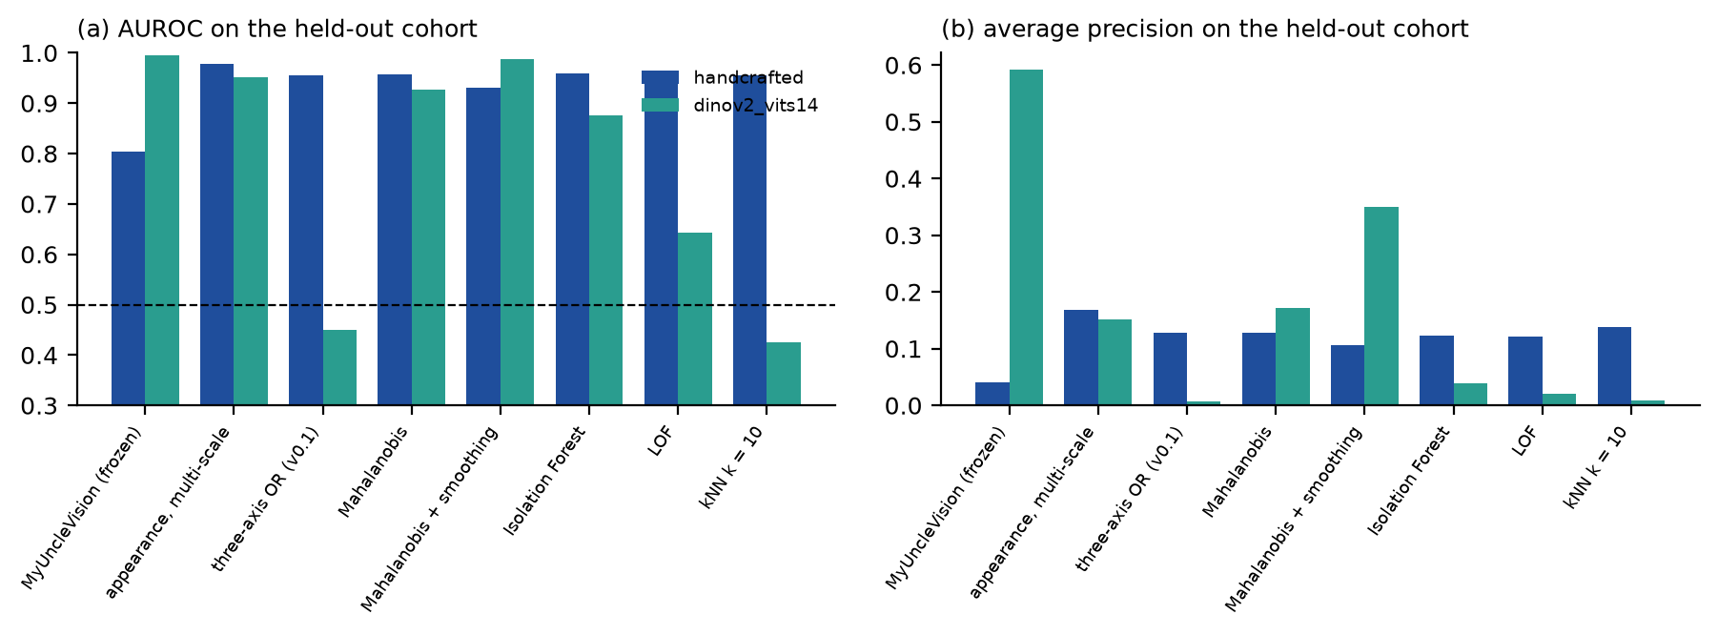
Fig. 3. AUROC and average precision of the main methods on the held-out cohort, both encoders.
With DINOv2 the frozen score was the best of all methods in average precision (0.59, AUROC 0.99, spatial coherence 0.65, region recall 1.00, 0.38 false regions per slide), ahead of Mahalanobis with smoothing (AP 0.35) and of the unsmoothed multi-scale appearance (AP 0.15). With handcrafted features it did badly: AP 0.04, region recall 0.29, although its AUROC was 0.80 and its spatial coherence 0.89. The unsmoothed multi-scale appearance score had an AP of 0.17 and a region recall of 0.86. The held-out anomalies are small (about five patches) and their prevalence is below 1%; with handcrafted features a 3 × 3 window mixes each of them with normal neighbors and dilutes the percentile ranks, which saturate. The choice to smooth, made on the development cohort, therefore did not generalize across encoders. The lattice axes behaved as on the development cohort: with smoothing they raised the AP with handcrafted features (0.26 against 0.04) and lowered it with DINOv2 (0.15 against 0.59). All methods had a low AP in absolute terms with handcrafted features (the best, kNN distance, k = 10, lattice-smoothed (raw score), was 0.32).
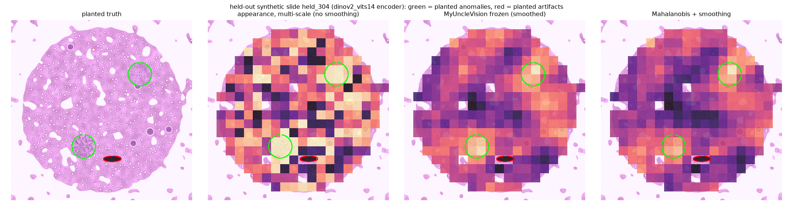
Fig. 4. One held-out slide (DINOv2): planted anomalies (green), planted artifact (red), the unsmoothed multi-scale appearance score, the frozen score and the smoothed Mahalanobis score on the patch lattice.
4.3 Robustness
Variant | Jacc. | AP | Jacc. | AP
default (frozen) | 1.00 | 0.04 | 1.00 | 0.59
seed 1 | 1.00 | 0.04 | 1.00 | 0.59
seed 2 | 1.00 | 0.04 | 1.00 | 0.59
seed 3 | 1.00 | 0.04 | 1.00 | 0.59
8 PCA components | 0.88 | 0.04 | 0.65 | 0.53
32 PCA components | 0.93 | 0.04 | 0.73 | 0.55
6 states | 1.00 | 0.04 | 1.00 | 0.59
24 states | 1.00 | 0.04 | 1.00 | 0.59
no lattice smoothing | 0.05 | 0.17 | 0.11 | 0.15
three-axis weights 0.4/0.4/0.2 | 0.10 | 0.26 | 0.20 | 0.15
equal axis weights | 0.06 | 0.18 | 0.19 | 0.10
coarser patches (0.75 um/px) | n/a | 0.04 | n/a | 0.26
Table 3. Held-out cohort: stability of the frozen method under changes of configuration. Jaccard = overlap of the top-3% patch set with the default configuration; AP = average precision. Handcrafted (columns 2, 3) and DINOv2 (columns 4, 5).
Seeds and the number of states did not change the flagged set (Jaccard 1.00), but this is not evidence of stability: at this cohort size the reference sample is the whole cohort and the default weights do not use the states, so those two settings have no effect here. The embedding dimension changed the top-3% set moderately (Jaccard 0.65 to 0.93 over both encoders). Switching smoothing off or adding the disorder and contact axes changed it almost completely (Jaccard 0.05 to 0.20), as the earlier tables imply: those are design choices, not noise. A coarser patch size (0.75 µm/px) was tolerated with DINOv2 (AUROC 0.96, AP 0.26, region recall 1.00) but not with handcrafted features (AUROC 0.60, AP 0.04, region recall 0.00). Stain and scanner shifts are built into the held-out cohort (palette and softness differ between slides); a systematic test of other scanners, patients and stains needs real slides.
4.4 What the lattice adds and what it does not
Added: the lattice makes the score spatially coherent. For every scorer, smoothing over the lattice raised the share of top-ranked patches that form connected regions, and with DINOv2 it turned a noisy patch-level score into compact regions (Fig. 4). That is the property that matters for an expert who has to look at places. Encoder-dependent: the two lattice-based axes, disorder and contact rarity, added detection power with handcrafted features and removed it with DINOv2 on both cohorts; because the sign depends on the embedding, they are diagnostics and options, not part of the default score. Not shown: that the specific appearance score is better than a Mahalanobis distance (it is not, on the development cohort), and any benefit on real tissue.
4.5 Simulated maintenance lattices (MyUncle)
The synthetic slides were written by the author of the method. A second testbed uses lattices that are not images and come from the simulation MyUncle was built for, through the bridge module: MyUncle's kinetic Monte Carlo (unmodified core) was run from a damaged start, and snapshots at steps 20, 40 and 60 (48 × 48 sites) were analysed as slides whose sites are patches. The sites that have lost their coupling in the simulation (the damaged sites) are the ground truth; the intact flag is never part of the embedding. Two embeddings were used: the rotor (cos θ, sin θ) and the rotor with the local disorder D of the site. The presets are model parameter sets that MyUncle labels with application names; they are not fitted to measurements of any material. The development set was one preset (chiral scaffold, four runs, damaged share 10%); the held-out set was three other presets (polymer photodegradation, liquid crystal, magnetic storage decay; four runs each; damaged share 30%, 26% and 8%). The settings of the image benchmark were used unchanged, with six states because the embedding has two or three dimensions, and the baselines were those of Section 3. The damaged share is not small, so this set also tests the assumption that interesting states are rare. Intervals in the json result files are 95% intervals over whole simulation runs, not over snapshots of one run, and overlap for the methods whose held-out averages are close (for example the frozen score and smoothed Isolation Forest with the rotor + D embedding).
Method | AUROC | AP | AUROC | AP | AP dev | AP dev
MyUncleVision frozen (smoothed) | 0.65 | 0.36 | 0.77 | 0.49 | 0.13 | 0.28
Isolation Forest | 0.72 | 0.59 | 0.75 | 0.50 | 0.45 | 0.36
+ smoothing | 0.65 | 0.36 | 0.76 | 0.49 | 0.13 | 0.27
Mahalanobis distance | 0.76 | 0.63 | 0.76 | 0.44 | 0.48 | 0.23
+ smoothing | 0.71 | 0.40 | 0.75 | 0.47 | 0.16 | 0.26
kNN distance, k = 10 | 0.72 | 0.56 | 0.72 | 0.38 | 0.42 | 0.20
+ smoothing | 0.65 | 0.36 | 0.75 | 0.47 | 0.13 | 0.25
local disorder D alone | 0.63 | 0.32 | 0.58 | 0.26 | 0.12 | 0.10
Table 4. Lattices simulated with MyUncle, damaged sites as ground truth. Held-out presets: AUROC and AP with the rotor embedding (columns 2, 3) and the rotor + D embedding (columns 4, 5); AP on the development preset (columns 6, 7).
With the rotor alone, the frozen score was no better than smoothed Isolation Forest or nearest-neighbor distance (held-out AP 0.36, AUROC 0.65) and clearly below the unsmoothed baselines (Mahalanobis AP 0.63, Isolation Forest 0.59) and the smoothed Mahalanobis score (AUROC 0.71). Smoothing lowered the AP of every baseline on both sets (for example Isolation Forest 0.59 to 0.36 on the held-out set): the damaged sites are not compact regions that a 3 × 3 window preserves, which is the dilution already seen with handcrafted features on the images, although here that explanation is a plausible reading and was not tested separately. Adding the local disorder as a feature raised the AP of the frozen score on both sets (development 0.13 to 0.28, held-out 0.36 to 0.49); on the held-out presets it was then within 0.02 of the best AP (0.49, tied with smoothed Isolation Forest), while on the development preset an unsmoothed Isolation Forest was clearly better (AP 0.36 against 0.28). The disorder map alone ranked the damaged sites poorly (held-out AP 0.26 with the rotor + D embedding), so the gain comes from combining it with the appearance of the site. The results are mixed in the same way as on the images: the lattice smoothing lowered the average precision of every baseline where the anomalies were scattered sites (the controlled study of Section 4.7 varies this), and a plain Gaussian or tree-based baseline is a strong competitor. The simulation is the author's own, the damaged sites are an easy kind of anomaly (a site that lost its coupling), and four runs per preset are few; this testbed shows that the pipeline and its baselines run on a lattice that is not an image and that its limits are the same ones, not that the method detects damage in a real system.
Fig. 5 shows one simulated run (preset chiral scaffold, 32 x 32 sites, snapshots 15 steps apart): the rotor angle, the local disorder D, the order information H_chi and the novelty score of the frozen method. Novelty is a percentile rank relative to the snapshots analysed together, so it marks where a state is unusual among the snapshots shown; it has not been validated against known defect locations.
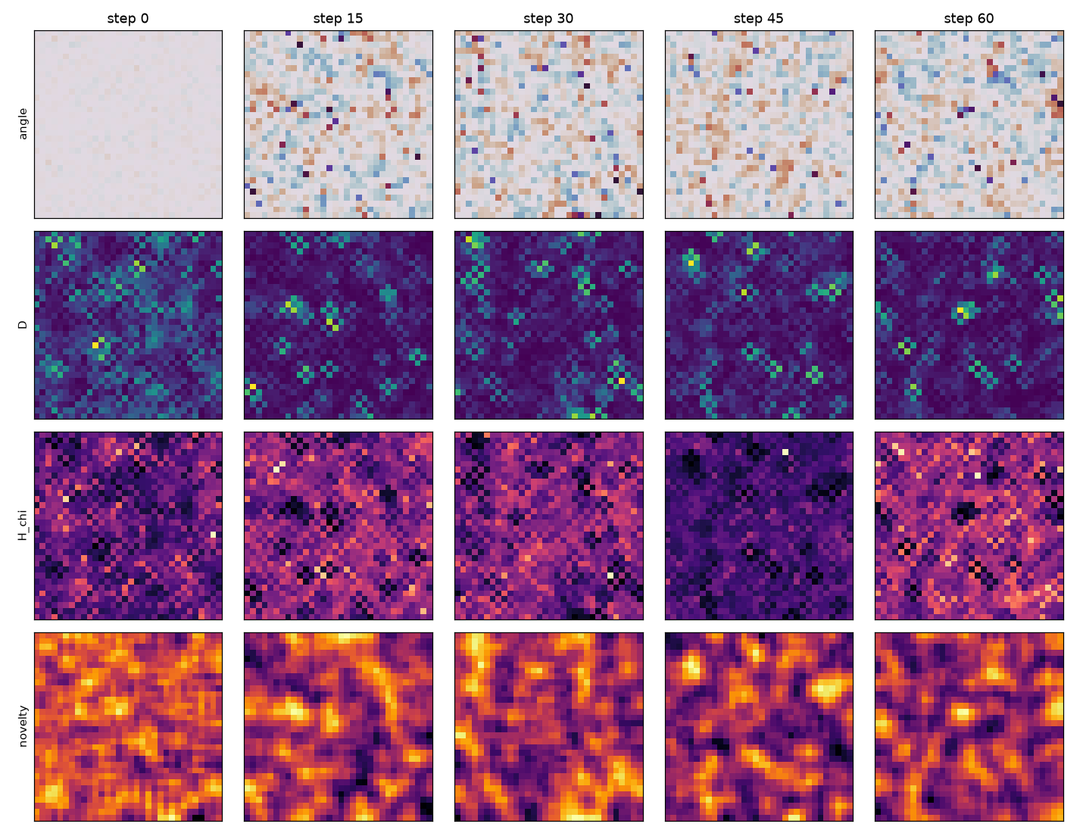
Fig. 5. A MyUncle simulation analysed with MyUncleVision (command python -m myuncle_vision bridge, preset chiral scaffold, 32 x 32 sites, seed 0). Rows: rotor angle, local disorder D, order information H_chi (von Mises-Fisher, d = 2) and novelty of the frozen method; columns: snapshots at steps 0, 15, 30, 45 and 60.
4.6 Configuration search with GaaR
The frozen configuration is one choice for all data, and the results above show that it is not best for every embedding. GaaR (Goal-Aware Adaptive Regulation) [5], an evolutionary search framework by the same author, was used to select a configuration of the score from 360 candidates: smoothing type and window (none, mean 3, 5, 7, Gaussian 5, 7, median 3, 5), five sets of axis weights, the PCA dimension (8, 16, 32) and the largest rarity scale (2, 5, 10%). This is supervised hyperparameter selection on labeled development scenarios, not label-free adaptation: the chosen configuration is fixed afterwards. The fitness is a lower-tail average precision, F = 0.5 mean(AP) + 0.5 min(AP), over four development scenarios (the development images with each embedding and the development lattices with each of their two embeddings). All 360 configurations were evaluated once on these scenarios, so any search can be compared exactly with the optimum; each strategy of GaaR and plain random search then ran 100 times with a budget of 40 evaluations. The champions were evaluated once on fresh test scenarios that no search saw: 16 new synthetic images (new seeds, the held-out anomaly types) and 48 new lattice states, including a preset not used before (superconducting scaffold).
Configuration | F dev | Img. hand. | Img. DINOv2 | Lat. rotor | Lat. rotor+D | F test [95% interval] | Difference from default [95% interval]
Frozen default | 0.26 | 0.04 | 0.50 | 0.32 | 0.46 | 0.18 [0.15, 0.39] | -
No smoothing | 0.28 | 0.18 | 0.11 | 0.56 | 0.43 | 0.21 [0.15, 0.31] | +0.03 [-0.16, +0.08]
GaaR restart / population champion | 0.35 | 0.17 | 0.41 | 0.41 | 0.45 | 0.26 [0.17, 0.42] | +0.08 [-0.05, +0.17]
GaaR greedy / random-search champion | 0.33 | 0.24 | 0.12 | 0.41 | 0.44 | 0.21 [0.14, 0.33] | +0.03 [-0.17, +0.10]
Exhaustive development optimum | 0.35 | 0.11 | 0.58 | 0.41 | 0.43 | 0.25 [0.18, 0.45] | +0.07 [-0.03, +0.19]
Table 5. Fresh test scenarios: average precision (AP) of the frozen configuration, of no smoothing and of the champions found on the development scenarios (development fitness F in column 2; test AP for handcrafted-feature images, DINOv2 images, and lattices with the rotor and the rotor + D embedding in columns 3-6; test fitness with a 95% interval in column 7 and its paired difference from the default in column 8; intervals resample the 16 images and the 16 simulation runs of each scenario).
The default configuration ranked 64th of 360 on the development fitness (0.26; optimum 0.35). With 40 evaluations, the greedy and restart strategies found a configuration in the top 1% in 59% and 60% of the runs and random search in 25% (population: 46%), whereas at the top 5% level random search did as well or better (87% against 71%, 72% and 85%). On the test scenarios (Table 5) the champion of the restart and population strategies raised the test fitness from 0.18 (default) to 0.26, mainly by lifting the worst scenario (handcrafted-feature images, AP 0.04 to 0.17), while the AP with DINOv2 fell from 0.50 to 0.41. The paired 95% interval of this gain (+0.08) is [-0.05, +0.17] and the champion was better than the default in 89% of the resamples, so with 16 independent units per scenario it cannot be distinguished from zero. The champion of the greedy strategy and of random search (the same configuration here) reached 0.21, and the exhaustive development optimum 0.25: every development-optimized configuration beat the default, but their order did not follow the development fitness. The gain is therefore due to the selected configuration (a smaller PCA dimension and the disorder axis at weight 0.5, with 3 x 3 mean smoothing) and not to the search algorithm; each strategy contributed one champion, four scenarios are few, and the test data come from the same generators as the development data.
4.7 Smoothing against anomaly morphology
The results above leave open when smoothing helps. A controlled study on an independent generator varied only the spatial size of the anomalies. Each of 50 lattices (32 x 32 sites, 16-dimensional embeddings) has smooth background domains and 3% anomalous sites with a fixed separability (a shift of 10 noise standard deviations, calibrated beforehand on the unsmoothed score only); the anomalies are b x b blocks, b = 1 being scattered single sites and b = 6 compact regions, and each block has its own direction, so no recurring state exists. Without smoothing the average precision was between 0.43 and 0.49 across sizes; the frozen 3 x 3 mean lowered it to 0.03 at b = 1 and 0.31 at b = 6 (Table 6). Smoothing hurt at every size, the loss shrinking as the anomalies grew, and a 5 x 5 mean was worse than the 3 x 3 mean at every size (paired 95% intervals of all these differences exclude zero). The champion of the GaaR search was better than the frozen configuration for b up to 3 and not distinguishable from it for b = 4 and 6, but it stayed below no smoothing at every size: configuration selection on the development scenarios, in which smoothing helped the DINOv2 images, mitigated the loss without removing it.
Configuration | b = 1 | b = 2 | b = 3 | b = 4 | b = 6
No smoothing | 0.44 | 0.43 | 0.45 | 0.49 | 0.43
Frozen (3 x 3 mean) | 0.03 | 0.06 | 0.11 | 0.21 | 0.31
5 x 5 mean | 0.03 | 0.04 | 0.04 | 0.07 | 0.16
GaaR restart champion | 0.05 | 0.14 | 0.21 | 0.26 | 0.29
Exhaustive development optimum | 0.04 | 0.09 | 0.13 | 0.20 | 0.25
Table 6. Average precision against anomaly block size b (independent embedding-lattice generator; 3% anomalous sites, fixed separability).
A label-free alternative was explored. Moran's I of the unsmoothed rarity score (spatial autocorrelation of the score field) was below 0.02 in exactly the two lattice scenarios, one development and one test, in which smoothing lost most of the AP, and above 0.1 in the other six. A rule that smooths only above 0.05 would have avoided the largest loss in both, but it would not have helped the handcrafted-feature test images (eight scenarios, one threshold, exploratory).
4.5b Contrast survival of the fixed window
What the evaluation supports. The order and entropy definitions are MyUncle's, verified at d = 2, and extend to unit vectors in d dimensions with the von Mises-Fisher distribution. The lattice smoothing gives spatially coherent candidate regions for any scorer when the anomalies form regions, and it is harmful when they do not: on the simulated lattices the damaged sites are scattered and smoothing lowered the average precision of every baseline, whereas on the synthetic images it raised the spatial coherence of every scorer. The multi-scale rarity removes the dependence on a prevalence chosen in advance, and a supervised search with GaaR improved the lower-tail average precision on fresh test scenarios, although random search also beat the default and the gain therefore belongs to the selected configuration, although the damaged share of three of the four parameter sets (about 10%, 30% and 26%; the fourth is 8%) is near or above the largest prevalence scale of the rarity score (10% of the reference set), a limit of the frozen settings that the simulated testbed exposes.
What it does not support. The lattices and the images are simulated, written by the author of the method (the simulation is MyUncle's, with an easy kind of anomaly, a site that lost its coupling, and with model parameter sets that carry application names but are not fitted to measurements); nothing here shows that the method finds anything in an experimental material or in tissue, or that what it finds is meaningful. The held-out sets were used once but are of the same family as the development sets, and four simulation runs per parameter set are few. The two embeddings of the images disagree on whether smoothing helps and on whether the lattice axes help, and a single Gaussian model scored higher than the frozen score on the development cohort. Novelty is not a defect: a rare state may be a rare sample preparation, an instrument, a staining or imaging batch, or a known feature that is merely uncommon in the set. The image embedding is trained on natural images and may group patches by stain or sharpness, and quality control flagged only part of the planted artifact patches in the development runs (42%).
Improvements: neighborhoods larger than four sites, a calibrated null for the novelty score, smoothing of the raw score instead of its rank, an embedding trained on micrographs of the system at hand, and active expert feedback in the manner of anomaly detection systems for astronomy [2]. Computing: the encoder dominates; an image of ten thousand patches takes about ten minutes on one CPU core and minutes on a GPU, and the pipeline offers a patch budget per image and a resumable cache.
Six aggregation rules turn the rarity score r into the final score s on the lattice (none; fixed w x w mean; similarity-weighted aggregation, which weights each neighbor by exp(-(1 - u_i . u_j)/tau) with tau the median of 1 - cos over lattice-adjacent pairs of the cohort, a label-free scale; a one-sided rule, which lets neighbors add evidence but never remove it; a nucleation-and-growth rule with hysteresis, in which a site whose rarity exceeds a nucleation threshold seeds and weaker neighbors are raised to the seed's score weighted by their compatibility, never lowered; and gates on the compatibility, on the resultant length R_i and on the von Mises-Fisher information H_chi of the neighbors, with an optional persistence factor over the windows 1, 3, 5 and 7). Similarity-weighted filtering is an established kind of edge-preserving filter; no novelty is claimed for it. H_chi is a monotone function of R_i, so a gate on the rank of H_chi is the same as a gate on the rank of R_i. The rarity score is computed once per scenario; the rule parameters (460 distinct configurations) were selected on ten development scenarios (the four of Sections 4.1-4.6 and six shapes of the controlled generator: scattered sites, 3 x 3 and 6 x 6 blocks, bars of 8, irregular 12-site clusters and 3 x 3 blocks on domain boundaries) by F = 0.5 mean(AP) + 0.5 min(AP), and the champions were evaluated once on ten independent test scenarios (new seeds, new images and lattices, a MyUncle preset not used before). Selecting rule parameters uses development labels; the rules are label-free.
The local disorder and the von Mises-Fisher order information of MyUncle generalize to lattices of unit vectors in d dimensions and equal MyUncle's at d = 2. A label-free score built on them, rarity of the state of a site at several prevalence scales smoothed over the lattice, was tested on lattices simulated with MyUncle and on synthetic stained-tissue images, with frozen settings and four baselines. The results are mixed: smoothing helped only with the DINOv2 embeddings of the synthetic images, whose unsmoothed score is noisy, and hurt on simulated lattices and in a controlled study on an independent generator, least for compact anomalies; adding the local disorder as a feature helped on the simulated lattices, the frozen score was competitive but not uniformly best, and a simple Mahalanobis baseline was a strong competitor. A supervised search of the scoring configuration with GaaR gave a gain whose paired interval included zero. Similarity-weighted aggregation of the scores raised the lower-tail average precision on independent test scenarios above both the fixed window and no smoothing (paired intervals above zero), gates on local order and on the von Mises-Fisher information did not beat ordinary similarity, and a GaaR search over rule configurations was not better than random search. All evidence is simulated; validation on experimental micrographs and on histology, with expert review, is the planned next step (Section 5).
The fixed 3 x 3 mean lowered the average precision of scattered anomalies from 0.37 to 0.03, of bars from 0.39 to 0.05 and of the rotor-embedding lattices from 0.56 to 0.32, and helped only the DINOv2 images (0.11 to 0.50); in the lower-tail fitness it was below no smoothing (0.11 against 0.23; paired difference -0.12 [-0.19, -0.07]). The untuned similarity-weighted rule reached F = 0.32, +0.21 [+0.14, +0.30] above the fixed mean and +0.09 [+0.04, +0.19] above no smoothing; it kept the region recall of scattered anomalies at 0.44 (fixed mean: 0.03) and of bars at 0.60 (0.07), but did not help the handcrafted-feature images (0.17 against 0.18 without smoothing). The one-sided rule matched no smoothing (+0.00 [+-0.00, +0.01]). The development-selected order gates reached F = 0.30 (compatibility) and 0.31 (resultant length and H_chi, which gave the same scores because H_chi is monotone in R_i), below the untuned similarity-weighted rule; the entropy extension is therefore a formal result that did not improve detection. Among the 460 distinct configurations, random search found a configuration in the top 5% in 94% of 100 runs of 40 evaluations, the GaaR strategies in 70% (greedy), 81% (restart) and 80% (population): GaaR was not better than random search here, because many configurations of the similarity-weighted family are nearly equivalent.
Two further ideas were tested. The nucleation-and-growth rule, with its parameters selected on the development scenarios, reached F = 0.23 on the test scenarios, the same as no smoothing (paired difference +0.00 [+-0.00, +0.00]) and below the similarity-weighted rule (-0.09 [-0.19, -0.04]). A label-free closure gap, motivated by the failure of mean-field closures that average a steep function over a heterogeneous neighborhood, is the share of the cohort's top 3% sites that are still in the top 3% after the fixed mean (the retention); it correlated with the effect of the fixed mean on the average precision over the 68 development and test cohorts (Spearman rho = 0.43, p = 0.0002), but a choice between the fixed mean and no smoothing based on it, fitted on the development cohorts, selected the mean for 6% of the test cohorts and reached a mean AP of 0.36 against 0.37 for no smoothing (oracle choice 0.38) and 0.48 for similarity weighting, which makes the choice unnecessary. As a robustness criterion in the spirit of grid convergence, the range of the average precision over the six anomaly shapes was 0.06 without smoothing, 0.22 for the fixed mean and 0.06 for the similarity-weighted rule.
5. Future work: validation on experimental micrographs and histology
The evidence in this paper is simulated: the lattices were generated with MyUncle by the author of the method, and the images were generated by the author with simple textures and sharply bounded anomalies. They cannot show that the method finds anything of physical, chemical or biological meaning in an experimental system. Validation on experimental data is therefore the principal next step, and the study is specified here in advance so that its design cannot be shaped by its results. It has not been started.
5.1 Data and design
Two kinds of data are planned. The first is micrographs of ordered materials whose defect structure can be established independently, such as polarized-light textures of liquid crystals or microscopy of block-copolymer and self-assembled films, with defects annotated by at least two experts or by an independent measurement. The second is publicly released whole-slide images of tissue, for which the imaging pipeline of Section 2 was built. For each kind a pilot of 10 to 20 images will be used to inspect the quality-control exclusions and the maps and to fix the settings. The settings, the list of baselines and the analysis plan will then be frozen and published in the repository before an independent set of images from other samples, instruments and operators is analysed once, following the procedure used here for the held-out cohorts.
5.2 Comparators and endpoints
The frozen score will be compared with the baselines of Section 3 (isolation forest, local outlier factor, nearest-neighbor and Mahalanobis distances, raw and smoothed) and with other spatial postprocessing (Gaussian and median filters, other window sizes). Primary endpoint: the share of the top-ranked regions that at least two experts, blinded to the method and to the ranking, judge to be a defect or an unexplained feature rather than a known feature or an artifact, with interrater agreement (Cohen's kappa) and bootstrap confidence intervals over images, compared between methods by paired resampling. Secondary endpoints: the recall of annotated defects at a fixed review budget; the fraction of artifact regions among the top-ranked ones; the stability of the flagged set under another seed, reference sample, embedding and patch size (Jaccard overlap); computing time. The success criteria will be written into the analysis plan before the independent set is analysed.
5.3 Further planned work
A second synthetic generator with different textures, anomaly boundaries and artifacts, evaluated once with the frozen settings; bootstrap intervals for the average precision and for the differences from the Mahalanobis baseline, with more planted instances than the seven of the present held-out image cohort and more than four simulation runs per parameter set; a direct comparison of the lattice smoothing with Gaussian and median filtering and other neighborhood sizes; smoothing of the raw score instead of its rank; fitting the MyUncle parameter sets to measured data, which would turn the labels used here for the parameter sets into calibrated models; stain normalization [13] and a pathology-pretrained encoder [14,15] for tissue images. If the experimental study shows no advantage over the baselines, that result will be reported.
6. Discussion
What the evaluation supports. The lattice smoothing gives spatially coherent candidate regions for any scorer, the multi-scale rarity removes the dependence on a prevalence chosen in advance, and with DINOv2 the frozen score was the best method on an unseen cohort. The order and entropy definitions are MyUncle's, verified at d = 2, and extend to the embedding space; the explanation of a finding is a list of measured numbers that a reviewer can check against the image.
What it does not support. The slides and the simulated lattices are synthetic, written by the author of the method (the simulation is MyUncle's, with an easy kind of anomaly), with simple textures and sharply bounded anomalies; nothing here shows that the method finds anything in a kidney or that what it finds is biologically meaningful. The held-out cohort was used once but is of the same family as the development cohort. The two encoders disagree on whether smoothing helps and on whether the lattice axes help; a single Gaussian model scored higher than the frozen score on the development cohort; and the frozen choice (the nonparametric score) is justified for real tissue only by an untested argument that tissue is multimodal. Novelty is not pathology: a rare state may be a rare preparation, a scanner, a stain batch or a known entity that is merely uncommon in the cohort. The embedding is trained on natural images and may group patches by stain or sharpness. Quality control flagged only part of the planted artifact patches in the development runs (42%), and partly blurred patches escape it.
Improvements: a pathology-pretrained encoder (foundation models trained on large slide collections have been reported [14,15], but were not available for this work), stain normalization [13], smoothing of the raw score instead of its rank, neighborhoods larger than four patches, a calibrated null for the novelty score, and active expert feedback in the manner of anomaly detection systems for astronomy [2]. Computing: the encoder dominates; a slide of ten thousand patches takes about ten minutes on one CPU core and minutes on a GPU, so the 2.4 TB of the first KPMP release is a cluster workload; the pipeline offers a patch budget per slide and a resumable cache.
7. Conclusions
MyUncleVision turns a whole-slide image into a lattice of tissue patches, scores the rarity of their appearance across prevalence scales and smooths the score over the lattice, which yields spatially coherent, explainable candidate regions. In synthetic evaluations with frozen settings and a held-out cohort, the frozen score was the best method with DINOv2 and a poor one with handcrafted features, a simple Mahalanobis baseline was competitive, and the disorder and contact axes of the lattice added detection power with handcrafted features but removed it with DINOv2. Its value for kidney and other histopathology is untested; validation on real slides with expert review is the planned next step (Section 5).
Appendix A. Exploratory scenario analysis (not evaluated)
An opt-in option (--scenarios) maps a slide onto the lattice of MyUncle: the rotor angle of a site is the angle of its first two principal components, a site is damaged when its state-wise disorder is above the 75th percentile, and the damaged fraction gives a repair parameter from the linear steady state of MyUncle's mean-field reduction, whose bistable window and kinetic Monte Carlo are then run from the slide under half, equal and double repair. This is a modeling analogy. It is not calibrated against any biological measurement, no result of it is reported in this paper, and its output is labeled exploratory; it is no evidence about disease progression or repair dynamics.
Declarations
Funding: this work received no external funding.
Competing interests: the author declares no competing interests.
Author contributions (CRediT): Leon Sandler, sole author: conceptualization, methodology, software, validation, formal analysis, investigation, visualization, writing – original draft, writing – review and editing.
Data and code availability: the code, the tests, the synthetic benchmarks and their results are open at https://github.com/sandlerleon/MyUncleVision (MIT license) and archived on Zenodo (software: https://doi.org/10.5281/zenodo.24066260, manuscript: https://doi.org/10.5281/zenodo.24066256, all versions). The MyUncle core is vendored unmodified (doi:10.5281/zenodo.21223570). No experimental, patient or tissue data were used.
Declaration of generative AI and AI-assisted technologies in the writing process: during the preparation of this work the author used Claude (Anthropic) to assist with writing and testing the code, running the analyses and drafting the text and figures. After using this tool, the author reviewed and edited the content as needed and takes full responsibility for the content of the publication.
References
[1] D. Baron, D. Poznanski, The weirdest SDSS galaxies: results from an outlier detection algorithm, Monthly Notices of the Royal Astronomical Society 465 (2017) 4530–4555. https://doi.org/10.1093/mnras/stw3021
[2] M. Lochner, B.A. Bassett, Astronomaly: personalised active anomaly detection in astronomical data, Astronomy and Computing 36 (2021) 100481. https://doi.org/10.1016/j.ascom.2021.100481
[3] T. Schlegl, P. Seeböck, S.M. Waldstein, G. Langs, U. Schmidt-Erfurth, f-AnoGAN: fast unsupervised anomaly detection with generative adversarial networks, Medical Image Analysis 54 (2019) 30–44. https://doi.org/10.1016/j.media.2019.01.010
[4] L. Sandler, MyUncle: a compact maintenance-lattice framework, software, Zenodo (2026). https://doi.org/10.5281/zenodo.21223570
[5] L. Sandler, GaaR: goal-aware adaptive regulation, evolutionary search on consumer hardware, software, GitHub (2026), commit 4021e64. https://github.com/sandlerleon/GaaR
[6] L. Sandler, MyUncleVision: a lattice-based framework for unsupervised anomaly discovery in images, software, Zenodo (2026). https://doi.org/10.5281/zenodo.24066260 (all versions; companion of MyUncle, https://doi.org/10.5281/zenodo.21223570)
[7] A. Goode, B. Gilbert, J. Harkes, D. Jukic, M. Satyanarayanan, OpenSlide: a vendor-neutral software foundation for digital pathology, Journal of Pathology Informatics 4 (2013) 27. https://doi.org/10.4103/2153-3539.119005
[8] M. Oquab, T. Darcet, T. Moutakanni, et al., DINOv2: learning robust visual features without supervision, Transactions on Machine Learning Research (2024), arXiv:2304.07193. https://doi.org/10.48550/arXiv.2304.07193
[9] A.C. Ruifrok, D.A. Johnston, Quantification of histochemical staining by color deconvolution, Analytical and Quantitative Cytology and Histology 23 (2001) 291–299 (PMID 11531144).
[10] F. Pedregosa, G. Varoquaux, A. Gramfort, et al., Scikit-learn: machine learning in Python, Journal of Machine Learning Research 12 (2011) 2825–2830.
[11] A. Banerjee, I.S. Dhillon, J. Ghosh, S. Sra, Clustering on the unit hypersphere using von Mises-Fisher distributions, Journal of Machine Learning Research 6 (2005) 1345–1382.
[12] K.V. Mardia, P.E. Jupp, Directional Statistics, Wiley, Chichester (2000).
[13] M. Macenko, M. Niethammer, J.S. Marron, et al., A method for normalizing histology slides for quantitative analysis, in: 2009 IEEE International Symposium on Biomedical Imaging, IEEE (2009) 1107–1110. https://doi.org/10.1109/isbi.2009.5193250
[14] R.J. Chen, T. Ding, M.Y. Lu, et al., Towards a general-purpose foundation model for computational pathology, Nature Medicine 30 (2024) 850–862. https://doi.org/10.1038/s41591-024-02857-3
[15] E. Vorontsov, A. Bozkurt, A. Casson, et al., A foundation model for clinical-grade computational pathology and rare cancers detection, Nature Medicine 30 (2024) 2924–2935. https://doi.org/10.1038/s41591-024-03141-0

