The auditory–cardiac channel in the last days of life: a neurovisceral hypothesis for modulating opioid escalation
Leon Sandler
Independent Researcher, Northbrook, Illinois, United States
ORCID: 0009-0007-4584-808X · Correspondence: sandler.leon@gmail.com
Abstract
In the last days of life, opioid infusion is commonly titrated against observed signs of distress, but these signs may reflect nociception, autonomic arousal, delirium, or opioid-related neurotoxicity. Where clearance of active metabolites declines, escalation and accumulation can interact: accumulation may produce agitation, agitation may be read as pain, and perceived pain may prompt further escalation. We propose that part of this escalation is driven not by nociception but by a self-reinforcing loop between autonomic arousal and perceived distress, and that the loop may be accessible through hearing. We separate what is established (auditory information reaches brainstem structures without requiring cortical processing; autonomic regulation involves brainstem, limbic and cortical structures; tone-evoked auditory potentials persist in actively dying patients) from what is hypothesised (that residual auditory processing can be used to lower autonomic arousal in dying patients) and from what is untested (whether this changes opioid requirement). A minimal, fully specified model of the loop, with illustrative parameters and a sensitivity analysis, indicates that damping arousal postpones rather than prevents metabolite accumulation, with a benefit bounded at about a day in the base case. We give five falsifiable predictions, a feasibility protocol for heart rate variability measurement in dying patients, and the conditions under which the proposal would cause harm. No patient data were collected, and nothing here is a treatment recommendation or a reason to withhold or delay analgesia.
Keywords: palliative care; opioid escalation; terminal agitation; auditory event-related potentials; neurovisceral integration; heart rate variability
1. The problem
Care of the dying is, pharmacologically, a titration problem. Continuous subcutaneous or intravenous opioid is adjusted against observed signs of distress: grimacing, restlessness, tachypnoea, tachycardia. The NICE guideline on care of dying adults recommends that medicines for symptoms including pain be prescribed and adjusted according to individual assessed need [1] (summarised in [2]), and opioids are the best-evidenced treatment for refractory breathlessness in advanced disease [3]. None of this is in question here.
Throughout this paper, pain, distress and agitation are treated as partially overlapping but non-equivalent clinical constructs. The hypothesis concerns the contribution of autonomic arousal to observed distress and to opioid titration; it does not claim that terminal agitation is itself pain.
The difficulty is that the signs being titrated against are not specific to nociception, and the patient can no longer disambiguate them. Where renal function declines, as it may in the last days of life, active opioid metabolites can accumulate. Opioid-induced neurotoxicity — myoclonus, hyperalgesia, delirium, agitation — is a recognised complication in palliative medicine [4], and some of its features, such as restlessness and apparent distress, can resemble under-treated pain. A clinician watching a restless, grimacing patient may not be able to tell from bedside signs alone whether the dose is too low or too high, and a common, humane response is to increase it.
We note at once that the mechanism usually invoked for this neurotoxicity is contested. Morphine-3-glucuronide was proposed as the neuroexcitatory agent [5], but the same group subsequently reported that M3G is not neurotoxic to primary hippocampal or cerebellar granule neurones [6]. The clinical syndrome is well described; its molecular basis is not settled, and we therefore treat metabolite accumulation as a phenomenological driver rather than asserting a specific mediator.
When escalation does occur, one potential cost is reduced capacity for communication, since both sedation and delirium limit interaction with those at the bedside. How often this happens, and how early, is not established here and is not assumed; the hypothesis concerns a mechanism that could contribute to it, and preserved responsiveness is the outcome the proposal ultimately seeks to measure (prediction P5).
2. The hypothesis
A component of terminal opioid escalation is driven by a self-reinforcing loop between autonomic arousal and perceived distress, rather than by nociceptive input alone. Because auditory processing appears to persist in dying patients when other channels have failed, structured auditory input may be able to lower autonomic arousal and damp that loop, postponing the point at which accumulation forces a choice between comfort and consciousness.
Two claims are separable here and should be judged separately. The first is that an arousal–distress loop contributes materially to dose escalation in the last days. The second is that the auditory channel is a usable point of entry to it. The first could be true and the second false. The chain that links them has four levels of evidence, and neuroanatomical connectivity at the first level is not evidence of a therapeutic effect at the fourth:
- Established: auditory information reaches brainstem structures without requiring cortical processing [7].
- Established: autonomic regulation involves brainstem, limbic and cortical structures [8,9].
- Hypothesis: structured auditory stimulation in actively dying patients can exploit residual auditory processing to alter autonomic state.
- Untested: whether this produces a clinically meaningful change in opioid escalation.
Neither claim implies that analgesia should be withheld, reduced or delayed. Throughout, the opioid is titrated to comfort exactly as it would otherwise be; any change in requirement is an outcome to be observed, never a target to be pursued (Section 8).
3. Why the auditory channel, and what has actually been shown
Acoustic signals reach the brainstem through the cochlear nuclei, superior olivary complex and inferior colliculus before thalamocortical routing, and some acoustic features elicit brainstem-level reflexive and autonomic responses without requiring cortical processing [7]. In animal studies, a direct projection from the auditory thalamus to the amygdala supports conditioned autonomic responses to sound without passing through auditory cortex [10]. Whether any such route remains functional, or usable, in actively dying patients is not known.
The evidentiary position must be stated precisely, because the source literature is often summarised more strongly than it supports. Two distinct findings are relevant and they are not the same finding.
- Hearing persists. Auditory event-related potentials to tone sequences persist in actively dying hospice patients, in some cases within hours of death, and resemble those of healthy controls [11]. This establishes that the auditory system is still processing structured acoustic input at the end of life. It does not establish that words are being understood.
- Semantic processing can survive unresponsiveness. The N400, an index of semantic mismatch, has been recorded in patients with disorders of consciousness, where its presence predicts later recovery [12]. This establishes that automatic semantic processing can survive profound unresponsiveness. It was not measured in dying patients, and its absence in many such patients is precisely what makes it prognostic.
No published study has demonstrated semantic processing in actively dying patients. The proposition that the dying brain decodes the meaning of what is said to it is therefore a hypothesis, not a premise, and we treat it as this paper's primary experimental prediction (Section 7). Framing it as established — as popular accounts of ‘hearing is the last sense to go’ routinely do — would put the weight of the argument on a claim the literature has not yet tested.
4. From acoustic input to autonomic state
The route from processed sound to cardiac output runs through the central autonomic network, a set of brainstem, hypothalamic, limbic and cortical structures that regulate autonomic outflow [8]. Under the neurovisceral integration account, prefrontal and limbic structures exert inhibitory control over sympathoexcitatory circuits, with vagally mediated heart rate variability as the accessible index of that control [9]. Afferent traffic from baroreceptors returns through the nucleus tractus solitarius to the insular cortex, which supports interoceptive representation of bodily state [13]. In healthy people the loop is bidirectional: cardiac state is an input to affective state as well as an output of it. None of these links has been examined in actively dying patients.
Hypnosis offers a supporting analogy rather than direct evidence. In healthy volunteers, suggestion directed at unpleasantness rather than intensity altered anterior cingulate activity without corresponding change in primary somatosensory cortex [14], showing that the affective component of pain can be moved while the sensory component is left intact, and meta-analysis supports an analgesic effect of hypnotic procedures [15]. These findings come from conscious, responsive people and are not evidence that the same effect occurs in dying patients. The argument does not depend on them; the chain it does depend on is auditory processing → autonomic state → distress → opioid titration → metabolite accumulation.
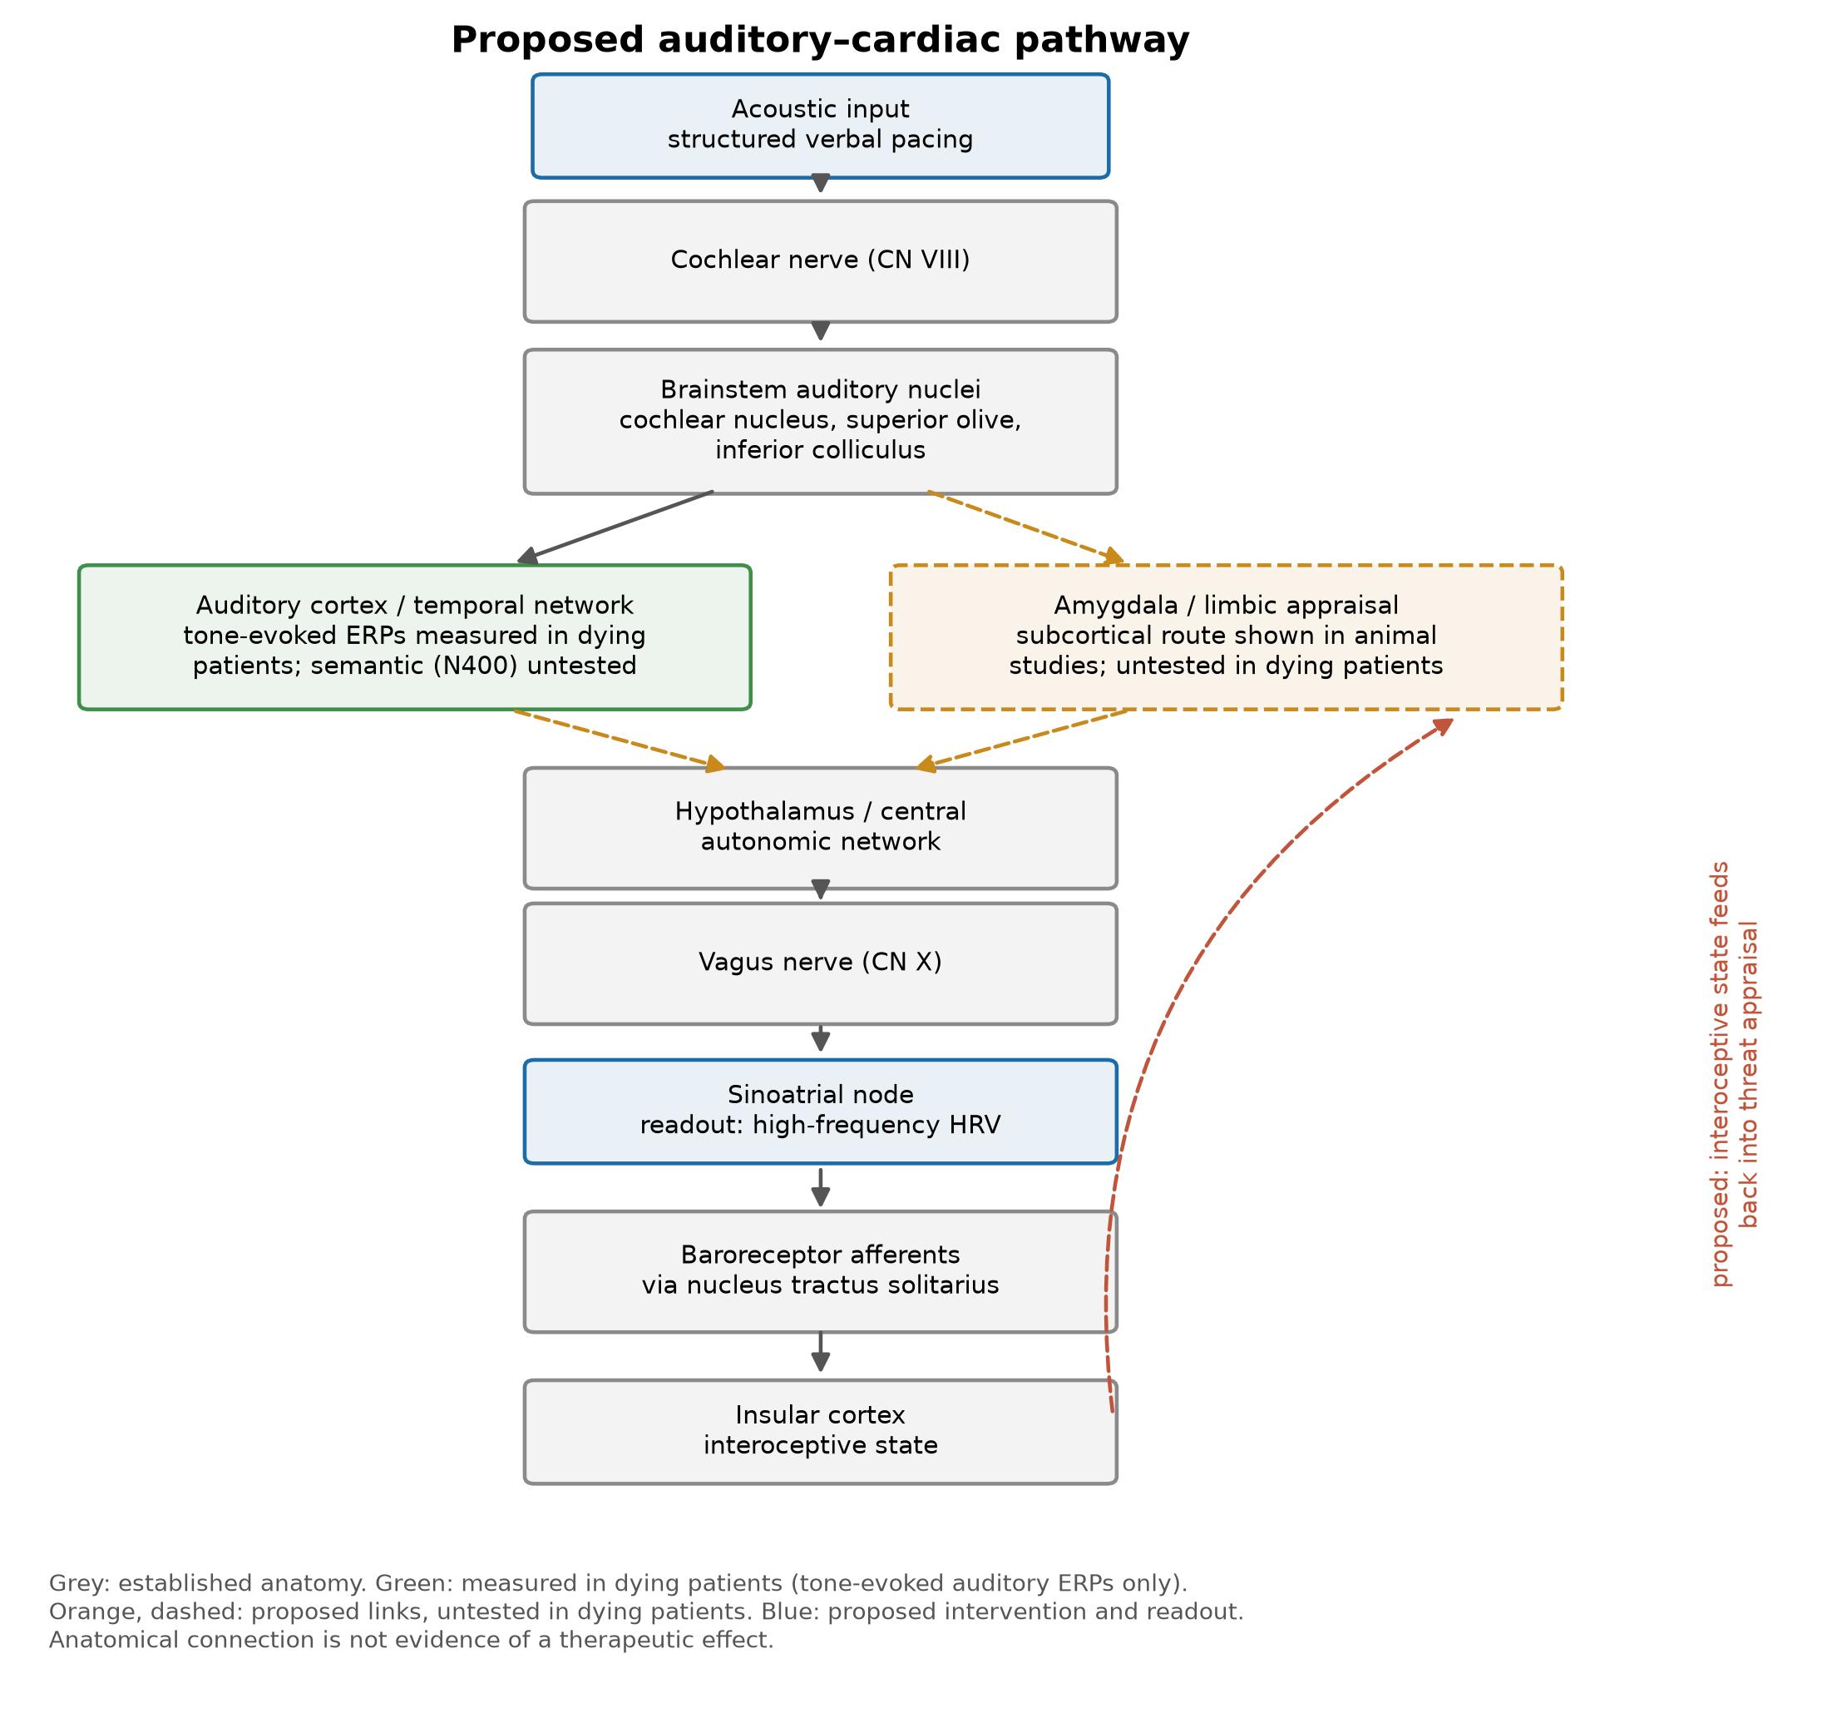
Figure 1. The proposed auditory–cardiac pathway. Grey boxes are established anatomy. Green marks the only step measured in dying patients: tone-evoked auditory event-related potentials [11]; semantic processing has not been measured in this population. Orange dashed boxes and arrows are proposed links that are untested in dying patients; the subcortical route to the amygdala is described in animal studies [10]. Blue marks the proposed intervention and the proposed readout. The red dashed limb is the proposed feedback from interoceptive state to threat appraisal. Anatomical connection is not evidence of a therapeutic effect.
5. A minimal model of the escalation loop
To ask whether the proposed loop can produce the clinical pattern, and what damping it would be worth, we analyse a deliberately minimal system. Perceived pain P is nociceptive drive N amplified by autonomic arousal A with gain g; arousal is driven by perceived pain and damped by a term V standing for the intervention; dose D is titrated toward perceived pain up to a ceiling; metabolite M accumulates as clearance declines exponentially; and once M first exceeds an illustrative model threshold M* an agitation term k_agit is added to N, which is what closes the loop. M* is a model construct, not an estimate of any neurotoxic concentration.
P = N(1 + gA), N = N₀ + k_agit·H(M − M*)
dA/dt = (a₀ + k_P·P − V − A)/τ_A, A ≥ 0
dD/dt = (min(P, D_max) − D)/τ_D
dM/dt = k_M·D − CL(t)·M, CL(t) = CL₀·exp(−t/τ_CL)
H is the unit step function. Initial conditions are A(0) = a₀, D(0) = 0 and M(0) = 0. The system is integrated by forward Euler with a step of 0.002 day over 10 days, and the crossing time is the first time at which M exceeds M*. Parameter values and units are listed in Table 1; with them, the equations above reproduce every number reported in this section.
Every parameter is illustrative. None is fitted to patient data, this is not a pharmacokinetic simulation of morphine, and no quantity below should be read as a predicted dose or survival time. The model is used only to ask what class of behaviour the loop can produce and what would have to be measured to refute it. Results are therefore reported as relative timings.
Symbol | Value | Meaning | Units
N₀ | 1 | baseline nociceptive drive | a.u.
g | 0.8 | affective gain: amplification of perceived pain by arousal | per unit arousal
a₀ | 0.3 | baseline autonomic arousal | a.u.
k_P | 0.55 | drive of arousal by perceived pain | arousal per unit pain
τ_A | 0.25 | arousal time constant | day
τ_D | 0.15 | dose-adjustment time constant | day
k_M | 1 | metabolite formation per unit dose | M units per dose unit
CL₀ | 1.6 | initial metabolite clearance | per day
τ_CL | 3 | clearance decay time constant | day
M* | 1 | illustrative model threshold | M units
k_agit | 0.9 | agitation added to N after M first exceeds M* | a.u.
D_max | 6 | dose ceiling | dose units
V | 0; 0.35; 1.5; swept 0–3 | vagal damping (no intervention; modest; maximal in Fig. 2; sweep in Fig. 2B) | arousal units
Table 1. Model parameters, all illustrative and none fitted to patient data. a.u., arbitrary units. Integration: forward Euler, step 0.002 day, 10 days.
Three results follow. First, the loop is capable of producing the clinical pattern: with the assumed parameters the threshold is crossed on day 1.04, after which dose saturates. Second, damping arousal postpones that crossing — a modest damping term delays it by 6.2 hours and lowers mean pre-threshold dose by 11%. Third, and most importantly, damping never prevents the crossing at any strength. The delay saturates at a ceiling of 34.8 hours, reached when arousal is fully suppressed; removing the affective loop altogether gives essentially the same answer (day 2.50). The benefit this hypothesis can claim is bounded, and the bound is hours to a little over a day.
These results are conditional on the assumed parameters, so each of the 11 parameters in Table 1 was scaled in turn by 0.75 and 1.25 (Table 2). Across the 22 runs the baseline crossing moved between day 0.79 and day 1.42, the delay from modest damping between 3.5 and 10.7 hours, and the ceiling between 21.0 and 50.7 hours. In no run did any damping strength prevent the crossing. The agitation term and the dose ceiling act only after the crossing and leave all three quantities unchanged. The qualitative result — a delay that is real, bounded at hours to about two days, and never a prevention — is therefore not an artefact of one parameter choice, though its size is.
Parameter | ×0.75: crossing (day) | delay (h) | ceiling (h) | ×1.25: crossing (day) | delay (h) | ceiling (h)
g | 1.26 | 7.0 | 29.7 | 0.89 | 5.1 | 38.4
a₀ | 1.10 | 7.3 | 33.5 | 1.00 | 5.3 | 36.0
k_P | 1.19 | 8.8 | 31.4 | 0.93 | 4.4 | 37.5
τ_A | 1.00 | 6.4 | 35.9 | 1.08 | 6.0 | 33.8
τ_D | 1.01 | 6.2 | 35.4 | 1.08 | 6.1 | 34.3
k_M | 1.42 | 10.7 | 50.7 | 0.84 | 4.0 | 23.8
CL₀ | 0.94 | 4.5 | 25.2 | 1.17 | 8.5 | 44.8
τ_CL | 1.01 | 5.3 | 27.8 | 1.07 | 6.9 | 42.0
M* | 0.79 | 3.5 | 21.0 | 1.32 | 9.5 | 47.1
k_agit | 1.04 | 6.2 | 34.8 | 1.04 | 6.2 | 34.8
D_max | 1.04 | 6.2 | 34.8 | 1.04 | 6.2 | 34.8
Table 2. One-at-a-time sensitivity. Each parameter is scaled by 0.75 or 1.25 with all others at the Table 1 values; the baseline case is crossing day 1.04, delay 6.2 h at V = 0.35, ceiling 34.8 h. No perturbation allows any damping strength (V swept 0–3) to prevent the crossing.
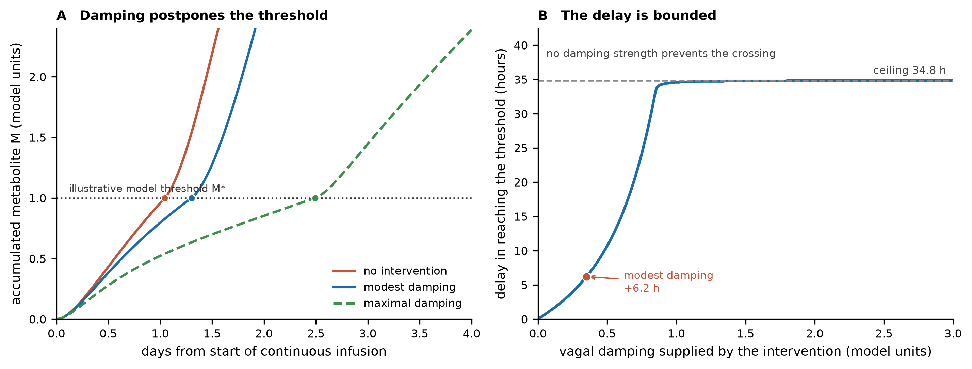
Figure 2. Behaviour of the minimal loop model. (A) Accumulated metabolite against time for no intervention, modest damping and maximal damping; the dotted line is the illustrative model threshold M*, not a neurotoxic concentration, and circles mark its crossing. (B) Delay in reaching the threshold as a function of damping strength. The delay saturates at 34.8 hours and no damping strength prevents the crossing. Parameters are illustrative throughout (Table 1); the figure shows the shape of the result, not a prediction for any patient.
That the modelled benefit is bounded is not a weakness of the proposal but the most useful thing the model says. An intervention that postpones the neurotoxic threshold by hours is worth having if those hours are lucid and the patient's family is present. An intervention sold as a way to avoid opioid escalation would be both wrong and dangerous.
6. Evidence status of each link
The argument above chains together claims of very different evidentiary standing. Table 3 assigns each a status rather than folding them into a single judgement about the hypothesis, so that a reader can locate the weak links directly.
Link | Status | Basis
Auditory information reaches brainstem structures and can evoke autonomic responses without requiring cortical processing | Demonstrated (healthy humans) | Review of brainstem and limbic responses to sound [7]
A direct auditory thalamus → amygdala route supports autonomic responses to sound | Demonstrated (animals) | Fear-conditioning circuitry [10]
Auditory ERPs to structured tone sequences persist in actively dying patients | Demonstrated | Direct measurement in hospice patients [11]
Automatic semantic processing can survive profound unresponsiveness | Demonstrated | N400 in disorders of consciousness [12]
Semantic processing persists in actively dying patients | Untested | Not measured in this population; prediction P1
Vagally mediated HRV indexes central autonomic control | Demonstrated (healthy humans) | Neurovisceral integration [9]
Hypnotic suggestion separates pain affect from pain sensation | Analogy only | ACC dissociation in healthy volunteers [14]
Hypnotic procedures reduce analgesic requirement | Analogy only | Randomised evidence in conscious sedation [16]; meta-analysis [15]
Arousal amplifies perceived pain via central sensitisation | Supported | Mechanistic review [17]
An arousal–distress loop drives a material share of terminal escalation | Proposed | This paper; prediction P2
Structured auditory input alters autonomic state in dying patients | Untested | This paper; prediction P3
That change alters opioid escalation | Untested | This paper; prediction P4
Damping postpones rather than prevents metabolite accumulation | Model result | Section 5; conditional on illustrative parameters (Tables 1–2)
A specific metabolite mediates opioid-induced neurotoxicity | Contested | Proposed [5], refuted by the same group [6]
Table 3. Status of each link in the chain. Rows 5, 10, 11 and 12 are the load-bearing untested claims and are the targets of the experimental programme in Section 7. 'Analogy only' marks evidence from conscious people that the argument does not depend on.
7. Predictions and falsification
The hypothesis is refuted by any of the following.
P1. Semantic processing in dying patients. N400 responses to semantic mismatch, recorded in actively dying patients using the paradigm already validated in disorders of consciousness, should be present in a substantial minority. If they are absent in essentially all patients while tone-based responses persist, the verbal content of the intervention is irrelevant and only prosody and familiarity could matter.
P2. An arousal component to escalation. Among patients matched for disease, site and nociceptive burden, those with lower vagally mediated heart rate variability should require larger opioid dose increments over the same interval. If dose trajectory is independent of autonomic state, the loop does not contribute materially and the proposal fails at its foundation.
P3. Auditory input moves autonomic state. Structured verbal pacing delivered to unresponsive dying patients should produce a measurable increase in high-frequency heart rate variability relative to matched acoustic control, within minutes. This is the most directly testable prediction and requires no change to any treatment.
P4. Dose trajectory. In a randomised comparison against an attention-matched control, the intervention arm should show a lower rate of dose escalation over 48 hours without any increase in observed distress scores. The model's bounded benefit means the expected effect is small; a trial powered for a large effect would fail for the wrong reason.
P5. Preserved responsiveness. If the mechanism operates, the intervention arm should retain measurable responsiveness longer. This is the outcome that matters to families and the one the hypothesis exists to serve, and it should be reported whatever the dose result.
P3 is the decisive early test. It is non-invasive, requires no protocol deviation, and would be informative whichever way it resolved.
Feasibility of P3. High-frequency heart rate variability is hard to measure in actively dying patients, and a protocol has to plan for that rather than discover it. Atrial fibrillation and frequent ectopy make short-term HRV uninterpretable, so patients in atrial fibrillation are excluded and ectopic beats are corrected or excluded by rules fixed in advance [18]. High-frequency power tracks respiratory sinus arrhythmia, so changes in breathing rate or pattern — including periodic and terminal breathing — move it independently of vagal tone; respiration must be recorded alongside the ECG and high-frequency indices interpreted only when breathing lies within the 0.15–0.40 Hz band [19]. Anticholinergics given for respiratory secretions, and opioids and sedatives themselves, alter cardiac vagal activity, so every dose is time-stamped and blocks adjacent to a bolus are excluded. Signal quality should come from ECG rather than photoplethysmography, at a sampling rate of at least 250 Hz [18], with the proportion of edited beats reported per segment and segments above a preset threshold discarded. Because the autonomic state of a dying patient drifts over hours, the comparison should be within patient: alternating short blocks of structured verbal input and a matched acoustic control, with the change in log high-frequency power or RMSSD as the outcome. The first study should report feasibility itself — the fraction of eligible patients and of recorded blocks that yield analysable data — because if that fraction is small, P3 cannot be tested in this population by this method.
8. How this proposal could cause harm
A hypothesis whose practical implication is a smaller opioid dose in dying patients carries a specific and serious risk, and enumerating it is part of the proposal rather than a caveat appended to it.
Under-treatment of pain. The principal danger is that the framework is read as a reason to withhold or delay analgesia in a patient who cannot report pain. Nothing here supports that. The proposal is adjunctive: the opioid is titrated to comfort exactly as it would otherwise be, and any reduction in requirement is an observed outcome, never a target to be pursued.
Misattribution of distress. If a patient appears calmer because arousal has been damped while nociception is unchanged, observed distress scores could fall without the underlying pain changing. This is the failure mode most likely to cause harm and is the reason P4 specifies distress scores as a safety endpoint rather than an efficacy one.
Burden on the dying and on families. Continuous verbal intervention at the bedside is not neutral. It occupies the room, may displace silence that families need, and may be experienced as intrusive by patients who cannot decline it. Consent cannot be obtained from an unresponsive patient, and advance preference should govern.
False reassurance. Presenting an unproven adjunct as a way to preserve lucidity risks families attributing an unavoidable decline to insufficient effort, or declining adequate analgesia in hope of more time. The bounded benefit in Section 5 should be communicated as a bound, not as an expectation.
Displacement of established care. Music therapy at the end of life has been systematically reviewed, with evidence judged insufficient for confident conclusions [20]. A new adjunct with weaker evidence should not compete for the same resources.
9. Relation to existing practice
Soothing speech, familiar voices and music are already part of good hospice practice, and hypnotherapy has been delivered to palliative patients for anxiety [21]. The claim here is narrower than 'sound helps'. It is that a specific, measurable autonomic pathway mediates the effect; that the relevant outcome is the trajectory of opioid requirement rather than a comfort score; and that the mechanism predicts a bounded, quantifiable benefit which can be tested and found absent. Existing practice is compatible with the hypothesis but does not test it, because it has not been paired with autonomic measurement or dose trajectory as endpoints.
10. Ethical statement
This is a conceptual hypothesis paper. No patient was studied, no data were collected, and no intervention described here has been tested in any population. Nothing in it constitutes clinical advice or a treatment recommendation, and nothing in it should delay, reduce or substitute for established palliative care, including adequate analgesia. Decisions about opioid dosing in dying patients are clinical judgements made at the bedside by those responsible for the patient. Any prospective evaluation would require research ethics approval with particular attention to consent by proxy, to the right to decline, and to safety monitoring for under-treated pain.
Declarations
Funding. This work received no external funding.
Competing interests. The author declares no competing interests.
Data availability. The model implementation, parameter set and figure generators are openly available at https://github.com/sandlerleon/auditory-cardiac-model and archived at https://doi.org/10.5281/zenodo.22860430. Running escalation_model.py followed by make_figures.py reproduces every number and figure. This manuscript is deposited at https://doi.org/10.5281/zenodo.22860432. Both are concept DOIs and resolve to the current version. The equations, initial conditions and parameter values needed to reproduce the model without the code are given in Section 5 and Tables 1–2. No patient data were generated or analysed.
Declaration of generative AI and AI-assisted technologies in the manuscript preparation process
During the preparation of this work the author used Claude (Anthropic) in order to assist with literature synthesis, implementation of the illustrative model, and drafting and editing of the text. After using this tool, the author reviewed and edited the content as needed, verified every cited reference against its source, and takes full responsibility for the content of the published article. No generative AI tool is listed as an author, and none was used to produce or alter data.
References
[1] National Institute for Health and Care Excellence. Care of dying adults in the last days of life. NICE guideline NG31. London: NICE; 2015. https://www.nice.org.uk/guidance/ng31
[2] Hodgkinson S, Ruegger J, Field-Smith A, Latchem S, Ahmedzai SH. Care of dying adults in the last days of life. Clinical Medicine 2016;16:254-258. https://doi.org/10.7861/clinmedicine.16-3-254
[3] Barnes H, McDonald J, Smallwood N, Manser R. Opioids for the palliation of refractory breathlessness in adults with advanced disease and terminal illness. Cochrane Database of Systematic Reviews 2016;(3):CD011008. https://doi.org/10.1002/14651858.cd011008.pub2
[4] Le Bihan A, Bridge S, Hedges V. Opioid-induced neurotoxicity in palliative medicine: a rapid review. BMJ Supportive & Palliative Care 2026. Published online; article spcare-2025-006002. https://doi.org/10.1136/spcare-2025-006002
[5] Smith M. Neuroexcitatory Effects Of Morphine And Hydromorphone: Evidence Implicating The 3‐Glucuronide Metabolites. Clinical and Experimental Pharmacology and Physiology 2000;27:524-528. https://doi.org/10.1046/j.1440-1681.2000.03290.x
[6] Hemstapat K, Smith SA, Monteith GR, Smith MT. The Neuroexcitatory Morphine Metabolite, Morphine‐3‐glucuronide (M3G), is not Neurotoxic in Primary Cultures of either Hippocampal or Cerebellar Granule Neurones. Pharmacology & Toxicology 2003;93:197-200. https://doi.org/10.1034/j.1600-0773.2003.930408.x
[7] Koelsch S. Brain correlates of music-evoked emotions. Nature Reviews Neuroscience 2014;15:170-180. https://doi.org/10.1038/nrn3666
[8] Benarroch EE. The Central Autonomic Network: Functional Organization, Dysfunction, and Perspective. Mayo Clinic Proceedings 1993;68:988-1001. https://doi.org/10.1016/s0025-6196(12)62272-1
[9] Thayer JF, Lane RD. Claude Bernard and the heart–brain connection: Further elaboration of a model of neurovisceral integration. Neuroscience & Biobehavioral Reviews 2009;33:81-88. https://doi.org/10.1016/j.neubiorev.2008.08.004
[10] LeDoux JE. Emotion Circuits in the Brain. Annual Review of Neuroscience 2000;23:155-184. https://doi.org/10.1146/annurev.neuro.23.1.155
[11] Blundon EG, Gallagher RE, Ward LM. Electrophysiological evidence of preserved hearing at the end of life. Scientific Reports 2020;10:10336. https://doi.org/10.1038/s41598-020-67234-9
[12] Steppacher I, Eickhoff S, Jordanov T, Kaps M, Witzke W, Kissler J. N400 predicts recovery from disorders of consciousness. Annals of Neurology 2013;73:594-602. https://doi.org/10.1002/ana.23835
[13] Critchley HD, Wiens S, Rotshtein P, Öhman A, Dolan RJ. Neural systems supporting interoceptive awareness. Nature Neuroscience 2004;7:189-195. https://doi.org/10.1038/nn1176
[14] Rainville P, Duncan GH, Price DD, Carrier B, Bushnell MC. Pain Affect Encoded in Human Anterior Cingulate But Not Somatosensory Cortex. Science 1997;277:968-971. https://doi.org/10.1126/science.277.5328.968
[15] Montgomery GH, Duhamel KN, Redd WH. A meta-analysis of hypnotically induced analgesia: How effective is hypnosis? International Journal of Clinical and Experimental Hypnosis 2000;48:138-153. https://doi.org/10.1080/00207140008410045
[16] Faymonville EM, Mambourg HP, Joris J, Vrijens B, Fissette J, Albert A, et al. Psychological approaches during conscious sedation. Hypnosis versus stress reducing strategies: a prospective randomized study. Pain 1997;73:361-367. https://doi.org/10.1016/s0304-3959(97)00122-x
[17] Woolf CJ. Central sensitization: Implications for the diagnosis and treatment of pain. Pain 2011;152:S2-S15. https://doi.org/10.1016/j.pain.2010.09.030
[18] Task Force of the European Society of Cardiology and the North American Society of Pacing and Electrophysiology. Heart rate variability: standards of measurement, physiological interpretation and clinical use. Circulation 1996;93:1043-1065. https://doi.org/10.1161/01.cir.93.5.1043
[19] Laborde S, Mosley E, Thayer JF. Heart Rate Variability and Cardiac Vagal Tone in Psychophysiological Research – Recommendations for Experiment Planning, Data Analysis, and Data Reporting. Frontiers in Psychology 2017;8:213. https://doi.org/10.3389/fpsyg.2017.00213
[20] Bradt J, Dileo C. Music therapy for end-of-life care. Cochrane Database of Systematic Reviews 2014;(3):CD007169. https://doi.org/10.1002/14651858.cd007169.pub3
[21] Plaskota M, Lucas C, Evans R, Pizzoferro K, Saini T, Cook K. A hypnotherapy intervention for the treatment of anxiety in patients with cancer receiving palliative care. International Journal of Palliative Nursing 2012;18:69-75. https://doi.org/10.12968/ijpn.2012.18.2.69

