Thermally Gated Autocatalytic Kinetics in Flowing Media
A non-linear mechanism for spatially and temporally separated phase transformation

Author: Leon Sandler, Independent Researcher
Date: August 2026
Target journal: npj Thermal Science and Engineering (Nature Portfolio, open access)
Article type: Theoretical / computational study. Primary evidence is mathematical and numerical, not experimental.

Scope and Positioning
This paper makes a theoretical and computational contribution to the control and management of heat-triggered phase transformation in flowing media: it formulates a coupled thermal-gating / autocatalytic-reaction model, analyzes its parameter space computationally, and derives falsifiable, quantitative predictions. It does not report laboratory measurements, and no result below should be read as experimental validation of any specific material system. All parameter values are literature-informed illustrative choices, stated explicitly wherever used, and are labeled throughout as Established (from cited literature), Computed (produced by the model in this paper), or Predicted (falsifiable but currently unverified).
A single motivating application — a nested-emulsion embodiment for downhole particle formation, in which a wax-encapsulated catalyst is thermally released into a curable resin — supplies illustrative parameter ranges and a concrete target window; it is treated here strictly as one candidate realization of a general thermal-kinetic coupling, not as a validated technology. The paper's contribution is the coupling and its consequences for thermal management of reactive flowing media generally — relevant to phase-change thermal storage, thermally triggered reactive transport, and self-healing or set-on-demand materials — not a specific downhole product.

Abstract
Delayed transformation of a flowing reactive material into a solid phase is limited, in most existing thermal-management approaches, by a basic trade-off: reaction mechanisms fast enough to complete transformation in a practical window also tend to permit some conversion during transport, because conversion begins gradually from the moment of mixing under monotonic heat accumulation rather than being withheld until a defined thermal threshold is crossed. We formulate and computationally analyze a coupled model in which a discrete thermal gate, H(T − T_melt), controls release of a reaction-triggering species into an autocatalytic (Kamal–Sourour) cure reaction, and ask whether the coupling is predicted to produce a sharper, more controllable separation between a stable transport regime and a rapidly solidifying regime than either mechanism achieves alone. A full 2×2 computational comparison across gated/ungated and autocatalytic/first-order kinetics predicts that the coupled system uniquely minimizes premature conversion during a nominal 25-minute transport period (α ≈ 0.09) while achieving the sharpest transition of the four cases (S = 1.84); the conventional (ungated, first-order) baseline is predicted to reach α ≈ 0.88 with S ≈ 20.6 under the same conditions. A dimensionless coupling ratio, Λ = τ_release/τ_cure — analogous to a Damköhler number for this thermally gated reactive-transport problem — organizes the parameter space and reveals that predicted transition sharpness and absolute transformation time can diverge at large Λ, meaning a favorable relative sharpness metric alone does not guarantee the transformation completes within a practical absolute time. Monte Carlo propagation of joint parameter uncertainty indicates the reaction-kinetics parameters, not the thermal trigger, dominate predicted performance variability under the illustrative ranges used. A non-ideal (finite-width) thermal gate is also analyzed, predicting that a broader activation range reduces premature conversion at the cost of slower completion — a quantifiable trade-off relevant to real phase-change materials with a melting range rather than a sharp transition point. Three falsifiable predictions, each paired with a standard dynamic-DSC or rheo-DSC validation protocol, are stated for future experimental testing.

1. Introduction
Controlling when and how quickly a flowing reactive material transforms into a solid phase is a recurring problem in thermal management: thermal energy storage systems that rely on phase-change or reactive materials, adaptive-rheology fluids, microfluidic thermal switches, and self-healing or set-on-demand conduits all require a material that remains stable and mobile under one set of thermal conditions and then transforms predictably under another. In each case, the practical requirement is the same — spatial and temporal separation between a transport state and a transformation state — and the same trade-off recurs: reaction or phase-change mechanisms fast enough to complete transformation in a useful time window also tend to proceed at some rate during transport, since a simple Arrhenius-accelerated or diffusion-limited process begins converting continuously and monotonically with heat accumulation from the moment conditions allow it, rather than being withheld until a defined threshold.
This paper asks a narrower, mechanistic question: can coupling two independently tunable non-linear processes — a thermally gated release of a reaction-triggering species, and an autocatalytic (self-accelerating) reaction once triggered — produce a sharper practical separation between a stable transport regime and a rapidly, predictably transforming regime than either mechanism achieves alone? Thermal gating alone (a step-like release keyed to a threshold temperature) controls only when a reaction can start; Arrhenius-type thermal acceleration alone controls only how fast a reaction proceeds once started, and does so continuously rather than with a delay. Neither, on its own, guarantees both a quiescent transport period and a rapid, complete transformation afterward. We formulate the coupled kinetics explicitly (Section 2), analyze the resulting parameter space computationally (Section 3), and compare the full coupled system against all three reduced control cases — gating without autocatalysis, autocatalysis without gating, and the conventional ungated first-order baseline — to isolate what each mechanism contributes and to test whether the coupling is genuinely synergistic rather than merely additive.
A single physical embodiment motivates the parameter choices used throughout: a nested emulsion (referred to here as the motivating system) in which a wax-encapsulated curing catalyst is released, upon reaching a target temperature, into a filled epoxy resin, intended to convert a pumpable fluid into discrete solid particles after placement in a subsurface thermal environment. This system supplies a concrete design target (a 25–75 minute transformation window) and literature-informed illustrative kinetic parameters, but is treated throughout as one candidate realization of the general coupling — the analysis and its conclusions are intended to generalize to any thermally gated, autocatalytically reactive flowing medium.

1.1 Novelty
Neither component mechanism is new: thermally triggered release of an encapsulated active species is established practice in latent-cure and controlled-release chemistry, and autocatalytic cure kinetics of the Kamal–Sourour form are a well-documented feature of many thermoset systems. The novel contribution of this paper is the explicit coupled dynamical framework linking the two — formulated as a single gated ODE with a dimensionless coupling parameter Λ (Section 2.2) — together with the predicted regime structure that follows from it: a synergistic (not merely additive) suppression of premature conversion (Section 3.3), a divergence between relative transition sharpness and absolute completion time at large Λ (Section 3.7), and a quantified trade-off between gate sharpness and completion speed for non-ideal (finite-width) thermal gates (Section 3.8). These regime predictions, and the design heuristics that follow from them, have not to our knowledge been previously derived for this class of coupled thermal-gating/autocatalytic-kinetics problem.

2. Theoretical Framework

2.1 Coupled kinetics
Reaction/phase-transformation conversion α ∈ [0,1] is governed by a Kamal–Sourour autocatalytic law (Kamal & Sourour, 1973) [Established], gated by a time- and temperature-dependent species-availability factor C(t,T) [Computed — this coupling is the paper's formulation]:
dα/dt = C(t,T) · (k₁(T) + k₂(T)·α^m)(1−α)^n,
with rate constants following Arrhenius temperature dependence, k_i(T) = A_i exp(−Ea_i/RT) [Established form; illustrative constants], and species availability governed by a thermal gate at threshold temperature T_melt with first-order release kinetics after the gate opens:
C(t,T) = H(T−T_melt) · [1 − exp(−t/τ_release)]
for an idealized (step-function) gate, generalized in Section 3.8 to a finite-width logistic gate G(T) = [1+exp(−(T−T_melt)/w)]⁻¹ to represent a realistic activation range (e.g., the melting range of a real phase-change material) rather than a single sharp transition temperature. Two reduced cases isolate each mechanism: setting C ≡ 1 removes the gate (species instantly available, as in a conventional thermally accelerated reaction); setting m = 0 removes the autocatalytic acceleration (first-order kinetics once triggered).

2.2 Dimensionless coupling parameter
A single dimensionless group organizes the parameter space: Λ = τ_release/τ_cure, where τ_cure = 1/k₂(T) is the characteristic autocatalytic timescale at the operating temperature. This plays a role directly analogous to a Damköhler number in reactive-flow problems, or a Fourier number in transient conduction: it compares a species-transport/release timescale against a reaction timescale, and its value determines which process is rate-limiting. Λ ≪ 1 corresponds to release that is fast relative to reaction (the gate opens functionally before the reaction proceeds significantly); Λ ≈ 1 corresponds to strong coupling between the two processes; Λ ≫ 1 corresponds to release becoming rate-limiting (Section 3.7).

2.3 Transition-sharpness measure
To compare how abruptly different mechanisms transition from low to high conversion, independent of absolute timescale, we define S = (t₉₀ − t₁₀)/t₁₀, where t₁₀ and t₉₀ are times to 10% and 90% conversion. Smaller S indicates a sharper, more switch-like transition relative to its own onset time. Section 3.7 shows this relative measure must be interpreted alongside the absolute time t₉₀, since the two can diverge.

2.4 Thermal transport assumption: isothermal limit
The model integrates the reaction kinetics at a fixed operating temperature reached instantaneously at t=0, rather than resolving a coupled heat-transfer problem. This isothermal treatment is the limiting case of a lumped thermal-capacitance description of the flowing medium,
ρ c_p dT/dt = hA(T∞ − T),
in which the thermal relaxation time of the fluid element (set by the Biot and Fourier numbers of the flow) is short compared to τ_release and τ_cure — formally, Fo ≫ 1 or Bi ≪ 1 for the relevant length scale, so that internal and boundary-layer temperature gradients equilibrate rapidly relative to the reaction-controlled timescales that are this paper's focus. Where this separation of timescales does not hold (e.g., large flow channels, poor thermal contact, or rapid transients), the gate-opening dynamics in Section 3.1 would be modulated by the thermal relaxation itself, coupling T(t) to the lumped equation above rather than treating it as a step input; this coupled-transport extension is identified as a specific direction for follow-on work and is not developed here.

3. Computational Methods and Results
The coupled ODE (Section 2.1) was integrated numerically (explicit Euler, dt = 0.02 min, t ∈ [0, 150] min) across the parameter sweeps below [Computed]. Kinetic prefactors and activation energies (A1 = 2.0×10³, Ea1 = 50 kJ/mol; A2 = 2.5×10⁷, Ea2 = 65 kJ/mol; m = 1.0, n = 1.5) are illustrative, literature-informed values giving representative autocatalytic-epoxy timescales (k2 ≈ 0.15 min⁻¹ near 140°C) [Established order of magnitude; not fitted to any measured system]. All code and parameters are available for reuse with measured values (Section 5.5).

3.1 Result 1: Thermal gating is predicted to produce an induction regime
Integrating the model at fixed T_melt = 118°C across a range of operating temperatures reproduces the qualitative behavior expected from the model structure: below T_melt, conversion is predicted to remain at zero indefinitely; above it, conversion is predicted to follow a sigmoidal curve whose onset time and steepness both decrease with increasing temperature, from the combined effect of gate-opening kinetics and Arrhenius acceleration (Figure 1) [Computed].
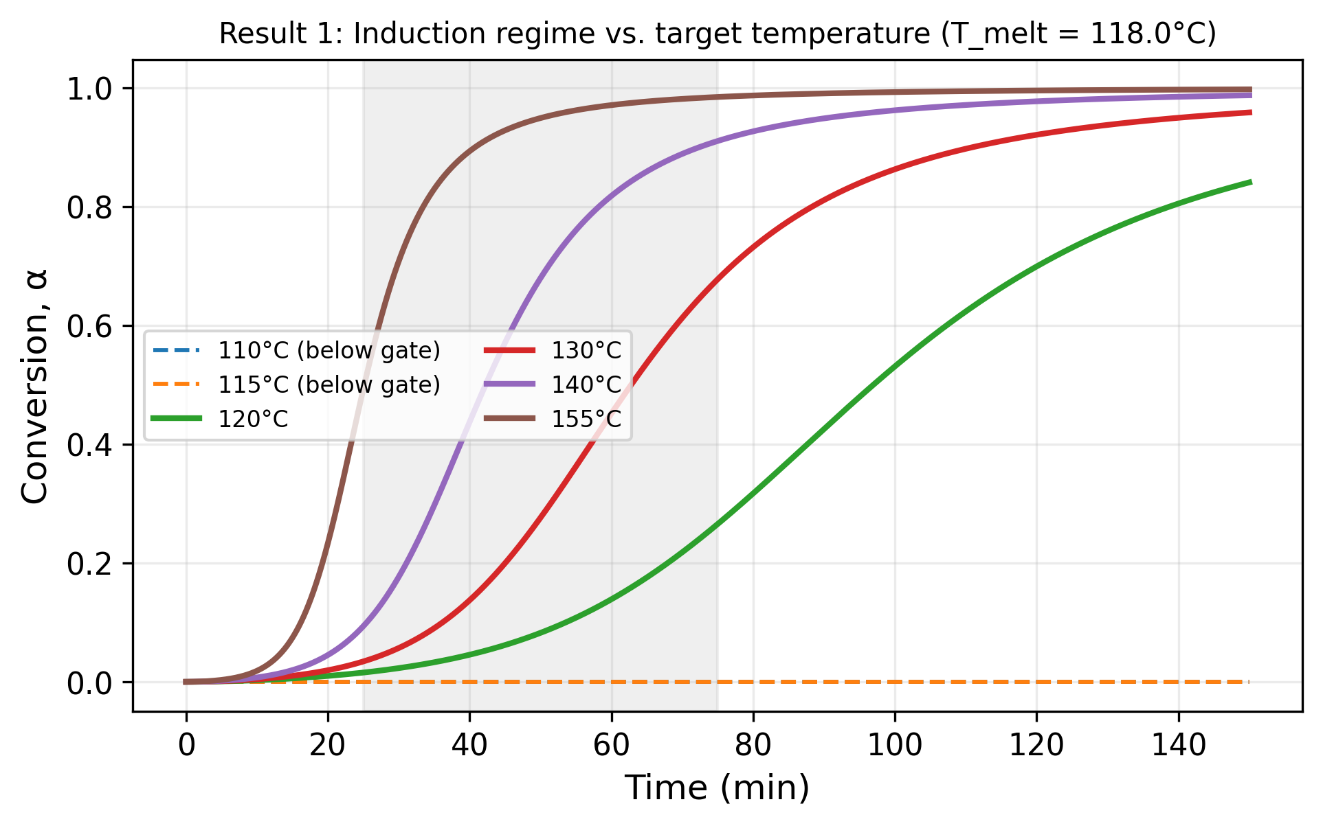
Figure 1. Conversion vs. time at six operating temperatures spanning T_melt = 118°C. Model prediction; illustrative parameters.

3.2 Result 2: Autocatalysis is predicted to sharpen the transition beyond gating alone
Holding the thermal gate fixed and comparing the autocatalytic model against a first-order control calibrated to a comparable rate constant, the model predicts a substantially sharper transition for the autocatalytic case: S = 1.84 versus S = 6.72 at 140°C (Figure 2) [Computed] — a ≈ 3.6-fold reduction in relative transition width. This isolates the autocatalytic form's own predicted contribution: because its rate depends on α^m starting from α ≈ 0, it is intrinsically slow to start and then self-accelerates, independent of the thermal gate.
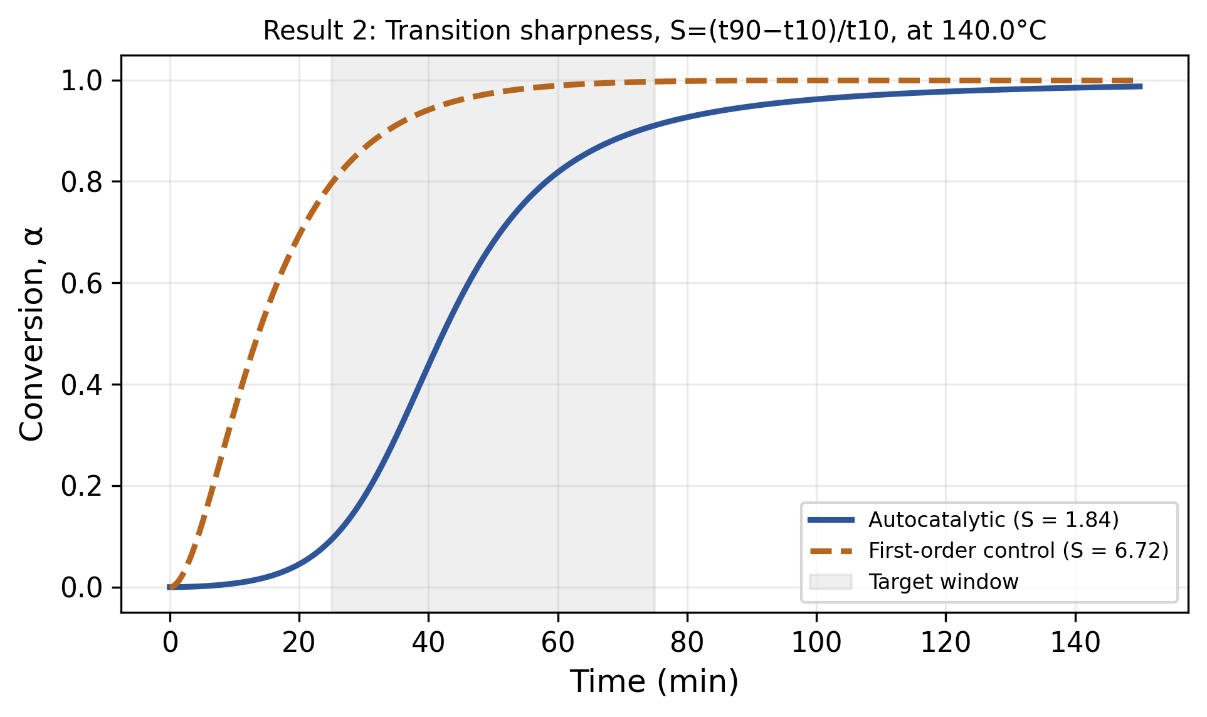
Figure 2. Autocatalytic vs. first-order conversion under an identical thermal gate at 140°C. S = (t90−t10)/t10; lower is sharper.

3.3 Result 3: A complete 2×2 control-system comparison
Four systems were compared under matched conditions: (A) no gate, autocatalytic; (B) gate, first-order; (C) gate, autocatalytic (the full coupled model); (D) no gate, first-order (the conventional thermally accelerated baseline). Conversion at a nominal 25-minute transport time, and sharpness S, were computed for each (Figure 3; Table 1) [Computed].
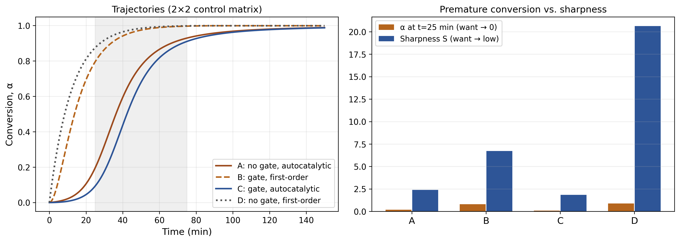
Figure 3. Left: conversion trajectories, systems A–D. Right: conversion at t = 25 min (premature-conversion risk) and sharpness S for each.
System | α at t = 25 min | Sharpness S
A: no gate, autocatalytic | 0.197 | 2.39
B: gate, first-order | 0.796 | 6.72
C: gate, autocatalytic (full model) | 0.094 | 1.84
D: no gate, first-order (conventional baseline) | 0.875 | 20.63
The model predicts that System C dominates all others on both metrics simultaneously, while System D, the conventional ungated first-order baseline, is predicted to be worst on both. The predicted ranking is not simply additive: System B (gate alone, first-order) is predicted to perform worse on premature conversion than System A (autocatalysis alone, no gate), because a first-order reaction has no intrinsic induction period — conversion is predicted to rise smoothly once triggered — whereas the autocatalytic form is predicted to be intrinsically slow to start even without a gate. This indicates that gating and autocatalysis are predicted to suppress premature conversion through distinct mechanisms (control of species availability, versus an intrinsic reaction-order delay) that combine synergistically rather than redundantly; this is the paper's central mechanistic prediction.

3.4 Result 4: Release timescale and a dimensionless design map
Sweeping the release time constant τ_release at three levels of autocatalytic strength shows a monotonic relationship between τ_release and time-to-90%-conversion (Figure 4) [Computed], and mapping this across Λ and normalized autocatalytic strength (Figure 5) shows the region satisfying a representative 75-minute boundary forms a broad, contiguous band rather than an isolated point — favorable for practical tolerance, since multiple parameter combinations reach a comparable target time.
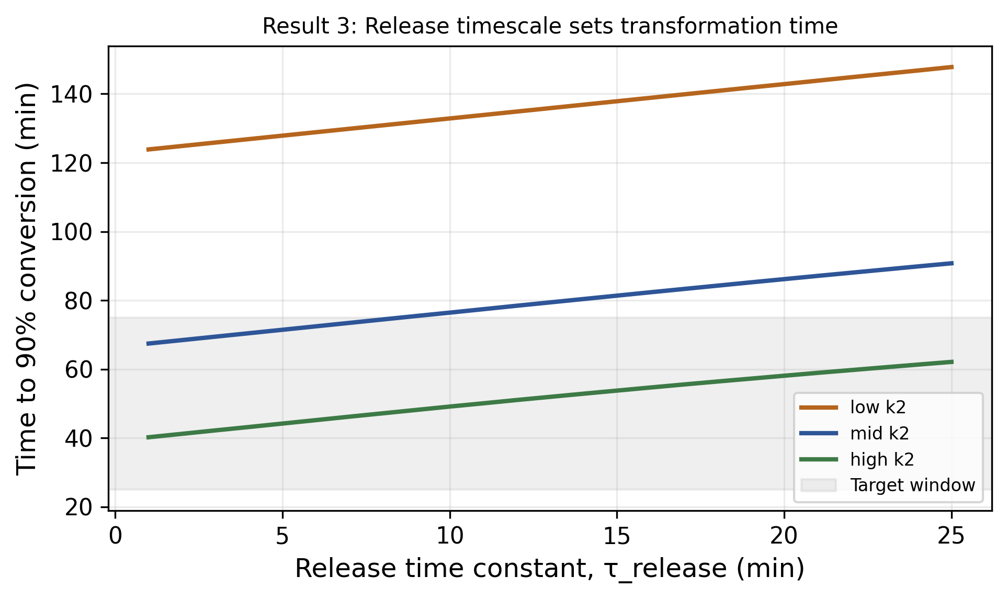
Figure 4. Time to 90% conversion vs. release time constant, at three levels of autocatalytic strength.
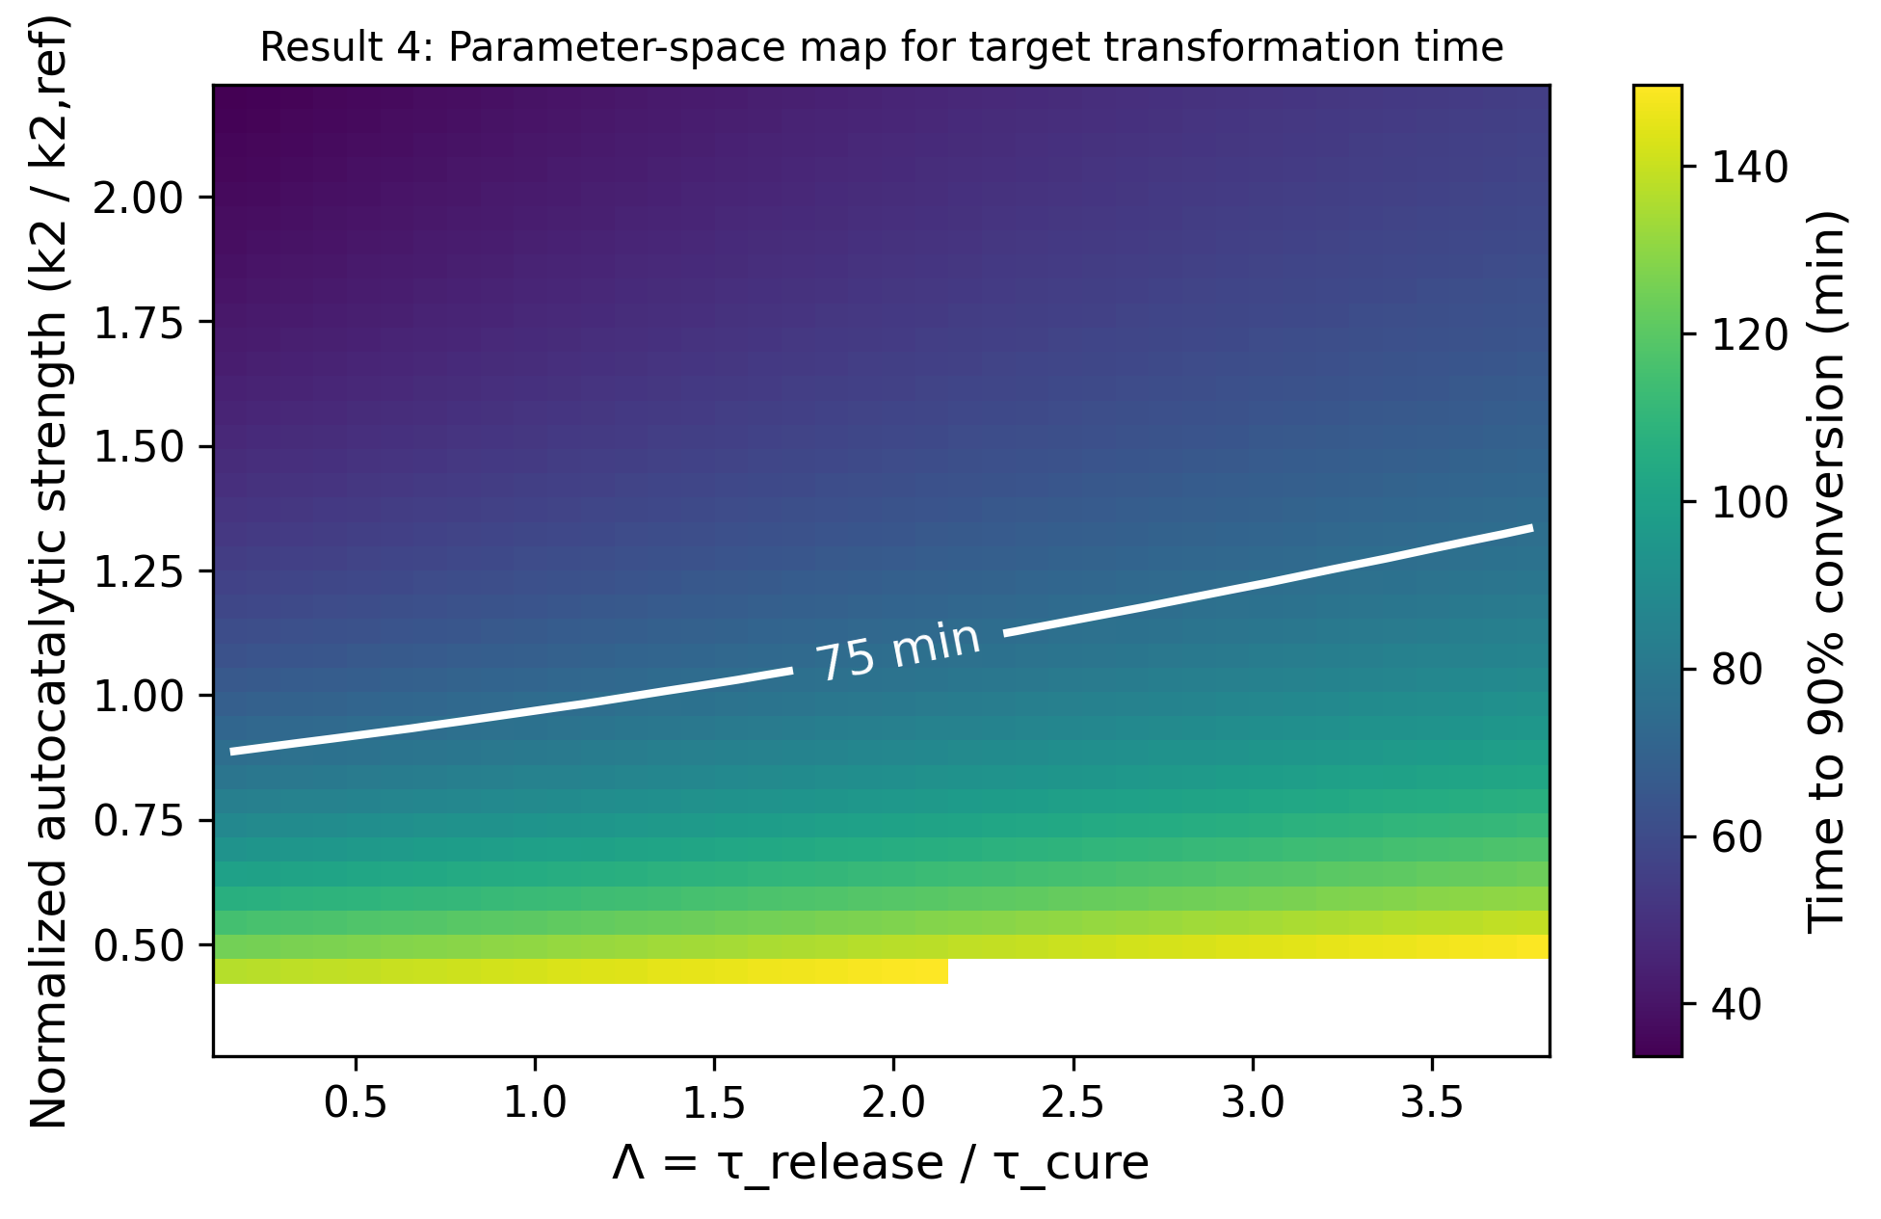
Figure 5. Time to 90% conversion across Λ and normalized autocatalytic strength. White contour marks the 75-minute boundary.

3.5 Result 5: Robustness under parameter uncertainty (Monte Carlo)
To test how sensitive the predicted transformation window is to joint uncertainty across all kinetic and release parameters simultaneously (rather than one at a time, as in Sections 3.1–3.4), parameter uncertainty was propagated using Monte Carlo sampling (N = 20,000 draws) over literature-informed, pre-experimental ranges for k1, k2_max, m, n, the melt-point offset, and τ_release [Computed]. Under these ranges, only 40.4% of draws satisfy both a minimum induction time (t₁₀ ≥ 5 min) and completion within the 75-minute target (median t₉₀ = 77.1 min, interquartile range 57–102 min), indicating the illustrative parameter ranges used are wide relative to the target window rather than pre-tuned to satisfy it (Figure 6, left). Sensitivity analysis (Spearman rank correlation with t₉₀) shows the autocatalytic rate constant k2_max and reaction-order exponents m, n dominate the predicted variance (|r| = 0.39–0.58), while the release time constant and melt-point offset contribute comparatively little (|r| ≤ 0.08) (Figure 6, right) [Computed]. This is consistent with the single-parameter sweeps of Sections 3.1–3.4 and indicates that, at least under these illustrative ranges, uncertainty in the reaction kinetics — not the thermal trigger — is predicted to dominate practical performance variability, which would argue for prioritizing kinetic characterization (e.g., dynamic DSC) over trigger-material tightening in an experimental program.
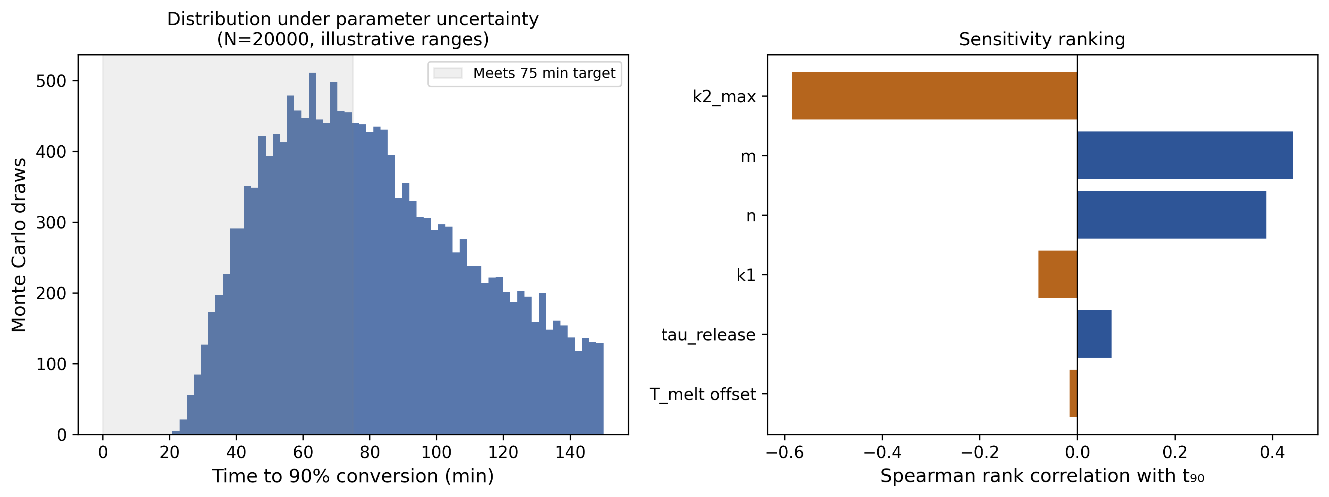
Figure 6. Left: distribution of predicted time-to-90%-conversion under joint parameter uncertainty. Right: sensitivity ranking by Spearman rank correlation with t90.

3.7 Result 7: Relative sharpness and absolute timing diverge at large Λ
Sweeping τ_release over a wide range (Λ from ≈ 0.08 to ≈ 12) at fixed autocatalytic strength reveals a finding not assumed in advance: the relative sharpness measure S decreases monotonically with Λ over this entire range (from S ≈ 2.4 at Λ ≈ 0.1 to S ≈ 1.1 at Λ ≈ 12), while the absolute time to 90% conversion, t₉₀, increases essentially linearly with Λ and exceeds the 75-minute target already beyond Λ ≈ 1.3 (Figure 7) [Computed]. In other words, the model predicts a system can have an arbitrarily favorable relative sharpness while still being far too slow in absolute terms once release is rate-limiting. This is a substantive refinement of the paper's initial hypothesis: Λ alone does not predict practical performance, and neither does S alone — both must be evaluated jointly, with S constraining transition quality and t₉₀ (or an absolute-time criterion) constraining practical usability. This yields a specific, falsifiable prediction (Section 4.2, Prediction 3).
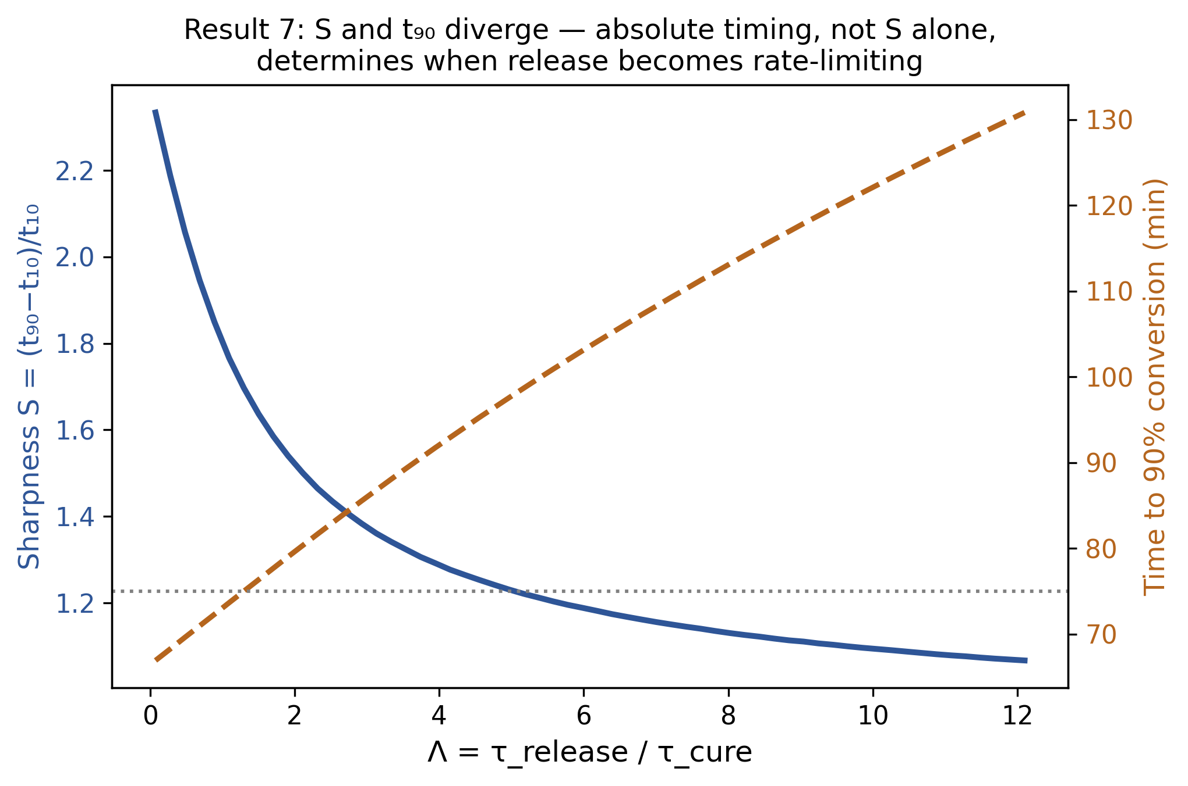
Figure 7. Sharpness S (left axis) and time-to-90%-conversion (right axis) vs. Λ. The two measures diverge: S continues improving while t90 exceeds the target window.

3.8 Result 8: A realistic (finite-width) thermal gate trades premature conversion against completion time
Real phase-change and thermally responsive materials activate over a finite temperature range rather than at a single sharp point. Replacing the ideal step gate with a logistic gate of width w and sweeping w at fixed operating-temperature offset (T_target − T_melt = 22°C) predicts that increasing gate width reduces premature conversion (α at t=25 min falls from 0.094 at w=0°C to 0.056 at w=15°C) but increases time to 90% conversion (from 72.4 to 87.8 min over the same range) (Figure 8) [Computed]. This occurs because a broad activation range, evaluated at a fixed operating-temperature offset, does not fully saturate species availability, reducing both premature leakage and the ultimate reaction rate. This is a direct, quantifiable design trade-off relevant to any real material with a distributed rather than sharp activation temperature, and argues for characterizing the full activation-temperature distribution of a candidate material, not just its nominal onset, when targeting a specific transformation window.
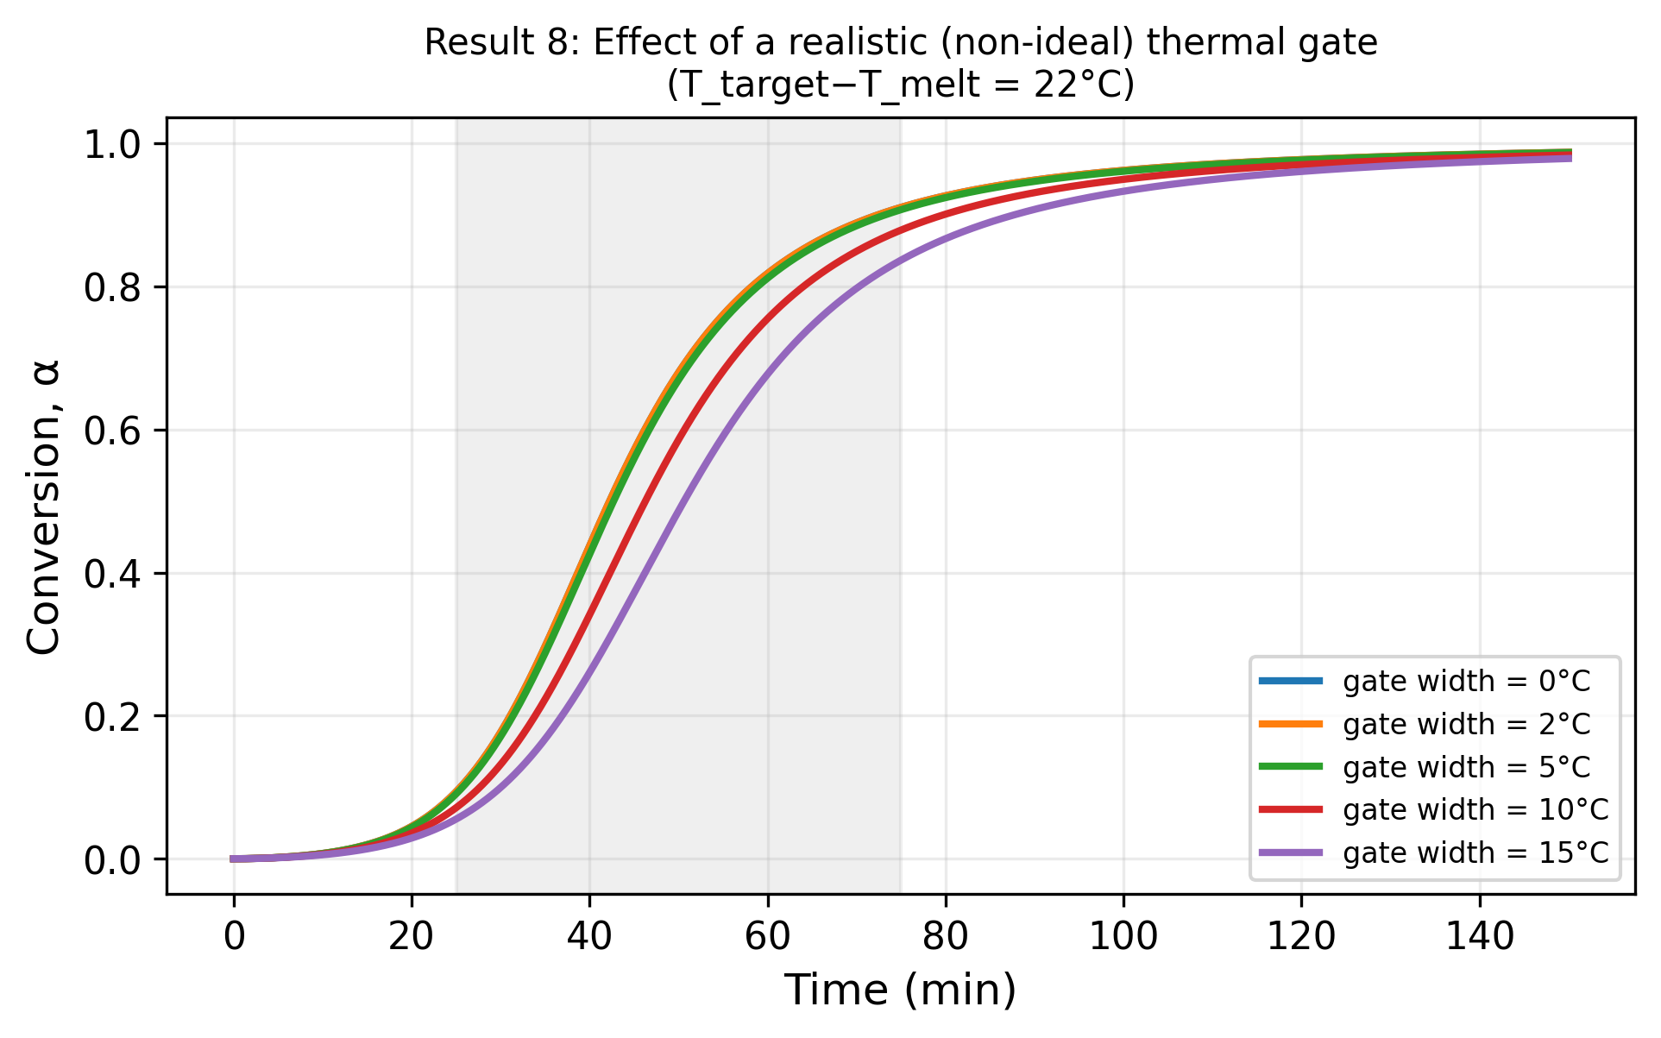
Figure 8. Conversion vs. time for five thermal-gate widths at a fixed 22°C operating-temperature offset above the nominal threshold.

3.9 Note on mechanical-function extensions
For applications where the transformed phase must also bear mechanical load (e.g., the motivating particle-formation application), the conversion kinetics developed here can in principle be coupled to a micromechanical strength model (e.g., a porosity–strength scaling such as Ryshkewitch–Duckworth (Ryshkewitch, 1953)) to predict a conversion–strength relationship. This extension is outside the thermal-transport scope of the present paper and is noted here only as a direction for follow-on, application-specific work; it is not developed or evaluated in this manuscript.

4. Discussion
The central computational finding (Section 3.3) is that thermal gating and autocatalytic kinetics are complementary, not redundant: each suppresses premature conversion through a distinct mechanism, and their combination outperforms either alone, or the conventional ungated first-order baseline, on both premature-conversion suppression and transition sharpness simultaneously. This is a general statement about the coupled kinetic structure and should transfer to other thermally gated, autocatalytically reactive systems regardless of the specific chemistry — phase-change thermal storage materials, thermally triggered reactive coatings, or set-on-demand structural materials, among others.
The dimensionless parameter Λ, analogous to a Damköhler or Fourier number for this problem, organizes the design space into a broad, contiguous feasible region (Section 3.4) rather than a narrow optimum, which is favorable for manufacturing tolerance. However, Section 3.7's finding that S and t₉₀ diverge at large Λ is an important qualification: Λ and S together are necessary but not sufficient design criteria, and an absolute-time constraint must be imposed independently. Section 3.8 adds a second qualification specific to real materials: a non-ideal, finite-width thermal gate trades reduced premature conversion against slower completion, meaning the common practice of characterizing a phase-change or latent-catalyst material by a single nominal activation temperature is insufficient for this class of design problem — the width of the activation range is an independent, consequential design parameter.

4.1 Limitations
- All kinetic parameters are illustrative and literature-informed, not fitted to any measured system; quantitative timing predictions should not be treated as specific performance claims for any real material.
- The model treats the target temperature as reached instantaneously (isothermal after t=0); a real transient thermal history (conductive/convective ramping, spatial temperature gradients in a flowing medium) is not modeled and could materially shift results, particularly near the gate threshold.
- The mechanical-function extension (Section 3.9) is noted but not developed; this paper's scope is the thermal/kinetic coupling only.
- The single-particle, well-mixed treatment does not capture spatial heterogeneity in a real flowing medium (e.g., radial temperature or concentration gradients in a pipe or channel flow).

4.2 Falsifiable predictions and validation protocols
The model makes three specific, testable predictions, each paired with a standard thermal-analysis validation protocol:
- Prediction 1: Conversion should remain near zero (below a few percent) throughout an isothermal hold at any temperature below the activation threshold, for holds of at least several times the expected transport duration. Validation protocol: isothermal differential scanning calorimetry (DSC) hold at the transport temperature, heat-flow integrated to conversion, over a duration several-fold longer than the intended transport time.
- Prediction 2: Once the activation threshold is exceeded, conversion should follow a measurably sharper (lower-S) transition than a first-order or diffusion-controlled reference reaction subject to the same thermal-gate protocol. Validation protocol: dynamic-ramp DSC across the activation range, compared against a non-gated or non-autocatalytic reference formulation run under an identical thermal protocol; rheo-DSC to additionally capture the viscoelastic (fluid-to-solid) transition threshold directly relevant to flow behavior.
- Prediction 3: Increasing the release timescale relative to the reaction timescale (Λ) beyond a system-specific threshold will cause the absolute transformation time to exceed a practical target window even as the relative sharpness measure S continues to appear favorable — i.e., S alone is an insufficient screening criterion. Validation protocol: a τ_release sweep (via systematic variation of the encapsulation/barrier thickness or permeability in the motivating material system) with paired measurement of both S and absolute time-to-90%-conversion by dynamic DSC.
These predictions remain experimentally unvalidated. Their confirmation or falsification would directly test the mechanistic hypothesis independent of any specific motivating material system.

5. Computational Methods

5.1 Numerical integration
The governing ODE (Section 2.1) was integrated using explicit Euler stepping, dt = 0.02 min, t ∈ [0, 150] min; conversion was clipped to [0, 0.999] to avoid numerical singularities in the (1−α)^n term. Crossing times (t10, t50, t90) were extracted as the first time step at which α exceeded the respective threshold.

5.2 Parameter sweeps
Section 3.4 swept τ_release ∈ [1, 25] min at three fixed autocatalytic-rate levels, and a 40×40 grid over τ_release ∈ [1, 25] min and normalized k2 ∈ [0.3, 2.2]× reference for the Λ map. Section 3.7 swept τ_release ∈ [0.5, 80] min at fixed k2 to resolve the S/t90 divergence. Section 3.8 swept logistic gate width w ∈ {0, 2, 5, 10, 15}°C at fixed T_target − T_melt = 22°C.

5.3 Control-system comparison (Section 3.3)
System A used the full autocatalytic model with the gate threshold set far below any simulated temperature (T_melt = −50°C, τ_release = 0.01 min), approximating instantaneous species availability. Systems B and D used m = 0 (first-order kinetics) with a rate constant set to 55% of the reference autocatalytic k2 for broad visual/timescale comparability; the qualitative ranking among systems is not sensitive to this specific scaling choice.

5.4 Realistic thermal gate (Section 3.8)
The step gate H(T−T_melt) was replaced with a logistic function G(T) = [1+exp(−(T−T_melt)/w)]⁻¹, recovering the ideal step as w → 0; G(T) sets the asymptotic (saturating) species-availability level rather than a binary on/off state.

5.5 Data and code availability
The complete integration, sweep, and Monte Carlo code used to generate every figure and numerical result in this paper is provided in full as Supplementary Code 1. All parameter values are specified as named constants at the top of the script for reproducibility and for substitution with measured values. [Author action required before submission: deposit Supplementary Code 1 in a public GitHub repository, mint a version-of-record DOI via Zenodo, and insert the resulting DOI here, per Nature Portfolio's code-availability requirements for code central to a paper's claims.]

References
- Kamal, M.R.; Sourour, S. Kinetics and thermal characterization of thermoset cure. Polymer Engineering & Science 1973, 13(1), 59–64. https://doi.org/10.1002/pen.760130110
- Bashir, M.A. Cure Kinetics of Commercial Epoxy-Amine Products with Iso-Conversional Methods. Coatings 2023, 13(3), 592. https://doi.org/10.3390/coatings13030592
- Ryshkewitch, E. Compression Strength of Porous Sintered Alumina and Zirconia. Journal of the American Ceramic Society 1953, 36(2), 65–68.
- Zhang, B.; Zhao, Y.; Sun, X.; Fei, X.; Wei, W.; Li, X.; Liu, X. Microcapsules derived from Pickering emulsions as thermal latent curing accelerator for epoxy resins. Journal of Industrial and Engineering Chemistry 2020, 83, 224–234. https://doi.org/10.1016/j.jiec.2019.11.032
- Gou, H.; Zhang, B.; Wei, W.; Fei, X.; Li, X.; Liu, X. Triphenylphosphine-containing microcapsules fabricated from Pickering emulsions as a thermal latent curing accelerator for an epoxy/anhydride system. Polymer International 2021, 70(12), 1680–1691. https://doi.org/10.1002/pi.6265

