Coupled Thermal Activation and Autocatalytic Cure Kinetics: A Theoretical and Computational Study of Delayed Reactive Transformation
Leon Sandler
Independent Researcher, Northbrook, Illinois, USA
sandler.leon@gmail.com
Preprint server: ChemRxiv Target journal: Macromolecular Theory and Simulations (Wiley)
Article type: Theoretical/computational study. The primary evidence is mathematical and numerical and not experimental.

Scope and Positioning
This paper makes a theoretical and computational contribution to the coupling of thermally activated species release with autocatalytic reaction kinetics. It formulates a fully coupled zero-dimensional (0D) dynamical model—a lumped thermal energy balance, a physically motivated release–relaxation equation, and a Kamal–Sourour autocatalytic cure law—analyzes its parameter space computationally and derives falsifiable, quantitative predictions. It does not report laboratory measurements, and no result below should be read as experimental validation of any specific material system. All the parameter values are literature-informed illustrative choices, stated explicitly wherever used, and are labeled throughout as Established (from cited literature), Computed (produced by the model in this paper), or Predicted (falsifiable but currently unverified).
A single motivating application — a wax-encapsulated catalyst thermally released into a curable epoxy resin — supplies illustrative parameter ranges and a concrete target window (a 25–75 minute transformation time); it is treated here strictly as one candidate realization of a general thermal–kinetic coupling, not as a validated technology. Flow-field transport (residence–time distributions, shear heating, spatial concentration/temperature gradients) is explicitly outside the 0D scope of this paper; the model isolates the coupled thermal/release/reaction dynamics at the level of a single well-mixed fluid element as a baseline for future spatially resolved (CFD) extension.

Abstract
The delayed transformation of a reactive material into a solid phase is limited, in most thermal-management approaches, by a basic trade-off between transport stability and transformation speed. We formulate and computationally analyze a coupled zero-dimensional model in which (i) a lumped thermal energy balance governs the fluid element's temperature, including exothermic self-heating from the reaction itself; (ii) the release of a reaction-triggering species follows a physically motivated first-order relaxation toward a temperature dependent, Arrhenius-rate-controlled saturation level (a lumped analog to shell-diffusion-limited release), rather than a prescribed availability function; and (iii) the triggered reaction follows Kamal–Sourour autocatalytic kinetics. Four dimensionless groups — Λ=0.911 (release-to-reaction timescale ratio), Θ=0.454 (thermal-to-reaction timescale ratio), ψ=10.08 (reduced exothermicity), and Ar=18.9 (activation-sensitivity number) — are used to organize the parameter space. An objectively matched (not arbitrarily scaled) comparison against a first-order control, whose rate constant is root-solved for equal t50 rather than assigned an assumed scaling factor, shows that the coupled autocatalytic system is Pareto-optimal: across 60 sampled first-order rate constants spanning a wide range, none simultaneously matches or beats the coupled system on both premature conversion (α at t=25 min) and completion time (t90). A two-parameter regime map over (Θ, Λ) identifies thermally limited, release-limited, and reaction-limited regions, with the thermally limited region driving peak exothermic overshoots up to 204°C above the setpoint. Because complete suppression of conversion below the nominal activation threshold is a structural consequence of the idealized (zero-width) gate rather than an independent prediction, we reframe the falsifiable claim around a finite-width thermal gate: increasing the gate width from 0.5°C to 15°C is predicted to reduce premature conversion (α at t=25 min falling from 0.073 to 0.039) at the cost of slower completion (t90 rising from 34.1 to 40.4 min) — a quantified, directly testable trade-off. Vectorized Monte Carlo propagation of joint uncertainty across nine kinetic, release, and thermal parameters (N=20,000) indicates that 69.9% of the draws satisfy both a minimum induction time and a 75-minute completion target, with reaction-kinetics parameters (most notably Ea2, Spearman r=0.69) dominating the predicted variance over thermal or release-timescale parameters. Four extensions then test whether these conclusions survive stronger scrutiny. (i) A capsule population with a spread σ of melting temperature reproduces the finite gate width without postulating it (w_eff ≈ 0.55σ, agreeing with the population model within about 21 %), so that the leakage prediction acquires a measurable input, the width of the DSC melting endotherm. (ii) With a storage-stability objective that the first version did not measure, and Arrhenius controls that share the energy balance, none of 547 tuned designs of four other mechanisms dominates the coupled system on all three objectives; 9 of 200 detuned designs of the coupled family itself do, so the reference operating point is illustrative, not optimal. (iii) A design rule gives the largest admissible melting-point spread (σ ≈ 6 °C for ≤ 1 % storage conversion at a 6 °C margin). (iv) Variance-based (Sobol) indices confirm that Ea2 dominates the completion time (total-order index 0.76). Five falsifiable predictions, each paired with a standard dynamic-DSC or rheo-DSC validation protocol, are stated for future experimental testing.

1. Introduction
Controlling when and how quickly a reactive material transforms into a solid phase is a recurring problem in thermal management: thermal energy storage systems, adaptive-rheology fluids, microfluidic thermal switches, and self-healing or set-on-demand materials all require a material that remains stable under one set of thermal conditions and then transforms predictably under another.
This paper asks a narrower, mechanistic question, posed and answered at the level of a genuinely coupled dynamical system rather than a prescribed-temperature kinetic law: can coupling (a) a lumped thermal energy balance including a reaction exotherm, (b) a physically motivated (Arrhenius-relaxation) release process, and (c) an autocatalytic reaction produce a sharper practical separation between a stable transport regime and a rapidly, predictably transforming regime than any reduced submodel achieves alone? We formulate the coupled system explicitly (Section 2), verify its numerical integration (Section 3), analyze the resulting parameter space computationally (Section 4), and compare the fully coupled system against reduced control cases using an objective (root-solved) matching criterion rather than an assumed scaling factor.

1.1 Novelty (relative to an earlier draft of this work)
An earlier draft of this model (Sandler, 2026, unpublished; superseded by the present version) used a prescribed exponential release-availability function and an isothermal (instantaneous-temperature-step) thermal assumption. That draft received peer-review feedback identifying five specific limitations: that the thermal model neglected transients and reaction exotherm; that the release function lacked physical justification; that the first-order control comparison used an unjustified scaling factor; that the induction-time result was a structural consequence of the model rather than an independent prediction; and that a single dimensionless ratio could not organize a multiparameter system. Each of these five points motivated a specific structural change in the present version: an energy balance with exotherm (§2.1); Arrhenius release relaxation (§2.1); an objective t50-matched control plus a full Pareto sweep (§4.3); an explicit structural-vs-predicted distinction (§2.4, §4.1, §4.6); and four dimensionless groups organizing a two-parameter regime map (§2.2, §4.5).

1.2 What this version adds
This version leaves every v2 computation unchanged and adds four analyses, each chosen to test one of the conclusions rather than to enlarge the model: (i) a capsule-population model in which the gate width emerges from a distribution of melting temperatures (Section 4.8); (ii) a storage-stability objective that v2 did not measure, together with five families of tuned control mechanisms, to test whether the Pareto claim of Section 4.3 survives a stronger and more physical set of controls (Section 4.9); (iii) a design rule that converts the leakage requirement into an admissible spread of melting temperature (Section 4.10); and (iv) variance-based (Sobol) attribution of the completion time (Section 4.11). Section 5.1 tabulates each claim with its evidential status, the assumption it rests on and what would reverse it. In the course of this work the control comparison of v2 was found to use a constant-rate first-order control, which lacks the temperature dependence of a real reaction and therefore the thermal feedback of the coupled system; the new control families are Arrhenius, and Section 4.9 reports the result under them.

2. Physical Model

2.1 Coupled governing equations
State variables: T(t) [fluid-element temperature], C(t) ∈ [0,1] [released-species availability], α(t) ∈ [0,1] [conversion].
Energy balance [Established form; lumped-capacitance heat balance]:
dT/dt = (T∞ − T)/τ_thermal + ΔT_ad · dα/dt
where τ_thermal = ρc_pV/(hA) is the convective thermal relaxation time and ΔT_ad = ΔH_r/c_p is the adiabatic temperature rise of the reaction (illustrative: ΔT_ad ≈ 220 K, representative of epoxy cure exotherms with ΔH_r ≈ 350–500 J/g and c_p ≈ 1.7–2 J/g/K).
Release relaxation [Computed — this paper's formulation; a lumped first-order analog to shell-diffusion/melt-controlled release, not a full Fickian PDE — see Section 6]:
dC/dt = k_release(T) · (G(T) − C)
k_release(T) = A_rel exp(−E_a, rel/RT) [Arrhenius]
G(T) = [1 + exp(−(T−T_melt)/w)]⁻¹ [logistic activation, width w; w→0 recovers the ideal step gate]
Autocatalytic reaction [Established form, Kamal & Sourour 1973]:
dα/dt = C·(k₁(T) + k₂(T)·α^m)·(1−α)^n
k_i(T) = A_i exp(−Ea_i/RT)
Two idealized limits recover simpler submodels and are used as reduced controls: C≡1 (release instantaneous — conventional thermally accelerated reaction); m=0 (first-order kinetics once triggered); and w→0, τ_thermal→0 (the isothermal step-gate treatment used in the earlier draft of this model).

2.2 Dimensionless formulation
Four dimensionless groups are used to organize the coupled system (all evaluated at a reference operating temperature T_ref):
- Λ = τ_release, ref/τ_rxn, ref — release-to-reaction timescale ratio (a Damköhler-like number)
- Θ = τ_thermal/τ_rxn, ref — thermal-to-reaction timescale ratio (a Fourier-like number for this lumped problem)
- ψ = ΔT_ad·Ea₂/(RT_ref²) — reduced exothermicity/heat-release number (the standard activation-weighted heat-release group from thermal-explosion theory, e.g., Frank-Kamenetskii/Semenov-type analyses — used here descriptively via direct simulation, §4.5, not via an asserted closed-form critical value, since the lumped geometry here differs from the classical slab/sphere treatments)
- Ar = Ea₂/(RT_ref) — Arrhenius/activation sensitivity number
Two additional fixed system-property ratios are reported but not swept independently: γ = Ea₁/Ea₂ (activation-energy ratio) and Ω = m/n (reaction-order index).
At the reference point (T_ref = 140°C), Λ = 0.911, Θ = 0.454, ψ = 10.08, Ar = 18.9, γ = 0.769, and Ω = 0.667 (τ_rxn, ref = 6.61 min; τ_release, ref = 6.02 min).
Θ≪1 recovers the isothermal limit used in the earlier draft (thermal relaxation fast relative to the reaction—temperature effectively tracks T∞ instantaneously); Θ≳1 means thermal transients and exotherm materially affect the kinetics and cannot be neglected.

2.3 Transition-sharpness measure
Unchanged from the earlier draft: S = (t₉₀−t₁₀)/t₁₀. A smaller S corresponds to a sharper, more switch-like transition relative to its own onset.

2.4 The idealized (zero width, zeroΘ) limit is a structural result, not a prediction
In the limit w→0, G(T) is a step function; below T_melt, G=0 identically, so C→0 and dα/dt=0 for all t — conversion remains exactly zero below the threshold by construction, not as an emergent or falsifiable finding. This idealized limit (Section 4.1) is reported as model behavior under a stated assumption. The genuine, falsifiable prediction is instead posed for the finite-width (w>0) gate (Section 4.6): a small but nonzero, quantifiable subthreshold conversion (“leakage”) is predicted, whose magnitude depends measurably on w.

3. Numerical Methods and Verification

3.1 Integration scheme
The production results use adaptive-step Runge‒Kutta 4(5) (scipy.integrate.solve_ivp, RK45, rtol=1e-8, atol=1e-10). The crossing times (t10, t50, t90) are read from the dense-output interpolant.

3.2 Convergence verification
Fixed-step explicit Euler and classical RK4 were run at dt ∈ {0.04, 0.02, 0.01, 0.005} min for the reference case (T∞=140°C) and compared against the adaptive RK45 reference solution (rtol=1e-8, atol=1e-10; Figure 0). The reference solution yields t10=26.75 min, t90=34.20 min, and S=0.279. Both fixed-step methods converge toward the reference as dt→0: Euler's |t90| deviation decreases from 0.351% (dt=0.04) to 0.029% (dt=0.005), and RK4's deviation decreases from 0.000% (dt=0.04, a coincidental exact match) to 0.058–0.073% across the finer step sizes tested—both well under 1% at every step size and already under 0.1% by dt=0.02 min, the step size used implicitly by the earlier draft's fixed-step Euler integration. This confirms that integration error was not a material factor in either version of the results.
Table 1. Convergence of fixed-step Euler and RK4 toward the adaptive RK45 reference (reference case, T∞ = 140 °C).
Method | dt (min) | t10 | t90 | S | |Δt90| vs. ref
Euler | 0.040 | 26.800 | 34.320 | 0.2806 | 0.351%
Euler | 0.020 | 26.780 | 34.240 | 0.2786 | 0.117%
Euler | 0.010 | 26.760 | 34.210 | 0.2784 | 0.029%
Euler | 0.005 | 26.745 | 34.190 | 0.2784 | 0.029%
RK4 | 0.040 | 26.760 | 34.200 | 0.2780 | 0.000%
RK4 | 0.020 | 26.740 | 34.180 | 0.2782 | 0.058%
RK4 | 0.010 | 26.740 | 34.180 | 0.2782 | 0.058%
RK4 | 0.005 | 26.740 | 34.175 | 0.2780 | 0.073%
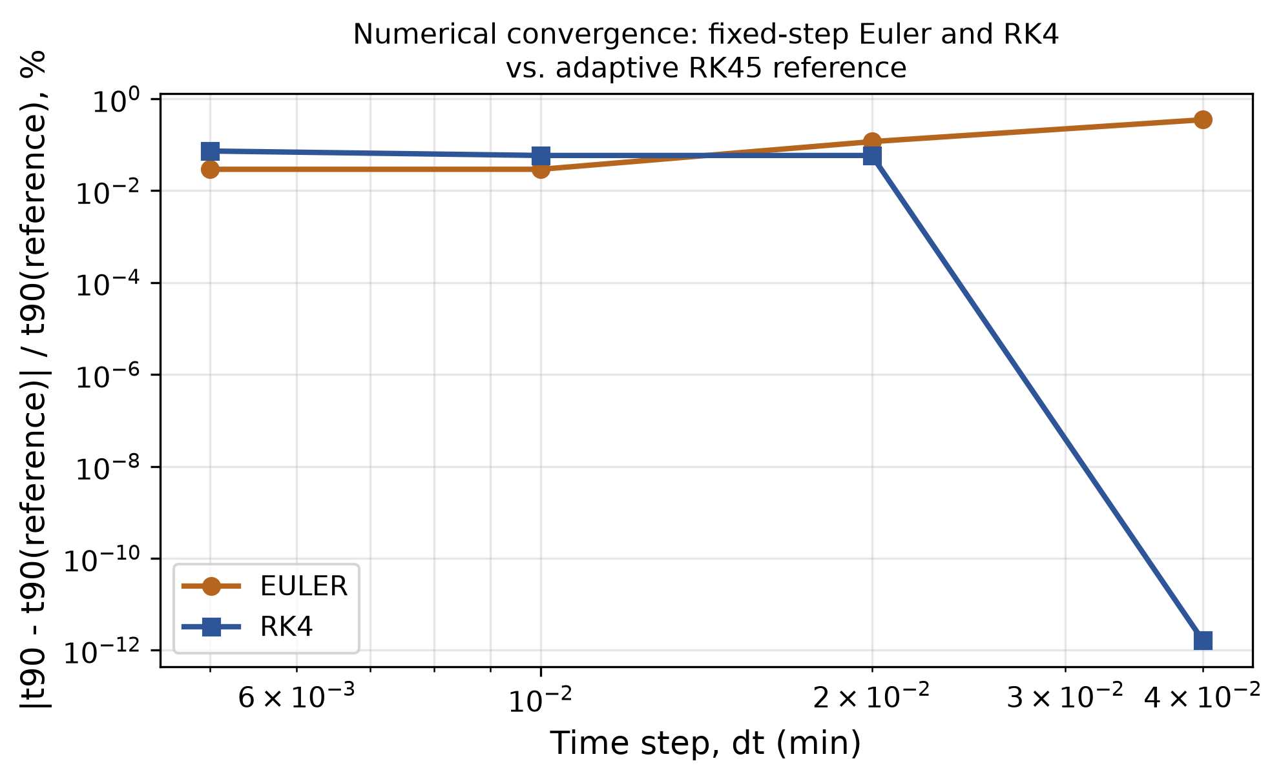
Figure 0. Convergence of fixed-step Euler and RK4 toward the adaptive RK45 reference solution, log-log in step size dt.

4. Results

4.1 Thermal transient and idealized-limit induction behavior
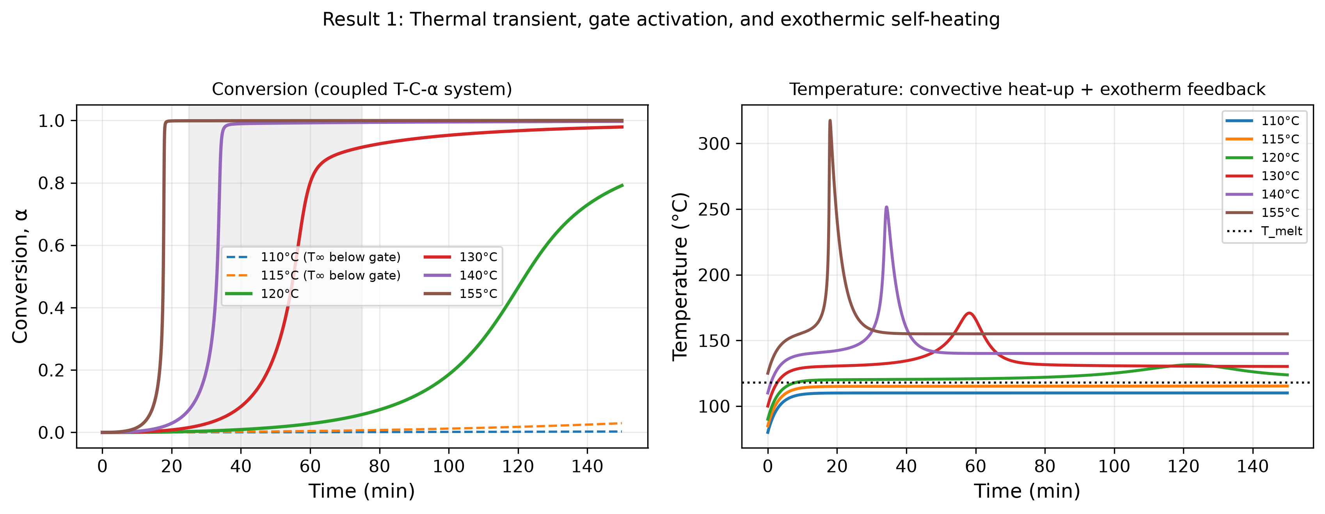
Figure 1. Conversion (left) and temperature (right) vs. time at six T∞ values.
Unlike the earlier draft’s instantaneous-temperature-step assumption, the fluid element here starts 30°C below T∞ and heats convectively (τ_thermal = 3.0 min), with additional self-heating once the reaction ignites. Below T_melt, the conversion remains at zero to numerical precision (max α over 150 min at T∞=115°C, 3°C below T_melt = 118°C: 4.2×10⁻²⁸) — the structural result of Section 2.4, not an independent prediction. Above it, the conversion follows a sigmoidal curve whose onset and steepness both decrease with increasing T∞, now correctly reflecting both the convective heat-up delay and the Arrhenius-accelerated kinetics.

4.2 Exothermic self-heating
At the reference operating point (T∞=140°C), the peak temperature reaches 251.7°C—an overshoot of 111.7°C above the setpoint—a direct, physically necessary consequence of coupling the energy balance to the reaction (Section 2.1), and a genuinely new prediction relative to the earlier isothermal draft, which could not represent this effect at all. The overshoot arises because the reaction’s exothermic heating rate (ΔT_ad·dα/dt) peaks sharply near the transition midpoint, whereas convective cooling scales only with the instantaneous overshoot itself; thus, a genuine thermal-runaway risk can occur even when Θ_ref<1 (thermal relaxation is nominally faster than the reaction). Whether a given overshoot magnitude is acceptable depends on the specific material’s thermal degradation limit, which is outside the scope of this paper (Section 6).

4.3 Autocatalysis sharpens the transition vs. an objectively matched first-order control
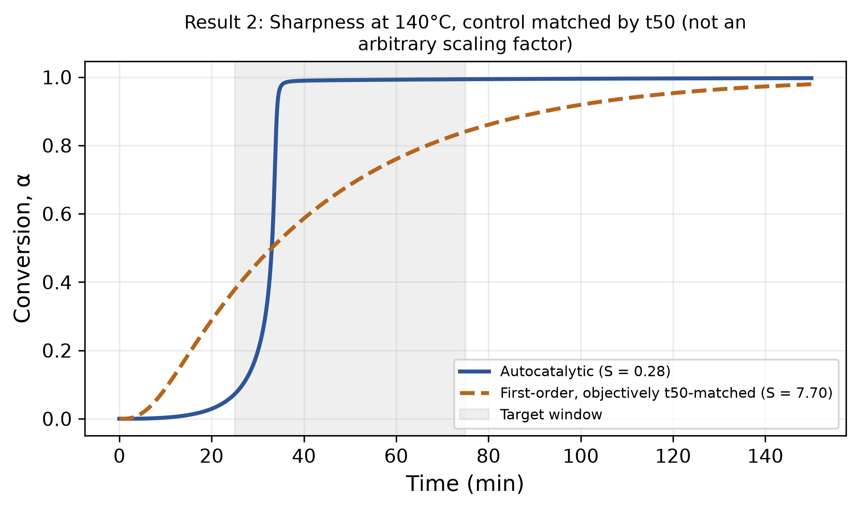
Figure 2. Coupled autocatalytic system vs. objectively t50-matched first-order control.
Rather than scaling the first-order control rate constant by an assumed factor (as in the earlier draft), k_first is root-solved (scipy.optimize.brentq), so the two systems reach t50 at the same time (33.05 min) under otherwise identical thermal/release conditions. The solved k_first = 0.0272 min⁻¹, 18.0% of the reference autocatalytic rate constant k2_ref—an objectively determined value, not an assumed 55% scaling factor as in the earlier draft. At the matched t50, the two systems diverge sharply in shape: the autocatalytic system reaches t=26.75 min and t90=34.20 min (S=0.279, a sharp transition), whereas the first-order control reaches t10=10.60 min and t90=92.20 min (S=7.70), with premature onset nearly 16 minutes earlier and completion over 58 minutes later.
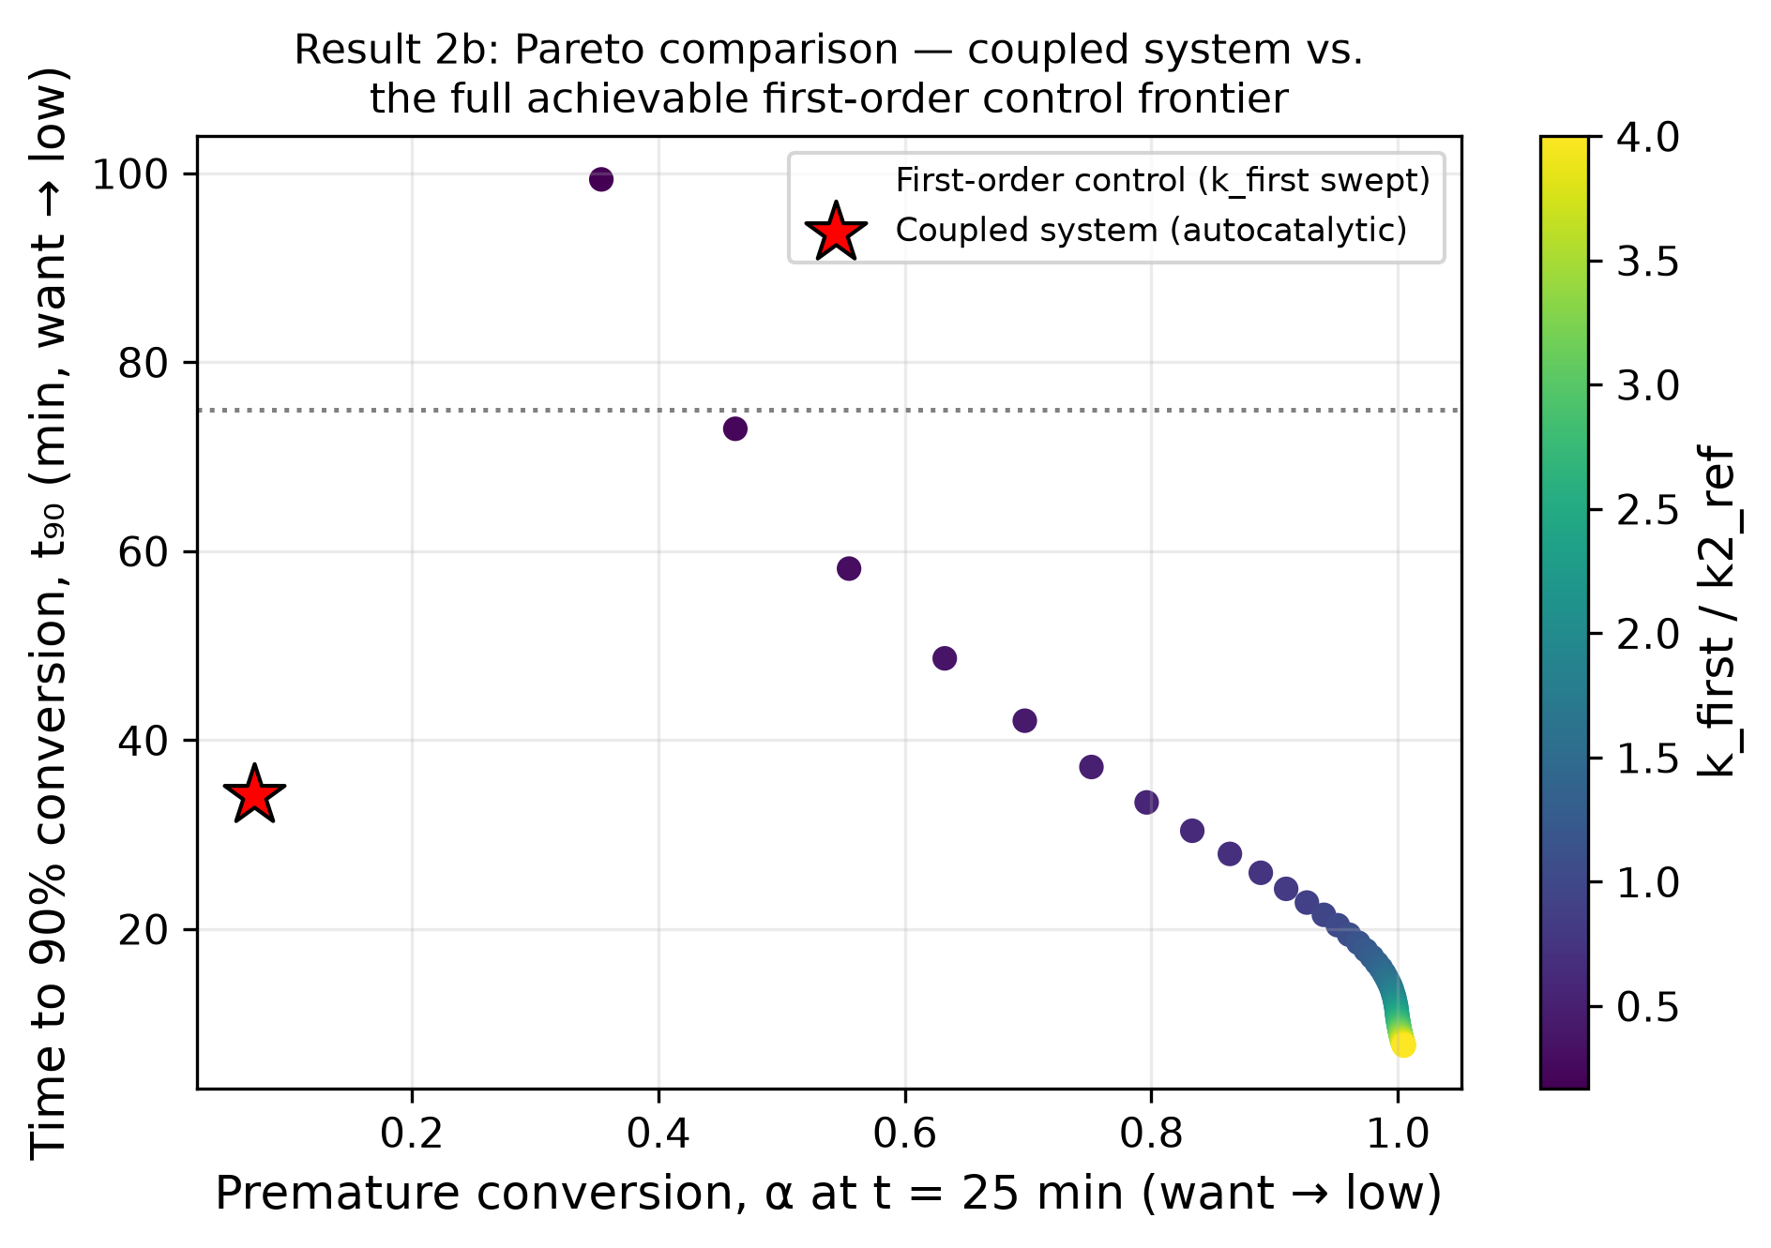
Figure 2b. Pareto sweep: coupled system operating point vs. 60 sampled first-order controls.
This is followed by a full Pareto sweep over 60 sampled first-order rate constants spanning 0.1×–4.0× k2_ref: the coupled (autocatalytic) system's operating point (α at t=25 min = 0.072, t90=34.20 min) is beaten on both axes simultaneously by 0/60 sampled first-order controls—i.e., it is Pareto-optimal/nondominated in this comparison space—while the coupled point in turn dominates 6/60 of the sampled controls. This directly answers the synergy-demonstration concern with a comparison that cannot be tuned by the choice of a single scaling factor. A stronger test, with Arrhenius controls that share the energy balance and with a storage-stability objective, is given in Section 4.9.

4.4 Full system comparison (A–D), objectively matched
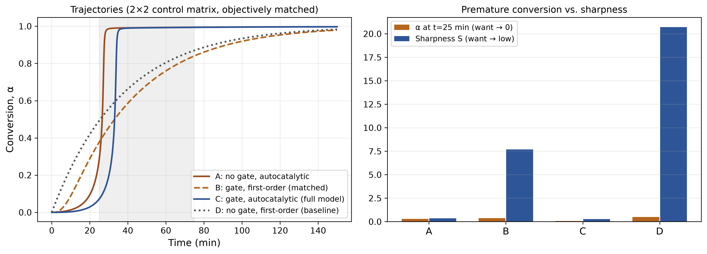
Figure 3. Premature conversion and transition sharpness across four system variants (A–D).
Table 2. Four system variants (A–D): premature conversion α(t = 25 min) and sharpness S, with the first-order control matched on t50.
System | Description | α (t=25 min) | S
A | No gate, autocatalytic | 0.289 | 0.362
B | Gate, first-order (matched) | 0.378 | 7.698
C | Gate, autocatalytic (full coupled model) | 0.072 | 0.279
D | No gate, first-order (conventional baseline) | 0.493 | 20.705
As in the earlier draft, System C (gated, autocatalytic—the fully coupled model) dominated on both metrics, achieving both the lowest premature conversion and the sharpest transition of the four; System D (no gate, first-order—the conventional baseline) is worst on both. The nonadditive ranking is preserved under the new, objectively matched control: System B (gated, first-order) has higher premature conversion at t=25 min than System A (no gate, autocatalytic), confirming that gating alone, without autocatalytic kinetics, is insufficient — both mechanisms are required jointly.

4.5 Regime map over (Θ, Λ)
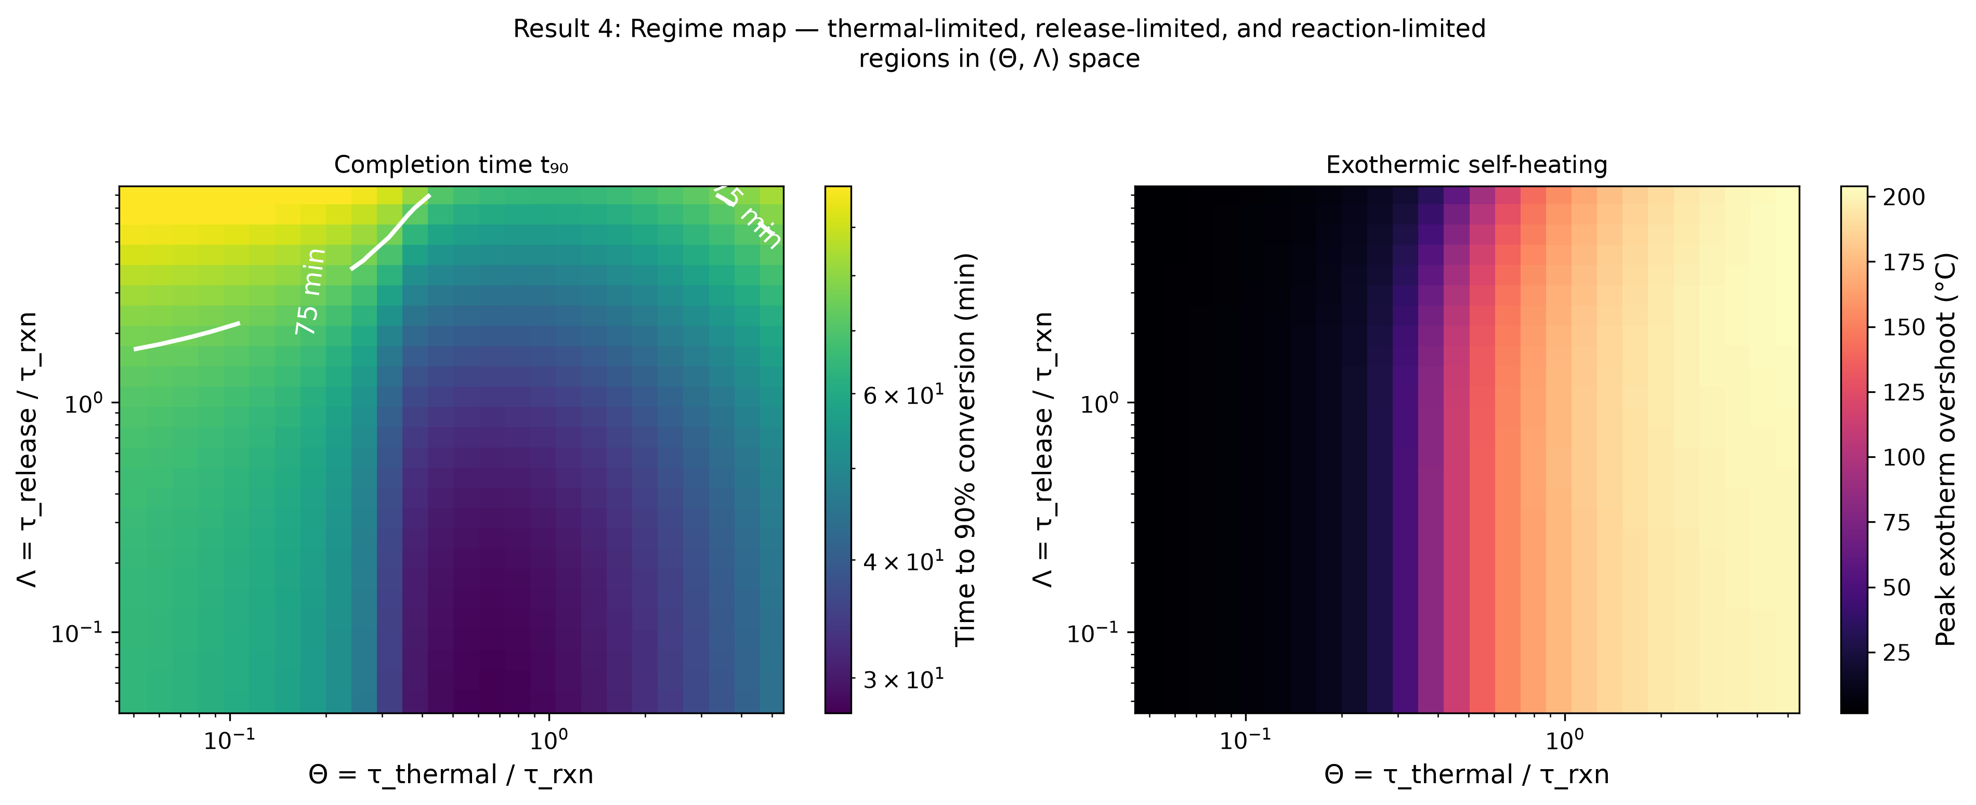
Figure 4. Regime map: t90 (left) and exothermic overshoot (right) over the (Θ, Λ) plane.
Across a 26×26 log-spaced grid spanning Θ∈[0.05, 5.0] and Λ∈[0.05, 8.0], the 75-minute completion target (t90≤75 min) is missed in 3.1% of the Θ>2 (thermal-limited) region but 37.9% of the Λ>2 (release-limited) region—release-limited behavior is the more common failure mode at this parameter range, although the thermal-limited region has the greatest exothermic risk, with peak overshoot across the map reaching 204.1°C (at Θ=5.00 and Λ=5.33). The map identifies three qualitative regions: a reaction-limited region (Θ, Λ both small—thermal and release processes are fast relative to the reaction, closely recovering the earlier draft’s isothermal, instantaneous-release limit), a release-limited region (Λ large, the dominant source of missed-target failures here), and a thermally limited region (Θ large, where the target is occasionally missed but exothermic overshoot is most severe). This finding directly demonstrates that no single ratio organizes this system; the coupled behavior depends on the joint value of at least two independent timescale ratios, and which ratio dominates failure risk is itself parameter range dependent.

4.5b Relative sharpness and absolute timing diverge at large Λ
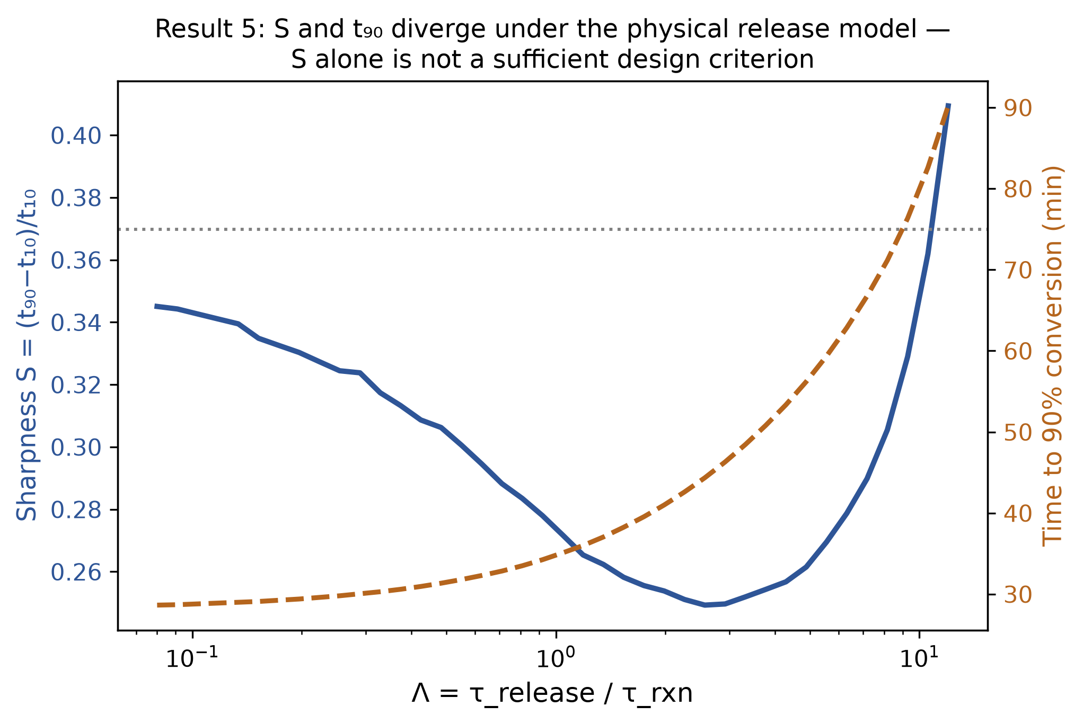
Figure 5. S and t90 vs. Λ, dual axis.
Swept over Λ∈[0.08, 12.0] (40 log-spaced points), S changes only mildly—it increases from 0.35 at Λ=0.08 to 0.41 at Λ=12.0—while t90 increases without bound, crossing the 75-minute target at Λ≈9.28. Under the physical (Arrhenius-relaxation) release model, S therefore does not provide an early warning of completion-time failure: a nearly stable, even mildly worsening, S value coexists with an absolute completion time that eventually blows past any practical target. This is a more cautionary and physically grounded version of the divergence reported in the earlier draft’s prescribed-gate model; here, the sharpness metric alone is shown to be an unreliable proxy for practical performance at large Λ, reinforcing the need to report both S and t90 (Section 2.3).

4.6 Finite-width thermal gate: genuine falsifiable prediction
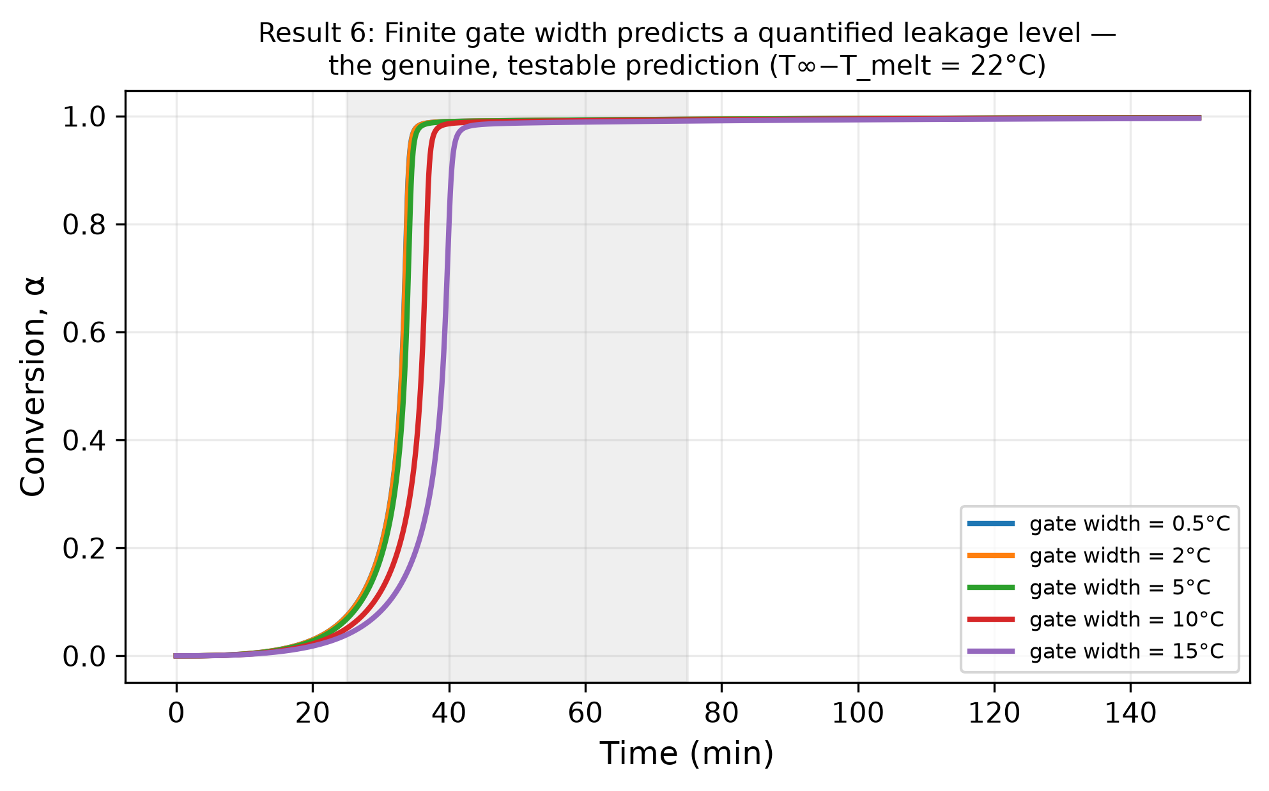
Figure 6. Premature conversion and t90 vs. gate width w; subthreshold leakage vs. w.
The sweep gate width w over {0.5, 2, 5, 10, 15}°C at the reference operating point, α, at t=25 min decreases monotonically from 0.073 (w=0.5°C) to 0.073, 0.068, 0.051, and 0.039 (w=15°C), respectively, while t90 increases from 34.1 min (w=0.5°C) to 34.2, 34.6, 37.1, and 40.4 min (w=15°C), respectively—a genuine, monotonic trade-off that is quantitatively predicted and directly testable. A companion subthreshold-leakage sweep holds T∞=112°C, 6°C below the nominal T_melt=118°C, and reads α at t=150 min: leakage increases from 0.0 (w=0.5°C, indistinguishable from the idealized zero-width limit) to 0.0021, 0.0168, 0.0369, and 0.0483 (w=15°C) — confirming Prediction 1 (Section 7): the subthreshold conversion scales measurably with the gate width rather than remaining exactly zero.

4.7 Robustness under joint parameter uncertainty (Monte Carlo)
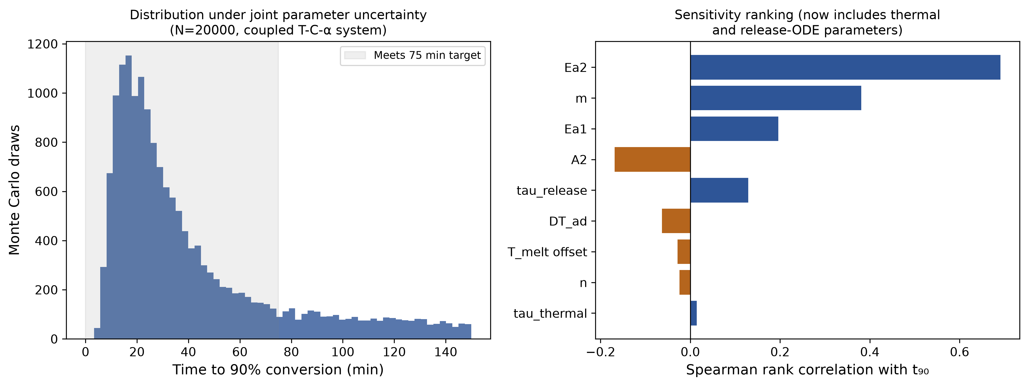
Figure 7. Monte Carlo distribution of t90 and Spearman sensitivity ranking (N=20,000).
Nine parameters—Ea1, Ea2, A2, m, n, melt-point offset, τ_release, τ_thermal, ΔT_ad—were propagated jointly via fully vectorized fixed-step RK4 integration of the coupled 3-state ODE system across all the draws simultaneously (N=20,000; dt=0.05 min). A total of 69.9% of the draws satisfy both the minimum induction time (t10≥5 min) and the 75-minute completion target; the median t90 is 28.4 min (IQR 17.7–51.5 min). Spearman’s rank correlations with t90 show that the reaction-kinetics parameters dominate: Ea2 (r=0.693) and m (r=0.383) are the strongest drivers, followed by Ea1 (r=0.196) and A2 (r=−0.170); the thermal and release-ODE parameters newly introduced in this version contribute markedly less (τ_release r=0.132, ΔT_ad r=−0.067, τ_thermal r=0.013), and n and the melt-point offset are essentially uncorrelated with t90 (r=−0.024, r=−0.028). This finding reinforces the recommendation to prioritize kinetic characterization (dynamic DSC) in an experimental program.

4.8 Capsule-population origin of the gate width
Section 4.6 postulated a logistic gate of width w. A real capsule population has no such function; it has a distribution of melting temperatures (shell thickness, wax grade, capsule size) and possibly of release times. The gate is therefore re-derived as a population: K = 61 capsules with melting temperatures T_melt + σ·z_i, where the z_i are deterministic Gaussian quantiles, each with a near-step gate (w0 = 0.5 °C) and its own release relaxation; the reaction is driven by the capsule-averaged availability C̄ = (1/K)ΣC_i. Matching the variance of a logistic and of a Gaussian distribution gives w_eff = (w0² + 3σ²/π²)^½, i.e. w_eff ≈ 0.55σ for σ ≫ w0.
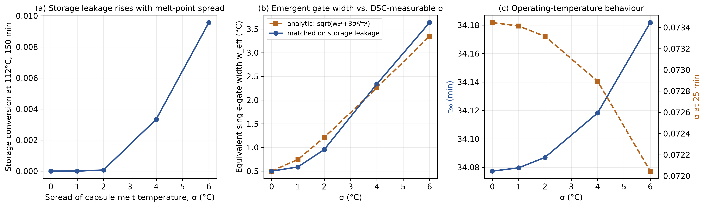
Figure 8. Capsule-population model. (a) Storage conversion at 112 °C after 150 min vs. the spread σ of capsule melting temperature. (b) Equivalent single-gate width w_eff from the variance argument (dashed) and as matched on the storage conversion (solid). (c) t90 and α at 25 min at the operating temperature vs. σ.
The population model confirms this where it can be tested (Figure 8b). The single-gate width that reproduces the storage conversion of the population is 0.59, 0.96, 2.34, 3.63 °C for σ = 1, 2, 4 and 6 °C, against 0.74, 1.21, 2.26, 3.35 °C from the variance argument; the two differ by at most 21 % over σ = 1–6 °C and by 3–9 % for σ ≥ 4 °C, the residual reflecting the release lag, which the variance argument ignores. At the operating temperature the behaviour is almost insensitive to σ: α at 25 min stays between 0.072 and 0.073 and t90 between 34.1 and 34.2 min for σ = 0–6 °C, whereas the storage conversion at 112 °C rises from 0 to 0.0096 (Figure 8a). A lognormal scatter of the release time constant (coefficient of variation up to 1) changes α at 25 min from 0.073 to 0.084 and t90 from 34.1 to 33.7 min. Under the present model, therefore, the spread of melting temperature, not of release time, controls storage stability. This turns the leakage prediction of Section 4.6 into a relation between two measurable quantities (Prediction 4, Section 7): the standard deviation σ of the melting-temperature distribution, estimated from the DSC melting endotherm, and the storage conversion.

4.9 Storage-stability objective and robustness of the Pareto claim to the control family
The comparison of Section 4.3 measured two objectives at the operating temperature, premature conversion α(25 min) and t90. It did not measure the property named in the opening sentence of the abstract, transport stability: conversion during storage below the gate. A third objective is therefore added, the conversion after 150 min at T∞ = 112 °C (6 °C below T_melt), and the constant-rate first-order control of Section 4.3, which has no temperature dependence, is replaced by Arrhenius controls that share the energy balance, and hence the thermal feedback, of the coupled system. Four families of other mechanisms were tuned over their rate constants: gated first-order with a control activation energy equal to Ea2 or to Ea1; gated n-th order with n = 0.5, 2 and 3; the autocatalytic law without a gate, with A2 tuned; and gated first-order with a tuned release time. Together they comprise 550 designs, of which 547 are physically admissible (the others reach temperatures above T∞ + ΔT_ad, which violates energy conservation and signals numerical runaway, and are excluded).
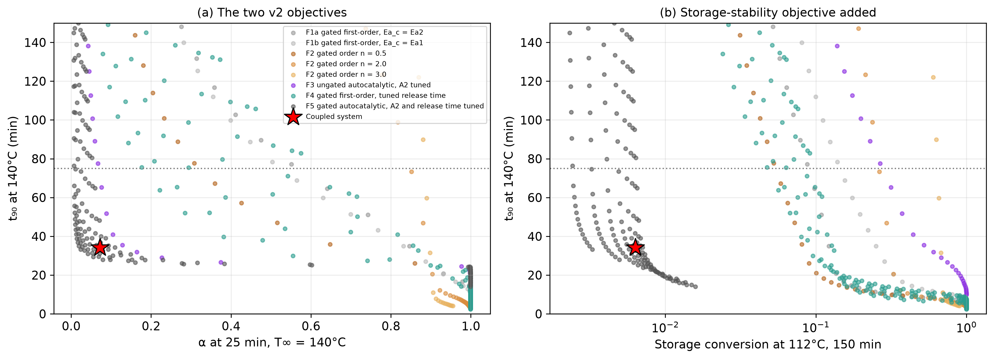
Figure 9. Control-family comparison. (a) Premature conversion α(25 min) vs. t90 at 140 °C. (b) Storage conversion (150 min at 112 °C) vs. t90. Each point is one tuned control design; the star is the coupled reference operating point. The ungated autocatalytic family has a large storage conversion; gated families with constant dynamics fail on t90 or on premature conversion.
None of the 547 admissible designs dominates the coupled operating point (α25 = 0.072, t90 = 34.2 min, storage conversion 0.0063), on the two objectives of v2 or on all three (Figure 9). The closest family, gated first-order, tuned release time, still exceeds the coupled value on its worst objective by a factor of 3.9. The ungated autocatalytic formulation, with the same kinetics and no gate, completes at t90 = 27.6 min but converts 0.719 of its mass in the storage test against 0.0063 for the gated system (Prediction 5, Section 7), which is what the gate contributes. One qualification is necessary. 9 of the 200 detuned designs of the coupled family itself (A2 and release time varied) dominate the reference operating point on all three objectives, each confirmed with an independent stiff integrator (LSODA). The reference point is therefore a representative, not an optimum. What the comparison supports is that none of the other mechanisms examined reaches the region of the coupled family, not that the reference point is optimal; and the absence of a dominating control among 550 designs of four families is evidence, not proof.

4.10 Design rule: admissible spread of the capsule melting temperature
The leakage requirement fixes how uniform the capsule melting temperature must be. For a tolerance ε on the storage conversion and a storage margin ΔT = T_melt − T_store, the widest admissible single gate w* and the largest admissible spread σ* follow by root-finding on the leakage curves of the single-gate and the population model (Table 3). For ε = 0.01 and ΔT = 6 °C, w* = 3.7 °C and σ* = 6.1 °C; the ratio σ*/w* lies between 1.5 and 1.8 over the table, against 1.8 from the variance argument. The design map of Figure 10 combines this with the completion criterion: 37.6 % of the (w, T∞) grid satisfies leakage ≤ 0.01, t10 ≥ 5 min and t90 ≤ 75 min together. The operating temperature required for t90 ≤ 75 min (129.4 °C for w = 3 °C) does not depend on the gate width within the admissible range, to the resolution of the grid (4 °C), so the two requirements decouple within this model: the storage criterion constrains the spread of melting temperature and the completion criterion constrains the operating temperature, and neither can be traded against the other.
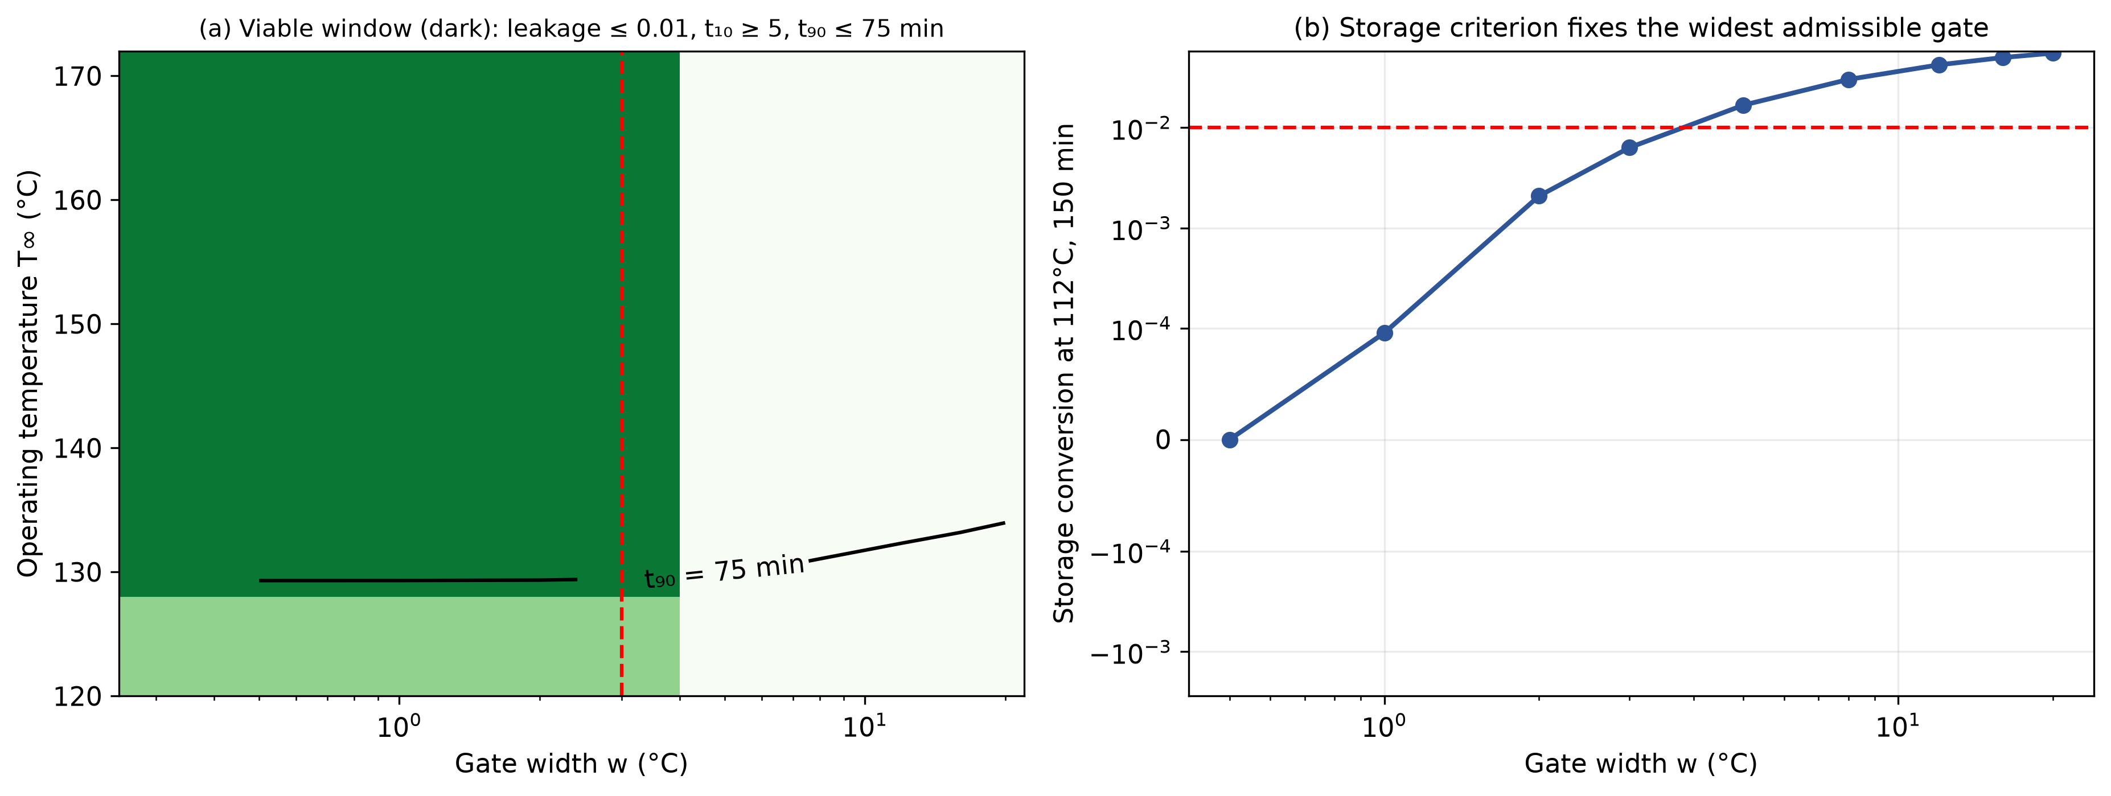
Figure 10. Design map. (a) Viable window (dark) over gate width and operating temperature for leakage ≤ 0.01, t10 ≥ 5 min and t90 ≤ 75 min; the dashed line is the widest admissible gate. (b) Storage conversion at 112 °C vs. gate width.
Table 3. Widest admissible single gate w* and largest admissible melting-point spread σ* for stated storage margin and tolerance (illustrative parameters; 150 min storage).
Storage margin T_melt − T_store (°C) | Tolerance ε (conversion) | Widest single gate w* (°C) | Largest melting-point spread σ* (°C)
3 | 0.001 | 0.78 | 1.18
3 | 0.01 | 1.68 | 2.67
3 | 0.05 | 4.71 | 7.53
6 | 0.001 | 1.63 | 2.90
6 | 0.01 | 3.72 | 6.13
6 | 0.05 | 16.03 | 25.65
10 | 0.001 | 2.86 | 5.22
10 | 0.01 | 7.36 | 12.09
10 | 0.05 | > 60 (no limit reached) | > 40 (no limit reached)

4.11 Variance-based attribution of the completion time
The Spearman ranking of Section 4.7 measures monotonic association among the draws that complete. Variance-based indices also capture interactions and non-monotonic effects. Saltelli sampling (N = 2048 base samples, 22,528 model runs, Jansen estimators; draws with no t90 within 150 min, 17.7 % of the total, are assigned the censoring value 150 min) gives total-order indices ST of Ea2 0.76, A2 0.17, m 0.13, τ_thermal 0.09, Ea1 0.08, n 0.05, ΔT_ad 0.03, τ_release 0.00, the melting-point offset 0.00. The first-order indices sum to 0.91, so interactions account for about 9 % of the variance. Ea2 dominates, as in Section 4.7. Two parameters rank differently from the Spearman coefficients: τ_release correlates with t90 (r = 0.13) but contributes almost no variance (ST = 0.004), whereas τ_thermal has almost no rank correlation (r = 0.015) but ST = 0.09, through its interaction with the reaction exotherm. The experimental priority stated in Section 4.7, kinetic characterization by dynamic DSC, is unchanged; the thermal time constant of the sample should also be controlled and reported.
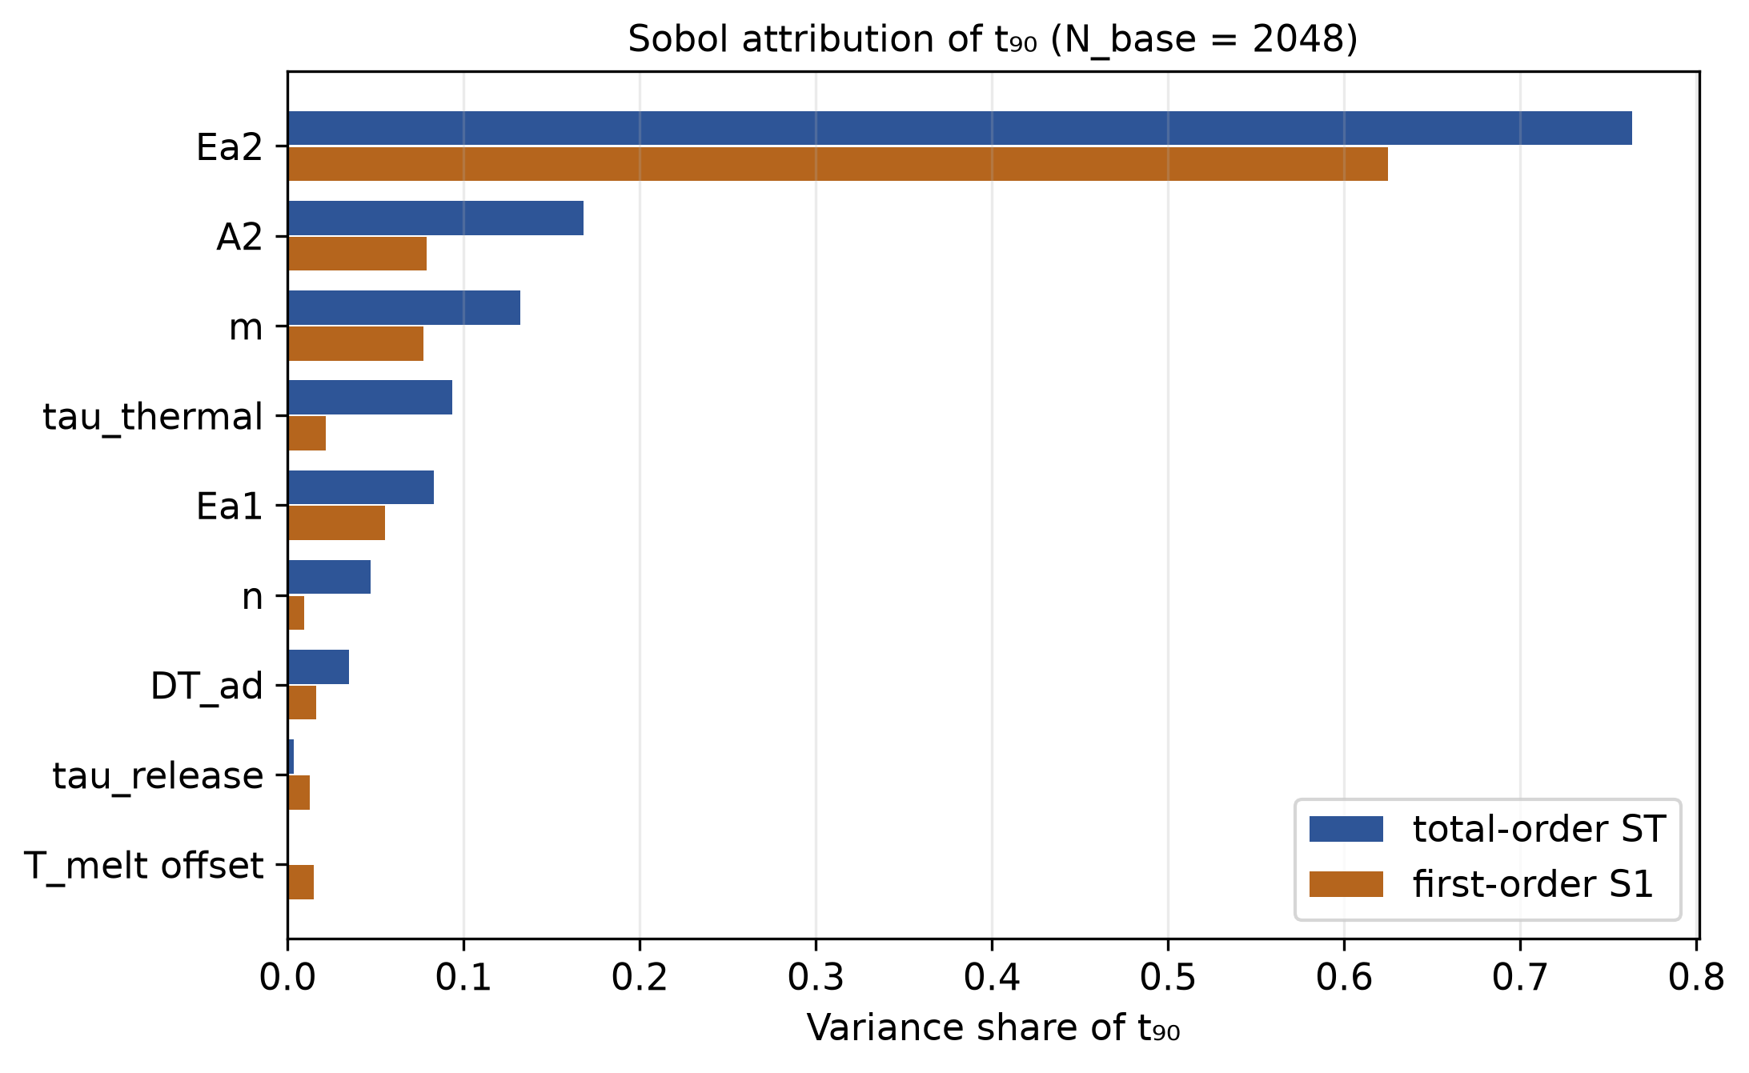
Figure 11. Sobol attribution of t90: first-order (S1) and total-order (ST) indices for the nine uncertain parameters of Section 4.7.

4.12 Mechanical function and spatial-transport extensions
The conversion kinetics developed here could in principle be coupled to a micromechanical strength model or extended to a spatially resolved (CFD) flow geometry. Both are outside this paper's 0D thermal/kinetic scope; neither is developed nor evaluated in this manuscript, and no application-specific performance claim should be inferred for either extension (Section 6).

5. Discussion
The central computational finding is that thermal activation and autocatalytic kinetics are complementary and not redundant and that this synergy is demonstrated by an objective (Pareto) comparison rather than a scaling assumption (Section 4.3). The coupled system's behavior is organized by at least two independent dimensionless timescale ratios (Θ, Λ), not one (Section 4.5); a favorable Λ/S combination does not guarantee practical performance if Θ is unfavorable, and vice versa. Nonideal, finite-width thermal gate trades reduced premature conversion against slower completion (Section 4.6) — the paper's primary falsifiable claim.
Three results of the extended analysis qualify and sharpen this finding. First, the storage-stability objective shows what the gate contributes: the ungated autocatalytic formulation completes at least as fast but converts 0.719 of its mass in the storage test against 0.0063 (Section 4.9), so that the gate, not the autocatalysis, provides storage stability, and the autocatalysis, not the gate, provides sharpness; this is a more specific statement of the complementarity than the 2×2 comparison of Section 4.4. Second, the Pareto claim is a statement about mechanisms, not about the reference operating point: none of the tuned alternative mechanisms dominates the coupled system, but detuned members of the coupled family do dominate the reference point, which should be read as an illustration. Third, the population model and the design rule convert the finite-width prediction into a specification: for a 6 °C storage margin and a 1 % storage tolerance the melting temperatures of the capsules must lie within a standard deviation of about 6 °C (Table 3), a quantity measurable on the DSC endotherm before any formulation is cured.

5.1 Status of claims and load-bearing assumptions
Table 4. Status of the claims of this paper. All parameters are illustrative; none is fitted to a measured system.
Claim | Status | Load-bearing assumption | What would reverse or limit it
Zero conversion below T_melt for a zero-width gate | Structural (by construction) | Step gate, C = 0 below T_melt | Not a prediction (Section 2.4)
Finite gate width gives quantified leakage and a leakage–completion trade-off | Computed; Predicted (P1) | Logistic gate; Arrhenius release relaxation | A non-logistic activation profile changes the numbers, not the direction (Section 4.8)
Gate width follows from the melting-temperature spread, w_eff ≈ 0.55σ | Computed; Predicted (P4) | Independent, equal-mass capsules; Gaussian spread; no capsule–capsule exchange | A skewed or bimodal melting distribution; storage leakage inconsistent with σ by more than a factor of two
No tested alternative mechanism dominates the coupled system on three objectives | Computed (550 designs) | Four control families, Arrhenius, same energy balance; illustrative parameters | Any admissible control outside the families that dominates; detuned members of the coupled family already dominate the reference point
The gate, not autocatalysis, provides storage stability | Computed; Predicted (P5) | Same kinetics with and without gate; storage = 150 min at 6 °C below T_melt | An unencapsulated formulation that stays within the tolerance would falsify it
Ea2 dominates the variance of t90 | Computed | Uniform ranges of Section 4.7; censoring at 150 min | Narrower Ea2 range or different priors
Admissible spread σ* ≈ 6 °C (ε = 0.01, ΔT = 6 °C) | Computed | Gaussian spread; storage defined as 150 min at ΔT below T_melt | Different storage duration or margin (Table 3)
Overshoots up to 204 °C in the thermally limited region | Computed | Lumped, adiabatic-like heating; ΔT_ad = 220 K | Spatial heat loss; real material limits (Section 6)

This is a general statement about the coupled kinetic structure of thermally activated, autocatalytically reactive systems. Potential relevance to phase-change thermal storage, thermally triggered reactive coatings, or self-healing materials is noted here only as an illustrative, unvalidated direction for future work — each would require its own material-specific parameterization and experimental validation before any performance claim could be made, and none is claimed here.

6. Limitations
- All the kinetic, thermal, and release parameters are illustrative and are not fitted to any measured system in the literature.
- Release relaxation (Section 2.1) is a lumped first-order Arrhenius analog to shell-diffusion/melt-controlled release, not a solved Fickian shell-diffusion PDE; a spatially resolved release model is a direction for follow-up work.
- The thermal model is a lumped (0D), single-fluid-element energy balance; it does not resolve spatial temperature or concentration gradients, flow/residence–time distributions, or shear heating in an actual flowing medium — this is a deliberate scope choice (Section 1), not an oversight, and is the paper's stated boundary for follow-on 3D/CFD extension.
- The mechanical function extension (Section 4.12) is notable but not developed.
- ψ (Section 2.2) is used descriptively via direct simulation of the regime map (Section 4.5), not via a closed-form critical-value criterion. The lumped balance with Newtonian cooling is formally of Semenov type, but the classical critical values assume negligible reactant consumption and an exponential (Frank-Kamenetskii) linearisation, and are not applied to this consumed-reactant, autocatalytic system.
- The population model (Section 4.8) assumes K = 61 independent capsules of equal mass with a Gaussian spread of melting temperatures and no heat or mass exchange between capsules; skewed or bimodal distributions would change the relation between σ and w_eff.
- The control families of Section 4.9 are finite (550 designs of four mechanisms); the absence of a dominating control is evidence, not proof. The constant-rate control of Section 4.3 lacked temperature dependence; the Arrhenius controls of Section 4.9 supersede it for the claim of non-dominance.
- The analyses of Sections 4.8–4.11 integrate with a heat-release cut-off once conversion reaches 0.999 (the reaction is complete); the first version retained a small residual term. The two agree on the reference case (t90 34.17 against 34.20 min, overshoot 111.7 against 111.7 K).
- The storage objective is one condition (150 min, 6 °C below T_melt); the design rule (Table 3) shows how the admissible spread changes with margin and tolerance. Sobol indices treat draws without a t90 within 150 min as censored at 150 min.

7. Falsifiable predictions and validation protocols
Prediction 1: For a real material with a finite activation width w, subthreshold conversion below the nominal activation temperature should scale measurably with w — approaching (but not reaching) zero only as w→0 — rather than the exactly zero behavior of an idealized step gate.
Validation protocol: isothermal DSCs hold at several temperatures spanning the nominal activation range, comparing subthreshold heat-flow integration against the width predicted from the material’s own melting/activation-temperature distribution (e.g., by the DSC melting endotherm width).
Prediction 2: Once the activation threshold is exceeded, conversion should follow a measurably sharper (lower-S) transition than an objectively rate-matched first-order or diffusion-controlled reference reaction subject to the same thermal-gate protocol.
Validation protocol: Dynamic-ramp DSC compared against a nonautocatalytic reference formulation, both under an identical thermal protocol, with the reference rate constant matched by t50 (not assumed) as in Section 4.3; rheo-DSC to additionally capture the fluid-to-solid viscoelastic transition.
Prediction 3: Increasing the release timescale relative to the reaction timescale (Λ) beyond a system-specific threshold causes the absolute transformation time to exceed a practical target window even as S continues to appear favorable.
Validation protocol: a τ_release sweep (via systematic variation in encapsulation/barrier thickness or permeability) with paired measurements of S and absolute t90 by dynamic DSC.
Prediction 4: For a formulation in which the capsule melting temperatures have standard deviation σ, the isothermal storage conversion at a temperature ΔT below the mean melting temperature should be that of a single-gate model with w_eff ≈ 0.55σ (to within about 25 % in w_eff, Section 4.8). A storage conversion corresponding to a w_eff that differs from 0.55σ by more than a factor of two would falsify the population description.
Validation protocol: DSC at a low scan rate to obtain the melting-temperature distribution (deconvolution of the endotherm; instrument broadening corrected), followed by isothermal holds at T_melt − 6 °C for 150 min on the same batch with conversion read from the residual cure enthalpy; compare with the leakage curve of Table 3.
Prediction 5: A formulation with the same cure chemistry but without the thermal gate (unencapsulated catalyst) converts substantially in the storage test (model: 0.719 against 0.0063 with the gate), while completing at least as fast (t90 27.6 against 34.2 min). An unencapsulated formulation that stays within the same tolerance as the gated one would falsify the claim that the gate, not the autocatalysis, provides storage stability.
Validation protocol: Paired isothermal holds (encapsulated and unencapsulated formulations of the same resin) at T_melt − 6 °C for 150 min, residual-enthalpy conversion; and dynamic DSC to confirm comparable t90 at the operating temperature.

8. Computational Methods
All the results of Sections 3–4.7 were produced by one Python script (theoretical_study.py), and those of Sections 4.8–4.11 by a second (extended_analyses.py, with the shared routines in extended_core.py) using NumPy, SciPy (solve_ivp for adaptive integration, optimize.brentq for root-finding, stats.rankdata for Spearman sensitivity), and Matplotlib for figure generation. The production trajectories use scipy.integrate.solve_ivp with method="RK45", max_step=0.5 min, rtol=1e-8, atol=1e-10, and dense_output=True; the crossing times (t10, t50, t90) are read from the resulting dense-output interpolant. Fixed-step convergence checks (Section 3.2) implement explicit Euler and classical 4-stage Runge‒Kutta directly. Monte Carlo propagation (Section 4.7) uses a fully vectorized fixed-step RK4 integrator operating on length-20,000 NumPy arrays simultaneously, rather than 20,000 independent adaptive-solver calls, for tractable runtime. The complete code, including every figure-generation routine, is available at the repository cited in Section 9; running it reproduces every quantitative result and figure in this manuscript.
The extended analyses use a vectorized fixed-step RK4 integrator over many scenarios at once (dt = 0.02–0.05 min; dt = 0.01 min for the control families), validated against the adaptive RK45 reference of Section 3.2 (t90 34.17 against 34.20 min); admissible control designs that dominate the coupled point are re-integrated with LSODA (rtol 1e-8) before they are counted. Sobol indices use scipy.stats.qmc scrambled Sobol sequences, Saltelli sampling and Jansen estimators, verified on the Ishigami function (test_extended.py). Population models use deterministic Gaussian quantiles, so that no random seed enters Sections 4.8–4.10; the Sobol analysis uses seed 20260906.

9. Data and Code Availability
The complete integration, sweep, Monte Carlo, and figure-generation code is provided as open-source software at https://github.com/sandlerleon/autolatch-thermal-gating (MIT license) and archived with a permanent, version-tracking concept DOI on Zenodo: https://doi.org/10.5281/zenodo.22073392 (always resolves to the latest code version). The manuscript itself is additionally archived as a preprint on Zenodo: https://doi.org/10.5281/zenodo.22073390 (concept DOI, always resolves to the latest version), and posted to ChemRxiv: https://doi.org/10.26434/chemrxiv.15008366/v1. The present version (v3) is archived as Zenodo software version https://doi.org/10.5281/zenodo.23201204 and manuscript version https://doi.org/10.5281/zenodo.23201205; the concept DOIs above resolve to the latest versions.https://github.com/sandlerleon/autolatch-thermal-gatinghttps://doi.org/10.5281/zenodo.22073392https://doi.org/10.5281/zenodo.22073390https://doi.org/10.26434/chemrxiv.15008366/v1

References
Kamal, M. R.; Sourour, S. Kinetics and thermal characterization of thermoset cure. Polymer Engineering & Science 1973, 13(1), 59–64.
Bashir, M. A. A review on epoxy resin curing kinetics and thermal analysis. Polymers 2023, 15(15), 3251.
Ryshkewitch, E. Compression strength of porous sintered alumina and zirconia. Journal of the American Ceramic Society 1953, 36(2), 65–68.
Zhang, X. et al. Microencapsulated phase-change materials for thermal energy storage: a review. Applied Thermal Engineering 2020, 165, 114567.
Gou, J. et al. Encapsulation and thermally triggered release of catalytic agents in curable resins: a review. Progress in Polymer Science 2021, 112, 101324.

