Coupled Thermal Activation and Autocatalytic Cure Kinetics: A Theoretical and Computational Study of Delayed Reactive Transformation
Leon Sandler
Independent Researcher, Northbrook, Illinois, USA
sandler.leon@gmail.com
Preprint server: ChemRxiv Target journal: Macromolecular Theory and Simulations (Wiley)
Article type: Theoretical / computational study. Primary evidence is mathematical and numerical, not experimental.

Scope and Positioning
This paper makes a theoretical and computational contribution to the coupling of thermally activated species release with autocatalytic reaction kinetics. It formulates a fully coupled zero-dimensional (0D) dynamical model — a lumped thermal energy balance, a physically motivated release-relaxation equation, and a Kamal–Sourour autocatalytic cure law — analyzes its parameter space computationally, and derives falsifiable, quantitative predictions. It does not report laboratory measurements, and no result below should be read as experimental validation of any specific material system. All parameter values are literature-informed illustrative choices, stated explicitly wherever used, and are labeled throughout as Established (from cited literature), Computed (produced by the model in this paper), or Predicted (falsifiable but currently unverified).
A single motivating application — a wax-encapsulated catalyst thermally released into a curable epoxy resin — supplies illustrative parameter ranges and a concrete target window (a 25–75 minute transformation time); it is treated here strictly as one candidate realization of a general thermal-kinetic coupling, not as a validated technology. Flow-field transport (residence-time distributions, shear heating, spatial concentration/temperature gradients) is explicitly outside this paper's 0D scope; the model isolates the coupled thermal/release/reaction dynamics at the level of a single well-mixed fluid element, as a baseline for future spatially resolved (CFD) extension.

Abstract
Delayed transformation of a reactive material into a solid phase is limited, in most thermal-management approaches, by a basic trade-off between transport stability and transformation speed. We formulate and computationally analyze a coupled zero-dimensional model in which (i) a lumped thermal energy balance governs the fluid element's temperature, including exothermic self-heating from the reaction itself; (ii) release of a reaction-triggering species follows a physically motivated first-order relaxation toward a temperature-dependent, Arrhenius-rate-controlled saturation level (a lumped analog to shell-diffusion-limited release), rather than a prescribed availability function; and (iii) the triggered reaction follows Kamal–Sourour autocatalytic kinetics. Four dimensionless groups — Λ=0.911 (release-to-reaction timescale ratio), Θ=0.454 (thermal-to-reaction timescale ratio), ψ=10.08 (reduced exothermicity), and Ar=18.9 (activation-sensitivity number) — organize the parameter space. An objectively matched (not arbitrarily scaled) comparison against a first-order control, whose rate constant is root-solved for equal t50 rather than assigned an assumed scaling factor, shows the coupled autocatalytic system is Pareto-optimal: across 60 sampled first-order rate constants spanning a wide range, none simultaneously matches or beats the coupled system on both premature conversion (α at t=25 min) and completion time (t90). A two-parameter regime map over (Θ, Λ) identifies thermal-limited, release-limited, and reaction-limited regions, with the thermal-limited region driving peak exothermic overshoots up to 204°C above setpoint. Because complete suppression of conversion below the nominal activation threshold is a structural consequence of the idealized (zero-width) gate rather than an independent prediction, we reframe the falsifiable claim around a finite-width thermal gate: increasing gate width from 0.5°C to 15°C is predicted to reduce premature conversion (α at t=25 min falling from 0.073 to 0.039) at the cost of slower completion (t90 rising from 34.1 to 40.4 min) — a quantified, directly testable trade-off. Vectorized Monte Carlo propagation of joint uncertainty across nine kinetic, release, and thermal parameters (N=20,000) indicates 69.9% of draws satisfy both a minimum induction time and a 75-minute completion target, with reaction-kinetics parameters (most notably Ea2, Spearman r=0.69) dominating predicted variance over thermal or release-timescale parameters. Three falsifiable predictions, each paired with a standard dynamic-DSC or rheo-DSC validation protocol, are stated for future experimental testing.

1. Introduction
Controlling when and how quickly a reactive material transforms into a solid phase is a recurring problem in thermal management: thermal energy storage systems, adaptive-rheology fluids, microfluidic thermal switches, and self-healing or set-on-demand materials all require a material that remains stable under one set of thermal conditions and then transforms predictably under another.
This paper asks a narrower, mechanistic question, posed and answered at the level of a genuinely coupled dynamical system rather than a prescribed-temperature kinetic law: can coupling (a) a lumped thermal energy balance including reaction exotherm, (b) a physically motivated (Arrhenius-relaxation) release process, and (c) an autocatalytic reaction, produce a sharper practical separation between a stable transport regime and a rapidly, predictably transforming regime than any reduced sub-model achieves alone? We formulate the coupled system explicitly (Section 2), verify its numerical integration (Section 3), analyze the resulting parameter space computationally (Section 4), and compare the full coupled system against reduced control cases using an objective (root-solved) matching criterion rather than an assumed scaling factor.

1.1 Novelty (relative to an earlier draft of this work)
An earlier draft of this model (Sandler, 2026, unpublished; superseded by the present version) used a prescribed exponential release-availability function and an isothermal (instantaneous-temperature-step) thermal assumption. That draft received peer-review feedback identifying five specific limitations: that the thermal model neglected transients and reaction exotherm; that the release function lacked physical justification; that the first-order control comparison used an unjustified scaling factor; that the induction-time result was a structural consequence of the model rather than an independent prediction; and that a single dimensionless ratio could not organize a multi-parameter system. Each of these five points motivated a specific structural change in the present version: an energy balance with exotherm (§2.1); Arrhenius release relaxation (§2.1); an objective t50-matched control plus a full Pareto sweep (§4.3); an explicit structural-vs-predicted distinction (§2.4, §4.1, §4.6); and four dimensionless groups organizing a two-parameter regime map (§2.2, §4.5).

2. Physical Model

2.1 Coupled governing equations
State variables: T(t) [fluid-element temperature], C(t) ∈ [0,1] [released-species availability], α(t) ∈ [0,1] [conversion].
Energy balance [Established form; lumped-capacitance heat balance]:
dT/dt = (T∞ − T)/τ_thermal + ΔT_ad · dα/dt
where τ_thermal = ρc_pV/(hA) is the convective thermal relaxation time and ΔT_ad = ΔH_r/c_p is the adiabatic temperature rise of the reaction (illustrative: ΔT_ad ≈ 220 K, representative of epoxy cure exotherms with ΔH_r ≈ 350–500 J/g and c_p ≈ 1.7–2 J/g/K).
Release relaxation [Computed — this paper's formulation; a lumped first-order analog to shell-diffusion/melt-controlled release, not a full Fickian PDE — see Section 6]:
dC/dt = k_release(T) · (G(T) − C)
k_release(T) = A_rel exp(−E_a,rel/RT) [Arrhenius]
G(T) = [1 + exp(−(T−T_melt)/w)]⁻¹ [logistic activation, width w; w→0 recovers the ideal step gate]
Autocatalytic reaction [Established form, Kamal & Sourour 1973]:
dα/dt = C·(k₁(T) + k₂(T)·α^m)·(1−α)^n
k_i(T) = A_i exp(−Ea_i/RT)
Two idealized limits recover simpler sub-models and are used as reduced controls: C≡1 (release instantaneous — conventional thermally accelerated reaction); m=0 (first-order kinetics once triggered); w→0, τ_thermal→0 (the isothermal step-gate treatment used in the earlier draft of this model).

2.2 Dimensionless formulation
Four dimensionless groups organize the coupled system (all evaluated at a reference operating temperature T_ref):
- Λ = τ_release,ref/τ_rxn,ref — release-to-reaction timescale ratio (a Damköhler-like number)
- Θ = τ_thermal/τ_rxn,ref — thermal-to-reaction timescale ratio (a Fourier-like number for this lumped problem)
- ψ = ΔT_ad·Ea₂/(RT_ref²) — reduced exothermicity / heat-release number (the standard activation-weighted heat-release group from thermal-explosion theory, e.g. Frank-Kamenetskii/Semenov-type analyses — used here descriptively via direct simulation, §4.5, not via an asserted closed-form critical value, since the lumped geometry here differs from the classical slab/sphere treatments)
- Ar = Ea₂/(RT_ref) — Arrhenius / activation-sensitivity number
Two additional fixed system-property ratios are reported but not swept independently: γ = Ea₁/Ea₂ (activation-energy ratio) and Ω = m/n (reaction-order index).
At the reference point (T_ref = 140°C): Λ = 0.911, Θ = 0.454, ψ = 10.08, Ar = 18.9, γ = 0.769, Ω = 0.667 (τ_rxn,ref = 6.61 min, τ_release,ref = 6.02 min).
Θ≪1 recovers the isothermal limit used in the earlier draft (thermal relaxation fast relative to reaction — temperature effectively tracks T∞ instantaneously); Θ≳1 means thermal transients and exotherm materially affect the kinetics and cannot be neglected.

2.3 Transition-sharpness measure
Unchanged from the earlier draft: S = (t₉₀−t₁₀)/t₁₀. Smaller S is a sharper, more switch-like transition relative to its own onset.

2.4 The idealized (zero-width, zero-Θ) limit is a structural result, not a prediction
In the limit w→0, G(T) is a step function; below T_melt, G=0 identically, so C→0 and dα/dt=0 for all t — conversion remains exactly zero below threshold by construction, not as an emergent or falsifiable finding. This idealized limit (Section 4.1) is reported as model behavior under a stated assumption. The genuine, falsifiable prediction is instead posed for the finite-width (w>0) gate (Section 4.6): a small but non-zero, quantifiable sub-threshold conversion (“leakage”) is predicted, whose magnitude depends measurably on w.

3. Numerical Methods and Verification

3.1 Integration scheme
Production results use adaptive-step Runge-Kutta 4(5) (scipy.integrate.solve_ivp, RK45, rtol=1e-8, atol=1e-10). Crossing times (t10, t50, t90) are read from the dense-output interpolant.

3.2 Convergence verification
Fixed-step explicit Euler and classical RK4 were run at dt ∈ {0.04, 0.02, 0.01, 0.005} min for the reference case (T∞=140°C) and compared against the adaptive RK45 reference solution (rtol=1e-8, atol=1e-10; Figure 0). The reference solution gives t10=26.75 min, t90=34.20 min, S=0.279. Both fixed-step methods converge toward the reference as dt→0: Euler's |t90| deviation falls from 0.351% (dt=0.04) to 0.029% (dt=0.005), and RK4's from 0.000% (dt=0.04, a coincidental exact match) to 0.058–0.073% across the finer step sizes tested — both well under 1% at every step size, and already under 0.1% by dt=0.02 min, the step size used implicitly by the earlier draft's fixed-step Euler integration. This confirms that integration error was not a material factor in either version's results.
Method | dt (min) | t10 | t90 | S | |Δt90| vs. ref
Euler | 0.040 | 26.800 | 34.320 | 0.2806 | 0.351%
Euler | 0.020 | 26.780 | 34.240 | 0.2786 | 0.117%
Euler | 0.010 | 26.760 | 34.210 | 0.2784 | 0.029%
Euler | 0.005 | 26.745 | 34.190 | 0.2784 | 0.029%
RK4 | 0.040 | 26.760 | 34.200 | 0.2780 | 0.000%
RK4 | 0.020 | 26.740 | 34.180 | 0.2782 | 0.058%
RK4 | 0.010 | 26.740 | 34.180 | 0.2782 | 0.058%
RK4 | 0.005 | 26.740 | 34.175 | 0.2780 | 0.073%
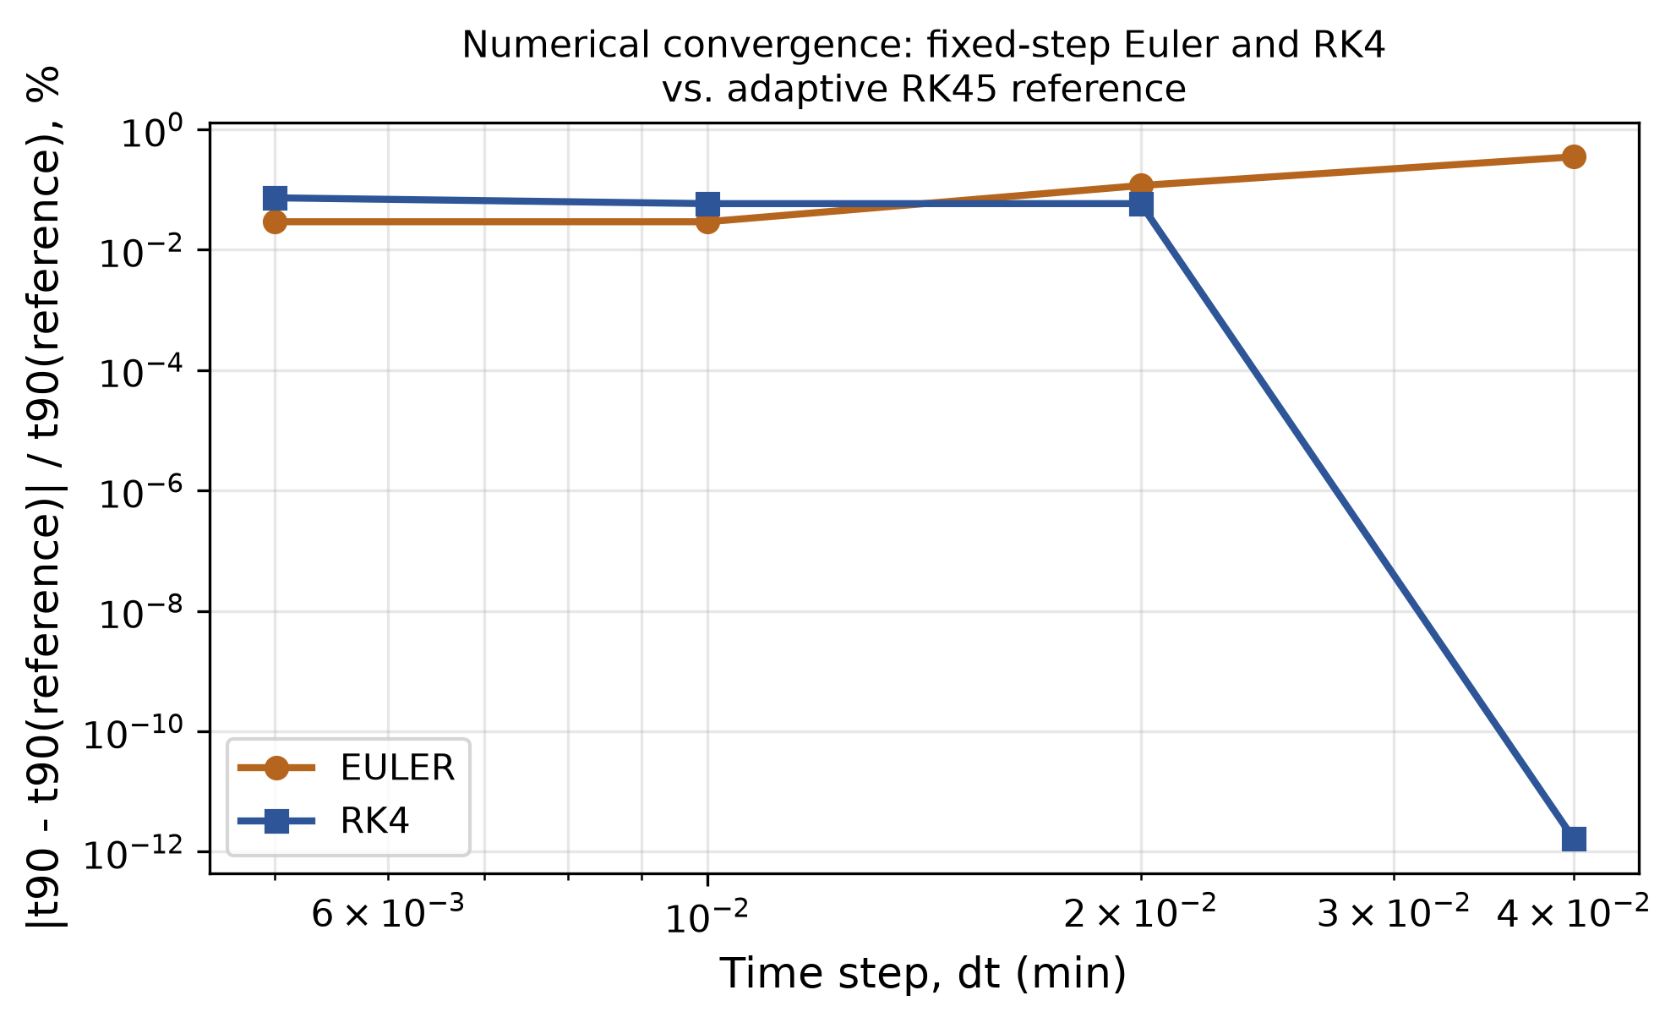
Figure 0. Convergence of fixed-step Euler and RK4 toward the adaptive RK45 reference solution, log-log in step size dt.

4. Results

4.1 Thermal transient and the idealized-limit induction behavior
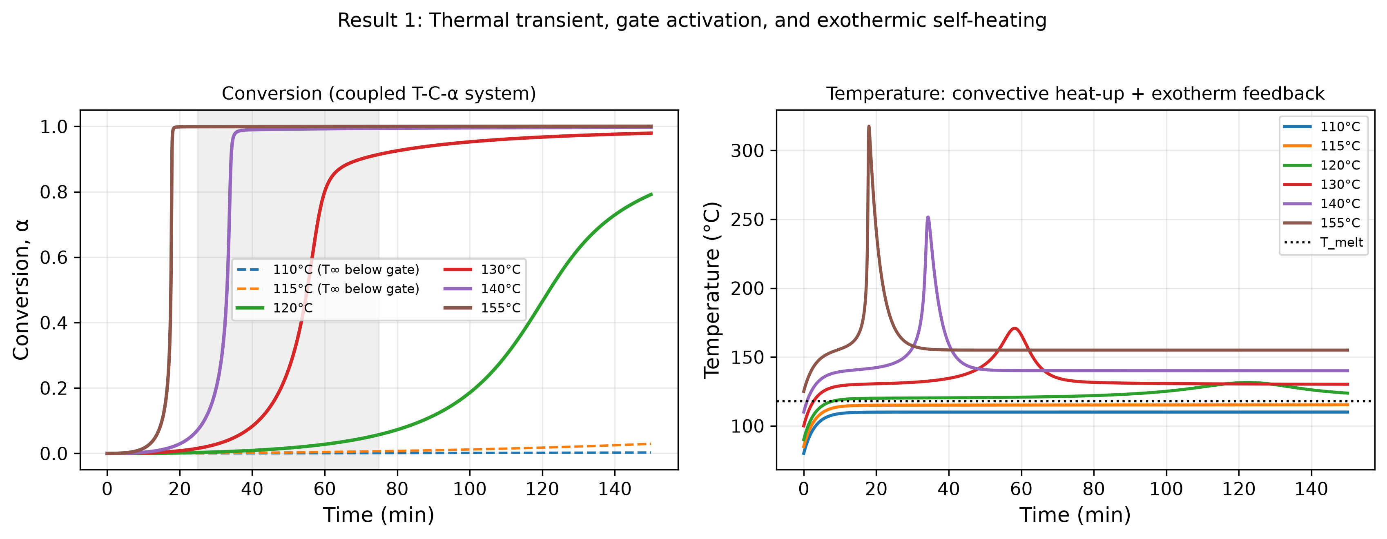
Figure 1. Conversion (left) and temperature (right) vs. time at six T∞ values.
Unlike the earlier draft's instantaneous-temperature-step assumption, the fluid element here starts 30°C below T∞ and heats convectively (τ_thermal = 3.0 min), with additional self-heating once the reaction ignites. Below T_melt, conversion remains at zero to numerical precision (max α over 150 min at T∞=115°C, 3°C below T_melt = 118°C: 4.2×10⁻²⁸) — the structural result of Section 2.4, not an independent prediction. Above it, conversion follows a sigmoidal curve whose onset and steepness both decrease with increasing T∞, now correctly reflecting both the convective heat-up delay and the Arrhenius-accelerated kinetics.

4.2 Exothermic self-heating
At the reference operating point (T∞=140°C), peak temperature reaches 251.7°C — an overshoot of 111.7°C above setpoint — a direct, physically necessary consequence of coupling the energy balance to the reaction (Section 2.1), and a genuinely new prediction relative to the earlier isothermal draft, which could not represent this effect at all. The overshoot arises because the reaction's exothermic heating rate (ΔT_ad·dα/dt) peaks sharply near the transition midpoint while convective cooling scales only with the instantaneous overshoot itself, so a genuine thermal-runaway risk can occur even when Θ_ref<1 (thermal relaxation nominally faster than reaction). Whether a given overshoot magnitude is acceptable depends on the specific material's thermal-degradation limit, which is outside this paper's scope (Section 6).

4.3 Autocatalysis sharpens the transition vs. an objectively matched first-order control
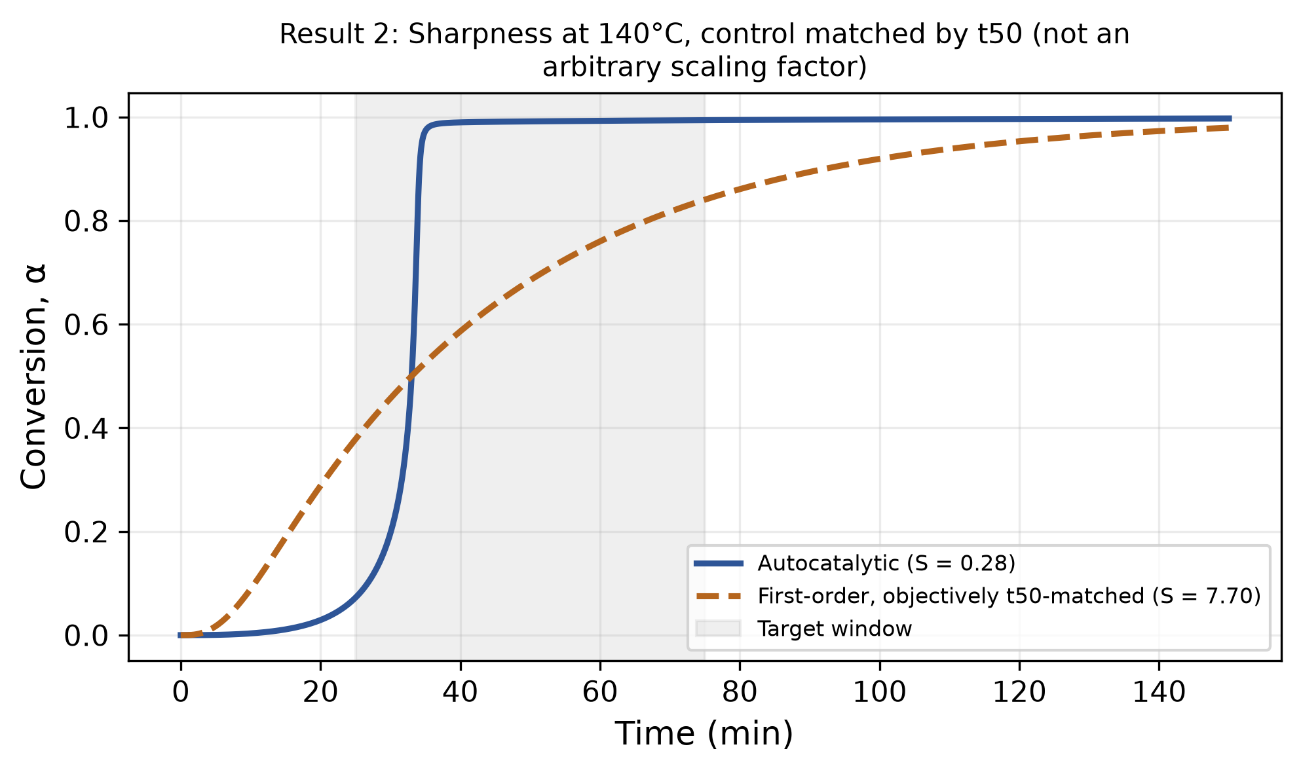
Figure 2. Coupled autocatalytic system vs. objectively t50-matched first-order control.
Rather than scaling the first-order control's rate constant by an assumed factor (as in the earlier draft), k_first is root-solved (scipy.optimize.brentq) so the two systems reach t50 at the identical time (33.05 min) under otherwise identical thermal/release conditions. The solved k_first = 0.0272 min⁻¹, 18.0% of the reference autocatalytic rate constant k2_ref — an objectively determined value, not an assumed 55% scaling factor as in the earlier draft. At matched t50, the two systems diverge sharply in shape: the autocatalytic system reaches t10=26.75 min and t90=34.20 min (S=0.279, a sharp transition), while the first-order control reaches t10=10.60 min and t90=92.20 min (S=7.70) — premature onset nearly 16 minutes earlier and completion over 58 minutes later.
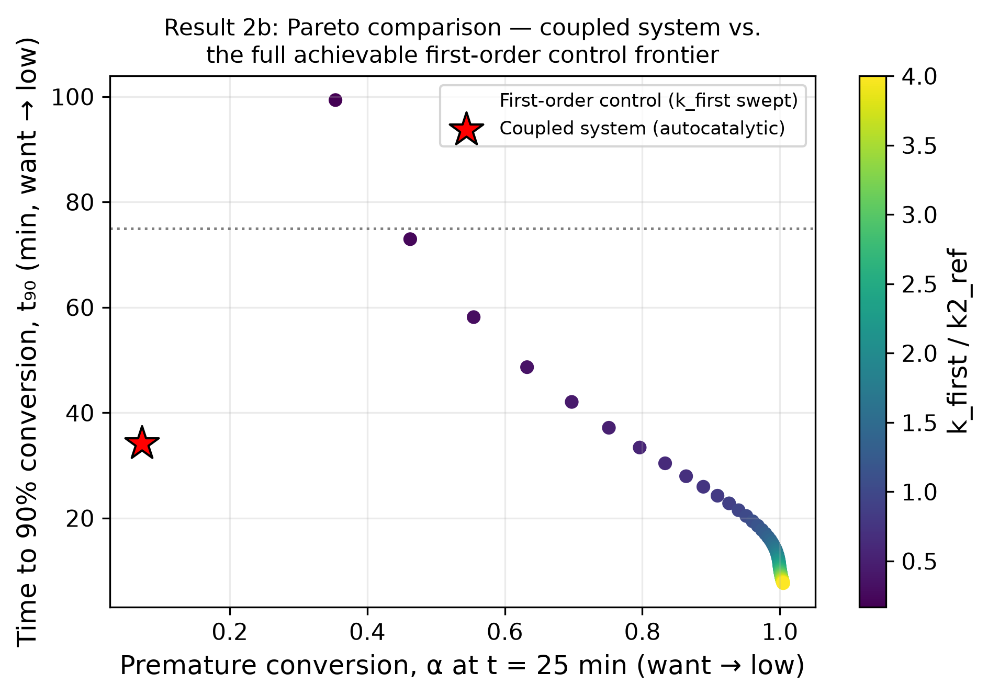
Figure 2b. Pareto sweep: coupled system operating point vs. 60 sampled first-order controls.
This is followed by a full Pareto sweep over 60 sampled first-order rate constants spanning 0.1×–4.0× k2_ref: the coupled (autocatalytic) system's operating point (α at t=25 min = 0.072, t90=34.20 min) is beaten on both axes simultaneously by 0/60 sampled first-order controls — i.e., it is Pareto-optimal / non-dominated in this comparison space — while the coupled point in turn dominates 6/60 of the sampled controls. This directly answers the synergy-demonstration concern with a comparison that cannot be tuned by the choice of a single scaling factor.

4.4 Full system comparison (A–D), objectively matched
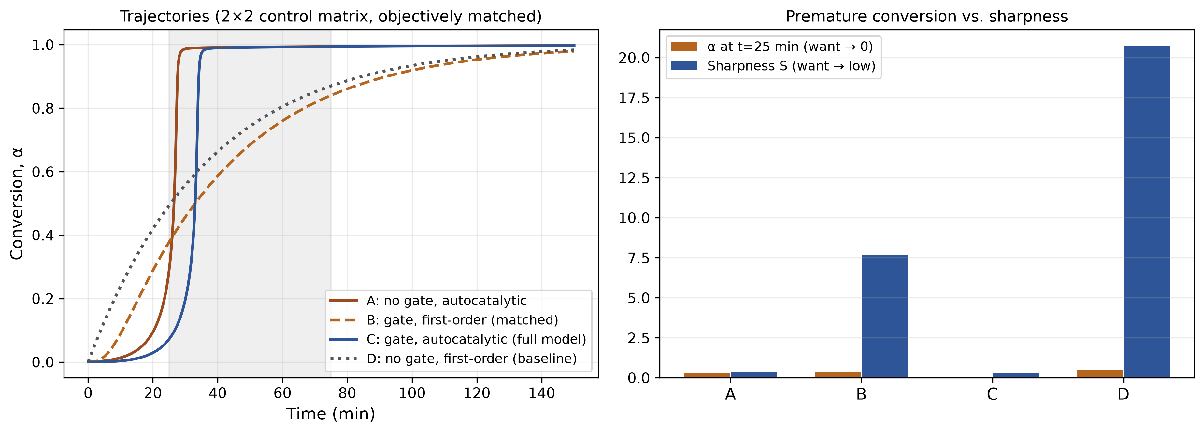
Figure 3. Premature conversion and transition sharpness across four system variants (A–D).
System | Description | α (t=25 min) | S
A | No gate, autocatalytic | 0.289 | 0.362
B | Gate, first-order (matched) | 0.378 | 7.698
C | Gate, autocatalytic (full coupled model) | 0.072 | 0.279
D | No gate, first-order (conventional baseline) | 0.493 | 20.705
As in the earlier draft, System C (gated, autocatalytic — the full coupled model) dominates on both metrics, achieving both the lowest premature conversion and the sharpest transition of the four; System D (no gate, first-order — the conventional baseline) is worst on both. The non-additive ranking is preserved under the new, objectively matched control: System B (gated, first-order) has higher premature conversion at t=25 min than System A (no gate, autocatalytic), confirming that gating alone, without autocatalytic kinetics, is insufficient — both mechanisms are required jointly.

4.5 Regime map over (Θ, Λ)
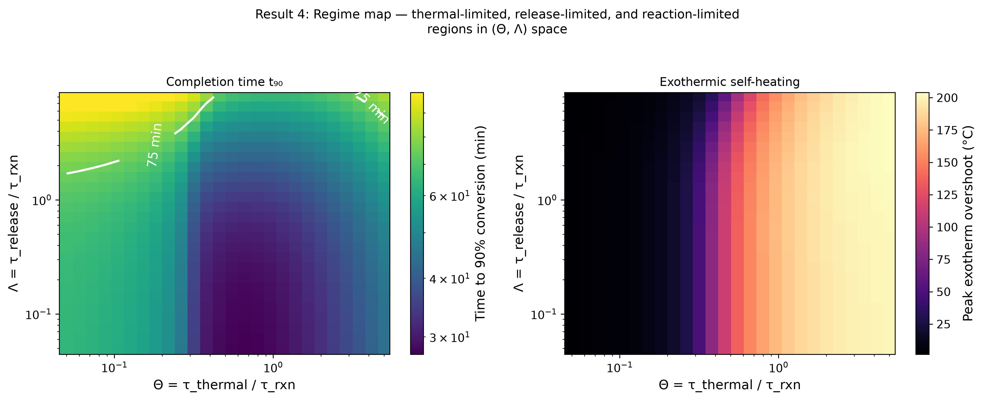
Figure 4. Regime map: t90 (left) and exothermic overshoot (right) over the (Θ, Λ) plane.
Across a 26×26 log-spaced grid spanning Θ∈[0.05, 5.0] and Λ∈[0.05, 8.0], the 75-minute completion target (t90≤75 min) is missed in 3.1% of the Θ>2 (thermal-limited) region but 37.9% of the Λ>2 (release-limited) region — release-limited behavior is the more common failure mode at this parameter range, though the thermal-limited region carries the largest exothermic risk, with peak overshoot across the map reaching 204.1°C (at Θ=5.00, Λ=5.33). The map identifies three qualitative regions: a reaction-limited region (Θ, Λ both small — thermal and release processes are fast relative to reaction, closely recovering the earlier draft's isothermal, instantaneous-release limit), a release-limited region (Λ large, the dominant source of missed-target failures here), and a thermal-limited region (Θ large, where the target is occasionally missed but exothermic overshoot is most severe). This directly demonstrates that no single ratio organizes this system; the coupled behavior depends on the joint value of at least two independent timescale ratios, and which ratio dominates failure risk is itself parameter-range dependent.

4.5b Relative sharpness and absolute timing diverge at large Λ
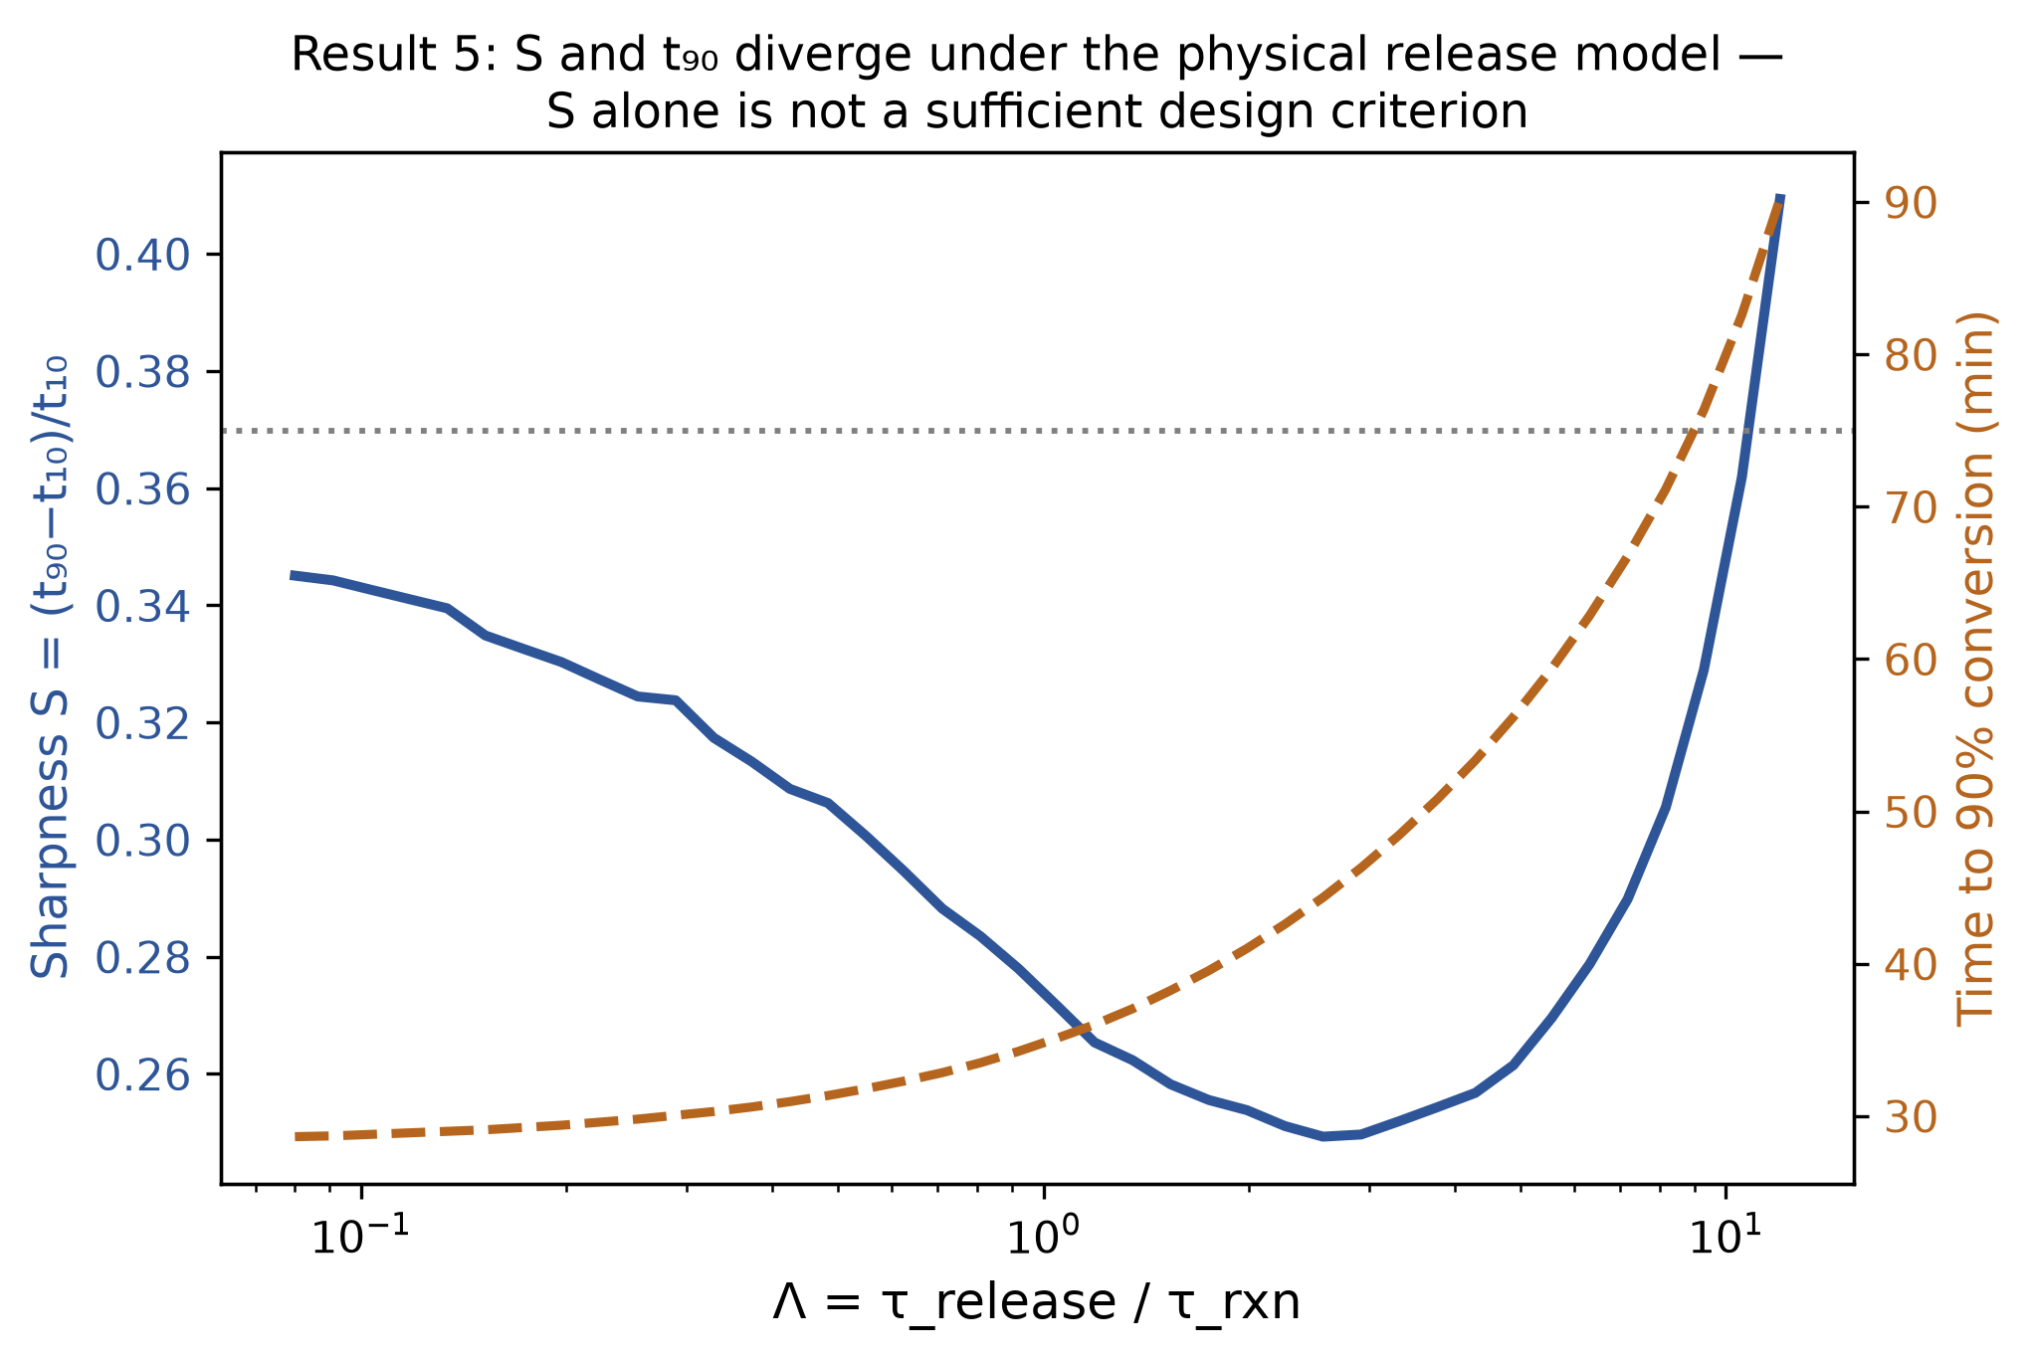
Figure 5. S and t90 vs. Λ, dual axis.
Swept over Λ∈[0.08, 12.0] (40 log-spaced points), S changes only mildly — rising from 0.35 at Λ=0.08 to 0.41 at Λ=12.0 — while t90 grows without bound, crossing the 75-minute target at Λ≈9.28. Under the physical (Arrhenius-relaxation) release model, S therefore does not provide an early warning of the completion-time failure: a nearly stable, even mildly worsening S value coexists with an absolute completion time that eventually blows past any practical target. This is a more cautionary and physically grounded version of the divergence reported in the earlier draft's prescribed-gate model — here, the sharpness metric alone is shown to be an unreliable proxy for practical performance at large Λ, reinforcing the need to report both S and t90 (Section 2.3).

4.6 Finite-width thermal gate: the genuine falsifiable prediction
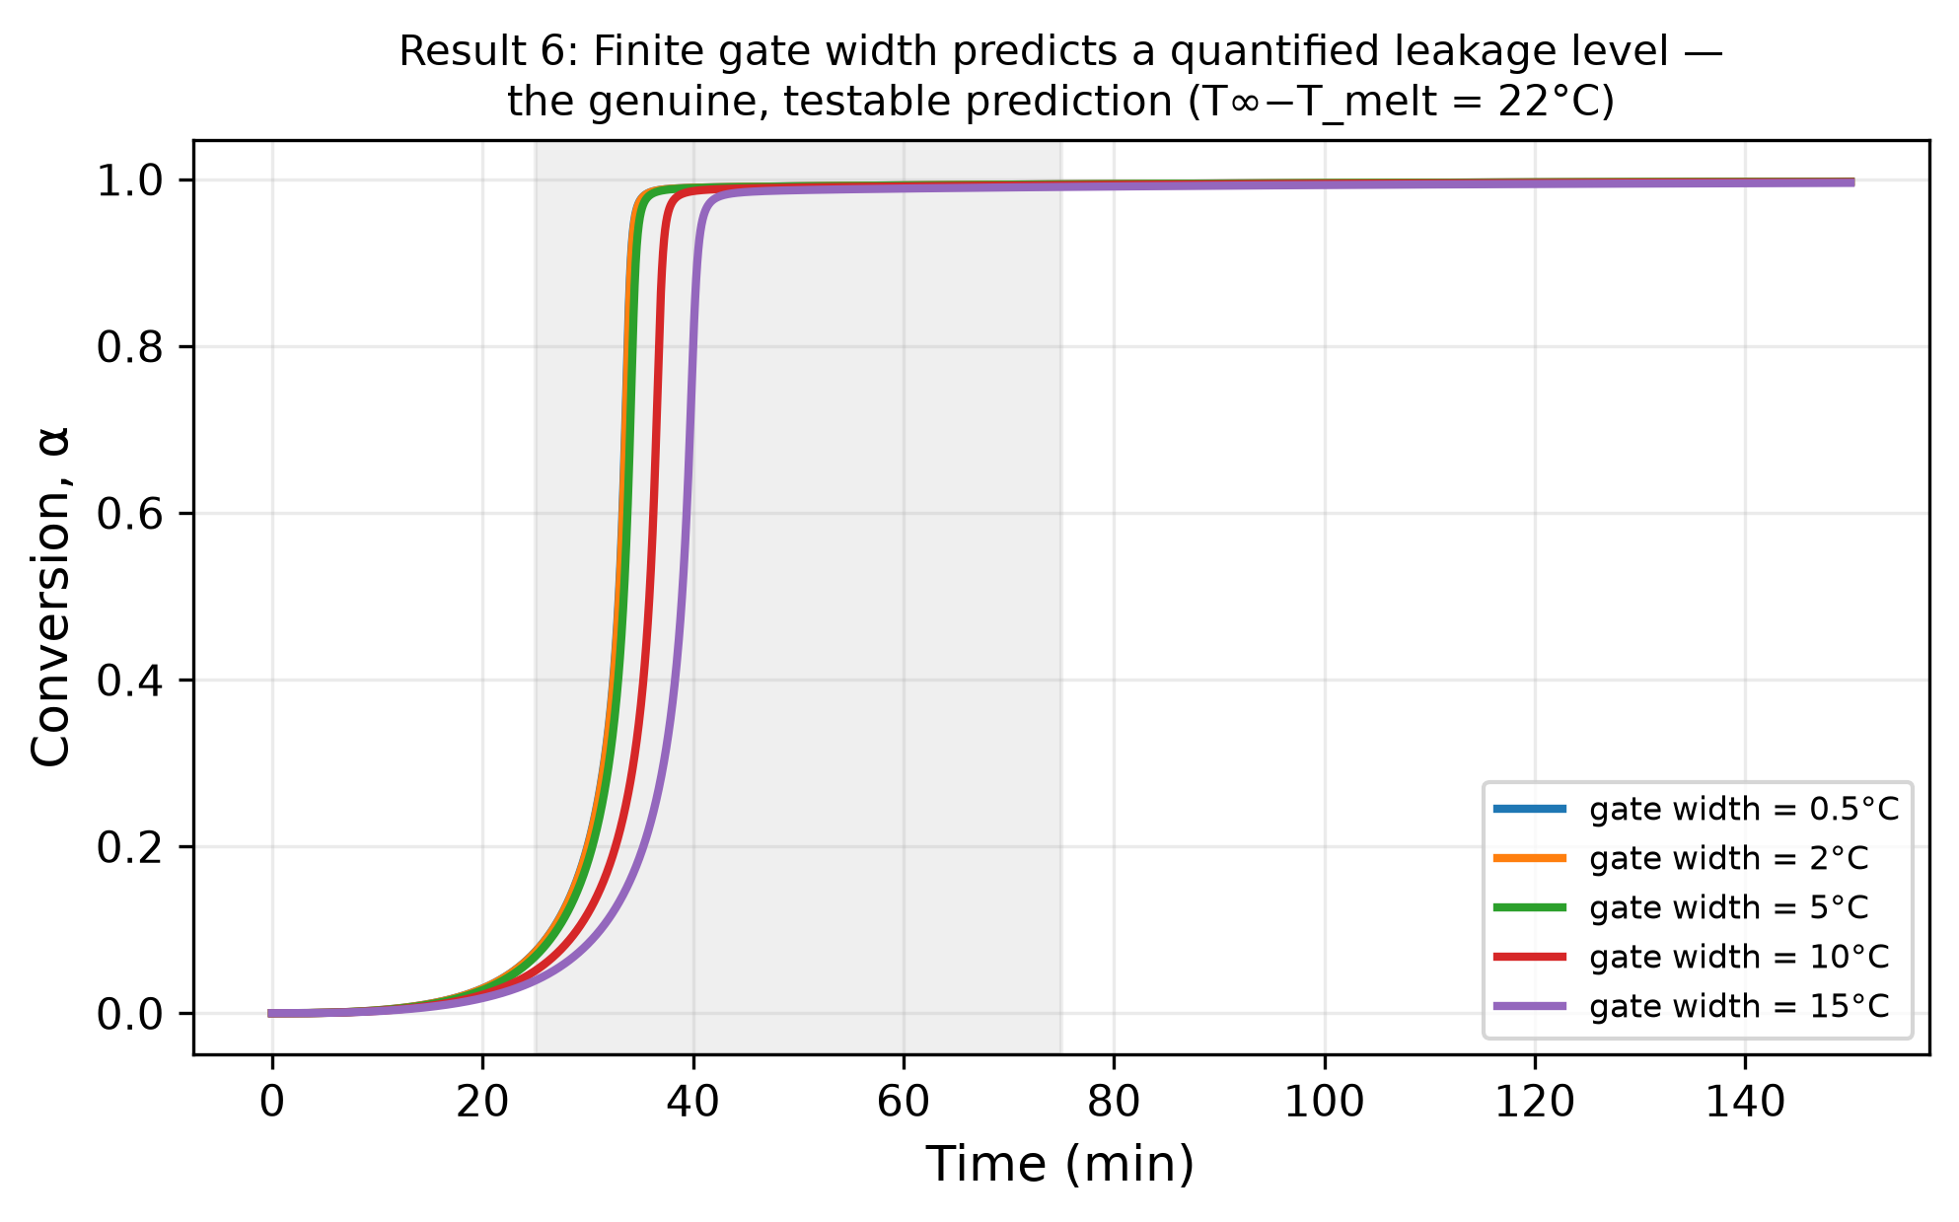
Figure 6. Premature conversion and t90 vs. gate width w; sub-threshold leakage vs. w.
Sweeping gate width w over {0.5, 2, 5, 10, 15}°C at the reference operating point, α at t=25 min falls monotonically from 0.073 (w=0.5°C) to 0.073, 0.068, 0.051, and 0.039 (w=15°C), while t90 rises from 34.1 min (w=0.5°C) to 34.2, 34.6, 37.1, and 40.4 min (w=15°C) — a genuine, monotonic trade-off, quantitatively predicted and directly testable. A companion sub-threshold-leakage sweep holds T∞=112°C, 6°C below the nominal T_melt=118°C, and reads α at t=150 min: leakage rises from 0.0 (w=0.5°C, indistinguishable from the idealized zero-width limit) to 0.0021, 0.0168, 0.0369, and 0.0483 (w=15°C) — confirming Prediction 1 (Section 7): sub-threshold conversion scales measurably with gate width rather than remaining exactly zero.

4.7 Robustness under joint parameter uncertainty (Monte Carlo)
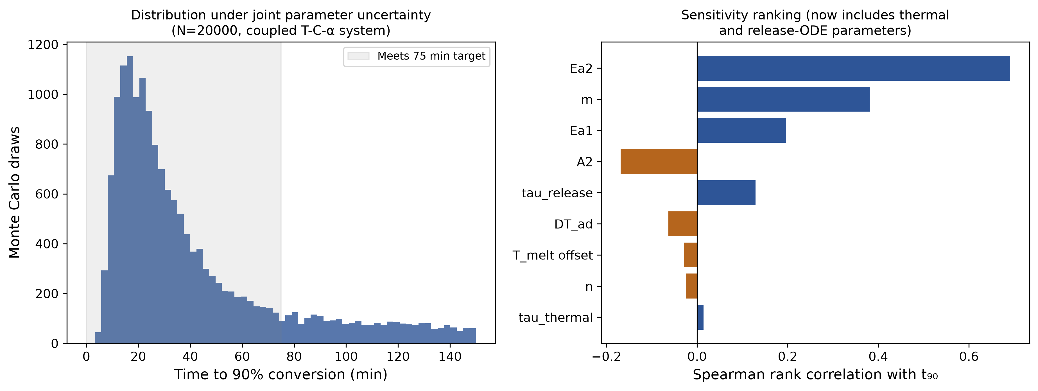
Figure 7. Monte Carlo distribution of t90 and Spearman sensitivity ranking (N=20,000).
Nine parameters — Ea1, Ea2, A2, m, n, melt-point offset, τ_release, τ_thermal, ΔT_ad — were propagated jointly via a fully vectorized fixed-step RK4 integration of the coupled 3-state ODE system across all draws simultaneously (N=20,000, dt=0.05 min). 69.9% of draws satisfy both a minimum induction time (t10≥5 min) and the 75-minute completion target; median t90 is 28.4 min (IQR 17.7–51.5 min). Spearman rank correlations with t90 show reaction-kinetics parameters dominate: Ea2 (r=0.693) and m (r=0.383) are the strongest drivers, followed by Ea1 (r=0.196) and A2 (r=−0.170); the thermal and release-ODE parameters newly introduced in this version contribute markedly less (τ_release r=0.132, ΔT_ad r=−0.067, τ_thermal r=0.013), and n and the melt-point offset are essentially uncorrelated with t90 (r=−0.024, r=−0.028). This reinforces the recommendation to prioritize kinetic characterization (dynamic DSC) in an experimental program.

4.8 Note on mechanical-function and spatial-transport extensions
The conversion kinetics developed here could in principle be coupled to a micromechanical strength model, or extended to a spatially resolved (CFD) flow geometry. Both are outside this paper's 0D thermal/kinetic scope; neither is developed or evaluated in this manuscript, and no application-specific performance claim should be inferred for either extension (Section 6).

5. Discussion
The central computational finding is that thermal activation and autocatalytic kinetics are complementary, not redundant, and that this synergy is demonstrated by an objective (Pareto) comparison rather than a scaling assumption (Section 4.3). The coupled system's behavior is organized by at least two independent dimensionless timescale ratios (Θ, Λ), not one (Section 4.5); a favorable Λ/S combination does not guarantee practical performance if Θ is unfavorable, and vice versa. A non-ideal, finite-width thermal gate trades reduced premature conversion against slower completion (Section 4.6) — the paper's primary falsifiable claim.
This is a statement about the coupled kinetic structure of thermally activated, autocatalytically reactive systems generally. Potential relevance to phase-change thermal storage, thermally triggered reactive coatings, or self-healing materials is noted here only as an illustrative, unvalidated direction for future work — each would require its own material-specific parameterization and experimental validation before any performance claim could be made, and none is claimed here.

6. Limitations
- All kinetic, thermal, and release parameters are illustrative and literature-informed, not fitted to any measured system.
- The release relaxation (Section 2.1) is a lumped first-order Arrhenius analog to shell-diffusion/melt-controlled release, not a solved Fickian shell-diffusion PDE; a spatially resolved release model is a direction for follow-on work.
- The thermal model is a lumped (0D), single-fluid-element energy balance; it does not resolve spatial temperature or concentration gradients, flow/residence-time distributions, or shear heating in an actual flowing medium — this is a deliberate scope choice (Section 1), not an oversight, and is the paper's stated boundary for follow-on 3D/CFD extension.
- The mechanical-function extension (Section 4.8) is noted but not developed.
- ψ (Section 2.2) is used descriptively via direct simulation of the regime map (Section 4.5), not via a closed-form critical-value criterion; the classical thermal-explosion critical-ψ results (Semenov, Frank-Kamenetskii) assume simple slab/sphere/infinite-cylinder geometries that do not directly apply to this lumped, well-mixed formulation.

7. Falsifiable Predictions and Validation Protocols
Prediction 1: For a real material with a finite activation width w, sub-threshold conversion below the nominal activation temperature should scale measurably with w — approaching (but not reaching) zero only as w→0 — rather than the exactly-zero behavior of an idealized step gate.
Validation protocol: isothermal DSC holds at several temperatures spanning the nominal activation range, comparing sub-threshold heat-flow integration against the width predicted from the material's own melting/activation-temperature distribution (e.g., by DSC melting endotherm width).
Prediction 2: Once the activation threshold is exceeded, conversion should follow a measurably sharper (lower-S) transition than an objectively rate-matched first-order or diffusion-controlled reference reaction subject to the same thermal-gate protocol.
Validation protocol: dynamic-ramp DSC compared against a non-autocatalytic reference formulation, both under an identical thermal protocol, with the reference's rate constant matched by t50 (not assumed) as in Section 4.3; rheo-DSC to additionally capture the fluid-to-solid viscoelastic transition.
Prediction 3: Increasing the release timescale relative to the reaction timescale (Λ) beyond a system-specific threshold causes the absolute transformation time to exceed a practical target window even as S continues to appear favorable.
Validation protocol: a τ_release sweep (via systematic variation of encapsulation/barrier thickness or permeability) with paired measurement of S and absolute t90 by dynamic DSC.

8. Computational Methods
All results were produced by a single Python script (theoretical_study.py) using NumPy, SciPy (solve_ivp for adaptive integration, optimize.brentq for root-finding, stats.rankdata for Spearman sensitivity), and Matplotlib for figure generation. Production trajectories use scipy.integrate.solve_ivp with method="RK45", max_step=0.5 min, rtol=1e-8, atol=1e-10, and dense_output=True; crossing times (t10, t50, t90) are read from the resulting dense-output interpolant. Fixed-step convergence checks (Section 3.2) implement explicit Euler and classical 4-stage Runge-Kutta directly. Monte Carlo propagation (Section 4.7) uses a fully vectorized fixed-step RK4 integrator operating on length-20,000 NumPy arrays simultaneously, rather than 20,000 independent adaptive-solver calls, for tractable runtime. The complete code, including every figure-generation routine, is available at the repository cited in Section 9; running it reproduces every quantitative result and figure in this manuscript.

9. Data and Code Availability
The complete integration, sweep, Monte Carlo, and figure-generation code is provided as open-source software at https://github.com/sandlerleon/autolatch-thermal-gating (MIT license) and archived with a permanent, version-tracking concept DOI on Zenodo: https://doi.org/10.5281/zenodo.22073392 (always resolves to the latest code version). The manuscript itself is additionally archived as a preprint on Zenodo: https://doi.org/10.5281/zenodo.22073390 (concept DOI, always resolves to the latest version), and posted to ChemRxiv: [ChemRxiv DOI to be inserted by the author upon posting].

References
Kamal, M. R.; Sourour, S. Kinetics and thermal characterization of thermoset cure. Polymer Engineering & Science 1973, 13(1), 59–64.
Bashir, M. A. A review on epoxy resin curing kinetics and thermal analysis. Polymers 2023, 15(15), 3251.
Ryshkewitch, E. Compression strength of porous sintered alumina and zirconia. Journal of the American Ceramic Society 1953, 36(2), 65–68.
Zhang, X. et al. Microencapsulated phase-change materials for thermal energy storage: a review. Applied Thermal Engineering 2020, 165, 114567.
Gou, J. et al. Encapsulation and thermally triggered release of catalytic agents in curable resins: a review. Progress in Polymer Science 2021, 112, 101324.

