Toward transparent rigid packaging from sugarcane bagasse: a consistency-testing framework for nanocellulose–chitosan sheets
Leon Sandler
Independent Researcher, Northbrook, Illinois, USA
ORCID: https://orcid.org/0009-0007-4584-808X
Corresponding author: sandler.leon@gmail.com
Manuscript prepared for submission to Cellulose (Springer). A theoretical and computational study: no experiments were performed, and every output is a screening estimate, not a measured or predicted material property.

Abstract
Transparent rigid packaging is dominated by fossil-derived polymers, whereas fibre-based packaging is opaque. Dense cellulose nanofibril (CNF) and nanocrystal sheets are transparent as flat films, but whether transparency, wet stiffness and a three-dimensional shape can coexist in one sugarcane-bagasse-derived package has not been established, and the one reported attempt to mould transparent CNF objects failed through drying shrinkage. This paper reports no experiments. It applies three consistency screens to a proposed bagasse CNF–chitosan–wax architecture: an optical screen derived from Debye–Bueche scattering theory, a wet-stiffness screen, and a geometric forming screen, each propagated through a seeded Monte Carlo analysis over ranges taken from verified literature or stated as assumptions. Haze rises with wall thickness and with the cube of the void-structure correlation length: a 100 µm wall at 10% haze and 5% voids requires a correlation length of 10 nm or less. Chitosan raises modelled wet stiffness mainly through cross-linking (median gain +1.1 GPa with it, -0.1 GPa without) and the benefit disappears in an acidic liquid. Geometry sets the forming burden: tray, bowl and cup shapes need total strain tolerances of 0.26, 0.67 and 1.10, and no combination of the assumed ranges forms the cup (best case 0.96). The framework yields measurable thresholds and a staged validation matrix.
Keywords cellulose nanofibrils; transparent nanopaper; chitosan; sugarcane bagasse; thermoforming; consistency testing

1 Introduction
Transparent rigid packaging is dominated by polyethylene terephthalate and, increasingly, polylactic acid, chosen largely because they combine clarity, stiffness and liquid tightness. Fibre-based alternatives address material origin; moulded pulp, increasingly made from bagasse, wheat and bamboo rather than wood, is an established example (Semple et al. 2022). Fibre-based packaging is opaque, however, and the reason is structural: ordinary paper and cellulose nanopaper consist of the same chemical constituents, and the difference lies in the fibre width and the size of the interstitial cavities that scatter light (Nogi et al. 2009).
Densifying nanofibrils removes that scattering. Films of TEMPO-oxidised cellulose nanofibrils only 3–4 nm wide are transparent and flexible (Fukuzumi et al. 2009), and clear nanopaper 40 µm thick has been reported with a total transmittance of 89.3–91.5% and a haze of 4.9–11.7% at a density of 1.29–1.55 g cm⁻³ (Hsieh et al. 2017). Haze can be tuned by mixing fibre scales (Fang et al. 2014; Yang et al. 2019), and hybrid nanofibril–nanocrystal paper reached a direct transmittance of 75.1% with 10.0% haze, against 31.1% and 62.0% for earlier nanopaper (Xu et al. 2016). Transparency survived tens of minutes at 150 °C in flat nanopaper (Nogi et al. 2013), and nanopaper made from sugarcane bagasse nanocrystals has been reported at 91% transmittance and 1.4% haze (Tao et al. 2017). Reviews cover the field (Isogai et al. 2011; Klemm et al. 2011; Moon et al. 2011; Zhu et al. 2014).
Several problems stand between these flat films and a rigid package. Maintaining mechanical properties under hydrated conditions is a recognised and often overlooked challenge for nanocelluloses (Toivonen et al. 2015), and a liquid barrier must be added without reintroducing haze (Lavoine et al. 2012; Azeredo et al. 2017; Hubbe et al. 2017). CNF films are brittle and not thermoplastic, with no clear softening point; thermal roll-to-roll imprinting could pattern them at the micrometre scale only with a softener present (Mäkelä et al. 2016). At the scale of a package the evidence is thinner and more discouraging. Wet moulding of CNF mats into three-dimensional objects was feasible, but because of shrinkage during drying none of the formation or drying routes tried yielded transparent and dimensionally stable objects (Rol et al. 2020), and deep drawing of paperboard is regarded as a sensitive process with many failure mechanisms (Hauptmann and Majschak 2011; Vishtal and Retulainen 2012). Nanofibrillation is also energy-intensive (Arvidsson et al. 2015; Kargupta et al. 2022).
The knowledge gap is therefore integration. Each property has been demonstrated, mostly on flat films and mostly separately; whether transparency, wet stiffness, barrier performance and a three-dimensional shape can be held together in a single agricultural-residue-derived wall is not established, and the published attempt to form one failed.
This paper asks that question as a consistency test. Each requirement is checked against what the literature supports or against a physical bound, the answer is allowed to be no, and the checks are propagated through the uncertainty that remains. The contribution is the framework and what it returns, not a material: (i) an optical screen whose scattering prefactor is derived from theory rather than fitted, with the haze budget it implies for a wall of given thickness; (ii) a wet-stiffness screen showing what determines whether chitosan helps, including in an acidic liquid; (iii) a forming screen showing that geometry fixes a strain budget independent of the material model; (iv) a ranking of the unknowns that most influence each outcome, so that the first measurements are the informative ones; and (v) falsifiable predictions and a validation matrix with numerical thresholds. No experiments were performed. Every parameter is either taken from a cited source or stated as an assumption, and the assumptions are listed (Table 3).

2 Hypotheses, research questions and status of evidence
Four hypotheses organise the analysis; each is stated so that it can fail.
- H1 (feedstock). Bagasse-derived nanocellulose can form a dense sheet whose void fraction and correlation length meet the haze budget of a rigid wall. It fails if bagasse nanofibril sheets exceed that budget.
- H2 (chitosan). Chitosan raises wet stiffness without optical loss, in the liquid the package is meant to hold. It fails if the wet gain is zero or negative in an acidic liquid, or if haze rises.
- H3 (barrier). A sub-micron natural wax layer gives liquid containment without added haze. It is not modelled here and is carried into the validation matrix.
- H4 (forming). The strain budget of the target geometry lies inside the strain the sheet tolerates. It fails for geometries whose budget exceeds the sum of the tolerated tensile and compressive strains.
These map onto five research questions. RQ1 Can densified bagasse-derived nanocellulose plausibly reach the optical properties a transparent wall requires? RQ2 Can chitosan improve wet performance without optical loss? RQ3 Can a thin hydrophobic layer give moisture resistance while preserving transparency? RQ4 What mechanisms limit forming, and which geometries survive them? RQ5 Which measurements are required to decide viability?
Every statement below carries one of four labels. Established means taken from a cited source. Computed means produced by the model in this paper under stated assumptions. Predicted means a falsifiable consequence of the computation. Unvalidated means not tested by anyone to the author’s knowledge. Table 2 applies these labels.

3 Proposed material architecture
The architecture (Fig. 1) is the author’s conceptual integration of separately published elements, not a description of an existing material. Sugarcane bagasse is fibrillated to nanofibrils, densified into a transparent sheet, combined with chitosan for wet integrity, coated with a thin hydrophobic layer, and formed into a package. Three consistency tests gate the chain: optical after densification, wet-mechanical after chitosan, and forming at the shaping step.
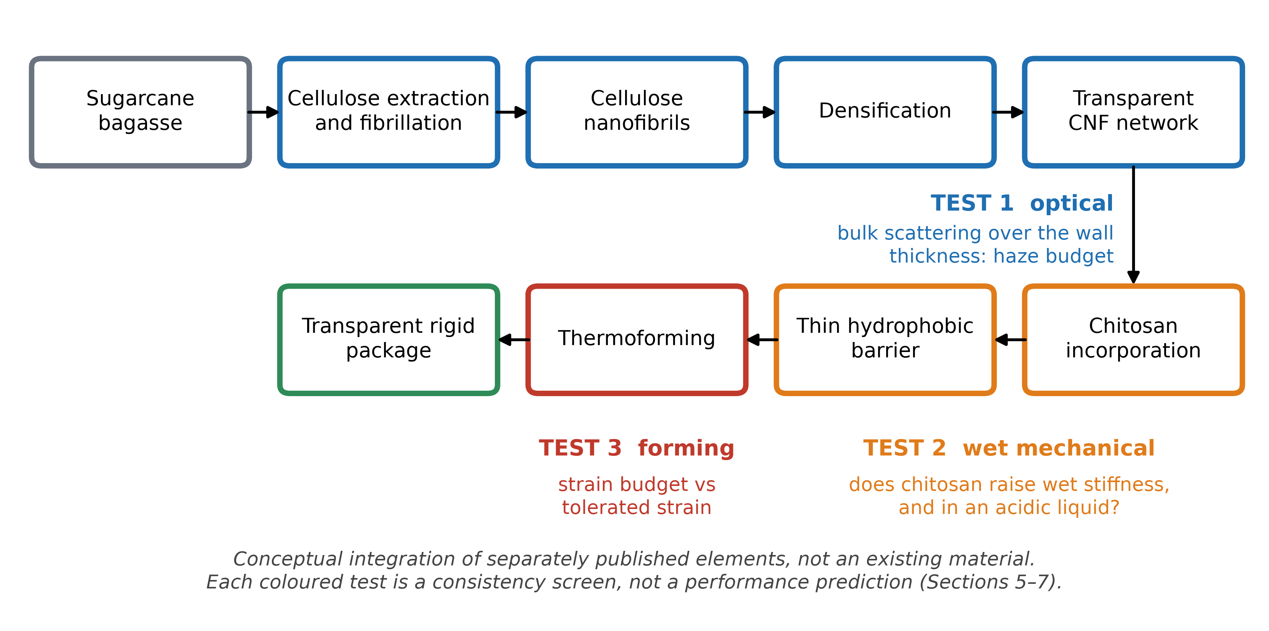
Fig. 1 Proposed processing chain and the three consistency tests that gate it. The diagram is a conceptual integration of separately published elements, not an existing installation.

3.1 Bagasse-derived nanocellulose
World sugarcane production was 1,921 Mt in 2022 (FAO 2024). Bagasse is the fibrous residue after juice extraction, produced in very large volumes and traditionally burned for energy (Kabeyi and Olanrewaju 2023; Ndikumana et al. 2025). Its composition, about 42% cellulose, 25% hemicellulose and 20% lignin (Kim and Day 2011), means that delignification and bleaching bear directly on colour and haze, and residual lignin has been shown to affect the production and properties of TEMPO-oxidised nanofibrils from partially delignified bagasse (Scopel et al. 2025). Nanocellulose has been isolated from bagasse by several routes (Bhattacharya et al. 2008; Mandal and Chakrabarty 2011); oxidised nanofibrils produced by microfluidisation measured 5–80 nm in diameter (Carneiro Pessan et al. 2023), and TEMPO-oxidised bagasse nanofibrils 150–600 nm long have been used to reinforce films (Otenda et al. 2022). Reviews note that nanostructure synthesis from bagasse still lacks high yields and the ability to scale up (Hiranobe et al. 2024). TEMPO-mediated oxidation of native cellulose is the route that gave the thin, uniform nanofibres behind the clear films above (Saito et al. 2007; Fukuzumi et al. 2009), and higher fibril aspect ratios have been reported to give stiffer and more ductile networks (Sellman et al. 2024), which makes the length distribution of bagasse nanofibrils a relevant unknown.
The feedstock evidence is mixed in a way that defines H1. Nanopaper from bagasse nanocrystals is reported at 91% transmittance and 1.4% haze (Tao et al. 2017), so bagasse can give a clear sheet. An agricultural-residue analogue prepared as nanofibrils, rice straw, gave films of only 13–42% transmittance (Jiang et al. 2016). No optical data for transparent sheets made from bagasse nanofibrils were found (Supplementary Information S4). The open question is therefore not whether bagasse can give a clear sheet, but whether bagasse nanofibrils, or a hybrid, keep the clarity at the thickness a rigid wall needs, and whether a sheet made of the stiffer, less entangled nanocrystals tolerates forming; the latter is an expectation, not a cited result.

3.2 Densified network
Scattering from a fibril and void network falls as the fibril width and the void fraction fall, because refractive-index contrast is then confined to features much smaller than the wavelength (Nogi et al. 2009; Fukuzumi et al. 2013). Haze in clear nanopaper has been attributed to compressed cavities in residual micro-sized fibres (Hsieh et al. 2017). The thermal stability of flat nanopaper at 150 °C (Nogi et al. 2013) is relevant to hot-liquid service but is not established for a formed wall. Higher strain to failure has been reported for porous nanopaper, 17% at a modulus of 1.4 GPa and 56% porosity (Sehaqui et al. 2011), with large strains attributed to slippage between fibrils (Henriksson et al. 2008); the mechanical property space of nanofibril sheets is reviewed in (Benítez and Walther 2017). Porosity of that order would defeat the haze budget derived below (Table 4), so ductility and clarity pull in opposite directions; this is an inference from the present screens, not a published result.

3.3 Chitosan reinforcement
Chitosan chemistry and solubility are reviewed in (Rinaudo 2006; Pillai et al. 2009). Chitosan is water-insoluble but dissolves in acidic solutions (Melro et al. 2021). It is made commercially from shellfish waste, and fungal sources are being explored as an alternative (Ghormade et al. 2017); the regulatory status of any chitosan for food contact is jurisdiction-specific and is not assessed here. Chitosan films are reported to be highly transparent (Sirviö et al. 2021) and neat films have a modulus of 2.3–3.4 GPa with an elongation above 13% (Fernández-Marín et al. 2024). The decisive precedent is physical cross-linking of nanofibrils with chitosan: films of 80/20 CNF/chitosan reached 70–90% transmittance, and when water-soaked retained a strength of 100 MPa, a strain of 28% and a modulus of 4 GPa at 0.5% strain, against 200 MPa and 8% at 50% relative humidity when dry (Toivonen et al. 2015). The mechanism is a pH switch: chitosan is processed dissolved at low pH, then raising the pH reduces its hydration and promotes multivalent interaction with the fibrils. That is also the vulnerability, since the cross-linking depends on a neutral or alkaline environment. A second precedent cuts the other way: adding chitosan lowered the modulus of carrot nanofibre films from 14.71 to 8.76 GPa at 5 wt% (Szymańska-Chargot et al. 2019). Chitosan can therefore help or hurt, and the sign depends on the interface. In the reverse arrangement, with CNF as the filler in chitosan films, tensile properties were optimised at 15 g of CNF per 100 g (Azeredo et al. 2010).

3.4 Hydrophobic barrier
A sub-micron natural wax layer is proposed. Its thickness is far below the scattering scale, so little added haze is expected, but this is inferred. Oxygen and oil barrier properties of microfibrillated cellulose films and coatings (Aulin et al. 2010) and reactive hydrophobisation of CNF films to lower water-vapour permeability (Li et al. 2019) are the closest precedents for the barrier function. Hydrophobisation of transparent TEMPO-oxidised films has been achieved with alkylketene dimer (Fukuzumi et al. 2009), carnauba wax coatings have given water contact angles above 140° on paper, although with nanoparticles and on an opaque substrate (Wang et al. 2017), and ionic cross-linking offers an alternative route to water resistance (Shimizu et al. 2016). A contact angle is not a liquid-holding test, and extended hot or cold containment is untested.

4 Evidence status
Table 1 sets out the published evidence and the uncertainty that remains for each requirement. Table 2 classifies every claim used here.
Table 1 Published evidence for each requirement of the proposed architecture and what remains uncertain.
Requirement | Published evidence | Status | Remaining uncertainty
Transparency, flat film | 89.3–91.5% total transmittance at 40 µm (wood-pulp CNF) (Hsieh et al. 2017); 91% with 1.4% haze from bagasse nanocrystals (Tao et al. 2017) | Established | Bagasse nanofibril sheets; thickness of a rigid wall
Low haze | 4.9–11.7% at 40 µm (Hsieh et al. 2017); 10.0% haze, 75.1% direct transmittance, hybrid (Xu et al. 2016) | Established | Haze versus thickness; haze after forming
Residue-derived CNF | Rice-straw CNF films 13–42% transmittance (Jiang et al. 2016); bagasse CNF characterised, no clear sheet reported (Otenda et al. 2022; Carneiro Pessan et al. 2023) | Mixed | Whether bagasse CNF meets the haze budget (H1)
Thermal stability | Transparency kept after tens of minutes at 150 °C, flat film (Nogi et al. 2013) | Established | Formed wall; hot-liquid service
Chitosan transparency | 70–90% transmittance in CNF/chitosan 80/20 (Toivonen et al. 2015) | Established | Haze; other loadings
Wet stiffness | Wet 80/20 films: 100 MPa, 28% strain, 4 GPa (Toivonen et al. 2015); chitosan lowered modulus elsewhere (Szymańska-Chargot et al. 2019) | Established, conflicting | Acidic liquids; interface; long exposure (H2)
Hydrophobicity | AKD on transparent films (Fukuzumi et al. 2009); wax on opaque paper (Wang et al. 2017) | Precedent only | Transparent wax layer; liquid hold (H3)
Forming | Moulded CNF objects not transparent or stable (Rol et al. 2020); micropatterning only (Mäkelä et al. 2016) | Negative / absent | Any transparent formed wall (H4)
Impact resistance | No evidence found for thin dense nanofibril walls | Unvalidated | Filled-container drop

Table 2 Classification of the claims used in this paper.
Label | Examples
Established (cited) | Transparent, low-haze CNF and CNC nanopaper as flat films; wet-state CNF/chitosan integrity at neutral pH; chitosan dissolves in acid
Computed (this work) | Haze budget; angular correction to the cubic law; sign of the chitosan effect; strain budgets and forming windows; Monte Carlo shares and rankings
Predicted (this work) | Haze growing with thickness; chitosan benefit lost in acid; forming limited by flange tolerance rather than fracture (Section 8)
Assumed | 11 of the 19 parameter ranges (Table 3); the 10% haze and 1 GPa wet-stiffness requirements
Unvalidated | Any formed transparent wall; filled-cup drop; liquid containment; lid sealing; life-cycle impact; compostability of the finished structure

5 Screening framework
Three screens test the requirements of Table 1. They are screens in the strict sense: each either implements a physical bound or states a relation whose assumptions are listed, and none is fitted to the paper’s own data.

5.1 Test 1: optical
Light scattered by a dense nanofibril network is treated as scattering from refractive-index fluctuations in a random two-phase medium, a solid cellulose phase of index n_{c} with air voids of volume fraction φ. In the Born approximation with an exponential correlation function of length a, the framework of Debye and Bueche (Debye and Bueche 1949), applied to random porous solids by Debye, Anderson and Brumberger (Debye et al. 1957), gives a scattering coefficient that depends on thickness-independent structure alone. The direct (unscattered) fraction of light through a sheet of thickness t is
$T_{\text{d}}\text{ = }\text{exp}\left(\text{−}τ t\right)$ (1)
and the scattering coefficient, integrated over all angles for unpolarised light, is
$τ\text{ = }\frac{K f_{\text{m}} φ\left(\text{1}\text{ − }φ\right){\left(Δε\right)}^{\text{2}}a^{\text{3}} g}{λ^{\text{4}}}$ (2)
where Δε = n_{c}² − 1 is the permittivity contrast, λ the vacuum wavelength (550 nm throughout), f_{m} a morphology factor carrying the uncertainty about the real structure, and K = 64π⁴/3 ≈ 2.08×10³. K is derived, not fitted: it is the small-angle limit of the angular integral of the Debye–Bueche expression multiplied by the polarisation factor of unpolarised light. The factor g(a) is the exact angular integral relative to that limit and equals 1 when a is much smaller than the wavelength. It matters here. Table S1 of the Supplementary Information gives g(a); in brief g = 0.97 at 5 nm, 0.90 at 10 nm, 0.69 at 20 nm, 0.37 at 40 nm and 0.14 at 80 nm, so the closed cubic law is accurate to about 12% up to 10 nm but overestimates scattering 7.2 times at 80 nm, the top of the reported bagasse nanofibril range. The haze, defined as the transmitted light deviating by more than 2.5° (ASTM International 2021), follows from single scattering as
$H\text{ = }\frac{f_{\text{h}}\left(\text{1}\text{ − }{\text{e}}^{\text{−}τt}\right)}{{\text{e}}^{\text{−}τt}\text{ + }f_{\text{h}}\left(\text{1}\text{ − }{\text{e}}^{\text{−}τt}\right)}$ (3)
where f_{h} is the fraction of scattered light going forward beyond 2.5°, computed from the same angular integral (0.5 for small features). Surface reflection multiplies direct and diffuse light alike and cancels in the ratio. Eqs. (1)–(3) are valid for τt up to about 1; beyond that, repeated scattering raises the real haze, so values there are optimistic. Three limits should be stated plainly. The screen represents bulk scattering only: surface roughness and residual fibre fragments, which dominate haze in some nanopapers (Hsieh et al. 2017), are not represented, and absorption by residual lignin is omitted. The void fraction is derived from film density as φ = 1 − ρ_{f}/ρ_{w}, which makes it sensitive to the assumed wall density at the percent level. And Eq. (2) is a screening relation: it has not been validated against small-angle scattering from nanocellulose sheets, which is the measurement that would validate it.

5.2 Test 2: wet mechanical
The stiffness of a water-saturated CNF/chitosan sheet with chitosan mass fraction w is screened with a rule of mixtures in which each phase has its own moisture knockdown:
$E_{\text{wet}}\left(w\right)\text{ = }\left(\text{1}\text{ − }w\right)ψ\left(w\right)κ_{\text{C}}\left(w\right)E_{\text{C}}\text{ + }w κ_{\text{H}}E_{\text{H}}$ (4)
$κ_{\text{C}}\left(w\right)\text{ = }κ_{\text{C0}}\text{ + }ξ\left(w\right)\left(\text{1}\text{ − }κ_{\text{C0}}\right)$ (5)
$ξ\left(w\right)\text{ = }ξ_{\text{max}}\left(\text{1}\text{ − }\text{exp}\left(\text{−}\frac{w}{w^{\text{*}}}\right)\right)$ (6)
E_{C} and E_{H} are the dry moduli of the CNF and chitosan phases; κ_{C0} and κ_{H} their water-saturated retention; ψ(w) a dry network-efficiency factor that equals 1 at w = 0 and relaxes to a constant ψ with added chitosan, so that disruption of fibril contacts (as in (Szymańska-Chargot et al. 2019)) can be represented; and ξ(w) the gain in CNF-phase retention from physical cross-linking by chitosan (as in (Toivonen et al. 2015)). In an acidic liquid chitosan hydrates, so its own retention falls to a small value and the cross-linking gain is multiplied by a surviving fraction. Eq. (4) is a Voigt-type bound that assumes perfect load sharing, so it is optimistic; interfacial failure and the swelling of chitosan are not otherwise represented. A linear interpolation in hydration h between the dry and saturated states (Supplementary Information S2) gives the chitosan–moisture map of Fig. 3.

5.3 Test 3: forming
Forming a flat sheet into a package requires the sheet to supply the surface area of the package. For a frustum container with base diameter d_{b}, top diameter d_{t} and depth h the surface area is
$A_{\text{cup}}\text{ = }\frac{π{d_{\text{b}}}^{\text{2}}}{\text{4}}\text{ + }\frac{π\left(d_{\text{b}}\text{ + }d_{\text{t}}\right)}{\text{2}}\sqrt{h^{\text{2}}\text{ + }{\left(\frac{d_{\text{t}}\text{ − }d_{\text{b}}}{\text{2}}\right)}^{\text{2}}}$ (7)
and the mean equibiaxial strain the sheet would carry if all of that area came from stretching, relative to the base footprint, is the strain budget
$ε_{\text{b}}\text{ = }\frac{\text{1}}{\text{2}}\text{ln}\left(\frac{A_{\text{cup}}}{\frac{π{d_{\text{b}}}^{\text{2}}}{\text{4}}}\right)$ (8)
Because strain is never perfectly uniform, the peak strain is not below this mean, so it is a lower bound on what the sheet must tolerate. Material drawn in from the flange reduces the tensile burden at the cost of compressive strain ln(LDR) at the flange edge, where LDR = D₀/d_{b} is the limiting draw ratio of a blank of diameter D₀. The tensile strain the sheet may carry is limited by fracture or, if it comes first, by the onset of scattering voids, which is lower than fracture whenever the ratio r_{v} of void-onset strain to failure strain is below one:
$ε_{\text{crit}}\text{ = }\text{min}\left(\text{1}\text{,} r_{\text{v}}\right)\left(ε_{\text{f0}}\text{ + }Δ_{}ε_{\text{w}} h\right)$ (9)
with ε_{f0} the ambient failure strain, Δε_{w} its gain when water-saturated and h the hydration (0 ambient, 1 saturated). The analogy for ε_{void} is deformation-induced cavitation and stress whitening in semicrystalline polymers (Lyu et al. 2019); for nanocellulose it is an inference. Tensile strain falls with LDR as ε = ε_{b} − ln(LDR), and flange compression is limited by a wrinkling tolerance ε_{wr}, so a forming window LDR_{min} ≤ LDR ≤ LDR_{max}, with LDR_{min} = exp(ε_{b} − ε_{crit}) and LDR_{max} = exp(ε_{wr}), exists if and only if
$ε_{\text{crit}}\text{ + }ε_{\text{wr}}\text{ ≥ }ε_{\text{b}}$ (10)
Three reference geometries are used (Table 3 caption): a lid-like tray (base 100 mm, top 120 mm, depth 12 mm), a bowl (100, 150, 50 mm) and a drinking cup (55, 80, 90 mm). Eq. (10) is exact for the stated geometry; whether a sheet can actually be formed also depends on friction, drying shrinkage (Rol et al. 2020) and temperature, none of which are represented.

5.4 Uncertainty propagation
The 19 parameters of the screens are listed with their ranges and bases in Table 3; 8 are informed by a cited source and 11 are assumptions. Each was sampled independently and uniformly, or log-uniformly where the range spans an order of magnitude, for N = 200,000 samples with a fixed seed (20261002). Outputs were summarised by quantiles, by the share of samples meeting a requirement, and by Spearman rank correlation with the output, which identifies which unknown to measure first. The assumed requirements (haze of 5% or 10%, wet stiffness of 0.5, 1 or 2 GPa) are exactly that, assumptions: transparency in packaging is reported by several non-equivalent measures (Guzman-Puyol et al. 2022), and the package-specific requirement belongs to a design brief, not to this paper.
Table 3 Parameter registry. Status ‘lit’ means the range is informed by the cited source; ‘assumed’ means it is the author’s bracket. Sampling is uniform (u) or log-uniform (lu). Reference geometries (base, top, depth in mm): tray 100, 120, 12; bowl 100, 150, 50; cup 55, 80, 90.
Parameter | Range | Unit | Dist. | Status | Basis
Film density ρ_{f} | 1.29 – 1.55 | g cm⁻³ | u | lit | Measured density of clear transparent nanopaper, Hsieh et al. 2017
Cell-wall density ρ_{w} | 1.5 – 1.6 | g cm⁻³ | u | assumed | Cell-wall density, amorphous (~1.5) to crystalline (~1.6) cellulose
Refractive index n_{c} | 1.5 – 1.62 | - | u | assumed | Refractive index of the cellulose phase; anisotropic, complex index measured for TEMPO-CNF films in Niskanen et al. 2022
Correlation length a, wood-pulp scale | 3 – 15 | nm | lu | lit | Correlation length scale of void structure ~ wood-pulp fibril width: 3-4 nm in Fukuzumi et al. 2009, 3-15 nm in Hsieh et al. 2017
Correlation length a, bagasse range | 5 – 80 | nm | lu | lit | Bagasse CNF diameters 5-80 nm after microfluidization, Carneiro Pessan et al. 2023
Morphology factor f_{m} | 0.3 – 3 | - | lu | assumed | Multiplier on the derived prefactor for departures from exponential correlation and the Born approximation
CNF dry modulus E_{C} | 4 – 14 | GPa | u | lit | Dry CNF film modulus: 4.79 GPa Qing et al. 2012; ~4 GPa Jiang et al. 2016; 14.7 GPa Szymańska-Chargot et al. 2019
Chitosan dry modulus E_{H} | 2 – 4 | GPa | u | lit | Neat chitosan film modulus 2.3 and 3.4 GPa, Fernández-Marín et al. 2024
Network efficiency ψ | 0.5 – 1.1 | - | u | lit | Dry network efficiency with chitosan present; 8.76/14.71 = 0.60 at 5 wt% in Szymańska-Chargot et al. 2019, up to ~1 or slightly above if no disruption
Plain-CNF wet retention κ_{C0} | 0.02 – 0.5 | - | lu | assumed | Retained fraction of plain-CNF stiffness when water-saturated
Chitosan wet retention κ_{H} | 0.05 – 0.6 | - | u | assumed | Retained fraction of chitosan stiffness when water-saturated (neutral)
Cross-linking gain ξ_{max} | 0 – 0.8 | - | u | assumed | Maximum wet-retention gain from physical cross-linking by chitosan; Toivonen et al. 2015 shows the effect exists (wet films keep 4 GPa)
Gain saturation w* | 0.05 – 0.2 | - | u | assumed | Chitosan fraction at which the cross-linking gain saturates
Chitosan retention, acid | 0 – 0.1 | - | u | assumed | Chitosan retention in an acidic liquid: chitosan is water-insoluble and dissolves in acidic solutions, Melro et al. 2021
Gain surviving acid | 0 – 0.5 | - | u | assumed | Fraction of the cross-linking gain surviving an acidic liquid
Ambient failure strain ε_{f0} | 0.03 – 0.16 | - | u | lit | Failure strain at ambient humidity: 8% at 50% RH Toivonen et al. 2015; 16% Jiang et al. 2016; lower bound assumed for a brittle dense sheet
Wet strain gain Δε_{w} | 0.05 – 0.3 | - | u | lit | Failure-strain gain when wet; Toivonen et al. 2015 reports 28% wet vs 8% at 50% RH
Void-onset ratio r_{v} | 0.2 – 1 | - | u | assumed | Ratio of microvoid-onset strain to failure strain; <1 means transparency is lost before the sheet fractures
Wrinkle tolerance ε_{wr} | 0.05 – 0.5 | - | u | assumed | Compressive log-strain the flange tolerates before wrinkling (maximum draw ratio is exp of this value); no value exists for nanocellulose sheets

5.5 Verification and computational methods
A screening model cannot be validated against data it was not built from, so the code is verified against limits known independently of it. The verification suite (43 checks, all passing) confirms that the angular integral reduces to its closed form for small features; that Debye–Bueche scattering reduces to the Rayleigh result for dilute small spheres; that the scattered-light fractions conserve energy; that Eq. (2) scales as a³ and as φ(1−φ) in the small-feature limit and more slowly beyond it; that the haze inversion round-trips; that the single-scattering relation maps the direct transmittance and haze pairs reported by Xu et al. (2016) to within 12 percentage points (14.2% against 10% and 52.6% against 62%); that the wet-stiffness screen recovers plain CNF at w = 0, neat chitosan at w = 1 and the rule of mixtures when cross-linking and disruption are switched off; and that the forming window opens exactly at the strain budget. All results were produced by one seeded run (Python 3, NumPy); the code is deposited (Data and code availability).
Use of generative AI and handling of evidence. Generative AI (Claude, Anthropic) was used as a drafting and analysis aid: it helped to write and review the model code, the verification suite, the figure scripts and the manuscript text. The author specified the physical model and its assumptions, directed the literature work, ran the code, inspected every output and figure and takes full responsibility for the content. No AI tool is an author, and none generated data; the study reports none. Every reference was resolved against its Crossref record by script, and each statement was checked against the cited source’s abstract where one was accessible. For references whose abstract could not be retrieved, the claim attached is limited to what the title states. Statements of absence rest on the documented searches in Supplementary Information S4.

6 Results

6.1 Optical: a haze budget set by thickness and correlation length
Haze depends on the structure only through φ(1−φ)a³g and on the wall only through its thickness, so a target haze fixes a budget (Fig. 2a). For a 100 µm wall at 5% haze the budget is φ(1−φ)a³ ≤ 22 nm³; at 200 µm it is 11 nm³. Expressed as the largest correlation length for a given void fraction (Table 4), a 100 µm wall at 10% haze and 5% voids needs a ≤ 10.0 nm, and a 200 µm wall at 5% haze and 5% voids needs a ≤ 6.2 nm. The wood-pulp fibril scale (3–15 nm) sits across these thresholds, and the bagasse range (5–80 nm) extends far above them.
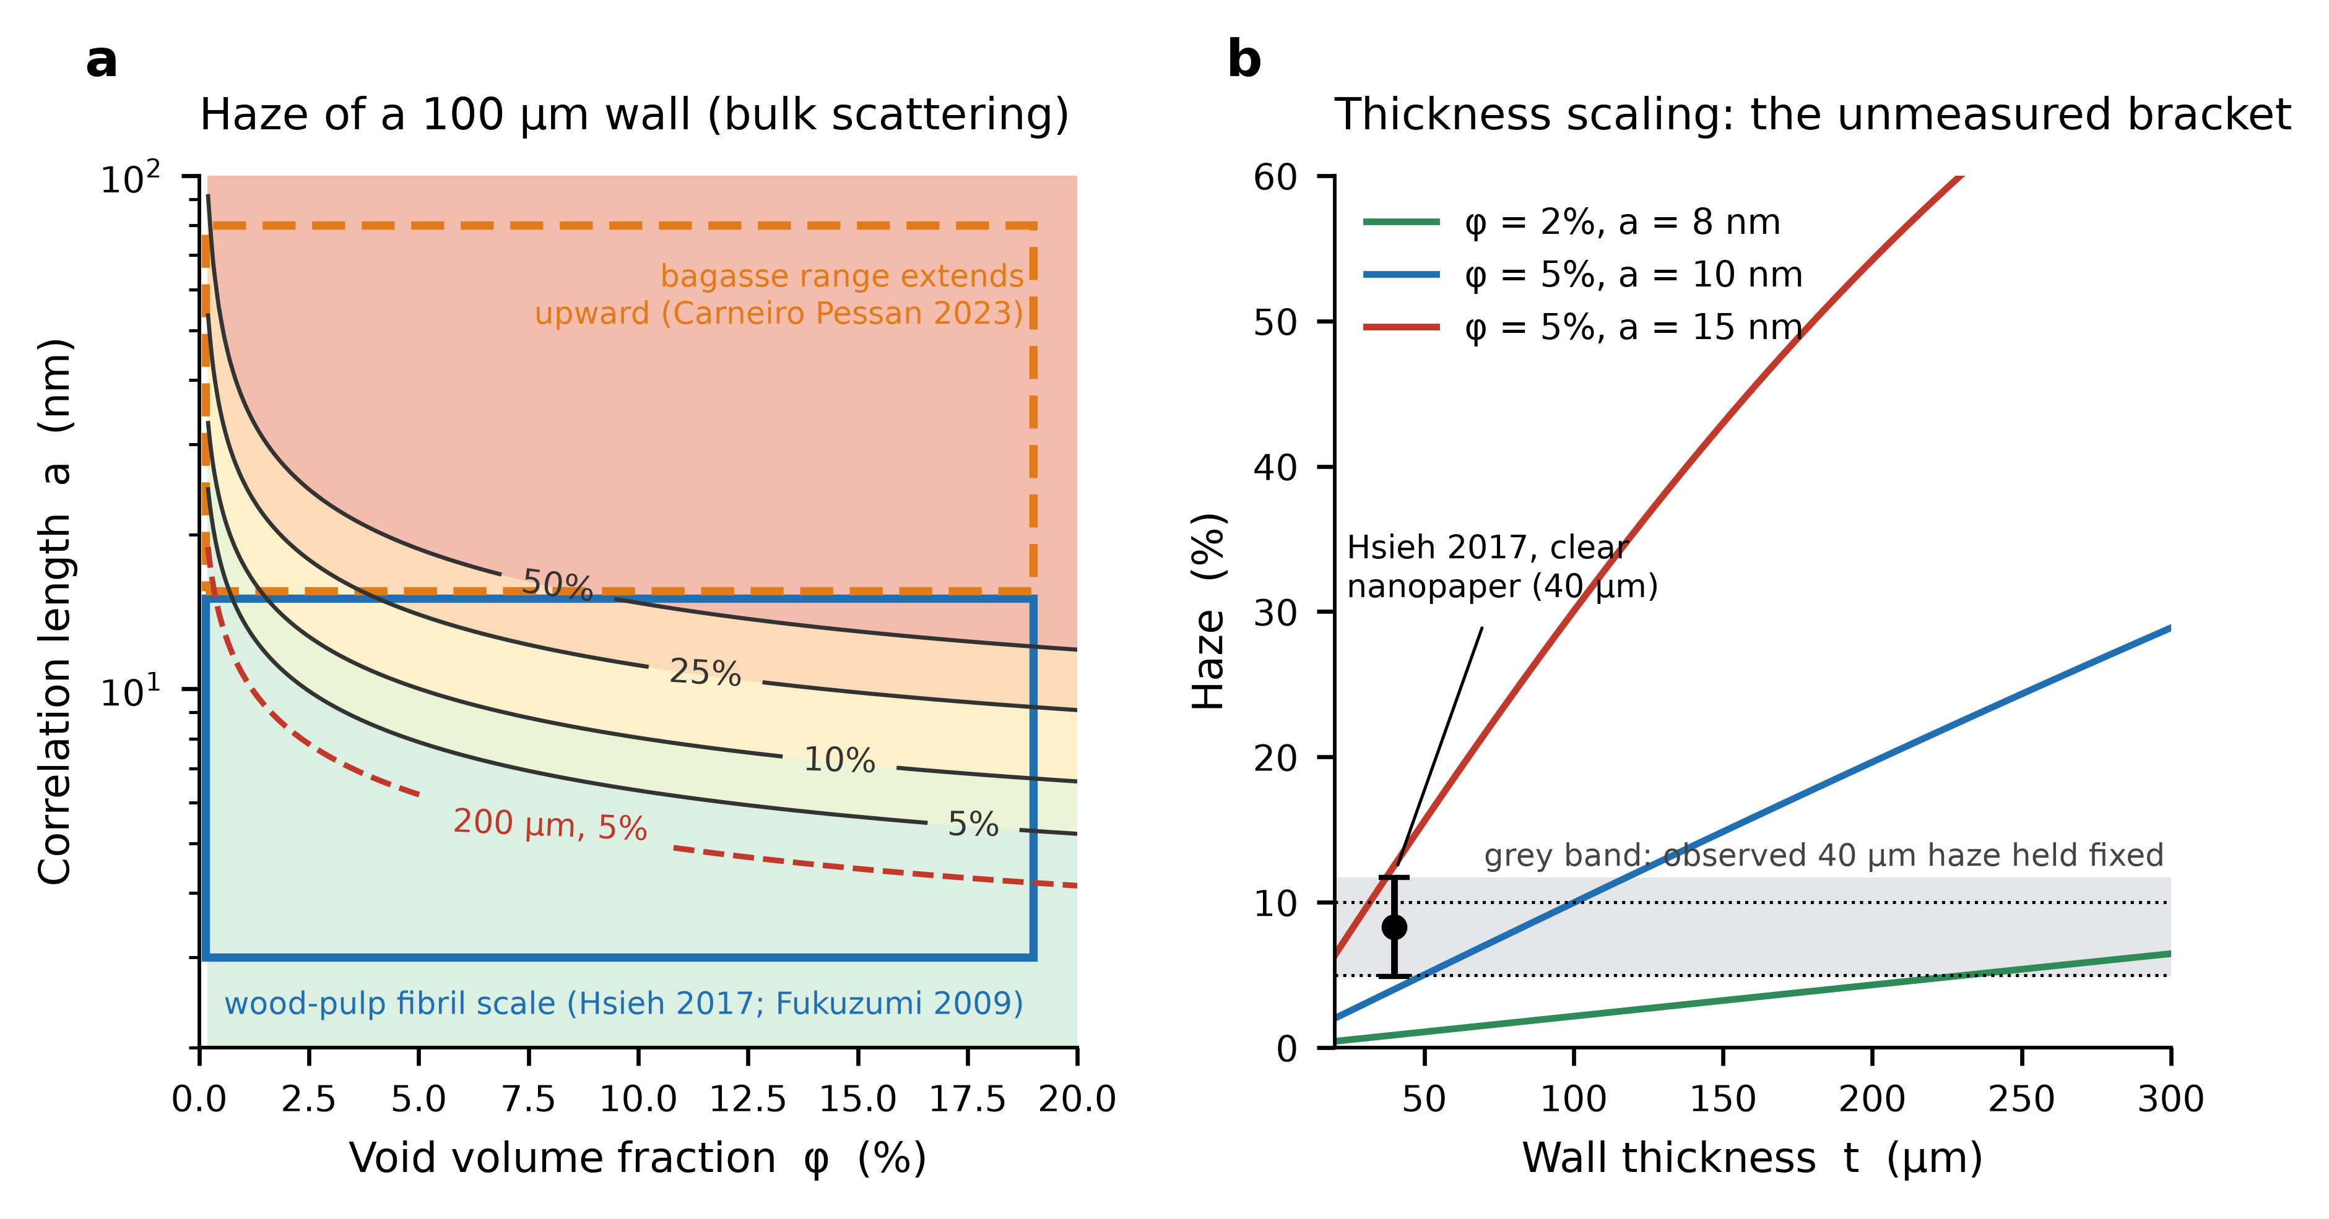
Fig. 2 Optical screen. a Haze of a 100 µm wall from bulk scattering as a function of void fraction and correlation length, with the wood-pulp fibril scale (blue box; Hsieh et al. 2017, Fukuzumi et al. 2009) and the extension to the reported bagasse range (orange; Carneiro Pessan et al. 2023); the dashed red curve is the 5% contour for a 200 µm wall. b Haze against thickness for three structures under bulk scattering, with the observed 4.9–11.7% haze of 40 µm clear nanopaper (point) and the grey band showing the opposite limit, in which that haze is surface-dominated and independent of thickness. The region between the two limits is what a thickness series must measure.
Table 4 Largest correlation length a (nm) that keeps the haze of a wall at or below its target, by thickness and void fraction φ (full angular integral, n_{c} = 1.55, f_{m} = 1).
Thickness (µm) | Haze ≤ 5%: φ = 2% | 5% | 10% | Haze ≤ 10%: φ = 2% | 5% | 10%
40 | 14.8 | 10.8 | 8.7 | 19.1 | 13.8 | 11.0
100 | 10.7 | 7.9 | 6.3 | 13.7 | 10.0 | 8.0
200 | 8.4 | 6.2 | 5.0 | 10.7 | 7.9 | 6.3

How well does the screen reproduce published haze? It is not a calibration. With structure drawn from the literature ranges the bulk-scattering haze of a 40 µm wood-pulp sheet has a median of 1.5% and reaches the observed 4.9–11.7% band in only 14% of samples (73% lie below it and 13% above) (Hsieh et al. 2017). Bulk void scattering at the nanofibril scale therefore does not by itself explain the haze of published clear nanopaper; surface roughness and residual fibre fragments probably contribute, as the original authors attribute. The most direct consequence is the bracket of Fig. 2b: if the observed haze is mostly bulk it scales with thickness and a 100–200 µm wall is far hazier than 40 µm nanopaper, and if it is mostly surface it does not. Which limit applies is unmeasured and is the first optical measurement.
Over the sampled ranges (Table 5), a wood-pulp-scale structure meets a 10% haze target at 100 µm in 69% of samples and at 200 µm in 56%; with the bagasse range the shares fall to 26% and 18%. Those shares are conditional on the assumed prior over correlation length, which is uniform on a logarithmic scale, and should be read as a ranking and not as a probability that the material works; for 53% of bagasse samples at 100 µm τt exceeds 1, where the single-scattering estimate is optimistic. The robust results are the thresholds of Table 4. Sensitivity is dominated by the correlation length (Spearman ρ = +0.80 for the bagasse range, +0.74 for the wood-pulp scale), followed by film density (-0.37), as the cubic law implies.
Table 5 Optical screen over the sampled ranges: median haze and the share of samples meeting a haze target, by feedstock range and wall thickness.
Range | Thickness (µm) | Median haze | Haze ≤ 5% | Haze ≤ 10% | τt > 1
Wood-pulp scale | 40 | 1.5% | 73% | 85% | 1%
Wood-pulp scale | 100 | 3.7% | 56% | 69% | 6%
Wood-pulp scale | 200 | 7.4% | 42% | 56% | 14%
Bagasse range | 40 | 27.4% | 28% | 37% | 39%
Bagasse range | 100 | 58.6% | 18% | 26% | 53%
Bagasse range | 200 | 85.9% | 12% | 18% | 62%

6.2 Wet mechanical: the sign of the chitosan effect
At neutral pH, adding 20% chitosan raises the median modelled wet stiffness from 0.85 to 2.36 GPa (5–95% range 0.69–5.56 GPa), and the share of samples reaching 1 GPa rises from 45% to 88%. In an acidic liquid the gain disappears: the median change is -0.01 GPa, the share reaching 1 GPa is 51%, and chitosan improves wet stiffness in 49% of samples, against 86% at neutral pH (Table 6, Fig. 3a). The effect is therefore not intrinsic to chitosan but depends on the cross-linking and on the liquid. Removing the cross-linking term on the same draws changes the median gain at neutral pH from +1.08 to -0.10 GPa and the share of samples in which chitosan helps from 86% to 35%, so in the screen the benefit is carried by cross-linking, not by the stiffness of the chitosan phase. Wet stiffness is most sensitive to the cross-linking gain ξ_{max} (Spearman ρ = +0.64 for the neutral case), then to the dry CNF modulus (+0.51) and the plain-CNF wet retention (+0.33); in acid the plain-CNF retention dominates (+0.70) because the chitosan contribution is lost.
The screen can be compared with the one published wet datum. The reported modulus of 4 GPa for water-soaked 80/20 films (Toivonen et al. 2015) lies at the 82nd percentile of the modelled distribution (18% of samples reach it), so the screen brackets the datum but its centre is conservative relative to it, as expected if the pH-switched processing sits at the favourable end of the cross-linking range. The ratio of 0.60 reported for chitosan-disrupted carrot nanofibre films (Szymańska-Chargot et al. 2019) lies inside the assumed range of the network-efficiency factor. These are consistency checks, not calibrations, and the acid case rests on the assumption, supported by the dissolution of chitosan in acid (Melro et al. 2021) but not by any wet CNF/chitosan measurement in acid, that the cross-linking gain is largely lost.
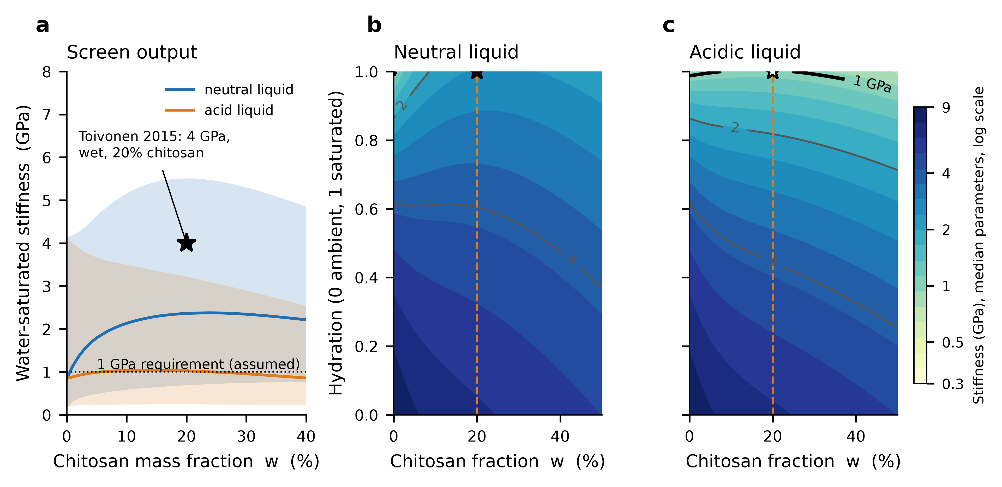
Fig. 3 Wet-stiffness screen. a Water-saturated stiffness against chitosan fraction for a neutral and an acidic liquid (median and 5–95% band); the star is the wet datum of Toivonen et al. (2015). b, c Stiffness against chitosan fraction and hydration at median parameters for the neutral and acidic liquid; contours at 0.5, 1, 2 and 4 GPa. The 20% chitosan column is the only loading with a published wet datum; the rest of each map is extrapolation.
Table 6 Wet-stiffness screen: median water-saturated stiffness, the share of samples reaching 1 GPa (an assumed requirement) and the share in which chitosan raises stiffness above that of plain CNF.
Chitosan (wt%) | Neutral: median (GPa) | ≥ 1 GPa | Helps | Acidic: median (GPa) | ≥ 1 GPa | Helps
0 | 0.85 | 45% | – | 0.85 | 45% | –
5 | 1.79 | 78% | 86% | 0.99 | 50% | 54%
10 | 2.13 | 85% | 86% | 1.04 | 52% | 53%
20 | 2.36 | 88% | 86% | 1.03 | 51% | 49%
30 | 2.34 | 90% | 84% | 0.96 | 48% | 44%

6.3 Forming: geometry sets the burden
The strain budget of Eq. (8) is 0.262 for the tray, 0.667 for the bowl and 1.105 for the cup, corresponding to surface areas 1.7, 3.8 and 9.1 times the base footprint (Fig. 4a). With no stretching, forming them would need blank-to-punch ratios of 1.30, 1.95 and 3.02. Over the sampled strain tolerances a forming window exists, for saturated forming, in 86% of tray samples, 7% of bowl samples and none of the cup samples (Table 7). The cup result does not depend on the sampling: the largest total tolerance ε_{crit} + ε_{wr} reachable anywhere in the assumed ranges is 0.96 for saturated forming, 0.81 at half hydration and 0.66 ambient, all below the cup’s 1.10 (the dashed box of Fig. 4a does not reach the cup line). The bowl is out of reach in the ambient state, where the best case of 0.660 falls just short of the 0.667 needed, and is reached only when the sheet is hydrated (0.81 at half hydration, 0.96 saturated) and at the upper end of the wrinkling tolerance.
Among the unknowns, the wrinkling tolerance of the flange dominates the bowl margin (Spearman ρ = +0.85), followed by the void-onset ratio (+0.39), the wet strain gain (+0.27) and, last, the ambient failure strain (+0.14). Where draw-in supplies most of the material, it is the compressive limit that matters, not fracture, which reorders the usual emphasis on strain to failure. At the median tolerances a straight-walled cup could have a depth of only 0.23 (ambient) to 0.33 (wet) base diameters.
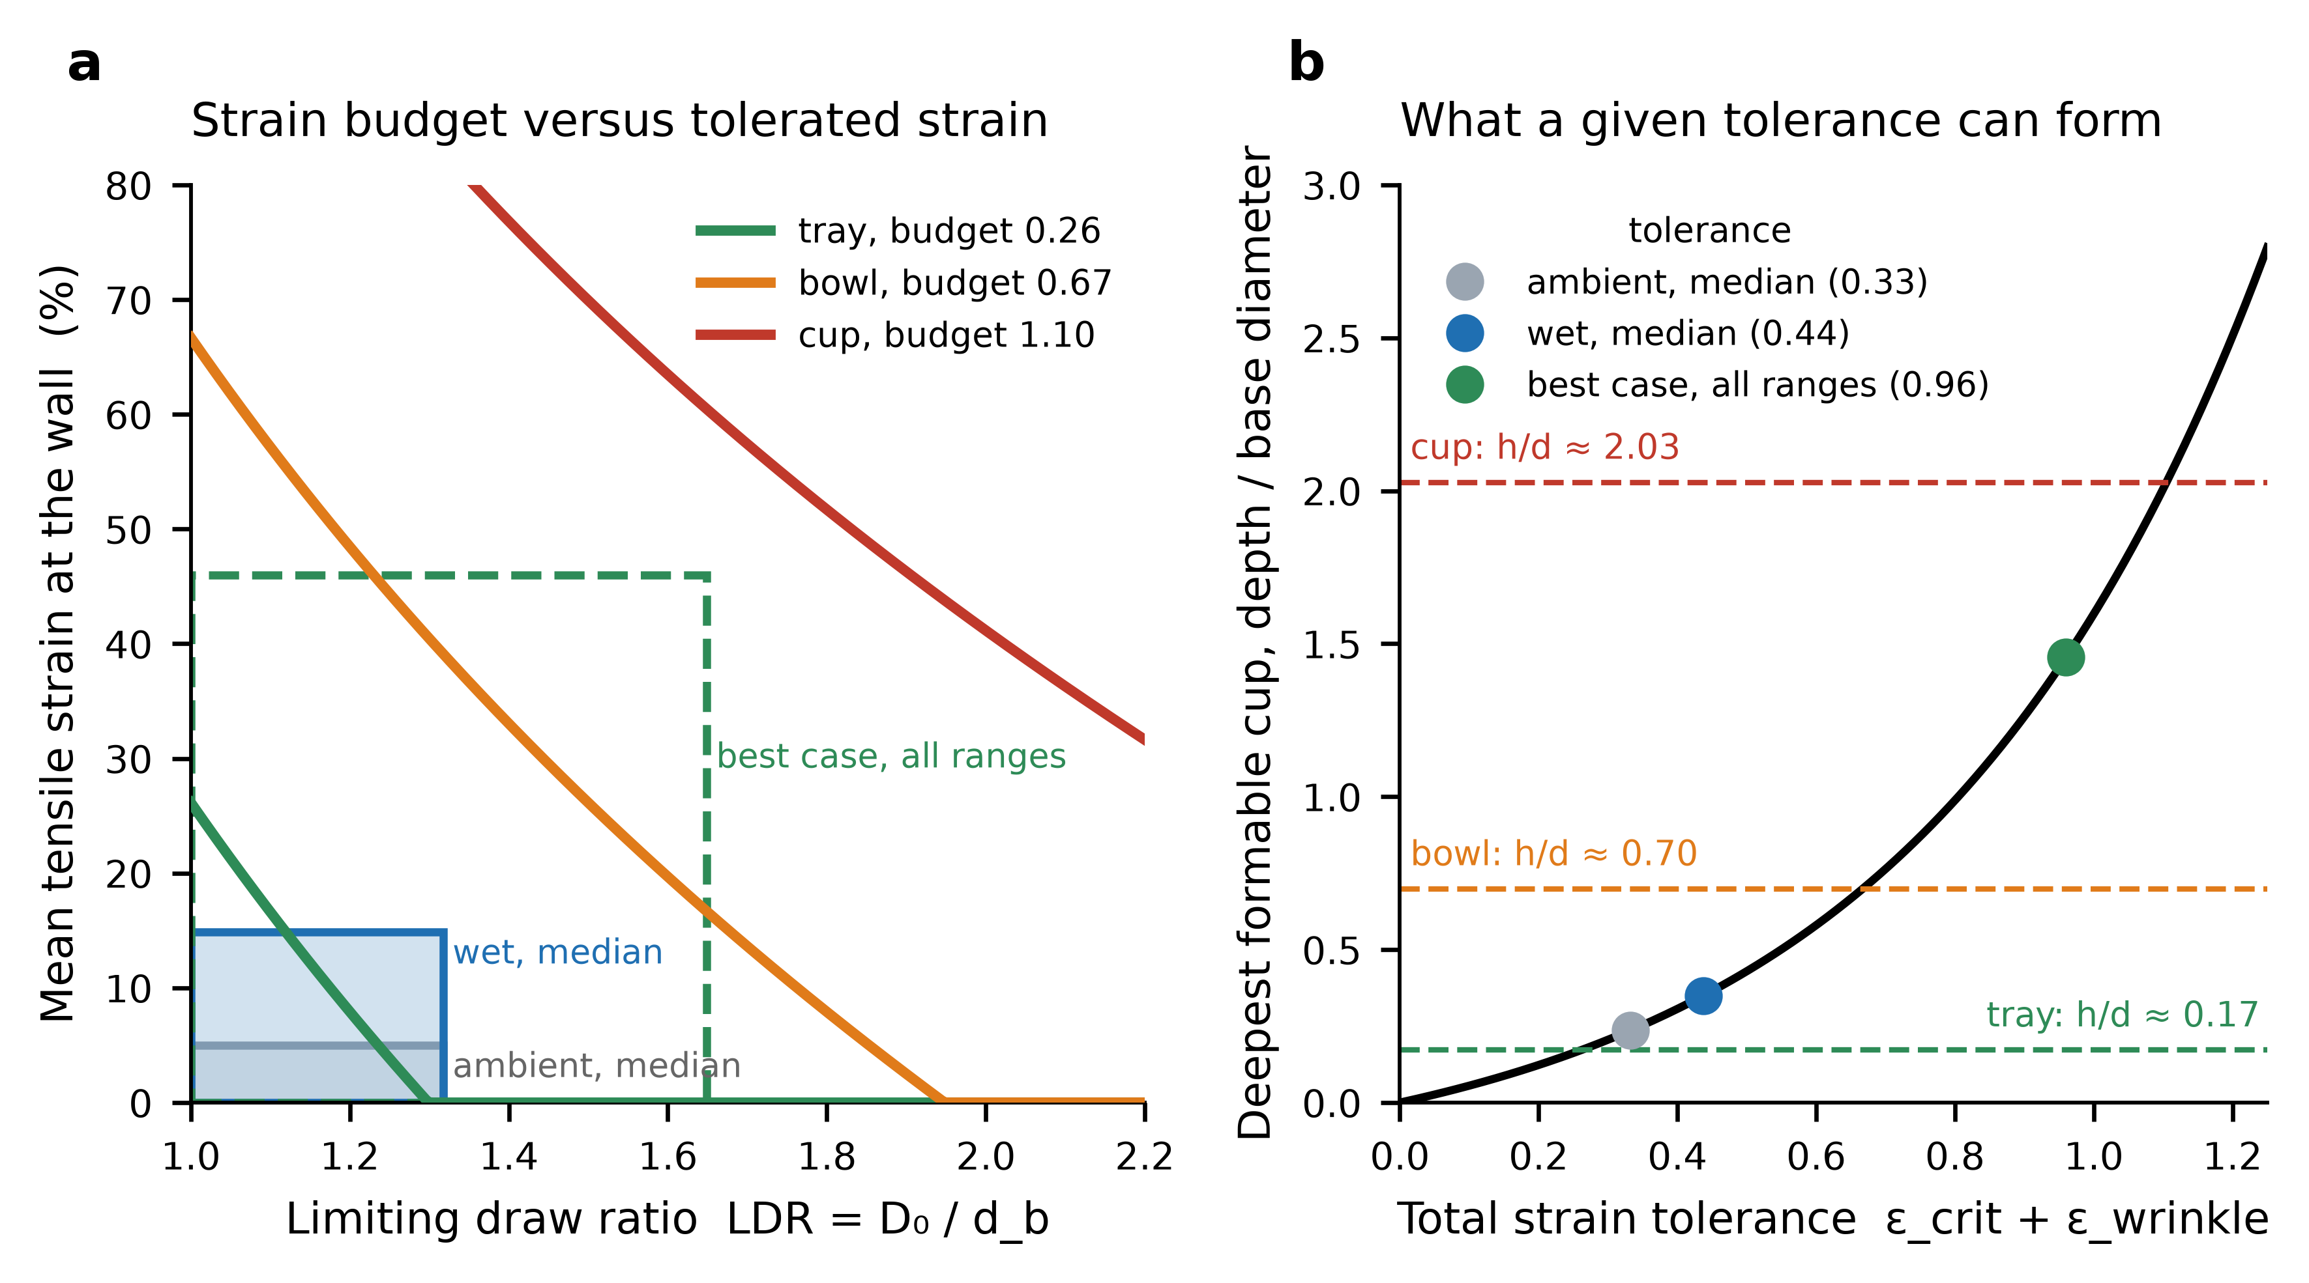
Fig. 4 Forming screen. a Mean tensile strain at the wall against limiting draw ratio for the three geometries (lines) and the box of tolerated strain at median ambient and wet tolerances (solid) and at the best case over all assumed ranges (dashed); a forming window exists only where a geometry line passes through a box. b Deepest straight-walled cup (depth over base diameter) that a given total tolerance can form, with the equivalent ratio of each geometry (dashed) and the three tolerances.
Table 7 Forming screen: strain budget of each geometry and the share of samples with a forming window, by forming hydration.
Geometry | Strain budget | Area ratio | Ambient | Half hydration | Saturated
Tray (lid-like) | 0.262 | 1.7 | 65.9% | 77.3% | 85.5%
Bowl | 0.667 | 3.8 | 0.0% | 1.2% | 6.9%
Cup | 1.105 | 9.1 | 0.0% | 0.0% | 0.0%

6.4 Integration
For a reference design (100 µm wall, 20% chitosan, haze ≤ 10%, wet stiffness ≥ 1 GPa, forming at saturation) the share of sampled designs passing all three tests is 52% for a tray with a wood-pulp-scale structure and a neutral liquid, 19% with a bagasse-range structure, and 30% and 11% in an acidic liquid; for a bowl it is 4% and 2%, and for the cup it is zero in every case (Fig. 5a). These shares depend on the assumed ranges and are reported to rank the cases. The conclusions that do not depend on them are the thresholds of Table 4, the bound on the cup, and the order of the unknowns in Fig. 5b.
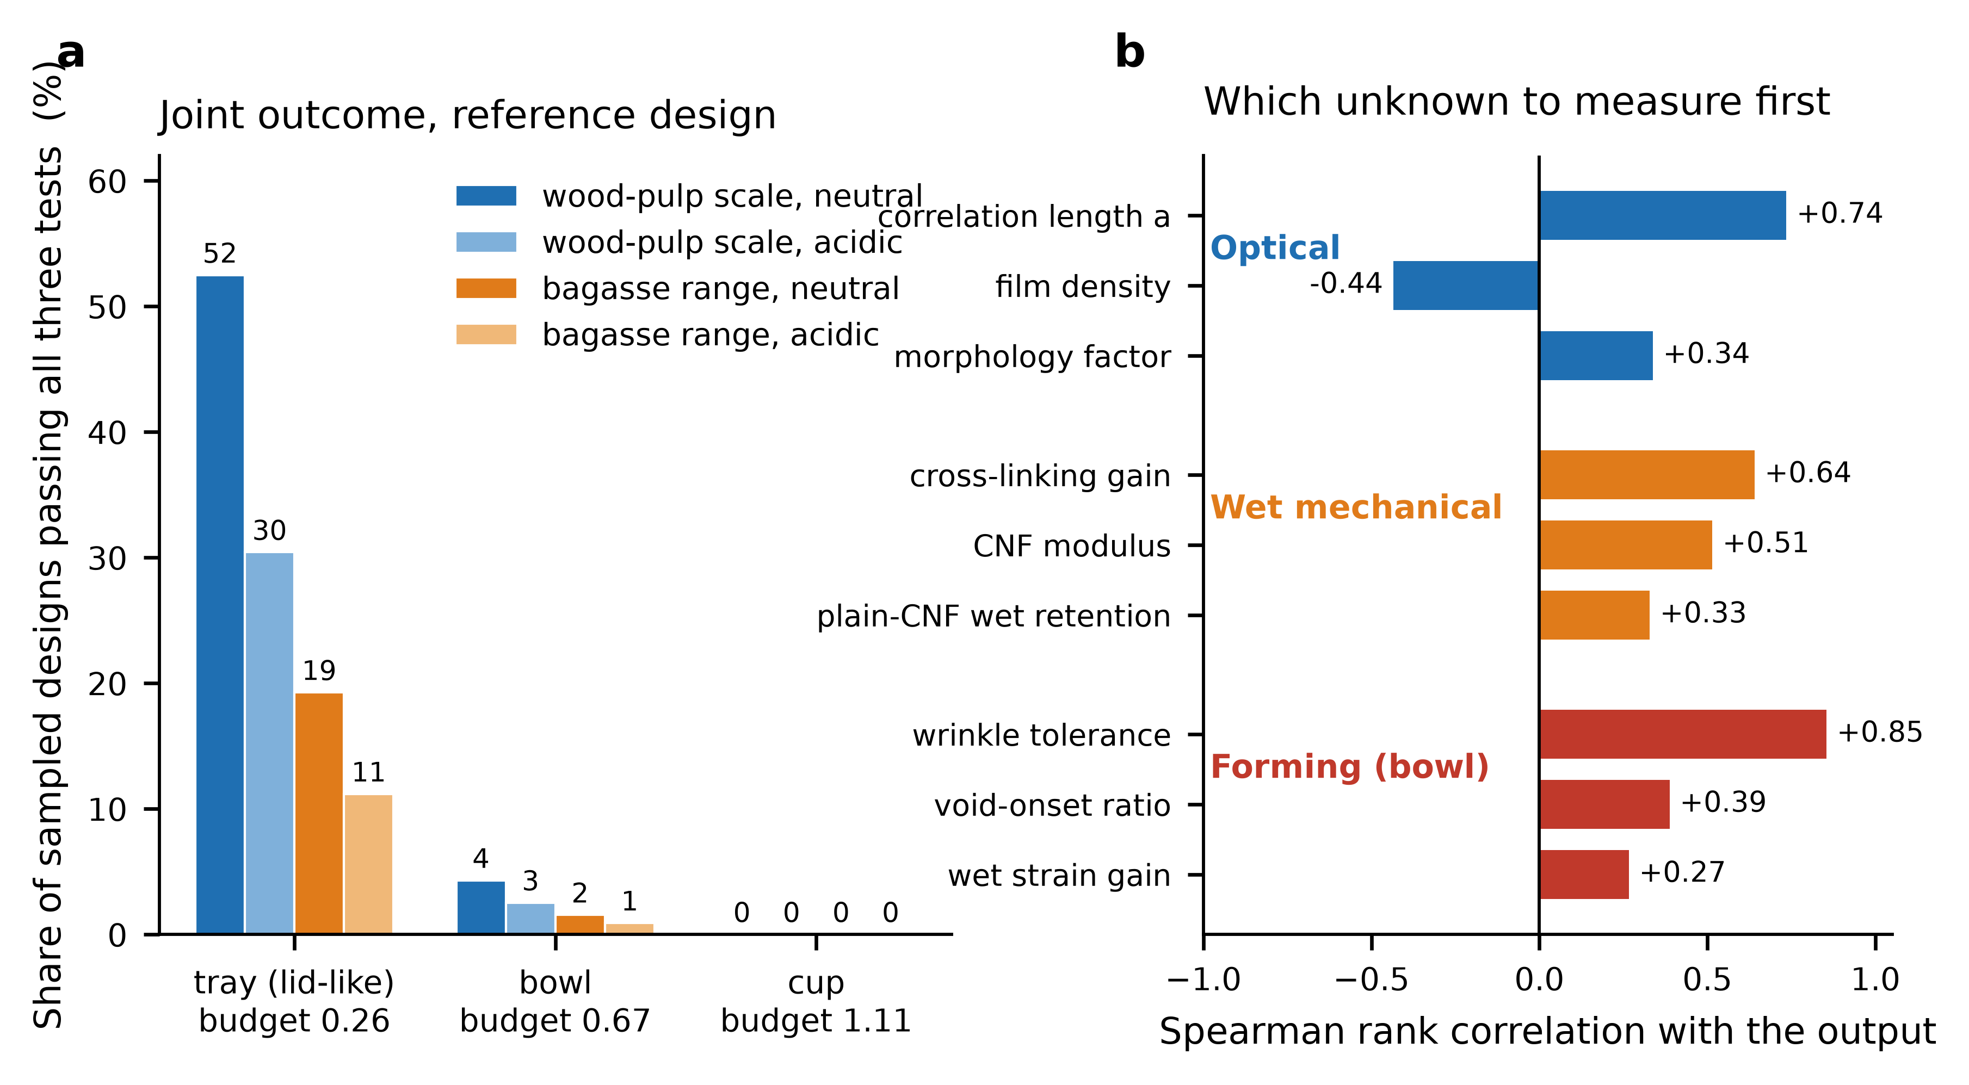
Fig. 5 Integration. a Share of sampled designs passing all three tests at the reference design (100 µm wall, 20% chitosan, haze ≤ 10%, wet stiffness ≥ 1 GPa, forming at saturation), by geometry, feedstock range and liquid. Shares depend on the assumed ranges; the zero for the cup does not (best case 0.96 < 1.10). b Spearman rank correlation of the leading unknowns with the optical, wet-mechanical and forming outputs: the quantities to measure first.

7 Discussion
What the three screens return. The optical screen shows that thickness and correlation length, not material identity, decide whether a dense nanofibril wall is clear: the same structure that gives single-digit haze at 40 µm can be several times hazier at 100–200 µm if scattering is bulk. The wet screen shows that chitosan is a cross-linker whose benefit is conditional on the liquid, not a reinforcement in the ordinary sense. The forming screen shows that, for deep geometries, the sheet would need to supply many times its footprint area, which no tolerance within the assumed ranges provides.
Consistency with prior art. The forming result agrees with the one reported attempt at three-dimensional CNF objects, which produced objects by wet moulding but not transparent or dimensionally stable ones because of drying shrinkage (Rol et al. 2020). The two findings are complementary: that study identifies a route-specific failure, shrinkage on drying, which this screen does not represent, while this analysis shows a geometric limit that applies whatever the route. The wet-state result is consistent with a pH-switched cross-linking mechanism (Toivonen et al. 2015), and the limits of the closed cubic law matter for the coarse end of the bagasse nanofibril range.
Design implications. The results do not say that a transparent bagasse package is impossible; they say what would have to be true. Shallow geometries such as lids and trays are the only ones inside the assumed tolerances. A cup-like container would need a construction that does not stretch a flat sheet, for example a wall formed from a flat blank by wrapping with a seam, which trades the strain constraint for seam, leak and optical-continuity requirements that are not analysed here; a transparent window in an otherwise opaque moulded-pulp body is another option. Reducing the wall thickness relaxes the optical budget in proportion but lowers stiffness and increases the sensitivity to surface defects.
What to measure first. The rankings give an order. For optics, the correlation length and void fraction of a dense bagasse sheet by small-angle X-ray scattering, since the Debye–Bueche form is exactly what such data are analysed with (Debye et al. 1957), followed by haze against thickness. For wet stiffness, the cross-linking gain and the plain-CNF wet retention, including in acidic liquids. For forming, the flange wrinkling tolerance and the strain at which haze first rises.
Relation to CNF and CNC. Nanocrystal sheets from bagasse have given the clearest reported result (Tao et al. 2017), but their stiffness and expected brittleness bear on forming in a way the present screens treat only through the assumed strain tolerances. A hybrid that keeps the clarity of crystals and the entanglement of fibrils, as in Xu et al. (2016), is a natural candidate for H1 and is accommodated by the framework through the structural parameters.

8 Falsifiable predictions and validation matrix
Each prediction below follows from the computation and can be shown wrong by a stated measurement.
- P1 (thickness scaling). If bulk scattering dominates, haze of a dense nanofibril sheet rises approximately in proportion to thickness between 40 and 200 µm (H ≈ f_{h}τt for τt ≲ 0.3); if surface scattering dominates, haze is nearly independent of thickness. A thickness series decides which, and measured haze outside the bracket of Fig. 2b falsifies the screen.
- P2 (structure predicts haze). Small-angle scattering of the sheet should give φ(1−φ)a³ and a Debye–Bueche correlation length that predict the measured bulk haze within the factor spanned by f_{m} (0.3–3).
- P3 (bagasse threshold). A dense bagasse nanofibril sheet meets a 10% haze target at 100 µm only if its correlation length is below about 10 nm at 5% voids (14 nm at 2%).
- P4 (acid reversal). The wet-stiffness gain from 20% chitosan measured after soaking in an acidic liquid is much smaller than after soaking in neutral water, and may be negative; a gain retained in acid falsifies the assumed loss of cross-linking.
- P5 (forming limit). Haze rises before fracture during forming if r_{v} < 1, and a flat dense sheet cannot be formed into the cup geometry by drawing alone; a transparent formed cup falsifies the bound of Eq. (10).
Table 8 Validation matrix: the measurement, the threshold derived here and what would falsify it.
Requirement | Measurement | Threshold derived here | Falsified if
Bulk scattering | Small-angle X-ray scattering, Debye–Bueche analysis of dense bagasse sheets | φ(1−φ)a³ ≤ 22 nm³ at 100 µm, 5% haze | Measured value exceeds it with haze still low
Thickness scaling | Haze (ASTM D1003) at 40, 100, 200 µm | Haze ∝ t (bulk) or constant (surface) | Outside the bracket of Fig. 2b
Feedstock (H1) | Correlation length, bagasse versus wood-pulp CNF at equal density | a ≤ 10 nm at 5% voids (100 µm, 10% haze) | Larger a with haze still within target
Wet stiffness (H2) | Wet tensile modulus at 0, 10, 20, 30 wt% chitosan in neutral water | ≥ 1 GPa; model median 2.4 GPa at 20% | Below 1 GPa, or no gain over plain CNF
Acid exposure (H2) | Wet modulus after soaking in acidic liquids | Gain over plain CNF near zero (model median -0.01 GPa) | Gain retained in acid
Barrier (H3) | Liquid-hold test, haze after coating, abrasion-induced haze | 24 h hold (proposed); no added haze | Leak, or coating raises haze
Strain tolerance (H4) | Wet and ambient strain to failure; in situ haze against strain | Total tolerance ≥ 0.26 (tray), 0.67 (bowl) | Below the budget of the target geometry
Flange wrinkling (H4) | Draw test with blank holder, LDR at wrinkle onset | LDR_{max} = exp(ε_{wr}); needed 1.30 (tray) | LDR_{max} below the requirement
Package | Filled-container drop, lid attachment, thermal cycling | 1 m drop (proposed) | Failure

The staged programme that would test these is: Phase I, material (fibril width, density, small-angle scattering, haze against thickness, with and without delignification); Phase II, composite (chitosan at 0, 5, 10, 20 and 30 wt%, transparency, dry and wet tensile properties in neutral and acidic liquids); Phase III, barrier (contact angle, liquid hold, durability, abrasion-induced haze); Phase IV, forming (shallow, intermediate and full-depth draw; haze, cracking and delamination); Phase V, package (filled-cup drop, extended containment, lid attachment, thermal cycling). Details are in Supplementary Information S6.

9 Sustainability and scalability
The constituents (cellulose, chitosan and natural wax) were chosen for potential compatibility with compostability pathways; compostability of the finished structure is unvalidated, and no life-cycle assessment has been performed. Nanofibrillation energy depends on the processing method (Spence et al. 2011) and production routes are reviewed in (Nechyporchuk et al. 2016); refining alone reached a plateau of barrier properties only after 1,800–12,000 kWh t⁻¹ depending on the refiner (Kargupta et al. 2022), and complete defibrillation of rice straw by aqueous counter collision was reported at 15 kWh kg⁻¹ (Jiang et al. 2016). These figures come from different feedstocks, equipment and end points and are not comparable. Life-cycle impact of nanofibril production depends strongly on the pretreatment route and on the electricity mix (Arvidsson et al. 2015), and the scale-up of nanostructures from bagasse remains a stated challenge (Hiranobe et al. 2024). Repulpability of a deliberately void-free sheet is a testable hypothesis, not a result.

10 Limitations
- No sheet or package was made or tested. Eleven of the nineteen parameter ranges are assumptions, and every share quoted in Section 6 is conditional on them; the thresholds and the cup bound are the results that depend least on them.
- The optical screen represents bulk scattering only. Surface scattering, absorption by residual lignin, multiple scattering beyond τt of about 1 and the anisotropy of cellulose are not represented, and Eq. (2) has not been validated against small-angle scattering from nanocellulose sheets. It does not by itself reproduce the haze of published clear nanopaper. The Born approximation is comfortable at the wood-pulp fibril scale but marginal for correlation lengths of tens of nanometres, where the phase shift across one correlation length reaches 0.25 at 40 nm and 0.50 at 80 nm (Supplementary Table S1).
- The wet-stiffness screen is a Voigt-type bound with an assumed cross-linking term, and its acid case rests on an assumption that is plausible but untested for CNF/chitosan sheets. Interfacial failure, creep and swelling are not represented.
- The forming screen bounds mean area strain and tolerance. Friction, nonuniform thinning, temperature, drying shrinkage (the failure route reported by Rol et al. 2020) and the strain state of the wall are not represented; the wrinkling tolerance has no reported value for nanocellulose sheets.
- The barrier hypothesis (H3) is not modelled, and a contact angle is not a liquid-holding test.
- Food-contact regulatory status of chitosan, waxes and any additives, compostability and life-cycle impact are not assessed. Some references were available to the verification process only by title, and the claims attached to them are limited accordingly.

11 Conclusions
The literature supports each ingredient of a transparent, bagasse-derived nanocellulose–chitosan package for flat films, and it records one failure at the package scale. Three consistency screens show what would have to be true for the ingredients to coexist. A dense wall is clear only if its void fraction and correlation length lie inside a budget set by its thickness: for 100 µm, 10% haze and 5% voids, a correlation length of about 10 nm or less, a threshold the reported bagasse nanofibril range straddles. Chitosan raises wet stiffness mainly through cross-linking, and in the screen that benefit is lost in an acidic liquid. And geometry sets a strain budget of 0.26, 0.67 and 1.10 for a tray, a bowl and a cup, of which only the tray lies within the assumed tolerances, while the cup lies outside every combination of them. These are conditional results from stated assumptions. They define the measurements, ranked by influence, that would confirm or falsify the concept, and they locate the binding constraint, forming, in geometry and not only in the material.

Declarations
Funding This research received no specific grant from funding agencies in the public, commercial or not-for-profit sectors.
Competing interests The author declares that there are no competing financial or non-financial interests.
Ethics approval and consent to participate Not applicable. This is a theoretical and computational study with no human participants, human data, animals or experiments.
Consent for publication Not applicable.
Data and code availability No experimental data were generated. The model, the verification suite, every figure script, the reference-verification tooling and the log of literature searches are openly available at https://github.com/sandlerleon/bagasse-cnf-chitosan-framework (MIT licence) and archived with a permanent concept DOI on Zenodo, https://doi.org/10.5281/zenodo.23111544, which always resolves to the latest version. This manuscript and its Supplementary Information are archived as a preprint on Zenodo, https://doi.org/10.5281/zenodo.23111546. All numerical results are produced by one seeded run (seed 20261002) of code/run_analysis.py.
Author contributions Leon Sandler conceived the study, specified the physical model and its assumptions, directed the literature work and the computation, analysed the results and wrote the manuscript.
Use of generative AI See Section 5.5.

Appendix: nomenclature
Symbol | Definition | Unit
T_{d} | Direct (unscattered) fraction of transmitted light | –
τ | Scattering coefficient | m⁻¹
H | Haze: transmitted light deviating by more than 2.5° | –
φ | Void volume fraction | –
a | Correlation length of the void structure | nm
n_{c} | Refractive index of the cellulose phase | –
Δε | Permittivity contrast, n_{c}² − 1 | –
λ | Vacuum wavelength (550 nm) | nm
t | Wall thickness | µm
K | Derived prefactor, 64π⁴/3 | –
f_{m} | Morphology factor | –
g | Angular correction to the cubic law | –
f_{h} | Forward-scattered fraction beyond 2.5° | –
w | Chitosan mass fraction | –
E_{wet} | Water-saturated stiffness | GPa
E_{C}, E_{H} | Dry moduli of the CNF and chitosan phases | GPa
ψ | Dry network-efficiency factor | –
κ_{C0}, κ_{H} | Water-saturated retention of CNF and chitosan stiffness | –
ξ | Gain in CNF-phase retention from cross-linking | –
d_{b}, d_{t}, h | Base diameter, top diameter and depth of the container | mm
A_{cup} | Surface area of the container | mm²
ε_{b} | Strain budget (mean equibiaxial log-strain) | –
ε_{crit} | Tolerated tensile strain, min(failure, void onset) | –
r_{v} | Ratio of void-onset strain to failure strain | –
ε_{wr} | Tolerated compressive (wrinkling) log-strain | –
LDR | Limiting draw ratio, D₀/d_{b} | –
h (hydration) | Hydration, 0 ambient to 1 saturated | –

References
Arvidsson R, Nguyen D, Svanström M (2015) Life cycle assessment of cellulose nanofibrils production by mechanical treatment and two different pretreatment processes. Environ Sci Technol 49:6881–6890. https://doi.org/10.1021/acs.est.5b00888
ASTM International (2021) ASTM D1003-21: standard test method for haze and luminous transmittance of transparent plastics. ASTM International, West Conshohocken, PA. https://doi.org/10.1520/D1003-21
Aulin C, Gällstedt M, Lindström T (2010) Oxygen and oil barrier properties of microfibrillated cellulose films and coatings. Cellulose 17:559–574. https://doi.org/10.1007/s10570-009-9393-y
Azeredo HM, Mattoso LHC, Avena‐Bustillos RJ et al (2010) Nanocellulose reinforced chitosan composite films as affected by nanofiller loading and plasticizer content. J Food Sci 75(1). https://doi.org/10.1111/j.1750-3841.2009.01386.x
Azeredo HM, Rosa MF, Mattoso LHC (2017) Nanocellulose in bio-based food packaging applications. Ind Crops Prod 97:664–671. https://doi.org/10.1016/j.indcrop.2016.03.013
Benítez AJ, Walther A (2017) Cellulose nanofibril nanopapers and bioinspired nanocomposites: a review to understand the mechanical property space. J Mater Chem A 5:16003–16024. https://doi.org/10.1039/c7ta02006f
Bhattacharya D, Germinario LT, Winter WT (2008) Isolation, preparation and characterization of cellulose microfibers obtained from bagasse. Carbohydr Polym 73:371–377. https://doi.org/10.1016/j.carbpol.2007.12.005
Carneiro Pessan C, Silva Bernardes J, Bettini SH et al (2023) Oxidized cellulose nanofibers from sugarcane bagasse obtained by microfluidization: Morphology and rheological behavior. Carbohydr Polym 304:120505. https://doi.org/10.1016/j.carbpol.2022.120505
Debye P, Bueche AM (1949) Scattering by an inhomogeneous solid. J Appl Phys 20:518–525. https://doi.org/10.1063/1.1698419
Debye P, Anderson HR, Brumberger H (1957) Scattering by an inhomogeneous solid. II. The correlation function and its application. J Appl Phys 28:679–683. https://doi.org/10.1063/1.1722830
Fang Z, Zhu H, Bao W et al (2014) Highly transparent paper with tunable haze for green electronics. Energy Environ Sci 7:3313–3319. https://doi.org/10.1039/c4ee02236j
FAO (2024) FAOSTAT: crops and livestock products, sugar cane (item 156), production quantity (element 5510), world total. Food and Agriculture Organization of the United Nations, Rome. https://www.fao.org/faostat/. Accessed via Our World in Data, 2 October 2026
Fernández-Marín R, Morales A, Erdocia X et al (2024) Chitosan–chitin nanocrystal films from lobster and spider crab: properties and environmental sustainability. ACS Sustain Chem Eng 12:10363–10375. https://doi.org/10.1021/acssuschemeng.4c01205
Fukuzumi H, Saito T, Iwata T et al (2009) Transparent and high gas barrier films of cellulose nanofibers prepared by TEMPO-mediated oxidation. Biomacromolecules 10:162–165. https://doi.org/10.1021/bm801065u
Fukuzumi H, Saito T, Isogai A (2013) Influence of TEMPO-oxidized cellulose nanofibril length on film properties. Carbohydr Polym 93:172–177. https://doi.org/10.1016/j.carbpol.2012.04.069
Ghormade V, Pathan E, Deshpande M (2017) Can fungi compete with marine sources for chitosan production? Int J Biol Macromol 104:1415–1421. https://doi.org/10.1016/j.ijbiomac.2017.01.112
Guzman-Puyol S, Benítez JJ, Heredia-Guerrero JA (2022) Transparency of polymeric food packaging materials. Food Res Int 161:111792. https://doi.org/10.1016/j.foodres.2022.111792
Hauptmann M, Majschak J (2011) New quality level of packaging components from paperboard through technology improvement in 3D forming. Packag Technol Sci 24:419–432. https://doi.org/10.1002/pts.941
Henriksson M, Berglund LA, Isaksson P et al (2008) Cellulose nanopaper structures of high toughness. Biomacromolecules 9:1579–1585. https://doi.org/10.1021/bm800038n
Hiranobe CT, Gomes AS, Paiva FFG et al (2024) Sugarcane bagasse: challenges and opportunities for waste recycling. Clean Technol 6:662–699. https://doi.org/10.3390/cleantechnol6020035
Hsieh M-C, Koga H, Suganuma K et al (2017) Hazy transparent cellulose nanopaper. Sci Rep 7:41590. https://doi.org/10.1038/srep41590
Hubbe MA, Ferrer A, Tyagi P et al (2017) Nanocellulose in thin films, coatings, and plies for packaging applications: a review. BioResources 12:2143–2233. https://doi.org/10.15376/biores.12.1.hubbe
Isogai A, Saito T, Fukuzumi H (2011) TEMPO-oxidized cellulose nanofibers. Nanoscale 3:71–85. https://doi.org/10.1039/c0nr00583e
Jiang F, Kondo T, Hsieh Y-L (2016) Rice straw cellulose nanofibrils via aqueous counter collision and differential centrifugation and their self-assembled structures. ACS Sustain Chem Eng 4:1697–1706. https://doi.org/10.1021/acssuschemeng.5b01653
Kabeyi MJB, Olanrewaju OA (2023) Bagasse electricity potential of conventional sugarcane factories. J Energy 2023:1–25. https://doi.org/10.1155/2023/5749122
Kargupta W, Seifert R, Martinez M et al (2022) Preparation and benchmarking of novel cellulose nanopaper. Cellulose 29:4393–4411. https://doi.org/10.1007/s10570-022-04563-0
Kim M, Day DF (2011) Composition of sugar cane, energy cane, and sweet sorghum suitable for ethanol production at Louisiana sugar mills. J Ind Microbiol Biotechnol 38:803–807. https://doi.org/10.1007/s10295-010-0812-8
Klemm D, Kramer F, Moritz S et al (2011) Nanocelluloses: a new family of nature‐based materials. Angew Chem Int Ed 50:5438–5466. https://doi.org/10.1002/anie.201001273
Lavoine N, Desloges I, Dufresne A et al (2012) Microfibrillated cellulose – Its barrier properties and applications in cellulosic materials: a review. Carbohydr Polym 90:735–764. https://doi.org/10.1016/j.carbpol.2012.05.026
Li W, Wang S, Wang W et al (2019) Facile preparation of reactive hydrophobic cellulose nanofibril film for reducing water vapor permeability (WVP) in packaging applications. Cellulose 26:3271–3284. https://doi.org/10.1007/s10570-019-02270-x
Lyu D, Tang Y, Qian L et al (2019) Large strain cavitation induced stress whitening in propylene-butene-1 copolymer during stretching. Polymer 167:146–153. https://doi.org/10.1016/j.polymer.2019.01.081
Mandal A, Chakrabarty D (2011) Isolation of nanocellulose from waste sugarcane bagasse (SCB) and its characterization. Carbohydr Polym 86:1291–1299. https://doi.org/10.1016/j.carbpol.2011.06.030
Melro E, Antunes FE, da Silva GJ et al (2021) Chitosan films in food applications. Tuning film properties by changing acidic dissolution conditions. Polymers 13:1. https://doi.org/10.3390/polym13010001
Moon RJ, Martini A, Nairn J et al (2011) Cellulose nanomaterials review: structure, properties and nanocomposites. Chem Soc Rev 40:3941. https://doi.org/10.1039/c0cs00108b
Mäkelä T, Kainlauri M, Willberg-Keyriläinen P et al (2016) Fabrication of micropillars on nanocellulose films using a roll-to-roll nanoimprinting method. Microelectron Eng 163:1–6. https://doi.org/10.1016/j.mee.2016.05.023
Ndikumana S, Tanane O, Aichi Y et al (2025) Innovative applications of sugarcane bagasse in the global sugarcane industry. Processes 13:3796. https://doi.org/10.3390/pr13123796
Nechyporchuk O, Belgacem MN, Bras J (2016) Production of cellulose nanofibrils: a review of recent advances. Ind Crops Prod 93:2–25. https://doi.org/10.1016/j.indcrop.2016.02.016
Niskanen I, Zhang K, Karzarjeddi M et al (2022) Optical properties of cellulose nanofibre films at high temperatures. J Polym Res 29:187. https://doi.org/10.1007/s10965-022-03019-0
Nogi M, Iwamoto S, Nakagaito AN et al (2009) Optically transparent nanofiber paper. Adv Mater 21:1595–1598. https://doi.org/10.1002/adma.200803174
Nogi M, Kim C, Sugahara T et al (2013) High thermal stability of optical transparency in cellulose nanofiber paper. Appl Phys Lett 102:181911. https://doi.org/10.1063/1.4804361
Otenda BV, Kareru PG, Madivoli ES et al (2022) Cellulose nanofibrils from sugarcane bagasse as a reinforcing element in polyvinyl alcohol composite films for food packaging. J Nat Fibers 19:3585–3597. https://doi.org/10.1080/15440478.2020.1848712
Pillai C, Paul W, Sharma CP (2009) Chitin and chitosan polymers: Chemistry, solubility and fiber formation. Prog Polym Sci 34:641–678. https://doi.org/10.1016/j.progpolymsci.2009.04.001
Qing Y, Sabo R, Wu Y et al (2012) High-performance cellulose nanofibril composite films. BioResources 7:3064–3075. https://doi.org/10.15376/biores.7.3.3064-3075
Rinaudo M (2006) Chitin and chitosan: properties and applications. Prog Polym Sci 31:603–632. https://doi.org/10.1016/j.progpolymsci.2006.06.001
Rol F, Billot M, Bolloli M et al (2020) Production of 100% cellulose nanofibril objects using the molded cellulose process: a feasibility study. Ind Eng Chem Res 59:7670–7679. https://doi.org/10.1021/acs.iecr.9b06127
Saito T, Kimura S, Nishiyama Y et al (2007) Cellulose nanofibers prepared by TEMPO-mediated oxidation of native cellulose. Biomacromolecules 8:2485–2491. https://doi.org/10.1021/bm0703970
Scopel E, Pinto LO, Rezende CA (2025) Residual lignin affects production and properties of TEMPO-oxidized cellulose nanofibrils from partially delignified sugarcane bagasse. Cellulose 32:9315–9331. https://doi.org/10.1007/s10570-025-06785-4
Sehaqui H, Zhou Q, Ikkala O et al (2011) Strong and tough cellulose nanopaper with high specific surface area and porosity. Biomacromolecules 12:3638–3644. https://doi.org/10.1021/bm2008907
Sellman FA, Rostami J, Östmans R et al (2024) Influence of fibril aspect ratio, chemical functionality, and volume fraction on the mechanical properties of cellulose nanofibril materials. Cellulose 31:8007–8025. https://doi.org/10.1007/s10570-024-06084-4
Semple KE, Zhou C, Rojas OJ et al (2022) Moulded pulp fibers for disposable food packaging: a state-of-the-art review. Food Packag Shelf Life 33:100908. https://doi.org/10.1016/j.fpsl.2022.100908
Shimizu M, Saito T, Isogai A (2016) Water-resistant and high oxygen-barrier nanocellulose films with interfibrillar cross-linkages formed through multivalent metal ions. J Membr Sci 500:1–7. https://doi.org/10.1016/j.memsci.2015.11.002
Sirviö JA, Kantola AM, Komulainen S et al (2021) Aqueous modification of chitosan with itaconic acid to produce strong oxygen barrier film. Biomacromolecules 22:2119–2128. https://doi.org/10.1021/acs.biomac.1c00216
Spence KL, Venditti RA, Rojas OJ et al (2011) A comparative study of energy consumption and physical properties of microfibrillated cellulose produced by different processing methods. Cellulose 18:1097–1111. https://doi.org/10.1007/s10570-011-9533-z
Szymańska-Chargot M, Chylińska M, Pertile G et al (2019) Influence of chitosan addition on the mechanical and antibacterial properties of carrot cellulose nanofibre film. Cellulose 26:9613–9629. https://doi.org/10.1007/s10570-019-02755-9
Tao J, Fang Z, Zhang Q et al (2017) Super‐clear nanopaper from agro‐industrial waste for green electronics. Adv Electron Mater 3:1600539. https://doi.org/10.1002/aelm.201600539
Toivonen MS, Kurki-Suonio S, Schacher FH et al (2015) Water-resistant, transparent hybrid nanopaper by physical cross-linking with chitosan. Biomacromolecules 16:1062–1071. https://doi.org/10.1021/acs.biomac.5b00145
Vishtal A, Retulainen E (2012) Deep-drawing of paper and paperboard: the role of material properties. BioResources 7:4424–4450. https://doi.org/10.15376/biores.7.3.4424-4450
Wang Y, He B, Zhao L (2017) Fabrication of hydrophobic coating on filter paper from self-emulsifying carnauba wax-alcohol emulsions with nano-TiO2 particles for water/diesel separation. BioResources 12:7774–7783. https://doi.org/10.15376/biores.12.4.7774-7783
Xu X, Zhou J, Jiang L et al (2016) Highly transparent, low-haze, hybrid cellulose nanopaper as electrodes for flexible electronics. Nanoscale 8:12294–12306. https://doi.org/10.1039/c6nr02245f
Yang W, Jiao L, Liu W et al (2019) Manufacture of highly transparent and hazy cellulose nanofibril films via coating TEMPO-oxidized wood fibers. Nanomaterials 9:107. https://doi.org/10.3390/nano9010107
Zhu H, Fang Z, Preston C et al (2014) Transparent paper: fabrications, properties, and device applications. Energy Environ Sci 7:269–287. https://doi.org/10.1039/c3ee43024c

