Toward transparent rigid packaging from sugarcane bagasse: a consistency-testing framework for nanocellulose–chitosan sheets
Leon Sandler
Independent Researcher, Northbrook, Illinois, USA
ORCID: https://orcid.org/0009-0007-4584-808X
Corresponding author: sandler.leon@gmail.com
Manuscript prepared for submission to Cellulose (Springer). A theoretical and computational study: No experiments were performed, and every output is a screening estimate, not a measured or predicted material property.

Abstract
Transparent rigid packaging is dominated by fossil-derived polymers, whereas fiber-based packaging is opaque. Dense cellulose nanofibril (CNF) and nanocrystal sheets are transparent as flat films, but whether transparency, wet stiffness and a three-dimensional shape can coexist in one sugarcane-bagasse-derived package has not been established, and one reported attempt to mold transparent CNF objects failed through drying shrinkage. This paper reports no experiments. It applies three consistency screens to a proposed bagasse CNF–chitosan–wax architecture: an optical screen derived from Debye–Bueche scattering theory, a wet-stiffness screen and a geometric forming screen, each propagated through a seeded Monte Carlo analysis over ranges traced to the cited literature or explicitly stated assumptions. Under the stated optical-screen assumptions, a 100 µm wall at 10% haze and 5% voids requires a correlation length of approximately 10 nm or less, and because stiffness fixes a minimum wall thickness, the liquid the package must resist feeds back into the optical budget. Chitosan increases the modeled wet stiffness mainly through cross-linking (median gain of +1.1 GPa with it and -0.1 GPa without), but its gain in an acidic liquid is small and uncertain. A tray, bowl and cup need total strain tolerances of 0.26, 0.67 and 1.10, respectively; no combination of the assumed ranges forms the cup (0.96 in the best case), which would need a flange wrinkling strain above 0.64. Pass shares depend on the priors, whereas the thresholds, the cup bound and the rank ordering do not. Barrier performance is untested, so every feasibility result is provisional.
Keywords cellulose nanofibrils; transparent nanopaper; chitosan; sugarcane bagasse; thermoforming; consistency testing

1 Introduction
Transparent rigid packaging is dominated by polyethylene terephthalate and, increasingly, polylactic acid, chosen largely because they combine clarity, stiffness and liquid tightness. Fiber-based alternatives address material origin; molded pulp, which is increasingly made from bagasse, wheat and bamboo rather than wood, is an established example (Semple et al. 2022). Fiber-based packaging is opaque; however, it is structural: ordinary paper and cellulose nanopaper consist of the same chemical constituents, and the difference lies in the width and size of the interstitial cavities that scatter light (Nogi et al. 2009).
Densifying nanofibrils removes that scattering. Films of TEMPO-oxidized cellulose nanofibrils that are only 3–4 nm wide are transparent and flexible (Fukuzumi et al. 2009), and clear nanopapers that are 40 µm thick have been reported to have a total transmittance of 89.3–91.5% and a haze of 4.9–11.7% at a density of 1.29–1.55 g cm⁻³ (Hsieh et al. 2017). Haze can be tuned by mixing fiber scales (Fang et al. 2014; Yang et al. 2019), and hybrid nanofibril–nanocrystal paper reached a direct transmittance of 75.1% with 10.0% haze, in contrast to 31.1% and 62.0% for earlier nanopaper (Xu et al. 2016). Transparency survives for tens of minutes at 150 °C in flat nanopaper (Nogi et al. 2013), and nanopaper made from sugarcane bagasse nanocrystals has been reported at 91% transmittance and 1.4% haze (Tao et al. 2017). Reviews cover the field (Isogai et al. 2011; Klemm et al. 2011; Moon et al. 2011; Zhu et al. 2014).
Several problems stand between these flat films and a rigid package. Maintaining mechanical properties under hydrated conditions is a recognized and often overlooked challenge for nanocelluloses (Toivonen et al. 2015), and a liquid barrier must be added without reintroducing haze (Lavoine et al. 2012; Azeredo et al. 2017; Hubbe et al. 2017). CNF films are brittle and not thermoplastic, with no clear softening point; thermal roll-to-roll imprinting can pattern them at the micrometer scale only when a softener is present (Mäkelä et al. 2016). At the scale of a package, the evidence is thinner and more discouraging. Wet molding of the three-dimensional objects of the CNF mats was feasible, but because of shrinkage during drying, none of the formation or drying routes tried yielded transparent and dimensionally stable objects (Rol et al. 2020), and deep drawing of the paperboard is regarded as a sensitive process with many failure mechanisms (Hauptmann and Majschak 2011; Vishtal and Retulainen 2012). Nanofibrillation is also energy intensive (Arvidsson et al. 2015; Kargupta et al. 2022).
The knowledge gap is therefore integration. Each property has been demonstrated mostly on flat films and mostly separately; whether transparency, wet stiffness, barrier performance and a three-dimensional shape can be held together in a single agricultural residue-derived wall has not been established, and the published attempt to form one failed.
This paper asks that question as a consistency test. Each requirement is checked against what the literature supports or against a physical bound, the answer is allowed to be no, and the checks are propagated through the uncertainty that remains. The contribution is the framework and what it returns, not a material: (i) an optical screen whose scattering prefactor is derived from theory rather than fitted, with the haze budget it implies for a wall of given thickness; (ii) a wet-stiffness screen showing what determines whether chitosan helps, including in an acidic liquid; (iii) a forming screen showing that geometry fixes a strain budget independent of the material model; (iv) a ranking of the unknowns that most influence each outcome so that the first measurements are the informative ones; and (v) falsifiable predictions and a validation matrix with numerical thresholds. No experiments were performed. Every parameter is either taken from a cited source or stated as an assumption, and the assumptions are listed in Table 3.
What the combination adds. Each screen alone restates a familiar trend. Three results need the screens together. First, stiffness fixes a minimum wall thickness, and the thickness fixes the haze, so the liquid the package must resist changes in the optical budget (Section 6.6). Second, a wax layer applied before forming must survive the strain the sheet survives, which narrows the forming window of the shallowest geometry (Section 6.8). Third, the joint outcome is set by whichever screen binds and for deep shapes that are forming, not the optics or the chemistry on which most of the literature concentrates (Section 6.4). The paper also separates what survives a change of prior from what does not (Section 6.7).

2 Hypotheses, research questions and status of evidence
Four hypotheses organize the analysis; each is stated so that it can fail.
- H1 (feedstock). Bagasse-derived nanocellulose can form a dense sheet whose void fraction and correlation length meet the haze budget of a rigid wall. It fails if bagasse nanofibril sheets exceed that budget.
- H2 (chitosan). Chitosan increases wet stiffness without optical loss; in the liquid, the package is meant to hold. It fails if the wet gain is zero or negative in an acidic liquid or if haze increases.
- H3 (barrier). A submicron natural wax layer contains liquid without added haze. It is not modeled here and is carried into the validation matrix.
- H4 (forming). The strain budget of the target geometry lies inside the strain the sheet tolerates. It fails for geometries whose budget exceeds the sum of the tolerated tensile and compressive strains.
These map onto five research questions. RQ1 Can densified bagasse-derived nanocellulose plausibly achieve the optical properties of a transparent wall? RQ2 Can chitosan improve wet performance without optical loss? RQ3 Can a thin hydrophobic layer provide moisture resistance while preserving transparency? RQ4 What mechanisms limit the formation of these structures, and which geometries survive them? RQ5 Which measurements are required to determine viability?
Every statement below has one of four labels. Established means taken from a cited source. Computed means produced by the model in this paper under the stated assumptions. “Predicted” indicates a falsifiable consequence of the computation. Unvalidated means not tested by anyone to the author’s knowledge. These labels are applied in Table 2.

3 Proposed material architecture
The architecture (Fig. 1) is the author’s conceptual integration of separately published elements, not a description of existing material. Sugarcane bagasse is fibrillated to nanofibrils, densified into a transparent sheet, combined with chitosan for wet integrity, coated with a thin hydrophobic layer, and formed into a package. Three consistency tests gate the chain: optical after densification, wet-mechanical after chitosan, and forming at the shaping step.
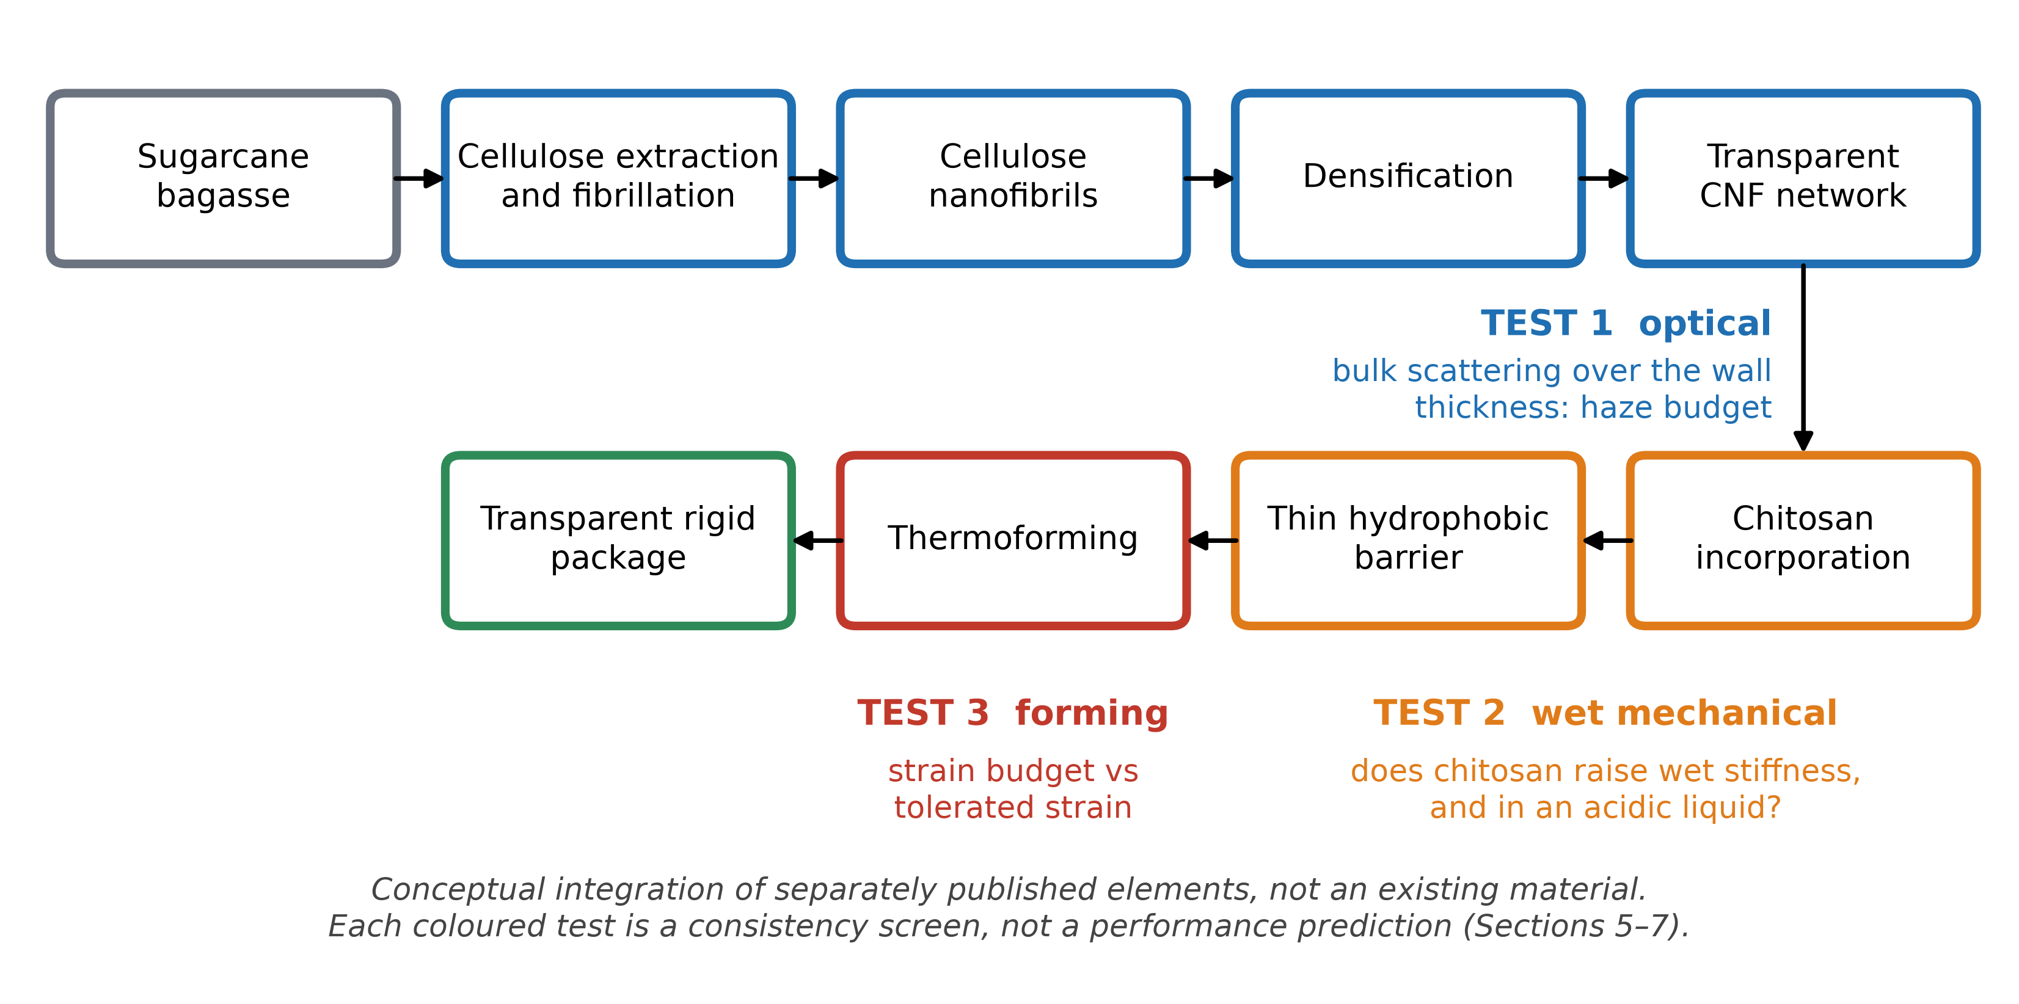
Fig. 1 Proposed processing chain and the three consistency tests that gate it. The diagram is a conceptual integration of separately published elements, not an existing installation.

3.1 Bagasse-derived nanocellulose
The worldwide sugarcane production was 1,921 Mt in 2022 (FAO 2024). After juice extraction, bagasse is a fibrous residue that is produced in very large volumes and traditionally burned for energy (Kabeyi and Olanrewaju 2023; Ndikumana et al. 2025). Its composition, approximately 42% cellulose, 25% hemicellulose and 20% lignin (Kim and Day 2011), means that delignification and bleaching directly affect color and haze, and residual lignin has been shown to affect the production and properties of TEMPO-oxidized nanofibrils from partially delignified bagasse (Scopel et al. 2025). Nanocellulose has been isolated from bagasse by several routes (Bhattacharya et al. 2008; Mandal and Chakrabarty); oxidized nanofibrils produced by microfluidization measured 5–80 nm in diameter (Carneiro Pessan et al. 2023), and TEMPO-oxidized bagasse nanofibrils 150–600 nm long have been used to reinforce films (Otenda et al. 2022). Reviews note that nanostructure synthesis from bagasse still lacks high yields and the ability to scale up (Hiranobe et al. 2024). TEMPO-mediated oxidation of native cellulose is the route that yields the thin, uniform nanofibers behind the clear films above (Saito et al. 2007; Fukuzumi et al. 2009), and higher fibril aspect ratios have been reported to give stiffer and more ductile networks (Sellman et al. 2024), which makes the length distribution of bagasse nanofibrils relatively unknown.
The feedstock evidence is mixed in a way that defines H1. Nanopaper from bagasse nanocrystals is reported at 91% transmittance and 1.4% haze (Tao et al. 2017); thus, bagasse can form a clear sheet. An agricultural residue analog prepared as a nanofibril, rice straw, resulted in films with only 13–42% transmittance (Jiang et al. 2016). No optical data for transparent sheets made from bagasse nanofibrils were found (Supplementary Information S4). The open question is therefore not whether bagasse can give a clear sheet but whether bagasse nanofibrils, or a hybrid, maintain the clarity at the thickness a rigid wall needs and whether a sheet made of the stiffer, less entangled nanocrystals tolerates forming; the latter is an expectation, not a cited result.

3.2 Densified network
Scattering from a fibril and void network decreases as the fibril width and void fraction decrease because the refractive index contrast is then confined to features much smaller than the wavelength (Nogi et al. 2009; Fukuzumi et al. 2013). Haze in clear nanopaper has been attributed to compressed cavities in residual microsized fibers (Hsieh et al. 2017). The thermal stability of flat nanopaper at 150 °C (Nogi et al. 2013) is relevant to hot-liquid service but is not established for a formed wall. High strain to failure has been reported for porous nanopaper, 17% at a modulus of 1.4 GPa and 56% porosity (Sehaqui et al. 2011), with large strains attributed to slippage between fibrils (Henriksson et al. 2008); the mechanical property space of nanofibril sheets is reviewed in (Benítez and Walther 2017). The porosity of that order would defeat the haze budget derived below (Table 4), so ductility and clarity pull in opposite directions; this is an inference from the present screens, not a published result.

3.3 Chitosan reinforcement
Chitosan chemistry and solubility are reviewed in (Rinaudo 2006; Pillai et al. 2009). Chitosan is water insoluble but dissolves in acidic solutions (Melro et al. 2021). It is made commercially from shellfish waste, and fungal sources are being explored as alternatives (Ghormade et al. 2017); the regulatory status of any chitosan for food contact is jurisdiction-specific and is not assessed here. Chitosan films are reported to be highly transparent (Sirviö et al. 2021), and neat films have a modulus of 2.3–3.4 GPa with an elongation above 13% (Fernández-Marín et al. 2024). The decisive precedent is physical cross-linking of nanofibrils with chitosan: films of 80/20 CNF/chitosan reached 70–90% transmittance, and when water-soaked, they retained a strength of 100 MPa, a strain of 28% and a modulus of 4 GPa at 0.5% strain, against 200 MPa and 8% at 50% relative humidity when dry (Toivonen et al. 2015). The mechanism is a pH switch: chitosan is dissolved at low pH, and increasing the pH reduces its degree of hydration and promotes multivalent interactions with the fibrils. This is also vulnerability, since cross-linking depends on a neutral or alkaline environment. A second precedent cuts the other way: adding chitosan lowered the modulus of carrot nanofiber films from 14.71 to 8.76 GPa at 5 wt% (Szymańska-Chargot et al. 2019). Chitosan can therefore help or hurt, and the sign depends on the interface. In the reverse arrangement, with CNFs as the filler in chitosan films, the tensile properties were optimized at 15 g of CNFs per 100 g (Azeredo et al. 2010).

3.4 Hydrophobic barrier
A submicron natural wax layer is proposed. Its thickness is far below the scattering scale, so little added haze is expected, but this is inferred. The oxygen and oil barrier properties of microfibrillated cellulose films and coatings (Aulin et al. 2010) and the reactive hydrophobization of CNF films to lower water-vapor permeability (Li et al. 2019) are the closest precedents for barrier function. Hydrophobization of transparent TEMPO-oxidized films has been achieved with alkylketene dimers (Fukuzumi et al. 2009); carnauba wax coatings have water contact angles above 140° on paper, although with nanoparticles and on an opaque substrate (Wang et al. 2017), and ionic cross-linking offers an alternative route to water resistance (Shimizu et al. 2016). A contact angle is not a liquid-holding test, and extended hot or cold containment is untested.

4 Evidence status
Table 1 presents the published evidence and the uncertainty that remains for each requirement. Table 2 classifies every claim used here.
Table 1 Published evidence for each requirement of the proposed architecture and what remains uncertain.
Requirement | Published evidence | Status | Remaining uncertainty
Transparency, flat film | 89.3–91.5% total transmittance at 40 µm (wood-pulp CNF) (Hsieh et al. 2017); 91% with 1.4% haze from bagasse nanocrystals (Tao et al. 2017) | Established | Bagasse nanofibril sheets; thickness of a rigid wall
Low haze | 4.9–11.7% at 40 µm (Hsieh et al. 2017); 10.0% haze, 75.1% direct transmittance, hybrid (Xu et al. 2016) | Established | Haze versus thickness; haze after forming
Residue-derived CNF | Rice-straw CNF films 13–42% transmittance (Jiang et al. 2016); bagasse CNF characterized, no clear sheet reported (Otenda et al. 2022; Carneiro Pessan et al. 2023) | Mixed | Whether bagasse CNF meets the haze budget (H1)
Thermal stability | Transparency kept after tens of minutes at 150 °C, flat film (Nogi et al. 2013) | Established | Formed wall; hot-liquid service
Chitosan transparency | 70–90% transmittance in CNF/chitosan 80/20 (Toivonen et al. 2015) | Established | Haze; other loadings
Wet stiffness | Wet 80/20 films: 100 MPa, 28% strain, 4 GPa (Toivonen et al. 2015); chitosan lowered modulus elsewhere (Szymańska-Chargot et al. 2019) | Established, conflicting | Acidic liquids; interface; long exposure (H2)
Hydrophobicity | AKD on transparent films (Fukuzumi et al. 2009); wax on opaque paper (Wang et al. 2017) | Precedent only | Transparent wax layer; liquid hold (H3)
Forming | Molded CNF objects not transparent or stable (Rol et al. 2020); micropatterning only (Mäkelä et al. 2016) | Negative/absent | Any transparent formed wall (H4)
Impact resistance | No evidence found for thin dense nanofibril walls | Unvalidated | Filled-container drop

Table 2 Classification of the claims used in this paper.
Label | Examples
Established (cited) | Transparent, low-haze CNF and CNC nanopaper as flat films; wet-state CNF/chitosan integrity at neutral pH; chitosan dissolves in acid
Computed (this work) | Haze budget; angular correction to the cubic law; sign of the chitosan effect; strain budgets and forming windows; Monte Carlo shares and rankings
Predicted (this work) | Haze growing with thickness; chitosan benefit lost in acid; forming limited by flange tolerance rather than fracture (Section 8)
Assumed | 11 of the 19 parameter ranges (Table 3); the 10% haze and 1 GPa wet-stiffness requirements
Unvalidated | Any formed transparent wall; filled-cup drop; liquid containment; lid sealing; life-cycle impact; compostability of the finished structure

5 Screening framework
Three screens test the requirements of Table 1. They are screens in the strict sense: each either implements a physical bound or states a relation whose assumptions are listed, and none is fitted to the paper’s own data.

5.1 Test 1: optical
Light scattered by a dense nanofibril network is treated as scattered from refractive index fluctuations in a random two-phase medium, a solid cellulose phase of index n_{c} with air voids of volume fraction φ. In the Born approximation with an exponential correlation function of length a, the framework of Debye and Bueche (Debye and Bueche 1949), applied to random porous solids by Debye, Anderson and Brumberger (Debye et al. 1957), gives a scattering coefficient that depends on the thickness-independent structure alone. The direct (unscattered) fraction of light through a sheet of thickness t is
$T_{\text{d}}\text{ = }\text{exp}\left(\text{−}τt\right)$ (1)
and the scattering coefficient, integrated over all angles for unpolarized light, is
$τ\text{ = }\frac{Kf_{\text{m}}φ\left(\text{1}\text{ − }φ\right){\left(Δε\right)}^{\text{2}}a^{\text{3}}g}{λ^{\text{4}}}$ (2)
where Δε = n_{c}² − 1 is the permittivity contrast, λ is the vacuum wavelength (550 nm throughout), f_{m} is a morphology factor carrying the uncertainty about the real structure, and K = 64π⁴/3 ≈ 2.08×10³. K is derived and not fitted: it is the small-angle limit of the angular integral of the Debye–Bueche expression multiplied by the polarization factor of unpolarized light. The factor g(a) is the numerically evaluated angular integral relative to that limit and equals 1 when a is much smaller than the wavelength. It matters here. Table S1 of the Supplementary Information gives g(a); in brief, g = 0.97 at 5 nm, 0.90 at 10 nm, 0.69 at 20 nm, 0.37 at 40 nm and 0.14 at 80 nm, so the closed cubic law is accurate to approximately 12% up to 10 nm but overestimates the scattering 7.2 times at 80 nm, the top of the reported bagasse nanofibril range. Haze, defined as transmitted light deviating by more than 2.5° (ASTM International 2021), follows from single scattering as follows:
$H\text{ = }\frac{f_{\text{h}}\left(\text{1}\text{ − }{\text{e}}^{\text{−}τt}\right)}{{\text{e}}^{\text{−}τt}\text{ + }f_{\text{h}}\left(\text{1}\text{ − }{\text{e}}^{\text{−}τt}\right)}$ (3)
where f_{h} is the fraction of scattered light going forward beyond 2.5° computed from the same angular integral (0.5 for small features). Surface reflection multiplies direct and diffuse light alike and cancels in the ratio. Eqs. (1)–(3) are valid for τt up to approximately 1; beyond that, repeated scattering increases the real haze, so the values there are optimistic. Three limits should be stated plainly. The core screen represents bulk scattering only: surface roughness and residual fiber fragments, which dominate haze in some nanopapers (Hsieh et al. 2017), are treated only as bound additions (Section 6.5), and absorption by residual lignin is omitted. The void fraction is derived from the film density as φ = 1 − ρ_{f}/ρ_{w}, which makes it sensitive to the assumed wall density at the percent level. Eq. (2) is a screening relation: it has not been validated against small-angle scattering from nanocellulose sheets, which is the measurement that would validate it.

5.2 Test 2: wet mechanical tests
The stiffness of a water-saturated CNF/chitosan sheet with a chitosan mass fraction w is screened with a rule of mixtures in which each phase has its own moisture knockdown:
$E_{\text{wet}}\left(w\right)\text{ = }\left(\text{1}\text{ − }w\right)ψ\left(w\right)κ_{\text{C}}\left(w\right)E_{\text{C}}\text{ + }wκ_{\text{H}}E_{\text{H}}$ (4)
$κ_{\text{C}}\left(w\right)\text{ = }κ_{\text{C0}}\text{ + }ξ\left(w\right)\left(\text{1}\text{ − }κ_{\text{C0}}\right)$ (5)
$ξ\left(w\right)\text{ = }ξ_{\text{max}}\left(\text{1}\text{ − }\text{exp}\left(\text{−}\frac{w}{w^{\text{*}}}\right)\right)$ (6)
E_{C} and E_{H} are the dry moduli of the CNF and chitosan phases, respectively; κ_{C0} and κ_{H} represent their water-saturated retention; and ψ(w) is a dry network-efficiency factor that equals 1 at w = 0 and relaxes to a constant ψ with added chitosan so that disruption of fibril contacts (as in (Szymańska-Chargot et al. 2019)) can occur; and ξ(w) is the gain in CNF-phase retention from physical cross-linking by chitosan (as in (Toivonen et al. 2015)). In acidic liquid chitosan hydrates, its own retention decreases to a small value, and the cross-linking gain is multiplied by the surviving fraction. Eq. (4) is a Voigt-type bound that assumes perfect load sharing, so it is optimistic; interfacial failure and the swelling of chitosan are not otherwise represented. Linear interpolation of the degree of hydration h between the dry and saturated states (Supplementary Information S2) yields the chitosan–moisture map shown in Fig. 3.

5.3 Test 3: forming
Forming a flat sheet into a package requires the sheet to supply the surface area of the package. For a frustum container with base diameter d_{b}, top diameter d_{t} and depth h, the surface area is
$A_{\text{cup}}\text{ = }\frac{π{d_{\text{b}}}^{\text{2}}}{\text{4}}\text{ + }\frac{π\left(d_{\text{b}}\text{ + }d_{\text{t}}\right)}{\text{2}}\sqrt{h^{\text{2}}\text{ + }{\left(\frac{d_{\text{t}}\text{ − }d_{\text{b}}}{\text{2}}\right)}^{\text{2}}}$ (7)
and the mean equibiaxial strain the sheet would carry if all of that area came from stretching, relative to the base footprint, is the strain budget
$ε_{\text{b}}\text{ = }\frac{\text{1}}{\text{2}}\text{ln}\left(\frac{A_{\text{cup}}}{\frac{π{d_{\text{b}}}^{\text{2}}}{\text{4}}}\right)$ (8)
Because the strain is never perfectly uniform, the peak strain is not below this mean, so it is a lower bound on what the sheet must tolerate. Material drawn in from the flange reduces the tensile burden at the cost of compressive strain ln(LDR) at the flange edge, where LDR = D₀/d_{b} is the limiting draw ratio of a blank of diameter D₀. The tensile strain the sheet may carry is limited by fracture or, if it comes first, by the onset of scattering voids, which is lower than fracture whenever the ratio r_{v} of void-onset strain to failure strain is less than one:
$ε_{\text{crit}}\text{ = }\text{min}\left(\text{1}\text{,}r_{\text{v}}\right)\left(ε_{\text{f0}}\text{ + }Δ_{}ε_{\text{w}}h\right)$ (9)
where ε_{f0} is the ambient failure strain, Δε_{w} is its gain when water is saturated and h is hydrated (0 ambient, 1 saturated). An analogy for ε_{void} is deformation-induced cavitation and stress whitening in semicrystalline polymers (Lyu et al. 2019); for nanocellulose, it is an inference. Tensile strain decreases with LDR as ε = ε_{b} − ln(LDR), and flange compression is limited by a wrinkling tolerance ε_{wr}, so a forming window LDR_{min} ≤ LDR ≤ LDR_{max}, with LDR_{min} = exp(ε_{b} − ε_{crit}) and LDR_{max} = exp(ε_{wr}), exists if and only if
$ε_{\text{crit}}\text{ + }ε_{\text{wr}}\text{ ≥ }ε_{\text{b}}$ (10)
Three reference geometries are used (Table 3 caption): a lid-like tray (base 100 mm, top 120 mm, depth 12 mm), a bowl (100, 150, 50 mm) and a drinking cup (55, 80, 90 mm). Eq. (10) follows exactly from the stated geometry and strain limits; whether a sheet can actually be formed also depends on friction, drying shrinkage (Rol et al. 2020) and temperature, none of which are represented.

5.4 Uncertainty propagation
The 19 parameters of the screens are listed with their ranges and bases in Table 3; 8 are informed by a cited source, and 11 are assumptions. Each was sampled independently and uniformly, or log-uniformly, where the range spans an order of magnitude, for N = 200,000 samples with a fixed seed (20261002). Outputs were summarized by quantiles, by the share of samples meeting a requirement, and by Spearman rank correlation with the output, which identifies which is unknown to measure first. The assumed requirements (haze of 5% or 10%, wet stiffness of 0.5, 1 or 2 GPa) are assumptions: transparency in packaging is reported by several nonequivalent measures (Guzman-Puyol et al. 2022), and the package-specific requirement belongs to a design brief, not to this paper.
Table 3 Parameter registry. Status ‘lit’ means that the range is informed by the cited source; ‘assumed’ means that it is the author’s bracket. Sampling is uniform (u) or log-uniform (lu). Reference geometries (base, top, depth in mm): tray 100, 120, 12; bowl 100, 150, 50; cup 55, 80, 90.
Parameter | Range | Unit | Dist. | Status | Basis
Film density ρ_{f} | 1.29 – 1.55 | g cm⁻³ | u | lit | Measured density of clear transparent nanopaper, Hsieh et al. 2017
Cell-wall density ρ_{w} | 1.5 – 1.6 | g cm⁻³ | u | assumed | Cell-wall density, amorphous (~1.5) to crystalline (~1.6) cellulose
Refractive index n_{c} | 1.5 – 1.62 | - | u | assumed | Refractive index of the cellulose phase; anisotropic, complex index measured for TEMPO-CNF films in Niskanen et al. 2022
Correlation length a, wood-pulp scale | 3 – 15 | nm | lu | lit | Correlation length scale of void structure ~ wood-pulp fibril width: 3-4 nm in Fukuzumi et al. 2009, 3-15 nm in Hsieh et al. 2017
Correlation length a, bagasse range | 5 – 80 | nm | lu | lit | Bagasse CNF diameters 5-80 nm after microfluidization, Carneiro Pessan et al. 2023
Morphology factor f_{m} | 0.3 – 3 | - | lu | assumed | Multiplier on the derived prefactor for departures from exponential correlation and the Born approximation
CNF dry modulus E_{C} | 4 – 14 | GPa | u | lit | Dry CNF film modulus: 4.79 GPa Qing et al. 2012; ~4 GPa Jiang et al. 2016; 14.7 GPa Szymańska-Chargot et al. 2019
Chitosan dry modulus E_{H} | 2 – 4 | GPa | u | lit | Neat chitosan film modulus 2.3 and 3.4 GPa, Fernández-Marín et al. 2024
Network efficiency ψ | 0.5 – 1.1 | - | u | lit | Dry network efficiency with chitosan present; 8.76/14.71 = 0.60 at 5 wt% in Szymańska-Chargot et al. 2019, up to ~1 or slightly above if no disruption
Plain-CNF wet retention κ_{C0} | 0.02 – 0.5 | - | lu | assumed | Retained fraction of plain-CNF stiffness when water-saturated
Chitosan wet retention κ_{H} | 0.05 – 0.6 | - | u | assumed | Retained fraction of chitosan stiffness when water-saturated (neutral)
Cross-linking gain ξ_{max} | 0 – 0.8 | - | u | assumed | Maximum wet-retention gain from physical cross-linking by chitosan; Toivonen et al. 2015 shows the effect exists (wet films keep 4 GPa)
Gain saturation w* | 0.05 – 0.2 | - | u | assumed | Chitosan fraction at which the cross-linking gain saturates
Chitosan retention, acid | 0 – 0.1 | - | u | assumed | Chitosan retention in an acidic liquid: chitosan is water-insoluble and dissolves in acidic solutions, Melro et al. 2021
Gain surviving acid | 0 – 0.5 | - | u | assumed | Fraction of the cross-linking gain surviving an acidic liquid
Ambient failure strain ε_{f0} | 0.03 – 0.16 | - | u | lit | Failure strain at ambient humidity: 8% at 50% RH Toivonen et al. 2015; 16% Jiang et al. 2016; lower bound assumed for a brittle dense sheet
Wet strain gain Δε_{w} | 0.05 – 0.3 | - | u | lit | Failure-strain gain when wet; Toivonen et al. 2015 reports 28% wet vs 8% at 50% RH
Void-onset ratio r_{v} | 0.2 – 1 | - | u | assumed | Ratio of microvoid-onset strain to failure strain; <1 means transparency is lost before the sheet fractures
Wrinkle tolerance ε_{wr} | 0.05 – 0.5 | - | u | assumed | Compressive log-strain the flange tolerates before wrinkling (maximum draw ratio is exp of this value); no value exists for nanocellulose sheets

5.5 Verification and computational methods
A screening model cannot be validated against data it was not built from; thus, the code is checked against limits known independently of it. The 58 automated verification passed; they confirm that the angular integral reduces to its closed form for small features; that the single-scattering relation maps the direct transmittance and haze pairs reported by Xu et al. (2016) to within 12 percentage points (14.2% against 10% and 52.6% against 62%), that the wet-stiffness screen recovers plain CNFs at w = 0 and neat chitosan at w = 1 and that the rule of mixtures when cross-linking and disruption are switched off; and that the forming window opens at the strain budget. that the composite surface-and-bulk slab reduces to Eq. (3) when the additions are zero, that rough-surface scattering reaches its small-roughness limit and that the thickness coupling conserves rigidity and that every prior scheme stays inside its stated support. These checks show that the code implements the stated relations; they are not experimentally validated. All the results were produced by one-seed run (Python 3, NumPy), and the code was deposited (data and code availability).
Use of generative AI and handling of evidence. Generative AI (Claude, Anthropic) was used as an assistive tool during manuscript preparation and software development, including code drafting, code review, figure-script drafting, scripts that retrieve literature records, and drafting and language editing of the manuscript text. The author defined the research question, the requirements and the assumptions, directed the computational workflow and the verification criteria, reviewed the interpretation of the literature and approved every scientific conclusion. All the computational results were generated by the deposited code and checked against the 58 automated verification checks described above; the author reviewed the outputs. No AI-generated data, references, experimental results or scientific conclusions were accepted without author verification, and the study reports no experimental data. No AI tool is an author. Every reference was resolved against its Crossref record by script; a final audit resolved every record and located each quoted number in the cited abstract where one was accessible (Supplementary Information S4), and for references whose abstract could not be retrieved, the claim attached is limited to what the title states. Statements of absence rest on the documented searches in Supplementary Information S4. The author takes full responsibility for the accuracy, integrity and interpretation of the work.

5.6 Bounded extensions
Four bounded extensions test how much the conclusions depend on what the core screens leave out. Every range they use is an assumption (Supplementary Information S7–S10), and none of them enter the 19-parameter registry or the numbers of Sections 6.1–6.4. Surface and coarse scattering. Each film face is treated as a rough interface of RMS height σ. For small slopes, scalar theory gives the fraction of light that one faces scattered beyond 2.5° as follows:
$s_{\text{face}}\text{ = }f_{\text{s}}\left(\text{1}\text{ − }\text{exp}\left(\text{−}Φ^{\text{2}}\right)\right)\text{,}Φ\text{ = }\frac{\text{2}π\left(n_{\text{f}}\text{ − }\text{1}\right)σ}{λ}$ (11)
where n_{f} is the film index and f_{s} is the share of that light leaving the cone. This is the Born-type description that relates the texture of a surface to the light it scatters (Jäger and Zeman 2009). A coarse residual population (fiber fragments, aggregates) is added as a second Debye–Bueche term with its own volume fraction and correlation length, bounded so that it is detectable only through its haze. The two faces, the nanofibril network and the coarse term, are combined by following the direct and diffuse light through each in turn (Supplementary Information S7); the result is reduced to Eq. (3) when the additions are zero. Prior sets. The Monte Carlo analysis is repeated under seven prior schemes (base, uniform, centered, widened, narrowed, optimistic, pessimistic; Supplementary Information S8) to separate results that survive a change of prior from shares that move with it. Thickness coupling. A rigid wall is judged by its flexural rigidity, which is proportional to E t³ in thin-plate theory. Anchoring the reference requirement (1 GPa at 100 µm), the thinnest wall of equal rigidity is
$t_{\text{min}}\text{ = }t_{\text{ref}}{\left(\frac{E_{\text{ref}}}{E}\right)}^{\frac{\text{1}}{\text{3}}}$ (12)
with t_{ref} = 100 µm and E_{ref} = 1 GPa, and the haze is evaluated at t_{min}. Only the t⁻³ scaling is physical; the anchor is an assumption. Wax layer. A layer of 0.2–1 µm with its own surface roughness and crystallite scattering is added on one face, and for the coating applied before forming, a cracking strain, ε_{wax}, decreases the tolerated tensile strain (Supplementary Information S10). Liquid containment itself is not modeled.

6 Results

6.1 Optical: a haze budget set by thickness and correlation length
Haze depends on the structure only through φ(1−φ)a³g and on the wall only through its thickness, so a target haze fixes a budget (Fig. 2a). For a 100 µm wall at 5% haze, the budget is φ(1−φ)a³ ≤ 22 nm³; at 200 µm, it is 11 nm³. Expressed as the largest correlation length for a given void fraction (Table 4), a 100 µm wall at 10% haze and 5% voids needs ≤ 10.0 nm, and a 200 µm wall at 5% haze and 5% voids needs ≤ 6.2 nm. The wood-pulp fibril scale (3–15 nm) lies across these thresholds, and the bagasse range (5–80 nm) extends far above them.
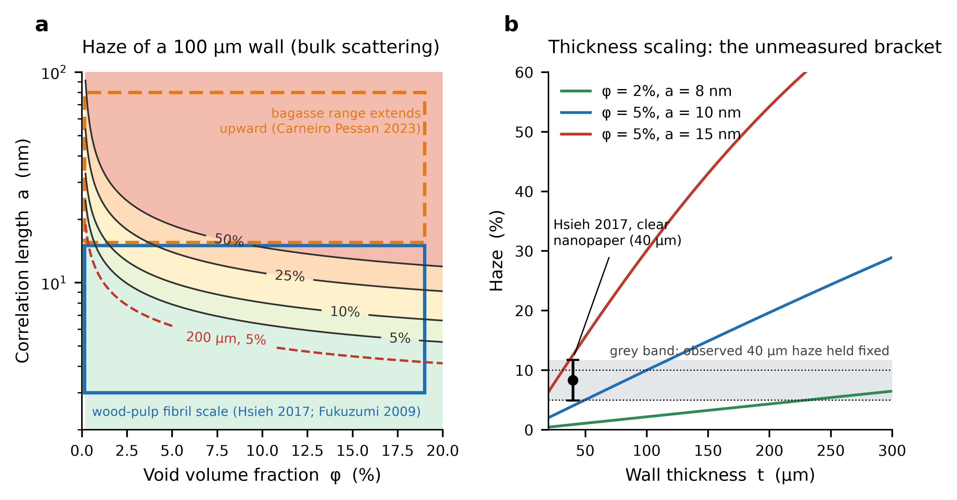
Fig. 2 Optical screen. a Haze of a 100 µm wall from bulk scattering as a function of void fraction and correlation length, with the wood-pulp fibril scale (blue box; Hsieh et al. 2017, Fukuzumi et al. 2009) and the extension to the reported bagasse range (orange; Carneiro Pessan et al. 2023); the dashed red curve is the 5% contour for a 200 µm wall. b Haze against thickness for three structures under bulk scattering, with the observed 4.9–11.7% haze of 40 µm clear nanopaper (point) and the gray band showing the opposite limit, in which that haze is surface-dominated and independent of thickness. The region between the two limits is what a thickness series must measure.
Table 4 Largest correlation length a (nm) that keeps the haze of a wall at or below its target by thickness and void fraction φ (full angular integral, n_{c} = 1.55; f_{m} = 1).
Thickness (µm) | Haze ≤ 5%: φ = 2% | 5% | 10% | Haze ≤ 10%: φ = 2% | 5% | 10%
40 | 14.8 | 10.8 | 8.7 | 19.1 | 13.8 | 11.0
100 | 10.7 | 7.9 | 6.3 | 13.7 | 10.0 | 8.0
200 | 8.4 | 6.2 | 5.0 | 10.7 | 7.9 | 6.3

How well does the screen reproduce published haze? It is not a calibration. With structures drawn from the literature, the bulk-scattering haze of a 40 µm wood-pulp sheet has a median of 1.5% and reaches the observed 4.9–11.7% band in only 14% of samples (73% lie below it and 13% above it) (Hsieh et al. 2017). Bulk void scattering at the nanofibril scale therefore does not by itself explain the haze of published clear nanopaper; surface roughness and residual fiber fragments probably contribute, as the original authors attribute. The most direct consequence is the bracket of Fig. 2b: if the observed haze is mostly bulk, it scales with thickness, and a 100–200 µm wall is far hazier than 40 µm nanopaper, and if it is mostly surface, it does not. Which limit applies is unmeasured and is the first optical measurement; Section 6.5 tests what could close the gap.
Over the sampled ranges (Table 5), a wood-pulp-scale structure meets a 10% haze target at 100 µm in 69% of samples and at 200 µm in 56%, with the bagasse range of the shares falling to 26% and 18%, respectively. Those shares are conditional on the assumed prior over correlation length, which is uniform on a logarithmic scale and should be read as a ranking and not as a probability that the material works; for 53% of bagasse samples at 100 µm, τt exceeds 1, where the single-scattering estimate is optimistic. The robust results are the thresholds of Table 4. Sensitivity is dominated by the correlation length (Spearman ρ = +0.80 for the bagasse range, +0.74 for the wood-pulp scale), followed by film density (-0.37), as the cubic law implies.
Table 5 Optical screen over the sampled ranges: median haze and the share of samples meeting a haze target, by feedstock range and wall thickness.
Range | Thickness (µm) | Median haze | Haze ≤ 5% | Haze ≤ 10% | τt > 1
Wood-pulp scale | 40 | 1.5% | 73% | 85% | 1%
Wood-pulp scale | 100 | 3.7% | 56% | 69% | 6%
Wood-pulp scale | 200 | 7.4% | 42% | 56% | 14%
Bagasse range | 40 | 27.4% | 28% | 37% | 39%
Bagasse range | 100 | 58.6% | 18% | 26% | 53%
Bagasse range | 200 | 85.9% | 12% | 18% | 62%

6.2 Wet mechanical properties: signs of the effect of chitosan
At neutral pH, the addition of 20% chitosan increases the median modeled wet stiffness from 0.85 to 2.36 GPa (5–95% range 0.69–5.56 GPa), and the share of samples reaching 1 GPa increases from 45% to 88%. With respect to an acidic liquid, the gain disappears: the median change is -0.01 GPa, the share reaching 1 GPa is 51%, and chitosan improves the wet stiffness in 49% of the samples, compared with 86% at neutral pH (Table 6, Fig. 3a). The effect is therefore not intrinsic to chitosan but depends on the cross-linking and on the liquid. Removing the cross-linking term on the same draw changes the median gain at neutral pH from +1.08 to -0.10 GPa, and the share of samples in which chitosan is present increases from 86% to 35%; thus, on the screen, the benefit is carried out by cross-linking, not by the stiffness of the chitosan phase. The wet stiffness is most sensitive to the cross-linking gain ξ_{max} (Spearman ρ = +0.64 for the neutral case), followed by the dry CNF modulus (+0.51) and plain-CNF wet retention (+0.33); in acid, plain-CNF retention is predominant (+0.70) because the contribution of chitosan is lost.
The screen can be compared with the published wet datum. The reported modulus of 4 GPa for water-soaked 80/20 films (Toivonen et al. 2015) lies at the 82nd percentile of the modeled distribution (18% of samples reach it), so the screen brackets the datum, but its center is conservative relative to it, as expected if the pH-switched processing sits at the favorable end of the cross-linking range. The ratio of 0.60 reported for chitosan-disrupted carrot nanofiber films (Szymańska-Chargot et al. 2019) lies inside the assumed range of the network-efficiency factor. These are consistency checks, not calibrations, and the acid case rests on the assumption, supported by the dissolution of chitosan in acid (Melro et al. 2021) but not by any wet CNF/chitosan measurement in acid, that the cross-linking gain is largely lost.
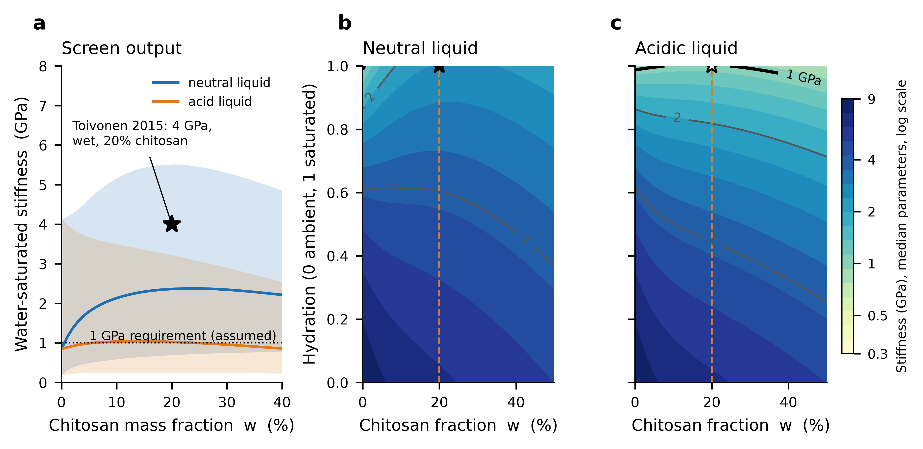
Fig. 3 Wet-stiffness screen. a Water-saturated stiffness against the chitosan fraction for a neutral and an acidic liquid (median and 5–95% band); the star is the wet datum of Toivonen et al. (2015). b, c Stiffness against the chitosan fraction and hydration at median parameters for the neutral and acidic liquids; contours at 0.5, 1, 2 and 4 GPa. The 20% chitosan column is the only loading with a published wet datum; the rest of each map is extrapolated.
Table 6 Wet-stiffness screen: median water-saturated stiffness, the share of samples reaching 1 GPa (an assumed requirement) and the share in which chitosan increases stiffness above that of plain CNF.
Chitosan (wt%) | Neutral: median (GPa) | ≥ 1 GPa | Helps | Acidic: median (GPa) | ≥ 1 GPa | Helps
0 | 0.85 | 45% | – | 0.85 | 45% | –
5 | 1.79 | 78% | 86% | 0.99 | 50% | 54%
10 | 2.13 | 85% | 86% | 1.04 | 52% | 53%
20 | 2.36 | 88% | 86% | 1.03 | 51% | 49%
30 | 2.34 | 90% | 84% | 0.96 | 48% | 44%

6.3 Forming: geometry sets the burden
The strain budget of Eq. (8) is 0.262 for the tray, 0.667 for the bowl and 1.105 for the cup, corresponding to surface areas 1.7, 3.8 and 9.1 times the base footprint, respectively (Fig. 4a). With no stretching, they would need blank-to-punch ratios of 1.30, 1.95 and 3.02. In terms of the sampled strain tolerances, a forming window exists for saturated forming in 86% of the tray samples, 7% of the bowl samples and none of the cup samples (Table 7). Within the assumed ranges, the cup result does not depend on the sampling: the greatest total tolerance ε_{crit} + ε_{wr} reachable in the assumed range is 0.96 for saturated forming, 0.81 at half of the initial hydration and 0.66 at ambient temperature, all below the cup’s 1.10 (the dashed box of Fig. 4a does not reach the cup line). The bowl is out of reach in the ambient state, where the best case of 0.660 falls just short of the 0.667 needed and is reached only when the sheet is hydrated (0.81 at half hydration, 0.96 saturated) and at the upper end of the wrinkling tolerance.
Among the unknowns, the wrinkling tolerance of the flange dominated the bowl margin (Spearman ρ = +0.85), followed by the void-onset ratio (+0.39), the wet strain gain (+0.27) and, last, the ambient failure strain (+0.14). When draw-in supplies most of the material, it is the compressive limit that matters, not fracture, which reorders the usual emphasis on strain to failure. At the median tolerances, a straight-walled cup could have a depth of only 0.23 (ambient) to 0.33 (wet) base diameter.
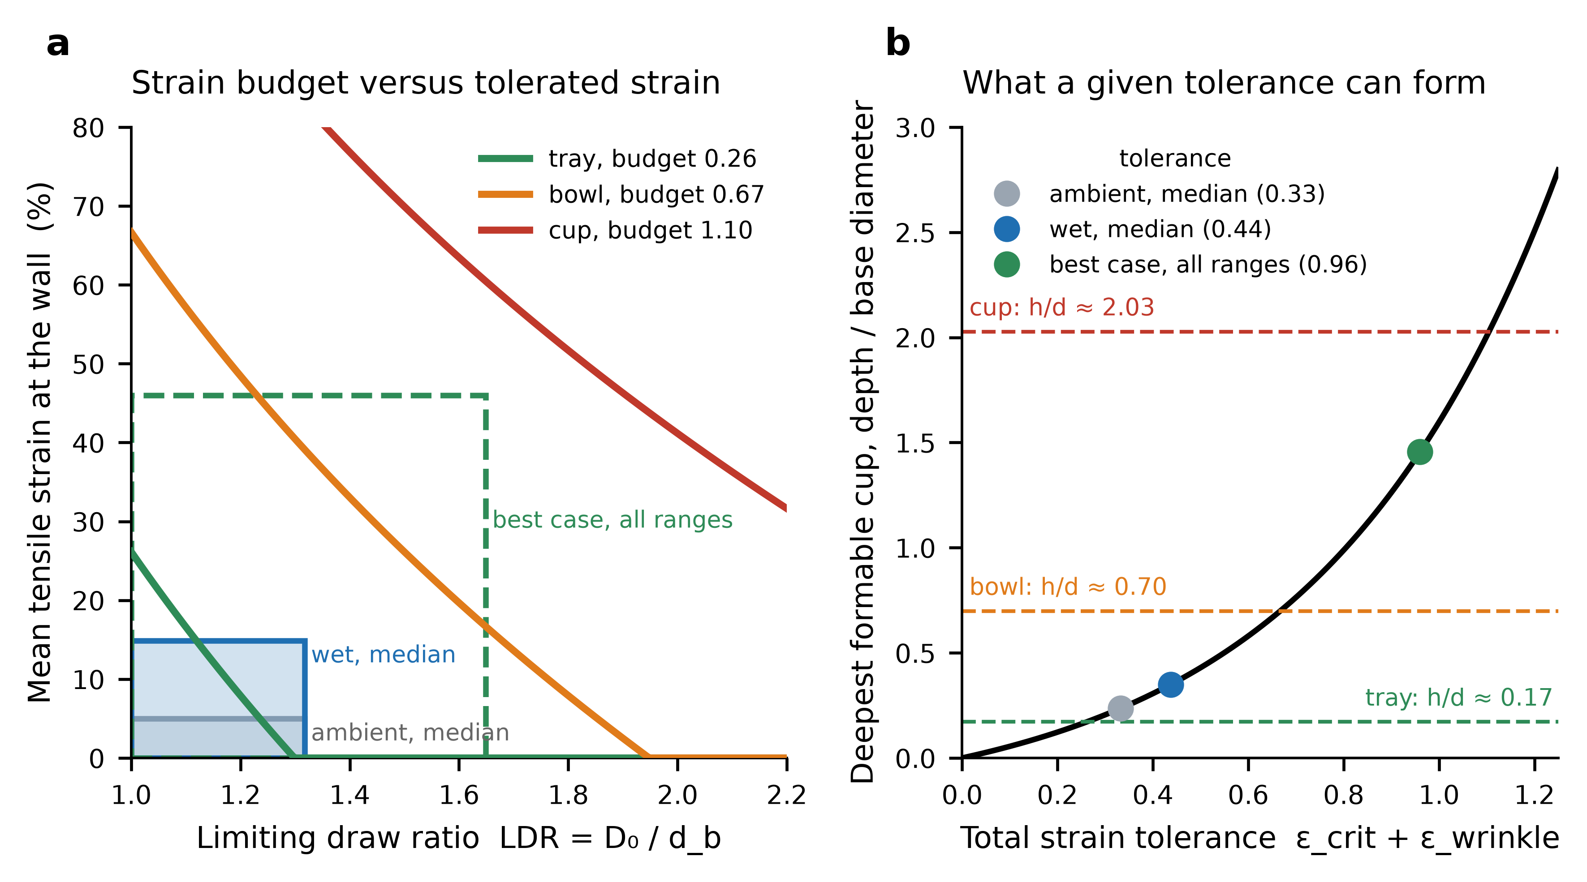
Fig. 4 Forming screen. a Mean tensile strain at the wall against the limiting draw ratio for the three geometries (lines) and the box of tolerated strain at median ambient and wet tolerances (solid) and at the best case over all assumed ranges (dashed); a forming window exists only where a geometry line passes through a box. b Deepest straight-walled cup (depth over base diameter) that a given total tolerance can form, with the equivalent ratio of each geometry (dashed) and the three tolerances.
Table 7 Forming screen: strain budget of each geometry and the share of samples with a forming window by forming hydration.
Geometry | Strain budget | Area ratio | Ambient | Half hydration | Saturated
Tray (lid-like) | 0.262 | 1.7 | 65.9% | 77.3% | 85.5%
Bowl | 0.667 | 3.8 | 0.0% | 1.2% | 6.9%
Cup | 1.105 | 9.1 | 0.0% | 0.0% | 0.0%

6.4 Integration
With respect to the reference design (100 µm wall, 20% chitosan, ≤ 10% haze, wet stiffness ≥ 1 GPa, and saturation), 52% of the samples passed all three tests for a tray with a wood-pulp-scale structure and a neutral liquid, 19% with a bagasse-range structure, and 30% and 11% in an acidic liquid; for a bowl, the percentage was 4% and 2%, respectively, and for every case, the percentage was zero (Fig. 5a). These shares depend on the assumed ranges and are reported to rank the cases. The conclusions that do not depend on them are the thresholds of Table 4, the bound on the cup, and the order of the unknowns in Fig. 5b; Section 6.7 tests them under alternative priors.
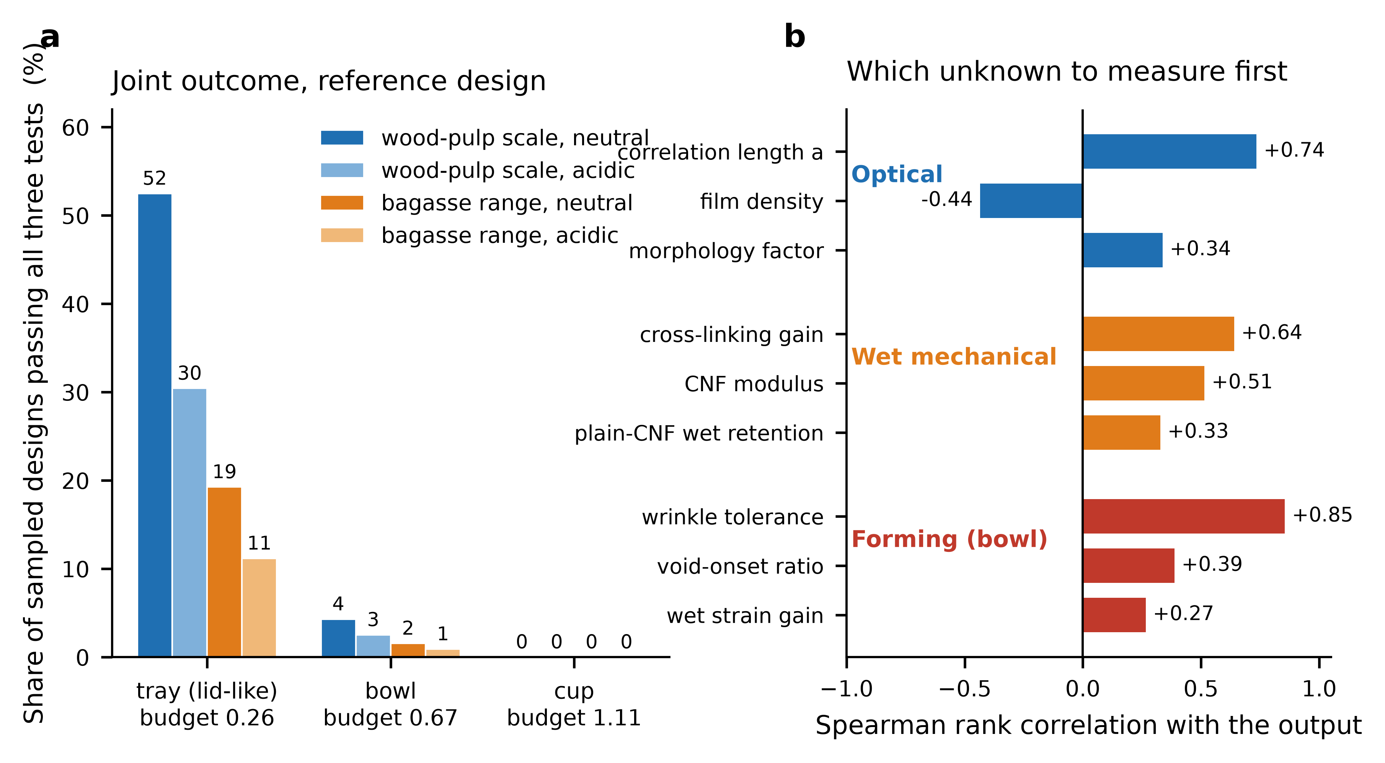
Fig. 5 Integration. a Share of sampled designs passing all three tests at the reference design (100 µm wall, 20% chitosan, haze ≤ 10%, wet stiffness ≥ 1 GPa, forming at saturation), by geometry, feedstock range and liquid. Shares depend on the assumed ranges; the zero for the cup holds within the assumed range (in the best case, 0.96 < 1.10). b Spearman rank correlation of the leading unknowns with the optical, wet-mechanical and forming outputs: the quantities to measure first.

6.5 Optical-model validation: what could close the gap
Section 6.1 reported that bulk scattering by the nanofibril network reproduces the observed haze of clear nanopaper in only 14% of samples. Two additions were tested (Section 5.6). Surface scattering on its own would need an RMS height of 28–44 nm on each of the two faces to yield the observed 4.9–11.7% haze (67 nm if only 30% of the scattered light leaves the 2.5° cone), several times the 3–15 nm fibril width; thus, the faces would be rougher than the fibrils that form them, and atomic force or optical profilometry of the faces is the measurement that is used. Over the assumed roughness range (1–30 nm), the median haze of a 40 µm wood-pulp-scale sheet increases from 1.5% to 2.3%, and the share inside the observed band increases from 14% to 17%. A coarse population with a volume fraction of 0.001–0.03% and a size of 50–300 nm acts more strongly: the median increases to 3.8%, and the share inside the band is 25%. With both, the median is 4.6%, and 29% of the samples lie inside the band, but 53% still lie below it (Table 8, Fig. 6a). The additions narrow the gap and do not close it, so the bulk screen remains at a lower bound on haze, and the observed 4.9–11.7% is most simply explained by a small population of coarse scatterers that no density measurement would reveal.
Table 8 Haze of a wood-pulp-scale sheet with the bulk screen alone and with the addition of bound material: median haze and the share of samples inside and below the observed 4.9–11.7% band at 40 µm.
Scattering included | Median haze 40 µm | Inside band | Below band | Median haze 100 µm | Median haze 200 µm
Nanofibril bulk only (core screen) | 1.5% | 14% | 73% | 3.6% | 7.3%
+ rough surfaces | 2.3% | 17% | 69% | 4.5% | 8.0%
+ coarse population | 3.8% | 25% | 58% | 9.4% | 18.1%
+ both | 4.6% | 29% | 53% | 10.0% | 18.7%

Consequences for the optical budget. The coarse-population explanation has a design consequence that no single-thickness measurement reveals. A population that alone gives 8% haze at 40 µm (volume fraction 0.054% at 100 nm, 0.015% at 300 nm) would give 19% haze at 100 µm and 34% at 200 µm regardless of the nanofibril scale because haze then increases with thickness. The correlation-length threshold of Table 4 is therefore a necessary condition under the bulk model, not a sufficient one: it holds only if the coarse population is controlled. The threshold itself is slightly changed by surface roughness (for 100 µm, 10% haze and 5% voids, a ≤ 10.0 nm with none, 9.8 nm at 10 nm RMS and 9.0 nm at 20 nm RMS) or by a small coarse population (9.4 nm at 0.005%). The thickness series of P1 (Section 8) separates these cases, since surface haze is independent of thickness and coarse-population haze is not.
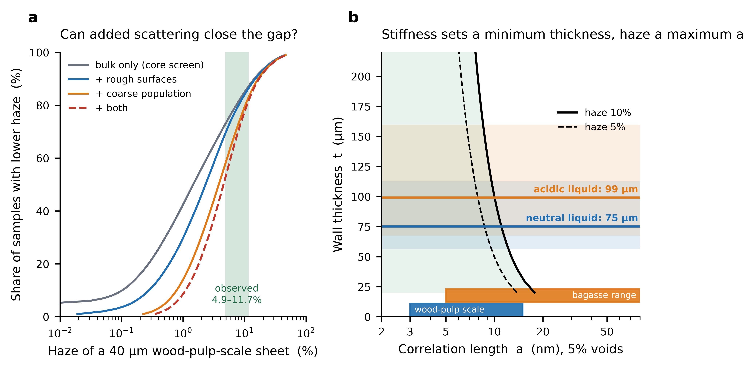
Fig. 6 Optical-model validation and the coupled window. a Cumulative distribution of the haze of a 40 µm wood-pulp-scale sheet for the bulk screen alone and with rough surfaces and a coarse population added (assumed ranges, Supplementary Table S10); the green band is the observed 4.9–11.7%. b Haze budget (maximum correlation length at 5% voids) against thickness for 10% (solid) and 5% (dashed) haze, with the minimum thickness that stiffness requires at the median wet modulus for a neutral and an acidic liquid (lines; bands are in the 5–95% range). A design must lie to the left of the budget curve and above the line.

6.6 Thickness couples the optical and stiffness screens
Equation (12) is used to determine the thickness of the variable that joins the screens: stiffness is set such that the thinnest wall is rigid enough, and the haze budget is set such that the finest structure that the wall may carry. At the median wet modulus, the minimum thickness is 75 µm for a neutral liquid (5–95% range 56–113 µm) and 99 µm for an acidic liquid (68–160 µm); thus, the liquid the package must resist changes in the optical budget: the allowed correlation length at 5% voids and 10% haze is 11.1 nm for the neutral case and 10.0 nm for the acidic case (Fig. 6b). With each sample’s own modulus setting its own thickness, a wood-pulp-scale structure meets the 10% haze target in 74% of samples for a neutral liquid and 69% for an acidic one and a bagasse-range structure in 29% and 26%, respectively; when evaluated at the fixed 100 µm of Section 6.4 and required to reach 1 GPa, the shares are 61% and 36% for the wood-pulp scale and 23% and 13% for the bagasse range, respectively. The coupling does not rescue the bagasse range, but it shows that the stiffness result and the optical result cannot be quoted at a common thickness without choosing one.

6.7 Robustness to the prior distributions
Eleven of the nineteen ranges are assumptions, so the Monte Carlo shares were recomputed under seven prior schemes (Section 5.6). The shares move by tens of percentage points (Table 9, Fig. 7): the share of wood-pulp-scale structures meeting the haze target at 100 µm ranges from 46% to 80%, that of the bagasse ranges from 2% to 35%, the tray’s forming window from 65% to 99%, the bowl’s from 0.3% to 27.5%, and the joint pass share of the tray from 25% to 78%. They are not results about the material. Four statements survived every scheme: the window of the tray is larger than that of the bowl, and the bowl is larger than the cup (yes); the wood-pulp scale beats the bagasse range optically (yes); chitosan helps in more samples at neutral pH than in acid (yes); and the median gain of chitosan is smaller in acid than at neutral pH (yes). Two statements are conditional. The sign of the median chitosan gain in acid is not fixed: it runs from -0.36 to +0.17 GPa across the schemes, against +0.56 to +1.46 GPa at neutral pH, so the defensible statement is that the gain is small and of uncertain sign in acid. The cup is closed in every scheme except for the widened one, where the upper bound of the wrinkling tolerance increases from 0.50 to 0.72 and the best-case total tolerance is 1.19, above the cup’s 1.10; 0.015% of the samples form it.
Table 9 Headline shares under seven prior schemes (base, uniform, centered, widened, narrowed, optimistic, pessimistic): the base value, the range across schemes and the schemes that give its extremes.
Output | Base | Lowest | Highest | Lowest in | Highest in
Optical pass, wood-pulp scale, 100 µm | 69% | 46% | 80% | uniform | optimistic
Optical pass, bagasse range, 100 µm | 26% | 2% | 35% | centered | optimistic
Chitosan helps, neutral | 86% | 70% | 99% | uniform | narrowed
Chitosan helps, acidic | 49% | 26% | 63% | uniform | widened
Forming window, tray | 85% | 65% | 99% | pessimistic | narrowed
Forming window, bowl | 7.0% | 0.3% | 27.5% | narrowed | widened
Forming window, cup | 0.00% | 0.00% | 0.02% | all other schemes | widened
All three pass, tray (wood-pulp) | 53% | 25% | 78% | pessimistic | optimistic
All three pass, bowl (wood-pulp) | 4.3% | 0.2% | 16.9% | narrowed | widened
Median acid gain (GPa) | -0.01 | -0.36 | +0.17 | uniform | widened

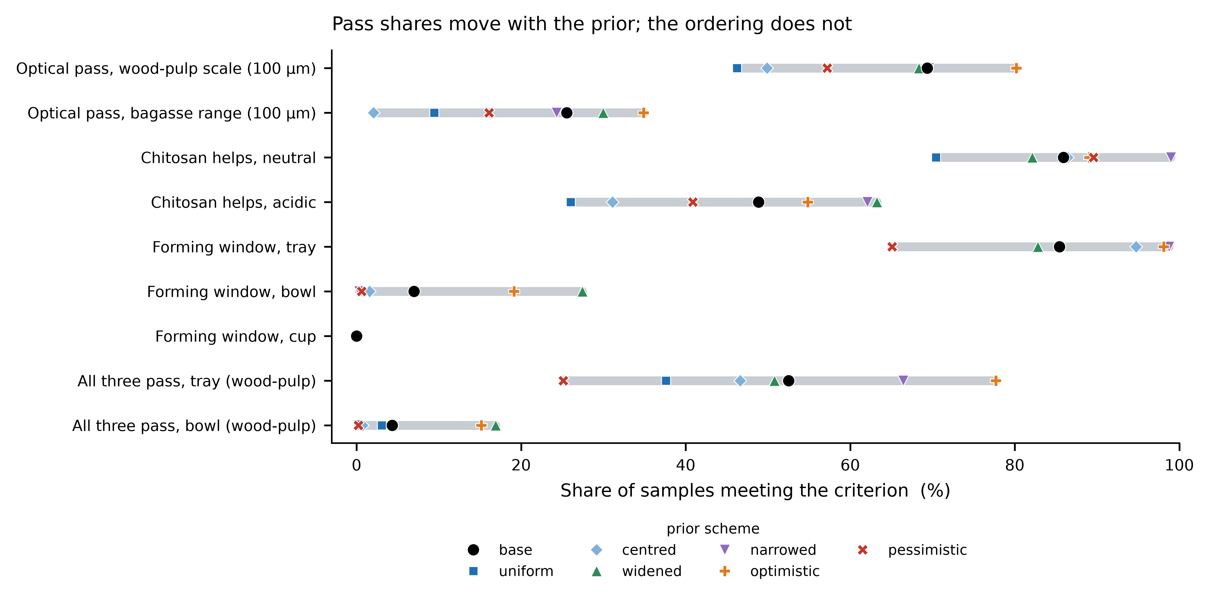
Fig. 7 Robustness to prior distributions. Each row is a headline share; the bar spans the seven prior schemes, and each marker is one scheme. The order of the rows within a pair (tray, bowl and cup; wood-pulp scale and bagasse range; neutral and acidic) is the same in every scheme.
What the cup needs. The closed cup is the result most worth stating as a requirement. Even with every tensile tolerance in its best case (0.46 for a saturated sheet), the flange would have to tolerate a wrinkling strain of 0.64, that is, a limiting draw ratio of 1.91, against an assumed upper bound of 0.50 (1.65). At the median tensile tolerance (0.15), the requirement is 0.96, and the draw ratio is 2.60. The conclusion is thus not that a cup cannot be drawn but that it needs a flange wrinkling tolerance well beyond anything assumed here, for which no measurement on nanocellulose sheets exists.

6.8 Barrier layer: a bounded test of H3
The wax layer of H3 is not part of the integrated screens, and liquid containment is untested. Its effect on the other two requirements can nevertheless be bounded (Section 5.6). Optically, the assumption that a submicron layer adds no haze is not safe: over the assumed ranges, a layer on one face of a 100 µm wall adds a median of 1.0 haze points (5–95% range 0.1–4.8), more than one point in 51% of samples, more than two in 28% and more than five in 4%. The surface roughness of the wax (Spearman ρ = +0.56), the index contrast of its crystallites (+0.45) and their size (+0.38) drive it. Mechanically, a coating applied before forming must survive the same strain as the sheet. With a cracking strain of 1–10%, the share of tray samples with a forming window at saturation decreases from 86% to 65%, and the bowl’s cracking strain decreases from 6.9% to 0.0%; coating after forming avoids this and moves the burden to conformal coating of a formed wall. These are the sensitivities to the assumed ranges. They classify every feasibility result in this paper as provisional because the liquid-holding function that the coating provides has not been tested, and they turn H3 from an inference of ‘no added haze’ into a measurable threshold: an added haze of at most one point.
Table 10 Bounded sensitivity of the wax layer (assumed ranges): added haze at 100 µm and the share of samples with a forming window at saturation, uncoated and coated before forming.
Quantity | Result
Added haze, median (5–95%) | 1.0 points (0.1–4.8)
Share adding > 1, > 2, > 5 points | 51%, 28%, 4%
Median added haze: surface only, crystallites only | 0.21, 0.47 points
Tray window: uncoated, coated before forming | 85.5%, 64.9%
Bowl window: uncoated, coated before forming | 6.9%, 0.0%
Cup window: uncoated, coated before forming | 0.0%, 0.0%

7 Discussion
What the three screens return? The optical screen shows that the thickness and correlation length, not the material identity, determine whether a dense nanofibril wall is clear: the same structure that gives a single-digit haze at 40 µm can be several times hazier at 100–200 µm if the scattering is bulk. The wet screen shows that chitosan is a cross-linker whose benefit is conditional on the liquid, not a reinforcement in the ordinary sense. The forming screen shows that, for deep geometries, the sheet would need to supply many times its footprint area, which no tolerance within the assumed ranges provides.
What only the combination returns? Each screen alone has a similar trend: smaller features scatter less, chitosan can cross-link nanofibrils, and deeper shapes need more strain. Table 11 lists the results that need the screens taken together and what would be missed if one screen were used alone.
Table 11 Results that require two or more screens and what a single screen would miss.
Result | Screens combined | What a single screen misses
The liquid changes the optical budget: median minimum thickness 75 µm (neutral) against 99 µm (acidic), allowed correlation length 11.1 against 10.0 nm (Section 6.6) | Wet stiffness and optical | Each fixes the thickness at 100 µm and cannot see the coupling
A wax layer applied before forming narrows the tray window from 86% to 65% and closes the bowl (Section 6.8) | Barrier and forming | The forming screen assumes a bare sheet
The correlation-length threshold is necessary, not sufficient: coarse scatterers that explain the observed 40 µm haze give approximately 19% at 100 µm (Section 6.5) | Optical and published haze data | The bulk model alone, or haze at a single thickness
Flange wrinkling tolerance, not fracture strain, decides the bowl (Spearman ρ = +0.85), and the cup needs a wrinkling strain above 0.64 | Forming and void-onset limit | Tensile‒strain data alone
Thresholds, orderings and the cup bound survive seven prior schemes; pass shares do not (Section 6.7) | All three and the prior sets | A single Monte Carlo run

Scope of the forming result. The cup result applies to forming a flat, dense sheet by drawing, with the strain limits assumed here; it is not universally impossible. Routes that change the burden include multistage drawing with intermediate drying; hydration beyond the saturated state; redistribution of thickness toward the wall, which the uniform-strain budget (a lower bound, Eq. 8) does not capture; storing areas in folds, pleats or a seam instead of strain; and direct molding from a suspension, the route of Rol et al. (2020), which avoids sheet strain at the price of the drying shrinkage that defeated it. None of these is modeled. Each is a candidate whose own limit would need its own measurement, and the framework states the corresponding requirement for the drawing route: a flange wrinkling tolerance above 0.64 for the cup.
Consistency with prior art. The results agree with those reported for three-dimensional CNF objects, which produced objects by wet molding but not transparent or dimensionally stable ones because of drying shrinkage (Rol et al. 2020). The two findings are complementary: that study identifies a route-specific failure, shrinkage on drying, which this screen does not represent, while this analysis shows a geometric limit that applies regardless of the route. The wet-state result is consistent with a pH-switched cross-linking mechanism (Toivonen et al. 2015), and the limits of the closed cubic law matter for the coarse end of the bagasse nanofibril range.
Design implications. The results do not say that a transparent bagasse package is impossible; they say what would have to be true. Shallow geometries such as lids and trays are the only ones inside the assumed tolerances. A cup-like container would need a construction that does not stretch a flat sheet, for example, a wall formed from a flat blank by wrapping with a seam, which trades the strain constraint for seam, leak and optical continuity requirements that are not analyzed here; a transparent window in an otherwise opaque molded-pulp body is another option. Reducing the wall thickness relaxes the optical budget in proportion but decreases stiffness and increases sensitivity to surface defects.
What to measure first. The rankings are given in order. With respect to optics, the correlation length and void fraction of a dense bagasse sheet are determined by small-angle X-ray scattering, since the Debye–Bueche form is the one with which such data are analyzed (Debye et al. 1957), followed by haze against thickness. With respect to wet stiffness, the cross-linking gain and plain-CNF wet retention are included in acidic liquids. For forming, the flange wrinkling tolerance and the strain at which haze first occurs increase.
Relation to CNFs and CNCs. Nanocrystalline sheets from bagasse have provided the clearest reported results (Tao et al. 2017), but their stiffness and expected brittleness depend on forming in a way that the present screens treat only through the assumed strain tolerances. A hybrid that maintains the clarity of crystals and the entanglement of fibrils, as in Xu et al. (2016), is a natural candidate for H1 and is accommodated by the framework through structural parameters.

8 Falsifiable predictions and validation matrix
Each prediction below follows from the computation and can be shown incorrectly by a stated measurement.
- P1 (thickness scaling). If bulk scattering is dominant, the haze of a dense nanofibril sheet increases approximately in proportion to the thickness between 40 and 200 µm (H ≈ f_{h}τt for τt ≲ 0.3); if surface scattering is dominant, the haze is nearly independent of the thickness. A thickness series determines which measured haze outside the bracket of Fig. 2b falsifies the screen.
- P2 (structure predicts haze). Small-angle scattering of the sheet should give φ(1−φ)a³ and a Debye–Bueche correlation length that predict the measured bulk haze within the factor spanned by f_{m} (0.3–3).
- P3 (bagasse threshold). A dense bagasse nanofibril sheet meets a 10% haze target at 100 µm only if its correlation length is less than approximately 10 nm at 5% voids (14 nm at 2%).
- P4 (acid reversal). The increase in wet stiffness from 20% chitosan measured after soaking in an acidic liquid is much smaller than that after soaking in neutral water and may be negative; a gain retained in acid falsifies the assumed loss of cross-linking.
- P5 (forming limit). Haze increases before fracture during forming if r_{v} < 1, and a flat dense sheet cannot be formed into the cup geometry by drawing alone; a transparent formed cup falsifies the bound of Eq. (10).
- P6 (what scatters). If a small coarse population explains the haze of clear nanopaper, haze increases with thickness (approximately 19% at 100 µm for a population that is 8% at 40 µm), and the population is visible by microscopy or wide-angle scattering; if the faces are scattered, haze is independent of thickness, and the RMS height of the faces is tens of nanometers (2.6% haze at 20 nm and 5.7% at 30 nm from the two faces).
- P7 (wax haze). A submicron wax layer adds measurable haze: in the bound analysis, it adds more than one point at 100 µm in 51% of the sampled structures, and a coating that adds at most one point needs smooth, fine-crystalline wax.
Table 12 Validation matrix: the measurement, the threshold derived here and what would falsify it.
Requirement | Measurement | Threshold derived here | Falsified if
Bulk scattering | Small-angle X-ray scattering, Debye–Bueche analysis of dense bagasse sheets | φ(1−φ)a³ ≤ 22 nm³ at 100 µm, 5% haze | Measured value exceeds it with haze still low
Thickness scaling | Haze (ASTM D1003) at 40, 100, 200 µm | Haze ∝ t (bulk) or constant (surface) | Outside the bracket of Fig. 2b
Surface or coarse scatterers | Profilometry of both faces; microscopy or wide-angle scattering of the bulk | Two-face haze 0.7% at 10 nm RMS, 5.7% at 30 nm; coarse volume fraction ≤ 0.054% at 100 nm | Observed haze unexplained by either
Feedstock (H1) | Correlation length, bagasse versus wood-pulp CNF at equal density | a ≤ 10 nm at 5% voids (100 µm, 10% haze) | Larger a with haze still within target
Wet stiffness (H2) | Wet tensile modulus at 0, 10, 20, 30 wt% chitosan in neutral water | ≥ 1 GPa; model median 2.4 GPa at 20% | Below 1 GPa, or no gain over plain CNF
Acid exposure (H2) | Wet modulus after soaking in acidic liquids | Gain over plain CNF near zero (model median -0.01 GPa) | Gain retained in acid
Barrier (H3) | Liquid-hold test, haze after coating, abrasion-induced haze | 24 h hold (proposed); added haze ≤ 1 point (exceeded in 51% of the bounded samples) | Leak, or coating adds more than one point
Strain tolerance (H4) | Wet and ambient strain to failure; in situ haze against strain | Total tolerance ≥ 0.26 (tray), 0.67 (bowl) | Below the budget of the target geometry
Flange wrinkling (H4) | Draw test with blank holder, LDR at wrinkle onset | LDR_{max} = exp(ε_{wr}); needed 1.30 (tray) | LDR_{max} below the requirement
Package | Filled-container drop, lid attachment, thermal cycling | 1 m drop (proposed) | Failure

The staged program used to test these materials is as follows: Phase I, material (fibril width, density, small-angle scattering, haze against thickness, with and without delignification); Phase II, composite (chitosan at 0, 5, 10, 20 and 30 wt%, transparency, dry and wet tensile properties in neutral and acidic liquids); Phase III, barrier (contact angle, liquid hold, durability, abrasion-induced haze); Phase IV, forming (shallow, intermediate and full-depth draw; haze, cracking and delamination); and Phase V, package (filled-cup drop, extended containment, lid attachment, thermal cycling). Details are provided in Supplementary Information S6.

9 Sustainability and scalability
The constituents (cellulose, chitosan and natural wax) were chosen for potential compatibility with the compostability pathways; the compostability of the finished structure was unvalidated, and no life-cycle assessment was performed. Nanofibrillation energy depends on the processing method (Spence et al. 2011), and production routes are reviewed in (Nechyporchuk et al. 2016); refining alone reached a plateau of barrier properties only after 1,800–12,000 kWh t⁻¹ depending on the refiner (Kargupta et al. 2022), and complete defibrillation of rice straw by aqueous counter collision was reported at 15 kWh kg⁻¹ (Jiang et al. 2016). These figures come from different feedstocks, equipment and end points and are not comparable. The life cycle impact of nanofibril production depends strongly on the pretreatment route and on the electricity mix (Arvidsson et al. 2015), and the scale-up of nanostructures from bagasse remains a stated challenge (Hiranobe et al. 2024). Repulpability of a deliberately void-free sheet is a testable hypothesis, not a result.

10 Limitations
- No sheet or package was made or tested. Eleven of the nineteen parameter ranges are assumptions, and every share quoted in Section 6 is conditional on them; the thresholds and the cup bound are the results that depend least on them, and Section 6.7 tests the dependence under six alternative prior sets.
- The core optical screen represents bulk scattering; surface and coarse scattering enter only as bounded additions with assumed ranges (Section 6.5). Absorption by residual lignin, multiple scattering beyond τt of approximately 1 and the anisotropy of cellulose are not represented, and Eq. (2) has not been validated against small-angle scattering from nanocellulose sheets. It does not by itself reproduce the haze of published clear nanopaper. The Born approximation is comfortable at the wood-pulp fibril scale but marginal for correlation lengths of tens of nanometers, where the phase shift across one correlation length reaches 0.25 at 40 nm and 0.50 at 80 nm (Supplementary Table S1).
- The wet-stiffness screen is a Voigt-type bound with an assumed cross-linking term, and its acid case rests on an assumption that is plausible but untested for CNF/chitosan sheets. Interfacial failure, creep and swelling are not represented.
- The forming screen bounds mean area strain and tolerance. Friction, nonuniform thinning, temperature, drying shrinkage (the failure route reported by Rol et al. 2020) and the strain state of the wall are not represented; the wrinkling tolerance is not reported for nanocellulose sheets.
- The thickness coupling rests on an assumed equal-rigidity anchor (1 GPa at 100 µm), and the forming screen treats the drawing of a flat sheet; other routes (multistage or wet forming, folds and seams, direct molding from suspension) are neither modeled nor excluded.
- Liquid containment (H3) is not modeled: only the optical and forming effects of a wax layer are bounded (Section 6.8), with assumed ranges, so every feasibility result is provisional until a liquid-holding test exists. A contact angle is not a liquid-holding test.
- The food-contact regulatory status of chitosan, waxes and any additives, compostability and life-cycle impact were not assessed. Some references were available to the verification process only by title, and the claims attached to them are limited accordingly.

11 Conclusions
The literature supports each ingredient of a transparent, bagasse-derived nanocellulose–chitosan package for flat films, and it records one failure at the package scale. Three consistency screens show what would have to be true for the ingredients to coexist. A dense wall is clear only if its void fraction and correlation length lie inside a budget set by its thickness: for 100 µm, 10% haze and 5% voids, a correlation length of approximately 10 nm or less, a threshold for the reported bagasse nanofibril range straddles. Chitosan increases wet stiffness mainly through cross-linking, and in the screen, the benefit is small and uncertain in an acidic liquid. Geometry sets strain budgets of 0.26, 0.67 and 1.10 for a tray, a bowl and a cup, respectively, of which only the tray lies within the assumed tolerances, whereas the cup lies outside every combination of them unless the flange tolerates a wrinkling strain above 0.64. Stiffness, through wall thickness, couples the liquid to the optical budget, and a wax layer is applied before forming narrows the forming window. These are conditional results from the stated assumptions. They define the measurements, ranked by influence, that would confirm or falsify the concept, and they locate the binding constraint, forming, in geometry and not only in the material.

Declarations
Funding This research received no specific grant from funding agencies in the public, commercial or not-for-profit sectors.
Competing interests The author declares that there are no competing financial or nonfinancial interests.
Ethics approval and consent to participate Not applicable. This is a theoretical and computational study with no human participants, human data, animals or experiments.
Consent for publication Not applicable.
Data availability No experimental data were generated in this study. The computational code, the parameter registry (Table 3 and Supplementary Table S10), the fixed random seed (20261002), the Monte Carlo outputs (code/results.json), the verification tests, the figure-generation scripts, the numerical tables underlying Figures 2–7 (code/figure_data), the reference-audit tooling and the log of literature searches are available in a public repository at https://github.com/sandlerleon/bagasse-cnf-chitosan-framework (MIT license for code, CC BY 4.0 for the manuscript files) and are archived on Zenodo, https://doi.org/10.5281/zenodo.23111544, which always resolves to the latest version. The repository contains the software versions (requirements.txt) and the commands that reproduce every reported number; all the results are produced by one seeded run of code/run_analysis.py. The literature-derived parameters are listed individually in Table 3 and the corresponding references. This manuscript and its Supplementary Information are archived as a preprint on Zenodo, https://doi.org/10.5281/zenodo.23111546.
Author contributions Leon Sandler conceived the study, specified the physical model and its assumptions, directed the literature work and the computation, analyzed the results, and reviewed, edited and approved the manuscript.
Generative AI (Claude, Anthropic) was used as an assistive tool for code drafting, code review, figure-script drafting, literature-record retrieval scripts, and draft and language editing of the manuscript text. The author defined the research question, requirements and assumptions; directed the workflow and verification; reviewed the literature interpretation; approved all conclusions; and takes full responsibility for the work. No AI-generated data, references or conclusions were accepted without author verification (Section 5.5).

Appendix: nomenclature
Symbol | Definition | Unit
T_{d} | Direct (unscattered) fraction of transmitted light | –
τ | Scattering coefficient | m⁻¹
H | Haze: transmitted light deviating by more than 2.5° | –
φ | Void volume fraction | –
a | Correlation length of the void structure | nm
n_{c} | Refractive index of the cellulose phase | –
Δε | Permittivity contrast, n_{c}² − 1 | –
λ | Vacuum wavelength (550 nm) | nm
t | Wall thickness | µm
K | Derived prefactor, 64π⁴/3 | –
f_{m} | Morphology factor | –
g | Angular correction to the cubic law | –
f_{h} | Forward-scattered fraction beyond 2.5° | –
w | Chitosan mass fraction | –
E_{wet} | Water-saturated stiffness | GPa
E_{C}, E_{H} | Dry moduli of the CNF and chitosan phases | GPa
ψ | Dry network-efficiency factor | –
κ_{C0}, κ_{H} | Water-saturated retention of CNF and chitosan stiffness | –
ξ | Gain in CNF-phase retention from cross-linking | –
d_{b}, d_{t}, h | Base diameter, top diameter and depth of the container | mm
A_{cup} | Surface area of the container | mm²
ε_{b} | Strain budget (mean equibiaxial log-strain) | –
ε_{crit} | Tolerated tensile strain, min(failure, void onset) | –
r_{v} | Ratio of void-onset strain to failure strain | –
ε_{wr} | Tolerated compressive (wrinkling) log-strain | –
LDR | Limiting draw ratio, D₀/d_{b} | –
h (hydration) | Hydration, 0 ambient to 1 saturated | –

References
Arvidsson R, Nguyen D, Svanström M (2015) Life cycle assessment of cellulose nanofibrils production by mechanical treatment and two different pretreatment processes. Environ Sci Technol 49:6881–6890. https://doi.org/10.1021/acs.est.5b00888
ASTM International (2021) ASTM D1003-21: standard test method for haze and luminous transmittance of transparent plastics. ASTM International, West Conshohocken, PA. https://doi.org/10.1520/D1003-21
Aulin C, Gällstedt M, Lindström T (2010) Oxygen and oil barrier properties of microfibrillated cellulose films and coatings. Cellulose 17:559–574. https://doi.org/10.1007/s10570-009-9393-y
Azeredo HM, Mattoso LHC, Avena‐Bustillos RJ et al (2010) Nanocellulose reinforced chitosan composite films as affected by nanofiller loading and plasticizer content. J Food Sci 75(1). https://doi.org/10.1111/j.1750-3841.2009.01386.x
Azeredo HM, Rosa MF, Mattoso LHC (2017) Nanocellulose in biobased food packaging applications. Ind Crops Prod 97:664–671. https://doi.org/10.1016/j.indcrop.2016.03.013
Benítez AJ, Walther A (2017) Cellulose nanofibril nanopapers and bioinspired nanocomposites: a review to understand the mechanical property space. J Mater Chem A 5:16003–16024. https://doi.org/10.1039/c7ta02006f
Bhattacharya D, Germinario LT, Winter WT (2008) Isolation, preparation and characterization of cellulose microfibers obtained from bagasse. Carbohydr Polym 73:371–377. https://doi.org/10.1016/j.carbpol.2007.12.005
Carneiro Pessan C, Silva Bernardes J, Bettini SH et al (2023) Oxidized cellulose nanofibers from sugarcane bagasse obtained by microfluidization: Morphology and rheological behavior. Carbohydr Polym 304:120505. https://doi.org/10.1016/j.carbpol.2022.120505
Debye P, Bueche AM (1949) Scattering by an inhomogeneous solid. J Appl Phys 20:518–525. https://doi.org/10.1063/1.1698419
Debye P, Anderson HR, Brumberger H (1957) Scattering by an inhomogeneous solid. II. The correlation function and its application. J Appl Phys 28:679–683. https://doi.org/10.1063/1.1722830
Fang Z, Zhu H, Bao W et al (2014) Highly transparent paper with tunable haze for green electronics. Energy Environ Sci 7:3313–3319. https://doi.org/10.1039/c4ee02236j
FAO (2024) FAOSTAT: crops and livestock products, sugarcane (item 156), production quantity (element 5510), world total. Food and Agriculture Organization of the United Nations, Rome. https://www.fao.org/faostat/. Accessed via Our World in Data, 2 October 2026
Fernández-Marín R, Morales A, Erdocia X et al (2024) Chitosan–chitin nanocrystal films from lobster and spider crab: properties and environmental sustainability. ACS Sustain Chem Eng 12:10363–10375. https://doi.org/10.1021/acssuschemeng.4c01205
Fukuzumi H, Saito T, Iwata T et al (2009) Transparent and high gas barrier films of cellulose nanofibers prepared by TEMPO-mediated oxidation. Biomacromolecules 10:162–165. https://doi.org/10.1021/bm801065u
Fukuzumi H, Saito T, Isogai A (2013) Influence of TEMPO-oxidized cellulose nanofibril length on film properties. Carbohydr Polym 93:172–177. https://doi.org/10.1016/j.carbpol.2012.04.069
Ghormade V, Pathan E, Deshpande M (2017) Can fungi compete with marine sources for chitosan production? Int J Biol Macromol 104:1415–1421. https://doi.org/10.1016/j.ijbiomac.2017.01.112
Guzman-Puyol S, Benítez JJ, Heredia-Guerrero JA (2022) Transparency of polymeric food packaging materials. Food Res Int 161:111792. https://doi.org/10.1016/j.foodres.2022.111792
Hauptmann M, Majschak J (2011) New quality level of packaging components from paperboard through technology improvement in 3D forming. Packag Technol Sci 24:419–432. https://doi.org/10.1002/pts.941
Henriksson M, Berglund LA, Isaksson P et al (2008) Cellulose nanopaper structures of high toughness. Biomacromolecules 9:1579–1585. https://doi.org/10.1021/bm800038n
Hiranobe CT, Gomes AS, Paiva FFG et al (2024) Sugarcane bagasse: challenges and opportunities for waste recycling. Clean Technol 6:662–699. https://doi.org/10.3390/cleantechnol6020035
Hsieh M-C, Koga H, Suganuma K et al (2017) Hazy transparent cellulose nanopaper. Sci Rep 7:41590. https://doi.org/10.1038/srep41590
Hubbe MA, Ferrer A, Tyagi P et al (2017) Nanocellulose in thin films, coatings, and plies for packaging applications: a review. BioResources 12:2143–2233. https://doi.org/10.15376/biores.12.1.hubbe
Isogai A, Saito T, Fukuzumi H (2011) TEMPO-oxidized cellulose nanofibers. Nanoscale 3:71–85. https://doi.org/10.1039/c0nr00583e
Jiang F, Kondo T, Hsieh Y-L (2016) Rice straw cellulose nanofibrils via aqueous counter collision and differential centrifugation and their self-assembled structures. ACS Sustain Chem Eng 4:1697–1706. https://doi.org/10.1021/acssuschemeng.5b01653
Jäger K, Zeman M (2009) A scattering model for surface-textured thin films. Appl Phys Lett 95:171108. https://doi.org/10.1063/1.3254239
Kabeyi MJB, Olanrewaju OA (2023) Bagasse electricity potential of conventional sugarcane factories. J Energy 2023:1–25. https://doi.org/10.1155/2023/5749122
Kargupta W, Seifert R, Martinez M et al (2022) Preparation and benchmarking of novel cellulose nanopaper. Cellulose 29:4393–4411. https://doi.org/10.1007/s10570-022-04563-0
Kim M, Day DF (2011) Composition of sugarcane, energy cane, and sweet sorghum suitable for ethanol production at Louisiana sugar mills. J Ind Microbiol Biotechnol 38:803–807. https://doi.org/10.1007/s10295-010-0812-8
Klemm D, Kramer F, Moritz S et al (2011) Nanocelluloses: a new family of nature‐based materials. Angew Chem Int Ed 50:5438–5466. https://doi.org/10.1002/anie.201001273
Lavoine N, Desloges I, Dufresne A et al (2012) Microfibrillated cellulose – Its barrier properties and applications in cellulosic materials: a review. Carbohydr Polym 90:735–764. https://doi.org/10.1016/j.carbpol.2012.05.026
Li W, Wang S, Wang W et al (2019) Facile preparation of reactive hydrophobic cellulose nanofibril film for reducing water vapor permeability (WVP) in packaging applications. Cellulose 26:3271–3284. https://doi.org/10.1007/s10570-019-02270-x
Lyu D, Tang Y, Qian L et al (2019) Large strain cavitation induced stress whitening in propylene-butene-1 copolymer during stretching. Polymer 167:146–153. https://doi.org/10.1016/j.polymer.2019.01.081
Mandal A, Chakrabarty D (2011) Isolation of nanocellulose from waste sugarcane bagasse (SCB) and its characterization. Carbohydr Polym 86:1291–1299. https://doi.org/10.1016/j.carbpol.2011.06.030
Melro E, Antunes FE, da Silva GJ et al (2021) Chitosan films in food applications. Tuning film properties by changing the acidic dissolution conditions. Polymers 13:1. https://doi.org/10.3390/polym13010001
Moon RJ, Martini A, Nairn J et al (2011) Cellulose nanomaterials review: structure, properties and nanocomposites. Chem Soc Rev 40:3941. https://doi.org/10.1039/c0cs00108b
Mäkelä T, Kainlauri M, Willberg-Keyriläinen P et al (2016) Fabrication of micropillars on nanocellulose films using a roll-to-roll nanoimprinting method. Microelectron Eng 163:1–6. https://doi.org/10.1016/j.mee.2016.05.023
Ndikumana S, Tanane O, Aichi Y et al (2025) Innovative applications of sugarcane bagasse in the global sugarcane industry. Processes 13:3796. https://doi.org/10.3390/pr13123796
Nechyporchuk O, Belgacem MN, Bras J (2016) Production of cellulose nanofibrils: a review of recent advances. Ind Crops Prod 93:2–25. https://doi.org/10.1016/j.indcrop.2016.02.016
Niskanen I, Zhang K, Karzarjeddi M et al (2022) Optical properties of cellulose nanofiber films at high temperatures. J Polym Res 29:187. https://doi.org/10.1007/s10965-022-03019-0
Nogi M, Iwamoto S, Nakagaito AN et al (2009) Optically transparent nanofiber paper. Adv Mater 21:1595–1598. https://doi.org/10.1002/adma.200803174
Nogi M, Kim C, Sugahara T et al (2013) High thermal stability of optical transparency in cellulose nanofiber paper. Appl Phys Lett 102:181911. https://doi.org/10.1063/1.4804361
Otenda BV, Kareru PG, Madivoli ES et al (2022) Cellulose nanofibrils from sugarcane bagasse as a reinforcing element in polyvinyl alcohol composite films for food packaging. J Nat Fibers 19:3585–3597. https://doi.org/10.1080/15440478.2020.1848712
Pillai C, Paul W, Sharma CP (2009) Chitin and chitosan polymers: Chemistry, solubility and fiber formation. Prog Polym Sci 34:641–678. https://doi.org/10.1016/j.progpolymsci.2009.04.001
Qing Y, Sabo R, Wu Y et al (2012) High-performance cellulose nanofibril composite films. BioResources 7:3064–3075. https://doi.org/10.15376/biores.7.3.3064-3075
Rinaudo M (2006) Chitin and chitosan: properties and applications. Prog Polym Sci 31:603–632. https://doi.org/10.1016/j.progpolymsci.2006.06.001
Rol F, Billot M, Bolloli M et al (2020) Production of 100% cellulose nanofibril objects using the molded cellulose process: a feasibility study. Ind Eng Chem Res 59:7670–7679. https://doi.org/10.1021/acs.iecr.9b06127
Saito T, Kimura S, Nishiyama Y et al (2007) Cellulose nanofibers prepared by TEMPO-mediated oxidation of native cellulose. Biomacromolecules 8:2485–2491. https://doi.org/10.1021/bm0703970
Scopel E, Pinto LO, Rezende CA (2025) Residual lignin affects production and properties of TEMPO-oxidized cellulose nanofibrils from partially delignified sugarcane bagasse. Cellulose 32:9315–9331. https://doi.org/10.1007/s10570-025-06785-4
Sehaqui H, Zhou Q, Ikkala O et al (2011) Strong and tough cellulose nanopaper with high specific surface area and porosity. Biomacromolecules 12:3638–3644. https://doi.org/10.1021/bm2008907
Sellman FA, Rostami J, Östmans R et al (2024) Influence of fibril aspect ratio, chemical functionality, and volume fraction on the mechanical properties of cellulose nanofibril materials. Cellulose 31:8007–8025. https://doi.org/10.1007/s10570-024-06084-4
Semple KE, Zhou C, Rojas OJ et al (2022) Molded pulp fibers for disposable food packaging: a state-of-the-art review. Food Packag Shelf Life 33:100908. https://doi.org/10.1016/j.fpsl.2022.100908
Shimizu M, Saito T, Isogai A (2016) Water-resistant and high oxygen-barrier nanocellulose films with interfibrillar cross-linkages formed through multivalent metal ions. J Membr Sci 500:1–7. https://doi.org/10.1016/j.memsci.2015.11.002
Sirviö JA, Kantola AM, Komulainen S et al (2021) Aqueous modification of chitosan with itaconic acid to produce strong oxygen barrier film. Biomacromolecules 22:2119–2128. https://doi.org/10.1021/acs.biomac.1c00216
Spence KL, Venditti RA, Rojas OJ et al (2011) A comparative study of energy consumption and physical properties of microfibrillated cellulose produced by different processing methods. Cellulose 18:1097–1111. https://doi.org/10.1007/s10570-011-9533-z
Szymańska-Chargot M, Chylińska M, Pertile G et al (2019) Influence of chitosan addition on the mechanical and antibacterial properties of carrot cellulose nanofiber film. Cellulose 26:9613–9629. https://doi.org/10.1007/s10570-019-02755-9
Tao J, Fang Z, Zhang Q et al (2017) Super‐clear nanopaper from agro‐industrial waste for green electronics. Adv Electron Mater 3:1600539. https://doi.org/10.1002/aelm.201600539
Toivonen MS, Kurki-Suonio S, Schacher FH et al (2015) Water-resistant, transparent hybrid nanopaper by physical cross-linking with chitosan. Biomacromolecules 16:1062–1071. https://doi.org/10.1021/acs.biomac.5b00145
Vishtal A, Retulainen E (2012) Deep-drawing of paper and paperboard: the role of material properties. BioResources 7:4424–4450. https://doi.org/10.15376/biores.7.3.4424-4450
Wang Y, He B, Zhao L (2017) Fabrication of hydrophobic coating on filter paper from self-emulsifying carnauba wax-alcohol emulsions with nano-TiO2 particles for water/diesel separation. BioResources 12:7774–7783. https://doi.org/10.15376/biores.12.4.7774-7783
Xu X, Zhou J, Jiang L et al (2016) Highly transparent, low-haze, hybrid cellulose nanopaper as electrodes for flexible electronics. Nanoscale 8:12294–12306. https://doi.org/10.1039/c6nr02245f
Yang W, Jiao L, Liu W et al (2019) Manufacture of highly transparent and hazy cellulose nanofibril films by coating TEMPO-oxidized wood fibers. Nanomaterials 9:107. https://doi.org/10.3390/nano9010107
Zhu H, Fang Z, Preston C et al (2014) Transparent paper: fabrications, properties, and device applications. Energy Environ Sci 7:269–287. https://doi.org/10.1039/c3ee43024c

