Article type: Controversy, Concepts, and Hypotheses in Epilepsy (hypothesis article; no new experimental data).
Title: Can Chronic Caffeine Exposure Increase Adenosine A₁ Receptor Reserve and Seizure Threshold? A Testable Hypothesis
Running title: Caffeine adaptation and seizure threshold
Author: Leon Sandler, Independent Researcher, Northbrook, Illinois 60062, USA. ORCID 0009-0007-4584-808X. Corresponding author: sandler.leon@gmail.com
Keywords: pentylenetetrazol; methylxanthine; receptor plasticity; withdrawal; Monte Carlo simulation; EEG
Word count: approximately 2650 (sections 1–8, excluding summary, tables, legends, declarations and references). Tables: 4. Figures: 4. References: 20. Supporting Information: protocol, model specification and full sensitivity results; simulation code (CaffeineMC.py).
Key Points
- Adenosine A₁ receptors are the brain’s built-in brake on seizures
- Chronic caffeine may adapt this brake, but the evidence is conflicting
- We propose a test that separates adaptation from withdrawal and residual drug
- Simulation is used for planning only and contains no experimental data

Summary
Adenosine, acting largely through A₁ receptors (A₁R), is an important endogenous seizure-termination system. Caffeine blocks A₁R and acutely lowers seizure threshold, yet long-term caffeine in rodents has been reported to increase A₁R binding and reduce chemoconvulsant susceptibility. Whether this adaptation persists after caffeine is cleared, and whether it can be separated from residual drug and withdrawal effects, is unresolved. The closest in vivo test, a rat PET study, found no persistent change in A₁R availability. We hypothesize that gradually escalated, EEG-gated, sub-convulsive caffeine exposure raises seizure threshold after washout by increasing functional, not necessarily numerical, A₁R reserve. We set this against two competing hypotheses, rebound excitability and no lasting change, and describe the group comparison that discriminates them. A Monte Carlo model with explicitly assumed adaptation parameters was used for design planning only. It suggests that continuity of exposure, rather than cumulative dose, becomes the critical variable under the model’s exposure-driven adaptation assumption, and that detectability depends chiefly on how fast adaptation reverses after withdrawal. The manuscript contains no experimental data, and nothing in it supports clinical use of caffeine.

Plain language summary
Adenosine is a natural chemical that helps stop seizures. Caffeine blocks it, so caffeine can make seizures more likely in the short term. Animals that drink caffeine for weeks sometimes become less prone to seizures, possibly because the brain compensates by building more or better adenosine receptors. We do not know whether this lasts once caffeine is gone, or whether withdrawal itself makes seizures more likely. We propose a carefully monitored mouse experiment to find out, and we use computer simulation only to plan it. This is not a suggestion that people with epilepsy should use caffeine.

1 The unresolved question
Extracellular adenosine rises during seizures and helps terminate them, chiefly through A₁ receptors that suppress glutamate release and hyperpolarize neurons (1,2,3). This suggests a question broader than whether one drug raises seizure threshold: can the adenosine-mediated seizure-termination system be primed before a seizure occurs? Caffeine, an adenosine receptor antagonist, is an unlikely but informative tool. Acutely it removes adenosinergic braking and is proconvulsant at high doses (4,5). Chronic exposure, however, engages homeostatic responses.
In mice, chronic caffeine ingestion increased cortical A₁R density by about 20% (6). Long-term methylxanthine treatment decreased susceptibility to bicuculline- and pentylenetetrazol (PTZ)-induced seizures (7), in one study without any change in A₁R number (8), and with evidence for A₂A involvement (9). Chronic caffeine also sensitizes the A₁R–adenylate cyclase system (10), and behavioural and pharmacological changes in mice persist for days after withdrawal (11).
Against this, the closest in vivo test of persistence used [¹⁸F]CPFPX PET in rats given 30 mg/kg/day for 12 weeks. Availability of A₁R fell shortly after withdrawal, attributed to residual caffeine and metabolites, and returned to baseline by about 27 h with no persistent change (12). Protection after chronic caffeine has therefore been reported, but whether it survives clearance of caffeine and its active metabolites, and whether it reflects adaptation or continuing pharmacological action, is open. The question is therefore sharper than whether caffeine helps: if controlled imaging found no persistent change in A₁R availability, what, if anything, explains the seizure protection reported after chronic caffeine? To our knowledge, the specific combination of gradual EEG-gated escalation, controlled withdrawal alongside a caffeine-continued comparison group, quantification of caffeine and metabolites, and seizure-threshold testing has not been systematically evaluated.

2 Central hypothesis and competing explanations
Hypothesis A (adaptation). Chronic, gradually escalated, sub-convulsive caffeine exposure induces compensatory enhancement of A₁R-mediated adenosinergic reserve, potentially through changes in receptor density, receptor coupling or endogenous adenosine tone. After caffeine and its metabolites are cleared, this reserve raises seizure threshold.
Hypothesis B (rebound). Withdrawal after adaptation produces transient hyperexcitability, so seizure threshold falls.
Hypothesis C (no lasting change). Adaptation is real but reverses within hours to a day, or does not alter threshold, so threshold is unchanged once caffeine is cleared.
The claim is deliberately modest. The rat PET result (12) lowers the prior for a persistent increase in receptor density, and protection without a density change (8) shows that density is not necessary. Hypothesis A is therefore framed in terms of functional reserve, and the design is intended to distinguish A, B and C rather than to confirm A. Figure 1 shows the logic and Table 1 the predictions that would discriminate the hypotheses.
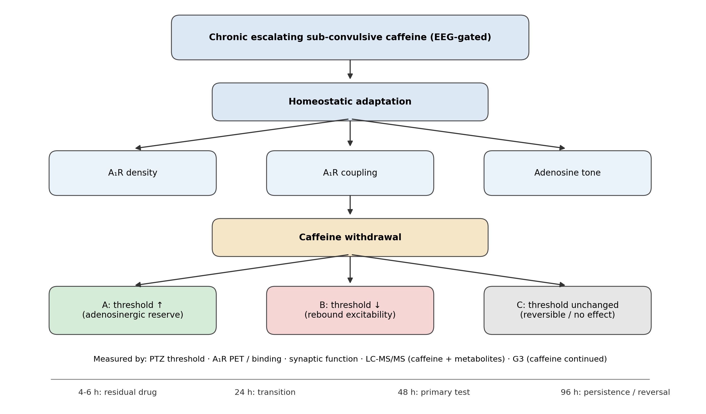
Figure 1. Conceptual framework. Chronic sub-convulsive caffeine may induce adaptation; after withdrawal, seizure threshold could rise (A), fall (B) or be unchanged (C). Several mechanisms could produce a threshold change, and specific groups and assays discriminate them.
Table 1. Predicted observations under the three hypotheses (G1 vehicle; G2 escalated caffeine then withdrawn; G3 escalated caffeine continued).
Observation | A: adaptation | B: rebound | C: no lasting change
PTZ threshold, G2 versus G1 | ↑ | ↓ | Unchanged
PTZ threshold, G3 versus G1 | Unchanged or ↓ (blockade masks adaptation) | ↓ | ↓ (acute blockade only)
A₁R density or coupling in G2 | ↑ (either) | Variable | Unchanged
Adenosine-mediated synaptic depression in G2 | ↑ | Unchanged or ↓ | Unchanged
Time course after withdrawal | Gain decays over days | Early fall, then normalizes | No change at any time
Residual caffeine and metabolites at test | Not detectable | Not detectable | Not detectable
A positive result is interpretable only if residual caffeine and metabolites are shown to be negligible at the time of testing.
Falsification criteria. The hypothesis, and this design, are refuted by any of the following.
C1. PTZ threshold in G2 does not differ from G1 at 48 h while residual caffeine and metabolites are confirmed negligible. Hypothesis A fails as stated.
C2. PTZ threshold in G2 is lower than G1 at any interval. Hypothesis B is supported and the safety implication takes precedence over the mechanistic one.
C3. A₁R binding and function are unchanged in G2 and G3 relative to G1. The proposed mechanism is absent, whatever the threshold does.
C4. A threshold difference is present but residual caffeine or active metabolites are detectable at testing. The result is attributed to continuing pharmacology, not adaptation, and is uninterpretable for this hypothesis.
C5. G3 and G2 do not differ. Adaptation cannot be separated from ongoing receptor blockade in this design.
C6. The effect is present only in one sex and does not survive the pre-specified interaction test. The hypothesis as stated is not supported without qualification.
C7. EEG gating removes a materially larger share of animals in the caffeine arms than assumed, so the exposure actually achieved is not the exposure the design tested. The trial answers a different question from the one asked.
C8. Adaptation is measurable but reverses faster than about two days, placing the design outside the powered region of Figure 4A. The mechanism may be real and the experiment still uninformative, which is a failure of the design rather than of the hypothesis.

3 Biological rationale and pharmacological plausibility
Occupancy and exposure. Caffeine crosses the blood–brain barrier freely by passive diffusion, and rodent affinity for A₁R lies in the low tens of micromolar range (4). In CD-1 mice, reported plasma caffeine half-life is approximately 1.3–1.6 h, with clearance of approximately 0.38–0.64 L/h/kg (13). These parameters, from acute single-dose experiments, imply low-micromolar mean concentrations across the proposed dose range, although actual exposure under drinking-water administration depends on the intake pattern and must be measured directly by LC-MS/MS. That is partial receptor occupancy. Whether partial occupancy suffices to drive adaptation in this paradigm has not been established, and the relationship between plasma concentration, brain concentration and adaptation used later in the simulation is an assumption. The highest dose scales to about 2.4 mg/kg/day in humans by body-surface area (14), given only for context.
Continuity of exposure. If adaptation is driven by sustained receptor occupancy, then how caffeine is delivered may matter more than how much is delivered. Caffeine is cleared within hours, so intermittent injections leave receptors unblocked for most of the week and produce high peaks, whereas continuous intake gives steady partial occupancy without peaks near the convulsive range.
The allergen-immunotherapy analogy. Gradual dose escalation with post-dose observation is borrowed from allergen immunotherapy build-up protocols (15). The analogy ends there: an allergen leaves durable immunological memory, whereas caffeine produces pharmacokinetic exposure and homeostatic, probably reversible, receptor adaptation. We therefore treat injected “caffeine shots” as a testable delivery mode (Supporting Information), not as an established analogue.

4 A minimal experimental test
The core experiment has three groups (Table 2). Mice receive plain water (G1) or caffeine in drinking water escalated from 5 to 30 mg/kg/day over 8 weeks and held to week 12, under continuous video-EEG with pre-specified rules that step a mouse back if interictal spikes, electrographic seizures or behavioural over-stimulation appear. Caffeine is then stopped (G2) or continued (G3). The G3 comparison separates adaptation from ongoing A₁ blockade, and G2 tests what remains after clearance.
Table 2. Core groups and the mechanistic contrast each provides.
Group | Caffeine at testing | Adaptation possible | Acute A₁ blockade
G1 Vehicle | No | No | No
G2 Escalated, then withdrawn | No, provided caffeine and metabolites are below predefined assay thresholds | Yes | No
G3 Escalated, continued | Yes | Yes | Yes
Exploratory (Supporting Information): taper; injected; sustained-release depot | As G2 | Yes | No

The primary outcome is i.v. PTZ seizure threshold. PTZ is a mechanistic first-pass screen of seizure susceptibility in healthy brains, not a model of epilepsy or a demonstration of antiseizure efficacy (16). Mechanistic outcomes are A₁R density (micro-PET with [¹⁸F]CPFPX (17) validated by ex vivo binding), A₁R function (DPCPX-sensitive adenosine-mediated depression of hippocampal synaptic transmission), and plasma and brain caffeine and its active metabolites (paraxanthine, theophylline, theobromine) by LC-MS/MS. Testing at several intervals after withdrawal (for example 24, 48 and 96 h, in separate cohorts) addresses the residual-drug window in which the rat PET study found a transient fall in availability associated with residual caffeine and metabolites (12). The intervals have distinct roles: 4–6 h is dominated by residual drug, 24 h is a transition zone, 48 h is the primary test and 96 h tests persistence or reversal. Sex is a factor throughout, allocation is randomized and outcome assessment blinded, and reporting follows ARRIVE 2.0 (18). If sustained-release delivery proves infeasible, osmotic minipumps with staged replacement serve as the positive control for continuous delivery. The full protocol is in the Supporting Information. No animal work is proposed here without prior institutional approval and registration.

5 Monte Carlo design analysis
A single-file Monte Carlo model (Supporting Information; open code) was used to explore delivery mode, washout schedule and sample size before any animals are used (19). It combines a one-compartment pharmacokinetic model anchored to published mouse data (13) with an assumed, slowly developing and reversible adaptation of A₁R availability driven by receptor occupancy, weekly EEG-style gating, and an assumed convulsive plasma threshold. Only the pharmacokinetic parameters are empirically anchored; the adaptation parameters are assumptions, and the model assumes the mechanism it explores. Its outputs are therefore planning scenarios, not predictions, and a modelled gain is not evidence that the gain occurs.
Continuity. For equal weekly exposure, continuous delivery yielded a modelled A₁R gain at testing of 22.0%, injections three times weekly 5.5% and a 14-day sustained-release depot 13.2% (Figure 2). Injections also produced peaks near the assumed EEG-flag level (median 197 µM versus 31 µM continuous), with at least one flagged week in 59% of virtual animals and none for continuous delivery. This ordering persisted across the sensitivity scenarios examined in Table 3, because the model’s premise is that adaptation follows time-averaged occupancy. If real adaptation were driven by peak exposure the ordering could reverse, which the exploratory injected arm would reveal. Halving the assumed convulsive threshold raised flag rates to 99% for injections and 78% for the depot, and left continuous delivery at 0.7%.
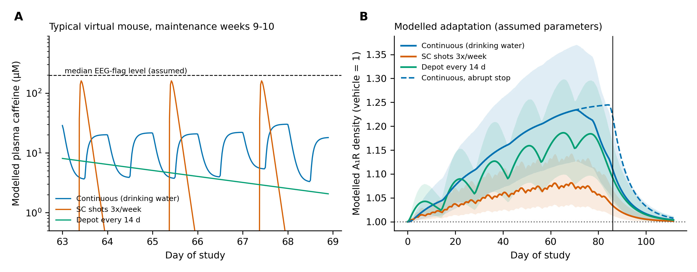
Figure 2. Modelled exposure and adaptation under assumed parameters. (A) Plasma caffeine in a typical virtual mouse during maintenance. (B) Modelled A₁R density over time (mean and 5th–95th percentile band); the vertical line marks testing at day 86. Continuous delivery, injections at equal weekly exposure and a depot are compared, with an abrupt stop as the dashed line. Model outputs are conditional on assumed adaptation parameters and should not be interpreted as experimental observations.
Persistence. The modelled gain at testing depends chiefly on how fast adaptation is assumed to reverse. With a receptor decay time constant of 7 days the gain was 22.0%, falling to 13.2% at 1 day and 9.2% at 0.5 day. A “fast reversal” scenario resembling the rat PET result (6-h occupancy averaging window, decay 0.5 day) gave 1.4%, with power (0.06) close to the type I error (Table 3, Figure 3). A 2-week taper approximately halved the gain (11.0% versus 22.0%), so the core design stops caffeine abruptly and tests early, with a taper sub-arm to check this.
Power. In the central scenario (abrupt stop), 12 mice per sex per group gave a power of 0.96 for the PTZ threshold if the receptor gain is fully transmitted to threshold (γ = 1), 0.50 at γ = 0.5, and the nominal 0.05 at γ = 0, which is the falsification limit. About 10 per sex sufficed for 80% power in the central scenario, and 25 per sex were needed with a taper. A weak adaptation scenario (Rmax 0.1) gave a power of 0.27. A₁R binding was more sensitive than the PTZ threshold, so a positive binding result with a null threshold would not refute adaptation.
Regime. The scenarios in Table 3 are points; the design question is which joint beliefs about the mechanism make the experiment worth running at all. Sweeping the two assumptions that matter — how fast adaptation reverses and how much of a receptor gain reaches threshold — gives a region rather than a list (Figure 4A). At 12 per sex per group the design is adequately powered over 13% of that plane. At the base-case decay constant of 7 days, γ must exceed 0.75 for 80% power; at full transmission (γ = 1) the decay constant must exceed 2.0 days. In the corner resembling the rat PET result, where adaptation reverses within about half a day, power is 0.40 even with γ = 1. The experiment is therefore informative about a specific and not especially large region of mechanism-space, and it is honest to say so before animals are used.
One caution about the sensitivity analysis follows from the same sweep. About the base case, the modelled gain is most elastic to the assumed maximum adaptation (elasticity +1.00, exactly proportional by construction) and only weakly elastic to the decay constant (+0.11). Read alone, that would suggest the decay constant hardly matters. It matters more than anything else, because its plausible range is the one that crosses the power boundary: the modelled gain falls from 23.7% to 6.4% as decay shortens from 21 to 0.25 days (Figure 4B). A local sensitivity coefficient evaluated in the flat part of that curve understates the assumption the design actually rests on.
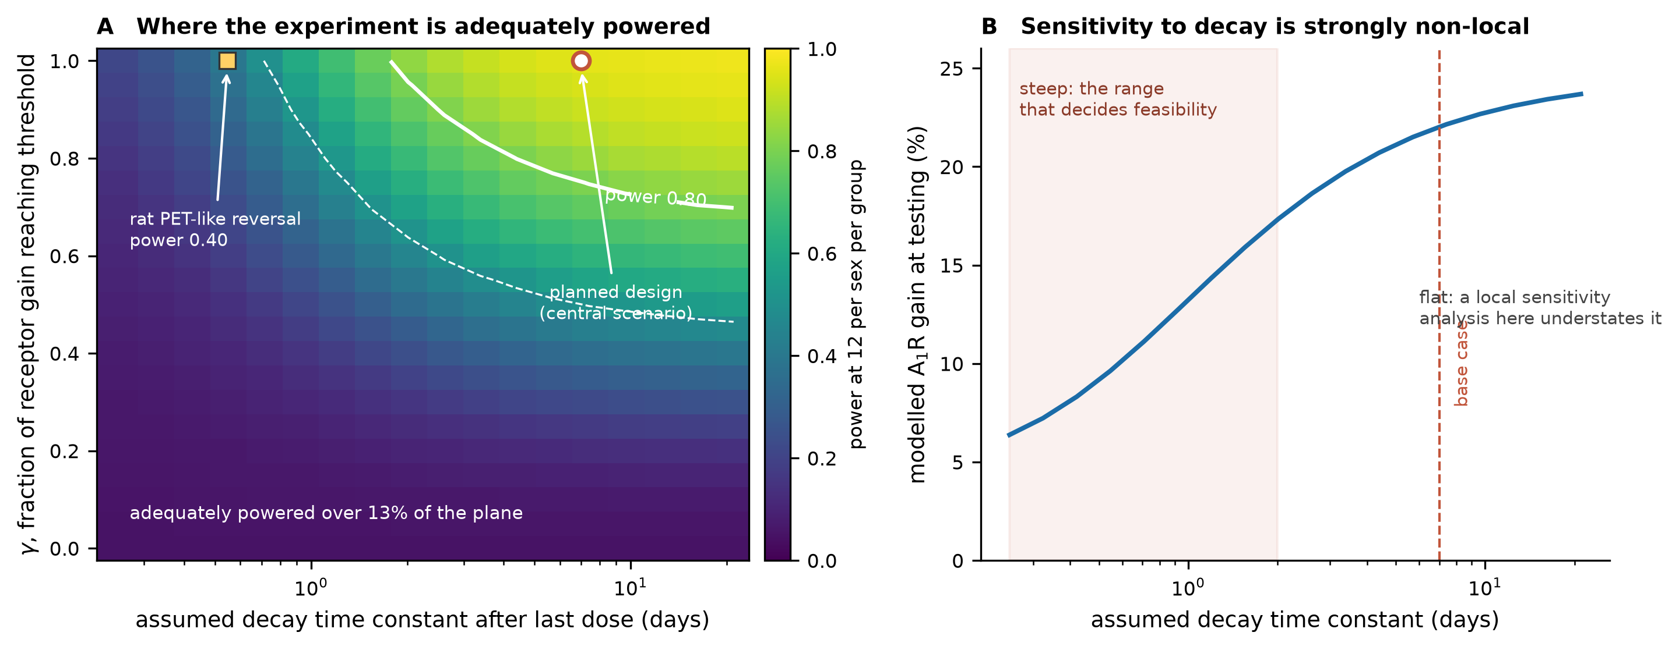
Figure 4. The region of assumption-space in which the experiment is informative. (A) Power for the primary endpoint over the assumed decay time constant and γ, at 12 per sex per group; the solid contour is power 0.80 and the dashed contour 0.50. The circle marks the planned central scenario and the square the rat PET-like reversal. (B) Modelled A₁R gain at testing against the assumed decay constant, showing that sensitivity to this assumption is concentrated below about two days. Both panels are conditional on the model's assumed adaptation parameters.
Table 3. Modelled A₁R gain at day 86 (mean, % versus vehicle) and power (12 per sex per group, α = 0.05) under alternative assumptions.
Scenario | Cont. abrupt (%) | Cont. taper (%) | Injected abrupt (%) | Depot abrupt (%) | PTZ power γ = 1 | PTZ power γ = 0.5
Base case | 22.0 | 11.0 | 5.5 | 13.2 | 0.96 | 0.50
Ki = 10 µM | 26.3 | 18.6 | 7.7 | 21.4 | 0.99 | 0.64
Ki = 50 µM | 16.2 | 6.0 | 3.8 | 7.7 | 0.78 | 0.31
Rmax = 0.1 | 7.3 | 3.7 | 1.8 | 4.4 | 0.27 | 0.10
Rmax = 0.2 | 14.7 | 7.3 | 3.7 | 8.8 | 0.71 | 0.27
Rmax = 0.5 | 36.7 | 18.3 | 9.2 | 21.9 | 1.00 | 0.88
Up-regulation τ = 7 d | 22.6 | 11.1 | 6.8 | 14.2 | 0.96 | 0.52
Up-regulation τ = 28 d | 19.9 | 10.4 | 4.4 | 11.7 | 0.92 | 0.43
Receptor decay τ = 0.5 d | 9.2 | 1.3 | 0.1 | 3.9 | 0.37 | 0.13
Receptor decay τ = 1 d | 13.2 | 2.6 | 0.6 | 4.9 | 0.64 | 0.22
Receptor decay τ = 3 d | 19.3 | 6.2 | 2.8 | 8.6 | 0.90 | 0.41
Receptor decay τ = 14 d | 23.3 | 15.3 | 7.9 | 16.7 | 0.97 | 0.54
Hill n = 1 | 19.3 | 12.5 | 8.1 | 14.2 | 0.90 | 0.41
Hill n = 4 | 24.8 | 9.9 | 4.0 | 12.0 | 0.98 | 0.59
Fast reversal (6-h window, decay 0.5 d) | 1.4 | 0.2 | 0.0 | 2.8 | 0.06 | 0.05
Base case (2000 virtual mice per regimen; 4000 simulated experiments per cell): Ki 25 µM, maximum adaptation (Rmax) 0.30, up-regulation τ 14 d, decay τ 7 d, Hill n = 2. All adaptation parameters are assumptions. Power at γ = 0 equals the type I error (about 0.05). All values in the text are generated by the same code run.
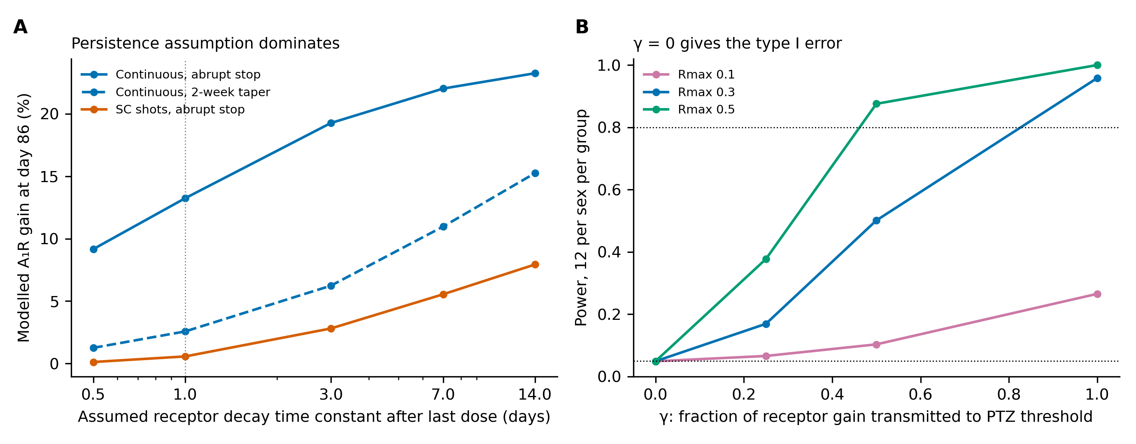
Figure 3. Sensitivity of the modelled outcome. (A) Modelled A₁R gain at testing versus the assumed decay time constant after the last dose. (B) Power for the primary endpoint versus γ, the assumed fraction of receptor gain transmitted to threshold, for three assumed maximum adaptations (Rmax).

6 Alternative mechanisms and limitations
Threshold changes need not involve A₁R density. A₁R coupling (10), endogenous adenosine tone and A₂A adaptation (9) could each contribute, and caffeine’s active metabolites act at the same receptors, which is why they are quantified. Withdrawal is not benign. In rats, chronic caffeine alone lengthened PTZ seizure latency, whereas caffeine combined with ethanol followed by withdrawal increased seizure-related mortality (20). That is not direct evidence of rebound after caffeine alone, but it shows that withdrawal-related vulnerability must be considered, and Hypothesis B remains a real possibility with safety implications. The G3 group, the time course and the residual-drug assay are the main defences against misattributing withdrawal or residual drug to adaptation.
PTZ measures acute chemoconvulsant threshold in otherwise healthy brains; a positive result would need confirmation in chronic epilepsy models. Mouse strain, sex, dose and tolerance may all matter, and human data on habitual caffeine and seizure risk are not addressed here. The simulation is a planning tool: its adaptation parameters, convulsive threshold and transmission of receptor change to threshold are assumptions, it omits tolerance, metabolites and sleep effects, and its numbers should be replaced by measured values as pilot data arrive. Nothing in this paper supports the use of caffeine as a treatment.
Table 4. Status of each link in the argument. ‘Reported’ denotes a published observation not independently replicated in this context; ‘Assumed’ denotes a modelling choice, not a claim about biology.
Link | Status | Basis
Adenosine acting at A₁R contributes to seizure termination | Established | Reviewed physiology (1,2,3)
Acute caffeine antagonises A₁R and is proconvulsant at high dose | Established | Pharmacology and dose-response (4,5)
Chronic caffeine increases A₁R density in mouse cortex | Reported | About 20% increase in one study (6)
Chronic methylxanthine reduces chemoconvulsant susceptibility | Reported | Bicuculline and PTZ (7); in one case without a density change (8)
Chronic caffeine sensitises A₁R-adenylate cyclase coupling | Reported | Rat cerebral cortex (10)
A₂A adaptation contributes to the protective effect | Reported | Receptor-knockout evidence (9)
A₁R availability returns to baseline after caffeine is cleared | Contested | Rat PET found no persistent change by about 27 h (12)
Protection survives clearance of caffeine and active metabolites | Untested | The question this design exists to answer
Adaptation is driven by time-averaged occupancy rather than peaks | Assumed | Premise of the simulation; the injected arm would reveal the opposite ordering
A receptor gain is transmitted to seizure threshold (γ) | Assumed | Swept from 0 to 1; γ = 0 is the falsification limit
Adaptation magnitude and reversal rate (Rmax, decay τ) | Assumed | Illustrative values; the decay constant decides feasibility (Figure 4)
Withdrawal produces rebound hyperexcitability (Hypothesis B) | Open | Indirect rodent evidence with ethanol co-exposure (20); a safety concern, not a demonstrated effect
How this proposal could cause harm. The practical risk of publishing this hypothesis is not that the experiment fails. It is that the question in the title is read as an answer.
Self-experimentation. People with epilepsy, or their families, may read a paper asking whether caffeine raises seizure threshold as a suggestion to increase caffeine intake. Acutely, caffeine is proconvulsant, the protective effect is unconfirmed in any species after clearance, and no human data are presented here. This paper provides no basis for any change in caffeine consumption by anyone.
Withdrawal-provoked seizures. If Hypothesis B holds, the hazard created by the framework is not caffeine but its cessation, which is exactly the behaviour a reader persuaded by Hypothesis A might later adopt. Abrupt withdrawal after sustained exposure is the condition under which the rodent literature reports increased seizure-related vulnerability.
Interaction with existing therapy. Caffeine and its metabolites interact with several antiseizure medicines through CYP1A2 and through adenosinergic and GABAergic mechanisms. Any change in habitual intake in a treated patient is a change to a regimen that has been titrated, and is a clinical decision rather than a lifestyle one.
Animal cost of an underpowered study. Figure 4A shows the design is uninformative across most of the plausible assumption space. Running it in the unpowered region would consume animals to produce a null that could not distinguish absence of mechanism from absence of power. The pilot estimate of the decay constant should therefore gate the full study, not follow it.
Framing in press coverage. A title phrased as a question is routinely reported as a finding. The abstract, plain language summary and conclusion each state that no clinical use is supported, and we would ask that any press summary retain that.

7 Implications for epilepsy research
If Hypothesis A were supported, it would show that the adenosinergic braking system can be primed before a seizure, and would point towards adenosine-based approaches that avoid caffeine’s side effects, such as receptor modulators or adenosine augmentation. If B were supported, it would identify a safety-relevant hazard of caffeine fluctuation or cessation. If C were supported, it would close a plausible but unproven line of reasoning and mark the persistence limit of receptor adaptation. All three outcomes are informative, and Epilepsia Open explicitly welcomes negative and confirmatory findings.

8 Conclusion
Chronic caffeine exposure may adapt the adenosinergic braking system, but the evidence is mixed, the closest in vivo test found no persistent receptor change, and the mechanism is unresolved. We propose a monitored, three-group mouse experiment that separates adaptation from withdrawal and residual drug. Under the assumptions tested, the Monte Carlo analysis suggests that continuous exposure followed by early post-withdrawal testing would provide the most informative test of the proposed mechanism, and that detectability rests mainly on how fast adaptation reverses. The design is falsifiable, and any of its outcomes would advance understanding.

Declarations
Ethics statement. No animals were used in this hypothesis and in-silico study. Any experimental work described here would require prior institutional animal-care approval.
Ethical publication statement. We confirm that we have read the Journal’s position on issues involved in ethical publication and affirm that this report is consistent with those guidelines.
Funding. This research received no external funding. Conflict of interest. The author declares no conflicts of interest. Acknowledgments. None.
Author contributions (CRediT). Leon Sandler: Conceptualization, Methodology, Software, Formal analysis, Writing – original draft, Writing – review and editing.
Data availability. No experimental data were generated. The simulation code (CaffeineMC.py, fixed random seed) is provided as Supporting Information and archived at https://doi.org/10.5281/zenodo.22860921; this manuscript is archived at https://doi.org/10.5281/zenodo.22860926. Both are concept DOIs and resolve to the current version.
Use of generative AI. Generative AI (Claude, Anthropic) was used to assist with drafting and editing the manuscript, developing the simulation code and generating the figures. The author reviewed and verified the scientific content, references, analyses, code and final manuscript, and takes full responsibility for the content.

References
1. Dunwiddie TV, Masino SA. The role and regulation of adenosine in the central nervous system. Annu Rev Neurosci. 2001;24:31–55.
2. Boison D. Adenosinergic signaling in epilepsy. Neuropharmacology. 2016;104:131–9.
3. Baltos JA, Casillas-Espinosa PM, Rollo B, Gregory KJ, White PJ, Christopoulos A, et al. The role of the adenosine system in epilepsy and its comorbidities. Br J Pharmacol. 2023. doi:10.1111/bph.16094.
4. Fredholm BB, Bättig K, Holmén J, Nehlig A, Zvartau EE. Actions of caffeine in the brain with special reference to factors that contribute to its widespread use. Pharmacol Rev. 1999;51:83–133.
5. Boison D. Methylxanthines, seizures, and excitotoxicity. Handb Exp Pharmacol. 2011;(200):251–66.
6. Shi D, Nikodijević O, Jacobson KA, Daly JW. Chronic caffeine alters the density of adenosine, adrenergic, cholinergic, GABA, and serotonin receptors and calcium channels in mouse brain. Cell Mol Neurobiol. 1993;13:247–61.
7. Johansson B, Georgiev V, Kuosmanen T, Fredholm BB. Long-term treatment with some methylxanthines decreases the susceptibility to bicuculline- and pentylenetetrazol-induced seizures in mice. Relationship to c-fos expression and receptor binding. Eur J Neurosci. 1996;8:2447–58.
8. Georgiev V, Johansson B, Fredholm BB. Long-term caffeine treatment leads to a decreased susceptibility to NMDA-induced clonic seizures in mice without changes in adenosine A1 receptor number. Brain Res. 1993;612:271–7.
9. El Yacoubi M, Ledent C, Parmentier M, Costentin J, Vaugeois JM. Evidence for the involvement of the adenosine A2A receptor in the lowered susceptibility to pentylenetetrazol-induced seizures produced in mice by long-term treatment with caffeine. Neuropharmacology. 2008;55:35–40.
10. Green RM, Stiles GL. Chronic caffeine ingestion sensitizes the A1 adenosine receptor-adenylate cyclase system in rat cerebral cortex. J Clin Invest. 1986;77:222–7.
11. Nikodijević O, Jacobson KA, Daly JW. Locomotor activity in mice during chronic treatment with caffeine and withdrawal. Pharmacol Biochem Behav. 1993;44:199–216.
12. Nabbi-Schroeter D, Elmenhorst D, Oskamp A, Laskowski S, Bauer A, Kroll T. Effects of long-term caffeine consumption on the adenosine A1 receptor in the rat brain: an in vivo PET study with [18F]CPFPX. Mol Imaging Biol. 2018;20:284–91.
13. Kaplan GB, Tai NT, Greenblatt DJ, Shader RI. Caffeine-induced behavioural stimulation is dose- and concentration-dependent. Br J Pharmacol. 1990;100:435–40.
14. Nair AB, Jacob S. A simple practice guide for dose conversion between animals and human. J Basic Clin Pharm. 2016;7:27–31.
15. Cox L, Nelson H, Lockey R, et al. Allergen immunotherapy: a practice parameter third update. J Allergy Clin Immunol. 2011;127(1 Suppl):S1–55.
16. Löscher W. Critical review of current animal models of seizures and epilepsy used in the discovery and development of new antiepileptic drugs. Seizure. 2011;20:359–68.
17. Elmenhorst D, Meyer PT, Matusch A, Winz OH, Bauer A. Caffeine occupancy of human cerebral A1 adenosine receptors: in vivo quantification with 18F-CPFPX and PET. J Nucl Med. 2012;53:1723–9.
18. Percie du Sert N, Hurst V, Ahluwalia A, et al. The ARRIVE guidelines 2.0: updated guidelines for reporting animal research. PLoS Biol. 2020;18:e3000410.
19. Morris TP, White IR, Crowther MJ. Using simulation studies to evaluate statistical methods. Stat Med. 2019;38:2074–102.
20. Matovu D, Alele PE. Seizure vulnerability and anxiety responses following chronic co-administration and acute withdrawal of caffeine and ethanol in a rat model. J Basic Clin Physiol Pharmacol. 2018;29:1–10.

