Damage–repair kinetics and phase stiffness in a site-diluted XY model: implications for irradiated superconductors
Leon Sandler
Independent researcher, Northbrook, Illinois, USA
E-mail: sandler.leon@gmail.com
ORCID: 0009-0007-4584-808X

Abstract
Neutron damage lowers the transition temperature of REBCO conductors roughly linearly with displacement damage, and annealing recovers part of it, implicating phase stiffness. We model this competition as a two-dimensional XY lattice of the superconducting phase whose sites are damaged at a rate rising with local phase disorder and repaired stochastically, simulated by kinetic Monte Carlo. A mean-field reduction predicts bistability; the lattice shows no hysteresis or dependence on the initial state in the ranges tested (L ≤ 64), because the closure of the reduction fails. At zero field, symmetry-preserving repair restores spontaneous coherence and a twist-response stiffness (validated on clean and diluted lattices) above an apparent threshold in the repair-to-damage ratio, bracketed by finite-size scans (L ≤ 96) at ρ between 7.00 and 7.75 (ρ between 5.50 and 6.00 with neighbor-phase repair), against ρ ≈ 2.5 without feedback; the equilibrium formula underestimates the driven stiffness by up to 30%. Numerically, ρ controls the state ever better as damage slows relative to phase relaxation. Finite-size analysis of random dilution estimates the stiffness loss at f ≈ 0.25 ± 0.01; clustered damage tolerates more. An illustrative effective mapping gives about ten model sites per dpa. The model is uncalibrated.
Keywords: superconductivity; kinetic Monte Carlo; XY model; phase stiffness; irradiation damage; annealing; REBCO; fusion magnets

1. Introduction and superconducting motivation
High-temperature superconducting (HTS) magnets are central to compact fusion concepts [1, 2]. In service the conductor is exposed to fast neutrons, which displace atoms and degrade its superconducting properties [3]. For REBCO coated conductors, fast-neutron irradiation first raises the critical current, which passes through a temperature-dependent maximum and then declines [4, 5]; at 50 K it falls below its pristine value at fluences of the order of 10²² m⁻², and the n-value decreases even at low fluence [6, 7]. The transition temperature, by contrast, decreases linearly with the calculated number of displacements per atom (dpa), at the same rate for neutrons and for helium ions [8]. Annealing partly reverses the damage: about 25% of the decrease of T_{c} was recovered at 150 °C and about 60% at 400 °C, and the degradation of T_{c} and of the critical current density were found to be closely related, “likely due to the expected loss of superfluid density” [7]. The engineering question is therefore not only how fast damage accumulates but whether superconducting order persists when damage and recovery act together.
The superfluid density is the physical counterpart of the phase stiffness of the order parameter. In two-dimensional superconductors the stiffness controls the Berezinskii–Kosterlitz–Thouless (BKT) transition [9–13], and in any superconductor it sets the London penetration depth [14]. A minimal model of how damage and recovery compete for phase coherence is therefore a two-dimensional XY model of the local phase, in which sites are damaged (pair breaking) and repaired. Diluted XY models and their BKT transitions have been studied [15]; what is new here is the kinetics. In the model used, damage is faster where phase order is already disrupted, as would be the case if disorder lowered the pair amplitude locally, and repair acts at a stochastic rate. The model is implemented in the open-source MyUncle framework [16].
We ask four questions. Does state-dependent damage make the response to the repair rate bistable and hysteretic, as a mean-field reduction suggests? Does recovery restore genuine phase stiffness, not merely alignment in an external field? Is the repair-to-damage ratio ρ the right control parameter, or does the competition between the phase-relaxation and damage–repair timescales matter? And what can such a model say about the experiments above, given that it contains no microscopic pairing physics, no vortex pinning and no transport current, and has not been calibrated to any conductor? We answer each with the numerical evidence stated together with its limits.

2. Model and numerical methodology

2.1 Hamiltonian and phase dynamics
An L × L square lattice with periodic boundaries carries a phase θ_{i} ∈ (−π, π] on each site, representing the phase of the local superconducting order parameter, and an integrity g_{i}. A site is intact (g = 1) or damaged (g = g₀ = 0.12); a damaged site is one whose pair amplitude has been suppressed by displacement damage (pair breaking), so that it couples only weakly to its neighbors. The energy is
$H\text{ = }\text{−}J_{\text{0}} \text{∑}\text{⟨}ij\text{⟩} g_{\text{i}}g_{\text{j}}\text{cos}\left(θ_{\text{j}}\text{ − }θ_{\text{i}}\text{ − }φ_{\text{ij}}\right)\text{ − }h_{\text{0}} \text{∑}g_{i}\text{cos} θ_{i}\text{,}$ (1)
with J₀ = 1 and k_{B} = 1 setting the units of energy and temperature, and T = 0.35 throughout unless stated. The twist φ_{ij} is zero except for bonds in the +x direction, where it takes the uniform value φ (a vector potential; Section 2.4). The term h₀ breaks the global U(1) phase symmetry explicitly. Most results below are for h₀ = 0, so that coherence is spontaneous; h₀ = 0.4 is the field of the superconducting preset of MyUncle [16] and is used only for the baseline scans. Phases are updated by checkerboard Metropolis sweeps with uniform proposals on (−π, π] at fixed integrity, two sweeps (relax = 2) between successive kinetic updates.

2.2 Damage and repair
After the phase sweeps each intact site is damaged, with probability per step
$λ_{i}\text{ = }λ_{\text{0}} μ\left(D_{i}\right)\text{,} μ\left(D\right)\text{ = }\text{1}\text{ + }β\frac{D^{h}}{K^{h}\text{ + }D^{h}}\text{,}$ (2)
where D_{i} = 1 − |¼ Σ_{j} exp(iθ_{j})| ∈ [0, 1], the sum running over the four nearest neighbors of site i, is the local phase disorder (the neighbor phases are measured in the gauge of the twist), h = 6 and K = 0.5. Damage is therefore faster where phase order is already disrupted; β = 0 is state-independent damage and β = 20 is the baseline feedback. Every damaged site is then repaired with probability R in the same step, so a site damaged in a step can be repaired in it. Repair restores g = 1 and treats the phase of the repaired site by one of three rules: reset0, θ → 0 (the rule of the MyUncle superconducting preset); keep, the phase is left unchanged and the dynamics relaxes it; or neighbor, the phase is set to that of the coupling-weighted neighboring phasors, so that the repaired site rejoins the coherent region around it. The first rule selects a phase that is common to all sites and therefore acts, at rate R, as a symmetry-breaking field even when h₀ = 0; the other two preserve the U(1) symmetry (this is tested, Section 2.4). The control ratio is ρ = R/λ₀, with λ₀ = 0.02, and one kinetic step is the unit of time. All rates are probabilities per step and must not exceed 1: for λ₀ = 0.02 the largest kill probability is λ₀(1 + β) = 0.42 < 1. In the scan over λ₀ (Section 3.4) the value λ₀ = 0.08 gives λ₀(1 + β) = 1.68 > 1, so the kill probability saturates at 1 where D_{i} ≳ 0.53, and the corresponding points are flagged.

2.3 Mean-field reduction
The reduction is derived from the update just defined. Let q be the damaged fraction (g = g₀), p = 1 − q the intact fraction, and μ̄ = ⟨μ(D_{i})⟩ the mean kill multiplier over the intact sites. Because damage is applied first and repair second, one step maps q to
$q\text{′}\text{ = }\left(\text{1}\text{ − }R\right)\left(q\text{ + }\left(\text{1}\text{ − }q\right)λ_{\text{0}}μ̄\right)$ (3)
For λ₀, R ≪ 1 and τ = λ₀t this is the rate equation
$\frac{\text{d}q}{\text{d}τ}\text{ = }μ̄\left(\text{1}\text{ − }q\right)\text{ − }ρq\text{.}$ (4)
The variable is the damaged fraction. For β = 0, μ̄ = 1 and q* = 1/(1 + ρ); the intact fraction is ρ/(1 + ρ), and it is the latter that increases with ρ like the order U; the damaged fraction 1/(1 + ρ) must not be used as a reference for U, which is not a comparison of like with like. The only approximation is the closure of μ̄, in which the mean over the intact sites of the local-disorder function is replaced by its value at the damaged fraction, μ̄ = μ(q) (the annealed identification D_{i} → q, motivated by the slaving of the phase order to the intact fraction, U ≈ 1 − q). Steady states then satisfy
$ρ\text{ = }\frac{μ\left(q\right)\left(\text{1}\text{ − }q\right)}{q}\text{,}$ (5)
which is S-shaped, and hence bistable, for cooperativity h > 1 and gain above a threshold β_{c}(h, K) (β_{c} = 2.42 at h = 6, K = 0.5; there is no bistability for h ≤ 1). For (h, K, β) = (6, 0.5, 20) the window of equation (5) is 3.92 < ρ < 11.30, and 2.80 < ρ < 3.51 for β = 5. Equation (5) is the continuous-time limit; the map (3) that the code implements gives, from its fixed points ρ = (1 − q)μ/[q + (1 − q)λ₀μ], the windows 3.64 < ρ < 9.22 (β = 20) and 2.66 < ρ < 3.28 (β = 5). The shift is appreciable because λ₀μ reaches 0.42 per step at high disorder, where the continuous-time limit is poor. The closure is tested against the lattice in Section 3.1.

2.4 Observables, protocols and uncertainty
Order and damage. The coherence is U = |⟨exp(iθ)⟩| over all sites; the damaged fraction q, the kill and repair currents (events per site and step), and the mean local disorder and kill multiplier of the intact sites are recorded. Phase stiffness. The helicity modulus of an equilibrium system is the second derivative of the free energy with respect to a uniform twist; in a non-equilibrium state with fluctuating damage there is no free energy and the equilibrium fluctuation formula cannot be assumed. We therefore measure the twist response: the linear response of the stationary bond current to a uniform vector potential φ applied along x,
$Υ_{\text{tw}}\text{ = }\text{−}\frac{\left(j_{\text{x}}\text{(+}φ_{\text{0}}\text{)}\text{ − }j_{\text{x}}\text{(−}φ_{\text{0}}\text{)}\right)}{\text{2}φ_{\text{0}}}\text{,}$ (6)
with j_{x}(φ) = ⟨N⁻¹ Σ_{⟨ij⟩∥x} J_{ij} sin(θ_{j} − θ_{i} − φ)⟩ the stationary mean current per site, φ₀ = 0.3π/L (0.03 at L = 32; see below), and the same random-number stream for both signs. It requires no detailed balance and measures what a superconductor measures: the supercurrent that the damaged-and-repairing medium sustains per unit imposed phase gradient (it is proportional to the superfluid density, and to d/λ_{L}² for a film of thickness d and London depth λ_{L}). In equilibrium it equals the helicity modulus. For comparison we also evaluate the equilibrium fluctuation formula on the same stationary runs,
$Υ_{\text{eq}}\text{ = }\frac{\text{1}}{N}\text{⟨}\text{∑} J_{\text{ij}}\text{cos} Δθ\text{⟩}\text{ − }\frac{N}{T}\left(\text{⟨}{j_{\text{x}}}^{\text{2}}\text{⟩}\text{ − }{\text{⟨}j_{\text{x}}\text{⟩}}^{\text{2}}\right)\text{.}$ (7)
Phase correlations are C(r) = ⟨cos(θ_{i} − θ_{i+*r*})⟩ over all pairs at separation r along x and y, and, separately, over pairs of intact sites.
Protocols. Unless stated, runs start from the intact state (and, for tests of bistability, also from a state with 95% of the sites damaged and random phases), equilibrate for 3000 steps (2000 in the baseline scan; both are over 30 times the longest autocorrelation time measured) and are measured for 3000–4000 steps, sampled every 5–10 steps. Each point is the mean over 6–10 independent seeds; the error is the standard error over seeds, and intervals are 95% percentile bootstrap intervals (2000 resamples) over seeds or disorder realizations [17]. Integrated autocorrelation times use the automatic window of Sokal [18] and are reported, but never used in place of the seed-to-seed spread. Comparisons of two starting states over many conditions are corrected for multiple comparisons by Holm’s procedure. Every run is seeded from a SeedSequence of a master seed and a code naming the study, parameters, size, replicate and initial state, so any run can be repeated alone. The engine reproduces the update rules of the MyUncle framework [16] bit for bit for the same seed (the superconducting preset, three parameter sets), and its test suite also verifies the discrete two-state fixed point at β = 0, the repair rules, the gauge consistency of the twisted lattice, the agreement of Υ_{tw} with the equilibrium formula on a clean lattice, and that with h₀ = 0 the two symmetric repair rules leave the global phase undetermined while reset0 selects phase 0 (|⟨exp(iψ)⟩| = 1.00).
Static dilution. For the field-free transition of a lattice with quenched random site removal (removed sites have g = 0), the helicity modulus is computed from equation (7), which is legitimate in equilibrium, and compared with the Nelson–Kosterlitz value 2T/π [10]. The crossing fraction f_{KT}(L) is located by linear interpolation of the realization-averaged Υ(f) and extrapolated in 1/ln²L and by a Weber–Minnhagen form [19]. The uncertainty of each crossing (a bootstrap over disorder realizations) is distinguished throughout from the scatter of the crossings over sizes, which is not an error estimate and no substitute for the extrapolation.

2.5 Validation of the twist response
The twist response is the central measurement of this paper, and the equilibrium formula that it replaces fails in the driven state, so it was validated in control simulations with the same engine and observables, with damage and repair switched off (λ₀ = R = 0), at T = 0.35 and h₀ = 0. Normalization and linearity. On the clean lattice, where equation (7) is exact, the twist response at φ₀ = 0.3π/L is 0.904 ± 0.000, 0.904 ± 0.000 and 0.905 ± 0.000 for L = 16, 32 and 64 (8 seeds), equal to the equilibrium formula evaluated on the same runs to within 0.001 and close to the first-order spin-wave value 1 − T/4 = 0.9125; the normalization 2φ₀ and the sign convention are therefore right, and Υ_{tw} does not depend on L. It varies little with the twist amplitude (Table 1): the decrease with φ₀ is the anharmonic (cosine) nonlinearity of the response, and is visible only for the smallest lattice and φ₀ > 0.6π/L. No clean-lattice run changed its winding number (0 slips in 120 pairs); phase slips matter in states with vortices, and an earlier run of the damage–repair states with a fixed φ₀ = 0.1, which exceeds π/L for L ≥ 32, was contaminated by them and was discarded in favor of φ₀ = 0.3π/L.
Table 1. Twist-response stiffness Υ_{tw} (mean ± s.e., 8 seeds) of the clean lattice (no damage or repair, T = 0.35) against the twist angle φ₀ in units of π/L.
L | φ₀ = 0.1 π/L | φ₀ = 0.3 π/L | φ₀ = 0.6 π/L | φ₀ = 1 π/L | φ₀ = 1.5 π/L
16 | 0.906 ± 0.001 | 0.904 ± 0.000 | 0.902 ± 0.000 | 0.898 ± 0.000 | 0.888 ± 0.000
32 | 0.905 ± 0.001 | 0.904 ± 0.000 | 0.904 ± 0.000 | 0.903 ± 0.000 | 0.901 ± 0.000
64 | 0.902 ± 0.001 | 0.905 ± 0.000 | 0.904 ± 0.000 | 0.904 ± 0.000 | 0.904 ± 0.000

Windings. A frozen global winding number W carries the current Υ(2πW/L − φ), so a pair of runs with different W gives a wrong response unless it is corrected by the integer difference. This was tested by preparing the two runs of each pair with imposed windings (L = 32, 8 seeds): with W = 0 in both, Υ_{tw} = 0.904 ± 0.000; with W = 1 in both, 0.882 ± 0.000 (a state with W = 1 is twisted by 2π/L per row, which lowers the response by about 2%, as the cosine nonlinearity, cos(2π/L) = 0.981, suggests); with W = 1 in one run and 0 in the other, the uncorrected value is -2.10 ± 0.00 and the corrected value, which is the one used throughout the damage–repair data (Section 3.3), is 0.898 ± 0.000, within 1% of the clean value. Independent equilibrium code. On static randomly diluted lattices (L = 32, f = 0.1 and 0.2, 16 coupling maps, runs of 12000 steps after 3000) the twist response of the dynamic engine, on the same coupling maps, is 0.622 ± 0.007 and 0.382 ± 0.010, against 0.622 ± 0.006 and 0.385 ± 0.008 from the equilibrium helicity modulus computed by the separate static Metropolis code used in Section 3.5 (paired differences 0.000 ± 0.003 and -0.003 ± 0.005) and 0.620 ± 0.006 and 0.380 ± 0.008 from the fluctuation formula on the same runs. With runs a quarter as long (8 maps) the response at f = 0.2 was lower than the fluctuation formula by 0.025 ± 0.007, a sampling effect that disappears in the longer runs, which is a reminder that the stiffness of near-critical states needs long runs; the damage–repair data use 6000 measured steps and their intervals are over seeds. The twist response and the equilibrium formula agree in equilibrium, as they should, and differ in the driven damage–repair state, which is the result of Section 3.3.

3. Results

3.1 Steady-state phase coherence
With the original repair rule (θ → 0) and a weak field (h₀ = 0.4), the phase coherence U rises smoothly with ρ and saturates at 0.946 for ρ = 40 (Figure 1a, Table 2); the saturation is below unity because of thermal phase fluctuations. State-dependent damage (β > 0) depresses U at small ρ, from 0.606 at ρ = 1 for β = 0 to 0.382 and 0.184 for β = 5 and 20 (L = 64), and its effect has disappeared by ρ ≈ 10. The results are independent of lattice size: the largest difference between L = 32 and L = 64 over all 33 conditions is 0.001. The state is reached quickly: runs started intact and 95% damaged enter the stationary band of U within 100 and 50 steps at ρ = 2.5 and 5 (late-time difference 0.002 and 0.003), a short protocol of 200 equilibration and 200 measurement steps agrees with the long runs to within 0.005 (15 conditions), the kill and repair currents balance to a relative 2 × 10⁻⁴, and the integrated autocorrelation time of U is 3–16 steps. The dashed line in Figure 1a is the intact fraction ρ/(1 + ρ) of the rate equation; it is shown for orientation only, since U is not an intact fraction (damaged sites remain weakly coupled and thermal fluctuations reduce U even for an intact lattice).
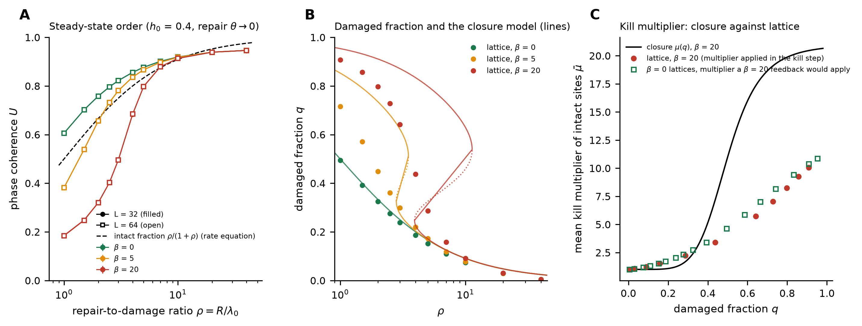
Figure 1. Steady-state order and the mean-field reduction (h₀ = 0.4, repair θ → 0). (a) U against ρ for three feedback strengths β, L = 32 (filled) and 64 (open), mean ± 95% CI over 10 and 6 seeds (the bars are smaller than the symbols); dashed: the intact fraction ρ/(1 + ρ) of the rate equation. (b) Damaged fraction q of the lattice (L = 64) and of the closure model, equation (5) (lines; dotted where unstable). (c) Mean kill multiplier of the intact sites in the lattice and in the closure μ(q).
Table 2. Steady-state coherence U (mean ± s.e., 6 seeds, L = 64, h₀ = 0.4, repair θ → 0). The corresponding values for L = 32 (10 seeds) differ by at most 0.001.
β | ρ = 1 | ρ = 2.5 | ρ = 5 | ρ = 10 | ρ = 40
0 | 0.606 ± 0.001 | 0.796 ± 0.000 | 0.877 ± 0.000 | 0.919 ± 0.000 | 0.946 ± 0.000
5 | 0.382 ± 0.000 | 0.732 ± 0.000 | 0.866 ± 0.000 | 0.918 ± 0.000 | 0.946 ± 0.000
20 | 0.184 ± 0.000 | 0.402 ± 0.000 | 0.798 ± 0.000 | 0.913 ± 0.000 | 0.946 ± 0.000

3.2 Tests for bistability and hysteresis
Section 2.3 predicts, for β = 20, a bistable window 3.64 < ρ < 9.22 in the map the code implements (3.92 < ρ < 11.30 in continuous time), and 2.66 < ρ < 3.28 for β = 5. We tested this on the lattice with the original repair rule and h₀ = 0.4 (Figure 2). From an intact start and from a start with 95% of the sites damaged and random phases, at 11 values of ρ from 2 to 12, for L = 32 and 48 (β = 5 and 20) and L = 64 (β = 20), with 6–10 seeds per condition and 3000 + 3000 steps, the two starts reach the same state everywhere. Over the 50 conditions the largest difference in U is 0.0027 and in the damaged fraction 0.0027, whereas the closure model, equation (5), has stable states at damaged fractions differing by 0.62 at ρ = 6. Nine of the 50 bootstrap intervals of the difference exclude zero; they are (difference [95% interval]) L = 32, β = 20, ρ = 3.5: -0.0025 [-0.0047, -0.0004]; L = 32, β = 20, ρ = 8: -0.0004 [-0.0008, -0.0000]; L = 48, β = 20, ρ = 3: -0.0027 [-0.0042, -0.0013]; L = 48, β = 20, ρ = 3.25: +0.0026 [+0.0011, +0.0045]; L = 48, β = 20, ρ = 5: -0.0010 [-0.0016, -0.0003]; L = 48, β = 20, ρ = 8: +0.0003 [+0.0001, +0.0006]; L = 48, β = 20, ρ = 10: +0.0003 [+0.0001, +0.0005]; L = 64, β = 20, ρ = 3: -0.0011 [-0.0020, -0.0002]; L = 64, β = 20, ρ = 4: -0.0009 [-0.0018, -0.0000]. All are at most 0.0027 in absolute value, they have no common sign, and none is significant after correction for the 50 comparisons by Holm’s procedure (smallest adjusted p = 0.19). With only 6–10 runs per start percentile bootstrap intervals are somewhat too narrow, so a few exclusions among 50 intervals are expected; they are not evidence of a residual dependence on the initial state.
The second test is a quasi-static ramp. At L = 48 the ratio ρ is stepped from 16 down to 1 and back in 31 steps, with a dwell of 25 to 1600 steps per value (8 runs per rate). A hysteresis loop is present at fast sweeps, with signed area ∫(U↓ − U↑)dρ = 0.18 ± 0.01 at 25 steps per value, but it closes as the sweep slows: 0.003 ± 0.004 at 1600 steps, and over the slowest dwells (400 steps and more, 24 runs) the area is -0.001 (95% bootstrap interval -0.006 to 0.004), consistent with zero (Figure 2c,d). The loop at finite sweep rate is therefore the lag of a single-valued steady state behind a moving control parameter, not metastability; a bistable system keeps a finite loop as the sweep slows [20]. We state the result as it is: within the tested ranges (L ≤ 64, β = 5 and 20, runs of 3000 steps, up to 1600 steps per ramp value), no hysteresis or dependence on the initial state is resolved. This does not prove that none exists: stronger feedback (β > 30), larger lattices or much longer runs were not explored.
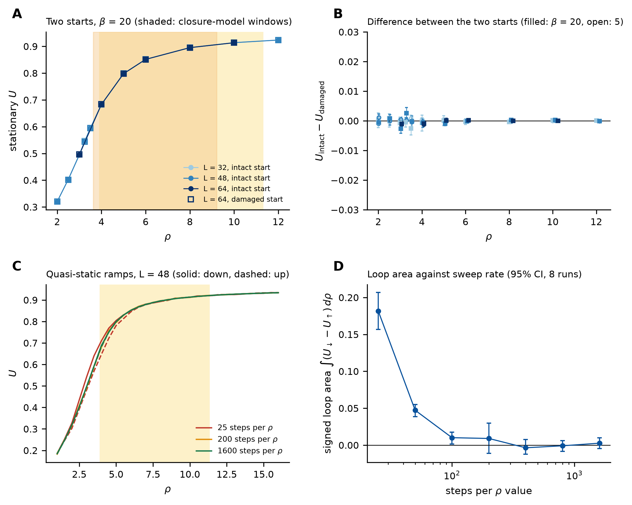
Figure 2. Tests for bistability and hysteresis (h₀ = 0.4, original repair rule). (a) Stationary U from an intact (filled) and a 95%-damaged (open) start for β = 20 and L = 32, 48, 64; shaded: the bistable windows of the closure model in continuous time (light) and in the implemented discrete-time map (dark). (b) Difference between the two starts with 95% bootstrap intervals, β = 20 (filled) and 5 (open). (c) Quasi-static ramps of ρ down (solid) and up (dashed), L = 48, at 25, 200 and 1600 steps per value. (d) Signed loop area against dwell, 95% CI over 8 runs.
The reduction fails to describe the lattice because its closure fails, not because of the kinetics. Because the kill step is where the closure enters, we recorded in every kill step the mean multiplier μ̄ that the lattice actually applies; with it the map (3) is satisfied by the stationary lattice to within 0.4% in ρ (a check of the map, equation (3), itself). Table 3 and Figure 1c show that μ̄ differs from the closure μ(q) in both directions: at ρ ≤ 4 the lattice kills far more slowly than the closure assumes, because the intact sites see a mean local disorder well below the damaged fraction, and at ρ ≥ 5 it kills faster, because the few intact sites in disordered pockets are killed at nearly the full rate even in a mostly coherent lattice. The effective feedback is flattened, and a flattened μ̄(q) does not bend the steady-state relation into an S shape. The test is not circular: lattices with state-independent damage (β = 0) give, at each damaged fraction, the multiplier that the β = 20 feedback would apply to them (last column of Table 3); inserted in the map (3), this multiplier gives a steady-state relation ρ(q) that is monotonic (a single steady state for every ρ) and predicts q = 0.705 and 0.350 at ρ = 3 and 5, against the measured 0.641 and 0.287 for β = 20 (the difference is the effect of the correlation between damage and disorder, which the β = 0 lattices lack).
Table 3. Kill multiplier in the steady-state lattice (h₀ = 0.4, β = 20, L = 32; repair θ → 0): the value μ̄ applied by the lattice in its kill step, the closure value μ(q) at the measured damaged fraction q, and the multiplier that a β = 20 feedback would apply to β = 0 lattices at the same q.
ρ | q (lattice) | μ̄ applied by the lattice | μ(q), closure | μ̄ from β = 0 lattices at the same q
2.0 | 0.798 | 8.24 | 19.86 | 8.95
3.0 | 0.641 | 5.73 | 17.33 | 6.69
4.0 | 0.437 | 3.39 | 7.19 | 3.95
5.0 | 0.287 | 2.24 | 1.69 | 2.42
7.0 | 0.158 | 1.52 | 1.02 | 1.56
10.0 | 0.091 | 1.25 | 1.00 | 1.26

3.3 Phase stiffness and spatial correlations without a field
The field h₀ aligns the phases by itself, and the rule θ → 0 selects a phase that is common to all sites, so for h₀ = 0 it still orders the lattice at rate R (Section 2.2; the global phase is pinned to 0, |⟨exp(iψ)⟩| = 1.00 in the test suite). To ask whether repair restores spontaneous phase coherence and stiffness we therefore set h₀ = 0 and use the two repair rules that preserve the U(1) symmetry, keep and neighbor, with reset0 shown for comparison. Figure 3a shows U(ρ) from an intact and from a 95%-damaged start. For both symmetric rules there is a narrow range of ρ in which the lattice goes from an incoherent state (U at the finite-size floor of about 0.03 for random phases at L = 32) to a coherent one, and the position of this range is set by the feedback and by the repair rule: with state-independent damage (β = 0) the stiffness sets in at ρ = 2.5, with the baseline feedback (β = 20) at ρ = 7.4 for keep and ρ = 5.7 for neighbor (L = 32, Figure 4a; finite-size estimates of the thresholds are given below). The reason is the one built into the model: damage is faster where phase order is already disrupted, so a coherent region must be repaired faster than a disordered one is damaged, and a repaired site that rejoins the coherence around it (neighbor) helps more than one that is left to relax (keep). With reset0 there is no transition: the resets themselves align the phases, and U rises smoothly (Figure 3a). The initial state makes almost no difference: of the 64 conditions compared (rules, β, ρ, L), the 95% interval of the difference of U between the two starts excludes zero in 5, and in 4 of these the difference is at most 0.012 (Figure 3c). The remaining one is state-independent damage (β = 0, keep) at ρ = 5, L = 32, where one of the ten runs started from random phases stayed incoherent for the whole run (U = 0.094, against 0.741–0.755 for the other nine and for all ten intact starts) at the same damaged fraction. We read it as a kinetic trap, a persistent configuration of phase defects inherited from the random initial phases, in a regime in which the coherent state is the stable one, and not as bistability; it is the only such run among the 640 two-start runs of this study, and the stiffness measured from damaged starts agrees with that from ordered starts where we tested it (below).
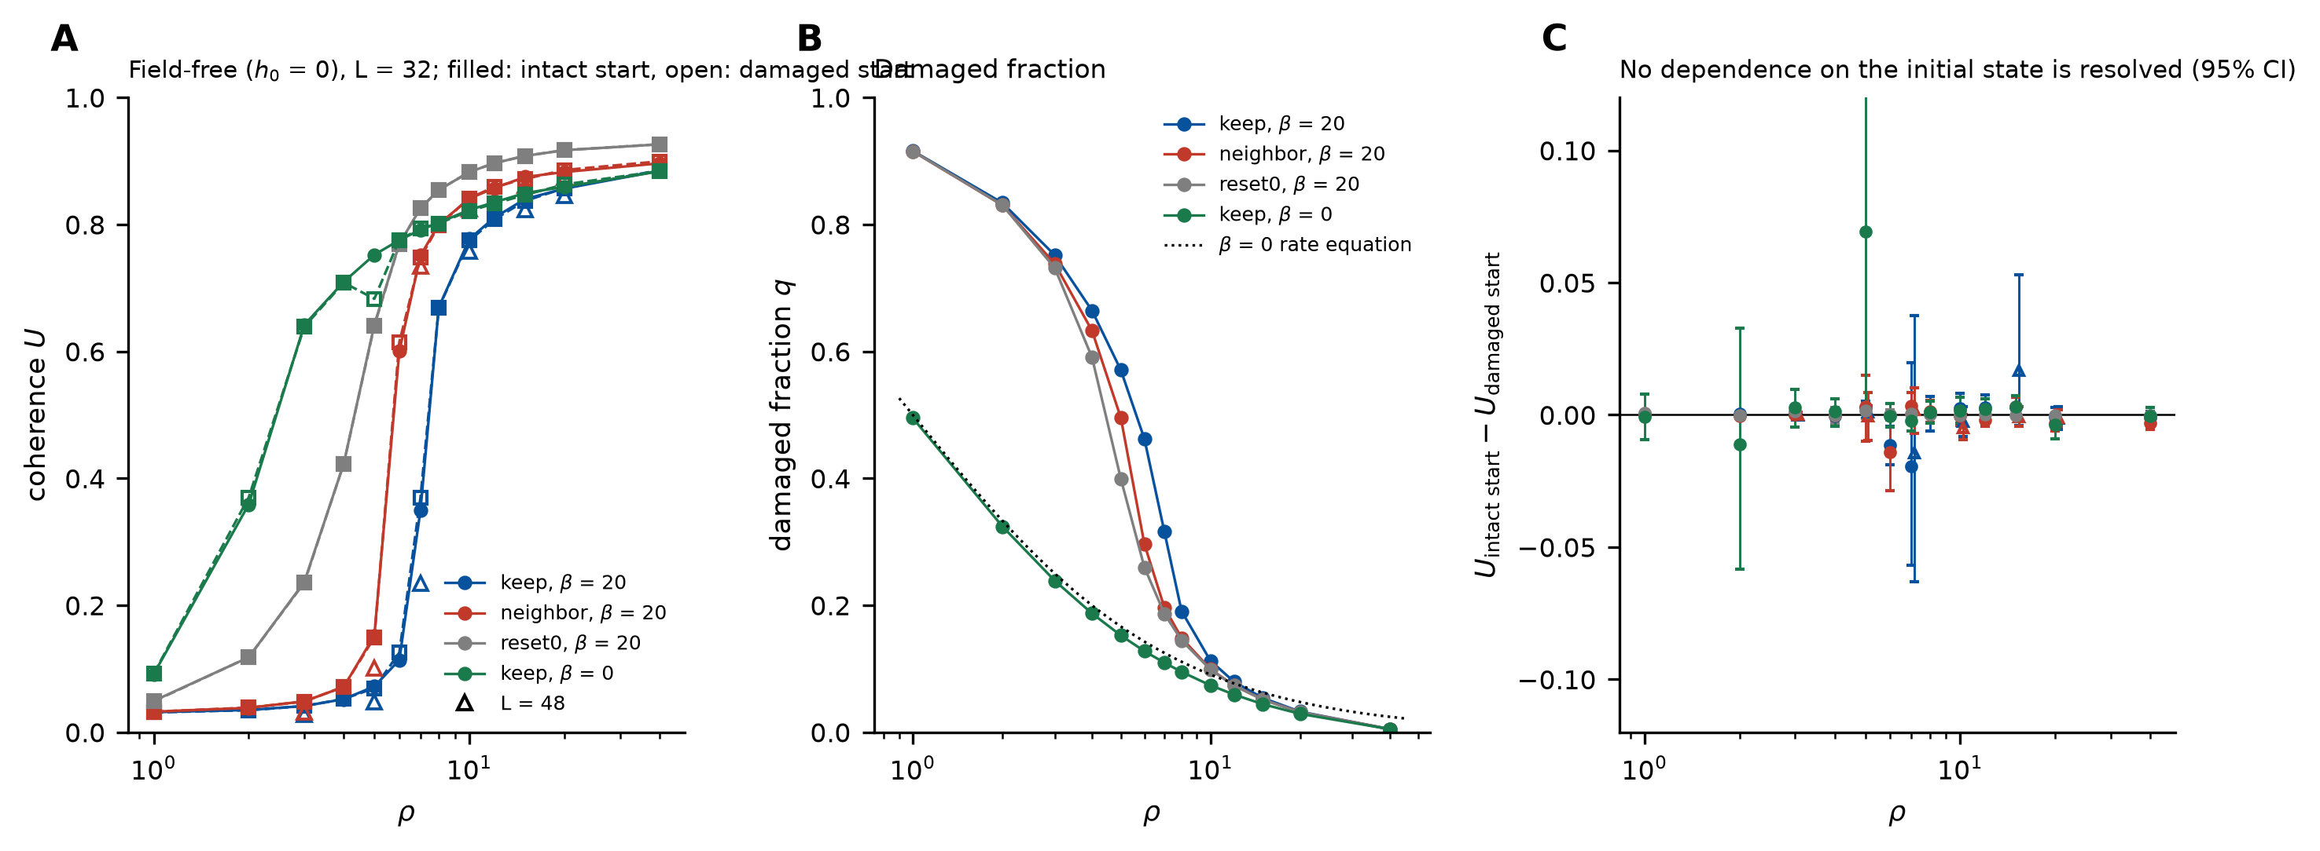
Figure 3. Field-free steady states (h₀ = 0) from two initial states. (a) U against ρ for the repair rules keep and neighbor (β = 20), reset0 (β = 20) and keep with state-independent damage (β = 0); L = 32, 10 seeds; filled: intact start, open: 95%-damaged start; triangles: L = 48. (b) Damaged fraction. (c) Difference of U between the two starts with 95% bootstrap intervals.
Coherence in magnitude is not the same as phase rigidity, so we measure the stiffness. Figure 4a shows the twist-response stiffness Υ_{tw}(ρ) of equation (6) in the ordered start state (L = 32; the twist φ₀ = 0.3π/L = 0.0295 is well below π/L, beyond which a periodic lattice changes its winding number, and the integer winding of every run is recorded; none of the 20 seed pairs differs in global winding). The stiffness is zero within error (|Υ_{tw}| ≤ 0.004) at ρ ≤ 6 for keep and ρ ≤ 5 for neighbor, and rises through the Nelson–Kosterlitz value 2T/π = 0.223, used only as a reference because the equilibrium criterion has not been justified here, at ρ = 7.4 (keep), 5.7 (neighbor) and 2.5 (β = 0), at L = 32. Repair therefore restores genuine phase stiffness, with a threshold in ρ. The spatial correlations (Figure 5) give the same threshold: for ρ below it C(r) decays exponentially with a correlation length of a few lattice spacings, and above it C(r) decays algebraically, ~ r^{−η}, with η = 0.06 ± 0.01 at ρ = 40 and η = 1/4 (the Berezinskii–Kosterlitz–Thouless value at the transition) crossed at ρ = 7.9 (keep), 6.0 (neighbor) and 2.8 (β = 0). In the algebraic phase the exponent measured from C(r) agrees with the spin-wave relation η = T/(2πΥ_{tw}) (Figure 5c) to within 16% over ρ ≥ 10, which supports Υ_{tw} as the stiffness of the damaged-and-repairing medium even though the state is not an equilibrium state.
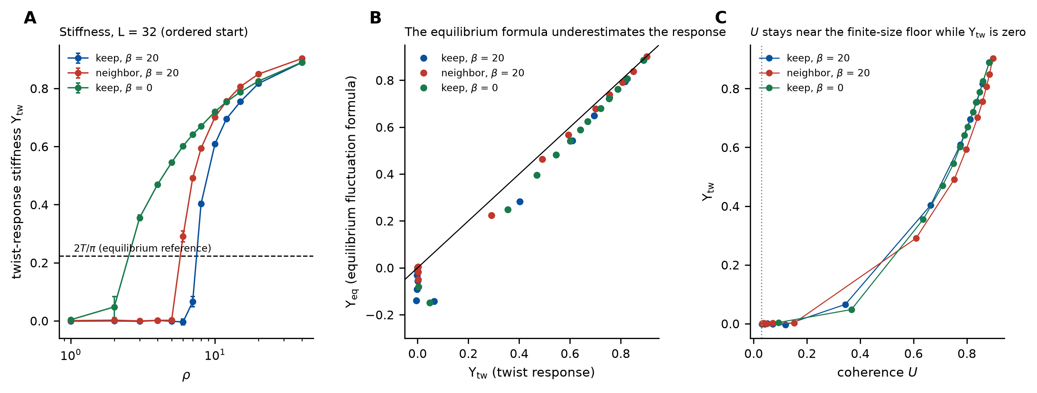
Figure 4. Phase stiffness. (a) Twist-response stiffness Υ_{tw}, equation (6), against ρ for the symmetric repair rules (h₀ = 0, L = 32, ordered start, 10 seeds, 95% CI); the dashed line is the Nelson–Kosterlitz value 2T/π, shown as a reference only. (b) The equilibrium fluctuation formula, equation (7), evaluated on the same runs, against Υ_{tw}; the line is equality. (c) Υ_{tw} against U.
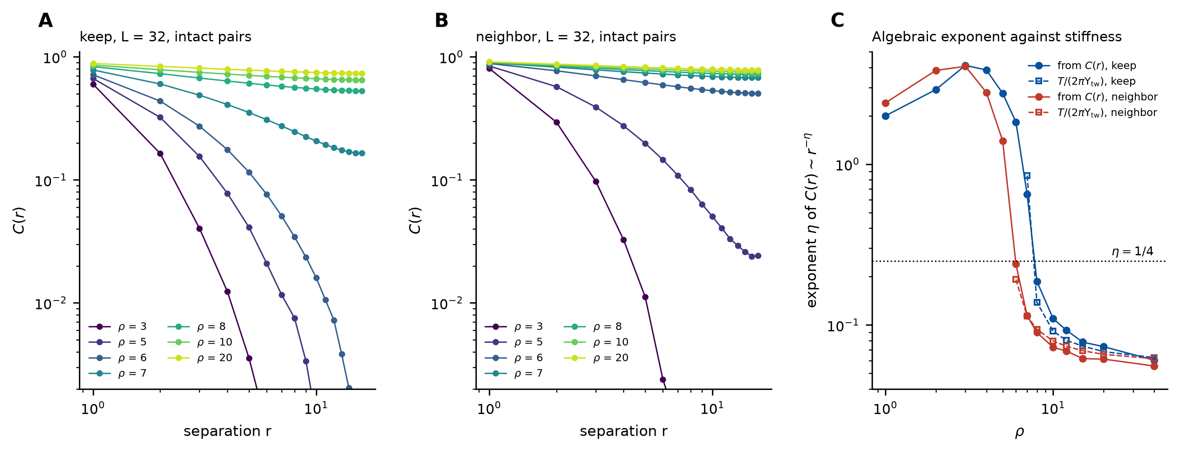
Figure 5. Phase correlations C(r) of intact-site pairs in the field-free steady state (L = 32, β = 20) for (a) keep and (b) neighbor at ρ from 3 to 20. (c) The exponent η of an algebraic fit (2 ≤ r ≤ L/4) and the spin-wave value T/(2πΥ_{tw}); dotted: η = 1/4.
The equilibrium fluctuation formula, equation (7), cannot be applied here without checking, and the check fails near the transition (Figure 4b). It underestimates the twist response by 30% at ρ = 8 for keep (ratio 0.70), by 23% at ρ = 6 for neighbor and by 11% and 4% at ρ = 10 and 15 for keep; far from the transition it recovers, to within 1% at ρ = 40. In the incoherent regime, where the twist response vanishes, it is negative (down to -0.14), which no stiffness can be. The cause is that the formula attributes all fluctuations of the bond current to the phases at a frozen coupling landscape, whereas here the couplings change with time as sites are damaged and repaired; the dependence of the discrepancy on the ratio of the damage and phase-relaxation times is examined in Section 3.4. Consequently the Nelson–Kosterlitz criterion Υ = 2T/π, which is an equilibrium statement, is used in this paper only for the static quenched dilution of Section 3.5, and the dynamic results are expressed through Υ_{tw}, η and the transition ratio ρ.
The stiffness does not depend on the initial state either. A start with 95% of the sites damaged and random phases can leave windings and vortices in the lattice, so for such states the twist response was measured with the winding number of every run recorded and the response corrected for a global integer winding when the two runs of a seed pair differ in it (3 of the 110 seed pairs). In the 11 conditions tested (keep, ρ = 8–20; neighbor, ρ = 7–20; L = 32, 10 seeds) the twist response from the damaged start agrees with that from the ordered start to within 0.040, the largest difference being -0.040 ± 0.036 at keep, ρ = 12.
Is the threshold a finite-size effect? Deep in the coherent state the stiffness does not depend on the size of the lattice (Table 4): at ρ = 10 and 20 the twist response of keep is 0.60–0.61 and 0.81–0.82 for L = 24 to 96, so Υ_{tw} is a bulk quantity. Near the threshold it depends on L. For keep at ρ = 7 it falls with size (0.12 at L = 24, 0.015 at 96) and is zero within error at the largest size, whereas at ρ = 8 it is finite and nearly size-independent (0.40 at L = 32, 0.37 at 96, a decrease of 8% that has stopped by L = 64). We call the stiffness vanished at a ρ if the twist response at the largest size is below 0.05 (with at least three sizes) and finite if it exceeds 0.15 there and has not fallen below 0.7 of its value at the smallest size; the finite-size estimate of the threshold is bracketed by the largest vanished and the smallest finite ρ. The cutoffs 0.05, 0.15 and 0.7 are operational choices, not properties of the model, and another choice would move the brackets. For the sizes studied the estimate lies between ρ = 7.00 and 7.75 for keep (L up to 96) and between 5.50 and 6.00 for neighbor (L up to 64) (Table 4); these brackets are consistent with a threshold, and are not bounds on its value in the thermodynamic limit. At the lowest ρ at which the stiffness is finite its value is 0.31 ± 0.02 for keep (L = 96) and 0.27 ± 0.01 for neighbor (L = 64), larger than 2T/π = 0.223. For keep the approach to the threshold is visible in the size dependence (Table 4): at ρ = 7.25 and 7.5 the stiffness still falls with L (0.15 → 0.06 and 0.25 → 0.15 from L = 32 to 96), while at ρ = 7.75 it is size-independent at 0.31 ± 0.02 (L = 96), so the finite-size estimate of the threshold lies in the upper part of the bracket, probably between 7.5 and 7.75 for L ≤ 96. A stiffness that decreases with size through 2T/π and settles above it just beyond the threshold is what a BKT-type continuous onset looks like; our data are compatible with it and do not exclude a discontinuity narrower than the step of 0.25 in ρ. No hysteresis between the two starts is resolved (Figure 3c).
Table 4. Twist-response stiffness Υ_{tw} (mean ± s.e.) of the field-free steady state (β = 20, T = 0.35, ordered start, 6–10 seeds) against the lattice size L across the threshold, with the status assigned by the operational criterion in the text (not a determination of the thermodynamic limit).
repair rule | ρ | L = 24 | 32 | 48 | 64 | 96 | status
keep | 5.00 | 0.000 ± 0.003 | -0.002 ± 0.003 | -0.002 ± 0.005 | 0.002 ± 0.004 | 0.003 ± 0.005 | vanished
 | 7.00 | 0.122 ± 0.009 | 0.048 ± 0.012 | -0.008 ± 0.012 | 0.030 ± 0.017 | 0.015 ± 0.013 | vanished
 | 7.25 | – | 0.153 ± 0.016 | 0.083 ± 0.016 | 0.036 ± 0.030 | 0.062 ± 0.035 | undecided
 | 7.50 | – | 0.254 ± 0.010 | 0.212 ± 0.024 | 0.183 ± 0.035 | 0.154 ± 0.014 | undecided
 | 7.75 | – | 0.323 ± 0.010 | 0.324 ± 0.013 | 0.288 ± 0.028 | 0.307 ± 0.017 | finite
 | 8.00 | – | 0.398 ± 0.006 | 0.384 ± 0.005 | 0.366 ± 0.019 | 0.366 ± 0.009 | finite
 | 9.00 | – | 0.530 ± 0.003 | 0.537 ± 0.003 | 0.526 ± 0.003 | 0.537 ± 0.004 | finite
 | 10.00 | 0.607 ± 0.003 | 0.602 ± 0.003 | 0.601 ± 0.003 | 0.612 ± 0.003 | 0.608 ± 0.002 | finite
 | 20.00 | 0.814 ± 0.001 | 0.814 ± 0.001 | 0.816 ± 0.001 | 0.816 ± 0.001 | 0.812 ± 0.002 | finite
neighbor | 5.25 | – | 0.009 ± 0.012 | 0.000 ± 0.011 | -0.000 ± 0.012 | – | vanished
 | 5.50 | – | 0.037 ± 0.016 | 0.008 ± 0.012 | 0.012 ± 0.013 | – | vanished
 | 5.75 | – | 0.149 ± 0.015 | 0.092 ± 0.023 | 0.146 ± 0.018 | – | undecided
 | 6.00 | – | 0.270 ± 0.007 | 0.259 ± 0.013 | 0.267 ± 0.014 | – | finite
 | 7.00 | – | 0.496 ± 0.004 | 0.495 ± 0.002 | 0.490 ± 0.005 | – | finite

3.4 Timescales: is the repair-to-damage ratio enough?
Changing the damage probability λ₀ at fixed ρ changes U appreciably, so ρ does not collapse the lattice data at a fixed number of phase sweeps per step. We decompose this dependence (Figure 6, Table 5 and Table 6). Three effects are involved. First, the kinetic update is discrete: at fixed ρ the per-step probabilities R = ρλ₀ and λ₀μ grow with λ₀, and the hazard-equivalent ratio ln(1 − R)/ln(1 − λ₀) exceeds ρ by a factor 1.06 at λ₀ = 0.04 and 1.15 at λ₀ = 0.08 (where, in addition, λ₀(1 + β) = 1.68 > 1 and the kill probability saturates). Second, the rule θ → 0 injects order at rate R (Section 3.3). Third, there is a genuine competition between kinetics and phase relaxation, measured by Ω = λ₀/relax, the number of damage events per site per phase sweep, which is proportional to the ratio of the phase-relaxation time to the damage time. The relaxation time of the phase field in a frozen damage landscape, measured as the integrated autocorrelation time of U, is 0.9–5.4 sweeps in the field (h₀ = 0.4) and 146–176 sweeps for the global phase of the coherent field-free state.
We therefore scanned λ₀ from 0.005 to 0.08 and the number of phase sweeps per kinetic step from 1 to 8 (Ω from 6.3 × 10⁻⁴ to 0.04) for the three repair rules at ρ = 2.5 and 5 (h₀ = 0.4, β = 20, L = 32, 8 seeds, 3000 + 1500 steps). At fixed relax, raising λ₀ from 0.005 to 0.04 at ρ = 5 raises U from 0.722 to 0.863 for reset0 and from 0.715 to 0.837 for neighbor, but leaves it almost unchanged for keep (0.680 to 0.697); at fixed λ₀, increasing relax lowers U for reset0 and neighbor and raises it for keep. The dependence of U on (ρ, λ₀, relax) is resolved by plotting U against the damaged fraction q that each run reaches (Figure 6c). For neighbor, U is a function of q alone: the rms deviation of the 32 unsaturated points from a single cubic curve U(q) is 0.003, with no trend in Ω (+0.0002 per decade). Its dependence on λ₀ at fixed ρ is therefore carried entirely by q, that is by the discrete-time effect above. For reset0 the deviation is 0.009 with a small trend (+0.0077 per decade). For keep it is 0.021, and U at a given q rises by 0.040 per decade as Ω falls (correlation -0.89 with log Ω): a repaired site retains the random phase it had while damaged and needs sweeps to rejoin the coherent background, so that rapid kinetics, relative to the relaxation, keep it incoherent; a site repaired to the phase of its neighbors has nothing to relax.
Table 5. Coherence U (mean ± s.e., 8 seeds, L = 32, β = 20, h₀ = 0.4) at the baseline kinetics (λ₀ = 0.02, two phase sweeps per step, Ω = 0.01) and in the slowest-damage state scanned (λ₀ = 0.005, eight sweeps, Ω = 6 × 10⁻⁴), for the three repair rules.
repair rule | ρ = 2.5, Ω = 10⁻² | ρ = 2.5, Ω = 6 × 10⁻⁴ | ρ = 5, Ω = 10⁻² | ρ = 5, Ω = 6 × 10⁻⁴
reset0 (θ → 0) | 0.402 ± 0.001 | 0.331 ± 0.001 | 0.797 ± 0.001 | 0.709 ± 0.001
keep | 0.273 ± 0.001 | 0.319 ± 0.001 | 0.676 ± 0.003 | 0.697 ± 0.001
neighbor | 0.337 ± 0.001 | 0.324 ± 0.001 | 0.778 ± 0.001 | 0.704 ± 0.001
spread over the rules | 0.129 | 0.012 | 0.121 | 0.012

The central result is the last row of Table 5. At the baseline kinetics the three repair rules differ in U by 0.13 at ρ = 2.5 and 0.12 at ρ = 5; at the slowest damage scanned they differ by 0.012 and 0.012, a tenfold convergence (Figure 6d, in which the spread falls roughly in proportion to Ω), and U at ρ = 5 is 0.71, 0.70 and 0.70 for reset0, keep and neighbor. The numerical evidence therefore supports the repair-to-damage ratio becoming the controlling parameter as Ω falls: over the range scanned the dependence on the repair rule and on λ₀ separately shrinks roughly in proportion to Ω, and at the slowest damage it is small. The mathematical limit Ω → 0 lies beyond the range tested, and we do not claim it; the dependences found at finite Ω are the finite-rate corrections of the three effects above. Two consequences follow. The values at the baseline kinetics, such as Table 2, are values at a finite Ω = 0.01 and lie up to 0.09 above the slowest-damage value at ρ = 5 for reset0; and the equilibrium fluctuation formula for the stiffness, which fails at finite Ω (Section 3.3), should approach the twist response as Ω falls. Over the range scanned it does: for the field-free keep state at ρ = 10 and λ₀ = 0.005 the ratio Υ_{eq}/Υ_{tw} is 0.90, 0.95 and 0.96 at Ω = 5 × 10⁻³, 2.5 × 10⁻³ and 6.3 × 10⁻⁴ (Figure 6f), the stiffness itself changing by only 4% over the same range. In a conductor the damage and the annealing proceed over hours to years, while the relaxation of the superconducting phase is expected to be many orders of magnitude faster (we do not quantify it here), so that experiments should lie at much smaller Ω than scanned, where ρ would be the controlling quantity if the trend continues; that extrapolation is an assumption.
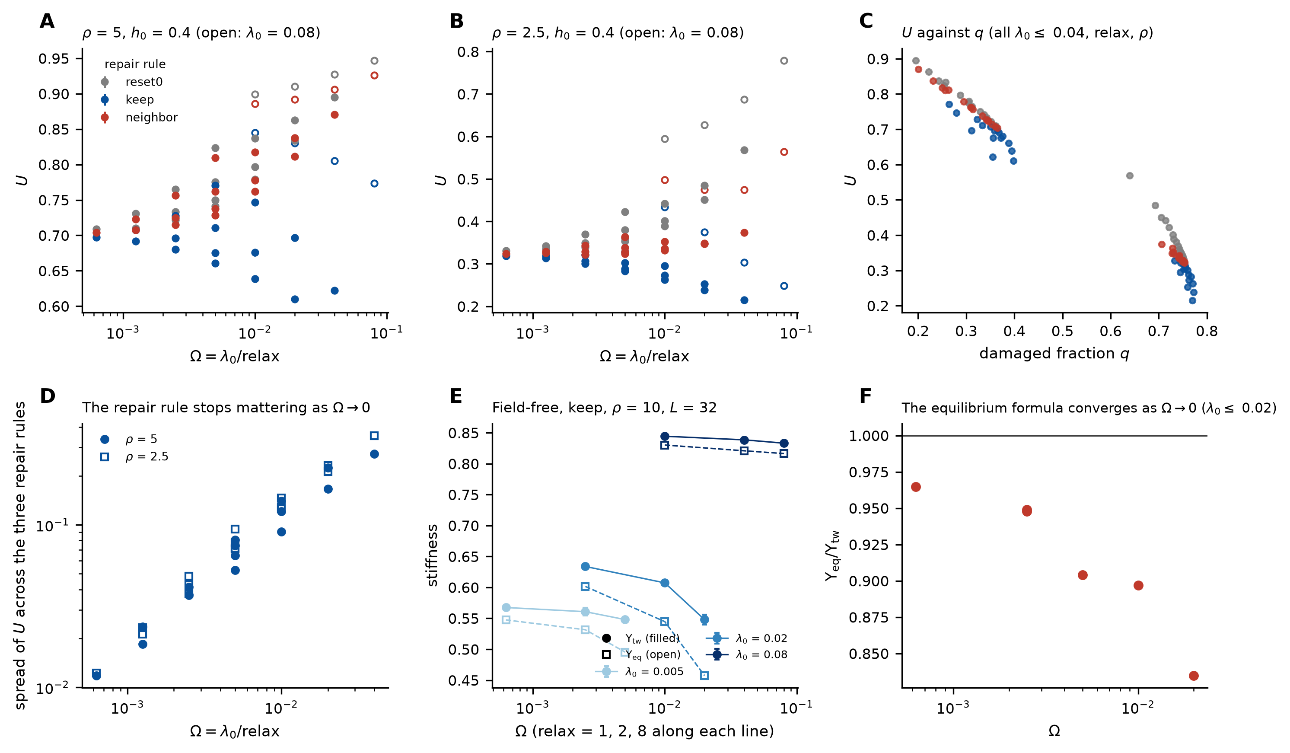
Figure 6. Is ρ enough? (a, b) U against Ω = λ₀/relax for the three repair rules (h₀ = 0.4, β = 20, L = 32; every combination of λ₀ = 0.005–0.08 and relax = 1–8; open symbols: λ₀ = 0.08, whose kill probability saturates) at ρ = 5 and 2.5. (c) The same points against the damaged fraction q reached. (d) Spread of U across the three rules at each (λ₀, relax). (e) Field-free stiffness Υ_{tw} (filled) and the equilibrium formula Υ_{eq} (open) at ρ = 10 for λ₀ = 0.005, 0.02 and 0.08 (relax = 1, 2, 8 along each line). (f) Υ_{eq}/Υ_{tw} for λ₀ ≤ 0.02.
Table 6 gives the sensitivity of U at the baseline kinetics to the other parameters, one at a time, with 10 seeds (6 at L = 96). U is independent of L from 24 to 96 within error, and depends strongly on temperature, on the field h₀ and the coupling g₀ of damaged sites, and on β (Table 6).
Table 6. Sensitivity of the steady-state U (baseline λ₀ = 0.02, two sweeps per step, repair θ → 0, h₀ = 0.4 unless varied; mean over 10 seeds (6 for L = 96); the standard errors are at most 0.001). Values are listed in the order of the parameter values.
parameter | values | U at ρ = 2.5 | U at ρ = 5
temperature T | 0.25, 0.35, 0.5, 0.7 | 0.630 / 0.403 / 0.272 / 0.196 | 0.894 / 0.798 / 0.605 / 0.424
damaged coupling g₀ (g₀ = 0: U over all sites) | 0, 0.03, 0.12, 0.3, 0.5 | 0.175 / 0.214 / 0.402 / 0.878 / 0.920 | 0.377 / 0.459 / 0.798 / 0.920 / 0.934
field h₀ (θ → 0 repair) | 0, 0.2, 0.4, 0.8 | 0.169 / 0.302 / 0.403 / 0.544 | 0.642 / 0.747 / 0.798 / 0.852
feedback β | 0, 5, 10, 20, 30 | 0.796 / 0.733 / 0.623 / 0.403 / 0.305 | 0.877 / 0.867 / 0.852 / 0.799 / 0.677
lattice size L | 24, 32, 48, 64, 96 | 0.403 / 0.404 / 0.402 / 0.402 / 0.402 | 0.798 / 0.798 / 0.798 / 0.798 / 0.798

3.5 Static dilution, finite-size extrapolation and clustered damage
The static limit, in which a fraction f of the sites is removed at random and the phases equilibrate (g = 0 on removed sites, T = 0.35, equation (7), which is legitimate in equilibrium), provides the reference for the dynamic results and the input to the mapping of Section 4. Υ(f) was computed for L = 16 to 96 (and 128 near the crossing) with 6–12 disorder realizations per point, 2000 equilibration and 4000 measurement sweeps, and a grid of 0.01 near the crossing (Figure 7a). The crossing with the Nelson–Kosterlitz value 2T/π = 0.223 [10] is at f_{KT}(L) = 0.262, 0.259, 0.263, 0.256, 0.258, 0.256 for L = 16, 24, 32, 48, 64, 96, each with a 95% bootstrap interval over realizations of half-width 0.005–0.009 (Table 7). The scatter of the crossings over sizes, standard deviation 0.0027, is smaller than the uncertainty of each one and must not be used as an error estimate; the uncertainty of the limit comes from the extrapolation. Extrapolating f_{KT}(L) linearly in 1/ln²L gives f_{KT}(∞) = 0.254 (95% interval 0.245–0.262), and a Weber–Minnhagen fit [19] of Υ_{L} = (2T/π)[1 + 1/(2 ln L + C)] to the sizes L ≥ 24 gives 0.245 (0.242–0.258; χ² = 0.29 for 4 degrees of freedom). The estimate is stable against the smallest lattices used: excluding L = 16, then also 24 and 32, gives 0.253, 0.248 and 0.258, with intervals that widen as fewer sizes remain (Table 7). We quote f_{KT} = 0.25 ± 0.01 as a numerical estimate for T = 0.35, from sizes up to 96 and 6–12 realizations, not as a precisely established critical value. It lies well below the site-percolation threshold 1 − p_{c} = 0.407 [21]: the intact sublattice still percolates, and the loss of stiffness is a phase-fluctuation effect, as in the BKT picture.
Table 7. Crossing of the helicity modulus with 2T/π under random dilution (T = 0.35): the crossing at each size with its own bootstrap interval, and the extrapolations to L → ∞ with their sensitivity to the smallest sizes used.
L | f_{KT}(L) | 95% CI of the crossing | realizations
16 | 0.2615 | 0.255–0.265 | 12
24 | 0.2589 | 0.253–0.271 | 12
32 | 0.2626 | 0.248–0.266 | 12
48 | 0.2562 | 0.251–0.267 | 10
64 | 0.2578 | 0.248–0.263 | 10
96 | 0.2565 | 0.250–0.263 | 8
∞, 1/ln²L, all sizes | 0.2539 | 0.245–0.262 | sizes 16–96
∞, 1/ln²L, L ≥ 24 | 0.2529 | 0.235–0.265 | sizes 24–96
∞, 1/ln²L, L ≥ 32 | 0.2478 | 0.232–0.273 | sizes 32–96
∞, 1/ln²L, L ≥ 48 | 0.2575 | 0.219–0.282 | sizes 48–96
∞, Weber–Minnhagen, L ≥ 24 | 0.2450 | 0.242–0.258 | sizes 24–96

Irradiation does not remove independent sites: displacement cascades produce extended defects. We compared random dilution with compact clusters of 5, 13 and 29 removed sites (discs of radius 1, 2 and 3, placed at random positions up to the same removed fraction f; L = 32 and 48, 10 realizations, T = 0.35). At L = 48 the crossing moves from 0.253 for random sites to 0.263 (0.251–0.294), 0.311 (0.301–0.333) and 0.360 (0.319–0.374) for the three cluster sizes (Figure 7c), towards the percolation value 0.407, and the same ordering holds at L = 32 (0.258, 0.287, 0.322, 0.365). At the same removed fraction, clustered damage therefore destroys the stiffness far less than independent point damage, and the mapping of Section 4.2, which assumes random point damage, gives the number of non-superconducting sites per dpa only for that assumption; it does not distinguish a cascade of many sites that each count little from fewer isolated ones.
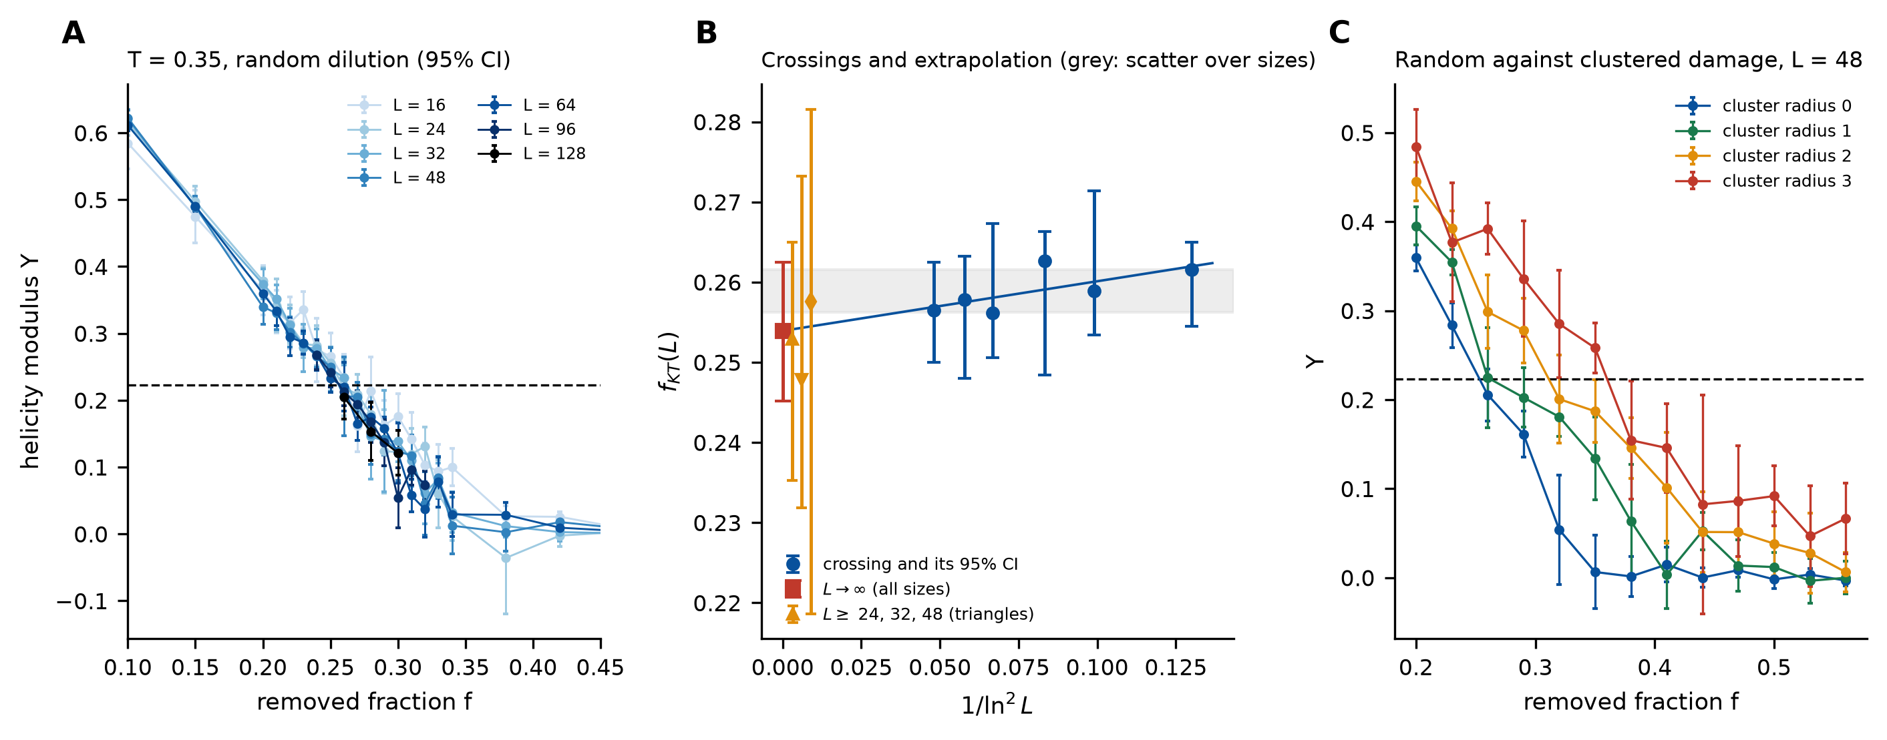
Figure 7. Static dilution. (a) Helicity modulus Υ against the removed fraction f at T = 0.35 for L = 16–128 (95% CI); dashed: 2T/π. (b) The crossing at each size with its bootstrap interval against 1/ln²L, the linear extrapolation (line, square), its sensitivity to dropping the smallest sizes (triangles, L ≥ 24, 32, 48) and, as a grey band, the scatter of the crossings over sizes, which is not an error estimate. (c) Υ(f) at L = 48 for random removal and for compact clusters of radius 1, 2 and 3 (5, 13 and 29 sites).

4. Relationship to irradiated superconductors

4.1 Experimental evidence the model is compared with
The experiments that bear on the model are those on REBCO coated conductors irradiated with fast neutrons and then annealed. (i) The transition temperature decreases linearly with the calculated displacement damage, at the same rate for neutrons and for helium ions; for neutron-irradiated tapes the decrease is from about 90 K to 81 K and from about 94 K to 84 K at 3.7–3.8 mdpa, a fractional decrease of about 0.10 [8]. (ii) The critical current first rises with fluence, passes a temperature-dependent maximum and falls below its pristine value at fluences of the order of 10²² m⁻² (at 50 K in most tapes), and the n-value decreases even where the critical current is enhanced [4–7]; this initial rise is due to added pinning and is outside the present model. (iii) The degradation of T_{c} and of the critical current density are closely related, attributed to a loss of superfluid density, and annealing for 12 h after a 5 °C min⁻¹ ramp recovers about 25% of the T_{c} decrease at 150 °C and about 60% at 400 °C, from near-linear increases of T_{c} with annealing temperature in several tapes (slopes of about 1.8–3.3 K per 100 °C); in an oxygen-poor environment oxygen loss limits the anneal to about 220 °C, so the higher-temperature recovery refers to anneals in oxygen [7]. These numbers are quoted from the cited papers; the model is compared with them only in the limited sense below.

4.2 From a damaged fraction to displacement damage
The superfluid density, which the experiments identify as what the damage removes, is the physical counterpart of the stiffness Υ (for a film of thickness d the phase stiffness is proportional to d/λ_{L}², with λ_{L} the London depth [11, 14]). The relative stiffness Υ_{tw}(ρ)/Υ_{tw}(∞) of the damage–repair steady state is therefore the model’s counterpart of the relative superfluid density and fixes λ_{L}/λ_{L}(0) = [Υ(∞)/Υ(ρ)]^{1/2}, a quantity that is measurable by penetration-depth experiments but that we do not compare with data (Table 8). We do not equate U, or Υ, with a critical current: the model has neither pinning nor a transport current.
Table 8. Relative stiffness and the implied London-depth ratio in the field-free steady state (L = 32, β = 20, ordered start); the reference is the stiffness at ρ = 40, where the damaged fraction is 0.5%.
ρ | q (keep) | Υ_{tw}/Υ_{tw}(40) | λ_{L}/λ_{L}(0) | q (neighbor) | Υ_{tw}/Υ_{tw}(40) | λ_{L}/λ_{L}(0)
8 | 0.192 | 0.453 | 1.486 | 0.149 | 0.658 | 1.233
10 | 0.112 | 0.685 | 1.208 | 0.100 | 0.777 | 1.135
12 | 0.080 | 0.782 | 1.131 | 0.074 | 0.837 | 1.093
15 | 0.054 | 0.849 | 1.086 | 0.052 | 0.893 | 1.058
20 | 0.033 | 0.919 | 1.043 | 0.032 | 0.940 | 1.031

To relate the damaged fraction f of static damage to displacement damage we need the dependence of the transition temperature on f, and here, unlike for the coherence U, the model has a precise answer: the BKT temperature T_{BKT}(f) of the diluted lattice, from the crossing of Υ(T) with 2T/π (Section 2.4) extrapolated in 1/ln²L, falls from the clean value 0.893 [22] to 0.77 (95% interval 0.74–0.80) at f = 0.05 and to 0.67 at f = 0.10 (Figure 8a). If the T_{c} of the conductor is taken to follow T_{BKT}(f), a fractional decrease of 0.10 at 3.7–3.8 mdpa [8] corresponds to f = 0.037, that is to a = 10 model sites made non-superconducting per dpa (range 7–14 across the interval estimates and the two tapes). This number is an effective conversion factor, not a measured or derived physical quantity: it depends on what a model site is taken to represent and on the assumption that T_{c} follows T_{BKT}(f), and we attach no further physical interpretation to it. The assumption that T_{c} follows T_{BKT}(f) of a two-dimensional XY model is an assumption and not a result; REBCO is a layered three-dimensional superconductor, and the proportionality of T_{c} to the phase stiffness is a relation that the experiments suggest [7] but that the model does not derive.
Rates, probabilities and time. The model’s probabilities are per kinetic step, and the physical duration of a step enters the mapping. With ṅ the rate at which a given site is made non-superconducting by displacement damage, ṅ = a × (dpa rate), and ν_{a} exp(−E/k_{B}T_{a}) the thermally activated recovery rate with attempt frequency ν_{a} and activation energy E, the per-step probabilities for a step of duration Δt are λ₀ = 1 − exp(−ṅΔt) and R = 1 − exp[−ν_{a}exp(−E/k_{B}T_{a})Δt]; a rate cannot be used as a probability. Their ratio ρ ≈ ν_{a}exp(−E/k_{B}T_{a})/ṅ is independent of Δt only when both probabilities are small, which is the condition under which the rate equation (4) holds; in the simulations the hazard-equivalent ratio ln(1 − R)/ln(1 − λ₀) exceeds R/λ₀ by a factor 1.06 at λ₀ = 0.04 and 1.15 at λ₀ = 0.08 (Section 3.4). Accumulated damage (dpa) and damage rate (dpa per second) enter differently: with no recovery the damaged fraction grows as f = a·dpa and the static dilution results of Section 3.5 apply; with simultaneous recovery the steady state is set by ρ.

4.3 Annealing
The rule θ → 0, the instant restoration of coupling and a single repair probability for all damaged sites are not physical descriptions of annealing. The first is replaced here by the keep and neighbor rules (Section 3.3), and we turn to the recovery kinetics. Consider, illustratively, 12 h isothermal anneals [7] of a tape damaged to the state above (f = 0.037), with a distribution of activation energies g(E) among the damaged sites, so that the fraction of sites still damaged after the anneal is ∫g(E)exp[−ν_{a}t exp(−E/k_{B}T_{a})]dE and the recovered fraction of the T_{c} decrease follows from T_{BKT}(f). A single activation energy gives a recovery that rises from 0 to 100% over a few tens of kelvin, which is not what is reported (about 25% at 150 °C and 60% at 400 °C, the latter in oxygen, increasing roughly linearly with the annealing temperature). A Gaussian spectrum reproduces both reported values for ν_{a} = 10¹³ s⁻¹ with a mean of 2.09 eV and a standard deviation of 0.98 eV, and a flat spectrum does so with a width of 2.5 eV (from 0.83 to 3.32 eV); the fit of two parameters to two numbers is not a validation and does not determine the width uniquely (the authors of the experiment infer only qualitatively a very broad distribution [7]), and it gives a testable consequence only through its shape: a recovery of 42% at 275 °C for both, and a recovery of 8% already at 25 °C for the flat spectrum. Varying ν_{a} from 10¹¹ to 10¹⁵ s⁻¹ shifts the energies by about 0.5 eV and leaves the shape unchanged. What survives any such choice is only the qualitative statement that recovery growing linearly over 150–400 °C in a 12 h anneal requires an activation spectrum much broader than a single process (the model fits give widths of the order of an electronvolt, which should be read as illustrative values of these two assumed forms), if the process is the independent thermally activated repair of independent damaged sites assumed here.
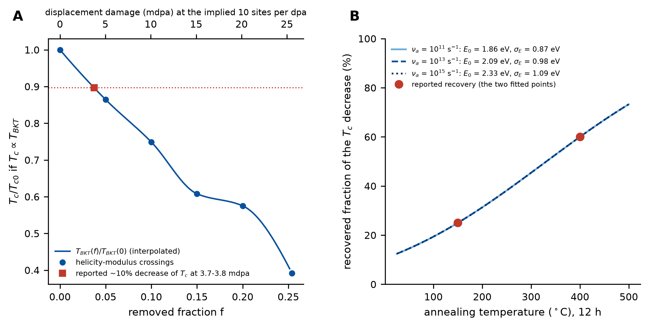
Figure 8. From damage to experiment. (a) T_{c}/T_{c0} = T_{BKT}(f)/T_{BKT}(0) from the helicity-modulus crossings (points, L = 16–48 extrapolated in 1/ln²L; T_{BKT}(0) from [22]) and the interpolation used; the square marks the reported fractional decrease of T_{c} at 3.7–3.8 mdpa [8], which fixes the number of model sites per dpa on the upper axis. (b) Recovered fraction of the T_{c} decrease after 12 h anneals for a Gaussian spectrum of activation energies, fitted to the two reported recoveries [7] (points) for three attempt frequencies.

4.4 What a calibration and a validation would require
A defensible calibration needs more than two annealing numbers. It requires (i) damage and anneal data on the same samples for T_{c}, for a quantity proportional to the stiffness (the penetration depth) and for the critical current, at several fluences; (ii) isochronal, not only isothermal, anneals, so that a spectrum of activation energies can be determined rather than assumed; (iii) a held-out set, for example a different fluence or a different tape, on which the mapping of Section 4.2 and the spectrum of Section 4.3 are tested; (iv) an extension of the model by pinning, to address the critical current, and by interlayer coupling, since the T_{c} of the conductor is not that of a single plane; and (v) spatially correlated damage. We have not attempted any of these, and the model remains uncalibrated.

4.5 Experimental validation using fission-reactor irradiation
A direct test of the damage–repair framework would use REBCO coated-conductor specimens exposed to controlled neutron irradiation in a materials-test or research fission reactor, an established route to displacement damage in these conductors [4, 5, 7]. Specimens irradiated to several damage levels would then be subjected to isochronal or isothermal anneals, with T_{c}, the critical current density and, where experimentally accessible, a quantity proportional to the stiffness (the penetration depth, Section 4.2) measured before irradiation, after irradiation and after each annealing step. This would show whether recovery depends only on the accumulated damage and the annealing state, or also on the timescales of damage and recovery. We propose it as a pathway to validation, not as evidence that the model has been validated.
The most discriminating comparison follows from Section 3.4: specimens that reach the same accumulated damage through different damage-rate histories (for example the same fluence at flux densities differing by orders of magnitude, or with interruptions), followed by the same recovery protocol. If the recovery differs systematically with the irradiation history at comparable accumulated damage, this supports the finding that the repair-to-damage ratio alone is not sufficient when the damage is not slow compared with the relaxation of the phase. If the measurements collapse onto the accumulated damage and the annealing state, the experiments are in the slow regime, where ρ controls the state, and the timescale parameter Ω of the model is constrained to be small. The model’s statement is about damage and recovery acting together, so the test is most direct at an irradiation temperature at which recovery is active.
A second comparison follows from Section 3.5: specimens with a similar removed or damaged fraction but different spatial correlations of the defects, for example neutron and light-ion irradiation, whose defect-cascade sizes differ, characterized by microscopy or spectroscopy. The model predicts that, at the same fraction, correlated damage preserves more stiffness than independent point damage, so that equal nominal damage should not give equal T_{c} or superfluid density.
Such experiments would not reproduce the fusion environment: fission and D–T fusion neutron spectra differ substantially, and transmutation, displacement cascades, dose rate and operating temperature must be accounted for, so that spectrum- and dpa-aware comparisons are required. Their role would be to calibrate and to falsify the kinetic framework before it is extrapolated to fusion-relevant conditions.

5. Discussion and limitations
What the results say. The mean-field reduction is an exact description of the kinetics only when its closure holds, and for the lattice it does not: the multiplier that the lattice applies to the damage rate is a smooth function of the damaged fraction, nearly the same whether the damage depends on phase order (β = 20) or not (β = 0), and far from the sharp sigmoid of the closure (Figure 1c). The bistability that the reduction predicts is therefore not found: two starting states converge, ramps close as they slow, and the interval exceptions are small, of mixed sign and not significant after correction. What survives in the lattice is a threshold, not a bistability. With the field removed and a repair that preserves the phase symmetry, the lattice has a threshold in ρ for spontaneous coherence, with phase correlations that change from exponential to algebraic and a stiffness, measured as a twist response, that is zero below it and large above it; state-dependent damage raises the threshold by a factor of about three over state-independent damage, because disordered regions are damaged faster, and a repair that restores the phase of the surroundings lowers it by a quarter. Numerically, ρ becomes the controlling parameter as the damage becomes slow compared with the relaxation of the phase, which we expect to be the regime of irradiation and annealing experiments; over the range of kinetics scanned the repair rule matters less and less, and we do not claim the mathematical limit.
What it does not say. The equilibrium Nelson–Kosterlitz criterion and the equilibrium helicity formula are not applied to the dynamic states, because the formula fails there (Section 3.3); the static dilution is the only place where they are used. The thresholds are finite-size estimates, not thermodynamic-limit bounds, and rest on operational cutoffs: for keep between ρ = 7.00 and 7.75, for neighbor between 5.50 and 6.00 (Table 4), from sizes up to L = 96 and 64. Whether the stiffness jumps at the threshold, as it does for a BKT transition, or rises continuously over an interval narrower than our grid is not resolved. The absence of hysteresis refers to the sizes, run lengths and feedback strengths tested. No entropy-production result is claimed: the entropy production of a closed-form two-state cycle is a property of a framework, not a measurement of the simulated dynamics.
Limitations of the model. The lattice is two-dimensional and the damage is removal of sites, whereas displacement cascades produce extended defects, which matter (Section 3.5), some of which improve pinning; repair restores the coupling of a site at once and independently of its neighbors; there are no vortices as dynamical objects with pinning, no applied field or transport current, so the critical current and its initial rise with fluence are out of reach; the layered three-dimensional structure of REBCO is absent, so that T_{c} is not the BKT temperature of a plane; the activation spectrum of the annealing is assumed. Lattices are at most 96 × 96 (128 × 128 near the crossing of the static analysis), runs are at most a few thousand steps (1600 per value in the ramps), and 6–10 seeds or realizations were used. The mapping to displacement damage and annealing is illustrative and is not a calibration.

6. Conclusions
A minimal damage–repair XY model gives three results that bear on the phase stiffness of irradiated superconductors, each stated with its limits. First, the mean-field bistability that the reduction predicts is not realized on the lattice in the ranges tested, because the closure of the reduction fails, and no hysteresis or dependence on the initial state is resolved. Second, repair restores spontaneous phase coherence and a twist-response stiffness above a threshold ratio of repair to damage that depends on the feedback and on the repair rule, the equilibrium fluctuation formula underestimates that stiffness by up to about 30% near the threshold, and the stiffness, not the magnitude U of the order, is the quantity that distinguishes the coherent from the incoherent state. Third, the numerical evidence is that the repair-to-damage ratio becomes the controlling parameter as the damage becomes slow relative to phase relaxation, the repair rule mattering less and less, and the finite-rate values differ from the slowest-damage values by up to 0.09 in U. The static dilution crossing, f_{KT} = 0.25 ± 0.01 at T = 0.35, and the clustered-damage results complete the picture; an illustrative effective mapping to displacement damage gives about ten model sites per dpa, and the annealing data are compatible with a broad spectrum of activation energies, whose width the two reported numbers do not determine; a calibration, which would need data that we did not have, remains to be done.

Declarations
Funding. This research received no specific grant from any funding agency in the public, commercial or not-for-profit sectors. Competing interests. The author declares no competing interests. Author contributions (CRediT). Leon Sandler: conceptualization, methodology, software, formal analysis, investigation, visualization, writing – original draft, writing – review and editing. Declaration of AI-assisted technology. During the preparation of this work the author used Claude (Anthropic) to write and test the simulation and analysis code to the author’s specification, to check the reference list against Crossref records and to assist with language and typesetting. The author reviewed and edited the content and takes full responsibility for it.
Data and code availability. The engine, its test suite, the study and analysis scripts, all raw run outputs, the figures and the manuscript build script are available at https://github.com/sandlerleon/damage-repair-xy-stiffness, archived at https://doi.org/10.5281/zenodo.23173811. This manuscript is available as a preprint at https://doi.org/10.5281/zenodo.23173812. The engine reproduces the update rules of the MyUncle framework [16] bit for bit. Experimental values quoted in Section 4 are taken from the cited papers and no experimental data were measured or fitted other than the numbers stated there.

References
[1] Sorbom B, Ball J, Palmer T et al 2015 ARC: a compact, high-field, fusion nuclear science facility and demonstration power plant with demountable magnets. Fusion Eng. Des. 100, 378–405. https://doi.org/10.1016/j.fusengdes.2015.07.008
[2] Creely A J, Greenwald M J, Ballinger S B et al 2020 Overview of the SPARC tokamak. J. Plasma Phys. 86, 865860502. https://doi.org/10.1017/S0022377820001257
[3] Zinkle S, Snead L 2014 Designing radiation resistance in materials for fusion energy. Annu. Rev. Mater. Res. 44, 241–267. https://doi.org/10.1146/annurev-matsci-070813-113627
[4] Prokopec R, Fischer D X, Weber H W, Eisterer M 2015 Suitability of coated conductors for fusion magnets in view of their radiation response. Supercond. Sci. Technol. 28, 014005. https://doi.org/10.1088/0953-2048/28/1/014005
[5] Fischer D X, Prokopec R, Emhofer J, Eisterer M 2018 The effect of fast neutron irradiation on the superconducting properties of REBCO coated conductors with and without artificial pinning centers. Supercond. Sci. Technol. 31, 044006. https://doi.org/10.1088/1361-6668/aaadf2
[6] Fischer D X 2019 Effect of neutron radiation damage on coated conductors for fusion magnets PhD Thesis TU Wien https://doi.org/10.34726/hss.2019.27911
[7] Unterrainer R, Fischer D X, Lorenz A, Eisterer M 2022 Recovering the performance of irradiated high-temperature superconductors for use in fusion magnets. Supercond. Sci. Technol. 35, 04LT01. https://doi.org/10.1088/1361-6668/ac4636
[8] Adams K, Iliffe W, Nicholls R J et al 2023 Comparing neutron and helium ion irradiation damage of REBa2Cu3O7-δ coated conductor using x-ray absorption spectroscopy. Supercond. Sci. Technol. 36, 10LT01. https://doi.org/10.1088/1361-6668/aced9e
[9] Kosterlitz J M, Thouless D J 1973 Ordering, metastability and phase transitions in two-dimensional systems. J. Phys. C: Solid State Phys. 6, 1181–1203. https://doi.org/10.1088/0022-3719/6/7/010
[10] Nelson D R, Kosterlitz J M 1977 Universal jump in the superfluid density of two-dimensional superfluids. Phys. Rev. Lett. 39, 1201–1205. https://doi.org/10.1103/PhysRevLett.39.1201
[11] Beasley M R, Mooij J E, Orlando T P 1979 Possibility of vortex-antivortex pair dissociation in two-dimensional superconductors. Phys. Rev. Lett. 42, 1165–1168. https://doi.org/10.1103/PhysRevLett.42.1165
[12] Halperin B I, Nelson D R 1979 Resistive transition in superconducting films. J. Low Temp. Phys. 36, 599–616. https://doi.org/10.1007/BF00116988
[13] Hebard A F, Fiory A T 1980 Evidence for the Kosterlitz-Thouless transition in thin superconducting aluminum films. Phys. Rev. Lett. 44, 291–294. https://doi.org/10.1103/PhysRevLett.44.291
[14] Tinkham M 2004 Introduction to Superconductivity 2nd edn (Mineola, NY: Dover)
[15] Costa B V, Lima L S, Coura P Z, Leonel S A, Lima A B 2014 Kosterlitz-Thouless transition: the diluted XY model. J. Phys.: Conf. Ser. 487, 012008. https://doi.org/10.1088/1742-6596/487/1/012008
[16] Sandler L 2026 MyUncle: a compact maintenance-lattice framework for order-persistence simulations across disciplines (Zenodo) https://doi.org/10.5281/zenodo.21223569
[17] Efron B 1979 Bootstrap methods: another look at the jackknife. Ann. Stat. 7, 1–26. https://doi.org/10.1214/aos/1176344552
[18] Madras N, Sokal A D 1988 The pivot algorithm: a highly efficient Monte Carlo method for the self-avoiding walk. J. Stat. Phys. 50, 109–186. https://doi.org/10.1007/BF01022990
[19] Weber H, Minnhagen P 1988 Monte Carlo determination of the critical temperature for the two-dimensional XY model. Phys. Rev. B 37, 5986–5989. https://doi.org/10.1103/PhysRevB.37.5986
[20] Rao M, Krishnamurthy H R, Pandit R 1990 Magnetic hysteresis in two model spin systems. Phys. Rev. B 42, 856–884. https://doi.org/10.1103/PhysRevB.42.856
[21] Newman M E J, Ziff R M 2000 Efficient Monte Carlo algorithm and high-precision results for percolation. Phys. Rev. Lett. 85, 4104–4107. https://doi.org/10.1103/PhysRevLett.85.4104
[22] Hasenbusch M 2005 The two-dimensional XY model at the transition temperature: a high-precision Monte Carlo study. J. Phys. A: Math. Gen. 38, 5869–5883. https://doi.org/10.1088/0305-4470/38/26/003

