Mechanistic Monte Carlo assessment of co-localized permeation enhancement and efflux modulation for oral peptide delivery
Leon Sandler
Independent Researcher, Northbrook, Illinois, USA
Corresponding author: sandler.leon@gmail.com · ORCID 0009-0007-4584-808X

Abstract
Oral absolute bioavailability of 2 to 4 kDa peptides stays near 1%. We built a mechanistic Monte Carlo model of a co-localized, reversible permeation-enhancer and efflux-modulator architecture (Dual-Lock) with explicit mass balances and evidence-graded, correlated priors, and asked when it would raise bioavailability to at least 4% with predicted reversible epithelial exposure. Arms shared random draws, so that ablations and negative controls isolate each component. Global sensitivity, benefit-risk and falsification analyses, spatial and uptake-constrained transport models, reversibility-endpoint scenarios, observation-conditioned analysis and an out-of-sample evaluation of an optimized design tested robustness.
With the reference calibrated to 1.2%, Dual-Lock reached a median of 5.0% at half the enhancer dose and met the target in 45% of draws against 15% for the reference. Confinement caused most of the benefit: a matrix-only control gained 8-fold over peptide alone, from thinning the niche (3.3-fold) and the protease shield, and the gain survived stagnant-layer and solubility limits. In the uptake-constrained model success was 54% (reference 9%); it was 21% to 34% if the reference performs like oral semaglutide, and the upper tail stayed beyond published values. The advantage survived damage at the efficacious concentration but not below it. A credible release-rate optimum added 8 to 12 points out of sample. The transport structure is not independently validated; failure boundaries define the first experiments. Results are conditional on author-assigned priors.
Keywords: Oral peptide delivery; Permeation enhancer; Efflux modulation; Monte Carlo simulation; Global sensitivity analysis; Falsifiability
Code and data: https://github.com/sandlerleon/dual-lock-oral-peptide-mc (software, DOI 10.5281/zenodo.23864330); manuscript preprint, DOI 10.5281/zenodo.23864327.
1. Introduction
Peptide drugs with molecular masses of 2 to 4 kDa combine high potency with good selectivity, but almost all are still injected. After oral administration they meet three barriers in series: luminal and brush-border proteolysis, low passive permeability across the epithelium, and, for some sequences, apical efflux (Maher et al., 2016; Drucker, 2020). Formulations built on permeation enhancers (PEs) are the most advanced response. They have delivered one approved tablet and several late-stage candidates, but absolute bioavailability has stayed at about 1% and is highly variable (Brayden et al., 2020). For oral semaglutide co-formulated with the enhancer salcaprozate sodium (SNAC), a population pharmacokinetic analysis gave a bioavailability of 0.8% under the recommended dosing conditions, with a within-subject variability of 137% (Overgaard et al., 2021). A higher and more reproducible bioavailability would lower dose, cost and pill burden.
The mechanistic work on SNAC points to an unusual feature of enhancer tablets: the effect is local. Absorption of semaglutide was transcellular, confined to the area next to the tablet surface, only transiently enhanced, and dependent on local buffering that protected the peptide from enzymatic degradation (Buckley et al., 2018). A comparison of SNAC with sodium caprate showed that both give single-digit, variable increases in bioavailability and that the mechanisms at in vivo doses remain debated (Twarog et al., 2019). If efficacy is a property of a micro-niche in which peptide, enhancer and protection coincide in space and time, then the controllable quantities are the size of the niche, how long it persists, and how closely the release of its components is synchronized. Conventional enhancer tablets do not control any of these deliberately, and no quantitative framework links them to bioavailability and to the reversibility of the epithelial effect.
Efflux is the second cell-level barrier. D-α-tocopheryl polyethylene glycol 1000 succinate (TPGS) inhibits P-glycoprotein in Caco-2 monolayers without being a substrate itself (Collnot et al., 2006) and has been reported to raise the oral bioavailability of P-glycoprotein substrates (Dintaman and Silverman, 1999), whereas piperine inhibits P-glycoprotein and CYP3A4 and carries a drug-interaction liability (Bhardwaj et al., 2002). Whether a 2 to 4 kDa hydrophilic peptide is an efflux substrate is peptide-specific, so the value of a modulator is conditional. Hydrophobic ion pairing is a non-covalent route to higher lipophilicity that is retained here only as an optional enabler (Griesser et al., 2017; Ristroph and Prud'homme, 2019).
Here we ask a design question that experiments cannot yet answer: under which conditions would a co-localized, reversible enhancer and efflux-modulator architecture, which we call Dual-Lock, raise oral bioavailability above 4% without an unacceptable epithelial exposure, and under which conditions would it fail? We answer it with a mechanistic Monte Carlo analysis whose inputs are evidence-graded priors, and we treat the answer as a set of falsifiable predictions rather than a performance claim. The study makes five contributions.
• a mechanistic model with every equation, unit, initial condition and numerical method stated (Section 3);
• a paired Monte Carlo design in which all arms share the same random draws, so that ablations and negative controls isolate co-localization, enhancer clearance, protection and efflux modulation (Sections 4 and 5);
• global variance-based sensitivity analysis and a decomposition of output uncertainty into peptide, enhancer, modulator and formulation contributions (Section 5);
• a benefit-risk (Pareto) analysis and falsification-region maps that state, in the units of future experiments, where the architecture fails (Sections 5 and 6);
• a structural-uncertainty analysis that replaces the lumped niche with a spatial diffusion-reaction model, and a comparison of the model with published human observations that were not used to calibrate it (Section 6).
The work is entirely computational. It contains no experimental data, none of its probabilities is an empirical probability of success, and the reference arm is calibrated to a published baseline, so the reference result is not a validation. Section 8 gives the experiments that would test the predictions.
2. Mechanistic framework
Dual-Lock is an excipient-only co-formulation of the unmodified peptide, delivered as a conventional solid dosage form, that combines four modules.
• M1, co-localization matrix. A mucoadhesive, pH-triggered matrix releases peptide, enhancer and modulator in step into a thin, slowly diluted niche against the mucosa. It is described by the niche thickness δ, the wash-out rate k_{dil}, the release rate k_{rel} and the release mismatch m.
• M2, reversible, self-limiting enhancer. A transcellular amphiphile is selected for fast partition-and-departure kinetics and enzymatic or pH-driven clearance (k_{dep}), and is dosed at half the reference amount. Its effect on permeability follows a Hill relation in the local concentration.
• M3, efflux modulator. A pharmaceutical-grade P-glycoprotein modulator (TPGS first-line) lowers the apical efflux ratio, but only for peptides that are efflux substrates.
• M4, local buffer and protease shield. A buffering and protease-protection module lowers the effective proteolysis rate by the protection factor Pr.
The framework gives four mechanistic hypotheses that the model is designed to test: H1, confinement of the niche raises the absorbed fraction of peptide at a lower total enhancer dose; H2, a self-limiting enhancer is the price of reversibility, because confinement also raises the local enhancer concentration; H3, efflux modulation matters only for efflux substrates; and H4, protection adds a smaller benefit than confinement.
What the niche thickness is. In the model, δ is the volume-to-contact-area ratio of the confined compartment, δ=V/A_{m} (cm). It is a design target for the matrix, not a measured mucus thickness. The adherent mucus gel measured in rat intestine is 20 to 830 μm thick (jejunum about 123 μm, colon about 830 μm) (Atuma et al., 2001), that is, 0.002 to 0.083 cm, whereas the nominal Dual-Lock value of 0.30 cm is the thickness of a continuously mixed fluid-gel layer holding the dose, and the reference value of 1.0 cm represents the larger volume around a conventional tablet. Because transport across a layer of this thickness by molecular diffusion alone would take hours (Section 6.1), the lumped model implicitly assumes mixing within the niche; the spatial model of Section 3.5 tests that assumption.
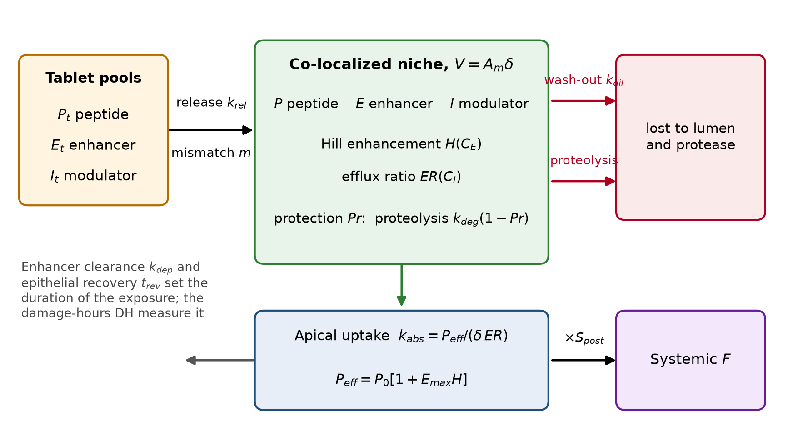
Fig. 1. Structure of the Dual-Lock model. Tablet pools release peptide, enhancer and modulator into a co-localized niche of volume V=A_{m}δ; uptake, proteolysis and wash-out compete for the peptide, and enhancer clearance and epithelial recovery set the duration of the exposure.
3. Mathematical methods
3.1 State variables and balances
Quantities are expressed per dose. The peptide dose is 1 (all peptide amounts are fractions of the dose); the enhancer and modulator doses E₀ and I₀ are in mmol. The peptide pools are the tablet pool P_{t}, the amount in the niche P, and the cumulative amounts absorbed (Q_{abs}), degraded (Q_{deg}) and washed out (Q_{dil}). Release from the tablet is first order, with the enhancer and modulator released at the same rate scaled by the mismatch factor m:
$\frac{dP_{t}}{dt}=−k_{rel}P_{t}, \frac{dE_{t}}{dt}=−m k_{rel}E_{t}, \frac{dI_{t}}{dt}=−m k_{rel}I_{t}$ (1)
The niche is a single compartment of volume V=A_{m}δ (mL, with A_{m} in cm² and δ in cm). With the apical uptake rate constant k_{abs} defined below,
$\frac{dP}{dt}=k_{rel}P_{t}−\left[k_{dil}+k_{deg}(1−Pr)+k_{abs}\right]P$ (2)
$\frac{dE}{dt}=m k_{rel}E_{t}−\left(k_{dil}+k_{dep}\right)E, \frac{dI}{dt}=m k_{rel}I_{t}−k_{dil} I$ (3)
All state variables start at zero except P_{t}=1, E_{t}=E₀ and I_{t}=I₀. The cumulative amounts obey dQ_{abs}/dt=k_{abs}P, dQ_{deg}/dt=k_{deg}(1−Pr)P and dQ_{dil}/dt=k_{dil}P, so that the peptide balance
$P_{t}+P+Q_{abs}+Q_{deg}+Q_{dil}=1$ (4)
holds at all times and serves as a numerical check (maximum error below 10⁻⁹ in all arms).
3.2 Enhancement, efflux, absorption and exposure
The enhancer and modulator concentrations in the niche, in mM, are C_{E}=10³E/V and C_{I}=10³I/V. Enhancement of transcellular permeability follows a Hill relation,
$H=\frac{C_{E}^{ h}}{EC_{50}^{ h}+C_{E}^{ h}}, P_{eff}=P_{0}\left(1+E_{max}H\right)$ (5)
where P₀ is the baseline apparent permeability of the peptide (cm h⁻¹), EC₅₀ the enhancer concentration for half-maximal enhancement, E_{max} the maximal fold-increase and h the Hill coefficient. For a peptide that is an efflux substrate the modulator lowers the efflux ratio from its baseline value ER₀ towards 1; for a non-substrate ER=1:
$ER=1+\frac{ER_{0}−1}{1+C_{I}/IC_{50}}, k_{abs}=\frac{P_{eff}}{δ ER}$ (6)
The absorbed fraction and the bioavailability follow from the post-absorptive survival S_{post} (intra-enterocyte handling and first pass),
$F=S_{post} Q_{abs}(T), Q_{abs}(T)={\text{∫}}_{0}^{T}k_{abs}P dt, T=8 \text{h}$ (7)
Epithelial exposure to the enhancer is summarized by damage-hours, using a steep Hill function of the enhancer concentration with half-damage concentration C_{tox},
$D(t)=\frac{C_{E}^{ 3}}{C_{tox}^{ 3}+C_{E}^{ 3}}, DH={\text{∫}}_{0}^{T}D(t) dt$ (8)
Reversibility requires both a bounded exposure and a bounded duration. With t_{clear} the last time at which C_{E}>0.1 EC₅₀ and t_{rev} the epithelial recovery time after the enhancer has fallen below that threshold,
$\text{reversible}iffDH≤0.5 \text{h} \text{and} t_{clear}+t_{rev}≤4 \text{h}; \text{success}iffF≥0.04 \text{and} \text{reversible}$ (9)
The thresholds of 4% bioavailability and reversibility within hours are those of the published challenge that motivated the work; they are design targets, not regulatory limits. Success is therefore a model-conditional indicator, and its mean over the prior is called P(success).
In this paper "reversible" always means predicted exposure reversibility, a model-defined indicator, and never demonstrated safety. Its two parts correspond to measurable epithelial endpoints: the time t_{clear}+t_{rev} stands for the recovery of transepithelial electrical resistance (TEER) after the enhancer has fallen below its effective concentration, and damage-hours stand for cumulative exposure to concentrations that reduce viability (for example lactate dehydrogenase release). Both are surrogates with known limitations. In isolated rat mucosae, SNAC and sodium caprate lowered TEER and caused minor epithelial damage at the concentrations that increased fluxes (Twarog et al., 2021), so the model's assumption that damage occurs only at about three times the effective concentration is tested explicitly (Section 5.9).
3.3 Calibration
Baseline permeability is the one parameter fixed by data. The median of P₀ is set by bisection so that the median bioavailability of the reference arm R1 (a SNAC-like enhancer tablet with a 1.0 cm niche) equals 1.2%, the mid-point of the 1 to 2% range usually quoted for enhancer tablets (Brayden et al., 2020):
$\text{median}\left\{F_{R1}(P_{0})\right\}=0.012$ (10)
The calibrated median is P₀=0.00975 cm h⁻¹ (about 2.7×10⁻⁶ cm s⁻¹). Because the reference arm is fitted, its bioavailability is not a validation; only the contrasts between arms, which share all other priors, carry information.
3.4 Numerical method and verification
Equations (1) to (3) and the cumulative terms are integrated with the explicit Euler method at Δt=0.01 h over 8 h, vectorized over draws. Halving the time step four times changed the median bioavailability by less than 2% (Section 5.3 and Supplementary Fig. S1), and extending the horizon to 24 h changed it by less than the stated tolerance (Section 5.3). Verification consists of the peptide balance of Eq. (4), module-logic tests (the efflux module cannot lower F and has no effect on non-substrates; the enhancer raises F over peptide alone), determinism for a fixed seed, and the tests of the extension listed in Supplementary Table S6. An early prototype contained a units error in the concentration (a factor of 10³) that made the enhancer and modulator appear inert; it was found by the module-logic tests, and all results here use the corrected code. These tests verify the software, not the biology.
3.5 Alternative structural models
The lumped niche assumes instantaneous mixing. Two alternatives test that assumption. In the stagnant-layer model a serial diffusion resistance is added between the mixed niche and the epithelial membrane, replacing P_{eff} in Eq. (6) by
$P_{eff,s}={\left(\frac{1}{P_{eff}}+\frac{h_{s}}{D_{m}}\right)}^{−1}$ (11)
with a layer thickness h_{s} and a peptide diffusivity D_{m} in the layer. In the spatial model the niche is resolved along the coordinate x from the matrix and lumen side (x=0) to the epithelial surface (x=δ). The peptide concentration c_{P}(x,t) (fraction of dose per mL) obeys
$\frac{∂c_{P}}{∂t}=D_{P}\frac{∂^{2}c_{P}}{∂x^{2}}−k_{deg}(1−Pr) c_{P}$ (12)
with a wash-out flux at x=0 through the mass-transfer coefficient h₀=k_{dil}δ and the release flux k_{rel}P_{t}/A_{m} entering there, and an absorbing boundary at x=δ with the same permeability as the lumped model:
$D_{P}{\left.\frac{∂c_{P}}{∂x}\right|}_{0}=h_{0} c_{P}(0,t)−\frac{k_{rel}P_{t}}{A_{m}}, −D_{P}{\left.\frac{∂c_{P}}{∂x}\right|}_{δ}=\frac{P_{eff}}{ER} c_{P}(δ,t)$ (13)
The enhancer and modulator obey the same equation with their own diffusivities, with the clearance k_{dep} acting on the enhancer only; P_{eff} and ER are evaluated from the enhancer and modulator concentrations in the epithelial cell. The scheme is a backward-Euler finite-volume discretization (24 cells, Δt=0.02 h), unconditionally stable and exactly conservative, with 1 to 10⁶ times the molecular diffusivity (an effective-dispersion multiplier that stands for luminal mixing). In the limit of strong mixing it reduces to the lumped model (tested; Section 5.3), and mesh and time-step refinement changed the median bioavailability by less than 3%. For each structural variant the baseline permeability is recalibrated so that R1 again has a median of 1.2%, because the calibration anchor must hold in every structure.
Uptake-constrained model. The compartment model lets the uptake rate constant P_{eff}/(δ ER) grow without bound as the niche is thinned, which is the origin of the large matrix-only gain discussed in Section 5.8. Two physical limits are therefore added. The stagnant layer of Eq. (11) caps the permeability that the epithelium can express. The dissolved peptide in the niche cannot exceed its solubility S (mg mL⁻¹); with the dose D (mg) and the niche volume V,
$P≤P_{max}=\frac{S V}{D}, \frac{dP_{t}}{dt}=−k_{rel}P_{t}{\left(1−\frac{P}{P_{max}}\right)}_{+}$ (14)
so that the peptide released into a small niche can only dissolve up to its solubility and the remainder stays in the tablet pool (the balance of Eq. (4) is unchanged). The dose and the solubility are grade-D priors (Table 2). Both limits are monotone: they can only lower the bioavailability of a given draw (tested), and the baseline permeability is recalibrated for every variant so that R1 keeps a median of 1.2%. Peptide-enhancer complexation is not modelled; measured affinities for exenatide with SNAC and sodium caprate are low (dissociation constants of about 10 to 100 μM) (Twarog et al., 2022).
4. Monte Carlo methods
4.1 Priors, evidence grades and correlations
Each uncertain input has a prior and an evidence grade: A, a directly applicable measurement; B, a measurement for a close analogue; C, an order-of-magnitude literature range; D, an author assumption without direct source. No input reaches grade A. Table 2 lists the common priors (log-normal unless stated, with the median and the standard deviation of the natural logarithm, σ_{ln} ). The probability that the peptide is an efflux substrate is a scenario axis, not a prior, and is set to 0.5 in the base case.
Symbol | Meaning | Unit | Grade | Prior
P₀ | baseline apparent permeability | cm h⁻¹ | C | 0.00975 (calibrated), σ_{ln} 0.60
k_{deg} | luminal proteolysis rate without protection | h⁻¹ | D | 2.0, 0.50
S_{post} | survival after apical entry | - | D | beta, mean 0.55, sd 0.15
ER₀ | efflux ratio if the peptide is a substrate | - | C | 2.5, 0.50
A_{m} | mucosal contact area of the niche | cm² | D | 30, 0.30
EC₅₀ | enhancer concentration for half-maximal effect | mM | C | 25, 0.50
E_{max} | maximal fold-increase of permeability | - | D | 80, 0.50
h | Hill coefficient of the enhancer effect | - | D | 2.0, 0.25
C_{tox} | enhancer concentration for half-maximal damage | mM | D | 80, 0.40
t_{rev} | epithelial recovery time | h | D | 1.0, 0.50
IC₅₀ | efflux-modulator potency | mM | C | 0.5, 0.80
D | peptide dose (uptake-constrained model) | mg | D | 100, 0.35
S | peptide solubility (uptake-constrained model) | mg mL⁻¹ | D | 20, 0.80
h_{s} | stagnant-layer thickness | cm | C | 0.015, 0.70 (20 to 830 μm)
D_{m} | peptide diffusivity in the layer | cm² s⁻¹ | C | 10⁻⁶, 0.50
Table 2. Common priors (log-normal: median, σ_{ln} ) with evidence grade. Bases: P₀ calibrated to the 1 to 2% enhancer-tablet baseline (Brayden et al., 2020); ER₀ from Caco-2 efflux ratios; EC₅₀ in the millimolar range reported for SNAC and sodium caprate (Maher et al., 2016; Twarog et al., 2019); IC₅₀ spans piperine at 15 to 74 μM in Caco-2 (Bhardwaj et al., 2002) and sub-millimolar TPGS (Collnot et al., 2006).
Formulation-controlled inputs are log-normal around arm-specific medians (dispersion σ_{ln} 0.30 for δ, k_{dil} and k_{dep}, 0.20 for k_{rel}, and the arm's mismatch value for m) and beta-distributed for Pr (sd 0.10). Table 3 lists the arms. All arm settings of the matrix are design hypotheses of grade D. The Dual-Lock enhancer has the same EC₅₀, E_{max} and toxicity priors as the reference enhancer, so that no benefit can arise from assumed potency.
Arm | PE | Modulator | δ | k_{dil} | m | Pr | k_{dep} | k_{rel}
R0 peptide alone | 0 | 0 | 1 | 1.5 | 0.6 | 0 | 0.5 | 2
R1 reference PE (SNAC-like) | 1 | 0 | 1 | 1.5 | 0.5 | 0.5 | 0.5 | 2
R2 R1 + efflux module | 1 | 0.033 | 1 | 1.5 | 0.5 | 0.5 | 0.5 | 2
P1 Dual-Lock | 0.5 | 0.033 | 0.3 | 0.8 | 0.15 | 0.7 | 3 | 1.2
P2 P1 without modulator | 0.5 | 0 | 0.3 | 0.8 | 0.15 | 0.7 | 3 | 1.2
P3 P1 without co-localization | 0.5 | 0.033 | 1 | 1.5 | 0.5 | 0.7 | 3 | 2
P4 P1 with reference protection | 0.5 | 0.033 | 0.3 | 0.8 | 0.15 | 0.5 | 3 | 1.2
P5 P1 without self-limiting PE | 0.5 | 0.033 | 0.3 | 0.8 | 0.15 | 0.7 | 0.5 | 1.2
Table 3. Arm definitions (medians of formulation-controlled inputs; all grade D). PE and modulator doses in mmol; δ in cm; k_{dil}, k_{dep}, k_{rel} in h⁻¹; m is the log-scale dispersion of the release mismatch; Pr the mean protection factor.
In the base case the inputs are independent. Biological and pharmacological parameters are in fact coupled, so correlated priors are added through a Gaussian copula with correlation matrix R on the normal scores: U=Φ(Z), Z∼N(0,R), followed by the inverse marginal distributions (Iman and Conover, 1982). The assumed (grade D) correlations are ρ(EC₅₀,C_{tox})=+0.6 (potent enhancers also damage the epithelium at lower concentration), ρ(EC₅₀,E_{max})=−0.3 and ρ(C_{tox},t_{rev})=−0.4 (more damaging agents recover more slowly). The central coupling is varied from 0 to 0.9 as a sensitivity analysis.
4.2 Sampling, paired design and convergence
Each arm is run with 20,000 draws and a fixed seed. For contrasts between arms all arms use the same matrix of uniform variates, that is, common random numbers, so that biological parameters are identical across arms within a draw and paired differences remove the Monte Carlo noise of the biology. The sampler was re-implemented to map uniform variates to the priors; it reproduced the success probability of the original independent sampler within sampling error (Section 5.1). Convergence was assessed from running estimates up to 10⁵ draws, batch means, 20 independent replicate runs, and a time-step and horizon study.
4.3 Global sensitivity and uncertainty decomposition
Global uncertainty and sensitivity analysis follows established practice in systems biology (Marino et al., 2008). Variance-based sensitivity indices were estimated for log ₁₀F, the success indicator and log ₁₀DH with the Saltelli design (a scrambled Sobol sequence, N=2¹³ base samples and N(d+2+g) model evaluations for d=18 inputs and g=4 groups). The first-order index is S_{i}=V[E(Y|X_{i})]/V(Y) and the total-order index S_{Ti}=E[V(Y|X_{∼i})]/V(Y), estimated with the Saltelli and Jansen estimators (Saltelli et al., 2010; Jansen, 1999; Sobol′, 2001); intervals are 95% bootstrap intervals (200 resamples). Group indices combine the inputs into peptide and epithelium (P₀, k_{deg}, S_{post}, ER₀, substrate status, A_{m}), enhancer pharmacology (EC₅₀, E_{max}, h, C_{tox}, t_{rev}), the modulator (IC₅₀) and the formulation architecture (δ, k_{dil}, m, Pr, k_{dep}, k_{rel}). The estimator was verified on the Ishigami function (Supplementary Table S6).
4.4 Ablations, negative controls, benefit-risk and falsification analyses
Ablations remove or add one component at a time (removal from P1; addition to R1), with the paired difference in P(success) as the effect measure. Negative controls are the matrix without enhancer or modulator (M0), the reference enhancer at half dose, and the architecture at full dose. The benefit-risk analysis sweeps the enhancer dose from 0.05 to 3 mmol for the reference, Dual-Lock, and the two ablations that matter for reversibility, and plots P(F≥4%) against the probability that the exposure is not reversible. The falsification map evaluates P(success) on a grid of niche thickness and enhancer dose (and of niche thickness and wash-out), with a predefined benefit region B: median F≥4% and P(reversible) ≥0.80 for some dose.
4.5 Calibration-independent checks
Because the reference arm is fitted, three checks do not rely on the calibration. First, an observation-conditioned analysis (approximate Bayesian computation by rejection (Beaumont et al., 2002)) keeps only the draws in which R1 falls in a published range (0.4 to 2.0%, or the 0.4 to 1.0% of oral semaglutide) and reports the Dual-Lock outcome among them. Second, the spread, the upper tail and the qualitative dependences of the reference arm are compared with published human observations (Overgaard et al., 2021; Granhall et al., 2019; Brayden et al., 2020; Pechenov et al., 2021; Buckley et al., 2018). Third, the structural variants of Section 3.5 are recalibrated and compared. These checks can reveal inconsistency; they cannot validate the Dual-Lock arm, which no data address.
4.6 Software and reproducibility
The model (oral_peptide_mc.py, unchanged from the first version apart from tie-corrected rank correlation), the extension (dualock_lib.py, run_extended.py, make_figures.py), the automated tests, all numerical results (JSON), the parameter provenance table, and the figure scripts are in a versioned repository archived with a DOI (Data availability). All numbers in the text are generated from the result files.
4.7 Analyses added in the revision
Uptake constraints and the matrix-only control. The reference arm, the matrix-only control (P1 architecture without enhancer or modulator), peptide alone, Dual-Lock and its main ablations were run in five variants: the original lumped model; the stagnant layer; the solubility limit; both limits (the uptake-constrained model); and the uptake-constrained model in which damage occurs at the efficacious concentration (C_{tox} set to the median EC₅₀). Each variant was recalibrated to the same 1.2% anchor. Within each variant the Dual-Lock outcome was also evaluated among the draws in which R1 lies in the published ranges, among the draws in which no arm exceeds 10% (a bounding analysis that treats larger values as non-credible), and under both restrictions.
Reversibility endpoints. The success indicator was recomputed on a grid of damage-hours limits (0.5 to 0.001 h) and recovery limits (2 to 6 h), and with the median C_{tox} reduced to 30%, 10% and 3% of its base value (potency-to-toxicity ratio from 3.2 down to 0.1).
Optimized design out of sample. The release rate (1.2 to 4 h⁻¹), enhancer dose (0.35 to 1.0 mmol) and wash-out (0.4 to 1.5 h⁻¹) of the nominal design were varied on a grid of 72 combinations; the combination with the highest P(success) on 8,000 training draws defines the optimized design, which, together with the nominal design and the reference, was evaluated on 20,000 independent test draws (new seed). The difference between the training and the test estimate is the optimism of the optimization.
5. Results
5.1 Reference comparison and sampler equivalence
With the reference arm calibrated to a median of 1.2%, the Dual-Lock arm P1 has a median bioavailability of 5.0% (5th to 95th percentile 0.6% to 28.5%) at half the enhancer dose, and 45.0% of draws satisfy both the 4% target and the reversibility rule, against 15.0% for the reference (Table 4, Fig. 2). The enhancer-free peptide has a median of 0.1%. The independent re-implementation of the sampler used for all paired analyses reproduced the original success probabilities within sampling error for four test arms (|z| ≤ 1.2).
Arm | Median F | 5th to 95th percentile | P(F≥4%) | P(reversible) | P(success) ± 95% MC error
R0 peptide alone | 0.09% | 0.0% to 0.4% | 0% | 100% | 0% ± 0.0
R1 reference PE | 1.19% | 0.1% to 11.0% | 21% | 84% | 15% ± 0.5
R2 R1 + efflux module | 1.38% | 0.1% to 12.0% | 23% | 84% | 17% ± 0.5
P1 Dual-Lock | 5.0% | 0.6% to 28.5% | 56% | 86% | 45% ± 0.7
P2 no efflux module | 3.9% | 0.4% to 25.9% | 49% | 86% | 39% ± 0.7
P3 no co-localization | 0.35% | 0.1% to 3.1% | 3% | 99% | 3% ± 0.2
P4 reference protection | 4.2% | 0.5% to 25.9% | 51% | 86% | 41% ± 0.7
P5 no self-limiting PE | 13.2% | 1.4% to 43.0% | 82% | 24% | 14% ± 0.5
M0 matrix only (negative control) | 0.77% | 0.1% to 3.3% | 3% | 100% | 3% ± 0.2
Table 4. Bioavailability and success by arm (paired draws, n=20,000 each). Success: F≥4% and reversible. Probabilities are conditional on the priors and are not empirical probabilities.
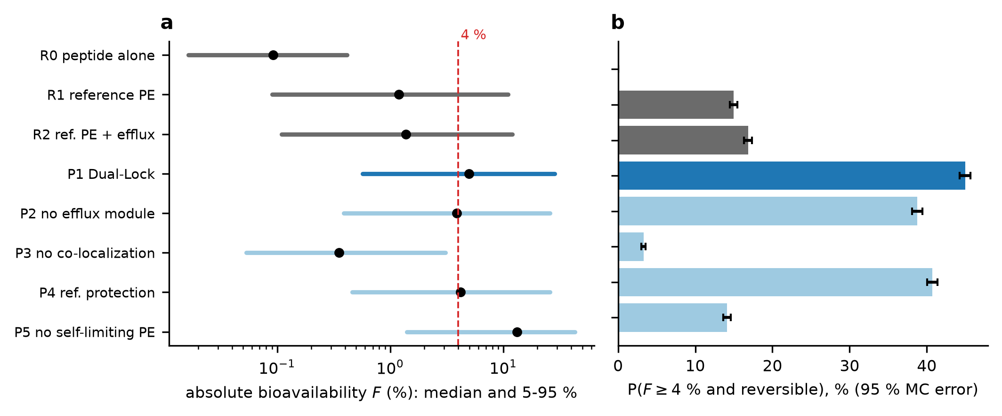
Fig. 2. (a) Median and 5th to 95th percentile of absolute bioavailability by arm (log scale; dashed line, 4% target). (b) Probability of success with 95% Monte Carlo error. The reference arm is calibrated to a median of 1.2%.
5.2 Paired contrasts, ablations and negative controls
Because all arms share the same draws, differences can be read draw by draw. P1 gave a higher bioavailability than R1 in 99.97% of draws and a lower damage-hours value in 79.9%; it succeeded where R1 failed in 31.0% of draws and failed where R1 succeeded in 1.0% (median bioavailability ratio 4.0, median damage-hours ratio 0.61). The paired success difference was +30.0 pp (95% CI +29.3 to +30.7).
Removing one component from P1 (Fig. 3, left) shows where the benefit arises. Reverting the niche thickness to the reference value costs −41.5 pp (95% CI −42.2 to −40.8) of success, reverting enhancer clearance (P5) −30.8 pp (95% CI −31.7 to −30.0), reverting the wash-out rate −9.3 pp (95% CI −9.8 to −8.8), removing the modulator (P2) −6.2 pp (95% CI −6.5 to −5.9), and reverting protection (P4) −4.3 pp (95% CI −4.5 to −4.0). Reverting the release mismatch changes success by only −1.9 pp (95% CI −2.3 to −1.6). Adding single components to R1 (right) reproduces the picture: the thin niche alone adds +23.1 pp (95% CI +22.3 to +23.9), but at the price of a lower probability of reversibility (50% against 84% for R1); the whole confinement bundle without a self-limiting enhancer gives a median bioavailability of 15.3% but only 8% reversible draws, so success changes by −10.2 pp (95% CI −10.8 to −9.6), that is, it falls.
Two results differ from the original design intuition. First, the release rate assumed for the matrix (1.2 h⁻¹, slower than the reference 2.0 h⁻¹) lowers success: reverting it raises P(success) by 18.0 points, so the model favors fast, synchronous release into the thin niche, not slow release. Second, the matrix-only negative control (P1 architecture, no enhancer and no modulator) has a median bioavailability of 0.77% against 0.09% for peptide alone, a gain of 8-fold from confinement alone. Published work found that absorption of semaglutide requires co-formulation with SNAC (Buckley et al., 2018), so this gain is a consequence of the lumped structure (a smaller volume per contact area raises the peptide uptake rate P_{eff}/δ and lowers dilution) and is not supported by data. It is flagged as a model assumption that the first experiment (Section 8) must test.
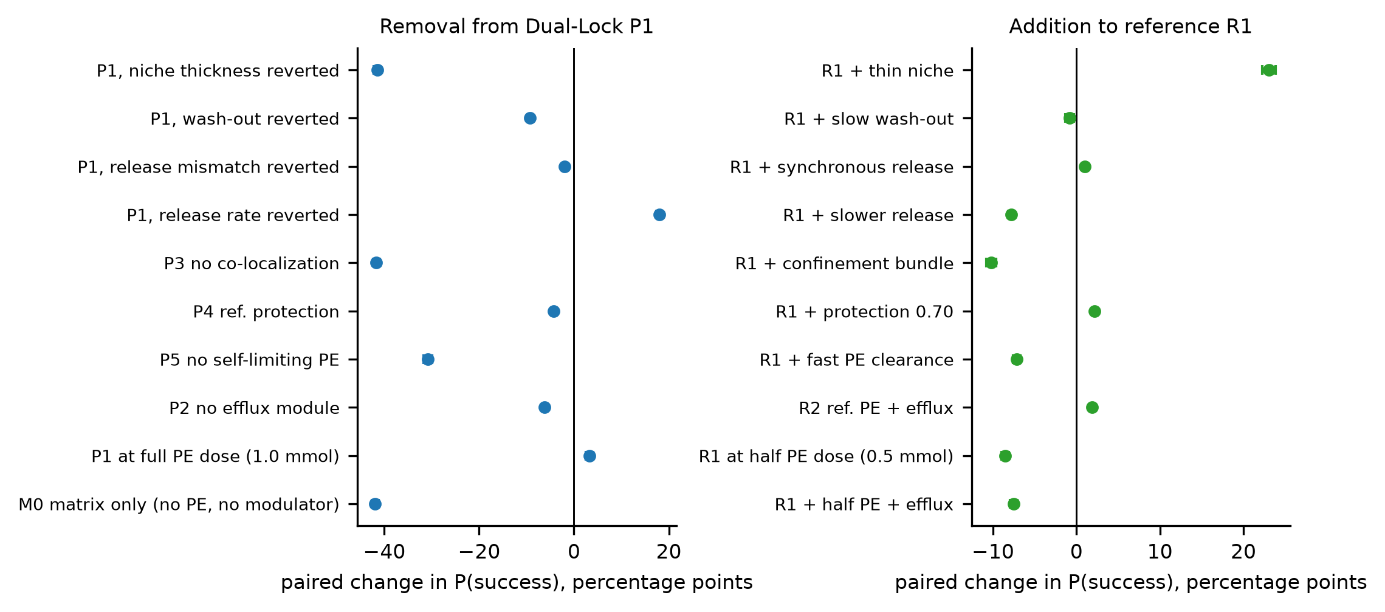
Fig. 3. Paired changes in P(success) (percentage points, 95% CI) when one component is removed from Dual-Lock P1 (left) or added to the reference R1 (right). All arms use the same random draws.
Modification | Median F | P(reversible) | P(success) | Δ (95% CI) | vs
P1 with reference niche thickness | 0.45% | 98% | 3% | −41.5 (−42.2 to −40.8) | P1
P1 with reference wash-out | 3.1% | 90% | 36% | −9.3 (−9.8 to −8.8) | P1
P1 with reference release mismatch | 4.8% | 84% | 43% | −1.9 (−2.3 to −1.6) | P1
P1 with reference release rate (2.0 h⁻¹) | 7.4% | 95% | 63% | +18.0 (+17.4 to +18.5) | P1
P1 with reference protection (P4) | 4.2% | 86% | 41% | −4.3 (−4.5 to −4.0) | P1
P1 without self-limiting enhancer (P5) | 13.2% | 24% | 14% | −30.8 (−31.7 to −30.0) | P1
P1 without modulator (P2) | 3.9% | 86% | 39% | −6.2 (−6.5 to −5.9) | P1
P1 without co-localization (P3) | 0.35% | 99% | 3% | −41.7 (−42.4 to −40.9) | P1
P1 at full enhancer dose (1.0 mmol) | 10.7% | 67% | 48% | +3.2 (+2.5 to +4.0) | P1
M0 matrix only, no enhancer or modulator | 0.77% | 100% | 3% | −41.9 (−42.6 to −41.2) | P1
R1 with thin niche (0.30 cm) | 12.1% | 50% | 38% | +23.1 (+22.3 to +23.9) | R1
R1 with slow wash-out (0.8 h⁻¹) | 2.2% | 59% | 14% | −0.9 (−1.4 to −0.3) | R1
R1 with slower release (1.2 h⁻¹) | 0.79% | 72% | 7% | −7.8 (−8.2 to −7.4) | R1
R1 with protection 0.70 | 1.37% | 84% | 17% | +2.1 (+1.9 to +2.3) | R1
R1 with fast enhancer clearance (3 h⁻¹) | 0.53% | 97% | 8% | −7.1 (−7.6 to −6.7) | R1
R1 with confinement bundle | 15.3% | 8% | 5% | −10.2 (−10.8 to −9.6) | R1
R1 with efflux module (R2) | 1.38% | 84% | 17% | +1.9 (+1.7 to +2.1) | R1
R1 at half enhancer dose (0.5 mmol) | 0.47% | 93% | 6% | −8.5 (−9.0 to −8.1) | R1
Table 5. Ablations and negative controls on shared draws. Δ is the paired change in P(success) in percentage points (95% CI) relative to the arm named in the last column.
5.3 Numerical and Monte Carlo convergence
Twenty independent replicate runs of 20,000 draws gave a P(success) for P1 of 45.1% (sd 0.33 percentage points, range 44.4 to 45.8) and a median bioavailability of 4.99% (sd 0.05 points); for R1 the values were 14.9% (sd 0.26 points). Running estimates were stable from about 10⁴ draws and the batch-means standard error at 10⁵ draws was 0.13 points (Fig. 5). Reducing the time step from 0.04 h to 0.0025 h changed the median bioavailability of P1 by 3.6%, and from 0.01 h (the step used) to 0.0025 h by 0.5%; success changed from 44.1% to 43.9%. Extending the horizon from 8 h to 24 h changed the median by 0.1% (Supplementary Fig. S1).
5.4 Global sensitivity and uncertainty decomposition
The variance of log ₁₀F for P1 is almost additive (sum of first-order indices 0.95). The largest total-order indices are the niche thickness δ (0.24), the enhancer EC₅₀ (0.19), the baseline permeability P₀ (0.18), the contact area A_{m} (0.08), the Hill coefficient (0.08). Grouped by origin, the total-order indices are 0.39 for peptide and epithelium, 0.32 for enhancer pharmacology, 0.32 for formulation architecture and 0.01 for the efflux modulator (Fig. 4). The uncertainty of the predicted bioavailability is thus shared about equally among peptide biology, enhancer pharmacology and the architecture, and the modulator potency contributes almost none, although removing the modulator costs −6.2 pp (95% CI −6.5 to −5.9) of success on average (Section 5.2): the modulator shifts the mean for substrate peptides without adding variance of its own (the first-order index of the substrate indicator is 0.02).
The success indicator is strongly interacting (sum of first-order indices 0.50). Its largest total-order indices are the enhancer EC₅₀ (0.44), the niche thickness δ (0.44), the baseline permeability P₀ (0.33), the contact area A_{m} (0.30), the recovery time t_{rev} (0.25), the enhancer clearance k_{dep} (0.25); group totals are 0.55 (peptide and epithelium), 0.68 (enhancer pharmacology), 0.56 (architecture) and 0.04 (modulator). The design lever with the largest effect on the mean (the niche, Section 5.2) therefore does not dominate the uncertainty: delivering the architecture is necessary, but the outcome still depends on the peptide and the enhancer.
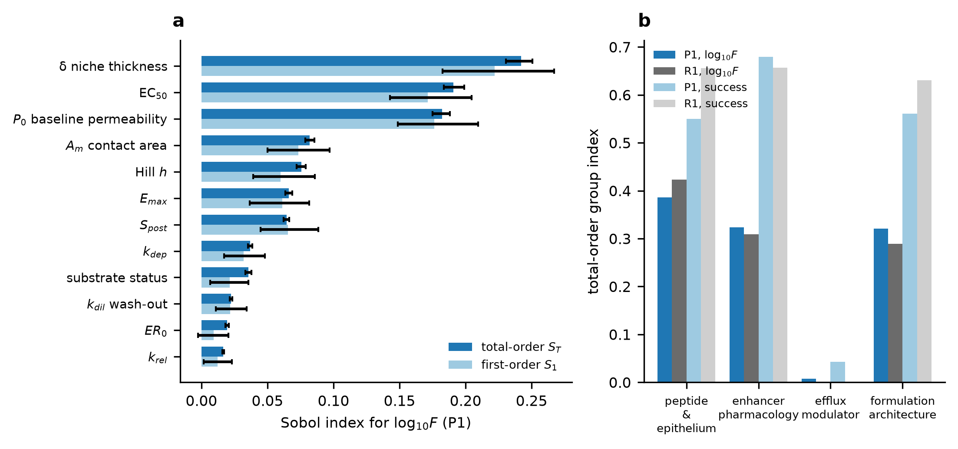
Fig. 4. Global variance-based sensitivity of Dual-Lock P1 (N=2¹³ base samples, Saltelli and Jansen estimators, 95% bootstrap intervals). (a) First-order and total-order indices for log ₁₀F (twelve largest). (b) Total-order indices of the four input groups for log ₁₀F and for the success indicator, P1 and R1.
5.5 Correlated priors
With the assumed correlation set, P(success) for P1 changed from 45.1% to 44.9% and for R1 from 14.7% to 15.3%. Varying the coupling between enhancer potency and toxicity from 0 to 0.9 changed P(success) by at most 0.01 percentage points, because the reversibility rule is governed by the recovery time and the enhancer clearance, not by damage-hours, in R1 and P1 (median damage-hours 0.002 h and 0.002 h against the 0.5 h limit). The adverse bundle of correlations gave 44.9% (P1) and 15.5% (R1), and the favorable bundle 45.3% and 14.1% (Fig. 5). The conclusion that P1 exceeds R1 does not depend on the assumed couplings.
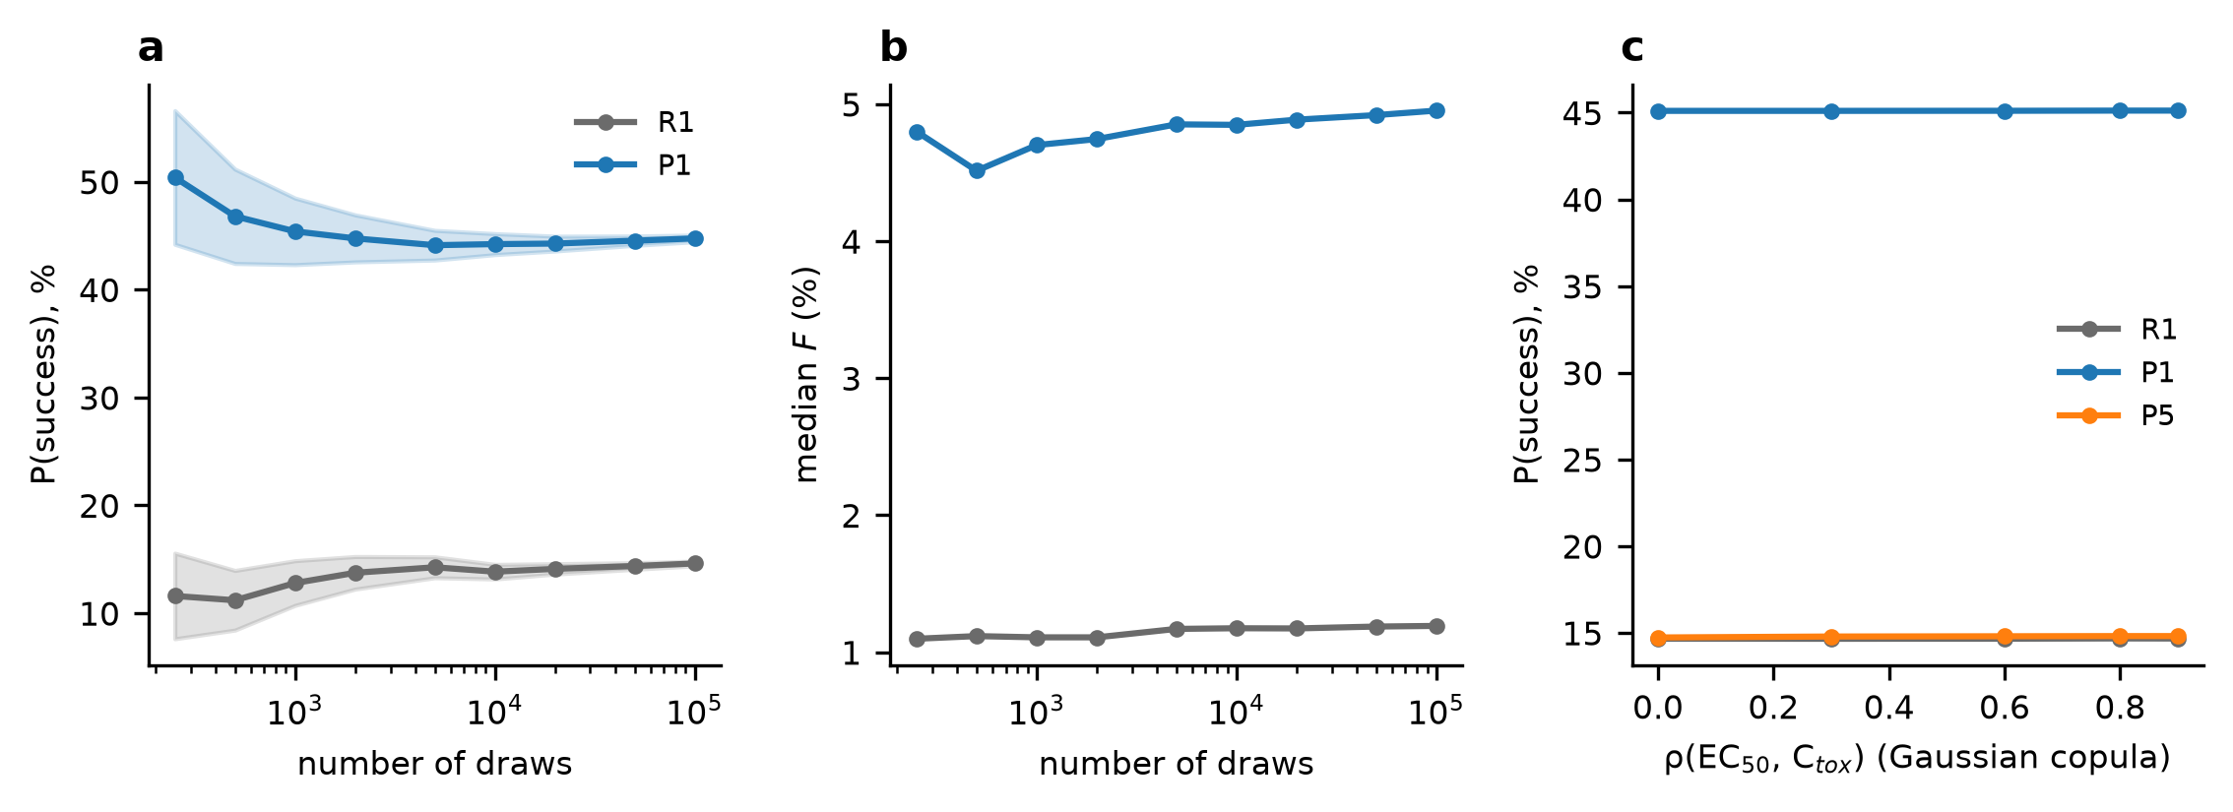
Fig. 5. Monte Carlo convergence and prior coupling. (a) Running P(success) of R1 and P1 with 95% error bands. (b) Running median bioavailability. (c) P(success) against the assumed rank coupling of enhancer potency and toxicity, ρ(EC₅₀,C_{tox}).
5.6 Benefit-risk (Pareto) analysis
A genuine benefit-risk improvement requires more than a higher bioavailability, so the enhancer dose was swept for the reference, Dual-Lock and two ablations and P(F≥4%) was plotted against the probability that the exposure is not reversible (Fig. 6). At 0.5 mmol P1 reaches P(F≥4%) of 56% with 14% of draws non-reversible; the reference needs 3 mmol to reach 50% and then 45% of its draws are non-reversible. At a similar risk (16% for R1 at 1.0 mmol, 14% for P1 at 0.5 mmol) the reference reaches 21% against 56% for P1. The curve of P1 lies above that of R1 at every dose tested, so Dual-Lock dominates the reference in this plane. P(success) peaks at 0.75 mmol for P1 (50%; 45% at the 0.5 mmol design dose), saturates at 22% for the reference (maximum at 2 mmol), and peaks at only 24% for P5 (0.2 mmol), which shows directly that a persistent enhancer raises bioavailability at the cost of reversibility. Removing co-localization (P3) leaves the exposure low but needs 3 mmol to reach 32%.
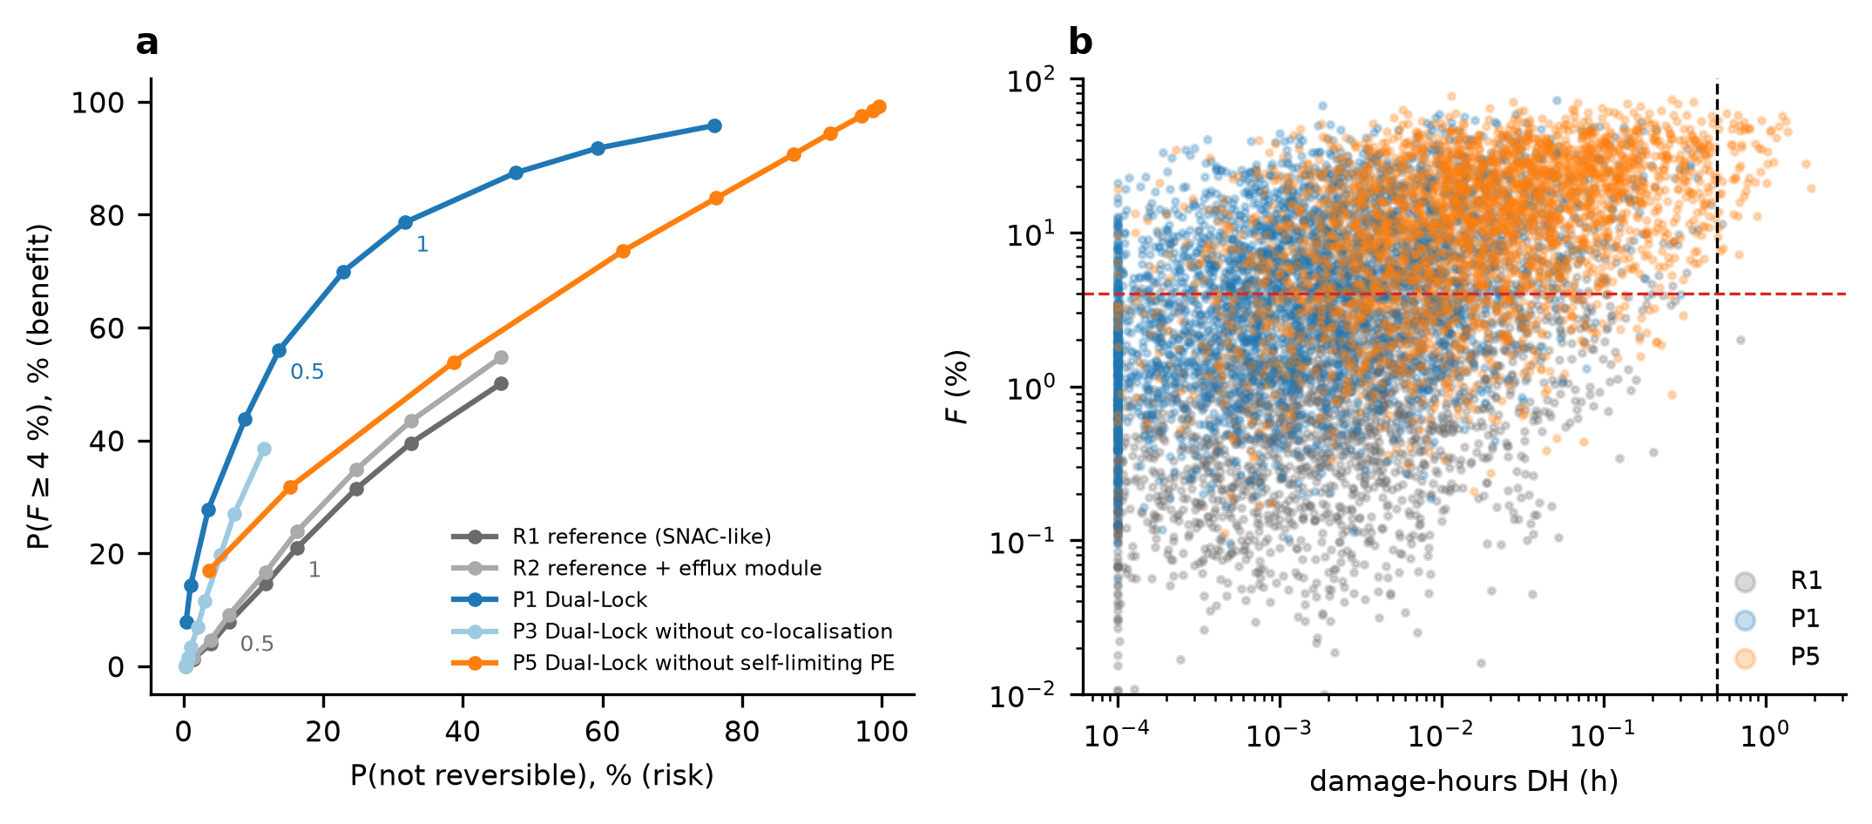
Fig. 6. Benefit-risk analysis. (a) P(F≥4%) against the probability that the exposure is not reversible for enhancer doses from 0.05 to 3 mmol (annotated: 0.5 and 1.0 mmol). (b) Individual draws: bioavailability against damage-hours (dashed lines: 4% and 0.5 h).
5.7 Falsification regions
The predefined benefit region B is the set of niche thickness and dose combinations for which the median bioavailability is at least 4% and at least 80% of draws are reversible (Fig. 7). Region B is non-empty for niche thicknesses up to 0.45 cm. Along δ, the best P(success) over the dose range falls from 63% at 0.15 cm through 49% at 0.30 cm and 34% at 0.60 cm to 20% at 1.0 cm, with a best dose of 0.75 mmol at 0.30 cm; the largest thickness at which some dose still achieves P(success) ≥ 30% is 0.6 cm. Dual-Lock therefore fails the predefined benefit target if the matrix cannot confine the effective niche to 0.45 cm or less (a 2.2-fold reduction of the reference volume per contact area), and it fails even the weaker 30% target above 0.6 cm (1.7-fold). The second map shows that slowing the wash-out helps less than thinning the niche, and that in very thin niches a slow wash-out lowers success through persistent exposure (17% of draws at 0.05 cm with a wash-out of 0.2 h⁻¹ against 54% at 4 h⁻¹).
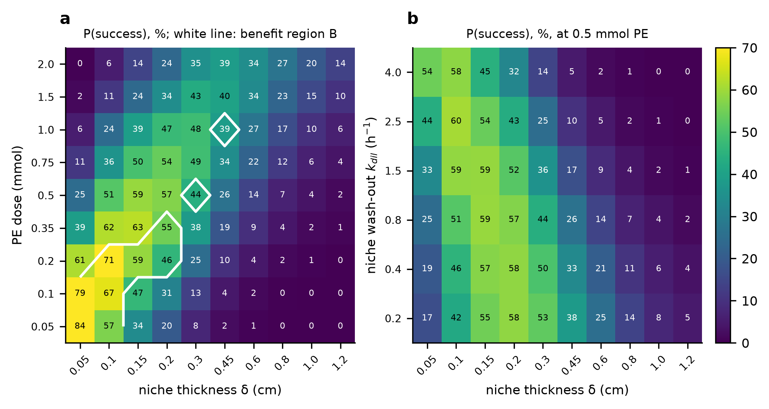
Fig. 7. Falsification maps for Dual-Lock P1. (a) P(success), %, against niche thickness and enhancer dose; the white line encloses the benefit region B (median F≥4% and P(reversible) ≥0.80). (b) P(success) against niche thickness and wash-out rate at 0.5 mmol.
δ (cm) | Best dose (mmol) | Best P(success) | Median F at best dose | P(reversible) at best dose | Region B non-empty
0.05 | 0.05 | 84% | 14.4% | 94% | yes
0.1 | 0.2 | 71% | 15.4% | 83% | yes
0.15 | 0.35 | 63% | 13.1% | 79% | yes
0.2 | 0.5 | 57% | 11.2% | 77% | yes
0.3 | 0.75 | 49% | 7.9% | 77% | yes
0.45 | 1.5 | 40% | 7.3% | 68% | yes
0.6 | 2 | 34% | 5.6% | 68% | no
0.8 | 2 | 27% | 3.0% | 77% | no
1 | 2 | 20% | 1.8% | 83% | no
1.2 | 2 | 14% | 1.2% | 86% | no
Table 6. Falsification map in numbers: for each niche thickness δ (cm), the dose (mmol) with the highest P(success) and the corresponding median F and P(reversible); the last column states whether benefit region B is non-empty. A best dose at the lower or upper edge of the grid (0.05 or 2 mmol) means that doses beyond it were not tested.
5.8 Uptake constraints and the matrix-only control
The matrix-only control (Section 5.2) raised the median bioavailability 8.3-fold without any enhancer, which could be an artefact of a compartment model in which the uptake rate constant P_{eff}/(δ ER) grows without limit as the niche is thinned. Two physical limits were therefore added (Section 3.5): a stagnant layer in series with the epithelium and a solubility limit on the dissolved peptide, alone and together, each variant recalibrated to the 1.2% anchor. Neither limit removes the gain: the matrix-only gain is 8.2 with the stagnant layer, 8.3 with the solubility limit and 8.2 with both, against 8.3 in the original model (Fig. 8). The solubility limit rarely binds for the assumed dose and solubility (the baseline permeability is unchanged, 0.99 times, and the median of P1 falls only from 4.87% to 4.57%); the stagnant layer lowers the enhanced permeability but requires a baseline permeability 2.7 times the lumped value, and the matrix-only control still reaches 1.74% (peptide alone 0.21%). The gain is therefore not caused by the missing uptake limits.
The decomposition in Table 7 shows where the gain comes from. Thinning the niche alone gives 3.3-fold, the protease shield alone 1.7-fold and the slower wash-out alone 1.3-fold (original model; uptake-constrained: 3.3, 1.7 and 1.3). A matrix without the shield gains 4.2-fold and one without niche thinning 2.5-fold. The gain is thus mostly a concentration effect (the flux across the membrane is proportional to the concentration at the membrane, and the same dose dissolved in a smaller volume is more concentrated), plus the protease shield. The shield is not an external assumption: local buffering that protects against degradation is part of the reported mechanism of SNAC (Buckley et al., 2018), so the matrix-only arm should be read as "matrix with shield", not as an inert carrier. What remains untested is whether a real matrix confines the dose into a smaller, mixed volume at all, which is the content of Gate G1.
Arm (no enhancer, no modulator) | Lumped: median F | Gain | Constrained: median F | Gain
R0 peptide alone | 0.09% | 1.0 | 0.21% | 1.0
R0 + thin niche (δ 0.30) | 0.30% | 3.3 | 0.70% | 3.3
R0 + slow wash-out (0.8) | 0.11% | 1.3 | 0.27% | 1.3
R0 + protection 0.70 | 0.15% | 1.7 | 0.36% | 1.7
R0 + niche + wash-out | 0.37% | 4.2 | 0.88% | 4.1
M0 without protection | 0.37% | 4.2 | 0.88% | 4.1
M0 without niche thinning | 0.23% | 2.5 | 0.53% | 2.5
M0 matrix only (all matrix parameters) | 0.75% | 8.3 | 1.74% | 8.2
Table 7. Decomposition of the matrix-only gain over peptide alone (no enhancer, no modulator): median F and gain, original lumped model and uptake-constrained model (both recalibrated; 20,000 shared draws).
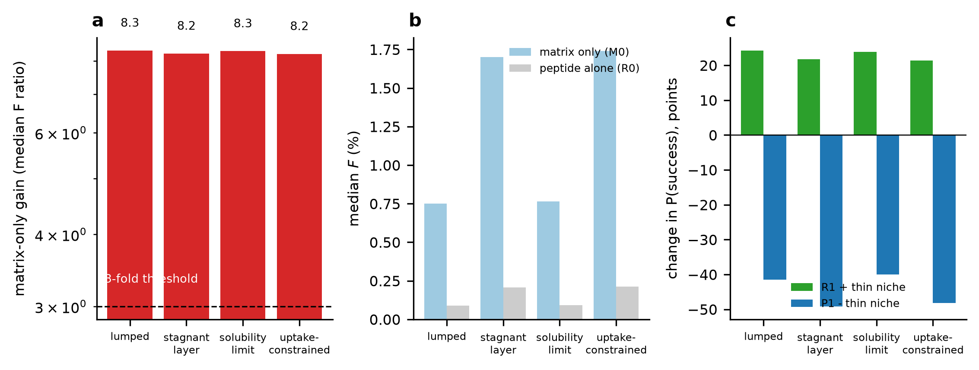
Fig. 8. Mechanism controls under the original and constrained transport formulations. (a) Matrix-only gain (median bioavailability relative to peptide alone; dashed line, 3-fold acceptance threshold of Table 13). (b) Median bioavailability of the matrix-only arm and of peptide alone. (c) Volume-only effects: change in P(success) when the thin niche is added to R1 or removed from P1.
The benefit of confinement itself is robust to the constraints. Adding the thin niche to R1 changes P(success) by +24.2 points in the original model and +21.4 points in the uptake-constrained model, and removing it from P1 by -41.5 and -48.2 points; in both formulations the thin niche is the largest single contributor and a self-limiting enhancer is still required, because adding the niche without it lowers the probability of reversible exposure (to 51%, uptake-constrained).
5.9 Reversibility endpoints
In the base case the damage-hours rule seldom binds (median damage-hours 0.0015 h for P1 and 0.0025 h for R1 against the 0.5 h limit), so reversibility is decided by the assumed recovery time: the probability that t_{clear}+t_{rev}≤ 2, 3, 4 and 6 h is 11%, 51%, 86% and 99% for P1. The predicted exposure reversibility is therefore a statement about the assumed recovery kinetics, and it should be tied to measurable endpoints: t_{rev} to the recovery of transepithelial electrical resistance (TEER) after washout, and C_{tox} to a viability endpoint such as lactate dehydrogenase release. Both are surrogates of epithelial integrity and not safety outcomes. Rat mucosae show a reduced TEER and minor epithelial damage at the concentrations at which SNAC and sodium caprate increase fluxes (Twarog et al., 2021), which argues against a toxicity threshold far above the efficacious concentration.
C_{tox}/EC₅₀ | R1 reference | P1 Dual-Lock | P5 no self-limiting enhancer
3.2 (base) | 15% / 83% / 0.002 | 44% / 86% / 0.001 | 15% / 24% / 0.016
0.96 (damage at efficacy) | 12% / 76% / 0.084 | 40% / 81% / 0.052 | 10% / 18% / 0.447
0.32 | 2% / 27% / 0.804 | 13% / 36% / 0.659 | 1% / 2% / 2.059
0.096 | 0% / 1% / 1.874 | 0% / 1% / 1.840 | 0% / 0% / 3.568
Table 8. Sensitivity of the reversibility endpoint to the ratio of the damage concentration to the effective concentration, C_{tox}/EC₅₀ (medians). Cells: P(success) / P(predicted reversible) / median damage-hours (h).
When damage occurs at the efficacious concentration (C_{tox}/EC₅₀= 0.96), P(success) is 40% for P1 and 12% for R1, so the advantage survives, and the reference and the non-self-limiting arm are hit hardest (P5 10%). When damage occurs below the efficacious concentration (C_{tox}/EC₅₀= 0.32) the median damage-hours of P1 is 0.66 h, 61% of its draws exceed the 0.5 h limit and P(success) falls to 13% (R1 2%); at a ratio of 0.10 no arm succeeds. Tightening the damage-hours limit has a similar effect: with 4 h recovery, P1 P(success) is 44% at 0.5 h, 40% at 0.02 h and 14% at 0.001 h. The Dual-Lock result is thus conditional on a toxicity threshold that is at or above the efficacious concentration, and Gate G2 must measure it.
5.10 Optimized design evaluated out of sample
The nominal design was not optimized: its release rate (1.2 h⁻¹) lowers success (Section 5.2). To separate the original design from an optimized one without presenting an in-sample optimum as performance, the release rate, enhancer dose and wash-out were optimized on 8,000 training draws (72 combinations) and the nominal design, the optimized design and the reference were evaluated on 20,000 independent test draws (Fig. 9, Table 9). The optimization is stable (optimism 0.2 points in the original model and 0.1 in the uptake-constrained model; the effect is too large for 72 candidates to overfit), but the unconstrained optimum lies on the boundary of the grid (release rate 4 h⁻¹, the largest value) and produces a median bioavailability of 22.0% with 80% of draws above 10%, which is outside the credible range of Section 6.2. It is therefore not a design recommendation.
Model | Design (dose, release, wash-out) | P(success) | P(reversible) | Median F | Draws >10%
lumped | nominal (0.5 mmol, 1.2 h⁻¹, 0.8 h⁻¹) | 44.7% (test) | 86% | 4.9% | 29%
 | unconstrained optimum (1 mmol, 4 h⁻¹, 0.4 h⁻¹) | 86.2% train / 86.1% test | 91% | 22.0% | 80%
 | credible optimum (0.5 mmol, 2 h⁻¹, 1.5 h⁻¹) | 53.9% train / 52.5% test | 96% | 4.9% | 29%
 | reference R1 | 15.1% (test) | 84% | 1.19% | 6%
uptake-constrained | nominal (0.5 mmol, 1.2 h⁻¹, 0.8 h⁻¹) | 53.3% (test) | 86% | 5.7% | 26%
 | unconstrained optimum (0.75 mmol, 4 h⁻¹, 0.4 h⁻¹) | 84.5% train / 84.4% test | 95% | 11.5% | 57%
 | credible optimum (0.35 mmol, 2.5 h⁻¹, 0.8 h⁻¹) | 65.4% train / 64.8% test | 97% | 5.9% | 27%
 | reference R1 | 9.1% (test) | 84% | 1.19% | 2%
Table 9. Nominal and optimized designs: P(success) on the training draws (in-sample) and on 20,000 independent test draws, P(predicted reversible), median F and fraction of draws above 10%. Design variables: enhancer dose, release rate k_{rel} and wash-out k_{dil}. The credible optimum maximizes training P(success) subject to k_{rel}≤2.5 h⁻¹ and at most 30% of draws above 10%.
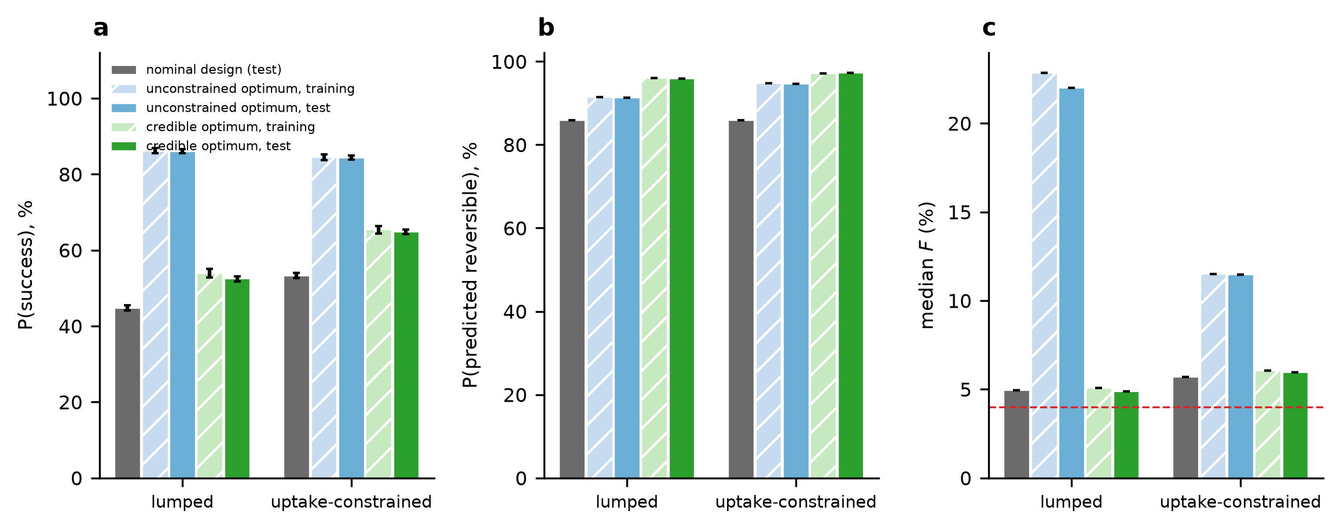
Fig. 9. Nominal design and optimized design in the original and uptake-constrained models: (a) P(success) with 95% Monte Carlo error, (b) probability of predicted reversible exposure, (c) median bioavailability (dashed line, 4%). Hatched bars: optimized design on the training draws (in-sample); solid bars: nominal and optimized design on independent test draws.
Restricting the search to a credible region gives a design with a release rate of 2 h⁻¹ (original model) and 2.5 h⁻¹ (uptake-constrained), whose out-of-sample P(success) is 52% and 65%, against 45% and 53% for the nominal design; the paired gain on the test draws is 7.8 and 11.5 points. These are model-conditional improvements that still rely on the priors; they identify the direction of a better design (faster, synchronous release) without validating its absolute performance.
6. Robustness and falsification
6.1 Structural uncertainty: stagnant layer and spatial transport
The lumped niche assumes instantaneous mixing. With the diffusivity of a 3-kDa peptide in a gel of 10⁻⁶ cm² s⁻¹, the time for diffusion across 0.30 cm is 25 h and across 1.0 cm 278 h, longer than the 8 h horizon, so an unmixed niche would behave very differently. Table 10 and Fig. 10 compare the lumped model with a serial stagnant layer (thickness 20 to 830 μm, median 150 μm (Atuma et al., 2001), diffusivity in mucus (Cu and Saltzman, 2009)) and with the spatial model for effective dispersion multipliers from 3 to 10⁶ times the molecular diffusivity. Each variant is recalibrated so that R1 again has a median of 1.2%.
Structural model | P₀/base | R1 median F | P1 median F | P(success) R1 / P1 | Ablations: P(success)
lumped (base) | 0.96x | 1.20% | 4.8% | 13% / 44% | P3 3%, P5 14%
lumped + stagnant layer | 2.73x | 1.20% | 6.1% | 10% / 55% | P3 4%, P5 16%
spatial, dispersion ×3 | n/a | n/a | n/a | n/a | R1 cannot reach 1.2% (maximum 0.0017% at P₀ = 40 cm h⁻¹)
spatial, dispersion ×10 | n/a | n/a | n/a | n/a | R1 cannot reach 1.2% (maximum 0.11% at P₀ = 40 cm h⁻¹)
spatial, dispersion ×30 | n/a | n/a | n/a | n/a | R1 cannot reach 1.2% (maximum 1.1% at P₀ = 40 cm h⁻¹)
spatial, dispersion ×100 | 5.41x | 1.25% | 14.9% | 14% / 74% | P3 7%, P5 20%
spatial, dispersion ×1000 | 1.21x | 1.20% | 5.7% | 13% / 49% | P3 3%, P5 15%
spatial, well-mixed limit (dispersion x10^6) | 0.96x | 1.18% | 4.7% | 13% / 43% | P3 3%, P5 13%
Table 10. Structural uncertainty. Each variant is recalibrated to a median F of 1.2% for R1 (P₀ relative to the lumped value is shown; a value far above 1 is implausible for a hydrophilic peptide). All variants use the same 2,000 draws per arm.
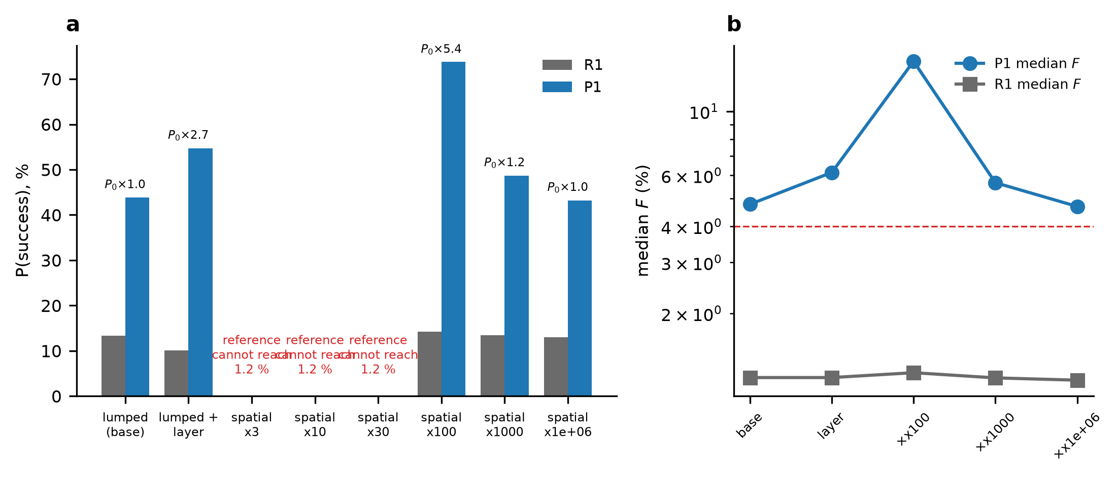
Fig. 10. Structural uncertainty. (a) P(success) of R1 and P1 under the lumped model, the lumped model with a stagnant layer and the spatial diffusion-reaction model at several effective dispersion multipliers; annotations give the recalibrated P₀ relative to the base value. (b) Median bioavailability of both arms (dashed line, 4%).
The structural variants lead to four findings. (i) With a stagnant layer in series and the baseline recalibrated, the median bioavailability of P1 is 6.1% (lumped 4.8%) and P(success) 55% against 10% for R1 (lumped 44% and 13%): the layer caps the enhanced permeability of the reference more than that of the confined arm. The recalibrated baseline permeability is 2.7 times the lumped value, a value that the prior (σ_{ln} =0.6) assigns an upper-tail probability of 4.7%. (ii) In the spatial model the reference arm cannot reach the 1.2% anchor when the effective dispersion is ×3, ×10, ×30 times the molecular diffusivity (maximum median 0.0017%, 0.11% and 1.1%). A conventional tablet in an unmixed 1 cm niche would absorb far less than observed, so the published baseline itself implies substantial mixing, and the lumped assumption is the one the anchor supports. (iii) Where the anchor can be met the Dual-Lock advantage does not disappear. At a dispersion multiplier of 100 the recalibrated P₀ is 5.4 times the lumped value (tail probability 0.2%, so this structure is implausible), P1 reaches a median of 14.9% and P(success) of 74% against 14% for R1; at 1000 (P₀ 1.2 times) the values are 5.7% and 49% against 13%, and in the well-mixed limit they return to the lumped result (43% against 13%). (iv) The lumped model (which equals the well-mixed limit of the spatial model) gives the smallest advantage of all calibratable structures, because transport resistance penalizes the thick-niche reference more than the thin-niche architecture; the lumped result is therefore not optimistic with respect to these alternatives. The high-advantage results of the poorly mixed structures should not be read as predictions, because they depend on an inflated baseline permeability and on a reference arm that is limited by diffusion rather than by permeability. Keeping P₀ at the lumped value instead of recalibrating gives reference bioavailabilities of 0.70% (stagnant layer) and 0.29% (dispersion ×100), far below the anchor, which is a second way of seeing that the data exclude an unmixed niche.
The qualitative ordering is the same in every calibratable structure: P1 above R1, and P3 (no co-localization) and P5 (no self-limiting enhancer) well below P1. The quantitative advantage is structure-dependent. Whether the matrix in vivo provides the mixing assumed here, and how thick its stagnant layer is, are therefore measurable quantities on which the prediction depends (Section 8).
6.2 Observation-conditioned analysis and comparison with published data
Condition on R1 | Accepted draws | P1 median F | P1 5th to 95th percentile | P1 P(F≥4%) | P1 P(success)
none (prior) | 100,000 | 5.0% | 0.6% to 28.9% | 56% | 45%
R1 F in [0.4, 2.0]% | 38,651 | 4.0% | 1.6% to 10.1% | 51% | 43%
R1 F in [0.4, 1.0]% (oral-semaglutide-like) | 21,058 | 2.9% | 1.5% to 6.8% | 27% | 22%
R1 F in [0.8, 1.6]% | 17,437 | 4.7% | 2.4% to 10.2% | 64% | 55%
Table 11. Observation-conditioned analysis (rejection ABC, n=10⁵ paired draws): outcome of Dual-Lock P1 among the draws in which the reference arm R1 falls in the stated published range.
Table 11 shows that the Dual-Lock result depends on how well the reference performs. If R1 lies anywhere in 0.4 to 2.0% (39% of the draws), P1 has a median of 4.0% and P(success) of 43%, close to the unconditioned value. If the reference performs like oral semaglutide, 0.4 to 1.0% (21% of the draws), the P1 median falls to 2.9% and P(success) to 22%, about half the headline value, because the 4% target is then much harder to reach from a lower starting point. Restricting R1 to 0.8 to 1.6% around the anchor gives 4.7% and 55%. The headline probability therefore rests on the assumption that the reference tablet performs at the 1.2% mid-point of the 1 to 2% range; the conditioning shifts the baseline-determining parameters only slightly (medians of P₀ and E_{max} by factors of 0.93 and 0.93 for the 0.4 to 1.0% range) but not the ordering of the arms.
Four comparisons with published data that were not used to calibrate the model give a mixed picture (Fig. 11). (a) Spread. The within-subject variability of oral semaglutide bioavailability is 137%, equivalent to a standard deviation of the natural logarithm of 1.03 (Overgaard et al., 2021); the reference arm has 1.46, because it combines variability with epistemic uncertainty about peptides, so the spread is wider than that of one product, as expected. (b) Upper tail. 6.2% of R1 draws and 29% of P1 draws exceed 10%, 12% of P1 draws exceed 20%, and 44% of P1 draws exceed 6%, whereas the highest bioavailability reported for an enhancer-based oral peptide in the sources used is about 6% in dogs for an engineered peptide (Pechenov et al., 2021) and typical values are about 1% (Brayden et al., 2020). The upper tail of P1 (95th percentile 28%) lies beyond any published value; it is the upper end of the prior, not a prediction. (c) Qualitative dependences. The model predicts that bioavailability falls with a larger niche volume and with faster wash-out (median R1 bioavailability 5.24%, 1.18% and 0.24% for δ of 0.5, 1 and 2 cm; 2.27%, 1.18% and 0.48% for wash-out multiplied by 0.5, 1 and 2), as oral semaglutide bioavailability falls with a larger water volume (Overgaard et al., 2021). (d) Enhancer dose. The model's bioavailability of R1 rises monotonically with the enhancer dose (0.48% at 0.5 mmol, 2.76% at 2 mmol and 6.6% at 8 mmol), whereas exposure to oral semaglutide was highest with 300 mg SNAC among 150 to 600 mg (Granhall et al., 2019). The model has no mechanism for such an optimum (for example a limit on local concentration, viscosity or pH); this structural deficiency matters for any dose-optimization claim. The transience reported by Buckley et al. (2018) is reproduced qualitatively: 83% of the final uptake of R1 occurs within 1 h and 99% within 2 h.
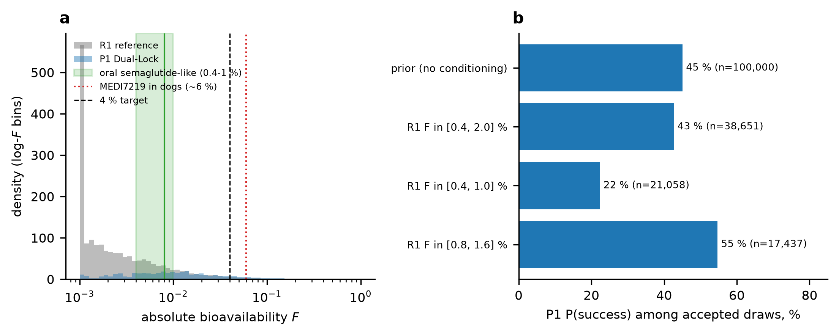
Fig. 11. Calibration-independent checks. (a) Distribution of bioavailability for R1 and P1 (first 3,000 paired draws) with published reference values: oral semaglutide (0.4 to 1.0%, line at 0.8%), an engineered peptide in dogs (about 6%) and the 4% target. (b) P(success) of P1 among the draws accepted under each conditioning rule.
Model | P₀ | Median F | 95th pct. | F>6% | All draws | R1 0.4-2.0% | R1 0.4-1.0% | F≤10% | both
lumped | 1.0x | 4.9% | 28% | 44% | 45% | 42% | 21% | 33% | 41%
uptake-constrained | 2.7x | 5.8% | 22% | 48% | 54% | 56% | 34% | 45% | 55%
constrained + damage at efficacy | 2.7x | 5.8% | 22% | 48% | 50% | 53% | 32% | 43% | 52%
Table 12. Biologically constrained recalibration of Dual-Lock P1: model variant, recalibrated baseline permeability relative to the original, median and 95th percentile of F, fraction of draws above 6%, and P(success) for all draws and after each restriction (R1 in 0.4 to 2.0%; R1 in 0.4 to 1.0%; no arm above 10%; R1 in 0.4 to 2.0% and no arm above 10%).
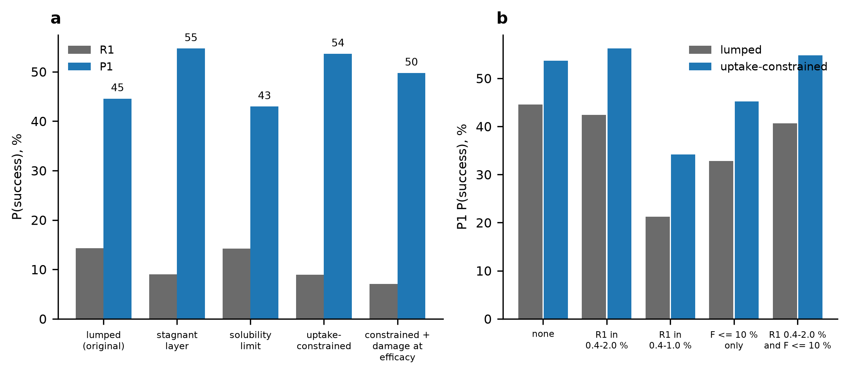
Fig. 12. Biologically constrained recalibration. (a) P(success) of R1 and P1 in the original model, with each physical limit, with both limits, and with damage at the efficacious concentration. (b) P(success) of P1 under the restrictions of Table 12 in the original and in the uptake-constrained model.
A peptide-specific calibration is not possible, because no measurements exist for the peptide that the architecture would carry; the nearest peptide-specific anchor is oral semaglutide (0.8%, with a within-subject variability of 137%) (Overgaard et al., 2021). Table 12 therefore reports how much of the advantage survives progressively stronger constraints. In the uptake-constrained model P1 has a median of 5.8% and a 95th percentile of 22% (original model 4.9% and 28%), and the fraction of draws above 6% is 48% (original 44%): the physical limits shorten the tail but do not remove it. If values above 10% are treated as non-credible and removed (73% of the draws are retained), P(success) is 33% in the original and 45% in the uptake-constrained model; if, in addition, the reference tablet must lie in 0.4 to 2.0%, it is 41% and 55%; if the reference is oral semaglutide-like (0.4 to 1.0%), 21% and 34%; and with damage at the efficacious concentration, 50%. Between roughly one fifth and one half of the draws therefore still meet the target under every constraint, but the advantage over the reference is smaller and the absolute figures are lower than the headline value.
Status of independent validation. The transport structure has not been validated independently. The published measurements found in the sources read do not contain the variables needed (peptide permeability as a function of enhancer concentration and exposure time through a mucus-like layer) in a form that can be compared quantitatively. Three consistency checks that did not set any parameter are available. (i) In isolated rat jejunal and colonic mucosae, 20 mM SNAC was needed to reach the efficacy of 10 mM sodium caprate (Twarog et al., 2021), consistent in order of magnitude with the millimolar-to-tens-of-millimolar EC₅₀ prior (median 25 mM). (ii) Measured adherent mucus thicknesses of 20 to 830 μm (Atuma et al., 2001) bracket the stagnant-layer prior. (iii) The weak binding of exenatide to SNAC and sodium caprate (dissociation constants of about 10 to 100 μM) (Twarog et al., 2022) supports omitting complexation. None of these tests the Dual-Lock transport mechanism. The prespecified test is the mucus-mimetic release experiment of Gate G1 (Section 8), and until it is done the transport structure remains an assumption, which is why the conclusions are stated as conditional.
6.3 Predefined failure conditions
Hypothesis or gate | Falsified if | Reference in this paper
Co-localization (Gate G1) | effective niche thickness δ> 0.6 cm (less than 1.7-fold confinement of the reference 1.0 cm) | best P(success) over doses 0.05 to 2 mmol below 30% (Section 5.7)
Benefit region B | median F<4% or P(reversible) <0.80 at every dose, for δ> 0.45 cm | region B is empty above this thickness (Fig. 7a)
Self-limiting enhancer (Gate G2) | measured enhancer clearance not at least about 3-fold above the reference 0.5 h⁻¹, or recovery time above 2.5 h | without it P(reversible) is 24% with confinement (P5) against 86% (P1)
Matrix-only negative control | matrix without enhancer raises F more than about 3-fold over peptide alone | the model gives 8-fold (M0: 3.3 from the thin niche, 1.7 from the shield); a larger gain in vivo would contradict the requirement for the enhancer (Buckley et al., 2018)
Toxicity threshold (Gate G2) | damage (viability or TEER loss) below the efficacious concentration, C_{tox}/EC₅₀< 1 | P(success) of P1 falls to 13% at a ratio of 0.32 (Table 8)
Efflux module (Gate G3) | efflux ratio below 2 for the peptide, or no reduction by the modulator | the module has no effect for non-substrates (tested)
Mixing and stagnant layer | effective dispersion below about 100 times the molecular diffusivity | the reference baseline of 1.2% cannot be reproduced in the spatial model below this (Table 10)
Reference performance | reference tablet at or below about 1% (semaglutide-like) | P(success) of P1 falls to 22% (Table 11)
Absolute performance (Gate G4) | median F<4% with P(reversible) ≥0.8 in the in vivo study | the 4 to 5% target is not met
Table 13. Predefined failure conditions derived from the model. Each row states a measurable condition under which the corresponding hypothesis, or the architecture as a whole, would be considered falsified.
7. Discussion
The analysis supports a narrow, conditional conclusion. If a matrix can confine the effective niche to about 0.3 cm and keep it mixed, and if the enhancer clears within tens of minutes, an architecture of this type would raise the modelled probability of reaching 4% bioavailability with reversible exposure from 15% to 45%, at half the enhancer dose and without any assumed potency advantage. That is the only sense in which the proposal is supported, and the figure falls to 22% if the reference tablet performs like oral semaglutide. Four aspects deserve emphasis.
What is new, and what is not. Permeation enhancers, P-glycoprotein modulators, mucoadhesive matrices and hydrophobic ion pairing are established. The contribution here is quantitative: a way to state when co-localization pays, how much of the benefit depends on each design variable, and where the architecture fails. The decomposition of the effect of design choices (large for the niche, small for the modulator) differs from the decomposition of the uncertainty of the outcome (shared among peptide biology, enhancer pharmacology and architecture), and both matter for experimental planning. The paired ablations also change the design: a slower release rate than the reference lowers success, so the matrix should release quickly and synchronously into the thin niche.
Biological plausibility. The model reproduces the qualitative features that motivated it (a local and transient effect; dependence on volume and wash-out), but it fails one qualitative check (no optimum enhancer dose) and has an upper tail beyond any published value that the uptake constraints shorten but do not remove. The matrix-only control gains 8.2-fold over peptide alone in every formulation of the transport (original, stagnant layer, solubility limit, both), so it is not an artefact of the missing uptake limits; it is a consequence of the concentration effect of a thin niche (3.3-fold) and of the protease shield (1.7-fold). Because absorption of semaglutide requires SNAC (Buckley et al., 2018), the matrix alone should not be expected to reach this level in vivo, and the first experiment therefore includes a matrix-only arm with a 3-fold acceptance threshold. The alternative transport structures did not remove the advantage, but only structures with substantial mixing reproduce the published baseline, so mixing is a second quantity the matrix must deliver, and the transport structure has not been independently validated (Section 6.2).
Limitations. All common priors and all arm settings are grade C or D; the dose, solubility and diffusion priors added for the uptake-constrained model are grade C or D as well. The model is linear in dose, lumps the niche, treats efflux as a divisor on permeability, and has no regional, motility or food effects. The reversibility criterion is a design target, not a safety limit, and the 4% target is borrowed from a published challenge, not derived from a clinical need. The calibration anchor is a single literature number; only two structural alternatives were tested; and no component of the work has been tested experimentally. No peptide-specific or independent dataset was found that tests the transport mechanism, and the reversibility indicator rests on assumed recovery kinetics, because damage-hours rarely bind in the base case. Chronic exposure and tolerability, the main safety questions for permeation enhancers, are not modelled.
Implications. The most useful outputs are the failure boundaries of Table 13: they translate the model into thresholds that can be measured with a release test in a mucus-mimetic layer, a Caco-2 recovery assay and a bidirectional transport screen before any animal study. If the thresholds are missed, the architecture should be abandoned in its present form; if they are met, the priors can be replaced by measurements and the analysis repeated. The nominal design is not the best design in the model: a credibility-constrained optimization evaluated on independent draws gains 7.8 and 11.5 points of P(success) (original and uptake-constrained model) through faster, more synchronous release; this identifies a direction, not a validated performance.
8. Experimental validation roadmap
Step | Question | Experiment | Acceptance criterion
1 | Co-localization and mixing (G1) | Biorelevant release in a small-volume apparatus with a mucus-mimetic layer: effective niche thickness, co-release of enhancer and peptide, stagnant-layer thickness; include a matrix-only arm. | δ≤ 0.6 cm, release mismatch m≤0.2, matrix-only gain below 3-fold, effective mixing consistent with a dispersion above 100 times molecular diffusivity
2 | Reversible enhancement (G2) | Caco-2 and mucus-secreting co-culture: P_{app}, TEER recovery, LDH release, enhancer clearance in brush-border or pancreatic preparations; library of about twelve amphiphiles. | composite E_{max}/EC₅₀ in the upper half of the prior; TEER recovery within 2 h; clearance half-life of tens of minutes
3 | Efflux (G3) | Bidirectional transport in MDCK-MDR1 and Caco-2 with and without modulator; glycyl-sarcosine competition counter-screen for PepT1. | efflux ratio ≥2 and a reduction to ≤1.3 at a TPGS-compatible concentration
4 | In vivo absolute bioavailability (G4) | Large-animal study (beagle or minipig) against an intravenous reference with the reference formulation in parallel; short tolerability read-out. | median F≥4% with reversible exposure; otherwise falsified (Table 13)
Table 14. Prioritized validation studies and acceptance criteria derived from the model. Each study replaces grade-D priors by measurements, after which the analysis is repeated.
9. Conclusions
A mechanistic, evidence-graded Monte Carlo analysis of a co-localized, reversible enhancer and efflux-modulator architecture for oral peptides gives the following conditional results. The architecture raises the modelled probability of reaching 4% bioavailability with predicted reversible exposure from 15% to 45% at half the enhancer dose (54% against 9% in the uptake-constrained model) and dominates the reference in the benefit-risk plane; the probability is 21% to 34% if the reference tablet performs like oral semaglutide. The benefit comes mainly from confinement and survives the stagnant-layer and solubility limits; it requires a self-limiting enhancer to remain reversible and a toxicity threshold at or above the efficacious concentration, and it is conditional on the matrix delivering a well-mixed niche of about 0.3 cm. Efflux modulation adds a smaller, substrate-dependent gain. The uncertainty of the prediction is shared among peptide biology, enhancer pharmacology and architecture; the nominal design is not optimal, and an out-of-sample test of a credibility-constrained optimum shows a further gain; the upper tail of the prediction is not credible. The transport structure has not been independently validated, and the study defines the measurements that would falsify it. It does not show that any formulation achieves 4 to 5% bioavailability.
CRediT authorship contribution statement
Leon Sandler: Conceptualization, Methodology, Software, Validation, Formal analysis, Investigation, Data curation, Writing – original draft, Writing – review and editing, Visualization, Project administration.
Declaration of competing interest
The author declares that he has no known competing financial interests or personal relationships that could have appeared to influence the work reported in this paper.
Funding
This research did not receive any specific grant from funding agencies in the public, commercial, or not-for-profit sectors.
Data availability
All code, tests, numerical results (JSON and CSV), parameter provenance tables and figure scripts are available at https://github.com/sandlerleon/dual-lock-oral-peptide-mc and archived on Zenodo (software, DOI 10.5281/zenodo.23864330; manuscript preprint, DOI 10.5281/zenodo.23864327). Fixed seeds regenerate every number; the extended analysis runs in about 15 minutes on one CPU core (Python 3.11.9, NumPy 2.4.6, SciPy 1.17.1, Matplotlib 3.11.1). The Supplementary Information accompanies this article.
Declaration of generative AI and AI-assisted technologies in the writing process
During the preparation of this work the author used Claude (Anthropic) to help develop and test the simulation code, to run the analyses and to draft and revise the text and figures. After using this tool, the author reviewed and edited the content as needed and takes full responsibility for the content of the publication.
References
Atuma, C., Strugala, V., Allen, A., Holm, L., 2001. The adherent gastrointestinal mucus gel layer: thickness and physical state in vivo. Am. J. Physiol. Gastrointest. Liver Physiol. 280(5), G922–G929. https://doi.org/10.1152/ajpgi.2001.280.5.g922
Beaumont, M.A., Zhang, W., Balding, D.J., 2002. Approximate Bayesian computation in population genetics. Genetics 162(4), 2025–2035. https://doi.org/10.1093/genetics/162.4.2025
Bhardwaj, R.K., Glaeser, H., Becquemont, L., Klotz, U., Gupta, S.K., Fromm, M.F., 2002. Piperine, a major constituent of black pepper, inhibits human P-glycoprotein and CYP3A4. J. Pharmacol. Exp. Ther. 302(2), 645–650. https://doi.org/10.1124/jpet.102.034728
Brayden, D., Hill, T., Fairlie, D., Maher, S., Mrsny, R., 2020. Systemic delivery of peptides by the oral route: Formulation and medicinal chemistry approaches. Adv. Drug Deliv. Rev. 157, 2–36. https://doi.org/10.1016/j.addr.2020.05.007
Buckley, S.T., Bækdal, T.A., Vegge, A., Maarbjerg, S.J., Pyke, C., Ahnfelt-Rønne, J., et al., 2018. Transcellular stomach absorption of a derivatized glucagon-like peptide-1 receptor agonist. Sci. Transl. Med. 10(467), eaar7047. https://doi.org/10.1126/scitranslmed.aar7047
Collnot, E.M., Baldes, C., Wempe, M.F., Hyatt, J., Navarro, L., Edgar, K.J., et al., 2006. Influence of vitamin E TPGS poly(ethylene glycol) chain length on apical efflux transporters in Caco-2 cell monolayers. J. Control. Release 111(1-2), 35–40. https://doi.org/10.1016/j.jconrel.2005.11.005
Cu, Y., Saltzman, W.M., 2009. Mathematical modeling of molecular diffusion through mucus. Adv. Drug Deliv. Rev. 61(2), 101–114. https://doi.org/10.1016/j.addr.2008.09.006
Dintaman, J.M., Silverman, J.A., 1999. Inhibition of P-glycoprotein by D-α-tocopheryl polyethylene glycol 1000 succinate (TPGS). Pharm. Res. 16(10), 1550–1556. https://doi.org/10.1023/a:1015000503629
Drucker, D.J., 2020. Advances in oral peptide therapeutics. Nat. Rev. Drug Discov. 19(4), 277–289. https://doi.org/10.1038/s41573-019-0053-0
Granhall, C., Donsmark, M., Blicher, T.M., Golor, G., Søndergaard, F.L., Thomsen, M., et al., 2019. Safety and pharmacokinetics of single and multiple ascending doses of the novel oral human GLP-1 analogue, oral semaglutide, in healthy subjects and subjects with type 2 diabetes. Clin. Pharmacokinet. 58(6), 781–791. https://doi.org/10.1007/s40262-018-0728-4
Griesser, J., Hetényi, G., Moser, M., Demarne, F., Jannin, V., Bernkop-Schnürch, A., 2017. Hydrophobic ion pairing: Key to highly payloaded self-emulsifying peptide drug delivery systems. Int. J. Pharm. 520(1-2), 267–274. https://doi.org/10.1016/j.ijpharm.2017.02.019
Iman, R.L., Conover, W.J., 1982. A distribution-free approach to inducing rank correlation among input variables. Commun. Stat. Simul. Comput. 11(3), 311–334. https://doi.org/10.1080/03610918208812265
Jansen, M.J., 1999. Analysis of variance designs for model output. Comput. Phys. Commun. 117(1-2), 35–43. https://doi.org/10.1016/s0010-4655(98)00154-4
Maher, S., Mrsny, R.J., Brayden, D.J., 2016. Intestinal permeation enhancers for oral peptide delivery. Adv. Drug Deliv. Rev. 106, 277–319. https://doi.org/10.1016/j.addr.2016.06.005
Marino, S., Hogue, I.B., Ray, C.J., Kirschner, D.E., 2008. A methodology for performing global uncertainty and sensitivity analysis in systems biology. J. Theor. Biol. 254(1), 178–196. https://doi.org/10.1016/j.jtbi.2008.04.011
Overgaard, R.V., Navarria, A., Ingwersen, S.H., Bækdal, T.A., Kildemoes, R.J., 2021. Clinical pharmacokinetics of oral semaglutide: Analyses of data from clinical pharmacology trials. Clin. Pharmacokinet. 60(10), 1335–1348. https://doi.org/10.1007/s40262-021-01025-x
Pechenov, S., Revell, J., Will, S., Naylor, J., Tyagi, P., Patel, C., et al., 2021. Development of an orally delivered GLP-1 receptor agonist through peptide engineering and drug delivery to treat chronic disease. Sci. Rep. 11, 22521. https://doi.org/10.1038/s41598-021-01750-0
Ristroph, K.D., Prud'homme, R.K., 2019. Hydrophobic ion pairing: encapsulating small molecules, peptides, and proteins into nanocarriers. Nanoscale Adv. 1(11), 4207–4237. https://doi.org/10.1039/c9na00308h
Saltelli, A., Annoni, P., Azzini, I., Campolongo, F., Ratto, M., Tarantola, S., 2010. Variance based sensitivity analysis of model output. Design and estimator for the total sensitivity index. Comput. Phys. Commun. 181(2), 259–270. https://doi.org/10.1016/j.cpc.2009.09.018
Sobol′, I., 2001. Global sensitivity indices for nonlinear mathematical models and their Monte Carlo estimates. Math. Comput. Simul. 55(1-3), 271–280. https://doi.org/10.1016/s0378-4754(00)00270-6
Twarog, C., Fattah, S., Heade, J., Maher, S., Fattal, E., Brayden, D.J., 2019. Intestinal permeation enhancers for oral delivery of macromolecules: A comparison between salcaprozate sodium (SNAC) and sodium caprate (C10). Pharmaceutics 11, 78. https://doi.org/10.3390/pharmaceutics11020078
Twarog, C., McCartney, F., Harrison, S.M., Illel, B., Fattal, E., Brayden, D.J., 2021. Comparison of the effects of the intestinal permeation enhancers, SNAC and sodium caprate (C10): Isolated rat intestinal mucosae and sacs. Eur. J. Pharm. Sci. 158, 105685. https://doi.org/10.1016/j.ejps.2020.105685
Twarog, C., Fattal, E., Noiray, M., Illel, B., Brayden, D.J., Taverna, M., et al., 2022. Characterization of the physicochemical interactions between exenatide and two intestinal permeation enhancers: Sodium caprate (C10) and salcaprozate sodium (SNAC). Int. J. Pharm. 626, 122131. https://doi.org/10.1016/j.ijpharm.2022.122131

