Hybrid Physics–Diagnostic Estimation of Liquid Loading for Wet-Gas Flowmeter Correction: A Model-Based Uncertainty Framework
Leon Sandler
Independent Researcher, Northbrook, IL 60062, USA
Corresponding author: sandler.leon@gmail.com
Abstract
The established wet-gas corrections express the indicated gas rate as the true rate multiplied by an over-reading factor that depends on the Lockhart–Martinelli parameter, which most production metering stations do not measure. This paper treats liquid loading as a latent variable to be estimated. A thermodynamic prediction from composition, pressure and temperature is combined with a structurally distinct estimate from flowmeter diagnostic signals already transmitted at the station, and their disagreement, quantified by a consistency index, governs whether the correction is applied. The study is computational: no wet-gas loop data were used, the diagnostic estimator is specified but not fitted, and every figure is a modeled uncertainty conditional on stated assumptions, not a measured accuracy. In a Monte Carlo study of 300,000 simulated realizations over a rich-gas envelope (60–85 kgf/cm², 5.9–8.3 MPa; 30–60 °C), the full method gives a simulated 95% error band of ±4.26% (±4.28% before the acceptance test) against ±3.99% for the diagnostic estimator alone. Fusion therefore does not improve on that baseline in the reference case; it does so only when carryover is infrequent (below about 16% of operating time) or the diagnostic estimator is poor, and inverse-variance fusion is worse still unless the thermodynamic estimator declares an allowance for upstream carryover. At the adopted threshold the consistency index has 94% precision but 3% sensitivity for carryover: it flags gross disagreement rather than detecting carryover. An independent orifice correlation in place of the matched forward model widens the band to ±5.26%. The covariance term must be retained in the index. A falsifiable experimental protocol is specified.
Keywords
Wet gas metering; Liquid loading estimation; Lockhart–Martinelli parameter; Differential pressure flowmeter; Uncertainty quantification; Estimator fusion
Nomenclature
Symbol | Meaning | Symbol | Meaning
Q_ind | indicated gas flow rate | u₁, u₂ | standard uncertainties of X⁽¹⁾, X⁽²⁾
Q_G | true gas flow rate | u_f | standard uncertainty of the fused estimate
φ | wet-gas over-reading factor | ρ₁₂ | correlation between the estimator errors
X_LM | Lockhart–Martinelli parameter | c | covariance, c = ρ₁₂ u₁ u₂
X⁽¹⁾ | thermodynamic estimate of X_LM | Z | estimator consistency index
X⁽²⁾ | diagnostic estimate of X_LM | k | damping threshold in the asymmetric rule
X_f | fused estimate of X_LM | Fr_G | gas densiometric Froude number
ṁ_L, ṁ_G | liquid and gas mass flow rates | ρ_G, ρ_L | gas and liquid densities

1. Introduction
1.1 The wet-gas measurement problem
Single-phase gas flowmeters are widely used on streams that carry entrained liquid. In a differential-pressure meter, the liquid raises the measured differential pressure above its dry-gas value; thus, a flow computer correctly applying ISO 5167 or AGA Report No. 3 reports a gas rate that is too high. The magnitude is not marginal: for a rich gas at typical production pressures, condensate–gas ratios of 50 and 100 bbl/MMscf produce readings of approximately 8% and 16%, respectively, on the Chisholm multiplier.
This phenomenon is well characterized. Murdock (1962) and Chisholm (1977) established the form of the two-phase multiplier for orifice plates; de Leeuw (1997) and Steven (2002) extended it to Venturi meters with an explicit Froude-number dependence; ISO/TR 11583:2012 codifies the approach; and Alkhurayef et al. (2026b) review the correlation literature for Venturi meters. All share one structural feature: the over-reading is expressed as a function of the Lockhart–Martinelli parameter, which is a property of the flow rather than of the meter, and which the meter does not measure.
1.2 Existing approaches
Empirical correlations. Murdock (1962), Chisholm (1977), de Leeuw (1997), Steven (2002), He et al. (2019) and Pan et al. (2019) fit over-reading to the liquid loading and density ratio, with progressively better treatment of the Froude number and geometry. Gajan et al. (2015) examined high-pressure behavior, and Zheng et al. (2019) investigated ultra-low liquid loading. These are accurate when the liquid loading is known and undefined when it is not.
Additional pressure or diagnostic measurements. Nasr et al. (2026) instrument an orifice plate with a third pressure tap and use the additional pressure information to detect and quantify liquid, reporting gas-rate prediction within approximately 3% over the range tested. This is the closest existing approach to the present one; the distinction is discussed in Section 6.1.
Dedicated multiphase metering. Where the budget and space allow, a multiphase or wet-gas meter measures the phases directly. This is a reference case rather than a competitor: it resolves the ambiguity by instrumentation at a cost and footprint that a large installed base of single-phase meters cannot absorb.
Data-driven correction. Pereira et al. (2026) predict gas and liquid rates from cone-meter pressure information using machine learning; Hosseini et al. (2026a) address generalization with transfer learning; Hosseini et al. (2026b) develop an uncertainty quantification framework for machine-learning wet-gas metering.
Hybrid physics–machine-learning correction. Alkhurayef and Alsarkhi (2026a) combined a physical over-reading model with a learned residual trained on 1,868 experimental points. This is the most direct recent precedent for coupling a correlation with a data-driven term.
1.3 Research gap
The mature correlation literature solves the problem of computing the correction once liquid loading is known, while the practical difficulty at an installed station is the preceding step: liquid loading is not measured. Recent data-driven and hybrid works address this by learning the over-reading, or the flow rates, directly from experimental datasets, which requires those datasets to cover the installation’s geometry, fluid and operating range.
The approach taken here differs in what is treated as the learned quantity. Liquid loading is treated as a latent variable to be estimated from information already available at the station, and the established correlation is retained unchanged to convert that estimate into a correction. This preserves the correlation's physical form and its extrapolation behavior and confines the data-driven element to a single scalar whose uncertainty can be stated and propagated.
It also permits something the direct-learning formulations do not naturally provide: because two structurally distinct estimates of the same latent variable are available, their disagreement is measurable and can be used to decide whether the correction should be applied at all.
The principal contribution is therefore the integrated estimation-and-decision framework, not any single component. The thermodynamic flash, the diagnostic regression and generalized least-squares fusion are each established. What this paper adds is their combination under an uncertainty budget that includes the carryover the flash cannot see, a one-sided damping rule for the failure mode that results, and a covariance-aware consistency test that decides whether a correction is applied at all. Section 5 reports where that combination helps and, equally, where the diagnostic estimator alone is the better choice.
1.4 Contributions and status of the results
The contributions are as follows:
- An integrated estimation and decision framework in which liquid loading is estimated from two structurally distinct sources, fused with an explicit uncertainty budget, and the disagreement between them decides whether the established correlation is applied (Sections 3.1–3.6).
- A specification of the diagnostic estimator sufficient to be fitted and reproduced (Section 3.3.1), and the identification of an uncertainty-budgeting requirement: the thermodynamic estimator must declare an allowance for upstream carryover that it cannot observe, failing which inverse-variance fusion performs worse than the diagnostic estimator alone.
- A one-sided damping rule motivated by the dominant failure mode of the thermodynamic estimator (Eq. 12), compared in Section 5.10 with alternative weighting rules and thresholds, including the diagnostic estimator alone.
- A covariance-aware consistency index and acceptance test, characterized as a detector by its confusion matrix, ROC and precision–recall behavior (Sections 5.4 and 5.9), with the cost of ignoring the covariance quantified (Section 5.5).
- Covariance-aware propagation of the estimator uncertainty and an allowance for model-form error to the corrected gas rate (Section 3.5.2), with its realized coverage tested against an independent forward model (Section 5.12).
- A Monte Carlo framework over a defined operating envelope, including an ablation, a sensitivity analysis, an admissibility map and stress tests of the diagnostic estimator, site bias and model form (Sections 5.2–5.12), with the full configuration and code deposited for reproduction.
The status of these results should be stated plainly at the outset. This is a model-based study. No experimental wet-gas data were used, the diagnostic estimator was specified but not fitted, and every performance figure reported is a modeled uncertainty conditional on the assumptions in Table 2, not a demonstrated measurement accuracy. Section 6.3 (Table 10) separates what the simulations demonstrate from what is proposed.
The central hypothesis is nevertheless falsifiable, and the test is specified in Section 4.4 rather than deferred to the discussion. It has two parts: an independently trained diagnostic estimator should recover X_LM within the uncertainty assumed here, and disagreement between the thermodynamic and diagnostic estimates should preferentially identify realizations in which liquid arrived from upstream rather than condensing locally. If either fails on loop data, the framework is refuted in the specific way named in Section 4.4.
2. Problem Formulation
For a differential-pressure meter in wet gas, the indicated gas rate is related to the true gas rate by an over-reading factor:
Q_ind = Q_G · φ(X_LM, ρ_G/ρ_L, Fr_G) (1)
so that the correction is
Q_G = Q_ind ⁄ φ(X_LM, ρ_G/ρ_L, Fr_G) (2)
where the Lockhart–Martinelli parameter is
X_LM = (ṁ_L ⁄ ṁ_G) · √(ρ_G ⁄ ρ_L) (3)
where ṁ_L and ṁ_G are the liquid and gas mass flow rates, respectively, and Fr_G is the gas densiometric Froude number. Equations (1)–(3) contain two unknowns, Q_G and ṁ_L, and a single-phase meter supplies one measurement. The system is underdetermined, and no processing of that single measurement resolves it.
The problem addressed is therefore as follows:
Estimate X_LM from process and meter information already available at the station, quantify the uncertainty of that estimate, and propagate it through Eq. (2) to a defensible uncertainty on the corrected gas rate.
Throughout, the Chisholm multiplier is used for the orifice case,
φ = √(1 + C·X_LM + X_LM²), C = (ρ_L/ρ_G)ⁿ + (ρ_G/ρ_L)ⁿ, n = 0.25 (4)
with the de Leeuw form and its Froude-dependent exponent available for the Venturi and cone geometries. The choice of correlation is not the subject of this study; the estimator developed below supplies the input that any of them requires. Eq. (4) is the correction model throughout. The model that generates the simulated meter reading is a separate choice, described in Section 4.5.
3. Method
3.1 Architecture
The estimation and decision flow are shown in Fig. 1. Two estimators of X_LM operate on different information; a fusion step combines them and quantifies their disagreement, and an acceptance test determines whether the correction is applied.
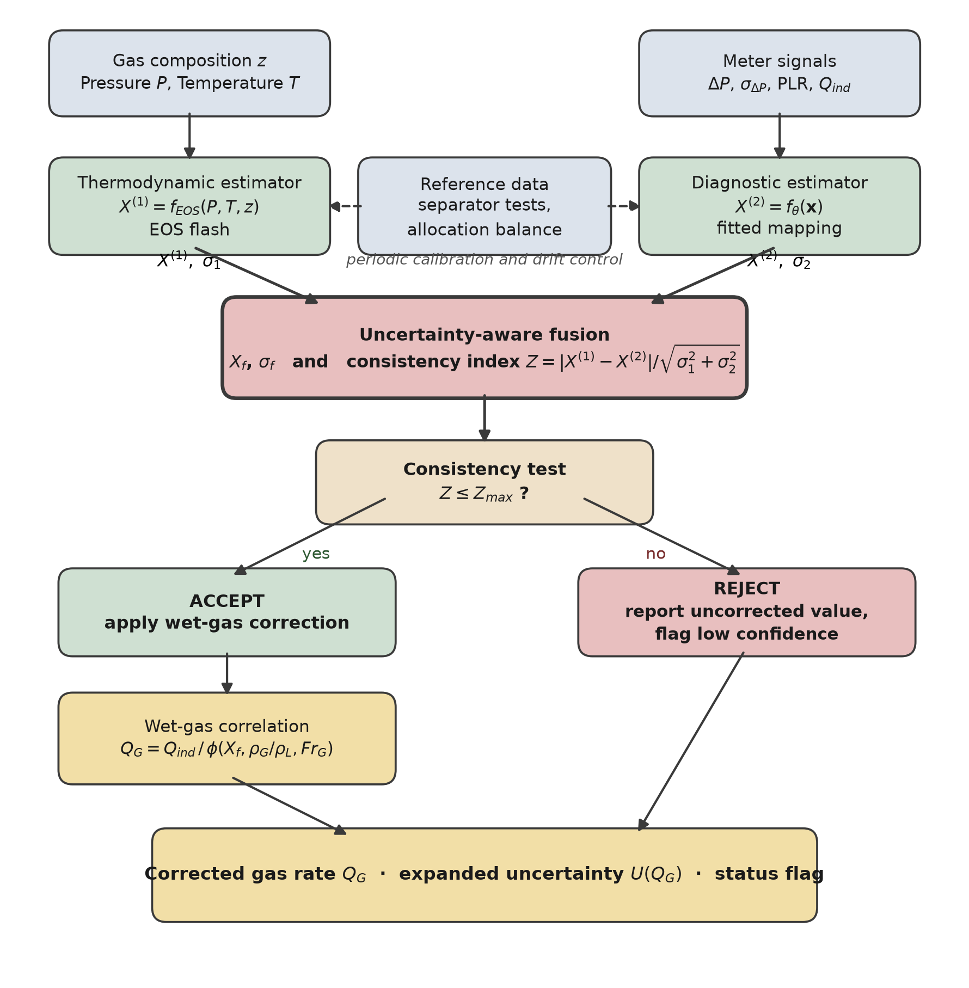
Fig. 1. Estimation and decision flow. The two estimators draw on structurally distinct information, so their disagreement is informative. Reference data act on the estimators through periodic calibration rather than on the real-time correction path.
3.2 Thermodynamic estimator
The first estimator predicts the liquid that condenses from the gas under the conditions of the meter:
X⁽¹⁾ = f_EOS(P, T, z) (5)
where z is the molar composition vector. The calculation is a standard isothermal flash: obtain the composition from the station chromatograph, obtain the local pressure and temperature, perform a phase equilibrium calculation with a cubic or reference equation of state (Peng and Robinson, 1976; Kunz and Wagner, 2012), extract the condensed mass fraction and both phase densities, and evaluate Eq. (3).
This estimator is predictive rather than observational, and it has several error sources: composition uncertainty and C6+ characterization, the limitations of the equation of state, departure from phase equilibrium at the meter, sampling representativeness, and errors in the local pressure and temperature. Any of these can bias the result in either direction.
One failure mode is treated separately because it is systematic and unidirectional at the population level. A flash calculation represents the liquid that the local stream should drop under the stated conditions; it does not represent liquid introduced from upstream — carryover past a separator, or re-entrainment from a low point — because that liquid is not a thermodynamic property of the local stream. The dominant unmodeled failure mode considered here is therefore underestimation caused by an externally introduced liquid. This is a statement about one specific mechanism, not a claim that the thermodynamic calculation cannot err in the other direction for the other reasons listed above.
3.3 Diagnostic estimator
The second estimator infers the liquid loading from the behavior of the meter. For the orifice case, the feature vector is
x = [ P, T, ΔP, σ_ΔP, PLR, Q_ind, ρ_G ] (6)
X⁽²⁾ = f_θ(x) (7)
where σ_ΔP is the standard deviation of the high-rate differential-pressure signal over the averaging window and PLR is the permanent pressure loss ratio, available where a downstream tapping exists. The fluctuation statistics provide information because the differential pressure variance responds to liquid film formation before the mean value shifts appreciably; the permanent pressure loss responds because the film alters the recovery downstream of the plate (Zheng et al., 2019; Liu et al., 2020).
The thermodynamic estimate X⁽¹⁾ is deliberately excluded from Eq. (6). Including it as a contextual feature would allow the mapping to learn where the thermodynamic prediction is reliable, but it would also correlate the two estimates, and Section 5.5 shows that correlation degrades the acceptance test that the architecture depends on. The two estimators are therefore structurally distinct by construction. They are not guaranteed to be statistically independent even so — both respond to pressure, temperature and gas density — so the covariance is retained explicitly in Section 3.5 rather than assumed away.
3.3.1 Specification of the diagnostic model
The diagnostic model is specified here in enough detail to be fitted and reproduced, although it is not fitted in this study. The specification is part of the contribution: an estimator that cannot be reproduced cannot be falsified.
Table 1. Specification of the diagnostic estimator (Section 3.3.1).
Element | Specification | Reason
Model class | Gradient-boosted regression trees with monotonic constraints, or a constrained generalized additive model | Both admit hard monotonicity constraints and handle the modest feature count without requiring the data volume a neural network would
Target | X_LM from the reference metering of the calibration facility | The latent variable itself, not the over-reading
Output transform | softplus, guaranteeing X⁽²⁾ > 0 | A negative liquid loading is unphysical and must be impossible by construction, not merely unlikely
Monotonic constraints | nondecreasing in σ_ΔP and in PLR at fixed P, T, ρ_G | Imposes the physical direction of the diagnostic response and disciplines extrapolation
Loss | Pinball (quantile) loss at the 0.05, 0.50 and 0.95 quantiles | Yields a predictive interval directly, rather than a point estimate to which an uncertainty must afterwards be attached
Uncertainty | u₂ from the fitted quantile spread, calibrated by split conformal prediction on a held-out fold | Conformal calibration gives finite-sample coverage without assuming the residual distribution
Data split | grouped by operating condition (X_LM and Fr_G combination), not by random point | Random splitting of loop data leaks information between folds because repeat points at one condition are near-duplicates, and inflates apparent accuracy
Out-of-domain | convex-hull or Mahalanobis distance test on x against the training set; outside it the estimator returns a flag rather than a value | Prevents a regressor from silently extrapolating outside the conditions it was fitted on
Regularization | depth and leaf-count limits selected by grouped cross-validation | Wet-gas loop matrices are small; the dominant risk is overfitting the condition grid

The assumed performance of this model in the computational study—a relative standard uncertainty of 20% with a 6% transfer bias—is an assumption, and Section 6.4 identifies it as the most consequential one in the paper.
Relation of the assumed uncertainty to the specified calibration. The specification yields a predictive interval, not a standard deviation. Under the quantile specification, the calibrated 90% interval [q0.05, q0.95] of the diagnostic estimate gives the standard uncertainty u₂ = (q0.95 − q0.05)/(2 × 1.645) when the residuals are approximately normal, and the 20% assumed in Table 2 therefore corresponds to a calibrated 90% interval of ±33% of X_LM. If the residuals are not normal, the conformal interval is retained as the primary statement of uncertainty and u₂ is its half-width divided by the coverage factor of the observed residual distribution; the Gaussian conversion is the reporting convention used in this study. The 20% is thus a performance requirement that the fitted estimator must meet, not a result. If the fitted model’s calibrated 90% interval is wider than ±33%, Fig. 10a shows what is lost.
Two bias terms are distinguished. The random relative uncertainty (20%) is the scatter of a single reading about the mapping. The transfer bias (6%) is the standard deviation, across installations, of the offset between the mapping fitted at the loop and the mapping at site; in the simulation it is drawn once per realization, so that the reported statistics integrate over a population of sites. A persistent offset at one site is a different situation, because it does not average out; it is evaluated separately, with a fixed bias at a single site, in Section 5.11.
3.4 Reference-based calibration and drift control
Periodic reference data — test-separator runs, allocation balances, or proving data — calibrate and validate the two estimators and correct slow drift. They are not real-time inputs to the correction because test separators carry uncertainties of several percent; admitting them per cycle would inject that uncertainty into every reading, whereas averaged over many runs, they constrain a slowly varying offset effectively.
3.5 Fusion with correlated estimators and the consistency index
Let u₁ and u₂ be the standard uncertainties of X⁽¹⁾ and X⁽²⁾, respectively; ρ₁₂ is the correlation between their errors; and c = ρ₁₂u₁u₂ is the covariance. The thermodynamic uncertainty is defined as follows:
u₁² = u²_flash + u²_carry (8)
where u_carry is the standard deviation of the carryover fraction over the site's operating conditions. The second term is not optional: Section 5.2 shows that omitting it makes the fused estimate worse than the diagnostic estimate alone because the weighting below then over-trusts the thermodynamic estimator.
Scaling of the carryover term. The carryover fraction f_c is the share of the total liquid that is not local condensate. Because X⁽¹⁾ = X_LM(1 − f_c)(1 + ε), a carryover fraction f_c is a relative error of −f_c in X⁽¹⁾, and u_carry is therefore applied as a relative standard uncertainty. For the assumed mixture (Bernoulli p = 0.25 times Uniform(0.15, 0.60)) u_carry = 17.5% of X⁽¹⁾, and the flash term u_flash = 12% gives u₁ = 21.2% of X⁽¹⁾. The allowance deliberately treats carryover as zero-mean scatter and so understates its mean (9.4% of X_LM); the mean shift is the task of the one-sided damping rule below, not of the budget.
The minimum-variance linear combination of two correlated estimates is
w₁ = (u₂² − c) ⁄ (u₁² + u₂² − 2c), w₂ = 1 − w₁ (9)
X_f = w₁X⁽¹⁾ + w₂X⁽²⁾, u_f² = w₁²u₁² + w₂²u₂² + 2w₁w₂c (10)
which reduces to inverse-variance weighting when ρ₁₂ = 0. Disagreement between the two estimates is quantified by the consistency index
Z = |X⁽¹⁾ − X⁽²⁾| ⁄ √(u₁² + u₂² − 2c) (11)
The covariance term in the denominator of Eq. (11) matters and is easy to omit. var(X⁽¹⁾ − X⁽²⁾) = u₁² + u₂² − 2c, so assuming independence when ρ₁₂ > 0 makes the denominator too large, Z too small, and the acceptance test progressively less sensitive. Section 5.5 quantifies this: at ρ₁₂ = 0.3, the rejection rate decreases from 2.0% to 0.5% if the covariance is ignored, and at ρ₁₂ = 0.7, it decreases from 8.2% to 0.2%. In practice, ρ₁₂ is estimated during the calibration of Section 3.4 from the joint residuals of the two estimators against the reference.
Because the thermodynamic estimator's dominant unmodeled failure is unidirectional, a significant excess of X⁽²⁾ over X⁽¹⁾ is evidence of carryover rather than noise in X⁽²⁾, and the weighting moves toward X⁽²⁾ rather than averaging. Disagreement in the opposite direction has no such interpretation and is treated as ordinary scatter:
e = (X⁽²⁾ − X⁽¹⁾) ⁄ √(u₁² + u₂² − 2c), w₁′ = w₁ ⁄ (1 + max(0, e − k)²) (12)
with the damping threshold set to k = 1 throughout this study so that damping begins only once the excess exceeds one combined standard uncertainty. The fused uncertainty is inflated by the Birge ratio max(1, Z) when the two estimates disagree by more than their stated uncertainties allow. The threshold k = 1 is a design choice, not a physical constant; Section 3.5.1 gives the justification of the rule and Section 5.10 the sensitivity of the results to k and to the form of the weighting.
The Birge ratio is used here as a robust uncertainty-inflation heuristic, not as a statistically optimal estimator. Its justification is pragmatic: when two estimates of the same quantity disagree by more than their stated uncertainties admit, at least one of those uncertainties is understated, and reporting the unadjusted u_f would be indefensible. It is not claimed to be the minimum-variance response to that situation, and the sensitivity of the results to this choice is small because the acceptance test of Eq. (11) removes the cases where inflation would be greatest.
3.5.1 Asymmetric damping: justification and recalculation of weights and uncertainty
Why a one-sided rule. A carryover fraction cannot be negative, so the thermodynamic estimate can fall below the true value because of upstream liquid but cannot rise above it for that reason. A large positive excess e therefore points to carryover rather than to noise in X⁽²⁾, whereas a large negative excess has no such reading and is left to the ordinary uncertainty budget and to the consistency test. The damping factor d = 1/(1 + r²), with r = max(0, e − k), is the Cauchy (Lorentzian) influence weight used in iteratively reweighted least squares (Holland and Welsch, 1977; Huber and Ronchetti, 2009): the weight of an estimate falls smoothly as its residual leaves the range its stated uncertainty allows, and the fused value remains a continuous function of the data. Applying it to the excess beyond k alone makes it one-sided. It is a robust-estimation device chosen for the failure mode, not a likelihood derived from a carryover model; a mixture likelihood with an explicit carryover prior would be the principled alternative, and it needs loop-calibrated carryover statistics that this study does not have.
The threshold. The parameter k is the number of combined standard uncertainties of excess tolerated before the thermodynamic estimate is down-weighted. Section 5.10 repeats the study for k from 0.5 to 3 and for four alternative weighting rules, with symmetric weighting and the diagnostic estimator alone as controls, and reports that another choice performs better in the reference case.
Recalculation after damping. The damping multiplies the generalized-least-squares weight w₁ of Eq. (9) to give the damped weight w₁′ of Eq. (12); w₂ is unchanged, the weights are renormalized, and the fused value and its uncertainty are recomputed from the renormalized weights:
w̃₁ = w₁′ ⁄ (w₁′ + w₂), w̃₂ = 1 − w̃₁ (13)
X_f = w̃₁X⁽¹⁾ + w̃₂X⁽²⁾, u_f² = (w̃₁²u₁² + w̃₂²u₂² + 2w̃₁w̃₂c)·max(1, Z)² (14)
Here c = ρ₁₂u₁u₂ is computed from the original standard uncertainties, the Birge factor multiplies the whole expression, and without damping and with ρ₁₂ = 0 Eqs. (13) and (14) reduce to inverse-variance fusion. The renormalized weights are not the minimum-variance weights for u₁ and u₂, so u_f is larger than the undamped value. This is intended, since the damping is triggered by evidence that u₁ is understated.
3.5.2 Uncertainty propagation and model-form error
The corrected gas rate is Q_G = K√(ΔP·ρ_G)/φ(X_f, ρ_G/ρ_L), where K collects the geometry and discharge coefficient. Its relative standard uncertainty follows from first-order propagation (JCGM 100:2008),
u²(Q_G)/Q_G² = sᵀ Σ s (15)
where s is the vector of normalized sensitivities to the inputs and Σ their relative covariance matrix. The inputs are the fused liquid loading X_f, the meter and secondary-instrument terms (differential pressure, gas density, discharge coefficient and expansion), the liquid density, the correlation residual after site calibration and a model-form term. For uncorrelated groups of inputs,
u²(Q_G)/Q_G² = S_X²(u_f ⁄ X_f)² + u²_meter + S_L²u²(ρ_L)/ρ_L² + u²_corr + u²_form (16)
with S_X = −d ln φ/d ln X_LM. How the inputs, their correlations and the model uncertainty enter is as follows. The uncertainties of the two liquid-loading estimates and their correlation enter through u_f (Eq. 14), which carries c = ρ₁₂u₁u₂. The meter term u_meter = 0.7% lumps the transmitter, discharge-coefficient and expansion contributions; gas density and differential pressure, which both the estimators and the meter use, are the two itemized components of Table 6. The correlation of X_f with the gas-density term is not zero in principle; the reported budget assumes independence and Table 6 states the bound obtained if the correlation were ±1. The term u_corr = 0.6% is the residual uncertainty of the correlation after calibration at site, systematic over the envelope. The term u_form is an allowance for the difference between the correlation and the true over-reading (departure from the Chisholm form, geometry, flow regime); it is zero in the reference case, where the forward and correction models coincide, and is declared as a relative uncertainty of the over-reading, (φ − 1)/φ, in the model-form scenarios of Section 5.12. The expanded uncertainty is U = 2u(Q_G), and its realized coverage is reported rather than assumed.
3.6 Correction and acceptance algorithm
Algorithm 1 — correction decision
1. Acquire P, T, composition z and meter diagnostics.
2. X1 := f_EOS(P, T, z); u1 := sqrt(u_flash^2 + u_carry^2) [Eq. 5, 8]
3. X2 := f_theta(x); u2 from the calibrated quantile spread [Eq. 6, 7]
4. c := rho_12 * u1 * u2 rho_12 from the calibration (Sec 3.4)
5. Z := |X1 - X2|/sqrt(u1^2 + u2^2 - 2c) [Eq. 11]
6. w1, w2 := GLS weights; damp w1 with k = 1, renormalize [Eqs. 9, 12]
7. X_f, u_f := fused estimate and uncertainty [Eqs. 13, 14]
8. if Z <= Z_max:
Q_G := Q_ind/phi(X_f, rho_G/rho_L, Fr_G) [Eq. 2]
propagate u_f, correlation and meter uncertainties to U(Q_G)
status := CORRECTION APPLIED
9. else:
Q_G := Q_ind (unchanged)
status := UNCORRECTED, LOW CONFIDENCE
10. Publish Q_G, U(Q_G), X_f, Z and status.
4. Computational Method
4.1 Forward model and operating envelope
The forward model is Eq. (4) and is evaluated under the sampled operating conditions. Gas density is computed from Standing pseudo-critical properties with the Dranchuk and Abou-Kassem (1975) Z-factor correlation, which over the sampled envelope returns 48.5–85.5 kg/m³ and Z of 0.785–0.889.
4.2 Sampling distributions and assumed uncertainties
Table 2 gives every distribution used so that the study can be reproduced and so that a reader can see exactly which quantities are assumed rather than measured.
Table 2. Complete specification of the Monte Carlo method. Every entry in the final column marked 'assumed' is a modeling choice, not a measurement; Section 6.4 discusses their standing, and Section 5.6 tests the sensitivity of the conclusions to the most consequential one.
Quantity | Distribution | Range/value | Basis
Line pressure P | Uniform | 60–85 kgf/cm² | Assumed operating envelope
Temperature T | Uniform | 30–60 °C | Assumed operating envelope
Condensate–gas ratio | Uniform | 5–100 bbl/MMscf | Assumed; converted to X_LM by Eq. (3)
Condensate density ρ_L | Uniform | 640–720 kg/m³ | Typical gas-condensate range
Superficial gas velocity | Uniform | 8–18 m/s in a 154 mm line | Assumed; sets Fr_G
Gas density ρ_G | Derived | 48.5–85.5 kg/m³ | Standing pseudo-criticals with DAK Z-factor
u_flash, relative | Gaussian | 12% | Assumed: flash calculation with composition uncertainty
Carryover occurrence | Bernoulli | p = 0.25 | Assumed prevalence; swept 0–60% in Section 5.6
Carryover magnitude | Uniform | U(0.15, 0.60) of total liquid | Assumed; the fraction invisible to the flash calculation
u_carry, relative | Derived | 17.5% | Standard deviation of the Bernoulli × Uniform mixture above, entering Eq. (8)
u₂ random, relative | Gaussian | 20% | Assumed performance of the fitted diagnostic model
u₂ transfer bias, relative | Gaussian | 6%, systematic | Assumed loop-to-site transfer error of the fitted mapping
ρ₁₂ | Parameter | 0 baseline; swept 0–0.7 | Correlation between estimator errors, Section 5.5
Correlation residual | Gaussian | 0.6%, systematic | Assumed, after site calibration
Meter and secondary instrumentation | Gaussian | 0.7% | Dry-gas meter and transmitter performance
Realizations | — | 300,000 per configuration; 4,000 per envelope cell | Fixed seed; see Data availability

Treatment of the bias terms. The transfer bias of the diagnostic estimator (6%) and the correlation residual (0.6%) are drawn independently for each realization, so that the reported statistics integrate over a population of installations; a persistent bias at one installation is evaluated separately in Section 5.11. Pressures are in kgf/cm² (1 kgf/cm² = 0.0980665 MPa), so that the envelope is 5.9–8.3 MPa.
4.3 Metrics
The reported metrics are the mean error (bias), mean absolute error, root-mean-square error, maximum absolute error, and the 95% error band taken as the larger absolute value of the 2.5th and 97.5th percentiles of the simulated error distribution. Errors are relative:
ε_Q = (Q_est − Q_ref) ⁄ Q_ref × 100% (17)
For configurations including the acceptance test, metrics are computed over accepted realizations, and the acceptance rate is reported alongside, since the method's output on rejected realizations is the uncorrected value with a flag rather than a corrected value.
Terminology. Error is the simulated deviation of an estimate from the reference (Eq. 17), and bias is its mean over the realizations. Uncertainty is a standard uncertainty declared by the method in the sense of JCGM 100:2008 (u), or the expanded uncertainty U = 2u. The 95% error band is the 95th percentile of the absolute simulated error, an empirical property of the simulated population; it is not an expanded uncertainty, and the coverage of the declared U is reported separately (Section 5.12). Accuracy is not used for simulated quantities, because it presupposes a measured reference. The sampling error of a band over 300,000 realizations is 0.015 percentage points (standard error from ten batches), which is the resolution below which differences between bands should not be interpreted.
4.4 Validation design and falsification criteria
Because the study is computational, the experiment that would test it is specified here in the Methods rather than deferred, so that the claims can be read against the test that would refute them.
Facility and configuration. A wet-gas flow loop with independent gas and liquid reference metering, controlled liquid injection, an orifice meter of known geometry with upstream and downstream tappings, pressure and temperature instrumentation, and either a chromatograph or a gas of known composition. The full high-rate differential-pressure signal must be recorded so that σ_ΔP and the spectral features of Eq. (6) can be computed rather than assumed.
Test matrix. X_LM at 0, 0.01, 0.02, 0.04, 0.06, 0.08 and 0.10, each at a minimum of four gas densiometric Froude numbers spanning the operating range. Deliberate liquid injection upstream of the flash-equilibrium point, in a subset of runs, to create the carryover condition that the consistency index is claimed to detect.
Comparisons. Four cases reported against the reference: (A) the uncorrected meter; (B) the standard correlation supplied with the reference liquid loading, which bounds achievable performance; (C) the estimated liquid loading against the reference liquid loading, which tests the estimator directly and independently of the correction; and (D) the fully corrected gas rate. Reporting (C) separately matters: it is the only comparison that isolates this paper's contribution from the correlation's.
Falsification criteria. The framework is refuted if any of the following holds on loop data: the fitted diagnostic estimator does not recover X_LM within the 20% relative uncertainty assumed in Table 2; the consistency index does not preferentially flag the runs with deliberate upstream injection; the measured correlation ρ₁₂ between the estimator residuals is large enough that the acceptance test loses the sensitivity reported in Section 5.5; or the corrected gas rate fails to improve on the uncorrected meter within the admissibility region of Fig. 8.
4.5 Additional computational experiments
Common random numbers. The experiments of Sections 5.9–5.12 draw every random primitive once (300,000 realizations, seed 20261027) and reuse it for every configuration compared, so a difference between two methods is a difference between methods and not between samples; this is propagation of distributions by Monte Carlo in the sense of JCGM 101:2008. With the baseline settings this machinery reproduces the ablation of Table 3 to within 0.030 percentage points, which is twice the sampling error. Tables 3, 5 and 6 and Figs 2–8 are the original results and are unchanged; Table 4 and the new tables and figures use the common-random-number sample.
Independent forward model. The correction is always the Chisholm multiplier of Eq. (4). The truth that generates the simulated meter reading is varied in three ways. (i) Matched: Chisholm itself, the reference case. (ii) Independent: the Murdock (1962) orifice correlation, φ = 1 + 1.26 X_LM, a separately published correlation for the same meter type. (iii) Perturbed: the over-reading φ − 1 is scaled by 0.90, 0.95, 1.05 or 1.10 (systematic), or multiplied by a random factor with a relative standard deviation of 5% or 10% (realization to realization). The perturbations are stress scenarios and are not measured error bounds. A Venturi correlation (de Leeuw, 1997) was also evaluated as a test of the consequence of a wrong functional form; it is not a model of an orifice plate, is outside its validated geometry, and is reported only in the text of Section 5.12.
Detector targets. The consistency test is evaluated against two conditions: the presence of upstream carryover, which is the failure mode it is designed for, and a consequential corrected-rate error, defined as an absolute error above 3%. Sensitivity, specificity, precision and false-positive rate are defined in the usual way from the counts of true and false positives and negatives (Fawcett, 2006), with a rejected realization as a positive.
5. Results
Every figure in this section is a simulation result. The quantities reported are modeled uncertainties conditional on Table 2, and the word 'accuracy' is deliberately avoided. The new analyses are in Sections 5.9–5.12.
5.1 Forward-model check
At representative envelope conditions, condensate–gas ratios of 50 and 100 bbl/MMscf give over-readings of 7.9% and 15.7%, and the simulated population mean over-reading across the envelope is +7.94%, with a 95% band of ±14.94%. These magnitudes are consistent with uncorrected errors reported for DP meters in wet gas, which is a necessary check on everything downstream.
5.2 Ablation study
Table 3 decomposes the method. The oracle row applies the same correlation supplied with the true liquid loading and bounds what any estimator can achieve; the residual ±1.82% is the correlation and meter uncertainty alone.
Table 3. Simulated contribution of each element of the estimator at ρ₁₂ = 0. Metrics in percent of gas rate over 300,000 realizations.
Configuration | Bias | MAE | RMSE | Max |ε| | 95% band | Accepted
Uncorrected meter | +7.94 | 7.94 | 8.96 | 17.03 | ±14.94 | 100%
Correlation with known X_LM (oracle) | +0.00 | 0.74 | 0.92 | 4.90 | ±1.82 | 100%
Thermodynamic estimator alone | +0.71 | 1.50 | 2.11 | 12.42 | ±5.83 | 100%
Diagnostic estimator alone | +0.03 | 1.44 | 1.90 | 12.71 | ±3.99 | 100%
Fusion, carryover omitted from budget | +0.77 | 1.42 | 1.99 | 11.85 | ±5.45 | 100%
Fusion, carryover allowance declared | +0.70 | 1.39 | 1.89 | 11.52 | ±4.96 | 100%
Asymmetric weighting, Eq. (12) | +0.59 | 1.30 | 1.72 | 11.41 | ±4.28 | 100%
Full method, with acceptance test | +0.58 | 1.29 | 1.71 | 11.70 | ±4.26 | 99%

The uncertainty budget is not cosmetic. Fusing while the thermodynamic estimator declares only its flash uncertainty gives ±5.45%, worse than the diagnostic estimator alone (±3.99%). Declaring the carryover allowance of Eq. (8) recovers ±4.96%. This is a general point about fusing estimators with different failure modes: inverse-variance weighting is only as good as the declared variances.
The asymmetric rule improves this to ±4.28% over all 300,000 realizations, and the acceptance test, which retains 99.2% of them, gives ±4.26% on the accepted ones. The two figures refer to different populations and differ by less than the sampling error of the band (0.015 percentage points), so at Z_max = 3 the acceptance test does not measurably narrow the band. The simulated bias falls from +7.94% uncorrected to +0.58%. The gap to the oracle remains substantial — ±4.26% against ±1.82% — and no amount of fusion closes it. Estimating the liquid loading rather than measuring it costs roughly a factor of two in the error band.
In the reference case the diagnostic estimator alone (±3.99%) is narrower than every fused configuration of Table 3, including the full method (±4.26%). Fusion is not claimed to outperform it here. Sections 5.6, 5.10 and 5.11 show the conditions under which fusion does: infrequent carryover, a poor diagnostic estimator, or a persistent bias in it.
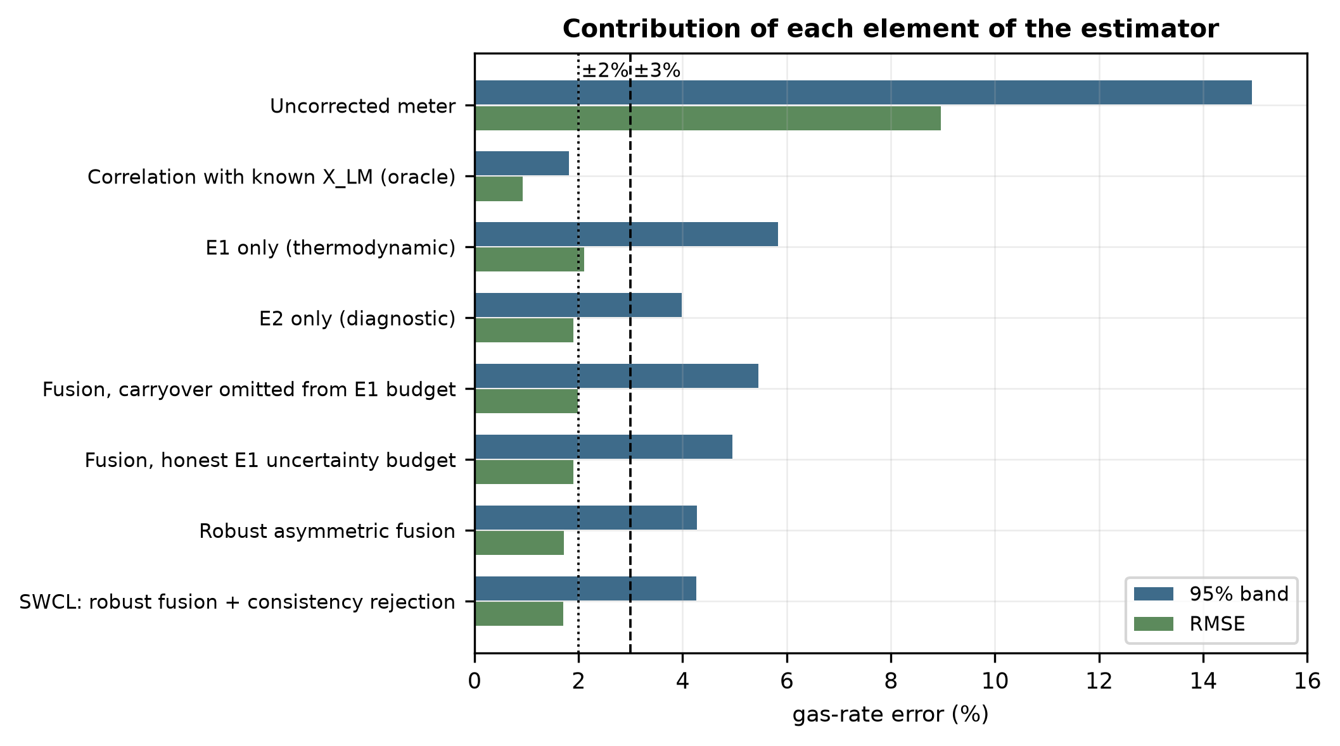
Fig. 2. Simulated ablation of the estimator. The naive-budget configuration is worse than the diagnostic estimator alone.
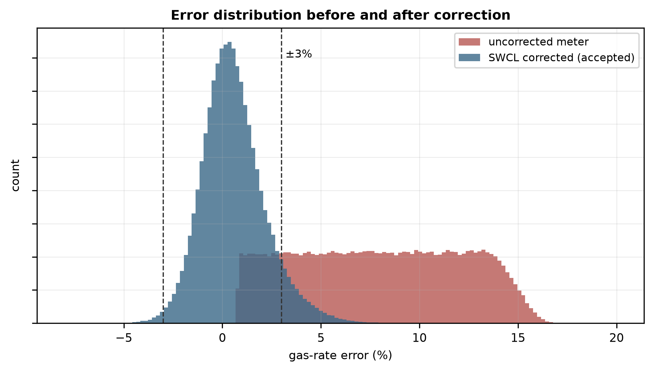
Fig. 3. Simulated error distribution before and after correction. The uncorrected distribution is strictly positive because wet-gas over-reading has a sign.
5.3 Behavior of the consistency index
Carryover is present in 25% of the simulated realizations, in 24% of the accepted realizations, and in 94% of the rejected realizations. The 94% is the precision of the rejection decision: the share of rejected realizations that contain carryover. It is not a specificity, and it depends on the prevalence of carryover. The full characterization of the test as a detector, including its sensitivity, is in Sections 5.4 and 5.9; at the threshold adopted here the test rejects very few realizations, and nearly all of those contain carryover, but it misses most of the carryover that is present.
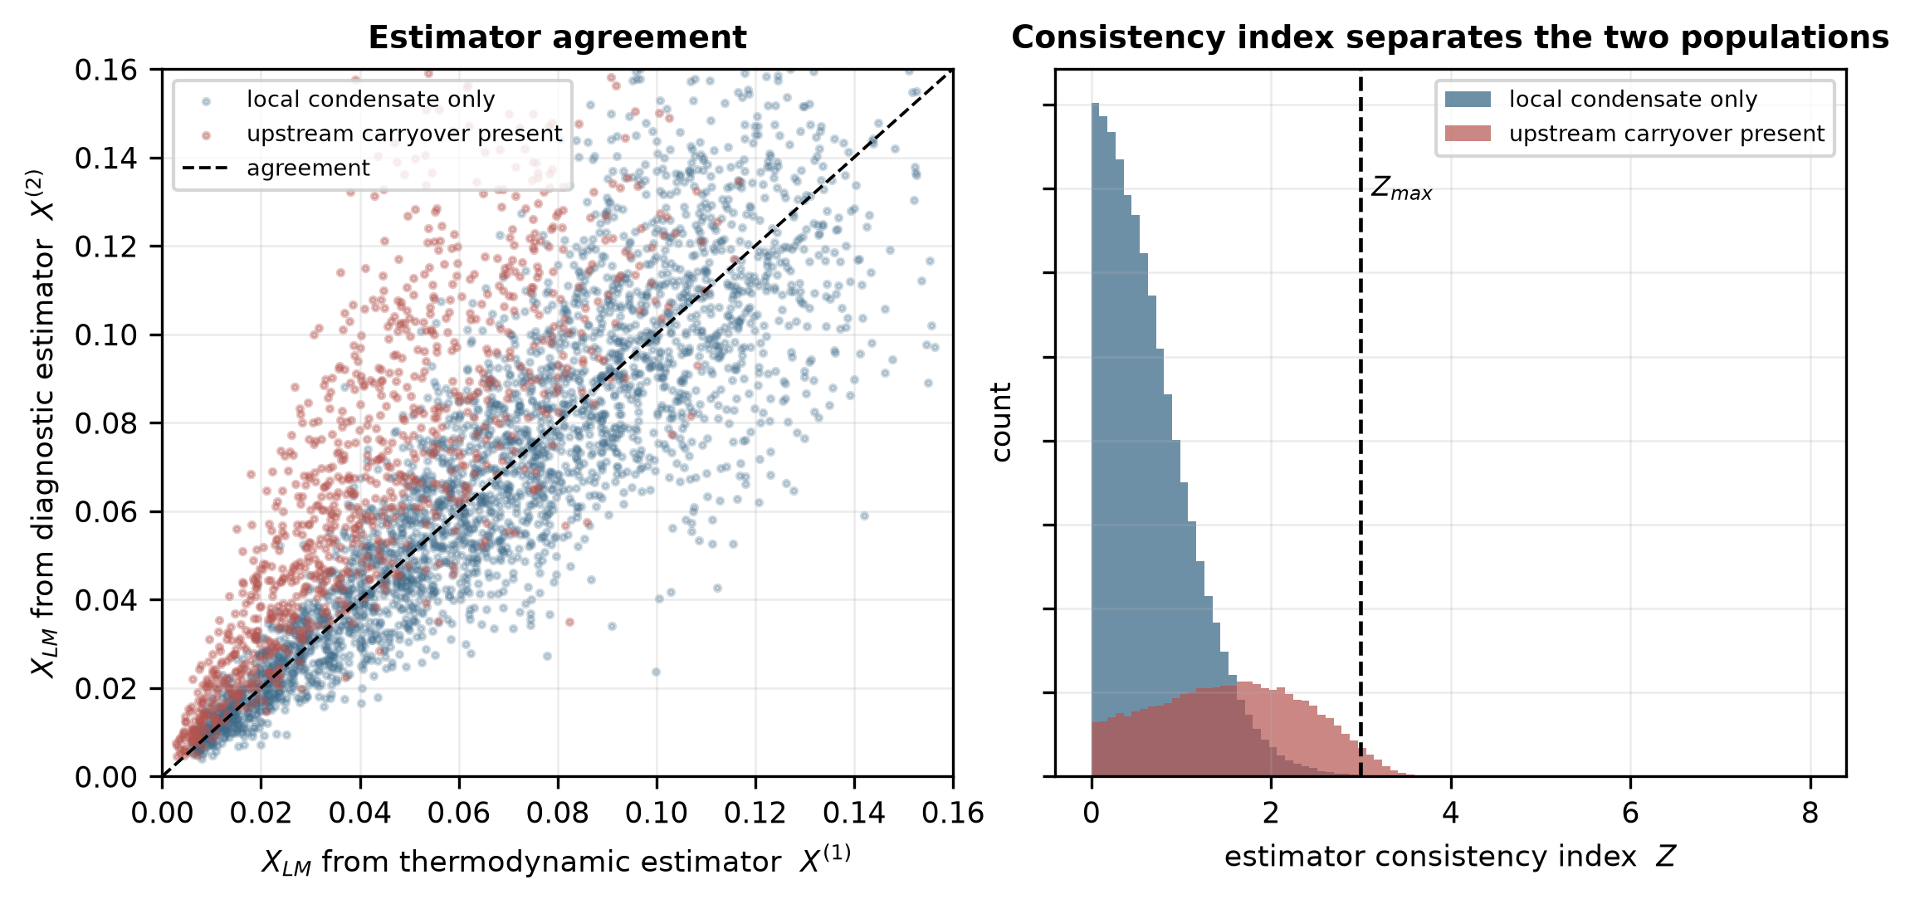
Fig. 4. Left: simulated agreement between the two estimators, separated by whether upstream carryover is present. Right: distribution of the consistency index for the two populations, with the acceptance threshold marked.
5.4 Threshold selection
Table 4. Simulated effect of the acceptance threshold on the retained data and on the detection of upstream carryover (rejected = positive). Sensitivity, specificity, precision and false-positive rate refer to the presence of carryover in any amount.
Z_max | Accepted | 95% band of accepted | Sensitivity | Specificity | Precision | False-positive rate
0.5 | 37.9% | ±2.98% | 87.1% | 46.3% | 35.2% | 53.7%
1.0 | 66.0% | ±3.19% | 71.2% | 78.5% | 52.6% | 21.5%
1.5 | 82.2% | ±3.53% | 51.9% | 93.6% | 73.2% | 6.4%
2.0 | 91.0% | ±3.90% | 31.4% | 98.5% | 87.6% | 1.5%
2.5 | 96.3% | ±4.14% | 13.7% | 99.68% | 93.5% | 0.32%
3.0 | 99.2% | ±4.26% | 2.9% | 99.95% | 94.8% | 0.05%
3.5 | 100.0% | ±4.30% | 0.1% | 99.99% | 80.8% | 0.01%

A tight threshold narrows the error band of what remains but discards a large fraction of operating time, which for a fiscal or allocation measurement is itself a cost. The two ways in which a threshold can be wrong pull in opposite directions. At Z_max = 3, the adopted value, the false-positive rate is 0.05%, and 0.8% of the realizations are rejected in all, but only 2.9% of the realizations that do contain carryover are detected. Z_max = 3 is therefore a completeness-priority setting: it removes gross disagreements and almost nothing else. If the priority is to catch carryover, Z_max = 1 detects 71% of it, at the cost of rejecting 21% of the realizations that contain none (precision 53%) and 34% of all realizations. The appropriate value at a given installation depends on whether a narrow error band or completeness is the priority, and on the cost of each kind of error.
5.5 Effect of correlation between the estimators
The two estimates are structurally distinct but not guaranteed to be statistically independent: both respond to pressure, temperature and gas density, and any implementation that admitted X⁽¹⁾ into the diagnostic feature vector would correlate them further. Fig. 5 varies ρ₁₂ from 0 to 0.7 and compares treating the estimates as independent against retaining the covariance term.
Table 5. Simulated cost of assuming independence. The rejection rate is the fraction of realizations on which the correction is withheld.
ρ₁₂ | Rejection rate, Z assumes independence | Rejection rate, Z retains covariance | Precision for carryover, covariance retained
0.0 | 0.8% | 0.8% | 94.9%
0.2 | 0.6% | 1.4% | 96.1%
0.3 | 0.5% | 2.0% | 96.7%
0.5 | 0.3% | 4.0% | 97.8%
0.7 | 0.2% | 8.2% | 97.8%

The consequences are unidirectional and severe. As ρ₁₂ increases, a consistency index that assumes independence has a denominator that is too large; thus, Z decreases, and the acceptance test progressively stops firing: the rejection rate decreases from 8.2% to 0.2% when ρ₁₂ = 0.7. The test does not fail loudly; it quietly accepts everything, which is the worst failure mode available to a mechanism whose purpose is to withhold a correction.
For the point estimate, the effect is different and smaller. Generalized least-squares weights are minimum-variance but not minimum-error when one estimator has an unmodeled bias, and in this regime, the error is bias-dominated; thus, the covariance-aware weights give a slightly wider band at high ρ₁₂ (±5.10% against ±4.42% at ρ₁₂ = 0.6) rather than a narrower one. The operating mechanism against bias remains the asymmetric damping of Eq. (12), not the weighting.
The column labelled precision in Table 5 is the share of rejected realizations that contain carryover. The sensitivity tells the same story as the rejection rate: at Z_max = 3 it is 2.9% at ρ₁₂ = 0, and 7.5% and 22.3% at ρ₁₂ = 0.3 and 0.6 when the covariance is retained, against 2.0% and 1.0% if it is ignored. Retaining the covariance makes the test more sensitive as the estimates become more correlated, because their difference then carries less noise.
Two practical consequences follow. First, X⁽¹⁾ should be excluded from the diagnostic feature vector, as in Eq. (6), so that ρ₁₂ is kept small by construction. Second, ρ₁₂ should be measured during calibration from the joint residuals of the two estimators and retained in Eqs. (9)–(12) rather than assumed to be zero.
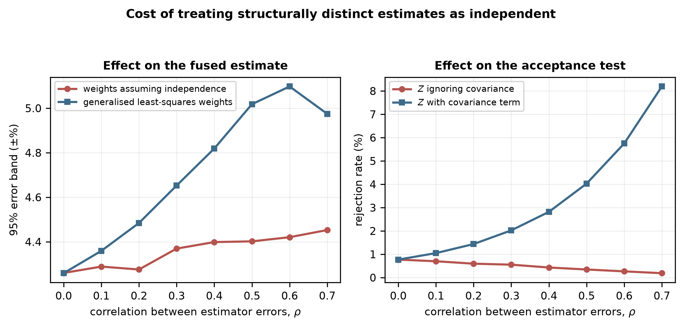
Fig. 5. Simulated cost of treating structurally distinct estimates as independent. Left: effect on the fused estimate. Right: effect on the acceptance test, which loses sensitivity as the correlation increases.
5.6 When does hybrid fusion outperform either estimator alone?
The value of combining the two estimators depends on how often the thermodynamic one is blind. The carryover prevalence varies from 0 to 60% of the operating time (Fig. 6).
With no carryover, the thermodynamic estimator is better (±2.70% against ±4.04%), and the method correctly falls back toward it (±2.72%). Between approximately 5% and 15% prevalence, the fused estimate beats either estimator alone. A finer sweep with common random numbers (Section 5.11) finds that the asymmetric rule remains narrower than the diagnostic estimator alone up to a prevalence of 15%, and the full method up to 16%. Beyond that, the diagnostic estimator is the narrower, by 0.3 percentage points at the reference prevalence of 25% and by about 0.8 at 60%, because the thermodynamic estimate is wrong too often to contribute.
The practical reading is a deployment rule: the hybrid architecture is most beneficial in installations where upstream separation is effective but imperfect, which is the condition an inlet separator and dehydration train produce. Where carryover is frequent, the sensible configuration is the diagnostic estimator alone, with the consistency index retained purely as a validity check. Carryover prevalence is therefore the first quantity to be established at a candidate installation, and it can be established from historical separator and meter data without any new instrumentation.
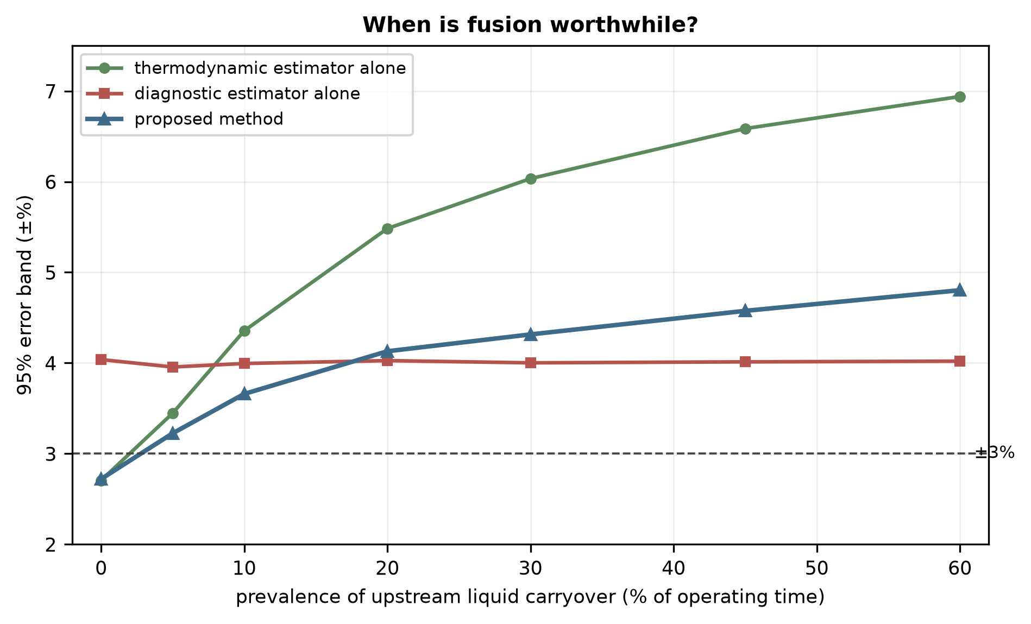
Fig. 6. Simulated effect of upstream carryover prevalence on the 95% error band of each configuration. The crossing points define the regime in which fusion is worthwhile.
5.7 Sensitivity analysis
Table 6. Normalized sensitivity coefficients and the corresponding contributions to the combined standard uncertainty of the corrected gas rate at X_LM = 0.05 (shares at X_LM = 0.10 in parentheses). Gas density and differential pressure are two itemized components of the lumped meter term, not additional terms. The relative uncertainty of the liquid-loading estimate is the median u_f/X_f of the fused estimate over realizations within ±10% of the stated loading.
Input | Sensitivity S_i | Relative standard uncertainty | Contribution to u_c(Q_G) | Share of u_c²
Liquid loading estimate X_LM | -0.051 | 15.0% | 0.76% (1.42%) | 40% (70%)
Meter and secondary terms (lumped) | — | 0.7% | 0.70% | 34% (17%)
of which gas density ρ_G | +0.505 | 0.4% | 0.20% | —
of which differential pressure ΔP | +0.499 | 0.5% | 0.25% | —
Correlation residual after calibration | — | 0.6% | 0.60% | 25% (13%)
Liquid density ρ_L | −0.006 | 3.0% | 0.02% | <1%
Combined u_c(Q_G) |  |  | 1.19% (1.70%) | bounds 1.06–1.32%

The corrected rate is about 10 times more sensitive to a relative change in gas density or differential pressure (S ≈ +0.5, the square-root dependence of the DP equation) than to a relative change in the liquid-loading estimate (S ≈ −0.05). Sensitivity alone would therefore suggest that liquid loading hardly matters. It matters because of the size of its uncertainty, not its coefficient: gas density and differential pressure are known to a fraction of a percent (0.4% and 0.5%), whereas the liquid-loading estimate carries a relative standard uncertainty of 15%, about 30 times larger. The product, which is what enters the budget, is 0.76% for the liquid-loading estimate against 0.20% and 0.25% for gas density and differential pressure, a ratio of about 3. The liquid-loading estimate is the largest single contribution to the combined standard uncertainty: 40% of the variance at X_LM = 0.05 and 70% at 0.10, where the sensitivity has doubled; at the lower loading the lumped meter term and the correlation residual together account for the larger part. Sensitivity coefficients reported without the associated uncertainties would invert the conclusion.
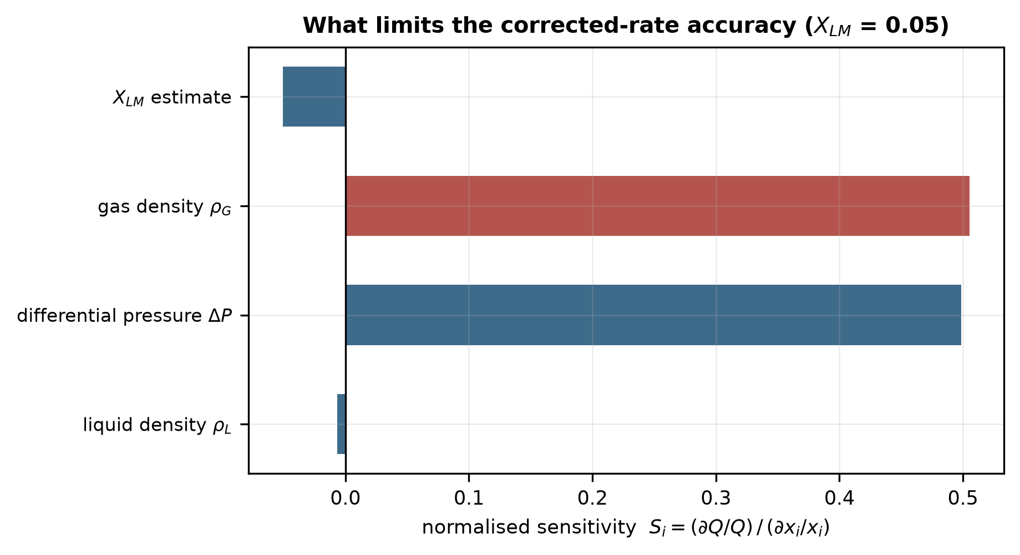
Fig. 7. Normalized sensitivity coefficients. The liquid-loading estimate has the smallest coefficient and the largest uncertainty contribution; see Table 6.
5.8 Admissibility envelope
The simulated 95% band and the acceptance rate over the (X_LM, Fr_G) plane are shown in Fig. 8, and each cell is classified according to whether the ±2% and ±3% levels are met. This defines a validity domain rather than a single headline figure. The error band widens with increasing liquid loading as the correlation sensitivity to X_LM increases; the Froude dependence is weak over the range examined because the Chisholm form does not contain an explicit Froude term.
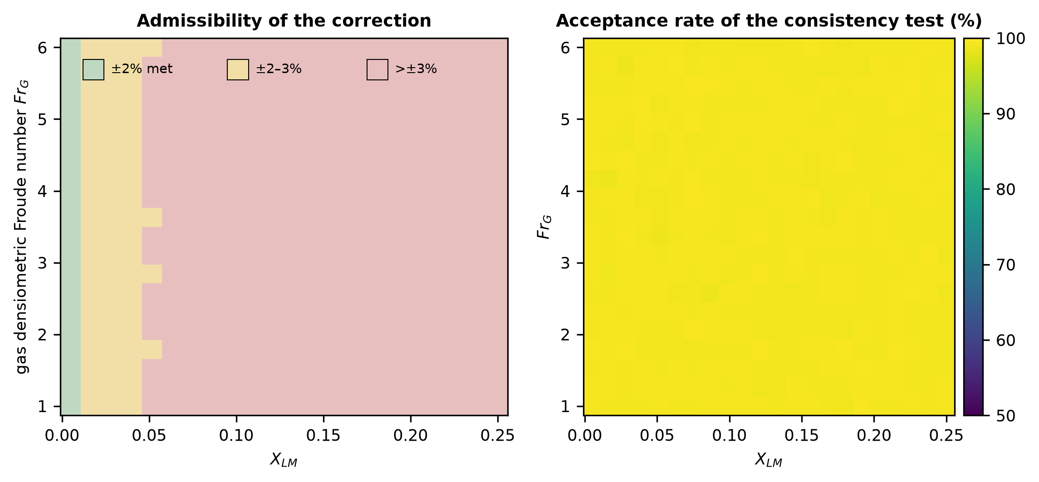
Fig. 8. Left: simulated admissibility of the correction over the (X_LM, Fr_G) plane. Right: acceptance rate of the consistency test. The upper part of the X_LM range lies beyond the loading expected for the sampled duty and is included to show where the method fails.
5.9 Characterization of the consistency detector
Section 5.3 reports that 94% of rejected realizations contain carryover. That is the precision of the decision, and it does not characterize a detector. Table 4 gives sensitivity, specificity, precision and false-positive rate over the threshold, and Fig. 9 shows the receiver operating characteristic and the precision–recall curve of the index over its whole range. At Z_max = 3 the test rejects 0.78% of all realizations; its specificity is 99.95%, its false-positive rate 0.05% and its precision 94.8% (94% on the original sample of Section 5.3), but its sensitivity is 2.9%, so 97% of the realizations that contain carryover are accepted. The area under the ROC curve is 0.81 (average precision 0.69 against a prevalence of 25%), so the index separates the two populations only partially (Fig. 9a, b).
Detection depends strongly on the size of the carryover (Fig. 9c). At Z_max = 3 the share of realizations rejected rises from 0.03% for carryover of 15–25% of the liquid to 8% for 45–60%; at Z_max = 1 it rises from 40% to 94%. The index therefore responds to large carryover and is nearly blind to small carryover, which is the regime in which the diagnostic estimator’s own scatter (20%) masks it. Against the consequential-error target (absolute corrected error above 3%, present in 8.5% of realizations) the area under the curve is 0.74 and the precision at Z_max = 3 is 31%; the index is a weaker predictor of a large corrected-rate error than of carryover.
The consistency test should therefore be read narrowly. At the adopted threshold the consistency index is a gross-disagreement flag with high precision and low sensitivity; it should not be described as a carryover detector, and its main role in the reference case is as a validity check that withholds the correction when the two estimates are irreconcilable. Where the priority is to find carryover, a lower threshold is required, at the cost shown in Table 4. If the diagnostic estimator is poorer than assumed (a relative uncertainty of 30%, for example, as may occur without the permanent pressure loss), the area under the curve falls to 0.71 and the sensitivity at Z_max = 3 to 0.4%.
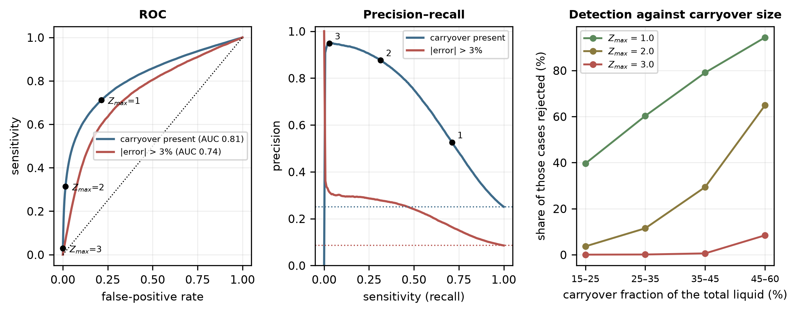
Fig. 9. Characterization of the consistency index at the reference configuration. (a) Receiver operating characteristic for the presence of carryover and for a corrected-rate error above 3%; points mark Z_max = 1, 2 and 3. (b) Precision against sensitivity; dotted lines are the prevalences. (c) Share of realizations rejected, by carryover size. All simulated.
5.10 Sensitivity to the weighting rule and the damping threshold
Table 7 compares the asymmetric rule of Eq. (12) with alternatives at three carryover prevalences, using the same realizations throughout. The controls are the thermodynamic and the diagnostic estimator alone and symmetric weighting, and the alternatives are the one-sided Cauchy rule at five thresholds, a one-sided Huber weight, a two-sided Cauchy weight and a one-sided hard switch that uses the diagnostic estimator alone when its excess exceeds k and the least-squares combination otherwise.
Table 7. Simulated 95% error band (±%) of the corrected gas rate for alternative weighting rules, over all 300,000 realizations, at carryover prevalences of 10%, 25% (reference) and 40%. The bias is that at 25%. The declared uncertainties are those of Table 2 in every case. Common random numbers (Section 4.5).
Weighting rule | 10% | 25% | 40% | Bias at 25%
Thermodynamic estimator alone | ±4.32 | ±5.83 | ±6.49 | +0.71%
Diagnostic estimator alone | ±4.00 | ±4.00 | ±4.00 | +0.03%
Symmetric least squares (no damping) | ±4.09 | ±4.99 | ±5.36 | +0.71%
One-sided Cauchy, k = 0.5 | ±3.56 | ±4.01 | ±4.25 | +0.50%
One-sided Cauchy, k = 1 (Eq. 12) | ±3.75 | ±4.30 | ±4.55 | +0.60%
One-sided Cauchy, k = 1.5 | ±3.93 | ±4.60 | ±4.88 | +0.66%
One-sided Cauchy, k = 2 | ±4.04 | ±4.84 | ±5.17 | +0.69%
One-sided Cauchy, k = 3 | ±4.09 | ±4.99 | ±5.36 | +0.71%
One-sided Huber, k = 1 | ±3.83 | ±4.43 | ±4.67 | +0.61%
Two-sided Cauchy, k = 1 (control) | ±3.94 | ±4.37 | ±4.58 | +0.61%
One-sided hard switch, k = 0.5 | ±3.79 | ±3.79 | ±3.79 | -0.10%
One-sided hard switch, k = 1 | ±3.46 | ±3.49 | ±3.68 | +0.05%
One-sided hard switch, k = 1.5 | ±3.23 | ±3.68 | ±3.96 | +0.23%
One-sided hard switch, k = 2 | ±3.44 | ±4.03 | ±4.38 | +0.38%

Three conclusions follow. First, k = 1 is not the best threshold in the reference case. Smaller thresholds do better (the one-sided Cauchy rule gives ±4.01% at k = 0.5 and ±4.30% at k = 1, against ±4.00% for the diagnostic estimator alone), and larger ones approach symmetric weighting (±4.99% at k = 3). Second, no rule is uniformly best. The smooth rule of Eq. (12) falls back toward the thermodynamic estimator when carryover is rare, and at 10% prevalence it is narrower than the diagnostic estimator alone (±3.75% against ±4.00%); at 25% and 40% the diagnostic estimator alone is narrower. The hard one-sided switch at k = 1 is narrower than the diagnostic estimator alone at all three prevalences (±3.49% at 25%), but it is poorer than Eq. (12) when carryover is absent (±3.49% against ±2.80% at zero prevalence, Fig. 10b). Third, the two-sided control is poorer than the one-sided rule (±4.37% against ±4.30%), which is the evidence for the one-sided form.
The rule of Eq. (12) is therefore presented as a smooth, continuous baseline, not as the preferred implementation. It is retained because the preceding sections are built on it, because the weight it gives each estimate is a continuous function of their disagreement, and because it falls back to the thermodynamic estimator when carryover is absent. The hard one-sided switch is a promising alternative and the better performer in the reference case, but its advantage rests on the assumed carryover statistics and on a discontinuity at the switching threshold, where a small change in the data changes the estimate abruptly; it needs independent validation, in particular of that threshold, before it is recommended. The best rule, and the best k, depend on the carryover prevalence and magnitude and on the diagnostic estimator, none of which is measured here, and a threshold chosen to minimize the error band of one simulated population would be tuned to its assumptions. The choice of rule and threshold is a calibration question for loop data, and Section 4.4 lists the measurement that would decide it.
5.11 Robustness to the diagnostic estimator, to prevalence and to a persistent site bias
Fig. 10 varies the assumptions on which the conclusions are most dependent. In Fig. 10a the actual relative uncertainty of the diagnostic estimator is varied from 10% to 60%, with the declared uncertainty either equal to the actual value (solid) or fixed at the assumed 20% (dashed). When the diagnostic estimator is better than assumed (10%), it is the best single estimator (±2.63%) and the full method is wider (±2.71%) when the uncertainty is declared correctly and much wider (±3.87%) when it is not; when it is worse (30%), the full method is narrower than the diagnostic estimator alone (±5.48% against ±5.71%, and ±4.97% if the 20% declaration is retained), and at 40% and 60% the thermodynamic estimator alone (±5.83%) is narrower than the diagnostic estimator alone (±7.55% and ±10.71%). The acceptance test limits the damage: the full method reaches ±6.10% at 60%, against ±9.88% for the asymmetric rule without it. The effect of the transfer bias is smaller: raising its spread from 0 to 20% widens the full method from ±4.13% to ±5.22%.
Fig. 10c replaces the population of sites by one site with a fixed transfer bias of the diagnostic estimator. The diagnostic estimator alone is narrowest with no bias (±3.91%) and widens in either direction, to ±5.12% at −15% and ±5.48% at +15%. The fused estimate is the more robust to a positive bias, because the thermodynamic estimate, which is biased low by carryover, offsets it: at +15% the full method is ±3.56% against ±5.48%, and at −15% the two are similar (±4.97% and ±5.12%). This asymmetry is a property of the simulated carryover bias, not a general benefit of fusion, and it would not occur if the thermodynamic estimator were biased in the same direction as the diagnostic one. The hard switch, which discards the thermodynamic estimate when the diagnostic excess is large, has no such protection (±5.34% at +15%).
Fig. 10b gives the prevalence sweep on a finer grid with common random numbers, and Fig. 10d shows where the full method is narrower than the diagnostic estimator alone over the plane of diagnostic uncertainty and carryover prevalence. At the assumed 20% the crossing lies at about 16% (as in Section 5.6); at 30% the full method is narrower up to about 30%; and at 40% at every prevalence examined, up to 60%. When the diagnostic estimator is as good as 10%, the advantage is below 0.3 percentage points and disappears above 10% prevalence. The dashed lines of Fig. 10b show the effect of leaving the carryover allowance of Eq. (8) at its 25% value when the actual prevalence differs: at 60% prevalence the full method is ±4.81% with a matched allowance and ±4.96% with the fixed one, and at zero prevalence ±2.71% and ±3.18%. Carryover prevalence need be known only approximately.
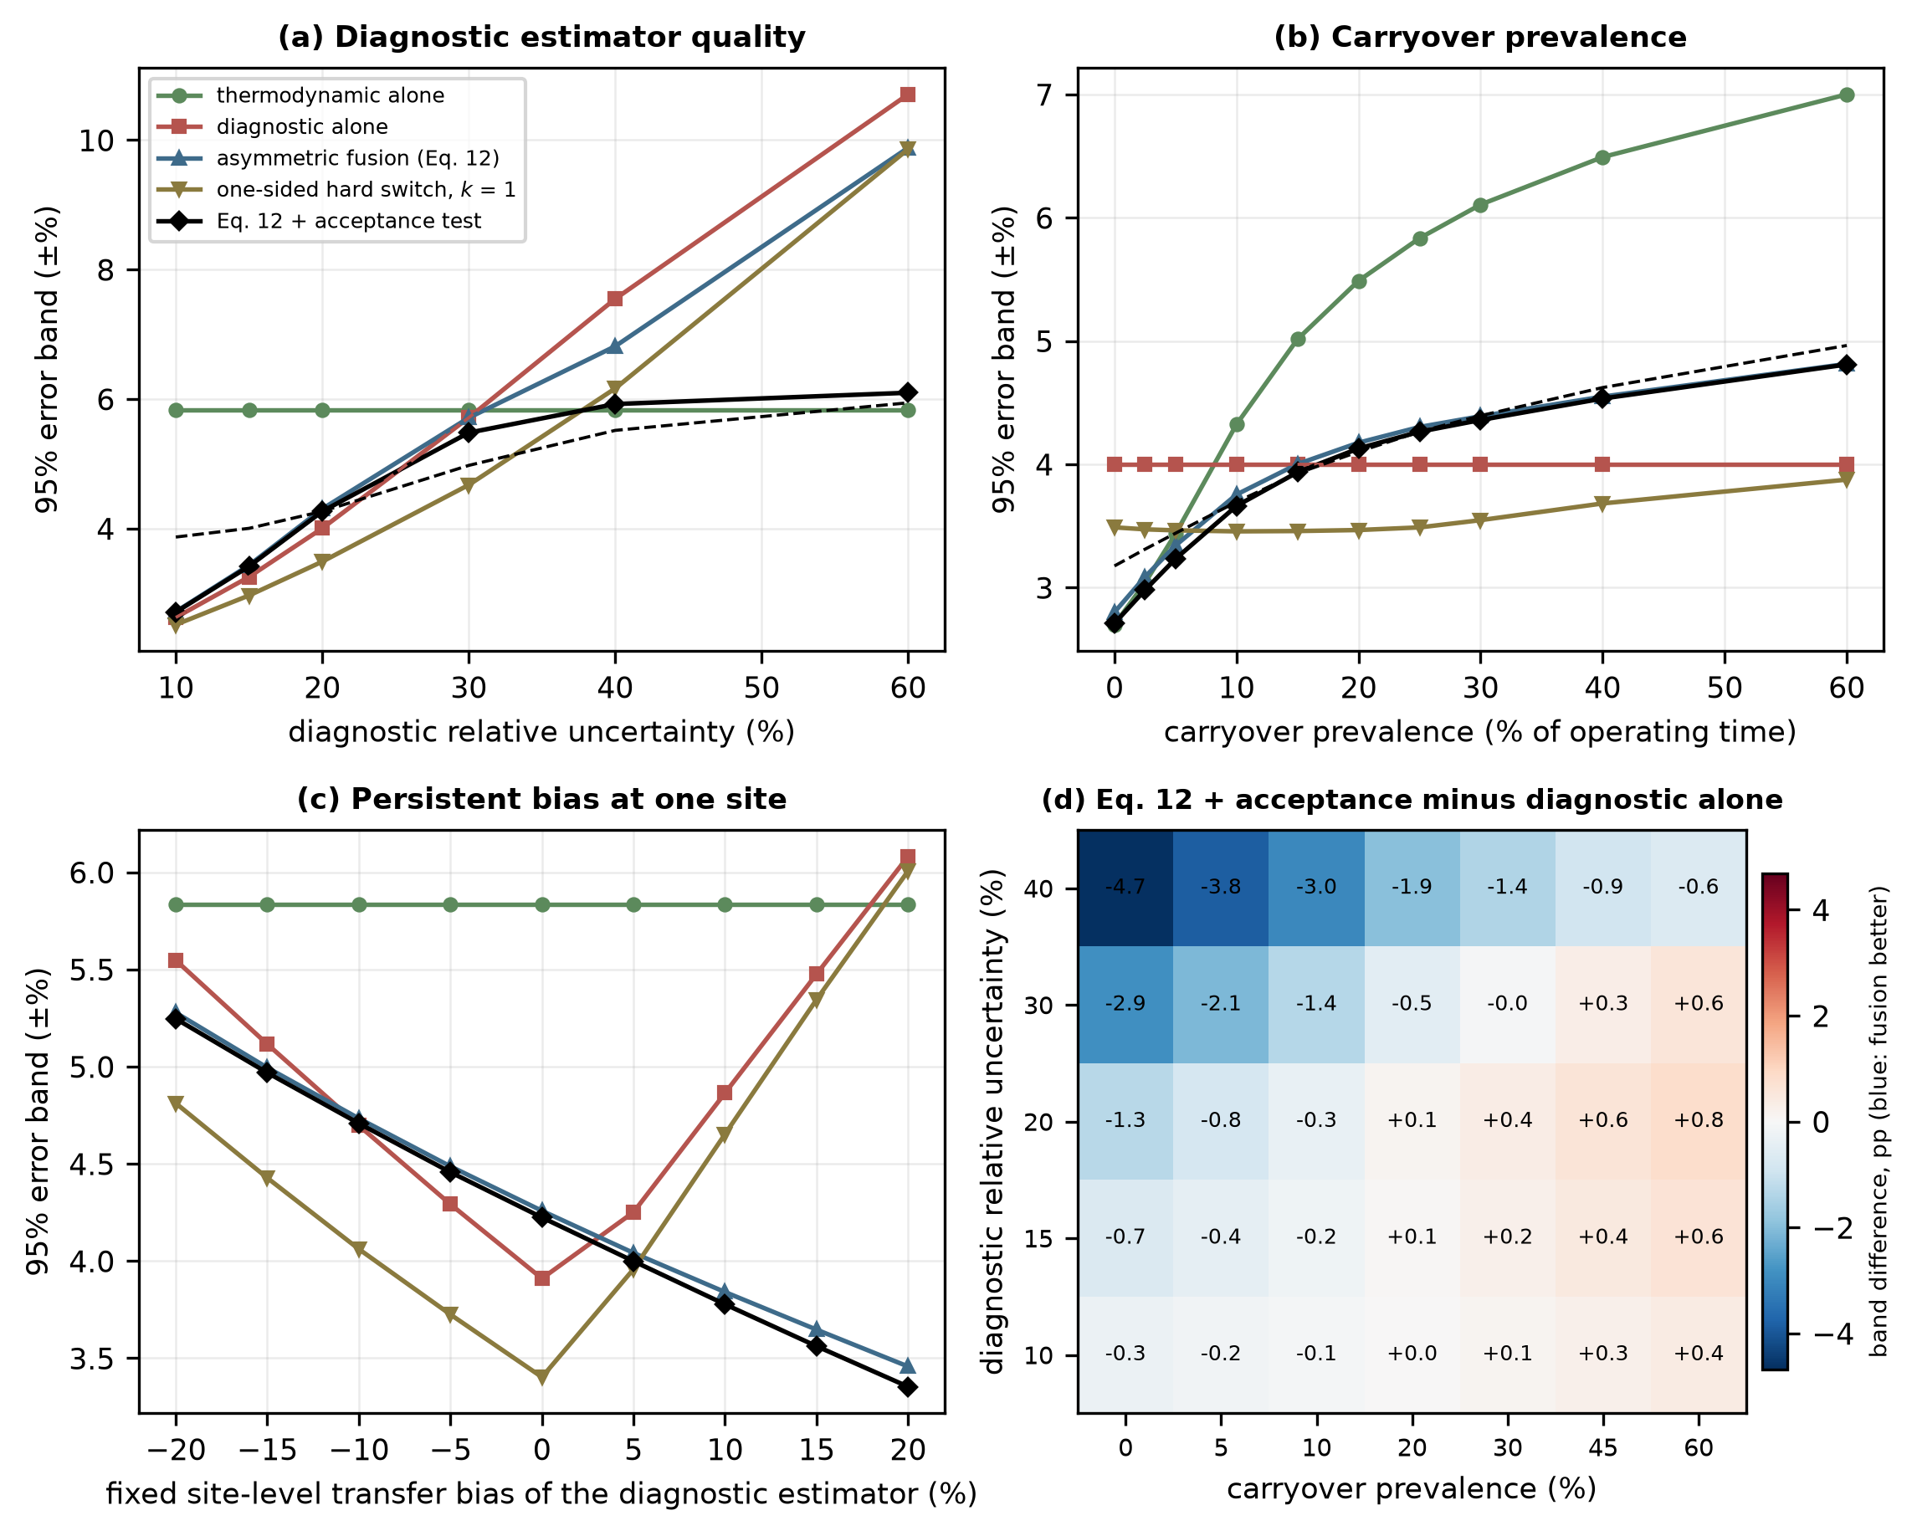
Fig. 10. Robustness of the conclusions. Common random numbers throughout. (a) Diagnostic-estimator uncertainty, declared equal to the actual value (solid) or fixed at the assumed 20% (dashed, diagnostic alone and full method). (b) Carryover prevalence, with the allowance of Eq. (8) matched to the prevalence (solid) or fixed at 25% (dashed). (c) One site with a fixed diagnostic transfer bias. (d) Full method minus diagnostic alone, in percentage points. All simulated.
5.12 Independent forward model and model-form error
The reference simulation generates the meter reading and corrects it with the same correlation, so some of the favorable performance is built in. Table 8 and Fig. 11 replace the generating model, keeping Chisholm as the correction (Section 4.5). With the independent orifice correlation of Murdock (1962), the oracle band, which isolates the correlation error alone, rises from ±1.82% to ±2.58%, the diagnostic estimator alone from ±4.00% to ±4.97%, and the full method from ±4.26% to ±5.26%, with a bias of +1.19% instead of +0.58%. The correction model contributes error that no liquid-loading estimator can remove, and the 95% error band of the whole method grows by about one percentage point.
Table 8. Simulated 95% error band (±%) and bias when the over-reading that generates the meter reading differs from the Chisholm correction. “Scaled” multiplies φ − 1 by the factor shown; “random” multiplies it by a random factor with the relative standard deviation shown. Coverage is the realized fraction of corrected values whose error lies inside the declared ±2u interval, without and with a declared model-form term of 5% of the over-reading. The perturbations are stress scenarios, not measured error bounds. Common random numbers (Section 4.5).
Generating model | Oracle | Diagnostic alone | Full method, bias | Full method, band | Coverage of ±2u | with 5% form term
Matched (Chisholm) | ±1.82 | ±4.00 | +0.58% | ±4.26 | 93.6% | 94.2%
Murdock (1962), independent | ±2.58 | ±4.97 | +1.19% | ±5.26 | 88.5% | 89.5%
Scaled by 0.90 | ±2.63 | ±4.82 | -0.14% | ±3.20 | 95.8% | 96.3%
Scaled by 0.95 | ±2.18 | ±4.31 | +0.22% | ±3.72 | 95.2% | 95.7%
Scaled by 1.05 | ±2.22 | ±4.54 | +0.95% | ±4.82 | 90.9% | 91.7%
Scaled by 1.10 | ±2.68 | ±5.10 | +1.31% | ±5.38 | 87.2% | 88.3%
Random, 5% | ±1.99 | ±4.09 | +0.58% | ±4.36 | 93.1% | 93.7%
Random, 10% | ±2.45 | ±4.38 | +0.58% | ±4.65 | 91.4% | 92.2%

Three observations qualify the headline. First, the realized coverage of the declared ±2u interval is 93.6% in the matched case, close to the nominal 95%, and falls to 88.5% with the independent correlation and 87.2% when the over-reading is scaled up by 10%; a declared model-form term of 5% of the over-reading restores only about one percentage point of it (89.5% and 88.3%). A term of about 15% of the over-reading is needed for the Murdock case to reach 94–95% coverage. The model-form allowance u_form of Eq. (16) is therefore an assumption that must be set from the spread between published correlations or from loop data, and it is larger than the 0.6% correlation residual used in the reference case. A generic allowance does not guarantee nominal coverage: the value that restores it here is specific to this pair of correlations, this meter geometry and this operating envelope, and must be calibrated for each applicable meter and set of conditions. Second, the ranking of the methods changes with the sign of the correlation error. When the true over-reading is smaller than the correction assumes (scaled by 0.90 or 0.95), the full method is narrower than the diagnostic estimator alone (±3.20% against ±4.82% at 0.90), but this is compensation of errors, since the downward bias that carryover gives the thermodynamic estimate offsets the overcorrection, and it should not be read as a benefit. When it is larger, or with the independent correlation, the diagnostic estimator alone is narrower, as in the reference case. Third, a wrong functional form cannot be rescued by the estimator: with a Venturi form (de Leeuw, 1997) as the truth, which is outside the validity of that correlation for an orifice and is shown only as a limiting case, the oracle band is ±8.76% and the full method ±11.31%, with a coverage of 24%.
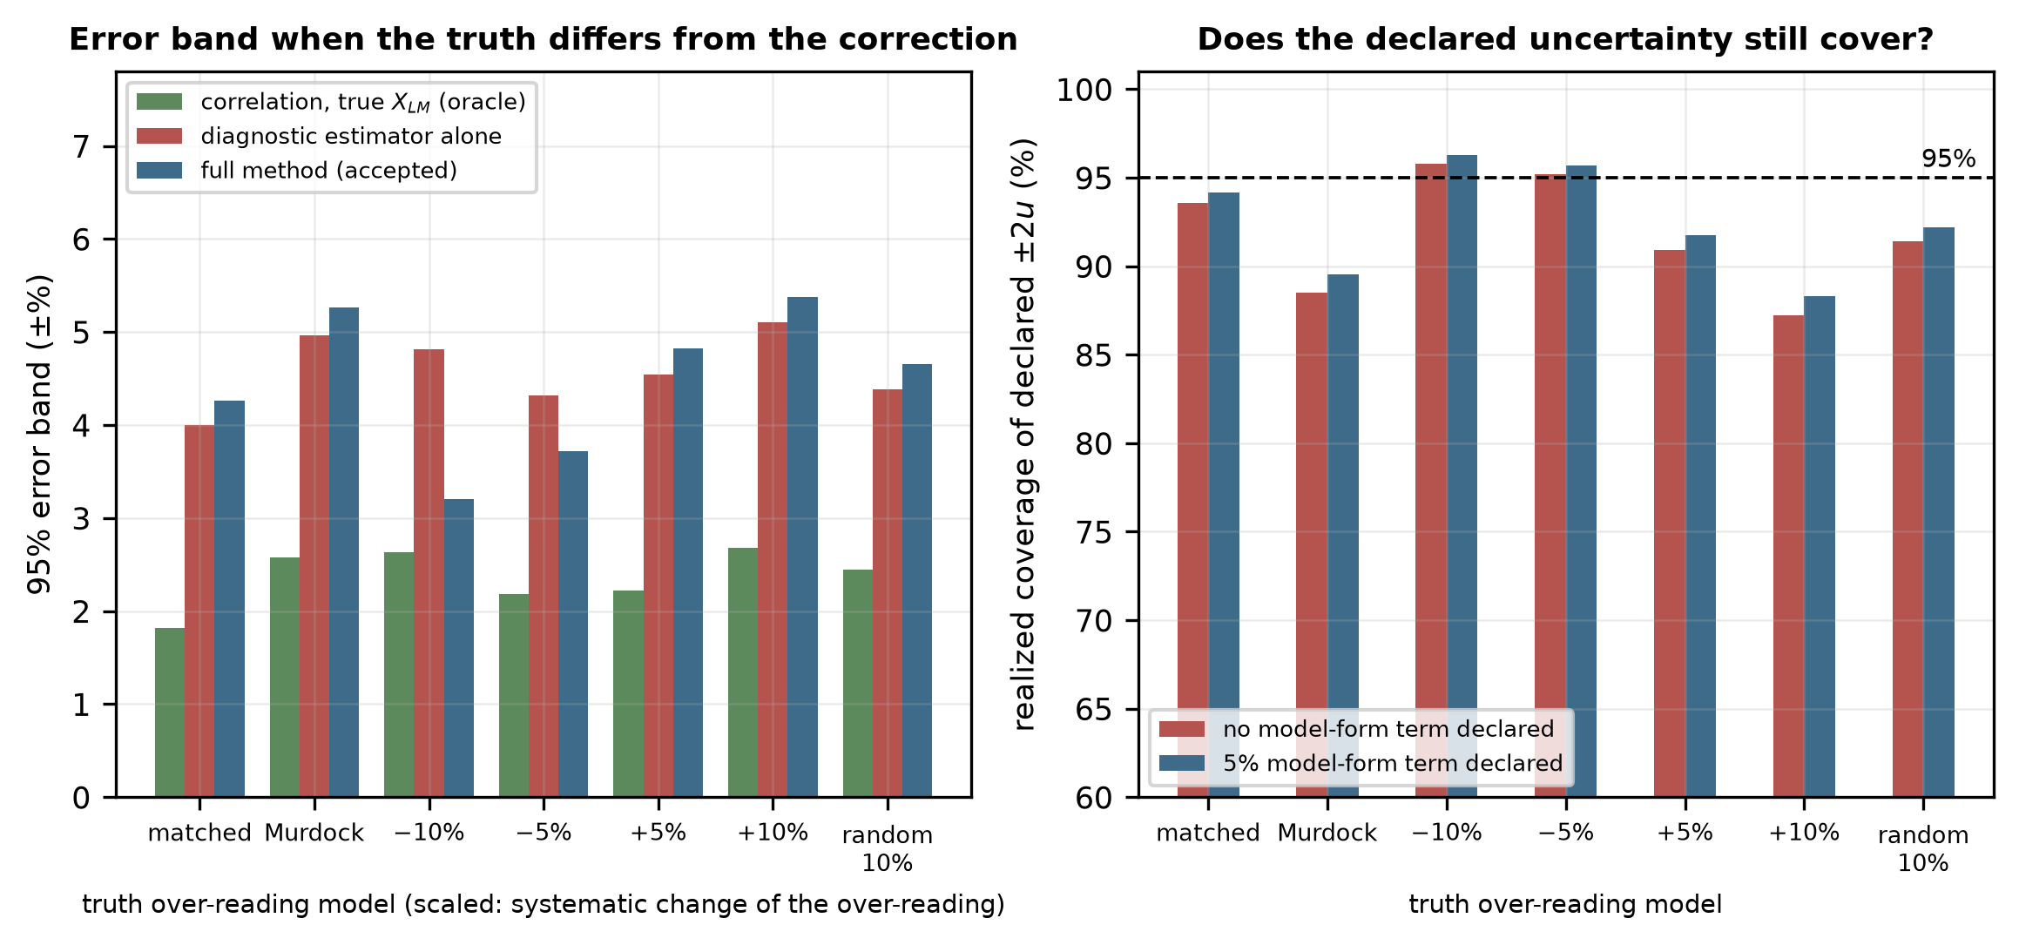
Fig. 11. Independent forward model. (a) 95% error band when the true over-reading is Chisholm (matched), Murdock (independent), scaled, or random (10%). (b) Realized coverage of the declared ±2u interval, without and with a declared model-form term of 5% of the over-reading. All simulated.
6. Discussion
6.1 Comparison with existing approaches
Table 9. Routes to a wet-gas corrected gas rate, compared by what supplies the liquid information and by what each requires.
Approach | Liquid information | Additional hardware | Experimental data required | Relation to this work
Empirical correlations | Assumed known | None | None beyond the original fit | Retained unchanged as the correction stage
Third pressure tap (Nasr et al., 2026) | Measured | Additional tapping and transmitter | Yes, for the specific geometry | Closest existing approach; adds instrumentation
Dedicated multiphase metering | Measured directly | Dedicated meter | Vendor calibration | Reference case rather than competitor
Data-driven rate prediction (Pereira et al., 2026; Hosseini et al., 2026a) | Bypassed; rates learned directly | None | Yes, covering the installation | Learns a different target; no explicit latent variable
Hybrid physics–ML over-reading (Alkhurayef and Alsarkhi, 2026a) | Bypassed; over-reading learned as a residual | None | Yes (1,868 points reported) | Closest in spirit; learns the correction rather than its input
This work | Estimated as a latent variable | None; uses existing diagnostics | Yes, to fit the diagnostic estimator before deployment | —

The distinction from Nasr et al. (2026) is the one most likely to be raised, since both target the orifice meter and both aim at quantifying liquid. They add a physical measurement point and obtain a more direct observation; the present approach attempts to extract the same information from the instrumentation already present and accepts a weaker observation in exchange. These are complementary: a third tapping, where it can be installed, would enter the framework of Section 3 as a higher-quality diagnostic estimator, and the fusion and acceptance machinery would apply unchanged.
The distinction from hybrid and data-driven work is what is learned. Those methods learn the correction; this one learns the correction's input and leaves the correlation intact. The cost is an extra inference step, and a weaker result than direct learning can achieve where training data are plentiful. The benefit is that the physical form governs extrapolation, the learned component is a single scalar with a stated uncertainty, and a second estimate of that scalar exists and can be cross-checked—which is what makes the rejection mechanism possible at all. A method that learns the over-reading directly has no second opinion to consult.
The uncertainty quantification framework of Hosseini et al. (2026b) addresses a related problem for machine-learning wet-gas metering. The difference in emphasis is that their framework quantifies the uncertainty of a learned predictor, whereas the mechanism here uses the disagreement between two structurally distinct estimators to decide whether to produce an output at all.
6.2 Practical implementation
The method is implementable as a secondary-instrumentation layer on an edge gateway adjacent to the existing flow computer, reading the transmitters, chromatograph and meter diagnostics and publishing the corrected rate, its uncertainty, the fused liquid loading and the status flag. Because it is realized in software and reads existing signals, it introduces no additional process restriction and therefore no additional pressure drop.
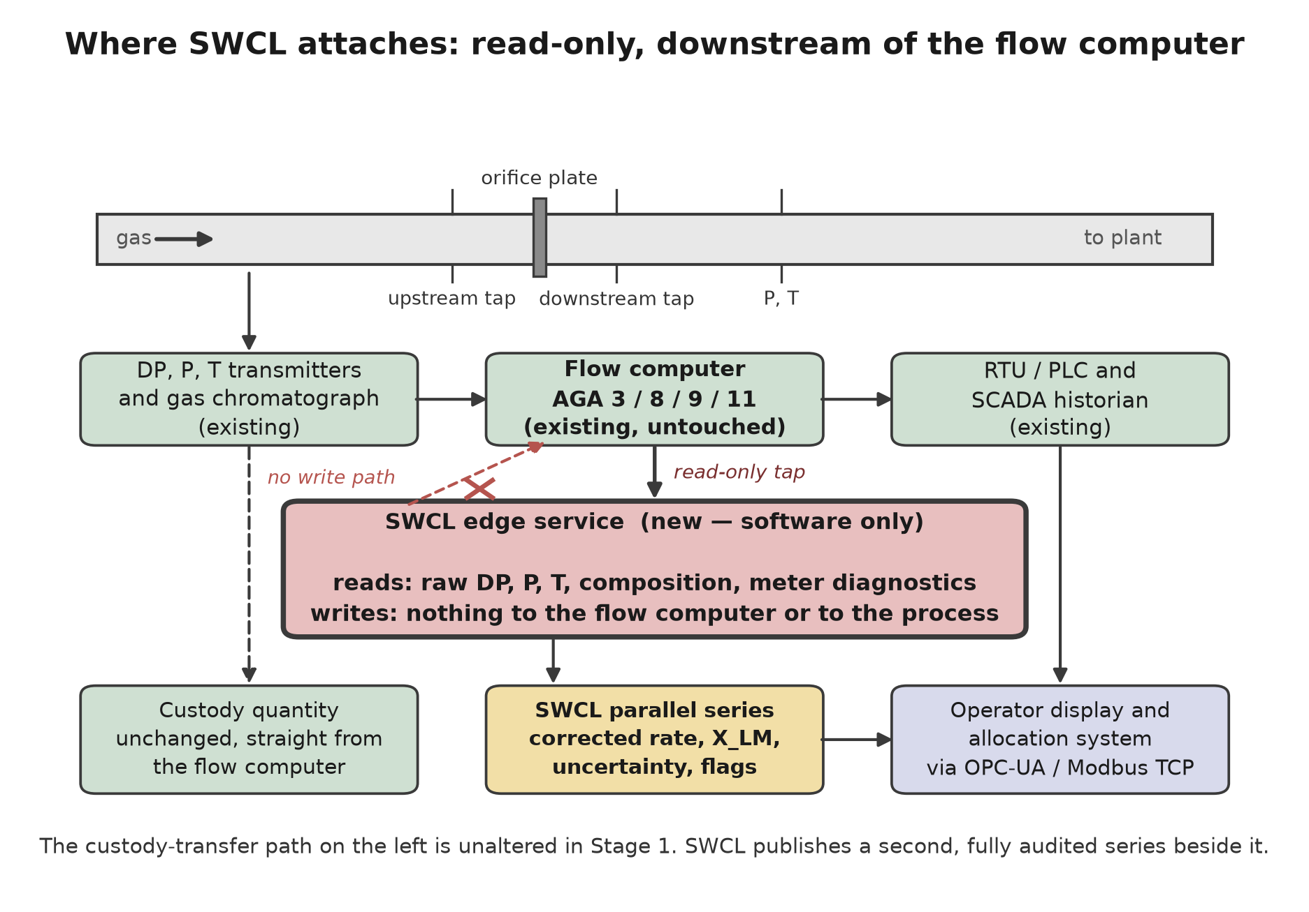
Fig. 12. Implementation as a secondary instrumentation layer. The path to the flow computer is read-only; thus, a fault in the correction layer cannot alter the primary measurement.
Two properties matter for an installed measurement system. The failure mode of the loss of the layer is the present-day behavior of the meter. In addition, the rejection mechanism means that the layer declines to answer rather than answering unreliably, which is the behavior a measurement system should exhibit when its assumptions are not met.
Minimum signal set. For the orifice case the diagnostic estimator requires the signals the flow computer already reads — line pressure, temperature, differential pressure and indicated rate — the gas density from the composition, a composition measurement for the thermodynamic estimator, and the high-rate differential-pressure signal from which σ_ΔP is computed. The permanent pressure loss ratio needs a downstream tapping. Where it is absent the feature vector of Eq. (6) loses its recovery term, the diagnostic estimator becomes less informative, and its declared uncertainty must be widened before the framework is used; the size of the widening can be known only from a fit without that feature. As an indication, Fig. 10a shows that if the actual relative uncertainty were 30% instead of 20%, the full method would reach ±5.48% (±4.97% if the 20% declaration were retained), against ±5.71% for the diagnostic estimator alone and ±5.83% for the thermodynamic estimator alone. Without the high-rate differential-pressure signal the diagnostic estimator is not specified by this paper, and the method is not supported; the thermodynamic estimator would then be the only estimator and no consistency test would be available.
6.3 Generalization to other meter types
The architecture is meter-agnostic, but the diagnostic estimator is not. For multipath ultrasonic meters, the natural features are the deviation of the measured speed of sound from the value computed from the composition (AGA Report No. 10), gain levels, signal-to-noise ratio, and per-path velocity ratios, since the liquid film degrades near-wall chords before the mid-radius chords. For Coriolis meters, they are the drive gain and the deviation of the indicated mixture density from the equation-of-state gas density.
These are extension pathways, not results. No computational assessment of either is presented, and the Coriolis case is expected to be harder: resolving gas from total mass requires the liquid fraction to a tighter tolerance than a differential-pressure meter does.
Table 10 separates what is demonstrated by the simulations from what is proposed. The demonstrated envelope is an orifice plate in a 154 mm line, one rich-gas composition family, 60–85 kgf/cm² (5.9–8.3 MPa) and 30–60 °C, with liquid loadings X_LM from 0.006 to 0.152 (5th–95th percentile 0.013–0.125) in the annular-mist regime; nothing is claimed outside it.
Table 10. Scope of the results: what the simulations demonstrate and what is proposed but not evaluated.
Aspect | Demonstrated by simulation in this paper | Proposed, not evaluated
Meter | Orifice plate, Chisholm correction (n = 0.25), 154 mm line | Venturi, cone, multipath ultrasonic and Coriolis meters (Section 6.3)
Pressure and temperature | 60–85 kgf/cm² (5.9–8.3 MPa); 30–60 °C | Other pressures, temperatures and line sizes
Fluid | One rich-gas composition family; gas density 48–86 kg/m³; condensate 640–720 kg/m³ | Lean gases, other condensates, produced water or glycol
Flow regime | Annular-mist; X_LM 0.006–0.152; Fr_G 1.8–5.7 | Slug, stratified and transitional flow (detection and suspension only)
Diagnostic signals | P, T, ΔP, σ_ΔP, PLR (downstream tapping), indicated rate, gas density; performance assumed (20% ± 6% bias) | Operation without a downstream tapping; a fitted estimator
Forward model | Chisholm (matched); Murdock and scaled or random departures as stress tests | Experimentally measured over-reading
Evidence | Monte Carlo simulation, 300,000 realizations per configuration | Wet-gas loop validation (Section 4.4)

6.4 Limitations
- No experimental wet-gas data were used. Every result is a modeled uncertainty. In the reference case the over-reading correlation is both the forward model and the correction. Section 5.12 replaces the forward model with an independent published orifice correlation and with systematic and random departures of 5–10%, and finds that the error band grows by about one percentage point and the realized coverage of the declared interval falls below 90% unless a model-form allowance of about 15% of the over-reading is declared. That allowance is specific to the correlation pair, meter geometry and conditions tested and must be calibrated for each application; a generic value cannot guarantee nominal coverage. Those scenarios are stress tests and not measured error bounds; an independent experimental reference is required to remove the circularity.
- The diagnostic mapping f_θ is specified in Section 3.3.1 but not fitted. Its assumed 20% relative uncertainty and 6% transfer bias are the most consequential assumptions in the paper: the ablation of Table 3 and the design rule of Section 5.6 depend on the relative standing of u₁ and u₂. Section 5.11 varies them: a diagnostic estimator that is better than assumed makes the diagnostic estimator alone the best choice, and one that is worse moves the crossing points of Fig. 6 and makes the full method narrower than the diagnostic estimator alone. The conversion from the specified predictive interval to the standard uncertainty (Section 3.3.1) is a convention and must be confirmed on fitted data.
- The carryover model is an assumption. Section 5.6 examines the sensitivity of the conclusions to its prevalence directly, and the qualitative conclusions hold across the range examined, but the specific figures in Table 3 are conditional on p = 0.25.
- ρ₁₂ is treated as a parameter rather than estimated from the data. Its value at a real installation is unknown until the joint residuals are measured, which is why Section 4.4 makes that measurement part of the validation protocol.
- Diagnostic availability is installation dependent. The permanent pressure loss ratio requires a downstream tapping that not every meter run has; where absent, u₂ widens, and the framework must reflect that rather than proceed unchanged.
- The weighting rule and its threshold are not established. Section 5.10 shows that k = 1 is not the best threshold and that a hard one-sided switch is narrower than Eq. (12) in the reference case; Eq. (12) is a smooth baseline and the switch an alternative that needs independent validation, especially of its switching threshold. The choice depends on carryover statistics and on the fitted diagnostic estimator, and is a matter for loop calibration.
- The consistency index at Z_max = 3 has a sensitivity of about 3% for carryover (Section 5.9). It is a gross-disagreement flag and should not be presented as a carryover detector; a lower threshold increases sensitivity at the cost of false rejections (Table 4).
- Slugging and flow-regime transitions are not modeled. The correlations used are valid in the annular-mist region; operation outside it requires detection and suspension rather than extrapolation.
- The results are for the orifice case at one composition family and one line size. The Chisholm form has no explicit Froude dependence, which limits what Fig. 8 can say about the Froude axis.
7. Conclusions
Wet-gas corrections for differential-pressure meters are mature, and the obstacle to applying them at an installed metering station is not the correlation but its input. In this paper, liquid loading is treated as a latent variable to be estimated from information already present at the station, rather than treating the over-reading as a quantity to be learned from experimental data.
A Monte Carlo study over a rich-gas envelope yields the following simulation results. Correction reduces the 95% error band of the orifice case from ±14.94% to ±4.26% (±4.28% over all realizations before the acceptance test), against ±1.82% for the same correlation supplied with the true liquid loading, and against ±3.99% for the diagnostic estimator alone. Fusion therefore does not improve on the diagnostic estimator alone in the reference case; it does so when carryover occupies less than about 16% of operating time, when the diagnostic estimator is poorer than assumed, or when it carries a persistent positive bias. Combining a thermodynamic and a diagnostic estimate requires the thermodynamic estimator to declare an uncertainty that includes the upstream carryover it cannot observe; without that allowance, inverse-variance fusion is worse (±5.45%) than the diagnostic estimator alone. A one-sided damping rule improves on symmetric weighting, but k = 1 is not the best threshold, and a hard one-sided switch is narrower in the reference case.
At the adopted threshold the consistency index has a precision of 94% for carryover, which occurs in 25% of the simulated realizations, and a sensitivity of 3%: it rejects very few realizations and nearly all contain carryover, but it misses most of the carryover that is present, and it responds mainly to large carryover. It is a gross-disagreement flag rather than a carryover detector, and a lower threshold trades completeness for sensitivity. Because the two estimates are not statistically independent, the covariance term must be retained in the index; omitting it does not degrade the test gracefully but progressively disables it so that it accepts everything.
The corrected rate is about ten times more sensitive to a relative change in gas density or differential pressure than to one in liquid loading, yet the liquid-loading estimate is the largest single contribution to the combined standard uncertainty (40% of its variance at X_LM = 0.05 and 70% at 0.10) because its relative uncertainty, 15%, is about thirty times larger. Sensitivity coefficients and uncertainty contributions must be reported together. Replacing the matched forward model by an independent orifice correlation widens the error band by about one percentage point and lowers the realized coverage of the declared interval to 89% unless a model-form allowance is declared, and that allowance must be calibrated for the meter geometry and conditions: a generic value cannot guarantee nominal coverage.
These are modeled uncertainties, not measured accuracies. Section 4.4 specifies the loop experiment that would convert them, including the comparison that isolates the estimator from the correlation and the criteria that would refute the framework.
CRediT authorship contribution statement
Leon Sandler: Conceptualization, Methodology, Software, Formal analysis, Investigation, Visualization, Writing – original draft, Writing – review & editing.
Declaration of Competing Interest
The author declares no known competing financial interests or personal relationships that could have appeared to influence the work reported in this paper.
Funding
This research received no specific grant from funding agencies in the public, commercial, or not-for-profit sectors.
Data availability
No experimental data were used. The entire quantitative content of this paper is computational, and the complete reproducibility package — the Python implementation, the simulation configuration, the random seeds, the figure generators and the generated summary data — is openly available at https://github.com/sandlerleon/hybrid-liquid-loading-estimation and permanently archived at https://doi.org/10.5281/zenodo.22760863. Running the deposited scripts reproduces every table and figure in this paper; the analyses added in the revision (Sections 5.9–5.12, Table 4 and Figs 9–11) are produced by fmi_revision_analysis.py, and verify_revision.py runs the checks of the revision code. A preprint of the manuscript is available on ChemRxiv at https://doi.org/10.26434/chemrxiv.15009070/v1.
Declaration of generative AI in the writing process
During the preparation of this work, the author used Claude (Anthropic) to assist with literature synthesis, analysis design, writing of the simulation code and drafting, including the additional experiments and the revision of the text. After using this tool, the author reviewed and edited the content as needed, verified the cited literature, checked the code against executable tests, and takes full responsibility for the content of the publication. No AI tool is listed as an author.
References
Alkhurayef, A., Alsarkhi, A., 2026a. A new hybrid physics–ML model for predicting over-reading in differential pressure measurements under wet gas flow. Flow Meas. Instrum. 111, 103465. https://doi.org/10.1016/j.flowmeasinst.2026.103465
Alkhurayef, A., Al-Sarkhi, A., AbdulMajeed, G., Gajbhiye, R., 2026b. A comprehensive review of wet gas flow correlations for Venturi meter. Flow Meas. Instrum. 109, 103224. https://doi.org/10.1016/j.flowmeasinst.2026.103224
American Gas Association, Report No. 3 / API MPMS Chapter 14.3. Orifice Metering of Natural Gas and Other Related Hydrocarbon Fluids.
American Gas Association, Report No. 8. Thermodynamic Properties of Natural Gas and Related Gases.
American Gas Association, Report No. 9. Measurement of Gas by Multipath Ultrasonic Meters.
American Gas Association, Report No. 10. Speed of Sound in Natural Gas and Other Related Hydrocarbon Gases.
American Gas Association, Report No. 11 / API MPMS Chapter 14.9. Measurement of Natural Gas by Coriolis Meter.
Birge, R.T., 1932. The calculation of errors by the method of least squares. Phys. Rev. 40, 207–227. https://doi.org/10.1103/PhysRev.40.207
Chisholm, D., 1977. Research note: two-phase flow through sharp-edged orifices. J. Mech. Eng. Sci. 19, 128–130. https://doi.org/10.1243/jmes_jour_1977_019_027_02
de Leeuw, R., 1997. Liquid correction of Venturi meter readings in wet gas flow. North Sea Flow Measurement Workshop, Kristiansand.
Dranchuk, P.M., Abou-Kassem, J.H., 1975. Calculation of Z factors for natural gases using equations of state. J. Can. Pet. Technol. 14 (3). https://doi.org/10.2118/75-03-03
Fawcett, T., 2006. An introduction to ROC analysis. Pattern Recognit. Lett. 27, 861–874. https://doi.org/10.1016/j.patrec.2005.10.010
Gajan, P., Decaudin, Q., Couput, J.P., 2015. Analysis of high pressure tests on wet gas flow metering with a Venturi meter. Flow Meas. Instrum. 44, 126–131. https://doi.org/10.1016/j.flowmeasinst.2014.12.004
He, D., Chen, S., Bai, B., 2019. A V-Cone meter measurement correlation in low pressure wet gas based on Chisholm model. Flow Meas. Instrum. 66, 12–17. https://doi.org/10.1016/j.flowmeasinst.2019.01.019
Holland, P.W., Welsch, R.E., 1977. Robust regression using iteratively reweighted least-squares. Commun. Stat. Theory Methods 6, 813–827. https://doi.org/10.1080/03610927708827533
Hosseini, S., Chinello, G., Lindsay, G., Loweimi, E., Ansari, M.A., McGlinchey, D., 2026a. Transfer learning for data-driven wet gas flow metering: enhancing generalisation in digital measurement systems. Flow Meas. Instrum. 108, 103146. https://doi.org/10.1016/j.flowmeasinst.2025.103146
Hosseini, S., Chinello, G., Lindsay, G., McGlinchey, D., 2026b. A robust uncertainty quantification framework for machine learning–based wet-gas flow metering. Measurement 269, 120670. https://doi.org/10.1016/j.measurement.2026.120670
Huber, P.J., Ronchetti, E.M., 2009. Robust Statistics, 2nd ed. Wiley, Hoboken. https://doi.org/10.1002/9780470434697
ISO 5167 (all parts). Measurement of fluid flow by means of pressure differential devices inserted in circular cross-section conduits running full.
ISO/TR 11583:2012. Measurement of wet gas flow by means of pressure differential devices inserted in circular cross-section conduits.
JCGM 100:2008. Evaluation of measurement data — Guide to the expression of uncertainty in measurement.
JCGM 101:2008. Evaluation of measurement data — Supplement 1 to the “Guide to the expression of uncertainty in measurement” — Propagation of distributions using a Monte Carlo method.
Kunz, O., Wagner, W., 2012. The GERG-2008 wide-range equation of state for natural gases and other mixtures. J. Chem. Eng. Data 57, 3032–3091. https://doi.org/10.1021/je300655b
Liu, W., Ma, Y., Lyu, J., Shao, J., Wang, S., 2020. Wet gas pressure drop across orifice plate in horizontal pipes in the region of flow pattern transition. Flow Meas. Instrum. 71, 101678. https://doi.org/10.1016/j.flowmeasinst.2019.101678
Lockhart, R.W., Martinelli, R.C., 1949. Proposed correlation of data for isothermal two-phase, two-component flow in pipes. Chem. Eng. Prog. 45 (1), 39–48.
Murdock, J.W., 1962. Two-phase flow measurement with orifices. J. Basic Eng. 84, 419–432. https://doi.org/10.1115/1.3658657
Nasr, M., Chacon, P., Brenskelle, L., Pereyra, E., 2026. Use of third pressure tap for liquid detection and quantification in an orifice plate meter for gas-liquid systems. Flow Meas. Instrum. 110, 103354. https://doi.org/10.1016/j.flowmeasinst.2026.103354
Pan, Y., Hong, Y., Sun, Q., Zheng, Z., Wang, D., Niu, P., 2019. A new correlation of wet gas flow for low pressure with a vertically mounted Venturi meter. Flow Meas. Instrum. 70, 101636. https://doi.org/10.1016/j.flowmeasinst.2019.101636
Peng, D.-Y., Robinson, D.B., 1976. A new two-constant equation of state. Ind. Eng. Chem. Fundam. 15, 59–64. https://doi.org/10.1021/i160057a011
Pereira, L.O.V., Farias, M.H., Rocha, W.F.d.C., Franco, L.G., Ramos, R., 2026. Machine learning-based prediction of gas and liquid flow rates in wet gas using single and dual cone meter configurations. Flow Meas. Instrum. 111, 103453. https://doi.org/10.1016/j.flowmeasinst.2026.103453
Steven, R.N., 2002. Wet gas metering with a horizontally mounted Venturi meter. Flow Meas. Instrum. 12, 361–372. https://doi.org/10.1016/S0955-5986(02)00003-1
Vovk, V., Gammerman, A., Shafer, G., 2005. Algorithmic Learning in a Random World. Springer, New York.
Zheng, X., He, D., Bai, B., 2019. Pressure drop of wet gas flow with ultra-low liquid loading through DP meters. Flow Meas. Instrum. 70, 101664. https://doi.org/10.1016/j.flowmeasinst.2019.101664

