Hybrid Physics–Diagnostic Estimation of Liquid Loading for Wet-Gas Flowmeter Correction: A Model-Based Uncertainty Framework
Leon Sandler
Independent Researcher, Northbrook, Illinois, USA
ORCID: https://orcid.org/0009-0007-4584-808X
Corresponding author: sandler.leon@gmail.com

Abstract
Wet-gas corrections for differential-pressure flowmeters express the indicated gas rate as the true rate multiplied by an over-reading factor that depends on the Lockhart–Martinelli parameter, which most metering stations do not measure. Here, the liquid loading is treated as a latent variable and estimated from two structurally distinct sources already at the station: a thermodynamic flash prediction from composition, pressure and temperature and a regression on the meter's own diagnostic signals. The two estimates are fused under an uncertainty budget that includes upstream liquid carryover, which the flash cannot see, and their disagreement, a consistency index, determines whether the correlation is applied. The study is computational: no loop data were used, and the diagnostic estimator is specified but not fitted, so every result is a modeled uncertainty. Over 300,000 Monte Carlo realizations of an orifice meter in a rich-gas envelope (60–85 kgf/cm², 30–60 °C), correction narrows the 95% error band from ±14.94% to ±4.26% (±4.28% before the acceptance test), against ±1.82% with the true liquid loading and ±3.99% for the diagnostic estimator alone. Fusion therefore improves on the diagnostic estimator only when carryover occupies less than approximately 16% of the operating time, when the diagnostic estimator is poorer than assumed, or when it has a persistent positive bias. At the adopted threshold, the consistency index has 94% precision but 3% sensitivity for carryover: it flags gross disagreement rather than detecting carryover. An independent orifice correlation in the forward model widens the band to ±5.26%. A falsifiable loop experiment is specified.
Keywords
Wet gas metering; Liquid loading estimation; Lockhart–Martinelli parameter; Differential pressure flowmeter; Uncertainty quantification; Estimator fusion
1. Introduction
Single-phase gas flowmeters are widely installed on streams that carry entrained liquid. In a differential-pressure meter, the liquid raises the measured differential pressure above its dry-gas value, so a flow computer that correctly applies ISO 5167 [1] or AGA Report No. 3 [2] reports a gas rate that is too high. The error is not marginal: for a rich gas at typical production pressures, condensate–gas ratios of 50 and 100 bbl/MMscf give over-readings of approximately 8% and 16% on the Chisholm multiplier. For a fiscal or allocation measurement, an error of this size is not a refinement of the uncertainty budget but its dominant term.
The over-reading itself is well characterized. Murdock [3] and Chisholm [4] established the form of the two-phase multiplier for orifice plates; de Leeuw [5] and Steven [6] extended it to Venturi meters with an explicit dependence on the gas Froude number; ISO/TR 11583 [7] codifies the approach; and Alkhurayef et al. [8] review the correlation literature for Venturi meters. Later correlations have improved the treatment of the density ratio, the Froude number and the geometry for V-cone meters at low pressure [9] and vertically mounted Venturi meters [10], and high-pressure behavior [11] and ultra-low liquid loading [12] have been examined experimentally. All of these share one structural feature. The over-reading is expressed as a function of the Lockhart–Martinelli parameter [13], which is a property of the flow rather than of the meter and which the meter does not measure. The correlations are accurate when the liquid loading is known and undefined when it is not.
Three responses to the missing input have developed. The first adds a measurement. Nasr et al. [14] instrumented an orifice plate with a third pressure tap and used the additional pressure information to detect and quantify the liquid, with the gas rate predicted to within approximately 3% over the range tested; this is the closest existing approach to the one developed here. A dedicated multiphase or wet-gas meter measures the phases directly, but it resolves the ambiguity by instrumentation at a cost and footprint that a large installed base of single-phase meters cannot absorb, and it is better regarded as a reference than as a competitor. The second response learns from data: Pereira et al. [15] predict the gas and liquid rates from cone-meter pressure information with machine learning, Hosseini et al. [16] address the generalization of such models with transfer learning, and the same group has developed an uncertainty quantification framework for machine-learning wet-gas metering [17]. The third response is hybrid: Alkhurayef and Alsarkhi [18] combined a physical over-reading model with a learned residual trained on 1,868 experimental points, which is the most direct recent precedent for coupling a correlation with a data-driven term.
The mature correlation literature therefore solves the problem of computing the correction once the liquid loading is known, whereas the practical difficulty at an installed station is the preceding step. The data-driven and hybrid methods address that step by learning the over-reading, or the flow rates, directly from experimental datasets, which must then cover the geometry, fluid and operating range of the installation. An alternative has not been examined: to learn the input of the correlation rather than its output and to obtain that input by two independent routes so that the disagreement between them can be measured and used to decide whether a correction should be applied at all.
This study develops and tests such a framework for an orifice meter. The liquid loading is treated as a latent variable and estimated from information already present at the station, by a thermodynamic prediction and by an estimate from the meter's diagnostic signals, and the established correlation is retained unchanged to convert the estimate into a correction. This preserves the physical form of the correlation and its extrapolation behavior, and it confines the data-driven element to a single scalar whose uncertainty can be stated and propagated. Three questions are posed. How much of the over-reading error is removed when the liquid loading is estimated rather than measured, and how does the result decompose among the elements of the method? Under what conditions does the combination of the two estimators outperform either alone? And can the disagreement between them identify the cases in which the correction should be withheld? The answers are, respectively, that correction narrows the simulated 95% error band from ±14.94% to ±4.26%, against ±1.82% for the correlation supplied with the true liquid loading; that fusion outperforms the diagnostic estimator alone only when carryover is infrequent, when the diagnostic estimator is poorer than assumed or when it has a persistent positive bias, and not in the reference case; and that the consistency index is a high-precision, low-sensitivity flag of gross disagreement rather than a detector of carryover.
The novelty claimed is that of the integrated estimation-and-decision framework, not of any single component: the thermodynamic flash, the diagnostic regression and generalized least-squares fusion are each established. It has four parts. First, the thermodynamic estimator is given an uncertainty budget that includes the upstream carryover it cannot observe, and the study shows that inverse-variance fusion is worse than the diagnostic estimator alone without it (Section 4.2). Second, a one-sided damping rule addresses that failure mode and is compared with alternative weighting rules and thresholds, including the diagnostic estimator alone (Section 4.9). Third, a covariance-aware consistency index determines whether the correction is applied; it is characterized as a detector, and the cost of ignoring the covariance is quantified (Sections 4.3, 4.4 and 4.8). Fourth, the estimator uncertainty and an allowance for model-form error are propagated to the corrected gas rate, and the realized coverage of the declared interval is tested against an independent forward model (Section 4.11). The diagnostic estimator is specified in enough detail to be fitted and reproduced, and the code is deposited so that every number in the paper can be regenerated.
The status of the results is stated at the outset. This is a model-based study. No experimental wet-gas data were used, the diagnostic estimator was specified but not fitted, and every performance figure is a modeled uncertainty conditional on the assumptions of Section 3.2, not a demonstrated measurement accuracy; Section 5.3 separates what the simulations demonstrate from what is proposed. The central hypothesis is nevertheless falsifiable. An independently trained diagnostic estimator should recover the liquid loading within the uncertainty assumed here, and disagreement between the two estimates should preferentially identify the cases in which the liquid arrived from upstream rather than condensing locally. Section 5.5 specifies the loop experiment and the criteria under which the framework would be refuted.
2. Estimation and decision architecture
The architecture examined here is shown in Fig. 1. Two estimators of the Lockhart–Martinelli parameter X_{LM} operate on different information; a fusion step combines them and quantifies their disagreement, and an acceptance test determines whether the established correction is applied. Periodic reference data act on the estimators through calibration and not on the real-time correction path.
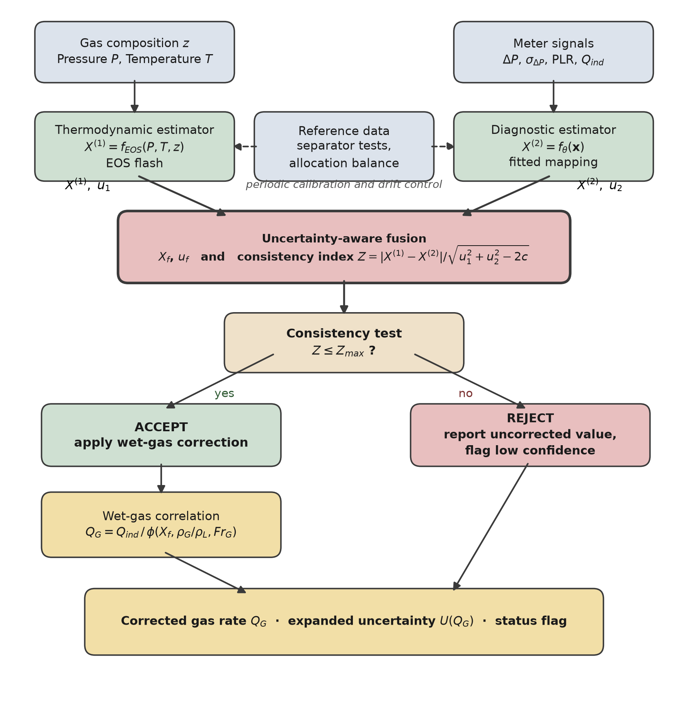
Fig. 1. Estimation and decision flow. The two estimators draw on structurally distinct information, so their disagreement is informative. Reference data act on the estimators through periodic calibration rather than on the real-time correction path.
2.1 The measurement problem
For a differential-pressure meter in wet gas, the indicated gas rate is the true gas rate multiplied by an over-reading factor φ that depends on X_{LM}, on the density ratio ρ_{G}/ρ_{L} and on the gas densiometric Froude number Fr_{G} (Eqs. (1)–(3), Section 3). These relations contain two unknowns, the gas rate Q_{G} and the liquid mass flow rate ṁ_{L}, whereas a single-phase meter supplies one measurement. The system is underdetermined, and no processing of that measurement alone resolves it. The problem addressed is therefore to estimate X_{LM} from process and meter information already available at the station to quantify the uncertainty of that estimate and to propagate it to a defensible uncertainty on the corrected gas rate.
The Chisholm multiplier, Eq. (4), is the correction model for the orifice case throughout; the de Leeuw form, with its Froude-dependent exponent, is available for the Venturi and cone geometries. The choice of correlation is not the subject of the study, since the estimator developed below supplies the input that any of them requires. The model that generates the simulated meter reading is a separate choice, and Section 3.2 varies it.
2.2 Thermodynamic estimator
The first estimator predicts the liquid that condenses from the gas under the conditions of the meter, Eq. (5). The calculation is a standard isothermal flash: the composition is taken from the station chromatograph, the local pressure and temperature are measured, the phase equilibrium is computed with a cubic or reference equation of state [19–21], and the condensed mass fraction and both phase densities give X_{LM} through Eq. (3). The estimator is predictive rather than observational. Its error sources — composition uncertainty and the characterization of the C6+ fraction, the limitations of the equation of state, departure from phase equilibrium at the meter, the representativeness of sampling, and errors in the local pressure and temperature — can bias it in either direction.
One failure mode is systematic and unidirectional at the population level, and it is treated separately. A flash calculation represents the liquid that the local stream should drop under the stated conditions. It does not represent liquid introduced from upstream, by carryover past a separator or re-entrainment from a low point, because that liquid is not a thermodynamic property of the local stream. The dominant unmodeled failure of the thermodynamic estimator is therefore an underestimation caused by externally introduced liquid. This is a statement about one mechanism, not a claim that the calculation cannot err in the other direction for the reasons listed above.
2.3 Diagnostic estimator
The second estimator infers the liquid loading from the behavior of the meter itself. For the orifice case its features, Eq. (6), are the line pressure and temperature, the differential pressure and its standard deviation σ_{Δ P} over the averaging window, the permanent pressure loss ratio PLR where downstream tapping exists, the indicated rate and the gas density, and the mapping to X_{LM} is Eq. (7). The fluctuation statistics carry information because the variance of the differential pressure responds to the formation of a liquid film before its mean shifts appreciably, and the permanent pressure loss responds because the film alters the pressure recovery downstream of the plate [12,22].
The thermodynamic estimate is deliberately excluded from the diagnostic features. Including it would allow the mapping to learn where the thermodynamic prediction is reliable, but it would also correlate the two estimates, and Section 4.4 shows that such correlation degrades the acceptance test on which the architecture depends. The two estimators are therefore structurally distinct by construction. They are not guaranteed to be statistically independent because both respond to pressure, temperature and gas density, and the covariance between them is retained explicitly in the fusion (Section 3) rather than assumed away.
The diagnostic model is not fitted in this study. It is, however, specified in enough detail to be fitted and reproduced (Table 1) because an estimator that cannot be reproduced cannot be falsified.
Element | Specification | Reason
Model class | Gradient-boosted regression trees with monotonic constraints, or a constrained generalized additive model | Both admit hard monotonicity constraints and handle the modest feature count without the data volume a neural network would require
Target | X_{LM} from the reference metering of the calibration facility | The latent variable itself, not the over-reading
Output transform | Softplus, guaranteeing X⁽²⁾ > 0 | A negative liquid loading is unphysical and must be impossible by construction, not merely unlikely
Monotonic constraints | Nondecreasing in σ_{Δ P} and in PLR at fixed P, T, ρ_{G} | Imposes the physical direction of the diagnostic response and disciplines extrapolation
Loss | Pinball (quantile) loss at the 0.05, 0.50 and 0.95 quantiles | Yields a predictive interval directly, rather than a point estimate to which an uncertainty must afterwards be attached
Uncertainty | u₂ from the fitted quantile spread, calibrated by split conformal prediction on a held-out fold | Conformal calibration gives finite-sample coverage without assuming the residual distribution
Data split | Grouped by operating condition (X_{LM} and Fr_{G} combination), not by random point | Random splitting of loop data leaks information between folds, because repeat points at one condition are near-duplicates, and inflates apparent accuracy
Out-of-domain test | Convex-hull or Mahalanobis distance of the feature vector x from the training set; outside it the estimator returns a flag rather than a value | Prevents a regressor from silently extrapolating outside the conditions on which it was fitted
Regularization | Depth and leaf-count limits selected by grouped cross-validation | Wet-gas loop matrices are small, and the dominant risk is overfitting the condition grid
Table 1. Specification of the diagnostic estimator.
The specification yields a calibrated predictive interval rather than a standard deviation, and the two are related as follows. For approximately normal residuals, the calibrated 90% interval [q_{0.05}, q_{0.95}] gives the standard uncertainty u₂ = (q_{0.95} − q_{0.05})/(2 × 1.645), so that the relative standard uncertainty of 20% assumed in the computational study corresponds to a calibrated 90% interval of ±33% of X_{LM}. For nonnormal residuals, the conformal interval [23] remains the primary statement of uncertainty, and u₂ is its half-width divided by the coverage factor of the observed residual distribution; the Gaussian conversion is the reporting convention used here. The 20% is therefore a performance requirement that a fitted estimator must meet, not a result, and Section 4.10 shows what is lost when it is not met.
Two further components of diagnostic uncertainty are distinguished. The random relative uncertainty, assumed at 20%, is the scatter of a single reading about the mapping. The transfer bias, assumed at 6%, is the standard deviation across installations of the offset between the mapping fitted at a loop and the mapping at a site. A persistent offset at one site does not average out over a population of sites, and it is evaluated separately in Section 4.10. Section 5.4 identifies the assumed performance of the diagnostic estimator as the most consequential assumption of the paper.
2.4 Calibration, fusion and the correction decision
Periodic reference data — test-separator runs, allocation balances or proving data — calibrate and validate the two estimators, correct slow drift, and provide the joint residuals from which the correlation ρ₁₂ between their errors is estimated. They are not real-time inputs because test separators carry uncertainties of several percent: admitted at every cycle, they would inject that uncertainty into each reading, whereas averaged over many runs, they constrain a slowly varying offset effectively.
In real time, the two estimates are combined by generalized least squares, with the weight of the thermodynamic estimate damped when the diagnostic estimate exceeds it significantly, which is the signature of carryover, and their disagreement is expressed as a consistency index Z. When Z does not exceed the acceptance threshold Z_{max}, the established correlation is applied to the fused liquid loading, and the corrected rate is published with its expanded uncertainty, the fused liquid loading and Z. Otherwise, the indicated rate is published unchanged with a low-confidence status. The method therefore declines to answer, rather than answering unreliably, when its assumptions are not met. The equations of each step are given in Section 3.
3. Mathematical model
Symbols are defined in the Nomenclature. The procedure is sequential and requires no iteration: Eqs. (1)–(4) define the over-reading and its correction; Eqs. (5)–(7) give the thermodynamic and diagnostic estimates; Eq. (8) gives the uncertainty budget of the thermodynamic estimate; Eqs. (9)–(11) fuse the two estimates and form the consistency index; Eqs. (12)–(14) apply the asymmetric damping and recompute the fused value and its uncertainty; and Eqs. (15)–(16) propagate that uncertainty to the corrected gas rate, to which Eq. (2) is applied when Z ≤ Z_{max}. The indicated gas rate and its correction are as follows:
$Q_{\text{ind}}=Q_{\text{G}} φ\left(X_{\text{LM}}, ρ_{\text{G}}/ρ_{\text{L}}, {\text{Fr}}_{\text{G}}\right)$ (1)
$Q_{\text{G}}=\frac{Q_{\text{ind}}}{φ\left(X_{\text{LM}}, ρ_{\text{G}}/ρ_{\text{L}}, {\text{Fr}}_{\text{G}}\right)}$ (2)
where the Lockhart–Martinelli parameter and, for the orifice case, the Chisholm multiplier are
$X_{\text{LM}}=\frac{{\dot{m}}_{\text{L}}}{{\dot{m}}_{\text{G}}}\sqrt{\frac{ρ_{\text{G}}}{ρ_{\text{L}}}}$ (3)
$φ=\sqrt{1+CX_{\text{LM}}+X_{\text{LM}}^{2}}, C={\left(\frac{ρ_{\text{L}}}{ρ_{\text{G}}}\right)}^{n}+{\left(\frac{ρ_{\text{G}}}{ρ_{\text{L}}}\right)}^{n}, n=0.25$ (4)
Here, ṁ_{L} and ṁ_{G} are the liquid and gas mass flow rates, respectively; ρ_{L} and ρ_{G} the liquid and gas densities, respectively; and Fr_{G} the gas densiometric Froude number. The thermodynamic estimate, diagnostic feature vector and diagnostic estimate are as follows:
$X^{(1)}=f_{\text{EOS}}(P, T, z)$ (5)
$x=\left[P, T, ΔP, σ_{ΔP}, \text{PLR}, Q_{\text{ind}}, ρ_{\text{G}}\right]$ (6)
$X^{(2)}=f_{θ}(x)$ (7)
where z is the molar composition vector and f_{θ} the fitted diagnostic mapping of Table 1. The standard uncertainty of the thermodynamic estimate includes an allowance for the carryover it cannot observe:
$u_{1}^{2}=u_{\text{flash}}^{2}+u_{\text{carry}}^{2}$ (8)
Let u₁ and u₂ be the standard uncertainties of X⁽¹⁾ and X⁽²⁾, ρ₁₂ the correlation between their errors and c = ρ₁₂u₁u₂ their covariance. The minimum-variance linear combination of the two estimates and the consistency index are as follows:
$w_{1}=\frac{u_{2}^{2}−c}{u_{1}^{2}+u_{2}^{2}−2c}, w_{2}=1−w_{1}$ (9)
$X_{\text{f}}=w_{1}X^{(1)}+w_{2}X^{(2)}, u_{\text{f}}^{2}=w_{1}^{2}u_{1}^{2}+w_{2}^{2}u_{2}^{2}+2w_{1}w_{2}c$ (10)
$Z=\frac{\left|X^{(1)}−X^{(2)}\right|}{\sqrt{u_{1}^{2}+u_{2}^{2}−2c}}$ (11)
The asymmetric damping of the thermodynamic weight and the fused value and uncertainty recomputed from the renormalized weights are as follows:
$e=\frac{X^{(2)}−X^{(1)}}{\sqrt{u_{1}^{2}+u_{2}^{2}−2c}}, w_{1}^{′}=\frac{w_{1}}{1+{\left[\text{max}(0, e−k)\right]}^{2}}$ (12)
${\tilde{w}}_{1}=\frac{w_{1}^{′}}{w_{1}^{′}+w_{2}}, {\tilde{w}}_{2}=1−{\tilde{w}}_{1}$ (13)
$X_{\text{f}}={\tilde{w}}_{1}X^{(1)}+{\tilde{w}}_{2}X^{(2)}, u_{\text{f}}^{2}=\left({\tilde{w}}_{1}^{2}u_{1}^{2}+{\tilde{w}}_{2}^{2}u_{2}^{2}+2{\tilde{w}}_{1}{\tilde{w}}_{2}c\right){\left[\text{max}(1, Z)\right]}^{2}$ (14)
The corrected gas rate is Q_{G} = K(Δ P ρ_{G})^{1/2}/φ(X_{f}, ρ_{G}/ρ_{L}), where K collects the geometry and the discharge coefficient. Its relative standard uncertainty follows from first-order propagation [24], in general and, for uncorrelated groups of inputs, in the form:
$\frac{u^{2}(Q_{\text{G}})}{Q_{\text{G}}^{2}}=s^{\text{T}}Σs$ (15)
$\frac{u^{2}(Q_{\text{G}})}{Q_{\text{G}}^{2}}=S_{X}^{2}{\left(\frac{u_{\text{f}}}{X_{\text{f}}}\right)}^{2}+u_{\text{meter}}^{2}+S_{L}^{2}\frac{u^{2}(ρ_{\text{L}})}{ρ_{\text{L}}^{2}}+u_{\text{corr}}^{2}+u_{\text{form}}^{2}$ (16)
where s is the vector of normalized sensitivities to the inputs, Σ their relative covariance matrix and S_{X} = −dlnφ/dln X_{LM}.
The carryover term of Eq. (8) is obtained as follows. The carryover fraction f_{c} is the share of the total liquid that is not local condensate. Because X⁽¹⁾ = X_{LM}(1 − f_{c})(1 + ε), a carryover fraction f_{c} is a relative error of −f_{c} in X⁽¹⁾, so u_{carry} is the standard deviation of f_{c} over the operating conditions of the site and is applied as a relative standard uncertainty. For the assumed mixture, a Bernoulli occurrence with p = 0.25 multiplied by a magnitude uniform between 0.15 and 0.60 of the liquid, u_{carry} = 17.5% of X⁽¹⁾, and with the flash term u_{flash} = 12% Eq. (8) gives u₁ = 21.2%. The allowance treats carryover as zero-mean scatter and therefore understates its mean, 9.4% of X_{LM}; the mean shift is the task of the damping rule and not of the budget. The term is not optional. Section 4.2 shows that omitting it makes the fused estimate worse than the diagnostic estimate alone because the weighting then over-trusts the thermodynamic estimator.
Equations (9) and (10) reduce to inverse-variance weighting when ρ₁₂ = 0. The covariance in the denominator of Eq. (11) is easily omitted and matters. Since var(X⁽¹⁾ − X⁽²⁾) = u₁² + u₂² − 2c, assuming independence when ρ₁₂ > 0 makes the denominator too large and Z too small, and the acceptance test becomes progressively less sensitive; Section 4.4 quantifies the effect. In practice, ρ₁₂ is estimated during calibration from the joint residuals of the two estimators against the reference.
The one-sided form of Eq. (12) follows from the failure mode of Section 2.2. A carryover fraction cannot be negative, so the thermodynamic estimate can fall below the true value because of the upstream liquid but cannot rise above it for that reason. A large positive excess e therefore points to carryover rather than to noise in X⁽²⁾, and the weighting moves toward X⁽²⁾ rather than averaging the two, whereas a large negative excess has no such reading and is left to the ordinary uncertainty budget and to the consistency test. The damping factor 1/(1 + r²), with r = max(0, e − k), is the Cauchy (Lorentzian) influence weight of iteratively reweighted least squares [25,26]: the weight of an estimate falls smoothly as its residual leaves the range its stated uncertainty allows, and the fused value remains a continuous function of the data. Applying the weight to the excess beyond k alone makes it one-sided. The rule is a robust-estimation device chosen for the failure mode, not a likelihood derived from a carryover model; a mixture likelihood with an explicit carryover prior would be the principled alternative, but it requires loop-calibrated carryover statistics that are not available. The threshold k is the number of combined standard uncertainties of excess tolerated before the thermodynamic estimate is downweighted. It is set to k = 1 throughout as a design choice, not a physical constant, and Section 4.9 shows that another choice performs better in the reference case.
In Eqs. (13) and (14) the damping multiplies the generalized-least-squares weight w₁ of Eq. (9) to give w₁′, w₂ is unchanged, the weights are renormalized, and the fused value and its uncertainty are recomputed from the renormalized weights. The covariance c is computed from the original standard uncertainties, and the Birge ratio max(1, Z) [27] multiplies the whole expression; without damping and with ρ₁₂ = 0, Eqs. (13) and (14) reduce to inverse-variance fusion. The renormalized weights are not the minimum-variance weights for u₁ and u₂, so u_{f} exceeds the undamped value, which is intended since the damping is triggered by evidence that u₁ is understated. The Birge ratio is used as a robust inflation heuristic and not as a statistically optimal estimator: when two estimates of one quantity disagree by more than their stated uncertainties admit, at least one of those uncertainties is understated, and reporting the unadjusted u_{f} would be indefensible. The sensitivity of the results to this choice is small because the acceptance test removes the cases in which inflation would be greatest.
In Eqs. (15) and (16) the inputs are the fused liquid loading, the meter and secondary-instrument terms (differential pressure, gas density, discharge coefficient and expansion), the liquid density, the residual of the correlation after site calibration and a model-form term. The uncertainties of the two liquid-loading estimates and their correlation enter through u_{f}, which has c (Eq. (14)). The meter term u_{meter} = 0.7% lumps the transmitter, discharge-coefficient and expansion contributions; gas density and differential pressure, which both the estimators and the meter use, are its two itemized components in Section 4.6. The correlation of X_{f} with the gas-density term is not zero in principle: the reported budget assumes independence, and Section 4.6 states the bound obtained if that correlation were ±1. The term u_{corr} = 0.6% is the residual uncertainty of the correlation after calibration at site, systematic over the envelope. The term u_{form} is an allowance for the difference between the correlation and the true over-reading, arising from departures from the Chisholm form, the geometry and the flow regime. It is zero in the reference case, where the forward and correction models coincide, and in the model-form scenarios of Section 4.11, it is declared as a relative uncertainty of the over-reading, (φ − 1)/φ. The expanded uncertainty is U = 2u(Q_{G}), and its realized coverage is reported rather than assumed.
3.1 Origin and assumptions of the equations
Equations (1)–(17) are not presented as new physics, and they differ in provenance, which is stated here and summarized in Table A1 (Appendix A). Three classes are distinguished. Established relations are the definition of the over-reading and its inverse, Eqs. (1) and (2), as codified in ISO/TR 11583 [7]; the Lockhart–Martinelli parameter, Eq. (3) [13]; the minimum-variance combination of two correlated estimates and the normalized difference between them, Eqs. (9)–(11); the first-order propagation of uncertainty, Eqs. (15) and (16) [24]; and the relative error of Eq. (17). Adapted relations are taken from the literature and used within the limits stated for each: the Chisholm multiplier of Eq. (4) [4], with n = 0.25, for the orifice plate in the annular-mist region; the flash of Eq. (5) with a cubic or reference equation of state [19,20]; the Cauchy influence weight in Eq. (12) [25,26]; and the Birge inflation in Eq. (14) [27]. Specific to this study are the diagnostic feature vector and mapping of Eqs. (6) and (7), specified in Table 1 but not fitted; the carryover allowance of Eq. (8) and its relative scaling; and the one-sided application of the damping weight with the renormalization of Eqs. (12)–(14). What belongs to this study is therefore not any single equation but their combination into one estimation-and-decision procedure under an explicit uncertainty budget.
Each relation carries assumptions that bound what it can support. Equation (4) has no explicit Froude term and is valid in the annular-mist region. Equation (5) assumes phase equilibrium at the meter, and its failure for liquid from upstream is the reason for Eq. (8), which in turn treats carryover as zero-mean scatter. Equation (12) is a robust heuristic and not a likelihood. Equations (15) and (16) are first-order and assume that the groups of inputs are uncorrelated except through c; the first-order propagation of the liquid-loading term agrees with the Monte Carlo propagation to within 0.42% (Table A2). The uncertainties, biases, carryover statistics and correlations that enter the equations are inputs, assumed and then swept (Table 2); none was fitted to loop data, and none is described as calibrated. The equations have not been validated against wet-gas measurements, which is why Section 5.5 specifies the experiment that would do so.
3.2 Monte Carlo propagation and operating envelope
The Monte Carlo analysis is probabilistic propagation of the input distributions through the deterministic model of Eqs. (1)–(16), in the sense of JCGM 101 [28]; it is not a simulation of two-phase hydrodynamics or of the meter's internal flow. For each realization the operating conditions, the true liquid loading, the carryover state and the errors of both estimators are drawn from the distributions of Table 2, the indicated rate is generated with the forward model, the method is applied, and the corrected rate is compared with the true one. Gas density is computed from Standing pseudo-critical properties with the Dranchuk and Abou-Kassem Z-factor correlation [29], which over the sampled envelope returns 48.5–85.5 kg/m³ and Z of 0.785–0.889. Pressures are given in kgf/cm² (1 kgf/cm² = 0.0980665 MPa), so the envelope of 60–85 kgf/cm² is 5.9–8.3 MPa. The transfer bias of the diagnostic estimator and the correlation residual are drawn independently for each realization so that the reported statistics integrate over a population of installations; a persistent bias at one installation is evaluated separately in Section 4.10.
Quantity | Distribution | Range or value | Basis
Line pressure P | Uniform | 60–85 kgf/cm² (5.9–8.3 MPa) | Assumed operating envelope
Temperature T | Uniform | 30–60 °C | Assumed operating envelope
Condensate–gas ratio | Uniform | 5–100 bbl/MMscf | Assumed; converted to X_{LM} by Eq. (3)
Condensate density ρ_{L} | Uniform | 640–720 kg/m³ | Typical gas-condensate range
Superficial gas velocity | Uniform | 8–18 m/s in a 154 mm line | Assumed; sets Fr_{G}
Gas density ρ_{G} | Derived | 48.5–85.5 kg/m³ | Standing pseudo-critical properties with the Dranchuk–Abou-Kassem Z-factor
u_{flash}, relative | Gaussian | 12% | Assumed: flash calculation with composition uncertainty
Carryover occurrence | Bernoulli | p = 0.25 | Assumed prevalence; swept from 0 to 60% (Sections 4.5, 4.10)
Carryover magnitude | Uniform | 0.15–0.60 of the total liquid | Assumed; the fraction invisible to the flash calculation
u_{carry}, relative | Derived | 17.5% | Standard deviation of the mixture above, entering Eq. (8)
u₂ random, relative | Gaussian | 20% | Assumed performance of the fitted diagnostic model
u₂ transfer bias, relative | Gaussian | 6%, systematic | Assumed loop-to-site transfer error of the fitted mapping
ρ₁₂ | Parameter | 0 baseline; swept 0–0.7 | Correlation between the estimator errors (Section 4.4)
Correlation residual | Gaussian | 0.6%, systematic | Assumed, after site calibration
Meter and secondary instrumentation | Gaussian | 0.7% | Dry-gas meter and transmitter performance
Realizations | – | 300,000 per configuration; 4,000 per envelope cell | Fixed seeds (Section 3.2)
Table 2. Specification of the Monte Carlo study. Every entry described as assumed is a modeling choice and not a measurement; Section 5.4 discusses their standing, and Sections 4.5 and 4.10 test the sensitivity of the conclusions to the most consequential ones.
Two samples are used. The ablation, the behavior of the consistency index, the correlation, prevalence and sensitivity analyses and admissibility map (Sections 4.2–4.7) are computed with 300,000 realizations per configuration and 4,000 per envelope cell, with fixed seeds (20260915 for the main study and 20260916 for the correlated-estimator study). The threshold table of Section 4.3, the detector characterization, the comparison of weighting rules, the robustness tests and the independent forward model (Sections 4.8–4.11) use common random numbers: every random primitive is drawn once (300,000 realizations, seed 20261027) and reused for every configuration compared so that a difference between the two methods is a difference between methods and not between samples. With the baseline settings, the second sample reproduces the ablation of Table 3 to within 0.030 percentage points, twice the sampling error of a band.
The correction model is always the Chisholm multiplier of Eq. (4), but the model that generates the simulated meter reading is varied in three ways. In the matched case, which is the reference, it is the Chisholm multiplier itself. In the independent case, it is the orifice correlation of Murdock [3], φ = 1 + 1.26X_{LM}, a separately published correlation for the same meter type. In the perturbed cases, the over-reading φ − 1 is scaled by 0.90, 0.95, 1.05 or 1.10 (systematic) or multiplied by a random factor with a relative standard deviation of 5% or 10% (realization to realization). The perturbations are stress scenarios and not measured error bounds. A Venturi correlation [5] is also used as the generating model, as a limiting case of a wrong functional form; it is not a model of an orifice plate, lies outside its validated geometry, and is reported only in the text of Section 4.11.
3.3 Metrics, terminology and verification
Errors of the corrected rate are relative to the reference:
$ε_{Q}=\frac{Q_{\text{est}}−Q_{\text{ref}}}{Q_{\text{ref}}}×100\%$ (17)
The reported metrics are the mean error (bias), the mean absolute error, the root-mean-square error, the maximum absolute error and the 95% error band, defined as the larger absolute value of the 2.5th and 97.5th percentiles of the simulated error. For configurations that include the acceptance test, the metrics are computed over the accepted realizations, and the acceptance rate is reported alongside because the output of the method on a rejected realization is the uncorrected value with a flag rather than a corrected value.
The terms are used as follows. Error is the simulated deviation of an estimate from the reference, Eq. (17), and the bias is its mean over the realizations. Uncertainty is a standard uncertainty declared by the method in the sense of JCGM 100 [24], u, or the expanded uncertainty U = 2u. The 95% error band is an empirical property of the simulated population and not an expanded uncertainty, and the coverage of the declared U is reported separately (Section 4.11). Accuracy is not used for simulated quantities because it presupposes a measured reference. The sampling error of a band over 300,000 realizations is 0.015 percentage points (standard error from ten batches), which is the resolution below which differences between bands should not be interpreted. For the consistency test, a rejected realization is a positive, and two conditions are used as targets: the presence of upstream carryover, the failure mode the test is designed for, and a consequential corrected-rate error, defined as an absolute error above 3%. Sensitivity, specificity, precision and false-positive rate are defined in the usual way from the counts of true and false positives and negatives [30].
Nine executable checks of the implementation are reported in Table A2. They confirm that the two samples agree that the fusion and damping equations reduce to their closed-form limits, that the detector statistics and the correlated-error generator are correct and that the first-order propagation of Eq. (16) agrees with Monte Carlo propagation to within 0.42%. They establish internal consistency and convergence, not validity against a wet-gas loop.
4. Results
Every result in this section is a simulation result, and the quantities reported are modeled uncertainties conditional on Table 2.
4.1 Forward-model check
At representative envelope conditions, the condensate–gas ratios of 50 and 100 bbl/MMscf give over-readings of 7.9% and 15.7%, respectively, and the simulated population mean over-reading across the envelope is +7.94%, with a 95% band of ±14.94%. These magnitudes are consistent with the uncorrected errors reported for differential-pressure meters in wet gas, which is a necessary check on everything downstream.
4.2 Contribution of each element of the method
Table 3 and Fig. 2 decompose the method. The oracle row applies the same correlation supplied with the true liquid loading and bounds what any estimator can achieve; its residual band of ±1.82% is the contribution of the correlation and the meter alone.
Configuration | Bias | MAE | RMSE | Max |ε| | 95% band | Accepted
Uncorrected meter | +7.94 | 7.94 | 8.96 | 17.03 | ±14.94 | 100%
Correlation with known X_{LM} (oracle) | +0.00 | 0.74 | 0.92 | 4.90 | ±1.82 | 100%
Thermodynamic estimator alone | +0.71 | 1.50 | 2.11 | 12.42 | ±5.83 | 100%
Diagnostic estimator alone | +0.03 | 1.44 | 1.90 | 12.71 | ±3.99 | 100%
Fusion, carryover omitted from the budget | +0.77 | 1.42 | 1.99 | 11.85 | ±5.45 | 100%
Fusion, carryover allowance declared | +0.70 | 1.39 | 1.89 | 11.52 | ±4.96 | 100%
Asymmetric weighting, Eq. (12) | +0.59 | 1.30 | 1.72 | 11.41 | ±4.28 | 100%
Full method, with acceptance test | +0.58 | 1.29 | 1.71 | 11.70 | ±4.26 | 99%
Table 3. Simulated contribution of each element of the estimator at ρ₁₂ = 0. Metrics in percent of the gas rate over 300,000 realizations.
The uncertainty budget is not cosmetic. Fusing while the thermodynamic estimator declares only its flash uncertainty gives ±5.45%, which is worse than the diagnostic estimator alone (±3.99%), and declaring the carryover allowance of Eq. (8) recovers ±4.96%. The general point concerns the fusion of estimators with different failure modes: inverse-variance weighting is only as good as the declared variances. The asymmetric rule narrows the band to ±4.28% over all 300,000 realizations, and the acceptance test, which retains 99.2% of them, gives ±4.26% on the accepted ones. The two figures refer to different populations and differ by less than the sampling error of the band (0.015 percentage points), so at Z_{max} = 3, the acceptance test does not measurably narrow the band. The simulated bias decreases from +7.94% uncorrected to +0.58%.
The gap to the oracle remains substantial, ±4.26% against ±1.82%, and no amount of fusion closes it: estimating the liquid loading rather than measuring it costs roughly a factor of two in the error band. Moreover, in the reference case, the diagnostic estimator alone (±3.99%) is narrower than every fused configuration of Table 3, including the full method. Fusion is therefore not claimed to outperform it here, and Sections 4.5, 4.9 and 4.10 establish the conditions under which it does: infrequent carryover, a poor diagnostic estimator, or a persistent bias in it. The distributions behind these figures are shown in Fig. 3; the uncorrected distribution is strictly positive because the wet-gas over-reading has a sign.
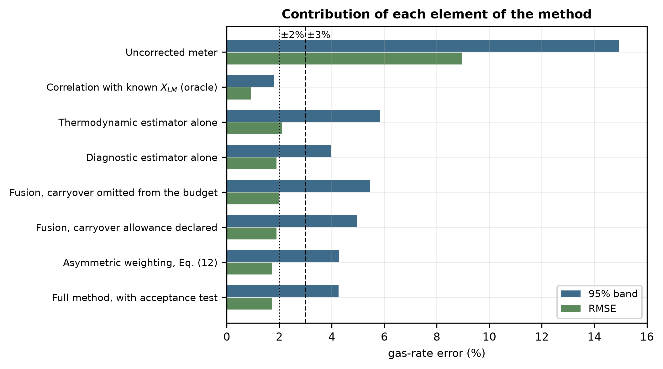
Fig. 2. Simulated ablation of the estimator. The configuration with a naive uncertainty budget is worse than the diagnostic estimator alone.
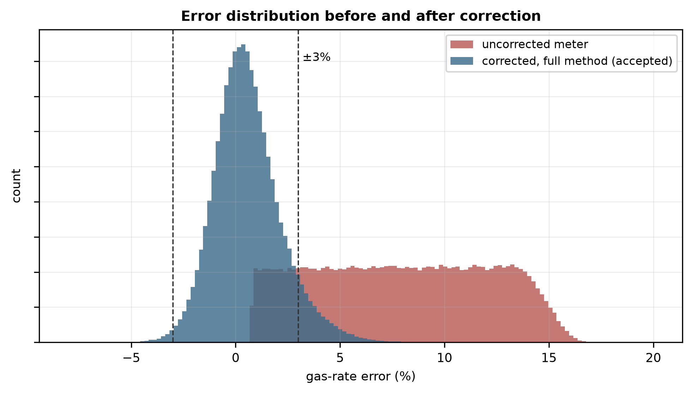
Fig. 3. Simulated error distribution of the gas rate before and after correction. The uncorrected distribution is strictly positive because wet-gas over-reading has a sign.
4.3 The consistency index and the acceptance threshold
Upstream carryover is present in 25% of the simulated realizations, in 24% of the accepted realizations and in 94% of the rejected ones (Fig. 4). The 94% is the precision of the rejection decision, that is, the share of rejected realizations that contain carryover; it is not a specificity, and it depends on the prevalence of carryover. At the threshold adopted here, the test rejects very few realizations, and nearly all of those contain carryover, but it misses most of the carryover that is present, and Table 4 gives the full behavior of the test over the threshold.
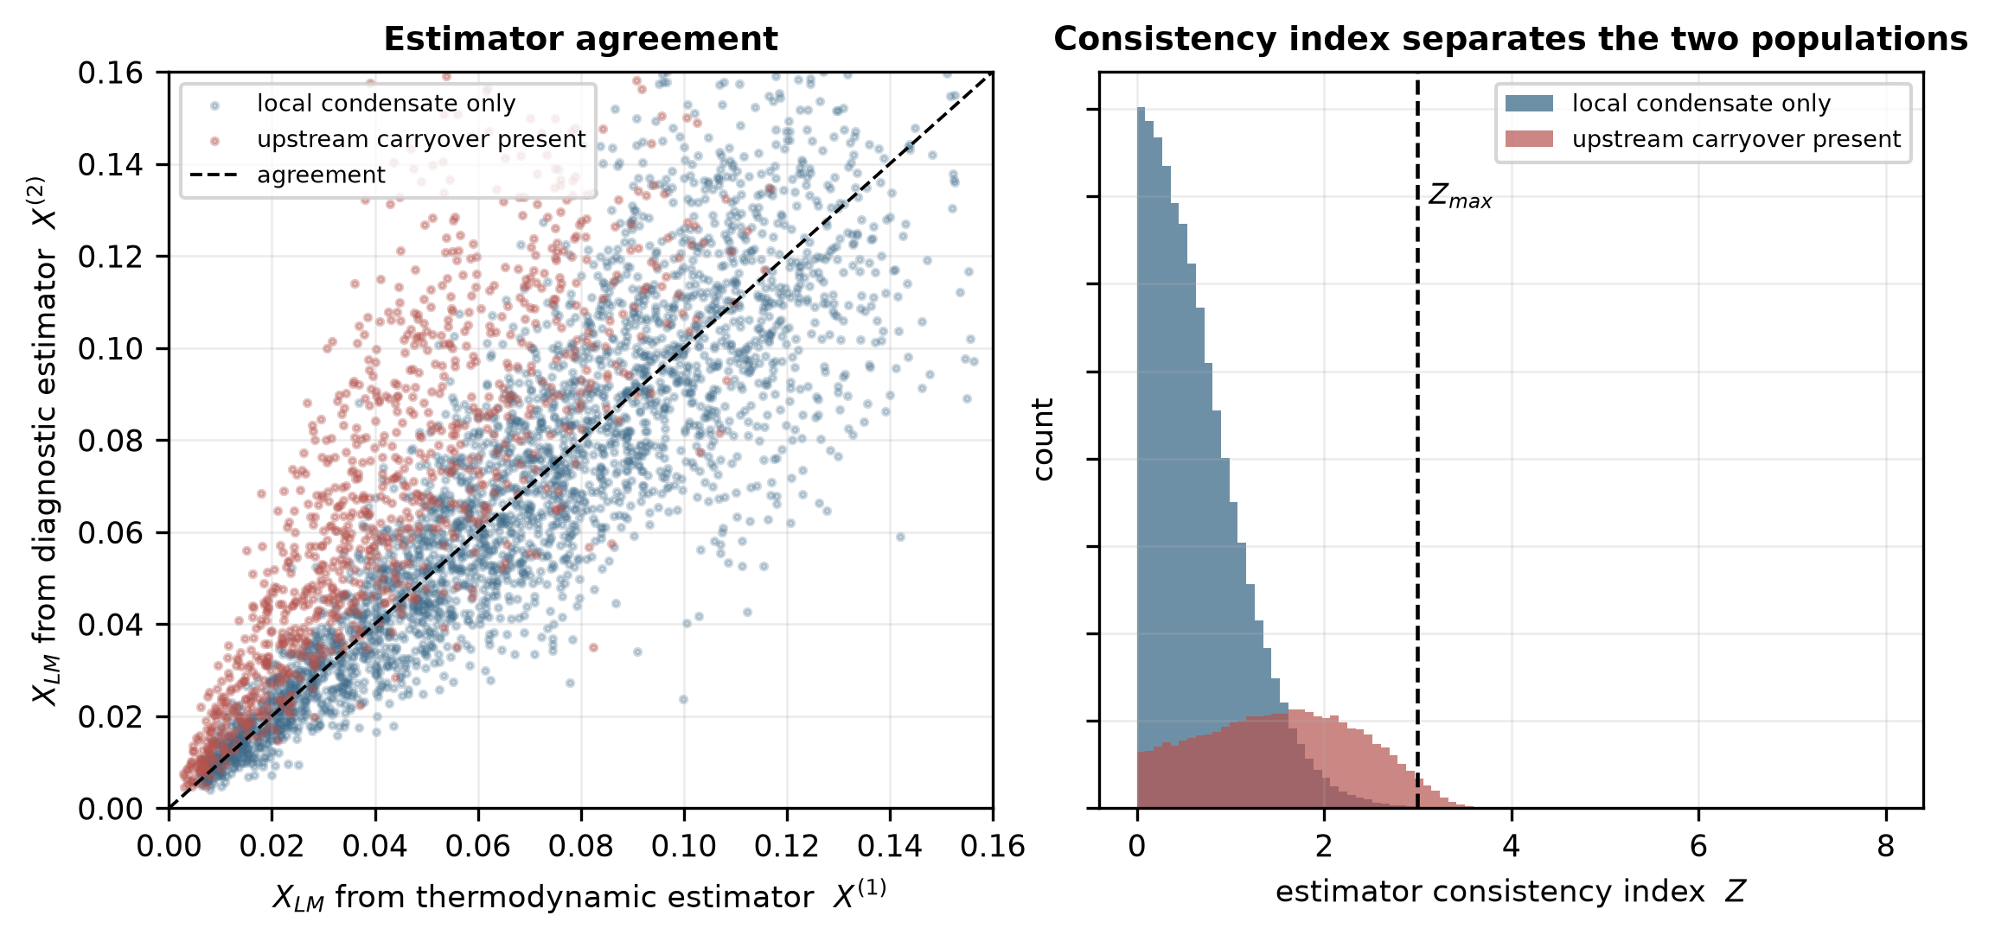
Fig. 4. Left: simulated agreement between the two estimators, separated by whether upstream carryover is present. Right: distribution of the consistency index for the two populations, with the acceptance threshold marked.
Z_{max} | Accepted | 95% band of accepted | Sensitivity | Specificity | Precision | False-positive rate
0.5 | 37.9% | ±2.98% | 87.1% | 46.3% | 35.2% | 53.7%
1.0 | 66.0% | ±3.19% | 71.2% | 78.5% | 52.6% | 21.5%
1.5 | 82.2% | ±3.53% | 51.9% | 93.6% | 73.2% | 6.4%
2.0 | 91.0% | ±3.90% | 31.4% | 98.5% | 87.6% | 1.5%
2.5 | 96.3% | ±4.14% | 13.7% | 99.68% | 93.5% | 0.32%
3.0 | 99.2% | ±4.26% | 2.9% | 99.95% | 94.8% | 0.05%
3.5 | 100.0% | ±4.30% | 0.1% | 99.99% | 80.8% | 0.01%
Table 4. Simulated effect of the acceptance threshold on the retained data and on the detection of upstream carryover (a rejected realization is positive). Sensitivity, specificity, precision and false-positive rate refer to the presence of carryover in any amount. Common random numbers (Section 3.2).
A tight threshold narrows the error band of what remains, but it discards a large fraction of operating time, which for a fiscal or allocation measurement is itself a cost, and the two ways in which a threshold can be wrong pull in opposite directions. At the adopted value, Z_{max} = 3, the false-positive rate is 0.05% and 0.8% of all the realizations are rejected, but only 2.9% of the realizations that contain carryover are detected. This is a completeness-priority setting that removes gross disagreement and almost nothing else. If the priority is to catch carryover, Z_{max} = 1 detects 71% of it, at the cost of rejecting 21% of the realizations that contain none (precision 53%) and 34% of all realizations. The appropriate value at a given installation depends on whether a narrow error band or completeness has priority and on the cost of each kind of error.
4.4 Effect of correlation between the estimators
The two estimates are structurally distinct but not guaranteed to be statistically independent: both respond to pressure, temperature and gas density, and any implementation that admitted X⁽¹⁾ into the diagnostic features would correlate them further. Fig. 5 and Table 5 vary ρ₁₂ from 0 to 0.7, and compare a consistency index that assumes independence with one that retains the covariance term.
ρ₁₂ | Rejection rate, independence assumed | Rejection rate, covariance retained | Precision for carryover, covariance retained
0.0 | 0.8% | 0.8% | 94.9%
0.2 | 0.6% | 1.4% | 96.1%
0.3 | 0.5% | 2.0% | 96.7%
0.5 | 0.3% | 4.0% | 97.8%
0.7 | 0.2% | 8.2% | 97.8%
Table 5. Simulated cost of assuming independence. The rejection rate is the fraction of realizations on which the correction is withheld; the precision is the share of rejected realizations that contain carryover.
The consequences are unidirectional and severe. As ρ₁₂ increases, an index that assumes independence has a denominator that is too large, Z decreases, and the acceptance test progressively stops firing: at ρ₁₂ = 0.7, the rejection rate decreases to 0.2%, against 8.2% when the covariance is retained, and at ρ₁₂ = 0.3 to 0.5%, against 2.0%. The test does not fail loudly; it quietly accepts everything, which is the worst failure mode available to a mechanism whose purpose is to withhold a correction. The sensitivity tells the same story. At Z_{max} = 3, it is 2.9% at ρ₁₂ = 0, and 7.5% and 22.3% at ρ₁₂ = 0.3 and 0.6 when the covariance is retained, against 2.0% and 1.0% when it is ignored; retaining the covariance makes the test more sensitive as the estimates become more correlated because their difference then carries less noise.
For the point estimate, the effect is different and smaller. Generalized least-squares weights are minimum-variance but not minimum-error when one estimator has an unmodeled bias, and in this regime, the error is bias-dominated, so the covariance-aware weights give a slightly wider band at high ρ₁₂ (±5.10% against ±4.42% at ρ₁₂ = 0.6) rather than a narrower one. The mechanism that acts against the bias remains the asymmetric damping of Eq. (12), not the weighting. Two practical consequences follow: X⁽¹⁾ should be excluded from the diagnostic features, as in Eq. (6), so that ρ₁₂ is kept small by construction, and ρ₁₂ should be measured during calibration from the joint residuals of the two estimators and retained in Eqs. (9)–(12) rather than assumed to be zero.
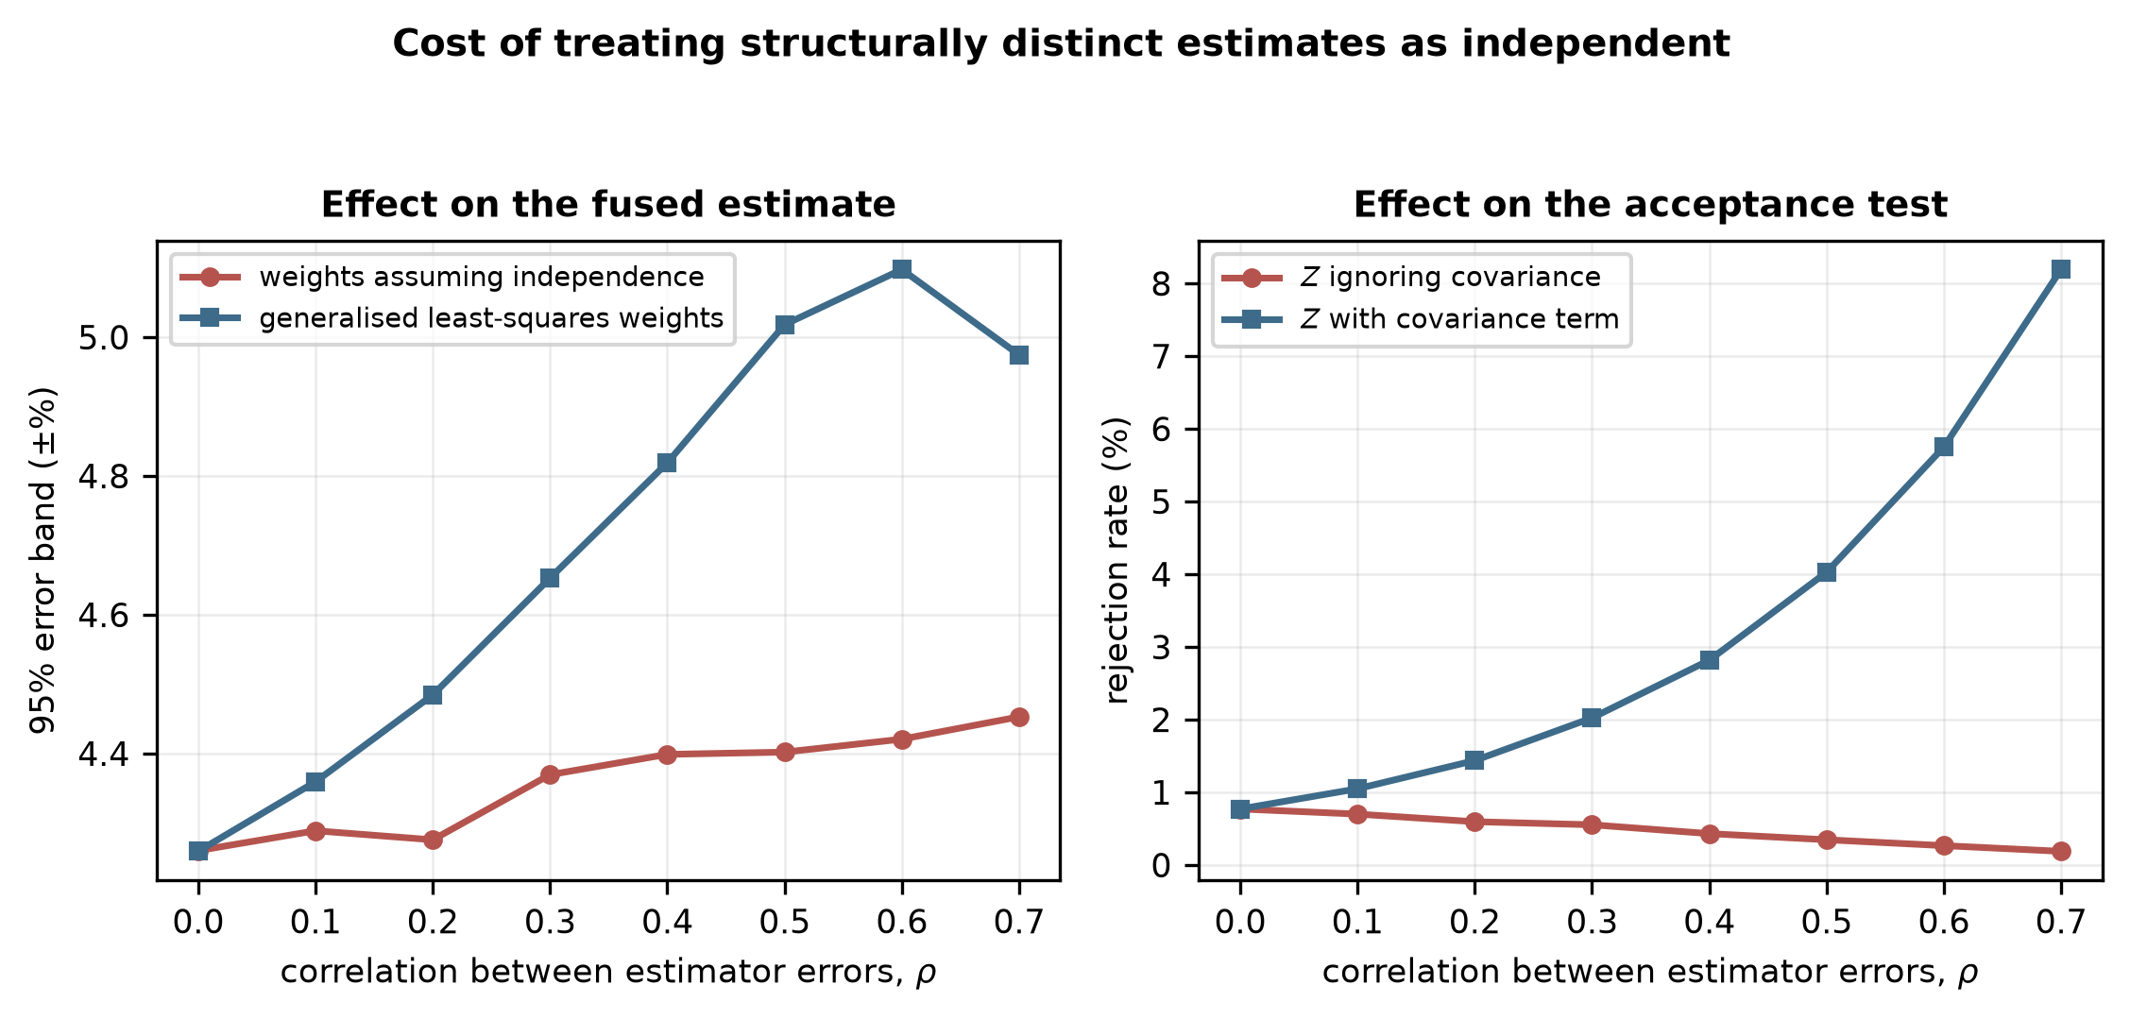
Fig. 5. Simulated cost of treating structurally distinct estimates as independent. Left: effect on the fused estimate. Right: effect on the acceptance test, which loses sensitivity as the correlation increases.
4.5 When does fusion outperform either estimator alone?
The value of combining the two estimators depends on how often the thermodynamic one is blind, and Fig. 6 varies the carryover prevalence from 0 to 60% of the operating time. With no carryover, the thermodynamic estimator is the better of the two (±2.70% against ±4.04%), and the method correctly falls back toward it (±2.72%). Between approximately 5% and 15% prevalence, the fused estimate is narrower than either estimator alone. A finer sweep with common random numbers (Section 4.10) reveals that the asymmetric rule remains narrower than the diagnostic estimator alone up to a prevalence of 15%, and the full method up to 16%. Beyond that, the diagnostic estimator is narrower, by 0.3 percentage points at the reference prevalence of 25% and by approximately 0.8 at 60%, because the thermodynamic estimate is wrong too often to contribute.
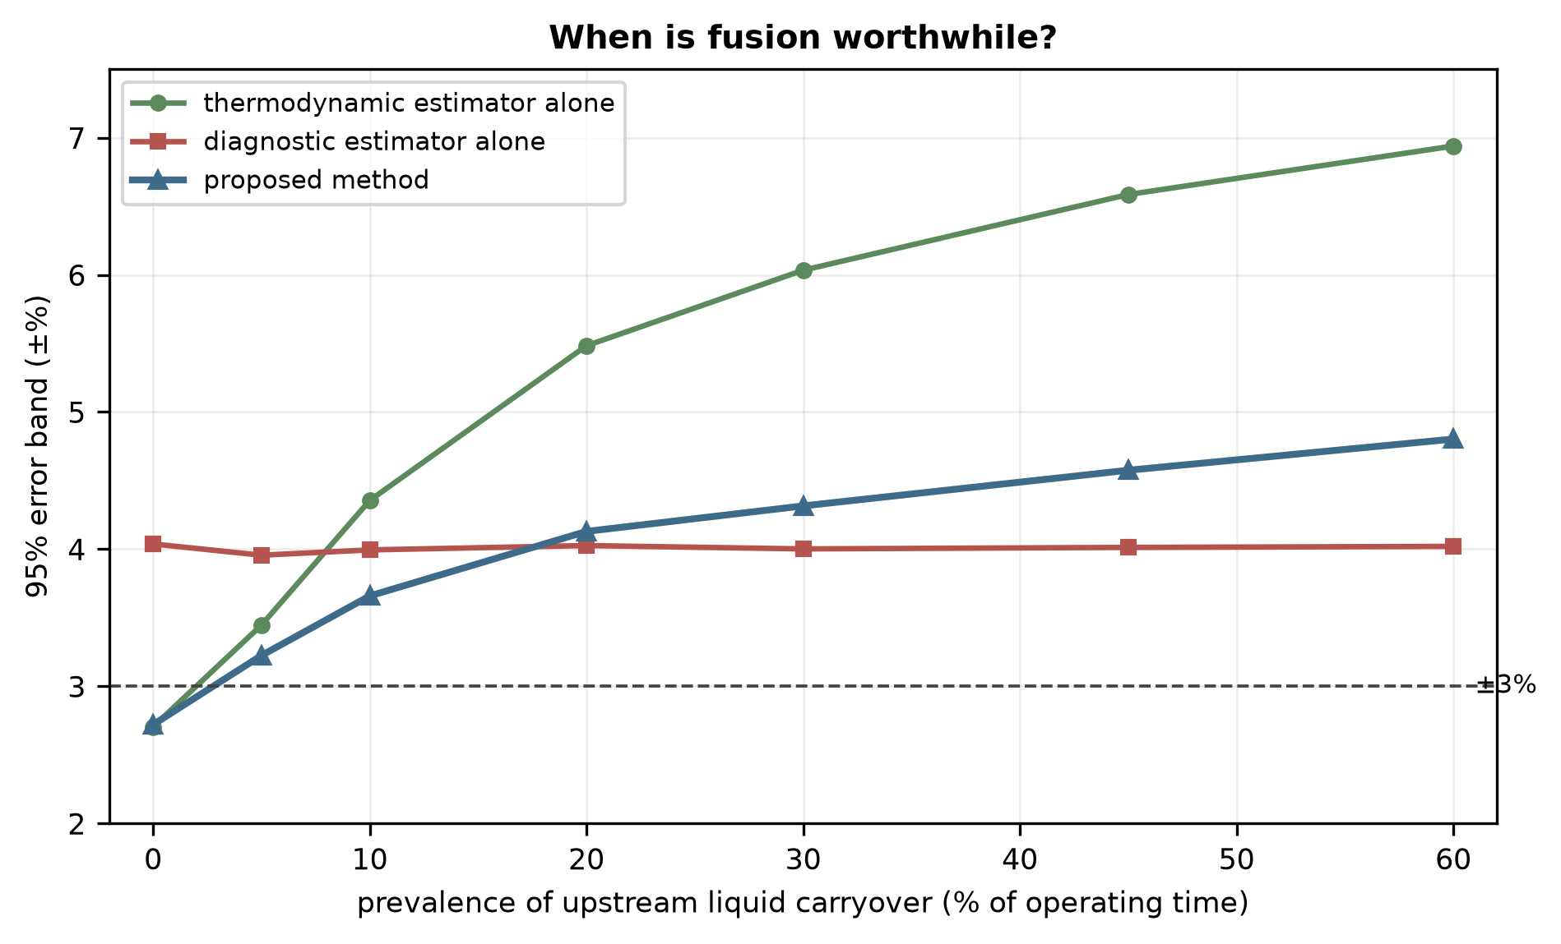
Fig. 6. Simulated effect of the prevalence of upstream carryover on the 95% error band of each configuration. The crossing points define the regime in which fusion is worthwhile.
The result can be read as a deployment rule. The hybrid architecture is most beneficial at installations where upstream separation is effective but imperfect, which is the condition an inlet separator and a dehydration train produce. Where carryover is frequent, the sensible configuration is the diagnostic estimator alone, with the consistency index retained as a validity check. The carryover prevalence is therefore the first quantity to establish at a candidate installation, and it can be established from historical separator and meter data without new instrumentation.
4.6 Sensitivity coefficients and uncertainty contributions
Table 6 and Fig. 7 give the normalized sensitivity coefficients of the corrected rate and the corresponding contributions to its combined standard uncertainty. The corrected rate is approximately 10 times more sensitive to a relative change in gas density or differential pressure (S ≈ +0.5, the square-root dependence of the differential-pressure equation) than to a relative change in the liquid-loading estimate (S ≈ −0.05). Sensitivity alone would therefore suggest that the liquid loading hardly matters.
Input | Sensitivity S_{i} | Relative standard uncertainty | Contribution to u_{c}(Q_{G}) | Share of u_{c}²
Liquid-loading estimate X_{LM} | −0.051 | 15.0% | 0.76% (1.42%) | 40% (70%)
Meter and secondary terms (lumped) | – | 0.7% | 0.70% | 34% (17%)
of which gas density ρ_{G} | +0.505 | 0.4% | 0.20% | –
of which differential pressure Δ P | +0.499 | 0.5% | 0.25% | –
Correlation residual after calibration | – | 0.6% | 0.60% | 25% (13%)
Liquid density ρ_{L} | −0.006 | 3.0% | 0.02% | <1%
Combined u_{c}(Q_{G}) |  |  | 1.19% (1.70%) | bounds 1.06–1.32%
Table 6. Normalized sensitivity coefficients and the corresponding contributions to the combined standard uncertainty of the corrected gas rate at X_{LM} = 0.05 (shares at X_{LM} = 0.10 in parentheses). Gas density and differential pressure are two itemized components of the lumped meter term, not additional terms. The relative uncertainty of the liquid-loading estimate is the median u_{f}/X_{f} of the fused estimate over realizations within ±10% of the stated loading.
It matters because of the size of its uncertainty rather than its coefficient. Gas density and differential pressure are known to a fraction of a percent (0.4% and 0.5%), whereas the liquid-loading estimate has a relative standard uncertainty of 15%, approximately 30 times greater. The product, which is what enters the budget, is 0.76% for the liquid-loading estimate against 0.20% and 0.25% for gas density and differential pressure, a ratio of approximately 3. The liquid-loading estimate is the largest single contribution to the combined standard uncertainty: 40% of its variance at X_{LM} = 0.05 and 70% at 0.10, where the sensitivity has doubled; at the lower loading, the lumped meter term and the correlation residual together account for the larger part. If the liquid-loading estimate were fully correlated with the gas-density term, the combined uncertainty at X_{LM} = 0.05 would lie between 1.06% and 1.32% instead of 1.19%. Sensitivity coefficients reported without the associated uncertainties would invert the conclusion.
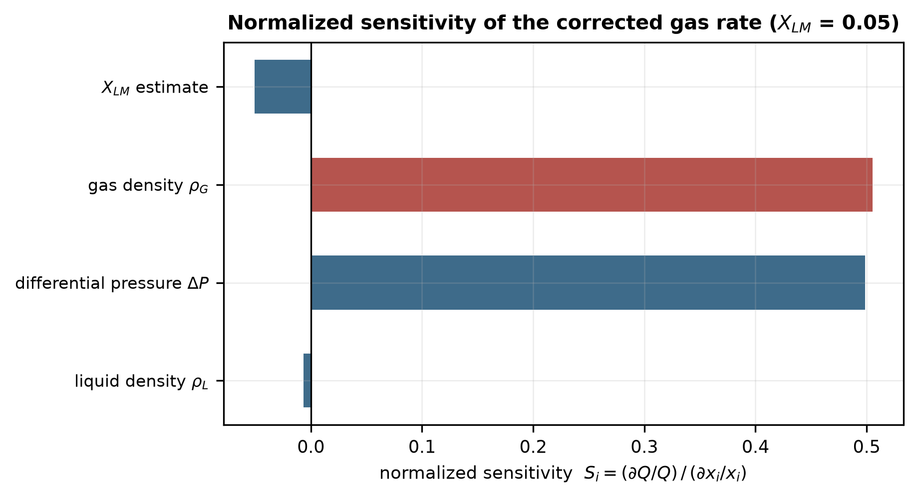
Fig. 7. Normalized sensitivity coefficients. The liquid-loading estimate has the smallest coefficient and the largest uncertainty contribution (Table 6).
4.7 Admissibility envelope
The simulated 95% band and the acceptance rate over the plane of X_{LM} and Fr_{G} are shown in Fig. 8, with each cell classified according to whether the ±2% and ±3% levels are met. The result is a validity domain rather than a single headline figure. The error band widens with increasing liquid loading as the sensitivity of the correlation to X_{LM} increases, whereas the Froude dependence is weak over the range examined because the Chisholm form contains no explicit Froude term.
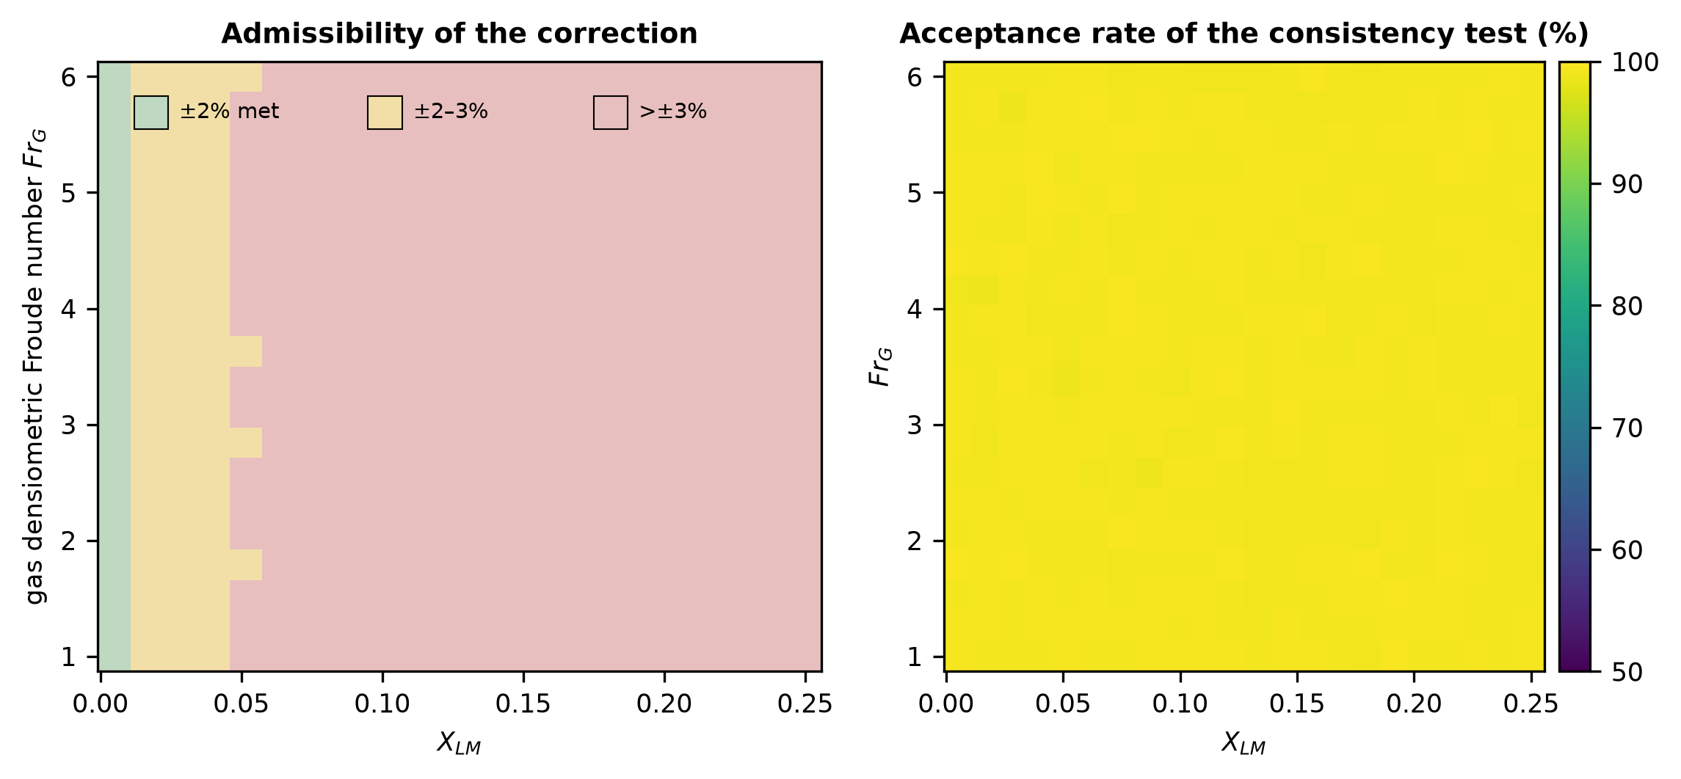
Fig. 8. Left: simulated admissibility of the correction over the plane of X_{LM} and Fr_{G}. Right: acceptance rate of the consistency test. The upper part of the X_{LM} range lies beyond the loading expected for the sampled duty and is included to show where the method fails.
4.8 Characterization of the consistency index as a detector
The precision of Section 4.3 does not by itself characterize a detector, and Fig. 9 shows the receiver operating characteristic and the precision–recall curve of the index over its whole range. At Z_{max} = 3, the test rejects 0.78% of all realizations; its specificity is 99.95%, its false-positive rate 0.05% and its precision 94.8% (94% on the sample of Section 4.3), but its sensitivity is 2.9%, so that 97% of the realizations that contain carryover are accepted. The area under the ROC curve is 0.81, and the average precision 0.69 against a prevalence of 25%, so the index separates the two populations only partially (Fig. 9a, b).
Detection depends strongly on the size of the carryover (Fig. 9c). At Z_{max} = 3 the share of realizations rejected increases from 0.03% for a carryover of 15–25% of the liquid to 8% for 45–60%, and at Z_{max} = 1 from 40% to 94%. The index responds to large carryover and is nearly blind to small carryover, which is the regime in which the diagnostic estimator's own scatter (20%) masks it. Against the consequential-error target (an absolute corrected error above 3%, present in 8.5% of realizations) the area under the curve is 0.74, and the precision at Z_{max} = 3 is 31%, so the index is a weaker predictor of a large corrected-rate error than of carryover. If the diagnostic estimator is poorer than assumed, with a relative uncertainty of 30%, as may occur without permanent pressure loss, the area under the curve decreases to 0.71, and the sensitivity at Z_{max} = 3 to 0.4%.
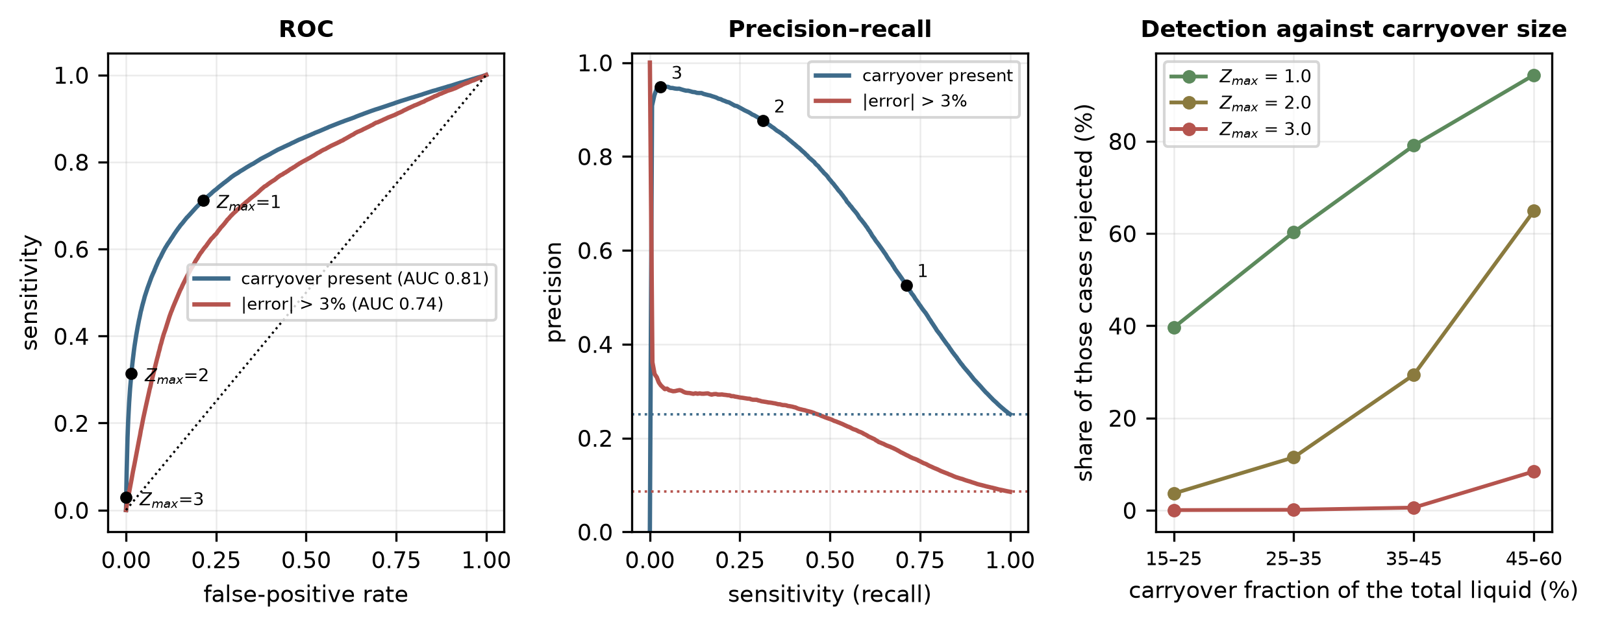
Fig. 9. Characterization of the consistency index at the reference configuration. (a) Receiver operating characteristic for the presence of carryover and for a corrected-rate error above 3%; points mark Z_{max} = 1, 2 and 3. (b) Precision against sensitivity; dotted lines are the prevalences. (c) Share of realizations rejected, by carryover size. All simulated.
The consistency test should therefore be read narrowly. At the adopted threshold, the index is a gross-disagreement flag with high precision and low sensitivity, and it should not be described as a carryover detector. Its main role in the reference case is that of a validity check that withholds the correction when the two estimates are irreconcilable. Where the priority is to find carryover, a lower threshold is required at the cost shown in Table 4.
4.9 Sensitivity to the weighting rule and the damping threshold
Table 7 compares the asymmetric rule of Eq. (12) with alternatives at three carryover prevalences, using the same realizations throughout. The controls are the thermodynamic and diagnostic estimator alone and symmetric weighting. The alternatives are the one-sided Cauchy rule at five thresholds, a one-sided Huber weight, a two-sided Cauchy weight, and a one-sided hard switch that uses the diagnostic estimator alone when its excess exceeds k and the least-squares combination otherwise.
Weighting rule | 10% | 25% | 40% | Bias at 25%
Thermodynamic estimator alone | ±4.32 | ±5.83 | ±6.49 | +0.71%
Diagnostic estimator alone | ±4.00 | ±4.00 | ±4.00 | +0.03%
Symmetric least squares (no damping) | ±4.09 | ±4.99 | ±5.36 | +0.71%
One-sided Cauchy, k = 0.5 | ±3.56 | ±4.01 | ±4.25 | +0.50%
One-sided Cauchy, k = 1 (Eq. (12)) | ±3.75 | ±4.30 | ±4.55 | +0.60%
One-sided Cauchy, k = 1.5 | ±3.93 | ±4.60 | ±4.88 | +0.66%
One-sided Cauchy, k = 2 | ±4.04 | ±4.84 | ±5.17 | +0.69%
One-sided Cauchy, k = 3 | ±4.09 | ±4.99 | ±5.36 | +0.71%
One-sided Huber, k = 1 | ±3.83 | ±4.43 | ±4.67 | +0.61%
Two-sided Cauchy, k = 1 (control) | ±3.94 | ±4.37 | ±4.58 | +0.61%
One-sided hard switch, k = 0.5 | ±3.79 | ±3.79 | ±3.79 | −0.10%
One-sided hard switch, k = 1 | ±3.46 | ±3.49 | ±3.68 | +0.05%
One-sided hard switch, k = 1.5 | ±3.23 | ±3.68 | ±3.96 | +0.23%
One-sided hard switch, k = 2 | ±3.44 | ±4.03 | ±4.38 | +0.38%
Table 7. Simulated 95% error band (±%) of the corrected gas rate for alternative weighting rules, over all 300,000 realizations, at carryover prevalences of 10%, 25% (reference) and 40%; the bias is that at 25%. The declared uncertainties are those of Table 2 in every case. Common random numbers (Section 3.2).
Three conclusions follow. First, k = 1 is not the best threshold in the reference case. Smaller thresholds do better (the one-sided Cauchy rule gives ±4.01% at k = 0.5 and ±4.30% at k = 1, against ±4.00% for the diagnostic estimator alone), and larger ones approach symmetric weighting (±4.99% at k = 3). Second, no rule is uniformly best. The smooth rule of Eq. (12) falls back toward the thermodynamic estimator when carryover is rare, and at 10% prevalence, it is narrower than the diagnostic estimator alone (±3.75% against ±4.00%), whereas at 25% and 40%, the diagnostic estimator alone is narrower. The hard one-sided switch at k = 1 is narrower than the diagnostic estimator alone at all three prevalences (±3.49% at 25%), but it is poorer than Eq. (12) when carryover is absent (±3.49% against ±2.80% at zero prevalence, Fig. 10b). Third, the two-sided control is poorer than the one-sided rule (±4.37% against ±4.30%), which is evidence for the one-sided form.
The rule of Eq. (12) is therefore presented as a smooth, continuous baseline and not as the preferred implementation. It is retained because the weight it gives each estimate is a continuous function of their disagreement and because it falls back to the thermodynamic estimator when carryover is absent. The hard one-sided switch is a promising alternative and the better performer in the reference case, but its advantage rests on the assumed carryover statistics and on a discontinuity at the switching threshold, where a small change in the data changes the estimate abruptly, and it requires independent validation, in particular of that threshold, before it can be recommended. The best rule and the best k depend on the prevalence and magnitude of carryover and on the diagnostic estimator, none of which is measured here, and a threshold chosen to minimize the error band of one simulated population would be tuned to its assumptions. The choice is a calibration question for loop data, and Section 5.5 specifies the measurement that would decide it.
4.10 Robustness to the diagnostic estimator, carryover prevalence and site bias
Fig. 10 varies the assumptions on which the conclusions depend most. In Fig. 10a, the actual relative uncertainty of the diagnostic estimator is varied from 10% to 60%, with the declared uncertainty either equal to the actual value or fixed at the assumed 20%. When the diagnostic estimator is better than assumed (10%), it is the best single estimator (±2.63%), and the full method is wider, ±2.71% when the uncertainty is declared correctly and ±3.87% when it is not. When it is worse (30%), the full method is narrower than the diagnostic estimator alone (±5.48% against ±5.71%, and ±4.97% if the 20% declaration is retained), and at 40% and 60%, the thermodynamic estimator alone (±5.83%) is narrower than the diagnostic estimator alone (±7.55% and ±10.71%). The acceptance test limits the damage: at 60% the full method reaches ±6.10%, against ±9.88% for the asymmetric rule without it. The transfer bias matters less: raising its spread from 0 to 20% widens the full method from ±4.13% to ±5.22%.
Fig. 10c replaces the population of sites by one site with a fixed transfer bias of the diagnostic estimator. The diagnostic estimator alone is narrowest with no bias (±3.91%) and widens in either direction, to ±5.12% at −15% and ±5.48% at +15%. The fused estimate is more robust to a positive bias because the thermodynamic estimate, biased low by carryover, offsets it: at +15%, the full method gives ±3.56% against ±5.48%, and at −15%, the two are similar (±4.97% and ±5.12%). This asymmetry is a property of the simulated carryover bias rather than a general benefit of fusion, and it would not occur if the thermodynamic estimator were biased in the same direction as the diagnostic one. The hard switch, which discards the thermodynamic estimate when the diagnostic excess is large, has no such protection (±5.34% at +15%).
Fig. 10b repeats the prevalence sweep of Section 4.5 on a finer grid with common random numbers, and Fig. 10d shows where the full method is narrower than the diagnostic estimator alone over the plane of diagnostic uncertainty and carryover prevalence. At the assumed 20%, the crossing lies at a prevalence of approximately 16%; at 30%, the full method is narrower up to approximately 30%; and at 40%, it is narrower at every prevalence examined, up to 60%. When the diagnostic estimator is as good as 10%, the advantage of fusion is less than 0.3 percentage points and disappears above 10% prevalence. The dashed lines of Fig. 10b show the effect of leaving the carryover allowance of Eq. (8) at its 25% value when the actual prevalence differs: at 60% prevalence, the full method gives ±4.81% with a matched allowance and ±4.96% with the fixed one, and at zero prevalence ±2.71% and ±3.18%. The carryover prevalence therefore needs to be known only approximately.
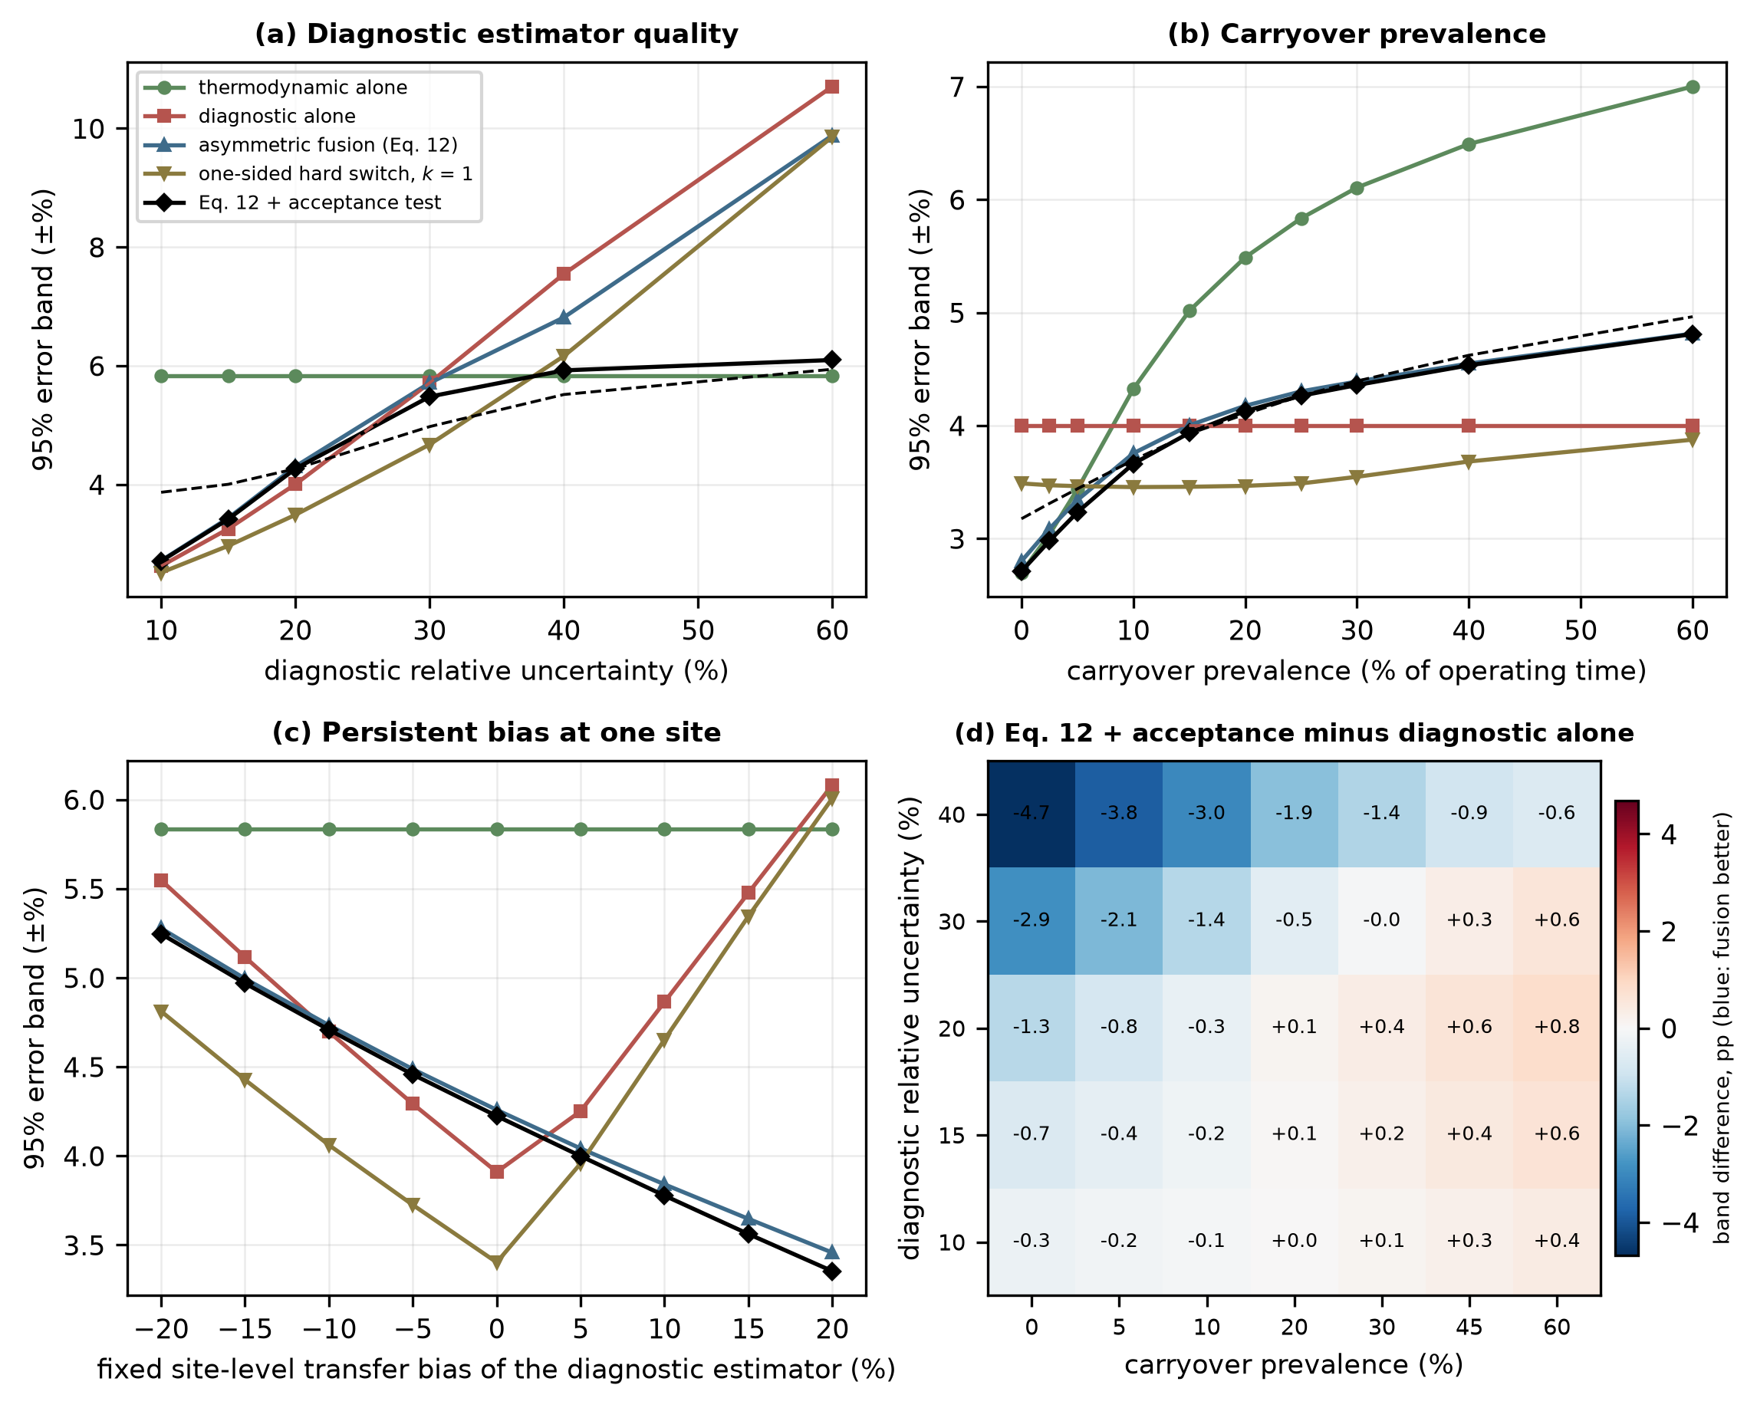
Fig. 10. Robustness of the conclusions, with common random numbers throughout. (a) Diagnostic-estimator uncertainty, declared equal to the actual value (solid) or fixed at the assumed 20% (dashed, diagnostic estimator alone and full method). (b) Carryover prevalence, with the allowance of Eq. (8) matched to the prevalence (solid) or fixed at 25% (dashed). (c) One site with a fixed diagnostic transfer bias. (d) Full method minus diagnostic estimator alone, in percentage points. All simulated.
4.11 Independent forward model and model-form error
In the reference simulation, the meter reading is generated and corrected with the same correlation, so part of the favorable performance is built in. Table 8 and Fig. 11 replace the generating model while keeping the Chisholm multiplier as the correction (Section 3.2). With the independent orifice correlation of Murdock, the oracle band, which isolates the correlation error, rises from ±1.82% to ±2.58%, the diagnostic estimator alone from ±4.00% to ±4.97%, and the full method from ±4.26% to ±5.26%, with a bias of +1.19% instead of +0.58%. The correction model contributes an error that no liquid-loading estimator can remove, and the 95% error band of the whole method grows by approximately one percentage point.
Generating model | Oracle | Diagnostic alone | Full method, bias | Full method, band | Coverage of ±2u | With 5% form term
Matched (Chisholm) | ±1.82 | ±4.00 | +0.58% | ±4.26 | 93.6% | 94.2%
Murdock, independent | ±2.58 | ±4.97 | +1.19% | ±5.26 | 88.5% | 89.5%
Scaled by 0.90 | ±2.63 | ±4.82 | −0.14% | ±3.20 | 95.8% | 96.3%
Scaled by 0.95 | ±2.18 | ±4.31 | +0.22% | ±3.72 | 95.2% | 95.7%
Scaled by 1.05 | ±2.22 | ±4.54 | +0.95% | ±4.82 | 90.9% | 91.7%
Scaled by 1.10 | ±2.68 | ±5.10 | +1.31% | ±5.38 | 87.2% | 88.3%
Random, 5% | ±1.99 | ±4.09 | +0.58% | ±4.36 | 93.1% | 93.7%
Random, 10% | ±2.45 | ±4.38 | +0.58% | ±4.65 | 91.4% | 92.2%
Table 8. Simulated 95% error band (±%) and bias when the over-reading that generates the meter reading differs from the Chisholm correction. “Scaled” multiplies φ − 1 by the factor shown; “random” multiplies it by a random factor with the relative standard deviation shown. Coverage is the realized fraction of corrected values whose error lies inside the declared ±2u interval, without and with a declared model-form term of 5% of the over-reading. The perturbations are stress scenarios, not measured error bounds. Common random numbers (Section 3.2).
Three observations qualify the headline result. First, the realized coverage of the declared ±2u interval is 93.6% in the matched case, close to the nominal 95%, but falls to 88.5% with the independent correlation and to 87.2% when the over-reading is scaled up by 10%, and a declared model-form term of 5% of the over-reading restores only approximately one percentage point (89.5% and 88.3%). A term of approximately 15% of the over-reading is needed for the Murdock case to reach 94–95% coverage. The model-form allowance u_{form} of Eq. (16) is therefore an assumption that must be set from the spread between published correlations or from loop data, and it is larger than the 0.6% correlation residual of the reference case. A generic allowance does not guarantee nominal coverage: the value that restores it here is specific to this pair of correlations, this meter geometry and this operating envelope, and it must be calibrated for each meter and set of conditions to which the method is applied.
Second, the ranking of the methods changes with the sign of the correlation error. When the true over-reading is smaller than the correction assumes (scaled by 0.90 or 0.95), the full method is narrower than the diagnostic estimator alone (±3.20% against ±4.82% at 0.90), but this is a compensation of errors, since the downward bias that carryover gives the thermodynamic estimate offsets the overcorrection, and it should not be read as a benefit. When the true over-reading is larger, or with the independent correlation, the diagnostic estimator alone is narrower, as in the reference case. Third, a wrong functional form cannot be rescued by the estimator. With the Venturi form of de Leeuw as the truth, which lies outside the validity of that correlation for an orifice and is shown only as a limiting case, the oracle band is ±8.76%, and the full method ±11.31%, with a coverage of 24%.
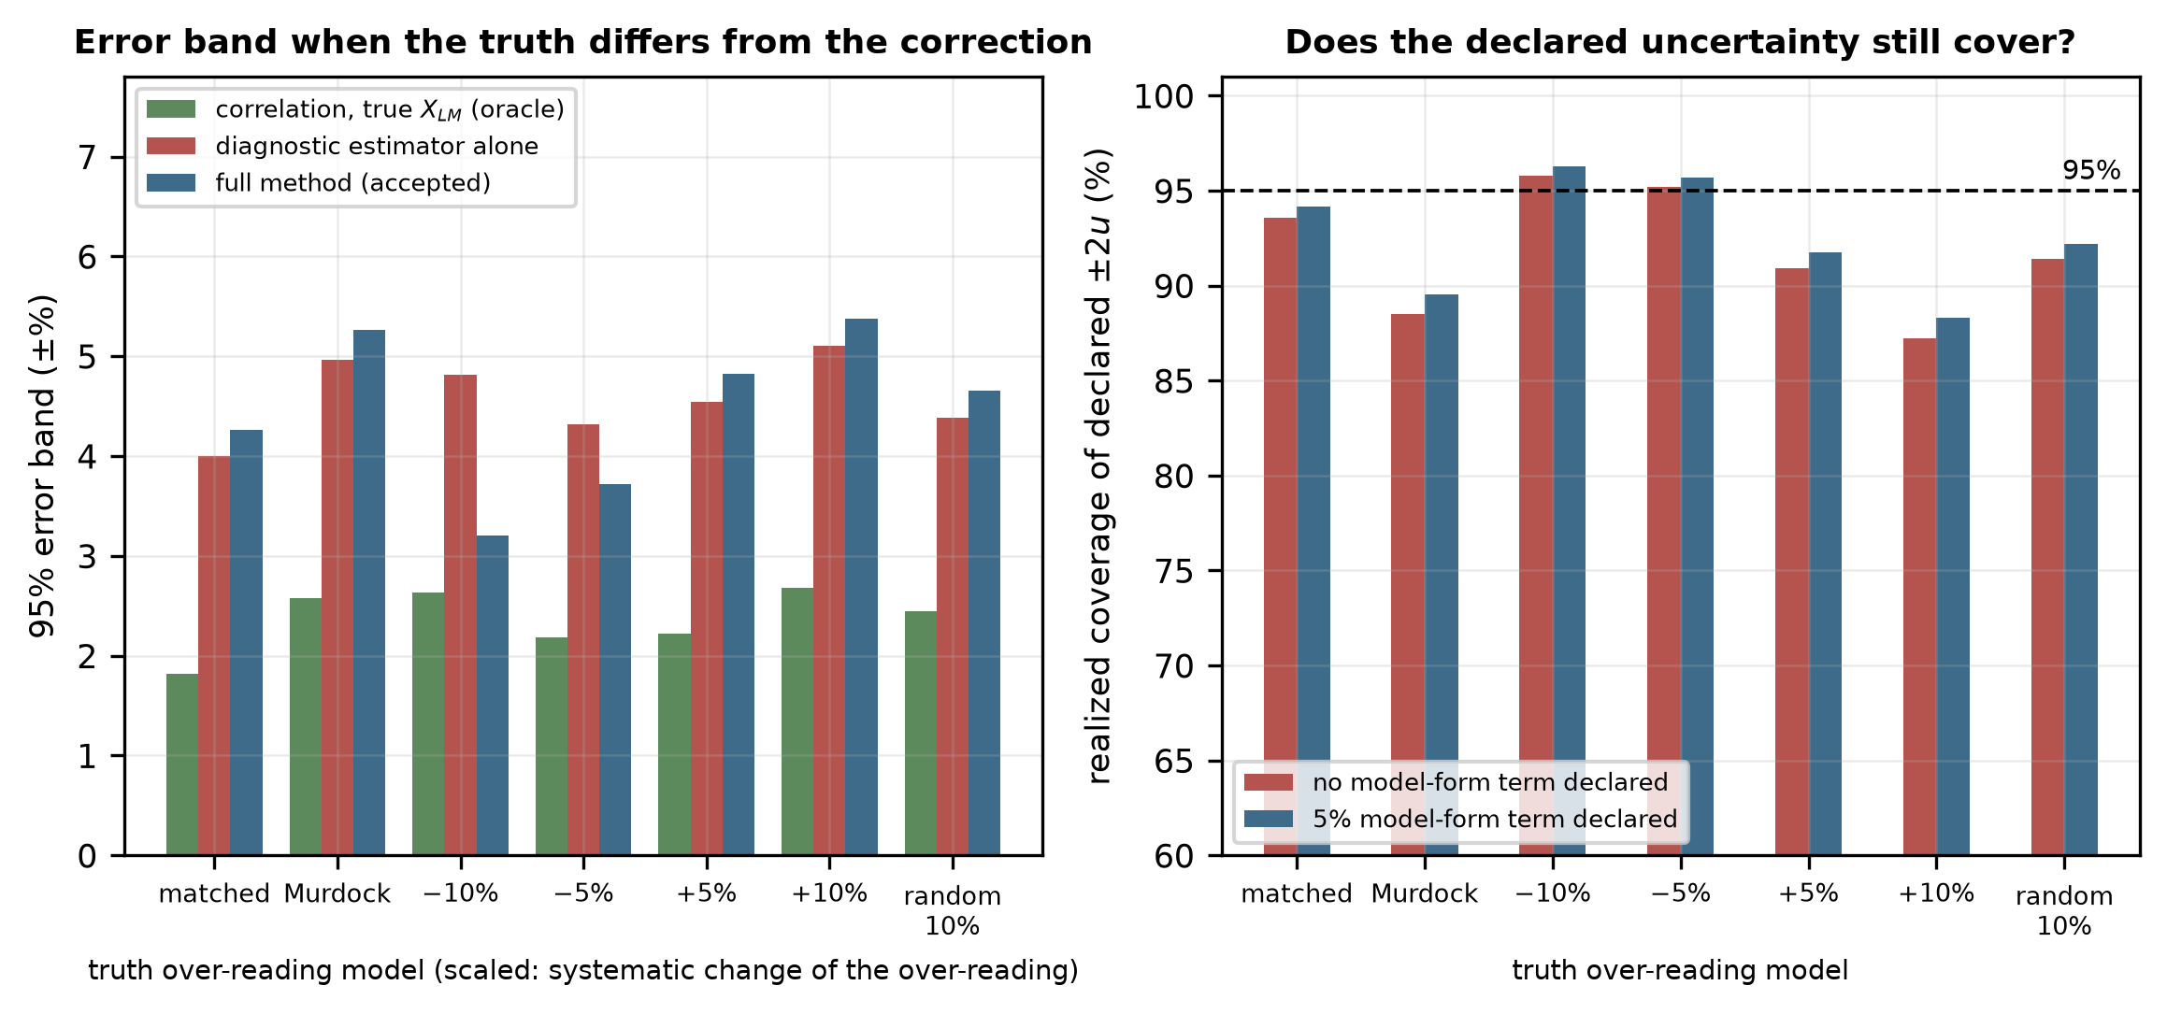
Fig. 11. Independent forward model. (a) 95% error band when the true over-reading is the Chisholm multiplier (matched), the Murdock correlation (independent), scaled, or random (10%). (b) Realized coverage of the declared ±2u interval, without and with a declared model-form term of 5% of the over-reading. All simulated.
5. Discussion
5.1 Comparison with existing approaches
The routes to a corrected gas rate differ in what supplies the liquid information and in what each requires (Table 9). The distinction from Nasr et al. [14] is the one most likely to be raised, since both approaches target the orifice meter and both aim at quantifying the liquid. That work adds a physical measurement point and obtains a more direct observation, whereas the present approach extracts the same information from the instrumentation already present and accepts a weaker observation in exchange. The two are complementary: a third tapping, where one can be installed, would enter the framework as a higher-quality diagnostic estimator, and the fusion and acceptance steps would apply unchanged.
Approach | Liquid information | Additional hardware | Experimental data required | Relation to this work
Empirical correlations [3–6] | Assumed known | None | None beyond the original fit | Retained unchanged as the correction stage
Third pressure tap [14] | Measured | Additional tapping and transmitter | Yes, for the specific geometry | Closest existing approach; adds instrumentation
Dedicated multiphase metering | Measured directly | Dedicated meter | Vendor calibration | Reference case rather than competitor
Data-driven rate prediction [15,16] | Bypassed; rates learned directly | None | Yes, covering the installation | Learns a different target; no explicit latent variable
Hybrid physics–ML over-reading [18] | Bypassed; over-reading learned as a residual | None | Yes (1,868 points reported) | Closest in spirit; learns the correction rather than its input
This work | Estimated as a latent variable | None; uses existing diagnostics | Yes, to fit the diagnostic estimator before deployment | –
Table 9. Routes to a wet-gas corrected gas rate, compared by what supplies the liquid information and by what each requires.
The distinction from the hybrid and data-driven methods is what is learned. Those methods learn the correction; the present one learns the input of the correction and leaves the correlation intact. The cost is an extra inference step, and a weaker result than direct learning can achieve where training data are plentiful. The benefit is that the physical form governs extrapolation, that the learned component is a single scalar with a stated uncertainty and that a second estimate of that scalar exists and can be cross-checked, which is what makes the rejection mechanism possible at all; a method that learns the over-reading directly has no second opinion to consult. The uncertainty quantification framework of Hosseini et al. [17] addresses a related problem with a different emphasis: it quantifies the uncertainty of a learned predictor, whereas the mechanism here uses the disagreement between two structurally distinct estimators to decide whether to produce an output at all.
5.2 Implementation and minimum signal set
The method can be implemented as a secondary-instrumentation layer adjacent to the existing flow computer (Fig. 12). The layer reads the transmitters, the chromatograph and the meter diagnostics and publishes the corrected rate, its uncertainty, the fused liquid loading and the status. Because it is realized in software and reads existing signals, it introduces no additional process restriction and therefore no additional pressure drop. Two properties matter for an installed measurement system. If the layer is lost, the meter reverts to its present behavior, and when its assumptions are not met, the layer declines to answer rather than answering unreliably, which is the behavior a measurement system should exhibit.
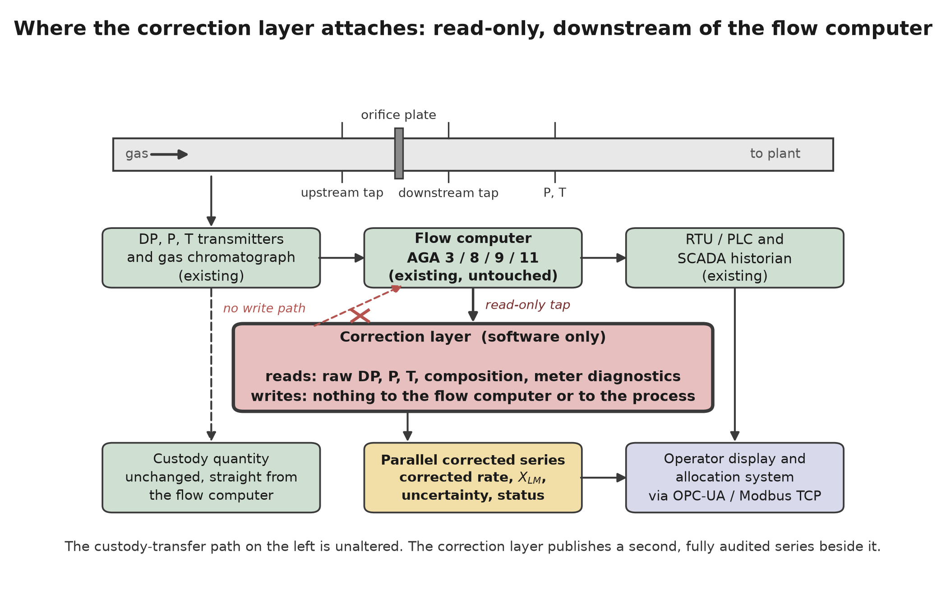
Fig. 12. Implementation as a secondary-instrumentation layer. The path to the flow computer is read-only, so a fault in the correction layer cannot alter the primary measurement.
For the orifice case, the diagnostic estimator requires the signals that the flow computer already reads — line pressure, temperature, differential pressure and indicated rate — together with the gas density from the composition, a composition measurement for the thermodynamic estimator, and the high-rate differential-pressure signal from which σ_{Δ P} is computed. The permanent pressure loss ratio requires downstream tapping. Where it is absent, the feature vector of Eq. (6) loses its recovery term, the diagnostic estimator becomes less informative, and its declared uncertainty must be widened before the framework is used; the size of that widening can be known only from a fit without the feature. As an indication, if the actual relative uncertainty were 30% instead of 20%, the full method would reach ±5.48% (±4.97% if the 20% declaration were retained), against ±5.71% for the diagnostic estimator alone and ±5.83% for the thermodynamic estimator alone (Fig. 10a). Without the high-rate differential-pressure signal, the diagnostic estimator is not specified by this paper, and the method is not supported since the thermodynamic estimator would then be the only estimator and no consistency test would be available.
5.3 Scope of the results and other meter types
The architecture is meter-agnostic, but the diagnostic estimator is not. For multipath ultrasonic meters [31] the natural features are the deviation of the measured speed of sound from the value computed from the composition [32], the gain levels, the signal-to-noise ratio and the ratios of the path velocities, since a liquid film degrades the near-wall chords before the mid-radius chords. For Coriolis meters [33] they are the drive gain and the deviation of the indicated mixture density from the gas density of the equation of state. These are extension pathways and not results. No computational assessment of either is presented, and the Coriolis case is expected to be more difficult because resolving the gas from the total mass requires the liquid fraction to a tighter tolerance than a differential-pressure meter does.
Table 10 separates what the simulations demonstrate from what is proposed. The demonstrated envelope is an orifice plate in a 154 mm line, one rich-gas composition family, 60–85 kgf/cm² (5.9–8.3 MPa) and 30–60 °C, with liquid loadings X_{LM} from 0.006 to 0.152 (5th–95th percentile 0.013–0.125) in the annular-mist regime, and nothing is claimed outside it.
Aspect | Demonstrated by simulation in this paper | Proposed, not evaluated
Meter | Orifice plate, Chisholm correction (n = 0.25), 154 mm line | Venturi, cone, multipath ultrasonic and Coriolis meters (Section 5.3)
Pressure and temperature | 60–85 kgf/cm² (5.9–8.3 MPa); 30–60 °C | Other pressures, temperatures and line sizes
Fluid | One rich-gas composition family; gas density 48–86 kg/m³; condensate 640–720 kg/m³ | Lean gases, other condensates, produced water or glycol
Flow regime | Annular-mist; X_{LM} 0.006–0.152; Fr_{G} 1.8–5.7 | Slug, stratified and transitional flow (detection and suspension only)
Diagnostic signals | P, T, Δ P, σ_{Δ P}, PLR (downstream tapping), indicated rate, gas density; performance assumed (20% with a 6% transfer bias) | Operation without a downstream tapping; a fitted estimator
Forward model | Chisholm (matched); Murdock and scaled or random departures as stress tests | Experimentally measured over-reading
Evidence | Monte Carlo simulation, 300,000 realizations per configuration | Wet-gas loop validation (Section 5.5)
Table 10. Scope of the results: what the simulations demonstrate and what is proposed but not evaluated.
5.4 Limitations
No experimental wet-gas data were used, and every result is a modeled uncertainty. In the reference case, the over-reading correlation is both the forward model and the correction. Section 4.11 shows that an independent correlation widens the error band by approximately one percentage point and that nominal coverage then requires a model-form allowance, approximately 15% of the over-reading here, which is specific to the correlations, geometry and conditions tested and must be calibrated for each application. Those scenarios are stress tests and not measured error bounds, and only an independent experimental reference removes the circularity.
The diagnostic mapping f_{θ} is specified but not fitted, and its assumed performance, a relative uncertainty of 20% with a 6% transfer bias, is the most consequential assumption of the paper: the ablation of Table 3 and the deployment rule of Section 4.5 depend on the relative standing of u₁ and u₂, and Section 4.10 shows how both change when it is varied. The conversion of the predictive interval into a standard uncertainty (Section 2.3) is a convention to be confirmed on fitted data. Diagnostic availability is installation dependent: where no downstream tapping exists, u₂ widens and must be declared accordingly rather than left unchanged.
The carryover model is an assumption. The qualitative conclusions hold over the prevalences examined (Sections 4.5 and 4.10), but the figures of Table 3 are conditional on p = 0.25. The correlation ρ₁₂ is treated as a parameter, and its value at an installation is unknown until the joint residuals are measured. The weighting rule and its threshold are not established (Section 4.9), and they are a matter for loop calibration. At Z_{max} = 3, the consistency index has a sensitivity of approximately 3% for carryover (Section 4.8), so it should not be presented as a carryover detector.
Finally, slugging and flow-regime transitions are not modeled. The correlations used are valid in the annular-mist region, so operation outside it requires detection and suspension rather than extrapolation. The results are for the orifice case at one composition family and one line size, and because the Chisholm form has no explicit Froude dependence, Fig. 8 says little about the Froude axis. The Monte Carlo analysis quantifies the sensitivity of the conclusions to the assumed distributions, not the probability of any outcome at a real installation.
5.5 Proposed validation
Because the study is computational, the experiment that would test it is specified here, so that the claims can be read against the test that would refute them. The facility required is a wet-gas flow loop with independent gas and liquid reference metering and controlled liquid injection, an orifice meter of known geometry with upstream and downstream tappings, pressure and temperature instrumentation, and either a chromatograph or a gas of known composition. The full high-rate differential-pressure signal must be recorded, so that σ_{Δ P} and the other features of Eq. (6) can be computed rather than assumed. The test matrix comprises X_{LM} = 0, 0.01, 0.02, 0.04, 0.06, 0.08 and 0.10, each at a minimum of four gas densiometric Froude numbers spanning the operating range, with deliberate liquid injection upstream of the flash-equilibrium point in a subset of runs to create the carryover condition that the consistency index is intended to flag.
Four cases should be reported against the reference: the uncorrected meter; the standard correlation supplied with the reference liquid loading, which bounds the achievable performance; the estimated liquid loading against the reference liquid loading, which tests the estimator directly and independently of the correction; and the fully corrected gas rate. The third comparison matters most, because it is the only one that isolates the contribution of this paper from that of the correlation. The same measurements would fix the actual uncertainty of the fitted diagnostic estimator, the correlation ρ₁₂ between the estimator residuals, and the weighting rule and threshold of Section 4.9.
The framework is refuted if any of the following holds on loop data: the fitted diagnostic estimator does not recover X_{LM} within the 20% relative uncertainty assumed in Table 2; the consistency index does not preferentially flag the runs with deliberate upstream injection; the measured correlation ρ₁₂ is large enough that the acceptance test loses the sensitivity reported in Section 4.4; or the corrected gas rate fails to improve on the uncorrected meter within the admissibility region of Fig. 8.
6. Conclusions
In this study, the liquid loading of a wet-gas stream is treated as a latent variable, estimated from two structurally distinct sources already present at a metering station and passed to the established over-reading correlation, and the framework is tested by Monte Carlo propagation over a rich-gas envelope. The outcome of each test is reported, including where the method does not improve on a simpler alternative.
Correction reduces the simulated 95% error band of the orifice case from ±14.94% to ±4.26% (±4.28% over all realizations before the acceptance test), against ±1.82% for the same correlation supplied with the true liquid loading. The diagnostic estimator alone gives ±3.99%, so fusion does not improve on it in the reference case; it does so when carryover occupies less than approximately 16% of the operating time, when the diagnostic estimator is poorer than assumed, or when it has a persistent positive bias. Combining a thermodynamic and a diagnostic estimate requires the thermodynamic estimator to declare an uncertainty that includes the upstream carryover it cannot observe, and without that allowance, inverse-variance fusion (±5.45%) is worse than the diagnostic estimator alone. A one-sided damping rule improves on symmetric weighting, but k = 1 is not the best threshold, and a hard one-sided switch is narrower in the reference case.
At the adopted threshold, the consistency index has a precision of 94% for carryover, which is present in 25% of the simulated realizations, and a sensitivity of 3%: it rejects very few realizations, and nearly all of them contain carryover, but it misses most of the carryover present and responds mainly to large carryover. It is a gross-disagreement flag rather than a carryover detector, and a lower threshold trades completeness for sensitivity. Because the two estimates are not statistically independent, the covariance term must be retained in the index; omitting it does not degrade the test gracefully but progressively disables it so that it accepts everything.
The corrected rate is approximately ten times more sensitive to a relative change in gas density or differential pressure than to one in liquid loading, yet the liquid-loading estimate is the largest single contribution to the combined standard uncertainty, 40% of its variance at X_{LM} = 0.05 and 70% at 0.10, because its relative uncertainty of 15% is approximately thirty times larger; sensitivity coefficients and uncertainty contributions must be reported together. Replacing the matched forward model by an independent orifice correlation widens the error band by approximately one percentage point and lowers the realized coverage of the declared interval to 89% unless a model-form allowance is declared and that allowance must be calibrated for the meter geometry and conditions, since a generic value cannot guarantee nominal coverage.
This paper does not report a validated measurement method. It reports modeled uncertainties, not measured accuracies, specifies the loop experiment that would convert them, including the comparison that isolates the estimator from the correlation, and states the criteria under which the framework would be refuted.
Nomenclature
Symbol | Definition | Unit
Q_{ind}, Q_{G} | Indicated and true gas flow rate | m³/s
φ | Wet-gas over-reading factor | –
X_{LM} | Lockhart–Martinelli parameter | –
X⁽¹⁾, X⁽²⁾, X_{f} | Thermodynamic, diagnostic and fused estimates of X_{LM} | –
ṁ_{L}, ṁ_{G} | Liquid and gas mass flow rates | kg/s
ρ_{G}, ρ_{L} | Gas and liquid densities | kg/m³
Fr_{G} | Gas densiometric Froude number | –
C, n | Chisholm coefficient and exponent | –
P, T, Δ P | Line pressure, temperature, differential pressure | kgf/cm², °C, Pa
σ_{Δ P} | Standard deviation of the high-rate differential pressure | Pa
PLR | Permanent pressure loss ratio | –
z, x | Molar composition vector; diagnostic feature vector | –
u₁, u₂, u_{f} | Standard uncertainties of X⁽¹⁾, X⁽²⁾ and X_{f} | –
u_{flash}, u_{carry} | Flash and carryover components of u₁ | –
f_{c}, p | Carryover fraction of the liquid; carryover prevalence | –
ρ₁₂, c | Correlation and covariance of the estimator errors | –
w₁, w₂; w̃₁, w̃₂ | Least-squares weights; renormalized weights after damping | –
e, k | Signed normalized excess; damping threshold | –
Z, Z_{max} | Consistency index; acceptance threshold | –
S_{X}, S_{L} | Normalized sensitivities of Q_{G} to X_{LM} and  ho_{L} | –
u_{meter}, u_{corr}, u_{form} | Meter, correlation-residual and model-form uncertainties | –
U | Expanded uncertainty, U = 2u | %
ε_{Q} | Relative error of the corrected gas rate | %

Data availability
No experimental data were used; the quantitative content of this paper is entirely computational. The Python implementation, the simulation configuration, the random seeds, the figure generators, the generated summary data and the scripts that build this manuscript are openly available at https://github.com/sandlerleon/hybrid-liquid-loading-estimation and permanently archived at https://doi.org/10.5281/zenodo.22760863, a concept DOI that resolves to the current version of the deposit. Running fmi_analysis.py, covariance_analysis.py, fmi_revision_analysis.py, generate_method_figure.py and generate_deployment_figure.py regenerates every table and figure of the paper, verify_revision.py executes the checks of Table A2, and build_fmi_v6.py builds this manuscript. The present revision changes the presentation of the paper and no number in it. A preprint of an earlier version is available on ChemRxiv at https://doi.org/10.26434/chemrxiv.15009070/v1.
Declaration of competing interest
The author declares no known competing financial interests or personal relationships that could have appeared to influence the work reported in this paper.
Funding
This research received no specific grant from funding agencies in the public, commercial, or not-for-profit sectors.
CRediT authorship contribution statement
Leon Sandler: Conceptualization, Methodology, Software, Formal analysis, Investigation, Visualization, Writing – original draft, Writing – review & editing.
Declaration of generative AI and AI-assisted technologies in the writing process
During the preparation of this work, the author used Claude (Anthropic) as a drafting and analysis aid: to draft and edit the manuscript text, including the restructuring of the present revision; to write the Python that implements the simulation and the scripts that check it; and to typeset the equations and tables. The author specified the measurement problem, the estimation architecture, the assumptions and their ranges, directed and reviewed the analysis, inspected the outputs and figures, and decided the conclusions, including the findings that the diagnostic estimator alone is narrower than the fused estimate in the reference case and that the consistency index is not a carryover detector. Verification was performed by the deposited scripts rather than by hand, which is a check of internal consistency and of the numbers as computed, not an independent check of the physical validity of the model. No AI tool is listed as an author, none generated or altered data, and the author takes full responsibility for the content of the publication.
Appendix A. Provenance of the model equations and verification of their implementation
Table A1 gives, for each equation of Section 3, its class (established, adapted from the literature, or specific to this study), its basis and the function that implements it in the deposited code. Table A2 reports the executable checks described in Section 3.3.
Eq. | Quantity | Class | Basis and source | Implemented in
(1), (2) | Over-reading and its correction | Established | Definition of the wet-gas over-reading [7] | fmi_revision_lib.py: phi_true(), phi_corr(), err()
(3) | Lockhart–Martinelli parameter | Established | Definition [13]; liquid rate from the sampled condensate–gas ratio | fmi_analysis.py: sample(); fmi_revision_lib.py: World
(4) | Chisholm multiplier | Adapted | Orifice correlation [4], n = 0.25, annular-mist region | swcl_physics.py: phi_chisholm()
(5) | Thermodynamic estimate | Adapted | Isothermal flash with a cubic or reference equation of state [19,20]; error simulated as X_{LM}(1 − f_{c})(1 + ε) | fmi_revision_lib.py: estimates()
(6), (7) | Diagnostic features and mapping | Specific to this study | Specified in Table 1, not fitted; error simulated with random and transfer-bias terms | fmi_revision_lib.py: estimates()
(8) | Carryover allowance | Specific to this study | Variance of the Bernoulli × uniform carryover mixture as a relative uncertainty | fmi_revision_lib.py: carry_variance()
(9)–(11) | Fusion and consistency index | Established | Minimum-variance combination of two correlated estimates; normalized difference | fmi_revision_lib.py: fuse(); covariance_analysis.py
(12)–(14) | Asymmetric damping and recalculation | Adapted; one-sided form specific to this study | Cauchy influence weight of iteratively reweighted least squares [25,26]; Birge inflation [27] | fmi_revision_lib.py: fuse()
(15), (16) | Uncertainty propagation | Established | First-order propagation [24] | fmi_revision_lib.py: sens_X(), declared_u_rel()
(17) | Relative error and metrics | Established | Definitions of Section 3.3 | fmi_revision_lib.py: err(), band95(), metrics()
Table A1. Provenance of Eqs. (1)–(17). Reference numbers refer to the reference list. The thermodynamic and diagnostic estimators, Eqs. (5)–(7), are not computed in the study; their errors are simulated with the distributions of Table 2.
Test | What is checked | Result | Outcome
V1 Reproduction | The common-random-number sample reproduces the ablation of Table 3 | Largest difference 0.030 percentage points; tolerance 0.065 | Passed
V2 Inverse variance | Symmetric fusion at ρ₁₂ = 0 against closed-form inverse-variance weighting | Largest difference 5.6 × 10⁻¹⁷ | Passed
V3 Damping limit | Asymmetric damping with a very large threshold against symmetric fusion | Largest difference 5.6 × 10⁻¹⁷ | Passed
V4 Eq. (14) | Without damping or Birge inflation, against the inverse-variance variance | Largest relative difference 6.7 × 10⁻¹⁶ | Passed
V5 Detector table | Table 4 reproduced from the consistency index by an independent count | Seven thresholds; largest rate difference 0 | Passed
V6 Correlated generator | Realized correlation of the estimator errors for requested ρ₁₂ = 0.3 and 0.6 | 0.2997 and 0.6002 | Passed
V7 Common random numbers | The matched model-form scenario equals the baseline, array for array | Identical | Passed
V8 Propagation | First-order propagation, Eq. (16), against Monte Carlo propagation of the liquid-loading term | Largest relative difference 0.42% | Passed
V9 Stored results | Shares of variance sum to one; ROC and precision–recall curves are valid | Consistent | Passed
Table A2. Verification of the implementation. Every entry is computed by verify_revision.py; differences are absolute unless otherwise stated.
References
[1] ISO 5167 (all parts), Measurement of fluid flow by means of pressure differential devices inserted in circular cross-section conduits running full, International Organization for Standardization, Geneva.
[2] American Gas Association, Orifice Metering of Natural Gas and Other Related Hydrocarbon Fluids, AGA Report No. 3 / API MPMS Chapter 14.3, American Gas Association, Washington, DC.
[3] J.W. Murdock, Two-phase flow measurement with orifices, Journal of Basic Engineering 84 (1962) 419–432. https://doi.org/10.1115/1.3658657
[4] D. Chisholm, Research note: two-phase flow through sharp-edged orifices, Journal of Mechanical Engineering Science 19 (1977) 128–130. https://doi.org/10.1243/jmes_jour_1977_019_027_02
[5] R. de Leeuw, Liquid correction of Venturi meter readings in wet gas flow, in: Proceedings of the North Sea Flow Measurement Workshop, Kristiansand, Norway, 1997.
[6] R.N. Steven, Wet gas metering with a horizontally mounted Venturi meter, Flow Measurement and Instrumentation 12 (2002) 361–372. https://doi.org/10.1016/S0955-5986(02)00003-1
[7] ISO/TR 11583:2012, Measurement of wet gas flow by means of pressure differential devices inserted in circular cross-section conduits, International Organization for Standardization, Geneva, 2012.
[8] A. Alkhurayef, A. Al-Sarkhi, G. AbdulMajeed, R. Gajbhiye, A comprehensive review of wet gas flow correlations for Venturi meter, Flow Measurement and Instrumentation 109 (2026) 103224. https://doi.org/10.1016/j.flowmeasinst.2026.103224
[9] D. He, S. Chen, B. Bai, A V-Cone meter measurement correlation in low pressure wet gas based on Chisholm model, Flow Measurement and Instrumentation 66 (2019) 12–17. https://doi.org/10.1016/j.flowmeasinst.2019.01.019
[10] Y. Pan, Y. Hong, Q. Sun, Z. Zheng, D. Wang, P. Niu, A new correlation of wet gas flow for low pressure with a vertically mounted Venturi meter, Flow Measurement and Instrumentation 70 (2019) 101636. https://doi.org/10.1016/j.flowmeasinst.2019.101636
[11] P. Gajan, Q. Decaudin, J.P. Couput, Analysis of high pressure tests on wet gas flow metering with a Venturi meter, Flow Measurement and Instrumentation 44 (2015) 126–131. https://doi.org/10.1016/j.flowmeasinst.2014.12.004
[12] X. Zheng, D. He, B. Bai, Pressure drop of wet gas flow with ultra-low liquid loading through DP meters, Flow Measurement and Instrumentation 70 (2019) 101664. https://doi.org/10.1016/j.flowmeasinst.2019.101664
[13] R.W. Lockhart, R.C. Martinelli, Proposed correlation of data for isothermal two-phase, two-component flow in pipes, Chemical Engineering Progress 45 (1949) 39–48.
[14] M. Nasr, P. Chacon, L. Brenskelle, E. Pereyra, Use of third pressure tap for liquid detection and quantification in an orifice plate meter for gas-liquid systems, Flow Measurement and Instrumentation 110 (2026) 103354. https://doi.org/10.1016/j.flowmeasinst.2026.103354
[15] L.O.V. Pereira, M.H. Farias, W.F.d.C. Rocha, L.G. Franco, R. Ramos, Machine learning-based prediction of gas and liquid flow rates in wet gas using single and dual cone meter configurations, Flow Measurement and Instrumentation 111 (2026) 103453. https://doi.org/10.1016/j.flowmeasinst.2026.103453
[16] S. Hosseini, G. Chinello, G. Lindsay, E. Loweimi, M.A. Ansari, D. McGlinchey, Transfer learning for data-driven wet gas flow metering: enhancing generalisation in digital measurement systems, Flow Measurement and Instrumentation 108 (2026) 103146. https://doi.org/10.1016/j.flowmeasinst.2025.103146
[17] S. Hosseini, G. Chinello, G. Lindsay, D. McGlinchey, A robust uncertainty quantification framework for machine learning–based wet-gas flow metering, Measurement 269 (2026) 120670. https://doi.org/10.1016/j.measurement.2026.120670
[18] A. Alkhurayef, A. Alsarkhi, A new hybrid physics–ML model for predicting over-reading in differential pressure measurements under wet gas flow, Flow Measurement and Instrumentation 111 (2026) 103465. https://doi.org/10.1016/j.flowmeasinst.2026.103465
[19] D.-Y. Peng, D.B. Robinson, A new two-constant equation of state, Industrial & Engineering Chemistry Fundamentals 15 (1976) 59–64. https://doi.org/10.1021/i160057a011
[20] O. Kunz, W. Wagner, The GERG-2008 wide-range equation of state for natural gases and other mixtures: an expansion of GERG-2004, Journal of Chemical & Engineering Data 57 (2012) 3032–3091. https://doi.org/10.1021/je300655b
[21] American Gas Association, Thermodynamic Properties of Natural Gas and Related Gases, AGA Report No. 8, American Gas Association, Washington, DC.
[22] W. Liu, Y. Ma, J. Lyu, J. Shao, S. Wang, Wet gas pressure drop across orifice plate in horizontal pipes in the region of flow pattern transition, Flow Measurement and Instrumentation 71 (2020) 101678. https://doi.org/10.1016/j.flowmeasinst.2019.101678
[23] V. Vovk, A. Gammerman, G. Shafer, Algorithmic Learning in a Random World, Springer, New York, 2005.
[24] JCGM 100:2008, Evaluation of measurement data – Guide to the expression of uncertainty in measurement, Joint Committee for Guides in Metrology, Sèvres, 2008.
[25] P.W. Holland, R.E. Welsch, Robust regression using iteratively reweighted least-squares, Communications in Statistics – Theory and Methods 6 (1977) 813–827. https://doi.org/10.1080/03610927708827533
[26] P.J. Huber, E.M. Ronchetti, Robust Statistics, second ed., Wiley, Hoboken, 2009. https://doi.org/10.1002/9780470434697
[27] R.T. Birge, The calculation of errors by the method of least squares, Physical Review 40 (1932) 207–227. https://doi.org/10.1103/PhysRev.40.207
[28] JCGM 101:2008, Evaluation of measurement data – Supplement 1 to the “Guide to the expression of uncertainty in measurement” – Propagation of distributions using a Monte Carlo method, Joint Committee for Guides in Metrology, Sèvres, 2008.
[29] P.M. Dranchuk, J.H. Abou-Kassem, Calculation of Z factors for natural gases using equations of state, Journal of Canadian Petroleum Technology 14 (1975) 34–36. https://doi.org/10.2118/75-03-03
[30] T. Fawcett, An introduction to ROC analysis, Pattern Recognition Letters 27 (2006) 861–874. https://doi.org/10.1016/j.patrec.2005.10.010
[31] American Gas Association, Measurement of Gas by Multipath Ultrasonic Meters, AGA Report No. 9, American Gas Association, Washington, DC.
[32] American Gas Association, Speed of Sound in Natural Gas and Other Related Hydrocarbon Gases, AGA Report No. 10, American Gas Association, Washington, DC.
[33] American Gas Association, Measurement of Natural Gas by Coriolis Meter, AGA Report No. 11 / API MPMS Chapter 14.9, American Gas Association, Washington, DC.

