Quantifying the Effectiveness of Independent Manual-Valve Verification in Preventing Product-Transfer Risks: A Monte Carlo Process-Safety Assessment
Leon Sandler
Independent Researcher, Northbrook, Illinois, USA
ORCID: https://orcid.org/0009-0007-4584-808X
Corresponding author: sandler.leon@gmail.com

Highlights
• Independent position sensing cuts modeled undetected misrouting 14-fold
• With uncertain operator response the median reduction decreases to 2.5-fold
• A 10-fold reduction needs about 97% alarm response and bypass below 53%
• Fail-safe blocking neutralizes gateway outages; misidentification erodes benefit
• Pilot power decreases from 95% to 50% when validations cluster by valve
Abstract
Manual valve line-ups before product transfers rely on rounds, radio confirmation and checklists, none of which observes valve position independently. We ask when an additional layer of temporary clamp-on position sensors on existing manual valves reduces transfer risk, and when alarm fatigue, bypass, common-cause failures and incomplete coverage remove the benefit. A Monte Carlo model of the line-up task, verified against closed-form results, an independent analytic model and automated tests, gave with assumed inputs for a 14-valve route an undetected-error probability per transfer of 4.03% with existing checks and 0.29% with direct sensing and NFC identity (14-fold; sampling interval 13.6–14.3), assuming that operators always act on alarms. Varying 13 inputs gave a median reduction of 9.7 (5th–95th percentile 4.4–28); adding uncertain operator response, alarm fatigue and common-cause failures of the sensing layer gave 2.5 (0.9–4.8), with response the strongest driver. A mean response time of 10 min against 20 min available gave a factor of approximately 2. A factor of 10 required a response of at least 97%, bypass below 53% and common-cause probability below 2.3%. An illustrative event tree gave a 14-fold reduction in expected loss. Clustering of validations by valve cut the power of a 1000-validation pilot from 95% to 50%. Inputs, consequence probabilities and losses are assumed: the results are conditional, not credited risk reduction.
Keywords: Manual valve verification; line-up error; human reliability; protection layer; common-cause failure; alarm response; Monte Carlo simulation; probabilistic sensitivity analysis; event tree
1. Introduction
Product transfers between tanks, plants and terminals depend on a correct valve line-up. Where valves are manual, the line-up is established by field operators who open and close a defined set of valves in sequence, and it is confirmed by inspection rounds, radio communication between control rooms and checklists. This arrangement is well established, but it observes valve position only indirectly, through the report of the person who handled the valve. Human reliability analysis treats omission of a step, selection of the wrong item and incomplete execution as distinct and persistent error modes [1–4], and quantification methods such as HEART assign them generic error probabilities that are modified by conditions of the task [5]. Analyses of process accidents repeatedly identify human and organizational factors [6], and collections of process-plant case histories include accidents in which the position of a manual valve was a factor [7]. In a transfer line-up each error mode can lead to a closed loop, contamination of another tank or delivery of the wrong product to a receiving site.
Process safety practice already places protection layers between such errors and their consequences, including procedures, second-person checks, locked valves and instrumented position indication on automated valves [8,9]. For manual valves in remote tank areas, continuous independent position indication is often not installed, because permanent limit switches or position transmitters require wiring, hazardous-area installation effort and capital cost per valve. Retrofit wireless position monitoring of valves has been demonstrated [10], and industrial demand reflects the same gap: operators want the position, identity and time of every manual valve action visible in the plant historian without replacing or automating the valve, as illustrated by a recent open-innovation call for such a solution [11].
Quantitative evidence for such a layer is scarce, and a design-stage assessment has two obvious weaknesses. It rests on assumed human error rates, and it tends to assume that the people involved react to every alarm. The central question of this paper is therefore not whether wireless sensors can detect a valve position, which has been shown [10], but under what conditions an independent manual-valve verification layer produces a meaningful reduction in transfer risk, and when alarm fatigue, slow response, bypass, common-cause failures and incomplete coverage undermine that benefit. Three hypotheses are tested: H1, independent verification reduces undetected errors across a defined range of human error and sensor-reliability assumptions; H2, alarm fatigue creates an interior optimum for alarm tolerance, so that the tightest tolerance is not the best; H3, common-cause failures, bypass, slow response and incomplete coverage define boundaries beyond which the layer gives insufficient benefit, and these boundaries can be quantified.
The study makes four contributions. First, it describes a sensing-layer architecture for temporary, reassignable, non-invasive verification of manual valve position that combines position, operator identity, time and procedure step. Second, it presents a Monte Carlo framework that quantifies how such a layer changes the probability that an error goes undetected at pump start or during the transfer, with the false-alarm cost, and propagates the uncertainty of the assumed inputs, the operator's response (as a probability and as a response time against the time available), common-cause failures of the sensing layer and the choice of defect threshold. Third, it links the undetected errors to consequences through an illustrative event tree, and derives boundaries (maximum bypass, minimum response, maximum common-cause probability) for a required risk-reduction factor. Fourth, it derives specification guidance and pilot acceptance criteria, including the loss of statistical power when validations are clustered by valve. It is a design-stage assessment based on assumed inputs and reports no field data. A first version of the model (HydraSense_MC.py, retained unchanged in the repository) addressed the architecture and the main trade-offs under one set of inputs; every added mechanism reduces to it when switched off, and this is tested (Section 4.9).
2. Problem definition
2.1 The line-up task
A representative task is an interplant transfer of a gasoline blend between a refinery and a logistics terminal. Before pumping, operators at both sites manually set a defined list of valves to required positions, mostly fully open or fully closed, with occasional intermediate settings. The route has V valves; this work examines routes of 6, 14 and 24 valves, and uses the 14-valve route (eight to be opened, four closed, two throttled) as the reference.
2.2 Error modes and existing barriers
Six error classes are considered: (i) a required valve action is skipped, including a false report that it was done; (ii) the wrong valve is operated and the intended valve is left unchanged; (iii) the movement stops short; (iv) an intermediate valve is set imprecisely; (v) steps are performed out of sequence; and (vi) a valve is moved without authorization after validation. Existing barriers (inspection rounds, radio confirmation, paper checklist) detect each class with some probability, but none provides independent, time-stamped observation of the physical position.
2.3 Requirements for an additional layer
The additional layer should (a) measure actual position, including intermediate openings, independently of operator confirmation; (b) record movements and deviations with time stamps; (c) work on existing manual valves without modification or process shutdown; (d) be installable for a few days and reassigned unambiguously to another valve, with an assignment history; (e) suit classified areas; (f) tolerate wrench operation; (g) use existing industrial wireless infrastructure and feed a plant historian; and (h) alarm on loss of signal, battery or communication while buffering data locally. These requirements follow the problem statement of an industrial open-innovation call for such a solution [11].
3. Sensing-layer architecture
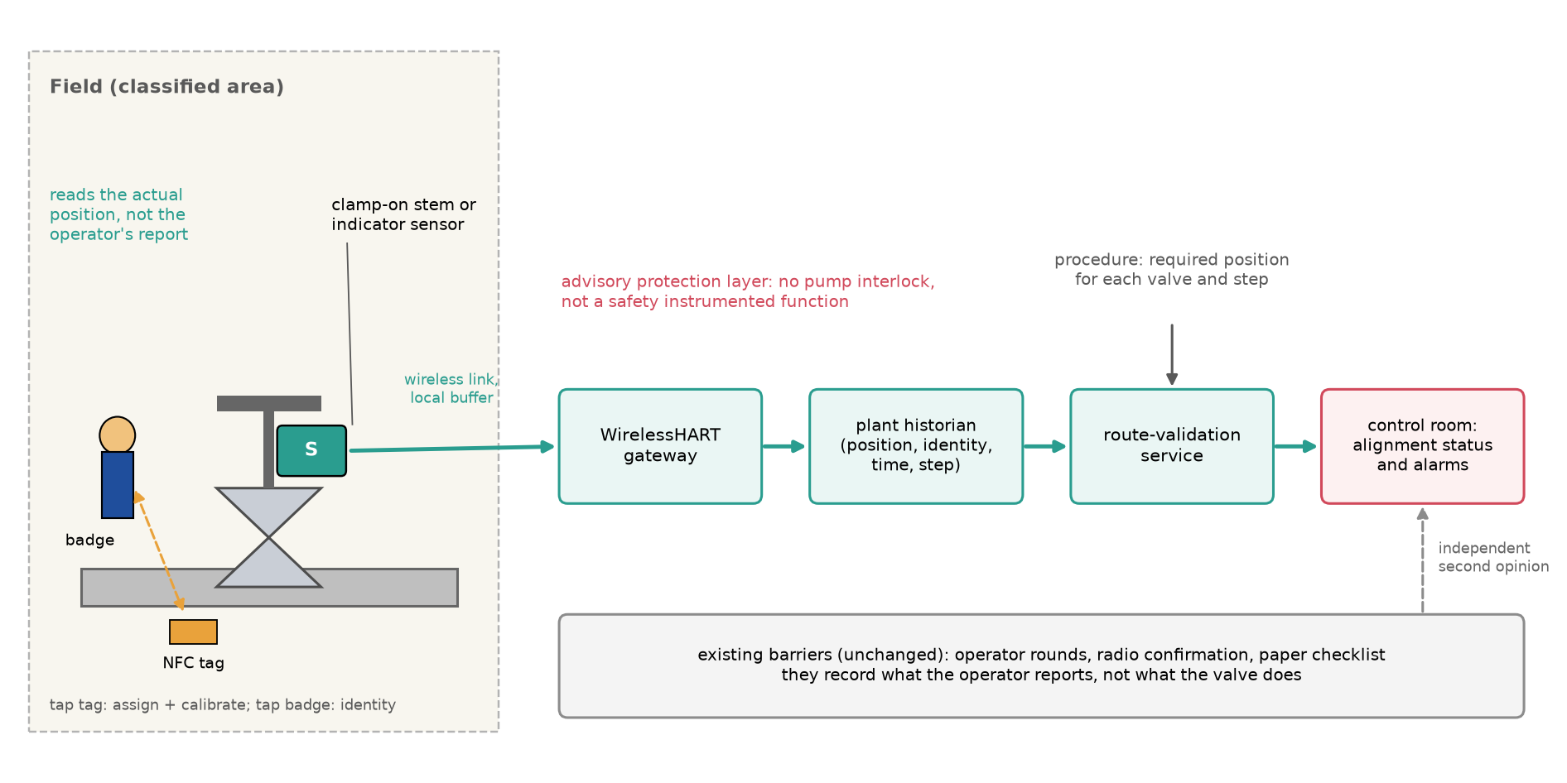
Fig. 1. Architecture of the sensing layer: a clamp-on sensor on the stem or indicator of an existing manual valve, an NFC tag for identity and assignment, a wireless link to the gateway and historian, a route-validation service that compares required and measured positions, and the existing barriers, which are unchanged.
3.1 Measurement principle
Two measurement concepts are compared. In the handwheel turn-count collar, a clamp-on device on the handwheel counts rotations and converts turns to percent of a calibrated stroke. It is simple to mount on many valves, but position is inferred: gear-operator lash, slippage and lost counts accumulate error. In direct stem or indicator sensing, a clamp-on kit reads the angle of the stem or position indicator (rotary) or the stem travel (rising stem), quantities that move with the closure element. Direct sensing also needs calibration but is not exposed to handwheel slip. The device is mounted outside the tool path and shrouded, so operation with a wrench does not load the sensor.
3.2 Identity, assignment and event logic
A passive near-field communication (NFC) tag carrying the valve identity is fixed to each valve. Tapping the device on the tag assigns it to the valve; a guided two-point calibration (fully closed and fully open) follows; and a backend ledger stores assignments over time. Tapping the operator badge before touching a valve links each movement to a person. A mismatch between the tapped valve and the valve required by the current procedure step can alarm before the wrong valve is moved, which converts some detection into prevention.
3.3 Communication and integration
Each device reports through a certified WirelessHART link [12] to the plant gateway, and the gateway forwards data to the plant historian through standard industrial protocols. Movements are reported on event, with a periodic heartbeat. The device stores events locally and forwards them when communication returns. A route-validation service compares required and measured positions and displays alignment status before pumping begins.
3.4 Role as a protection layer
The layer is advisory. It does not interlock pumps and is not claimed as a safety instrumented function under the functional-safety standards for the process sector [13]. Its value is an additional, independent detection opportunity for human errors. Hazardous-area use requires an appropriate protection concept such as intrinsic safety [14], which also limits the energy available to the electronics and motivates a low-power design.
4. Monte Carlo model
4.1 Overview
The model simulates N independent transfers. For each transfer, the actual position a_{v} of every route valve v is generated from the required position r_{v} and the error model of Section 4.2; existing barriers then detect some defects (Section 4.3); and the sensing layer measures positions and raises alarms (Section 4.4). A defect is defined as |a_{v}−r_{v}|>0.10 of stroke. The Monte Carlo method follows its standard formulation [15], and probabilities are reported with Wilson 95% intervals [16,17].
4.2 Operator error model
Per valve action, the probabilities of skipping, operating the wrong valve and stopping short are 0.002, 0.0015 and 0.006. These are order-of-magnitude values in the range used in human reliability practice for procedural tasks [1,2], and they are assumed priors, not measurements. A skipped or wrong-valve action leaves the intended valve at its random initial state. An incomplete movement completes a fraction uniformly distributed between 0.60 and 0.97 of the required travel. Intermediate valves are set with a standard deviation of 0.04 of stroke. Out-of-sequence steps occur with probability 0.004 per transfer. Unauthorized or accidental movement occurs at 5×10⁻⁵ per valve-hour over a lognormal transfer duration with median 8 h; its size is uniform between 0.10 and 1.0 of stroke.
4.3 Existing barriers
Existing checks detect a skipped, wrong-valve, incomplete, imprecise, out-of-sequence and post-validation defect with probabilities 0.80, 0.80, 0.60, 0.50, 0.10 and 0.20 respectively. Each probability is perturbed per transfer on the logit scale with standard deviation 0.5 to represent uncertainty. When a sensing layer is present, operator complacency reduces the effectiveness of the existing checks by a relative factor, taken as 0.20 in the base case, because operators may rely on the system.
4.4 Sensing layer
The measured position of valve v is m_{v}=a_{v}+b+e+d√k+s, where b is the calibration bias (standard deviation σ_{c}), e is noise (σ_{n}), d is drift per square root of operation for k operations since calibration, and s is a slip event that occurs with probability 1−(1−p_{s})^{k} and has magnitude uniform between 0.05 and 0.30 of stroke with random sign. The device alarms if |m_{v}−r_{v}|>τ, with τ=0.08 in the base case. With probability p_{a} the device is linked to the wrong valve, so that it measures another route valve. A device is unavailable at validation with probability 0.006 (communication 0.003, battery 0.001, hardware 0.002); if any route device is unavailable the validation is blocked, and with probability 0.20 the operator proceeds without sensor validation (bypass). Table 1 lists the architecture parameters.
Parameter | Existing checks | Turn-count collar | Direct sensing | Direct + NFC
Noise σ_{n} (stroke) | – | 0.020 | 0.015 | 0.015
Calibration bias σ_{c} (stroke) | – | 0.030 | 0.020 | 0.020
Drift d (stroke per √operation) | – | 0.0040 | 0.0005 | 0.0005
Slip probability p_{s} per operation | – | 0.0040 | 0.0003 | 0.0003
Wrong-device assignment p_{a} | – | 0.005 | 0.005 | 0.0002
NFC identity and tap-before-touch | no | no | no | yes
Table 1. Sensing architectures compared (assumed parameters).
4.5 Outputs and closed-form verification
The primary output is the probability per transfer that at least one defect, out-of-sequence step or post-validation movement escapes all barriers. Secondary outputs are false alarms (an alarm on a valve that is not defective), the share of true defects missed by the sensors, the probability that validation is blocked, and detection within 60 s of a post-validation movement. The simulation was checked against three closed-form results. For ideal Gaussian measurement with standard deviation σ, the false-alarm probability is 2[1−Φ(τ/σ)]. For a defect of offset e, the miss probability is Φ((τ−e)/σ)−Φ((−τ−e)/σ). For independent binary-valve defects detected by existing barriers with probabilities d_{i}, the residual risk is 1−∏(1−q_{i}(1−d_{i})). Simulated and closed-form values were 0.770% and 0.766%, 0.286% and 0.257%, and 1.85% and 1.84%, respectively.
The simulated and closed-form missed-defect values differ by 0.03 percentage points, approximately three standard errors. The difference is not sampling noise: the closed form omitted the slip events of the sensor model (probability 0.09% per valve at three operations since calibration); with the slip term included the closed form gives 0.285% against 0.285% simulated (3,000,000 draws, 95% interval 0.279% to 0.292%). A second, independent check uses an analytic barrier model for the binary 14-valve route with a Gaussian sensor, written without code shared with the simulation: it gives 0.060% against 0.064% simulated (95% interval 0.060% to 0.069%) for the probability of an undetected error per transfer.
The base case uses 300,000 transfers per architecture and route, 120,000 per sweep point and fixed random seeds; it follows the structure of an open simulation framework previously published by the author [18].
4.6 Extensions of the model
Five mechanisms were added to the first version; each can be switched off. (i) Common cause: the three operator error rates of a transfer are multiplied by a lognormal factor with mean one and log-standard deviation σ_{cc}, which represents fatigue, poor lighting or a mislabeled valve group acting on all the valves of one transfer. (ii) Operator response: an alarm on a truly defective valve is acted on with probability ρ=ρ₀ exp(−κF), where F is the number of nuisance alarms (alarms on valves that are not defective) in the same validation, ρ₀ is the response to an isolated alarm and κ is a fatigue coefficient; this is a parametric description of alarm fatigue [19], not a fitted model, and it applies to all alarm-driven detections. (iii) Separate alarm tolerance for intermediate (throttled) valves. (iv) End-stop re-zeroing: when a binary valve reaches its end stop the sensor offset is re-zeroed, so that for those valves the operations since the last zero are at most one. (v) Collateral movement: a wrong-valve action moves a neighboring valve that carries no route device with probability 0.5; the neighbor carries a device with probability equal to the coverage c; a covered movement is detected unless the validation was bypassed and is then acted on with the response probability ρ, and an uncovered movement is detected only by the existing barriers (detection probability 0.50 for such events). In the default model a covered neighbor is detected with the noise, bias and availability of the sensor model, not with certainty. Three further mechanisms were added in this version. (vi) Common cause of the sensing layer: per validation, with probability q each, a gateway outage or a failure of the historian and route-validation service (validation unavailable for all devices), wrong valve identification (all assignments shifted by one valve) and a calibration procedure error (a shared bias with standard deviation 0.06 of stroke on all devices of the transfer); an outage is either ignored, with the bypass probability of 0.20, or blocks the transfer (fail-safe), which is the distinction between a gateway outage that prevents a transfer and one that is ignored. (vii) Time-dependent response: the response time to an isolated alarm is exponential with mean m multiplied by exp (κF), the alarms of the pre-transfer validation have 10 min before pump start, and after a movement during the transfer the time before a consequence develops is lognormal (median 5 to 40 min, log-standard deviation 0.7); an alarm acted on later is not a barrier. This is an illustrative response-time distribution, not an empirical operator model. (viii) The defect threshold and the alarm tolerance are free parameters.
4.7 Probabilistic sensitivity analysis
The first version varied one input at a time. Here the 13 uncertain inputs of Table 3 are varied together. Each draw samples the inputs from the distributions of the table (lognormal multipliers whose 90% interval is the stated factor, and uniform distributions for the three policy and behavior inputs), simulates 40,000 transfers for each of the existing-checks, direct-sensing and direct-plus-NFC cases with the same seed, and records the residual risks and the risk-reduction factor RRF=P_{existing}/P_{full}. 200 draws were made. The percentiles of the draws describe the effect of the assumed uncertainty, not of the sampling (the sampling error of a proportion near 0.9 from 200 draws is approximately 0.02). Partial rank correlation coefficients (PRCC) between the inputs and the logarithm of the output rank the drivers [20]. The prior distributions are assumed; they are wider than a typical expert interval on purpose, because the model has no plant data to narrow them. The analysis assumes that operators respond to every alarm; a second analysis (Section 5.17) adds the response probability (uniform 0.7 to 1.0), the fatigue coefficient (uniform 0 to 1.0) and a common-cause probability for the sensing layer (log-uniform 10⁻⁴ to 10^{−1.5}). The uncertainty in the assumed input distributions, which these analyses describe, is distinct from the Monte Carlo sampling uncertainty of one probability, which is described by Wilson intervals and by the interval of the risk-reduction factor from 20 independent replications (Section 5.1).
Input | Base value | Distribution
Operator error rates (skip, wrong, incomplete) | × 1 | lognormal, 90% factor 4
Existing-barrier miss probability | × 1 | lognormal, 90% factor 3
Out-of-sequence rate | 0.004 | lognormal, 90% factor 3
Unauthorized-movement rate | 5e−5 per valve-hour | lognormal, 90% factor 3
Sensor noise | × 1 | lognormal, 90% factor 2
Sensor calibration bias | × 1 | lognormal, 90% factor 2
Sensor drift | × 1 | lognormal, 90% factor 3
Slip rate | × 1 | lognormal, 90% factor 3
Wrong-device assignment | × 1 | lognormal, 90% factor 3
Device unavailability (communication, battery, hardware) | × 1 | lognormal, 90% factor 4
Bypass probability when blocked | 0.20 | uniform 0–0.5
Operator complacency | 0.20 | uniform 0–0.6
Time-stamp sequence detection | 0.95 | uniform 0.7–1.0
Table 3. Input distributions of the probabilistic sensitivity analysis (assumed). A lognormal multiplier with 90% factor f has 5th and 95th percentiles 1/f and f.
4.8 Pilot sizing
The acceptance criteria of a pilot are exact binomial tests. For nuisance alarms, a pilot validates N valves and accepts the device if no more than c nuisance alarms occur, where c is the largest count whose probability under the unacceptable rate (3% per valve, twice the modeled rate) is at most 5% (consumer risk); the power is the probability of acceptance at the modeled 1.4% per valve. For missed defects, a number of defects injected on purpose (valves set deliberately off by more than the defect threshold) is detected or not, and the test is built the same way for an unacceptable miss rate of 15%, with the power evaluated at the modeled 6%. The accuracy of a device is described by the width of the chi-square interval for the standard deviation of repeated readings. The unacceptable rates are illustrative thresholds chosen for this study, not criteria set by any operator. These binomial tests assume independent validations; because validations of one valve or one transfer are correlated, beta-binomial tests with an intraclass correlation are also evaluated (Section 5.13). Valves validated, validation events and transfers are distinguished there.
4.9 Verification and reproducibility
The extended engine imports the first version unchanged (its file hash is checked) and, with all new mechanisms off, reproduces its event counts exactly for the same seeds. A suite of 16 automated checks covers this equivalence, the closed-form cases of Section 4.5 (including the slip term and the independent analytic model), the direction of every added mechanism (response, response time, sensing-layer common cause, tolerance, per-type tolerance, re-zeroing, coverage), the exact binomial calculations of the pilot, the probabilistic sensitivity analysis and the reproduction of the packaged results of the first version. One command regenerates every number and figure; the code, results and manuscript sources are archived with DOIs (Data availability).
4.10 Consequence-based assessment
An undetected valve error does not necessarily cause an accident. To connect the detection results to process consequences, the undetected errors are classified into mutually exclusive scenarios E_{i} (a required-open valve left closed or partly closed; a required-closed valve left open or partly open; an out-of-sequence step; a movement after validation; a collateral movement of a neighbor), each with a probability per transfer from the Monte Carlo model. A simple event tree assigns to each scenario conditional probabilities P(C_{j}|E_{i}) of four consequences: benign or recoverable, product contamination or misrouting, tank overflow or release, and blocked-in or overpressure. Then P(C_{j})=Σ_{i} P(E_{i})P(C_{j}|E_{i}), and with an assumed loss L_{j} per consequence and N_{T} transfers per year the expected annual loss is EAL=N_{T} Σ_{j} P(C_{j}) L_{j}. The conditional probabilities, the losses and N_{T} are illustrative assumed values chosen to show the method (all listed in the Supplementary Information), and their uncertainty is propagated with lognormal factors; the numbers must not be read as accident frequencies or costs.
5. Results
Sections 5.1 to 5.6 are the base-case results of the first version of the study (single set of assumed inputs); Sections 5.7 to 5.13 are the extended studies. All probabilities are per transfer unless stated, for the 14-valve route unless stated.
5.1 Residual risk by architecture
For the 14-valve route (Table 2, Fig. 2), existing checks alone leave a probability of 4.03% per transfer that an error escapes. A handwheel turn-count collar reduces it to 0.45%, direct stem sensing to 0.30% and direct sensing with NFC identity to 0.29%, a 14-fold reduction (95% sampling interval 13.6 to 14.3, from 20 independent replications of 150,000 transfers). In the single runs of Table 2 the difference between direct sensing with and without NFC is 1.2 standard errors and is not resolved; with common random numbers in the replications, NFC lowers the residual risk by 6% (5.5% to 6.7%) relative to direct sensing, a small effect that should not be read as establishing the superiority of one architecture and that is small against the input uncertainty of Section 5.7. The NFC benefit appears mainly in prevention (Section 5.5). Absolute values depend on assumed error rates, but the ratios depend mainly on detection logic and are therefore more robust; Sections 5.7 and 5.17 test how robust.
Route | Existing checks | Turn-count collar | Direct sensing | Direct + NFC
6 valves | 2.069% | 0.215% | 0.138% | 0.136%
14 valves | 4.027% | 0.454% | 0.302% | 0.285%
24 valves | 6.345% | 0.786% | 0.544% | 0.510%
Table 2. Probability per transfer that an error escapes all barriers (300,000 transfers per cell).
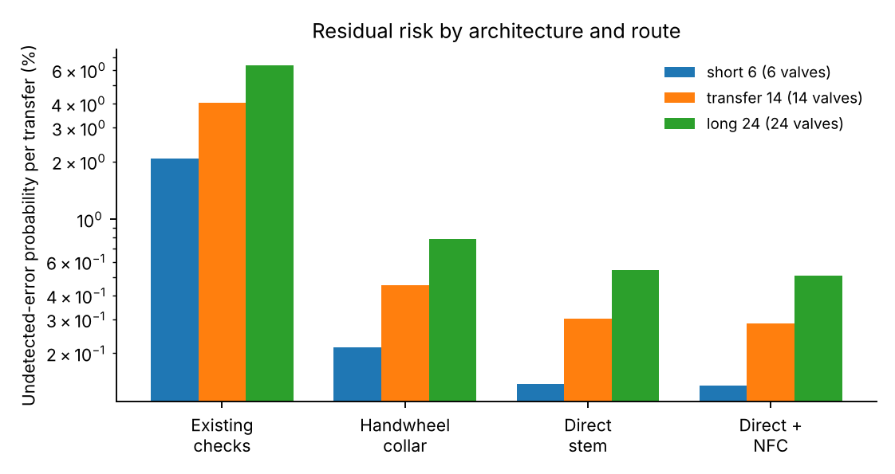
Fig. 2. Residual risk by architecture and route length.
Residual risk grows with route length for every architecture, from 0.14% for 6 valves to 0.51% for 24 valves with the full layer, because more valves give more opportunities for error and more exposure to device unavailability.
5.2 Alarm tolerance
Alarm tolerance controls the trade-off between nuisance alarms and missed defects (Fig. 3). With direct sensing at a 5% tolerance, false alarms reach 7.9% per valve, equivalent to approximately 1.1 alarms per 14-valve validation, which is unlikely to be acceptable under alarm-management practice, which limits alarm rates to what an operator can handle [21]. At 8%, false alarms drop to 1.4% per valve while 5.6% of true defects are missed, and these misses concentrate in defects only slightly larger than the 0.10 definition. At 10% the miss rate increases to 12.2%. For the turn collar at 8%, false alarms are 5.4% per valve, approximately four times higher than direct sensing. In the full-layer one-at-a-time analysis, tolerance moved the residual risk from 0.09% at half the base value to 1.96% at double, the largest effect of any parameter.
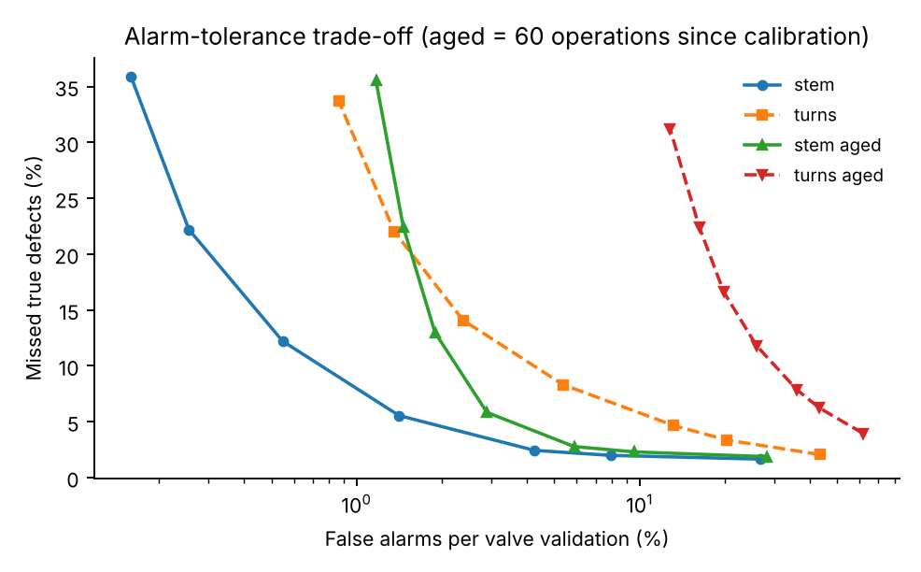
Fig. 3. False alarms versus missed defects as alarm tolerance varies; aged curves assume 60 operations since calibration.
5.3 Calibration age
Measurement quality degrades with operations since calibration (Fig. 4). For direct sensing, false alarms rise from 1.4% per valve at one operation to 2.1% at 30 and 8.7% at 300 operations. For the turn collar the corresponding values are 4.5%, 15.8% and 64.7%. A turn collar is therefore suitable only for short deployments calibrated at every assignment, whereas direct sensing tolerates approximately 100 operations between calibrations (3.9% false alarms per valve) and supports longer installations.
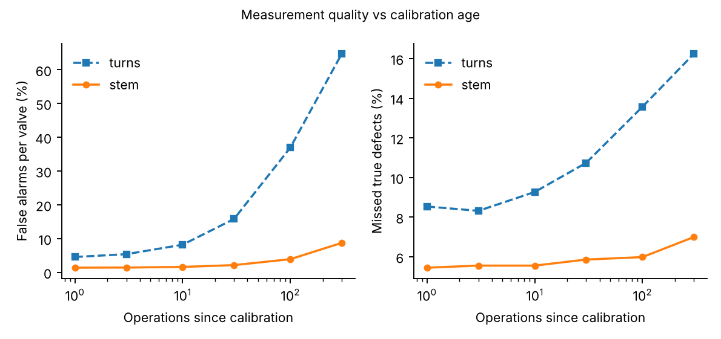
Fig. 4. False alarms and missed defects versus operations since calibration.
5.4 Availability and bypass
At the base device unavailability, validation is blocked in 8.0% of transfers on the 14-valve route and bypass occurs in 1.6% (Fig. 5). If bypass were prohibited, residual risk would fall to 0.21% regardless of communication quality in the range studied, while with 20% bypass it is 0.27% at the base communication-loss probability of 0.003 and 0.71% at 0.05. Blocking increases quickly with per-device communication loss, reaching 17% at 0.01. Availability is thus an operational constraint, and bypass policy determines whether it becomes a safety constraint.
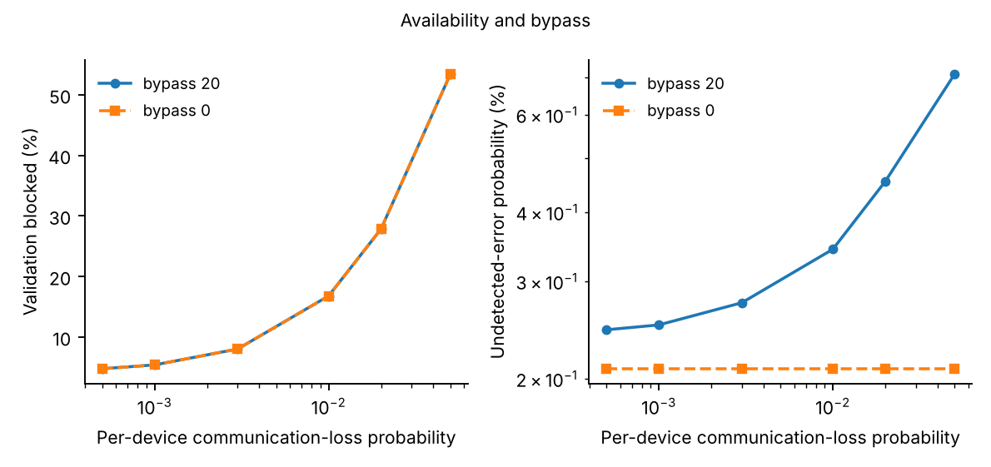
Fig. 5. Validation blocked and residual risk versus per-device communication loss, with and without bypass.
5.5 Operator complacency and identity checks
If operators relax existing checks because a sensing layer is present, residual risk increases from 0.229% with no complacency to 0.274% at 20% and 0.431% at 80% (Fig. 6), still far below 4.03% for existing checks alone, because the sensors observe independently. NFC tap-before-touch addresses a different problem: wrong-valve events, which move a valve that carries no device and are invisible to the sensing layer. At 90% tap compliance, wrong-valve events fall from 20.4 to 3.1 per 1000 transfers.
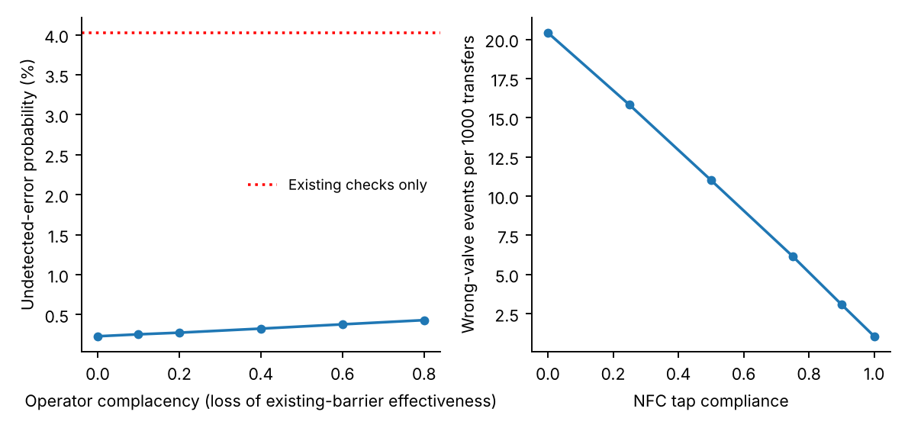
Fig. 6. Residual risk versus complacency (left) and wrong-valve events versus NFC tap compliance (right).
5.6 One-at-a-time sensitivity and device energy
In one-at-a-time sensitivity analysis over a factor 0.5 to 2 (Fig. 7), the ranking by effect on residual risk is alarm tolerance, calibration bias (0.18% to 0.48%), the miss rate of existing barriers (0.18% to 0.46%) and sensor noise, followed by bypass, availability and complacency. Operator error rates themselves have smaller effects once the sensing layer is present, because the layer detects defects regardless of how they arise. A design-level energy model (primary lithium cells, wake-on-motion, 16 s heartbeat) gives a median battery life of 4.8 years with a 5th to 95th percentile range of 2.9 to 7.9 years (Supplementary Information); this must be confirmed by bench measurement.
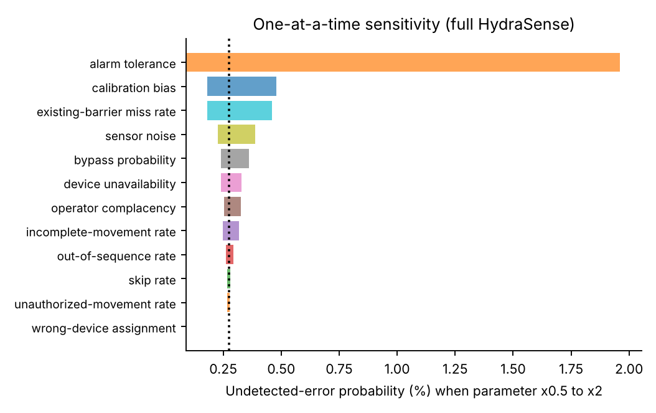
Fig. 7. One-at-a-time sensitivity of residual risk for the full layer (parameters varied by 0.5 and 2 times).
5.7 Uncertainty of the assumed inputs
Varying the 13 assumed inputs of Table 3 together (Fig. 8, Table 4) gives a median residual risk of 4.4% with existing checks alone (5th to 95th percentile 1.5% to 15%) and 0.42% with the full layer (0.17% to 1.17%). The risk-reduction factor has a median of 9.7 with a 5th to 95th percentile range of 4.4 to 28; it exceeds 2 in 100% of the draws, 5 in 88% and 10 in 46%. The nominal 14-fold reduction is exceeded in only 24% of the draws, and the reduction is better stated as roughly a factor of 10 with a plausible range from 4 to 28 than as a single value. The nuisance-alarm rate has a median of 1.5% per valve with an upper 95th percentile of 7.2%.
Quantity | 5th percentile | Median | 95th percentile
Existing checks only | 1.50 | 4.42 | 15.15
Direct sensing | 0.18 | 0.47 | 1.24
Direct sensing + NFC (full layer) | 0.17 | 0.42 | 1.17
Nuisance alarms per valve (full layer) | 0.83 | 1.46 | 7.23
Risk-reduction factor (existing / full) | 4.4 | 9.7 | 28.4
Table 4. Probabilistic sensitivity analysis: percentiles of the residual risk per transfer (%) and of the risk-reduction factor over 200 draws of the assumed inputs (40,000 transfers per draw and case).
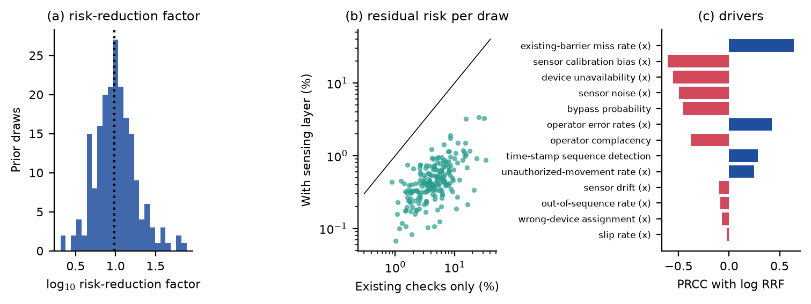
Fig. 8. Probabilistic sensitivity analysis over the assumed inputs. (a) Distribution of the risk-reduction factor; the dotted line is the median. (b) Residual risk with the sensing layer against existing checks only for each draw; the line is no reduction. (c) Partial rank correlation of each input with the logarithm of the risk-reduction factor.
The strongest rank correlations with the risk-reduction factor are the miss rate of the existing barriers (0.64), the sensor calibration bias (−0.61), device unavailability (−0.55), sensor noise (−0.50) and the bypass probability (−0.45). The sign has a simple reading: the more the existing barriers miss, or the more the operators err (0.42), the more the layer adds; the worse the sensing layer performs or the more often it is unavailable or bypassed, the less. Sensor calibration and availability, which a design can control, are therefore as important to the benefit as the unknown human error rates that the study cannot control. These draws assume that operators always act on an alarm; Section 5.17 relaxes that assumption, with a much lower median.
5.8 Common-cause variation
Making the error rates of a transfer share a lognormal multiplier with mean one changes the per-transfer probability very little (4.06% to 3.92% for existing checks and 0.28% to 0.27% for the full layer as the log-standard deviation grows from 0 to 1.5, Fig. 9a), and the risk-reduction factor from 14.7 to 14.3. This is expected: a mean-preserving multiplier concentrates errors in fewer transfers but leaves the expected number almost unchanged, and the probability of at least one error is slightly reduced by the concentration. The independence assumption between valves therefore matters little for the headline probability, though it would matter for the probability of several simultaneous errors, which is not an output of this study.
5.9 Operator response and the choice of tolerance
If operators act on only part of the true alarms the benefit decreases quickly (Fig. 9b gives the effect on the tolerance; the grid is in the Supplementary Information). With a response of 90% to an isolated alarm and no fatigue, the residual risk of the full layer increases from 0.27% to 0.72% and the risk-reduction factor decreases from 14.8 to 5.6; with 80% response and a fatigue coefficient of 0.6 the factor is 2.9. A model without a response mechanism assumes a response of 100%; the extended model shows that the first result is the upper end of what a design can claim. The response also changes the optimum alarm tolerance. With perfect response, residual risk decreases steadily as the tolerance tightens (0.09% at 4%), at the price of 2.1 nuisance alarms per validation, against 0.19 at 8%. With a response of 95% and fatigue coefficients of 0.3 and 0.6, the residual risk has its minimum at a tolerance of 8% of stroke for both coefficients (0.66% and 0.79%), because below it nuisance alarms teach the operator to ignore the true ones and above it defects go unflagged. The 8% tolerance used in the first version is therefore close to optimal once alarm fatigue is included, but the shallow minimum and the dependence on the assumed response mean that the tolerance should be set by the pilot (Section 5.13).
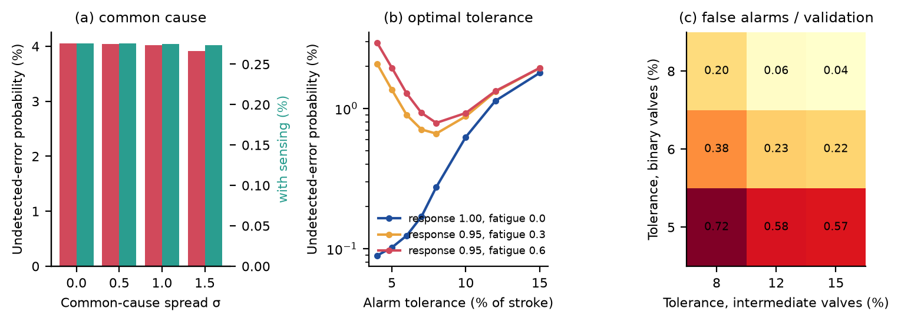
Fig. 9. (a) Common cause: undetected-error probability against the log-standard deviation of the shared multiplier. (b) Residual risk of the full layer against alarm tolerance for perfect and imperfect operator response. (c) Nuisance alarms per validation for direct sensing as the tolerances for binary and intermediate valves are varied separately.
5.10 Separate tolerance for throttled valves
With a common tolerance of 8%, the two throttled valves of the route produce 81% of the nuisance alarms: 8.1% per throttled valve against 0.3% per binary valve, because the operator's setting scatter (standard deviation 0.04 of stroke) is a large part of the 0.08 band. Widening the tolerance of the throttled valves alone to 12% cuts the nuisance alarms per validation from 0.20 to 0.06 (Fig. 9c), but it also raises the share of defects that are missed from 5.6% to 20.4% and the residual risk of direct sensing from 0.31% to 1.08%, because the defect threshold (0.10 of stroke) lies inside the wider band. The trade-off follows from the definition of a defect: if the process tolerates a wider band on a throttled valve, the defect threshold and the alarm band should be widened together; if it does not, the nuisance alarms are the cost of detecting a real defect and the design should reduce the setting scatter (a graduated scale, a detent) instead.
5.11 End-stop re-zeroing
Re-zeroing a binary valve each time it reaches an end stop removes most of the calibration-age effect for those valves (Fig. 10a): at 100 operations since calibration the nuisance alarms are 1.7% per valve with re-zeroing against 3.9% without, and at 300 operations 2.3% against 8.7%. The throttled valves cannot be re-zeroed at an end stop, so the benefit is partial, and the share of missed defects is almost unchanged (6.5% against 7.2% at 300 operations). The first version could only conjecture this benefit.
5.12 Coverage of neighboring valves
A wrong-valve action that moves a neighbor without a device is invisible to the layer unless the neighbor is covered. With the NFC tap-before-touch check the layer already cuts the collateral events from 10.1 to 1.4 per 1000 transfers, and without any device on the neighbors the undetected events are 0.83 per 1000 (existing checks alone: 5.07). The undetected events decrease in proportion to the coverage (Fig. 10c) and almost vanish when every neighbor carries a device (0.02). Coverage of neighbors is therefore a design choice with a quantifiable return, and a partial coverage, for example of the valves adjacent to the route, removes a proportional part.
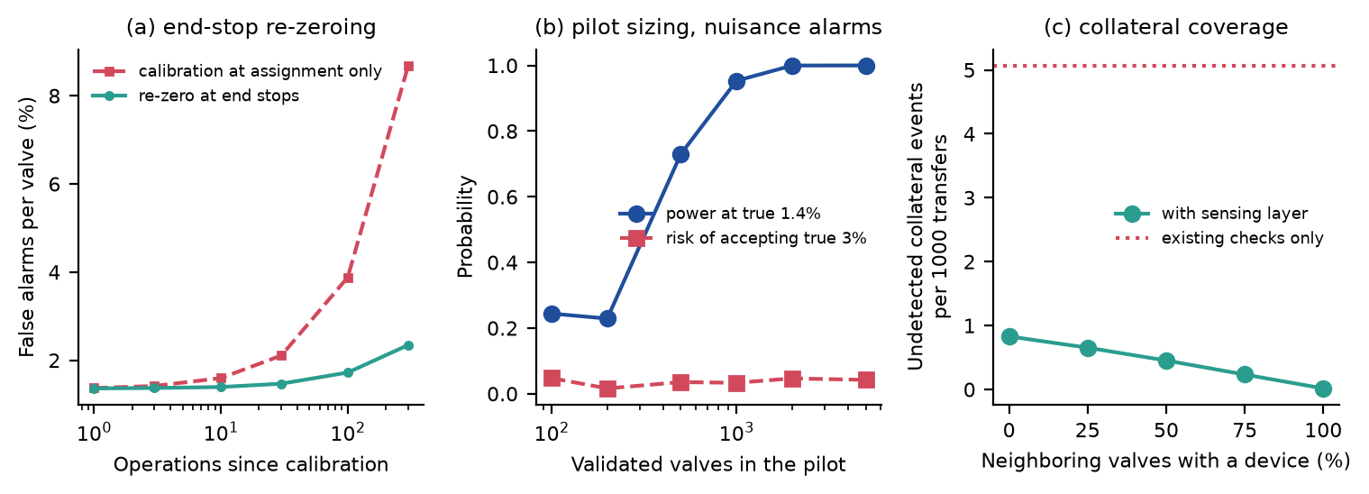
Fig. 10. (a) False alarms against operations since calibration with and without end-stop re-zeroing. (b) Pilot sizing for nuisance alarms: power at the modeled rate and risk of accepting an unacceptable rate. (c) Undetected collateral events against the fraction of neighboring valves that carry a device.
5.13 Pilot sizing and acceptance criteria
Table 5 gives exact binomial acceptance numbers for the nuisance-alarm rate. A pilot of 1000 valves with an acceptance number of 20 has a power of 95% at the modeled 1.4% and a risk of 3.3% of accepting a device whose true rate is 3%; smaller pilots cannot separate the two (100 to 200 valves have a power below 23%), and the extra information of more than 2000 valves is small. A pilot on one route therefore needs approximately 1000 valve validations, which at 14 valves per validation is approximately 70 transfers, or the same valves validated repeatedly across several routes.
Valves validated N | Acceptance number | Power at a true rate of 1.4% | Risk of accepting a true rate of 3% | Upper 95% limit if 1.4% is observed
100 | ≤ 0 | 24% | 4.8% | 5.4%
200 | ≤ 1 | 23% | 1.6% | 4.3%
500 | ≤ 8 | 73% | 3.5% | 2.9%
1,000 | ≤ 20 | 95% | 3.3% | 2.3%
2,000 | ≤ 47 | 100% | 4.7% | 2.0%
5,000 | ≤ 129 | 100% | 4.2% | 1.8%
Table 5. Pilot acceptance test for the nuisance-alarm rate: accept if the number of nuisance alarms among the N validated valves is at most the acceptance number (consumer risk 5% at a true rate of 3%).
For missed defects, the injected-defect test of Table 6 needs approximately 80 deliberately misplaced valves to demonstrate a miss rate below 15% with a power of 80% at the modeled 6% (150 valves give 98%). The accuracy of the device is shown by repeated readings of a valve held at a known position: with 100 readings the 95% interval for the standard deviation is 0.88 to 1.16 times the observed value, with 500 readings 0.94 to 1.07.
Defects injected | Accept if misses | Power at a true miss rate of 6%
20 | ≤ 0 | 29%
40 | ≤ 2 | 57%
80 | ≤ 6 | 80%
150 | ≤ 15 | 98%
300 | ≤ 34 | 100%
Table 6. Pilot acceptance test for missed defects: injected defects detected or missed (consumer risk 5% at a true miss rate of 15%).
The binomial tests assume that validations are independent. Validations of the same valve share its device, mount and calibration, and validations of the same transfer share its operator and conditions, so nuisance alarms are clustered. With an intraclass correlation ρ and m validations per cluster the effective sample size is N/(1+(m−1)ρ), and a beta-binomial model gives the acceptance number and power that keep the 5% consumer risk (Table 9). With 12 valves of 83 validations each, an intraclass correlation of 0.05 cuts the effective sample size from approximately 1000 to 195 and the power at the modeled 1.4% from 95% to 50%; 30 valves of 33 validations keep 70%, and clusters formed by 71 transfers keep 84%. A pilot is therefore better served by more valves than by more repetitions of the same few, and its first task is to estimate the intraclass correlation, which is unknown. Valves validated, validation events and transfers are different sampling units: a validation event is one line-up check of a route, it contains one validation of each valve of the route, and a transfer may contain more than one validation event; in this paper a transfer has one validation event unless stated.
Design (clusters) | Intraclass correlation | Effective sample size | Acceptance number | Power at 1.4% | Risk at 3%
12 valves x 83 validations | 0.00 | 996 | ≤ 20 | 95% | 3.5%
12 valves x 83 validations | 0.02 | 377 | ≤ 16 | 70% | 4.7%
12 valves x 83 validations | 0.05 | 195 | ≤ 12 | 50% | 4.9%
12 valves x 83 validations | 0.10 | 108 | ≤ 7 | 34% | 4.2%
30 valves x 33 validations | 0.00 | 990 | ≤ 20 | 96% | 3.7%
30 valves x 33 validations | 0.02 | 604 | ≤ 18 | 84% | 4.1%
30 valves x 33 validations | 0.05 | 381 | ≤ 16 | 70% | 4.8%
30 valves x 33 validations | 0.10 | 236 | ≤ 13 | 54% | 4.8%
71 transfers x 14 valves | 0.00 | 994 | ≤ 20 | 96% | 3.6%
71 transfers x 14 valves | 0.02 | 789 | ≤ 19 | 90% | 3.6%
71 transfers x 14 valves | 0.05 | 602 | ≤ 18 | 84% | 4.0%
71 transfers x 14 valves | 0.10 | 432 | ≤ 16 | 70% | 3.7%
Table 9. Pilot acceptance test for nuisance alarms when validations are clustered (beta-binomial; approximately 1000 validations; consumer risk at most 5% at a true rate of 3%).
5.14 Common-cause failures of the sensing layer
The independence of the sensing layer from the operator does not make its devices independent of each other. Four common causes were simulated (Fig. 11b), each with a probability q per validation from 10⁻⁴ to 10⁻¹: an outage of the gateway or of the historian and route-validation service, which makes validation unavailable for all devices at once; wrong valve identification, a systematic shift of all device assignments by one valve; and a calibration procedure error, a shared systematic bias (standard deviation 0.06 of stroke) on all devices of the transfer. An outage that is ignored (the operator proceeds as in the bypass of Section 5.4, probability 0.20) and an outage that blocks the transfer (fail-safe) are distinguished. At q=10⁻² the risk-reduction factor is 13.5 for an ignored gateway outage, 13.0 for incorrect identification and 13.7 for a calibration error, against 14.1 without common cause; at q=10⁻¹ it decreases to 10.6, 7.7 and 12.2. Fail-safe blocking removes the effect of outages entirely (14.0 at q=10⁻¹) at the price of delayed transfers in a fraction q of validations. All four causes together at q=10⁻² give 12.0 if outages are ignored and 12.6 with blocking, and at q=10⁻¹ 5.7 and 7.3. Incorrect identification is the most damaging single cause, because it produces both missed defects and nuisance alarms; it is the failure that the NFC assignment check is meant to prevent.
5.15 Time-dependent operator response
A response probability ignores when the operator acts. In a time-dependent model the response time to an isolated alarm is exponential with mean m (an illustrative distribution, not an empirical operator model), multiplied by exp (κF) for F nuisance alarms in the validation. Alarms of the pre-transfer validation have 10 min before pump start; after a movement during the transfer the time before a consequence develops is lognormal with a median of 5 to 40 min (log-standard deviation 0.7), and an alarm acted on after that time is not a barrier. With a mean response time of 1 min the risk-reduction factor is 12.6 to 13.7 (shortest to longest time available), with 3 min 7.3 to 9.2, with 10 min 2.0 to 2.2 and with 20 min 1.3 to 1.4, against 13.7 for the probability model with certain response (Fig. 11c). The benefit therefore depends on the response time relative to the time available much more than on the sensor. The alarm design must put the information in front of someone who can act within minutes, and the pre-transfer validation, which gives a long window, is the more robust use of the layer than the alarm during pumping.
Because the alarm-fatigue parameters are assumed, the response probability (0.7 to 1.0) and fatigue coefficient (0 to 1.0) were varied on a grid (Supplementary Information). The risk-reduction factor is 14.1 at a response of 1.0 and no fatigue, 5.6 at 0.9 and no fatigue, 3.6 at 0.9 and a coefficient of 1.0, and 2.5 at 0.7 and no fatigue. In a pilot these parameters can be estimated rather than assumed: every injected deviation (Section 5.13) is an alarm to which the operator's action and its delay are recorded, so that 80 injections give the response probability to about ±8 percentage points (Wilson interval at 0.9), and regression of the logged action on the number of nuisance alarms in the same validation estimates the fatigue coefficient.
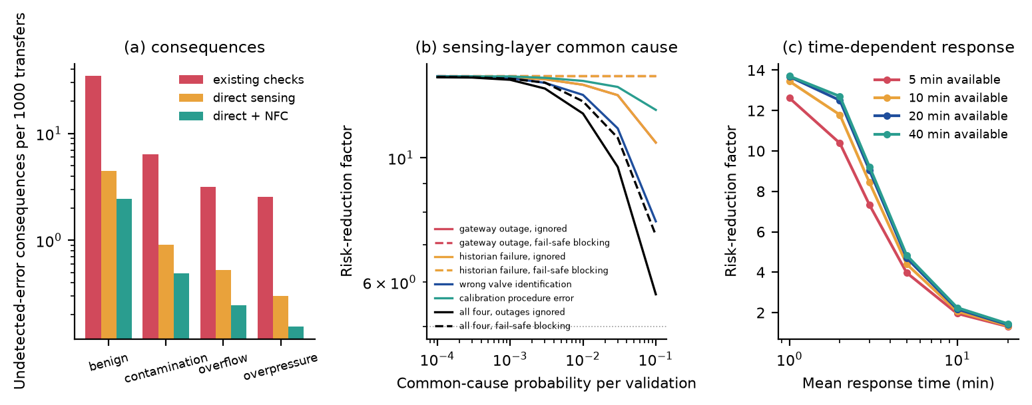
Fig. 11. (a) Consequences per 1000 transfers of the undetected errors, from the illustrative event tree of Section 5.19. (b) Risk-reduction factor against the probability of a common cause of the sensing layer (dotted line: factor 5). (c) Risk-reduction factor against the mean operator response time for different times available before a consequence develops.
5.16 Sensitivity to the defect threshold
The 10%-of-stroke threshold that defines a defect is not a hazardous valve position; it is a convention that a plant would replace by the deviation that matters for its piping. Varying it (Table 10) shows that the risk-reduction factor is a property of the pair of defect threshold and alarm tolerance. With a threshold of 5% an 8% tolerance cannot detect the defects and the factor is 1.4; a tolerance of 4% restores 5.0 but gives 1.7 nuisance alarms per validation. With thresholds of 15% and 20% the factor is 43 and 41 at 8% tolerance with few nuisance alarms. The threshold, and the tolerance derived from it, must therefore be set per valve from a consequence analysis (for example how far a valve can be off before the line is hydraulically wrong), and the results of this paper for the 10% case should not be transferred to other thresholds.
Defect threshold | Alarm tolerance | Existing checks | Full layer | Risk-reduction factor | Nuisance alarms per validation
5% | 8% | 22.3% | 16.09% | 1.4 | 0.06
5% | 4% | 22.3% | 4.46% | 5.0 | 1.73
10% | 8% | 4.1% | 0.29% | 13.9 | 0.18
15% | 8% | 2.5% | 0.06% | 42.7 | 0.21
15% | 12% | 2.5% | 0.08% | 30.9 | 0.04
20% | 8% | 2.2% | 0.05% | 40.6 | 0.22
20% | 16% | 2.2% | 0.09% | 24.0 | 0.02
Table 10. Defect threshold and alarm tolerance: probability of an undetected error with existing checks and with the full layer, risk-reduction factor and nuisance alarms per validation (14-valve route).
5.17 Uncertainty including operator response and common cause
Section 5.7 varied the inputs with the operator always responding. Repeating it with the response probability uniform between 0.7 and 1.0, the fatigue coefficient uniform between 0 and 1.0 and a common-cause probability, the same for the four sensing-layer causes, log-uniform between 10⁻⁴ and 10^{−1.5} (150 draws, Fig. 12b) gives a median risk-reduction factor of 2.5 with a 5th to 95th percentile range of 0.9 to 4.8; it exceeds 2 in 67% of the draws and 5 in 5%, and in 7% of the draws the layer does not reduce the risk at all (factor below 1), because relaxed existing checks are then not compensated by alarms that are acted on. The operator's response to the alarm is now the strongest driver (rank correlation 0.78), ahead of the miss rate of the existing barriers (0.71) and the sensor calibration bias (−0.66). The assumed ranges are pessimistic on purpose and are not data; the contrast with the median of Section 5.7 is the finding. A claim of order-of-magnitude risk reduction rests on operators who act on the alarm, and it cannot be separated from the human-factors design of the alarm.
5.18 Boundaries of the benefit
From sweeps of single parameters with the others at their base values (Fig. 12a), the largest bypass probability, the smallest response probability and the largest common-cause and communication-loss probabilities that keep the risk-reduction factor at or above a required value are given in Table 7. A factor of 5 survives complete bypass (the factor is still 7.0 if every blocked validation is bypassed) but needs a response of at least 0.88 and a common-cause probability below 0.13; a factor of 10 needs a response of at least 0.97, bypass below 0.53, a common-cause probability below 0.023 and a communication-loss probability below 0.012. These boundaries are conditional on the other parameters and on the assumed model, but they translate the abstract claim of independence into conditions that a plant can check: how often devices are unavailable, whether an unavailable device may be bypassed, and how quickly alarms are acted on.
Condition | Factor of at least 5 | Factor of at least 10
Probability of proceeding without validation (bypass), at most | none within the range studied | 0.53
Response to an alarm, at least | 0.88 | 0.97
Common-cause probability of the sensing layer (each of four, outages ignored), at most | 0.127 | 0.023
Communication-loss probability per device, at most | 0.067 | 0.012
Table 7. Boundaries for a required risk-reduction factor (single-parameter sweeps, 14-valve route, other parameters at base values).
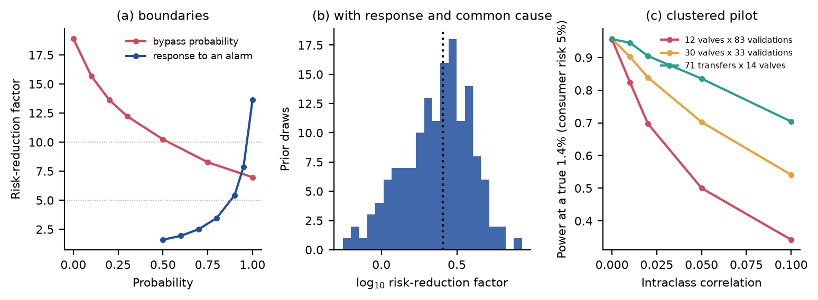
Fig. 12. (a) Risk-reduction factor against the bypass probability and against the response probability (dotted lines: factors 5 and 10). (b) Distribution of the risk-reduction factor with response and common cause varied with the other inputs. (c) Power of the nuisance-alarm acceptance test at the modeled 1.4% when validations are clustered, against the intraclass correlation.
5.19 Consequence-based illustration
An undetected valve error is not an accident. To connect the detection results to consequences, each undetected-error scenario E_{i} (a required-open valve left closed or partly closed, a required-closed valve left open or partly open, an out-of-sequence step, a movement after validation, a collateral movement of a neighbor with half the neighbors covered) was assigned assumed conditional probabilities P(C_{j}|E_{i}) of four consequences C_{j} (benign or recoverable, product contamination or misrouting, tank overflow or release, blocked-in or overpressure) and an assumed loss L_{j}, so that P(C_{j})=Σ_{i} P(E_{i})P(C_{j}|E_{i}) and the expected annual loss is N_{T} Σ_{j} P(C_{j}) L_{j} for N_{T} = 1,000 transfers per year (Supplementary Information lists all assumptions). These numbers are illustrative, chosen to show the method; they are not accident frequencies or costs. With them (Table 8, Fig. 11a) the full layer reduces the consequence probabilities by factors of 13.0 (contamination), 12.9 (overflow) and 16.3 (overpressure), and the expected annual loss by 13.5. When the conditional probabilities of the hazardous consequences and the losses are varied by lognormal factors with a 90% factor of 3 (4,000 draws), the reduction in expected loss has a median of 13.6 (5th to 95th percentile 12.2 to 16.4); this range covers only the consequence assumptions and not the input uncertainty of Sections 5.7 and 5.17, which would be multiplied onto it. The reduction in expected loss is similar to the reduction in detection probability because the layer acts on all scenarios in a similar proportion; the absolute figures depend entirely on the assumed matrix, and the method is the contribution.
Consequence | Existing checks | Full layer | Reduction factor
benign or recoverable | 34.48 | 2.45 | 14.0
product contamination or misrouting | 6.41 | 0.49 | 13.0
tank overflow or release | 3.16 | 0.25 | 12.9
blocked-in or overpressure | 2.54 | 0.16 | 16.3
Expected annual loss, 1,000 transfers per year (illustrative units) | 9.31 M | 0.69 M | 13.5
Table 8. Illustrative consequence-based assessment (assumed conditional probabilities and losses): undetected-error consequences per 1000 transfers and expected annual loss, existing checks and full layer.
6. Discussion
Five findings are useful for specification. First, the headline reduction should be quoted as a distribution and as conditional on operators acting on the alarms, not as the nominal 14-fold. With the operator always responding the median is 9.7 (plausible range 4.4 to 28); with uncertain response, fatigue and common cause it is 2.5 (0.9 to 4.8), and a mean response time of 10 min against a window of 20 min leaves a factor of approximately 2. The benefit is a property of the whole layer, sensor plus people plus procedure, and a pilot must measure the response, not only the sensor (H1 holds across the sensor and human error ranges, but its size depends on the response). Second, alarm tolerance has an interior optimum once alarm fatigue is included (H2): 8% with two-point calibration at every assignment keeps nuisance alarms near 1% per valve with direct sensing; end-stop re-zeroing of binary valves removes most of the dependence on calibration age; throttled valves need their own, explicitly derived band; and the defect threshold itself, which changes the factor by an order of magnitude between 5% and 15%, must be set per valve from the consequences. Third, the boundaries of H3 are concrete: a factor of 10 needs a response of at least 97%, bypass below 53% and a common-cause probability below 2.3%, and a factor of 5 still needs a response of at least 88%. On-site calibration quality, availability, bypass policy and fail-safe blocking of outages, not the radio technology, govern what the sensors contribute. Fourth, the common causes differ in kind: an outage that blocks the transfer costs time but not protection, an ignored outage erodes it slowly, and systematic incorrect identification is the most damaging, which supports the NFC assignment check and a validation that the assignments match the procedure. Fifth, a pilot with the clustering that real validations have needs more valves than repeats: 1000 validations from 12 valves have a power of 50% at an intraclass correlation of 0.05, against 95% if validations were independent.
The comparison of the two sensing concepts supports sensing at the stem or indicator where this is mechanically feasible. The turn collar remains attractive where only the handwheel is accessible, but the simulation indicates it needs recalibration at nearly every assignment and a wider tolerance.
6.1 Position relative to layer-of-protection practice
A protection layer is credited in layer-of-protection analysis only when it is independent of the initiating event and of other layers, specific, dependable and auditable [9]. The sensing layer is independent of the operator's report by construction, and its time-stamped record is auditable. It is not dependable in the required sense until its availability, accuracy, common-cause behavior and the response time of the people who act on it have been measured; the study shows that these are the parameters that decide the benefit. The layer is therefore proposed as an advisory barrier whose value is to be demonstrated by a pilot with the acceptance criteria of Section 5.13, and not as a credited independent protection layer or a safety instrumented function. Table 11 keeps the status of each claim explicit.
Claim | Support in this paper
The modeled architecture reduces undetected errors under assumed conditions | Supported by the simulations
Alarm response, response time and tolerance materially change the modeled benefit | Supported by the sensitivity, time-response and boundary analyses
A given pilot size can test chosen thresholds | Supported conditionally by the binomial and beta-binomial assumptions
The hardware will reach the assumed measurement accuracy | Not demonstrated
The system reduces actual accident frequency | Not demonstrated; the event tree is illustrative
The system qualifies as a credited independent protection layer | Not demonstrated
Table 11. Claims and their support.
6.2 Limitations
The study has important limitations. (i) All input probabilities, the consequence probabilities and the losses are assumed. The probabilistic sensitivity analyses propagate the uncertainty of the input ranges, but the ranges are themselves assumptions, and human error rates, existing-barrier detection and valve behavior at a real facility may differ by more than the factors used. (ii) Common cause of the operator error rates is a shared multiplier, and common cause of the sensing layer is represented by four scenarios with assumed probabilities; other dependencies (a shared firmware fault, a shared mounting error, correlated environmental conditions) are not modeled. (iii) The operator-response models are parametric descriptions with assumed coefficients, not fitted models; the exponential response time is illustrative, and the alarm during pumping and the pre-transfer alarm are the only two windows considered. (iv) The event tree is a simplified single-level tree with assumed conditional probabilities; it does not model the process hydraulics of any specific route, and the defect threshold of 10% of stroke is a convention. (v) Detection of out-of-sequence steps is represented by a single probability rather than a full procedure model. (vi) Security, electromagnetic and mechanical failure modes, hazardous-area certification and the installation effort were not simulated. (vii) The device concept has not been built or tested, and the battery estimate is analytical. (viii) The literature cited for the human-reliability and incident background was checked for existence and bibliographic data, not read in full for each statement; this must be completed before submission.
6.3 Relation to existing practice and future work
Permanent position transmitters and limit switches provide equivalent information at higher installation cost per valve, and they are the natural choice for valves on critical lines that are operated frequently. The temporary, reassignable layer studied here addresses the complementary case of many manual valves that matter only on some routes or during some operations. The next step is the pilot of Section 5.13, which measures sensor accuracy, nuisance alarms, availability, installation time, the intraclass correlation of the validations and the operator's action and its delay on every alarm, replaces the assumed inputs with data and allows the model to be calibrated; the sensitivity analyses can then be rerun with posterior distributions and with a consequence analysis of the actual route.
7. Conclusions
The size of the benefit of an independent sensing layer on existing manual valves depends on the operators' response more than on the sensors. With assumed inputs and operators who always act on the alarms, the modeled probability of an undetected misalignment or unauthorized movement per transfer decreases from 4.03% to 0.29% on a 14-valve route (14-fold), and by a median factor of 9.7 when the uncertainty of the inputs is propagated; when the response of the operators, alarm fatigue and common-cause failures of the sensing layer are also uncertain, the median factor is 2.5 (5th to 95th percentile 0.9 to 4.8). A factor of 10 needs a response of at least 97%, bypass below 53% and a common-cause probability below 2.3%; fail-safe blocking neutralizes gateway outages, and wrong valve identification is the most damaging common cause. An illustrative event tree translates the detection reduction into a 14-fold reduction in expected loss under assumed consequence probabilities. Direct stem sensing outperforms handwheel turn counting in false alarms and in robustness to calibration age; an alarm tolerance near 8% of stroke, end-stop re-zeroing, a separate band and an explicit defect threshold for throttled valves, spare availability and no unrecorded bypass are the main design levers. A pilot needs approximately 1000 validated valves from more valves rather than more repeats, with an acceptance number set for the clustering observed, and an injected-deviation test with logged operator actions and delays. The layer cannot be credited as a quantified protection layer before that.
Declaration of competing interest
The author has prepared a related commercial proposal in response to a public open-innovation challenge concerning real-time verification of manual valve position and may benefit commercially from the concept described. The author has no other competing interests.
Funding
This research did not receive any specific grant from funding agencies in the public, commercial, or not-for-profit sectors.
CRediT authorship contribution statement
Leon Sandler: Conceptualization, Methodology, Software, Validation, Formal analysis, Investigation, Visualization, Writing – original draft, Writing – review and editing.
Data availability
The simulation code, the data behind every figure and table, the automated tests and the manuscript sources (version 1.1.1) are archived at https://doi.org/10.5281/zenodo.24046773 (software, all versions) and https://doi.org/10.5281/zenodo.24046771 (manuscript, all versions), and are available at https://github.com/sandlerleon/hydrasense-valve-verification-mc. The study uses no field data.
Declaration of generative AI and AI-assisted technologies in the writing process
During the preparation of this work the author used Claude (Anthropic) to assist with drafting text, writing and testing simulation code and generating figures from that code. After using this tool, the author reviewed and edited the content as needed and takes full responsibility for the content of the publication.
References
[1] A.D. Swain, H.E. Guttmann, Handbook of Human Reliability Analysis with Emphasis on Nuclear Power Plant Applications, NUREG/CR-1278, U.S. Nuclear Regulatory Commission, Washington, DC (1983).
[2] B. Kirwan, A Guide to Practical Human Reliability Assessment, Taylor & Francis, London (1994).
[3] J. Reason, Human Error, Cambridge University Press, Cambridge (1990). https://doi.org/10.1017/cbo9781139062367
[4] B. Kirwan, Human error identification in human reliability assessment. Part 1: Overview of approaches, Applied Ergonomics 23 (1992) 299–318. https://doi.org/10.1016/0003-6870(92)90292-4
[5] J.C. Williams, A data-based method for assessing and reducing human error to improve operational performance, in: Conference Record for 1988 IEEE Fourth Conference on Human Factors and Power Plants, IEEE (1988) 436–450. https://doi.org/10.1109/hfpp.1988.27540
[6] E. Zarei, M. Yazdi, R. Abbassi, F. Khan, A hybrid model for human factor analysis in process accidents: FBN-HFACS, Journal of Loss Prevention in the Process Industries 57 (2019) 142–155. https://doi.org/10.1016/j.jlp.2018.11.015
[7] T. Kletz, P. Amyotte, Case histories and their use in enhancing process safety knowledge, in: What Went Wrong?, Elsevier (2019) 3–17. https://doi.org/10.1016/b978-0-12-810539-9.00001-x
[8] S. Mannan (Ed.), Lees' Loss Prevention in the Process Industries: Hazard Identification, Assessment and Control, fourth ed., Butterworth-Heinemann, Oxford (2012); chapter 14, Human factors and human error, pp. 687–751. https://doi.org/10.1016/b978-0-12-397189-0.00014-8
[9] Center for Chemical Process Safety, Guidelines for Initiating Events and Independent Protection Layers in Layer of Protection Analysis, Wiley, Hoboken (2015). https://doi.org/10.1002/9781118948743
[10] F. Chraim, K. Pister, Wireless valve position monitoring: A MEMS approach, in: IECON 2013 – 39th Annual Conference of the IEEE Industrial Electronics Society, IEEE (2013) 4016–4021. https://doi.org/10.1109/iecon.2013.6699778
[11] Wazoku (InnoCentive), Real-Time Verification of Manual Valve Position during Critical Product Transfers (scouting challenge for YPF), https://ypf.community.innocentive.com/challenge/1ca6a86eaede4555a14d7b1746c9d79e (accessed 7 November 2026).
[12] IEC 62591, Industrial networks – Wireless communication network and communication profiles – WirelessHART, International Electrotechnical Commission, Geneva (current edition).
[13] IEC 61511 series, Functional safety – Safety instrumented systems for the process industry sector, International Electrotechnical Commission, Geneva.
[14] IEC 60079-11, Explosive atmospheres – Part 11: Equipment protection by intrinsic safety "i", International Electrotechnical Commission, Geneva (current edition).
[15] N. Metropolis, S. Ulam, The Monte Carlo method, Journal of the American Statistical Association 44 (1949) 335–341. https://doi.org/10.1080/01621459.1949.10483310
[16] E.B. Wilson, Probable inference, the law of succession, and statistical inference, Journal of the American Statistical Association 22 (1927) 209–212. https://doi.org/10.1080/01621459.1927.10502953
[17] L.D. Brown, T.T. Cai, A. DasGupta, Interval estimation for a binomial proportion, Statistical Science 16 (2001) 101–133. https://doi.org/10.1214/ss/1009213286
[18] L. Sandler, MyUncle: maintenance-lattice simulation framework, GitHub repository, https://github.com/sandlerleon/MyUncle.
[19] J.C. Laberge, P. Bullemer, M. Tolsma, D.V.C. Reising, Addressing alarm flood situations in the process industries through alarm summary display design and alarm response strategy, International Journal of Industrial Ergonomics 44 (2014) 395–406. https://doi.org/10.1016/j.ergon.2013.11.008
[20] S. Marino, I.B. Hogue, C.J. Ray, D.E. Kirschner, A methodology for performing global uncertainty and sensitivity analysis in systems biology, Journal of Theoretical Biology 254 (2008) 178–196. https://doi.org/10.1016/j.jtbi.2008.04.011
[21] IEC 62682, Management of alarm systems for the process industries, International Electrotechnical Commission, Geneva (current edition).

