Supplementary Information
Quantifying the Effectiveness of Independent Manual-Valve Verification in Preventing Product-Transfer Risks: A Monte Carlo Process-Safety Assessment
Leon Sandler
Independent Researcher, Northbrook, Illinois, USA. sandler.leon@gmail.com

S1. First suite: all outputs for the 14-valve route
Output | Existing checks | Turn-count collar | Direct sensing | Direct + NFC
Undetected error per transfer | 4.027% (3.957–4.098%) | 0.454% (0.431–0.479%) | 0.302% (0.283–0.322%) | 0.285% (0.267–0.305%)
from a valve position | 3.206% | 0.414% | 0.264% | 0.247%
from an out-of-sequence step | 0.346% | 0.026% | 0.026% | 0.026%
from a post-validation movement | 0.503% | 0.015% | 0.013% | 0.013%
Validation with at least one nuisance alarm | 0.0% | 54.1% | 18.6% | 17.5%
Validation blocked (device unavailable) | 0.0% | 8.0% | 8.0% | 8.0%
Bypass of a blocked validation | 0.00% | 1.61% | 1.61% | 1.61%
Nuisance alarms per valve | 0.00% | 5.37% | 1.42% | 1.33%
Defects missed by the sensors | – | 8.5% | 5.5% | 5.6%
Detection of a post-validation movement within 60 s | – | 96.6% | 97.0% | 97.0%
Wrong-valve events per 1000 transfers | 20.6 | 20.6 | 20.6 | 3.0
Table S1. Outputs of the first suite for the 14-valve route (300,000 transfers per cell; Wilson 95% interval for the primary output).
Tolerance | Direct: alarms | Direct: missed | Turns: alarms | Turns: missed | Direct aged: alarms | Direct aged: missed | Turns aged: alarms | Turns aged: missed
3% | 26.7% | 1.7% | 43.4% | 2.1% | 28.3% | 1.9% | 61.7% | 4.0%
5% | 7.9% | 2.0% | 20.4% | 3.4% | 9.6% | 2.3% | 43.1% | 6.3%
6% | 4.3% | 2.4% | 13.2% | 4.7% | 5.9% | 2.8% | 36.0% | 7.9%
8% | 1.4% | 5.6% | 5.4% | 8.3% | 2.9% | 5.8% | 25.9% | 11.8%
10% | 0.5% | 12.2% | 2.4% | 14.1% | 1.9% | 13.0% | 19.9% | 16.6%
12% | 0.3% | 22.2% | 1.4% | 22.0% | 1.5% | 22.4% | 16.3% | 22.5%
15% | 0.2% | 35.9% | 0.9% | 33.7% | 1.2% | 35.5% | 12.8% | 31.2%
Table S2. Alarm tolerance sweep (nuisance alarms per valve, share of true defects missed); aged = 60 operations since calibration.
Operations | Direct: alarms per valve | Direct: missed | Turns: alarms per valve | Turns: missed
1 | 1.4% | 5.4% | 4.5% | 8.5%
3 | 1.4% | 5.6% | 5.4% | 8.3%
10 | 1.6% | 5.6% | 8.2% | 9.3%
30 | 2.1% | 5.9% | 15.8% | 10.7%
100 | 3.9% | 6.0% | 36.9% | 13.6%
300 | 8.7% | 7.0% | 64.7% | 16.2%
Table S3. Operations since calibration (tolerance 8%).
Communication loss | Validation blocked | Residual risk, 20% bypass | Residual risk, no bypass
0.0005 | 4.8% | 0.245% | 0.208%
0.0010 | 5.4% | 0.250% | 0.208%
0.0030 | 8.0% | 0.274% | 0.208%
0.0100 | 16.8% | 0.343% | 0.208%
0.0200 | 27.8% | 0.454% | 0.208%
0.0500 | 53.4% | 0.709% | 0.208%
Table S4. Per-device communication-loss probability: validation blocked, and residual risk of the full layer with 20% and 0% bypass.
Complacency | Residual risk
0% | 0.229%
10% | 0.253%
20% | 0.274%
40% | 0.325%
60% | 0.378%
80% | 0.431%
Table S5. Operator complacency (relative reduction of the effectiveness of existing checks) and residual risk of the full layer.
Tap compliance | Wrong-valve events per 1000
0% | 20.4
25% | 15.8
50% | 11.0
75% | 6.2
90% | 3.1
100% | 1.1
Table S6. NFC tap compliance and wrong-valve events per 1000 transfers.
Parameter | Half | Double
existing-barrier miss rate | 0.18% | 0.46%
skip rate | 0.27% | 0.28%
incomplete-movement rate | 0.25% | 0.32%
out-of-sequence rate | 0.26% | 0.29%
unauthorized-movement rate | 0.27% | 0.28%
sensor noise | 0.23% | 0.39%
calibration bias | 0.18% | 0.48%
alarm tolerance | 0.09% | 1.96%
device unavailability | 0.24% | 0.33%
bypass probability | 0.24% | 0.36%
operator complacency | 0.25% | 0.33%
wrong-device assignment | 0.27% | 0.27%
Table S7. One-at-a-time sensitivity of the residual risk of the full layer (base 0.27%) for the parameter at half and double its base value.
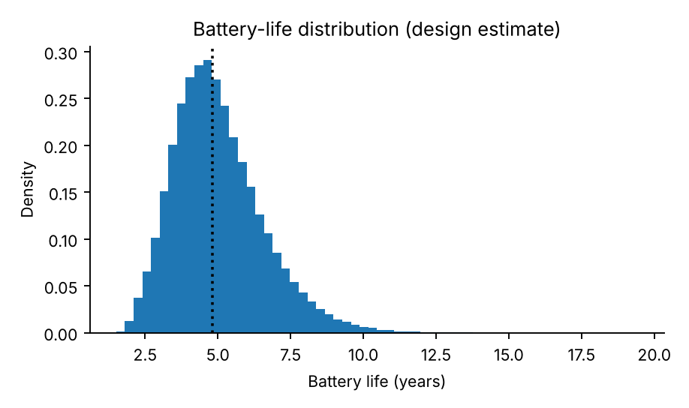
Fig. S1. Design-level battery-life estimate (primary lithium cells, wake-on-motion, 16 s heartbeat): median 4.8 years, 5th to 95th percentile 2.9 to 7.9 years; the analytic mean is 4.7 years.
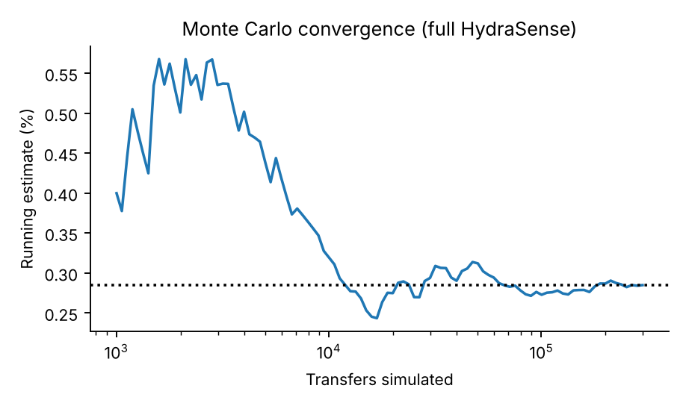
Fig. S2. Convergence of the Monte Carlo estimate of the residual risk with the number of transfers.
S2. Extended studies: all cases
Response | Fatigue coefficient | Residual risk | Risk-reduction factor
100% | 0.0 | 0.275% (0.249–0.302%) | 14.8
100% | 0.3 | 0.454% (0.421–0.489%) | 8.9
100% | 0.6 | 0.591% (0.553–0.631%) | 6.9
90% | 0.0 | 0.720% (0.678–0.764%) | 5.6
90% | 0.3 | 0.884% (0.838–0.933%) | 4.6
90% | 0.6 | 1.009% (0.960–1.061%) | 4.0
80% | 0.0 | 1.145% (1.092–1.200%) | 3.5
80% | 0.3 | 1.301% (1.245–1.360%) | 3.1
80% | 0.6 | 1.405% (1.347–1.466%) | 2.9
Table S8. Operator response to an isolated alarm, fatigue coefficient, residual risk of the full layer (Wilson 95% interval) and risk-reduction factor (existing checks 4.06%).
Response | Fatigue | Tolerance | Residual risk | Nuisance alarms per validation
100% | 0.0 | 4% | 0.089% | 2.06
100% | 0.0 | 5% | 0.102% | 1.10
100% | 0.0 | 6% | 0.124% | 0.59
100% | 0.0 | 7% | 0.169% | 0.33
100% | 0.0 | 8% | 0.275% | 0.19
100% | 0.0 | 10% | 0.625% | 0.06
100% | 0.0 | 12% | 1.132% | 0.02
100% | 0.0 | 15% | 1.791% | 0.01
95% | 0.3 | 4% | 2.079% | 2.06
95% | 0.3 | 5% | 1.355% | 1.10
95% | 0.3 | 6% | 0.898% | 0.59
95% | 0.3 | 7% | 0.707% | 0.33
95% | 0.3 | 8% | 0.661% | 0.19
95% | 0.3 | 10% | 0.878% | 0.06
95% | 0.3 | 12% | 1.315% | 0.02
95% | 0.3 | 15% | 1.936% | 0.01
95% | 0.6 | 4% | 2.939% | 2.06
95% | 0.6 | 5% | 1.945% | 1.10
95% | 0.6 | 6% | 1.277% | 0.59
95% | 0.6 | 7% | 0.929% | 0.33
95% | 0.6 | 8% | 0.788% | 0.19
95% | 0.6 | 10% | 0.927% | 0.06
95% | 0.6 | 12% | 1.329% | 0.02
95% | 0.6 | 15% | 1.943% | 0.01
Table S9. Alarm tolerance with operator response: residual risk of the full layer and nuisance alarms per validation.
Binary tol. | Intermediate tol. | Alarms per binary valve | Alarms per intermediate valve | Alarms per validation | Defects missed | Residual risk
5% | 8% | 4.67% | 8.10% | 0.722 | 5.3% | 0.295%
5% | 12% | 4.67% | 0.91% | 0.578 | 20.1% | 1.063%
5% | 15% | 4.67% | 0.33% | 0.567 | 30.0% | 1.578%
6% | 8% | 1.81% | 8.10% | 0.379 | 5.3% | 0.297%
6% | 12% | 1.81% | 0.91% | 0.235 | 20.1% | 1.064%
6% | 15% | 1.81% | 0.33% | 0.223 | 30.0% | 1.579%
8% | 8% | 0.31% | 8.10% | 0.199 | 5.6% | 0.312%
8% | 12% | 0.31% | 0.91% | 0.055 | 20.4% | 1.079%
8% | 15% | 0.31% | 0.33% | 0.044 | 30.3% | 1.594%
Table S10. Separate tolerances for binary and intermediate valves (direct sensing, 14-valve route).
Operations | Calibration | Nuisance alarms per valve | Defects missed
1 | calibration at assignment | 1.37% | 5.2%
1 | re-zero at end stops | 1.36% | 5.2%
3 | calibration at assignment | 1.42% | 5.6%
3 | re-zero at end stops | 1.37% | 5.6%
10 | calibration at assignment | 1.60% | 5.7%
10 | re-zero at end stops | 1.39% | 5.7%
30 | calibration at assignment | 2.11% | 5.8%
30 | re-zero at end stops | 1.47% | 5.7%
100 | calibration at assignment | 3.88% | 5.8%
100 | re-zero at end stops | 1.72% | 5.6%
300 | calibration at assignment | 8.69% | 7.2%
300 | re-zero at end stops | 2.35% | 6.5%
Table S11. End-stop re-zeroing (direct sensing).
Coverage | Undetected, full layer | Undetected, existing checks | Events, with NFC | Events, without NFC
0% | 0.83 | 5.07 | 1.38 | 10.11
25% | 0.65 | 5.07 | 1.38 | 10.11
50% | 0.45 | 5.07 | 1.38 | 10.11
75% | 0.23 | 5.07 | 1.38 | 10.11
100% | 0.02 | 5.07 | 1.38 | 10.11
Table S12. Coverage of neighboring valves: undetected collateral events per 1000 transfers (full layer and existing checks), and collateral events (with and without NFC tap-before-touch).
Log-standard deviation | Existing checks (95% interval) | Full layer (95% interval) | Risk-reduction factor
0.0 | 4.06% (3.99–4.13%) | 0.276% (0.258–0.295%) | 14.7
0.5 | 4.04% (3.97–4.11%) | 0.276% (0.258–0.295%) | 14.7
1.0 | 4.02% (3.95–4.10%) | 0.275% (0.257–0.294%) | 14.6
1.5 | 3.92% (3.85–3.99%) | 0.273% (0.255–0.293%) | 14.3
Table S13. Common cause: log-standard deviation of the shared multiplier of the operator error rates.
Input | Risk-reduction factor | Full layer risk | Existing-checks risk
existing-barrier miss rate (x) | 0.64 | 0.73 | 0.96
sensor calibration bias (x) | −0.61 | 0.61 | −0.03
device unavailability (x) | −0.55 | 0.54 | 0.05
sensor noise (x) | −0.50 | 0.54 | −0.04
bypass probability | −0.45 | 0.52 | 0.05
operator error rates (x) | 0.42 | 0.59 | 0.91
operator complacency | −0.38 | 0.44 | 0.03
time-stamp sequence detection | 0.28 | −0.32 | 0.06
unauthorized-movement rate (x) | 0.25 | 0.06 | 0.46
sensor drift (x) | −0.10 | 0.06 | −0.02
out-of-sequence rate (x) | −0.09 | 0.27 | 0.32
wrong-device assignment (x) | −0.07 | −0.04 | −0.08
slip rate (x) | −0.02 | −0.04 | −0.01
Table S14. Partial rank correlation coefficients of the 13 assumed inputs with the logarithm of the risk-reduction factor, of the residual risk of the full layer and of the residual risk of existing checks.
Readings | Lower | Upper
30 | 0.796 | 1.344
50 | 0.835 | 1.246
100 | 0.878 | 1.162
200 | 0.911 | 1.109
500 | 0.942 | 1.066
Table S15. 95% interval for the standard deviation of repeated readings, as a multiple of the observed value.
S3. Studies added in version 1.1.0
Sampling uncertainty. 20 independent replications of 150,000 transfers (common random numbers across architectures within a replication) give a residual risk of 4.046% for existing checks and 0.289% for the full layer, a risk-reduction factor of 13.99 (95% bootstrap interval 13.63 to 14.31) and of 13.19 (12.85 to 13.50) for direct sensing without NFC; the relative reduction of residual risk by NFC is 6.1% (5.5% to 6.7%). Slip check: 3,000,000 draws of the sensor error for a defect of 15% of stroke give a miss probability of 0.285% (95% interval 0.279% to 0.292%); the closed form without slip is 0.257% and with slip 0.285%.
Scenario | 0.0001 | 0.0003 | 0.001 | 0.003 | 0.01 | 0.03 | 0.1
gateway outage, ignored | 14.0 | 14.0 | 13.9 | 13.8 | 13.5 | 12.9 | 10.6
gateway outage, fail-safe blocking | 14.0 | 14.0 | 14.0 | 14.0 | 14.0 | 14.0 | 14.0
historian failure, ignored | 14.0 | 14.0 | 13.9 | 13.8 | 13.5 | 12.9 | 10.6
historian failure, fail-safe blocking | 14.0 | 14.0 | 14.0 | 14.0 | 14.0 | 14.0 | 14.0
wrong valve identification | 14.0 | 14.0 | 13.9 | 13.6 | 13.0 | 11.3 | 7.7
calibration procedure error | 14.0 | 14.0 | 14.0 | 13.9 | 13.7 | 13.4 | 12.2
all four, outages ignored | 13.9 | 13.9 | 13.8 | 13.3 | 12.0 | 9.6 | 5.7
all four, fail-safe blocking | 13.9 | 13.9 | 13.8 | 13.6 | 12.6 | 10.9 | 7.3
Table S16. Risk-reduction factor of the full layer against the probability q of a common cause of the sensing layer per validation (existing checks 4.01%; no common cause: 14.0).
Fatigue | Mean response (min) | Time available (min) | Residual risk | Factor | Share from movements
0.0 | 1 | 5 | 0.318% | 12.6 | 10%
0.0 | 1 | 10 | 0.298% | 13.4 | 5%
0.0 | 1 | 20 | 0.293% | 13.7 | 3%
0.0 | 1 | 40 | 0.292% | 13.7 | 3%
0.0 | 2 | 5 | 0.386% | 10.4 | 20%
0.0 | 2 | 10 | 0.340% | 11.8 | 10%
0.0 | 2 | 20 | 0.321% | 12.5 | 4%
0.0 | 2 | 40 | 0.316% | 12.7 | 3%
0.0 | 3 | 5 | 0.546% | 7.3 | 23%
0.0 | 3 | 10 | 0.475% | 8.4 | 11%
0.0 | 3 | 20 | 0.443% | 9.0 | 5%
0.0 | 3 | 40 | 0.434% | 9.2 | 3%
0.0 | 5 | 5 | 1.010% | 4.0 | 20%
0.0 | 5 | 10 | 0.911% | 4.4 | 11%
0.0 | 5 | 20 | 0.852% | 4.7 | 5%
0.0 | 5 | 40 | 0.830% | 4.8 | 2%
0.0 | 10 | 5 | 2.053% | 2.0 | 15%
0.0 | 10 | 10 | 1.943% | 2.1 | 10%
0.0 | 10 | 20 | 1.845% | 2.2 | 5%
0.0 | 10 | 40 | 1.786% | 2.2 | 2%
0.0 | 20 | 5 | 3.056% | 1.3 | 13%
0.0 | 20 | 10 | 2.971% | 1.3 | 10%
0.0 | 20 | 20 | 2.862% | 1.4 | 7%
0.0 | 20 | 40 | 2.765% | 1.4 | 4%
0.3 | 1 | 5 | 0.321% | 12.5 | 11%
0.3 | 1 | 10 | 0.298% | 13.4 | 5%
0.3 | 1 | 20 | 0.293% | 13.7 | 3%
0.3 | 1 | 40 | 0.292% | 13.7 | 3%
0.3 | 2 | 5 | 0.403% | 9.9 | 21%
0.3 | 2 | 10 | 0.355% | 11.3 | 10%
0.3 | 2 | 20 | 0.333% | 12.0 | 4%
0.3 | 2 | 40 | 0.328% | 12.2 | 3%
0.3 | 3 | 5 | 0.585% | 6.9 | 23%
0.3 | 3 | 10 | 0.509% | 7.9 | 11%
0.3 | 3 | 20 | 0.475% | 8.4 | 5%
0.3 | 3 | 40 | 0.464% | 8.6 | 3%
0.3 | 5 | 5 | 1.072% | 3.7 | 19%
0.3 | 5 | 10 | 0.975% | 4.1 | 11%
0.3 | 5 | 20 | 0.912% | 4.4 | 5%
0.3 | 5 | 40 | 0.887% | 4.5 | 2%
0.3 | 10 | 5 | 2.124% | 1.9 | 15%
0.3 | 10 | 10 | 2.014% | 2.0 | 10%
0.3 | 10 | 20 | 1.918% | 2.1 | 6%
0.3 | 10 | 40 | 1.855% | 2.2 | 2%
0.3 | 20 | 5 | 3.104% | 1.3 | 13%
0.3 | 20 | 10 | 3.022% | 1.3 | 10%
0.3 | 20 | 20 | 2.913% | 1.4 | 7%
0.3 | 20 | 40 | 2.817% | 1.4 | 4%
Table S17. Time-dependent operator response: fatigue coefficient, mean response time (min), median time available after a movement during the transfer (min), residual risk of the full layer, risk-reduction factor and share of the residual risk from movements during the transfer (pre-transfer window 10 min).
Response | Fatigue coefficient | Residual risk | Risk-reduction factor
70% | 0.0 | 1.617% | 2.5
70% | 0.2 | 1.698% | 2.4
70% | 0.4 | 1.778% | 2.2
70% | 0.6 | 1.836% | 2.2
70% | 0.8 | 1.881% | 2.1
70% | 1.0 | 1.915% | 2.1
80% | 0.0 | 1.181% | 3.4
80% | 0.2 | 1.287% | 3.1
80% | 0.4 | 1.368% | 2.9
80% | 0.6 | 1.439% | 2.8
80% | 0.8 | 1.486% | 2.7
80% | 1.0 | 1.529% | 2.6
90% | 0.0 | 0.718% | 5.6
90% | 0.2 | 0.844% | 4.7
90% | 0.4 | 0.934% | 4.3
90% | 0.6 | 1.011% | 4.0
90% | 0.8 | 1.082% | 3.7
90% | 1.0 | 1.120% | 3.6
100% | 0.0 | 0.283% | 14.1
100% | 0.2 | 0.406% | 9.8
100% | 0.4 | 0.518% | 7.7
100% | 0.6 | 0.596% | 6.7
100% | 0.8 | 0.665% | 6.0
100% | 1.0 | 0.715% | 5.6
Table S18. Response probability and fatigue coefficient: residual risk of the full layer and risk-reduction factor.
Parameter | Value | Risk-reduction factor
bypass probability | 0 | 18.9
bypass probability | 0.1 | 15.7
bypass probability | 0.2 | 13.6
bypass probability | 0.3 | 12.2
bypass probability | 0.5 | 10.2
bypass probability | 0.75 | 8.3
bypass probability | 1 | 7.0
response probability | 0.5 | 1.6
response probability | 0.6 | 1.9
response probability | 0.7 | 2.5
response probability | 0.8 | 3.5
response probability | 0.9 | 5.4
response probability | 0.95 | 7.9
response probability | 1 | 13.6
common-cause probability (each of four) | 0.0001 | 13.6
common-cause probability (each of four) | 0.001 | 13.4
common-cause probability (each of four) | 0.003 | 12.9
common-cause probability (each of four) | 0.01 | 11.8
common-cause probability (each of four) | 0.03 | 9.2
common-cause probability (each of four) | 0.1 | 5.4
common-cause probability (each of four) | 0.3 | 2.9
communication-loss probability | 0.0005 | 14.8
communication-loss probability | 0.003 | 13.6
communication-loss probability | 0.01 | 10.6
communication-loss probability | 0.02 | 8.0
communication-loss probability | 0.05 | 5.5
communication-loss probability | 0.1 | 4.2
alarm tolerance | 0.04 | 39.0
alarm tolerance | 0.06 | 28.2
alarm tolerance | 0.08 | 13.6
alarm tolerance | 0.1 | 6.3
alarm tolerance | 0.12 | 3.5
alarm tolerance | 0.15 | 2.2
Table S19. Single-parameter sweeps of the risk-reduction factor (14-valve route, other parameters at base values).
Threshold | Tolerance rule | Tolerance | Existing checks | Full layer | Factor | Alarms per validation | Defects missed
5% | fixed 8% | 8% | 22.32% (22.17–22.47%) | 16.089% (15.958–16.221%) | 1.4 | 0.06 | 59.1%
5% | 0.8 x threshold | 4% | 22.32% (22.17–22.47%) | 4.464% (4.391–4.538%) | 5.0 | 1.73 | 16.0%
10% | fixed 8% | 8% | 4.07% (4.00–4.14%) | 0.292% (0.273–0.312%) | 13.9 | 0.18 | 6.0%
10% | 0.8 x threshold | 8% | 4.07% (4.00–4.14%) | 0.292% (0.273–0.312%) | 13.9 | 0.18 | 6.0%
15% | fixed 8% | 8% | 2.53% (2.48–2.59%) | 0.059% (0.051–0.069%) | 42.7 | 0.21 | 1.6%
15% | 0.8 x threshold | 12% | 2.53% (2.48–2.59%) | 0.082% (0.072–0.093%) | 30.9 | 0.04 | 2.1%
20% | fixed 8% | 8% | 2.20% (2.15–2.26%) | 0.054% (0.047–0.063%) | 40.6 | 0.22 | 1.7%
20% | 0.8 x threshold | 16% | 2.20% (2.15–2.26%) | 0.092% (0.081–0.103%) | 24.0 | 0.02 | 1.8%
Table S20. Defect threshold and alarm tolerance (direct sensing plus NFC).
Design | Intraclass correlation | Design effect | Effective sample size | Acceptance number | Power | Risk at 3%
12 valves x 83 validations | 0.00 | 1.0 | 996 | ≤ 20 | 95.5% | 3.5%
12 valves x 83 validations | 0.01 | 1.8 | 547 | ≤ 18 | 82.4% | 4.7%
12 valves x 83 validations | 0.02 | 2.6 | 377 | ≤ 16 | 69.8% | 4.7%
12 valves x 83 validations | 0.05 | 5.1 | 195 | ≤ 12 | 50.0% | 4.9%
12 valves x 83 validations | 0.10 | 9.2 | 108 | ≤ 7 | 34.3% | 4.2%
30 valves x 33 validations | 0.00 | 1.0 | 990 | ≤ 20 | 95.7% | 3.7%
30 valves x 33 validations | 0.01 | 1.3 | 750 | ≤ 19 | 90.2% | 4.1%
30 valves x 33 validations | 0.02 | 1.6 | 604 | ≤ 18 | 83.9% | 4.1%
30 valves x 33 validations | 0.05 | 2.6 | 381 | ≤ 16 | 70.2% | 4.8%
30 valves x 33 validations | 0.10 | 4.2 | 236 | ≤ 13 | 54.1% | 4.8%
71 transfers x 14 valves | 0.00 | 1.0 | 994 | ≤ 20 | 95.6% | 3.6%
71 transfers x 14 valves | 0.01 | 1.1 | 880 | ≤ 20 | 94.5% | 4.5%
71 transfers x 14 valves | 0.02 | 1.3 | 789 | ≤ 19 | 90.5% | 3.6%
71 transfers x 14 valves | 0.05 | 1.6 | 602 | ≤ 18 | 83.5% | 4.0%
71 transfers x 14 valves | 0.10 | 2.3 | 432 | ≤ 16 | 70.4% | 3.7%
Table S21. Clustered pilot (beta-binomial): design effect, effective sample size, acceptance number, power at 1.4% and risk of accepting 3%.
Coverage | Realistic sensor | Certain detection | Existing checks | Events with NFC | Events without NFC
0% | 0.83 | 0.83 | 5.07 | 1.38 | 10.11
25% | 0.65 | 0.65 | 5.07 | 1.38 | 10.11
50% | 0.45 | 0.45 | 5.07 | 1.38 | 10.11
75% | 0.23 | 0.23 | 5.07 | 1.38 | 10.11
100% | 0.02 | 0.01 | 5.07 | 1.38 | 10.11
Table S22. Coverage of neighboring valves with a realistic sensor (noise, bias, availability) and with certain detection: undetected collateral events per 1000 transfers.
Scenario | P(benign) | P(product) | P(tank) | P(blocked-in) | Existing checks per 1000 | Full layer per 1000
required-open valve left closed or partly closed | 0.90 | 0.02 | 0.00 | 0.08 | 19.21 | 1.34
required-closed valve left open or partly open | 0.55 | 0.30 | 0.15 | 0.00 | 13.63 | 1.22
out-of-sequence step | 0.85 | 0.05 | 0.03 | 0.07 | 3.70 | 0.24
movement after validation | 0.60 | 0.20 | 0.10 | 0.10 | 4.79 | 0.08
collateral movement of a neighbor | 0.70 | 0.15 | 0.10 | 0.05 | 5.25 | 0.47
Table S23. Event tree (all values assumed or illustrative): conditional probabilities of each consequence given each undetected-error scenario, and scenario probabilities per 1000 transfers (half of the neighbors covered).
Item | Value
benign or recoverable | 0
product contamination or misrouting | 150,000
tank overflow or release | 2,000,000
blocked-in or overpressure | 800,000
Transfers per year N_T | 1,000
Table S24. Assumed losses per consequence (illustrative currency units) and transfers per year.
S4. Configuration, seeds and tests
Seeds: first suite 2026 (300,000 transfers per case, 120,000 per sweep point); extended studies 2026 (hydrasense_v2.py); version 1.1.0 studies 2027 (hydrasense_v3.py: replications 20270 to 20289; common-cause sweeps seed 21, 300,000 transfers per point; time-response seed 31, 200,000; boundaries seed 41, 200,000; defect threshold seed 51, 300,000; fatigue grid seed 61, 100,000; event tree seed 71, 300,000 per architecture with coverage 0.5 and 4000 draws of the consequence assumptions; second sensitivity analysis 150 draws of 40,000 transfers per case, seeds 7000 to 7149). Base parameters are those of the Params and Arch classes in HydraSense_MC.py (listed in Table 1 and Section 4); new parameters and defaults are the fields of Params2 in hydrasense_v2.py. Tests: python tests/test_all.py (16 checks; the independent analytic model is tests/independent_check.py).
S5. Reproducibility
The repository (https://github.com/sandlerleon/hydrasense-valve-verification-mc, version 1.1.1) contains the unchanged first-suite model (HydraSense_MC.py), the extended engine and studies (hydrasense_v2.py), the results (results/original_results.json, results/results_v2.json, results/results_v3.json), the figures, the 16 automated tests (tests/test_all.py) and the manuscript sources. Commands: python HydraSense_MC.py --reproduce reproduces the first suite; python hydrasense_v2.py --all runs the extended studies (approximately 4.5 min on one core), python tests/test_all.py runs the tests; python hydrasense_v3.py --all runs the studies of version 1.1.0 (approximately 8 min), python make_schematic.py draws Fig. 1. The seed of the extended studies is 2026; every study uses fixed seeds, so rerunning reproduces every number in the text. The code needs Python 3, numpy, scipy and matplotlib.

