WHITE PAPER | WAZOKU / INNOCENTIVE (YPF COMMUNITY) SUBMISSION

HydraTorque: Portable High-Torque Valve Actuation Powered by Existing Firewater Infrastructure
A water-hydraulic, spark-free portable valve operator that draws its power from standard fire hoses, hydrants and firewater systems, with no batteries, no electrical supply, no compressed air and no hydraulic oil.
Item | Detail
Submitted by | Leon Sandler, Independent Researcher (The Conscious Machine), ORCID 0009-0007-4584-808X
Solver type | Individual solver
Concept maturity | TRL 2-3 (concept formulated; first-order engineering sizing completed in this paper)
Document status | Submission version 2.1 (includes Monte Carlo validation)

1. Executive Summary
Many large or seized industrial valves must still be operated by hand, or with a battery tool, a pneumatic tool or an oil-hydraulic power pack. Each option has a weakness at the worst moment: batteries run flat and are ignition-source concerns in hazardous areas, compressed air and electrical supply fail when the plant loses power, and hydraulic power packs are heavy, need oil and leak.
HydraTorque replaces the power source with something refineries, tank farms, terminals and pipeline stations already own: pressurized firewater. A Smart Power Coupling connects a standard fire hose to a compact water motor. The motor drives a multi-stage planetary gearbox and a universal valve interface, producing several kilonewton-metres of torque while drawing only a modest fraction of the flow of a single hose line.
First-order sizing in Section 5 shows that a 200 cc/rev water motor operating at 100 psi differential pressure, with a 250:1 gearbox, can deliver roughly 3.3 kN.m at the valve while consuming about 50 to 100 L/min (13 to 26 US gpm). A single 1.5-inch attack line at 100 psi and 150 gpm carries about 6.5 kW of hydraulic power, so the energy is available with a wide margin. The remaining work is engineering and certification, not new physics.
A Monte Carlo study (Section 5.3; 200,000 samples per case) propagates uncertainty in supply pressure, hose, elevation, fouling, valve torque, seizure and efficiency. For a representative mix of valve classes, the baseline tool completes the stroke within 15 minutes of operating time without exceeding allowable stem torque in about 80 percent of cases. The study also exposes the main design constraints honestly: weak supply and the torque-limiter setting cap success, and a 60 gpm draw can interfere with firefighting flow unless a dedicated source is used.
Design choice: a hydraulic intensifier is not part of the baseline. An intensifier conserves power (it trades flow for pressure) and adds seals, losses and a high-pressure water hazard, and it is not needed to reach the target torque. It is retained only as an optional compact variant (Section 3.2).

2. Problem Addressed
Operators of oil and gas, refining, utility and offshore assets need to open or close large manual valves (gate, globe, ball, butterfly, plug) quickly and safely, particularly:
- during emergencies when plant electrical power, instrument air or hydraulic supply is lost;
- in classified (explosive atmosphere) areas where electrical and battery equipment is restricted;
- for stiff or seized valves that exceed safe manual effort and risk operator injury;
- at remote or offshore sites where carrying heavy power packs and oil is impractical.
The design requirement derived from this is a portable, intrinsically spark-free valve operator that needs no consumable energy store and no fluid other than water, deployable in minutes by a small crew.

3. Proposed Solution and Core Innovation
HydraTorque is a portable water-hydraulic torque tool. Its innovation is the system concept, not any single component: existing firefighting infrastructure (trucks, hydrants, ring mains, firewater pumps and hoses) is treated as a distributed, always-available portable power network, and a purpose-built Smart Power Coupling and torque tool convert that network into controlled valve torque.

3.1 Architecture
Module | Function | Design notes
1. Smart Power Coupling (SPC) | Connects to hose, hydrant, firewater tap or portable pump; strainer, flow limiter, mechanical pressure gauge, shut-off, quick-disconnect | Standard fire-service threads and Storz-type options; low-flow draw limiter protects firefighting pressure; no electronics required in baseline
2. Water motor | Converts pressure and flow to rotation | Gerotor, piston or vane water-hydraulic motor; 150 to 400 cc/rev class; corrosion-resistant materials
3. Planetary torque amplifier | Multi-stage reduction (typical 100:1 to 500:1) | Sealed, grease-lubricated; torque-rated output shaft
4. Torque control | Inlet relief valve sets maximum torque (torque is proportional to pressure drop across the motor); operator-selectable pressure setting | Prevents over-torque of stems and seats; stall shows as a pressure rise
5. Universal valve interface | Adapters for handwheels, square operating nuts, rising-stem and part-turn valves | Based on common actuator mounting practice (for example ISO 5210 / 5211 and MSS SP-102 flange patterns); includes a reaction arm or yoke anchor
6. Discharge path | Routes exhaust water to drain, sump or return hose | Required because the motor passes water continuously while turning

3.2 Optional Intensifier Variant
A differential-area intensifier can raise working pressure so that a physically smaller motor produces the same torque. Because power is conserved, 100 psi raised to 5,000 psi cuts available flow to about 2 percent of the inlet flow, and the stage adds seal friction and a high-pressure water hazard. It is therefore reserved for a later, size-optimized variant and is not part of the baseline.

4. Operating Scenario
A refinery isolation valve with a seized handwheel must be closed during a power outage.
- Crew confirms the valve, the required closing direction and the area classification; hose and tool are bonded to ground.
- Crew fits the valve adapter and anchors the reaction arm to the valve yoke, flange or a fixed structure.
- The SPC is connected to the nearest firewater tap or a fire truck; the discharge hose is routed to a drain.
- The relief setting is selected from a torque chart for the valve and the supply is opened slowly to avoid pressure surges.
- The motor turns the valve. A stall pressure signal indicates end of travel or an obstruction; the operator closes the supply and verifies valve position.
- The tool is disconnected and drained. No electrical power, battery or hydraulic oil is involved at any step.

5. Technical Feasibility

5.1 Available Hydraulic Power
Hydraulic power is pressure multiplied by flow. Typical firewater conditions give ample power for a portable tool:
Source condition | Pressure | Flow | Hydraulic power
1.5-inch attack line | 100 psi | 150 gpm | about 6.5 kW (8.8 hp)
2.5-inch supply line | 100 psi | 250 gpm | about 10.9 kW (14.6 hp)
Hydrant or firewater tap | 150 psi | 500 gpm | about 32.6 kW (43.8 hp)

5.2 Baseline Torque and Flow Sizing
Motor torque is T = D x dP / (2 pi) x efficiency, where D is displacement per revolution and dP is the pressure drop across the motor. The following is an illustrative baseline, with assumed motor efficiency 0.85 and gearbox efficiency 0.70:
Parameter | Value | Notes
Motor displacement | 200 cc/rev | Mid-size water-hydraulic motor class
Pressure drop across motor | 100 psi (6.9 bar) | Allows for hose and coupling losses from a 150 psi source
Gearbox ratio | 250:1 | Compact 3-4 stage planetary
Output torque | about 3.3 kN.m | About 1.3 kN.m at 100:1 or 6.5 kN.m at 500:1
Flow at 1 rpm output | about 50 L/min (13 gpm) | About 5 to 9 percent of one hose line
Flow at 2 rpm output | about 100 L/min (26 gpm) | About 10 to 17 percent of one hose line

The torque and speed envelope can be moved by changing displacement and gear ratio. The target torque range must be confirmed against the challenge requirements and against measured breakaway torques of representative valves; it is expected to be adequate for the typical 500 to 3,000 N.m class, with a larger configuration for the upper range.

5.3 Monte Carlo Validation
The deterministic sizing above uses single values. To test it under realistic variability, a Monte Carlo model (HydraTorque_MC.py, supplied with this submission) samples the following inputs for every trial:
- Supply: source type (firewater ring, fire truck, municipal hydrant) with its pressure distribution, hose size and length, elevation difference, and strainer fouling including a 3 percent chance of severe fouling.
- Valve: lognormal breakaway torque by valve class, seizure events (1.5 to 3 times breakaway torque), running torque at 30 to 60 percent of breakaway, handwheel turns to stroke, and allowable stem torque.
- Tool: motor and gearbox efficiencies, and the tolerance of the relief set-point.
A trial succeeds if the tool delivers breakaway torque, sustains the running torque, and strokes the valve within 15 minutes of operating time. A trial counts as an over-torque (damage-risk) event if the delivered stall torque exceeds the sampled allowable stem torque. All input distributions are assumed priors, to be calibrated against measured data in Phase 1; they are not field measurements.
Verification. With the input randomness removed except valve demand, the simulation matches the closed-form lognormal-mixture result to within 0.0024 (absolute probability) across 40 to 200 psi (Figure 1), and the mechanical output power never exceeds the hydraulic input power (maximum ratio 0.75).
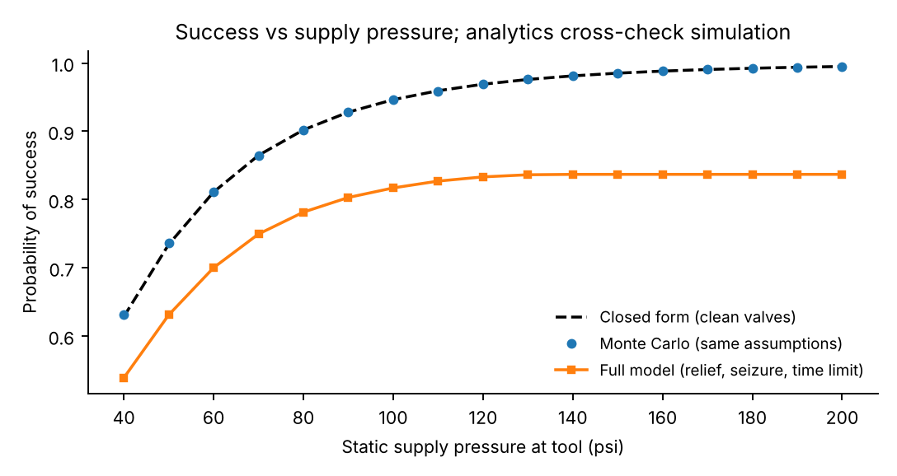
Figure 1. Success probability versus supply pressure: closed form, Monte Carlo under the same assumptions, and the full model.
Results for the baseline tool (200 cc/rev motor, 250:1 gearbox, 60 gpm flow limiter, relief set at 2 times the class median breakaway torque):
Valve class | Success | Breakaway | Over-torque | Interference | Median time (min)
gate 12in | 90.3% | 90.5% | 6.2% | 32.5% | 4.3
gate 24in | 84.0% | 84.4% | 5.4% | 31.6% | 9.6
butterfly 36in | 66.4% | 84.5% | 4.9% | 31.3% | 11.7
plug 16in | 86.8% | 87.1% | 6.0% | 32.2% | 2.9
legacy seized | 66.2% | 66.5% | 3.9% | 28.5% | 10.2
Weighted mix | 80.0% | 82.9% | 5.3% | 31.3% | 7.6
Success, breakaway and over-torque are probabilities over all trials; interference is the probability that the tool draws more than 25 percent of the source flow. Class weights in the mix: 12-inch gate 30%, 24-inch gate 25%, 36-inch butterfly 15%, 16-inch plug 10%, legacy seized 20%.

Findings
1. Baseline performance. Overall success is 80.0 percent (95 percent interval 79.9 to 80.2). The shortfall comes from a weak supply (9.7 percent of trials cannot reach breakaway torque), the relief limit stopping stiff valves (7.3 percent) and slow strokes (6.9 percent exceed 15 minutes).
2. The torque limiter is essential. Without the relief valve, success rises to 87.2 percent but 59.2 percent of trials exceed allowable stem torque. At a 2 times chart setting, success is 80.0 percent with 5.5 percent over-torque risk (Figure 2). The setting is therefore a safety-critical, valve-specific parameter, and the torque chart is part of the product.
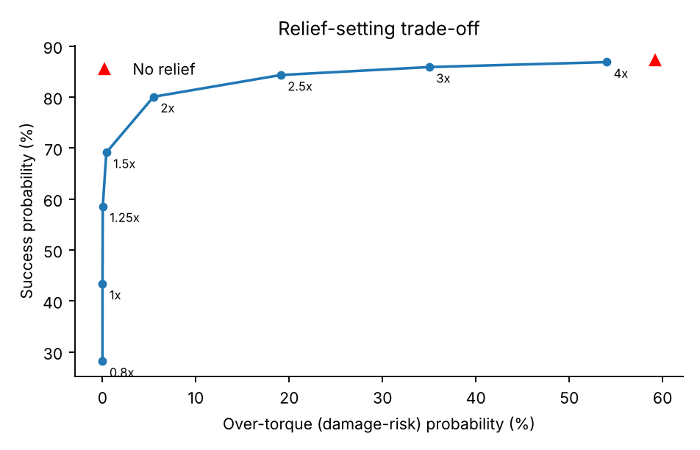
Figure 2. Trade-off between success and over-torque risk as the relief setting (multiple of class median breakaway torque) is varied.
3. Displacement and ratio sit on a ridge. With the flow limited, torque scales with displacement times gear ratio and speed falls by the same factor, so useful designs lie along a ridge where D x R is about 50,000 (for example 100 cc at 500:1, 200 cc at 250:1, 300 cc at 150:1; all give about 80 percent). Off the ridge success falls to as low as 14 percent (Figure 3). The baseline is a sound choice, not a lucky one.
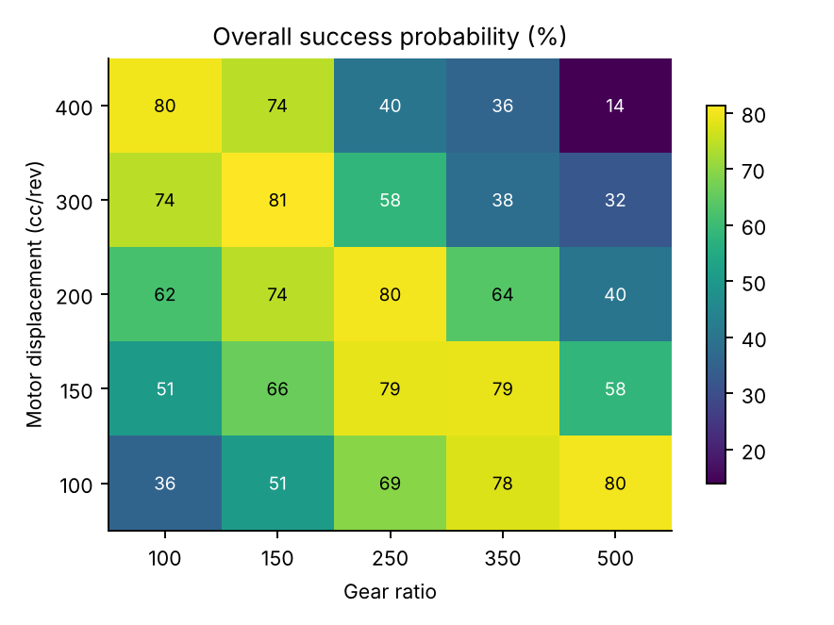
Figure 3. Overall success probability (%) versus motor displacement and gear ratio.
4. Firewater interference is the main operational constraint. At a 60 gpm limit the tool draws more than a quarter of the source flow in 31 percent of trials. Lowering the limit to 40 gpm cuts interference to 10 percent but success drops to 57 percent because strokes become too slow (Figure 4). The product therefore needs an operating rule: use a dedicated tap or portable pump for large valves, and keep the limiter low when drawing from a shared firewater main.
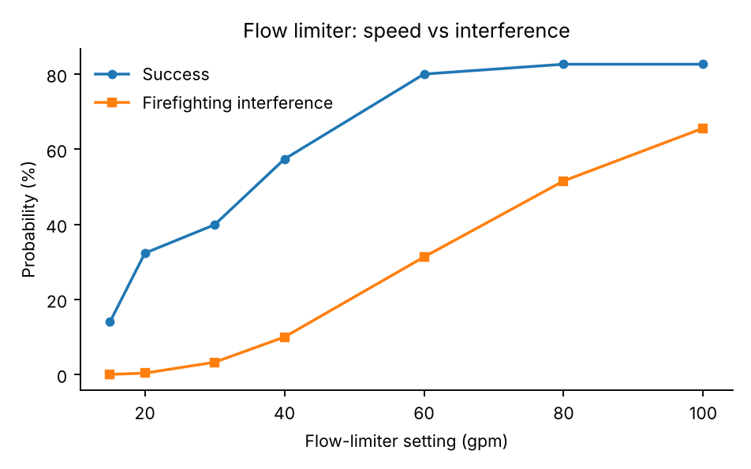
Figure 4. Effect of the flow-limiter setting on success and on firefighting interference.
5. Valve class matters; one setting does not fit all. Butterfly valves with many handwheel turns are time-limited: a lower-ratio configuration (300 cc/rev at 150:1) lifts their success from 66 to 81 percent. Legacy seized valves stay at about 66 percent whatever the gearing, because they are limited by supply pressure and relief headroom, so these valves will need a higher-pressure source (a pumped fire truck) or a different tool. A kit with interchangeable gearing is therefore justified, but it is not a cure-all.
6. What drives capability. Valve breakaway torque dominates the torque margin (rank correlation -0.68), followed by seizure (-0.19) and supply pressure (+0.14). Hose friction is negligible at these flows (correlation 0.00), so hose length is not a design driver. Priority for Phase 1 is therefore a measured valve-torque survey.

5.4 Technical Risks and Mitigations
Risk | Why it matters | Mitigation
Over-torque of valve | Bent stems or damaged seats | Relief valve sets maximum torque; torque chart per valve class; operator training
Reaction torque | Tool body rotates and can injure the operator | Reaction arm anchored to yoke or structure; design to carry full stall torque with a safety factor
Water hammer | Rapid supply opening can spike pressure | Slow-opening shut-off in the SPC; hose-side accumulator option
Firefighting pressure loss | Tool draws water needed for fire suppression | Flow limiter; operating procedure to supply the tool from a dedicated tap or portable pump
Debris and fouling | Firewater can carry scale, sand or marine growth | Cleanable strainer in the SPC; materials for the motor suited to raw or sea water
Corrosion (offshore) | Seawater firewater | Duplex stainless or bronze wetted parts; ceramic or hard-faced bearings
Freezing | Water trapped in tool and hose | Drain-down procedure; optional glycol flush for cold sites
Static electricity | Ignition risk in classified areas | Bonding and grounding; static-dissipative hose; non-sparking materials at tool contact points
Hazardous-area approval | Required for use in classified zones | Non-electrical equipment assessment (for example the ISO 80079-36 / 80079-37 series) and local certification
Discharge water | Wet work area, contamination, ice | Discharge hose to drain or sump; site spill plan

6. Benefits and Limitations

Benefits
- No batteries, charging infrastructure or electrical supply.
- No hydraulic oil, so no oil leaks or spills, and no electrical ignition source in the baseline design.
- Uses assets that are already deployed, inspected and maintained at most industrial sites.
- Can work during a total power outage.
- Reduces manual effort and operator injury risk on stiff valves.

Limitations (stated for transparency)
- Requires a water source and hose reach; run time is limited by water availability, not unlimited.
- Not suitable for valves that cannot be reached by hose or for sub-freezing conditions without precautions.
- The tool is heavier than a battery tool of equal torque, and needs a reaction anchor.
- Requires a discharge path for the motor exhaust water.

7. Comparison With Existing Approaches
Feature | HydraTorque | Battery tool | Pneumatic tool | Hydraulic power pack
Uses existing site infrastructure | Yes (firewater) | No | Partly (plant air) | No
Needs battery or electrical supply | No | Yes | No (needs air) | Often (or engine)
Needs hydraulic oil | No | No | No | Yes
Works with plant power and air lost | Yes | Yes, until flat | No | Yes with engine drive
Run time | Limited by water supply | Limited by charge | Limited by air supply | Limited by fuel
Ignition-source concern | Low | Higher | Low | Moderate
Weight at high torque | Moderate | Low to moderate | Moderate | High

8. Prior Art and Novelty
A preliminary literature and patent scan shows that the neighbouring field is active, and the novelty claim is therefore deliberately narrow:
- Portable rotary valve actuators powered by electricity, batteries, gasoline or compressed air are commercially available, with torque in the order of 1,000 N.m for hydrant and waterworks maintenance.
- Patents describe hydrant-mounted portable apparatus with hose couplers and drive sockets for operating the hydrant valve stem, and hydrant-attached portable remote-controlled valves.
- Patents describe oscillatory rotary actuators for fire-truck valves, and water-hydraulic motors are an established commercial technology.
What this scan did not locate is a portable valve-operating tool whose motive power is delivered through a standard fire hose from existing firewater infrastructure, with a purpose-built coupling that meters flow, limits torque by inlet pressure and routes the exhaust. The claimed contribution is the combination of: (a) fire-hose-fed power delivery to a portable torque tool, (b) pressure-set torque limiting integrated with a flow-limiting coupling, and (c) a universal valve interface with reaction anchoring for emergency use. This is a preliminary view only; a full prior-art search and freedom-to-operate review are required in Phase 1 before any patent claim is made.

9. Development Plan, TRL and Indicative Cost
Phase | Scope | Duration | Indicative cost (USD) | TRL on exit
1. Engineering study | Requirements, valve torque survey, detailed sizing, prior-art and FTO review, HAZID | 3 months | 40,000 - 80,000 | 3-4
2. Bench prototype | Motor, gearbox, SPC, relief valve; test rig with torque transducer; test on representative valves | 6-9 months | 150,000 - 300,000 | 4-5
3. Field pilot | Pilot at a refinery, terminal or training site; HAZOP; operator trials; durability testing | 9-12 months | 300,000 - 600,000 | 6
4. Certification | Non-electrical hazardous-area assessment; pressure-equipment compliance; user documentation | 12 months | 200,000 - 500,000 | 7
5. Production | Industrialization, supply chain, service network | 12+ months | Commercial investment | 8-9
Costs are indicative planning estimates by the submitter (accuracy about plus or minus 50 percent) and will be refined in Phase 1.

10. Commercial Applications
- Oil and gas: pipelines, refineries, tank farms, terminals and production facilities.
- Offshore: platforms and FPSOs, where firewater rings are already installed.
- Utilities and water: treatment plants and municipal transmission valves.
- Fire services and emergency response: emergency valve isolation and disaster recovery, including military infrastructure recovery.

11. Conclusion
HydraTorque turns a resource every hazardous facility already has, firewater, into controlled valve torque with no battery, no electrical supply and no hydraulic oil. The first-order sizing shows a comfortable power margin and a simple, robust baseline architecture. The proposed path is a short engineering study, a bench prototype and a field pilot, with hazardous-area certification as the main gate to deployment.

12. Source Notes
- US 4,561,459, Remote fire hydrant actuator (portable hydrant operating apparatus with hose coupler and boom-mounted drive socket).
- US 8,733,387 B2, Portable remote controlled valve (hydrant-attached remote valve for fire hoses).
- US 5,101,862, Rotary actuator and valve control system (oscillatory actuator for fire-truck valves).
- Modec portable rotating valve actuators, product information (pneumatic, electric and gasoline options; hydrant maintenance torque up to about 1,000 N.m).
- Fire-service hose friction loss, FL = C (Q/100)^2 (L/100) psi with C = 15.5 (1.75 in), 2.0 (2.5 in), 0.8 (3 in), as commonly used in fire-service hydraulics; verify coefficients against current fire-service references.
- Fire-service hydraulic power from pressure and flow: hp = psi x gpm / 1714 (standard hydraulic relation).

Appendix A: Wazoku Submission Fields
Each section below is written to be pasted into the matching field of the Wazoku / InnoCentive submission form. Field labels differ between challenges; where the form uses a different label, use the section whose content matches. Word limits are not known in advance, so each field gives a short version first and a long version after it.

Field 1: Solution Title
Short and descriptive.
HydraTorque: Portable High-Torque Valve Actuation Powered by Existing Firewater Infrastructure

Field 2: Solution Summary (short, about 100 words)
Use if the form asks for an abstract or elevator pitch.
HydraTorque is a portable valve operator powered by water from standard fire hoses, hydrants and firewater systems. A Smart Power Coupling meters and strainer-filters the water and feeds a compact water-hydraulic motor, which drives a planetary gearbox and a universal valve interface. An inlet relief valve sets and limits output torque. First-order sizing shows about 3.3 kN.m of torque from a 200 cc/rev motor at 100 psi differential pressure using only 50 to 100 L/min, a small fraction of one hose line. The tool needs no batteries, no electrical power and no hydraulic oil, and it can operate during a plant power outage.

Field 3: Detailed Description of the Solution
Full technical description.
See Sections 3 to 5 of the white paper. In brief: pressurized water from a hose enters the Smart Power Coupling, where a strainer, flow limiter, slow-opening shut-off and mechanical pressure gauge condition the supply. The water drives a gerotor, piston or vane motor of 150 to 400 cc/rev. A 100:1 to 500:1 planetary gearbox multiplies the torque. An adjustable inlet relief valve limits motor pressure drop and therefore limits output torque, protecting valve stems and seats. A universal adapter set engages handwheels, operating nuts and part-turn valves, and a reaction arm anchors to the valve yoke or structure. Exhaust water is routed through a discharge hose to a drain.
Power basis: a 1.5-inch line at 100 psi and 150 gpm carries about 6.5 kW of hydraulic power, and a 500 gpm, 150 psi firewater tap about 32.6 kW. The baseline design needs only about 50 to 100 L/min, so the available power exceeds the requirement by a wide margin.

Field 4: How the Solution Works (step by step)
Use for a process or operating-concept field.
- Connect the SPC to a hydrant, firewater tap, fire truck or portable pump and bond the equipment to ground.
- Fit the valve adapter and anchor the reaction arm.
- Route the discharge hose to a drain and set the relief valve to the torque chart value for the valve.
- Slowly open the supply; the motor turns the valve through the gearbox.
- Stall pressure indicates end of travel or an obstruction; close the supply, verify position, drain and disconnect.

Field 5: Innovation and Novelty
What is new compared with existing solutions.
Existing portable valve operators run on batteries, electricity, gasoline, compressed air or oil hydraulics. HydraTorque delivers its power through a standard fire hose from firewater infrastructure that most hazardous facilities already own. Novel elements are the fire-hose-fed power coupling with built-in flow limiting, the pressure-set torque limiting that doubles as a stall indicator, and the emergency-oriented universal valve interface with reaction anchoring. A preliminary prior-art scan found neighbouring art (hydrant actuators, portable electric, pneumatic and gasoline valve actuators, fire-truck valve actuators) but no tool with this combination; a full search is planned in Phase 1.

Field 6: Why It Will Work (Feasibility Evidence)
Technical credibility.
The solution uses established engineering: water-hydraulic motors, planetary gearing, relief-valve pressure control and fire-service couplings. Hydraulic power available from a single hose line (6.5 to 32.6 kW) is far above the requirement. Torque of about 3.3 kN.m follows from T = D x dP / (2 pi) x efficiency with D = 200 cc/rev, dP = 100 psi, a 250:1 gearbox and assumed efficiencies of 0.85 and 0.70.
A Monte Carlo simulation (200,000 trials per case, script and figures attached) propagates uncertainty in supply pressure, hose, elevation, fouling, valve torque, seizure and efficiency. For a representative mix of valve classes the baseline tool strokes the valve within 15 minutes without exceeding allowable stem torque in about 80 percent of trials, and the simulation agrees with the closed-form result to within 0.002 and respects the energy balance. The study also identifies the limits: weak supply pressure, relief-limited stiff valves, and interference with firefighting flow. Input distributions are assumed priors to be calibrated in Phase 1.

Field 7: Assumptions and Constraints
State openly what the concept depends on.
- A water source of at least 100 psi and 50 to 100 L/min can be dedicated to the tool for the duration of the operation.
- The valve is within hose reach and a reaction anchor point is available.
- Target torque is in the 500 to 3,000 N.m class, with larger configurations for higher values; the real requirement will be confirmed in Phase 1.
- A discharge path for exhaust water is available.
- The tool is purely mechanical in its baseline; any added electronics would need separate hazardous-area approval.
- Monte Carlo input distributions (supply pressure, valve torque, seizure rates, efficiencies) are assumed priors, not measurements; Phase 1 replaces them with surveyed data.

Field 8: Risks and Mitigation
Short list; full table in Section 5.4.
Principal risks are over-torque of the valve (mitigated by pressure-set torque limiting), reaction torque on the operator (reaction arm), water hammer (slow-opening shut-off), debris and corrosion (strainer and corrosion-resistant materials), freezing (drain-down), static and hazardous-area approval (bonding, non-sparking materials, non-electrical equipment assessment) and diversion of firefighting water (flow limiter and dedicated supply procedure).

Field 9: Implementation Plan and Timeline
Phases and milestones.
Phase | Deliverable | Duration | TRL on exit
1 | Requirements, valve torque survey, detailed design, prior-art and FTO review, HAZID | 3 months | 3-4
2 | Bench prototype tested on representative valves with instrumented torque | 6-9 months | 4-5
3 | Field pilot and operator trials with HAZOP | 9-12 months | 6
4 | Hazardous-area and compliance certification | 12 months | 7
5 | Production and service network | 12+ months | 8-9

Field 10: Resources and Budget Required
Indicative only.
Phases 1 to 3 are estimated at about USD 490,000 to 980,000 in total (planning estimate, plus or minus 50 percent). Required resources: a mechanical and hydraulic design engineer, a test-rig builder with torque instrumentation, access to a range of representative industrial valves, a pilot host site with firewater infrastructure, and a notified body for hazardous-area assessment in Phase 4.

Field 11: Technology Readiness Level
State honestly.
Current TRL 2-3 (concept formulated and first-order sizing completed). Target TRL 4-5 after the bench prototype, TRL 6 after the field pilot, and TRL 7-8 after certification.

Field 12: Safety, Health and Environment
HSE field.
No hydraulic oil, batteries or electrical energy are used, which removes oil spills, battery thermal runaway and electrical ignition sources. The key operator hazards (reaction torque, pressurized hose, wet work area, water hammer) are addressed in the design and in the operating procedure. Discharge water is routed to a drain or sump. Hazardous-area use requires certification before deployment.

Field 13: Scalability and Commercial Potential
Market field.
The same architecture scales through motor displacement and gear ratio from hand-portable units to larger tools for high-torque valves. Markets are oil and gas, refining, offshore, utilities and fire services. The product can be sold as a tool kit with a range of adapters, with a service and calibration offering.

Field 14: Intellectual Property
Declare accurately.
The solver has not filed any patent application on this concept to date. Potential protectable elements, subject to a full prior-art and freedom-to-operate review, are the fire-hose-fed power coupling with flow limiting, the pressure-set torque limiting integrated with that coupling, and the universal emergency valve interface. The solver acknowledges the intellectual property terms of the challenge and will follow them.

Field 15: Prior Work and Disclosures
Prior art awareness.
Related art includes portable electric, battery, gasoline and pneumatic valve actuators; hydrant operating apparatus with hose couplers and drive sockets (for example US 4,561,459); hydrant-mounted remote-controlled valves (for example US 8,733,387); and oscillatory actuators for fire-truck valves (for example US 5,101,862). No prior implementation of the proposed concept by the solver exists.

Field 16: Attachments and Declarations
Final checks before pressing submit.
- Attach this white paper as a Word or PDF file if the form allows it.
- Attach the simulation package if the form allows it: HydraTorque_MC.py, results.json, results.md and the figures.
- Confirm that the content is the solver's own original work.
- Confirm acceptance of the challenge terms, including intellectual property and confidentiality provisions.
- Confirm that solver identity and contact details are entered through the platform account.

Submission Tagline
Turning firewater into mechanical power: a portable, safe and sustainable way to operate high-torque industrial valves.

Appendix B: Simulation Model and Reproducibility
All distributions are assumed priors for a concept-stage study. They are listed here so a reviewer can challenge them.
Input | Distribution | Basis
Supply source | Firewater ring 50% (N 140, sd 20 psi); fire truck 30% (N 120, sd 25); municipal hydrant 20% (N 60, sd 15); clipped 20-250 psi | Assumed; to be surveyed
Hose | 1.75 in 30%, 2.5 in 50%, 3 in 20%; length uniform 50-400 ft; fire-service friction coefficients | Common fire-service practice
Elevation | N(0, 15 ft), 0.433 psi per ft | Assumed
Strainer fouling | Lognormal median 2 psi, sigma 0.8; 3% chance of an extra 20-60 psi | Assumed
Breakaway torque | Lognormal by class: 12 in gate 400 N.m (s 0.45); 24 in gate 1,200 (0.50); 36 in butterfly 1,500 (0.45); 16 in plug 800 (0.50); legacy 2,000 (0.60) | Assumed; requires valve torque survey
Seizure | Probability 5-25% by class; torque multiplier uniform 1.5-3 | Assumed
Running torque | 30-60% of breakaway | Assumed
Allowable stem torque | 3 x class median, lognormal sigma 0.25 | Assumed
Efficiencies | Motor N(0.85, 0.03); volumetric N(0.92, 0.02); gearbox and interface N(0.70, 0.05) | Typical component ranges
Relief set-point | Chart value 2 x class median; tolerance sd 5% | Design choice
Success criterion | Breakaway delivered, running torque sustained, stroke within 15 min operating time | Assumed requirement

Reproduction (numpy and matplotlib only, runs on a laptop in about six seconds):
- python HydraTorque_MC.py --demo (self-test: closed form versus simulation, energy balance)
- python HydraTorque_MC.py --reproduce --outdir results (figure suite, results.json, results.md, SQLite run log; seed 2026)
- python HydraTorque_MC.py --preset gate_24in --n 500000 (single valve class)
The reported figures in this paper come from seed 2026, 200,000 trials for the class table and 60,000 per sweep point.

