Probabilistic Design and Safety-Constrained Optimization of a Firewater-Powered Portable Valve Actuation System
Leon Sandler
Independent Researcher, Northbrook, Illinois, USA
ORCID: https://orcid.org/0009-0007-4584-808X
Corresponding author: leon.sandler@alumni.swinburne.edu

Abstract
Almost every hazardous facility owns a pressurized, regularly inspected source of hydraulic power: its firewater system. This study asks whether a portable water-hydraulic operator driven through a fire hose can stroke seized or stiff valves without overloading the stem or taking the water that firefighting needs, and which design and operating rules make that likely. A Monte Carlo model with an explicit hydraulic circuit, motor leakage, a relief valve and the surge on stall is evaluated on 200,000 draws; every added mechanism can be switched off, recovering the earlier first-order model exactly. Under assumed input distributions a baseline tool (200 cc, 250:1, 60 gpm) completes the stroke in 75% of the draws but without exceeding the allowable stem torque in only 63%, because a median surge of 45 psi accompanies the stall; a stroke needs about 1,600 L of water, not the 50 to 100 L/min first assumed. A hose-side accumulator and a relief chart set from the stem strength reduce the over-torque probability to 1% at a cost of 3 to 9 percentage points of safe strokes, and a slow creep flow at the start and end of travel recovers 4 to 6 percentage points of that cost. The optimum holds out of sample but not under a weaker stem or a larger surge, and the firefighting reserve is protected only if the spare flow of the source is known. The results are simulation outputs under assumed priors, not measurements.
Keywords
Water hydraulics; Valve actuation; Firewater; Monte Carlo simulation; Multi-objective optimization; Emergency response
1. Introduction
Large industrial valves must sometimes be operated when the plant has lost the services that normally move them. In an emergency, refineries, tank farms, terminals, pipeline stations and offshore platforms may need to close or open a gate, plug or butterfly valve whose handwheel is stiff or seized, while electrical power, instrument air and hydraulic supply are unavailable. Manual effort is limited, and the operator is exposed to injury when improvised extensions or cheater bars are used [1]. The reliability of emergency valves is usually assessed by partial-stroke testing of the installed actuator [2], which does not cover the case in which the actuator itself has no power. Portable operators powered by batteries, compressed air, gasoline or an oil-hydraulic power pack exist, but each has a weakness at the moment it is needed: a battery tool depends on a charged pack and is an ignition-source concern in classified areas, a pneumatic tool depends on plant air, and a hydraulic power pack is heavy and needs oil. The need is recognised by industry: an energy company has recently sought a portable, preferably non-electric device that multiplies an operator's torque four- to six-fold for valves of 2 to 16 inches, ready for deployment in remote, cold regions [3].
Almost every hazardous facility already owns a pressurized, distributed and regularly inspected source of hydraulic power: the firewater system. A hose at 100 psi and 150 gpm carries about 6.5 kW of hydraulic power, far more than a portable valve tool needs. Water-hydraulic motors are an established technology [4–6], pressure relief of water circuits has been studied [7], and the hydraulics of fire hoses [8] and of hydrant supplies [9,10] are well characterised. Patents describe hydrant-mounted operating apparatus with hose couplers and drive sockets [11], hydrant-attached remote-controlled valves [12] and oscillatory actuators for fire-truck valves [13]. To the author's knowledge, based on a search that was not exhaustive, none of these treats the question that a designer of a firewater-powered portable valve operator has to answer: with uncertain supply, uncertain valve demand and a torque limiter whose setting protects the valve but can also prevent the stroke, how often does the tool complete the stroke without exceeding the allowable stem torque and without taking water that firefighting needs, and which design and operating rules make that probability high?
The question matters because the three requirements conflict. Raising the relief setting lets the tool break stiff valves free but raises the probability that the stem is overloaded. Raising the flow limit shortens the stroke but draws water that a fire may need. Lowering the gear ratio speeds the stroke and lowers the torque. A first-order calculation shows that pressurized firewater can drive a valve operator, which follows from established hydraulic principles; the contribution that can be defended is a reproducible design and operating envelope that treats valve actuation success, stem overload, stroke time, water consumption and preservation of firefighting capacity together, and says how far it can be trusted.
This paper provides that envelope for a concept-stage tool, in four steps. First, it formulates a probabilistic model of the tool with an explicit hydraulic circuit (source characteristic, hose, motor leakage and efficiency, relief override, and the pressure surge on stall), in which each added mechanism can be switched off so that the earlier first-order model is recovered exactly. Second, it defines the safety criteria separately: success of the stroke, exceedance of the allowable stem torque, damage to the stem, and violation of the firefighting reserve. Third, it formulates a multi-objective design problem, in which the motor, the ratio, the relief chart, the flow limit and a slow creep flow at the start and the end of travel are chosen to maximize the probability of a safe stroke subject to a limit on the over-torque probability and on water use, and tests the optimum out of sample and under deliberately wrong input distributions. Fourth, it compares the tool with an idealised water-hydraulic benchmark and with capability-limited conventional operators. All input distributions are assumed priors for a concept-stage study, and the paper states which of its conclusions depend on them.
Section 2 describes the architecture and the operating rule, Section 3 the model, Section 4 the probabilistic methodology and its verification, Section 5 the optimization problem, Section 6 the results, Section 7 their interpretation and Section 8 the limitations and the validation that is needed. Section 9 concludes.
2. System architecture and operating rule
The tool (Fig. 1) is a portable water-hydraulic torque operator. A hose connects a hydrant, a firewater tap, a fire truck or a portable pump to a Smart Power Coupling that carries a cleanable strainer, a flow limiter, a slow-opening shut-off valve and a mechanical pressure gauge. Water drives a gerotor, piston or vane motor of 150 to 400 cc per revolution [5,6]. A multi-stage planetary reducer of 100:1 to 500:1 multiplies the torque, and a universal interface with a reaction arm engages handwheels, operating nuts and part-turn valves in the manner of the standard actuator attachments [14]. An adjustable inlet relief valve limits the pressure drop across the motor, and therefore the torque, because motor torque is proportional to that pressure drop; a stall shows as a pressure rise, which tells the operator that the end of travel has been reached. A hose-side accumulator is an option to absorb the pressure surge on stall, and the flow limiter can be made adjustable so that the tool runs at a slow creep flow for the first turns of the stroke, to build torque gradually against a stuck valve, and for the last turns before the end of travel, to approach the stop slowly. The motor passes water continuously while it turns, so a discharge hose routes the exhaust to a drain. Everything in the baseline is mechanical, which keeps it clear of the electrical ignition concerns of classified areas and places it under the assessment of non-electrical equipment [15].
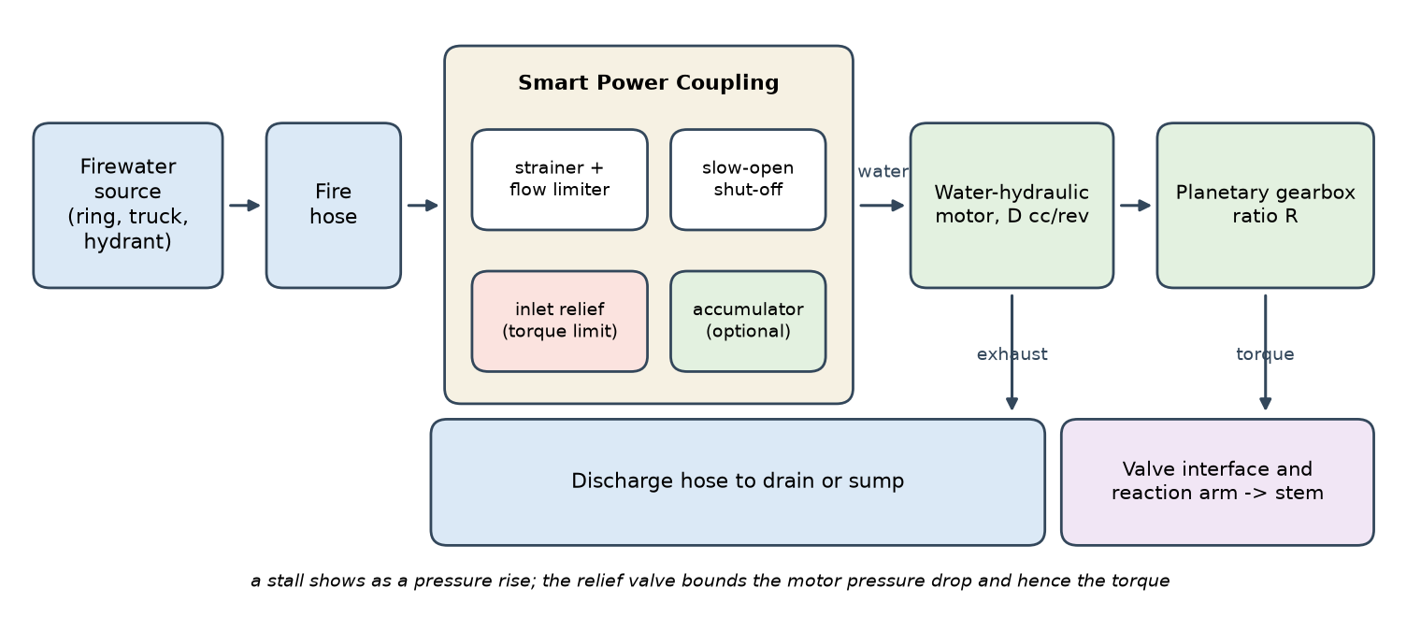
Fig. 1. Architecture of the firewater-powered valve operator. Water from a shared or dedicated source reaches the Smart Power Coupling (strainer and flow limiter, slow-opening shut-off, inlet relief valve that limits the torque, optional accumulator), drives the motor and gearbox, and is discharged through a hose. The torque is delivered to the valve stem through the interface and a reaction arm.
Two design variables are discrete in practice and are treated as such: the motor displacement D and the gear ratio R are chosen from a kit. Four are operating variables: the relief setting, which is read from a torque chart, the flow limit, and the creep flows at the start and at the end of travel, each held for a few turns (one at the start and two at the end in the study). The chart is the safety-critical document of the tool. Two bases are compared: a chart expressed as a multiple of the median breakaway torque of the valve class, which is what a designer who knows only the operating torque of the valve would use, and a chart expressed as a fraction of the nominal allowable stem torque, which requires the valve data sheet.
The tool is subject to one operating rule that the model enforces: it must not draw water from a fire-protection system when doing so could compromise the performance that system must deliver. A shared source (a firewater ring or a municipal hydrant) may therefore be used only up to the flow that it can spare without cutting its firefighting reserve; a dedicated source (a fire truck or a portable pump) carries no such limit. The model evaluates the rule in two forms: the event that the tool draws more than the spare flow of a shared source (a reserve violation), and an adaptive rule in which the flow limit is lowered to the spare flow of the source in use.
3. Mathematical formulation
3.1 Hydraulic power and torque
The hydraulic power of a supply at pressure Δp and flow Q is
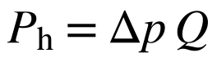 (1)
and the torque at the valve stem of a motor of displacement D operating at a pressure drop Δp_{m} through a gearbox of ratio R is
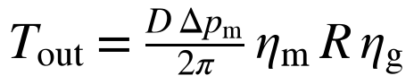 (2)
where η_{m} and η_{g} are the motor and gearbox efficiencies. The efficiency at breakaway and at stall is lower than the running efficiency because of static friction and start-up leakage, so the breakaway and stall torque uses η_{m}−δ, with δ a sampled loss; this is the mechanism by which the concept-stage model, which used one efficiency, overstated the stall torque. For the baseline D=200 cc, R=250, η_{m}=0.85, η_{g}=0.70 and Δp_{m}=100 psi, Eq. (2) gives 3,265 N.m.
3.2 Supply, hose and circuit pressure balance
The pressure available at the tap falls as flow is drawn. In the form used in hydrant flow tests [9], with a static pressure p_{s} and a flow capacity Q_{a} at the residual pressure p_{r}=20 psi,
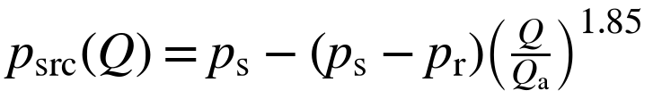 (3)
The hose loses pressure as C (Q/100)² (L/100) psi for a hose of length L in feet and a flow in gpm, with a coefficient C that depends on the hose size [8]. The coupling, the strainer and the exhaust hose add losses that are proportional to the square of the flow. The flow in operation is the largest flow at which the pressure balance
(4)
holds, limited by the flow limiter Q_{lim}, where Δp_{z} is the elevation head, k_{spc} the coupling coefficient, c_{f} the fouling loss at the reference flow Q_{ref}, C_{d}L_{d} the exhaust-hose term, and Δp_{run}=T_{run}/k_{T} the pressure drop that the running torque T_{run} requires. Eq. (4) is solved by bisection for every draw.
3.3 Motor speed, leakage, stroke time and water use
A water-hydraulic motor leaks through its clearances, and the leakage is nearly proportional to the pressure drop because the viscosity of water is low. The flow into the motor is therefore
(5)
where n_{m} is the motor speed, η_{v} the volumetric efficiency at the reference point (Δp_{ref}=100 psi, n_{ref}=100 rpm) and c_{L} the leakage coefficient. The output speed is n_{out}=n_{m}/R, the stroking time is t=N_{turns}/n_{out} for N_{turns} handwheel turns, and the water used in one stroke is V=Q t. With creep flows Q_{s} and Q_{e} held for N_{s} and N_{e} turns, at output speeds n_{s} and n_{e}, the time is t=(N_{turns}−N_{s}−N_{e})/n_{out}+N_{s}/n_{s}+N_{e}/n_{e} and the water is the sum of the three phases. A stroke is required to be completed within 15 minutes of operating time, excluding set-up.
3.4 Relief valve, stall and the pressure surge
The relief valve opens at the set pressure p_{set}, which the chart derives from the valve class: p_{set}=μ T_{ref}/k_{T}^{nom} for a multiple μ of a reference torque T_{ref}, which is the median breakaway torque or the nominal allowable stem torque. The set point has a tolerance, and the relief valve overshoots by a fraction ε_{r} at full flow. When the motor stops abruptly, at the end of travel or against an obstruction, the moving column of water produces a surge, estimated by the Joukowsky relation for an instantaneous stop and reduced when the stop takes longer than the wave takes to travel the hose and return [16],
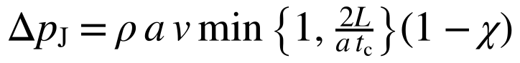 (6)
where a is the wave speed in the compliant hose, v=Q_{stall}/A_{h} the velocity in the hose of cross-section A_{h} just before the stall, t_{c} the stopping time and χ the fraction absorbed by an accumulator. The flow before the stall is the end creep flow Q_{e} when the stroke proceeds to its end, the start creep flow Q_{s} when the valve does not break free (the tool then stalls at the start), and the running flow when there is no creep. The peak pressure at the motor is the smaller of the unrelieved surge and the relief override,
(7)
where κ is the fraction of the surge that the relief valve does not relieve in time. The peak torque is T_{peak}=k_{T}^{st} p_{peak}, with the stall constant k_{T}^{st} of Eq. (2) and the reduced efficiency. Without a relief valve p_{peak}=p_{s}+Δp_{J}.
3.5 Events and the metrics reported
Five events are defined for every draw. A stroke succeeds if the tool delivers the breakaway torque (T_{cap}=k_{T}^{st}min {Δp_{s},p_{set}}≥T_{break}), sustains the running torque, and completes the stroke within the time limit. An exceedance occurs when the peak stall torque T_{peak} is greater than the allowable stem torque T_{allow}, which is a design limit that already contains a safety factor. Damage occurs when T_{peak} is greater than T_{allow} times a sampled ratio between yield and allowable torque. A safe stroke is a successful stroke without exceedance. A reserve violation occurs on a shared source when the flow is greater than the spare flow. The concept-stage study reported a success probability of about 80% and, separately, an over-torque probability of about 5.5%; they were not combined, and the abstract of that study described the 80% as success without exceeding the allowable stem torque, which it was not. The safe stroke is the combined measure used here.
4. Probabilistic methodology
4.1 Inputs and sampling
Every input of the model is a random variable with an assumed distribution (Table 1). Three groups are sampled for each trial. The supply: the source type (firewater ring, fire truck, municipal hydrant) with its static pressure and flow capacity, the hose size and length, the elevation difference, the strainer fouling with a 3% chance of severe fouling, and the spare flow of shared sources. The valve: a lognormal breakaway torque by valve class, seizure events that multiply the torque by 1.5 to 3, a running torque of 30 to 60% of breakaway (the stem packing alone can add a force that is a sizeable part of the actuation load [17]), the number of handwheel turns to stroke, an allowable stem torque, and the ratio between yield and allowable torque. The tool: motor, volumetric and gearbox efficiencies, the loss of efficiency at stall, the tolerance and overshoot of the relief valve, and the wave speed, stopping time and unrelieved fraction of the surge. The valve classes are a 12-inch gate valve, a 24-inch gate valve, a 36-inch butterfly valve, a 16-inch plug valve and a legacy seized valve, weighted 30, 25, 15, 10 and 20% in the reference mix; a separate class represents the 1,500 N.m valve of the industrial challenge [3].
Latin-hypercube sampling is used for the design search [18,19], and plain random sampling for every reported probability. All designs are evaluated on the same random draws (common random numbers [20]), so that differences between designs are not blurred by sampling noise. Correlations between inputs are not imposed, which is a limitation; rank-correlation methods are available if data on correlated inputs are obtained [21]. Probabilities are reported with Wilson 95% intervals, which describe only the Monte Carlo sampling error of the 200,000 draws of each case. They are not confidence intervals for the performance of a real tool, because the input distributions are assumptions.
Input | Distribution | Basis
Supply source | Firewater ring 50% (N 140, sd 20 psi); fire truck 30% (N 120, sd 25); municipal hydrant 20% (N 60, sd 15); clipped to 20–250 psi | Assumed
Source flow capacity at 20 psi residual | Lognormal, median 2,000 (ring), 500 (truck), 1,000 (hydrant) gpm; sigma 0.5, 0.4, 0.5 | Assumed
Spare flow of a shared source | Lognormal, median 400 (ring), 200 (hydrant) gpm, sigma 0.6, 0.5; unlimited for a truck | Assumed
Hose | 1.75 in 30%, 2.5 in 50%, 3 in 20%; length uniform 50–400 ft; friction coefficients 15.5, 2.0, 0.8 | Fire-service practice [8]
Elevation, fouling | Elevation N(0, 15 ft); fouling lognormal median 2 psi, sigma 0.8, plus 3% chance of 20–60 psi | Assumed
Breakaway torque | Lognormal by class: gate 12 in 400 N.m (sigma 0.45); gate 24 in 1,200 (0.50); butterfly 36 in 1,500 (0.45); plug 16 in 800 (0.50); legacy 2,000 (0.60); challenge valve 1,500 (0.35) | Assumed; no published distribution was found
Seizure, running torque | Probability 5–25% by class, multiplier uniform 1.5–3; running torque 30–60% of breakaway | Assumed
Allowable stem torque | 3 x class median, lognormal sigma 0.25; ratio of yield to allowable uniform 1.3–2.0 | Assumed
Efficiencies | Motor N(0.85, 0.03); gearbox and interface N(0.70, 0.05); volumetric N(0.92, 0.02); loss at stall uniform 0.05–0.20 | Typical ranges; assumed
Relief valve | Set-point tolerance sd 5%; override above the set point uniform 5–25%; unrelieved surge fraction uniform 0–30% | Assumed
Surge | Wave speed uniform 150–400 m/s; stopping time uniform 0.05–0.5 s | Assumed [16]
Table 1. Input distributions of the model (all assumed priors; none is a measurement).
4.2 Verification and its limits
The model is verified in five ways, none of which validates its physical assumptions. First, with all six added mechanisms switched off the engine reproduces the concept-stage model draw for draw (identical outcomes for every valve class). Second, with all random inputs fixed except the valve demand, the simulated breakaway probability agrees with the closed form for a mixture of lognormal valve classes to within 0.0024 (absolute probability) over supply pressures of 40 to 200 psi (Fig. 2a); the over-torque probability of a relief-limited tool agrees with the closed form P(T_{allow}<μ T_{med}) to within 0.004. Third, the mechanical output power never exceeds the hydraulic power delivered to the motor (maximum ratio 0.791), and the hydraulic power at the tap is never smaller than the power at the motor. Fourth, unit conversions, the hose-friction form, the Joukowsky value, the monotonic behavior of the outcomes in the supply pressure, the accumulator fraction and the relief setting, and the creep logic (a creep flow above the running flow changes nothing; end creep lowers the surge and adds time; start creep acts only on valves that do not break free; the water of the phases adds up) are checked by automated tests (25 tests in the repository). Fifth, the convergence of the estimates is checked by batch means: the standard error of the baseline probability of a safe stroke over ten blocks is 0.09 percentage points (Supplementary Fig. S1).
Numerical verification is distinguished from physical validation. The simulation is consistent with its own assumptions; whether those assumptions describe real valves, hoses, motors and relief valves can only be decided by measurement [22]. The input distributions in particular are not calibrated. For that reason the conclusions are tested against deliberately wrong distributions (Section 4.3).
4.3 Assumption shifts
Eight shifts are applied to the draws, one at a time and then together, to see whether a conclusion survives a wrong prior: breakaway torques multiplied by 1.5; the scatter of the breakaway torque increased by 0.15 in log units; supply pressure lowered by 30 psi; seizure probabilities doubled; motor and gearbox efficiencies lowered by 0.10; fouling tripled; allowable stem torque multiplied by 0.7; and a combined stress with all of them at reduced strength. The shifts change the distributions, not the design, so the same design can be evaluated under each; the worst case over the shifts is a robustness measure [23].
5. Multi-objective optimization
The design problem has four variables: the displacement D (60 to 500 cc), the ratio R (60 to 600), the relief multiple μ (0.2 to 1.0 of the nominal allowable stem torque, or 0.6 to 4 times the class median breakaway torque), and the flow limit Q_{lim} (15 to 100 gpm), and, when creep is allowed, two more: the creep flows at the start and at the end of travel (5 to 60 gpm; a value above the flow limit means no creep), held for one and two turns. The adaptive reserve rule is applied. Eight families of designs are searched: two relief bases, each without an accumulator and with an accumulator that absorbs 75% of the surge, each with and without creep. The objectives are to maximize the probability of a safe stroke, to minimize the probability of exceedance and to minimize the median water used in a stroke. The decision constraint is
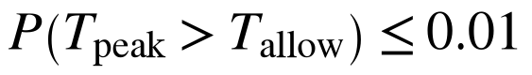 (8)
The limit of 1% is an illustrative research constraint, not an established acceptable industrial safety limit; an operator or regulator would set its own, and Section 6.6 shows how the result moves with it. Each family is searched with 1,500 Latin-hypercube designs evaluated on 15,000 common draws; the non-dominated set is found by exhaustive comparison [24,25]. The best design of a family is the one with the largest probability of a safe stroke among those that meet the constraint. The search is a sampling method, not a proof of optimality; its purpose is to show the structure of the trade-off. To control the optimizer's curse, the chosen designs are re-evaluated on independent draws (200,000 draws), and a robust design is chosen by taking the best candidates and maximizing the worst-case probability of a safe stroke over the assumption shifts, subject to a limit of 2% on the worst-case over-torque probability.
6. Results
6.1 The baseline tool and what the added mechanisms change
The baseline tool has a 200 cc motor, a 250:1 gearbox, a 60 gpm flow limiter and a relief valve set at twice the median breakaway torque of the valve class, and is evaluated on 200,000 draws. Under the assumed priors it completes the stroke in 75.3% of the draws (Wilson interval 75.1 to 75.5), but it does so without exceeding the allowable stem torque in only 62.6% (62.4 to 62.8). The stall torque exceeds the allowable value in 15.2% of the draws and the yield margin in 1.1% (Table 2). The concept-stage model gave a success probability of 80.0%, an over-torque probability of 5.3% and, when the two are combined, 75.3%. Model 2 gives 62.6%: about five eighths of the draws, not four fifths, give a safe stroke, and the surge on stall, which the concept-stage model omitted, is the main reason the over-torque probability now exceeds 15%.
Valve class | Success v1 | Success | Safe stroke | Over-torque | Stem damage | Time (min) | Water (L)
Gate 12 in | 90.3% | 84.2% | 60.9% | 27.0% | 2.8% | 4.0 | 900
Gate 24 in | 84.0% | 77.1% | 68.0% | 11.1% | 0.3% | 8.8 | 2,002
Butterfly 36 in | 66.4% | 72.5% | 65.1% | 9.3% | 0.3% | 11.4 | 2,578
Plug 16 in | 86.8% | 80.2% | 67.6% | 15.1% | 0.7% | 2.6 | 600
Legacy seized | 66.2% | 58.7% | 53.8% | 6.8% | 0.2% | 9.4 | 2,128
Weighted mix | 80.0% | 75.3% | 62.6% | 15.2% | 1.1% | 7.1 | 1,601
Table 2. Baseline tool (200 cc, 250:1, 60 gpm, relief at 2 x class median breakaway). Success of the concept-stage model (v1) and of model 2; probabilities over 200,000 draws per class; time and water are medians of successful strokes. Safe stroke = success without exceedance of the allowable stem torque.
The six added mechanisms do not change the result equally (Table 3, Fig. 2b). The source characteristic, the flow-dependent fouling loss and the exhaust back-pressure change the success probability by less than 0.2 percentage points, because the flow limiter, not the circuit, sets the flow in most draws (the median operating flow is 60 gpm, the limiter setting). The lower torque efficiency at breakaway and stall lowers the success probability by 6.7 points and the over-torque probability by 3.8 points, since the stall torque is smaller than the concept-stage model assumed. Replacing the constant volumetric factor by a leakage that is proportional to the pressure drop raises the success probability by 1.7 points (the motor leaks less at the low running pressures than the constant factor implied). The surge on stall changes the picture: it raises the over-torque probability from 1.6% to 15.4% and the damage probability from 0.02% to 1.1%.
Step | Success | Safe stroke | Over-torque | Stem damage | Interference (v1 metric)
v1 physics | 80.0% | 75.3% | 5.5% | 0.09% | 31.3%
+ flow supply | 80.0% | 75.3% | 5.5% | 0.09% | 31.3%
+ foul flow | 80.2% | 75.5% | 5.5% | 0.09% | 31.4%
+ back | 80.2% | 75.5% | 5.5% | 0.09% | 31.4%
+ start eff | 73.6% | 72.2% | 1.6% | 0.02% | 31.4%
+ leak | 75.3% | 73.9% | 1.6% | 0.02% | 31.4%
+ surge | 75.3% | 62.3% | 15.4% | 1.08% | 31.4%
Table 3. Switching the model-2 mechanisms on one at a time, in order, on the same 60,000 draws (baseline tool, valve-class mix).
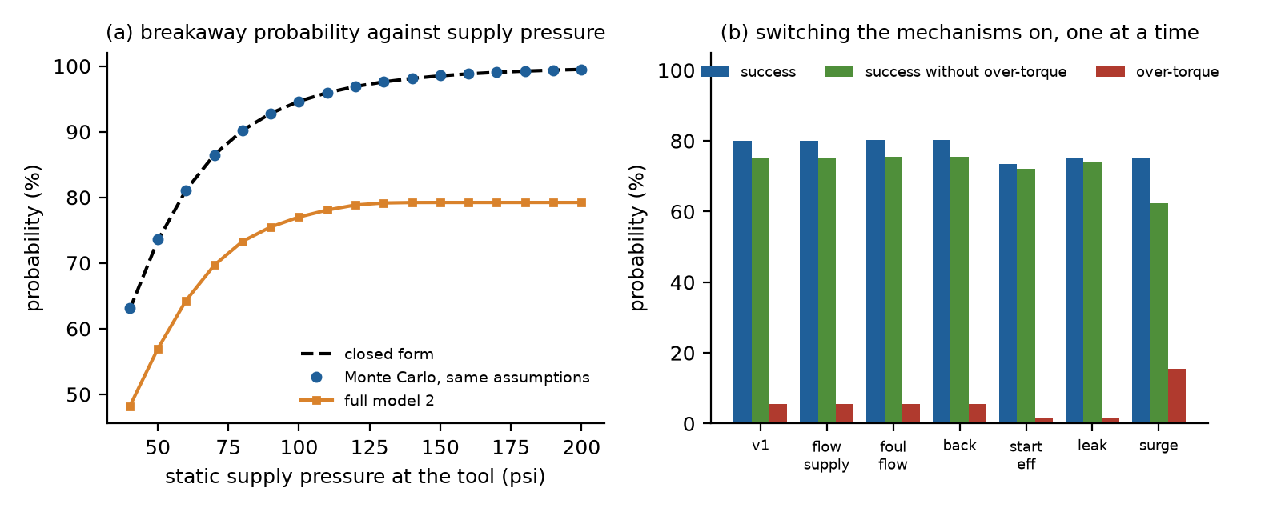
Fig. 2. Verification and mechanism ladder. (a) Breakaway probability against the supply pressure at the tool: closed form, Monte Carlo with the same assumptions, and the full model. (b) Success, success without over-torque and over-torque probability as the mechanisms of model 2 are switched on in order (v1: the concept-stage physics).
The concept-stage study stated that the tool draws 50 to 100 L/min (13 to 26 gpm), and its simulation used a 60 gpm (227 L/min) flow limiter. The two numbers describe different things, and the difference matters for the water budget. The 13 to 26 gpm is the flow that a 200 cc motor needs at an output speed of 1 to 2 rpm. Valves that need 30 to 70 handwheel turns cannot be stroked in 15 minutes at that speed: the median output speed of a successful stroke in the simulation is 4.5 rpm. The operating flow is therefore the limiter setting, 60 gpm (227 L/min), in most draws, and a successful stroke uses a median of 1,601 L of water (90th percentile 2,632 L; Fig. 12b). A limit of 20 gpm completes the stroke within 15 minutes in only 40% of the draws, and 40 gpm in 73% (Fig. 7a).
6.2 The torque limiter, the surge on stall and stem damage
The relief valve is essential. Without it the success probability is 86.5%, but the success without exceedance of the allowable stem torque is only 19.1% and the probability of damage (a torque above the yield margin) is 44.9%. With the relief valve set at twice the median breakaway torque the safe-stroke probability is 62.7% (Fig. 4a). Lowering the setting to 1.5 times the median reduces the over-torque probability to 5.1% while the safe-stroke probability falls to 57.5%; at a setting equal to the median breakaway torque the safe-stroke probability is 32.9% because the tool can no longer break half of the valves free. The success probability and the over-torque probability both rise with the setting, so the probability of a safe stroke has an interior maximum near twice the median; the setting is a safety-critical, valve-specific parameter, and whatever safety the chart buys is paid for in valves that the tool cannot move.
The surge on stall is the largest single source of over-torque in the model. Its median is 45 psi (40% of the static supply pressure), with a 95th percentile of 119 psi. For a small valve the relief pressure is low: a 12-inch gate valve with a median breakaway torque of 400 N.m has a relief set-point of about 25 psi on the baseline tool, below the typical surge, so the pressure that the relief valve cannot relieve in time exceeds the pressure that the chart is meant to enforce; the over-torque probability of this class is 27% (Table 2). A hose-side accumulator that absorbs a quarter, a half or three quarters of the surge lowers the over-torque probability of the baseline tool from 15.2% to 12.3%, 9.5% and 6.9%, and the damage probability from 1.11% to 0.18% (Fig. 4b). The surge inputs, the wave speed in the hose, the stopping time and the unrelieved fraction, are assumed, and Fig. 10a shows how the over-torque probability follows the surge multiplier: when the surge is twice the prior the over-torque probability is 26% for the baseline tool, 10% with the accumulator, and 1.9% for the optimized design of Section 6.6.
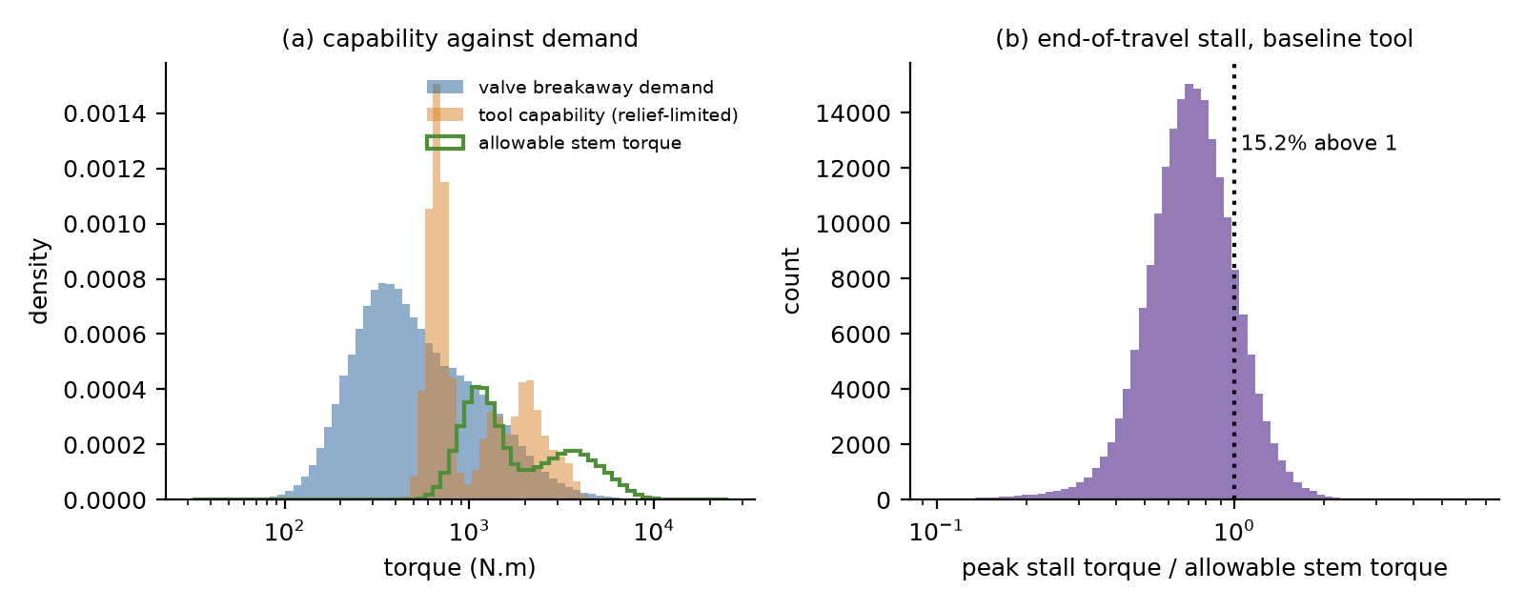
Fig. 3. (a) Distributions of the valve breakaway demand, the stall capability of the baseline tool (limited by the relief valve) and the allowable stem torque over the draws. (b) Ratio of the peak stall torque to the allowable stem torque; the dotted line marks the exceedance.
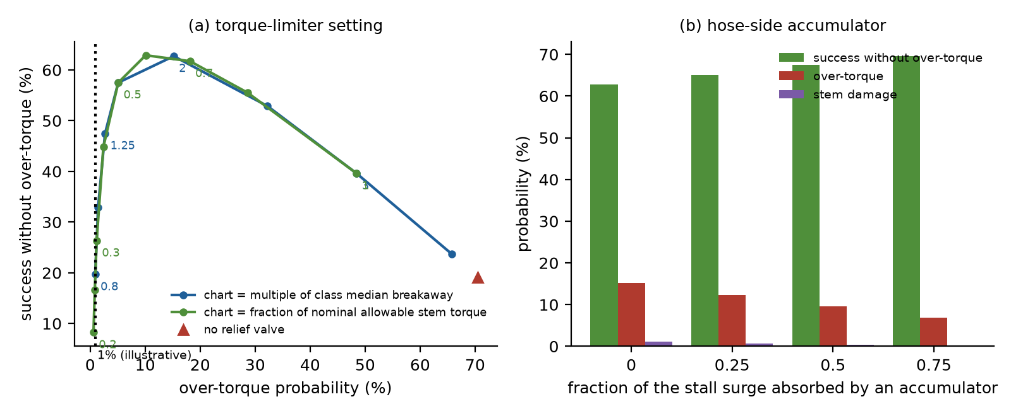
Fig. 4. (a) Probability of a safe stroke against the probability of over-torque as the relief setting is varied (labels: multiple of the median breakaway torque, or fraction of the nominal allowable stem torque), for the two chart bases and without a relief valve. (b) Effect of a hose-side accumulator on the safe stroke, the over-torque and the stem damage.
6.3 Creep at the start and at the end of travel
A tool whose flow can be turned down is a natural remedy for the surge, because the surge is proportional to the velocity of the water that the stall has to stop. Two creep phases are evaluated for the baseline tool: a slow flow for the first turns of the stroke, which builds the torque gradually against a stuck valve, and a slow flow for the last turns before the end of travel, which brings the tool to the stop slowly. In the model the creep at the end lowers the flow before the stall, and the creep at the start lowers it for the valves that stall at the start because they do not break free; both cost time, because the slow turns take longer, and a stroke that no longer finishes in 15 minutes is a failure. The transient of opening the supply is not modeled; the slow-opening shut-off is assumed to remove it.
Accum. | Start | End | Turns | Safe | Over-torque | Damage | Success | Time | Water
none | - | - | - | 62.7% | 15.2% | 1.11% | 75.5% | 7.1 | 1,609
none | - | 40 | 1.0 + 2.0 | 65.6% | 12.0% | 0.61% | 75.2% | 7.3 | 1,603
none | - | 20 | 1.0 + 2.0 | 67.6% | 8.9% | 0.34% | 74.1% | 7.9 | 1,583
none | - | 10 | 1.0 + 2.0 | 66.4% | 7.6% | 0.28% | 71.4% | 9.0 | 1,528
none | 20 | - | 1.0 + 2.0 | 62.1% | 14.0% | 0.98% | 74.8% | 7.5 | 1,597
none | 10 | - | 1.0 + 2.0 | 61.2% | 13.8% | 0.97% | 73.8% | 8.1 | 1,576
none | 20 | 20 | 1.0 + 2.0 | 67.0% | 7.8% | 0.21% | 73.4% | 8.2 | 1,570
none | 10 | 10 | 1.0 + 2.0 | 63.1% | 6.2% | 0.15% | 68.0% | 9.3 | 1,343
none | 10 | 10 | 0.5 + 1.0 | 67.8% | 6.2% | 0.15% | 72.9% | 8.5 | 1,560
none | 10 | 10 | 2.0 + 4.0 | 42.3% | 6.2% | 0.15% | 45.9% | 10.7 | 935
none | 10 | 10 | 4.0 + 8.0 | 28.6% | 6.2% | 0.15% | 31.3% | 12.5 | 819
0.75 | - | - | - | 69.6% | 6.9% | 0.18% | 75.5% | 7.1 | 1,609
0.75 | - | 20 | 1.0 + 2.0 | 69.5% | 5.7% | 0.12% | 74.1% | 7.9 | 1,583
0.75 | 10 | 10 | 1.0 + 2.0 | 63.9% | 5.2% | 0.11% | 68.0% | 9.3 | 1,343
Table 4. Creep at the start and at the end of travel, baseline tool (200 cc, 250:1, 60 gpm, relief at 2 x median), 60,000 draws: flows (gpm), turns at those flows, safe stroke, over-torque, damage, success, median time of successful strokes (min) and water (L). First column: accumulator fraction.
Creep at the end of travel works. Two turns at 20 gpm lower the over-torque probability from 15.2% to 8.9%, the damage probability from 1.11% to 0.34%, and raise the probability of a safe stroke from 62.7% to 67.6%, at the cost of 0.8 minutes of median stroking time and 1.4 percentage points of success (the strokes that no longer finish in 15 minutes). A slower approach, 10 gpm, lowers the over-torque probability to 7.6% but costs more: the safe-stroke probability is 66.4% and the success 71.4%. Creep at the start alone does little for the over-torque probability (14.0% at 20 gpm and 13.8% at 10 gpm, against 15.2%) because in this model it matters only for the valves that stall at the start, which are already failed strokes; its practical benefit, a shock-free build-up of torque against a stuck valve, is not captured. Combining 10 gpm at both ends lowers the over-torque probability to 6.2% but leaves the safe-stroke probability at 63.1%, because the time limit begins to bind (success 68.0%). The length of the slow phases matters as much as their flow (Fig. 5c): doubling both to two and four turns raises the median time to 10.7 minutes, and four and eight turns to 12.5 minutes, and the success falls to 45.9% and 31.3%. With the accumulator the gain of the end creep is smaller (over-torque from 6.9% to 5.7%), because the accumulator has already removed most of the surge: the two measures are complementary but the second has diminishing returns.
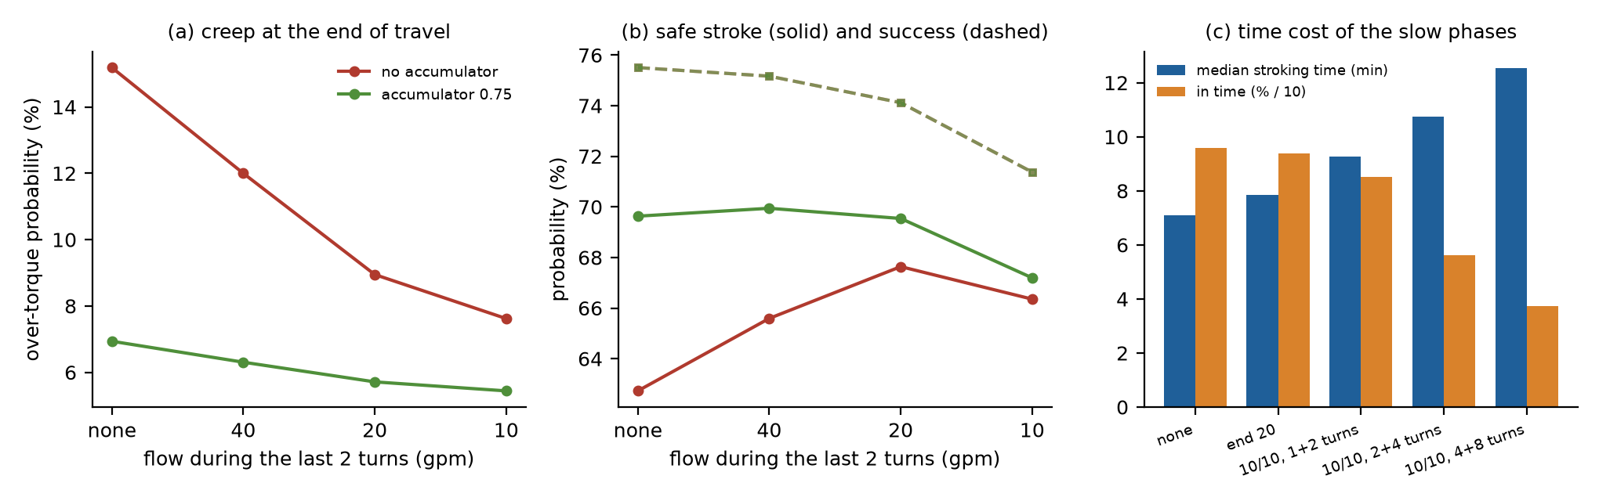
Fig. 5. Creep at the start and at the end of travel, baseline tool. (a) Over-torque probability against the flow during the last two turns, without and with an accumulator. (b) Probability of a safe stroke (solid) and of success (dashed). (c) Median stroking time and share of strokes finishing in 15 minutes (divided by 10) for slow phases of different flow and length.
6.4 The design space
With the flow limited, the torque scales with D R and the speed falls in the same proportion, so the useful designs lie along a ridge of constant D R (Fig. 6a): 62% or more of the draws give a safe stroke along the diagonal from 100 cc at 500:1 to 400 cc at 100:1, and the probability falls to 7% for the largest products. The ridge is not the whole story, because the over-torque probability rises with D R (Fig. 6b, from 2% to 42% over the grid): for a given torque chart a larger product means a lower relief pressure, and the surge, which is a pressure, becomes a larger fraction of it. Along the ridge the over-torque probability is 15% at 100 cc and 500:1 and 12% at 400 cc and 100:1, so the larger motor with the lower ratio is somewhat safer at the same success probability.
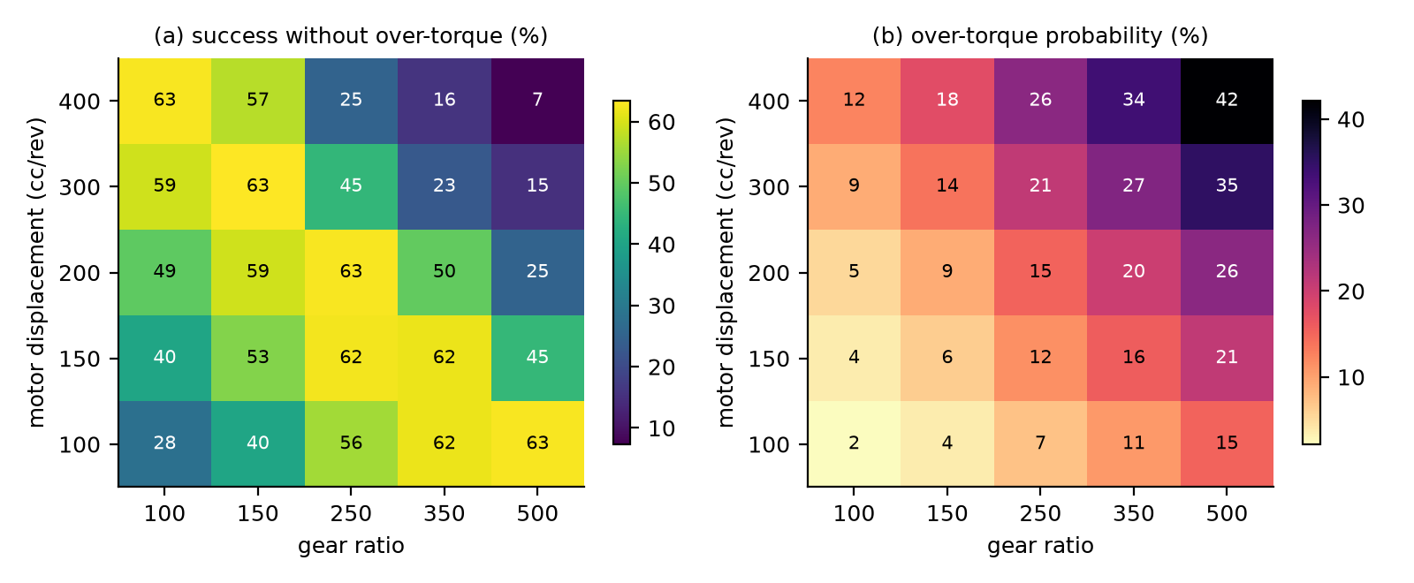
Fig. 6. (a) Probability of a safe stroke and (b) probability of over-torque against motor displacement and gear ratio, for the baseline relief chart (2 x median) and 60 gpm.
6.5 Firewater reserve and the flow limit
The concept-stage study found that the tool draws more than a quarter of the available source flow in 31% of the draws. That figure depends on how the source flow is defined and is 32% in the present model, where it is kept for continuity (Table 3). The event that matters for safety is different: the tool takes more than the flow a shared source can spare without cutting its firefighting reserve. Under the assumed spare flows (median 400 gpm for a firewater ring and 200 gpm for a hydrant) this reserve violation occurs in only 0.2% of the draws at 60 gpm and in 2.7% at 150 gpm, but it is very sensitive to the assumption: if the spare flow is a quarter of the prior it occurs in 21%, and if it is a tenth in 55% (Fig. 7c). The adaptive rule, which lowers the limiter to the spare flow of a shared source, removes the violations by construction and costs success: the safe-stroke probability falls from 62.3% to 60.0% with a quarter of the spare flow, and to 48.2% with a tenth, where only 71% of the strokes finish in 15 minutes. A site that has not measured its spare firewater flow cannot be assured that the tool is compatible with its firefighting reserve, and the right operating rule is to use a dedicated source for large valves.
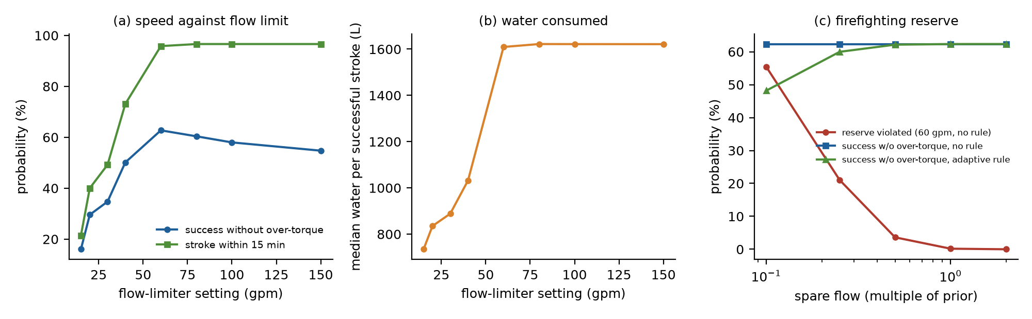
Fig. 7. (a) Probability of a safe stroke and of finishing within 15 minutes against the flow limit. (b) Median water used in a successful stroke against the flow limit. (c) Probability of violating the firefighting reserve at 60 gpm, and the probability of a safe stroke without and with the adaptive rule, against the spare flow of shared sources (multiple of the prior).
6.6 Safety-constrained optimization
Design | D | R | Relief | Q | Creep | Safe | Over-torque | Damage | Water (L)
Baseline tool | 200 | 250 | 2.0 x median | 60 | none | 62.6% | 15.2% | 1.06% | 1,601
Chart from allowable torque, no accumulator | 305 | 100 | 0.50 x allowable | 33 | none | 53.8% | 1.0% | 0.01% | 906
Chart from median breakaway, no accumulator | 203 | 148 | 1.51 x median | 29 | none | 51.4% | 0.9% | 0.01% | 656
Chart from allowable torque, accumulator 0.75 | 81 | 438 | 0.52 x allowable | 76 | none | 59.9% | 1.0% | 0.01% | 1,122
Chart from median breakaway, accumulator 0.75 | 141 | 217 | 1.58 x median | 75 | none | 58.4% | 0.9% | 0.01% | 944
Chart from allowable torque, creep, no accumulator | 270 | 160 | 0.51 x allowable | 70 | 30 / 5 | 59.5% | 0.9% | 0.01% | 1,366
Chart from median breakaway, creep, no accumulator | 392 | 100 | 1.56 x median | 59 | 16 / 7 | 60.6% | 0.8% | 0.00% | 1,240
Chart from allowable torque, creep, accumulator 0.75 | 77 | 554 | 0.54 x allowable | 96 | 26 / 22 | 63.7% | 1.0% | 0.01% | 1,373
Chart from median breakaway, creep, accumulator 0.75 | 447 | 115 | 1.58 x median | 73 | 33 / 16 | 64.0% | 0.9% | 0.01% | 1,676
Table 5. Best design of each family under P(over-torque) <= 1%, found on 15,000 draws and re-evaluated on 200,000 independent draws (shown). Relief multiple of the allowable stem torque or of the median breakaway torque; D in cc, flow limit and creep flows (start / end) in gpm; water is the median per successful stroke (L).
A design that satisfies the 1% constraint exists in every family (316 to 690 of the 1,500 designs searched meet it), and the constraint is respected out of sample (Table 5): the over-torque probability of the chosen designs, re-evaluated on independent draws, is between 0.9% and 1.0%. The price is the probability of a safe stroke. Without an accumulator the best design completes a safe stroke in 53.8% of the draws, against 62.6% for the baseline tool, which exceeds the allowable stem torque in 15%; with an accumulator that absorbs three quarters of the surge the best design reaches 59.9%. The baseline tool with the accumulator and the original chart gives 69.5% with 6.9% over-torque, so at the 1% constraint the safer configuration gives up 2.7 to 8.8 percentage points of the safe-stroke probability of the baseline against a reduction of the over-torque probability by a factor of about 15. The chosen designs have a relief setting at about half of the nominal allowable stem torque (0.50 to 0.52 of it, which is 1.5 to 1.6 times the median breakaway torque), flow limits of 29 to 76 gpm and a product D R of 30,026 to 35,490: lower than the baseline's 50,000. The probability of a safe stroke at this constraint is not sensitive to the exact displacement and ratio along the ridge (Fig. 8a).
Allowing the creep flows at the start and at the end of travel to be chosen raises the best probability of a safe stroke under the same constraint (Table 5, out of sample) from 53.8% to 59.5% without an accumulator and from 59.9% to 63.7% with one. The gain comes from the end of travel: the chosen designs run at 5 and 22 gpm for the last two turns, which is 8% and 23% of their flow limit, so the flow that the stall has to stop, and with it the surge, is a small fraction of the running flow, and the flow limit and the relief chart can be set higher for the same over-torque probability (relief at 0.51 and 0.54 of the allowable stem torque, flow limits of 70 and 96 gpm). Without an accumulator the optimizer chooses a very slow approach (about 5 gpm) and pays for it in time (median 9.5 minutes against 7.0 without creep); with an accumulator a moderate one. The start creep chosen, 30 and 26 gpm, should not be read as an optimum: in this model it acts only on valves that do not break free, so the objective is nearly flat in it.
The 1% limit is illustrative, and Table 6 shows how the best safe-stroke probability found by the search moves with it: for the family with the accumulator it is 56.5% at 0.5%, 60.0% at 1%, 65.5% at 2% and 68.5% at 5%. The decision belongs to the operator and the regulator, and the figures give them the exchange rate.
Family | P(over-torque) <= 0.5% | <= 1% | <= 2% | <= 5%
Chart from allowable torque, no accumulator | 43.3% | 54.0% | 57.5% | 62.7%
Chart from allowable torque, accumulator 0.75 | 56.5% | 60.0% | 65.5% | 68.5%
Chart from allowable torque, creep, no accumulator | 53.4% | 59.5% | 63.5% | 68.6%
Chart from allowable torque, creep, accumulator 0.75 | 58.9% | 63.9% | 66.7% | 70.2%
Table 6. Best probability of a safe stroke among the searched designs (in-sample) as the limit on the over-torque probability is varied.
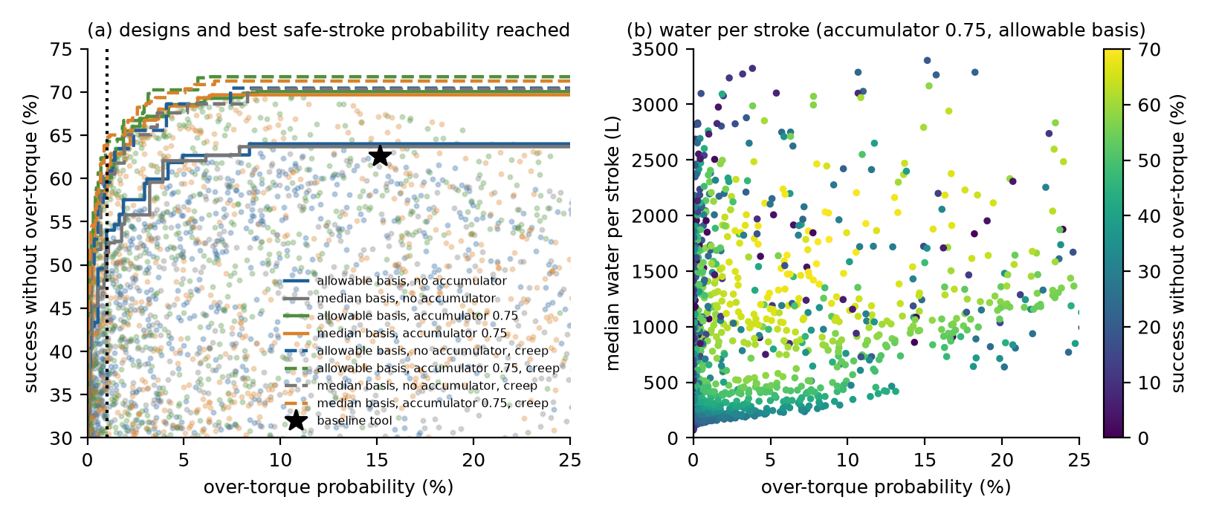
Fig. 8. (a) Searched designs (points) and non-dominated sets (lines) in the plane of safe-stroke probability against over-torque probability, for the eight families; dashed lines are the families with creep, the star is the baseline tool and the dotted line the 1% constraint. (b) Median water per stroke of the designs of the family with the accumulator and the allowable-torque chart.
A single configuration is almost as good as valve-class-specific ones. If the displacement, ratio, relief setting and flow limit are chosen separately for each class under the same 1% constraint, the weighted safe-stroke probability of the kit is 62.2%, against 59.9% for the best single design with the accumulator; the gain is 2.3 percentage points, a modest one, and part of it is the optimism of choosing the best of 500 designs for each class. What cannot be shared is the relief setting, which has to be read from the chart of each class, as it is already in the single design. The interchangeable gearing that the concept-stage study proposed for butterfly valves buys little once the over-torque constraint is in force (Supplementary Fig. S2).
6.7 Robustness to wrong input distributions
Assumption shift | Baseline | Baseline + accumulator | Optimized, no accumulator | Optimized, accumulator | Optimized, accumulator and creep
nominal priors | 63% / 15.0% | 69% / 6.8% | 54% / 1.0% | 60% / 1.0% | 64% / 1.0%
valve torque x1.5 | 41% / 14.8% | 46% / 6.8% | 28% / 1.0% | 32% / 1.0% | 36% / 1.0%
valve scatter +0.15 | 59% / 14.9% | 65% / 6.8% | 52% / 1.0% | 57% / 1.0% | 60% / 1.0%
supply -30 psi | 57% / 13.8% | 63% / 5.7% | 46% / 0.9% | 53% / 0.8% | 57% / 0.8%
seizure x2 | 58% / 14.9% | 65% / 6.8% | 49% / 1.0% | 55% / 1.0% | 59% / 1.0%
efficiencies -0.10 | 55% / 2.9% | 57% / 0.6% | 34% / 0.0% | 40% / 0.0% | 43% / 0.0%
fouling x3 | 63% / 14.9% | 69% / 6.8% | 54% / 1.0% | 60% / 1.0% | 63% / 1.0%
stem strength x0.7 | 33% / 53.0% | 44% / 38.7% | 46% / 12.2% | 51% / 13.0% | 54% / 13.7%
surge x2 | 54% / 25.6% | 67% / 9.3% | 53% / 2.6% | 59% / 1.9% | 63% / 1.2%
combined stress | 33% / 20.3% | 40% / 8.2% | 25% / 1.8% | 30% / 1.4% | 33% / 1.2%
Table 7. Probability of a safe stroke / probability of over-torque under each assumption shift, for the baseline tool, the baseline with an accumulator, and the best designs of the allowable-torque families, with and without creep (120,000 draws each).
The optimum is not robust to every wrong prior (Table 7, Fig. 9). At the assumed priors the baseline tools have the larger probability of a safe stroke, but they pay for it in over-torque; the optimized designs keep the over-torque probability near 1% under shifts of the valve torque, the supply, the seizure, the efficiencies and the fouling, because the chart limits the torque whatever the demand, and the safe-stroke probability moves as the demand moves, for example from 60% to 32% when the breakaway torques are multiplied by 1.5. One shift breaks the constraint decisively. If the true stem strength is 30% lower than the data sheet says, the over-torque probability of the optimized design with the accumulator rises to 13% (14% with creep as well), because the chart was computed from the nominal strength; a surge twice the prior roughly doubles it, to 1.9%, against 26% for the baseline tool. With the stems 30% weaker the order of the designs by safe strokes reverses: the optimized designs then lead, because the baseline tools lose most of their safe strokes to over-torque. These are the two inputs of which the model knows least, and they are the first things to measure. A chart that is safe against both would have to be lower, at a cost in the safe-stroke probability: among 150 candidate designs with a nominal over-torque probability of at most 2%, the largest worst-case safe-stroke probability that keeps the worst-case over-torque probability at or below 3%, 5% and 10% is 18%, 23% and 29% for the family with the accumulator (15%, 19% and 23% without it).
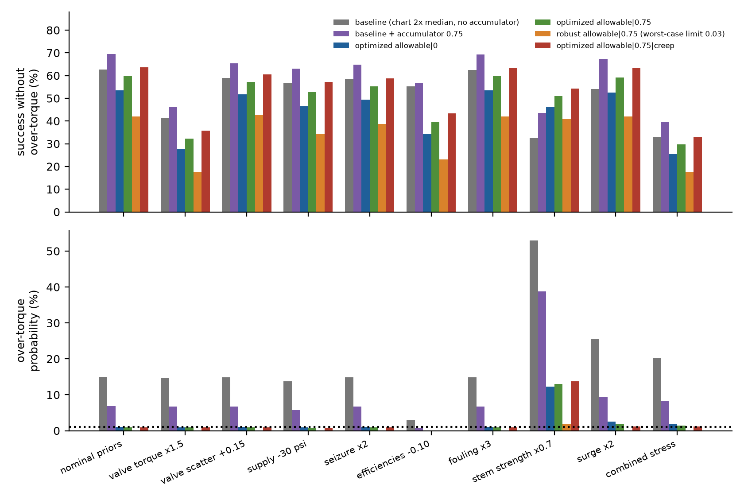
Fig. 9. Probability of a safe stroke (top) and of over-torque (bottom) under the assumption shifts for the baseline tool, the baseline with an accumulator, and the best designs found with and without an accumulator. The dotted line marks 1%.
The choice of chart basis matters only when the stems are not all equally strong relative to the operating torque. With a stem strength proportional to the median breakaway torque, as in the prior of Table 1, a chart expressed as a fraction of the allowable stem torque is algebraically the same as a chart expressed as a multiple of the median breakaway torque, and the two families of Table 5 differ only by search noise. In practice a stem is sized by its structural limit, and a butterfly valve or a corroded legacy valve can have a stem that is weak for its operating torque. Repeating the optimization with allowable torques of 4.0, 3.0, 2.2, 3.5 and 2.0 times the median breakaway torque for the five classes, the best design with a chart from the median breakaway torque has a safe-stroke probability of 56.0%, but its over-torque probability for the worst class (butterfly 36 in) is 3.5%, while the chart from the allowable torque reaches 60.3% with a worst class at 1.4% (Fig. 10b). The data sheet of the stem, not only the operating torque of the valve, is therefore part of the information that the torque chart needs.
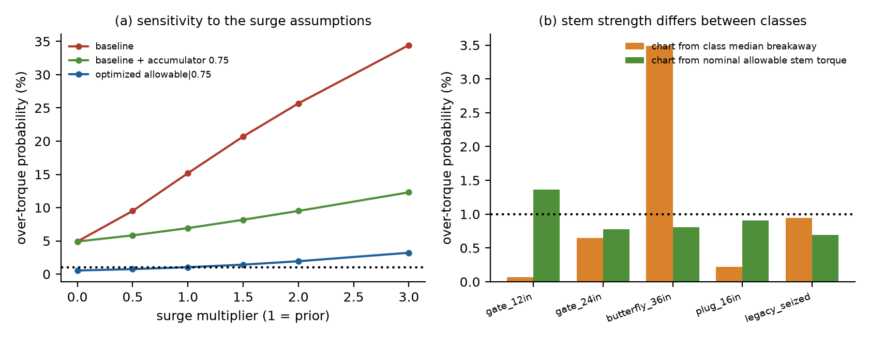
Fig. 10. (a) Over-torque probability against a multiplier of the assumed surge, for the baseline tool, the baseline with an accumulator, and the best design with an accumulator. (b) Over-torque probability of each valve class for the best designs of the two chart bases when the stem strength differs between classes.
6.8 Sensitivity
The torque margin of the tool (the logarithm of its stall capability over the breakaway demand) is controlled by the breakaway torque of the valve (partial rank correlation −0.95; variance-based indices [26] are a natural extension), the supply pressure (0.45) and the gearbox efficiency (0.40); hose length, the hose coefficient, the fouling and the source capacity have correlations below 0.05 in magnitude, so the hose does not limit the torque margin at these flows. The ratio of the peak stall torque to the allowable stem torque is controlled by the allowable stem torque (−0.89), the valve class (−0.60) and the gearbox efficiency (0.49), and it also depends on the hose, through the velocity of the water that the stall has to stop (hose coefficient 0.37) (Fig. 11). A measurement programme should therefore start with the stem strength and the breakaway torque of real valves, and with an instrumented stall test.
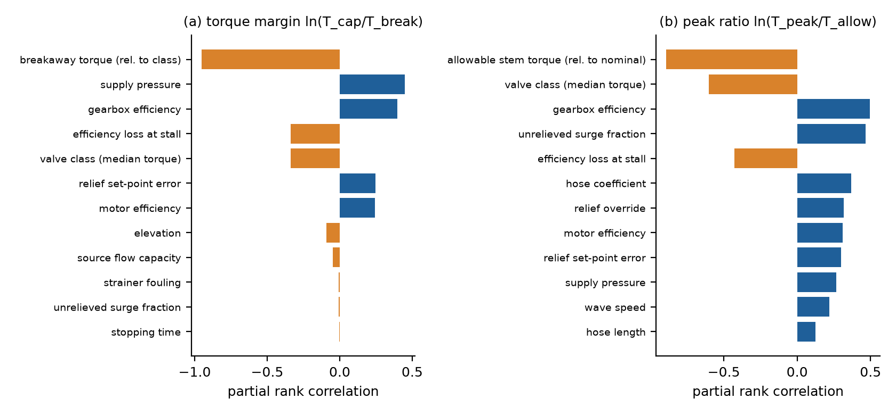
Fig. 11. Partial rank correlation of the inputs with (a) the torque margin ln(T_cap/T_break) and (b) the peak ratio ln(T_peak/T_allow), baseline tool, valve-class mix.
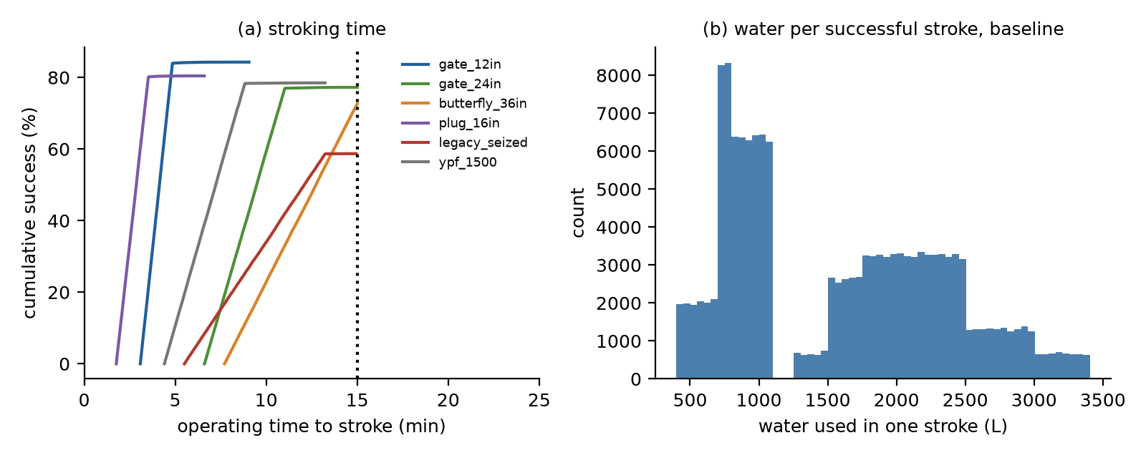
Fig. 12. (a) Distribution of the stroking time of successful strokes by valve class, baseline tool; the dotted line is the 15-minute limit. (b) Water used in one successful stroke.
6.9 Comparison with benchmark tools
Two benchmarks put the tool in context under the same valve draws. A lossless water-hydraulic tool with the same displacement and ratio, no hose or coupling loss, no leakage and no start-up loss reaches a success probability of 76.4%, against 75.5% for the baseline: the circuit and efficiency losses cost about 0.9 percentage points of success, and the shortfall of the baseline from an ideal tool is therefore not in the hydraulics. Three conventional portable operators, represented only by a rated torque, a power, an availability of the energy source and a rated speed, are evaluated on the same draws: battery-electric operator, 1,000 N.m, 1.5 kW: success 43%, safe 37%; pneumatic operator, 1,500 N.m, 3 kW (plant air): success 33%, safe 21%; engine-driven oil-hydraulic pack, 3,000 N.m, 5 kW: success 85%, safe 43%. The engine-driven pack reaches a higher success probability than the water tool because its rating is higher, not because of any advantage in safety. The conventional operators are capability-limited, with a rated torque that is either too low for the stiff valves or, for the engine-driven pack, without a torque limiter, so that the rated torque would exceed the allowable stem torque in 45% of the draws. These figures rest on assumed ratings and availabilities, not on measured performance; they show where the torque ceiling of each approach lies and do not support a claim of superiority.
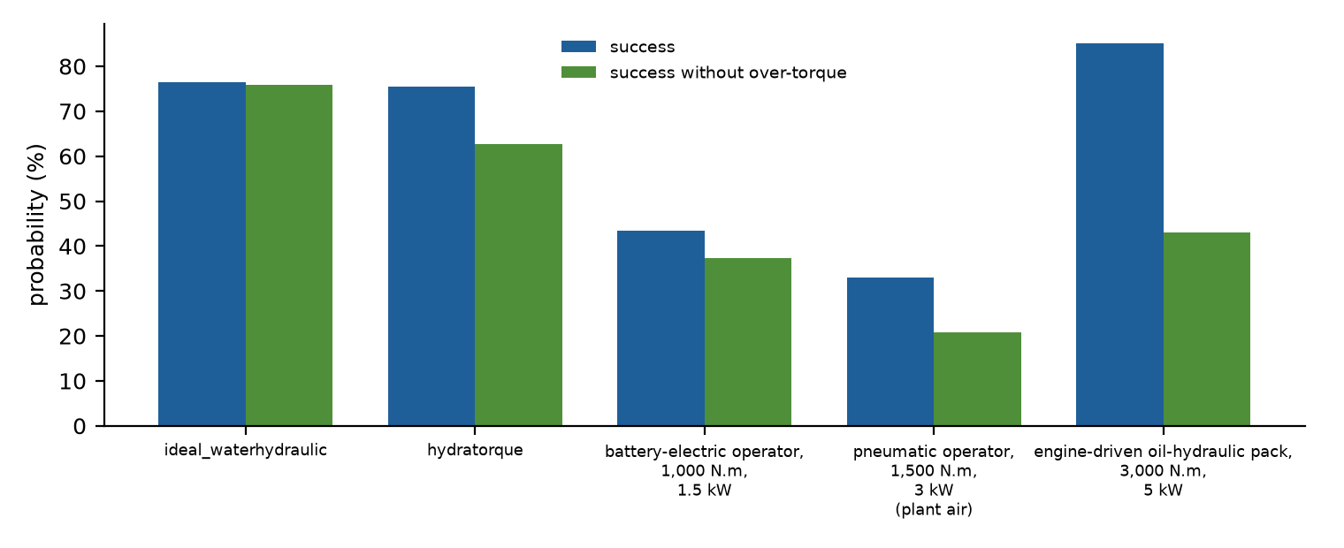
Fig. 13. Success and success without over-torque of the baseline tool, a lossless water-hydraulic tool (no surge model) and three conventional portable operators described by rated torque, power and availability, on the same valve draws.
6.10 The 1,500 N.m valve of the industrial challenge
For a valve class with the 1,500 N.m breakaway torque quoted in the industrial challenge [3] (lognormal, sigma 0.35, 10% seizure), the baseline tool completes the stroke in 78% of the draws, with a safe stroke in 70% and an over-torque probability of 9.6%; the best design of the family with the accumulator and the allowable-torque chart gives a safe stroke in 60% with 0.6% over-torque. The challenge asks for a multiplication of the operator's torque of four to six times; the median stall capability of the baseline tool is 2,450 N.m, about 8 times an operator effort of 300 N.m, but the value of the limit is set by the stem, not by the tool.
7. Discussion
7.1 What the study says about the design of the tool
Three results are specific enough to guide a bench programme, and each is conditional on the assumed priors. First, the safety of the tool is decided at the end of the stroke, not during it. The tool is strong enough, and the hose and the circuit are not the limiting elements: a lossless tool gains about one percentage point of success. What limits the safe-stroke probability is the torque that the tool can deliver at stall, which is set by a relief valve whose pressure is low for small valves and which cannot relieve a surge in time. The relief chart and the surge, not the motor, are the design problem. Second, a chart that is computed from the stem strength, together with a hose-side accumulator, brings the over-torque probability to 1% at a cost of 3 to 9 percentage points of safe strokes relative to the baseline, a cost that a slow approach to the end of travel recovers in part (4 to 6 points); the rest is paid in valves that the tool then cannot break free, and those valves need a higher-pressure source or another tool. Third, the water budget is a design variable. A stroke uses of the order of a thousand litres, and whether that is acceptable depends on a spare flow that the operator has to know.
The results suggest the following design hypotheses, to be tested on the bench before they are rules: a relief chart set at about half of the nominal allowable stem torque of the valve; a hose-side accumulator or an equivalent surge absorber; a variable flow limiter that creeps for the first turn and the last two turns of the stroke; a flow limit between 29 and 96 gpm for strokes of 30 to 70 turns, with the adaptive reduction on shared sources; a product of displacement and gear ratio of about 30,000 to 51,500; and a dedicated source for the large valves and for any site that has not measured its spare firewater flow. The numbers will move with the priors, and the robustness analysis shows in which direction: a weaker stem or a larger surge calls for a lower chart.
7.2 Relation to existing devices and what is claimed
Existing portable valve operators run on electricity, batteries, gasoline or compressed air; hydrant operating apparatus carries a hose coupler and a drive socket for the hydrant stem [11]; a hydrant-attached remote-controlled valve opens a flow channel with a pilot-operated piston [12]; and an oscillatory actuator controls a valve on a fire truck [13]. Water-hydraulic motors are established components [5,6], and the pressure surge in water lines is well understood [16]. The contribution claimed here is neither the use of water to turn a motor nor the surge on stall, but the joint probabilistic treatment of a firewater-powered tool: the safe stroke as a combined event, the surge-aware relief chart, the water and firefighting-reserve constraints, and the test of the optimum against wrong priors. The comparison with conventional operators (Section 6.9) rests on assumed ratings and availabilities, and the study does not claim superiority over any of them. A preliminary search of the literature and of patents is not a proof of novelty, and a full prior-art and freedom-to-operate review would be needed before any claim of that kind.
7.3 Deployment constraints
Four constraints follow from the setting and are not captured by the numbers above. The tool must not be used on a firewater system in a way that could compromise the reserve it has to deliver; the study turns this into an operating rule, and the rule is only as good as the knowledge of the spare flow. The reaction torque of the tool must be carried by an anchor: at a peak stall torque of 3 kN.m and a reaction arm of 0.6 m the arm and the anchor see 5 kN, and a failure of the anchor is a hazard to the operator that the model does not include. Water-filled equipment freezes, so use in cold regions, such as the Austral Zone of Patagonia named in the industrial challenge [3], requires drain-down procedures or an anti-freeze flush, and a mechanical tool of this kind would have to be assessed as non-electrical equipment for explosive atmospheres [15] and under the risk-assessment principles for machinery [27] before it is used in a classified area; the valve itself is subject to its own pressure-class rules [28]. Finally, the technology readiness of the concept is that of a computational study, not of a tool: the industrial challenge asks for a solution that is commercially available or at a readiness level of 5 to 9 with proven field reliability [3], which this concept does not meet.
8. Limitations and future validation
The principal limitation is that every input distribution is an assumed prior. No published distribution of breakaway torques of the industrial valves of interest was found; the surge parameters, the efficiency at stall and the spare flows of firewater sources are assumptions. A larger number of simulations does not compensate for uncertain input distributions, and the robustness analysis of Section 6.7 is the only protection against that. The model is lumped: the motor, the relief valve and the hose are not simulated as a transient system, the relief valve acts as an override with sampled overshoot, the hose compliance is represented by a sampled wave speed, and the stem is a single strength with a sampled yield margin. The inputs are independent, although valve size, age, stem strength and breakaway torque are correlated in reality. The reaction arm, the bearings and the gearbox are not checked against the stall torque. The comparison with conventional operators uses ratings that are assumed. The model is verified numerically, not validated physically [22], and the paper's numbers should not be quoted as field reliability.
A validation programme that would replace the assumed priors with data has six steps. (i) A survey of breakaway, running and allowable stem torques of the valves to be served, for the 2 to 16 inch range of the challenge, calibrates the valve classes and the stem strengths. (ii) A bench rig with a torque transducer measures the motor torque and leakage against the pressure drop and speed, including the loss at start-up, and calibrates the efficiencies. (iii) An instrumented stall test with fast pressure transducers measures the surge, the wave speed and the response of the relief valve, with and without an accumulator, and calibrates the inputs on which the over-torque probability depends most. (iv) Hydrant and firewater flow tests [9] give the spare flows of shared sources. (v) A field pilot on a range of valves, with a hazard identification, tests the operating procedure. (vi) A hazardous-area assessment closes the certification path.
9. Conclusions
1. A simulation of a firewater-powered portable valve operator, with an explicit hydraulic circuit and the surge on stall, shows that a stroke without exceeding the allowable stem torque occurs in 63% of the draws for the baseline tool, against the 80% success reported by the first-order model; the over-torque probability is 15%, not 5%, and the stem-damage probability is 1.1%. These are simulation outputs under assumed priors.
2. The surge on stall is the main source of over-torque, and it is largest in relative terms for small valves, whose relief pressure is low. A hose-side accumulator lowers the over-torque probability of the baseline tool from 15% to 7%, and a slow creep flow for the last two turns of the stroke lowers it from 15% to 9% (two turns at 20 gpm), at a cost of about 0.8 minutes of stroking time.
3. Under a 1% limit on the over-torque probability, which is an illustrative constraint, a design exists in every family searched, and it holds out of sample; the cost is 3 to 9 percentage points of the safe-stroke probability. A single configuration is almost as good as valve-class-specific ones; the relief chart is what has to be specific.
4. A stroke uses about 1,600 L of water at the 60 gpm limit; the 50 to 100 L/min of the first-order study is the flow for 1 to 2 rpm, too slow for a 15-minute stroke. The firefighting reserve is protected only if the spare flow of a shared source is known, and a dedicated source is the safe default for large valves.
5. The optimum is robust to wrong priors for valve torque, supply, seizure, efficiency and fouling, but not to a weaker stem or a larger surge; the data sheet of the stem and an instrumented stall test are the first measurements to make.
6. The chart basis matters only if stem strength differs between valve classes relative to their operating torque, in which case a chart from the allowable stem torque is required.
Declarations
Funding. The work received no external funding. It was carried out by the author as an independent researcher, with no grant, contract or award; the industrial challenge that motivated it states no prize, and the concept was prepared at the author's own expense.
Competing interests. The author has no financial or non-financial interests that are directly or indirectly related to the work. The concept was prepared by the author as a white paper for an industrial scouting challenge [3]; no patent has been filed and no contract or payment has resulted.
Availability of data and material. All results are generated by the code archived at https://doi.org/10.5281/zenodo.23969346 (all versions) and available at https://github.com/sandlerleon/hydratorque-firewater-valve-actuation-mc; the manuscript and its Supplementary Information are archived at https://doi.org/10.5281/zenodo.23969344 (all versions). No measured data were used.
Code availability. The simulation (HydraTorque_MC.py, version 2.1.0, numpy and matplotlib only), its automated tests and the figure and manuscript builders are in the repository; python HydraTorque_MC.py --reproduce regenerates every number and figure (seed 2026).
Author contributions. The author is the sole contributor.
Use of generative AI. During the preparation of this work the author used a generative AI tool (Claude, Anthropic) for code development (the extended hydraulic model, the optimization and the automated tests), for the analysis scripts and for drafting and editing the text. After using the tool, the author reviewed and edited the content and takes full responsibility for the content of the publication.
References
[1] A.A. Olsen, Manual Valve Operation, Access, Location and Orientation, Applying Physical Ergonomics to Modern Ship Design (2024) 45–54. https://doi.org/10.1007/978-3-031-57974-5_7
[2] B. Ahmad, N. Abdul Wahab, A. Abdul Rahman, Emergency shutdown valve reliability function test by automated partial stroke testing system, Jurnal Teknologi 78 (2016). https://doi.org/10.11113/jt.v78.9418
[3] Wazoku (InnoCentive), A portable device for valve operations that require high torque (scouting challenge for YPF), https://www.innocentive.com/challenges/a-portable-device-for-valve-operations-that-require-high-torque/, accessed 4 November 2026.
[4] C. Seabrook, C.R. Burrows, Water Hydraulics: Some Design Challenges, Fluid Power Systems and Technology, ASME IMECE 1994, pp. 59–63. https://doi.org/10.1115/imece1994-0683
[5] L. Yang, S. Nie, S. Yin, J. Zhao, F. Yin, Numerical and experimental investigation on torque characteristics of seawater hydraulic axial piston motor for underwater tool system, Ocean Engineering 104 (2015) 168–184. https://doi.org/10.1016/j.oceaneng.2015.05.003
[6] F. Majdič, Influences on the Efficiency of a Water-Hydraulic Motor, Proceedings of the International Conference Fluid Power 2019, University of Maribor Press (2019) 89–96. https://doi.org/10.18690/978-961-286-300-5.7
[7] F. Majdič, Research on the water hydraulic pressure relief valve, Proceedings of the International Conference Fluid Power 2021, University of Maribor Press (2021) 29–40. https://doi.org/10.18690/978-961-286-513-9.3
[8] M.E. Benfer, E. Forssell, J. Scheffey, Determination of Fire Hose Friction Loss Characteristics, Fire Technology 53 (2016) 1059–1075. https://doi.org/10.1007/s10694-016-0617-z
[9] NFPA 291, Recommended Practice for Fire Flow Testing and Marking of Hydrants, National Fire Protection Association, Quincy, MA (current edition).
[10] D.P. Nolan, Sources of Firewater Pump Supply, Fire Pump Arrangements at Industrial Facilities (2017) 29–44. https://doi.org/10.1016/b978-0-12-813043-8.00005-1
[11] W. Jackman, Remote fire hydrant actuator, US Patent 4,561,459, published 31 December 1985. https://patents.google.com/patent/US4561459A/en
[12] D.J. Kolacz, S.G. McMillan, S.W. Akins, T.S. Miller, Portable remote controlled valve, US Patent 8,733,387 B2, Task Force Tips LLC, granted 27 May 2014. https://patents.google.com/patent/US8733387B2/en
[13] B.C. Leete, Rotary actuator and valve control system, US Patent 5,101,862, published 7 April 1992. https://patents.google.com/patent/US5101862A/en
[14] ISO 5210:2017, Industrial valves — Multi-turn valve actuator attachments, International Organization for Standardization, Geneva, 2017.
[15] ISO 80079-36:2016, Explosive atmospheres — Part 36: Non-electrical equipment for explosive atmospheres — Basic method and requirements, International Organization for Standardization, Geneva, 2016.
[16] M.S. Ghidaoui, M. Zhao, D.A. McInnis, D.H. Axworthy, A Review of Water Hammer Theory and Practice, Applied Mechanics Reviews 58 (2005) 49–76. https://doi.org/10.1115/1.1828050
[17] J. Drago, W. Evans, Gauging the Force Effects of Valve Stem Packing on Valve Stem Actuation, ASME/NRC 2017 13th Pump and Valve Symposium (2017), paper PVS2017-3518. https://doi.org/10.1115/pvs2017-3518
[18] M.D. McKay, R.J. Beckman, W.J. Conover, Comparison of Three Methods for Selecting Values of Input Variables in the Analysis of Output from a Computer Code, Technometrics 21 (1979) 239–245. https://doi.org/10.1080/00401706.1979.10489755
[19] J. Helton, F. Davis, Latin hypercube sampling and the propagation of uncertainty in analyses of complex systems, Reliability Engineering & System Safety 81 (2003) 23–69. https://doi.org/10.1016/s0951-8320(03)00058-9
[20] P. Glasserman, D.D. Yao, Some Guidelines and Guarantees for Common Random Numbers, Management Science 38 (1992) 884–908. https://doi.org/10.1287/mnsc.38.6.884
[21] R.L. Iman, W.J. Conover, A distribution-free approach to inducing rank correlation among input variables, Communications in Statistics - Simulation and Computation 11 (1982) 311–334. https://doi.org/10.1080/03610918208812265
[22] W.L. Oberkampf, T.G. Trucano, Verification and validation in computational fluid dynamics, Progress in Aerospace Sciences 38 (2002) 209–272. https://doi.org/10.1016/s0376-0421(02)00005-2
[23] H.G. Beyer, B. Sendhoff, Robust optimization – A comprehensive survey, Computer Methods in Applied Mechanics and Engineering 196 (2007) 3190–3218. https://doi.org/10.1016/j.cma.2007.03.003
[24] R. Marler, J. Arora, Survey of multi-objective optimization methods for engineering, Structural and Multidisciplinary Optimization 26 (2004) 369–395. https://doi.org/10.1007/s00158-003-0368-6
[25] K. Deb, A. Pratap, S. Agarwal, T. Meyarivan, A fast and elitist multiobjective genetic algorithm: NSGA-II, IEEE Transactions on Evolutionary Computation 6 (2002) 182–197. https://doi.org/10.1109/4235.996017
[26] A. Saltelli, P. Annoni, I. Azzini, F. Campolongo, M. Ratto, S. Tarantola, Variance based sensitivity analysis of model output. Design and estimator for the total sensitivity index, Computer Physics Communications 181 (2010) 259–270. https://doi.org/10.1016/j.cpc.2009.09.018
[27] ISO 12100:2010, Safety of machinery — General principles for design — Risk assessment and risk reduction, International Organization for Standardization, Geneva, 2010.
[28] ASME B16.34, Valves — Flanged, Threaded, and Welding End, American Society of Mechanical Engineers, New York (current edition).

